Name of journal: World Journal of Gastroenterology
Manuscript NO: 36647
Manuscript Type: ORIGINAL ARTICLE

Basic Study
Hypoxia preconditioning protects Ca²⁺-ATPase activation of intestinal mucosal cells against R/I injury in a rat liver transplantation model

Zhi-Peng Ji, Yuan-Xin Li, Bao-Xu Shi, Zhuo-Nan Zhuang, Jing-Yan Yang, Guo Sen, Xiao-Zhou Xu, Ke-Sen Xu, Hai-Lin Li

Ji ZP et al. Hypoxia preconditioning in liver transplantation model

Zhi-peng Ji, Department of General Surgery, The Second Hospital of Shandong University, Jinan 250033, Shandong Province, China

Yuan-xin Li, Zhuo-nan Zhuang, Department of Gastrointestinal Surgery, Beijing Tsinghua Changgung Hospital, School of Clinical Medicine, Tsinghua University, Beijing 102218, China

Bao-xu Shi, Department of Neurology, People’s Hospital of Rizhaolanshan, Rizhao 276800, Shandong Province, China

Guo Sen, Department of Hepatobiliary Surgery, Qilu Hospital, Shandong University, Jinan 250033, Shandong Province, China

Xiao-zhou Xu, Ke-sen Xu, Hai-lin Li, Department of Hepatobiliary Surgery, The Second Hospital of Shandong University, Shandong University, Jinan 250033, Shandong Province, China

Jing-Yan Yang, Department of Pathology, The Second Hospital of Shandong University, 250033, Jinan, PR China

ORCID number: Zhi-peng Ji (0000-0002-6541-1244); Yuan-xin Li (0000-0001-8176-822X); Bao-xu Shi (0000-0001-6148-2662); Zhuo-nan Zhuang (0000-0002-0881-2631); Jing-Yan Yang (0000-0001-7556-0326); Sen Guo (0000-0003-0175-3963); Xiao-Zhou Xu (0000-0002-0601-4871); Ke-sen Xu (0000-0003-2168-8214); Hai-lin Li (0000-0001-5150-3693).

Author contributions: Ji ZP and Li HL designed the research, drafted and revised the paper; Ji ZP and Zhuang ZN performed the research; Shi BX, Guo S, Xu XZ and Zhuang ZN searched the literature and analysed the data; Xu KS and Li HL revised the paper and approved the final version. Yang JY provided pathology technical assistance and analysis.

Supported by The Second Hospital of Shandong University Youth Foundation, No. Y2013010033.

Institutional review board statement: The study was reviewed and approved by The Second Hospital of Shandong University Institutional Review Board.

Conflict-of-interest statement: We declare that there are no conflicts of interest to disclose.

Data sharing statement: No additional data are available.

Open-Access: This article is an open-access article which was selected by an in-house editor and fully peer-reviewed by external reviewers. It is distributed in accordance with the Creative Commons Attribution Non Commercial (CC BY-NC 4.0) license, which permits others to distribute, remix, adapt, build upon this work non-commercially, and license their derivative works on different terms, provided the original work is properly cited and the use is non-commercial. See: http://creativecommons.org/licenses/by-nc/4.0/

Manuscript source: Unsolicited manuscript

Correspondence to: Hai-lin Li, MD, PhD, Adjunct Professor, Department of Hepatobiliary Surgery, The Second Hospital of Shandong University, Shandong University, 247#, Beiyuan Street, Jinan 250033, Shandong Province, China. lehaln01@163.com
Telephone: +86-531-82169203
Fax: +86-531-82169243

Received: October 17, 2017
Peer-review started: October 17, 2017
First decision: October 31, 2017
Revised: November 7, 2017
Accepted: November 28, 2017
Article in press:
Published online:

Abstract
AIM
To investigate the effect of ischaemia and reperfusion (I/R) injury on the Ca²⁺-ATPase activation of rat intestine tissue in a rat autologous orthotopic liver transplantation model and to determine if hypoxia preconditioning (HP) therapy induced HIF-1α to protect rat intestine tissue against I/R injury.

METHODS
The rats received non-lethal hypoxic preconditioning therapy to induce HIF-1α expression. We used the autologous orthotopic liver transplantation model to imitate the I/R injury of intestinal tissue. Then, we detected the microstructure changes in small intestinal tissues, Ca²⁺-ATPase activity, apoptosis and inflammation within 48 h post-operatively.

RESULTS
HIF-1α expression was significantly increased in intestine tissue at post-operative 12 h in rats that were exposed to a hypoxic environment for 90 min compared with a non-hypoxia preconditioning group (HP vs AT, P = 0.0177). Pathology was performed on the intestinal mucosa cells, and the cells in the HP group appeared healthier than the cells in the AT group. The Ca²⁺-ATPase activity in the small intestine cells in the AT group was significantly lower after the operation, and the Ca²⁺-ATPase activity in the HP group recovered faster than that in the AT group at post-operative 6 h (HP vs AT, P = 0.0106). The BCL-2 expression in the HP group was significantly higher than that in the AT group at post-operative 12 h (HP vs AT P = 0.0010). The expression of the inflammation factors NO, SOD, IL-6 and TNF-α was significantly lower in the HP group than that in the AT group.

CONCLUSION
Hypoxia-induced HIF-1α could protect intestine mucosal cells against mitochondrial damage after I/R injury. Hypoxic preconditioning could improve hypoxia tolerance in small intestine mucosal cells and protect Ca²⁺-ATPase activity to reduce the apoptosis of and pathological damage to intestinal cells. Hypoxic preconditioning could be a useful way to promote the earlier recovery of intestine function after graft procedure.

Key words: Hypoxic precondition; Intestinal function; Ischemia/reperfusion; Liver transplantation; Rat

© The Author(s) 2017. Published by Baishideng Publishing Group Inc. All rights reserved.

Core tip: Ischaemia/reperfusion (I/R) injury affects the recovery of post-operative bowel function in liver transplantation. In our research, hypoxia-induced HIF-1α expression could protect mitochondria function and Ca²⁺-ATPase activity against the I/R injury to reduce the apoptosis and pathological damage of intestinal cells. So we suggest that hypoxic preconditioning therapy could improve the tolerance of small intestine mucosal cell to hypoxia in rat autologous orthotopic liver transplantation.

Ji ZP, Li YX, Shi BX, Zhuang ZN, Guo S, Xu XZ, Yang JY, Xu KS, Li HL. Hypoxia preconditioning protects Ca²⁺-ATPase activation of intestinal mucosal cells against R/I injury in a rat liver transplantation model. World J Gastroenterol 2017; In press

INTRODUCTION
During liver transplantation, intestinal ischaemia/reperfusion (I/R) injury is usually caused by the blockage of blood flow in the portal vein. The digestive tract usually plays an important role in the pathophysiological process of trauma and shock due to its unique physiological environment, metabolic factors, network of mucosal blood vessels and counter-current exchange mechanism. In particular, intestinal mucosal I/R injury can link systemic inflammatory response syndrome (SIRS) and multiple organ dysfunction syndrome (MODS) after shock or trauma^{[1]}. The post-operative recovery of small intestinal mucosa cells is important in treatment and prognosis.
Under normal circumstances, the intestinal mucosa play an important role in maintaining normal barrier function, absorbing nutrients and resisting the invasion of local bacteria and toxins in the intestine^{[2]}. The intestinal villus nutrient vessels resemble a hairpin that sits at the top of the intestinal villi, and they are extremely curved. Due to its high metabolism and villus microvascular structure characteristics, the tolerance of intestinal mucosa cells to I/R injury, especially the top of the intestinal villus epithelial cells, is much lower than that in other tissue cells; thus, these cells are particularly sensitive to hypo-perfusion^{[3]}. Another cause of intestinal mucosal damage is the presence of hypoxia and acidosis in the gastrointestinal tract. Therefore, the intestinal villi can undergo ischaemic damage.
Non-lethal hypoxic preconditioning (HP) can increase tolerance to I/R injury and is effective in reducing damage to a variety of organs^{[4]}, including the liver and kidney^{[5]}. For tumour cells, research has found that HIF-1α plays an important role in hypoxia conditioning, and HIF-1α is also the critical transcription factor that mediates cell hypoxia reactions^{[6]}. In our previous study, we induced HIF-1α expression in liver tissue by exposing rats to a non-lethal hypoxia environment, and detected changes in the NF-κB and Erk pathways. Moreover, changes in glucose metabolism were also detected, and hypoxia-induced HIF-1α expression promoted HK2 and Glut1 expression, which could decrease liver inflammation and I/R injury after orthotopic liver transplantation. Bcl-2 (B-cell lymphoma 2), encoded in humans by the BCL2 gene, is the founding member of the Bcl-2 family of regulator proteins that regulate cell death (apoptosis), by either inducing (pro-apoptotic) or inhibiting (anti-apoptotic) apoptosis^{[7,8]}. Bcl-2 is considered an important anti-apoptotic protein. Studies of human cancer cells also confirmed that the expression of Bcl-2 was positively correlated with VEGF and HIF1A, which are target genes of miR-27a and miR-17, and the expression of VEGF and HIF1A was related to the poor prognosis of patients^{[9]}. The BCL2 protein functions as an antiapoptotic protein and inhibits programmed cell death^{[10]}. Both gene amplification and translocation are common mechanisms for BCL2 protein overexpression in diffuse large B-cell lymphoma (DLBCL). The clinical significance of BCL2 protein expression in DLBCL is still controversial^{[11]}. Ca²⁺-ATPase damage is one of the early manifestations in intestinal mucosa cells during ischaemia-reperfusion injury. During intestinal ischaemia, calcium mobilization and extracellular calcium influx greatly increase the calcium ion concentration in the cytoplasm. Intracellular calcium activates proteolytic enzymes, which produce a large number of free radicals that are involved in cell injury during reperfusion. Oxygen free radicals damage cell membrane lipids, and the peroxidation of calcium channels can lead to the inactivation of the Na⁺-K⁺-ATP enzyme and the Ca²⁺ Na⁺ exchange, which can enhance Ca²⁺ influx, leading to intracellular calcium overload^{[12]}. Cell damage is caused by mitochondrial oxygen utilization and the synthesis of ATP is further damaged. Acidic products are produced during anaerobic metabolism, which leads to a change in intracellular enzyme activity and a deficient transmembrane ion gradient. When the duration of tissue ischaemia exceeds a certain critical value, I/R injury will be irreversible and the tissue will become necrotic^{[13]}.
In this study, we investigated how I/R injury affects the Ca²⁺-ATPase activation of rat intestine tissue in a rat autologous orthotopic liver transplantation model. Hypoxia-induced HIF-1α could protect against the I/R injury of mitochondria and preserve Ca²⁺-ATPase activity in rat intestine tissue. Hypoxic preconditioning can improve the tolerance of small intestine mucosal cells to hypoxia, and reduce the apoptosis by increasing BCL2 expression and pathological damage to intestinal cells. It could be a useful way to promote the earlier recovery of intestine function after graft procedure.

MATERIALS AND METHODS
Materials
Healthy 8-10-wk-old male SD rats that weighed 225-275 g were provided by the Experimental Animal Center of Jiangsu Province. All studies were approved by our Institutional Animal Care and Use Committee. The homemade hypoxic device (refer to Vannucci and other methods^{[4]}) consisted of a noninvasive vascular folder of 8% nitrogen-oxygen mixed gas (containing 8% oxygen, 92% nitrogen, provided by the Nanjing Flextronics Gas Co., Ltd.). Hypoxia equipment consisted of a high pressure tank filled with nitrogen-oxygen mixed gas, a 5-L sealed hypoxic disposal tank, an outflow of gas, water bottle, mask, oxygen valve, an oxygen flow metre and connection tubes. The rats can be completely enclosed in the transparent low-disposal tank. Rats were maintained at atmospheric pressure for 90 min with an 8% nitrogen-oxygen gas mixture (containing 8% oxygen and 92% nitrogen) with a flow rate of 5 L/min. Eight hours later, we administered anaesthesia and began the autologous orthotopic liver transplantation surgery.

Autologous orthotopic liver transplantation
The healthy SD rats were randomly divided into three groups as follows: the normal control group (NC; n = 3, total n = 18), the autotransplantation group (AT; n = 3, total n = 18), or the hypoxic preconditioning group (HP; n = 3, total n = 18). The autologous orthotopic liver transplantation procedure is as follows: after rats were injected with 100 mg/kg ketamine and 0.03 mg atropine intraperitoneally, they were maintained on semi-open mask inhalation ether anaesthesia for 10 min. After the abdominal cavity was opened, the falciform ligament was resected, and the blood vessel along the oesophagus was removed. The liver was dissected until the suprahepatic vena cava (SVC) was completely liberated. A homemade leash was prepared to guide the SVC for blockage. The PV was dissected from the convergence of the inferior mesenteric and splenic veins. The hepatic artery and biliary tract were freed together. Vascular clamps were used at the convergence of the inferior mesenteric and splenic veins, hepatic artery, SVC, and IVC. The PV was punctured with a No. 4 transfixion pin in preparation for reperfusion, and fixed with a vascular clamp. Ringer’s lactate solution was injected for reperfusion at 2.5 mL/min, and a 1-mm incision was made in the wall of the IVC as an outflow tract. The liver gradually turned yellow when reperfusion was successful. A total of 20-25 min passed to imitate the operation range of liver transplantation and the duration of ischaemia/reperfusion injury. At the end of the procedure, the rats received an injection of 1.6 million units of penicillin in the abdomen and 4 mL of Ringer’s lactate was infused through the abdominal wall vein, then the abdomen was sutured. After surgery, rats were kept in a 38 °C incubator^{[5]}.

Western blot analysis
Intestinal tissue samples were lysed and cell lysates were collected with radioimmuno-precipitation assay (RIPA) protein lysate buffer. The cytoplasm was centrifuged at 750 g and 4 °C for 5 min, then the supernatant was collected and centrifuged at 13000 rpm at 4 °C for 30 min to collect the sediment. A total of 30 μg of protein were loaded and run on the gel, then transferred to nylon membranes (Immobilon-P, Millipore, Bedford, MA, United States) for 1 h at 300 mA followed by blocking with 5% non-fat dry milk in 0.1% TBST for 1 h. PVDF membranes were incubated with primary antibodies overnight at 4 °C. The primary antibodies against HIF-1α, caspase-3, cleaved caspase-3, and cleaved PARP were purchased from cell signalling technology (United States) and diluted at 1:500. The secondary antibodies and β-actin antibody were purchased from Abcam Biotechnology Company.

Histology and immunohistochemistry
Formalin-fixed paraffin-embedded tissue sections were subjected to immunostaining using the streptavidin-peroxidase technique, with diaminobenzidine as a chromogen. Haematoxylin and eosin (H&E) staining and the analysis of immunohistochemistry were performed according to standard procedures. The protein expression of bcl-2 was evaluated with immunohistochemistry. The target protein was detected via the Elivison two-step immunohistochemical method. Then, tissues were dewaxed by xylene, ethanol, 95% ethanol in water, 85% ethanol in water and 70% ethanol in water. A high-temperature plastic staining tray submerged in a beaker of antigen retrieval buffer was used for antigen retrieval. The enzyme was inactivated, and the antigen was added to the reaction. The sections were incubated in 50 μl of universal IgG antibody-Fab-HRP polymer for 30 min. Then, colour, staining, dehydration and sealed glass slides. The expression of bcl-2 protein was represented by a blue colour in the cells. Image-Pro Plus 6.0 software was used to analyse the optical density of immunohistochemical results. In brief, the scoring was as follows: 0, < 10% of cells stained; 1, 10% to 25% of cells stained; 2, 25% to 50% of cells stained; 3, > 50% of cells stained. For all cases, slides with scores of ≥ 2 were considered positive.

Ca²⁺-ATPase activity analysis
ATPase (Ca²⁺-ATPase) activity was detected from 0.2 mL of the supernatant added to 0.8 mL of normal saline. One ATPase activity unit per hour is the amount of 1 μmol of inorganic phosphorus produced by the decomposition of ATP by per milligram of protein.

ELISA analysis
Blood samples were collected from rats and centrifuged 0 h, 2 h, 6 h, 12 h, 24 h and 48 h after the operation to separate the serum and were stored at -80°C. All samples were analysed with ELISA assay kits, which were purchased from Kaiji Biology, Inc., (Nanjing, China). Nitric oxide (NO), superoxide dismutase (SOD), interleukin 6 and anti-rat tumour necrosis factor (TNF-α) rat ELISA kits were purchased from Kaiji Biology Company, Nanjing, China.

Statistical analysis
Statistical analysis was performed with commercially available SPSS version 19.0 software (Chicago, IL, United States) and GraphPad Prism software (La Jolla, CA, United States). All experimental data were analysed via analysis of variance and are expressed as mean ± standard deviation ($\overline{x}$± s). Independent t-tests were used to analyse the differences between groups. P < 0.05 was considered statistically significant.

RESULTS
Hypoxia preconditioning induced HIF-1α expression in liver and intestinal tissues in a rat autologous orthotopic liver transplantation model
The rats in the HP group were exposed to a hypoxic environment for 90 min before the procedure; this experimental protocol has been used in our lab previously^{[14]}. Then, the rats underwent an autologous orthotopic liver transplantation. The changes in HIF-1α levels in the total cellular extract of liver tissue and intestine tissue were detected 12 h after the procedure. HIF-1α expression induced by hypoxia preconditioning was increased in rat liver tissue 12 h after the operation (Figure 1A). We also observed that HIF-1α expression in the AT group was higher than in the NC group, but the difference was not significant (AT vs NC, P = 0.0738, Figure 1B). The increased HIF-1α expression in ischaemia and hypoxia tissues may have been caused by the procedure, which includes clamping and blocking the blood circulation during the liver transplantation. HIF-1α expression was significantly higher after the hypoxia preconditioning therapy than in the non-hypoxia preconditioning group (HP vs AT, P = 0.0177, Figure 1B).
The intestine tissues were also examined for changes in HIF-1α levels 12 h after the procedure via Western Blot. We observed that HIF-1α expression in intestine tissue was significantly higher after hypoxia preconditioning therapy than in non-hypoxia preconditioning group (HP vs AT, P = 0.0118, Figure 1D). The HIF-1α level in the AT group was not significantly different compared to the NC group (AT vs NC, P = 0.1938, Figure 1D).

Changes in intestinal morphology and Ca²⁺-ATPase activity
Intestinal cells, particularly mucosa cells, usually suffer I/R injury during the liver transplantation procedure. In this study, we collected rat intestine tissue for pathology 12 h after the operation. The intestinal mucosa cells in the AT group exhibited noticeable oedema, and capillary vessels were filled with red blood cells and blood clots. The villus epithelial cells were shedding, glands were severely damaged and were infiltrated with inflammatory cells (Figure 2A.b). Mitochondria are important cellular organs that affect the oxidative respiratory chain, and damage to mitochondria that occurs during the early stage of ischaemia/reperfusion injury leads to cell apoptosis. We observed that the mitochondria in the AT group appeared swollen, round, and degenerated 12 h after the operation, and the visible crest appeared less fractured or even disappeared (Figure 2B.e). Our previous study showed that hypoxia preconditioning induced HIF-1α expression and decreased oxidative respiratory chain damage in the mitochondria and protected against I/R injury in liver tissue^{[14]}. In this study, we also observed that the intestine cells appeared to have slight oedema, fewer inflammatory cells were present, and less damage was present in rat intestine tissue after hypoxia preconditioning therapy compared with the AT group (Figure 2A.c). The mitochondria of intestinal cells appeared less swollen with fewer cristae. The structure of the endoplasmic reticulum was maintained (Figure 2B.f). The intestinal cells and mitochondria appeared normal in the NC group (Figure 2A.a and 2B.d).
The I/R injury of intestine tissue during the procedure may decrease Ca²⁺-ATPase activity, which was evaluated to assess the damage to intestinal cell membranes and to predict functional recovery.
Ca²⁺-ATPase activity in the AT group was significantly lower compared with the NC group, and decreased to the lowest level 2 h post-operative (Figure 2C, AT vs NC, P = 0.0193), then recovered. The same pattern was evident in the HP group, which exhibited decreased cellular Ca²⁺-ATPase activity after the procedure. However, we observed that the cellular Ca²⁺-ATPase activity in the HP group was significantly higher than in the AT group post-operative 12 h (Figure 2D, HP vs AT, P = 0.0106). To further detect the affection of hypoxia precondition on the activity of cellular Ca²⁺-ATPase, we analysed the enzyme bioactivity changes at different time points. Table 1 shows that the cellular Ca²⁺-ATPase activity was significantly higher than in the AT group at 2 h, 12 h and 24 h post-operation (Table l).

Hypoxia preconditioning promotes BCL2 expression and decreases apoptosis in response to I/R injury in rat intestinal tissues
Our previous study showed that hypoxia preconditioning therapy induced HIF-1α expression and could protect against mitochondrial damage and against apoptosis in liver tissue^{[14]}. In this study, rat intestinal tissues were analysed by immunohistochemistry to detect BCL2 expression, which can affect cell apoptosis by regulating mitochondrial membrane permeability. Immunohistochemistry demonstrated that the ratio of BCL2 positive signal in the HP group was significantly higher than in the AT group at post-operative 12 h (Figure 3B, HP vs AT P = 0.0010). The ratio of positive BCL2 signal was detected at several time points after the operation (2 h, 6 h, 12 h, 24 h, 48 h) in the NC, AT and HP groups. The expression of BCL2 in the HP group was increased after the operation, peaked at post-operation 12 h and stayed at a high level. It was significantly higher in the HP group compared with the NC group and the AT group (Figure 3C, 6 h: HP vs AT, P = 0.0407; 12 h: HP vs AT, P = 0.0301). However, for the AT group, we observed that there was no significant difference in BCL2 expression compared with the NC group (Figure 3C, 6 h: AT vs NC, P = 0.0544). To confirm that BCL2 expression inhibited apoptosis in rat intestine tissue, we detected the cleaved-caspase3 and cleaved-PARP expression levels by Western blot and found that cleaved-caspase3 expression was increased in rat intestine tissue that had undergone I/R injury at post-operation 24 h. In the AT group, the level of cleaved-caspase3 was significantly higher than that in the NC group (Figure 4B, AT vs NC, P = 0.0004), while cleaved-Caspase3 expression in the HP group was lower than in the AT group at post-operation 24 h (Figure 4B, HP vs AT, P = 0.0038). The expression of cleaved-PARP was increased in rat intestine tissue that had undergone I/R injury at post-operation 24 h. The level of cleaved-PARP in the AT group was significantly higher than in the NC group (Figure 4D, AT vs NC, P < 0.0001). Cleaved-PARP expression in the HP group was lower than in the AT group at post-operation 24 h (Figure 4D, HP vs AT, P = 0.0001).

Changes in the levels of serum inflammation factors in a rat autologous orthotopic liver transplantation model
To investigate the ability of HP treatment to protect intestinal tissue from I/R injuries, we monitored changes in the levels of NO, SOD, IL-6 and TNF-α in rat serum samples. In the HP group, serum NO and SOD levels increased after the operation, but they were lower compared with the AT group, in which NO and SOD levels stayed elevated after the operation (Figure 5A and B, NO, 24 h: AT vs NC, P = 0.0260; AT vs HP, P = 0.0083; HP vs NC, P = 0.0599; SOD, 24 h: AT vs NC, P = 0.0357; HP vs AT, P = 0.0352; HP vs NC, P = 0.2036). We measured the serum levels of IL-6 and TNF-α, and found that HP treatment appeared to relieve some of the inflammatory reaction due to the lower IL-6 and TNF-α levels that were detected (Figure 5C and D, IL-6, 24 h: AT vs NC, P < 0.0001; AT vs HP, P = 0.0097; HP vs NC, P = 0.0113; TNF-α, 24 h: AT vs NC, P < 0.0001; HP vs AT, P = 0.0029; HP vs NC, P = 0.0007).

DISCUSSION
There is a close relationship between the contractile activity of the small intestine and the intracellular concentration of Ca^{2+[15]}. Ca²⁺-ATPase can be found in the plasma membrane, endoplasmic reticulum and mitochondrial membrane. It can be activated and hydrolyse ATP to provide energy when the concentration of Ca²⁺ rises to a certain level. Therefore, Ca²⁺-ATPase levels can indicate ischaemia-reperfusion injury because they can reflect the severity of cell injury^{[16]}. The results of the present study showed that the intestine suffered hypoxia with congestion after the occlusion of the liver portal vein during autologous orthotopic liver transplantation. The calcium balance system became dysfunctional because the activity of the Ca²⁺-ATPase in intestinal tissue was damaged due to the presence of toxins in the blood. We found that the Ca²⁺-ATPase activity in intestinal tissue which suffered the I/R injury after the procedure of autologous orthotopic liver transplantation was significantly lower compared with the non-surgery intestinal tissue. Therefore, the systolic and diastolic function of the intestinal smooth muscle was inhibited in the autologous orthotopic liver transplantation group, resulting in decreased peristalsis of the stomach and intestines.
Due to the hypoxia, intestinal epithelial cells were shedding and necrosis occurred, increasing intestinal permeability and triggering intestinal bacteria and endotoxin translocation^{[17]}. In previous study, we showed HIF-1α promoted HK2 and Glut1expression could decrease the liver inflammation and I/R injury after orthotopic liver transplantation^{[14]}. In this study, due to non-noticeably reduced Ca²⁺-ATPase activity in the liver transplantation group with hypoxia preconditioning therapy, small intestinal tissue exhibited less apoptosis and hypoxia tolerance was increased after ischaemic reperfusion injury and exposure to oxygen free radicals and toxins in the intestines. Our previous study found that hypoxic preconditioning protects mitochondria against ischaemia-reperfusion injury^{[18]}. In this study, we observed Ca²⁺-ATPase activity in intestinal tissue of the rat with hypoxia preconditioning therapy was not noticeably reduced compared to the non-surgery intestinal tissue. The cells could adapt to hypoxia and post-operative injury in a hypoxic environment was reduced.
BCL2 family proteins affect cell apoptosis by regulating mitochondrial membrane permeability. The mechanism may be that BCL2 is formed and changes the pores or channels in the mitochondrial membrane^{[19-21]}. BCL2 is considered an important anti-apoptotic protein. BCL2 can affect cell apoptosis by regulating mitochondrial membrane permeability.
Our studies previously found that HP was sufficient to activate the BCL2 signaling pathway and up-regulated the expression of BCL2 protein, a regulatory factor restrained apoptosis, and it may regulate apoptosis by altering the configuration of mitochondria in liver tissue on rat liver transplantation model^{[22]}. In this study, the rat with hypoxia preconditioning therapy was detected the intestinal tissue after procedure to show a low level of cleaved-caspase3 and cleaved-PARP expressions and seemed to be less apoptosis compared to the rat with non-HP therapy. BCL2 expression was also increased in Hypoxia conditioning therapy group and may be relation with Ca²⁺-ATPase activity and mitochondria protection after intestinal I/R injury on the rat autologous liver transplantation model. It requires further studies to show the relationship between hypoxia preconditioning and BCL2.
During hypoxic preconditioning, intestinal mucosal cells could be resistance to hypoxia caused by the blockage of blood flow during liver transplant, which would reduce apoptosis. Hypoxia preconditioning therapy protected the intestinal mucosa cells against I/R injury with less morphology changes, which exhibited slight oedema, fewer inflammatory cells, and the tops of the epithelial cells were less damaged, and the mitochondrial showed less swelling and fewer cristae and the endoplasmic reticulum structure survived. However, the situation was worse in the autologous orthotopic liver transplantation group; cells were filled with red blood cells and blood clots in capillary vessels, intestinal mucosa cells exhibited obvious oedema, and infiltrated inflammatory cells surrounded the epithelial cells. The villus epithelial cells were shedding, had severely damaged glands, and had been infiltrated by inflammatory cells. The swollen mitochondria appeared round, had degenerated, and had severe visible crests that had fewer fractures or had disappeared.
In summary, the early recovery of enteral nutrition is very important for intestinal prognosis after liver transplantation. It is essential to reduce the damage of small intestinal mucosal cells. In this study, we used the rat autologous orthotopic liver transplantation model to simulate intestinal I/R injury and observed that hypoxic preconditioning could protect Ca²⁺-ATPase and reduce small intestine mucosa mitochondrial damage and apoptosis. The protective mechanism of Ca²⁺-ATPase against intestinal ischaemia-reperfusion injury in rat autologous liver transplantation requires further study. Ischemia-reperfusion injury was decreased in the intestine, and inflammation was reduced. These findings may provide a theoretical basis for the clinical recovery and treatment of liver transplantation, but further experimental evidence is needed.

ARTICLE HIGHLIGHTS
Research background
During liver transplantation, intestinal ischaemia/reperfusion (I/R) injury usually occurs due to the blockage of blood flow in the portal vein. Intestinal mucosal I/R injury is related with SIRS and MODS after shock or trauma. The post-operative recovery of small intestinal mucosa cells is important in treatment and prognosis. Non-lethal hypoxic preconditioning (HP) can increase tolerance to I/R injury and is effective in reducing damage to a variety of organs.In our previous study, we induced HIF-1α expression in liver tissue by exposing rats to a non-lethal hypoxia environment, and detected changes in the NF-κB and Erk pathways. Moreover, changes in glucose metabolism were also detected, and hypoxia-induced HIF-1α expression promoted HK2 and Glut1 expression, which could decrease liver inflammation and I/R injury after orthotopic liver transplantation. Bcl-2 is considered an important anti-apoptotic protein. Ca2+-ATPase damage is one of the early manifestations in intestinal mucosa cells during ischaemia-reperfusion injury.

Research motivation
In this study, we investigated how I/R injury affects the Ca2+-ATPase activation of rat intestine tissue in a rat autologous orthotopic liver transplantation model.

Research objectives
To investigate the effect of I/R injury on the Ca2+-ATPase activation of rat intestine tissue in a rat autologous orthotopic liver transplantation model and to determine if HP therapy induced HIF-1α to protect rat intestine tissue against I/R injury.

Research methods
Non-lethal hypoxic preconditioning therapy was applied to induce HIF-1α expression. Autologous orthotopic liver transplantation model was established to imitate the I/R injury of intestinal tissue. Then, we detected the microstructure changes in small intestinal tissues using histology and immunohistochemistry, the expression of HIF-1α, cleaved-Caspase3 and cleaved-PARP by Western blot analysis, the expression of inflammation factors in rat serum using ELISA analysis, separately.

Research results
After hypoxic preconditioning therapy, HIF-1α expression was significantly increased in intestine tissue at post-operative 12 h in rats. Pathology on the intestinal mucosa cells appeared healthier in the HP group than those in the AT group. The Ca²⁺-ATPase activity of small intestine cells in the HP group recovered faster than that in the AT group. The BCL-2 expression in the HP group was significantly higher than that in the AT group. The expression of the inflammation factors NO, SOD, IL-6 and TNF-α was significantly lower in the HP group than that in the AT group.

Research conclusions
Hypoxia-induced HIF-1α could protect against the I/R injury of mitochondria and preserve Ca2+-ATPase activity in rat intestine tissue. Hypoxic preconditioning can improve the tolerance of small intestine mucosal cells to hypoxia, and reduce the apoptosis by increasing BCL2 expression and pathological damage to intestinal cells.

Research perspectives
Non-lethal hypoxic preconditioning (HP) could be a useful way to promote the earlier recovery of intestine function after graft procedure.

REFERENCES
1 Fink MP, Delude RL. Epithelial barrier dysfunction: a unifying theme to explain the pathogenesis of multiple organ dysfunction at the cellular level. Crit Care Clin 2005; 21: 177-196 [PMID: 15781156 DOI: 10.1016/j.ccc.2005.01.005]
2 Moore-Olufemi SD, Kozar RA, Moore FA, Sato N, Hassoun HT, Cox CS Jr, Kone BC. Ischemic preconditioning protects against gut dysfunction and mucosal injury after ischemia/reperfusion injury. Shock 2005; 23: 258-263 [PMID: 15718925]
3 Fujise T, Iwakiri R, Wu B, Amemori S, Kakimoto T, Yokoyama F, Sakata Y, Tsunada S, Fujimoto K. Apoptotic pathway in the rat small intestinal mucosa is different between fasting and ischemia-reperfusion. Am J Physiol Gastrointest Liver Physiol 2006; 291: G110-G116 [PMID: 16574989 DOI: 10.1152/ajpgi.00393.2005]
4 Schurr A, Reid KH, Tseng MT, Edmonds HL Jr, West CA, Rigor BM. Effect of electrical stimulation on the viability of the hippocampal slice preparation. Brain Res Bull 1986; 16: 299-301 [PMID: 3697795]
5 Liang SH, Tao LD, Zhang PJ, Wang ML, Feng M, Liu XY, Zhang M. The effect of hypoxic preconditioning to rat liver function and organizational structure. Jiangsu Daxue Xuebao (Medical Sciences), 2007; 17: 220-221 [DOI: 10.13312/j.issn.1671-7783.2007.03.010]
6 Vannucci RC, Towfighi J, Vannucci SJ. Hypoxic preconditioning and hypoxic-ischemic brain damage in the immature rat: pathologic and metabolic correlates. J Neurochem 1998; 71: 1215-1220 [PMID: 9721747 DOI: 10.1046/j.1471-4159.1998.71031215.x]
7 Zou C, Xu Q, Mao F, Li D, Bian C, Liu LZ, Jiang Y, Chen X, Qi Y, Zhang X, Wang X, Sun Q, Kung HF, Lin MC, Dress A, Wardle F, Jiang BH, Lai L. MiR-145 inhibits tumor angiogenesis and growth by N-RAS and VEGF. Cell Cycle 2012; 11: 2137-2145 [PMID: 22592534 DOI: 10.4161/cc.20598]
8 Fasanaro P, D'Alessandra Y, Di Stefano V, Melchionna R, Romani S, Pompilio G, Capogrossi MC, Martelli F. MicroRNA-210 modulates endothelial cell response to hypoxia and inhibits the receptor tyrosine kinase ligand Ephrin-A3. J Biol Chem 2008; 283: 15878-15883 [PMID: 18417479 DOI: 10.1074/jbc.M800731200]
9 Maniotis AJ, Folberg R, Hess A, Seftor EA, Gardner LM, Pe'er J, Trent JM, Meltzer PS, Hendrix MJ. Vascular channel formation by human melanoma cells in vivo and in vitro: vasculogenic mimicry. Am J Pathol 1999; 155: 739-752 [PMID: 10487832 DOI: 10.1016/S0002-9440(10)65173-5]
10 Nichols AC, Finkelstein DM, Faquin WC, Westra WH, Mroz EA, Kneuertz P, Begum S, Michaud WA, Busse PM, Clark JR, Rocco JW. Bcl2 and human papilloma virus 16 as predictors of outcome following concurrent chemoradiation for advanced oropharyngeal cancer. Clin Cancer Res 2010; 16: 2138-2146 [PMID: 20233885 DOI: 10.1158/1078-0432.CCR-09-3185]
11 Iqbal J, Neppalli VT, Wright G, Dave BJ, Horsman DE, Rosenwald A, Lynch J, Hans CP, Weisenburger DD, Greiner TC, Gascoyne RD, Campo E, Ott G, Müller-Hermelink HK, Delabie J, Jaffe ES, Grogan TM, Connors JM, Vose JM, Armitage JO, Staudt LM, Chan WC. BCL2 expression is a prognostic marker for the activated B-cell-like type of diffuse large B-cell lymphoma. J Clin Oncol 2006; 24: 961-968 [PMID: 16418494 DOI: 10.1200/JCO.2005.03.4264]
12 Lounsbury KM, Hu Q, Ziegelstein RC. Calcium signaling and oxidant stress in the vasculature. Free Radic Biol Med 2000; 28: 1362-1369 [PMID: 10924855]
13 Grace PA. Ischaemia-reperfusion injury. Br J Surg 1994; 81: 637-647 [PMID: 8044536 DOI: 10.1002/bjs.1800810504]
14 Zhuonan Z, Sen G, Zhipeng J, Maoyou Z, Linglan Y, Gangping W, Cheng J, Zhongliang M, Tian J, Peijian Z, Kesen X. Hypoxia preconditioning induced HIF-1α promotes glucose metabolism and protects mitochondria in liver I/R injury. Clin Res Hepatol Gastroenterol 2015; 39: 610-619 [PMID: 25726501 DOI: 10.1016/j.clinre.2014.12.012]
15 Schreiber R, Faria D, Skryabin BV, Wanitchakool P, Rock JR, Kunzelmann K. Anoctamins support calcium-dependent chloride secretion by facilitating calcium signaling in adult mouse intestine. Pflugers Arch 2015; 467: 1203-1213 [PMID: 24974903 DOI: 10.1007/s00424-014-1559-2]
16 Wei L, Chen WY, Hu T, Tang YX, Pan BB, Jin M, Kong GY. Effect and mechanism of propofol in hepatic ischemia/reperfusion injury of rat. Eur Rev Med Pharmacol Sci 2017; 21: 3516-3522 [PMID: 28829487]
17 van der Heijden KM, van der Heijden IM, Galvao FH, Lopes CG, Costa SF, Abdala E, D'Albuquerque LA, Levin AS. Intestinal translocation of clinical isolates of vancomycin-resistant Enterococcus faecalis and ESBL-producing Escherichia coli in a rat model of bacterial colonization and liver ischemia/reperfusion injury. PLoS One 2014; 9: e108453 [PMID: 25255079 DOI: 10.1371/journal.pone.0108453]
18 Zhuang Z, Lian P, Wu X, Shi B, Zhuang M, Zhou R, Zhao R, Zhao Z, Guo S, Ji Z, Xu K. Abate Cytochrome C induced apoptosome to protect donor liver against ischemia reperfusion injury on rat liver transplantation model. Am J Transl Res 2016; 8: 1738-1747 [PMID: 27186297]
19 Tsujimoto Y. Cell death regulation by the Bcl-2 protein family in the mitochondria. J Cell Physiol 2003; 195: 158-167 [PMID: 12652643 DOI: 10.1002/jcp.10254]
20 Kuwana T, Mackey MR, Perkins G, Ellisman MH, Latterich M, Schneiter R, Green DR, Newmeyer DD. Bid, Bax, and lipids cooperate to form supramolecular openings in the outer mitochondrial membrane. Cell 2002; 111: 331-342 [PMID: 12419244]
21 Saito M, Korsmeyer SJ, Schlesinger PH. BAX-dependent transport of cytochrome c reconstituted in pure liposomes. Nat Cell Biol 2000; 2: 553-555 [PMID: 10934477 DOI: 10.1038/35019596]
22 Jin C, Zhang PJ, Wu XM, Zhou B, Li Y, Liu XY, Feng M, Tao LD. Impact of hypoxic preconditioning on apoptosis and its possible mechanism in orthotopic liver autotransplantation in rats. Hepatobiliary Pancreat Dis Int 2009; 8: 40-45 [PMID: 19208513]
P-Reviewer: Berger BM, Cetinkunar S, Gad EH S-Editor: Gong ZM
L-Editor: E-Editor:
Specialty type: Gastroenterology and hepatology
Country of origin: China
Peer-review report classification
Grade A (Excellent): A
Grade B (Very good): B
Grade C (Good): 0
Grade D (Fair): D
Grade E (Poor): 0

Table 1 Ca²⁺-ATPase activity in intestinal cells ($\overline{X}$± SD)
 | n | 1 h | 2 h | 12 h | 24 h | 48 h
HP Group | 12 | 0.923 ± 0.008ª | 0.389 ± 0.014^{ac} | 0.566 ± 0.013 ^{ac} | 0.771 ± 0.011 ^{ac} | 0.908 ± 0.014ª
AT Group | 12 | 0.904 ± 0.06e | 0.323 ± 0.018 e | 0.374 ± 0.011e | 0.575 ± 0.033 e | 0.871 ± 0.012 e
NC Group | 12 | 0.923 ± 0.004 | 0.916 ± 0.010 | 0.928 ± 0.034 | 0.932 ± 0.011 | 0.909 ± 0.010
F |  | 3.075 | 501.688 | 616.699 | 274.498 | 3.109
P |  | 0.0600 | < 0.001 | <0.001 | < 0.001 | 0.0580
ªP < 0.05 vs the AT group; ^{c}P < 0.05 vs the NC group; ^{e}P < 0.05, AT Group vs the NC group.

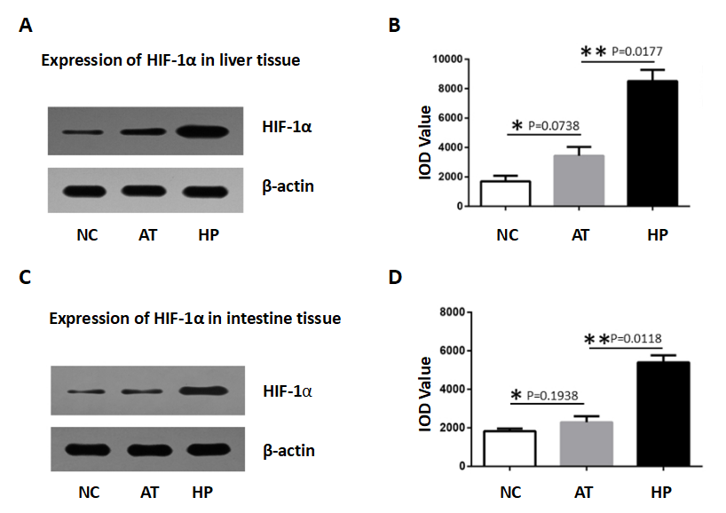
Figure 1 The expression of HIF-1α in liver and intestine tissues in a rat autologous orthotopic liver transplantation model. A: The Western Blot assay showed that the level of HIF-1α protein expression induced by hypoxia preconditioning was increased in rat liver tissue at 12 h post-operation. B: The chart shows that the level of HIF-1α in the HP group was higher at different post-operation time points. At 12 h post-operation, HIF-1α expression in liver tissue in the HP group was significantly higher than in the AT group and NC group. C: The Western Blot assay showed that HIF-1α expression was increased in rat intestine tissue after hypoxia preconditioning at 12 h post-operation. D: The chart shows that HIF-1α expression induced by hypoxia preconditioning in intestine tissues was elevated at different post-operation time points. HIF-1α expression was significantly higher in the HP group compared with the AT group and NC group at 12 h post-operation.

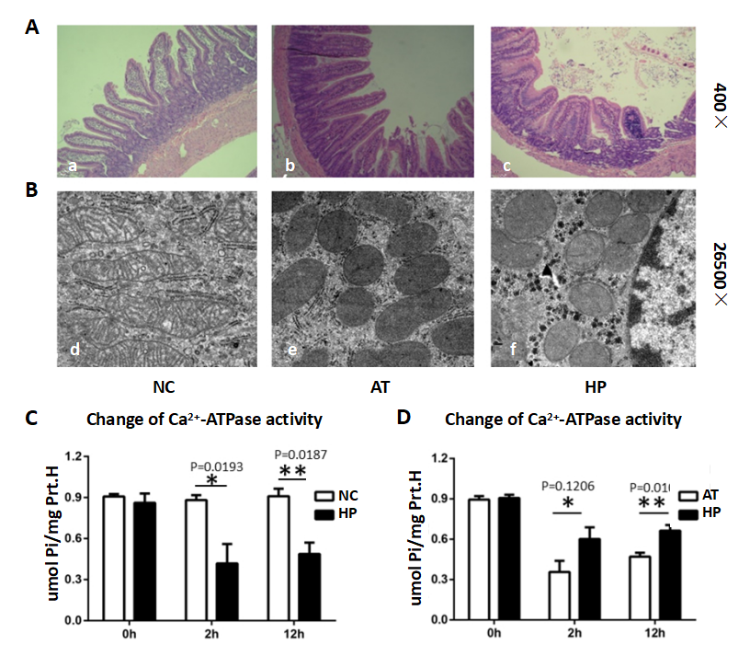
Figure 2 Hypoxia-induced HIF-1α expression increased intestinal cellular mitochondria integrity and of Ca²⁺-ATPase activity after I/R injury. A: Pathological changes in intestinal cells are shown (HE,10×20). a: The normal morphology of intestinal cells in the NC group. b: The intestinal cells in the AT group exhibited oedema, red blood cell deposition and blood clots in capillary vessels; The villus epithelial cells were shedding, had severely damaged glands, and had been infiltrated by inflammatory cells. c: The intestinal cells in the HP group exhibited slight oedema and fewer inflammatory cells. The villus epithelial cells were less damaged. B: The mitochondrial changes in intestinal cells are shown (× 46000). d: The normal morphology of mitochondria in the NC group. e: The mitochondria in the AT group appeared swollen, round, and degenerated. The visible crest of the mitochondria was less fractured or disappeared. f: The mitochondria in the HP group showed less swelling and fewer cristae. The endoplasmic reticulum structure had survived. C: The Ca²⁺-ATPase activity in the AT group was significantly lower compared with the NC group, and decreased to the lowest level at post-operative 2 h (AT group vs NC Group: P < 0.05), then recovered. D: The Ca²⁺-ATPase activity in the HP group was lower after the operation but was significantly higher than in the AT group at post-operative 2 h (HP group vs AT Group: P < 0.05).

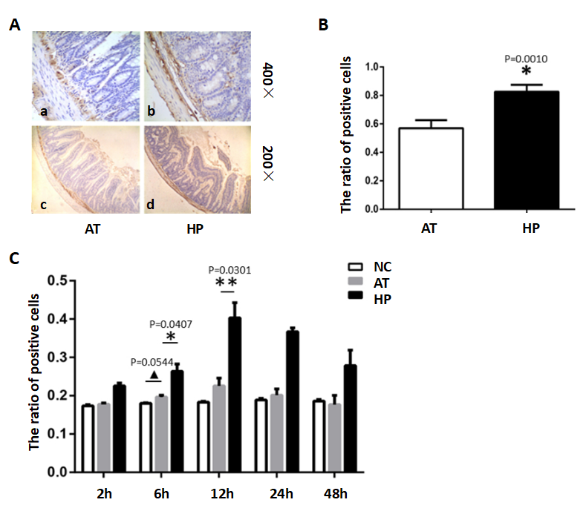

Figure 3 Hypoxia preconditioning promotes BCL2 expression in rat intestinal tissues. A: Immunohistochemistry revealed the expression of BCL2 in rat intestinal tissue in the AT and HP groups at post-operation 12 h. B: The ratio of BCL2 expression in the HP group was significantly higher than in the AT group at post-operative 12 h (HP vs AT P = 0.001). C: The ratio of positive BCL2 expression was detected at several time points post-operation (2 h, 6 h, 12 h, 24 h, and 48 h) in the NC, AT and HP groups. The expression of BCL2 in the HP group was increased after the operation, peaked at post-operation 2 h and was maintained at a high level. At post-operation 12 h, the HP group was significantly higher than the NC group and the AT group. No significant difference in BCL2 expression was found in the AT group and NC group.

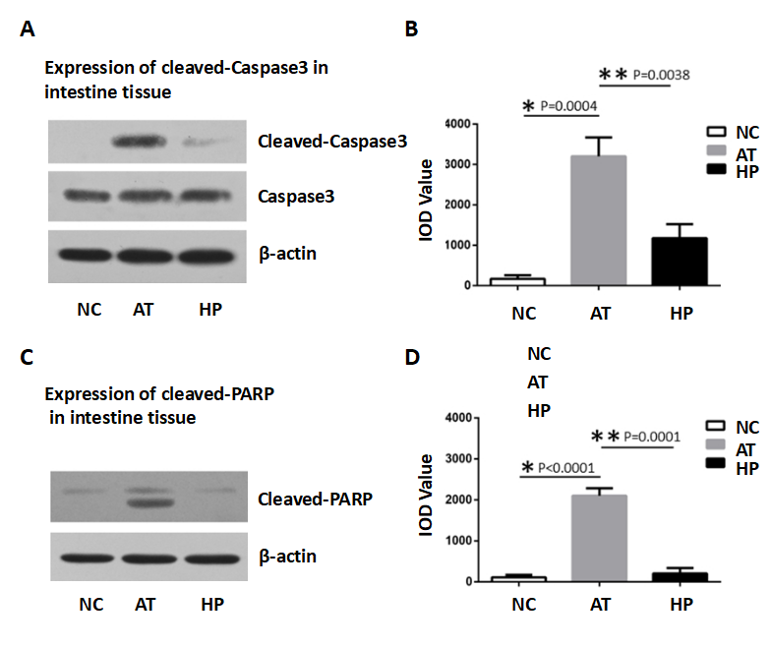
Figure 4 The changes of Caspase3 and PARP expressions in rat intestine tissue at post-operation 24 h. A: The apoptosis was detected by Western blot assay to show the expressions of cleaved-Caspase3 were increased in rat intestine tissue with ischemia and reperfusion injury at post-operation 24 h. B: The bar-table showed the level of cleaved-Caspase3 expression in AT group was significantly higher than that in NC group. The cleaved-Caspase3 expression in HP group was lower than that in AT group at post-operation 24 h. C: The expressions of cleaved-PARP were increased in rat intestine tissue with ischemia and reperfusion injury at post-operation 24 h. D: The bar-table showed the level of cleaved-PARP expression in AT group was significantly higher than that in NC group. The cleaved-PARP expression in HP group was lower than that in AT group at post-operation 24 h.

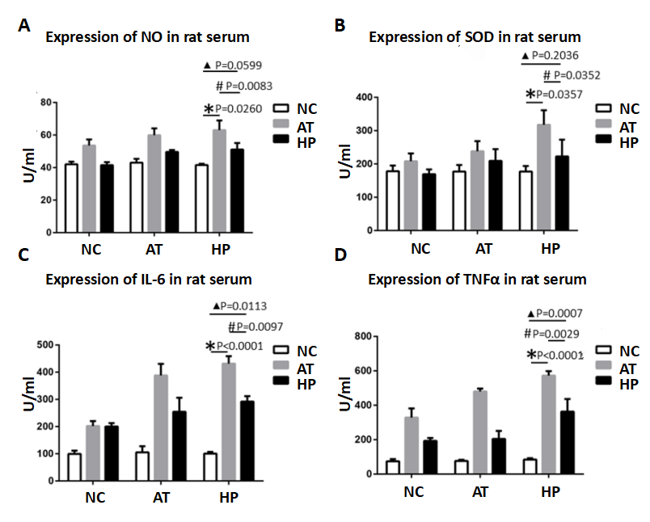Figure 5 Hypoxia preconditioning decreases the expression of inflammation factors in rat serum after post-operative I/R injury of intestinal tissue. A: In the HP group, NO levels in the serum were lower, especially at 12 h and 24 h after the operation, compared with the AT group. B: The SOD levels in the HP group 12 h and 24 h after the operation were significantly lower than in the AT group. C: After the operation, the IL-6 levels in rat liver tissues that had undergone ischaemia-reperfusion injury were significantly higher in the AT group compared with the HP group and the NC group. D: TNF-α levels in the HP group were slightly decreased compared with the AT group.

