Name of Journal: World Journal of Gastrointestinal Oncology
Manuscript NO: 78112
Manuscript Type: ORIGINAL ARTICLE

Retrospective Study
Predictive value of a serum tumor biomarkers scoring system for clinical stage II/III rectal cancer with neoadjuvant chemoradiotherapy

Zhao JY et al. Rectal cancer tumor biomarkers scoring system

Jie-Yi Zhao, Qing-Qing Tang, Yu-Ting Luo, Shu-Min Wang, Xiao-Rui Zhu, Xiao-Yu Wang

Jie-Yi Zhao, Xiao-Yu Wang, Department of Neurosurgery, West China Hospital, Sichuan University, Chengdu 610041, Sichuan Province, China

Qing-Qing Tang, Department of Ophthalmology, West China Hospital, Sichuan University, Chengdu 610041, Sichuan Province, China

Yu-Ting Luo, Shu-Min Wang, Xiao-Rui Zhu, West China Medical School, Sichuan University, Chengdu 610041, Sichuan Province, China

Author contributions: Zhao JY and Wang XY designed the research and wrote the manuscript; Tang QQ and Luo YT analyzed the data; Wang SM and Zhu XR performed data extraction; all authors have read and approved the final version.

Corresponding author: Xiao-Yu Wang, MD, Doctor, Department of Neurosurgery, West China Hospital, Sichuan University, No. 37 Guo Xue Alley, Chengdu 610041, Sichuan Province, China. yuxixi1052006@126.com

Received: June 8, 2022
Revised: July 6, 2022
Accepted: August 22, 2022
Published online: October 15, 2022

Abstract
BACKGROUND
Multiple classes of molecular biomarkers have been studied as potential predictors for rectal cancer (RC) response. Carcinoembryonic antigen (CEA) is the most widely used blood-based marker of RC and has proven to be an effective predictive marker. Cancer antigen 19-9 (CA19-9) is another tumor biomarker used for RC diagnosis and postoperative monitoring, as well as monitoring of the therapeutic effect. Using a panel of tumor markers for RC outcome prediction is a practical approach.

AIM
To assess the predictive effect of pre-neoadjuvant chemoradiotherapy (NCRT) CEA and CA19-9 levels on the prognosis of stage II/III RC patients.

METHODS
CEA and CA19-9 levels were evaluated 1 wk before NCRT. According to the receiver operating characteristic curve analysis, the optimal cut-off point of CEA and CA19-9 levels for the prognosis were 3.55 and 19.01, respectively. The novel serum tumor biomarker (NSTB) scores were as follows: score 0: Pre-NCRT CEA < 3.55 and CA19-9 < 19.01; score 2: Pre-NCRT CEA > 3.55 and CA19-9 > 19.01; score 1: Other situations. Pathological information was recorded according to histopathological reports after the operation.

RESULTS
In the univariate analysis, pre-NCRT CEA < 3.55 [P = 0.025 for overall survival (OS), P = 0.019 for disease-free survival (DFS)], pre-NCRT CA19-9 < 19.01 (P = 0.014 for OS, P = 0.009 for DFS), a lower NSTB score (0-1 vs 2, P = 0.009 for OS, P = 0.005 for DFS) could predict a better prognosis. However, in the multivariate analysis, only a lower NSTB score (0-1 vs 2; for OS, HR = 0.485, 95%CI: 0.251-0.940, P = 0.032; for DFS, HR = 0.453, 95%CI: 0.234-0.877, P = 0.019) and higher pathological grade, node and metastasis stage (0-I vs II-III; for OS, HR = 0.363, 95%CI: 0.158-0.837, P = 0.017; for DFS, HR = 0.342, 95%CI: 0.149-0.786, P = 0.012) were independent predictive factors.

CONCLUSION
The combination of post-NCRT CEA and CA19-9 was a predictive factor for clinical stage II/III RC patients receiving NCRT, and the combined index had a stronger predictive effect.

Key Words: Rectal cancer; Neoadjuvant chemoradiotherapy; Scoring system; Carcinoembryonic antigen; Carbohydrate antigen 19-9; Predictive

©The Author(s) 2022. Published by Baishideng Publishing Group Inc. All rights reserved.

Citation: Zhao JY, Tang QQ, Luo YT, Wang SM, Zhu XR, Wang XY. Predictive value of a serum tumor biomarkers scoring system for clinical stage II/III rectal cancer having neoadjuvant chemoradiotherapy. World J Gastrointest Oncol 2022; 14(10): 2014-2024
URL: https://www.wjgnet.com/1948-5204/full/v14/i10/2014.htm
DOI: https://dx.doi.org/10.4251/wjgo.v14.i10.2014

Core Tip: Tumor microenvironment (TME) combined with neoadjuvant chemotherapy (NCRT) is the standard treatment for resectable stage II/III rectal cancer (RC). Multiple classes of molecular biomarkers have been studied as potential predictors for RC response but there is no sufficient evidence for any of them to be introduced into clinical practice. By retrospectively evaluating clinical stage II/III RC patients undergoing NCRT followed by standard TME, we found that the combination of NCRT carcinoembryonic antigen and carbohydrate antigen 19-9 levels could be a prognostic predictor for clinical stage II/III RC patients receiving NCRT, and the combined indexes had a stronger predictive effect than the index alone.
INTRODUCTION
In the United States, tumor microenvironment (TME) combined with neoadjuvant chemotherapy (NCRT) is the standard treatment for resectable stage II/III rectal cancer (RC)^{[1-3]}. Although numerous studies have shown that NCRT can reduce the rate of local recurrence, it is difficult to improve overall survival (OS)^{[4-6]}. Multiple classes of molecular biomarkers have been studied as potential predictors for RC response but there is no sufficient evidence for any of them to be introduced into clinical practice^{[7]}. Moreover, additional systematic chemotherapy could increase the toxicity ^{[8,9]}. Therefore, it is critical to identify predictive factors for clinical stage II/III patients and give additional chemotherapy or more aggressive treatment strategies.
Pathological indicators are generally considered to be the most effective predictive factors^{[10,11]}. Unfortunately, pathological characteristics are difficult to obtain and quantitate and are usually affected by the operation and specimen-processing quality^{[8,9]}. Moreover, the pathological indicators, which can only be obtained after surgery, do not assist in judging whether patients need additional chemotherapy before undergoing NCRT or surgery.
A glycoprotein, carcinoembryonic antigen (CEA), is the most widely used blood-based marker of RC and has proven to be an effective predictive marker^{[12-14]}. According to You et al^{[15]}, the increment in postoperative serum CEA levels (CEA < 5 vs > 5) was an independent predictor of a poor prognosis. However, the major problem with the use of CEA as a marker of RC is its association with other types of cancer and benign diseases (inflammatory bowel disease)^{[16-18]}. Cancer antigen 19-9 (CA19-9) is another tumor biomarker used for RC diagnosis and postoperative monitoring, as well as monitoring of the therapeutic effect^{[19,20]}. Due to the highly heterogeneous nature of RC, a single tumor marker is unlikely to become a stand-alone predictive factor. Using a panel of tumor markers for RC outcome prediction is a practical approach.
In this study, we analyzed the predictive value of the combination of pre-NCRT serum tumor markers (CEA and CA19-9) in clinical stage II/III RC patients.

MATERIALS AND METHODS
Patients screening
We retrospectively evaluated clinical stage II/III RC patients undergoing NCRT followed by standard TME in our hospital from February 2011 to August 2020. We included the following categories of patients: (1) Patients receiving preoperative NCRT; (2) patients with colorectal adenocarcinoma confirmed by pathological biopsy; (3) patients whose serum CEA and CA19-9 levels were measured within one week before NCRT; and (4) patients undergoing NCRT followed by standard TME. We excluded the following categories of patients: (1) Patients with distal metastasis; (2) patients with other concomitant tumors; (3) patients with insufficient blood, clinicopathological, or follow-up data; and (4) patients with unresectable RC. The patient-screening flowchart is shown in Figure 1.
This retrospective study was approved by the ethics committee of our hospital. The requirement for patients’ informed consent was waived due to the retrospective nature of the study.

Treatment and follow-up of patients
All patients in this study received NCRT followed by standard TME. Their CEA and CA19-9 levels were evaluated within 1 wk pre-NCRT. Pathological, node and metastasis (TNM) stages and histological grades were noted according to histopathological reports. The receiver operating characteristic (ROC) curve was adopted to determine the best cut-off values of pre-NCRT CEA and CA19-9 levels for predicting OS. The novel serum tumor biomarker (NSTB) scores were as follows: score 0: Pre-NCRT CEA < 3.55 and CA19-9 < 19.01; score 2: Pre-NCRT CEA > 3.55 and CA19-9 > 19.01; score 1: Pre-NCRT CEA < 3.55 and CA19-9 > 19.01 or pre-NCRT CEA > 3.55 and CA19-9 < 19.01.
Postoperative follow-up was performed according to the National Comprehensive Cancer Network guidelines^{[13]}. Generally, patients were followed up clinically and radiographically at three-month intervals in the first 2 years after surgery, then every 6 mo for 3 years, and annually thereafter^{[13]}. Follow-up data were obtained from medical records, telephone follow-ups, out-patient clinics, or visits.
OS was defined as the survival time until death by any reason^{[21]}. DFS was defined as the time-lapse between surgery and either RC recurrence or death^{[22]}. Patients lost to follow-up or still alive at the final follow-up were included in the analysis as censored data^{[21]}.

Statistical analysis
Data were analyzed using SPSS for Windows (IBM Corp. Released 2013. IBM SPSS Statistics for Windows, Version 22.0. Armonk, NY: IBM Corp.). Continuous data were described in terms of the median and interquartile range (IQR) whereas categorical variables were described in terms of frequencies and percentages. Significant parameters identified in the univariate analysis (P < 0.05) were entered into the multivariate Cox regression analysis to determine independent predictive factors^{[23,24]}. All statistical tests were two-sided, and a P value of < 0.05 was considered statistically significant^{[25]}.
In general, pathological characteristics have the strongest predictive value for patient outcomes^{[21]}. To compare the predictive effect of the NSTB score, several pathological indicators were included. To prevent the effects of pre-NCRT CEA and CA19-9 levels on the NSTB score, two models, one including and the other excluding the NSTB score in the multivariate analysis, were established.

RESULTS
Patient characteristics
Eighty-seven (36.7%) patients were female and 150 (63.3%) were male. The distribution of the patients according to pathological evaluation was as follows: vascular invasion was detected in 13 (5.5%) patients, lymphatic invasion in 13 (5.5%) patients, perineural invasion in 41 (17.3%) patients, and circumferential resection margin (CRM) positivity in 8 (3.8%) patients. Regarding the pathological TNM classification, 45 (19.0%) patients were in stage 0, 57 (24.1%) were in stage I, 72 (30.4%) were in stage II, and 63 (26.6%) were in stage III (Table 1). A total of 118 (49.8%) patients were in pT stage 0-2 while 119 (50.2%) were in pT stage 3-4. Sixty (25.3%) patients had pN metastases while 177 (74.7%) did not have pN metastases. The median (IQR) level of pre-NCRT CEA was 4.15 (2.18-10.07) and that of pre-NCRT CA19-9 was 13.56 (7.80-25.40).
During follow-up, 9 (3.8%) patients were lost to follow-up and 36 (15.2%) developed cancer recurrence and died.

Kaplan-Meier curves stratified by pre-NCRT CEA, CA19-9, and the NSTB score
ROC curves identified the optimal cut-off for survival prediction by pre-NCRT CEA and CA19-9 were 3.55 and 19.01, respectively. They divided patients into different groups. Figures 2-4A show the OS of included patients stratified by pre-NCRT CEA, CA19-9, and the NSTB score, respectively, and Figures 2-4B show their DFS stratified by the same parameters. According to the Kaplan–Meier curves, increased pre-NCRT CEA and CA19-9 levels and higher NSTB scores were all associated with decreased OS and DFS.

Cox regression analysis of factors affecting the prognosis
Possible clinicopathological parameters that may predict patient outcome were reviewed. In the univariate analysis, pre-NCRT CEA > 3.55, pre-CA19-9 > 19.01, a higher pathological TNM stage, and a higher NSTB score were significantly associated with decreased OS (Table 2) and DFS (Table 3).
In the multivariate analysis of OS (Table 4), only a lower pathological TNM stage (stage 0-I vs II-III, HR = 0.363, 95%CI: 0.158-0.837, P = 0.017) and the NSTB score (score 0-1 vs 2, HR = 0.485, 95%CI: 0.251-0.940, P = 0.032) were significant predictors of a better outcome while pre-NCRT CEA < 3.55 (HR = 0.529, 95%CI: 0.23-1.205, P = 0.130) and CA19-9 < 19.01 (HR = 0.604, 95%CI: 0.300-1.215, P = 0.158) were not. In the multivariate analysis of DFS (Table 5), a lower pathological TNM stage (stage 0-I vs II–III, HR = 0.342, 95%CI: 0.149-0.786, P = 0.012) and the NSTB score (score 0-1 vs 2, HR = 0.453, 95%CI: 0.234-0.877, P = 0.019) could also predict a better outcome while pre-NCRT CEA < 3.55 (HR = 0.521, 95%CI: 0.226-1.162, P = 0.109) and CA19-9 < 19.01 (HR = 0.570, 95%CI: 0.284-1.141, P = 0.112) could not. The nomogram of OS (Figure 5) and DFS (Figure 6) shows the precise prognosis.

DISCUSSION
Our data showed that the combination of pre-NCRT tumor markers had better predictive value than a single marker. Although univariate analyses demonstrated that lower pre-NCRT CEA and CA19-9 levels were potential indicators of a better prognosis, the multivariate analysis proved that only the NSTB score and pathological TNM stage could independently determine the prognosis. In general, pathological indicators had a more robust predictive value than other indicators in determining the prognosis^{[8]}; however, the multivariate analysis revealed that the NSTB score could predict outcomes better than pathological characteristics of lymphatic invasion, vascular invasion, nerve infiltration, and CRM invasion. Thus, we propose that the NSTB score should be used to guide the treatment and determine the prognosis of patients with RC of clinical stage II/III.
Pathological findings were generally recognized as the most effective indicators to predict the prognosis^{[8]}. A previous study revealed that lymphatic invasion, perineural invasion, vascular invasion, CRM invasion, LN metastasis, and a higher tumor invasion stage can predict a worse outcome^{[4]}. However, pathological characteristics were difficult to identify as they are usually affected by the quality of surgery and specimen-processing, and their analysis is significantly subjective and difficult to quantitate^{[15]}. Moreover, pathological indicators could only be obtained after surgery, which means that it was impossible to judge whether patients needed additional chemotherapy before undergoing NCRT or surgery. Moreover, the NSTB score could be obtained before NCRT and surgery.
Some molecules or proteins can determine a patient’s prognosis. Lin et al^{[26]} reported that the high expression of EphA4 served as an independent adverse predictor for DFS. Rödel et al^{[27]} found that an increase in survivin levels was a significant risk factor for local recurrence and decreased DFS. Hiyoshi et al^{[28]} demonstrated that serum miR-143 was a non-invasive and novel predictive marker for locally advanced rectal cancer (LARC) patients. Unfortunately, all of these molecular or protein markers had the following disadvantages: First, the detection cost of these markers was high, which increased the economic burden for patients; second, these novel markers could only be detected in large medical centers, which made them difficult to be used widely in clinical practice; finally, these new indicators lack uniform standards, and the test results may vary a lot in different medical centers. CEA and CA19-9 levels are widely used clinically because they are cheap, convenient to detect, and have uniform standards in different hospitals.
CEA is currently one of the primary markers for the diagnosis and follow-up of RC^{[2,18,19]}. We found that lower CEA levels could predict a better prognosis in a univariate analysis. CA19-9 has shown great value for the differential diagnosis of malignant tumors and disease monitoring and evaluation^{[19]}. Compared to either CA19-9 or CEA alone, an essential advantage of the combination was that it could reduce the interference of other factors and increase the predictive effectiveness. Although some studies also focused on the influence of CEA and CA19-9 levels on the prognosis, the two markers were studied separately^{[2,18-20,29]}. Consequently, they failed to identify CEA and CA19-9 as predictive factors, which was similar to our findings. However, the predictive value increased significantly and was even stronger than that of several pathological factors when they were combined.
Our study had a few strengths: Firstly, to the best of our knowledge, this is the first study that combined CEA and CA19-9 to evaluate the prognosis of clinical stage II/III patients undergoing NCRT. Secondly, we adopted an ROC curve to determine the cut-off point of CEA and CA19-9 instead of just evaluating whether they were higher than the normal values, which optimized the efficiency of the OS prediction. Ultimately, the NSTB score was cheap and easily accessible before treatment.
Our study also had some shortcomings. First, this was a retrospective study conducted in a single medical center. Second, the cut-off points of pre-NCRT CEA and CA19-9 levels in our center may not always be reproducible in other centers.

CONCLUSION
This study established a NSTB score by combining pre-NCRT CEA and CA19-9 levels. The NSTB score can independently predict the prognosis of patients with LARC of clinical stage II/III who underwent NCRT. Its predictive value was stronger than that of either marker alone, and even some pathologic characteristics.

ARTICLE HIGHLIGHTS
Research background
Multiple classes of molecular biomarkers were studied as potential predictors for rectal cancer (RC) response but there was no sufficient evidence for any of them to be introduced into clinical practice.

Research motivation
To assess the predictive effect of pre-neoadjuvant chemoradiotherapy (NCRT) carcinoembryonic antigen (CEA) and cancer antigen 19-9 (CA19-9) levels on the prognosis of stage II/III RC patients.

Research objectives
The objective of this study is to establish a novel serum tumor biomarker score by combining pre-NCRT CEA and CA19-9 levels. The novel serum tumor biomarker (NSTB) score may predict the prognosis of patients with locally advanced rectal cancer (LARC) of clinical stage II/III who underwent NCRT independently.

Research methods
A total of 237 patients were included in this study. CEA and CA 19-9 levels were evaluated 1 wk before NCRT. The NSTB score was as follows: score 0: pre-NCRT CEA < 3.55 and CA19-9 < 19.01; score 2: pre-NCRT CEA > 3.55 and CA19-9 > 19.01; score 1: other situations. Pathological information was recorded according to histopathological reports after the operation.

Research results
In the univariate analysis, pre-NCRT CEA < 3.55, pre-NCRT CA19-9 < 19.01, and a lower NSTB score could predict a better prognosis. However, in the multivariate analysis, only a lower NSTB score and higher pathological tumor-node-metastasis (TNM) stage were independent predictive factors.

Research conclusions
We established a novel serum tumor biomarker score by combining pre-NCRT CEA and CA19-9 levels. The NSTB score can independently predict the prognosis of patients with LARC of clinical stage II/III who underwent NCRT.

Research perspectives
More accurate prediction models need to be established by studies with a larger number of patients.

REFERENCES
1 Naffouje S, Sabesan A, Powers BD, Dessureault S, Sanchez J, Schell M, Imanirad I, Sahin I, Xie H, Felder S. Patient Risk Subgroups Predict Benefit of Adjuvant Chemotherapy in Stage II Rectal Cancer Patients Following Neoadjuvant Chemoradiation and Total Mesorectal Excision. Clin Colorectal Cancer 2021; 20: e155-e164 [PMID: 33775560 DOI: 10.1016/j.clcc.2021.02.006]
2 Zhang S, Zhang R, Li RZ, Wang QX, Chang H, Ding PR, Li LR, Wu XJ, Chen G, Zeng ZF, Xiao WW, Gao YH. Beneficiaries of radical surgery among clinical complete responders to neoadjuvant chemoradiotherapy in rectal cancer. Cancer Sci 2021; 112: 3607-3615 [PMID: 34146368 DOI: 10.1111/cas.15039]
3 Zhou S, Jiang Y, Pei W, Zhou H, Liang J, Zhou Z. Neoadjuvant chemoradiotherapy followed by lateral pelvic lymph node dissection for rectal cancer patients: A retrospective study of its safety and indications. J Surg Oncol 2021; 124: 354-360 [PMID: 33882149 DOI: 10.1002/jso.26509]
4 Diefenhardt M, Ludmir EB, Hofheinz RD, Ghadimi M, Minsky BD, Rödel C, Fokas E. Association of Treatment Adherence With Oncologic Outcomes for Patients With Rectal Cancer: A Post Hoc Analysis of the CAO/ARO/AIO-04 Phase 3 Randomized Clinical Trial. JAMA Oncol 2020; 6: 1416-1421 [PMID: 32644104 DOI: 10.1001/jamaoncol.2020.2394]
5 Kroon HM, Malakorn S, Dudi-Venkata NN, Bedrikovetski S, Liu J, Kenyon-Smith T, Bednarski BK, Ogura A, van de Velde CJH, Rutten HJT, Beets GL, Thomas ML, Kusters M, Chang GJ, Sammour T. Local recurrences in western low rectal cancer patients treated with or without lateral lymph node dissection after neoadjuvant (chemo)radiotherapy: An international multi-centre comparative study. Eur J Surg Oncol 2021; 47: 2441-2449 [PMID: 34120810 DOI: 10.1016/j.ejso.2021.06.004]
6 Zhang YZ, Song M, Geng JH, Zhu XG, Li S, Li YH, Cai Y, Wang WH. Patterns of failure and implications for clinical target volume definition of locally advanced T4b rectal cancer identified with magnetic resonance imaging and treated using neoadjuvant chemoradiotherapy and surgery. Radiother Oncol 2021; 161: 132-139 [PMID: 34126137 DOI: 10.1016/j.radonc.2021.06.017]
7 Smolskas E, Mikulskytė G, Sileika E, Suziedelis K, Dulskas A. Tissue-Based Markers as a Tool to Assess Response to Neoadjuvant Radiotherapy in Rectal Cancer-Systematic Review. Int J Mol Sci 2022; 23 [PMID: 35682714 DOI: 10.3390/ijms23116040]
8 Bauer PS, Chapman WC Jr, Atallah C, Makhdoom BA, Damle A, Smith RK, Wise PE, Glasgow SC, Silviera ML, Hunt SR, Mutch MG. Perioperative Complications After Proctectomy for Rectal Cancer: Does Neoadjuvant Regimen Matter? Ann Surg 2022; 275: e428-e432 [PMID: 32209914 DOI: 10.1097/SLA.0000000000003885]
9 Petrelli F, Trevisan F, Cabiddu M, Sgroi G, Bruschieri L, Rausa E, Ghidini M, Turati L. Total Neoadjuvant Therapy in Rectal Cancer: A Systematic Review and Meta-analysis of Treatment Outcomes. Ann Surg 2020; 271: 440-448 [PMID: 31318794 DOI: 10.1097/SLA.0000000000003471]
10 Xu T, Zhang L, Yu L, Zhu Y, Fang H, Chen B, Zhang H. Log odds of positive lymph nodes is an excellent prognostic factor for patients with rectal cancer after neoadjuvant chemoradiotherapy. Ann Transl Med 2021; 9: 637 [PMID: 33987335 DOI: 10.21037/atm-20-7590]
11 Zhao Q, Wan L, Zou S, Zhang C, E T, Yang Y, Ye F, Zhao X, Ouyang H, Zhang H. Prognostic risk factors and survival models for T3 locally advanced rectal cancer: what can we learn from the baseline MRI? Eur Radiol 2021; 31: 4739-4750 [PMID: 34003351 DOI: 10.1007/s00330-021-08045-y]
12 Cheong C, Shin JS, Suh KW. Prognostic value of changes in serum carcinoembryonic antigen levels for preoperative chemoradiotherapy response in locally advanced rectal cancer. World J Gastroenterol 2020; 26: 7022-7035 [PMID: 33311947 DOI: 10.3748/wjg.v26.i44.7022]
13 You YN, Hardiman KM, Bafford A, Poylin V, Francone TD, Davis K, Paquette IM, Steele SR, Feingold DL; On Behalf of the Clinical Practice Guidelines Committee of the American Society of Colon and Rectal Surgeons. The American Society of Colon and Rectal Surgeons Clinical Practice Guidelines for the Management of Rectal Cancer. Dis Colon Rectum 2020; 63: 1191-1222 [PMID: 33216491 DOI: 10.1097/DCR.0000000000001762]
14 Zheng Z, Wang X, Huang Y, Lu X, Huang Z, Chi P. Defining and predicting early recurrence in patients with locally advanced rectal cancer treated with neoadjuvant chemoradiotherapy. Eur J Surg Oncol 2020; 46: 2057-2063 [PMID: 32782202 DOI: 10.1016/j.ejso.2020.07.019]
15 You W, Yan L, Cai Z, Xie L, Sheng N, Wang G, Wu X, Wang Z. Clinical Significances of Positive Postoperative Serum CEA and Post-preoperative CEA Increment in Stage II and III Colorectal Cancer: A Multicenter Retrospective Study. Front Oncol 2020; 10: 671 [PMID: 32509572 DOI: 10.3389/fonc.2020.00671]
16 Doos WG, Wolff WI, Shinya H, DeChabon A, Stenger RJ, Gottlieb LS, Zamcheck N. CEA levels in patients with colorectal polyps. Cancer 1975; 36: 1996-2003 [PMID: 1203857 DOI: 10.1002/cncr.2820360911]
17 Moore TL, Kantrowitz PA, Zamcheck N. Carcinoembryonic antigen (CEA) in inflammatory bowel disease. JAMA 1972; 222: 944-947 [PMID: 4678960 DOI: 10.1001/jama.1972.03210080028007]
18 Rule AH, Goleski-Reilly C, Sachar DB, Vandevoorde J, Janowitz HD. Circulating carcinoembryonic antigen (CEA): relationship to clinical status of patients with inflammatory bowel disease. Gut 1973; 14: 880-884 [PMID: 4761608 DOI: 10.1136/gut.14.11.880]
19 Huang D, Lin Q, Song J, Xu B. Prognostic Value of Pretreatment Serum CA199 in Patients with Locally Advanced Rectal Cancer Treated with CRT Followed by TME with Normal Pretreatment Carcinoembryonic Antigen Levels. Dig Surg 2021; 38: 24-29 [PMID: 33171467 DOI: 10.1159/000508442]
20 Mizuno H, Miyake H, Nagai H, Yoshioka Y, Shibata K, Asai S, Takamizawa J, Yuasa N. Optimal cutoff value of preoperative CEA and CA19-9 for prognostic significance in patients with stage II/III colon cancer. Langenbecks Arch Surg 2021; 406: 1987-1997 [PMID: 34148158 DOI: 10.1007/s00423-021-02236-3]
21 Dossa F, Acuna SA, Rickles AS, Berho M, Wexner SD, Quereshy FA, Baxter NN, Chadi SA. Association Between Adjuvant Chemotherapy and Overall Survival in Patients With Rectal Cancer and Pathological Complete Response After Neoadjuvant Chemotherapy and Resection. JAMA Oncol 2018; 4: 930-937 [PMID: 29710274 DOI: 10.1001/jamaoncol.2017.5597]
22 Zhang XY, Wang S, Li XT, Wang YP, Shi YJ, Wang L, Wu AW, Sun YS. MRI of Extramural Venous Invasion in Locally Advanced Rectal Cancer: Relationship to Tumor Recurrence and Overall Survival. Radiology 2018; 289: 677-685 [PMID: 30152742 DOI: 10.1148/radiol.2018172889]
23 Goh TS, Lee JS, Il Kim J, Park YG, Pak K, Jeong DC, Oh SO, Kim YH. Prognostic scoring system for osteosarcoma using network-regularized high-dimensional Cox-regression analysis and potential therapeutic targets. J Cell Physiol 2019; 234: 13851-13857 [PMID: 30604867 DOI: 10.1002/jcp.28065]
24 Li Z, Wang Q, Qiao Y, Wang X, Jin X, Wang A. Incidence and associated predictors of adverse pregnancy outcomes of maternal syphilis in China, 2016-19: a Cox regression analysis. BJOG 2021; 128: 994-1002 [PMID: 33021043 DOI: 10.1111/1471-0528.16554]
25 Hsu CH, Yu M. Cox regression analysis with missing covariates via nonparametric multiple imputation. Stat Methods Med Res 2019; 28: 1676-1688 [PMID: 29717943 DOI: 10.1177/0962280218772592]
26 Lin CY, Lee YE, Tian YF, Sun DP, Sheu MJ, Lin CY, Li CF, Lee SW, Lin LC, Chang IW, Wang CT, He HL. High Expression of EphA4 Predicted Lesser Degree of Tumor Regression after Neoadjuvant Chemoradiotherapy in Rectal Cancer. J Cancer 2017; 8: 1089-1096 [PMID: 28529623 DOI: 10.7150/jca.17471]
27 Rödel F, Hoffmann J, Distel L, Herrmann M, Noisternig T, Papadopoulos T, Sauer R, Rödel C. Survivin as a radioresistance factor, and prognostic and therapeutic target for radiotherapy in rectal cancer. Cancer Res 2005; 65: 4881-4887 [PMID: 15930309 DOI: 10.1158/0008-5472.CAN-04-3028]
28 Hiyoshi Y, Akiyoshi T, Inoue R, Murofushi K, Yamamoto N, Fukunaga Y, Ueno M, Baba H, Mori S, Yamaguchi T. Serum miR-143 levels predict the pathological response to neoadjuvant chemoradiotherapy in patients with locally advanced rectal cancer. Oncotarget 2017; 8: 79201-79211 [PMID: 29108299 DOI: 10.18632/oncotarget.16760]
29 Chen Y, Gao SG, Chen JM, Wang GP, Wang ZF, Zhou B, Jin CH, Yang YT, Feng XS. Serum CA242, CA199, CA125, CEA, and TSGF are Biomarkers for the Efficacy and Prognosis of Cryoablation in Pancreatic Cancer Patients. Cell Biochem Biophys 2015; 71: 1287-1291 [PMID: 25486903 DOI: 10.1007/s12013-014-0345-2]

Footnotes
Institutional review board statement: This study was reviewed and approved by the West China hospital, Sichuan University Institutional Review Board, Approval No. 2020.18.

Informed consent statement: The requirement for patients’ informed consent was waived due to the retrospective nature of the study.

Conflict-of-interest statement: All author reports no conflict of interest.

Data sharing statement: Anyone who wants the data can connect to the corresponding author (yuxixi1052006@126.com).

Open-Access: This article is an open-access article that was selected by an in-house editor and fully peer-reviewed by external reviewers. It is distributed in accordance with the Creative Commons Attribution NonCommercial (CC BY-NC 4.0) license, which permits others to distribute, remix, adapt, build upon this work non-commercially, and license their derivative works on different terms, provided the original work is properly cited and the use is non-commercial. See: https://creativecommons.org/Licenses/by-nc/4.0/

Provenance and peer review: Unsolicited article; Externally peer reviewed.
Peer-review model: Single blind

Peer-review started: June 8, 2022
First decision: June 23, 2022
Article in press: August 22, 2022

Specialty type: Gastroenterology and hepatology
Country/Territory of origin: China
Peer-review report’s scientific quality classification
Grade A (Excellent): 0
Grade B (Very good): 0
Grade C (Good): C, C
Grade D (Fair): 0
Grade E (Poor): 0

P-Reviewer: Dulskas A, Lithuania; Elkady N, Egypt S-Editor: Zhang H L-Editor: Ma JY-MedE P-Editor: Zhang H
Figure Legends
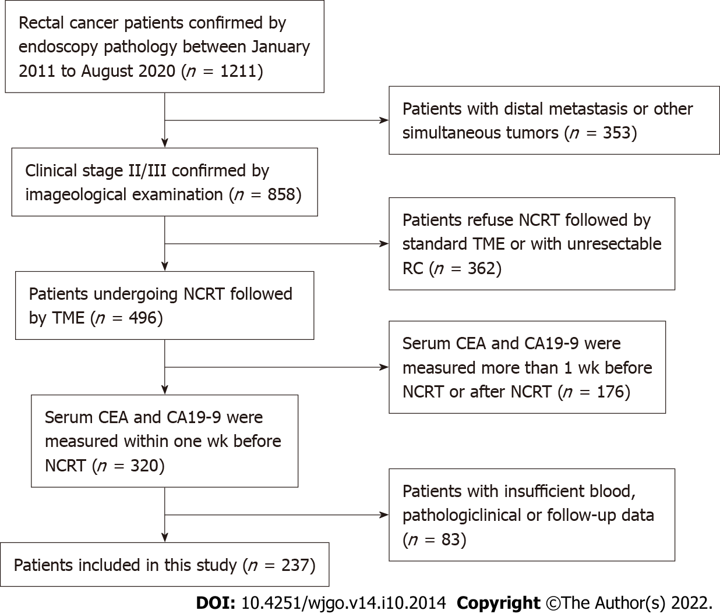
Figure 1 Patient-screening flowchart. NCRT: Neoadjuvant chemoradiotherapy; TME: Tumor microenvironment; RC: Rectal cancer; CEA: Carcinoembryonic antigen; CA19-9: Cancer antigen 19-9.
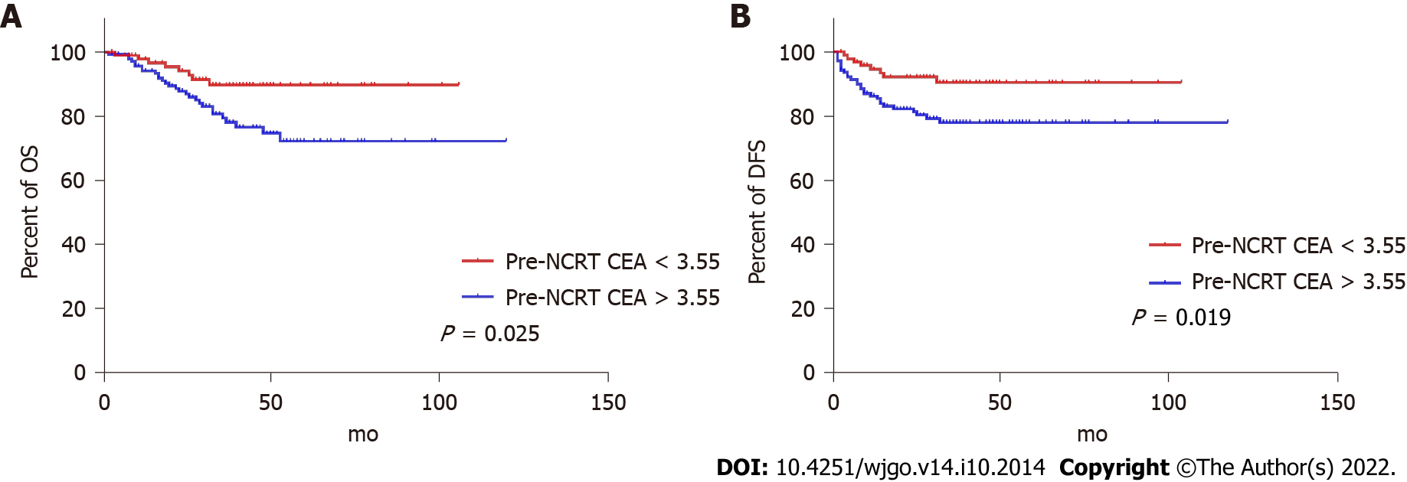
Figure 2 Overall survival curves and disease-free survival curves stratified by pre-neoadjuvant chemoradiotherapy carcinoembryonic antigen levels. A: Overall survival curves stratified by pre-neoadjuvant chemoradiotherapy carcinoembryonic antigen (CEA) levels; B: Disease-free survival curves stratified by pre-neoadjuvant chemoradiotherapy CEA levels. NCRT: Neoadjuvant chemoradiotherapy; CEA: Carcinoembryonic antigen; OS: Overall survival; DFS: Disease-free survival.
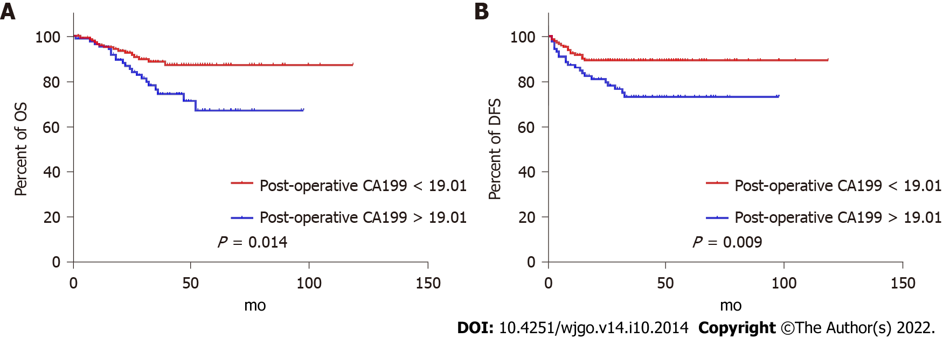
Figure 3 Overall survival curves and disease-free survival curves stratified by pre-neoadjuvant chemoradiotherapy cancer antigen 19-9 levels. A: Overall survival curves stratified by pre-neoadjuvant chemoradiotherapy cancer antigen 19-9 (CA19-9) levels; B: Disease-free survival curves stratified by pre-neoadjuvant chemoradiotherapy CA19-9 levels. CA19-9: Cancer antigen 19-9; OS: Overall survival; DFS: Disease-free survival.
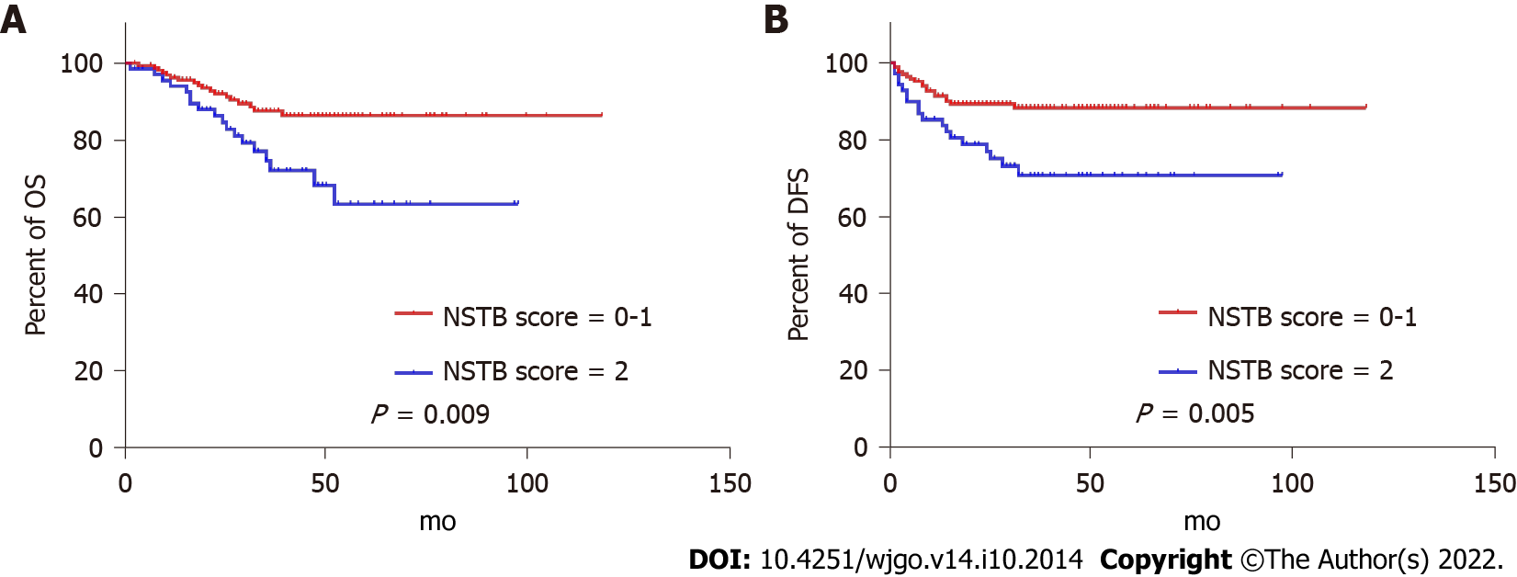
Figure 4 Overall survival curves and disease-free survival curves stratified by novel serum tumor biomarker scores. A: Overall survival curves stratified by novel serum tumor biomarker scores; B: Disease-free survival curves stratified by novel serum tumor biomarker scores. NSTB: Novel serum tumor biomarker; OS: Overall survival; DFS: Disease-free survival.
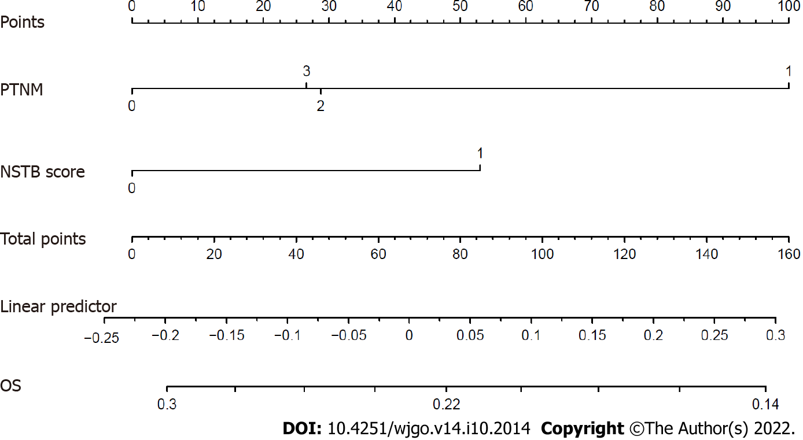
Figure 5 Predictive nomogram predicting overall survival in clinical stage II/III RC patients undergoing NCRT. PTNM: Pathological tumor-node- metastasis; NSTB: Novel serum tumor biomarker; OS: Overall survival.

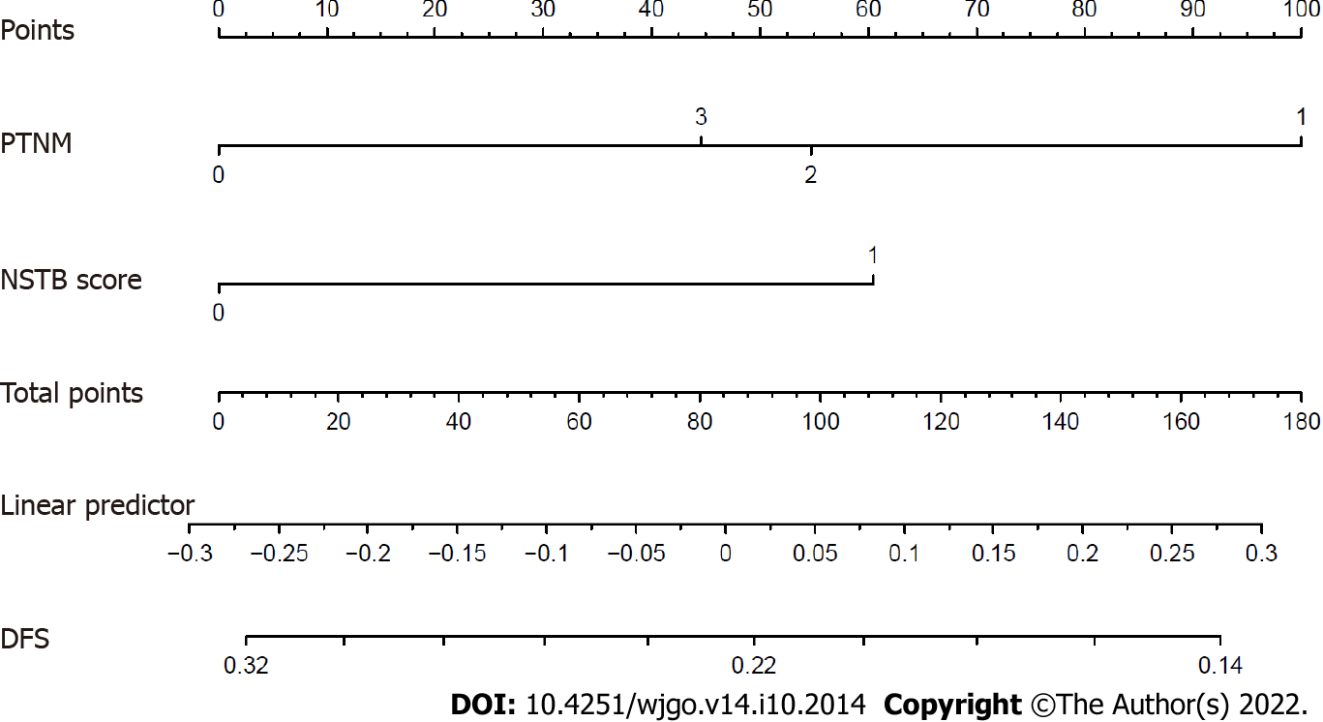
Figure 6 Predictive nomogram predicting disease-free survival in clinical stage II/III RC patients undergoing NCRT. PTNM: Pathological tumor-node-metastasis; NSTB: Novel serum tumor biomarker; DFS: Disease-free survival.
Table 1 Clinicopathological characteristics
Features | Median (IQR)
Pre-NCRT CEA | 4.15 (2.18-10.07)
Pre-NCRT CA19-9 | 13.56 (7.80-25.40)
Age in yr | 57.0 (50.0-66.5)
Sex
Male | 150
Female | 87
Pathological T stage
T0-2 | 118
T3-4 | 119
Pathological N stage
N0 | 177
N+ | 60
Pathological TNM stage
0 | 45
I | 57
II | 72
III | 63
Pathological vascular invasion
Yes | 13
No | 224
Pathological lymphatic invasion
Yes | 13
No | 224
Pathological perineural invasion
Yes | 41
No | 196
Pathological CRM
Positive | 8
Negative | 229
NCRT: Neoadjuvant chemoradiotherapy; CEA: Carcinoembryonic antigen; CA19-9: Cancer antigen 19-9; TNM: Tumor, node and metastasis; CRM: Circumferential resection margin; IQR: Interquartile range.
Table 2 Univariate analysis of factors affecting the overall survival
Characteristics | HR (95%CI) | P value
Pre-NCRT CEA (< 3.55/> 3.55) | 0.407 (0.185-0.893) | 0.025
Pre-NCRT CA19-9 (< 19.01/> 19.01) | 0.437 (0.225-0.849) | 0.014
Sex (male/female) | 0.478 (0.218-1.049) | 0.066
Pathological TNM stage (0-I/II-III) | 0.321 (0.141-0.732) | 0.007
Pathological vascular invasion (absent/present) | 0.556 (0.170-1.821) | 0.332
Pathological lymphatic invasion (absent/present) | 0.400 (0.141-1.136) | 0.085
Pathological perineural invasion (absent/present) | 0.534 (0.250-1.141) | 0.105
Pathological CRM (negative/positive) | 0.826 (0.198-3.449) | 0.793
NSTB score (0-1/2) | 0.416 (0.217-0.800) | 0.009
NCRT: Neoadjuvant chemoradiotherapy; CEA: Carcinoembryonic antigen; CA19-9: Cancer antigen 19-9; TNM: Tumor, node and metastasis; CRM: Circumferential resection margin; NSTB: Novel serum tumor biomarker score.
Table 3 Univariate analysis of factors affecting disease-free survival
Characteristic | HR (95%CI) | P value
Pre-NCRT CEA (< 3.55/> 3.55) | 0.391 (0.178-0.859) | 0.019
Pre-NCRT CA19-9 (< 19.01/> 19.01) | 0.413 (0.213-0.802) | 0.009
Sex (male/female) | 0.466 (0.213-1.023) | 0.057
Pathological TNM stage (0-I/II-III) | 0.302 (0.132-0.690) | 0.005
Pathological vascular invasion (absent/present) | 0.571 (0.175-1.863) | 0.353
Pathological lymphatic invasion (absent/present) | 0.435 (0.154-1.231) | 0.117
Pathological perineural invasion (absent/present) | 0.595 (0.279-1.265) | 0.177
Pathological CRM (negative/positive) | 0.657 (0.158-2.738) | 0.564
NSTB score (0-1/2) | 0.391 (0.203-0.751) | 0.005
NCRT: Neoadjuvant chemoradiotherapy; CEA: Carcinoembryonic antigen; CA19-9: Cancer antigen 19-9; TNM: Tumor, node and metastasis; CRM: Circumferential resection margin; NSTB: Novel serum tumor biomarker score.
Table 4 Multivariate analysis of factors affecting the overall survival
Characteristic | Multivariate analysis
 | Model 1 |  | Model 2
 | HR (95%CI) | P value | HR (95%CI) | P value
Pre-NCRT CEA (< 3.55/> 3.55) | 0.529 (0.232-1.205) | 0.130
Pre-NCRT CA19-9 (< 19.01/> 19.01) | 0.604 (0.300-1.215) | 0.158
Pathological TNM stage (0-I/II-III) | 0.373 (0.162-0.859) | 0.020 | 0.363 (0.158-0.837) | 0.017
NSTB score (0-1/2) |  |  | 0.485 (0.251-0.940) | 0.032
Model 1: Including pre-neoadjuvant chemoradiotherapy (NCRT) carcinoembryonic antigen (CEA) and cancer antigen 19-9 (CA19-9) into multivariate analysis, not including novel serum tumor biomarker (NSTB) score; Model 2: Including NSTB score into multivariate analysis, not including pre-NCRT CEA and CA19-9. NCRT: Neoadjuvant chemoradiotherapy; CEA: Carcinoembryonic antigen; CA19-9: Cancer antigen 19-9; NSTB: Novel serum tumor biomarker score; TNM: Tumor, node and metastasis.

Table 5 Multivariate analysis of factors affecting the disease-free survival
Characteristic | Multivariate analysis
 | Model 1 |  | Model 2
 | HR (95%CI) | P value | HR (95%CI) | P value
Pre-NCRT CEA (< 3.55/> 3.55) | 0.512 (0.226-1.162) | 0.109
Pre-NCRT CA19-9 (< 19.01/> 19.01) | 0.570 (0.284-1.141) | 0.112
Pathological TNM stage (0-I/II-III) | 0.350 (0.152-0.806) | 0.014 | 0.342 (0.149-0.786) | 0.012
NSTB score (0-1/2) |  |  | 0.453 (0.234-0.877) | 0.019
Model 1: Including pre-neoadjuvant chemoradiotherapy (NCRT) carcinoembryonic antigen (CEA) and cancer antigen 19-9 (CA19-9) into multivariate analysis, not including novel serum tumor biomarker (NSTB) score; Model 2: Including NSTB score into multivariate analysis, not including pre-NCRT CEA and CA19-9. NCRT: Neoadjuvant chemoradiotherapy; CEA: Carcinoembryonic antigen; CA19-9: Cancer antigen 19-9; NSTB: Novel serum tumor biomarker score; TNM: Tumor, node and metastasis.

Published by Baishideng Publishing Group Inc
7041 Koll Center Parkway, Suite 160, Pleasanton, CA 94566, USA
Telephone: +1-925-3991568
E-mail: bpgoffice@wjgnet.com
Help Desk: https://www.f6publishing.com/helpdesk
https://www.wjgnet.com

© 2022 Baishideng Publishing Group Inc. All rights reserved.

