Name of Journal: World Journal of Clinical Cases
Manuscript NO: 71119
Manuscript Type: CASE REPORT

Pneumothorax during retroperitoneal laparoscopic partial nephrectomy in a lupus nephritis patient: A case report

Zhao Y et al. Pneumothorax in retroperitoneal nephrectomy

Yi Zhao, Xiao-Qiang Xue, Di Xia, Wei-Feng Xu, Guang-Hua Liu, Yi Xie, Zhi-Gang Ji

Yi Zhao, Xiao-Qiang Xue, Wei-Feng Xu, Guang-Hua Liu, Yi Xie, Zhi-Gang Ji, Department of Urology, Peking Union Medical College Hospital, Beijing 100730, China

Di Xia, Department of Anesthesiology, Peking Union Medical College Hospital, Beijing 100730, China

Author contributions: Zhao Y and Xue XQ are co-first authors who contributed equally to this work; Zhao Y and Xue XQ reviewed the literature, acquired the data, and contributed to manuscript drafting; Xu WF, Liu GH, Xia D, and Xie Y contributed to manuscript revision; Xia D provided further interpretation of the figures and data; Ji ZG managed the patient, performed the operation, and was responsible for the revision of the manuscript for important intellectual content. All authors issued final approval for the version to be submitted.

Corresponding author: Zhi-Gang Ji, MD, Chief Doctor, Professor, Department of Urology, Peking Union Medical College Hospital, No. 1 Shuaifuyuan Road, Dongcheng District, Beijing 100730, China. jizhiganguro@126.com

Received: August 26, 2021
Revised: October 24, 2021
Accepted: January 5, 2022
Published online:

Abstract
BACKGROUND
Downgrading target treatment and laparoscopic partial nephrectomy have become increasingly popular in patients with renal cell carcinomas. Rare as it is, pneumothorax is one of the most severe intraoperative complications which needs immediate recognition. On the other hand, as a rheumatological disease, lupus nephritis requires a long period of hormone therapy. Cases of pneumothorax in hormone-consuming renal cancer patients are even fewer.

CASE SUMMARY
A 39-year-old woman was admitted to our department to take a laparoscopic partial nephrectomy. The patient had a medical history of lupus nephritis and renal clear cell carcinoma with hormone and target treatment. Her blood oxygen saturation dropped to 92% during the operation, and pneumothorax was detected by ultrasound. O₂ inhalation and lung dilation were performed. Her vital signs were monitored closely throughout the operation. The operation was accomplished, and she regained consciousness smoothly. A postoperative bedside chest X-ray was conducted after she was transferred to the urosurgery ward, while no evidence of further pneumothorax or lib injury was observed.

CONCLUSION
Pneumothorax is a severe complication in laparoscopic or robotic-assisted laparoscopic operations, especially in retroperitoneal ones. It is easily neglected unless the injury of the diaphragm is found. Low insufflation pressure and shorter operation time are necessary for patients with a history of long-term hormone consumption or chronic immune system disease.

Key Words: Pneumothorax; Laparoscopic partial nephrectomy; Lupus nephritis; Case report

Zhao Y, Xue XQ, Xia D, Xu WF, Liu GH, Xie Y, Ji ZG. Pneumothorax during retroperitoneal laparoscopic partial nephrectomy in lupus nephritis patient: A case report. World J Clin Cases 2021; In press

Core Tip: Controlling the gas pressure in the abdomen or retroperitoneum is an essential issue in laparoscopic operations. High gas pressure may lead to the injury of the diaphragm and, thereafter, pneumothorax. This article presents a case with accidental pneumothorax during the operation. The novelties are: First, this patient may be at high risk of pneumothorax due to long-term hormone application, and this article could arouse everyone's attention to this issue by sharing a clinical example; second, our early recognition and quick reaction to the pneumothorax could provide precious data for peers. Overall, this case should have enlightening significance for managing surgical patients with long-term application of hormones.
INTRODUCTION
Laparoscopic partial nephrectomy and robotic-assisted laparoscopic partial nephrectomy have been widely used with features of less invasiveness and quicker recovery. However, some complications such as pneumothorax or potential bleeding are uncommon but lethal. The approximate incidence rate of pneumothorax was 1%. Moreover, it could be detected in almost all laparoscopic or robotic operations and calls for prompt treatment^{[1]}. There are many reasons for pneumothorax, amongst which spontaneous diaphragm injury is one of the most difficult to discover. We present a lupus nephritis case with a long-term target treatment and hormone therapy who developed a pneumothorax during the operation.

CASE PRESENTATION
Chief complaints
A 39-year-old woman demanded the resection of her primary renal carcinoma after receiving 6-mo target therapy.

History of present illness
The patient was diagnosed with renal clear cell carcinoma with bone metastasis half a year ago. After receiving 6-mo target therapy, manifestations of bone lesions disappeared while the size of the renal mass increased. A partial nephrectomy was recommended for the treatment of her primary renal tumor.

History of past illness
The patient had been on hormone for lupus nephritis treatment for 17 years.

Personal and family history
The patient had no markable personal and family history.

Physical examination
On arrival at the urosurgery ward, the patient’s blood pressure (BP) was 128/76 mmHg, and her pulse rate was 77 beats per minute (bpm). No percussion pain was detected alongside her urinary system.

Laboratory examinations
Nothing abnormal was shown in the laboratory examinations.

Imaging examinations
A mass with mixing density was found on her left kidney on the enhanced computed tomography (CT). Its size was about 5.6 cm × 4.4 cm × 4.8 cm.

Intraoperative pneumothorax
Hydrocortisone was prescribed as a premedication preoperatively. The patient's electrocardiogram, blood oxygen saturation (SpO₂), heart rate (HR), BP, body temperature, and end-tidal carbon dioxide (EtCO2) were monitored. Anesthesia was induced with 150 mg of propofol, 10 mg of oxycodone, and 40 mg of rocuronium. The endotracheal intubation depth was 21 cm from the incisors. The anesthesia was maintained by inhaled sevoflurane and intravenous remifentanil. Ventilation parameters were set to volume-controlled mode (tidal volume at 6-8 mL/kg, respiratory rate at 10-12 times/min). As a result, the EtCO₂ partial pressure was about 31-44 mmHg, and airway pressure was maintained between 20-25 mmHg.
The patient was set to the right lateral position for laparoscopic partial nephrectomy. After establishing the retroperitoneal space, continuous CO₂ insufflation was adopted to maintain the pneumoperitoneal pressure at 14 mmHg. The operation went on smoothly for half an hour, then suddenly, the patient's SpO₂ dropped to 92%, while her HR increased to 106 bpm, and her BP increased from 80-90/60-65 mmHg to 106/80 mmHg. We paused the operation to recheck all equipment to make sure they were working well. Minutes later, her SpO₂ decreased to 85%-88%, and BP dropped to 80-85/50-60 mmHg like in a roller coaster. On the contrary, her HR increased to 116-125 bpm. The auscultation revealed that no breath sound of her right lung could be heard. Intraoperative pneumothorax was suspected, whereas pulmonary embolism could not be excluded, either.
The operation had to be ceased temporarily to set the patient's body position to supine. The anesthetist withdrew all intravenous medications and maximized the O₂ supply to 100%. Lung dilation was also conducted. However, after a 5-min resuscitation, her highest SpO₂ could only reach 92%. Arterial blood gas analysis showed that her partial CO₂ pressure was 47.5 mmHg, and blood lactic acid was 1.0 mmol/L. Due to the shielding of the metal part of the operating table, intraoperative X-ray was not feasible in this case. Intraoperative ultrasound of the right lung was conducted, and the result showed an advection requisition on M-mode (Figure 1). With this evidence, intraoperative pneumothorax was diagnosed. Residual retroperitoneal CO₂ was released immediately. The patient's SpO₂ could be maintained at 94%-98%, and intraarterial pressure was controlled at 90-100/60-70 mmHg after 30 min of pure O₂ flow and lung dilation. Finally, her breath sound of the right lung could be heard again.
After careful evaluation, the patient was again set to the right lateral position, and the retroperitoneal CO₂ pressure was lowered to 10-12 mmHg. Laparoscopic exploration proved the integrity of the diaphragm: No injury or damage was found. The surgery was finished within the next hour, and the patient's SpO₂ could still be around 90%-94% after turning her back to a supine position. An extra 30-min pure O₂ insufflation and lung dilation were performed until her SpO₂ reached 100%. We transferred the patient to the post-anesthesia care unit and monitored her vital signs for more than 1 h. The patient claimed mild pain in her right chest during the monitoring. She was sent back to the urosurgery ward after her SpO₂ was sustained at 100% and all other vital signs were steady.
As soon as she entered the ward, she received low-flow oxygen support with a nasal cannula, and her SpO₂ was maintained at 100%. A bedside chest X-ray (Figure 2) was ordered, whereas no evidence of pneumothorax or lib injury was found. Her spontaneous breathing SpO₂ was about 96%-98% on the first day after surgery. There were no other complications till the patient was discharged.

FINAL DIAGNOSIS
The final diagnosis of the presented case was left renal cell carcinoma with a history of bone metastasis. Intraoperative pneumothorax was diagnosed in this patient.

TREATMENT
After pure O₂ flowing, lung dilation, and lowering the retroperitoneal CO₂ pressure, the patient's breath sound of the right lung could be heard again. Laparoscopic partial nephrectomy was performed successfully for this patient.

OUTCOME AND FOLLOW-UP
The patient reported no shortness of breath or chest pain at her first and second postoperative outpatient visits.

DISCUSSION
Pneumothorax is one of the most dangerous complications during laparoscopic or robot-assisted laparoscopic operations. The literature review showed 11 cases of intraoperative pneumothorax that happened^{[2-3]}. The diagnosis of a pneumothorax always depends on ultrasound, X-ray, or chest CT scanning. Chest X-ray is usually the initial tool to detect potential cases. However, its application is limited in the operation room due to the inconvenience of fetching the equipment and low accuracy.
In contrast, transthoracic ultrasound has been reported to be a cheaper, more efficient, and more accurate source of evidence than chest X-ray with an 81% sensitivity and 100% specificity^{[4]}. The typical manifestation of pneumothorax under ultrasound is the multiple advection levels on M-mode, and the pleura moves without line B. X-ray or CT scan reveals the compression or atrophy of the lung. Intraoperative pneumothorax may result from: (1) Intraoperative diaphragm injury, including sharp instrument puncturing or thermal burning; (2) the congenital defection of the diaphragm, which was not discovered before the operation^{[5]}; and (3) high insufflation pressure and long surgery time^{[6]}.
Pneumothorax is sometimes misdiagnosed or confused with pulmonary embolism. In this case, we performed the arterial blood gas analysis to assess the patient's condition and exclude pulmonary embolism. An intraoperative ultrasound examination of the lung was also performed to seek more evidence of the pneumothorax. In this case, no injury or damage to the diaphragm was found before or during the operation. However, intraoperative exploration showed that her connective tissues and vessels were extremely fragile. Considering that cases had been sporadically reported, a 12-15 mmHg pneumoperitoneum pressure might cause intraoperative pneumothorax^{[3,7]}, while the insufflation pressure was set to 14 mmHg in this case. Given that this patient had a medical history of lupus nephritis and had been on hormone therapy for more than 10 years, we supposed that this might be the reason for the development of the pneumothorax, as CO₂ could transfer from the retroperitoneal space to the chest under a higher insufflation pressure and a longer operation time.
The treatment of the pneumothorax should be adjusted dynamically according to its cause and severity. Regardless, the CO₂ insufflation should be discontinued, whereas endotracheal intubation, hyperventilation, and higher positive end-expiratory pressure should be maintained for lung dilation^{[8]}. In this patient, an insufflation pressure of 10-12 mmHg might be feasible as her renal tumor was located in the middle to lower kidney, where there was a relatively wider retroperitoneal space. However, in those where the tumors are particularly close to the diaphragm, lowering the retroperitoneal CO₂ pressure might interfere with the operation.

CONCLUSION
Pneumothorax is a rare but severe complication in laparoscopic or robot-assisted laparoscopic operations. It is sometimes neglected unless the injury or damage of the diaphragm is found. Intraoperative ultrasound is a convenient method for diagnosis. Low insufflation pressure and shorter operation time might be necessary for patients with a long-term hormone treatment history or chronic immune systematic disease.

REFERENCES
1 Del Pizzo JJ, Jacobs SC, Bishoff JT, Kavoussi LR, Jarrett TW. Pleural injury during laparoscopic renal surgery: early recognition and management. J Urol 2003; 169: 41-44 [PMID: 12478098 DOI: 10.1097/01.ju.0000035357.98762.cc]
2 Wu Q, Zhang H. Carbon dioxide pneumothorax following retroperitoneal laparoscopic partial nephrectomy: a case report and literature review. BMC Anesthesiol 2018; 18: 202 [PMID: 30579345 DOI: 10.1186/s12871-018-0662-x]
3 Mamić I, Danolić D, Puljiz M, Kasum M, Alvir I, Kostić L, Milas I, Šoštar A, Pedišić I, Bečejac T. Pneumothorax and Pneumomediastinum as a Rare Complication of Laparoscopic Surgery. Acta Clin Croat 2016; 55: 501-504 [PMID: 29046017 DOI: 10.20471/acc.2016.55.03.22]
4 Lichtenstein DA, Mezière GA. Relevance of lung ultrasound in the diagnosis of acute respiratory failure: the BLUE protocol. Chest 2008; 134: 117-125 [PMID: 18403664 DOI: 10.1378/chest.07-2800]
5 Park HJ, Kim DK, Yang MK, Seo JE, Kwon JH. Carbon dioxide pneumothorax occurring during laparoscopy-assisted gastrectomy due to a congenital diaphragmatic defect: a case report. Korean J Anesthesiol 2016; 69: 88-92 [PMID: 26885310 DOI: 10.4097/kjae.2016.69.1.88]
6 Murdock CM, Wolff AJ, Van Geem T. Risk factors for hypercarbia, subcutaneous emphysema, pneumothorax, and pneumomediastinum during laparoscopy. Obstet Gynecol 2000; 95: 704-709 [PMID: 10775733 DOI: 10.1016/s0029-7844(00)00781-x]
7 Aravind A, Shroff P, Dewoolkar L. Epigastric pain caused by pneumothorax following extubation in a case of transperitoneal laparoscopic nephrectomy. Intern J Anesthesiol 2006; 13 [DOI: 10.5580/1ca1]
8 Joris JL, Chiche JD, Lamy ML. Pneumothorax during laparoscopic fundoplication: diagnosis and treatment with positive end-expiratory pressure. Anesth Analg 1995; 81: 993-1000 [PMID: 7486090 DOI: 10.1097/00000539-199511000-00017]

Footnotes
Informed consent statement: Informed written consent was obtained from the patient for publication of this report and any accompanying images.

Conflict-of-interest statement: The authors declare that they have no conflict of interest to disclose.

CARE Checklist (2016) statement: The authors have read the CARE Checklist (2016), and the manuscript was prepared and revised according to the CARE Checklist (2016).

Open-Access: This article is an open-access article that was selected by an in-house editor and fully peer-reviewed by external reviewers. It is distributed in accordance with the Creative Commons Attribution NonCommercial (CC BY-NC 4.0) license, which permits others to distribute, remix, adapt, build upon this work non-commercially, and license their derivative works on different terms, provided the original work is properly cited and the use is non-commercial. See: http://creativecommons.org/Licenses/by-nc/4.0/

Provenance and peer review: Unsolicited article; Externally peer reviewed
Peer-review model: Single blind

Peer-review started: August 26, 2021
First decision: October 22, 2021
Article in press:

Specialty type: Urology and nephrology
Country/Territory of origin: China
Peer-review report’s scientific quality classification
Grade A (Excellent): 0
Grade B (Very good): 0
Grade C (Good): C
Grade D (Fair): 0
Grade E (Poor): 0

P-Reviewer: Surani S S-Editor: Zhang H L-Editor: Wang TQ P-Editor: Zhang H

Figure Legends
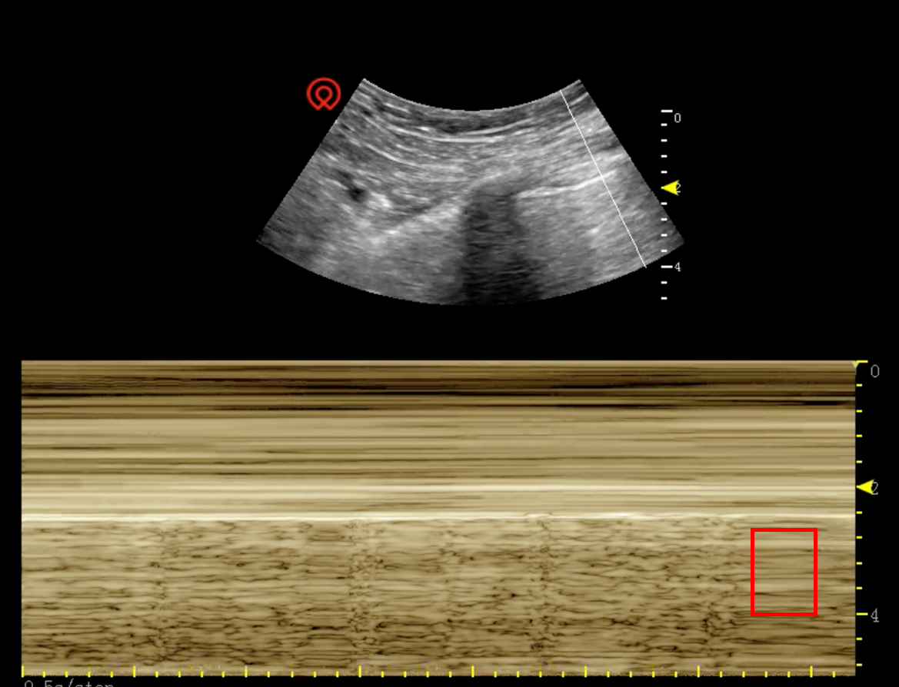
Figure 1 Ultrasound showed an advection level sign on M-mode during the operation. Red square indicates the advection level sign on M-mode, whereas no B line could be detected on ultrasonography.
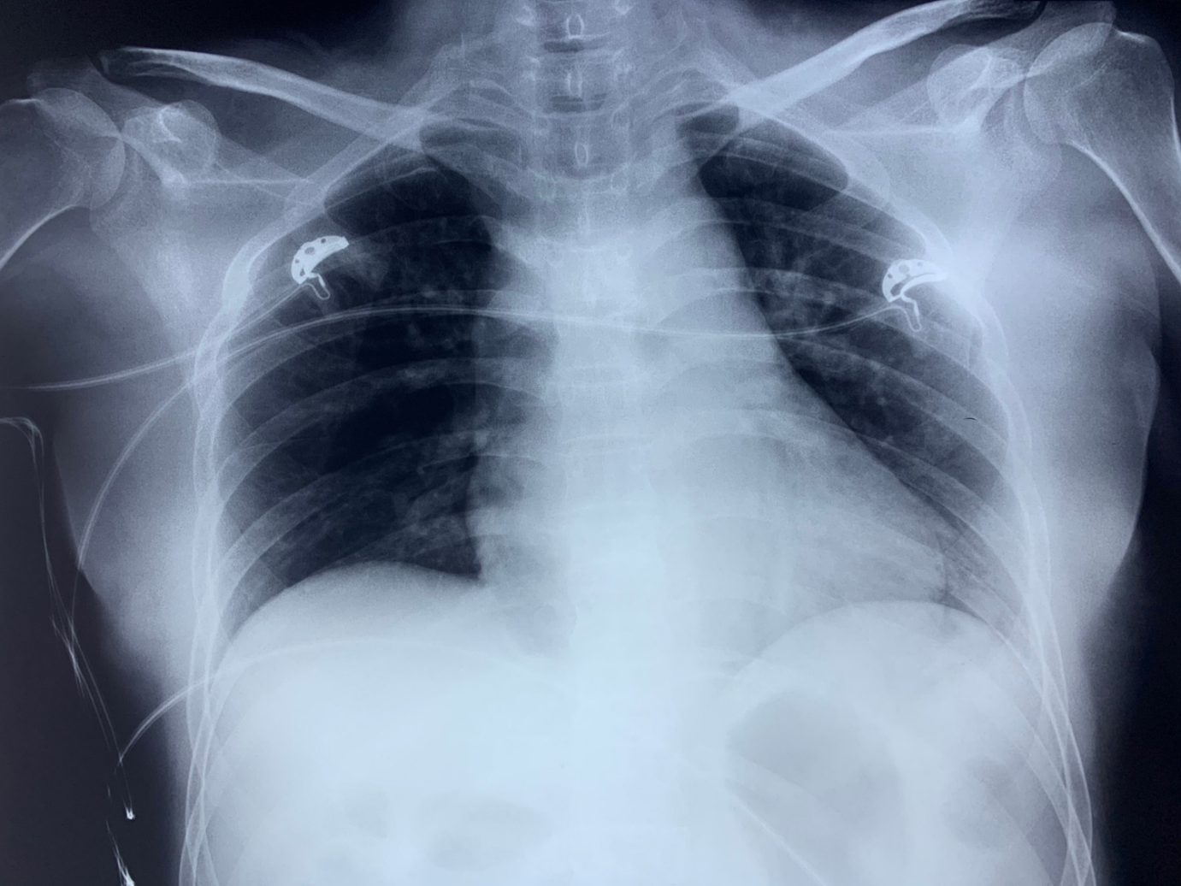
Figure 2 Bedside chest X-ray result after the patient had been transferred to the urosurgery ward. No evidence of pneumothorax or lib injury was found after the lung dilation.

