Name of Journal: World Journal of Clinical Cases
Manuscript NO: 62239
Manuscript Type: META-ANALYSIS

Effect of antifoaming agent on benign colorectal tumors in colonoscopy: A meta-analysis

Zhang H et al. Antifoaming agent on benign colorectal tumors

Hu Zhang, Jing Gong, Lin-Song Ma, Ting Jiang, Heng Zhang

Hu Zhang, Jing Gong, Lin-Song Ma, Ting Jiang, Heng Zhang, Department of Gastroenterology, The Central Hospital of Wuhan, Tongji Medical College, Huazhong University of Science and Technology, Wuhan 430014, Hubei Province, China

Hu Zhang, Department of Gastroenterology, The Eighth Hospital of Wuhan, Wuhan 430014, Hubei Province, China

Author contributions: Heng Z designed this study and critically revised the manuscript; Hu Z and JL were responsible for data acquisition and extraction; Hu Z drafted the manuscript, analyzed the data, and interpreted the results; Hu Z, Ma LS, Jiang T, and Gong J were involved in editing the manuscript; All authors read and approved the final manuscript.

Supported by the Natural Science Foundation of Wuhan, No. WX18Y04.

Corresponding author: Heng Zhang, MA, MD, Chief Doctor, Department of Gastroenterology, The Central Hospital of Wuhan, Tongji Medical College, Huazhong University of Science and Technology, No. 26 Shengli Street, Jiangan District, Wuhan 430014, Hubei Province, China. 653262549@qq.com

Received: January 3, 2021
Revised: February 25, 2021
Accepted: March 12, 2021
Published online:

Abstract
BACKGROUND
Although several trials have shown that the addition of antifoaming agents to polyethylene glycol (PEG) can improve bowel preparation, whether PEG plus antifoaming agents have a beneficial role in the detection of benign tumors during colonoscopy has yet to be confirmed. Our aim was to clarify whether adding simethicone to PEG solution could improve the detection of benign colorectal tumors.

AIM
To clarify whether adding simethicone to PEG solution could improve the detection of benign colorectal tumors.

METHODS
The PubMed, EMBASE, and Cochrane Library databases were searched for articles published prior to September 2019. The outcomes included the detection rates of colorectal adenomas and polyps.

RESULT
Twenty studies were eligible. Although there was no difference in the colorectal adenoma detection rate (ADR), a significant effect of simethicone for diminutive adenomas (< 10 mm) was revealed in the group taking simethicone. We also found that simethicone could significantly improve the ADR in the proximal colon but did not affect the colorectal polyp detection rate. Furthermore, the subgroup analyses revealed a beneficial effect of simethicone on the ADR among Asians (P = 0.005) and those with an ADR < 25% (P = 0.003). Moreover, it was a significant finding that the low dose simethicone was as effective as the high dose one with respect to the detection of benign colorectal tumors.

CONCLUSION
In summary, the addition of simethicone to PEG might improve the detection of diminutive adenomas in the right colon by colonoscopy in Asia. Low-dose simethicone was recommended for the detection of benign colorectal tumors. However, large clinical trials are necessary to validate our results and determine the ideal dose of simethicone.

Key Words: Antifoaming agent; Simethicone; Polyethylene glycol; Colonoscopy; Meta-analysis

Zhang H, Gong J, Ma LS, Jiang T, Zhang H. Effect of antifoaming agent on benign colorectal tumors in colonoscopy: A meta-analysis. World J Clin Cases 2021; In press

Core Tip: The addition of simethicone to polyethylene glycol might improve the detection of diminutive adenomas in the right colon by colonoscopy in Asia. Low-dose simethicone was recommended for the detection of benign colorectal tumors.

INTRODUCTION
Colorectal cancer (CRC) is a common cancer worldwide. The incidence and mortality of CRC have been rapidly increasing in Asian countries^{[1,2]}. Early diagnosis is associated with better survival and quality of life. Currently, colonoscopy is a standard first-line tool for the screening, surveillance, and prevention of colorectal tumors^{[3,4]}. The colorectal adenoma detection rate (ADR) is regarded as the most important indicator of colonoscopy. Polyethylene glycol (PEG) is recommended as the preferred choice for bowel preparation^{[5]}. However, up to a quarter of patients have shown inadequate bowel preparation^{[6]}. Inadequate bowel preparation is related to an increased risk of missed benign colorectal tumors and more discomfort for patients^{[7-9]}.
Simethicone, which prevents bubble formation and gas retention to alleviate bloating, is an effective and safe antifoaming agent for use during endoscopic procedures. A combination of simethicone and PEG has been shown to improve the visualization of the bowel for colonoscopy. Thus, simethicone could have a theoretical benefit in the detection of benign tumors in colonoscopy, especially diminutive lesions.
A large number of previous studies have evaluated the effect of simethicone in ADR during colonoscopy, but the results have been inconsistent. Hence, a recent meta-analysis is necessary. However, whether simethicone plus PEG has a beneficial role in the detection of benign tumors during colonoscopy has yet to be confirmed. Therefore, we performed a meta-analysis to investigate its effect on the detection of benign colorectal tumors.

MATERIALS AND METHODS
Literature search
The PubMed, EMBASE, and Cochrane Central databases (up to September 1, 2019) were searched using the keywords ‘colonoscopy,’ ‘antifoaming agent’ or ‘simethicone,’ and ‘randomized’. We also performed a manual search of the reference lists of the published articles.

Inclusion criteria
(1) Study design: randomized studies as full manuscripts; (2) Language: limited to English; (3) Population: patients who underwent a colonoscopy; (4) Controls: PEG without simethicone for bowel preparation; (5) Intervention: PEG with simethicone for bowel preparation; and (6) Outcomes: primary endpoints: colorectal ADR and polyp detection rate (PDR) and secondary endpoint: adverse events.

Exclusion criteria
(1) Bowel preparation without PEG or simethicone; (2) Nonhuman studies; (3) Duplicate publications; and (4) Studies without available data.

Data extraction
The data were extracted by 3 investigators (HZ, JG, and LM) independently. Disagreements were resolved by consensus. The data included the author, year, number of patients, country or region, detailed information on interventions and controls (ADR and PDR), and adverse events.

Assessment of study quality
The Cochrane Collaboration’s risk of bias tool^{[10]} was used to evaluate the quality of the randomized studies. The quality scale was assessed as ‘low risk of bias,’ ‘unclear risk of bias,’ and ‘high risk of bias’.

Data syntheses and statistical analysis
The odds ratio (OR) was used for discrete variables, and the mean difference and standardized difference in mean were used for continuous variables. The pooled ORs and 95% confidence intervals (CIs) were calculated from the studies using either a fixed-effects model or a random-effects model. When the heterogeneity was significant, the random-effects model was used for the pooled data; otherwise, a fixed-effects model was used. Heterogeneity among the studies was assessed using the I² statistic or the c² test. I² > 50% or P < 0.10 was considered to indicate heterogeneity. Publication bias was evaluated by Egger’s test, where P < 0.10 in a two-tailed test was regarded as positive. In the subgroup analyses, P < 0.05 for the c² test indicated statistically significant heterogeneity. By excluding one or more studies each time, sensitivity analysis was conducted to evaluate the robustness of the pooled results^{[11]}. All of the statistical analyses and plots were performed using Review Manager statistical software, version 5.0 (the Cochrane Collaboration, Copenhagen, Denmark) and Stata software, version 12.0 (Stata Corp LLC, Texas, United States).

RESULTS
Study selection
The literature search retrieved 169 citations, 96 of which were excluded due to duplication. Of the 73 eligible studies, 53 studies were excluded, and 20 studies focused on comparing PEG with and without simethicone to evaluate the effects on ADR and PDR. This meta-analysis was conducted according to the guidelines of the Preferred Reporting Items for Systematic Reviews and Meta-Analysis^{[12]} (Figure 1).

Study characteristics
The 20 studies^{[13-32]} included 6306 patients, of whom 3162 and 3144 patients were assigned to the PEG plus simethicone group and PEG group, respectively (Tables 1 and 2). These studies were performed in five countries (China, South Korea, Italy, United States, and Netherlands).

Quality assessment
The quality of the randomized studies was evaluated by the Cochrane Collaboration’s risk of bias tool. Although all of the studies were single-blind to the examiner, the blinding of outcome assessments was not affected. Therefore, the risk bias of selective reporting of each trial was considered low risk. The quality assessment of the randomized studies is shown in Supplementary Table 1.

Primary endpoints
ADR: For the primary endpoint, nine studies reported data on the ADR, including 4069 patients (2042 patients treated with PEG plus simethicone and 2027 patients treated with PEG). The overall ADR during colonoscopy was similar in both groups: 30.9% in the PEG group and 31.0% in the PEG plus simethicone group. The heterogeneity among the studies was not significant (I² = 41%; P = 0.10). According to the fixed-effects model, the pooled OR was not significant (OR = 1.01; 95%CI: 0.88-1.15; P = 0.94), suggesting that there was no statistically significant difference in the ADR during colonoscopy between the two groups (Figure 2). Begg’s funnel plots and Egger’s regression test revealed that there was no significant effect of publication bias on the overall ADR (P = 0.307).

PDR: Overall, the PDR was available in 10 studies, including 4544 patients (2279 patients treated with PEG plus simethicone and 2265 patients treated with PEG). The overall PDR was higher in the group treated with simethicone during colonoscopy (49.1% vs 48.0%). The heterogeneity among the studies was significant (I² = 64%; P = 0.003). The pooled OR, according to a random-effects model for PDR (OR = 1.13; 95%CI: 0.89-1.42; P = 0.31), was not significantly different between the two groups (Figure 3). Egger’s regression test revealed that there was no significant effect of publication bias on the overall PDR (P = 0.221).

Secondary endpoints
Adverse events: Sixteen studies reported data on adverse events, including bloating, vomiting, nausea, abdominal pain, and sleep disturbance. Simethicone significantly reduced the incidence of bloating (15.8% vs 25.3%) (OR = 0.52; 95%CI: 0.44-0.63, P < 0.00001). There were no statistically significant differences in other adverse events. Egger’s regression test revealed that there was no significant effect of publication bias.

Sensitivity analyses: We performed further sensitivity analyses to assess the impact on the heterogeneity by the exclusion of one or more studies at a time. There was statistically significant heterogeneity for the ADR in the right colon (heterogeneity P = 0.09, I² = 58%). When Bai et al^{[14]} was excluded, it no longer showed heterogeneity for the ADR (heterogeneity P = 0.18, I² = 45%). The other two outcomes had significant heterogeneity, including the PDR and adverse events of bloating. When Valiante et al^{[21]} was excluded, they no longer showed heterogeneity of the PDR. The studies associated with the heterogeneity of each outcome are listed in Table 3.

Subgroup analyses: The results of the subgroup analyses for the ADR and PDR in relation to sites of colorectal adenomas or polyps (right or left colon), sizes of adenomas or polyps (≥ 10 mm or < 10 mm), populations (Asian or non-Asian), dose of simethicone (≥ 400 mg or < 400 mg and NR), and proportion of ADR (≥ 25% or < 25%) are shown in Table 3.
The analysis separately revealed that there was no significant difference (OR = 1.39, 95%CI: 0.67-2.86, P = 0.38) or heterogeneity (P = 0.48, I² = 0%) between the two groups for ADR ≥ 10 mm. However, our study displayed a significant increase in the ADR for small adenomas (< 10 mm) during colonoscopy in the group treated with simethicone (OR = 2.36; 95%CI: 1.79-3.10; P < 0.00001) (Figure 4A).
When analyzed separately, a significantly larger proportion of ADR in the right colon was present in the PEG plus simethicone group (21.5% vs 9.7%, OR = 2.61, 95%CI: 1.43-4.76, P = 0.002) (Figure 4B). In addition, the ADR in the left colon was also higher than that in the PEG group, with borderline statistical significance (13.8% vs 10.0%, P = 0.04).
The subgroup analysis revealed a significant increase in the ADR in the studies from Asia in the PEG with simethicone group (26.8% vs 20.7%, OR= 1.45, 95%CI: 1.12-1.87, P = 0.005) (Figure 4C), and a baseline ADR < 25% of the studies included was associated with a significant benefit of simethicone (OR = 1.55, 95%CI: 1.16-2.07, P = 0.003) (Figure 4D). In addition, our analysis revealed that there was no significant difference in ADR between the two groups with respect to the dose of simethicone, suggesting that the low dose of simethicone was as effective as the high dose with respect to the detection of benign colorectal tumors.
The comparison of PDR between the two groups showed no differences in the proportion of PDR, dose of simethicone, size of polyps, or populations when simethicone was added.

DISCUSSION
The effectiveness of colonoscopy could significantly reduce the incidence and mortality of CRC^{[33]}, depending on adequate bowel preparation and removal of colorectal precancerous lesions^{[34]}. Inadequate bowel preparation increases economic costs, prolongs procedure times, and increases the likelihood of potential lesions being missed, especially those in the proximal colon^{[35]}.
Simethicone is an effective antifoaming agent used during endoscopic procedures. The Gastroenterological Society of Australia consensus panel found that the current evidence supported the use of simethicone for improving visibility and that it likely facilitates adenoma detection at colonoscopy^{[36]}. Although simethicone addition to PEG solution could improve bowel cleanness and mucosal visibility^{[37]}, our results found that simethicone did not affect the total ADR or PDR. This outcome might be related to the possible explanation that solid stool was unlikely to be cleaned, although simethicone could improve the overall bowel cleanness.
The ADR has been recognized as the most important indicator of colonoscopy quality. The current international guidelines have recommended that the ADR should be ≥ 25% overall as the minimal requirement for surveillance colonoscopy^{[38]}. In the subgroup analysis, we revealed a positive effect of simethicone with statistical significance in the low ADR group (< 25%). An interesting finding in our study was that the population of the low ADR group was Asian. This phenomenon might be related to the genes, diet, and/or microbiota of Asians.
The most important finding in our study was that simethicone could significantly improve detection of small adenomas (< 10 mm) of the proximal colon. The main reason is that simethicone can improve bowel preparation, especially in the right colon^{[39]}. Because bubbles usually present in the ascending colon, bubble elimination could enhance the ability to detect smaller proximal adenomas. A previous study revealed that missed cancers in the proximal colon were more often found with poor bowel preparation^{[40]}. A previous study reported that CRC in Eastern China has undergone a rightward change in the site distribution over the past two decades^{[41]}. Therefore, improving the effectiveness of right-sided cleansing plays a key role in improving compliance with screening programs, which is crucial for screening efficiency in CRC prevention. However, simethicone did not significantly affect the ADR in the left colon, which might be associated with the small samples in the studies included. Therefore, further large clinical trials are necessary to confirm our results.
Although a recent study reported a 10% increase in the detection rate of colorectal polyps when simethicone was added to the water pump during colonoscopy^{[42]}, residual simethicone in biopsy channels could promote biofilm formation^{[43]}. In addition, endoscopists with higher ADRs likely spent more time cleaning the colon. Simethicone addition to PEG solution could decrease the infection risk from endoscope transmission^{[31]}. However, the optimal dose of simethicone has yet to be ascertained^{[44]}. The addition of 2–3 mL of 120 mg/mL simethicone to lavage fluid was recommended ^{[33]}. In the subgroup analysis, we compared the effect of low-dose simethicone (< 400 mg) to that of high-dose simethicone (≥ 400 mg) for the ADR and PDR. Our results revealed that simethicone at a high or low dose made no significant difference in terms of ADR and PDR, suggesting that the low dose was not inferior to the high dose, similar to the study of Li et al^{[45]}. Further research is required to determine the optimal dose of simethicone in clinical practice.
The strengths were as follows in our study. First, subgroup analyses and sensitivity analyses were conducted to seek potential reasons. To reduce possible bias, we conducted sensitivity analyses to assess the impact on the heterogeneity by excluding one or more studies at a time and performing subgroup analyses according to the site and size of colorectal benign tumors, the population included, and the proportion of ADR. There was no significant heterogeneity found in the meta-analysis of the ADR, except for right-side ADR. When Valiante et al^{[21]} study was excluded, it no longer showed heterogeneity of the PDR. Second, our results of the subgroup analyses for the ADR and PDR included the population included and the dose of simethicone before colonoscopy. Third, 20 studies were included in our meta-analysis. This large number of studies allowed for ﬁrm conclusions and adequate subgroup analyses. Therefore, the results of our study are convincing.
There are several limitations to our meta-analysis. First, our meta-analysis was restricted to publications written in English, which might have produced potential selection bias. Second, all of the included studies were single blinded for outcome assessment; therefore, further double-blind randomized controlled trials should be conducted to confirm the positive effects of simethicone. Third, demographic and procedure data, such as race, diet, microbiota, and genes, might have been interesting to evaluate, but these data were not analyzed due to the limited condition. Fourth, although the endoscopists were trained adequately, the effects of observer bias cannot be ignored.

CONCLUSION
In conclusion, we believe that simethicone might improve small ADRs, especially in the proximal colon, for colonoscopy in Asians with low baseline ADRs. Simethicone at a low dose was not inferior to that at a high dose with respect to the detection of benign colorectal tumors. Additional large clinical trials are necessary to validate our results and to evaluate the ideal dose of simethicone.

ARTICLE HIGHLIGHTS
Research background
The incidence and mortality of colorectal cancer have been rapidly increasing in Asian countries, and inadequate bowel preparation is related to an increased risk of missed benign colorectal tumors and more discomfort for patients.

Research motivation
Simethicone is an effective and safe antifoaming agent for use during endoscopic procedures. A combination of simethicone and polyethylene glycol has been shown to improve the visualization of the bowel for colonoscopy.

Research objectives
We performed a meta-analysis to investigate its effect on the detection of benign colorectal tumors.

Research methods
The PubMed, EMBASE, and Cochrane Library databases were searched for articles published.

Research results
A significant effect of simethicone for diminutive adenomas (< 10 mm) and the adenoma detection rate in the proximal colon were revealed in the group taking simethicone. Moreover, it was a significant finding that the low dose simethicone was as effective as the high dose one with respect to the detection of colorectal benign tumors.

Research conclusions
The addition of simethicone to polyethylene glycol might improve the detection of diminutive adenomas in the right colon by colonoscopy in Asia. Low-dose simethicone was recommended for the detection of benign colorectal tumors.

Research perspectives
We believe that simethicone might improve small adenoma detection rates, especially in the proximal colon for colonoscopy in Asians with low baseline adenoma detection rates.

REFERENCES
1 Ng SC, Wong SH. Colorectal cancer screening in Asia. Br Med Bull 2013; 105: 29-42 [PMID: 23299409 DOI: 10.1093/bmb/lds040]
2 Shin A, Kim KZ, Jung KW, Park S, Won YJ, Kim J, Kim DY, Oh JH. Increasing trend of colorectal cancer incidence in Korea, 1999-2009. Cancer Res Treat 2012; 44: 219-226 [PMID: 23341785 DOI: 10.4143/crt.2012.44.4.219]
3 Meester RG, Doubeni CA, Lansdorp-Vogelaar I, Jensen CD, van der Meulen MP, Levin TR, Quinn VP, Schottinger JE, Zauber AG, Corley DA, van Ballegooijen M. Variation in Adenoma Detection Rate and the Lifetime Benefits and Cost of Colorectal Cancer Screening: A Microsimulation Model. JAMA 2015; 313: 2349-2358 [PMID: 26080339 DOI: 10.1001/jama.2015.6251]
4 Corley DA, Jensen CD, Marks AR, Zhao WK, Lee JK, Doubeni CA, Zauber AG, de Boer J, Fireman BH, Schottinger JE, Quinn VP, Ghai NR, Levin TR, Quesenberry CP. Adenoma detection rate and risk of colorectal cancer and death. N Engl J Med 2014; 370: 1298-1306 [PMID: 24693890 DOI: 10.1056/NEJMoa1309086]
5 Wexner SD, Beck DE, Baron TH, Fanelli RD, Hyman N, Shen B, Wasco KE; American Society of Colon and Rectal Surgeons; American Society for Gastrointestinal Endoscopy; Society of American Gastrointestinal and Endoscopic Surgeons. A consensus document on bowel preparation before colonoscopy: prepared by a task force from the American Society of Colon and Rectal Surgeons (ASCRS), the American Society for Gastrointestinal Endoscopy (ASGE), and the Society of American Gastrointestinal and Endoscopic Surgeons (SAGES). Gastrointest Endosc 2006; 63: 894-909 [PMID: 16733101 DOI: 10.1016/j.gie.2006.03.918]
6 Lebwohl B, Kastrinos F, Glick M, Rosenbaum AJ, Wang T, Neugut AI. The impact of suboptimal bowel preparation on adenoma miss rates and the factors associated with early repeat colonoscopy. Gastrointest Endosc 2011; 73: 1207-1214 [PMID: 21481857 DOI: 10.1016/j.gie.2011.01.051]
7 Clark BT, Protiva P, Nagar A, Imaeda A, Ciarleglio MM, Deng Y, Laine L. Quantification of Adequate Bowel Preparation for Screening or Surveillance Colonoscopy in Men. Gastroenterology 2016; 150: 396-405; quiz e14-5 [PMID: 26439436 DOI: 10.1053/j.gastro.2015.09.041]
8 Bugajski M, Wieszczy P, Hoff G, Rupinski M, Regula J, Kaminski MF. Modifiable factors associated with patient-reported pain during and after screening colonoscopy. Gut 2018; 67: 1958-1964 [PMID: 28970289 DOI: 10.1136/gutjnl-2017-313905]
9 Horton N, Garber A, Hasson H, Lopez R, Burke CA. Impact of Single- vs. Split-Dose Low-Volume Bowel Preparations on Bowel Movement Kinetics, Patient Inconvenience, and Polyp Detection: A Prospective Trial. Am J Gastroenterol 2016; 111: 1330-1337 [PMID: 27377521 DOI: 10.1038/ajg.2016.273]
10 Higgins JP, Altman DG, Gøtzsche PC, Jüni P, Moher D, Oxman AD, Savovic J, Schulz KF, Weeks L, Sterne JA; Cochrane Bias Methods Group; Cochrane Statistical Methods Group. The Cochrane Collaboration's tool for assessing risk of bias in randomised trials. BMJ 2011; 343: d5928 [PMID: 22008217 DOI: 10.1136/bmj.d5928]
11 Higgins JP. Commentary: Heterogeneity in meta-analysis should be expected and appropriately quantified. Int J Epidemiol 2008; 37: 1158-1160 [PMID: 18832388 DOI: 10.1093/ije/dyn204]
12 Moher D, Shamseer L, Clarke M, Ghersi D, Liberati A, Petticrew M, Shekelle P, Stewart LA; PRISMA-P Group. Preferred reporting items for systematic review and meta-analysis protocols (PRISMA-P) 2015 statement. Syst Rev 2015; 4: 1 [PMID: 25554246 DOI: 10.1186/2046-4053-4-1]
13 Zhang S, Zheng D, Wang J, Wu J, Lei P, Luo Q, Wang L, Zhang B, Wang H, Cui Y, Chen M. Simethicone improves bowel cleansing with low-volume polyethylene glycol: a multicenter randomized trial. Endoscopy 2018; 50: 412-422 [PMID: 29132175 DOI: 10.1055/s-0043-121337]
14 Bai Y, Fang J, Zhao SB, Wang D, Li YQ, Shi RH, Sun ZQ, Sun MJ, Ji F, Si JM, Li ZS. Impact of preprocedure simethicone on adenoma detection rate during colonoscopy: a multicenter, endoscopist-blinded randomized controlled trial. Endoscopy 2018; 50: 128-136 [PMID: 28985630 DOI: 10.1055/s-0043-119213]
15 Yoo IK, Jeen YT, Kang SH, Lee JH, Kim SH, Lee JM, Choi HS, Kim ES, Keum B, Chun HJ, Lee HS, Kim CD. Improving of bowel cleansing effect for polyethylene glycol with ascorbic acid using simethicone: A randomized controlled trial. Medicine (Baltimore) 2016; 95: e4163 [PMID: 27428209 DOI: 10.1097/MD.0000000000004163]
16 Zorzi M, Valiante F, Germanà B, Baldassarre G, Coria B, Rinaldi M, Heras Salvat H, Carta A, Bortoluzzi F, Cervellin E, Polo ML, Bulighin G, Azzurro M, Di Piramo D, Turrin A, Monica F; TriVeP Working Group. Comparison between different colon cleansing products for screening colonoscopy. A noninferiority trial in population-based screening programs in Italy. Endoscopy 2016; 48: 223-231 [PMID: 26760605 DOI: 10.1055/s-0035-1569574]
17 Kump P, Hassan C, Spada C, Brownstone E, Datz C, Haefner M, Renner F, Schoefl R, Schreiber F. Efficacy and safety of a new low-volume PEG with citrate and simethicone bowel preparation for colonoscopy (Clensia): a multicenter randomized observer-blind clinical trial vs. a low-volume PEG with ascorbic acid (PEG-ASC). Endosc Int Open 2018; 6: E907-E913 [PMID: 30083580 DOI: 10.1055/a-0624-2266]
18 Parente F, Vailati C, Bargiggia S, Manes G, Fontana P, Masci E, Arena M, Spinzi G, Baccarin A, Mazzoleni G, Testoni PA. 2-Litre polyethylene glycol-citrate-simethicone plus bisacodyl versus 4-litre polyethylene glycol as preparation for colonoscopy in chronic constipation. Dig Liver Dis 2015; 47: 857-863 [PMID: 26232311 DOI: 10.1016/j.dld.2015.06.008]
19 Mussetto A, Frazzoni L, Paggi S, Dari S, Laterza L, Radaelli F, Hassan C, Triossi O, Fuccio L. Split dosing with a low-volume preparation is not inferior to split dosing with a high-volume preparation for bowel cleansing in patients with a history of colorectal resection: a randomized trial. Endoscopy 2015; 47: 917-924 [PMID: 25910064 DOI: 10.1055/s-0034-1391987]
20 de Leone A, Tamayo D, Fiori G, Ravizza D, Trovato C, De Roberto G, Fazzini L, Dal Fante M, Crosta C. Same-day 2-L PEG-citrate-simethicone plus bisacodyl vs split 4-L PEG: Bowel cleansing for late-morning colonoscopy. World J Gastrointest Endosc 2013; 5: 433-439 [PMID: 24044042 DOI: 10.4253/wjge.v5.i9.433]
21 Valiante F, Bellumat A, De Bona M, De Boni M. Bisacodyl plus split 2-L polyethylene glycol-citrate-simethicone improves quality of bowel preparation before screening colonoscopy. World J Gastroenterol 2013; 19: 5493-5499 [PMID: 24023492 DOI: 10.3748/wjg.v19.i33.5493]
22 Cesaro P, Hassan C, Spada C, Petruzziello L, Vitale G, Costamagna G. A new low-volume isosmotic polyethylene glycol solution plus bisacodyl versus split-dose 4 L polyethylene glycol for bowel cleansing prior to colonoscopy: a randomised controlled trial. Dig Liver Dis 2013; 45: 23-27 [PMID: 22917636 DOI: 10.1016/j.dld.2012.07.011]
23 Gentile M, De Rosa M, Cestaro G, Forestieri P. 2 L PEG plus ascorbic acid versus 4 L PEG plus simethicon for colonoscopy preparation: a randomized single-blind clinical trial. Surg Laparosc Endosc Percutan Tech 2013; 23: 276-280 [PMID: 23751992 DOI: 10.1097/SLE.0b013e31828e389d]
24 Matro R, Tupchong K, Daskalakis C, Gordon V, Katz L, Kastenberg D. The effect on colon visualization during colonoscopy of the addition of simethicone to polyethylene glycol-electrolyte solution: a randomized single-blind study. Clin Transl Gastroenterol 2012; 3: e26 [PMID: 23238113 DOI: 10.1038/ctg.2012.16]
25 Repici A, Cestari R, Annese V, Biscaglia G, Vitetta E, Minelli L, Trallori G, Orselli S, Andriulli A, Hassan C. Randomised clinical trial: low-volume bowel preparation for colonoscopy - a comparison between two different PEG-based formulations. Aliment Pharmacol Ther 2012; 36: 717-724 [PMID: 22924336 DOI: 10.1111/apt.12026]
26 Jansen SV, Goedhard JG, Winkens B, van Deursen CT. Preparation before colonoscopy: a randomized controlled trial comparing different regimes. Eur J Gastroenterol Hepatol 2011; 23: 897-902 [PMID: 21900786 DOI: 10.1097/MEG.0b013e32834a3444]
27 Pontone S, Angelini R, Standoli M, Patrizi G, Culasso F, Pontone P, Redler A. Low-volume plus ascorbic acid vs high-volume plus simethicone bowel preparation before colonoscopy. World J Gastroenterol 2011; 17: 4689-4695 [PMID: 22180711 DOI: 10.3748/wjg.v17.i42.4689]
28 Lazzaroni M, Petrillo M, Desideri S, Bianchi Porro G. Efficacy and tolerability of polyethylene glycol-electrolyte lavage solution with and without simethicone in the preparation of patients with inflammatory bowel disease for colonoscopy. Aliment Pharmacol Ther 1993; 7: 655-659 [PMID: 8161673 DOI: 10.1111/j.1365-2036.1993.tb00148.x]
29 McNally PR, Maydonovitch CL, Wong RK. The effect of simethicone on colonic visibility after night-prior colonic lavage. A double-blind randomized study. J Clin Gastroenterol 1989; 11: 650-652 [PMID: 2584664 DOI: 10.1097/00004836-198912000-00010]
30 McNally PR, Maydonovitch CL, Wong RK. The effectiveness of simethicone in improving visibility during colonoscopy: a double-blind randomized study. Gastrointest Endosc 1988; 34: 255-258 [PMID: 3292345 DOI: 10.1016/s0016-5107(88)71324-3]
31 Moraveji S, Casner N, Bashashati M, Garcia C, Dwivedi A, Zuckerman MJ, Carrion A, Ladd AM. The role of oral simethicone on the adenoma detection rate and other quality indicators of screening colonoscopy: a randomized, controlled, observer-blinded clinical trial. Gastrointest Endosc 2019; 90: 141-149 [PMID: 30926430 DOI: 10.1016/j.gie.2019.03.018]
32 Rishi M, Kaur J, Ulanja M, Manasewitsch N, Svendsen M, Abdalla A, Vemala S, Kewanyama J, Singh K, Singh N, Gullapalli N, Osgard E. Randomized, double-blinded, placebo-controlled trial evaluating simethicone pretreatment with bowel preparation during colonoscopy. World J Gastrointest Endosc 2019; 11: 413-423 [PMID: 31236194 DOI: 10.4253/wjge.v11.i6.413]
33 Citarda F, Tomaselli G, Capocaccia R, Barcherini S, Crespi M; Italian Multicentre Study Group. Efficacy in standard clinical practice of colonoscopic polypectomy in reducing colorectal cancer incidence. Gut 2001; 48: 812-815 [PMID: 11358901 DOI: 10.1136/gut.48.6.812]
34 Rex DK, Schoenfeld PS, Cohen J, Pike IM, Adler DG, Fennerty MB, Lieb JG 2nd, Park WG, Rizk MK, Sawhney MS, Shaheen NJ, Wani S, Weinberg DS. Quality indicators for colonoscopy. Gastrointest Endosc 2015; 81: 31-53 [PMID: 25480100 DOI: 10.1016/j.gie.2014.07.058]
35 Froehlich F, Wietlisbach V, Gonvers JJ, Burnand B, Vader JP. Impact of colonic cleansing on quality and diagnostic yield of colonoscopy: the European Panel of Appropriateness of Gastrointestinal Endoscopy European multicenter study. Gastrointest Endosc 2005; 61: 378-384 [PMID: 15758907 DOI: 10.1016/s0016-5107(04)02776-2]
36 Devereaux BM, Taylor ACF, Athan E, Wallis DJ, Brown RR, Greig SM, Bailey FK, Vickery K, Wardle E, Jones DM. Simethicone use during gastrointestinal endoscopy: Position statement of the Gastroenterological Society of Australia. J Gastroenterol Hepatol 2019; 34: 2086-2089 [PMID: 31242327 DOI: 10.1111/jgh.14757]
37 Pan P, Zhao SB, Li BH, Meng QQ, Yao J, Wang D, Li ZS, Bai Y. Effect of supplemental simethicone for bowel preparation on adenoma detection during colonoscopy: A meta-analysis of randomized controlled trials. J Gastroenterol Hepatol 2019; 34: 314-320 [PMID: 30069899 DOI: 10.1111/jgh.14401]
38 Rex DK, Boland CR, Dominitz JA, Giardiello FM, Johnson DA, Kaltenbach T, Levin TR, Lieberman D, Robertson DJ. Colorectal Cancer Screening: Recommendations for Physicians and Patients From the U.S. Multi-Society Task Force on Colorectal Cancer. Gastroenterology 2017; 153: 307-323 [PMID: 28600072 DOI: 10.1053/j.gastro.2017.05.013]
39 Benmassaoud A, Parent J. Canadian Association of Gastroenterology Position Statement on the Impact of Simethicone on Endoscope Reprocessing. J Can Assoc Gastroenterol 2018; 1: 40-42 [PMID: 31294395 DOI: 10.1093/jcag/gwx002]
40 Doubeni CA, Corley DA, Quinn VP, Jensen CD, Zauber AG, Goodman M, Johnson JR, Mehta SJ, Becerra TA, Zhao WK, Schottinger J, Doria-Rose VP, Levin TR, Weiss NS, Fletcher RH. Effectiveness of screening colonoscopy in reducing the risk of death from right and left colon cancer: a large community-based study. Gut 2018; 67: 291-298 [PMID: 27733426 DOI: 10.1136/gutjnl-2016-312712]
41 Zhang S, Cui Y, Weng Z, Gong X, Chen M, Zhong B. Changes on the disease pattern of primary colorectal cancers in Southern China: a retrospective study of 20 years. Int J Colorectal Dis 2009; 24: 943-949 [PMID: 19424708 DOI: 10.1007/s00384-009-0726-y]
42 Kutyla M, O'Connor S, Gurusamy SR, Gururatsakul M, Gould K, Whaley A, Kendall BJ, Hourigan L, Holtmann GJ. Influence of Simethicone Added to the Rinse Water during Colonoscopies on Polyp Detection Rates: Results of an Unintended Cohort Study. Digestion 2018; 98: 217-221 [PMID: 30045043 DOI: 10.1159/000489304]
43 Barakat MT, Huang RJ, Banerjee S. Simethicone is retained in endoscopes despite reprocessing: impact of its use on working channel fluid retention and adenosine triphosphate bioluminescence values (with video). Gastrointest Endosc 2019; 89: 115-123 [PMID: 30125574 DOI: 10.1016/j.gie.2018.08.012]
44 Hassan C, East J, Radaelli F, Spada C, Benamouzig R, Bisschops R, Bretthauer M, Dekker E, Dinis-Ribeiro M, Ferlitsch M, Fuccio L, Awadie H, Gralnek I, Jover R, Kaminski MF, Pellisé M, Triantafyllou K, Vanella G, Mangas-Sanjuan C, Frazzoni L, Van Hooft JE, Dumonceau JM. Bowel preparation for colonoscopy: European Society of Gastrointestinal Endoscopy (ESGE) Guideline - Update 2019. Endoscopy 2019; 51: 775-794 [PMID: 31295746 DOI: 10.1055/a-0959-0505]
45 Li DF, Luo MH, Du QQ, Zhang HY, Tian YH, Liu TT, Shi RY, Xiong F, Lai MG, Li YX, Luo S, Song Y, Wu BH, Xu ZL, Zhang DG, Yao J, Wang LS. Efficacy of low-dose versus high-dose simethicone with polyethylene glycol for bowel preparation: A prospective randomized controlled trial. J Gastroenterol Hepatol 2020; 35: 1488-1494 [PMID: 32128877 DOI: 10.1111/jgh.15022]
Footnotes
Conflict-of-interest statement: All of the authors declare that they have no conflicts of interest regarding this paper.

PRISMA 2009 Checklist statement: The authors have read the PRISMA 2009 Checklist statement, and the manuscript was prepared and revised according to the PRISMA 2009 Checklist statement.

Open-Access: This article is an open-access article that was selected by an in-house editor and fully peer-reviewed by external reviewers. It is distributed in accordance with the Creative Commons Attribution NonCommercial (CC BY-NC 4.0) license, which permits others to distribute, remix, adapt, build upon this work non-commercially, and license their derivative works on different terms, provided the original work is properly cited and the use is non-commercial. See: http://creativecommons.org/Licenses/by-nc/4.0/

Manuscript source: Unsolicited manuscript

Peer-review started: January 3, 2021
First decision: February 11, 2021
Article in press:

Specialty type: Gastroenterology and hepatology
Country/Territory of origin: China
Peer-review report’s scientific quality classification
Grade A (Excellent): 0
Grade B (Very good): B
Grade C (Good): 0
Grade D (Fair): 0
Grade E (Poor): 0

P-Reviewer: Panteris V S-Editor: Zhang H L-Editor: Filipodia P-Editor:
Figure Legends
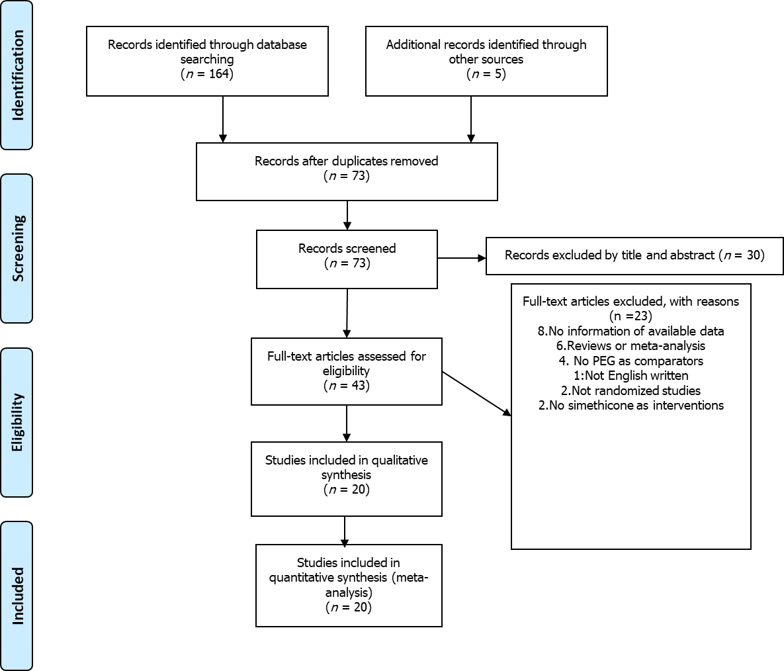
Figure 1 Flowchart of the study selection. PEG: Polyethylene glycol.
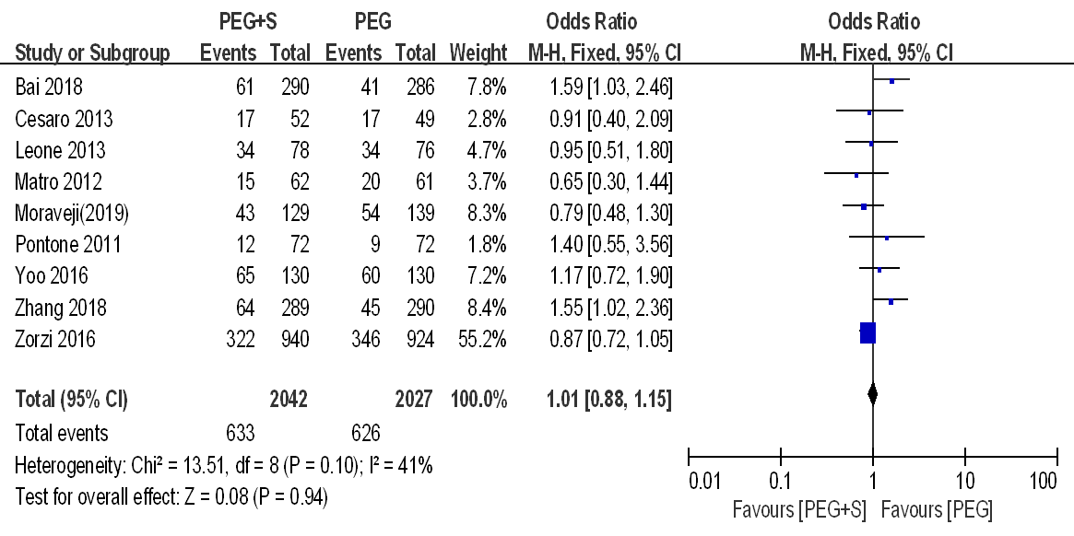
Figure 2 Forest plot of the effect of simethicone on overall adenoma detection rate. CI: Confidence interval; PEG: Polyethylene glycol; PEG+S: Polyethylene glycol plus simethicone.
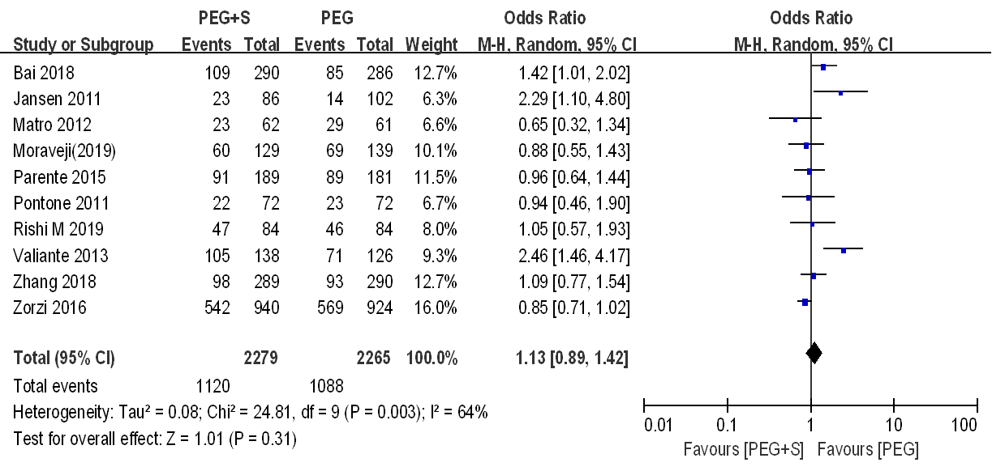
Figure 3 Forest plot of the effect of simethicone on overall polyp detection rate. CI: Confidence interval; PEG: Polyethylene glycol; PEG+S: Polyethylene glycol plus simethicone.
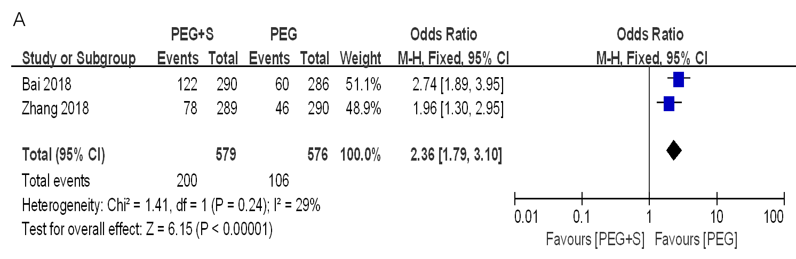
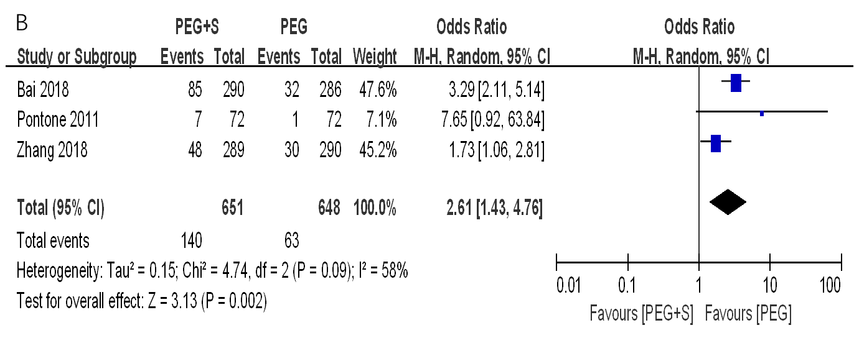
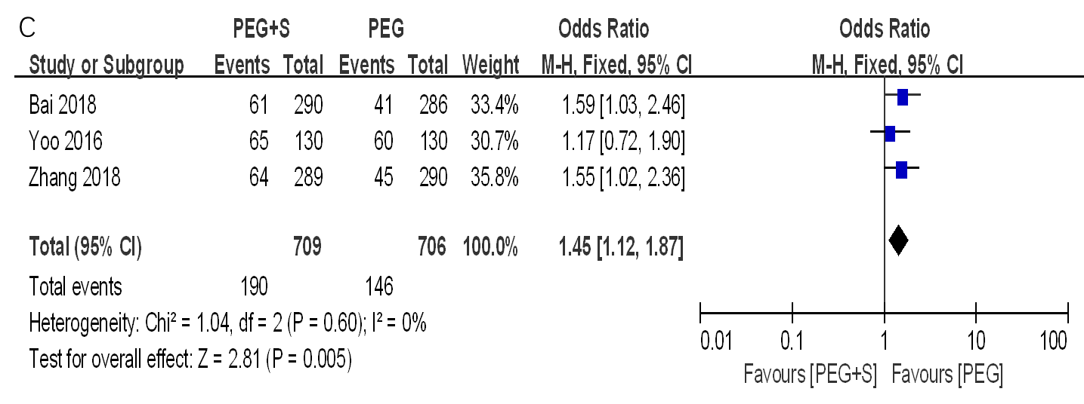
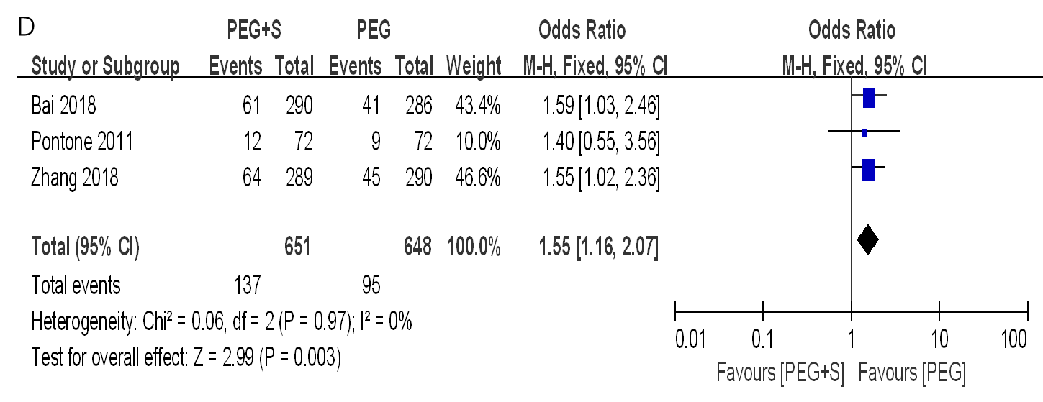
Figure 4 Forest plots of subgroup analysis. A: Forest plot of subgroup analysis of the effect of simethicone on adenoma detection rate (ADR) in trials with small adenomas (< 1 cm); B: Forest plot of subgroup analysis of the effect of simethicone on ADR in trials with right-side adenomas; C: Forest plot of subgroup analysis of the effect of simethicone on ADR in trials of the population from Asia; D: Forest plot of subgroup analysis of the effect of simethicone on ADR in trials with the baseline ADR < 25%. CI: Confidence interval; PEG: Polyethylene glycol; PEG+S: Polyethylene glycol plus simethicone.

Table 1 Characteristics of the studies included in the meta-analysis
Ref. | Groups |  | n | Dose of simethicone in  mg | Bubble  score | Insertion time in min | Withdraw time in min | Adverse events
 |  |  |  |  |  |  |  | Bloating | Nausea | Vomiting | Abdominal pain | Sleep  disorder
Rishi et al^{[32]} (2019) | NS | 2L | 84 | 200 | 1.77 ± 1.00 | 5.48 ± 2.82 | 11.23 ± 3.99 | NR | 20 | 6 | 12 | NR
 | S | 2L + Sim | 84 |  | 1.20 ± 0.60 | 6.06 ± 3.55 | 11.73 ± 5.52 | NR | 13 | 4 | 10 | NR
Morave et al^{[31]} (2019) | NS | 4L | 139 | 480 | 2.10 ± 2.15 | 6.19 ± 4.62 | 6.65 ± 1.28 | NR | NR | NR | NR | NR
 | S | 4L + Sim | 129 |  | 0.10 ± 0.15 | 6.06 ± 3.71 | 6.60 ± 1.15 | NR | NR | NR | NR | NR
Zhang et al^{[13]} (2018) | NS | 2L | 290 | 1200 | 2.5 ± 0.7 | 7.5 ± 5.1 | NR | 59 | 57 | 20 | 24 | 57
 | S | 2L + Sim | 289 |  | 2.8 ± 0.5 | 6.3 ± 3.1 | NR | 34 | 61 | 24 | 21 | 53
Bai et al^{[14]} (2018) | NS | 2L | 286 | 1200 | 3.98 ± 2.50 | 7.55 ± 4.19 | 6.87 ± 2.03 | 57 | 38 | 27 | 9 | NR
 | S | 2L + Sim | 290 |  | 1.00 ± 1.26 | 7.84 ± 5.12 | 6.47 ± 1.80 | 23 | 39 | 30 | 11 | NR
Yoo et al^{[15]} (2016) | NS | 2L | 130 | 400 | NR | 6.75 ± 5.13 | 17.29 ± 13.17 | 71 | 51 | 15 | 31 | 39
 | S | 2L + Sim | 130 |  | NR | 6.78 ± 3.78 | 13.35 ± 7.86 | 31 | 54 | 8 | 7 | 36
Zorzi et al^{[16]} (2016) | NS | 2L | 924 | NR | NR | NR | 10.4 ± 29.9 | NR | NR | NR | NR | NR
 | S | 2L + Sim | 940 |  | NR | NR | 10.6 ± 30.0 | NR | NR | NR | NR | NR
Kump et al^{[17]} (2018) | NS | 2L | 193 | NR | NR | NR | NR | 28 | 26 | 3 | 37 | NR
 | S | 2L + Sim | 194 |  | NR | NR | NR | 26 | 26 | 1 | 34 | NR
Parente et al^{[18]} (2015) | NS | 4L | 189 | NR | NR | 12 ± 7 | 10 ± 3 | NR | NR | NR | NR | 43
 | S | 2L + Sim | 193 |  | NR | 13 ± 7 | 11 ± 6 | NR | NR | NR | NR | 37
Mussetto et al^{[19]} (2015) | NS | 4L | 60 | NR | NR | 7.8 ± 5.1 | 13.8 ± 9.6 | 21 | 20 | NR | 6 | 26
 | S | 2L + Sim | 60 |  | NR | 6.5 ± 3.5 | 11.4 ± 9.4 | 15 | 23 | NR | 9 | 17
Leone et al^{[20]} (2013) | NS | 4L | 79 | NR | NR | 9.8 ± 3.6 | NR | 1 | 7 | 2 | 2 | 3
 | S | 2L + Sim | 78 |  | NR | 10.9 ± 6.1 | NR | 1 | 5 | 6 | 5 | 7
Valiante et al^{[21]} (2013) | NS | 4L | 126 | 160 | NR | NR | NR | 33 | 26 | NR | 5 | NR
 | S | 2L + Sim | 138 |  | NR | NR | NR | 11 | 27 | NR | 13 | NR
Cesaro et al^{[22]} (2013) | NS | 4L | 51 | 160 | NR | 9.5 ± 5.8 | 7.0 ± 1.8 | 12 | 23 | NR | 2 | NR
 | S | 2L + Sim | 50 |  | NR | 8.1 ± 3.8 | 7.6 ± 2.4 | 4 | 10 | NR | 6 | NR
Gentile et al^{[23]} (2013) | NS | 2L | 60 | 160 | NR | NR | NR | NR | 6 | 3 | 1 | 0
 | S | 4L + Sim | 60 |  | NR | NR | NR | NR | 12 | 4 | 1 | 0
Matro et al^{[24]} (2012) | NS | 2L | 61 | 400 | NR | NR | NR | 32 | 18 | 3 | 21 | 16
 | S | 2L + Sim | 62 |  | NR | NR | NR | 25 | 22 | 3 | 17 | 16
Repici et al^{[25]} (2012) | NS | 2L | 190 | 160 | NR | 7.3 ± 3.5 | NR | 43 | 57 | NR | 30 | NR
 | S | 2L + Sim | 187 |  | NR | 7.9 ± 3.7 | NR | 47 | 60 | NR | 34 | NR
Jansen et al^{[26]} (2011) | NS | 2L | 102 | NR | NR | NR | NR | NR | NR | NR | 12 | NR
 | S | 2L + Sim | 86 |  | NR | NR | NR | NR | NR | NR | 9 | NR
Pontone et al^{[27]} (2011) | NS | 2L | 72 | 160 | NR | NR | NR | NR | 7 | 4 | 2 | 1
 | S | 4L + Sim | 72 |  | NR | NR | NR | NR | 16 | 5 | 1 | 1
Lazzaroni et al^{[28]} (1993) | NS | 4L | 48 | 120 | NR | NR | NR | 26 | 23 | NR | 15 | 21
 | S | 4L + Sim | 57 |  | NR | NR | NR | 26 | 20 | NR | 13 | 11
McNally et al^{[29]} (1989) | NS | NR | 12 | 160 | 0.778 ± 0.278 | NR | NR | NR | NR | NR | NR | NR
 | S | NR | 14 |  | 0.180 ± 0.054 | NR | NR | NR | NR | NR | NR | NR
McNally et al^{[30]} (1988) | NS | NR | 48 | 80 | 0.696 ± 0.112 | NR | NR | NR | NR | NR | NR | NR
 | S | NR | 49 |  | 0.114 ± 0.050 | NR | NR | NR | NR | NR | NR | NR
N: Total number of patients included; NR: Not reported; NS: Polyethylene glycol group only; S: Polyethylene glycol with simethicone group; Sim: Simethicone.
Table 2 Adenoma detection rate and polyp detection rate of the studies included in the meta-analysis
Ref. | Country | Groups |  | N | Adenoma |  |  |  |  |  | Polyp
 |  |  |  |  | n | % | Left colon | Right colon | < 10 mm | ≥ 10 mm | n | % | Left colon | Right colon | < 10 mm | ≥ 10 mm
Rishi et al^{[32]} (2019) | United States | NS | 2L | 84 | NR | NR | NR | NR | NR | NR | 46 | 54.8 | NR | NR | NR | NR
 |  | S | 2L + Sim | 84 | NR | NR | NR | NR | NR | NR | 47 | 56.0 | NR | NR | NR | NR
Morave et al^{[31]} (2019) | United States | NS | 4L | 139 | 54 | 38.8 | NR | NR | NR | NR | 69 | 49.6 | NR | NR | NR | NR
 |  | S | 4L + Sim | 129 | 43 | 33.3 | NR | NR | NR | NR | 60 | 46.5 | NR | NR | NR | NR
Zhang et al^{[13]} (2018) | China | NS | 2L | 290 | 45 | 15.5 | 22 | 30 | 46 | 6 | 93 | 32.1 | 64 | 46 | NR | NR
 |  | S | 2L + Sim | 289 | 64 | 22.1 | 36 | 48 | 78 | 6 | 98 | 33.9 | 67 | 62 | NR | NR
Bai et al^{[14]} (2018) | China | NS | 2L | 286 | 41 | 14.3 | 35 | 32 | 60 | 7 | 85 | 29.7 | NR | NR | NR | NR
 |  | S | 2L + Sim | 290 | 61 | 21.0 | 49 | 85 | 122 | 12 | 109 | 37.6 | NR | NR | NR | NR
Yoo et al^{[15]} (2016) | Korea | NS | 2L | 130 | 60 | 46.2 | NR | NR | NR | NR | NR | NR | NR | NR | NR | NR
 |  | S | 2L + Sim | 130 | 65 | 50.0 | NR | NR | NR | NR | NR | NR | NR | NR | NR | NR
Zorzi et al^{[16]} (2016) | Italy | NS | 2L | 924 | 346 | 37.4 | NR | NR | NR | NR | 569 | 61.6 | NR | NR | 403 | 166
 |  | S | 2L + Sim | 940 | 322 | 34.3 | NR | NR | NR | NR | 542 | 57.7 | NR | NR | 380 | 162
Kump et al^{[17]} (2018) | Austria | NS | 2L | 193 | NR | NR | NR | NR | NR | NR | NR | NR | NR | NR | NR | NR
 |  | S | 2L + Sim | 194 | NR | NR | NR | NR | NR | NR | NR | NR | NR | NR | NR | NR
Parente et al^{[18]} (2015) | Italy | NS | 4L | 189 | NR | NR | NR | NR | NR | NR | 89 | 49.2 | NR | NR | 61 | NR
 |  | S | 2L + Sim | 193 | NR | NR | NR | NR | NR | NR | 91 | 48.1 | NR | NR | 59 | NR
Mussetto et al^{[19]} (2015) | Italy | NS | 4L | 60 | NR | NR | NR | NR | NR | NR | NR | NR | NR | NR | NR | NR
 |  | S | 2L + Sim | 60 | NR | NR | NR | NR | NR | NR | NR | NR | NR | NR | NR | NR
Leone et al^{[20]} (2013) | Italy | NS | 4L | 79 | 34 | 44.7 | NR | NR | NR | NR | NR | NR | NR | NR | NR | NR
 |  | S | 2L + Sim | 78 | 34 | 43.6 | NR | NR | NR | NR | NR | NR | NR | NR | NR | NR
Valiante et al^{[21]} (2013) | Italy | NS | 4L | 126 | NR | NR | NR | NR | NR | NR | 71 | 56.3 | NR | NR | 55 | 16
 |  | S | 2L + Sim | 138 | NR | NR | NR | NR | NR | NR | 105 | 76.1 | NR | NR | 84 | 21
Cesaro et al^{[22]} (2013) | Italy | NS | 4L | 51 | 17 | 34.7 | NR | NR | NR | NR | NR | NR | NR | NR | NR | NR
 |  | S | 2L + Sim | 50 | 17 | 32.7 | NR | NR | NR | NR | NR | NR | NR | NR | NR | NR
Gentile et al^{[23]} (2013) | Italy | NS | 2L | 60 | NR | NR | NR | NR | NR | NR | NR | NR | NR | NR | NR | NR
 |  | S | 4L + Sim | 60 | NR | NR | NR | NR | NR | NR | NR | NR | NR | NR | NR | NR
Matro et al^{[24]} (2012) | United States | NS | 2L | 61 | 20 | 32.8 | NR | NR | NR | NR | 29 | 47.5 | NR | NR | NR | NR
 |  | S | 2L + Sim | 62 | 15 | 24.2 | NR | NR | NR | NR | 23 | 37.1 | NR | NR | NR | NR
Repici et al^{[25]} (2012) | Italy | NS | 2L | 190 | NR | NR | NR | NR | NR | NR | NR | NR | NR | NR | NR | NR
 |  | S | 2L + Sim | 187 | NR | NR | NR | NR | NR | NR | NR | NR | NR | NR | NR | NR
Jansen et al^{[26]} (2011) | Netherlands | NS | 2L | 102 | NR | NR | NR | NR | NR | NR | 14 | 13.7 | NR | NR | NR | NR
 |  | S | 2L + Sim | 86 | NR | NR | NR | NR | NR | NR | 23 | 26.7 | NR | NR | NR | NR
Pontone et al^{[27]} (2011) | Italy | NS | 2L | 72 | 9 | 12.5 | 8 | 1 | NR | NR | 13 | 18.1 | NR | NR | NR | NR
 |  | S | 4L + Sim | 72 | 12 | 16.7 | 5 | 7 | NR | NR | 22 | 30.6 | NR | NR | NR | NR
Lazzaroni et al^{[28]} (1993) | Italy | NS | 4L | 48 | NR | NR | NR | NR | NR | NR | NR | NR | NR | NR | NR | NR
 |  | S | 4L + Sim | 57 | NR | NR | NR | NR | NR | NR | NR | NR | NR | NR | NR | NR
McNally et al^{[29]} (1989) | United States | NS | PEG | 12 | NR | NR | NR | NR | NR | NR | NR | NR | NR | NR | NR | NR
 |  | S | PEG + Sim | 14 | NR | NR | NR | NR | NR | NR | NR | NR | NR | NR | NR | NR
McNally et al^{[30]} (1988) | United States | NS | PEG | 48 | NR | NR | NR | NR | NR | NR | NR | NR | NR | NR | NR | NR
 |  | S | PEG + Sim | 49 | NR | NR | NR | NR | NR | NR | NR | NR | NR | NR | NR | NR
N: Total number of patients included; NR: Not reported; NS: Polyethylene glycol group only; PEG: Polyethylene glycol; S: Polyethylene glycol with simethicone group; Sim: Simethicone.
Table 3 Sensitivity analyses and subgroup analyses of the studies included in the meta-analysis
 | Number of trials | Number of patients |  | OR/MD (95%CI) | P value | I² | Study associated with heterogeneity
Primary outcome
ADR | 9 | 4069 | 1.01 (0.88-1.15) |  | 0.94 | 41% | -
Proportion of ADR
< 25% | 3 | 1299 | 1.55 (1.16-2.07) |  | 0.003 | 0% | -
≥ 25% | 6 | 2770 | 0.88 (0.76-1.03) |  | 0.12 | 0% | -
Dose of simethicone
≥ 400 mg | 5 | 1806 | 1.21 (0.97-1.50) |  | 0.09 | 50% | -
< 400 mg and NR | 4 | 2263 | 0.89 (0.75-1.06) |  | 0.20 | 0%
Size of adenoma
< 10 mm | 2 | 1155 | 2.36 (1.79-3.10) |  | < 0.00001 | 29% | -
≥ 10 mm | 2 | 1155 | 1.39 (0.67-2.86) |  | 0.38 | 0% | -
Location of adenoma
Right colon | 3 | 1299 | 2.61 (1.43-4.76) |  | 0.002 | 58% | Bai 2018 (I² = 45%)
Left colon | 3 | 1299 | 1.44 (1.02-2.02) |  | 0.04 | 23% | -
Regions of the populations
Asia | 3 | 1415 | 1.45 (1.12-1.87) |  | 0.005 | 0% | -
Not-Asia | 5 | 2386 | 0.88 (0.74-1.04) |  | 0.14 | 0% | -
PDR | 10 | 4544 | 1.13 (0.89-1.42) |  | 0.31 | 64% | Valiante 2013 (I2 = 41%)
Dose of simethicone
≥ 400 mg | 4 | 1546 | 1.06 (0.80-1.41) |  | 0.67 | 40%
< 400 mg and NR | 6 | 2998 | 1.23 (0.85-1.79) |  | 0.28 | 74% | Valiante 2013 (I2 = 41%)
Size of adenoma
< 10 mm | 3 | 2498 | 0.93 (0.79-1.09) |  | 0.37 | 46% | -
≥ 10 mm | 2 | 2128 | 0.98 (0.78-1.22) |  | 0.84 | 0% | -
Proportion of PDR
< 40% | 4 | 1487 | 1.29 (0.97-1.72) |  | 0.08 | 31% | -
≥ 40% | 6 | 3057 | 1.03 (0.75-1.41) |  | 0.86 | 67% | Valiante 2013 (I2 = 0%)
Regions of the populations
Asia | 2 | 1155 | 1.24 (0.95-1.62) |  | 0.11 | 14% | -
Not-Asia | 8 | 3389 | 1.10 (0.82-1.47) |  | 0.53 | 66% | Valiante 2013 (I² = 22%)
Secondary outcome
Adverse events
Bloating | 11 | 3049 | 0.51 (0.36-0.73) |  | 0.0002 | 67% | Repici 2012 (I² = 49%)
Nausea | 14 | 3397 | 1.03 (0.87-1.22) |  | 0.69 | 33% | -
Vomiting | 9 | 2514 | 1.02 (0.75-1.40) |  | 0.89 | 0% | -
Abdominal pain | 15 | 3669 | 0.89 (0.72-1.10) |  | 0.29 | 42% | -
Sleep disturbance | 9 | 1990 | 0.81 (0.64-1.01) |  | 0.06 | 25% | -
ADR: Detection rate of colorectal adenoma; MD: Mean difference; NR: Not reported; OR: Odds ratio; PDR: Detection rate of colorectal polyp.

