Name of Journal: World Journal of Clinical Cases
Manuscript NO: 81329
Manuscript Type: CASE REPORT

Finger compartment syndrome due to a high-pressure washer injury: A case report

Choi JH et al. Fingertip compartment syndrome

Jun Ho Choi, Seung Yeon Choi, Jae Ha Hwang, Kwang Seog Kim, Sam Yong Lee

Jun Ho Choi, Seung Yeon Choi, Jae Ha Hwang, Kwang Seog Kim, Sam Yong Lee, Department of Plastic and Reconstructive Surgery, Chonnam National University Hospital Chonnam National University Medical School, Gwangju 61469, South Korea

Author contributions: Choi JH and Choi SY contributed to manuscript writing and data collection; Hwang JH and Kim KS contributed to editing and conceptualization; Lee SY contributed to supervision; All authors have read and approved the final manuscript.

Corresponding author: Jae Ha Hwang, MD, PhD, Professor, Surgeon, Department of Plastic and Reconstructive Surgery, Chonnam National University Hospital Chonnam National University Medical School, 42 Jebong-ro, Dong-gu, Gwangju 61469, South Korea. psjhhwang@daum.net

Received: November 9, 2022
Revised: February 3, 2023
Accepted: April 4, 2023
Published online: May 6, 2023

Abstract
BACKGROUND
Although the finger compartment syndrome is not common, it compresses the neurovascular bundles in a limited space and blocks blood flow to the fingers, causing necrosis of the fingertips. Finger fasciotomy through unilateral or bilateral midline release of the finger can achieve decompression of the finger compartment. Herein, we report a case of the compartment syndrome in a finger injury caused by a high-pressure water flow which is commonly used in car washing stations.

CASE SUMMARY
A 60-year-old man injured his right middle finger while using a high-pressure washer at a car washing station. The patient complained of severe pain in his middle finger and a 0.2 cm punctured open wound on the volar side of the distal phalangeal joint of the middle finger. The fingertip was pale, numb, and characterized by severe swelling and a limited range of motion. Finger radiography showed that there was no fracture in the finger. Digital decompression was performed through finger fasciotomy by bilateral midline incision. On the second day after surgery, the color of the fingertip returned to pink, swelling was resolved, and the range of motion returned to normal. The sensation of the fingertip was completely restored, and the capillary refill test and pinprick test were positive.

CONCLUSION
The fingertip compartment syndrome can be caused by a high-pressure water flow damage to the fingers when using high-pressure washers at a car washing station. To avoid finger necrosis, rapid diagnosis of the finger compartment syndrome and appropriate digital decompression are essential to better outcome.

Key Words: Compartment syndrome; Crush injuries; Fasciotomy; Finger injuries; Case report

©The Author(s) 2023. Published by Baishideng Publishing Group Inc. All rights reserved.

Citation: Choi JH, Choi SY, Hwang JH, Kim KS, Lee SY. Finger compartment syndrome due to a high-pressure washer injury: A case report. World J Clin Cases 2023; 11(13): 3017-3021
URL: https://www.wjgnet.com/2307-8960/full/v11/i13/3017.htm
DOI: https://dx.doi.org/10.12998/wjcc.v11.i13.3017

Core Tip: Though the fingertip compartment syndrome is not common, the digital decompression through finger fasciotomy with midlateral release is essential. In this case, compartment syndrome occurred in the middle finger without fracture due to a crushing injury caused by a common high-pressure washer. Fasciotomy was performed immediately. The patient was concerned about necrosis of the finger and demanded early amputation on the first day after operation. But the complete recovery was confirmed on the next day without significant complications. Therefore, we should avoid determining the recovery of finger circulation hastily and performing premature amputation of the fingertip.

INTRODUCTION
Compartment syndrome is a pathologic condition in which blood circulation to tissues is impaired due to increased pressure in the closed osteofascial compartment ^{[1]}. High pressure in the compartment leads to increased interstitial fluid pressure, capillary bed stenosis, decreased perfusion into tissues, and cell death ^{[1]}. This causes not only severe pain and swelling, but also tissue necrosis and functional morbidity. The most common cause of compartment syndrome is trauma, and other causes include burn, muscle overuse, infection and snake bites^{[1,2]}.
In the finger, two neurovascular bundles on the radial and ulnar sides of fingers are confined by the digital cutaneous ligament, Cleland’s ligament, and Grayson’s ligament^{[3]}. Severe swelling of the finger compresses the neurovascular bundles in a limited space and blocks the blood flow of the fingers, causing necrosis of the fingertips. Although finger compartment syndrome is not common, finger fasciotomy through midlateral release of the finger can achieve decompression of the finger compartment^{[2]}. Here, we report a case of compartment syndrome in a finger injury caused by a high-pressure water flow system commonly used at car washing stations.

CASE PRESENTATION
Chief complaints
A 60-year-old man injured his right middle finger while using a high-pressure washer at a car washing station.

History of present illness
The middle finger was penetrated by high-pressure stream from a 2 mm nozzle of a high-pressure washer. The patient complained of severe pain in his middle finger and was admitted to the emergency room four hours after the injury. There was a 0.2 cm puncture wound on the volar side of the distal phalangeal joint of the middle finger, and the fingertip was pale and numb (Figure 1A). The water flow pressure of the high-pressure washer was 140 bar.

History of past illness
The patient had a 90-pack-year smoking history without other underlying diseases.

Personal and family history
The patient had no other relevant personal and family history.

Physical examination
Severe swelling and a limited range of motion were observed. Since the middle finger showed negative results in the capillary refill test and the pinprick test, finger fasciotomy was immediately performed (Figure 1B and C).

Laboratory examinations
No laboratory examinations were performed.

Imaging examinations
Finger radiography showed that there was no fracture in the finger.

FINAL DIAGNOSIS
The final diagnosis was the compartment syndrome in finger injury.

TREATMENT
Incisions were performed on both lateral midlines in the distal and middle phalanx, and digital compartment decompression was achieved. After fasciotomy, an improvement in capillary perfusion was observed in the fingertip, but without complete recovery (Figure 1D).

OUTCOME AND FOLLOW-UP
On the first day after surgery, the fingertip was still pale, swollen, and numb (Figure 1E). The capillary refill test and pinprick test were also negative and the patient requested amputation of the fingertip because he did not want the treatment period to be prolonged. However, we proposed delaying amputation for a few days because there was a possibility that the blood flow would improve after fasciotomy and the boundary of necrosis was not yet demarcated. On the second day after surgery, the color of the fingertip returned to pink, swelling was resolved, and the range of motion returned to normal. The sensation of the fingertip was completely restored. The pinprick test was positive, and the capillary refill test time was normal (i.e., within 2 s). The patient was discharged on the third day after surgery (Figure 1F). After two weeks, the patient recovered without complications, and the fasciotomy incision sites underwent wound healing by secondary intention.

DISCUSSION
Compartment syndrome is caused by increased interstitial tissue pressure due to intrinsic or extrinsic factors. This increased pressure causes progressive arteriole collapse and local tissue hypoxia. If this condition continues without appropriate treatment, it can lead to loss of function, limb, or life^{[2,4]}. The most common cause of compartment syndrome is traumatic injury associated with crushing-type mechanisms^{[2]}. However, few studies have investigated acute compartment syndrome of the fingers and presented data on its prevalence^{[5]}. In this case, compartment syndrome occurred in the middle finger without fracture due to a crushing injury caused by a high-pressure washer.
Although the compartment pressure may be helpful for diagnosis, consensus on the threshold is still lacking. However, McQueen et al^{[6]} reported that the difference between tissue pressure and perfusion pressure can be a useful clinical marker. Codding et al^{[7]} recommended that the hand compartment be released when the tissue pressure is within 30 mmHg of the patient’s diastolic blood pressure. The “5 P’s” are often associated with compartment syndrome: Pain, paleness, paresthesia, lack of pulse, and paralysis. These 5 P’s are used as a routine evaluation method as a clinical feature of compartment syndrome for diagnosis^{[2]}. In our case, the patient’s compartment syndrome symptoms were clear, but it would have been better to check the tissue pressure to obtain objective results.
Since digital neurovascular bundles are limited by the finger skin ligaments, Cleland’s ligaments, and Grayson’s ligaments, excessive finger swelling can constrict the neurovascular bundles in this space^{[3]}. Cleland’s ligaments are located dorsal to the digital blood vessels and nerves, and Grayson’s ligaments are located volar to these structures^{[8]}. These ligaments provide stability to the digits, and protect the digital blood vessels and nerves. However, these ligaments need to be released when finger compartment syndrome is diagnosed.
Digital decompression is an operation to release Cleland’s ligament through a midaxial incision of the phalanx^{[4]}. During operation, care must be taken with the skin incision to avoid iatrogenic injury to the neurovascular bundles. Ischemic damage in the muscle area can recover within 4 h, but irreversible damage remains if the interval until treatment exceeds 8 h. Therefore, for a better prognosis in treatment of compartment syndrome treatment, not delaying treatment is important^{[9]}. In this case, fasciotomy was performed 4 h after the injury, but recovery was not clear until the first day after surgery. The patient was convinced of necrosis of the fingertip on the first day after surgery. Because the patient did not want to prolong the treatment period, he urged the medical staff to amputate the distal phalanx prematurely. However, complete recovery was observed on the second day.
The relationship between the degree of injury and recovery time has not been reported in fingertip compartment syndrome. However, in this case, proper digital decompression was performed, and complete recovery was confirmed on the second day after surgery. It would not be an appropriate judgement to hastily evaluate the recovery of finger circulation and perform premature amputation of the fingertip.

CONCLUSION
Fingertip compartment syndrome can be caused by high-pressure water flow damage to the fingers when using a high-pressure washer at a car washing station. To avoid finger necrosis, a rapid diagnosis of finger compartment syndrome and digital decompression are essential.

REFERENCES
1 Oak NR, Abrams RA. Compartment Syndrome of the Hand. Orthop Clin North Am 2016; 47: 609-616 [PMID: 27241383 DOI: 10.1016/j.ocl.2016.03.006]
2 Leversedge FJ, Moore TJ, Peterson BC, Seiler JG 3rd. Compartment syndrome of the upper extremity. J Hand Surg Am 2011; 36: 544-59; quiz 560 [PMID: 21371631 DOI: 10.1016/j.jhsa.2010.12.008]
3 Zwanenburg RL, Werker PM, McGrouther DA. The anatomy and function of Cleland's ligaments. J Hand Surg Eur Vol 2014; 39: 482-490 [PMID: 24305724 DOI: 10.1177/1753193413511944]
4 Rubinstein AJ, Ahmed IH, Vosbikian MM. Hand Compartment Syndrome. Hand Clin 2018; 34: 41-52 [PMID: 29169596 DOI: 10.1016/j.hcl.2017.09.005]
5 Schwartz-Fernandes F, McDermott E, Culp J. Crush Injury-induced Finger Compartment Syndrome: A Case Report and Literature Review. Cureus 2020; 12: e7509 [PMID: 32373412 DOI: 10.7759/cureus.7509]
6 McQueen MM, Gaston P, Court-Brown CM. Acute compartment syndrome. Who is at risk? J Bone Joint Surg Br 2000; 82: 200-203 [PMID: 10755426]
7 Codding JL, Vosbikian MM, Ilyas AM. Acute compartment syndrome of the hand. J Hand Surg Am 2015; 40: 1213-6; quiz 1216 [PMID: 25801580 DOI: 10.1016/j.jhsa.2015.01.034]
8 de-Ary-Pires B, Valdez CF, Shecaira AP, de Ary-Pires R, Ary Pires-Neto M. Cleland's and Grayson's ligaments of the hand: a morphometrical investigation. Clin Anat 2007; 20: 68-76 [PMID: 17080463 DOI: 10.1002/ca.20241]
9 Donaldson J, Haddad B, Khan WS. The pathophysiology, diagnosis and current management of acute compartment syndrome. Open Orthop J 2014; 8: 185-193 [PMID: 25067973 DOI: 10.2174/1874325001408010185]

Footnotes
Informed consent statement: Written informed consent was obtained from the patient for the publication of this case report.

Conflict-of-interest statement: All the authors report no relevant conflicts of interest for this article.

CARE Checklist (2016) statement: The authors have read the CARE Checklist (2016), and the manuscript was prepared and revised according to the CARE Checklist (2016).

Open-Access: This article is an open-access article that was selected by an in-house editor and fully peer-reviewed by external reviewers. It is distributed in accordance with the Creative Commons Attribution NonCommercial (CC BY-NC 4.0) license, which permits others to distribute, remix, adapt, build upon this work non-commercially, and license their derivative works on different terms, provided the original work is properly cited and the use is non-commercial. See: https://creativecommons.org/Licenses/by-nc/4.0/

Provenance and peer review: Unsolicited article; Externally peer reviewed.

Peer-review model: Single blind

Peer-review started: November 9, 2022
First decision: January 30, 2023
Article in press: April 4, 2023

Specialty type: Medicine, research and experimental
Country/Territory of origin: South Korea
Peer-review report’s scientific quality classification
Grade A (Excellent): A
Grade B (Very good): 0
Grade C (Good): C
Grade D (Fair): 0
Grade E (Poor): 0

P-Reviewer: Jamaluddin J, Malaysia; Malik S, Pakistan S-Editor: Liu GL L-Editor: A P-Editor: Liu GL
Figure Legends
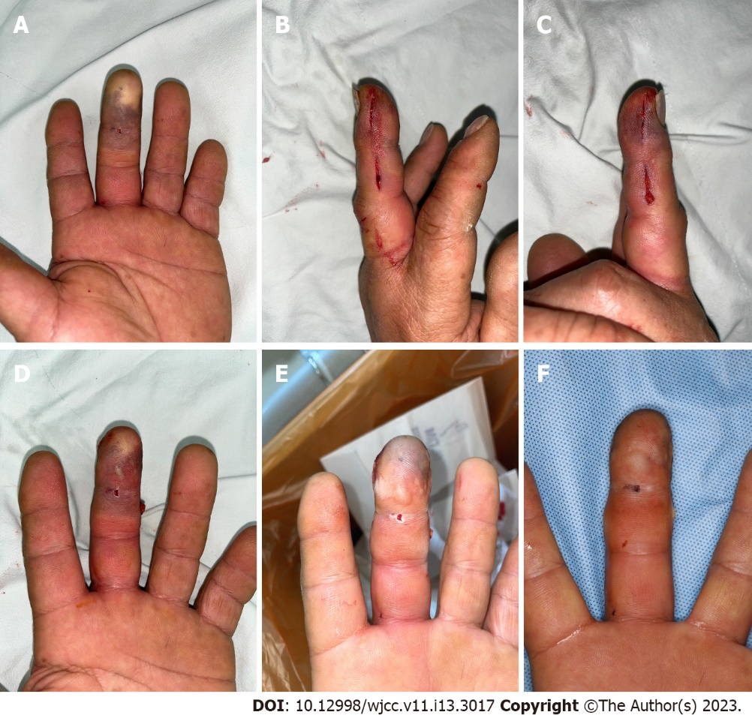
Figure 1 Clinical course of finger compartment syndrome. A 60-year-old man was diagnosed with compartment syndrome in the right middle finger with an 0.2 cm penetrating wound on the distal phalangeal joint. A: Preoperative photograph showing the pale and tense distal phalanx in the middle finger; B and C: Finger fasciotomy on the radial and ulnar sides of the middle finger; D: Immediate postoperative photograph showing incomplete recovery of the fingertip; E: First-day postoperative photograph showing no further recovery at the middle fingertip; F: Third-day postoperative photograph showing complete recovery at the middle fingertip.

Published by Baishideng Publishing Group Inc
7041 Koll Center Parkway, Suite 160, Pleasanton, CA 94566, USA
Telephone: +1-925-3991568
E-mail: bpgoffice@wjgnet.com
Help Desk: https://www.f6publishing.com/helpdesk
https://www.wjgnet.com

© 2023 Baishideng Publishing Group Inc. All rights reserved.

