Name of Journal: World Journal of Clinical Cases
Manuscript NO: 69901
Manuscript Type: CASE REPORT

Treatment of extracranial internal carotid artery dissecting aneurysm with SUPERA stent implantation: Two case reports

Qiu MJ et al. SUPERA stent for extracranial ICA aneurysms

Min-Jian Qiu, Bao-Rong Zhang, Shui-Jiang Song

Min-Jian Qiu, Bao-Rong Zhang, Shui-Jiang Song, Department of Neurology, The Second Affiliated Hospital of Zhejiang University School of Medicine, Hangzhou 310009, Zhejiang Province, China

Author contributions: Qiu MJ conceived and coordinated the study, performed and analyzed the experiments, wrote the paper; Zhang BR and Song SJ carried out the data collection, data analysis, and revised the paper; all authors have read and approve the final manuscript.

Corresponding author: Min-Jian Qiu, MD, Doctor, Department of Neurology, The Second Affiliated Hospital of Zhejiang University School of Medicine, Hangzhou 310009, Zhejiang Province, China. 3196011@zju.edu.cn

Received: July 16, 2021
Revised: October 26, 2021
Accepted: January 8, 2022
Published online: February 16, 2022

Abstract
BACKGROUND
There is no standard endovascular treatment for extracranial internal carotid artery dissecting aneurysms. In the past, stent-graft isolation and stent-assisted coil embolization were commonly used for wide-necked and fusiform aneurysms. Here, we present two cases of extracranial internal carotid artery dissecting aneurysms treated successfully using the SUPERA stent.

CASE SUMMARY
Case 1 was a 57-year-old male patient with sudden right limb weakness and vague speech and diagnosed with cerebral infarction in February 2019. Cervical computed tomographic angiography (CTA) revealed left internal carotid artery dissection with stenosis. CTA at 2 mo showed an eccentric wide-necked dissecting aneurysm (5 mm × 5 mm × 12 mm, 10-mm neck) that was enlarged at 4 mo (7 mm × 6 mm × 12 mm, 11-mm neck). The patient underwent SUPERA stent implantation. His condition was stable in July 2020. Case 2 was a 57-year-old man who suddenly felt dizzy and developed unsteady walking in November 2019. Cervical CTA suggested right internal carotid artery dissecting aneurysm (11 mm × 9 mm × 31 mm) complicated with severe lumen stenosis (95%). The patient underwent SUPERA stent implantation. The patient had no residual symptoms and was stable in December 2020.

CONCLUSION
SUPERA stent implantation might achieve good results in treating wide-necked or long fusiform internal carotid artery dissecting aneurysms.

Key Words: Extracranial; Internal carotid artery; Dissecting aneurysm; Stent; Case report

©The Author(s) 2022. Published by Baishideng Publishing Group Inc. All rights reserved.

Citation: Qiu MJ, Zhang BR, Song SJ. Treatment of extracranial internal carotid artery dissecting aneurysm with SUPERA stent implantation: Two case reports. World J Clin Cases 2022; 10(5): 1602-1608
URL: https://www.wjgnet.com/2307-8960/full/v10/i5/1602.htm
DOI: https://dx.doi.org/10.12998/wjcc.v10.i5.1602

Core Tip: There is no standard endovascular treatment for extracranial internal carotid artery dissecting aneurysms. Stent-graft isolation and stent-assisted coil embolization are commonly used for wide-necked and fusiform aneurysms, but safety and effectiveness can be unsatisfactory. The SUPERA stent is a braided metal stent especially designed for arterial stenosis of the lower extremities. Here, we present two cases of extracranial internal carotid artery dissecting aneurysms treated successfully using the SUPERA stent. Hence, SUPERA stent implantation might achieve good results in treating wide-necked or long fusiform internal carotid artery dissecting aneurysms.

INTRODUCTION
Carotid artery dissections account for about 2.5% of all strokes^{[1]}, and the incidence of extracranial carotid dissection with dissecting aneurysms is about 9.1%^{[2]}. About 10.7% of patients with extracranial carotid dissection develop a new dissecting aneurysm within 3 mo^{[2]}. Patients under medical therapy for recurrent neurologic episodes and persistent high-grade stenosis or growing aneurysms are considered candidates for surgery or endovascular therapy^{[2]}.
There is no recognized endovascular treatment for extracranial internal carotid artery dissecting aneurysms. In the past, stent-graft isolation and stent-assisted coil embolization were commonly used for wide-necked and fusiform aneurysms^{[3-5]}. New and more suitable endovascular treatment materials could possibly improve the safety and effectiveness of endovascular therapy. Inspired by the flow diverter for intracranial wide-necked aneurysms, we looked for a metal stent with a similar treatment mechanism to treat two complex internal carotid dissecting cases aneurysm, i.e., wide-necked or long fusiform dissecting aneurysms. It is expected that through the implantation of a dense mesh stent to change the local hemodynamics, the aneurysm would shrink and disappear^{[6]}. The SUPERA stent is a braided metal stent especially designed for arterial stenosis of the lower extremities^{[7]}. When the stent is released, the wire density at the aneurysm is increased by the push-pull technique. In theory, it can change the aneurysm cavity's blood flow state like a flow diverter so that the aneurysm can be gradually reduced and cured.
Here we introduce for the first time two cases of extracranial internal carotid artery lesions treated successfully using the SUPERA stent system implantation.

CASE PRESENTATION
Chief complaints
Case 1: Weakness of right limb and vague speech for 4 mo.
Case 2: Dizziness and unsteady walking for 1 mo.

History of present illness
Case 1: A 57-year-old male patient with sudden right limb weakness and vague speech was diagnosed with cerebral infarction in February 2019 at the Department of Neurology of The Second Affiliated Hospital of Zhejiang University School of Medicine. Cervical computed tomographic angiography (CTA) revealed left internal carotid artery dissection with stenosis. Blood glucose, blood lipids, and routine blood and biochemistry examinations were all within the normal ranges. The patient received antiplatelet therapy with aspirin (100 mg) and clopidogrel (75 mg). In April 2019, i.e., 2 mo after medical treatment, cervical CTA showed that the left internal carotid artery dissecting stenosis had disappeared but turned into an eccentric wide-necked dissecting aneurysm (Figure 1A and B). The size of the aneurysm was 5 mm × 5 mm × 12 mm, and its neck was 10 mm. In June 2019, i.e., 4 mo after medical treatment, the aneurysm had enlarged to 7 mm × 6 mm × 12 mm, and its neck was 11 mm.
Case 2: The patient was a 57-year-old man who suddenly felt dizzy and developed unsteady walking in November 2019 and was admitted to the Department of Neurology of The Second Affiliated Hospital of Zhejiang University School of Medicine. MRI showed cerebral infarction in the right frontal lobe and parietal lobe. The left lower limb's muscle strength was grade 4, and the left Babinski sign was positive. Blood glucose, blood lipids, and routine blood and biochemistry examinations were all within the normal ranges. Cervical CTA suggested right internal carotid artery fusiform dissecting aneurysm complicated with severe lumen stenosis (Figure 2A). The size of the aneurysm was 11 mm × 9 mm × 31 mm, and the degree of stenosis was about 95%. The patient received antiplatelet therapy with aspirin (100 mg) and clopidogrel (75 mg).

FINAL DIAGNOSIS
Case 1: Wide-necked dissecting aneurysm of left internal carotid artery.
Case 2: Fusiform dissecting aneurysm of right internal carotid artery with severe lumen stenosis.

TREATMENT
Case 1: Endovascular treatment was considered because of the enlarging aneurysm and the risk of rupture. Under local anesthesia, a 5F puncture sheath (Terumo Corporation, Hatagaya, Tokyo, Japan) was inserted into the right femoral artery. A 6F90cm sheath (Cook Medical, Bloomington, IN, United States) was exchanged and inserted into the left internal carotid artery. Intraoperative digital subtraction angiography (DSA) showed the wide-necked aneurysm in the carotid segment of the left internal carotid artery (Figure 1C), and the proximal artery wall was not smooth, which was considered to be fibromuscular dysplasia with dissecting aneurysm. Heparin (3000 IU) was injected intravenously. A 0.014 Synchro microwire (Stryker Neurovascular, West Valley City, CA, United States) and a Rebar27 microcatheter (Micro Therapeutics Inc, Irvine, CA, United States) were inserted to the cavernous sinus segment of the internal carotid artery through the guide catheter, followed by the exchange of an 0.018 Steelcore guidewire (Abbott, Santa Clara, CA, United States). A 6 mm × 40 mm SUPERA stent (Abbott Vascular, Santa Clara, CA, United States) was inserted along the guidewire and released at the appropriate position (Figure 1D-E). The stent was released by the push-pull technique, and the stent wire was compacted in the aneurysm segment. Repeated angiography showed that the contrast medium in the lumen was unobstructed, and the blood flow in the aneurysm was slowed down. There were no postoperative complications.
Case 2: Because the stroke in this patient was associated with severe internal carotid artery stenosis shown by CTA and ipsilateral cerebral infarction shown by MRI, SUPERA stent implantation was considered and performed in December 2019. Under local anesthesia, the right femoral artery was punctured, an 8F sheath (Terumo Corporation, Hatagaya, Tokyo, Japan) was placed, and an 8F guide catheter (Boston Scientific Corporation, Marlborough, MA, United States) was inserted into the right common carotid artery. Intraoperative DSA confirmed the severe stenosis and dissecting aneurysm of the right internal carotid artery (Figure 2B). Heparin (3000 IU) was injected intravenously. A 0.014 Synchro microwire (Stryker Neurovascular, West Valley City, CA, United States) and a Rebar27 microcatheter (Micro Therapeutics Inc, Irvine, CA, United States) were inserted across the stenosis to the cavernous sinus segment of the internal carotid artery through the guide catheter. After exchanging for an 0.018 Steelcore guidewire (Abbott Vascular, Santa Clara, CA, United States), a 5 mm × 20 mm fast exchange balloon catheter (Abbott Vascular, Santa Clara, CA, United States) was inserted along the guidewire to dilate the narrow segment. A 5 mm × 60 mm SUPERA stent was implanted by the same technique. Repeated DSA showed that the stenosis was significantly improved, the contrast medium in the lumen was unobstructed, and the blood flow in the aneurysm was slowed down (Figure 2 C and D).

OUTCOME AND FOLLOW-UP
Case 1: Three months later, in September 2019, CTA showed that the dissecting aneurysm had disappeared completely (Figure 1F-G). The patient reported no new symptoms and was able to take care of himself. Muscle strength of the left limb remained decreased, and speech was slow. At 1 year after the operation, in July 2020, DSA showed that the lumen was completely repaired (Figure 1H). The symptoms remained the same.
Case 2: There were no postoperative complications, and the patient recovered well after the operation. Three months later, in April 2020, CTA showed that the dissecting aneurysm had disappeared completely (Figure 2E). DSA showed that the lumen was repaired entirely in December 2020 (Figure 2F). This patient had no residual abnormal symptoms during follow-up.

DISCUSSION
Endovascular treatment of extracranial cervical dissecting aneurysm is controversial because of the possible operative complications, and there is a possibility that the risks of treatment will be greater than the benefits to the patients^{[2,8]}. Cothren et al^{[9]} reported a 21% (4/19) complication rate and a documented occlusion rate of 45% (8/18) in the endovascular treatment of pseudoaneurysms from extracranial carotid dissections. They claim that the risks outweigh the benefits of stenting in the treatment of carotid dissecting pseudoaneurysms^{[9]}. Nevertheless, there is no doubt that the incidence of complications is very low in the available case series of selective endovascular therapy reported in the literature, and the short- and long-term benefits are probably significant^{[4,5,10-12]}. These previous studies highlighted the importance of selecting the right patients and using the right materials and tools in an individualized manner. In previous reports, endovascular treatment of extracranial cervical dissecting aneurysm included endovascular exclusion with a covered stent, stent-assisted coil embolization, and multi-stent overlap. A self-expanding covered stent is the first choice for treatment because of its immediate and long-term effect^{[4]}. On the other hand, internal carotid artery dissections are usually located in the upper part of the extracranial internal carotid artery, and it is technically challenging to transport a covered stent for treating dissecting aneurysms near or involving the petrous segment. In contrast, balloon-dilated covered stents might be easier to transport, but there is a possible danger of acute closure after external force compression, and the adhesion of balloon stents is often not as good as that of self-expanding stents. Hence, it is suggested that balloon dilatation stents should not be used in extracranial carotid arteries, which are prone to external force compression. For wide-necked or fusiform dissecting aneurysms, bare carotid artery stents used alone often have difficulties eliminating the dissecting aneurysms. Balloon embolization is the only option for the treatment of this type of aneurysm. Later, it was found that coil-assisted embolization stent implantation can effectively eliminate dissecting aneurysm, but it is expensive and a residual space-occupying effect cannot be avoided.
The SUPERA stent is a braided metal stent specially designed for arterial stenosis of the lower extremities^{[7]}. In theory, it can change the aneurysm cavity's blood flow state like a flow diverter so that the aneurysm can be gradually reduced and cured. We used this braided bare metal stent to treat two cases of extracranial internal carotid artery dissecting aneurysms, which were a wide-necked aneurysm and a long fusiform aneurysm with severe lumen stenosis. There were no postoperative complications in the two cases. The symptoms of cerebral ischemia disappeared, and there was no recurrence of stroke during the follow-up period. The lumen was anatomically repaired perfectly. The aneurysms had entirely disappeared at 3 mo, and there was no residual space-occupying effect. One year after the operation, DSA showed that the lumen was repaired well and there was no restenosis. Satisfactory results have been achieved. The literature presents studies of its use in femoropopliteal disease^{[13]} and the subclavian artery^{[14]}. Previous studies used different bare-metal stents (other than the SUPERA stent) to manage the carotid disease successfully^{[15,16]}. The SUPERA stent might be easier to implant and have better outcomes, but the study is still necessary.
The SUPERA Stent System has moderate flexibility, convenient delivery, and uncomplicated release and can change the stent mesh size. We believe that it is a suitable choice to treat wide-necked dissecting aneurysms and long fusiform aneurysms. Nevertheless, several aspects must be mentioned. First, it is an over-to-wire catheter system, and the inner core will move back and forth when the stent is released. If a distal protected device has been used, it will be challenging to maintain the system's stability. Therefore, we did not use remote embolization protection devices. Second, this stent system is best used in patients with straight parent arteries, and we have not tried it on very circuitous arteries. Only two cases were reported here. Additional studies with larger numbers of patients are necessary to determine the benefits of the SUPERA stent in managing extracranial internal carotid artery dissecting aneurysms.

CONCLUSION
In conclusion, according to the treatment and follow-up of these two cases, SUPERA stent implantation might achieve good results in treating a wide-necked or long fusiform internal carotid artery dissecting aneurysms. Still, additional studies are necessary to confirm these observations.

REFERENCES
1 Goodfriend SD, Tadi P, Koury R. Carotid Artery Dissection. StatPearls. Treasure Island (FL), 2020 [DOI: 10.32388/ivp1ee]
2 Larsson SC, King A, Madigan J, Levi C, Norris JW, Markus HS. Prognosis of carotid dissecting aneurysms: Results from CADISS and a systematic review. Neurology 2017; 88: 646-652 [PMID: 28087823 DOI: 10.1212/WNL.0000000000003617]
3 Saito R, Ezura M, Takahashi A, Yoshimoto T. Combined neuroendovascular stenting and coil embolization for cervical carotid artery dissection causing symptomatic mass effect. Surg Neurol 2000; 53: 318-322 [PMID: 10825514 DOI: 10.1016/s0090-3019(00)00206-8]
4 Scavée V, De Wispelaere JF, Mormont E, Coulier B, Trigaux JP, Schoevaerdts JC. Pseudoaneurysm of the internal carotid artery: treatment with a covered stent. Cardiovasc Intervent Radiol 2001; 24: 283-285 [PMID: 11779022 DOI: 10.1007/s00270-001-0012-z]
5 Feugier P, Vulliez A, Bina N, Floccard B, Allaouchiche B. Urgent endovascular covered-stent treatment of internal carotid artery injury caused by a gunshot. Eur J Vasc Endovasc Surg 2007; 34: 663-665 [PMID: 17681828 DOI: 10.1016/j.ejvs.2007.06.011]
6 Turk AS 3rd, Martin RH, Fiorella D, Mocco J, Siddiqui A, Bonafe A. Flow diversion vs traditional endovascular coiling therapy: design of the prospective LARGE aneurysm randomized trial. AJNR Am J Neuroradiol 2014; 35: 1341-1345 [PMID: 24831596 DOI: 10.3174/ajnr.A3968]
7 Scheinert D, Grummt L, Piorkowski M, Sax J, Scheinert S, Ulrich M, Werner M, Bausback Y, Braunlich S, Schmidt A. A novel self-expanding interwoven nitinol stent for complex femoropopliteal lesions: 24-month results of the SUPERA SFA registry. J Endovasc Ther 2011; 18: 745-752 [PMID: 22149221 DOI: 10.1583/11-3500.1]
8 Markus HS, Levi C, King A, Madigan J, Norris J; Cervical Artery Dissection in Stroke Study (CADISS) Investigators. Antiplatelet Therapy vs Anticoagulation Therapy in Cervical Artery Dissection: The Cervical Artery Dissection in Stroke Study (CADISS) Randomized Clinical Trial Final Results. JAMA Neurol 2019; 76: 657-664 [PMID: 30801621 DOI: 10.1001/jamaneurol.2019.0072]
9 Cothren CC, Moore EE, Ray CE Jr, Ciesla DJ, Johnson JL, Moore JB, Burch JM. Carotid artery stents for blunt cerebrovascular injury: risks exceed benefits. Arch Surg 2005; 140: 480-5; discussion 485-6 [PMID: 15897444 DOI: 10.1001/archsurg.140.5.480]
10 Castellan L, Casasco A, Toso V, Bernardi L. Stenting of the extracranial internal carotid artery for dissecting aneurysm. Ital J Neurol Sci 1999; 20: 251-253 [PMID: 10551913 DOI: 10.1007/s100720050040]
11 Cohen JE, Leker RR, Gotkine M, Gomori M, Ben-Hur T. Emergent stenting to treat patients with carotid artery dissection: clinically and radiologically directed therapeutic decision making. Stroke 2003; 34: e254-e257 [PMID: 14605318 DOI: 10.1161/01.STR.0000101915.11128.3D]
12 Wilson MP, Murad MH, Krings T, Pereira VM, O'Kelly C, Rempel J, Hilditch CA, Brinjikji W. Management of tandem occlusions in acute ischemic stroke - intracranial vs extracranial first and extracranial stenting vs angioplasty alone: a systematic review and meta-analysis. J Neurointerv Surg 2018; 10: 721-728 [PMID: 29523749 DOI: 10.1136/neurintsurg-2017-013707]
13 Bishu K, Armstrong EJ. Supera self-expanding stents for endovascular treatment of femoropopliteal disease: a review of the clinical evidence. Vasc Health Risk Manag 2015; 11: 387-395 [PMID: 26203255 DOI: 10.2147/VHRM.S70229]
14 Vinayakumar D, Sulaiman S, Govindan Sajeev C. Recurrent Spontaneous Stent Fracture in a Case of Takayasu Arteritis Treated Successfully with Supera Stent System. J Cardiol Cardiovasc Ther 2018; 10: 555778 [DOI: 10.19080/jocct.2018.10.555778]
15 Ahlhelm F, Kaufmann R, Ahlhelm D, Ong MF, Roth C, Reith W. Carotid artery stenting using a novel self-expanding braided nickel-titanium stent: feasibility and safety porcine trial. Cardiovasc Intervent Radiol 2009; 32: 1019-1027 [PMID: 19533229 DOI: 10.1007/s00270-009-9572-0]
16 Cornwall JW, Png CYM, Han DK, Tadros RO, Marin ML, Faries PL. Endovascular techniques in the treatment of extracranial carotid artery aneurysms. J Vasc Surg 2021; 73: 2031-2035 [PMID: 33098945 DOI: 10.1016/j.jvs.2020.06.133]

Footnotes
Informed consent statement: Informed written consent was obtained from the patient for publication of this report and any accompanying images.

Conflict-of-interest statement: The authors declare that they have no conflict of interest.

CARE Checklist (2016) statement: The authors have read the CARE Checklist (2016), and the manuscript was prepared and revised according to the CARE Checklist (2016).

Open-Access: This article is an open-access article that was selected by an in-house editor and fully peer-reviewed by external reviewers. It is distributed in accordance with the Creative Commons Attribution NonCommercial (CC BY-NC 4.0) license, which permits others to distribute, remix, adapt, build upon this work non-commercially, and license their derivative works on different terms, provided the original work is properly cited and the use is non-commercial. See: https://creativecommons.org/Licenses/by-nc/4.0/

Provenance and peer review: Unsolicited article; Externally peer reviewed.
Peer-review model: Single blind

Peer-review started: July 16, 2021
First decision: October 18, 2021
Article in press: January 8, 2022

Specialty type: Neurosciences
Country/Territory of origin: China
Peer-review report’s scientific quality classification
Grade A (Excellent): A
Grade B (Very good): 0
Grade C (Good): 0
Grade D (Fair): 0
Grade E (Poor): 0

P-Reviewer: Ciccone MM S-Editor: Li JH L-Editor: A P-Editor: Li JH

Figure Legends
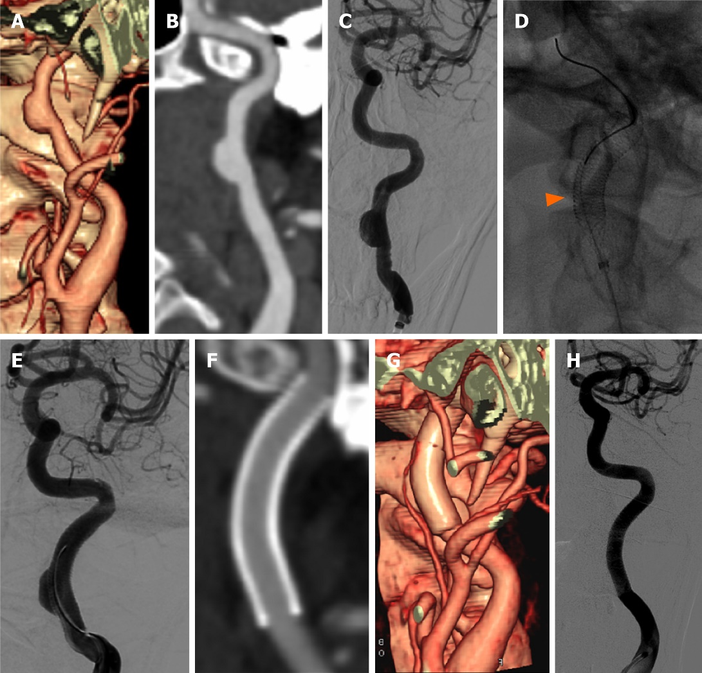
Figure 1 Case 1 was a 57-year-old male patient with sudden right limb weakness and vague speech and was diagnosed with cerebral infarction in February 2019. He was ultimately treated using a SUPERA stent. A: Cervical computed tomographic angiography (CTA) volume reconstruction; B: curved surface reconstruction show that the wide-necked dissecting aneurysm was situated on the upper segment of the left internal carotid artery; C: confirmed by digital subtraction angiography (DSA); D and E: The patient underwent SUPERA stent endovascular therapy, the arrow shows the dense stent mesh; F and G: Three months later, cervical CTA showed that the aneurysm had disappeared completely. H: One year later, DSA showed that the internal carotid artery was repaired perfectly.
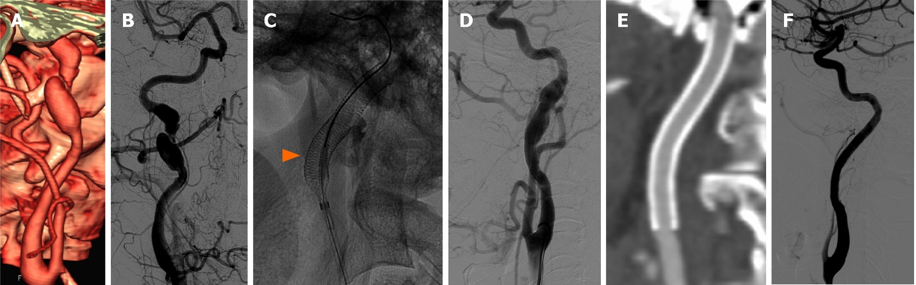Figure 2 Case 2 was a 57-year-old man who suddenly felt dizzy and developed unsteady walking in November 2019. He was ultimately treated using a SUPERA stents. A: Cervical computed tomographic angiography (CTA) volume reconstruction; B: digital subtraction angiography (DSA) showed a fusiform dilated dissecting aneurysm with severe stenosis located in the upper segment of the right internal carotid artery, involving the petrous segment; C and D: It was treated with SUPERA stent endovascular treatment, the arrow shows the dense stent reticular wire; E: Three months later, cervical CTA showed that the aneurysm had disappeared completely, and the lumen of the internal carotid artery was unobstructed; F: One year later, DSA showed that the internal carotid artery was repaired perfectly.

Published by Baishideng Publishing Group Inc
7041 Koll Center Parkway, Suite 160, Pleasanton, CA 94566, USA
Telephone: +1-925-3991568
E-mail: bpgoffice@wjgnet.com
Help Desk: https://www.f6publishing.com/helpdesk
https://www.wjgnet.com

© 2022 Baishideng Publishing Group Inc. All rights reserved.

