Name of Journal: World Journal of Gastroenterology
Manuscript NO: 34979
Manuscript Type: CASE REPORT

Rupture of small cystic pancreatic neuroendocrine tumor with many microtumors

Sagami R et al. Rupture of cystic pancreatic neuroendocrine tumor

Ryota Sagami, Hidefumi Nishikiori, Shoichiro Ikuyama, Kazunari Murakami

Ryota Sagami, Hidefumi Nishikiori, Department of Gastroenterology, Oita San-ai Medical Center, Oita 8701151, Japan.

Shoichiro Ikuyama, Department of Internal Medicine and Clinical Investigation, Oita San-ai Medical Center, Oita 8701151, Japan

Kazunari Murakami, Department of Gastroenterology, Faculty of Medicine, Oita University, Yuhu 8795503, Japan

Author contributions: Sagami R, Nishikiori H and Ikuyama S designed the study and wrote the manuscript; Sagami R and Nishikiori H collected and analyzed the patient’s clinical data; and Murakami K made critical revisions to the article for important intellectual content.

Institutional review board statement: The ethics committee of Oita San-ai Medical Center approved this clinical study and the publication of this case report.

Informed consent statement: The patients involved in this case report authorized the disclosure of her protected health information for academic purposes.

Conflict-of-interest statement: All authors indicate that they have no financial interests or potential conflicts of interest to declare.

Open-Access: This article is an open-access article which was selected by an in-house editor and fully peer-reviewed by external reviewers. It is distributed in accordance with the Creative Commons Attribution Non Commercial (CC BY-NC 4.0) license, which permits others to distribute, remix, adapt, build upon this work non-commercially, and license their derivative works on different terms, provided the original work is properly cited and the use is non-commercial. See: http://creativecommons.org/licenses/by-nc/4.0/

Manuscript source: Unsolicited manuscript

Correspondence to: Ryota Sagami, MD, Department of Gastroenterology, Oita San-ai Medical Center, Oita 8701151, Japan. sagami1985@yahoo.co.jp
Telephone: +81-975-411311
Fax: +81-975-415218

Received: June 9, 2017
Peer-review started: June 10, 2017
First decision: July 10, 2017
Revised: July 26, 2017
Accepted:
Article in press:
Published online:

Abstract
Pancreatic neuroendocrine tumors (pNETs) are particularly rare. The various forms of PNETs, such as cystic degeneration, make differentiation from other similar pancreatic lesions difficult. We can detect small lesions by endoscopic ultrasound (EUS) and obtain preoperative pathological diagnosis by EUS-guided fine needle aspiration (FNA). We describe an interesting case of pNET in a 42-year-old woman with no family history. Computed tomography (CT) and magnetic resonance imaging (MRI) revealed an 18 mm × 17 mm cystic lesion with a nodule in the pancreatic tail. Two microtumors about 7 mm in diameter in the pancreatic body detected only by EUS, cystic rim, and nodules all showed similar enhancement on contrast-harmonic EUS. Preoperative EUS-FNA of the microtumor was performed, diagnosing multiple pNETs. Macroscopic examination of the resected pancreatic body and tail showed that the cystic lesion had morphologically changed to a 13-mm main nodule, and 11 new microtumors (diameter 1-3 mm). Microscopically, all microtumors represented pNETs. From the findings of a broken peripheral rim on the main lesion with fibrosis, rupture of the cystic pNET was suspected. Postoperatively, pituitary adenoma and parathyroid adenoma were detected. The final diagnosis was multiple grade 1 pNETs with multiple endocrine neoplasia type 1. To the best of our knowledge, no case of spontaneous rupture of a cystic pNET has previously been reported in the English literature. Therefore, this case of very rare pNET with various morphological changes is reported.

Key words: Rupture; Cystic pancreatic neuroendocrine tumor; MEN1; NET; Microtumor

© The Author(s) 2017. Published by Baishideng Publishing Group Inc. All rights reserved.

Core tip: Cystic or multiple pancreatic neuroendocrine tumors (pNETs) are very rare. This report describes a case of cystic pNET with multiple small tumors diagnosed from endoscopic ultrasonography (EUS) alone. Preoperative diagnosis was able to be obtained by EUS-guided fine needle aspiration biopsy. Postoperatively, 11 other micro-pNETs with multiple endocrine neoplasia type 1 were detected and cystic pNET morphologically changed to a small nodule because of suspected spontaneous rupture. Spontaneous rupture of cystic pNET has not been reported previously in the English literature.

Sagami R, Nishikiori H, Shoichiro Ikuyama, Murakami K. Rupture of small cystic pancreatic neuroendocrine tumor with many microtumors. World J Gastroenterol 2017; In press

INTRODUCTION
Neuroendocrine tumors can arise in endocrine organs throughout the whole body, and cause various clinical symptoms. Pancreatic neuroendocrine tumors (pNETs) are particularly rare, representing only 1%-2% of all pancreatic neoplasms^{[1]}. PNETs sometimes show various forms, such as cystic degeneration^{[2]} or multiple microtumors^{[3]}, but such variations appear rare.
Most pNETs are solid and show strong enhancement during the arterial phases on contrast-enhanced computed tomography (CT)^{[4-6]}. Diagnosis is therefore relatively easy. However, morphologically changed pNETs, such as cystic pNETs, are difficult to differentiate from other pancreatic cystic tumors^{[7]}. Multiple PNETs are often diagnosed in multiple endocrine neoplasia type 1 (MEN1)^{[8]}, but diagnosis of microtumors in the pancreas on CT is difficult. In such cases, endoscopic ultrasonography (EUS) is superior to CT for detecting pNETs, particularly small lesions^{[9]}. Furthermore, contrast-enhanced harmonic EUS (CH-EUS) allows the diagnosis as pNETs with hypervascular enhanced tumors with high sensitivity and specificity, and EUS-guided fine needle aspiration (EUS-FNA) enables preoperative pathological diagnosis^{[10]}. This paper presents a case of pNETs with microtumors detected only by EUS in a 42-year old woman with MEN1. In addition, a rare event of spontaneous rupture of the cystic pNET was strongly suspected from the postoperative pathological findings.

CASE REPORT
A 42-year-old woman was referred to our hospital because of a pancreatic cystic lesion incidentally detected on unenhanced CT performed for inspection of painless enlargement of a cervical lymph node 1 month earlier. No physical findings involving the abdomen were evident. No contributory family history was elicited. The patient had a history of urinary stones at 30 years old. The only abnormality from laboratory tests was a mild elevation of liver enzymes. Unenhanced CT revealed a 16 mm × 15 mm, somewhat obscure cystic lesion in the pancreatic tail (Figure 1A). Contrast-enhanced CT revealed an 18 mm × 17 mm cystic lesion with a well-defined, hyperenhanced thin peripheral rim and a nodule about 6 mm in diameter inside the rim (Figure 1B). The outer rim was enhanced to a greater degree than normal pancreatic parenchyma during the arterial phases of bolus contrast administration, and iso-enhanced during the portal venous phase (Figure 1B, 1C). On magnetic resonance imaging (MRI), the lesion in the pancreatic tail appeared hypointense and some areas appeared relatively hyperintense compared to inside the cyst on T1-weighted images (Figure 2A), and mainly hyperintense with a hypointense peripheral rim and nodule on T2-weighted images (Figure 2B). On diffusion-weighted images, the lesion appeared relatively hyperintense (Figure 2C). The lesion was not continuous with the main pancreatic duct on magnetic resonance cholangiopancreatography (Figure 2D). We also performed EUS, showing the cyst with a low echoic peripheral rim and nodule. Inside the cyst, no echoic fluid or solid structure was detected, and internal bleeding or necrosis was expected (Figure 3A). Apart from the main lesion, we detected two microtumors (7 mm and 6 mm in diameter) in the pancreatic body only on EUS (Figure 3B). On CH-EUS, the relatively thick rim of the cystic lesion, nodule, and two microtumors showed similar enhancement from immediately after the injection of contrast medium (Figure 3C, 3D). We performed endoscopic ultrasound guided fine needle aspiration (EUS-FNA) of a 7-mm microtumor (Figure 3E).
Histopathologically, the EUS-FNA specimen comprised cells with round nuclei. (hematoxylin and eosin stain, ×100) (Figure 4A). Tumor cells were negative for CD10 and CD56 (Figure 4B, 4C), but positive for chromogranin A and synaptophysin (Figure 4D, 4E) by immunohistochemical staining (×100). Based on these findings, multiple grade 1 endocrine neoplasms of the pancreas were diagnosed^{[11]}.
Preoperatively, endocrine examination was performed. Abnormal laboratory results included elevated parathyroid hormone at 136 pg/ml (normal, 15-65 pg/ml) and cortisol at 25.1 μg/dL (normal, 4.5-21.1 μg/dL), while other values were within normal ranges. The tumor was non-functional pNET, because levels of pancreatic endocrine hormones such as insulin were not elevated. After sufficient preparation and obtaining consent from the patient and her family members, we performed laparoscopic spleen-preserving pancreatic body and tail resection 50 d after EUS-FNA. Macroscopically, the main cystic lesion morphologically changed to a nodule 13 mm in diameter with internal scarring (Figure 5A, C), considered to represent traces of cystic degeneration. The microtumor in the pancreatic body on which EUS-FNA was performed was separate from the main lesion (Figure 5A, B). A scar from EUS-FNA was identified in the microtumor (Figure 5B). Besides the main lesion and two microtumors detected previously on EUS, 11 microtumors (diameter, 1-3 mm) were newly detected (Figure 5D).
Microscopically, the main lesion comprised cells with round nuclei arranged in sheets or rosettes (Figure 6A), with < 2 mitoses per 50 high-power fields (Figure 6B). The Ki-67 index in the main lesion was 1.01%. All other microtumors showed similar findings (Figure 6C, 6D). After evaluating the potential causes of morphological changes to the main cystic lesion, the peripheral rim was considered most likely to have broken in one place, followed by fibrosis after inflammation (Figure 6E). After surgery, whole-body examination detected asymptomatic pituitary adenoma and parathyroid adenoma on MRI and ultrasound. The final diagnosis was multiple pNET grade 1, stage1 T1N0M0 with MEN1 and a strong suspicion of spontaneous rupture of the cystic pNET. As of the time of writing, the patient remains alive without recurrence more than 2 years postoperatively. Asymptomatic pituitary adenoma and parathyroid adenoma are being followed-up by an endocrine physician, and no clinical symptoms or abnormal results from blood testing have been encountered.

DISCUSSION
Image features of pNETs and various morphological changes
PNETs are rare and represent only 1%-2％ of all pancreatic neoplasms^{[1]}. However, due to the development of increasingly sophisticated imaging modalities, more pNETs are being reported^{[12]}.
The clinical symptoms of pNET primarily depend on whether the tumor is functional or non-functional, and the type of hormone produced by a functional tumor^{[1]}. Most pNETs are solid lesions, but some are detected as tumor with cystic degeneration^{[2]}. Cystic pNETs were classically considered very rare, but recent studies have suggested that cystic pNETs may be more common than previously reported^{[13]}. Some studies have reported that 9.3%-21% of pNETs are detected as cystic degeneration on imaging modalities including CT, ultrasound, MRI, EUS or pathological examination of a resected specimen^{[14-19]}.
Solid pNETs are typically enhanced to a greater degree than normal pancreatic parenchyma during the arterial and portal venous phases of bolus contrast administration^{[4-6]}, because of the rich vascularity^{[20]}.
On the other hand, the radiological features of cystic pNETs have been suggested to be an enhanced outer rim with blood flow-rich tissue^{[21]}. As other specific finding of pNETs, multiple and microtumors in the pancreas are rarely detected. Multiple PNETs are often diagnosed in cases of MEN1^{[8]}, but diagnosis of microtumors in the pancreas on contrast-enhanced CT is difficult^{[9]}.

EUS as one of the best imaging modalities for small pNETs
EUS is superior to CT for detecting small pNETs. In a study of 231 pNETs, CT detected 84% of tumors, but was more likely to miss lesions < 2 cm in diameter (P = 0.005), while the sensitivity of EUS for detecting 56 pNETs (91.7%) was greater than that of CT (63.3%; P = 0.0002), and EUS detected 20 of 22 CT-negative tumors (91%)^{[10]}. Furthermore, CH-EUS allowed the diagnosis of hypervascularly enhanced tumor as pNETs with 78.9% sensitivity (95%CI: 61.4%-89.7%) and 98.7% specificity (95%CI: 96.7-98.8%), respectively^{[11]}.
In this manner, EUS appears useful for the diagnosis of pNETs, but we often encounter challenges, particularly in diagnosing cystic pNET. This is because we need to differentiate the pathology from other pancreatic cystic tumors, such as intraductal papillary mucinous neoplasm, mucinous cystic neoplasms, mucinous cystadenocarcinoma, serous cystic neoplasms, solid and cystic papillary tumors, or even non-neoplastic pseudocyst^{[7]}.
In such cases, we should consider EUS-FNA for preoperative histological diagnosis. EUS-FNA correctly diagnosed PNETs, offering 90.1% diagnostic accuracy^{[22]}. When CH-EUS was combined with EUS-FNA, the sensitivity of EUS-FNA increased from 92.2% to 100%^{[11]}. EUS-FNA accuracies for the malignancy of cystic and solid PNETs were 89.3% and 90%^{[23]}, but EUS-FNA for cystic lesions of the pancreas is not recommended in Japan. In our case, the cystic lesion in the pancreas tail was initially detected on CT. MRI was additionally performed, but we could not obtain a confirmed diagnosis from the imaging findings. The cystic lesion was evaluated in more detail and 2 new microtumors were detected in the pancreatic body only on EUS. In addition, the rim of the cyst and microtumors were hyperenhanced on CH-EUS, and we became confident the lesions represented pNETs. In addition, we performed EUS-FNS of a microtumor, and obtained pathological confirmation of the preoperative diagnosis.

Features of pNETs in MEN1
MEN is an autosomal-dominant inherited disease presenting with tumorous lesions, mainly in various endocrine organs^{[3]}, and 15% of MEN1 patients have no family history^{[24]}. MEN1 is diagnosed when at least 2 of the main tumorous diseases (parathyroid tumor, pNET, or pituitary tumor) are found, and hyperparathyroidism is the most frequent initial disease in MEN1 (85%)^{[25]}. According to a Japanese nationwide survey, MEN1 was found in 10% of pNET patients. The type of pNET in MEN1 was gastrinoma in 25%, insulinoma in 14%, and non-functioning in 6.1%^{[12]}. In addition, PNETs in MEN1 often have multiple tumors in the pancreas, and 74% of pNET with MEN1 had multiple tumors^{[8]}.

Rupture of cystic neoplasms
This was a typical case of pNETs with MEN1, but spontaneous rupture of the cystic pNET was a remarkable feature. The rupture of a pancreatic neoplasm is very rare. Ruptures of intraductal papillary mucinous neoplasm^{[26-28]}, mucinous cystic neoplasms^{[29]}, acinar cell carcinoma^{[30,31]}, and anaplastic cell carcinoma^{[32]} have been reported, but rupture of cystic pNET does not appear to have been described. Involvement of either infarction and liquefactive necrosis of a large tumor or internal hemorrhage have been considered as causes of cystic degeneration in pNETs^{[21,33]}. The cause of cyst formation of cystic pancreatic NET thus remains controversial^{[15,34,35]}. Spontaneous rupture of cystic lesions of the pancreas has been suggested due to high pressure inside the cyst or inflammatory stimulation by others factors, such as acute pancreatitis^{[27]}, but only a small number of cases have been reported, and the exact cause thus remains unknown. In our case, internal bleeding, rather than necrosis, might have been involved in cystic degeneration. We performed EUS-FNA of the microtumor in the pancreatic body separate from the cystic pNET in the pancreatic tail, so EUS-FNA might not have been related to rupture. We could not rule out the possibility that rupture was associated with instrumental pressure from EUS examinations, but such high pressure on the cystic lesion was considered unlikely to arise in normal EUS examination or EUS-FNA. The scar from EUS-FNA is shown in Figure 5B. The thin part of rim was not intact, and thinning of the tumor part and high pressure inside the cyst were considered as causes, but more detailed causes of the rupture could not be clarified.
In conclusion, pNETs are rare and show various forms of tumor, such as cystic degeneration. PNETs with MEN1 often show multiple tumors, and detecting microtumors on CT or MRI is sometimes difficult, so EUS and CH-EUS should be performed. In addition, we should search for endocrine tumors in other organs affected by MEN1. To the best of our knowledge, spontaneous rupture has not been reported previously, so this case was reported.

ACKNOWLEDGMENTS
We wish to thank endoscopic engineers Ohata T, Yamasaki K. Sakata N, Tauchi M, Tasaki M, Matou M, and Kudou C, of Oita San-ai Medical Center, for their helpful technical assistance for EUS.

COMMENTS
Case characteristics
A 42-year old woman was referred to our hospital with a pancreatic cystic lesion found incidentally on computed tomography (CT). She had no family history.

Clinical diagnosis
Cystic pancreatic neuroendocrine tumor (pNET) with many microtumors.

Differential diagnosis
Differential diagnoses included intraductal papillary mucinous neoplasm, mucinous cystic neoplasm, solid pseudopapillary tumor, pancreatic neuroendocrine tumor.

Laboratory diagnosis
Abnormal laboratory results included mild liver enzyme, cortisol and intact parathyroid hormone elevation in blood serum

Imaging diagnosis
Contrast-enhanced CT showed an 18 mm× 17 mm cystic lesion with a well-defined hyperenhanced thin peripheral rim. On magnetic resonance imaging (MRI), the lesion appeared mainly hypointense on T1-weighted images and hyperintense on T2-weighted images. On EUS, apart from the main lesion, two microtumors was detected (7 mm and 6 mm) in the pancreatic body.

Pathological diagnosis
The final pathological diagnosis was multiple grade1 pNETs. The main cystic lesion changed to a 13 mm nodule and spontaneous rupture of the cystic pNET was strongly suspected.

Treatment
The patients was treated with pancreatic body tail resection.

Related reports
Recent studies suggest that cystic pNETs may be more common than previously reported, but rupture of a cystic pNET has not been reported.

Term explanation
There are no non-standard terms used in this manuscript.

Experience and lessons
The authors present this case to share important knowledge for pNET diagnosis.

Peer-review
The authors reported an interesting case, which they believed it as a spontaneous rupture of cystic pNET with many microtumors.

REFERENCES
1 Metz DC, Jensen RT. Gastrointestinal neuroendocrine tumors: pancreatic endocrine tumors. Gastroenterology 2008; 135: 1469-1492 [PMID: 18703061 DOI: 10.1053/j.gastro.2008.05.047]
2 Colović R, Bilanović D, Milićević M, Barisić G. Cystadenomas of the pancreas. Acta Chir Iugosl 1999; 46: 39-42 [PMID: 10951797]
3 WERMER P. Genetic aspects of adenomatosis of endocrine glands. Am J Med 1954; 16: 363-371 [PMID: 13138607]
4 Ichikawa T, Peterson MS, Federle MP, Baron RL, Haradome H, Kawamori Y, Nawano S, Araki T. Islet cell tumor of the pancreas: biphasic CT versus MR imaging in tumor detection. Radiology 2000; 216: 163-171 [PMID: 10887243 DOI: 10.1148/radiology.216.1.r00jl26163]
5 King AD, Ko GT, Yeung VT, Chow CC, Griffith J, Cockram CS. Dual phase spiral CT in the detection of small insulinomas of the pancreas. Br J Radiol 1998; 71: 20-23 [PMID: 9534694 DOI: 10.1259/bjr.71.841.9534694]
6 Stafford-Johnson DB, Francis IR, Eckhauser FE, Knol JA, Chang AE. Dual-phase helical CT of nonfunctioning islet cell tumors. J Comput Assist Tomogr 1998; 22: 335-339 [PMID: 9530406]
7 Mori E, Yuen K, Medrano H, Torres J, García C, Montes J. [Management of pancreatic cystic tumors in the Alberto Sabogal Sologuren hospital]. Rev Gastroenterol Peru 2012; 32: 169-177 [PMID: 23023180]
8 Sakurai A, Suzuki S, Kosugi S, Okamoto T, Uchino S, Miya A, Imai T, Kaji H, Komoto I, Miura D, Yamada M, Uruno T, Horiuchi K, Miyauchi A, Imamura M; MEN Consortium of Japan, Fukushima T, Hanazaki K, Hirakawa S, Igarashi T, Iwatani T, Kammori M, Katabami T, Katai M, Kikumori T, Kiribayashi K, Koizumi S, Midorikawa S, Miyabe R, Munekage T, Ozawa A, Shimizu K, Sugitani I, Takeyama H, Yamazaki M. Multiple endocrine neoplasia type 1 in Japan: establishment and analysis of a multicentre database. Clin Endocrinol (Oxf) 2012; 76: 533-539 [PMID: 21950691 DOI: 10.1111/j.1365-2265.2011.04227.x]
9 Khashab MA, Yong E, Lennon AM, Shin EJ, Amateau S, Hruban RH, Olino K, Giday S, Fishman EK, Wolfgang CL, Edil BH, Makary M, Canto MI. EUS is still superior to multidetector computerized tomography for detection of pancreatic neuroendocrine tumors. Gastrointest Endosc 2011; 73: 691-696 [PMID: 21067742 DOI: 10.1016/j.gie.2010.08.030]
10 Kitano M, Kudo M, Yamao K, Takagi T, Sakamoto H, Komaki T, Kamata K, Imai H, Chiba Y, Okada M, Murakami T, Takeyama Y. Characterization of small solid tumors in the pancreas: the value of contrast-enhanced harmonic endoscopic ultrasonography. Am J Gastroenterol 2012; 107: 303-310 [PMID: 22008892 DOI: 10.1038/ajg.2011.354]
11 Rindi G, Klöppel G, Alhman H, Caplin M, Couvelard A, de Herder WW, Erikssson B, Falchetti A, Falconi M, Komminoth P, Körner M, Lopes JM, McNicol AM, Nilsson O, Perren A, Scarpa A, Scoazec JY, Wiedenmann B; all other Frascati Consensus Conference participants; European Neuroendocrine Tumor Society (ENETS). TNM staging of foregut (neuro)endocrine tumors: a consensus proposal including a grading system. Virchows Arch 2006; 449: 395-401 [PMID: 16967267 DOI: 10.1007/s00428-006-0250-1]
12 Ito T, Sasano H, Tanaka M, Osamura RY, Sasaki I, Kimura W, Takano K, Obara T, Ishibashi M, Nakao K, Doi R, Shimatsu A, Nishida T, Komoto I, Hirata Y, Nakamura K, Igarashi H, Jensen RT, Wiedenmann B, Imamura M. Epidemiological study of gastroenteropancreatic neuroendocrine tumors in Japan. J Gastroenterol 2010; 45: 234-243 [PMID: 20058030 DOI: 10.1007/s00535-009-0194-8]
13 Patel KK, Kim MK. Neuroendocrine tumors of the pancreas: endoscopic diagnosis. Curr Opin Gastroenterol 2008; 24: 638-642 [PMID: 19122508 DOI: 0.1097/MOG.0b013e32830bf7fb]
14 Ahrendt SA, Komorowski RA, Demeure MJ, Wilson SD, Pitt HA. Cystic pancreatic neuroendocrine tumors: is preoperative diagnosis possible? J Gastrointest Surg 2002; 6: 66-74 [PMID: 11986020]
15 Goh BK, Ooi LL, Tan YM, Cheow PC, Chung YF, Chow PK, Wong WK. Clinico-pathological features of cystic pancreatic endocrine neoplasms and a comparison with their solid counterparts. Eur J Surg Oncol 2006; 32: 553-556 [PMID: 16580809 DOI: 10.1016/j.ejso.2006.02.017]
16 Bordeianou L, Vagefi PA, Sahani D, Deshpande V, Rakhlin E, Warshaw AL, Fernández-del Castillo C. Cystic pancreatic endocrine neoplasms: a distinct tumor type? J Am Coll Surg 2008; 206: 1154-1158 [PMID: 18501813 DOI: 10.1016/j.jamcollsurg.2007.12.040]
17 Baker MS, Knuth JL, DeWitt J, LeBlanc J, Cramer H, Howard TJ, Schmidt CM, Lillemoe KD, Pitt HA. Pancreatic cystic neuroendocrine tumors: preoperative diagnosis with endoscopic ultrasound and fine-needle immunocytology. J Gastrointest Surg 2008; 12: 450-456 [PMID: 18157720 DOI: 10.1007/s11605-007-0219-7]
18 Figueiredo FA, Giovannini M, Monges G, Bories E, Pesenti C, Caillol F, Delpero JR. EUS-FNA predicts 5-year survival in pancreatic endocrine tumors. Gastrointest Endosc 2009; 70: 907-914 [PMID: 19640525 DOI: 10.1016/j.gie.2009.05.020]
19 Kawamoto S, Johnson PT, Shi C, Singhi AD, Hruban RH, Wolfgang CL, Edil BH, Fishman EK. Pancreatic neuroendocrine tumor with cystlike changes: evaluation with MDCT. AJR Am J Roentgenol 2013; 200: W283-W290 [PMID: 23436873 DOI: 10.2214/AJR.12.8941]
20 Lewis RB, Lattin GE Jr, Paal E. Pancreatic endocrine tumors: radiologic-clinicopathologic correlation. Radiographics 2010; 30: 1445-1464 [PMID: 21071369 DOI: 10.1148/rg.306105523]
21 Ligneau B, Lombard-Bohas C, Partensky C, Valette PJ, Calender A, Dumortier J, Gouysse G, Boulez J, Napoleon B, Berger F, Chayvialle JA, Scoazec JY. Cystic endocrine tumors of the pancreas: clinical, radiologic, and histopathologic features in 13 cases. Am J Surg Pathol 2001; 25: 752-760 [PMID: 11395552]
22 Atiq M, Bhutani MS, Bektas M, Lee JE, Gong Y, Tamm EP, Shah CP, Ross WA, Yao J, Raju GS, Wang X, Lee JH. EUS-FNA for pancreatic neuroendocrine tumors: a tertiary cancer center experience. Dig Dis Sci 2012; 57: 791-800 [PMID: 21964743 DOI: 10.1007/s10620-011-1912-7]
23 Ridtitid W, Halawi H, DeWitt JM, Sherman S, LeBlanc J, McHenry L, Coté GA, Al-Haddad MA. Cystic pancreatic neuroendocrine tumors: outcomes of preoperative endosonography-guided fine needle aspiration, and recurrence during long-term follow-up. Endoscopy 2015; 47: 617-625 [PMID: 25763832 DOI: 10.1055/s-0034-1391712]
24 Trump D, Farren B, Wooding C, Pang JT, Besser GM, Buchanan KD, Edwards CR, Heath DA, Jackson CE, Jansen S, Lips K, Monson JP, O'Halloran D, Sampson J, Shalet SM, Wheeler MH, Zink A, Thakker RV. Clinical studies of multiple endocrine neoplasia type 1 (MEN1) QJM 1996; 89: 653-669 [PMID: 8917740]
25 Brandi ML, Gagel RF, Angeli A, Bilezikian JP, Beck-Peccoz P, Bordi C, Conte-Devolx B, Falchetti A, Gheri RG, Libroia A, Lips CJ, Lombardi G, Mannelli M, Pacini F, Ponder BA, Raue F, Skogseid B, Tamburrano G, Thakker RV, Thompson NW, Tomassetti P, Tonelli F, Wells SA Jr, Marx SJ. Guidelines for diagnosis and therapy of MEN type 1 and type 2. J Clin Endocrinol Metab 2001; 86: 5658-5671 [PMID: 11739416 DOI: 10.1210/jcem.86.12.8070]
26 Rosenberger LH, Stein LH, Witkiewicz AK, Kennedy EP, Yeo CJ. Intraductal papillary mucinous neoplasm (IPMN) with extra-pancreatic mucin: a case series and review of the literature. J Gastrointest Surg 2012; 16: 762-770 [PMID: 22258877 DOI: 10.1007/s11605-012-1823-8]
27 Lee SE, Jang JY, Yang SH, Kim SW. Intraductal papillary mucinous carcinoma with atypical manifestations: report of two cases. World J Gastroenterol 2007; 13: 1622-1625 [PMID: 17461460]
28 Shimizu Y, Imaizumi H, Yamauchi H, Okuwaki K, Miyazawa S, Iwai T, Takezawa M, Kida M, Suzuki E, Saegusa M, Koizumi W. Pancreatic Fistula Extending into the Thigh Caused by the Rupture of an Intraductal Papillary Mucinous Adenoma of the Pancreas. Intern Med 2017; 56: 307-313 [PMID: 28154275 DOI: 10.2169/internalmedicine.56.7422]
29 Bergenfeldt M, Poulsen IM, Hendel HW, Serizawa RR. Pancreatic ascites due to rupture of a mucinous cystic neoplasm. Acta Oncol 2008; 47: 978-981 [PMID: 17917820 DOI: 10.1080/02841860701666097]
30 Mohammadi A, Porghasem J, Esmaeili A, Ghasemi-Rad M. Spontaneous rupture of a pancreatic acinar cell carcinoma presenting as an acute abdomen. Int J Surg Case Rep 2012; 3: 293-295 [PMID: 22543229 DOI: 10.1016/j.ijscr.2012.03.025]
31 Ando K, Ohkuni Y, Kaneko N, Narita M. Spontaneous rupture of the splenic metastasis in acinar cell carcinoma. Pancreas 2009; 38: 836-838 [PMID: 19893460 DOI: 10.1097/MPA.0b013e3181ac75f3]
32 Narita M, Ikai I. Spontaneous Rupture of Anaplastic Pancreatic Cancer. J Gastrointest Surg 2016; 20: 664-665 [PMID: 26597268 DOI: 10.1007/s11605-015-3029-3]
33 Takeshita K, Furui S, Makita K, Yamauchi T, Irie T, Tsuchiya K, Kusano S, Ohtomo K. Cystic islet cell tumors: radiologic findings in three cases. Abdom Imaging 1994; 19: 225-228 [PMID: 8019348]
34 Adsay NV. Cystic neoplasia of the pancreas: pathology and biology. J Gastrointest Surg 2008; 12: 401-404 [PMID: 17957438 DOI: 10.1007/s11605-007-0348-z]
35 Adsay NV, Klimstra DS. Cystic forms of typically solid pancreatic tumors. Semin Diagn Pathol 2000; 17: 81-88 [PMID: 10721809]
P-Reviewer: Chowdhury P, Yasuda K, Yang F S-Editor: Ma YJ L-Editor: E-Editor:

Specialty type: Gastroenterology and hepatology
Country of origin: Japan
Peer-review report classification
Grade A (Excellent): 0
Grade B (Very good): B
Grade C (Good): C, C
Grade D (Fair): 0
Grade E (Poor): 0

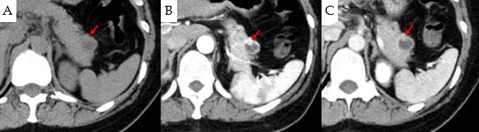Figure 1 Findings from computed tomography. A: Unenhanced computed tomography (CT) shows a 16 mm× 15 mm, somewhat obscure cystic lesion (red arrow) in the pancreatic tail; B: Contrast-enhanced CT shows an 18 mm× 17 mm cystic lesion (red arrow) with a well-defined, hyper-enhanced, thin peripheral rim and a 6-mm nodule during the arterial phase; C: The outer rim appears iso-enhanced compared to normal pancreatic parenchyma during the portal venous phases (red arrow).

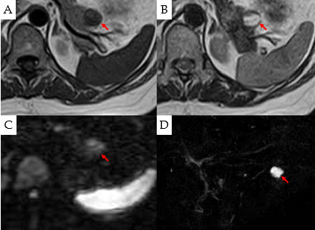
Figure 2 Findings from magnetic resonance imaging. A: The cystic lesion in the pancreatic tail (red arrow) appears hypointense and some areas appear relatively hyperintense compared to inside the cyst on T1-weighted images; B: The lesion (red arrow) appears mainly hyperintense, while the peripheral rim and nodule appear hypointense on T2-weighted images; C: The lesion (red arrow) appears relatively hyperintense on diffusion-weighted images; D: The lesion (red arrow) is not continuous with the main pancreatic duct on magnetic resonance cholangiopancreatography.

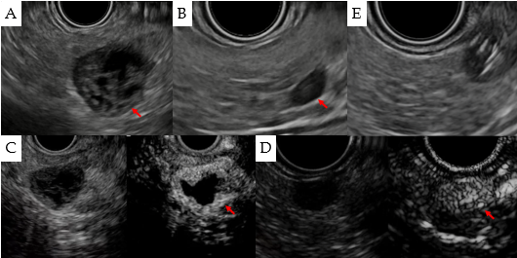
Figure 3 Findings from endoscopic ultrasound and contrast-enhanced harmonic endoscopic ultrasound. A: The lesion in the pancreatic tail shows a hypoechoic peripheral rim and nodule. Inside the cyst, no echoic fluid or solid structure is detected; B: A new, 7-mm microtumor in the pancreatic body, apparent only on endoscopic ultrasound (EUS); C: The rim of the cystic lesion and nodule appear enhanced immediately after injection of contrast medium on contrast-enhanced harmonic-EUS (CH-EUS); D: The 7-mm microtumor is similarly enhanced on CH-EUS; E: endoscopic ultrasound - fine needle aspiration to biopsy the 7-mm microtumor.

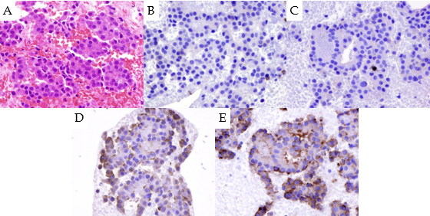
Figure 4 Histopathological findings for the specimen obtained by endoscopic ultrasound - fine needle aspiration. A: The specimen comprises cells with round nuclei arranged in sheets or rosettes (hematoxylin and eosin, ×100); B, C: Tumor cells show negative results for CD10 and CD56 immunohistochemical staining (×100); D, E: Tumor cells show positive results for chromogranin A and synaptophysin on immunohistochemical staining (×100).

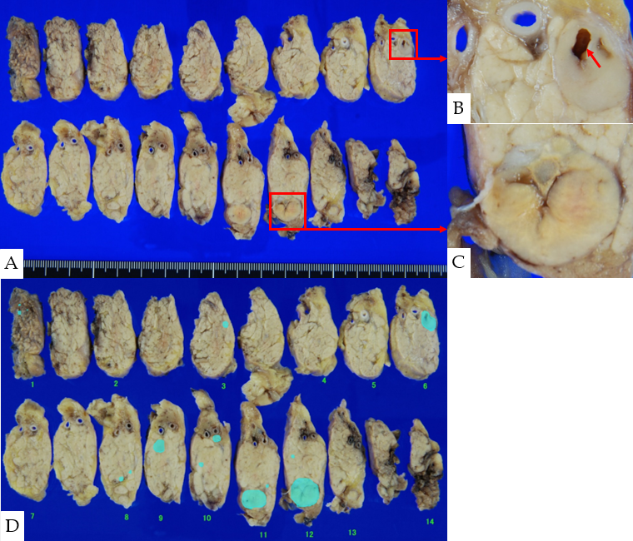
Figure 5 Macroscopic findings for the resected pancreas. A: The main cystic lesion has morphologically changed to a 13-mm nodule (red square C). The microtumor in the pancreatic body on which EUS-FNA was performed was separate from the main lesion; B: A scar from EUS-FNA is evident in the microtumor (red arrow); C: The main nodule shows internal scarring; D: The main lesion and two microtumors detected on EUS, and another 11 new microtumors (1-3 mm) (blue areas).

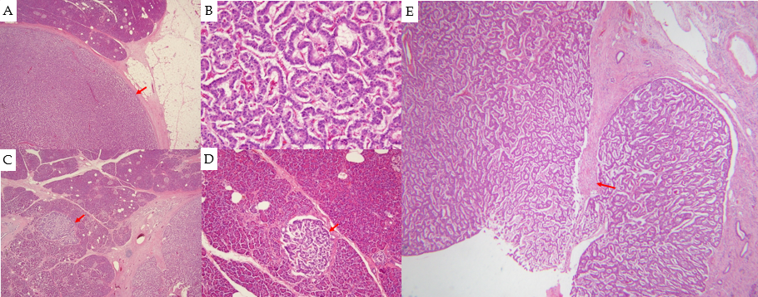
Figure 6 Microscopic findings for the resected pancreas. A: The main lesion (red arrow) comprises cells with round nuclei arranged in sheets or rosettes (hematoxylin and eosin, ×4); B: Less than 2 mitoses per 50 high-power fields are evident (hematoxylin and eosin, ×40); C, D: The other microtumors (red arrow) show similar findings (hematoxylin and eosin; C, ×4; D, ×10); E: The peripheral rim appears broken at one site, and fibrosis (red arrow) is evident inflammation (hematoxylin and eosin, ×10). A trace of a cystic lumen is apparent below the red arrow.

