Name of Journal: World Journal of Gastrointestinal Oncology
Manuscript NO: 85934
Manuscript Type: ORIGINAL ARTICLE

Retrospective Study
Mitomycin C and capecitabine: An additional option as an advanced line therapy in patients with metastatic colorectal cancer

Mullin G et al. MMC/capecitabine in metastatic CRC

Gil Mullin, Michal Sternschuss, Yosef Landman, Aaron Sulkes, Baruch Brenner

Gil Mullin, Aaron Sulkes, Baruch Brenner, Sackler Faculty of Medicine, Tel-Aviv University, Tel Aviv 6997801, Israel

Gil Mullin, Michal Sternschuss, Yosef Landman, Aaron Sulkes, Baruch Brenner, Department of Oncology, Davidoff Cancer Center, Beilinson Campus, Petah-Tikva 4941492, Israel

Author contributions: Brenner B, Sternschuss M, and Mullin G contributed to study design; Mullin G contributed to acquisition of data; Mullin G, Sternschuss M, Brenner B, Sulkes A, and Landman Y contributed to data analysis and interpretation; Mullin G, Sternschuss M, Brenner B, and Sulkes A contributed to manuscript writing; Mullin G, Sternschuss M, Brenner B, Sulkes A, and Landman Y contributed to final manuscript approval.

Corresponding author: Baruch Brenner, MD, Professor, Department of Oncology, Davidoff Cancer Center, Beilinson Campus, 39 Jabotinski Street, Petah-Tikva 4941492, Israel. brennerb@clalit.org.il

Received: May 23, 2023
Revised: August 31, 2023
Accepted: October 11, 2023
Published online:

Abstract
BACKGROUND
In recent years survival of patients with metastatic colorectal cancer (mCRC), though still limited, has improved significantly; clearly, when the disease becomes refractory to standard regimens, additional treatment options are needed. Studies have shown that mitomycin C (MMC), an antitumor antibiotic, and capecitabine, a precursor of 5-fluorouracil, may act synergistically in combination. The efficacy of MMC/Capecitabine has been demonstrated in the first-line setting, but only a few small studies have tested it in the advanced-line setting, with contradictory results.

AIM
To summarize our experience using MMC/capecitabine as an advanced line treatment for mCRC.

METHODS
A retrospective study was conducted at a tertiary medical center including all patients with histologically proven mCRC who were treated with MMC/capecitabine after at least two previous lines of standard chemotherapy in 2006-2020. Data on patient demographics and past medical history, laboratory, pathological, and radiological factors, and treatment and survival were collected from the files. Survival analyses were performed using the Kaplan-Meier method. The association of patient and tumor characteristics with treatment effectiveness and toxicity was evaluated with univariate and multivariate proportional hazard Cox regression analyses. P ≤ 0.05 was considered statistically significant.

RESULTS
The cohort consisted of 119 patients of median age 64 years (range 37-85). Patients received a median of 2 MMC/capecitabine cycles (range 0.5-9.0). Thirty-four patients (28.6%) experienced grade ≥ 3 toxicity, including 2 (1.7%) with grade 4; there was no drug-related mortality. The objective response rate was 0.8%, and the disease control rate, 24.4%. Median progression-free survival (PFS) was 2.1 mo (range 0.2-20.3), and median overall survival, 4.8 mo (range 0.2-27.5). The 6-month overall survival rate was 44%; 8.7% of patients remained progression-free. Factors associated with longer PFS were lower gamma-glutamyl transferase level (P = 0.030) and primary tumor location in the left colon (P = 0.017). Factors associated with longer overall survival were lower gamma-glutamyl transferase level (P = 0.022), left-colon tumor location (P = 0.044), low-to-moderate histological grade (P = 0.012), Eastern Cooperative Oncology Group performance status 0-1 (P = 0.036), and normal bilirubin level (P = 0.047).

CONCLUSION
MMC/capecitabine is an active, available, and relatively safe regimen for use beyond standard lines of therapy in mCRC. Several clinical and laboratory parameters can identify patients more likely to benefit.

Key Words: Colorectal cancer; Metastatic cancer; Chemotherapy; Mitomycin C; Capecitabine; Advanced line treatment

Mullin G, Sternschuss M, Landman Y, Sulkes A, Brenner B. Mitomycin C and capecitabine: An additional option as an advanced line therapy in patients with metastatic colorectal cancer. World J Gastrointest Oncol 2023; In press

Core Tip: Survival with metastatic colorectal cancer has improved significantly. However, when the disease becomes refractory, patients are left with limited options. Mitomycin C (MMC) and capecitabine combination is a potential treatment option for mCRC patients beyond standard lines of treatment. Only a few small studies have tested it in the advanced-line setting, with contradictory results. We present our experience using the MMC/capecitabine combination. Our findings suggest that MMC/capecitabine is a safe, well-tolerated regimen. Ours is the largest series on the use of MMC/capecitabine in refractory mCRC. We were able to identify well-defined subgroups which derived clinical benefit from this combination.

INTRODUCTION
With about two million new cases a year worldwide, colorectal cancer (CRC) is the third most diagnosed malignancy and the second cause of cancer related mortality^{[1]}. Despite screening efforts, the disease has often already spread by the time patients are diagnosed. Altogether, up to 40%-50% present with or progress to metastatic disease (mCRC)^{[2]}; most of them are considered incurable, and treatment aims at prolonging survival and improving quality of life.
As a consequence of the substantial treatment advances made in recent years, the median overall survival (OS) for metastatic CRC (mCRC) is now approximately 30 mo, with a 5-year rate of 25%^{[3,4]}. First line regimens for mCRC include FOLFIRI (5-fluorouracil, leucovorin, irinotecan), FOLFOX (5-fluorouracil, leucovorin, and oxaliplatin) or XELOX (capecitabine and oxaliplatin)^{[5]}. Combining cytotoxic agents with biologicals such as bevacizumab^{[6]}, cetuximab and panitumumab^{[7,8]} has brought an improvement in objective response rate (ORR), progression-free survival (PFS) and OS. In the second-line regimen, irinotecan is switched to oxaliplatin or vice versa^{[9]}. When the disease becomes refractory to standard lines of chemotherapy and biologicals, OS with best supportive care (BSC) is only 4 mo to 6 mo^{[10]}. For these patients, treatment options are limited and may include, in recent years, regorafenib^{[11]}, TAS-102^{[12]}, pembrolizumab for those with microsatellite instability^{[13,14]} and tyrosine kinase inhibitors in carriers of the BRAF V600 mutation^{[15]}.
The combination of mitomycin C (MMC) and capecitabine (MMC/capecitabine), which has known tolerable toxicity, serves as a potential treatment option in patients with mCRC who have exhausted standard lines of treatment. MMC is an antibiotic which inhibits DNA replication and transcription^{[16,17]}; capecitabine is an oral fluoropyrimidine that converts to 5-fluorouracil by thymidine phosphorylase within the tumor cells^{[18]}. Since thymidine phosphorylase is regulated by MMC, combining the two drugs may yield a synergistic effect^{[19]}. One study found MMC/capecitabine to be comparable in efficacy to 5-fluorouracil/Leucovorin as a first-line treatment in mCRC^{[18]}. At present, however, only a few small prospective phase II trials and retrospective studies have investigated MMC/capecitabine as an advanced line treatment in mCRC.
The aim of this study was to report our experience with MMC/capecitabine as a third or later line of treatment in mCRC, focusing on efficacy and toxicity.

MATERIALS AND METHODS
A retrospective study was conducted at Davidoff Cancer Center, Rabin Medical Center, a large tertiary facility in Israel, between March 2006 and November 2020. The cohort included all patients with histologically proven mCRC who were treated with MMC/capecitabine after at least two previous lines of standard chemotherapy for metastatic disease. The study was approved by the Institutional Ethics Committee.
Data for the study were collected from the electronic medical records, as follows: patient and tumor characteristics, surgical interventions, radiation therapy, duration and outcome of previous lines of treatment, and Eastern Cooperative Oncology Group (ECOG) performance status (PS) at onset of MMC/capecitabine treatment.
ORR was defined as the proportion of patients with a complete response (CR) or partial response (PR). Disease control rate (DCR) was defined as the proportion of patients with CR, PR, or stable disease. Duration of disease control (DDC) was defined as the time from initiation of MMC/capecitabine to documented clinical or radiological progression or the last date the patient was known to be progression-free, in patients with CR, PR, or stable disease. PFS was defined as the time from initiation of MMC/capecitabine to documented clinical or radiological progression or the last date the patient was known to be progression-free. OS was defined as the time from initiation of MMC/capecitabine to the time of death from any cause or the last date the patient was known to be alive.

Statistical analysis
Survival analyses were performed using the Kaplan-Meier (KM) method for the entire cohort and separately for patients who did and did not gain disease control with the study treatment. Patient characteristics were compared between the groups using t-tests and Mann-Whitney tests for continuous variables with and without normal distribution, respectively. Chi-square tests were used for categorical variables. A similar comparison was made between patients who did or did not suffer any grade 3 or higher toxicity. The effect of different patient characteristics on PFS and OS was evaluated with univariate and multivariate proportional hazard Cox regression analysis. P value of ≤ 0.05 was considered statistically significant.

RESULTS
Patient and tumor characteristics
Between 03/2006 and 11/2020, 119 patients received MMC/capecitabine as advanced line treatment for mCRC in the Davidoff Center; all were evaluable. Patient and tumor characteristics at the onset of MMC/capecitabine are presented in Table 1. Sixty-eight patients (57.1%) were male. Median age at diagnosis and at initiation of MMC/capecitabine were 61 years (range: 33-84) and 64 years (range: 37-85), respectively. Eighty-two patients (68.9%) presented with metastatic disease at diagnosis. Ninety patients (75.6%) had a primary tumor located in the left colon; 97 (81.5%) had liver metastases. Median duration of previous treatments was 2 years (range: 0.2-9.3 years). Fifty patients (42.0%) received MMC/capecitabine as third line treatment, and 69 (58.0%) received it as fourth or later line. Seventy patients (58.8%) had an ECOG PS of 0-1 at the initiation of MMC/capecitabine and 105 (88.2%) were capecitabine naïve. Most of the patients (79.1%) underwent surgery at some stage of their disease course. We did not notice any difference in the effectiveness of the studied drugs related to previous surgery.

Treatment delivery
The MMC/capecitabine regimen was administered in a 42-d cycle. MMC (7 mg/m²) was given intravenously on day 1, and capecitabine (1250 mg/m² twice daily) was given orally on days 1-14 and 22-36. Treatment delivery is summarized in Table 2. Patients received a median number of 2 cycles (range 0.5-9.0); the median duration of treatment was 2.8 mo (range 0.5-20.0). Treatment was started with the full dosage of MMC in 114 patients (95.8%) and with the full dosage of capecitabine in 45 patients (37.8%). Dose reductions were required in 19 patients (16.0%), mainly for capecitabine, and delays in treatment for any reasons occurred in 22 patients (18.5%). Median dose intensity for MMC was 1.17 mg/m²/wk (range 0.6-1.6 mg/m²/wk), and for capecitabine, 9.33 g/m²/wk (4.6-11.9 g/m²/wk), representing 100% and 80% of each drug’s planned dose intensity, respectively. The main reason for discontinuation of therapy (90.8% of patients) was disease progression.

Toxicity
All patients were evaluable for toxicity, defined using the National Cancer Institute Common Terminology Criteria for Adverse Events (CTCAE) version 4.0, with emphasis on the documentation of grade 3 and 4 adverse events (AEs), i.e., serious AEs (SAEs). A total of 54 grade ≥ 3 AEs were documented in 34 patients (28.6%), out of which only 4 were grade 4 events, experienced by 2 patients (1.7%). Toxicity details are presented in Table 3. The most common grade 3 AE was anemia (10.1%); there were 4 events of overt bleeding (3.4%). There were 2 cases of grade 3 and one case of grade 4 neutropenia, none of which were complicated by neutropenic fever. Only one patient (0.8%) received granulocyte colony stimulating factor (GCSF). The most common non-hematological grade ≥ 3 AE was diarrhea (7.6%). A univariate analysis of the effect of different characteristics on the occurrence of AEs was performed, including patients’ medical background and tumor and treatment characteristics. Only lower albumin levels correlated with higher occurrence of grade ≥ 3 AEs (P = 0.01). Treatment discontinuation due to toxicity occurred in 6 patients (5.0%). There were no treatment related deaths.

Efficacy
All 119 patients were evaluable for efficacy (Table 4): PR was achieved in 1 patient (0.8%) and SD was noted in 28 (23.5%). Therefore, the ORR was 0.8% and the DCR was 24.4%. Thirty-five patients (29.4%) went on to receive further lines of therapy after discontinuing MMC/capecitabine. Subsequent therapies consisted mainly of re-challenging with previously used chemotherapies. At the time of analysis, 115 patients (96.6%) have died of the disease and 4 were lost to follow-up (3.4%). Median DDC was 4.2 mo (range: 2.4-20.3) and median PFS of the entire cohort was 2.1 mo (range: 0.2-20.3). Median OS of the entire cohort was 4.8 mo (range: 0.2-27.5) and extended to 12.3 mo (range: 3.9-25.2) in the disease control subgroup. The estimated 6 mo OS rate was 44% and the estimated 6 mo PFS was 8.7%. The estimated 12 mo PFS rate was 2.5% and the estimated 12 mo OS rate was 15.8%. Of note, we also analyzed our results in two different time periods. For patients who began treatment between the years 2006-2012 (n = 53) DCR was 30.2%, median PFS was 2.3 mo and median OS was 4.9 mo. For patients who began treatment between the years 2013-2020 (n = 62) DCR was 21%, median PFS was 1.8 mo and median OS was 4.3 mo. ECOG PS during treatment was known in 82 patients (68.9%), in whom it either improved (2 patients) or stabilized (37 patients).

Patient and tumor characteristics and disease control
Univariate analysis of the effect of patient and tumor characteristics on the achievement of disease control was performed. The DCR was significantly higher in patients with metachronous vs synchronous metastatic disease (40.5% vs 17.1%, P = 0.006). Lower pre-treatment serum gamma-glutamyl transferase (GGT) levels (P = 0.013), normal hemoglobin levels (P = 0.039) and higher albumin levels (P = 0.008) also correlated with disease control. For example, DCR in patients with lower pre-treatment GGT levels (< 60 IU/L) was 39.1% compared with 20.8% in those with higher GGT levels (≥ 60 IU/L).

Patient and tumor characteristics and survival
Univariate and multivariate analyses of the effects of various patient and tumor characteristics on survival outcomes were performed. In a univariate analysis, several features correlated with PFS and OS, including factors related to patient history, tumor molecular and pathological characteristics, PS, and various laboratory values. In multivariate analyses, however, fewer statistically significant correlations were found. PFS correlated with left tumor location (HR = 0.50, P = 0.017) and lower GGT levels (HR = 0.53, P = 0.030). OS correlated with histological grade (HR = 0.53, P = 0.012), left tumor location (HR = 0.52, P = 0.044), ECOG PS (HR = 0.59, P = 0.036), lower GGT levels (HR = 0.52, P = 0.022) and normal serum bilirubin levels (HR = 0.47, P = 0.047). For example, the median PFS in patients with lower GGT levels (< 60 IU/L) was 2.9 mo compared with 1.7 mo in patients with higher GGT levels (≥ 60 IU/L), and the median OS was 8.4 mo and 4.1 mo, respectively. KM survival curves by the various prognostic factors are presented (Figures 1-3).

DISCUSSION
The present study shows that the combination of MMC and capecitabine may serve as a feasible advanced-line treatment option in patients with mCRC.
The progress made in the management of patients with mCRC in recent years has led to longer survival^{[20]}; however, there remains an unmet need for well-tolerated regimens that further prolong OS and maintain quality of life. The choice between active treatment or BSC is complex and should be based on baseline functional status and comorbidities of the patient as well as the balance between the efficacy and the potential toxicity of the different available regimens. These are important aspects to consider in all cancer patients, and more so in the unique population of patients with mCRC who have progressed beyond the standard lines of treatment and are commonly frail.
MMC/capecitabine may be a suitable regimen in this clinical setting. Currently, no phase III trials have been conducted and only three small prospective phase II and three retrospective trials have evaluated MMC/capecitabine as third or later line of treatment in mCRC, with variable results (Table 4). This variation can be attributed to the fact that all studies were based on small cohorts of 15-61 patients as well as the nature of retrospective analyses. The phase II trials reported ORR of 4.8%-15.2%, PFS of 2.6-5.4 mo and OS of 6.0-9.3 mo^{[2,17,19]} and the retrospective studies reported ORR of 5%-20%, PFS of 2.7-3.3 mo and OS of 5.4-9.3 mo^{[21-23]}. In all these studies, prospective or retrospective, toxicity was mild and tolerable. In light of these findings, we investigated and summarized our own experience with MMC/capecitabine as third or further line of treatment in mCRC.
Our results revealed median PFS and OS of 2.1 mo and 4.8 mo, respectively, for the entire cohort, slightly lower values compared to previous reports. While the DCR in our cohort was 24.4%, consistent with earlier studies, the ORR was lower than previously reported, 0.8%. This can mostly be attributed to the fact that our patients were more heavily pretreated than in previous studies (Table 4). When analyzing separately the group that achieved disease control, we observed a substantial clinical benefit, durable in some patients, with median PFS and OS reaching 4.2 mo and 12.3 mo, respectively. Furthermore, at 6 mo from the onset of treatment the OS rate reached 44% and 8.7% survived without disease progression, and at 12 mo the OS rate was 15.8% and the PFS rate was 2.5%. As expected, the disease control achieved with MMC/capecitabine was accompanied by a clinical benefit: 47.5% of the patients either maintained or improved their ECOG PS during treatment. While less toxic, the efficacy of MMC/capecitabine seems to be comparable to the registered treatment options in this setting: The ORRs in the CORRECT trial, evaluating regorafenib, and in the RECOURSE trial, evaluating TAS-102, were 1.0% and 1.6%, respectively, and the median OS in these trials was 6.4 mo and 7.1 mo, respectively^{[11,12]}.
To identify subgroups of patients who may benefit more from MMC/capecitabine, we investigated the correlation between various patient and tumor characteristics and several outcome measures. In terms of patient-related predictive factors, our results were consistent with the existing literature, suggesting consideration of well-established, readily available parameters to improve patient selection: ECOG PS 0-1, lower pretreatment serum GGT levels, higher serum albumin levels, and normal serum hemoglobin and bilirubin levels all correlated with better outcome. As these parameters largely represent the general condition of the patient, it comes as no surprise that those who had a better nutritional status as well as a higher functional level at onset of treatment fared better.
With regard to tumor related factors, as could be expected, left tumor location (including the descending colon, sigmoid colon, and rectum), well-to-moderate tumor grade, and metachronous metastases, all were associated with better patient outcome. This is in line with multiple previous studies^{[24-27]}. It should be emphasized however that these parameters represent general favorable prognostic factors and not necessarily tumor responsiveness to MMC/capecitabine.
In heavily pretreated patients, choosing a regimen with a tolerable toxicity profile is of the highest priority, as their ability to withstand the treatment is crucial. Our results showed that MMC/capecitabine is a well-tolerated regimen with mild toxicity. We observed similar rates of CTCAE grade 3/4 AEs to previous studies, including those that tested the regimen as first- or second-line therapy^{[28-30]}. For example, in the phase I trial by Hofheinz et al^{[29]} investigating MMC/capecitabine as second-line therapy, 4 patients (13.3%) exhibited AEs at the phase II recommended-dose level. Chong et al^{[2]}, Lim et al^{[19]} and Scartozzi et al^{[17]} reported partial information regarding toxicity: None specified the proportion of patients who experienced AEs, but rather reported the prevalence of each AE separately. Martorana et al^{[21]}, in a retrospective study, reported grade 3/4 AEs in 9% of patients without specifying the prevalence of each type of event (Table 4).
In comparison, in our larger cohort of 119 heavily pre-treated patients, grade 3/4 AEs occurred in 28.6% of the patients and grade 4 in only 1.7%; there were only 6 treatment discontinuations due to toxicity and there were no toxicity related deaths (Table 3). Notably, in line with earlier reports^{[31]}, lower albumin levels correlated with occurrence of severe toxicity, emphasizing normal albumin levels as an important factor in patient selection. When comparing MMC/capecitabine to the available alternatives, 51% of the patients treated with regorafenib in the CORRECT trial^{[11]} experienced grade 3 AEs and 3% experienced grade 4 events. In the RECOURSE trial evaluating TAS-102, the rate of grade 3 or higher AEs was even higher, 69%^{[12]}.
The main limitation of our study is the retrospective design. As capecitabine is an oral agent, the accurate assessment of patient compliance with the prescribed schedule and dosage is challenging. Additionally, the occurrence of AEs that are clinically based (nausea, vomiting, etc.) and not laboratory-based (anemia, neutropenia, etc.) is harder to assess retrospectively.
Nonetheless, our study has several strengths. Primarily, our cohort is by far the largest to be examined in this setting. All patients were treated in a single center by the same medical team, with the same protocols and methods. Furthermore, all medical records were available for data collection including detailed and accurate information on the clinical course and toxicity, and all patients were evaluable for efficacy and safety. This is even more important considering the limited pre-existing data on the overall rate of severe toxicities with the use of MMC/capecitabine in advanced lines. Finally, treated in a large tertiary center, all of our patients had been exposed to the best available regimens before receiving MMC/capecitabine.

CONCLUSION
In summary, MMC/capecitabine in the advanced line setting for mCRC patients is a safe, well-tolerated and affordable regimen, with substantial DCR and durable effect on QoL and OS. Our study identified some readily available clinical and laboratory-based parameters, previously validated in multiple clinical settings, which may define subgroups of patients more likely to benefit from this combination. We believe that larger scale evaluation of MMC/capecitabine in the advanced setting is warranted.

ARTICLE HIGHLIGHTS
Research background
Colorectal cancer (CRC) represents one of the most common and lethal solid tumors. When diagnosed in an early stage, surgery +/- adjuvant chemotherapy may result in cure; however, up to half of all patients present or develop metastases during the course of the disease (mCRC). Standard chemotherapy combinations in use for the treatment of metastatic disease include FOLFIRI, FOLFOX, and XELOX, frequently administered with biological agents such as bevacizumab and cetuximab, resulting in an improved outcome. However, once the disease becomes resistant to standard lines, the prognosis is dismal and further treatment options are limited. In the present study we retrospectively examined the effectiveness and tolerability of mitomycin C (MMC)/capecitabine as an advanced line in patients with mCRC who had progressed on standard systemic regimens.

Research motivation
To determine whether the MMC/capecitabine regimen, a potentially synergistic combination, could represent a valid therapeutic option in patients with refractory mCRC. The use of this combination in this setting has not been fully investigated as yet.

Research objectives
Ours is the largest study published so far on the use of MMC/capecitabine as third or further line of treatment in mCRC. We were able to determine the antitumor activity of this regimen as well as the adverse events resulting from its administration.

Research methods
This was a retrospective analysis which included 119 patients with previously treated mCRC cared for at a single tertiary facility in Israel over a period of 14 years (2006-2020). Data on patient and tumor characteristics at the onset of MMC/capecitabine and prior treatments were retrieved from the patients’ medical records. A detailed analysis on the delivery of MMC/capecitabine including number of cycles, duration of treatment, dose intensity, its efficacy and toxicity, was carried out. Univariate and multivariate analyses on the impact of various patient and tumor characteristics on response and survival outcomes were performed.

Research results
All 119 patients were evaluable for efficacy and toxicity. One patient (0.8%) achieved a partial remission and 28 patients (23.5%) had stable disease for a disease control rate of 24.3%. Median duration of disease control, progression-free survival (PFS) and overall survival (OS) were 4.2 mo, 2.1 mo, and 4.8 mo, respectively, with an estimated 6-mo OS rate of 44.0% and of PFS of 8.7%. The disease control rate was higher in patients with metachronous than with synchronous metastatic disease, and in patients with lower pre-treatment GGT levels, normal hemoglobin, and higher serum albumin levels. PFS correlated with left tumor location and lower GGT levels, while OS correlated with those two parameters as well as with histological grade, performance status and normal bilirubin levels.

Research conclusions
MMC/capecitabine as an advanced line in patients with mCRC is well tolerated and notwithstanding the almost universally lack of objective responses, about one quarter of our patient population achieved disease control. Moreover, the efficacy and safety features of this easily accessible regimen seem comparable to the two approved treatment options in this setting, regorafenib and TAS-102. Importantly, based on simple and readily available clinical and laboratory parameters, we were able to identify subgroups of patients more likely to benefit from the administration of MMC/capecitabine.

Research perspectives
Based on our results, we believe that evaluation of MMC/capecitabine as an advanced line in mCRC should be further pursued. At the same time, intensive research should focus on identifying active novel combinations as this remains an unmet need in refractory mCRC.

REFERENCES
1 Sung H, Ferlay J, Siegel RL, Laversanne M, Soerjomataram I, Jemal A, Bray F. Global Cancer Statistics 2020: GLOBOCAN Estimates of Incidence and Mortality Worldwide for 36 Cancers in 185 Countries. CA Cancer J Clin 2021; 71: 209-249 [PMID: 33538338 DOI: 10.3322/caac.21660]
2 Chong G, Dickson JL, Cunningham D, Norman AR, Rao S, Hill ME, Price TJ, Oates J, Tebbutt N. Capecitabine and mitomycin C as third-line therapy for patients with metastatic colorectal cancer resistant to fluorouracil and irinotecan. Br J Cancer 2005; 93: 510-514 [PMID: 16091760 DOI: 10.1038/sj.bjc.6602733]
3 Stintzing S, Modest DP, Rossius L, Lerch MM, von Weikersthal LF, Decker T, Kiani A, Vehling-Kaiser U, Al-Batran SE, Heintges T, Lerchenmüller C, Kahl C, Seipelt G, Kullmann F, Stauch M, Scheithauer W, Held S, Giessen-Jung C, Moehler M, Jagenburg A, Kirchner T, Jung A, Heinemann V; FIRE-3 investigators. FOLFIRI plus cetuximab versus FOLFIRI plus bevacizumab for metastatic colorectal cancer (FIRE-3): a post-hoc analysis of tumour dynamics in the final RAS wild-type subgroup of this randomised open-label phase 3 trial. Lancet Oncol 2016; 17: 1426-1434 [PMID: 27575024 DOI: 10.1016/S1470-2045(16)30269-8]
4 Venook AP, Niedzwiecki D, Lenz HJ. Effect of First-Line Chemotherapy Combined With Cetuximab or Bevacizumab on Overall Survival in Patients With KRAS Wild-Type Advanced or Metastatic Colorectal Cancer. JAMA 2017; 317: 2392-2401 [DOI: 10.3410/f.727734555.793550882]
5 Fakih MG. Metastatic colorectal cancer: current state and future directions. J Clin Oncol 2015; 33: 1809-1824 [PMID: 25918280 DOI: 10.1200/JCO.2014.59.7633]
6 Giantonio BJ, Catalano PJ, Meropol NJ, O’Dwyer PJ, Mitchell EP, Alberts SR, Schwartz MA, Benson AB 3rd; Eastern Cooperative Oncology Group Study E3200. Bevacizumab in combination with oxaliplatin, fluorouracil, and leucovorin (FOLFOX4) for previously treated metastatic colorectal cancer: results from the Eastern Cooperative Oncology Group Study E3200. J Clin Oncol 2007; 25: 1539-1544 [PMID: 17442997 DOI: 10.1200/jco.2006.09.6305]
7 Li XX, Liang L, Huang LY, Cai SJ. Standard chemotherapy with cetuximab for treatment of colorectal cancer. World J Gastroenterol 2015; 21: 7022-7035 [PMID: 26078581 DOI: 10.3748/wjg.v21.i22.7022]
8 Amado RG, Wolf M, Peeters M, Van Cutsem E, Siena S, Freeman DJ, Juan T, Sikorski R, Suggs S, Radinsky R, Patterson SD, Chang DD. Wild-type KRAS is required for panitumumab efficacy in patients with metastatic colorectal cancer. J Clin Oncol 2008; 26: 1626-1634 [PMID: 18316791 DOI: 10.1200/JCO.2007.14.7116]
9 Mocellin S, Baretta Z, Roqué I Figuls M, Solà I, Martin-Richard M, Hallum S, Bonfill Cosp X. Second-line systemic therapy for metastatic colorectal cancer. Cochrane Database Syst Rev 2017; 1: CD006875 [PMID: 28128439 DOI: 10.1002/14651858.CD006875.pub3]
10 Foubert F, Matysiak-Budnik T, Touchefeu Y. Options for metastatic colorectal cancer beyond the second line of treatment. Dig Liver Dis 2014; 46: 105-112 [PMID: 23954144 DOI: 10.1016/j.dld.2013.07.002]
11 Grothey A, Van Cutsem E, Sobrero A, Siena S, Falcone A, Ychou M, Humblet Y, Bouché O, Mineur L, Barone C, Adenis A, Tabernero J, Yoshino T, Lenz HJ, Goldberg RM, Sargent DJ, Cihon F, Cupit L, Wagner A, Laurent D; CORRECT Study Group. Regorafenib monotherapy for previously treated metastatic colorectal cancer (CORRECT): an international, multicentre, randomised, placebo-controlled, phase 3 trial. Lancet 2013; 381: 303-312 [PMID: 23177514 DOI: 10.1016/S0140-6736(12)61900-X]
12 Mayer RJ, Van Cutsem E, Falcone A, Yoshino T, Garcia-Carbonero R, Mizunuma N, Yamazaki K, Shimada Y, Tabernero J, Komatsu Y, Sobrero A, Boucher E, Peeters M, Tran B, Lenz HJ, Zaniboni A, Hochster H, Cleary JM, Prenen H, Benedetti F, Mizuguchi H, Makris L, Ito M, Ohtsu A; RECOURSE Study Group. Randomized trial of TAS-102 for refractory metastatic colorectal cancer. N Engl J Med 2015; 372: 1909-1919 [PMID: 25970050 DOI: 10.1056/NEJMoa1414325]
13 André T, Shiu KK, Kim TW, Jensen BV, Jensen LH, Punt C, Smith D, Garcia-Carbonero R, Benavides M, Gibbs P, de la Fouchardiere C, Rivera F, Elez E, Bendell J, Le DT, Yoshino T, Van Cutsem E, Yang P, Farooqui MZH, Marinello P, Diaz LA Jr; KEYNOTE-177 Investigators. Pembrolizumab in Microsatellite-Instability-High Advanced Colorectal Cancer. N Engl J Med 2020; 383: 2207-2218 [PMID: 33264544 DOI: 10.1056/NEJMoa2017699]
14 Aparicio T. PD-1 blockade in tumors with mismatch-repair deficiency. Colon Rectum 2015; 9: 182-184 [DOI: 10.1007/s11725-015-0588-4]
15 Hong DS, Morris VK, El Osta B, Sorokin AV, Janku F, Fu S, Overman MJ, Piha-Paul S, Subbiah V, Kee B, Tsimberidou AM, Fogelman D, Bellido J, Shureiqi I, Huang H, Atkins J, Tarcic G, Sommer N, Lanman R, Meric-Bernstam F, Kopetz S. Phase IB Study of Vemurafenib in Combination with Irinotecan and Cetuximab in Patients with Metastatic Colorectal Cancer with BRAFV600E Mutation. Cancer Discov 2016; 6: 1352-1365 [PMID: 27729313 DOI: 10.1158/2159-8290.cd-16-0050]
16 Iyer VN, Szybalski W. A molecular mechanism of mitomycin action: linking of complementary dna strands. Proc Natl Acad Sci U S A 1963; 50: 355-362 [PMID: 14060656 DOI: 10.1073/pnas.50.2.355]
17 Scartozzi M, Falcone A, Pucci F, Braconi C, Pierantoni C, Cavanna L, Franciosi V, Berardi R, Beretta G, Masi G, Allegrini G, Zaniboni A, Labianca R, Cascinu S. Capecitabine and mitomycin C may be an effective treatment option for third-line chemotherapy in advanced colorectal cancer. Tumori 2006; 92: 384-388 [PMID: 17168429 DOI: 10.1177/030089160609200503]
18 Twelves C; Xeloda Colorectal Cancer Group. Capecitabine as first-line treatment in colorectal cancer. Pooled data from two large, phase III trials. Eur J Cancer 2002; 38 Suppl 2: 15-20 [PMID: 11841931 DOI: 10.1016/s0959-8049(01)00415-4]
19 Lim DH, Park YS, Park BB, Ji SH, Lee J, Park KW, Kang JH, Lee SH, Park JO, Kim K, Kim WS, Jung CW, Im YH, Kang WK, Park K. Mitomycin-C and capecitabine as third-line chemotherapy in patients with advanced colorectal cancer: a phase II study. Cancer Chemother Pharmacol 2005; 56: 10-14 [PMID: 15782313 DOI: 10.1007/s00280-004-0963-2]
20 Biller LH, Schrag D. Diagnosis and Treatment of Metastatic Colorectal Cancer: A Review. JAMA 2021; 325: 669-685 [PMID: 33591350 DOI: 10.1001/jama.2021.0106]
21 Martorana F, Vigneri P, Cordio SS, Martines C, Novello G, Aiello MM, Bordonaro R, Parra HJS. Efficacy of A Fluoropyrimidine plus Mitomycin C in Pretreated Patients with Metastatic Colorectal Cancer Eligible for Regorafenib: A Retrospective Study. AIMS Med Sci 2017; 4: 456-464 [DOI: 10.3934/medsci.2017.4.456]
22 Saif MW, Kaley K, Brennan M, Garcon MC, Rodriguez G. Mitomycin-C and capecitabine (MIXE) as salvage treatment in patients with refractory metastatic colorectal cancer: a retrospective study. Anticancer Res 2013; 33: 2743-2746 [PMID: 23749935]
23 Chua W, Beale P, Leung M, Clarke S. Retrospective review of mitomycin C use as third-line chemotherapy in metastatic colorectal cancer. Clin Onco 2008; 4: 132-136 [DOI: 10.1111/j.1743-7563.2008.00178.x]
24 2015 European Society of Coloproctology collaborating group. Risk factors for unfavourable postoperative outcome in patients with Crohn’s disease undergoing right hemicolectomy or ileocaecal resection An international audit by ESCP and S-ECCO. Colorectal Dis 2017 [PMID: 28913968 DOI: 10.1111/codi.13889]
25 Kemeny N, Niedzwiecki D, Shurgot B, Oderman P. Prognostic variables in patients with hepatic metastases from colorectal cancer. Importance of medical assessment of liver involvement. Cancer 1989; 63: 742-747 [PMID: 2521570 DOI: 10.1002/1097-0142(19890215)63:4<742::aid-cncr2820630423>3.0.co;2-t]
26 Mekenkamp LJ, Koopman M, Teerenstra S, van Krieken JH, Mol L, Nagtegaal ID, Punt CJ. Clinicopathological features and outcome in advanced colorectal cancer patients with synchronous vs metachronous metastases. Br J Cancer 2010; 103: 159-164 [PMID: 20551951 DOI: 10.1038/sj.bjc.6605737]
27 Aparicio T. Prognostic survival associated with left-sided vs. right-sided Colon cancer: a systematic review and meta-analysis. Colon Rectum 2017; 11: 185-186 [DOI: 10.1007/s11725-017-0716-4]
28 Tebbutt NC. Capecitabine, bevacizumab, and mitomycin in first-line treatment of metastatic colorectal cancer: results of the Australasian Gastrointestinal Trials Group Randomized Phase III MAX Study. J Clin Onco 2010; 28: 3191-3198 [DOI: 10.3410/f.720139980.793500613]
29 Hofheinz RD, Hartmann JT, Willer A, Oechsle K, Hartung G, Gnad U, Saussele S, Kreil S, Bokemeyer C, Hehlmann R, Hochhaus A. Capecitabine in combination with mitomycin C in patients with gastrointestinal cancer: results of an extended multicentre phase-I trial. Br J Cancer 2004; 91: 834-838 [PMID: 15238990 DOI: 10.1038/sj.bjc.6602025]
30 Rao S, Cunningham D, Price T, Hill ME, Ross PJ, Tebbutt N, Norman AR, Oates J, Shellito P. Phase II study of capecitabine and mitomycin C as first-line treatment in patients with advanced colorectal cancer. Br J Cancer 2004; 91: 839-843 [PMID: 15266319 DOI: 10.1038/sj.bjc.6602039]
31 Barret M, Malka D, Aparicio T, Dalban C, Locher C, Sabate JM, Louafi S, Mansourbakht T, Bonnetain F, Attar A, Taieb J. Nutritional status affects treatment tolerability and survival in metastatic colorectal cancer patients: results of an AGEO prospective multicenter study. Oncology 2011; 81: 395-402 [PMID: 22269999 DOI: 10.1159/000335478]

Footnotes
Institutional review board statement: The study was reviewed and approved by the Rabin Medical Center Institutional Review Board (Approval No. 0639-19-RMC).

Informed consent statement: All study participants, or their legal guardian, provided informed written consent prior to study enrollment.

Conflict-of-interest statement: The authors declare that they have no conflict of interest.

Data sharing statement: Technical appendix, statistical code, and dataset available from the corresponding author at brennerb@clalit.org.il. Consent was not obtained but the presented data are anonymized and risk of identification is low.

Open-Access: This article is an open-access article that was selected by an in-house editor and fully peer-reviewed by external reviewers. It is distributed in accordance with the Creative Commons Attribution NonCommercial (CC BY-NC 4.0) license, which permits others to distribute, remix, adapt, build upon this work non-commercially, and license their derivative works on different terms, provided the original work is properly cited and the use is non-commercial. See: https://creativecommons.org/Licenses/by-nc/4.0/

Provenance and peer review: Unsolicited article; Externally peer reviewed.
Peer-review model: Single blind

Peer-review started: May 23, 2023
First decision: July 31, 2023
Article in press:

Specialty type: Oncology
Country/Territory of origin: Israel
Peer-review report’s scientific quality classification
Grade A (Excellent): 0
Grade B (Very good): B
Grade C (Good): C
Grade D (Fair): 0
Grade E (Poor): 0

P-Reviewer: Ahmadyousefi Y, Iran; Wang XB, China S-Editor: Chen YL L-Editor: A P-Editor:
Figure Legends
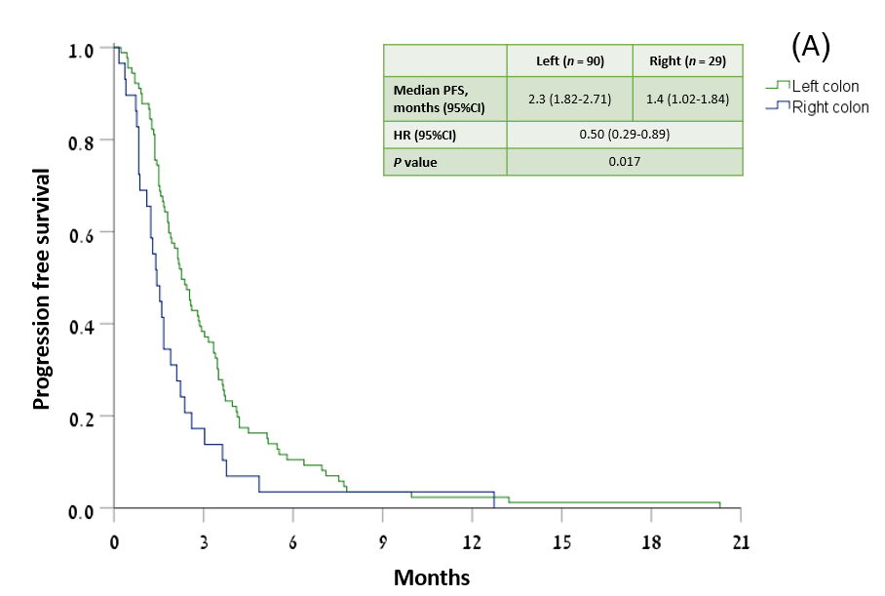
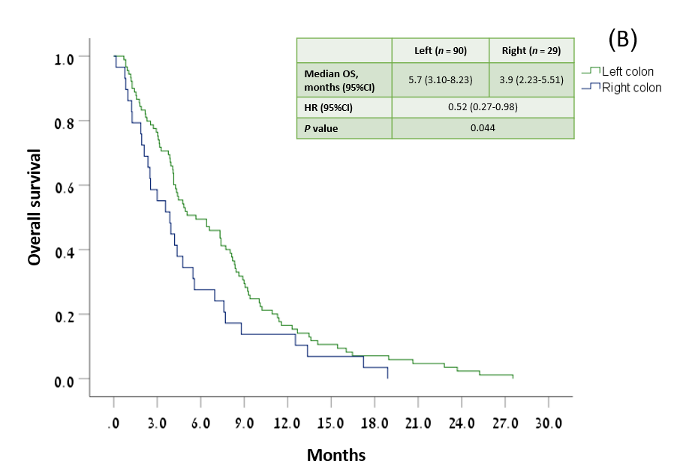
Figure 1 Tumor location and progression-free survival and overall survival. A: Progression-free survival; B: Overall survival. OS: Overall survival; PFS: Progression-free survival; HR: Hazard ratio; 95%CI: 95% confidence interval.

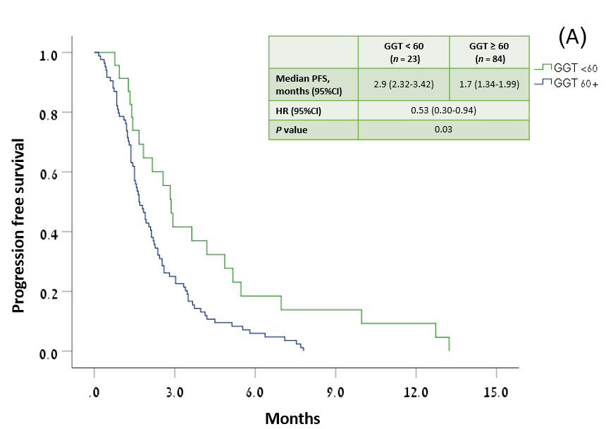
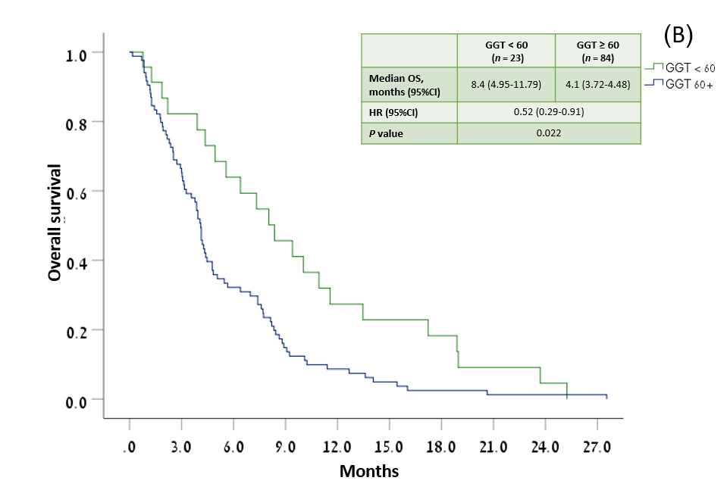
Figure 2 Serum gamma-glutamyl transferase and progression-free survival and overall survival. A: Progression-free survival; B: Overall survival. GGT: Gamma-glutamyl transferase; OS: Overall survival; PFS: Progression-free survival; HR: Hazard ratio; 95%CI: 95% confidence interval.
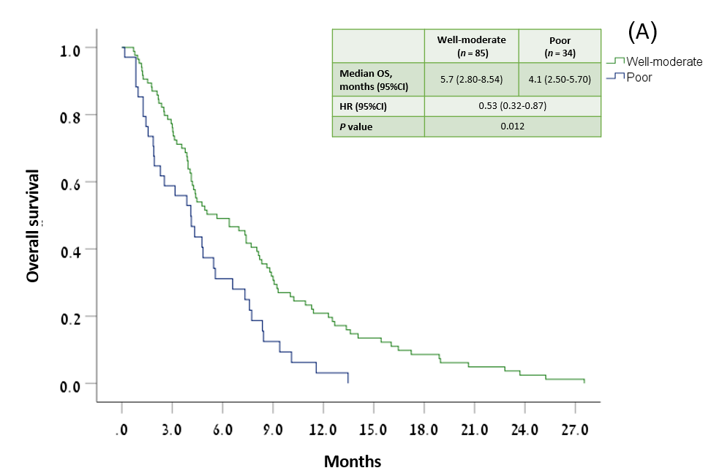
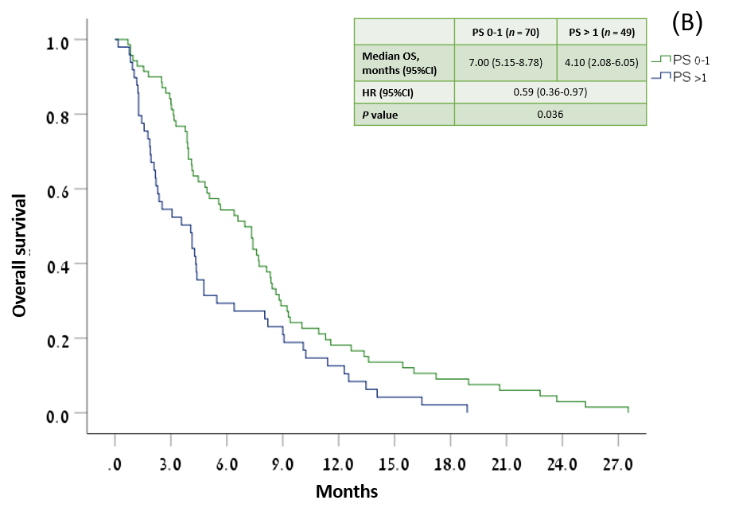
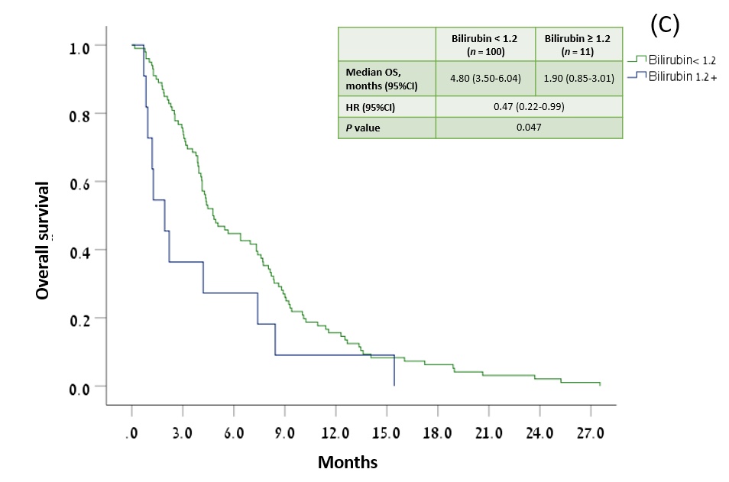
Figure 3 Overall survival by tumor histological grade, performance status, and bilirubin. A: Tumor histological grade; B: Performance status; C: Bilirubin. PS: Performance status; OS: Overall survival; PFS: Progression-free survival; HR: Hazard ratio; 95%CI: 95% confidence interval.

Table 1 Patient and tumor characteristics (n = 119)
 | Median | Range
Age at diagnosis (yr) | 61 | 33-84
Age at MMC/capecitabine onset (yr) | 64 | 37-85
Previous treatment duration (yr) | 2.03 | 0.2-9.3
 | n | Valid %¹
Male gender | 68 | 57.1
Smoking history | 33 | 30.6
Ethnicity
Jewish Ashkenazi | 61 | 51.3
Other | 58 | 48.7
Family history of cancer
Any | 67 | 67.7
GI | 32 | 32.3
Synchronous metastatic disease | 82 | 68.9
Liver metastases | 97 | 81.5
Tumor grade
Well-moderate | 85 | 71.4
Poor | 34 | 28.6
Tumor location
Right colon | 29 | 24.4
Left colon | 90 | 75.6
KRAS mutation | 44 | 44.4
NRAS mutation | 3 | 7.5
BRAF mutation | 1 | 5.3
MSI-H/ MMRd | 2 | 7.4
MMC/capecitabine line
3rd | 50 | 42.0
4th | 35 | 29.4
Subsequent | 34 | 28.6
Previous drug exposure
Oxaliplatin | 119 | 100.0
Irinotecan | 118 | 99.2
5-FU | 118 | 99.2
Capecitabine | 14 | 11.8
Bevacizumab | 109 | 91.6
Cetuximab/panitumumab | 51 | 42.9
Regorafenib | 14 | 11.8
TAS-102 | 7 | 5.9
ECOG PS
0-1 | 70 | 58.8
> 1 | 49 | 41.2
¹Data were missing on smoking (11 patients), family history (20), KRAS (20), NRAS (79), BRAF (100), and MSI/MMR (92).
N: Number; MMC: Mitomycin C; GI: Gastrointestinal; MSI: Microsatellite instability; MMRd: Mismatch repair deficient; ECOG PS: Eastern cooperative oncology group performance status; 5-FU: 5-fluorouracil.

Table 2 Treatment delivery and subsequent therapies
 | Median | Range | n | %
MMC/capecitabine | 2.0 | 0.5-9.0
Cycles administrated
Duration of treatment (mo) | 2.8 | 0.5-20.0
Patients beginning Tx at full dosage
MMC
Capecitabine |  |  | 114 | 95.8
 |  |  | 45 | 37.8
Dose reductions
MMC |  |  | 3 | 2.5
Capecitabine |  |  | 16 | 13.5
Any |  |  | 19 | 16.0
Dose intensity (median)
MMC (mg/m²/wk) | 1.17 | 0.6-1.6
Capecitabine (g/m²/wk) | 9.33 | 4.6-11.9
Treatment delay (> 3 d)
Yes |  |  | 22 | 18.5
No |  |  | 97 | 81.5
Reason for discontinuation
Progression |  |  | 108 | 90.8
Toxicity |  |  | 6 | 5.0
Other/unknown |  |  | 5 | 4.2
Subsequent therapies
Any |  |  | 35 | 29.4
Oxaliplatin |  |  | 12 | 10.1
Irinotecan |  |  | 8 | 6.7
5-FU |  |  | 18 | 15.1
Bevacizumab |  |  | 3 | 2.5
Cetuximab/panitumumab |  |  | 6 | 5.0
Regorafenib |  |  | 5 | 4.2
TAS-102 |  |  | 5 | 4.2
Other/clinical trial |  |  | 8 | 6.7
None |  |  | 84 | 70.6
MMC: Mitomycin C; Tx: Treatment; 5-FU: 5-fluorouracil.

Table 3 Adverse events
 | CTCAE grade ≥ 3 |  | CTCAE grade 4
 | n | % | n | %
Any | 34 | 28.6 | 2 | 1.7
Hematological (n = 25)
Leukopenia
Neutropenia | 4 | 3.4 | 1 | 0.8
Thrombocytopenia | 3 | 2.5 | 1 | 0.8
Anemia | 6 | 5.0 | 1 | 0.8
 | 12 | 10.1 | 0 | 0
Non-hematological (n = 29)
Bleeding
Diarrhea | 4 | 3.4 | 0 | 0
Nausea | 9 | 7.6 | 1 | 0.8
Vomiting | 3 | 2.5 | 0 | 0
Stomatitis | 6 | 5.0 | 0 | 0
Dermal | 2 | 1.7 | 0 | 0
HFS | 1 | 0.8 | 0 | 0
 | 4 | 3.4 | 0 | 0
CTCAE: Common terminology criteria for adverse events; HFS: Hand-foot syndrome; SAEs: Serious adverse events.

Table 4 Previous studies of mitomycin C/capecitabine as advanced line therapy in metastatic colorectal cancer
Ref. | Phase | Line of treatment | Number of patients (evaluable) | Study period (mo/ yr) | Grade ≥ 3 AEs (%) | ORR (%) | DCR (%) | Median PFS (mo) | Median OS (mo) | 1-yr OS (%)
Prospective studies
Chong et al^{[2]}, 2005 | II | 3 | 36 (33) | 07/2001- 11/2003 | NR¹ | 15.2 | 63.7 | 5.4 | 9.3 | 30.6
Lim et al^{[19]}, 2005 | II | 3 | 21 (19) | 03/2003- 03/2004 | NR¹ | 4.8 | 26.3 | 2.6 | 6.8 | NR
Scartozzi et al^{[17]}, 2006 | II | 3 | 61 | NR | NR¹ | 8.0 | 48.0 | 3.0 | 6.0 | NR
Retrospective studies
Chua et al^{[23]}, 2008 | - | 3 | 18 (14) | 06/2003- 06/2007 | 16.7 | 0 | 11.0 | 2.7 | 5.4 | NR
Saif, ²² | - | 4 | 15 | 07/2007- 02/2013 | 0 | 20.0 | 53.0 | NA | NA | NR
Martorana et al^{[21]}, 2017 | - | 3 | 61 | 01/2008- 12/2014 | 9.0 | 5.0 | 29.5 | 3.3 | 9.3 | NR
Current, 2022 | - | > 3 | 119 | 03/2006- 11/2020 | 28.6 | 0.8 | 24.4 | 2.1 | 4.2 | 15.8
¹Studies reported the rates of each AE individually and did not report the total proportion of patients who experienced adverse events.
MMC: Mitomycin C; mCRC: Metastatic colorectal cancer; AE: Adverse event; ORR: Objective response rate; DCR: Disease control rate; PFS: Progression free survival; OS: Overall survival; NR: Not reported; NA: Not available.

