Name of Journal: World Journal of Clinical Cases
Manuscript NO: 72068
Manuscript Type: CASE REPORT

Mantle cell lymphoma with endobronchial involvement: A case report

Ding YZ et al. MCL with endobronchial involvement

Yi-Zong Ding, Dao-Qiang Tang, Xiao-Jing Zhao

Yi-Zong Ding, Xiao-Jing Zhao, Department of Thoracic Surgery, Renji Hospital, School of Medicine, Shanghai Jiao Tong University, Shanghai 200127, China

Dao-Qiang Tang, Department of Pathology, Renji Hospital, School of Medicine, Shanghai Jiao Tong University, Shanghai 200127, China

Author contributions: Ding YZ collected the clinical data and wrote the manuscript; Tang DQ analyzed the clinical data; and Zhao XJ designed the work; all authors read and approved the final manuscript.

Corresponding author: Xiao-Jing Zhao, PhD, Chief Doctor, Department of Thoracic Surgery, Renji Hospital, School of Medicine, Shanghai Jiao Tong University, No. 160 Pujian Road, Shanghai 200127, China. 18133@renji.com

Received: October 2, 2021
Revised: December 14, 2021
Accepted: February 10, 2022
Published online:

Abstract
BACKGROUND
Mantle cell lymphoma (MCL) is a subtype of Non-Hodgkin's lymphoma (NHL). MCL frequently affects extranodal sites while endobronchial involvement is uncommon. Only 5 cases of MCL with endobronchial involvement have been previously reported.

CASE SUMMARY
A 56-year-old male patient arrived at the hospital complaining of a dry cough. A mass in the right upper lobe of the lung was revealed in Chest computed tomography (CT). Right lung hilar and mediastinal lymphadenopathies were also found by CT scan. The patient was diagnosed with central-type lung cancer with multiple lymph node metastases after positron emission tomography (PET) CT scan examination. The fiber optic bronchoscope examination revealed diffuse neoplasm infiltration in the inlet of the right up lobar bronchus. The patient was finally diagnosed with MCL based on the bronchoscopy and mediastinoscopy biopsy results.

CONCLUSION
MCL could masquerade as central type lung cancer. An endobronchial biopsy examination is necessary for the early diagnosis of MCL.

Key Words: Mantle cell lymphoma; Endobronchial involvement; Central type lung cancer; Endobronchial biopsy; Bronchoscopy; Mediastinoscopy; Case report

Ding YZ, Tang DQ, Zhao XJ. Mantle cell lymphoma with endobronchial involvement: A case report. World J Clin Cases 2022; In press

Core Tip: We reported a case of mantle cell lymphoma (MCL) with endobronchial involvement. MCL with endobronchial involvement is very rare. Only five such cases have been previously reported. Positron emission tomography - computed tomography is recommended for differential diagnosis and detection of extranodal sites of MCL. A pathological diagnosis can be made based on an endobronchial biopsy by bronchoscopy but doctors should prompt efforts to establish enough tissues.

INTRODUCTION
Mantle cell lymphoma (MCL) is a subtype of Non-Hodgkin's lymphoma (NHL). Over expression of cyclin D1 and reciprocal chromosomal translocation t(11;14)(q13;q32) are the distinguishing features of MCL^{[1,2]}. MCL represents approximately 4%-6% of all NHL^{[3,4]}. This disease is more often diagnosed in male patients in their 60s and almost all patients present with advanced stages III–IV of the disease. Extranodal involvements, include the bone marrow, gastrointestinal tract, liver, spleen, skin, Waldeyer's ring, lacrimal glands and central nervous system, are very common^{[5,6]}. Even though, airway involvement is very rare^{[7-9]}. We represent here a case of MCL with endobronchial as well as multiple lymph node involvement. Bronchoscopy and mediastinoscopy biopsies of the endobronchial and mediastinal lymph nodes were done to confirm the diagnosis.

CASE PRESENTATION
Chief complaints
A 56-year-old male patient arrived at the hospital complaining of dry cough for two months.

History of present illness
The patient suffered from dry cough for the past two months prior to his visit to our hospital. The chest computed tomography (CT) scan performed at the local hospital revealed a mass in the right upper lobe of the lung, with right lung hilar and mediastinal lymphadenopathies.

History of past illness
The patient had no prior medical history and was a smoker with 30 pack-years.

Personal and family history
The patient was healthy and have no personal or family history of tumors.

Physical examination
The patient presented mild coarse breath sounds in the right upper lung during auscultation.

Laboratory examinations
Laboratory tests revealed an increased percentage of neutrophilic leukocytes (78.4%) with normal hematocrit and platelet count values. His CYFRA 21-1 level was 4.03 ng/mL, which was far above the maximum normal limit (3.3 ng/mL). Other tumor markers were all in the normal range.

Imaging examinations
Chest enhanced CT scans revealed a central-type mass in the right lung with enlarged lymph nodes in the right lung hilar, mediastinal and bilateral axillary areas (Figure 1A). The CT also displayed thickening of the right bronchial wall (Figure 1B). PET-CT showed an increased uptake of 18-fludeoxyglucose in the mass of the right lung hilum and the fear of malignancy was a major concern. This examination also revealed lymph node metastases in the right lung hilar, mediastinal, celiac, right cervical, right supraclavicular and bilateral axillary areas (Figure 2).

Bronchoscopic examinations
Flexible bronchoscopy revealed mucosal infiltrative changes at the level of the right upper lobe inlet and the right upper lobe bronchus was obstructed (Figure 3). The other bronchial mucosa was normal. The mucosal endobronchial biopsy at the level of the right upper lobe inlet showed lymphoid hyperplasia. These cells were CD20 positive B-cells and Bcl-2, CD5, CD19, and cyclin D1 were also expressed. This result indicates the possibility of MCL. As the tissue sample of the endobronchial biopsy was insufficient, a mediastinoscopy biopsy of the mediastinal lymph nodes was scheduled.

Mediastinoscopy examinations
Subcarinal lymph node biopsy was performed under mediastinoscopy. The specimen also showed lymphoid hyperplasia. The immunohistochemical staining showed that these cells were positive for Bcl-2, CD5, CD19, CD20, Cyclin D1 and SOX11 while negative for Bcl-6, CD3, CD10, CD21 and CD23. The percentage of Ki67 positive cells was 25% (Figure 4). Therefore, the diagnosis of MCL was confirmed.

FINAL DIAGNOSIS
The final diagnosis for this patient was MCL.

TREATMENT
After the diagnosis of MCL, the patient was transferred to the hematology department of another hospital. The therapy was proceeded to rituximab and bendamustine maintenance.

OUTCOME AND FOLLOW-UP
The review of recent communication exchanges with his wife indicated that he was tolerating chemotherapy well, with early signs of clinical response a year after the diagnosis.

DISCUSSION
MCL is a kind of B cell aggressive NHL with the feature of hyperplasia of B-cells. These B-cells is a subset arising from antigen-experienced B cells resembling those found in the follicular mantle zones ^{[1]}. Immunohistochemical staining was positive for Bcl-2, CD5, CD19, CD20 and cyclin D1 and negative for Bcl-6, CD10 and CD23^{[9]}. According to the latest research, SOX11 has been described as a very important diagnostic marker when cyclin D1 is negative as it is equally expressed in D1-positive and D1-negative MCL^{[9]}.
Although MCL was more likely to have extranodal involvement, endobronchial involvement is uncommon^{[5,6]}. As far as we know, only 5 cases of MCL with tracheobronchial involvement have been represented in the literature (Table 1)^{[1,2,10-12]}. Lymphoma with endobronchial involvement is divided into two types: Diffuse submucosal infiltration (type I) and localized solitary mass (type II)^{[13]}. Interestingly, all 5 cases exhibited a type I pattern^{[13]}. In contrast, the case presented in this report exhibited a type II pattern, and the mechanisms of endobronchial metastasis may be caused by direct bronchial invasion from a parenchymal mass or mediastinal mass.
Type II endobronchial MCL has a large chance of being diagnosed as central-type lung cancer. PET-CT was useful in the differential diagnosis and detection of extranodal involvement. In addition, for detecting both nodal and extranodal involvement in patients with MCL, PET has a high sensitivity^{[14]}.
The diagnosis of MCL should be made on the basis of lymph node biopsy results, tissue, bone marrow, or blood phenol type^{[5]}. Typical positive results of immunohistochemistry and morphology of infiltrating small-to-medium-sized cells were displayed in most cases^{[15]}. In cases where endobronchial involvement is suspected, bronchoscopy with endobronchial biopsy results is an important and useful diagnostic tool. However, it is worth mentioning that the sample of tissue may be too small to determine a pathological diagnosis. In this case report, the patient underwent mediastinoscopy to obtain sufficient tissue from mediastinal lymph nodes, and then the diagnosis of MCL was confirmed.
MCL is one of the most difficult-to-treat B-cell lymphomas^{[1]}. In previously untreated patients,conventional chemotherapy is the most common treatment andthe remission rates is high. However, relapse within a few years is common and median survival of five to seven years is low^{[9]}. Proteasome inhibitors, mTOR inhibitors, and lenalidomide are available in addition to conventional chemotherapy for the treatment of relapsed MCL patients^{[1]}. Buttheir mechanisms of action and determinants of efficacy were still unclear^{[9]}.

CONCLUSION
In conclusion, we have reported a case of MCL with endobronchial involvement. MCL with endobronchial involvement is very rare and can be misdiagnosed as central-type lung cancer. PET-CT is recommended in MCL for differential diagnosis and the detection of extranodal sites. A pathological diagnosis can be based on bronchoscopy and endobronchial biopsy, but doctors are required to focus their efforts on collecting appropriate samples of tissue.

REFERENCES
1 Tong L, Gan G, Xu C, Yuan L, Li Z, Li H. Tracheobronchial involvement of mantle cell lymphoma. Respirol Case Rep 2018; 6: e00346 [PMID: 30009030 DOI: 10.1002/rcr2.346]
2 Katono K, Shirasawa M, Harada S, Niwa H, Nakahara Y, Igawa S, Yokoba M, Kubota M, Masuda N. Endobronchial involvement of mantle cell lymphoma: A case report. Respir Med Case Rep 2016; 19: 77-79 [PMID: 27536549 DOI: 10.1016/j.rmcr.2016.07.012]
3 Zhou Y, Wang H, Fang W, Romaguer JE, Zhang Y, Delasalle KB, Kwak L, Yi Q, Du XL, Wang M. Incidence trends of mantle cell lymphoma in the United States between 1992 and 2004. Cancer 2008; 113: 791-798 [PMID: 18615506 DOI: 10.1002/cncr.23608]
4 . The world health organization classification of malignant lymphomas in japan: incidence of recently recognized entities. Lymphoma Study Group of Japanese Pathologists. PatholInt 2000; 50: 696-702 [PMID: 11012982 DOI: 10.1046/j.1440-1827.2000.01108.x]
5 Vose JM. Mantle cell lymphoma: 2015 update on diagnosis, risk-stratification, and clinical management. Am J Hematol 2015; 90: 739-745 [PMID: 26103436 DOI: 10.1002/ajh.24094]
6 Sander B, Quintanilla-Martinez L, Ott G, Xerri L, Kuzu I, Chan JK, Swerdlow SH, Campo E. Mantle cell lymphoma--a spectrum from indolent to aggressive disease. Virchows Arch 2016; 468: 245-257 [PMID: 26298543 DOI: 10.1007/s00428-015-1840-6]
7 Depew ZS, Vassallo R. Pulmonary mantle cell lymphoma: a rare manifestation of an uncommon condition. Rare Tumors 2012; 4: e11 [PMID: 22532909 DOI: 10.4081/rt.2012.e11]
8 Baheti AD, Tirumani SH, Sewatkar R, Sachin SS, Shinagare AB, Ramaiya NH. MDCT of extranodal mantle cell lymphoma: a single institute experience. Abdom Imaging 2015; 40: 1693-1699 [PMID: 25724714 DOI: 10.1007/s00261-015-0389-9]
9 Pérez-Galán P, Dreyling M, Wiestner A. Mantle cell lymphoma: biology, pathogenesis, and the molecular basis of treatment in the genomic era. Blood 2011; 117: 26-38 [PMID: 20940415 DOI: 10.1182/blood-2010-04-189977]
10 Figgis PA, Rainer SP, Ma D, Glanville AR. Endobronchial mantle cell lymphoma. Intern Med J 2003; 33: 261-262 [PMID: 12752899 DOI: 10.1046/j.1445-5994.2003.00393.x]
11 Miyoshi I, Togitani K, Kuwayama Y, Daibata M, Matsumoto M, Taguchi H. Bilateral endobronchial involvement in mantle cell lymphoma. Intern Med 2007; 46: 429-430 [PMID: 17409613 DOI: 10.2169/internalmedicine.46.6385]
12 Imai H, Ogura K, Endo M, Ikeda T. Recurrence of mantle cell lymphoma occurring in the tracheobronchial wall. Intern Med 2012; 51: 1143-1144 [PMID: 22576406 DOI: 10.2169/internalmedicine.51.7248]
13 Solomonov A, Zuckerman T, Goralnik L, Ben-Arieh Y, Rowe JM, Yigla M. Non-Hodgkin's lymphoma presenting as an endobronchial tumor: report of eight cases and literature review. Am J Hematol 2008; 83: 416-419 [PMID: 18175356 DOI: 10.1002/ajh.21112]
14 Alavi A, Shrikanthan S, Aydin A, Talanow R, Schuster S. Fluorodeoxyglucose-positron-emission tomography findings in mantle cell lymphoma. Clin Lymphoma MyelomaLeuk 2011; 11: 261-266 [PMID: 21658653 DOI: 10.1016/j.clml.2011.03.013]
15 Ghielmini M, Zucca E. How I treat mantle cell lymphoma. Blood 2009; 114: 1469-1476 [PMID: 19556426 DOI: 10.1182/blood-2009-02-179739]

Footnotes
Informed consent statement: A written informed consent was obtained from the patient included in this case report.

Conflict-of-interest statement: The authors declare that they have no competing interests.

CARE Checklist (2016) statement: We have read the CARE Checklist (2016), and the manuscript was prepared and revised according to the CARE Checklist (2016).

Open-Access: This article is an open-access article that was selected by an in-house editor and fully peer-reviewed by external reviewers. It is distributed in accordance with the Creative Commons Attribution NonCommercial (CC BY-NC 4.0) license, which permits others to distribute, remix, adapt, build upon this work non-commercially, and license their derivative works on different terms, provided the original work is properly cited and the use is non-commercial. See: https://creativecommons.org/Licenses/by-nc/4.0/

Provenance and peer review: Unsolicited article; externally peer reviewed.
Peer-review model: Single blind

Peer-review started: October 2, 2021
First decision: December 10, 2021
Article in press:

Specialty type: Respiratory system
Country/Territory of origin: China
Peer-review report’s scientific quality classification
Grade A (Excellent): 0
Grade B (Very good): B
Grade C (Good): C
Grade D (Fair): 0
Grade E (Poor): 0

P-Reviewer: Acik DY, Shariati MBH S-Editor: Liu JH L-Editor: A P-Editor:
Figure Legends
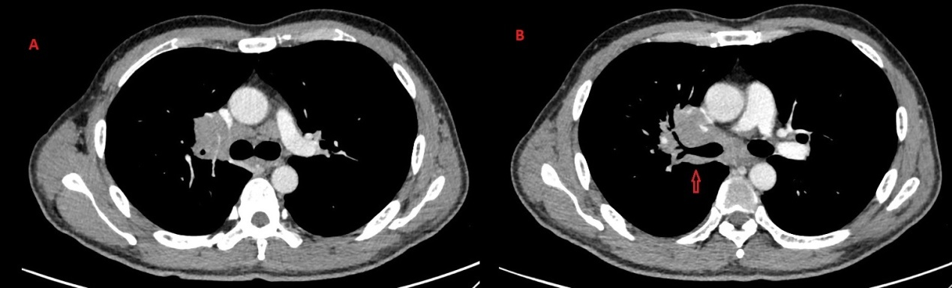
Figure 1 Chest enhanced computed tomography scan. A: Right central type lung mass with enlarged lymph nodes in the right lung hilar, mediastinal and bilateral axillary areas; B: The computed tomography scan also displayed thickening of the right bronchial wall.
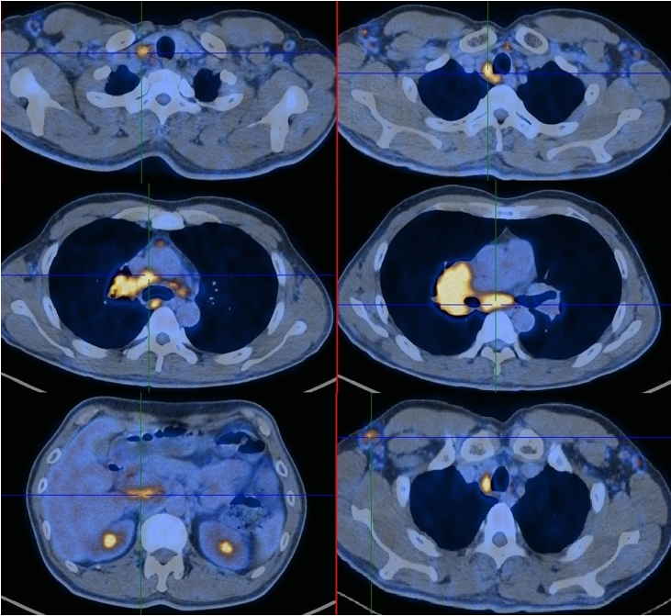
Figure 2 Positron emission tomography - computed tomography showed an increased uptake of 18-fludeoxyglucose in the mass of the right lung hilum and revealed lymph node metastases in the right lung hilar, mediastinal, celiac, right cervical, right supraclavicular and bilateral axillary areas.
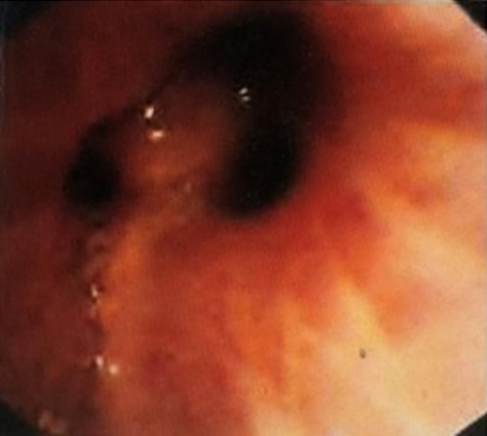
Figure 3 Flexible bronchoscopy displayed mucosal infiltrative changes at the level of the right upper lobe inlet and the right upper lobe bronchus was obstructed.

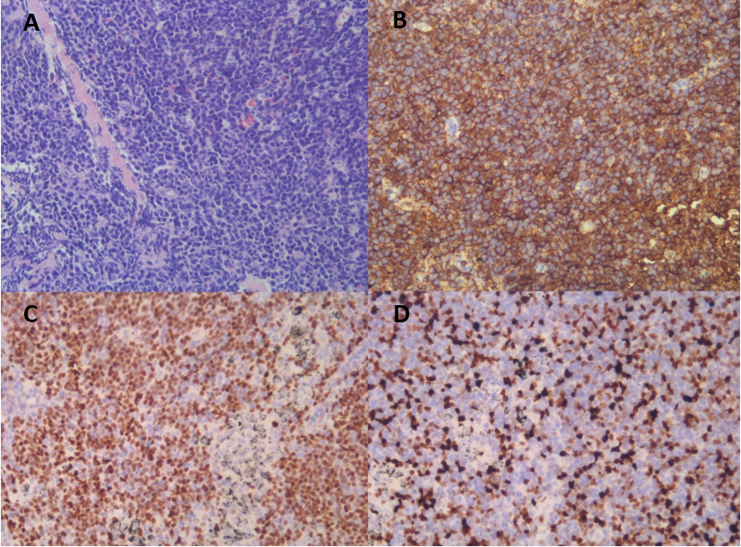
Figure 4 Mucosal endobronchial biopsy at the level of the right upper lobe inlet showing lymphoid hyperplasia. A: H&E staining; B and C: With immunohistochemical staining, these cells were found to be positive for CD5 and SOX11; D: The percentage of Ki67-positive cells was 25%. (Original magnification × 200).
Table 1 Mantle cell lymphoma with endobronchial involvement
Ref. | Age | Gender | Time between MCL first diagnosis and endobronchial involvement | Smoking history | Presenting symptoms | CyclinD1
Figgis et al^{[10]} | 53 | Female | More than three years (second relapse) | N/A | Cough, dyspnoea, wheeze | N/A
Miyoshi et al^{[11]} | 70 | Female | Five years (fifth relapse) | N/A | Stridor, respiratory failure | Positive
Imai et al^{[12]} | 86 | Male | Two years (first relapse) | N/A | Dyspnoea | N/A
Katono et al^{[2]} | 87 | Male | 0 (diagnosed by endobronchial biopsy) | Never-smoker | Dyspnoea on exertion | Positive
Tong et al^{[1]} | 65 | Male | 0 (diagnosed by endobronchial biopsy) | Current smoker with 40 pack-years | Productive cough, dyspnoea | Positive
Current case | 56 | Male | 0 (diagnosed by endobronchial biopsy) | Current smoker with 30 pack-years | Cough | Positive
N/A: Not applicable; MCL: Mantle cell lymphoma.

