Name of Journal: World Journal of Experimental Medicine
Manuscript NO: 86933
Manuscript Type: ORIGINAL ARTICLE

Case Control Study
Altered expression of miR-125a and dysregulated cytokines in systemic lupus erythematosus: Unveiling diagnostic and prognostic markers

Alsbihawi TQ et al. Dysregulation of miR-125a and cytokines in SLE

Tagreed Qassim Alsbihawi, Mojtaba Zare Ebrahimabad, Fakhri Sadat Seyedhosseini, Homa Davoodi, Nafiseh Abdolahi, Alireza Nazari, Saeed Mohammadi, Yaghoub Yazdani

Tagreed Qassim Alsbihawi, Department of Immunology, Faculty of Medicine, Golestan University of Medical Sciences, Gorgan 49341-74515, Iran

Mojtaba Zare Ebrahimabad, Metabolic Disorders Research Center, Golestan University of Medical Sciences, Gorgan 49341-74515, Iran

Fakhri Sadat Seyedhosseini, Yaghoub Yazdani, Laboratory Sciences Research Center, Golestan University of Medical Sciences, Gorgan 49341-74515, Iran

Homa Davoodi, Department of Immunology, Golestan University of Medical Sciences, Gorgan 4934174515, Iran

Nafiseh Abdolahi, Golestan Rheumatology Research Center, Golestan University of Medical Sciences, Gorgan 49341-74515, Iran

Alireza Nazari, Department of Surgery, Faculty of Medicine, Rafsanjan University of Medical Sciences, Rafsanjan 7717933777, Iran

Saeed Mohammadi, Golestan Research Center of Gastroenterology and Hepatology, Golestan University of Medical Sciences, Gorgan 49341-74515, Iran

Author contributions: Alsbihawi TQ, Seyedhosseini F, Davoodi H, Mohammadi S, and Yazdani Y contributed to conceptualization (Mohammadi S and Yazdani Y), contributed to methodology; Alsbihawi TQ, Ebrahimabad MZ, and Mohammadi S contributed to software; Alsbihawi TQ, Mohammadi S, and Yazdani Y contributed to validation; Alsbihawi TQ, and Mohammadi S contributed to formal analysis; Alsbihawi TQ, Ebrahimabad MZ, and Mohammadi S contributed to investigation; Alsbihawi TQ, Mohammadi S, and Yazdani Y contributed to resources; Alsbihawi TQ, Mohammadi S, and Yazdani Y contributed to data curation; Alsbihawi TQ, Ebrahimabad MZ, Seyedhosseini FS, Davoodi H, Abdolahi N, Mohammadi S, and Yazdani Y contributed to writing – original draft preparation; Alsbihawi TQ, Ebrahimabad MZ, Seyedhosseini FS, Davoodi H, Abdolahi N, Mohammadi S, and Yazdani Y contributed to writing – review and editing; Mohammadi S and Yazdani Y contributed to supervision; Mohammadi S and Yazdani Y contributed to project administration; Mohammadi S and Yazdani Y contributed to funding acquisition; All authors have read and approved the final version of the manuscript.

Supported by the Department of Research and Technology at Golestan University of Medical Sciences, No. 113017.

Corresponding author: Saeed Mohammadi, PhD, Assistant Professor, Golestan Research Center of Gastroenterology and Hepatology, Golestan University of Medical Sciences, R9Q4+242, Gorgan 49341-74515, Iran. s.mohammadi@goums.ac.ir

Received: July 14, 2023
Revised: September 18, 2023
Accepted: October 23, 2023
Published online: December 20, 2023

Abstract
BACKGROUND
Systemic lupus erythematosus (SLE) is a chronic autoimmune disorder impacting multiple organs, influenced by genetic factors, especially those related to the immune system. However, there is a need for new biomarkers in SLE. MicroRNA-125a (miR-125a) levels are decreased in T cells, B cells, and dendritic cells of SLE patients. MiR-125a plays a regulatory role in controlling the levels of tumor necrosis factor-alpha (TNF-α) and interleukin 12 (IL-12), which are crucial pro-inflammatory cytokines in SLE pathogenesis.

AIM
To assess the levels of miR-125a, IL-12, and TNF-α in SLE patients’ plasma, evaluating their diagnostic and prognostic value.

METHODS
The study included 100 healthy individuals, 50 newly diagnosed (ND), and 50 SLE patients undergoing treatment. The patients were monitored for a duration of 24 wk to observe and record instances of relapses. MiR-125a expression was measured using real-time reverse transcription polymerase chain reaction, while ELISA kits were used to assess IL-12 and TNF-α production.

RESULTS
The results showed significantly reduced miR-125a expression in SLE patients compared to healthy individuals, with the lowest levels in ND patients. TNF-α and IL-12 expression levels were significantly elevated in SLE patients, especially in the early stages of the disease. Receiver operating characteristic curve analyses, and Cox-Mantel Log-rank tests indicated miR-125a, TNF-α, and IL-12 as proper diagnostic biomarkers for SLE. A negative correlation was found between plasma miR-125a expression and IL-12/TNF-α levels in SLE patients.

CONCLUSION
Decreased miR-125a levels may be involved in the development of SLE, while elevated levels of IL-12 and TNF-α contribute to immune dysregulation. These findings offer new diagnostic and prognostic markers for SLE. Moreover, the negative correlation observed suggests an interaction between miR-125a, TNF-α, and IL-12. Further research is necessary to uncover the underlying mechanisms that govern these relationships.

Key Words: Systemic lupus erythematosus; microRNA-125a; Interleukin-12; Tumor necrosis factor alpha; Biomarker

©The Author(s) 2023. Published by Baishideng Publishing Group Inc. All rights reserved.

Citation: Alsbihawi TQ, Zare Ebrahimabad M, Seyedhosseini FS, Davoodi H, Abdolahi N, Nazari A, Mohammadi S, Yazdani Y. Altered expression of miR-125a and dysregulated cytokines in systemic lupus erythematosus: Unveiling diagnostic and prognostic markers. World J Exp Med 2023; 13(5): 102-114
URL: https://www.wjgnet.com/2220-315x/full/v13/i5/102.htm
DOI: https://dx.doi.org/10.5493/wjem.v13.i5.102

Core Tip: The aim of this study was to investigate the levels of microRNA-125a (miR-125a), interleukin 12 (IL-12), and tumor necrosis factor-alpha (TNF-α) in the plasma of systemic lupus erythematosus (SLE) patients, and assess the diagnostic and prognostic value of these biomarkers in SLE. The study included healthy individuals, newly diagnosed SLE patients, and SLE patients undergoing treatment. The results revealed decreased levels of miR-125a in SLE patients, particularly in newly diagnosed cases. On the other hand, elevated levels of IL-12 and TNF-α were observed in SLE patients, especially in the early stages of the disease. The study also identified miR-125a, TNF-α, and IL-12 as potential diagnostic biomarkers for SLE. The negative correlation observed between miR-125a and IL-12/TNF-α suggests an interaction between these factors. These findings provide insights into new diagnostic and prognostic markers for SLE, highlighting the importance of immune dysregulation in the disease.
INTRODUCTION
Systemic lupus erythematosus (SLE) involves an overactive immune system causing organ damage and posing significant health risks^{[1]}. SLE significantly reduces quality of life, increases susceptibility to premature death, and imposes substantial financial burdens^{[2]}. Both genetic and environmental factors contribute to the development of SLE, leading to the production of autoantibodies that attack and harm the body’s own tissues and organs^{[3,4]}. Epigenetic changes like deoxyribonucleic acid methylation, histone modifications, non-coding RNAs, and chromatin remodeling are associated with SLE development^{[5,6]}.
MicroRNAs (miRNAs) are small non-coding RNA molecules that regulate gene expression and play a significant role in various biological processes, impacting disease development and progression^{[7,8]}. miRNAs are crucial in regulating immune function and their imbalance is linked to autoimmunity in SLE. Specific miRNAs like miR-146a, miR-155, miR-148a, miR-21, and miR-125a are implicated in SLE^{[6,9,10]}. The imbalance of these miRNAs may contribute to SLE mechanisms by fostering autoreactivity, where the immune system reacts against the body’s own cells and tissues^{[11]}.
Research suggests reduced miR-125a levels in SLE patients’ T cells, B cells, and dendritic cells, leading to increased activation, proliferation, and inflammatory cytokine production^{[12]}. Restoring miR-125a levels shows potential as a treatment target, suppressing abnormal activation^{[13]}. It directly regulates key SLE-related cytokines and serves as a diagnostic and prognostic marker, correlating with disease activity and organ damage^{[14,15]}. Adjusting miR-125a expression in animal models has shown promise in reducing autoantibody production and improving outcomes^{[16]}, although further research is crucial for human application and personalized treatment strategies^{[11]}.
Imbalanced and dysfunctional cytokine production and signaling significantly contribute to SLE onset. Dysregulation of cytokines like interleukin (IL)-6, interferon alpha (IFN-α), tumour necrosis factor alpha (TNF-α), IL-17, and IL-12 is linked to SLE development and progression^{[17]}. IL-12, essential in Th1 cell differentiation and immune responses, is linked to SLE severity and lupus nephritis, exerting both pro-inflammatory and immune-regulatory effects. Therapeutic targeting of IL-12 in SLE yields mixed results, reflecting disease complexity and diverse signaling pathways^{[18-24]}. TNF-α, a pro-inflammatory cytokine, exhibits disrupted regulation in SLE, promoting abnormal immune function and autoantibody production. Its role in inflammation includes immune cell recruitment, cytokine and chemokine production, and endothelial cell activation, potentially leading to tissue damage and fibrosis in affected organs. While TNF-α inhibitors hold promise for SLE therapy, identifying responsive patient subsets and optimizing treatment strategies remain essential for improving outcomes^{[25-29]}.
Common molecular biomarkers for diagnosing and monitoring SLE include antinuclear antibodies, anti-dsDNA antibodies, complement levels, C-reactive protein, erythrocyte sedimentation rate, IFN-α, and B-cell activating factor. Yet, these markers have limitations such as lack of specificity, sensitivity, and predictability, high costs, and invasive testing, prompting the search for more reliable alternatives^{[30,31]}. MiR-125a regulates TNF-α and IL-12 by targeting their mRNA and influencing related signaling molecules like NF-κB, mitogen activated protein kinases, and signal transducer and activator of transcription proteins. Given the association of TNF-α and IL-12 dysregulation with inflammation, miR-125a holds potential as a therapeutic target. Adjusting miR-125a expression could restore cytokine balance and mitigate inflammation in conditions like rheumatoid arthritis and inflammatory bowel disease, although challenges persist in understanding its regulation^{[32-35]}.
To the best of our knowledge, no study has comprehensively examined the expressions of miR-125a, IL-12, and TNF-α in SLE patients collectively and evaluated their diagnostic and prognostic significance. Hence, the aim of this study was to analyze the levels of miR-125a, TNF-α, and IL-12 in the plasma of both SLE patients and healthy individuals, explore their potential correlations, and investigate their usefulness as diagnostic and prognostic biomarkers for SLE.

MATERIALS AND METHODS
Study participants and samplings
A total of 200 participants were enrolled in this study, including 50 newly diagnosed (ND) and 50 under-treatment (UT) SLE patients from the Rheumatology Clinic at Sayyad Shirazi Hospital in Gorgan. Additionally, 100 healthy individuals were included as controls. SLE cases were diagnosed based on the ACR criteria and UT group were receiving standard treatment for SLE without any immunomodulatory or immunosuppressive therapies that could impact the variables under investigation. The control group consisted of age, sex, and ethnicity-matched individuals with no history of autoimmune diseases. All participants were within the age range of 18-65 years and were excluded if they had other autoimmune diseases, active infections, or were pregnant. Under-treatment cases had a minimum disease duration of 6 mo, and their disease activity was recorded at the time of serum collection to minimize the influence of disease activity on the variables of interest. The study received ethical approval from the Committee of Ethics at Golestan University of Medical Sciences (GoUMS), Gorgan, Iran, and adhered to the principles of the Declaration of Helsinki. Informed consent was obtained from all participants prior to their inclusion. Blood samples (5 per participant) were collected and sent to the Research Central Laboratory at GoUMS. Plasma was isolated from the whole blood through centrifugation and stored at -80°C to ensure sample integrity and prevent contamination. Table 1 presents the levels of miR-125a, IL-12, and TNF-α in relation to various clinical characteristics of SLE patients.

ELISA cytokine assay
The expression of cytokines was examined using commercially available ELISA kits from ZellBio (ZellBio GmbH, Germany; IL-12 Cat.NO. RK00072-96; TNF-α Cat.NO. RK00030-96). We strictly adhered to the manufacturer’s instructions provided in the kit datasheet to ensure precise and reliable results. The optical density values from the samples and standards were measured using a StatFax 3300 ELISA reader (Awareness Technology, Inc., United States)^{[36]}. Non-linear regression analysis was employed to generate standard curves and calculate the concentrations of IL-12, and TNF-α in each sample, measured in picograms per milliliter (pg/mL) for IL-12 and pg/dL for TNF- α^{[37]}.

RNA isolation, cDNA synthesis and real time reverse transcription polymerase chain reaction
Total RNA was extracted from the plasma samples using TRIzol reagent (Invitrogen, United States) following a previously described protocol^{[38]}. The RNA concentration and purity were measured using a Nanodrop 2000 spectrophotometer (Thermo Fisher Scientific, United States). The RNA was either stored at -80°C or used immediately for subsequent applications, ensuring the use of RNase-free reagents and equipment throughout the process. For cDNA synthesis, the Sinnaclon First Strand cDNA Synthesis Kit (Cinnagen, Iran; Cat. NO. RT5201) was employed. To convert mature miRNA molecules into cDNA for amplification and quantification through quantitative polymerase chain reaction (qPCR), the stem-loop method was utilized, along with a specific stem-loop primer and a common reverse primer (as listed in Table 2). The expression levels of miRNA were quantitatively analyzed using Sina Green HS-qPCR Mix (Cinnagen, Iran; Cat. NO. MM2042) along with specific primers. The qPCR reactions were conducted on a Step One Plus cycler (Thermo Fisher Scientific, Iran). In this study, the cycle threshold (Ct) values of miR-125a plasma expression levels were normalized using the internal control U6 (small nuclear RNA U6). The 2-dCt method, a commonly used approach for normalizing gene and miRNA expression levels, was utilized for data analysis^{[39]}.

Statistical analysis
Statistical analyses were performed using SPSS 22.0 (IBM Corporation, United States) and Prism 8.0 (GraphPad Software Inc, United States). The Shapiro-Wilk test was used to assess the normality of the data, and parametric or non-parametric tests were chosen accordingly. Independent Samples t-test or Mann-Whitney U test was employed for comparisons between two groups, while one-way ANOVA with Tukey’s post-test or Kruskal-Wallis with Dunn-Bonferroni post-test was used for comparisons involving more than two groups. Pearson/Spearman tests were utilized for correlation analyses based on the distribution of the data. Receiver operating characteristic (ROC) curve analyses were conducted to evaluate the diagnostic utility of each variable, and logistic regression was employed for combined ROC curve analysis and prediction of variable performance. The Mantel-Haenszel (Mantel-Cox) log-rank test was utilized to assess the prognostic value of variables in predicting flare occurrence after a 24-wk follow-up. All experiments were performed in triplicates. The significance level for all statistical tests was set at 0.05, with a 95% confidence interval and a test power of 80%.

RESULTS
Expression levels of miR-125a, TNF-α, and IL-12 in SLE patients
This study analyzed the expression levels of miR125a, TNF-α, and IL-12 in SLE patients and normal subjects. The results indicated that the expression level of miR-125a was significantly decreased in SLE patients compared to normal subjects (P value < 0.0001) (Figure 1A). However, it was shown that miR-125a expression was lowest in ND SLE patients compared to those UT (P value < 0.01) (Figure 1B). TNF-α was significantly elevated in SLE patients compared to normal subjects (P value < 0.0001) (Figure 1C). The expression level of TNF-α was compared among SLE patients with different disease states (under treatment and newly diagnosed). The results showed that TNF-α expression was highest in ND SLE patients compared to UT patients (P value < 0.01) (Figure 1D). Independent samples t-test indicated that the expression level of IL-12 was significantly elevated in SLE patients compared to normal subjects (P value < 0.0001) (Figure 1E). The expression level of IL-12 was highest in ND SLE patients compared to those with longer disease durations (P value < 0.01) (Figure 1F).

The diagnostic utilities of miR-125a, TNF-α and IL-12
ROC curve analysis was conducted to evaluate the diagnostic utility of miR-125a, TNF-α and IL-12 to distinguish SLE patients from normal subjects, and ND SLE patients from UT. The area under the curve (AUC) for the expression of miR-125a [humic subjects (HS) vs Patients (PAT)] (Figure 2A) was 0.8370 (95%CI: 0.7803 to 0.8936; P < 0.0001). The cut-off point was set at the fold change level of 0.2365 with the sensitivity of 72.00% (95%CI: 62.51% to 79.86%), the specificity of 88.00% (95%CI: 80.19% to 93.00%), and likelihood ratio (LR) of 6.0. The calculated AUC for miR-125a (ND vs UT) (Figure 2B) was 0.8102 (95%CI: 0.7279 to 0.8925; P < 0.0001). The cut-off value was set at the FC level of 0.1849 with the sensitivity of 70.0% (95%CI: 56.25% to 80.90%), the specificity of 78.0% (95%CI: 64.76% to 87.25%), and LR of 3.182.
The AUC for the expression of TNF-α (HS vs PAT) (Figure 2C) was 0.9668 (95%CI: 0.9476 to 0.9860; P < 0.0001). The cut-off point was set at the level of 34.50 with the sensitivity of 84.00% (95%CI: 75.58% to 89.90%), the specificity of 92.00% (95%CI: 85.00% to 95.89%), and LR of 10.50. Similarly, the calculated AUC for TNF-α (ND vs UT) (Figure 2D) was 0.9748 (95%CI: 0.9513 to 0.9983; P < 0.0001). The cut-off value was set at the level of 44.50 with the sensitivity of 88.00% (95%CI: 76.20% to 94.38%), the specificity of 92.00% (95%CI: 81.16% to 96.85%), and LR of 11.00. The AUC for the expression of IL-12 (HS vs PAT) (Figure 2E) was 0.9778 (95%CI: 0.9599 to 0.9957; P < 0.0001). The cut-off point was set at the level of 69.50 pg/mL with the sensitivity of 91.00% (95%CI: 83.77% to 95.19%), the specificity of 98.00% (95%CI: 93.00% to 99.64%), and LR of 45.5. Similarly, the calculated AUC for IL-12 (ND vs UT) (Figure 2F) was 0.9600 (95%CI: 0.9289 to 0.9911; P < 0.0001). The cut-off value was set at the level of 119.50 pg/mL with the sensitivity of 72% (95%CI: 58.33% to 82.53%), the specificity of 98% (95%CI: 89.50% to 99.90%), and LR of 36.0.

The correlations of miR-125a with TNF-α and IL-12
We examined the relationship between plasma levels of miR-125a and IL-12 as well as miR-125a and TNF-α. The results of a Pearson correlation analysis revealed a negative correlation between IL-12 and miR-125a (r = -0.569, P < 0.0001) (Figure 3A). Similarly, a negative correlation was observed between TNF-α and miR-125a (r = -0.570, P < 0.0001) (Figure 3B).

The prognostic utilities of miR-125a, TNF-α and IL-12
The levels of miR-125a, TNF-α, and IL-12 were categorized as low or high based on the optimal cut-off points determined from ROC curve analyses. The predictive ability of these biomarkers for the outcome (Flare) of SLE patients was assessed using the log-rank test. The results showed that miR-125a did not significantly predict the outcome of SLE patients (P < 0.7151) (Figure 4A). TNF-α, on the other hand, had a predictive potential for the outcome of SLE patients, but the association was not statistically significant (P = 0.4828) (Figure 4B). In contrast, IL-12 demonstrated a significant predictive ability for the outcome of SLE patients (P = 0.0508) (Figure 4C) according to the log-rank test.

DISCUSSION
Recent research has focused on exploring the diagnostic and prognostic potential of various biomarkers in SLE. Our study investigated the levels of miR-125a, IL-12, and TNF-α in the plasma of individuals with SLE. The main objective was to evaluate the usefulness of these biomarkers in predicting SLE flares after 24 wk. By analyzing their diagnostic utilities and prognostic power, this study aimed to improve the detection and management of SLE.
Our study found a significant decrease in miR125a expression in SLE patients compared to normal individuals. Furthermore, miR125a expression was observed to be lowest in newly diagnosed SLE patients as compared to those who were already under treatment. These results are consistent with the findings of Zhao et al^{[15]}, who showed reduced expression of miR-125a and increased expression of its predicted target gene KLF13 in SLE patients. The study by Zhao et al^{[15]} had limited samples, while our study had a larger sample size. Furthermore, while Zhao et al^{[15]} did not categorize their SLE patients based on disease duration, our study did so and revealed that miR-125a expression is more reduced in newly-diagnosed SLE patients. Consequently, our findings suggest that treatment may have an impact on miR-125a expression levels in SLE patients. A study conducted by Zhang et al^{[40]} also aimed to investigate the roles of circRNAs in SLE and their findings were consistent with ours. They utilized microarray analysis, which was verified by qPCR, to demonstrate that miR-125a was downregulated in SLE patients as compared to healthy controls, and this reduction was linked to SLE characteristics. However, their sample size was limited (n = 3), which may have affected the generalizability of their results. Our results were consistent with those reported by Nascimento et al^{[41]}, who observed downregulation of miR-125 in peripheral blood mononuclear cells (PBMCs) of childhood-onset systemic lupus erythematosus (cSLE) patients. However, their study was limited to cSLE patients and PBMC samples, while our investigation focused on adult females and plasma samples. While our findings regarding reduced miR-125a expression in SLE patients are similar to those reported by Eissa et al^{[42]}, there is a difference in the focus of our studies. Eissa et al^{[42]} evaluated the plasma expression of miR-125a specifically in juvenile SLE patients, whereas our study did not differentiate between adult and juvenile SLE patients. In summary, our study provides additional evidence to support the idea that levels of miR-125a are lower in patients with SLE and decrease further in more severe cases of the disease.
The expression of miR-125a was found to be significantly different between individuals with SLE and those without the disease. To determine whether miR-125a could be a useful diagnostic tool for detecting SLE and distinguishing between newly diagnosed patients and those already undergoing treatment, we analyzed ROC curves. The results showed that miR-125a has an AUC of 0.8370 and 0.8102 for distinguishing SLE patients from normal individuals and newly diagnosed patients from those already under treatment, respectively. This suggests that miR-125a is effective in identifying SLE patients and differentiating them from healthy individuals or those at different stages of treatment. Biomarkers used for diagnosis can be classified based on their AUC values, which determine how accurately they can differentiate between two groups, such as healthy and diseased individuals. An AUC value of 0.9-1.0 indicates an excellent biomarker, meaning that it is highly dependable in identifying the presence or absence of a target condition. A biomarker with an AUC value between 0.8-0.9 is considered good, indicating reasonably accurate diagnostic ability. An AUC value of 0.7-0.8 is classified as fair, meaning that it has moderate diagnostic accuracy but may not be as reliable. Biomarkers with an AUC value below 0.7 should be considered poor and should not be relied upon for diagnoses^{[43]}. Therefore, miR-125a is classified as an effective diagnostic biomarker for SLE. While Zhang et al^{[40]} have suggested that miR-125a could serve as a diagnostic biomarker for SLE based on its significant reduction in SLE patients, and several studies have introduced miR-125a as diagnostic biomarkers for malignancies such as Pancreatic Cancer^{[44]}, and Cervical Cancer^{[45]}, our study is, to the best of our knowledge, the first to propose miR-125a as an effective diagnostic biomarker for both discriminating between SLE patients and healthy subjects, as well as distinguishing under-treatment patients from newly diagnosed ones. In this study, patients were also divided into high and low expression groups based on the suggested miR-125a cut-off point. These individuals were then monitored for 24 wk to determine if they experienced a flare or not. Based on the results of the log-rank test, it was concluded that miR-125a is not a predictor of SLE patient outcomes after 24 wk. It should be noted that, to date, no other research has explored the utility of miR-125a as a prognostic marker for SLE flare outcome. Further research is required to confirm these findings.
Regarding the function of miR-125a in SLE pathogenesis, Zhang and his colleagues suggested that miR-125a may play a role in the development of SLE. They speculated that miR-125a could help maintain self-tolerance by limiting the activity of T cells that promote inflammation, but they found that its expression is lower in T cells from individuals with SLE. Based on these findings, they proposed that increasing levels of miR-125a might be a promising strategy for treating SLE^{[46]}. In their study, Zhao and colleagues discovered that the expression of miR-125a was lower in individuals with SLE. They also observed an increase in KLF13, a gene that miR-125a is predicted to target. When miR-125a was overexpressed, it led to a significant decrease in the expression of RANTES and KLF13. The researchers found that miR-125a inhibited KLF13 expression in a dose-dependent manner using gain- and loss-of-function methods. Additionally, introducing miR-125a into T cells from SLE patients reduced the high levels of RANTES expression. Notably, the expression of miR-125a in T cells increased in a dose- and time-dependent manner^{[15]}. However, further research is needed.
Our study analyzed the expression level of TNF-α in SLE patients and normal subjects. The results showed that the expression level of TNF-α was significantly elevated in SLE patients compared to normal subjects. Additionally, TNF-α expression was highest in newly diagnosed SLE patients compared to those with longer disease durations. ROC curve analysis was used to assess the diagnostic accuracy of TNF-α in distinguishing SLE patients from normal subjects and newly diagnosed SLE patients from those under treatment. The AUC for TNF-α expression was high in both cases, indicating excellent diagnostic utility. However, Log-rank test results revealed that TNF-α was not capable of predicting the outcome (Flare) of SLE patients, after 24 wk. The role of TNF-α in the pathogenesis of SLE is well established, and our findings are supported by several confirmatory studies, further strengthening their significance. According to the results of their research, Idborg and colleagues carried out a study aimed at determining potential biomarkers for identifying disease activity in patients with SLE by evaluating a large group of cytokines and basic laboratory tests. They discovered that TNF-α had the most significant ability to differentiate between SLE patients and healthy individuals, with higher levels detected in SLE patients. The researchers also observed a strong association between TNF-α and measures of disease activity, particularly in the subgroup of patients with nephritis^{[47]}. In research conducted by Ma and colleagues, it was observed that SLE patients had higher levels of plasma TNF-α than healthy individuals, which is consistent with our own results. Additionally, the study found that TNF-α levels were elevated in SLE patients who were experiencing active symptoms compared to those who were not, as well as compared to healthy controls, which agrees with previous findings of increased TNF-α expression in patients who have recently been diagnosed with SLE^{[48]}. In addition to their other findings, Rana and colleagues discovered that the TNF-α gene was highly expressed in most patients with SLE. Furthermore, they observed a strong association between these expression levels and both renal involvement and disease activity as measured by SLE Disease Activity Index (SLEDAI) scores^{[49]}. According to Sabry and colleagues, SLE patients with active hematological disease exhibited elevated levels of TNF-α as compared to those with inactive disease or healthy individuals. Additionally, they found a strong positive correlation between the TNF-α levels and the SLEDAI score. The results of their study indicated that increased levels of TNF-α may contribute to the onset of anemia among Egyptian patients with Lupus Nephritis^{[50]}. According to our research, a study conducted by Sabry et al^{[27]} came up with similar results. They found that patients who had active SLE had significantly higher levels of TNF-α compared to those who had inactive SLE or were healthy. They concluded that measuring the levels of TNF-α in the blood could be a useful way to predict disease activity and distinguish between individuals with SLE and those without. The elevated levels of TNF-α and its possible role as a diagnostic marker was also confirmed in other studies by Aringer et al^{[51]}, Umare et al^{[52]}, and Zhu et al^{[53]}.
Regarding the association between TNF-α and diverse clinical manifestations in SLE, notably, patients with CNS involvement exhibit markedly elevated TNF-α levels in contrast to those without CNS involvement. Furthermore, TNF-α levels are significantly heightened in lupus patients overall, particularly in those with NPLE. Additionally, a substantial TNF-α level increase is observed in patients presenting with multiple focal pattern hypoperfusion, the predominant SPECT pattern in individuals with NPLE^{[54]}. Diffusion tensor imaging (DTI) relies on assessing water diffusion within cellular compartments. In this context, DTI holds the potential to serve as an imaging biomarker for neuropsychiatric systemic lupus erythematosus and a valuable tool for correlation with TNF-α levels^{[55]}.
We also analyzed the expression level of IL-12 in SLE patients and normal subjects. The results revealed that the expression level of IL-12 was significantly higher in SLE patients than in normal subjects. Additionally, among SLE patients, those who were newly diagnosed had the highest levels of IL-12 expression compared to those who had been under treatment for longer periods. The diagnostic ability of IL-12 to distinguish SLE patients from normal subjects and newly diagnosed SLE patients from those under treatment was evaluated through ROC curve analysis, suggesting that IL-12 may be a useful diagnostic marker for SLE, particularly in distinguishing between newly diagnosed and under-treated patients. Following the patients for 24 wk, Log-rank test results revealed that IL-12 was capable of predicting the outcome (Flare) of SLE patients. Similarly, the role of IL-12 in SLE pathogenesis is established in previous studies, and there are several studies highlighting the elevation of IL-12 in SLE patients. According to our discoveries, Capper and colleagues demonstrated that the levels of IL-12 were noticeably elevated in individuals with SLE when compared to those who did not have the condition. This difference was observed irrespective of whether the SLE patients were having an active episode of the disease or not^{[56]}. Lauwerys and colleagues also noted similar results, where they observed an increase in IL-12 p40 levels in the blood of SLE patients. They further demonstrated that the administration of immunosuppressive therapy resulted in a significant decrease in serum IL-12 levels, which verified the lower levels of IL-12 found in individuals without SLE in our study^{[20]}, supported in the studies conducted by Qiu et al^{[57]}, and, Uzrail et al^{[58]}.
Despite the significant role of IL-12 in SLE pathogenesis, few studies assessed its diagnostic and prognostic accuracy for SLE. In a study by Ye et al^{[22]} SLE patients had significantly higher plasma levels of IL-12, and the area under the curve (AUC) for IL-12 was 0.756, indicating its potential as biomarkers for SLE diagnosis. Through our study on a larger sample size, we have discovered that IL-12 can serve as an excellent biomarker for SLE. While Ye et al^{[22]} identified it as a fair biomarker, our findings indicate its potential as a stronger indicator of the disease. Additionally, our study is the first to evaluate the occurrence of flares in SLE patients after 24 wk of follow-up. Thus, our results provide valuable insights into the long-term management and prognosis of SLE.
While our study yielded promising results regarding the potential diagnostic and prognostic utilities of miR-125a, TNF-α, and IL-12 in SLE patients, we acknowledge that there were limitations to our research. Despite having a larger sample size compared to previous studies, the generalizability of our findings could be further improved by increasing the sample size even more. Furthermore, as our study only assessed the plasma levels of these molecules, it may be worthwhile to explore their expression in different types of cells or tissues to gain a more comprehensive understanding of their role in SLE pathogenesis. Moreover, it is important to note that our study had a cross-sectional design which limits our ability to establish a cause-and-effect relationship between the levels of these molecules and disease progression. Therefore, we suggest conducting a longitudinal cohort study to further investigate the potential causal relationships between miR-125a, TNF-α, and IL-12 levels and SLE progression.

CONCLUSION
Our study has shed light on the potential of miR-125a, TNF-α, and IL-12 as biomarkers for SLE diagnosis and management. We found that the downregulation of miR-125a is an effective diagnostic tool for distinguishing between SLE patients and healthy individuals, as well as newly diagnosed patients from those under treatment. Furthermore, TNF-α and IL-12 levels were elevated in SLE patients, with TNF-α serving as a useful diagnostic marker and IL-12 being both a diagnostic and prognostic marker for SLE flare outcome. These findings could contribute to improved patient outcomes and better management of SLE. However, further research is needed to fully understand the mechanisms by which these biomarkers are involved in SLE pathogenesis and their potential as therapeutic targets.

ARTICLE HIGHLIGHTS
Research background
Systemic lupus erythematosus (SLE) is a long-lasting autoimmune disorder that impacts multiple organs and significantly increases the risk of morbidity and mortality. MicroRNA-125a (miR-125a) levels are decreased in T cells, B cells, and dendritic cells of SLE patients. MiR-125a plays a regulatory role in controlling the levels of tumor necrosis factor-alpha (TNF-α) and interleukin 12 (IL-12), which are crucial pro-inflammatory cytokines in SLE pathogenesis.

Research motivation
Recent research has focused on exploring the diagnostic and prognostic potential of various biomarkers in SLE. Since the levels of miR-125a, TNF-α, and IL-12 are altered in SLE, these molecules could be introduced as novel biomarkers.

Research objectives
The aim of this study was to analyze the levels of miR-125a, TNF-α, and IL-12 in the plasma of both SLE patients and healthy individuals, explore their potential correlations, and investigate their usefulness as diagnostic and prognostic biomarkers for SLE.

Research methods
The study included 100 healthy individuals, 50 newly diagnosed (ND), and 50 SLE patients undergoing treatment. The patients were monitored for a duration of 24 wk to observe and record instances of relapses. MiR-125a expression was measured using real-time reverse transcription polymerase chain reaction, while ELISA kits were used to assess IL-12 and TNF-α production.

Research results
The results showed significantly reduced miR-125a expression in SLE patients compared to healthy individuals, with the lowest levels in ND patients. TNF-α and IL-12 expression levels were significantly elevated in SLE patients, especially in the early stages of the disease. Receiver operating characteristic curve analyses, and Cox-Mantel Log-rank tests indicated miR-125a, PDCD4, and IL-10 as proper diagnostic biomarkers for SLE. A negative correlation was found between plasma miR-125a expression and IL-12/TNF-α levels in SLE patients.

Research conclusions
Decreased miR-125a levels may be involved in the development of SLE, while elevated levels of IL-12 and TNF-α contribute to immune dysregulation. These findings offer new diagnostic and prognostic markers for SLE. Moreover, the negative correlation observed suggests an interaction between miR-125a, TNF-α, and IL-12.

Research perspectives
Further research is necessary to uncover the underlying mechanisms that govern the relationships between miR-125a, TNF-α, and IL-12 in SLE pathogenesis.

ACKNOWLEDGEMENTS
We extend our heartfelt gratitude and appreciation to the personnel and staff of Sayyad Shirazi Hospital and Research Central Laboratory at Golestan University of Medical Sciences for their invaluable support and assistance throughout this research endeavor.

REFERENCES
1 Dörner T, Furie R. Novel paradigms in systemic lupus erythematosus. Lancet 2019; 393: 2344-2358 [PMID: 31180031 DOI: 10.1016/S0140-6736(19)30546-X]
2 Danchenko N, Satia JA, Anthony MS. Epidemiology of systemic lupus erythematosus: a comparison of worldwide disease burden. Lupus 2006; 15: 308-318 [PMID: 16761508 DOI: 10.1191/0961203306lu2305xx]
3 Pons-Estel GJ, Alarcón GS, Scofield L, Reinlib L, Cooper GS. Understanding the epidemiology and progression of systemic lupus erythematosus. Semin Arthritis Rheum 2010; 39: 257-268 [PMID: 19136143 DOI: 10.1016/j.semarthrit.2008.10.007]
4 Saghaeian Jazi M, Mohammadi S, Zare Ebrahimabad M, Sedighi S, Abdolahi N, Tabarraei A, Yazdani Y. Genetic variation in CYP1A1 and AHRR genes increase the risk of systemic lupus erythematosus and exacerbate disease severity in smoker patients. J Biochem Mol Toxicol 2021; 35: e22916 [PMID: 34580959 DOI: 10.1002/jbt.22916]
5 Markopoulou A, Kyttaris VC. Small molecules in the treatment of systemic lupus erythematosus. Clin Immunol 2013; 148: 359-368 [PMID: 23158694 DOI: 10.1016/j.clim.2012.09.009]
6 Eghbalpour F, Aghaei M, Ebrahimi M, Tahsili MR, Golalipour M, Mohammadi S, Yazdani Y. Effect of indole-3-carbinol on transcriptional profiling of wound-healing genes in macrophages of systemic lupus erythematosus patients: an RNA sequencing assay. Lupus 2020; 29: 954-963 [PMID: 32517571 DOI: 10.1177/0961203320929746]
7 Pasquinelli AE, Hunter S, Bracht J. MicroRNAs: a developing story. Curr Opin Genet Dev 2005; 15: 200-205 [PMID: 15797203 DOI: 10.1016/j.gde.2005.01.002]
8 Hammond SM. An overview of microRNAs. Adv Drug Deliv Rev 2015; 87: 3-14 [PMID: 25979468 DOI: 10.1016/j.addr.2015.05.001]
9 Ibrahim SA, Afify AY, Fawzy IO, El-Ekiaby N, Abdelaziz AI. The curious case of miR-155 in SLE. Expert Rev Mol Med 2021; 23: e11 [PMID: 34470679 DOI: 10.1017/erm.2021.11]
10 Omidi F, Khoshmirsafa M, Kianmehr N, Faraji F, Delbandi A, Seif F, Shekarabi M. Comparison of circulating miR-148a and miR-126 with autoantibodies as biomarkers of lupus nephritis in patients with SLE. J Immunoassay Immunochem 2022; 43: 634-647 [PMID: 35938736 DOI: 10.1080/15321819.2022.2099225]
11 Miao CG, Yang YY, He X, Huang C, Huang Y, Zhang L, Lv XW, Jin Y, Li J. The emerging role of microRNAs in the pathogenesis of systemic lupus erythematosus. Cell Signal 2013; 25: 1828-1836 [PMID: 23707525 DOI: 10.1016/j.cellsig.2013.05.006]
12 Choi D, Kim J, Yang JW, Kim JH, Park S, Shin JI. Dysregulated MicroRNAs in the Pathogenesis of Systemic Lupus Erythematosus: A Comprehensive Review. Int J Biol Sci 2023; 19: 2495-2514 [PMID: 37215992 DOI: 10.7150/ijbs.74315]
13 Zhang Y, Chen X, Deng Y. miR-125a-3p decreases levels of interlukin-17 and suppresses renal fibrosis via down-regulating TGF-β1 in systemic lupus erythematosus mediated Lupus nephritic mice. Am J Transl Res 2019; 11: 1843-1853 [PMID: 30972208]
14 Chi M, Ma K, Li Y, Quan M, Han Z, Ding Z, Liang X, Zhang Q, Song L, Liu C. Immunological Involvement of MicroRNAs in the Key Events of Systemic Lupus Erythematosus. Front Immunol 2021; 12: 699684 [PMID: 34408748 DOI: 10.3389/fimmu.2021.699684]
15 Zhao X, Tang Y, Qu B, Cui H, Wang S, Wang L, Luo X, Huang X, Li J, Chen S, Shen N. MicroRNA-125a contributes to elevated inflammatory chemokine RANTES levels via targeting KLF13 in systemic lupus erythematosus. Arthritis Rheum 2010; 62: 3425-3435 [PMID: 20589685 DOI: 10.1002/art.27632]
16 Hu R, O'Connell RM. MicroRNA control in the development of systemic autoimmunity. Arthritis Res Ther 2013; 15: 202 [PMID: 23379780 DOI: 10.1186/ar4131]
17 Cross JT, Benton HP. The roles of interleukin-6 and interleukin-10 in B cell hyperactivity in systemic lupus erythematosus. Inflamm Res 1999; 48: 255-261 [PMID: 10391113 DOI: 10.1007/s000110050456]
18 Maczynska I, Millo B, Ratajczak-Stefańska V, Maleszka R, Szych Z, Kurpisz M, Giedrys-Kalemba S. Proinflammatory cytokine (IL-1beta, IL-6, IL-12, IL-18 and TNF-alpha) levels in sera of patients with subacute cutaneous lupus erythematosus (SCLE). Immunol Lett 2006; 102: 79-82 [PMID: 16154204 DOI: 10.1016/j.imlet.2005.08.001]
19 Liu TF, Jones BM, Wong RW, Srivastava G. Impaired production of IL-12 in systemic lupus erythematosus. III: deficient IL-12 p40 gene expression and cross-regulation of IL-12, IL-10 and IFN-gamma gene expression. Cytokine 1999; 11: 805-811 [PMID: 10525320 DOI: 10.1006/cyto.1999.0512]
20 Lauwerys BR, Van Snick J, Houssiau FA. Serum IL-12 in systemic lupus erythematosus: absence of p70 heterodimers but presence of p40 monomers correlating with disease activity. Lupus 2002; 11: 384-387 [PMID: 12139377 DOI: 10.1191/0961203302lu213oa]
21 Larosa M, Zen M, Gatto M, Jesus D, Zanatta E, Iaccarino L, Inês L, Doria A. IL-12 and IL-23/Th17 axis in systemic lupus erythematosus. Exp Biol Med (Maywood) 2019; 244: 42-51 [PMID: 30664357 DOI: 10.1177/1535370218824547]
22 Ye Q-L, Guoliu R-N, Qin H, Shen Y-Y, Wang B, Zhai Z-MJIJCEP. Elevated plasma levels of IL-12 and IFN-γ in systemic lupus erythematosus. Lupus 2017; 10: 3286-3291 [DOI: 10.1177/0961203316646462]
23 La Cava A. Anticytokine therapies in systemic lupus erythematosus. Immunotherapy 2010; 2: 575-582 [PMID: 20636010 DOI: 10.2217/imt.10.29]
24 Squatrito D, Emmi G, Silvestri E, Ciucciarelli L, D'Elios MM, Prisco D, Emmi L. Pathogenesis and potential therapeutic targets in systemic lupus erythematosus: from bench to bedside. Auto Immun Highlights 2014; 5: 33-45 [PMID: 26000154 DOI: 10.1007/s13317-014-0058-y]
25 Svenungsson E, Fei GZ, Jensen-Urstad K, de Faire U, Hamsten A, Frostegard J. TNF-alpha: a link between hypertriglyceridaemia and inflammation in SLE patients with cardiovascular disease. Lupus 2003; 12: 454-461 [PMID: 12873047 DOI: 10.1191/0961203303lu412oa]
26 Postal M, Appenzeller S. The role of Tumor Necrosis Factor-alpha (TNF-α) in the pathogenesis of systemic lupus erythematosus. Cytokine 2011; 56: 537-543 [PMID: 21907587 DOI: 10.1016/j.cyto.2011.08.026]
27 Sabry A, Sheashaa H, El-Husseini A, Mahmoud K, Eldahshan KF, George SK, Abdel-Khalek E, El-Shafey EM, Abo-Zenah H. Proinflammatory cytokines (TNF-alpha and IL-6) in Egyptian patients with SLE: its correlation with disease activity. Cytokine 2006; 35: 148-153 [PMID: 17027280 DOI: 10.1016/j.cyto.2006.07.023]
28 Dadashzadeh E, Saghaeian Jazi M, Abdolahi N, Mohammadi S, Saeidi M. Comparison of a Suggested Model of Fibrosis in Human Dermal Fibroblasts by Serum from Systemic Sclerosis Patients with Transforming Growth Factor β Induced in vitro Model. Int J Mol Cell Med 2022; 11: 31-40 [PMID: 36397805 DOI: 10.22088/IJMCM.BUMS.11.1.31]
29 Aringer M, Smolen JS. The role of tumor necrosis factor-alpha in systemic lupus erythematosus. Arthritis Res Ther 2008; 10: 202 [PMID: 18226185 DOI: 10.1186/ar2341]
30 Mohammadi S, Sedighi S, Memarian A, Yazdani YJL. Overexpression of interferon-γ and indoleamine 2, 3-dioxygenase in systemic lupus erythematosus: relationship with the disease activity. Laboratoriums Medizin 2017; 41: 41-47 [DOI: 10.1515/Labmed-2016-0076]
31 Ahearn JM, Liu CC, Kao AH, Manzi S. Biomarkers for systemic lupus erythematosus. Transl Res 2012; 159: 326-342 [PMID: 22424435 DOI: 10.1016/j.trsl.2012.01.021]
32 Banerjee S, Cui H, Xie N, Tan Z, Yang S, Icyuz M, Thannickal VJ, Abraham E, Liu G. miR-125a-5p regulates differential activation of macrophages and inflammation. J Biol Chem 2013; 288: 35428-35436 [PMID: 24151079 DOI: 10.1074/jbc.M112.426866]
33 Ha TY. The Role of MicroRNAs in Regulatory T Cells and in the Immune Response. Immune Netw 2011; 11: 11-41 [PMID: 21494372 DOI: 10.4110/in.2011.11.1.11]
34 Lee HM, Kim TS, Jo EK. MiR-146 and miR-125 in the regulation of innate immunity and inflammation. BMB Rep 2016; 49: 311-318 [PMID: 26996343 DOI: 10.5483/bmbrep.2016.49.6.056]
35 Tili E, Michaille JJ, Croce CM. MicroRNAs play a central role in molecular dysfunctions linking inflammation with cancer. Immunol Rev 2013; 253: 167-184 [PMID: 23550646 DOI: 10.1111/imr.12050]
36 Roohi A, Yazdani Y, Khoshnoodi J, Jazayeri SM, Carman WF, Chamankhah M, Rashedan M, Shokri F. Differential reactivity of mouse monoclonal anti-HBs antibodies with recombinant mutant HBs antigens. World J Gastroenterol 2006; 12: 5368-5374 [PMID: 16981270 DOI: 10.3748/wjg.v12.i33.5368]
37 Yazdani Y, Sadeghi H, Alimohammadian M, Andalib A, Moazen F, Rezaei A. Expression of an innate immune element (mouse hepcidin-1) in baculovirus expression system and the comparison of its function with synthetic human hepcidin-25. Iran J Pharm Res 2011; 10: 559-568 [PMID: 24250389]
38 Jazi MS, Mohammadi S, Yazdani Y, Sedighi S, Memarian A, Aghaei M. Effects of valproic acid and pioglitazone on cell cycle progression and proliferation of T-cell acute lymphoblastic leukemia Jurkat cells. Iran J Basic Med Sci 2016; 19: 779-786 [PMID: 27635203]
39 Ghasemi H, Jamshidi A, Ghatee MA, Mazhab-Jafari K, Khorasani M, Rahmati M, Mohammadi S. PPARγ activation by pioglitazone enhances the anti-proliferative effects of doxorubicin on pro-monocytic THP-1 leukemia cells via inducing apoptosis and G2/M cell cycle arrest. J Recept Signal Transduct Res 2022; 42: 429-438 [PMID: 34645362 DOI: 10.1080/10799893.2021.1988972]
40 Zhang C, Wang X, Chen Y, Wu Z, Zhang C, Shi W. The down-regulation of hsa_circ_0012919, the sponge for miR-125a-3p, contributes to DNA methylation of CD11a and CD70 in CD4(+) T cells of systemic lupus erythematous. Clin Sci (Lond) 2018; 132: 2285-2298 [PMID: 30237316 DOI: 10.1042/CS20180403]
41 Nascimento DQ, da Silva IIFG, Lima CAD, Cavalcanti AS, Roberti LR, Queiroz RGP, Ferriani VPL, Crovella S, Carvalho LM, Sandrin-Garcia P. Expression of the miR-9-5p, miR-125b-5p and its target gene NFKB1 and TRAF6 in childhood-onset systemic lupus erythematosus (cSLE). Autoimmunity 2022; 55: 515-519 [PMID: 36177494 DOI: 10.1080/08916934.2022.2128781]
42 Eissa E, Morcos B, Abdelkawy RFM, Ahmed HH, Kholoussi NM. Association of microRNA-125a with the clinical features, disease activity and inflammatory cytokines of juvenile-onset lupus patients. Lupus 2021; 30: 1180-1187 [PMID: 33866896 DOI: 10.1177/09612033211010328]
43 Babania O, Mohammadi S, Yaghoubi E, Sohrabi A, Sadat Seyedhosseini F, Abdolahi N, Yazdani Y. The expansion of CD14+ CD163+ subpopulation of monocytes and myeloid cells-associated cytokine imbalance; candidate diagnostic biomarkers for celiac disease (CD). J Clin Lab Anal 2021; 35: e23984 [PMID: 34449925 DOI: 10.1002/jcla.23984]
44 Tang S. miR-125 is a Novel Biomarker in Pancreatic Cancer Patients. University of Pittsburgh, 2014 [DOI: 10.7150/jca.31361]
45 Lv A, Tu Z, Huang Y, Lu W, Xie B. Circulating exosomal miR-125a-5p as a novel biomarker for cervical cancer. Oncol Lett 2021; 21: 54 [PMID: 33281965 DOI: 10.3892/ol.2020.12316]
46 Zhang J, Chen C, Fu H, Yu J, Sun Y, Huang H, Tang Y, Shen N, Duan Y. MicroRNA-125a-Loaded Polymeric Nanoparticles Alleviate Systemic Lupus Erythematosus by Restoring Effector/Regulatory T Cells Balance. ACS Nano 2020; 14: 4414-4429 [PMID: 32203665 DOI: 10.1021/acsnano.9b09998]
47 Idborg H, Eketjäll S, Pettersson S, Gustafsson JT, Zickert A, Kvarnström M, Oke V, Jakobsson PJ, Gunnarsson I, Svenungsson E. TNF-α and plasma albumin as biomarkers of disease activity in systemic lupus erythematosus. Lupus Sci Med 2018; 5: e000260 [PMID: 29955370 DOI: 10.1136/lupus-2018-000260]
48 Ma CY, Jiao YL, Zhang J, Yang QR, Zhang ZF, Shen YJ, Chen ZJ, Zhao YR. Elevated plasma level of HMGB1 is associated with disease activity and combined alterations with IFN-α and TNF-α in systemic lupus erythematosus. Rheumatol Int 2012; 32: 395-402 [PMID: 21120500 DOI: 10.1007/s00296-010-1636-6]
49 Rana A, Minz RW, Aggarwal R, Anand S, Pasricha N, Singh S. Gene expression of cytokines (TNF-α, IFN-γ), serum profiles of IL-17 and IL-23 in paediatric systemic lupus erythematosus. Lupus 2012; 21: 1105-1112 [PMID: 22759859 DOI: 10.1177/0961203312451200]
50 Sabry A, Elbasyouni SR, Sheashaa HA, Alhusseini AA, Mahmoud K, George SK, Kaleek EA, abo-Zena H, Kalil AM, Mohsen T, Rahim MA, El-samanody AZ. Correlation between levels of TNF-alpha and IL-6 and hematological involvement in SLE Egyptian patients with lupus nephritis. Int Urol Nephrol 2006; 38: 731-737 [PMID: 17260180 DOI: 10.1007/s11255-006-0047-9]
51 Aringer M, Feierl E, Steiner G, Stummvoll GH, Höfler E, Steiner CW, Radda I, Smole JS, Graninger WB. Increased bioactive TNF in human systemic lupus erythematosus: associations with cell death. Lupus 2002; 11: 102-108 [PMID: 11958572 DOI: 10.1191/0961203302lu160oa]
52 Umare V, Pradhan V, Nadkar M, Rajadhyaksha A, Patwardhan M, Ghosh KK, Nadkarni AH. Effect of proinflammatory cytokines (IL-6, TNF-α, and IL-1β) on clinical manifestations in Indian SLE patients. Mediators Inflamm 2014; 2014: 385297 [PMID: 25548434 DOI: 10.1155/2014/385297]
53 Zhu LJ, Landolt-Marticorena C, Li T, Yang X, Yu XQ, Gladman DD, Urowitz MB, Fortin PR, Wither JE. Altered expression of TNF-alpha signaling pathway proteins in systemic lupus erythematosus. J Rheumatol 2010; 37: 1658-1666 [PMID: 20516030 DOI: 10.3899/jrheum.091123]
54 El-Zorkany BK, Mahmoud GA, Shahin HA, Moustafa H, Shahin AA. Tumor necrosis factor-alpha and neuropsychiatric lupus erythematosus: relation to single photon emission computed tomography findings. Mod Rheumatol 2003; 13: 250-255 [PMID: 24387213 DOI: 10.3109/s10165-003-0231-z]
55 Postal M, Lapa AT, Reis F, Rittner L, Appenzeller S. Magnetic resonance imaging in neuropsychiatric systemic lupus erythematosus: current state of the art and novel approaches. Lupus 2017; 26: 517-521 [PMID: 28394232 DOI: 10.1177/0961203317691373]
56 Capper ER, Maskill JK, Gordon C, Blakemore AI. Interleukin (IL)-10, IL-1ra and IL-12 profiles in active and quiescent systemic lupus erythematosus: could longitudinal studies reveal patient subgroups of differing pathology? Clin Exp Immunol 2004; 138: 348-356 [PMID: 15498048 DOI: 10.1111/j.1365-2249.2004.02607.x]
57 Qiu F, Song L, Yang N, Li X. Glucocorticoid downregulates expression of IL-12 family cytokines in systemic lupus erythematosus patients. Lupus 2013; 22: 1011-1016 [PMID: 23884985 DOI: 10.1177/0961203313498799]
58 Uzrail AH, Assaf AM, Abdalla SS. Correlations of Expression Levels of a Panel of Genes (IRF5, STAT4, TNFSF4, MECP2, and TLR7) and Cytokine Levels (IL-2, IL-6, IL-10, IL-12, IFN-γ, and TNF-α) with Systemic Lupus Erythematosus Outcomes in Jordanian Patients. Biomed Res Int 2019; 2019: 1703842 [PMID: 31871930 DOI: 10.1155/2019/1703842]

Footnotes
Institutional review board statement: The study obtained approval from the ethics committee at Golestan University of Medical Sciences (Code of Ethics: IR.GOUMS.REC.1401.261).

Informed consent statement: All participants provided informed consent prior to their involvement. Utmost confidentiality and privacy were ensured throughout the study, and precautionary measures were implemented to prevent any form of undue influence or coercion.

Conflict-of-interest statement: All the authors declare that there are no conflicts of interest to disclose.

Data sharing statement: The data supporting the findings of this study will be made accessible upon reasonable request by the corresponding author, Dr. Saeed Mohammadi (s.mohammadi@goums.ac.ir).

STROBE statement: The authors have read the STROBE Statement – checklist of items, and the manuscript was prepared and revised according to the STROBE Statement – checklist of items.

Open-Access: This article is an open-access article that was selected by an in-house editor and fully peer-reviewed by external reviewers. It is distributed in accordance with the Creative Commons Attribution NonCommercial (CC BY-NC 4.0) license, which permits others to distribute, remix, adapt, build upon this work non-commercially, and license their derivative works on different terms, provided the original work is properly cited and the use is non-commercial. See: https://creativecommons.org/Licenses/by-nc/4.0/

Provenance and peer review: Invited article; Externally peer reviewed.
Peer-review model: Single blind

Peer-review started: July 14, 2023
First decision: September 13, 2023
Article in press: October 23, 2023

Specialty type: Medicine, research and experimental
Country/Territory of origin: Iran
Peer-review report’s scientific quality classification
Grade A (Excellent): 0
Grade B (Very good): B
Grade C (Good): C, C
Grade D (Fair): 0
Grade E (Poor): 0

P-Reviewer: Reis F, Brazil; Gong F, China S-Editor: Liu JH L-Editor: A P-Editor: Yuan YY

Figure Legends
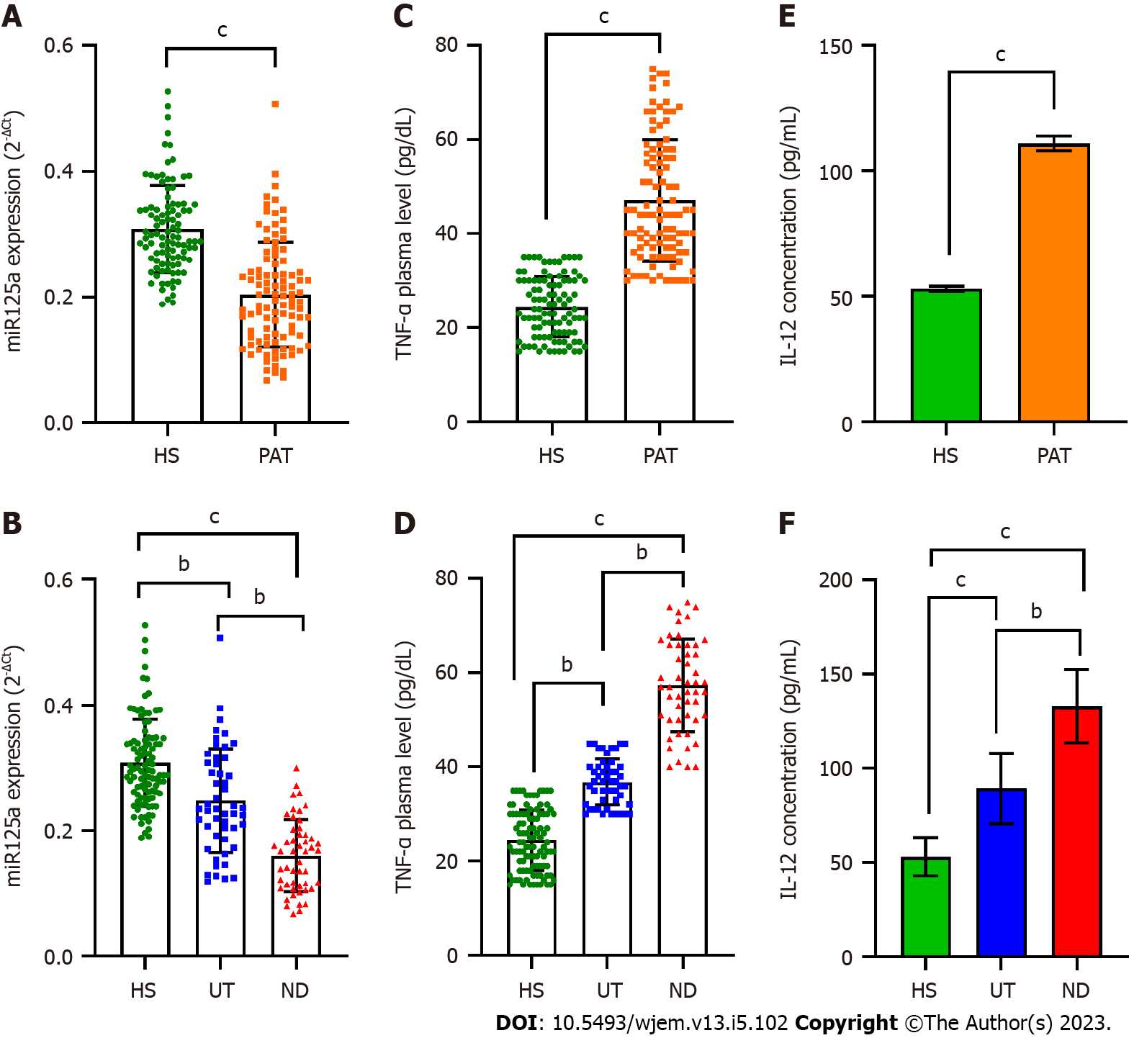
Figure 1 The expression levels of microRNA-125a, tumor necrosis factor-alpha, and interleukin 12 in systemic lupus erythematosus patients and normal subjects. This study examined the expression levels of microRNA-125a (miR-125a), tumor necrosis factor-alpha (TNF-α), and interleukin 12 (IL-12) in systemic lupus erythematosus (SLE) patients and normal subjects. A: The findings revealed that miR-125a expression was significantly lower in SLE patients compared to normal subjects; B: With the lowest levels observed in newly diagnosed patients; C: TNF-α expression was higher in SLE patients compared to normal subjects; D: Its levels were highest in newly diagnosed patients; E: Similarly, the expression of IL-12 was significantly elevated in SLE patients compared to normal subjects; F: It was highest in newly diagnosed patients. The Independent Samples t-test or Mann-Whitney U test were employed for comparing two groups, while one-way ANOVA with Tukey’s post-test or Kruskal-Wallis with Dunn-Bonferroni post-test were used for comparing more than two groups. The error bars represent means ± SD. Significance levels are denoted as ^{b}P < 0.01 and ^{c}P < 0.0001. HS: Humic subjects; PAT: Patients; UT: Under-treatment; ND: Newly diagnosed.
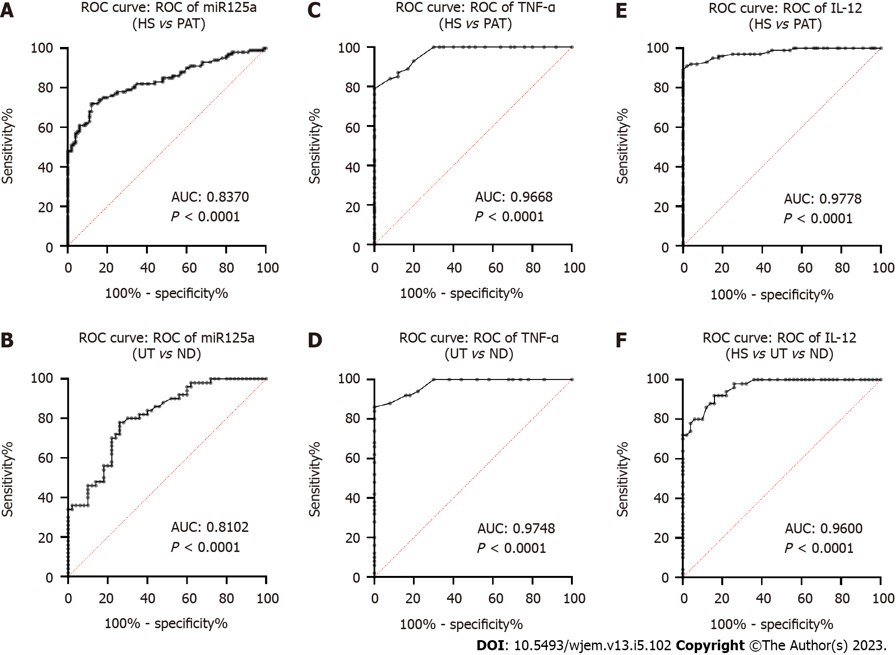
Figure 2 Diagnostic utilities of microRNA-125a, tumor necrosis factor-alpha, and interleukin 12 in systemic lupus erythematosus patients. Receiver operating characteristic curve analysis was performed to assess the diagnostic accuracy of microRNA-125a (miR-125a), tumor necrosis factor-alpha (TNF-α), and interleukin 12 (IL-12) in distinguishing systemic lupus erythematosus (SLE) patients from normal subjects and newly diagnosed SLE patients from those under treatment. A: The area under the curve (AUC) values for miR-125a were 0.8370 (95%CI: 0.7803 to 0.8936; P < 0.0001) in SLE patients vs normal subjects; B: 0.8102 (95%CI: 0.7279 to 0.8925; P < 0.0001) in newly diagnosed vs under treatment SLE patients; C: For TNF-α, the AUC values were 0.9668 (95%CI: 0.9476 to 0.9860; P < 0.0001) in SLE patients vs normal subjects; D: 0.9748 (95%CI: 0.9513 to 0.9983; P < 0.0001) in newly diagnosed vs. under treatment SLE patients; E: Regarding IL-12, the AUC values were 0.9778 (95%CI: 0.9599 to 0.9957; P < 0.0001) in SLE patients vs normal subjects; F: 0.9600 (95%CI: 0.9289 to 0.9911; P < 0.0001) in newly diagnosed vs under treatment SLE patients. HS: Humic subjects; PAT: Patients; UT: Under-treatment; ND: Newly diagnosed.
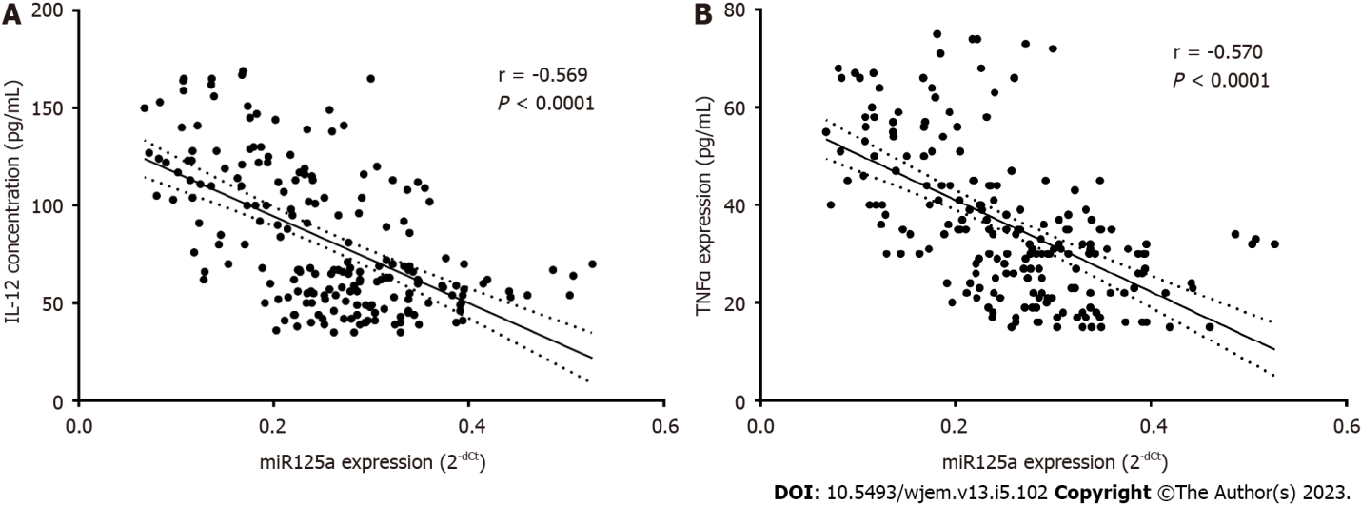
Figure 3 The correlations of microRNA-125a with tumor necrosis factor-alpha and tumor necrosis factor-alpha. A: The relationship between plasma levels of microRNA-125a (miR-125a) and interleukin 12 was assessed, revealing a significant negative correlation (r = -0.569, P < 0.0001) as demonstrated by Pearson correlation analysis; B: Similarly, the plasma levels of miR-125a and tumor necrosis factor-alpha showed a significant negative correlation (r = -0.570, P < 0.0001) based on the Pearson correlation study.
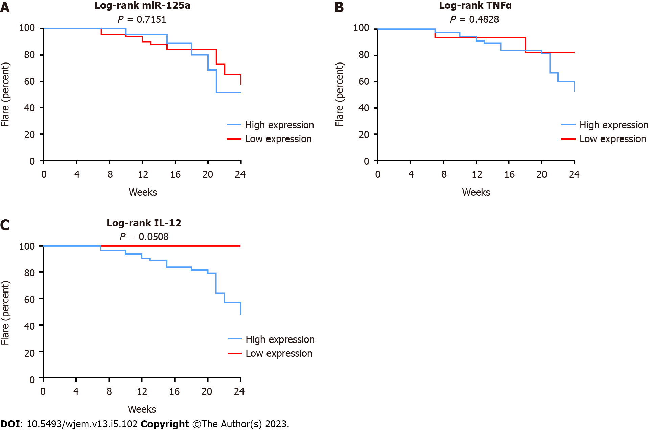
Figure 4 The prognostic utilities of microRNA-125a, tumor necrosis factor-alpha, and interleukin 12 to predict flare in systemic lupus erythematosus patients. Based on the optimal cut-off points obtained from receiver operating characteristic curve analyses, the levels of microRNA-125a (miR-125a), tumor necrosis factor-alpha (TNF-α), and interleukin 12 (IL-12) were categorized as low or high. The predictive ability of these biomarkers for the outcome (Flare) in systemic lupus erythematosus (SLE) patients was assessed using the log-rank test. A: The results showed that miR-125a was not significantly predictive of the outcome (P < 0.7151); B: TNF-α showed a potential for predicting the outcome, but the association was not statistically significant (P = 0.4828); C: In contrast, IL-12 demonstrated a significant predictive capability for the outcome in SLE patients (P = 0.0508) based on the log-rank test results.
Table 1 The association of microRNA-125a, tumor necrosis factor-alpha, and interleukin 12 with major clinical symptoms of systemic lupus erythematosus patients
Characteristics |  | miR-125a |  | TNF-α |  | IL-12
Lupus nephritis | Yes | 0.199 ± 0.07 | P = 0.576 | 53.42 ± 14.44 | P = 0.153 | 122.37 ± 22.36 | P = 0.104
 | No | 0.205 ± 0.09 |  | 45.60 ± 12.13 |  | 108.34 ± 29.87
Malar rash | Yes | 0.180 ± 0.06 | P = 0.017 | 54.60 ± 12.44 | P = 0.360 | 128.45 ± 20.28 | P = 0.065
 | No | 0.216 ± 0.09 |  | 43.37 ± 11.51 |  | 102.42 ± 28.94
Hair loss | Yes | 0.188 ± 0.06 | P = 0.022 | 52.63 ± 13.08 | P = 0.401 | 126.87 ± 20.62 | P = 0.049
 | No | 0.211 ± 0.09 |  | 44.34 ± 11.98 |  | 103.19 ± 29.48
SLEDAI | ≤ 4 | 0.202 ± 0.08 | P = 0.005 | 44.00 ± 14.71 | P = 0.001 | 102.43 ± 23.38 | P = 0.000
 | 5-12 | 0.280 ± 0.08 |  | 30.49 ± 12.59 |  | 69.54 ± 32.43
 | ≥ 12 | 0.199 ± 0.09 |  | 49.11 ± 13.51 |  | 113.26 ± 28.54
Table 2 List of primers for microRNA-125a and U6 internal control
Primer | Sequence (5'>3')
miR-125a | F: GTCGTATCCAGTGCAGGGTCCGAGGTATTCGCACTGGATACGACCGT
 | R: GTCGTATCCAGTGCAGGGTCCGAGGTGCCGAGGATTTCCACCACCTG
U6 | F: GCTTCGGCAGCACATATACTAAAAT
 | R: CGCTTCACGAATTTGCGTGTCAT

Published by Baishideng Publishing Group Inc
7041 Koll Center Parkway, Suite 160, Pleasanton, CA 94566, USA
Telephone: +1-925-3991568
E-mail: bpgoffice@wjgnet.com
Help Desk: https://www.f6publishing.com/helpdesk
https://www.wjgnet.com

© 2023 Baishideng Publishing Group Inc. All rights reserved.

