Name of Journal: World Journal of Anesthesiology
Manuscript NO: 57283
Manuscript Type: CASE REPORT

Unusual bronchoscopic value in percutaneous dilatational tracheostomy: A case report

Omar AS et al. Bronchoscopic guided percutaneous tracheostomy

Amr Salah Omar, Suraj Sudarsanan, Abdulaziz AlKhulaifi

Amr Salah Omar, Department of Cardiothoracic Surgery/Cardiac Anaesthesia and Intensive Care Units, Hamad Medical Corporation, Doha 3050, Qatar

Suraj Sudarsanan, Abdulaziz AlKhulaifi, Cardiothoracic surgery, Hamad medical corporation, Doha 3050, Qatar

Author contributions: The manuscript was prepared by Omar AS; Sudarsanan S reviewed the manuscript; AlKhulaifi A supervised the work; all authors read and approved the final manuscript.

Supported by the Medical Research Center, Hamad Medical Corporation, No. MRC-04-18-474.

Corresponding author: Amr Salah Omar, MBChB, MD, MSc, PhD, Professor, Department of Cardiothoracic Surgery/Cardiac Anaesthesia and Intensive Care Units, Hamad Medical Corporation, PO Box, Doha 3050, Qatar. a_s_omar@yahoo.com

Received: June 8, 2020
Revised: July 10, 2020
Accepted: August 25, 2020
Published online:

Abstract
BACKGROUND
The usage of bronchoscopy during percutaneous dilatational tracheostomy remains under debate. The proponents of bronchoscopy advocating safety of the procedure, whereas the critics raised the concern about the cost, the possible delay in the procedure, and waiting for the device.

CASE SUMMARY
We are highlighting a case of percutaneous dilatational tracheostomy where bronchoscopy aided in diagnosing a rare situation of wire entrapment within the endotracheal tube, treated by withdrawing the wire from the endotracheal tube with good outcome.

CONCLUSION
The bronchoscopy guided approach permitted early diagnosis and helped to end the procedure without complication or possible major surgery in a case of accidental wire puncturing of the endotracheal tube.

Key words: Bronchoscopy; Percutaneous; Tracheostomy; Outcome; Complication; case report

Omar AS, Sudarsanan S, AlKhulaifi A. Unusual bronchoscopic value in percutaneous dilatational tracheostomy: A case report. World J Anesthesiol 2020; In press

Core tip: Bronchoscopic guided approach made diagnosis help to end the procedure without complication or possible major surgery.

INTRODUCTION
Percutaneous dilatational tracheostomy (PDT) is a minimally invasive procedure that has greatly replaced surgical technique in modern intensive care units (ICU)^{[1]}. The procedure is safe, rapid and effective in establishing long term airway for patients with long term ventilatory requirements^{[2]}. The use of bronchoscopy during the procedure was suggested, as it provides tracheal visualization, during needle insertion, tracheal dilatation and tracheostomy tube placement^{[3]}. In a recent single center study comparing both techniques, the authors found that PDT using blind technique was as safe as bronchoscopic one in terms of percentage reported complications^{[4]}. Additional advantage of cost effectiveness described by Taha et al^{[5]}. We are highlighting a case of PDT where bronchoscopy played a pivotal role in saving the patient from potential catastrophe.

CASE PRESENTATION
Chief complaints
A 56-year-old man was admitted to the ICU after cardiac surgery, he had a complicated course and prolonged mechanical ventilation, requiring percutaneous tracheostomy after 14 d of intubation.

History of present illness
The patient course was complicated with stroke with inability to wean from mechanical ventilation.

History of past illness
The patient is a nonsmoker, not known to have diabetes mellitus; he had 10 years history of essential arterial hypertension, he had dyslipidemia. A coronary angiography done 6 months back showed a three-vessel disease for surgical intervention. His routine medications included atenolol (50 mg/d), acetylsalicylic acid (150 mg/d), and rosuvastatine (10 mg/d). The patient had family history of ischemic heart disease and dyslipidemia.

Physical examination
The patient showed disturbed conscious level with inability to protect his airways. The vital signs showed temperature of 37.0 °C, blood pressure of 110/66 mmHg, heart rate of 71 beats/min, and oxygen saturation of 97% on mechanical ventilation with FIO2 of 30%. The heart rate was regular. The rest of cardiac, chest and abdomen examinations were unremarkable.

Laboratory examinations
Laboratory work-up was unremarkable.

Imaging examinations
Computed tomography (CT) scan showed multiple lacunar infarctions.

FINAL DIAGNOSIS
The patient was scheduled for percutaneous tracheostomy due to delayed recovery and expected long course. The procedure was done under bronchoscopic guidance, the needle followed by the guide wire were noted to pass into the trachea. Successive dilatations by the small followed by the large blue Rhino dilators were carried out, the procedure ended with insertion of the adequate tracheostomy tube size over the respective dilator. Attempt to withdraw the wire was met with difficulty in the form of resistance, this aroused suspicion of abnormal course of wire or its entrapment. The bronchoscope was passed through the tracheostomy tube revealing normal position and level of the tracheostomy tube, the point where the wire was stuck could not be identified through the tracheostomy tube. The bronchoscope withdrawn and advanced again through the endotracheal tube (ETT), it was noted that wire punctured the terminal end of the ETT distal to the Murphy’s eye and got entrapped in this position (Figure 1). The case was diagnosed as wire entrapment in the ETT after accidental trocar puncturing.

TREATMENT
After careful bronchoscopic inspection the best option was to withdraw the ETT from the mouth, which pulled the wire accordingly.

OUTCOME AND FOLLOW-UP
The procedure ended smoothly, and the patient left in a stable condition without any procedure related complications, follow up chest X-ray showed no complications.

DISCUSSION
Percutaneous dilational tracheostomy (PDT) became a standard procedure since its introduction at by Cigalia more than 30 years back^{[6]}. However, the safety of the procedure remains questionable. The concomitant use of bronchoscopy was associated with a significant reduction of the trachesotomy related complications in the early reports^{[7]}. Identifying the place of the first tracheal puncture, confirming the position of the needle are additional bronchoscopic guided procedure advantages^{[8]}. However, Taha and Omar performed a randomized controlled trial comparing bronchoscopic and blind techniques and argued that blind technique could be as safe as the bronchoscopy guided one, when experience exist^{[5]}. Sampling of the airway could be an additional advantage in patients with suspected airway infection^{[9]}. In our patient the bronchoscope provided an unusual advantage that needs to be highlighted. Our case emphasized this role when a gentle trial to remove the wire from tracheostomy end failed after which we elected to withdraw the ETT, the wire followed the tube without further complications (Figure 2).

CONCLUSION
The bronchoscopy guided approach permitted early diagnosis and helped to end the procedure without complication or possible major surgery in a case of accidental wire puncturing of the endotracheal tube.

REFERENCES
1 Heikkinen M, Aarnio P, Hannukainen J. Percutaneous dilational tracheostomy or conventional surgical tracheostomy? Crit Care Med 2000; 28: 1399-1402 [PMID: 10834685 DOI: 10.1097/00003246-200005000-00023]
2 Putensen C, Theuerkauf N, Guenther U, Vargas M, Pelosi P. Percutaneous and surgical tracheostomy in critically ill adult patients: a meta-analysis. Crit Care 2014; 18: 544 [PMID: 25526983 DOI: 10.1186/s13054-014-0544-7]
3 Porter JM, Ivatury RR. Preferred route of tracheostomy--percutaneous versus open at the bedside: a randomized, prospective study in the surgical intensive care unit. Am Surg 1999; 65: 142-146 [PMID: 9926749]
4 Gadkaree SK, Schwartz D, Gerold K, Kim Y. Use of Bronchoscopy in Percutaneous Dilational Tracheostomy. JAMA Otolaryngol Head Neck Surg 2016; 142: 143-149 [PMID: 26720516 DOI: 10.1001/jamaoto.2015.3123]
5 Taha A, Omar AS. Percutaneous dilatational tracheostomy. Is bronchoscopy necessary? A randomized clinical trial. Trends Anaesth Crit Care 2017; 15: 20-24 [DOI: 10.1016/j.tacc.2017.06.002]
6 Ciaglia P, Firsching R, Syniec C. Elective percutaneous dilatational tracheostomy. A new simple bedside procedure; preliminary report. Chest 1985; 87: 715-719 [PMID: 3996056 DOI: 10.1378/chest.87.6.715]
7 Kost KM. Endoscopic percutaneous dilatational tracheotomy: a prospective evaluation of 500 consecutive cases. Laryngoscope 2005; 115: 1-30 [PMID: 16227862 DOI: 10.1097/01.MLG.0000163744.89688.E8]
8 Cho YJ. Percutaneous dilatational tracheostomy. Tuberc Respir Dis (Seoul) 2012; 72: 261-274 [PMID: 23227066 DOI: 10.4046/trd.2012.72.3.261]
9 Afolabi-Brown O, Marcus M, Speciale P, Pagala M, Kazachkov M. Bronchoscopic and nonbronchoscopic methods of airway culturing in tracheostomized children. Respir Care 2014; 59: 582-587 [PMID: 24129334 DOI: 10.4187/respcare.02483]

Footnotes
Informed consent statement: Informed written consent was obtained from the patient for publication of this report and any accompanying images.

Conflict-of-interest statement: The authors declare that they have no competing interests.

CARE Checklist (2016) statement: The authors have read the CARE Checklist (2016), and the manuscript was prepared and revised according to the CARE Checklist (2016).

Open-Access: This article is an open-access article that was selected by an in-house editor and fully peer-reviewed by external reviewers. It is distributed in accordance with the Creative Commons Attribution NonCommercial (CC BY-NC 4.0) license, which permits others to distribute, remix, adapt, build upon this work non-commercially, and license their derivative works on different terms, provided the original work is properly cited and the use is non-commercial. See: http://creativecommons.org/licenses/by-nc/4.0/

Manuscript source: Unsolicited manuscript

Peer-review started: June 2, 2020
First decision: July 4, 2020
Article in press:

Specialty type: Critical care medicine
Country/Territory of origin: Qatar
Peer-review report’s scientific quality classification
Grade A (Excellent): 0
Grade B (Very good): B
Grade C (Good): C
Grade D (Fair): 0
Grade E (Poor): 0

P-Reviewer: Terrani A S-Editor: Zhang H L-Editor: P-Editor:
Figure Legends
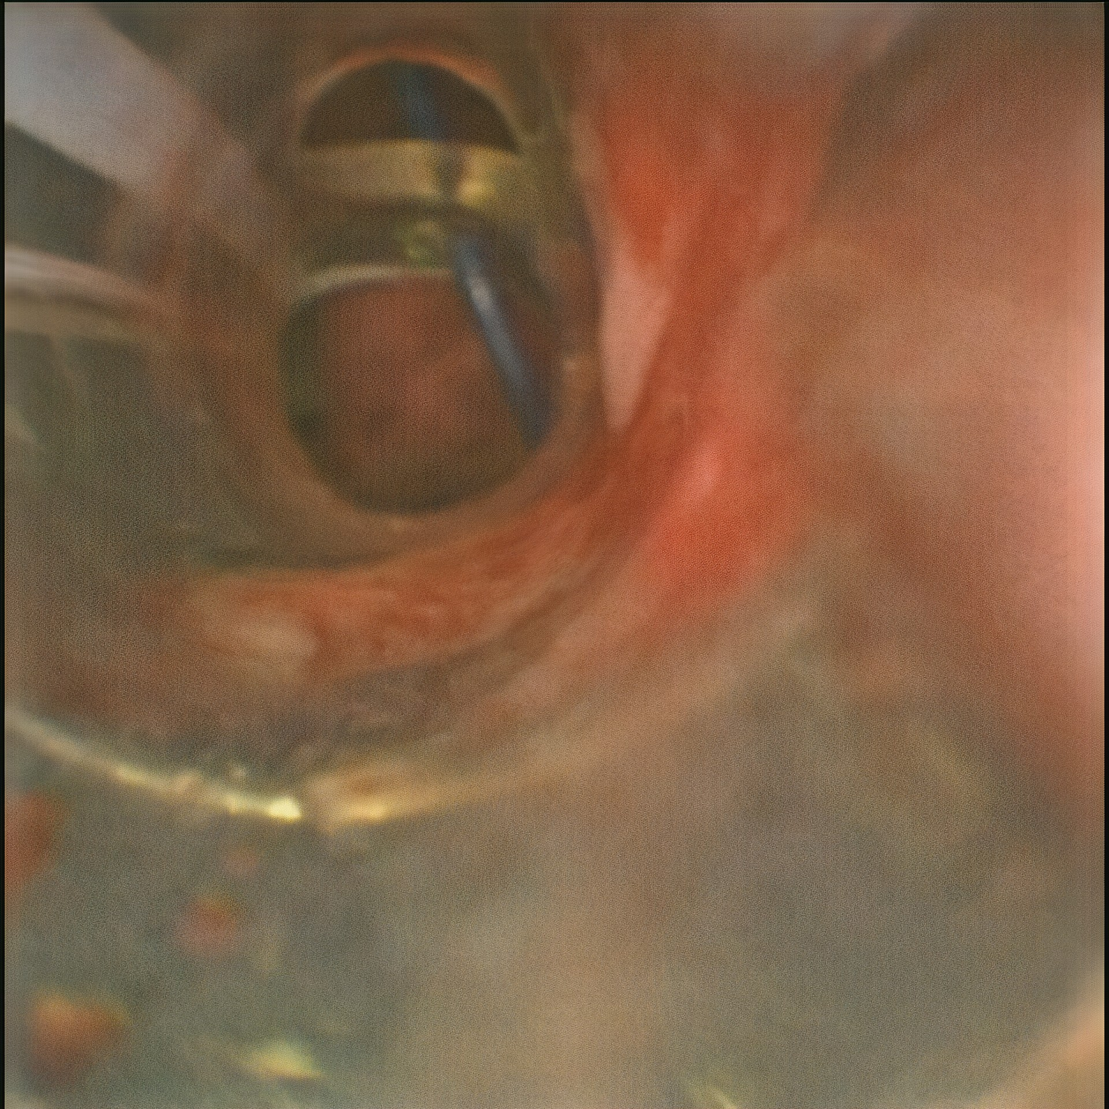
Figure 1 Percutaneous tracheostomy wire is noted to puncture the endotracheal tube (bronchoscopic view).

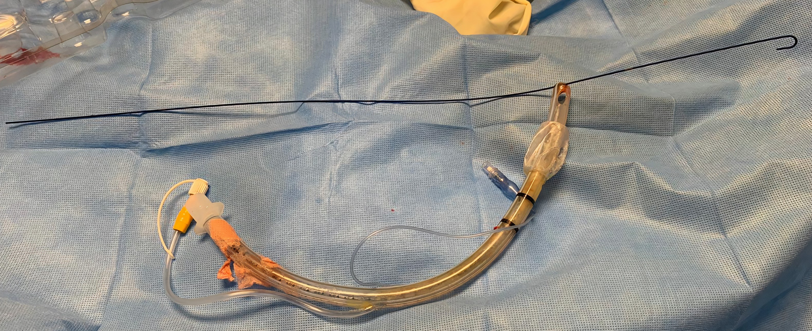
Figure 2 Endotracheal tube removed, and the wire is stuck distal to the Murphy’s eye.

