Name of Journal: World Journal of Ophthalmology
Manuscript NO: 50771
Manuscript Type: ORIGINAL ARTICLE

Retrospective cohort study
series of cataract surgeries with i-ring pupil expansion ring

Lu K et al. I-ring pupil expansion case series

Kenneth Lu, Martin Garcia, Jack Tian, Rustum Karanjia

Kenneth Lu, Martin Garcia, Jack Tian, Rustum Karanjia, Doheny Eye Institute, University of California, Los Angeles, CA 91007, United States

ORCID number: Kenneth Lu (0000-0002-6096-5977); Martin Garcia (0000-0002-2678-9068); Jack Tian (0000-0002-5340-7635); Rustum Karanjia (0000-0002-6101-0160).

Author contributions: Lu K and Karanjia R designed the study; Garcia M and Tian J collected the data; Lu K prepared the manuscript.

Supported by a research grant from Beaver-Visited International, the manufacturer of the I-ring.

Institutional review board statement: The UCLA Institutional Review Board has approved the above-referenced study.

Informed consent statement: Since this was a retrospective review of cases already performed with no release of any personal information, our institutional review board has waived the need for informed consent of the specific patients.

Conflict-of-interest statement: The authors do not have any financial interest in the company or the device.

Open-Access: This article is an open-access article which was selected by an in-house editor and fully peer-reviewed by external reviewers. It is distributed in accordance with the Creative Commons Attribution Non Commercial (CC BY-NC 4.0) license, which permits others to distribute, remix, adapt, build upon this work non-commercially, and license their derivative works on different terms, provided the original work is properly cited and the use is non-commercial. See: http://creativecommons.org/licenses/by-nc/4.0/

Manuscript source: Unsolicited manuscript

Corresponding author: Kenneth Lu, MD, Assistant Professor, Doheny Eye Institute, University of California, Los Angeles, 622 W. Duarte Rd, Suite 101, Arcadia, CA 91007, United States. klu@doheny.org
Received: May 17, 2019
Peer-review started: May 20, 2019
First decision: May 30, 2019
Revised: August 28, 2019
Accepted: October 3, 2019
Article in press:
Published online:

Abstract
BACKGROUND
The retrospective review of I-ring pupil expansion ring use is designed to examine the patient characteristics and associated surgical challenges in a clinical practice. The hypothesis is that I-ring provides a necessary additive tool in dealing with challenging cataract surgeries with small pupils.

AIM
To document the safety profile and use of I-ring pupil expansion ring in a clinical practice.

Methods
A retrospective chart review of 12 consecutive cases within the same year (2016) of cataract surgeries employing I-ring pupil expansion ring (Beaver-Visitec, International) by a single surgeon at the same ambulatory surgical center was conducted. Demographic, pre-op, intra-op, and post-op data were recorded. Total number of cataract cases performed was also recorded.

Results
8 of 12 cases were planned I-ring cases. 1 case was decided intraoperatively when femtosecond laser caused the pupil to shrink. The other 3 cases were also decided upon intraoperatively when pupil was deemed to be small. 7 patients had IFIS from Flomax use. 2 patients had pseudoexfoliation syndrome as the cause of small pupil. 2 patients had narrow angles with brunescent cataracts. 2 patients had pre-op partial zonular dehiscence. 1 patient had 360º of posterior synechiae. 2 cases had ruptured posterior capsule that required anterior vitrectomy. No complications were attributed to the pupil expansion ring. A total of 296 cataract surgeries were performed that year by the surgeon, making the rate of pupil ring use 4.1%.

Conclusion
Small pupil requiring pupil expansion ring during cataract surgery is often associated with other challenges, such as brunescent cataract, zonular weakness, and posterior synechiae in this series. I-ring helped to reduce at least one challenge in these difficult cases.

Key words: Malyugin ring; I-ring; Small pupil; Pseudoexfoliation syndrome; Cataract; Iris retraction; IFIS; Zonular dehiscence; Challenging cataract surgeries; Pupil expansion device

© The Author(s) 2019 Published by Baishideng Publishing Group Inc. All rights reserved.

Core tip: Pupil expansion rings are not new devices, however, to date, there are no clinical series that examines the nuanced factors that go into the decision and use of I-ring. This study provides a front-line peek at the use of I-ring.

Lu K, Garcia M, Tian J, Karanjia R. Series of cataract surgeries with i-ring pupil expansion ring. World J Ophthalmol 2019; In press

Introduction
Pupil expansion devices have made an impact on cataract surgery for many years now^{[1,2]}. Small pupils obstruct the view during surgery and make for more challenging cases. Pupil expansion devices provide a safe, temporary method for expanding the pupil during surgery without permanently distorting the pupil, which can occur with manual stretching^{[3]} or sphincterotomies^{[4]}. The term, “surgical pupil” often came from these scenarios. These devices have become widely adapted into cataract practices worldwide.
The Malyugin Ring (MicroSurgical Technology, Redmond, WA) was the the most widely used pupil expansion device^{[5]}. It simplified the insertion and removal by packaging it into an insertion device similar to IOL injectors. It provided a stable 4 point (later 8 points with 2.0 version) fixation that allowed for improved visualization and manipulation of cataract. The I-ring improved upon the design by employing a softer, more flexible polyurethane instead of the Malyugin Ring’s more rigid polypropylene material. The I-ring also engages 360º circumference of the pupil, distributing the expansion force throughout the pupillary margin instead of on select few points, which can result in distortion of pupil post-operatively. A pictorial depiction of a patient with use of these two different devices in each eye was published previously^{[6]}, showing a less traumatic pupil expansion by the I-ring.
There have been relatively few case series on pupil expansion devices^{[7,8]}, with most focusing on the complication rate or time of surgery involved. None have truly examined the pathologies and the decisions involved in a clinical practice. We undertook a more comprehensive examination of a single surgeon practice in one calendar year of 2016 to determine the underlying pathology, the decision, as well as the outcome of cases involving I-ring. The surgeon uses I-ring exclusively due to the above rationale.

MATERIALS AND METHODS
A retrospective chart review of all I-ring cases were performed, recording demographic, pre-operative, intra-operative and post-operative data. Whether I-ring use was planned or decided upon intra-operatively was also recorded. Total number of cataract cases was determined by using the 66984 and 66982 CPT codes. All I-ring cases were documented as complex cataract cases. The cases were all performed by a single surgeon at the same ambulatory surgery center, Specialty Surgical Center of Arcadia, California. IRB approval was obtained from University of California, Los Angeles prior to initiation of this project. Funding was provided by Beaver-Visitec, International.

Results
Twelve patients (6 male and 6 female) underwent 12 cataract surgeries with I-ring Pupil Expansion device. Average age was 77. 8 of 12 cases were planned I-ring cases. 1 case was decided intraoperatively when femtosecond laser caused the pupil to shrink. The other 3 cases were also decided upon intraoperatively when pupil was deemed to be small. 7 patients had IFIS from Flomax use. 2 patients had pseudoexfoliation syndrome as the cause of small pupil. 2 patients had narrow angles with brunescent cataracts. 2 patients had pre-op partial zonular dehiscence. 1 patient had 360º of posterior synechiae (Table 1).
A total of 296 cataract surgeries were performed that year by the surgeon, making the rate of pupil expansion ring use 4.1%. The rate of ruptured capsule in all surgeries was 1.0%. Of the small pupil cataract cases that required use of the I-ring, there were 2 ruptured posterior capsule that required anterior vitrectomy (16.6%). One was in a case of near 5 clock hours of pre-op zonular dehiscence and the other was in a case of dense, brunescent cataract without view to the retina. No complications were attributed to the pupil expansion ring. Excluding these more challenging cases, the rate of rupture posterior capsule would have been 0.4%. There was only one other anterior vitrectomy performed the whole year.
None of the cases were noted to have experienced difficulty inserting or removing the I-ring, including the case with 360º of posterior synechiae. Synechiolysis was performed with blunt-tip viscoelastic cannula, and the I-ring was easily deployed onto pupillary margin for intra-operative expansion. Insertion involved placement of one to three engagement points onto pupillary margin with the injector, followed by manual engagement of the remaining segments. Removal of all cases was carried out in one motion by grasping the distal ring segment at the notch and retracted into the injector sleeve.
The two partial zonular dehiscence cases were not fully recognized until the I-ring was engaged. The 5’clock hour dehiscence patient had pseudoexfoliation and it was immediately apparent upon I-ring deployment. The other case involved one to two clock hours and was recognized once phacoemulsification was initiated. The small amount of capsular bag instability did not create significant problems, and surgery was successfully completed without complication in that case.

Discussion
It is apparent from this series that small pupils often accompany other pathologies that can make surgery more challenging^{[9,10]}. These include IFIS^{[11]}, pseudoexfoliation, zonular dehiscence, and dense cataracts^{[12]}. A small pupil adds an additional challenge to these already difficult cases, as is illustrated by the dramatic difference in the rates of ruptured posterior capsule^{[13,14]}. However, with the availability of pupil expansion rings, these challenges can be overcome^{[15]}. Pre-operative planning as well as having the device available in the OR provides solutions intraoperatively. For instance, with the cases of zonular dehiscence, pupil expansion allows for identification of zonular problem, and further interventions such as capsule tension rings^{[16]} may be used to help avoid complications. Additionally, with the advent of femtosecond laser assisted cataract surgeries, another cause for intraoperative miosis is identified. Several previous papers have discussed use of pupil expansion rings either pre-femoto laser, or post to assist in miosis issue^{[17-20]}.
The choice of pupil expansion ring rests upon the ease of use and atraumatic insertion and removal. We have previously published a study demonstrating that the I-ring is less traumatic than the Malyugin Ring due to its softer material and 360º engagement design^{[6]} (Figure 1). Because it is softer, it is slightly more difficult than the Malyugin Ring to engage 3 points of fixation upon injection. A Sinsky Hook with a longer tip, or a chopper can be used to manipulate the last fixation point into position. Once engaged, the expansion force is evenly distributed throughout the pupillary margin instead of concentrated at the fixation points. This leads to less distortion of the pupillary margin after surgery.
During surgery, the I-ring does have a thicker, or higher anteroposterior profile, but due to its softer material, it gives way instead of obstruct phaco probe motion. The Malyugin Ring^{[21]} has a thinner profile, but because it is stiffer, this can be felt with movement of the phaco probe. This however is usually a minor nuisance of no consequence. In cases with very shallow anterior chambers this may become a bigger issue. Removal of the I-ring, by contrast, is slightly easier, as it can be grasped and retracted into injector device in one smooth motion instead of having to manually disengage the ring first then retract into injector, as with the Malyugin Ring.
What is of value in this series is the understanding of how the pupil expansion ring fits into a cataract practice in the major metropolitan area of Los Angeles. The overall use of pupil expansion ring was 4.1% of total cataract cases. 8 of the 12 cases were planned during the pre-operative evaluation. The other 4 were identified once surgery began. One case was due to femtosecond laser application^{[22]}. When the decision was undertaken to utilize the pupil expansion ring had no impact on the success or outcome of the surgery. There were many other patients taking Flomax at the time of surgery who did not require use of pupil expansion rings. The decision is normally based on the size of the pupil. Some patients on Flomax have normal-sized pupil with only minimal amount of iris floppiness. Usually, once phacoemulsification commences, pupil expansion ring is not employed, but if the pupil does become more floppy or constricts, pupil expansion ring can be used mid-phaco.
Pupil expansion ring is a valuable tool to have in the OR^{[23]} for those challenging cases with small pupils that may accompany other difficulties^{[24,25]}. To have one problem solved makes the others easier to deal with. The choice of expansion ring depends on surgeon preference^{[26]}. The advantages and disadvantages of two leading rings were discussed. It is the opinion of the authors that the I-ring is less traumatic to the pupillary margin due to its softer material and 360º engagement design.

ARTICLE HIGHLIGHTS
Research background
Pupil expansion rings are widely accepted as a useful tool in cataract surgery. However, there are no studies that compare different devices or examine in detail the decision to goes into the decision and clinical settings to use the device.

Research motivation
This study examines a new member of this class of device, providing advantages in design over previous devices. It also examines the co-morbidities associated with small pupil in the cataract milieu of 2019.

Research objectives
To document the safety profile and use of I-ring pupil expansion ring in a clinical practice. The study showed a better understanding of the challenges associated with small pupil cataract surgery and hopefully will assist cataract surgeons in dealing with these challenges.

Research methods
Retrospective review of case series.

Research results
A surprisingly high rate of complication and co-morbidities were found in this case series. Further innovations in dealing with zonular dehiscence, posterior capsule rupture, and dense cataracts need to be continually sought after.

Research conclusions
I-ring is a useful tool in the armamentarium of cataract surgery. It is less traumatic to the pupil than its predecessors due to its softer material in 360º engagement of the pupil. It helps to maintain pupil dilation in small pupil cases relating to pseudoexfoliation, IFIS and femtosecond laser induced myosis.

Research perspectives
This study illustrates that there are still challenges to be met in cataract surgery. Despite the technical advances with phaco fluidics, femtosecond laser, pupil expansion rings, dense cataracts with zonular problems and small pupils are still a challenge for cataract surgeons. Further research and innovations are still needed to address these problems.

REFERENCES
1 Hashemi H, Seyedian MA, Mohammadpour M. Small pupil and cataract surgery. Curr Opin Ophthalmol 2015; 26: 3-9 [PMID: 25390859 DOI: 10.1097/ICU.0000000000000116]
2 Akman A, Yilmaz G, Oto S, Akova YA. Comparison of various pupil dilatation methods for phacoemulsification in eyes with a small pupil secondary to pseudoexfoliation. Ophthalmology 2004; 111: 1693-1698 [PMID: 15350324 DOI: 10.1016/j.ophtha.2004.02.008]
3 Miller KM, Keener GT Jr. Stretch pupilloplasty for small pupil phacoemulsification. Am J Ophthalmol 1994; 117: 107-108 [PMID: 8291576 DOI: 10.1016/s0002-9394(14)73023-5]
4 Cole MD, Brown R, Ridgway AE. Role of sphincterotomy in extracapsular cataract surgery. Br J Ophthalmol 1986; 70: 692-695 [PMID: 3756126 DOI: 10.1136/bjo.70.9.692]
5 Wilczynski M, Wierzchowski T, Synder A, Omulecki W. Results of phacoemulsification with Malyugin Ring in comparison with manual iris stretching with hooks in eyes with narrow pupil. Eur J Ophthalmol 2013; 23: 196-201 [PMID: 23112041 DOI: 10.5301/ejo.5000204]
6 Tian JJ, Garcia GA, Karanjia R, Lu KL. Comparison of 2 pupil expansion devices for small-pupil cataract surgery. J Cataract Refract Surg 2016; 42: 1235-1237 [PMID: 27531301 DOI: 10.1016/j.jcrs.2016.07.002]
7 Jiraskova N, Rozsival P, Lestak J. Case report open access use of Malyugin Pupil Expansion Ring in femtosecond laser-assisted cataract surgery. J Clin Exp Ophthalmol 2013; 4: 312 [doi: 10.4172/2155-9570.1000312]
8 Chang DF. Use of Malyugin pupil expansion device for intraoperative floppy-iris syndrome: results in 30 consecutive cases. J Cataract Refract Surg 2008; 34: 835-841 [PMID: 18471643 DOI: 10.1016/j.jcrs.2008.01.026]
9 Zare M, Javadi MA, Einollahi B, Baradaran-Rafii AR, Feizi S, Kiavash V. Risk Factors for Posterior Capsule Rupture and Vitreous Loss during Phacoemulsification. J Ophthalmic Vis Res 2009; 4: 208-212 [PMID: 23198076]
10 Narendran N, Jaycock P, Johnston RL, Taylor H, Adams M, Tole DM, Asaria RH, Galloway P, Sparrow JM. The Cataract National Dataset electronic multicentre audit of 55,567 operations: risk stratification for posterior capsule rupture and vitreous loss. Eye (Lond) 2009; 23: 31-37 [PMID: 18327164 DOI: 10.1038/sj.eye.6703049]
11 Santaella RM, Destafeno JJ, Stinnett SS, Proia AD, Chang DF, Kim T. The effect of alpha1-adrenergic receptor antagonist tamsulosin (Flomax) on iris dilator smooth muscle anatomy. Ophthalmology 2010; 117: 1743-1749 [PMID: 20466425 DOI: 10.1016/j.ophtha.2010.01.022]
12 Halkiadakis I, Chatziralli I, Drakos E, Katzakis M, Skouriotis S, Patsea E, Mitropoulos P, Kandarakis A. Causes and management of small pupil in patients with cataract. Oman J Ophthalmol 2017; 10: 220-224 [PMID: 29118499 DOI: 10.4103/ojo.OJO_102_2016]
13 Megbelayin EO, Pindikura S. Managing challenges of recalcitrant intraoperative miosis during small incision cataract surgery. Int J Sci Res Knowl 2013; 1: 74–81 [DOI: 10.12983/ijsrk-2013-p074-081]
14 Bartlett JD, Miller KM. Phacoemulsification techniques for patients with small pupils. Compr Ophthalmol Update 2003; 4: 171–176
15 Nderitu P, Ursell P. Iris hooks versus a pupil expansion ring: Operating times, complications, and visual acuity outcomes in small pupil cases. J Cataract Refract Surg 2019; 45: 167-173 [PMID: 30527439 DOI: 10.1016/j.jcrs.2018.08.038]
16 Weber CH, Cionni RJ. All about capsular tension rings. Curr Opin Ophthalmol 2015; 26: 10-15 [PMID: 25390861 DOI: 10.1097/ICU.0000000000000118]
17 Conrad-Hengerer I, Hengerer FH, Schultz T, Dick HB. Femtosecond laser-assisted cataract surgery in eyes with a small pupil. J Cataract Refract Surg 2013; 39: 1314-1320 [PMID: 23988243 DOI: 10.1016/j.jcrs.2013.05.034]
18 Kankariya VP, Diakonis VF, Yoo SH, Kymionis GD, Culbertson WW. Management of small pupils in femtosecond-assisted cataract surgery pretreatment. Ophthalmology 2013; 120: 2359-2360, 2360.e1 [PMID: 24182567 DOI: 10.1016/j.ophtha.2013.07.057]
19 Roberts TV, Lawless M, Hodge C. Laser-assisted cataract surgery following insertion of a pupil expander for management of complex cataract and small irregular pupil. J Cataract Refract Surg 2013; 39: 1921-1924 [PMID: 24140373 DOI: 10.1016/j.jcrs.2013.08.041]
20 Kránitz K, Takács AI, Gyenes A, Filkorn T, Gergely R, Kovács I, Nagy ZZ. Femtosecond laser-assisted cataract surgery in management of phacomorphic glaucoma. J Refract Surg 2013; 29: 645-648 [PMID: 23777238 DOI: 10.3928/1081597X-20130611-02]
21 Malyugin B. Cataract surgery in small pupils. Indian J Ophthalmol 2017; 65: 1323-1328 [PMID: 29208812 DOI: 10.4103/ijo.IJO_800_17]
22 Malyugin B, Sobolev N, Arbisser LB, Anisimova N. Combined use of an iris hook and pupil expansion ring for femtosecond laser-assisted cataract surgery in patients with cataracts complicated by insufficient mydriasis and an ectopic pupil. J Cataract Refract Surg 2016; 42: 1112-1118 [PMID: 27531285 DOI: 10.1016/j.jcrs.2016.07.001]
23 Zarei-Ghanavati S, Bagherian H. Stabilizing the capsular bag and expanding the pupil with a pupil expansion device. J Cataract Refract Surg 2015; 41: 1801-1803 [PMID: 26471052 DOI: 10.1016/j.jcrs.2015.08.010]
24 Canabrava S, Rezende PH, Eliazar GC, Figueiredo SB, Resende AF, Batista WD, Diniz-Filho A. Efficacy of the Canabrava Ring (pupil expansion device) in cataract surgery for eyes with small pupils: the first 30 cases. Arq Bras Oftalmol 2018; 81: 202-211 [PMID: 29924194 DOI: 10.5935/0004-2749.20180042]
25 Fay J, Shrivastava A, Channa P, Madu A. Postoperative course of patients undergoing phacoemulsification cataract extraction with Malyugin Ring™ pupil expansion. Invest Ophthalmol Vis Sci 2014; 55: 2815
26 Papaconstantinou D, Kalantzis G, Brouzas D, Kontaxakis A, Koutsandrea C, Diagourtas A, Georgalas I. Safety and efficacy of phacoemulsification and intraocular lens implantation through a small pupil using minimal iris manipulation. Clin Interv Aging 2016; 11: 651-657 [PMID: 27274213 DOI: 10.2147/CIA.S97254]
P-Reviewer: Nowak MS, Tzamalis A S-Editor: Ma YJ L-Editor: E-Editor:

Specialty type: Ophthalmology
Country of origin: United States
Peer-review report classification
Grade A (Excellent): 0
Grade B (Very good): B, B
Grade C (Good): 0
Grade D (Fair): 0
Grade E (Poor): 0

Table 1 Patient characteristics
Characteristics of patients (n = 12) | Total number | Percentage
IFIS from Flomax use | 7 | 58%
Pseudoexfoliation | 2 | 17%
Narrow angles | 2 | 17%
Brunescent cataract | 2 | 17%
Zonular weakness | 2 | 17%
Posterior synechiae | 1 | 8%

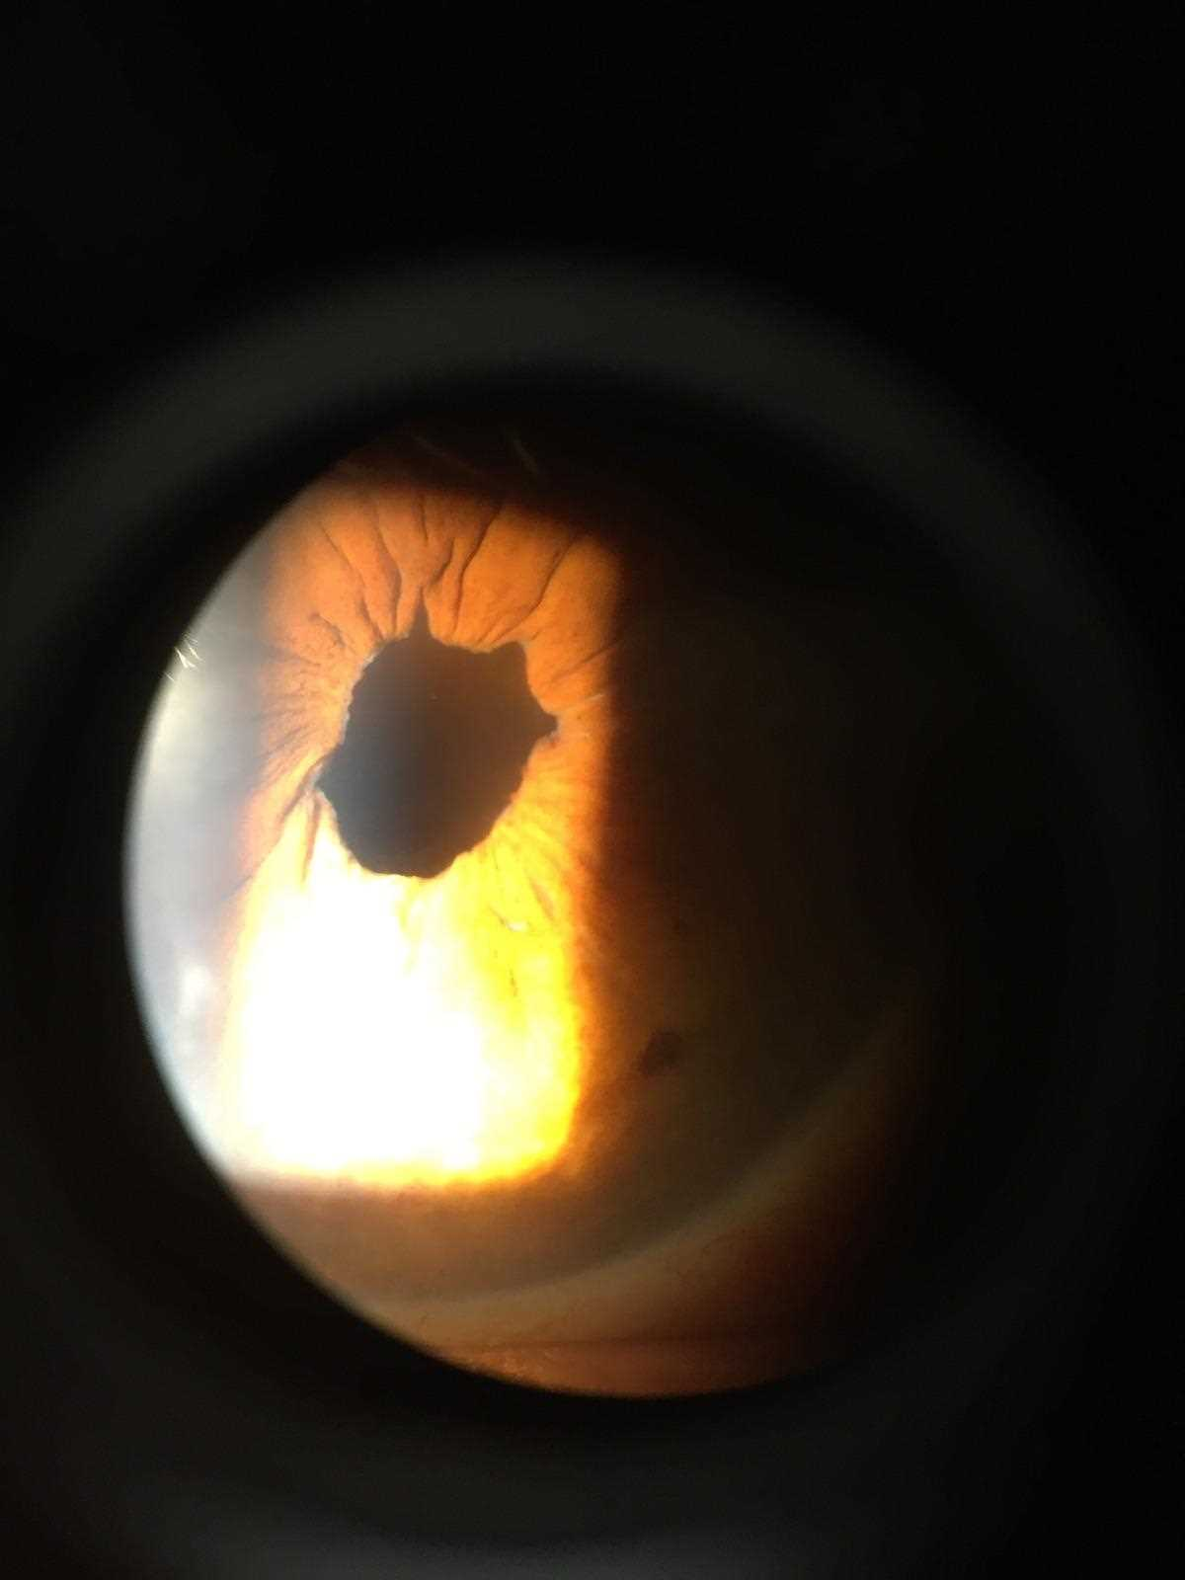
A
B

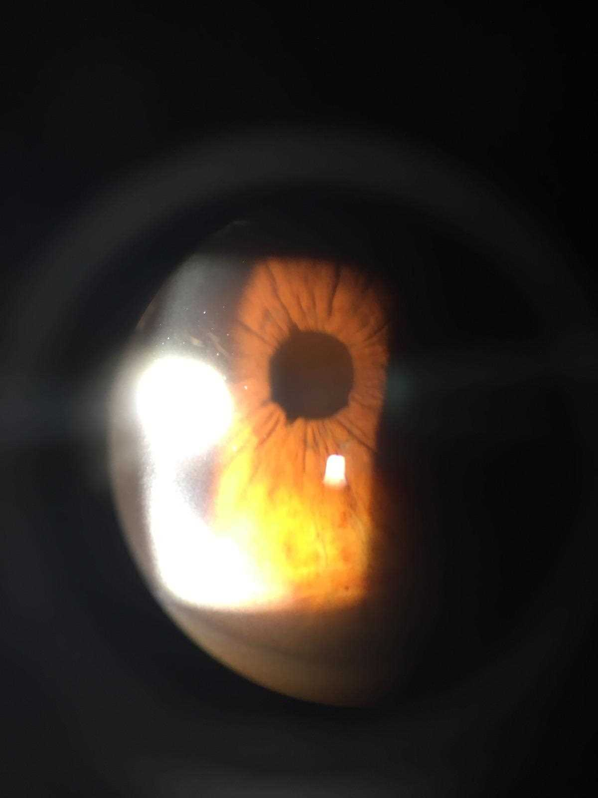
Figure 1 Post-op photos after cataract extraction with different pupil expansion rings in the same patient. A: with I-ring; B: with Malyugin Ring. I-ring eye showed significantly less distortion of the pupil after surgery. Previously published by the same authors.

