Name of Journal: World Journal of Gastrointestinal Endoscopy
ESPS Manuscript NO: 30854
Manuscript Type: Case Report

Successful endoscopic treatment of an intraductal papillary neoplasm of the bile duct

Natov NS et al. Successful endoscopic treatment of an IPNB

Nikola S Natov, Laura C Horton, Sanjay R Hegde

Nikola S Natov, Sanjay R Hegde, the Gastroenterology/Hepatology Division, Tufts Medical Center, Boston, MA 02111, United States

Laura C Horton, Department of Medicine, Brigham and Women’s Hospital, Boston, MA 02115-6110, United States

Author contributions: Natov NS and Hegde SR participated equally in conception, acquisition, and analysis of data in the creation of the manuscript; Horton LC assisted with analysis of data and revision.

Institutional review board statement: This case report was exempt from the Institutional Review Board standards of Tufts University School of Medicine and Tufts Medical Center.

Informed consent statement: The subject provided written informed consent prior to planned treatments.

Conflict-of-interest statement: The authors report no financial or other conflicts of interest (including but not limited to commercial, personal, political, intellectual, or religious interests).

Open-Access: This is an open-access article that was selected by an in-house editor and fully peer-reviewed by external reviewers. It is distributed in accordance with the Creative Commons Attribution Non Commercial (CC BY-NC 4.0) license, which permits others to distribute, remix, adapt, build upon this work non-commercially, and license their derivative works on different terms, provided the original work is properly cited and the use is non-commercial. See: http://creativecommons.org/licenses/by-nc/4.0/

Manuscript source: Unsolicited manuscript

Correspondence to: Nikola S Natov, MD, Gastroenterology Fellow, the Gastroenterology/Hepatology Division, Tufts Medical Center, 800 Washington Street, #233, Boston, MA 02111, United States. nnatov@tuftsmedicalcenter.org
Telephone: +1-617-6365883
Fax: +1-617-6369292

Received: October 19, 2016
Peer-review started: October 23, 2016
First decision: December 1, 2016
Revised: December 27, 2016
Accepted: January 11, 2017
Article in press:
Published online:

Abstract
We present a case of a 76-year-old man with right upper quadrant abdominal pain and weight loss, who was found to have an intraductal papillary neoplasm of the bile duct (IPNB) of the pancreaticobiliary subtype, deemed curatively resectable. The patient declined surgery and opted for endoscopic therapy. He underwent two sessions of endoscopic retrograde cholangiopancreatography (ERCP)-guided radiofrequency ablation (RFA). Ten months later, no evidence of recurrence was identified on repeat ERCP. To our knowledge, this is the first reported case of successful use of RFA as a primary treatment modality for resectable IPNB.

Key words: Bile duct neoplasms; Ablation technique; Common bile duct diseases; Extrahepatic bile duct; Advanced endoscopy

© The Author(s) 2017. Published by Baishideng Publishing Group Inc. All rights reserved.

Core tip: Intraductal neoplasms of the bile duct (IPNB) classically present with jaundice and/or pruritus, but nonspecific symptoms such as right upper quadrant discomfort and weight loss may also develop. The first-line treatment for these tumors is surgical resection. Endoscopic retrograde cholangiopancreatography-guided radiofrequency ablation (RFA) has historically been used as adjunctive treatment; self-expanding metal stents may be used for palliation. We report a case of successful primary treatment of an IPNB with RFA alone.

Natov NS, Horton LC, Hegde SR. Successful endoscopic treatment of an intraductal papillary neoplasm of the bile duct. World J Gastrointest Endosc 2017; In press

INTRODUCTION
Intraductal papillary neoplasms of the bile duct were first recognized as a distinct entity by the World Health Organization in 2010^{[1]}. These tumors may harbor varying degrees of dysplasia and even invasive malignancy^{[1,2]}. Surgical resection is therefore recommended in patients who are operative candidates^{[1]}. Non-surgical cases are managed with palliative biliary stenting using self-expandable metal stents (SEMSs), and radiofrequency ablation (RFA) has been employed as an adjunctive therapy for malignant biliary obstruction of several different etiologies^{[3-6]}. RFA is safe, produces good 90-d stent luminal patency rates, and has been associated with an improvement in clinical outcomes^{[5,7,8]}. However, its utility as a primary treatment modality has not been studied.

CASE REPORT
A 76-year-old man with a history of coronary artery disease and tobacco abuse was referred to our institution for evaluation of a common bile duct (CBD) stricture. Several months prior, he had presented to his primary care physician with right upper quadrant abdominal pain associated with an unintentional weight loss of 13 kg. Liver function tests (LFTs) revealed an AST of 46 IU/L (10-42), ALT of 37 IU/L (0-54), ALP of 197 IU/L (40-130), and a TB of 0.4 mg/dL (0.2-1.1). Mild intrahepatic ductal dilatation and a CBD of 10 mm were seen on right upper quadrant ultrasound. There was no choledocholithiasis. Subsequent magnetic resonance cholangiopancreatography revealed intra- and extrahepatic biliary ductal dilatation and a filling defect in the distal CBD. The pancreatic duct was not dilated. The patient was referred for endoscopic retrograde cholangiopancreatography (ERCP) at a different facility. Inspection of the ampulla of Vater was normal. The CBD was cannulated using a 0.35 inch sphincterotome and guidewire, and initial contrast injection showed dilatation of the CBD to approximately 15 mm and a saccular collection of contrast distally. A 10 mm biliary sphincterotomy was performed, and no choledocholithiasis or sludge was found after sweeping of the CBD. Cholangiogram showed a distal CBD stricture 10 mm proximal to the ampulla. Brushings for cytology were obtained, and a 10 Fr × 5 cm plastic stent was deployed across the stricture to facilitate biliary drainage. Cytology revealed atypical cells but was otherwise non-diagnostic. Due to the intraductal location of the lesion, ERCP was considered the best modality through which to obtain a tissue diagnosis, and endoscopic ultrasound was thus not performed. The patient was brought back for repeat ERCP six weeks later. Following removal of the plastic stent and balloon sphincteroplasty to 10 mm, the CBD was cannulated using a pediatric gastroscope to allow for direct visualization of the intraductal mucosa. Catheter-based cholangioscopy was not available at the outside hospital. The area of the stricture appeared nodular and erythematous. The procedure was aborted due to hypotension and hypoxemia before biopsies could be obtained. The patient was then transferred to our institution for ERCP with SpyGlass™ cholangioscopy (Boston Scientific, Natick, MA). Initial cholangiogram confirmed a distal CBD stricture (Figure 1). A 10 mm polypoid lesion was seen with SpyGlass™ cholangioscopy (Figure 2), and targeted intraductal biopsies were performed using SpyBite™ forceps (Boston Scientific, Natick, MA). Pathological findings of atypical cells, papillary configuration, and bile duct epithelium with mucinous metaplasia were consistent with intraductal papillary neoplasm of the bile duct (IPNB) without malignant transformation (Figure 3). Immunohistochemical staining was positive for MUC1 and negative for CDX2, highlighting pancreaticobiliary and lack of intestinal epithelium, respectively. The normal appearance of the ampulla, intraductal location of the neoplasm, and histology excluded an ampullary lesion. Furthermore, the most distal aspect of the CBD was normal. He was referred to hepatobiliary surgery for consideration of pancreaticoduodenectomy with curative intent, but surgical intervention was deferred due to patient preference. The decision was made to proceed with ERCP-guided RFA as primary therapy. Two sessions of RFA using an 8 Fr Habib™ EndoHPB probe were performed at 10 watts for 90 s (EMcision, Montreal, Canada). A 10 mm × 4 cm WallFlex™ fully covered SEMS was deployed following the first round of RFA and exchanged at the completion of the second RFA session, three months later (Boston Scientific, Natick, MA). The procedures were uncomplicated. Four months after the second RFA session, ERCP with SpyGlass™ was repeated, the biliary stent was removed, and no residual polypoid tissue or stricture was observed on occlusion cholangiogram (Figure 4) or with Spyglass™ choledochoscopy (Figure 5). The stent was not replaced. Cytology of distal CBD brushings revealed no malignant cells. Repeat ERCP six months later (nine months after the last RFA session) demonstrated a 10 mm distal CBD stricture but no mass lesion (Figure 6). Spyglass™ choledochoscopy revealed only erythematous mucosa in the distal CBD; targeted intraductal biopsies of this area were performed using SpyBite™ forceps and revealed reactive epithelium. Cytology was negative for malignant cells, and fluorescence in situ hybridization (FISH) analysis of the distal CBD brushings showed no abnormalities. The patient underwent his last ERCP six months later, and no residual stricture or CBD lesion was seen on cholangiogram. He remained asymptomatic, and his LFTs and weight normalized.

DISCUSSION
In 2010, the World Health Organization first categorized rare bile duct tumors characterized by papillary growth as intraductal papillary neoplasms of the bile duct^{[1]}. IPNBs are associated with mucobilia due to excessive mucin secretion, and are more commonly found in the hepatic biliary system^{[1]}. However, mucobilia may be absent, and extrahepatic growth patterns have been described^{[1,9]}. Four histological subtypes exist including pancreaticobiliary, oncocytic, gastric, and intestinal^{[10,11]}. Differentiation between subtypes is made according to morphology seen on hematoxylin and eosin staining and immunohistochemical features of mucin glycoproteins^{[10]}. Pancreaticobiliary IPNB is more frequently associated with an invasive phenotype and harbors a worse prognosis^{[10,11]}. IPNB tumors are graded based on degree of dysplasia, from low- to high-grade and finally to invasive carcinoma, which was seen in 74% of IPNBs in one study^{[1,2]}. Pancreatic IPMNs are classified similarly and are thought to follow the same sequence from benign to malignant^{[2]}. The incidence of IPNBs is highest in Far Eastern countries, and particularly in patients between 50 and 70 years of age, with a slight male predominance^{[1]}. Patients may be asymptomatic, or may present with abdominal pain, jaundice, elevated LFTs, or cholangitis^{[1,2]}. Biliary ductal dilatation and an intraductal mass may be seen on computed tomography or magnetic resonance imaging^{[1]}. Duodenoscopy may reveal a prominent ampulla with mucinous secretion^{[1]}. Diagnosis is often difficult; sensitivity of brush cytology and fluoroscopically-guided biliary biopsies is low, and mixed pathologic findings may be present within a single lesion^{[1,12]}. The majority of IPNBs contain high-grade epithelial neoplasia or carcinoma; low- or intermediate grade neoplasia is infrequent^{[1]}. Excessive mucin secretion may impede identification of IPNB via cholangiography; cholangioscopy, however, can allow direct visualization of IPNBs^{[1]}. Regardless of the level of dysplasia or presence of malignancy, treatment of IPNBs is warranted due to the heterogeneity of pathology within a single lesion, and to prevent complications such as obstructive jaundice and cholangitis^{[1]}. Preoperative assessment of disease extent should be performed, and surgical resection is recommended for patients who are candidates without distant metastasis^{[1]}. The surgical approach depends on tumor location, with pancreaticoduodenectomy being the procedure of choice for distal biliary lesions^{[1]}. Palliative biliary stenting with SEMSs is employed in non-operative cases^{[12]}. Over the last decade, much effort has been devoted to studying RFA as an adjunct therapy to stent placement. Using thermal energy, RFA induces coagulative necrosis of tumor tissue^{[13]}. The procedure is safe and produces good 90-d stent luminal patency rates in patients with unresectable pancreatic carcinoma with obstructive jaundice^{[7,8]}. RFA has also been used in the treatment of cholangiocarcinoma and biliary obstruction as a result of metastatic disease from distant primary malignancies^{[3-6]}. These studies included only one patient with IPNB^{[4]}. Use of RFA may result in benefits beyond local tumor ablation, and may induce secondary anti-tumor effects in patients with hepatocellular carcinoma and metastatic colorectal cancer^{[14]}. RFA has also been associated with improved clinical outcomes, including prolonged survival^{[5,7]}. The mechanism behind this positive effect on survival is not known but could be due to improved stent patency resulting in less infectious complications and superior biliary drainage which subsequently allows patients to receive oncologic treatment. Complications of RFA are rare but include biliary tract perforation, stricture formation, post-procedural pain, pancreatitis, cholecystitis, and bleeding^{[5,15]}. Further investigation is needed to elucidate the effect of RFA on outcomes in patients with IPNB. This case demonstrates that, in patients who defer surgery, RFA, in combination with biliary stenting, may be used as a primary therapy for intraductal malignancies.

COMMENTS
Case characteristics
A 76-year-old man presenting with right upper quadrant abdominal pain and weight loss.

Clinical diagnosis
He had dilatation of the common bile duct (CBD), a 10 mm polypoid lesion visualized on cholangioscopy, and pathology consistent with intraductal papillary neoplasm of the bile duct.

Differential diagnosis
The differential diagnosis includes a biliary stricture, choledocholithiasis, pancreatic adenocarcinoma, cholangiocarcinoma, and choledochal cyst.

Laboratory diagnosis
Aspartate aminotransferase, alanine aminotransferase, and alkaline phosphatase were mildly elevated.

Imaging diagnosis
Right upper quadrant ultrasound was notable for mild intrahepatic and CBD dilatation. Magnetic resonance cholangiopancreatography showed intra- and extra-hepatic biliary ductal dilatation and a filling defect in the distal CBD. Serial endoscopic retrograde cholangiopancreatography revealed CBD dilatation and a nodular and erythematous distal CBD stricture. SpyGlass™ choledochoscopy showed a polypoid mass within the CBD.

Pathological diagnosis
Initial cytology from brushings showed atypical cells. Intraductal biopsies of the CBD mass revealed atypical cells, papillary configuration, and bile duct epithelium with mucinous metaplasia; immunohistochemistry was positive for MUC1 and negative for CDX2. Intraductal biopsies after treatment were negative for malignant cells.

Treatment
Two sessions of radiofrequency ablation were performed.

Related reports
Radiofrequency ablation (RFA) has not been previously studied as the primary treatment modality for Intraductal neoplasms of the bile duct (IPNB).

Experiences and lessons
In patients who choose to defer or forego surgery, RFA may be an acceptable option for primary treatment of intraductal malignancies.

Peer-review
Authors describe a case of successful treatment of intraductal papillary tumor of the bile duct with endoscopic retrograde cholangiopancreatography guided RFA. The case is interesting.

REFERENCES
1 Ohtsuka M, Shimizu H, Kato A, Yoshitomi H, Furukawa K, Tsuyuguchi T, Sakai Y, Yokosuka O, Miyazaki M. Intraductal papillary neoplasms of the bile duct. Int J Hepatol 2014; 2014: 459091 [PMID: 24949206 DOI: 10.1155/2014/459091]
2 Rocha FG, Lee H, Katabi N, DeMatteo RP, Fong Y, D'Angelica MI, Allen PJ, Klimstra DS, Jarnagin WR. Intraductal papillary neoplasm of the bile duct: a biliary equivalent to intraductal papillary mucinous neoplasm of the pancreas? Hepatology 2012; 56: 1352-1360 [PMID: 22504729 DOI: 10.1002/hep.25786]
3 Tal AO, Vermehren J, Friedrich-Rust M, Bojunga J, Sarrazin C, Zeuzem S, Trojan J, Albert JG. Intraductal endoscopic radiofrequency ablation for the treatment of hilar non-resectable malignant bile duct obstruction. World J Gastrointest Endosc 2014; 6: 13-19 [PMID: 24527176 DOI: 10.4253/wjge.v6.i1.13]
4 Figueroa-Barojas P, Bakhru MR, Habib NA, Ellen K, Millman J, Jamal-Kabani A, Gaidhane M, Kahaleh M. Safety and efficacy of radiofrequency ablation in the management of unresectable bile duct and pancreatic cancer: a novel palliation technique. J Oncol 2013; 2013: 910897 [PMID: 23690775 DOI: 10.1155/2013/910897]
5 Sharaiha RZ, Natov N, Glockenberg KS, Widmer J, Gaidhane M, Kahaleh M. Comparison of metal stenting with radiofrequency ablation versus stenting alone for treating malignant biliary strictures: is there an added benefit? Dig Dis Sci 2014; 59: 3099-3102 [PMID: 25033929 DOI: 10.1007/s10620-014-3264-6]
6 Dolak W, Schreiber F, Schwaighofer H, Gschwantler M, Plieschnegger W, Ziachehabi A, Mayer A, Kramer L, Kopecky A, Schrutka-Kölbl C, Wolkersdörfer G, Madl C, Berr F, Trauner M, Püspök A. Endoscopic radiofrequency ablation for malignant biliary obstruction: a nationwide retrospective study of 84 consecutive applications. Surg Endosc 2014; 28: 854-860 [PMID: 24196547 DOI: 10.1007/s00464-013-3232-9]
7 Kallis Y, Phillips N, Steel A, Kaltsidis H, Vlavianos P, Habib N, Westaby D. Analysis of Endoscopic Radiofrequency Ablation of Biliary Malignant Strictures in Pancreatic Cancer Suggests Potential Survival Benefit. Dig Dis Sci 2015; 60: 3449-3455 [PMID: 26038094 DOI: 10.1007/s10620-015-3731-8]
8 Steel AW, Postgate AJ, Khorsandi S, Nicholls J, Jiao L, Vlavianos P, Habib N, Westaby D. Endoscopically applied radiofrequency ablation appears to be safe in the treatment of malignant biliary obstruction. Gastrointest Endosc 2011; 73: 149-153 [PMID: 21184881 DOI: 10.1016/j.gie.2010.09.031]
9 Kawaguchi Y, Kawashima Y, Maruno A, Ito H, Ogawa M, Izumi H, Furukawa D, Yazawa N, Nakagori T, Hirabayashi K, Mine T. An intraductal papillary neoplasm of the bile duct at the duodenal papilla. Case Rep Oncol 2014; 7: 417-421 [PMID: 25126070 DOI: 10.1159/000364999]
10 Kim KM, Lee JK, Shin JU, Lee KH, Lee KT, Sung JY, Jang KT, Heo JS, Choi SH, Choi DW, Lim JH. Clinicopathologic features of intraductal papillary neoplasm of the bile duct according to histologic subtype. Am J Gastroenterol 2012; 107: 118-125 [PMID: 21946282 DOI: 10.1038/ajg.2011.316]
11 Gordon-Weeks AN, Jones K, Harriss E, Smith A, Silva M. Systematic Review and Meta-analysis of Current Experience in Treating IPNB: Clinical and Pathological Correlates. Ann Surg 2016; 263: 656-663 [PMID: 26501712 DOI: 10.1097/SLA.0000000000001426]
12 Narita M, Endo B, Mizumoto Y, Matsusue R, Hata H, Yamaguchi T, Otani T, Ikai I. Multicentric recurrence of intraductal papillary neoplasms of bile duct in the remnant intrahepatic bile duct after curative resection. Int J Surg Case Rep 2015; 12: 123-127 [PMID: 26070186 DOI: 10.1016/j.ijscr.2015.05.033]
13 Itoi T, Isayama H, Sofuni A, Itokawa F, Tamura M, Watanabe Y, Moriyasu F, Kahaleh M, Habib N, Nagao T, Yokoyama T, Kasuya K, Kawakami H. Evaluation of effects of a novel endoscopically applied radiofrequency ablation biliary catheter using an ex-vivo pig liver. J Hepatobiliary Pancreat Sci 2012; 19: 543-547 [PMID: 22038500 DOI: 10.1007/s00534-011-0465-7]
14 Hansler J, Wissniowski TT, Schuppan D, Witte A, Bernatik T, Hahn EG, Strobel D. Activation and dramatically increased cytolytic activity of tumor specific T lymphocytes after radio-frequency ablation in patients with hepatocellular carcinoma and colorectal liver metastases. World J Gastroenterol 2006; 12: 3716-3721 [PMID: 16773688 DOI: 10.3748/WJG.v12.i23.3716]
15 Zhou C, Wei B, Gao K, Zhai R. Biliary tract perforation following percutaneous endobiliary radiofrequency ablation: A report of two cases. Oncol Lett 2016; 11: 3813-3816 [PMID: 27313699 DOI: 10.3892/ol.2016.4436]

P-Reviewer: Akamatsu N, Cardinale V, Sperti C S-Editor: Ji FF L-Editor: E-Editor:

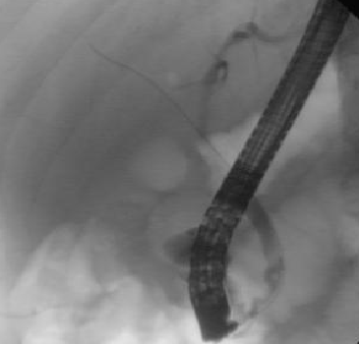
Figure 1 Distal common bile duct stricture on initial cholangiogram.

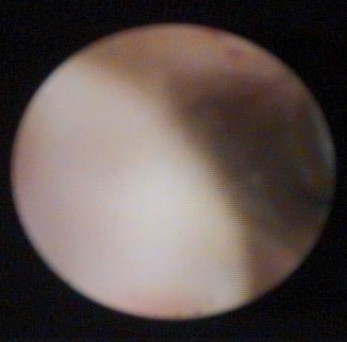
Figure 2 Polypoid lesion seen with SpyGlass™ cholangioscopy.

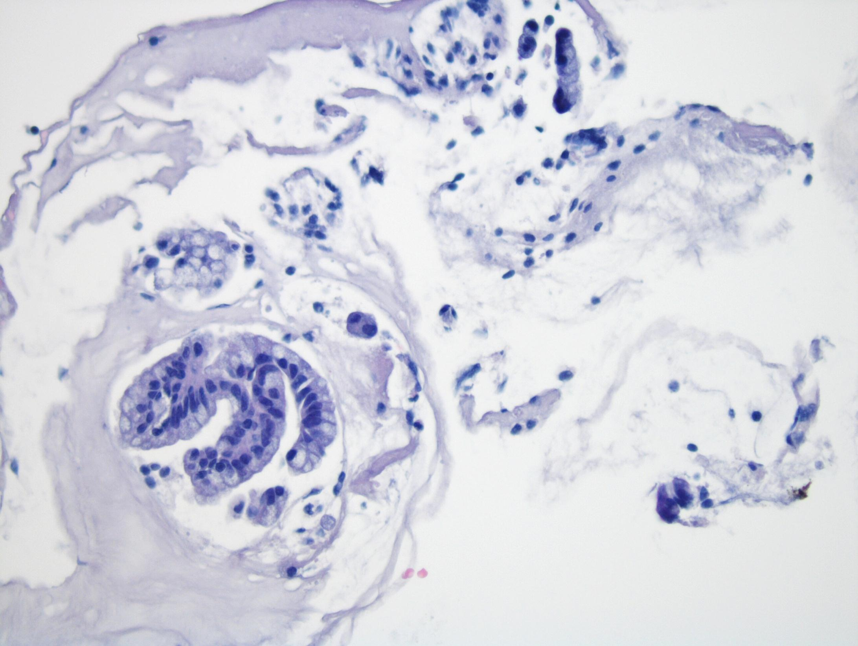
Figure 3 Biliary epithelium with papillary configuration and atypical cells.
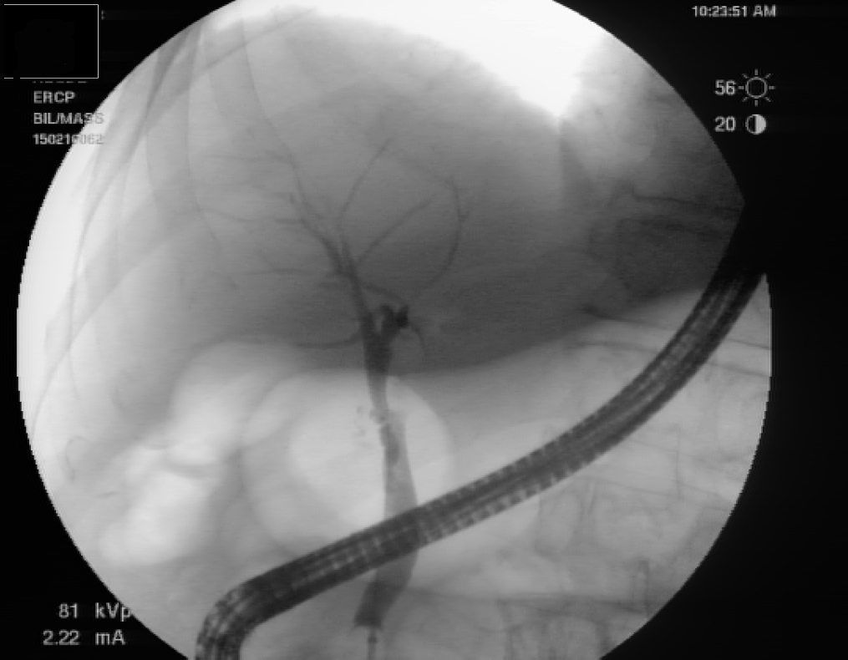
Figure 4 Occlusion cholangiogram performed four months after last radiofrequency ablation treatment, revealing no polypoid lesion or stricture in the distal common bile duct.

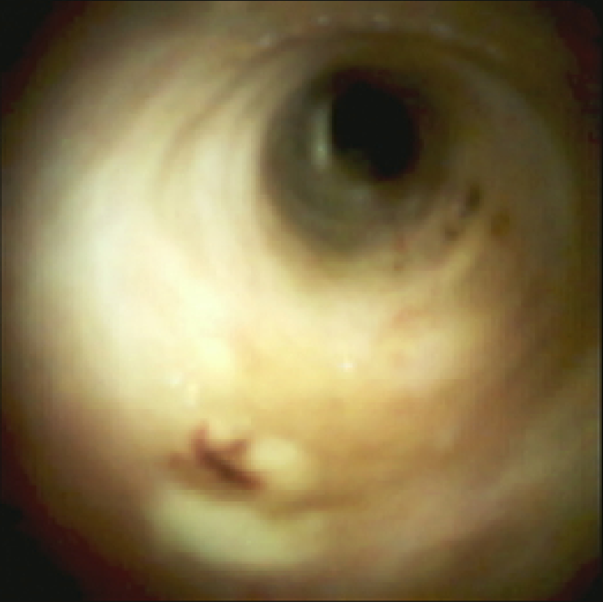
Figure 5 Repeat SpyGlass™ cholangioscopy showing no residual polypoid lesion.
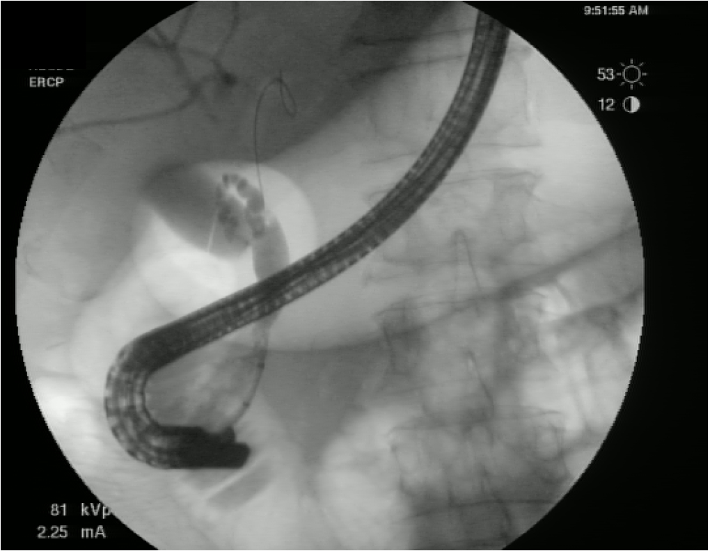
Figure 6 Repeat endoscopic retrograde cholangiopancreatography demonstrating a 10 mm distal common bile duct stricture without evidence of a mass lesion.

