Name of Journal: World Journal of Meta-Analysis
Manuscript NO: 76661
Manuscript Type: META-ANALYSIS

Clinical outcomes of the omicron variant compared with previous SARS-CoV-2 variants; meta-analysis of current reports

Karbalaei M et al. Omicron variant compared with previous SARS-CoV-2 variants

Mohsen Karbalaei, Masoud Keikha

Mohsen Karbalaei, Department of Microbiology and Virology, School of Medicine, Jiroft University of Medical Sciences, Jiroft, Iran

Masoud Keikha, Department of Microbiology and Virology, Faculty of Medicine, Mashhad University of Medical Sciences, Mashhad, Iran

Author contributions: Keikha M contribute in design of study, study conceptual, literature search, writhing the draft; Karbalaei M revision the draft and manuscript editing; all authors agree with publish in this journal.

Corresponding author: Masoud Keikha, PhD, Doctor, Instructor, Teaching Assistant, Department of Microbiology and Virology, Faculty of Medicine, Mashhad University of Medical Sciences, Mashhad, Iran. masoud.keykha90@gmail.com

Received: March 24, 2022
Revised: May 15, 2022
Accepted: June 24, 2022
Published online: June 28, 2022

Abstract
BACKGROUND
Omicron (B.1.1.529) is a SARS-CoV-2 variant of concern; however, there is no comprehensive analysis regarding clinical features, disease severity, or clinical outcomes of this variant.

AIM
To compare the clinical characteristics of infection with omicron and previous variants of SARS-CoV-2.

METHODS
We searched major international databases consisting ISI Web of Science, PubMed, Scopus, MedRxiv, and Reference Citation Analysis to collect the potential relevant documents. Finally, clinical features, e.g., death rate, intensive care unit (ICU) admission, length of hospitalization, and mechanical ventilation, of infection with SARS-CoV-2 omicron variant compared with previous variants were assessed using odds ratio and 95% confidence intervals by Comprehensive Meta-Analysis software version 2.2.

RESULTS
A total of 12 articles met our criteria. These investigated the clinical outcomes of infection with omicron variant compared with other variants such as alpha, beta and delta. Our results suggested that ICU admission, need for mechanical ventilation, and death rate were significantly lower for omicron than previous variants. In addition, the average length of hospitalization during the omicron wave was significantly shorter than for other variants.

CONCLUSION
The infectivity of omicron variant was higher than for previous variants due to several mutations, particularly in the spike protein. However, disease severity was mild to moderate compared previous variants.

Key Words: SARS-CoV-2; COVID-19; Omicron; Infectious disease

©The Author(s) 2022. Published by Baishideng Publishing Group Inc. All rights reserved.

Citation: Karbalaei M, Keikha M. Clinical outcomes of the omicron variant compared with previous SARS-CoV-2 variants; meta-analysis of current reports. World J Meta-Anal 2022; 10(3): 177-185
URL: https://www.wjgnet.com/2308-3840/full/v10/i3/177.htm
DOI: https://dx.doi.org/10.13105/wjma.v10.i3.177

Core Tip: SARS-CoV-2 omicron (B.1.1.529) is a variant of concern that was first identified on 24 November 2021 as a new global threat. However, due to the lack of comprehensive statistical analysis, clinical characteristics and disease outcomes of infection with omicron variant have remained unknown. Hence, the comparison of clinical profile between cases infected with this new variant and previous variants will lead to the establishment of a strategy regarding appropriate management and global control of this variant.

INTRODUCTION
COVID-19 is a global pandemic that first emerged from Wuhan, China in December 2019. According to the World Health Organization (WHO), so far > 378 million cases, as well as 5.67 million deaths have occurred due to SARS-CoV-2 infection^{[1]}. On 24 November 2021, the Network for Genomics Surveillance in South Africa (NGS-SA) reported a new variant of this virus from Gauteng Province, named omicron (B.1.1.529); the new variant was confirmed by WHO on 25 November 2021^{[2,3]}.
The omicron variant rapidly replaced the previous variants in South Africa and spread to other countries, so it quickly became a dominant variant. In the USA, approximately 95% of all new cases of COVID-19 were diagnosed as being caused by the omicron variant by January 2022^{[4,5]}.
The genome of this variant contains 26–32 mutations in the spike gene as well as 45–52 amino acid substitutions. these mutations are associated with increases in viral characteristics such as transmissibility, immune escape, and S gene target failure (SGTF). SGTF is due to the 69 to 70 deletion in the S gene of B.1.1.7^{[6-8]}. Early studies have shown the inefficacy of current vaccines (vaccination schemes and booster doses) and the higher rate of re-infection with the omicron variant^{[9,10]}. Based on animal model findings, the severity of symptoms as well as the viral load of the omicron variant were lower compared to the previously reported variants of SARS-CoV-2^{[11,12]}. Clinical reports from Scotland, England, Canada, and the USA have also confirmed animal experiments^{[13-16]}. However, the fourth global wave of COVID-19 caused by the omicron variant was not associated with increased hospitalization or death in comparison with previous SARS-CoV-2 variants^{[17]}.
Understanding the clinical characteristics, susceptibility factors, and immune response against the new SARS-CoV-2 variants could be useful strategies in managing these viruses and development of novel treatment options. In this study, we evaluated the clinical severity of SARS-CoV-2 omicron variant compared with previous variants.

MATERIALS AND METHODS
We searched global databases such as ISI Web of Science, PubMed, Scopus, MedRxiv, and Reference Citation Analysis (https://www.referencecitationanalysis.com/) using MeSH keywords such as “Omicron”, “COVID-19”, “SARS-CoV-2”, “Disease severity”, “Variant of concern”, “ICU”, “Intensive care unit”, and “fourth wave”. We retrieved all potential studies related to the clinical severity of SARS-CoV-2 omicron variant regardless of language and publication date. All eligible documents were carefully screened; required data including mean age, immunization status, mortality rate, intensive care unit (ICU) admission, length of hospitalization, and mechanical ventilation are summarized in Table 1. We also reviewed the bibliography of documents to avoid missing relevant articles. Finally, the severity of COVID-19 caused by omicron compared with previous SARS-CoV-2 variants was evaluated using odds ratio (OR) and 95% confidence interval (CI). We used a random-effect size due to the presence of significant heterogeneity (I² index and Cochrane P value test). Data were pooled using Comprehensive Meta-Analysis software version 2.2 (Biostat, Englewood, NJ, USA).

RESULTS
A total of 12 studies investigated the clinical outcomes of infection with SARS-CoV-2 omicron variant compared with other variants such as alpha, beta and delta (Figure 1). Eligible studies were performed in South Africa, USA, Portugal and UK from 2021 to 2022^{[18-29]}. We pooled the data of 887 132 cases with positive PCR test for SARS-CoV-2, including 163 457 cases positive for omicron variant, as well as 723 675 cases positive for other variants.
The mean age of patients infected with omicron variant was 28.93 ± 15 years. The frequency of events such as ICU admission, need for mechanical ventilation, and death rate for omicron variant was 0.8% (95% CI: 0.2%–3.7%; I²: 99.89; P = 0.01; Egger’s P = 0.01; Begg’s P = 0.29), 0.2% (95% CI: 0.1%–0.5%; I²: 95.75; P = 0.01; Egger’s P = 0.16; Begg’s P = 0.26), and 0.4% (95% CI: 0.1%–1.0%; I²: 98.47; P = 0.01; Egger’s P = 0.01; Begg’s P = 0.45), respectively. The average length of hospitalization for omicron was significantly less than for other variants (3.36 ± 1 d vs. 7.98 ± 3 d; P < 0.05). The incidence of omicron infection among fully vaccinated individuals was 12.9% (95% CI: 5%–27%; I²: 99.89; P = 0.01; Egger’s P = 0.22; Begg’s P = 0.40). the current findings revealed that the severity of infections caused by omicron was less than for previous infections caused by alpha, beta, and delta variants. The current findings are consistent with similar reports^{[30,31]}. In comparing the fourth wave of COVID-19 caused by the omicron variant with previous waves, it should be said that the mean age for patients infected with omicron was ~13 years (28.93 ± 15 years), which was less than that for other variants (41.29 ± 17 years). There was a significant reduction in ICU admission (OR: 0.18; 95% CI: 0.094–0.37; P = 0.01; I²: 99.05; P = 0.01; Egger’s P = 0.2; Begg’s P value: 0.07) (Figure 2). Our results suggested a significant reduction in the need for mechanical ventilation (OR: 0.135; 95% CI: 0.05–0.31; P = 0.01; I²: 97.24; P = 0.01; Egger’s P = 0.12; Begg’s P = 0.26) among omicron cases (Figure 3). The mortality rate also declined among patients infected with omicron variant (OR: 0.17; 95% CI: 0.06–0.46; P = 0.01; I²: 98.32; P = 0.01; Egger’s P = 0.44; Begg’s P = 0.71) compared with previous variants (Figure 4).

DISCUSSION
We found that the severity of COVID-19 caused by the SARS-CoV-2 omicron variant was significantly less than for previous variants; however, there was significant heterogeneity that could be due to differences in several factors such as study design, geographical region, time for assessment of clinical outcomes, and diverse conditions of included cases; publication bias was also significant. Recently, Zhao et al^{[32]}, showed that the omicron variant is less dependent on the TMPRSS2-mediated entry pathway, which leads to less-efficient replication and decreased viral load within the lungs. In addition, the omicron variant is more susceptible to interferons than other variants are, especially the delta variant^{[33]}. Similar evidence could be a reasonable explanation for the lower severity of COVID-19 with the omicron variant, as confirmed by numerous observational studies^{[15]}.
The omicron variant nucleotide sequence has several mutations, especially 32 single substitutions in the spike protein that cause resistance to neutralizing antibodies, as well as inefficiency of current vaccines^{[34-36]}. We revealed that omicron variant causes less severity of COVID-19 than previous variants; however, heterogeneity and publication bias were significant in our estimations (Figure 5). Further studies need to confirm the present findings.

CONCLUSION
A new global increase in COVID-19 has been accompanied by the emergence of the SARS-CoV-2 omicron variant that is associated with less disease severity, as well as fewer ICU admissions, shorter hospitalization, and lower mortality rate. Nonetheless, there is limited information about the effect of omicron on children, pregnant women, and immunodeficient individuals. Overall, omicron has been considered as the most contagious SARS-CoV-2 variant that affects children and young adults more than other groups. Continuation of the current situation can have deadly consequences for these age groups.

ARTICLE HIGHLIGHTS
Research background
Omicron (B.1.1.529) is a new variant of concern of SARS-CoV-2; however, there is no comprehensive analysis regarding clinical features, disease severity, and clinical outcomes of infection with this variant.

Research motivation
There is insufficient evidence regarding clinical characteristics, standard therapeutic regimen, and efficacy of currently available vaccines against the omicron variant.

Research objectives
This study was a comprehensive review and statistical analysis to compare the clinical characteristics of infection with the omicron and previous variants.

Research methods
We searched major international databases consisting ISI Web of Science, PubMed, Scopus, and MedRxiv to collect the potential relevant documents. Finally, clinical features, e.g., death rate, intensive care unit (ICU) admission, length of hospitalization, and need for mechanical ventilation of patients infected with omicron variant compared with previous variants, were assessed.

Research results
Twelve articles met our criteria. These studies investigated the clinical outcomes of infection with SARS-CoV-2 omicron variant compared with other variants such as alpha, beta and delta. Our results suggested that ICU admission, need for mechanical ventilation, and death rate were significantly lower for omicron than previous variants. In addition, the average length of hospitalization during the omicron wave was significantly shorter than for other variants.

Research conclusions
The infectivity of the omicron variant was much higher than for previous variants due to the presence of several mutations, particularly in the spike protein. However, disease severity was mild to moderate disease compared with previous variants.

Research perspectives
We revealed that the disease severity of infection with omicron was lower than for previous variants. However, this variant was more contagious. Nevertheless, further investigation with larger samples is needed to confirm the present findings.

REFERENCES
1 Okonji OC, Okonji EF, Mohanan P, Babar MS, Saleem A, Khawaja UA, Essar MY, Hasan MM. Marburg virus disease outbreak amidst COVID-19 in the Republic of Guinea: A point of contention for the fragile health system? Clin Epidemiol Glob Health 2022; 13: 100920. [PMID: 34901523 DOI: 10.1016/j.cegh.2021.100920]
2 Roessler A, Riepler L, Bante D, von Laer D, Kimpel J. SARS-CoV-2 B. 1.1. 529 variant (Omicron) evades neutralization by sera from vaccinated and convalescent individuals. medRxiv 2021 [DOI: 10.1101/2021.12.08.21267491]
3 Rahimi F, Talebi Bezmin Abadi A. Is Omicron the last SARS-CoV-2 Variant of Concern? Arch Med Res 2022; 53: 336-338 [PMID: 35093242 DOI: 10.1016/j.arcmed.2022.01.001]
4 Burki TK. Omicron variant and booster COVID-19 vaccines. Lancet Respir Med 2022; 10: e17 [PMID: 34929158 DOI: 10.1016/S2213-2600(21)00559-2]
5 Control CfD, Prevention. COVID data tracker: variant proportions. Atlanta, GA2021. 2021. Available from: https://covid cdc gov/covid-data-tracker/#datatracker-home.
6 Wu C, Yin W, Jiang Y, Xu HE. Structure genomics of SARS-CoV-2 and its Omicron variant: drug design templates for COVID-19. Acta Pharmacol Sin [DOI: 10.1038/s41401-021-00851-w]
7 Brierley AS, Fernandes PG, Brandon MA, Armstrong F, Millard NW, McPhail SD, Stevenson P, Pebody M, Perrett J, Squires M, Bone DG, Griffiths G. Antarctic krill under sea ice: elevated abundance in a narrow band just south of ice edge. Science 2002; 295: 1890-1892 [PMID: 11884754 DOI: 10.1126/science.1068574]
8 Abdulnoor M, Eshaghi A, Perusini SJ, Broukhanski G, Corbeil A, Cronin K, Fittipaldi N, Forbes JD, Guthrie JL, Kus JV, Li Y, Majury A, Mallo GV, Mazzulli T, Melano RG, Olsha R, Sullivan A, Tran V, Patel SN, Allen VG, Gubbay JB. Real-Time RT-PCR Allelic Discrimination Assay for Detection of N501Y Mutation in the Spike Protein of SARS-CoV-2 Associated with B.1.1.7 Variant of Concern. Microbiol Spectr 2022; 10: e0068121 [PMID: 35170989 DOI: 10.1128/spectrum.00681-21]
9 Nemet I, Kliker L, Lustig Y, Zuckerman N, Erster O, Cohen C, Kreiss Y, Alroy-Preis S, Regev-Yochay G, Mendelson E, Mandelboim M. Third BNT162b2 Vaccination Neutralization of SARS-CoV-2 Omicron Infection. N Engl J Med 2022; 386: 492-494 [PMID: 34965337 DOI: 10.1056/NEJMc2119358]
10 Papanikolaou V, Chrysovergis A, Ragos V, Tsiambas E, Katsinis S, Manoli A, Papouliakos S, Roukas D, Mastronikolis S, Peschos D, Batistatou A, Kyrodimos E, Mastronikolis N. From delta to Omicron: S1-RBD/S2 mutation/deletion equilibrium in SARS-CoV-2 defined variants. Gene 2022; 814: 146134 [PMID: 34990799 DOI: 10.1016/j.gene.2021.146134]
11 Bentley EG, Kirby A, Sharma P, Kipar A, Mega DF, Bramwell C, Penrice-Randal R, Prince T, Brown JC., Zhou J. SARS-CoV-2 Omicron-B. 1.1. 529 Variant leads to less severe disease than Pango B and Delta variants strains in a mouse model of severe COVID-19. bioRxiv 2021 [DOI: 10.1101/2021.12.26.474085]
12 Naranbhai V, Nathan A, Kaseke C, Berrios C, Khatri A, Choi S, Getz MA, Tano-Menka R, Ofoman O, Gayton A, Senjobe F, Denis KJS, Lam EC, Garcia-Beltran WF, Balazs AB, Walker BD, Iafrate AJ, Gaiha GD. T cell reactivity to the SARS-CoV-2 Omicron variant is preserved in most but not all prior infected and vaccinated individuals. medRxiv 2022 [PMID: 35018386 DOI: 10.1101/2022.01.04.21268586]
13 Sheikh A, Kerr S, Woolhouse M, McMenamin J, Robertson C; EAVE II Collaborators. Severity of omicron variant of concern and effectiveness of vaccine boosters against symptomatic disease in Scotland (EAVE II): a national cohort study with nested test-negative design. Lancet Infect Dis 2022 [PMID: 35468332 DOI: 10.1016/S1473-3099(22)00141-4]
14 Nyberg T, Ferguson NM, Nash SG, Webster HH, Flaxman S, Andrews N, Hinsley W, Bernal JL, Kall M, Bhatt S, Blomquist P, Zaidi A, Volz E, Aziz NA, Harman K, Funk S, Abbott S; COVID-19 Genomics UK (COG-UK) consortium, Hope R, Charlett A, Chand M, Ghani AC, Seaman SR, Dabrera G, De Angelis D, Presanis AM, Thelwall S. Comparative analysis of the risks of hospitalisation and death associated with SARS-CoV-2 omicron (B.1.1.529) and delta (B.1.617.2) variants in England: a cohort study. Lancet 2022; 399: 1303-1312 [PMID: 35305296 DOI: 10.1016/S0140-6736(22)00462-7]
15 Ulloa AC, Buchan SA, Daneman N, Brown KA. Early estimates of SARS-CoV-2 Omicron variant severity based on a matched cohort study, Ontario, Canada. MedRxiv 2021 [DOI: 10.1101/2021.12.24.21268382]
16 Jansen L, Tegomoh B, Lange K, Showalter K, Figliomeni J, Abdalhamid B, Iwen PC, Fauver J, Buss B, Donahue M. Investigation of a SARS-CoV-2 B.1.1.529 (Omicron) Variant Cluster - Nebraska, November-December 2021. MMWR Morb Mortal Wkly Rep 2021; 70: 1782-1784 [PMID: 34968376 DOI: 10.15585/mmwr.mm705152e3]
17 Wolter N, Jassat W, Walaza S, Welch R, Moultrie H, Groome M, Amoako DG, Everatt J, Bhiman JN, Scheepers C, Tebeila N, Chiwandire N, du Plessis M, Govender N, Ismail A, Glass A, Mlisana K, Stevens W, Treurnicht FK, Makatini Z, Hsiao NY, Parboosing R, Wadula J, Hussey H, Davies MA, Boulle A, von Gottberg A, Cohen C. Early assessment of the clinical severity of the SARS-CoV-2 omicron variant in South Africa: a data linkage study. Lancet 2022; 399: 437-446 [PMID: 35065011 DOI: 10.1016/S0140-6736(22)00017-4]
18 Abdullah F, Myers J, Basu D, Tintinger G, Ueckermann V, Mathebula M, Ramlall R, Spoor S, de Villiers T, Van der Walt Z, Cloete J, Soma-Pillay P, Rheeder P, Paruk F, Engelbrecht A, Lalloo V, Myburg M, Kistan J, van Hougenhouck-Tulleken W, Boswell MT, Gray G, Welch R, Blumberg L, Jassat W. Decreased severity of disease during the first global omicron variant covid-19 outbreak in a large hospital in tshwane, south africa. Int J Infect Dis 2022; 116: 38-42 [PMID: 34971823 DOI: 10.1016/j.ijid.2021.12.357]
19 Cloete J, Kruger A, Masha M, du Plessis NM, Mawela D, Tshukudu M, Manyane T, Komane L, Venter M, Jassat W. Rapid rise in paediatric COVID-19 hospitalisations during the early stages of the Omicron wave, Tshwane District, South Africa. medRxiv 2021 [DOI: 10.1101/2021.12.21.21268108]
20 Christensen PA, Olsen RJ, Long SW, Snehal R, Davis JJ, Ojeda Saavedra M, Reppond K, Shyer MN, Cambric J, Gadd R, Thakur RM, Batajoo A, Mangham R, Pena S, Trinh T, Kinskey JC, Williams G, Olson R, Gollihar J, Musser JM. Signals of Significantly Increased Vaccine Breakthrough, Decreased Hospitalization Rates, and Less Severe Disease in Patients with Coronavirus Disease 2019 Caused by the Omicron Variant of Severe Acute Respiratory Syndrome Coronavirus 2 in Houston, Texas. Am J Pathol 2022; 192: 642-652 [PMID: 35123975 DOI: 10.1016/j.ajpath.2022.01.007]
21 Davies MA, Kassanjee R, Rosseau P, Morden E, Johnson L, Solomon W, Hsiao NY, Hussey H, Meintjes G, Paleker M, Jacobs T, Raubenheimer P, Heekes A, Dane P, Bam JL, Smith M, Preiser W, Pienaar D, Mendelson M, Naude J, Schrueder N, Mnguni A, Roux SL, Murie K, Prozesky H, Mahomed H, Rossouw L, Wasserman S, Maughan D, Boloko L, Smith B, Taljaard J, Symons G, Ntusi N, Parker A, Wolter N, Jassat W, Cohen C, Lessells R, Wilkinson RJ, Arendse J, Kariem S, Moodley M, Vallabhjee K, Wolmarans M, Cloete K, Boulle A. Outcomes of laboratory-confirmed SARS-CoV-2 infection in the Omicron-driven fourth wave compared with previous waves in the Western Cape Province, South Africa. medRxiv 2022 [PMID: 35043121 DOI: 10.1101/2022.01.12.22269148]
22 Goga A, Bekker LG, Garret N, Reddy T, Yende-Zuma N, Fairall L, Moultrie H, Takalani A, Trivelli V, Faesen M. Breakthrough Covid-19 infections during periods of circulating Beta, Delta and Omicron variants of concern, among health care workers in the Sisonke Ad26. COV2. S vaccine trial, South Africa. medRxiv 2021 [DOI: 10.1101/2021.12.21.21268171]
23 Lewnard JA, Hong VX, Patel MM, Kahn R, Lipsitch M, Tartof SY. Clinical outcomes among patients infected with Omicron (B. 1.1. 529) SARS-CoV-2 variant in southern California. medRxiv 2022. [DOI: 10.1101/2022.01.11.22269045]
24 Iuliano AD, Brunkard JM, Boehmer TK, Peterson E, Adjei S, Binder AM, Cobb S, Graff P, Hidalgo P, Panaggio MJ, Rainey JJ, Rao P, Soetebier K, Wacaster S, Ai C, Gupta V, Molinari NM, Ritchey MD. Trends in Disease Severity and Health Care Utilization During the Early Omicron Variant Period Compared with Previous SARS-CoV-2 High Transmission Periods - United States, December 2020-January 2022. MMWR Morb Mortal Wkly Rep 2022; 71: 146-152 [PMID: 35085225 DOI: 10.15585/mmwr.mm7104e4]
25 Maslo C, Friedland R, Toubkin M, Laubscher A, Akaloo T, Kama B. Characteristics and Outcomes of Hospitalized Patients in South Africa During the COVID-19 Omicron Wave Compared With Previous Waves. JAMA 2022; 327: 583-584 [PMID: 34967859 DOI: 10.1001/jama.2021.24868]
26 Peralta-Santos A, Rodrigues EF, Moreno J, Ricoca V, Casaca P, Fernandes E, Gomes JP, Ferreira R, Isidro J, Pinto M. Omicron (BA. 1) SARS-CoV-2 Variant Is Associated With Reduced Risk of Hospitalization and Length of Stay Compared With Delta (B. 1.617. 2). [DOI: 10.2139/ssrn.4017381]
27 Torjesen I. Covid-19: Omicron variant is linked to steep rise in hospital admissions of very young children. BMJ 2022; 376: o110 [PMID: 35031537 DOI: 10.1136/bmj.o110]
28 Wang L, Berger NA, Kaelber DC, Davis PB, Volkow ND, Xu R. Comparison of outcomes from COVID infection in pediatric and adult patients before and after the emergence of Omicron. medRxiv 2022 [PMID: 35018384 DOI: 10.1101/2021.12.30.21268495]
29 Wang L, Berger NA, Kaelber DC, Davis PB, Volkow ND, Xu R. COVID infection severity in children under 5 years old before and after Omicron emergence in the US. medRxiv 2022 [PMID: 35043116 DOI: 10.1101/2022.01.12.22269179]
30 Del Rio C, Omer SB, Malani PN. Winter of Omicron-The Evolving COVID-19 Pandemic. JAMA 2022; 327: 319-320 [PMID: 34935863 DOI: 10.1001/jama.2021.24315].
31 Madhi S, Kwatra G, Myers JE, Jassat W, Dhar N, Mukendi CK, Nana A, Blumberg L, Welch R, Ngorima-Mabhena‎ N. South African population immunity and severe Covid-19 with omicron variant. MedRxiv 2021 [DOI: 10.1101/2021.12.20.21268096]
32 Zhao H, Lu L, Peng Z, Chen LL, Meng X, Zhang C, Ip JD, Chan WM, Chu AW, Chan KH, Jin DY, Chen H, Yuen KY, To KK. SARS-CoV-2 Omicron variant shows less efficient replication and fusion activity when compared with Delta variant in TMPRSS2-expressed cells. Emerg Microbes Infect 2022; 11: 277-283 [PMID: 34951565 DOI: 10.1080/22221751.2021.2023329]
33 Bojkova D, Widera M, Ciesek S, Wass MN, Michaelis M, Cinatl J Jr. Reduced interferon antagonism but similar drug sensitivity in Omicron variant compared to Delta variant of SARS-CoV-2 isolates. Cell Res 2022; 32: 319-321 [PMID: 35064226 DOI: 10.1038/s41422-022-00619-9]
34 Song Y, Masaki F. Preparation for the challenge of heavily mutated Omicron variant. Clin Transl Med 2021; 11: e679 [PMID: 34898041 DOI: 10.1002/ctm2.679]
35 Hoffmann M, Krüger N, Schulz S, Cossmann A, Rocha C, Kempf A, Nehlmeier I, Graichen L, Moldenhauer AS, Winkler MS, Lier M, Dopfer-Jablonka A, Jäck HM, Behrens GMN, Pöhlmann S. The Omicron variant is highly resistant against antibody-mediated neutralization: Implications for control of the COVID-19 pandemic. Cell 2022; 185: 447-456.e11 [PMID: 35026151 DOI: 10.1016/j.cell.2021.12.032]
36 Tada T, Zhou H, Dcosta BM, Samanovic MI, Chivukula V, Herati RS, Hubbard SR, Mulligan MJ, Landau NR. Increased resistance of SARS-CoV-2 Omicron variant to neutralization by vaccine-elicited and therapeutic antibodies. EBioMedicine 2022; 78: 103944 [PMID: 35465948 DOI: 10.1016/j.ebiom.2022.103944]

Footnotes
Conflict-of-interest statement: All the authors declare that they have no conflict of interest.

PRISMA 2009 Checklist statement: This study was conducted according to PRISMA 2009 Checklist statement.

Open-Access: This article is an open-access article that was selected by an in-house editor and fully peer-reviewed by external reviewers. It is distributed in accordance with the Creative Commons Attribution NonCommercial (CC BY-NC 4.0) license, which permits others to distribute, remix, adapt, build upon this work non-commercially, and license their derivative works on different terms, provided the original work is properly cited and the use is non-commercial. See: https://creativecommons.org/Licenses/by-nc/4.0/

Provenance and peer review: Unsolicited article; Externally peer reviewed.
Peer-review model: Single blind

Peer-review started: March 24, 2022
First decision: April 28, 2022
Article in press: June 24, 2022

Specialty type: Infectious diseases
Country/Territory of origin: Iran
Peer-review report’s scientific quality classification
Grade A (Excellent): 0
Grade B (Very good): B
Grade C (Good): C
Grade D (Fair): 0
Grade E (Poor): 0

P-Reviewer: Cure E, Turkey; Lelisho ME, Ethiopia S-Editor: Liu JH L-Editor: Kerr C P-Editor: Liu JH
Figure Legends
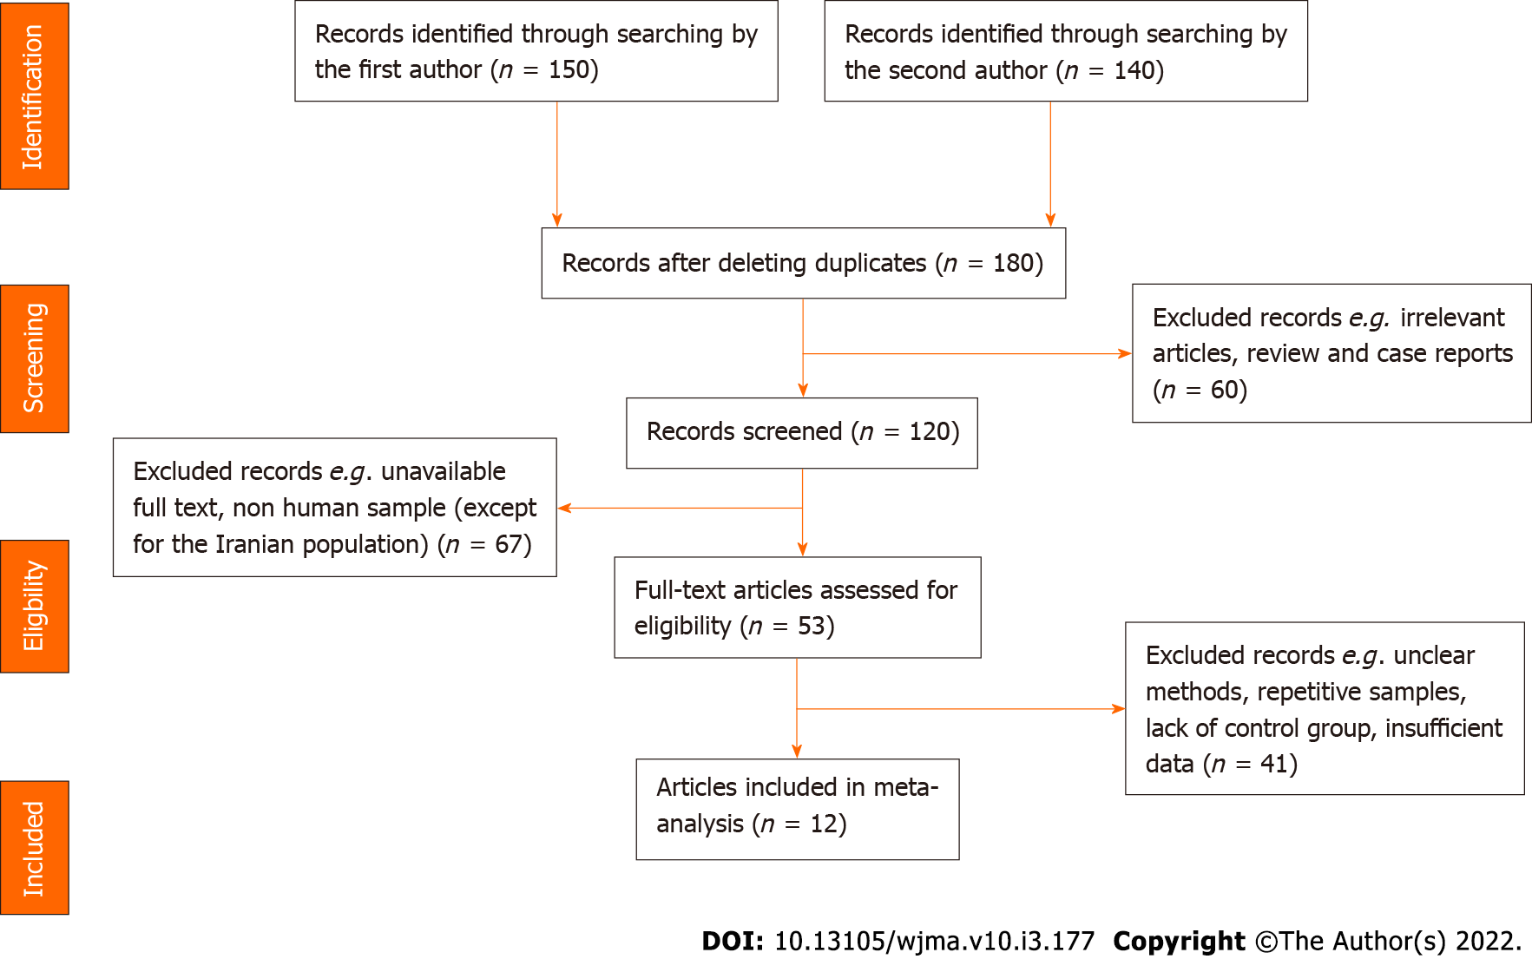
Figure 1 Flowchart of literature search and study selection process.‎

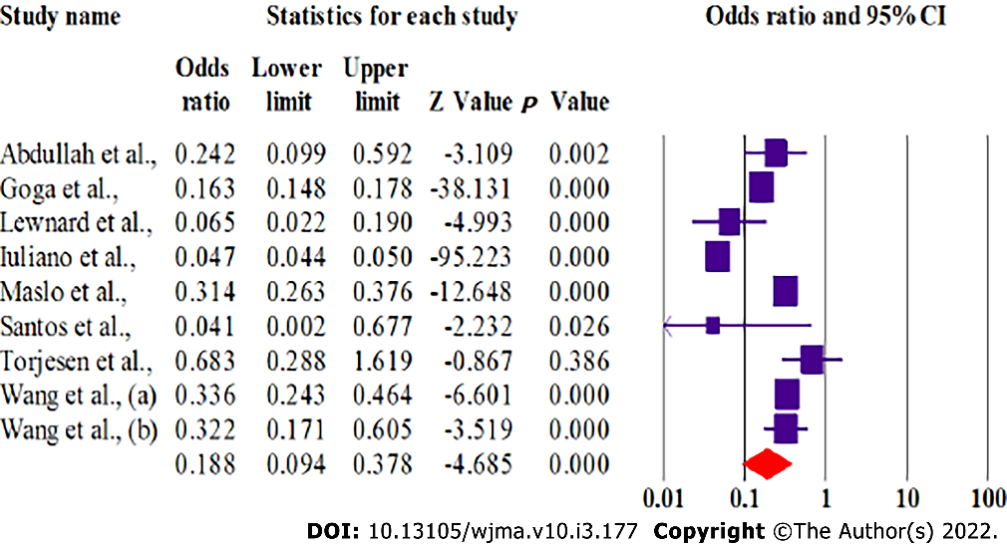
Figure 2 Forest plot of the meta-analysis on intensive care unit admission for patients infected with SARS-CoV-2 omicron variant.
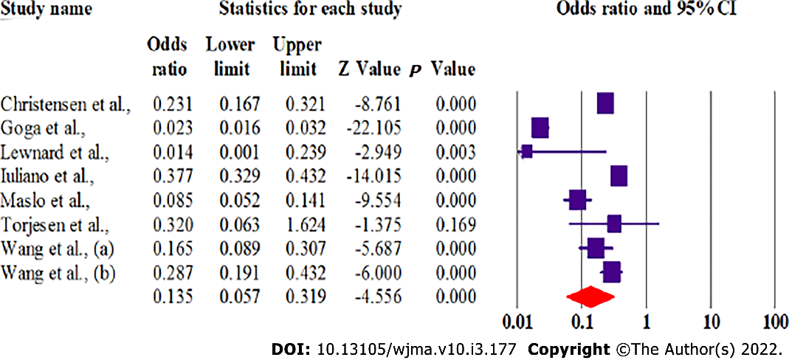
Figure 3 Forest plot of the meta-analysis for need for mechanical ventilation in patients infected with SARS-CoV-2 omicron variant.
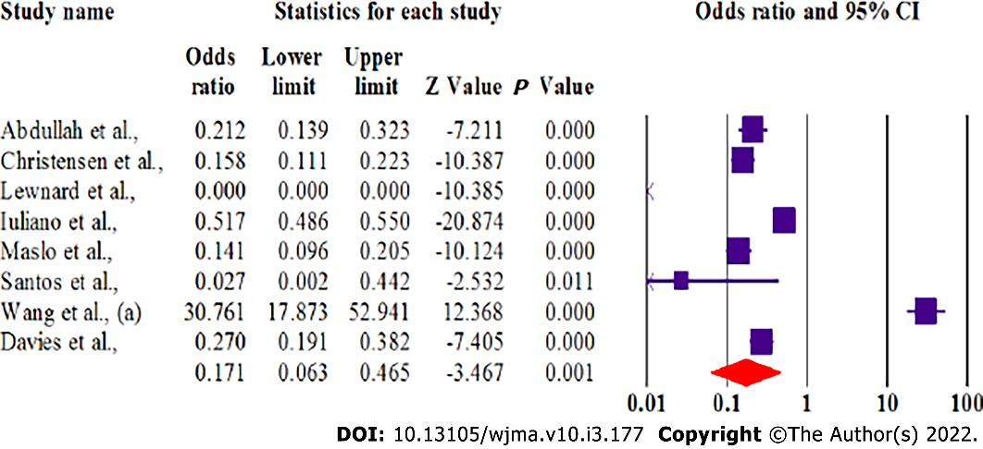
Figure 4 Forest plot of meta-analysis of risk of mortality in patients infected with SARS-CoV-2 omicron variant.

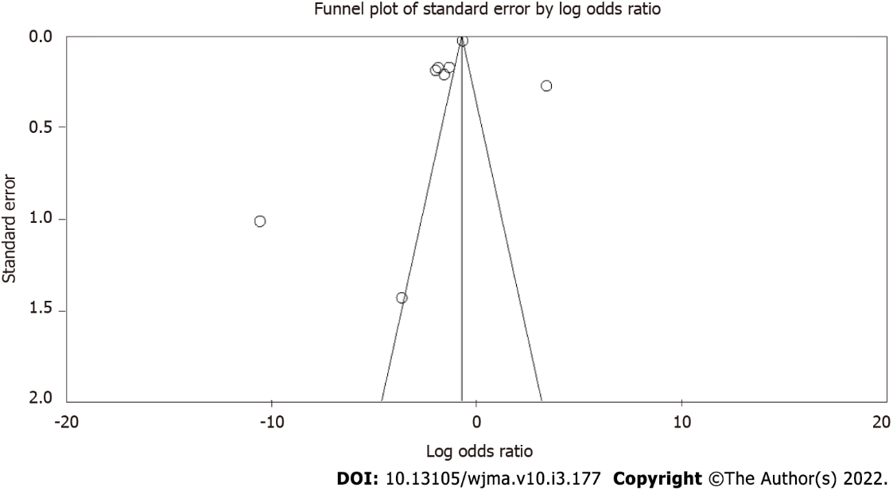Figure 5 Funnel plot of meta-analysis of disease severity of patients intfected with SARS-CoV-2 omicron variant compared with previous variants.

Table 1 Characteristics of included studies
First author | Country | Mean age |  | Immunization |  | Death rate |  | ICU admission |  | Length of stay |  | Ventilation |  | Number of cases |  | Ref.
 |  | Omicron | Previous variants | Omicron | Previous variants | Omicron | Previous variants | Omicron | Previous variants | Omicron | Previous variants | Omicron | Previous variants | Omicron | Previous variants
Abdullah | South Africa | 39 | 49.8 | NA | NA | 4.5% | 21.3% | 1% | 4.3% | 4 | 8.8 | NA | NA | 466 | 3962 | ^{[18]}
Cloete | South Africa | 4.2 | NA | NA | NA | 4 | NA | 7 | NA | 3.2 | NA | 7 | NA | 6287 | NA | ^{[19]}
Christensen | USA | 44.3 | 50.0 | 2497 | 101 | 38 | 170 | NA | NA | 3.2 | 5.1 | 49 | 144 | 4468 | 3149 | ^{[20]}
Davies | South Africa | NA | NA | HR:0.41, 95%CI: 0.29-0.59 |  | HR: 0.27, 95%CI: 0.19-0.38 |  | NA | NA | NA | NA | NA | NA | 5144 | 11609 | ^{[21]}
Goga | South Africa | 33 | 55 | NA | NA | NA | NA | 3% | 16% | 3 | 6 | 0.2% | 8% | 17650 | 22888 | ^{[22]}
Lewnard | USA | NA | NA | 6,981 | 784 | 1 | 12 | 4 | 20 | 5.5 | 15.8 | 0 | 11 | 52297 | 16982 | ^{[23]}
Iuliano | USA | NA | NA | NA | NA | 1854 | 1924 | 24776 | 24774 | 3 | 5 | 358 | 503 | 48238 | 25873 | ^{[24]}
Maslo | South Africa | 36 | 53 | 235 | NA | 27 | 520 | 180 | 1104 | 3 | 8 | 16 | 431 | 971 | 2628 | ^{[25]}
Santos | Portugal | 37.1 | 43.4 | 295 | 201 | 0 | 26 | 0 | 17 | 3.7 | 8.6 | NA | NA | 6581 | 9397 | ^{[26]}
Torjesen | UK | NA | NA | NA | NA | NA | NA | 9.9% | 14% | 1.7 | 6.6 | 2% | 5.8% | NA | NA | ^{[27]}
Wang | USA | 36.4 | 36.1 | 2.4% | 3.1% | 23 | 30 | 0.26% | 0.78% | NA | NA | 0.07% | 0.43% | 14054 | 563884 | ^{[28]}
Wang | USA | 1.49 | 1.73 | NA | NA | NA | NA | 0.14% | 0.43% | NA | NA | 0.33% | 1.15% | 7201 | 63203 | ^{[29]}
ICU: Intensive care unit; NA: Not available; HR: Hazard ratio; CI: Confidence interval.

Published by Baishideng Publishing Group Inc
7041 Koll Center Parkway, Suite 160, Pleasanton, CA 94566, USA
Telephone: +1-925-3991568
E-mail: bpgoffice@wjgnet.com
Help Desk: https://www.f6publishing.com/helpdesk
https://www.wjgnet.com

© 2022 Baishideng Publishing Group Inc. All rights reserved.

