Name of Journal: World Journal of Gastroenterology
Manuscript NO: 38303
Manuscript Type: ORIGINAL ARTICLE

Basic Study
Mucosa repair mechanisms of Tong-Xie-Yao-Fang mediated by CRH-R2 in murine, dextran sulfate sodium induced colitis

Gong SS et al. Mucosa repair mechanisms of ulcerative colitis

Shan-Shan Gong, Shi-Yi Wang, Qing-Qing Han, Bin Lv, Yi Xu, Xi Chen, Yao-Er He, Yi-Hong Fan

Shan-Shan Gong, Shi-Yi Wang, Qing-Qing Han, Xi Chen, Yao-Er He, The First Clinical Medical College of Zhejiang Chinese Medical University, Hangzhou 310053, Zhejiang Province, China

Bin Lv, Yi Xu, Yi-Hong Fan, Department of Gastroenterology, The First Affiliated Hospital of Zhejiang Chinese Medical University, Hangzhou 310006, Zhejiang Province, China

ORCID number: Shan-Shan Gong (0000-0001-5483-720X); Shi-Yi Wang (0000-0002-2134-3892); Qing-Qing Han (0000-0002-3155-3746); Bin Lv (0000-0002-6247-571X); Yi Xu (0000-0002-3265-9534); Xi Chen (0000-0002-6236-6345); Yao-Er He (0000-0003-3511-8554) ; Yi-Hong Fan (0000-0001-8217-9793).

Author contributions: Gong SS and Wang SY performed the experiments, analyzed the data and wrote the paper; Fan YH and Han QQ designed the research, revised the paper and contributed equally to this study; Xu Y and Lv B performed parts of the experiments and provided valuable suggestions for this study; Chen X and He YE contributed new analytic tools; all authors have read and approved the final manuscript.

Supported by National Natural Science Foundation of China, No. 81473506; Natural Science Foundation of Zhejiang Province, No. LY13H030011; State Administration of Traditional Chinese Medicine of Zhejiang Province, No. 2013ZB050. Natural Science Foundation of Zhejiang Province, No. Y17H290033; Department of zhejiang province to build funded project, No. WKJ-ZJ-1531; Zhejiang TCM science and technology project, No. 2016ZB047; Zhejiang TCM science and technology project, No. 2017ZA056; Zhejiang TCM science and technology project, No. 2018ZB046.

Institutional review board statement: The study was reviewed and approved by the Institutional Review Board of Zhejiang Chinese Medical University.

Institutional animal care and use committee statement: All procedures involving animals were reviewed and approved by the Institutional Animal Care and Use Committee of Zhejiang Chinese Medical University.

Conflict-of-interest statement: No potential conflicts of interest exist.

Data sharing statement: No additional data are available.

Open-Access: This article is an open-access article which was selected by an in-house editor and fully peer-reviewed by external reviewers. It is distributed in accordance with the Creative Commons Attribution Non Commercial (CC BY-NC 4.0) license, which permits others to distribute, remix, adapt, build upon this work non-commercially, and license their derivative works on different terms, provided the original work is properly cited and the use is non-commercial. See: http://creativecommons.org/licenses/by-nc/4.0/

Manuscript source: Unsolicited manuscript

Correspondence to: Yi-Hong Fan, PhD, Associate Professor, Department of Gastroenterology, The First Affiliated Hospital of Zhejiang Chinese Medical University, No. 54, Youdian Road, Shangcheng District, Hangzhou 310006, Zhejiang Province, China. yhfansjr@163.com
Telephone: +86-571-87608001
Fax: +86-571-87608001

Received: February 12, 2018
Peer-review started: February 13, 2018
First decision: March 9, 2018
Revised: March 14, 2018
Accepted: March 31, 2018
Article in press:
Published online:

Abstract
AIM
To explore the significance of CRH-R2 in the mucosal healing of dextran sulfate sodium (DSS) induced colitis and to study the effect of Tong-Xie-Yao-Fang on CRH-R2 expression and regulation.

METHODS
Ulcerative colitis (UC) were induced in mice with 3% (w/v) dextran sulfate sodium for 7 d. Once the model was established, mice were administered urocortin-2 (30 µg/kg), a peptide which binds exclusively to CRH-R2 or various doses of aqueous TXYF extracts (2.8-11.2 g/kg), a CRH-R2 antagonist -Astressin 2B (20 µg/kg), Ast2B+Ucn2, or Ast2B with various doses of aqueous TXYF extracts for 9 d. Colonic mucosal permeability were then evaluated by measuring the fluorescence intensity in serum. The colitis disease activity index (DAI), histological evaluation, body weight loss and colon length were performed to evaluate the condition of colitis. Terminal deoxynucleotidyl transferase dUTP nick-end labeling (TUNEL) detected the apoptosis of intestinal epithelial cells. The expression level of Ki-67 represented the proliferation of colonic epithelial cells and was detected by immunohistochemistry. The expression levels of inflammation cytokines IL-6, TNF-αand CXCL-1 were examined in colon tissues using real-time PCR and ELISA kits.

RESULTS
Compared with DSS group, mice treated with CRH-R2 antagonist Ast2B showed greater loss of body weight, shorter colon lengths (4.90 ± 0.32 vs 6.21 ± 0.34 cm, P < 0.05), higher DAI (3.61 ± 0.53 vs 2.42 ± 0.32, P < 0.05), and histological scores (11.50 ± 1.05 vs 8.33 ± 1.03, P < 0.05). Additionally, the Ast2B group showed increased intestinal permeability (2.76 ± 0.11 vs 1.47 ± 0.11 μg/mL, P < 0.001), improved secretion of inflammatory cytokines in colon tissue and reduced colonic epithelial cell proliferation (4.97 ± 4.25 vs 22.51 ± 8.22, P < 0.05). Increased apoptosis (1422.39 ± 90.71 vs 983.01 ± 98.17, P < 0.001) was also demonstrated. Ucn 2 group demonstrated lower DAI (0.87 ± 0.55 vs 2.42 ± 0.32, P < 0.001) and histological scores (4.33 ± 1.50 vs 8.33 ± 1.03, P < 0.05). Diminished weight loss, longer colon length (9.58 ± 0.62 vs 6.21 ± 0.34 cm, P < 0.001), reduced intestinal permeability (0.75 ± 0.07 vs 1.47 ± 0.11 μg/mL, P < 0.001), inhibited secretion of inflammatory cytokines in colon tissue and increased colonic epithelial cell proliferation (90.04 ± 15.50 vs 22.51 ± 8.22, P < 0.01) were all observed. Reduced apoptosis (149.55 ± 21.68 vs 983.01 ± 98.17, P < 0.05) was also observed. However, significant statistical differences in the results of Ast2B group and Ast2B+Ucn2 group were observed. Tong-Xie-Yao-Fang was also found to ameliorate symptoms of DSS-induced colitis in mice and promoted mucosal repair like Ucn2. There were significant differences between the Ast2B+TXYF groups and Tong-Xie-Yao-Fang groups.

CONCLUSION
CRH-R2 activates the intestinal mucosal anti-inflammatory response by regulating the migration, proliferation and apoptosis of intestinal epithelial cells in colitis mice, and plays an important anti-inflammatory role. The Tong-Xie-Yao-Fang promotes the mucosal repair process of colitis mice by regulating CRH-R2.

Key words：Tong-Xie-Yao-Fang; Aqueous extracts; Corticotropin-releasing hormone receptor 2; Urocortin 2; Astressin 2B; Mucosal healing; Ulcerative colitis

© The Author(s) 2018. Published by Baishideng Publishing Group Inc. All rights reserved.

Core tip: Mucosal healing is a desired therapeutic endpoint in the treatment of inflammatory bowel disease (IBD). However, it is difficult to treat IBD thoroughly, and there are some adverse reactions. Studies have shown that CRH-R2 can activate the inflammatory response of intestinal mucosa and play an anti-inflammatory effect. Our preliminary study found that Tong-Xie-Yao-Fang could reduce the expression of CRH-R1, increase the CRH-R2, and participated in the reconstruction of intestinal barrier. The aim of this study is to explore the significance of CRH-R2 in the mucosal healing of DSS induced colitis and to study the effect of Tong-Xie-Yao-Fang on CRH-R2 expression and regulation.

Gong SS, Wang SY, Han QQ, Lv B, Xu Y, Chen X, He YE, Fan YH. Mucosa repair mechanisms of Tong-Xie-Yao-Fang mediated by CRH-R2 in murine, dextran sulfate sodium induced colitis. World J Gastroenterol 2018; In press

INTRODUCTION
Inflammatory bowel disease (IBD), including Crohn’s disease (CD), and ulcerative colitis (UC), is a group of chronic inflammatory disorders of the gastrointestinal tract characterized by intestinal inflammation and mucosal damage^{[1]}. In traditional Chinese medicine theory (TCM), UC is known as the “changpi” and chronic dysentery^{[2]}. Characterized by chronic mucosal inflammation and damage of the colon, UC presents with bloody diarrhea, tenesmus, abdominal pain, weight loss, anemia, and even toxic megacolon. Intestinal perforation, intestinal obstruction, intestinal bleeding, and cancer are also observed, thus affecting an individual’s quality of life^{[3]}.
Treatment targets for IBD have changed over the recent years. Previous therapeutic strategies focusing on induction and maintenance of clinical remission have shown no effect on the natural course of the disease^{[4,5]}. However, in the late 1990s, the advent of biologic agents for the treatment of IBD has shown that while patients may be in clinical remission, ongoing mucosal inflammation may still be present, resulting in structural damage^{[6-11]}.
This finding has led to the concept of mucosal healing (MH) as a more meaningful therapeutic target in clinical practice. Indeed, emerging data suggests that MH is strongly associated with a reduction in steroid use, complications, hospitalizations, and surgeries^{[12]}.
Mucosal repair of the intestinal barrier is a tightly coordinated response to injury that preserves homeostasis and limits the adverse effects of inflammation. After damage to the epithelial tissue,
intestinal epithelial cells migrate to the site of injury in a critical process known as epithelial restitution^{[13-15]}. Restitution is followed by epithelial cell proliferation and differentiation which is regulated by factors that promote cell viability and limit apoptosis^{[14,16]}. IBD is a chronic relapsing inflammatory disorder that involves a defective epithelial barrier^{[17]}.
Corticotropin-releasing hormone (CRH), the primary mediator of the stress response, is expressed in both the central nervous system and the periphery, including the intestine^{[18]}. The CRH family of peptides interacts with a variety of cell types in the intestinal mucosa, including epithelial cells, enteric neurons, and immune cells^{[19]}. In addition to CRH, three distinct peptides known as urocortins (Ucn1, Ucn2, and Ucn3) bind to two types of G protein-coupled receptors to exert their effects, CRH receptor (CRHR) 1 and CRH-R2. Yet, Ucn1 has greater affinity for CRH-R2 than CRH-R1, and Ucn2 and Ucn3 bind exclusively to CRH-R2^{[20]}. Interactions between CRH receptors and their ligands modulate several functional and pathophysiologic responses within the gut, including stress induced alterations in motility, ion secretion, and visceral pain, and the development, and maintenance of intestinal inflammation^{[21]}.
Studies from others have found that CRH may be involved in the maintenance of intestinal barrier integrity by regulating autophagy in the intestinal epithelial cells^{[18]}. Our previous studies have also found that CRH could cause an increase in intercellular permeability in the intestinal epithelium^{[22]}. Some studies have found that CRH-R2 can activate the anti-inflammatory response of intestinal mucosa and play an anti-inflammatory effect^{[23]}. In addition, activation of CRH-R2 can promote the migration and proliferation of colon cancer cells and gastric mucosa cells^{[24,25]}. Furthermore, the expression of CRH-R2 was down regulated in the biopsy specimens of UC patients^{[26]} and CRH-deficient mice are unable to initiate healing responses after acute experimental colitis^{[27]}, suggesting a role for the CRH peptide family especially CRH-R2 in mucosal repair mechanisms.
Tong-Xie-Yao-Fang (TXYF) is a prescription in traditional Chinese medicine, used for relieving abdominal pain and diarrhea. Tong-Xie-Yao-Fang have also been shown to involve in the reconstruction of the intestinal epithelial barrier and promote the healing of mucosa in the ulcerative colitis^{[28,29]}. While the mechanism is not understood, it is thought to target and intervene with CRH-R2. This regulates the migration, proliferation and apoptosis of epithelial cells, like the role of Ucn2^{[30,31]}.
The overall aim of the present investigation was to determine whether CRH-R2 regulates mucosal repair on Dextran Sulfate Sodium-Induced Colitis in mice and to examine the relationship between Tong-Xie-Yao-Fang and CRH-R2 signaling.

MATERIALS AND METHODS

TXYF composition and dosage preparation
TXYF was prepared with large head atractylodes rhizome (Rhizoma Atractylodis Macrocephalae)，white peony root (Radix Paeoniae Alba)，dried tangerine peel (Pericarpium Citri Reticulatae)，and divaricate saposhnikovia root (Radix Saposhnikoviae)^{[32]}, which were composed in 15:12:6:10 proportions. Raw components were soaked in an 8 fold volume of distilled water for 1 h and boiled twice for 0.5 h each．Two of the boiled ingredients were filtered, mixed together, concentrated at a 1:1 ratio (100% concentration), and stored at 4 ℃ for later use．

Animal model and drug treatment
Male CD-1(ICR) mice (8-10 wk old) were purchased from Shanghai Xipuer-bikai Experimental Animal Co., Ltd., (Shanghai, China) and housed 1 week under a 12 h light/dark cycle at 22-24 ℃ with 50%-60% humidity and a noise level < 50 d．Prior to experimentation, mice were allowed free access to food and tap water．All the procedures involving animals were conducted in accordance with the ethical principles adopted by the Animal Experimental Center of Zhejiang Chinese Medical University and were approved by the Ethics Committee on Animal Experiments at Zhejiang Chinese Medical University．
Mice (n = 110) were randomized into assigned to 11 groups as follows: control group (n = 10), DSS group (n = 10), DSS +Ast2B group (Ast2B group; n = 10), DSS +Ucn2 group (Ucn2 group; n = 10), DSS +Ast2B +Ucn2 group (Ast2B +Ucn2 group; n = 10), DSS +Ast2B + low-dose (2.8 g/kgd) aqueous TXYF extract group (Ast2B + TXYF-L group; n = 10), DSS +Ast2B +medium-dose (5.6 g/kgd) aqueous TXYF extract group (Ast2B + TXYF-M group; n = 10), DSS +Ast2B +high-dose (11.2 g/(kgd)) aqueous TXYF extract group (Ast2B + TXYF-H group; n = 10), DSS +low-dose (2.8 g/kgd) aqueous TXYF extract group (TXYF-L group; n = 10), DSS+medium-dose (5.6 g/kgd) aqueous TXYF extract group (TXYF-M group; n = 10), DSS +high-dose (11.2 g/kgd) aqueous TXYF extract group (TXYF-H group; n = 10). Colitis was induced in mice by administering 3% (w/v) DSS (MP Biomedicals, Inc., Aurora, OH, United States) in their drinking water for 7 d. On days 8 to 16, mice were switched to normal water. Additionally, the mice treated with Ast2B were injected daily with CRHR2 antagonist Ast2B (Sigma-Aldrich) administered intraperitoneally (20 µg/kg). The mice treated with Ucn2 were received an intraperitoneal injection of Ucn2 (Peptide Institute. Inc., Japan) (30 µg/kg). The mice treated with TXYF were administered the aqueous TXYF extract. The doses of 2.8 g/kgd, 5.6 g/kgd, and 11.2 g/kgd aqueous TXYF extract at an equivalent of 0.5 ×, 1.0 ×, and 2.0 × for the human adult dosage.

Disease activity index
Intestinal disease activity was assessed based on weight loss, the presence of diarrhea accompanied by blood and mucus, and colonic shortening^{[33]}. Disease Activity Index (DAI) were calculated by scoring weight loss, diarrhea, and rectal bleeding, based on a previous scoring system (Table 1) as described by Murthy et al^{[34]} with little modification. Weight loss was defined as the difference between the initial and final weights. Diarrhea was defined by the absence of fecal pellet formation and the presence of continuous fluid fecal material in the colon. Rectal bleeding was assessed based on the presence of diarrhea containing visible blood and on the presence of gross rectal bleeding, and was scored as diarrhea. DAI values were calculated using the following formula: DAI = [(weight loss score) + (diarrhea score) + (rectal bleeding score)]/3. The clinical parameters used in the present study were chosen to represent the subjective clinical symptoms observed in human ulcerative colitis.

Histological process
Sections of colon fixed in 10% formalin, paraffin-embedded, and stained with hematoxylin and eosin were used for histological scoring. The sections were graded by two blinded investigators with a range from 0 to 3 as to amount of inflammation (acute and chronic), depth of inflammation and with a range from 0 to 4 as to the amount of crypt damage or regeneration as indicated in Table 2^{[35]}. These changes were also quantified as to the percentage involvement by the disease process: (1) 1%-25%; (2) 26%-50%; (3) 51%-75%; (4) 76%-100%. Histological score was calculated using the following formula: Histological colitis score = Inflammation + Depth of lesions + Destruction of crypt + Width of lesions.

Immunohistochemistry and imaging
Formalin-fixed, paraffin-embedded colons were sectioned (1µm) and stained with a Ki-67 antigen (dilution 1:100; AF0198; Affinity Biosciences) or terminal deoxynucleotidyl transferase dUTP nick-end labeling (TUNEL) with the Apop-Tag Plus Peroxidase in situ cell death detection kit, POD (11684817910; Roche) according to the manufacturer’s instructions. To quantify Ki-67 immunoreactivity and TUNEL, pixel-based quantification of staining intensity was performed with Image-Pro Plus 6.0. Stained sections were observed under a 40 × objective lens.

In vivo intestinal permeability
The intestinal permeability was measured by determination of the amount of FITC-dextran (molecular weight 4.0 kDa; Sigma-Aldrich) in blood after oral administration as described previously^{[36]}. Briefly, mice were fasted overnight and FITC-dextran solution (4 kDa, 600 mg/kg) was administered. Blood samples were obtained after 3 h, centrifuged at 10000 x rpm for 5 min, and serum was collected. Serum levels of FITC were read at 483 and 525 nm on a full wavelength multifunctional enzyme spectrometer (Thermo Varioskan Flash).

Real-time quantitative PCR
RNAiso Plus (9108; Takara Bio, Inc., Otsu, Shiga, Japan) was used to extract RNA from frozen tissue samples, and the concentration of RNA was measured using a trace nucleic acid analyzer (Thermo Fisher Scientific, Waltham, MA, United States). RNA was reverse transcribed to cDNA using a PrimeScript RT reverse transcription kit (RR036A; Takara BioInc.). Quantitative real-time PCR was carried out by ABI 7500 real-time PCR system (7500; Applied Biosystems of Thermo Fisher Scientific). Primers were designed and synthesized by Shenggong Biology and Engineering Co., Ltd.(Shanghai, China) (Table 3). β-Actin was used as the normalization control, and the 2^{-ΔΔCT} method was used to calculate the relative expression of target genes.

TNF-α, CXCL-1 and IL-6 measurement
CXCL-1 level and IL-6 level were measured by Mouse TNF-α ELISA kit、Mouse CXCL-1 ELISA kit and Mouse IL-6 ELISA kit (Shanghai WesTang Bio-Tech Co., Ltd, Shanghai, China), respectively. All assays were conducted by following the manufacturer’s instruction.

Statistical analysis
All analyses were performed using SPSS 24.0 statistical software (SPSS Inc., Chicago, IL, United States). Comparisons between groups were performed using one-way analysis of variance (ANOVA), followed by Scheffe post hoc test for multiple comparisons, otherwise a Dunnett’s T3 method was used. All data are expressed as the mean ± SD. P < 0.05 was considered statistically significant.

RESULTS

Inhibition of CRH-R2 signaling aggravates the symptoms of DSS-induced colitis in mice
We first assessed the involvement of CRH-R2 signaling in mucosal repair after colitis by administering the CRH-R2 antagonist Ast2B to mice after induction of DSS colitis. Mice received an intraperitoneal injection of Ast2B daily for 9 d after withdrawal of DSS, and body weight loss, DAI, colon length and histological score were monitored.
Compared with DSS group, mice treated with CRH-R2 antagonist Ast2B showed more body weight loss (P < 0.05) (Figure 1A) and shorter colon lengths (4.90 ± 0.32 vs 6.21 ± 0.34 cm, P < 0.05) (Figure 1B). DAI score and histological score were used to evaluate the severity of UC in mice. The mice in Ast2B group exhibited a significantly higher DAI scores (3.61 ± 0.53 vs 2.42 ± 0.32, P < 0.05) (Figure 1D) and histological scores (11.50 ± 1.05 vs 8.33 ± 1.03, P < 0.05) (Figure 1E) compared to the mice in DSS group.
Interestingly, mice treated with Ucn2 after DSS-induced colitis in mice showed a smaller degree of body weight loss (P < 0.001) (Figure 1A), longer colon lengthn (9.58 ± 0.62 vs 6.21 ± 0.34 cm, P < 0.001) (Figure 1B), lower DAI (0.87 ± 0.55 vs 2.42 ± 0.32, P < 0.001) (Figure 1D) and improved histological scores (4.33 ± 1.50 vs 8.33 ± 1.03, P < 0.05) (Figure 1E), compared to the mice in DSS group. However, a significant statistical difference was found between the Ast2B+Ucn2 group with the Ucn2 group (Figure 1A-F).

Inhibition of CRH-R2 signaling increases secretion of inflammatory cytokines in colon tissue of DSS-induced UC mice
The levels of proinflammatory factors such as TNF-α, CXCL-1, and IL-6 in mouse colon tissues were detected by RT-PCR and ELISA. Compared with DSS group, Ast2B group significantly upregulated the mRNA expression of TNF-α (6.19 ± 0.51 vs 3.87 ± 0.98, P < 0.05) (Figure 2A), CXCL-1 (10.77 ± 2.55 vs 5.08 ± 0.76, P < 0.05) (Figure 2B), and IL-6 (5.93 ± 0.99 vs 3.55 ± 0.62, P < 0.05) (Figure 2C). Meanwhile, the protein expression levels of TNF-α (Figure2D), CXCL-1 (Figure 2E), and IL-6 (Figure2F), were increased markedly on Ast2B group.
However, compared with DSS group, Ucn2 group significantly decreased the mRNA expression of TNF-α (Figure2A), CXCL-1 (Figure2B), and IL-6 (Figure 2C). Simultaneously, the Ucn2 group demonstrated reduced protein expression of TNF-α (Figure 2D), CXCL-1 (Figure 2E), and IL-6 (Figure 2F). Interestingly, the Ast2B+Ucn2 group showed drastically increased mRNA and protein expression of TNF-α, CXCL-1, and IL-6 compared with Ucn2 group (P < 0.05 for all).

Inhibition of CRH-R2 signaling promotes intestinal permeability in DSS induced colitis
To determine the effect of CRH-R2 signaling on epithelial permeability, we analyzed intestinal permeability in DSS-induced colitis model by measuring the concentration of the serum FITC. The concentration of serum FITC-dextran was higher in the Ast2B group than DSS group (2.76 ± 0.11 vs 1.47 ± 0.11 μg/mL, P < 0.05) (Figure 3). However, the concentration of serum FITC-dextran in the Ucn2 group was lower than DSS group (0.75 ± 0.07 vs 1.47 ± 0.11 μg/mL, P < 0.05) (Figure 3). An obvious difference was observed between the the Ast2B+Ucn2 group and the Ucn2 group.

Inhibition of CRH-R2 signaling promotes colonic epithelial cell apoptosis and reduces epithelial cell proliferation
The effect of Ast2B on cell proliferation and cell death was then determined. TUNEL significantly increased in Ast2B group, compared with DSS group (1422.39 ± 90.71 vs 983.01 ± 98.17, P < 0.001) (Figure 4L). At the same time, Ast2B group significantly decreased the cell proliferation (4.97 ± 4.25 vs 22.51 ± 8.22, P < 0.05) (Figure 5L). Interestingly, Ucn2 group promoted colonic epithelial cell proliferation (Figure 5L) and reduced epithelial cell apoptosis (Figure 4L). However, significant statistical differences were found between the Ucn2 group and the Ast2B+Ucn2 group with regards to colonic epithelial cell apoptosis and proliferation (P < 0.01 for both).

Tong-Xie-Yao-Fang promoted mucosal repair in colitis mice by regulating CRH-R2 signaling
To obtain insight into the underlying mechanism responsible for promoting mucosal repair of Tong-Xie-Yao-Fang, DSS-Induced Colitis mice were pretreated with CRH-R2 antagonist-Ast2B, and later treated with various doses of aqueous TXYF extracts.
Compared with DSS group, TXYF-H groups had lower DAI scores (Figure 1D), histological scores (Figure 1E), and decreased body weight loss (Figure 1A). TXYF-M,H groups on the other hand, had longer colon length (Figure 1B), and improved intestinal permeability (Figure 3). Furthermore, Tong-Xie-Yao-Fang inhibited secretion of inflammatory cytokines in colon tissues (Figure 2A-F) and promoted colonic epithelial cell proliferation (Figure 5L) with reduced apoptosis (Figure 4L). However, Ast2B + TXYF groups showed significant statistical difference in DAI, body weight loss, colon length and histological scores when compared with TXYF groups. As for inhibiting secretion of inflammatory cytokines, Ast2B + TXYF groups demonstrated significant differences within TXYF groups. Additionally, Ast2B + TXYF groups reported markedly improved intestinal permeability in DSS induced colitis, compared with TXYF groups, respectively. In addition, Ast2B + TXYF groups demonstrated significant differences with TXYF groups, in promoting colonic epithelial cell proliferation and reducing epithelial cell apoptosis.
These results further confirm the idea that CRH-R2 signaling is the main mechanism of Tong-Xie-Yao-Fang mediated mucosal repair on DSS-Induced Colitis in mice.

DISCUSSION
Mucosal healing is a desired therapeutic endpoint in the treatment of IBD; interventions that promote restoration of the epithelial barrier are needed to limit inflammation and to prevent future injury. Mucosal healing consists of two processes^{[15]}: Firstly, intact cells in the adjacent region migrate to the injured area; then, the cells compensate for damaged cells by proliferation and help maintain normal thickness of the intestinal epithelium. Therefore, the migration and proliferation of intestinal epithelial cells are the key mechanisms for the healing of epithelial defects after mucosal injury. In addition, inhibiting apoptosis of intestinal epithelial cells can promote the healing process of mucosa^{[37]}. It is well known that intestinal epithelial barrier defects are characterized by increased intestinal permeability.
In the present study, it was found that selective inhibition of CRH-R2 signaling can aggravate symptoms of DSS-induced colitis, destroy the impaired intestinal barrier function, promote colonic epithelial cell apoptosis and reduce epithelial cell proliferation. After treatment with ucn2 and Tong-Xie-Yao-Fang DSS-induced mice demonstrated ameliorated symptoms of DSS-induced colitis, improved impaired intestinal barrier function, promoted colonic epithelial cell proliferation and reduced epithelial cell apoptosis. Moreover, ucn2 and Tong-Xie-Yao-Fang reduced the expression of pro-inflammatory factors TNF-α, CXCL-1, and IL-6 in colon tissues. Cytokines play a central role in the regulation of both intestinal inflammation and mucosal repair mechanisms^{[38]}. Treatments that neutralize the proinflammatory actions of TNF-α promote mucosal healing and are a standard of current IBD treatment paradigms^{[7,38]}. In addition, production of the key proinflammatory cytokine IL-6 correlates with the degree of active intestinal inflammation in IBD patients^{[39]}, further supporting the concept that therapeutic interventions that modulate cytokine production and/or release may promote mucosal repair after inflammation. Taken together, these results indicate that Ucn2 and Tong-Xie-Yao-Fang promotes mucosal repair.
Studies from others have found that CRH may be involved in the maintenance of intestinal barrier integrity by regulating autophagy in the intestinal epithelial cells^{[18]}.Our previous studies also found that CRH could induce an increase in intercellular permeability in the intestinal epithelium^{[22]}. Some studies have found that CRH-R2 can activate the anti-inflammatory response of intestinal mucosa and play an anti-inflammatory effect^{[23]}. In addition, activation of CRH-R2 can promote the migration and proliferation of colon cancer cells and gastric mucosa cells^{[24,25]}. Furthermore, the expression of CRH-R2 was downregulated in biopsy specimens of UC patients^{[26]} and CRH-deficient mice were unable to initiate healing responses after acute experimental colitis^{[27]} This result suggests a role for the CRH peptide family especially CRH-R2 in mucosal repair mechanisms. It is known that, Ucn2 is a peptide which binds exclusively to CRH-R2. A significant statistical differences was found between Ast2B group with Ast2B+Ucn2 group. Resultantly, a conclusion can be made that CRH-R2 activated the intestinal mucosal anti-inflammatory response by regulating the migration, proliferation and apoptosis of intestinal epithelial cells in colitis mice.
Subsequently, the efficacy of Tong-Xie-Yao-Fang was assessed. According to the theory of TCM, inflammatory bowel disease belongs to “diarrhea, dysentery”. The principle of treatment is focused on relieving pain, eliminating dampness and diarrhea. Tong-Xie-Yao-Fang is a classic formula in the Jing yue quan shu (Jingyue's Complete Book), which consists of atractylodes rhizome (Rhizoma Atractylodis Macrocephalae) head groups, white peony root (Radix Paeoniae Alba), dried tangerine peel (Pericarpium Citri Reticulatae), and divaricate saposhnikovia root (Radix Saposhnikoviae). Tong-Xie-Yao-Fang has been believed to be effective in improving disorders of the digestive system, alleviating abdomen pain, diarrhea and widely used as a medication to treat IBS and UC clinically without inducing hepatomegaly or splenomegaly^{[40-42]}. Tong-Xie-Yao-Fang have also been shown to improve in the reconstruction of the intestinal epithelial barrier and promote the healing of mucosa in the ulcerative colitis^{[28,29]}. Our previous study found that Tong-Xie-Yao-Fang down-regulated CRH-R1 and Up-regulated CRH-R2. While the mechanism of Tong-Xie-Yao-Fang promoted mucosal repair is not well understood, it is thought to intervene using CRH-R2, and regulate the migration, proliferation and apoptosis of epithelial cells, like the role of Ucn2^{[30,31]}.
Herein, we selective inhibition of CRH-R2 signaling in the intestinal mucosa of mice after experimental colitis meanwhile treated Tong-Xie-Yao-Fang, leads to exacerbated symptoms of DSS-induced colitis, delayed healing, increased expression of pro-inflammatory factors TNF-α, CXCL-1, and IL-6 in colon tissues, decreased epithelial cell proliferation and promoted cell apoptosis. These results suggest that Tong-Xie-Yao-Fang promoted the mucosal repair process of colitis mice by regulating CRH-R2.

In conclusion, CRH-R2 activates the intestinal mucosal anti-inflammatory response by regulating the migration, proliferation and apoptosis of intestinal epithelial cells in colitis mice, and plays an anti-inflammatory effect. The effects of Tong-Xie-Yao-Fang on the mucosal repair process are focused on regulating CRH-R2 in colitis mice.

ARTICLE HIGHLIGHTS
Research background
Mucosal healing is a desired therapeutic endpoint in the treatment of inflammatory bowel disease (IBD). However, thoroughly treat IBD is difficult and there are some adverse reactions. According to studies, CRH-R2 can activate the inflammatory response of intestinal mucosa. Our preliminary study found that Tong-Xie-Yao-Fang could lower CRH-R1, increase the expression of CRH-R2, and participated in the reconstruction of intestinal barrier.

Research motivation
Mucosal healing is a desired therapeutic endpoint in the treatment of IBD. However, the mechanism of mucosal healing is still unclear.

Research objectives
Explore the significance of CRH-R2 in the mucosal healing of dextran sulfate sodium (DSS) induced colitis and study the effect of Tong-Xie-Yao-Fang on CRH-R2.

Research methods
Ulcerative colitis (UC) were induced in mice with 3% (w/v) dextran sulfate sodium for 7 d. Then, Mice were administered urocortin-2 or various doses of aqueous TXYF extracts, a CRH-R2 antagonist -Astressin 2B, Ast2B+Ucn2, or Ast2B with various doses of aqueous TXYF extracts for 9 d. The colitis disease activity index (DAI), were performed to evaluate the condition of colitis. The expression level of Ki-67 represented the proliferation of colonic epithelial cells. The expression levels of inflammation cytokines IL-6, TNF-αand CXCL-1 were examined by PCR and ELISA kits.

Research results
Compared with DSS group, mice treated with CRH-R2 antagonist Ast2B showed greater loss of body weight, shorter colon lengths, higher DAI, and histological scores. Additionally, the Ast2B group showed increased intestinal permeability, improved secretion of inflammatory cytokines in colon tissue and reduced colonic epithelial cell proliferation. Increased apoptosis was also demonstrated. Ucn 2 group demonstrated lower DAI and histological scores. Diminished weight loss, longer colon length, reduced intestinal permeability, inhibited secretion of inflammatory cytokines in colon tissue and increased colonic epithelial cell proliferation were all observed. Reduced apoptosis was also observed.

Research conclusions
CRH-R2 activates the intestinal mucosal anti-inflammatory response and plays an important anti-inflammatory role. The Tong-Xie-Yao-Fang promotes the mucosal repair process of colitis mice.

Research perspectives
CRH-R2 signaling pathway plays a pivotal role of Mucosal healing in experimental UC in mice. Mucosal healing is a desired therapeutic endpoint in the treatment of IBD. Thus, the findings of this study indicate a new potential mechanism by which CRH-R2 treats UC. Tong-Xie-Yao-Fang which has fewer side effects than other medicines, promotes the mucosal repair process of colitis mice by regulating CRH-R2. Therefore, Tong-Xie-Yao-Fang can be used in patients with ulcerative colitis to promote their mucosal repair.

ACKOWLEDGEMENTS
We would like to thank our colleagues in the Institute of Digestive Disease affiliated the First Clinical Medical College of Zhejiang Chinese Medical University for their help and support in this research.

REFERENCES
1 Norouzinia M, Chaleshi V, Alizadeh AHM, Zali MR. Biomarkers in inflammatory bowel diseases: insight into diagnosis, prognosis and treatment. Gastroenterol Hepatol Bed Bench 2017; 10: 155-167 [PMID: 29118930]
2 Jin F L, Yi-Ping L I. Progress in the traditional Chinese medicine treatment of ulcerative colitis. China Modern Medicine 2016
3 Ouyang Q, Xue LY. Inflammatory bowel disease in the 21(st) century in China: turning challenges into opportunities. J Dig Dis 2012; 13: 195-199 [PMID: 22435503 DOI: 10.1111/j.1751-2980.2012.00579.x.]
4 Bernstein CN, Loftus EV Jr, Ng SC, Lakatos PL, Moum B; Epidemiology and Natural History Task Force of the International Organization for the Study of Inflammatory Bowel Disease (IOIBD). Hospitalisations and surgery in Crohn's disease. Gut 2012; 61: 622-629 [PMID: 22267595 DOI: 10.1136/gutjnl-2011-301397]
5 Magro F, Rodrigues A, Vieira AI, Portela F, Cremers I, Cotter J, Correia L, Duarte MA, Tavares ML, Lago P, Ministro P, Peixe P, Lopes S, Garcia EB. Review of the disease course among adult ulcerative colitis population-based longitudinal cohorts. Inflamm Bowel Dis 2012; 18: 573-583 [PMID: 21793126 DOI: 10.1002/ibd.21815]
6 Baars JE, Nuij VJ, Oldenburg B, Kuipers EJ, van der Woude CJ. Majority of patients with inflammatory bowel disease in clinical remission have mucosal inflammation. Inflamm Bowel Dis 2012; 18: 1634-1640 [PMID: 22069022 DOI: 10.1002/ibd.21925]
7 van Dullemen HM, van Deventer SJ, Hommes DW, Bijl HA, Jansen J, Tytgat GN, Woody J. Treatment of Crohn's disease with anti-tumor necrosis factor chimeric monoclonal antibody (cA2). Gastroenterology 1995; 109: 129-135 [PMID: 7797011 DOI: 10.1016/0016-5085(95)90277-5]
8 Rutgeerts P, D'Haens G, Targan S, Vasiliauskas E, Hanauer SB, Present DH, Mayer L, Van Hogezand RA, Braakman T, DeWoody KL, Schaible TF, Van Deventer SJ. Efficacy and safety of retreatment with anti-tumor necrosis factor antibody (infliximab) to maintain remission in Crohn's disease. Gastroenterology 1999; 117: 761-769 [PMID: 10500056 DOI: 10.1016/S0016-5085(99)70332-X]
9 Rutgeerts P, Diamond RH, Bala M, Olson A, Lichtenstein GR, Bao W, Patel K, Wolf DC, Safdi M, Colombel JF, Lashner B, Hanauer SB. Scheduled maintenance treatment with infliximab is superior to episodic treatment for the healing of mucosal ulceration associated with Crohn's disease. Gastrointest Endosc 2006; 63: 433-442; quiz 464 [PMID: 16500392 DOI: 10.1016/j.gie.2005.08.011]
10 Hanauer SB, Feagan BG, Lichtenstein GR, Mayer LF, Schreiber S, Colombel JF, Rachmilewitz D, Wolf DC, Olson A, Bao W, Rutgeerts P; ACCENT I Study Group. Maintenance infliximab for Crohn's disease: the ACCENT I randomised trial. Lancet 2002; 359: 1541-1549 [PMID: 12047962 DOI: 10.1016/S0140-6736(02)08512-4]
11 Sands BE, Anderson FH, Bernstein CN, Chey WY, Feagan BG, Fedorak RN, Kamm MA, Korzenik JR, Lashner BA, Onken JE, Rachmilewitz D, Rutgeerts P, Wild G, Wolf DC, Marsters PA, Travers SB, Blank MA, van Deventer SJ. Infliximab maintenance therapy for fistulizing Crohn's disease. N Engl J Med 2004; 350: 876-885 [PMID: 14985485 DOI: 10.1056/NEJMoa030815]
12 Römkens TE, Gijsbers K, Kievit W, Hoentjen F, Drenth JP. Treatment Targets in Inflammatory Bowel Disease: Current Status in Daily Practice. J Gastrointestin Liver Dis 2016; 25: 465-471 [PMID: 27981302 DOI: 10.15403/jgld.2014.1121.254.ken.]
13 Taupin D, Podolsky DK. Trefoil factors: initiators of mucosal healing. Nat Rev Mol Cell Biol 2003; 4: 721-732 [PMID: 14506475 DOI: 10.1038/nrm1203]
14 Sturm A, Dignass AU. Epithelial restitution and wound healing in inflammatory bowel disease. World J Gastroenterol 2008; 14: 348-353 [PMID: 18200658]
15 Neurath MF. New targets for mucosal healing and therapy in inflammatory bowel diseases. Mucosal Immunol 2014; 7: 6-19 [PMID: 24084775 DOI: 10.1038/mi.2013.73]
16 Neurath MF, Travis SP. Mucosal healing in inflammatory bowel diseases: a systematic review. Gut 2012; 61: 1619-1635 [PMID: 22842618 DOI: 10.1136/gutjnl-2012-302830]
17 Laukoetter MG, Nava P, Nusrat A. Role of the intestinal barrier in inflammatory bowel disease. World J Gastroenterol 2008; 14: 401-407 [PMID: 18200662]
18 Giannogonas P, Apostolou A, Manousopoulou A, Theocharis S, Macari SA, Psarras S, Garbis SD, Pothoulakis C, Karalis KP. Identification of a novel interaction between corticotropin releasing hormone (Crh) and macroautophagy. Sci Rep 2016; 6: 23342 [PMID: 26987580 DOI: 10.1038/srep23342]
19 Bonaz BL, Bernstein CN. Brain-gut interactions in inflammatory bowel disease. Gastroenterology 2013; 144: 36-49 [PMID: 23063970 DOI: 10.1053/j.gastro.2012.10.003]
20 Hillhouse EW, Grammatopoulos DK. The molecular mechanisms underlying the regulation of the biological activity of corticotropin-releasing hormone receptors: implications for physiology and pathophysiology. Endocr Rev 2006; 27: 260-286 [PMID: 16484629 DOI: 10.1210/er.2005-0034]
21 Hoffman JM, Baritaki S, Ruiz JJ, Sideri A, Pothoulakis C. Corticotropin-Releasing Hormone Receptor 2 Signaling Promotes Mucosal Repair Responses after Colitis. Am J Pathol 2016; 186: 134-144 [PMID: 26597886 DOI: 10.1016/j.ajpath.2015.09.013]
22 Wang X T, Hu Y, Li M, Lv B. Study on the role of stress through CRF up regulation of CK8 mediated change of close connexin in the pathogenesis of irritable bowel syndrome. The national association of Chinese and western medicine on digestive system disease academic conference, 2015
23 Im E, Rhee SH, Park YS, Fiocchi C, Taché Y, Pothoulakis C. Corticotropin-releasing hormone family of peptides regulates intestinal angiogenesis. Gastroenterology 2010; 138: 2457-2467, 2467.e1-2467.e5 [PMID: 20206175 DOI: 10.1053/j.gastro.2010.02.055]
24 Ducarouge B, Pelissier-Rota M, Lainé M, Cristina N, Vachez Y, Scoazec JY, Bonaz B, Jacquier-Sarlin M. CRF2 signaling is a novel regulator of cellular adhesion and migration in colorectal cancer cells. PLoS One 2013; 8: e79335 [PMID: 24260200 DOI: 10.1371/journal.pone.0079335]
25 Chatzaki E, Lambropoulou M, Constantinidis TC, Papadopoulos N, Taché Y, Minopoulos G, Grigoriadis DE. Corticotropin-releasing factor (CRF) receptor type 2 in the human stomach: protective biological role by inhibition of apoptosis. J Cell Physiol 2006; 209: 905-911 [PMID: 16972272 DOI: 10.1002/jcp.20792]
26 Chatzaki E, Anton PA, Million M, Lambropoulou M, Constantinidis T, Kolios G, Taché Y, Grigoriadis DE. Corticotropin-releasing factor receptor subtype 2 in human colonic mucosa: down-regulation in ulcerative colitis. World J Gastroenterol 2013; 19: 1416-1423 [PMID: 23539366 DOI: 10.3748/wjg.v19.i9.1416]
27 Chaniotou Z, Giannogonas P, Theoharis S, Teli T, Gay J, Savidge T, Koutmani Y, Brugni J, Kokkotou E, Pothoulakis C, Karalis KP. Corticotropin-releasing factor regulates TLR4 expression in the colon and protects mice from colitis. Gastroenterology 2010; 139: 2083-2092 [PMID: 20732324 DOI: 10.1053/j.gastro.2010.08.024]
28 Stanisic V, Quigley EM. The overlap between IBS and IBD: what is it and what does it mean? Expert Rev Gastroenterol Hepatol 2014; 8: 139-145 [PMID: 24417262 DOI: 10.1586/17474124.2014.876361]
29 Quigley EM. Overlapping irritable bowel syndrome and inflammatory bowel disease: less to this than meets the eye? Therap Adv Gastroenterol 2016; 9: 199-212 [PMID: 26929782 DOI: 10.1177/1756283X15621230]
30 Chao G, Lv B, Meng L, Zhang S, Zahng L, Guo Y. [Influence of tongxie prescription on CRF expression in spinal cord and brain of hypersensitive viscera rats]. Zhongguo Zhong Yao Za Zhi 2010; 35: 2012-2016 [PMID: 20931858]
31 Ding Y, Lv B, Meng L N, Fan Y H, Shen Y. Effect of Tongxieyaofang on Colonic Mucosal Protein Expression Profile in Rats with Visceral Hypersensitivity. Chinese Journal of Gastroenterology. 2012; 17(11):660-664[DOI: 10.3969/j.issn.1008-7125.2012.11.005]
32 Yang C, Xiong Y, Zhang SS, An FM, Sun J, Zhang QL, Zhan Q. Regulating effect of TongXie-YaoFang on colonic epithelial secretion via Cl- and HCO3- channel. World J Gastroenterol 2016; 22: 10584-10591 [PMID: 28082810 DOI: 10.3748/wjg.v22.i48.10584]
33 Hendrickson BA, Gokhale R, Cho JH. Clinical aspects and pathophysiology of inflammatory bowel disease. Clin Microbiol Rev 2002; 15: 79-94 [PMID: 11781268]
34 Murthy SN, Cooper HS, Shim H, Shah RS, Ibrahim SA, Sedergran DJ. Treatment of dextran sulfate sodium-induced murine colitis by intracolonic cyclosporin. Dig Dis Sci 1993; 38: 1722-1734 [PMID: 8359087]
35 Dieleman LA, Palmen MJ, Akol H, Bloemena E, Peña AS, Meuwissen SG, Van Rees EP. Chronic experimental colitis induced by dextran sulphate sodium (DSS) is characterized by Th1 and Th2 cytokines. Clin Exp Immunol 1998; 114: 385-391 [PMID: 9844047]
36 Nguyen HT, Dalmasso G, Torkvist L, Halfvarson J, Yan Y, Laroui H, Shmerling D, Tallone T, D'Amato M, Sitaraman SV, Merlin D. CD98 expression modulates intestinal homeostasis, inflammation, and colitis-associated cancer in mice. J Clin Invest 2011; 121: 1733-1747 [PMID: 21490400 DOI: 10.1172/JCI44631]
37 Seidelin JB, Larsen S, Linnemann D, Vainer B, Coskun M, Troelsen JT, Nielsen OH. Cellular inhibitor of apoptosis protein 2 controls human colonic epithelial restitution, migration, and Rac1 activation. Am J Physiol Gastrointest Liver Physiol 2015; 308: G92-G99 [PMID: 25394657 DOI: 10.1152/ajpgi.00089.2014]
38 Neurath MF. Cytokines in inflammatory bowel disease. Nat Rev Immunol 2014; 14: 329-342 [PMID: 24751956 DOI: 10.1038/nri3661]
39 Suzuki Y, Saito H, Kasanuki J, Kishimoto T, Tamura Y, Yoshida S. Significant increase of interleukin 6 production in blood mononuclear leukocytes obtained from patients with active inflammatory bowel disease. Life Sci 1990; 47: 2193-2197 [PMID: 2266787]
40 Fan H, Qiu MY, Mei JJ, Shen GX, Liu SL, Chen R. Effects of four regulating-intestine prescriptions on pathology and ultrastructure of colon tissue in rats with ulcerative colitis. World J Gastroenterol 2005; 11: 4800-4806 [PMID: 16097047]
41 Hu X, Zhang X, Han B, Bei W. The inhibitory effect of tongxieyaofang on rats with post infectious irritable bowel syndrome through regulating colonic par-2 receptor. BMC Complement Altern Med 2013; 13: 246 [PMID: 24088410 DOI: 10.1186/1472-6882-13-246]
42 Lu X, Zhang S, Yang C, Wang Z, Zhao L, Wu Z, Xie J. Effect of TongXie-YaoFang on Cl(-) and HCO3 (-) Transport in Diarrhea-Predominant Irritable Bowel Syndrome Rats. Evid Based Complement Alternat Med 2016; 2016: 7954982 [PMID: 27403199 DOI: 10.1155/2016/7954982]

P-Reviewer: Gassler N, Ozen H, Tarnawski AS S-Editor: Wang XJ L-Editor: E-Editor:

Specialty type: Gastroenterology and hepatology
Country of origin: China
Peer-review report classification
Grade A (Excellent): 0
Grade B (Very good): B
Grade C (Good): C
Grade D (Fair): D
Grade E (Poor): 0

Table 1 Criteria for disease activity index
Score | Weight loss (%) | Stool consistency | Bloodstain or gross bleeding
0 | None | Normal | Negative
1 | 1-5 | - | -
2 | 5-10 | Loose stool | Positive
3 | 10-15 | - | -
4 | > 15 | Diarrhea | Gross bleeding

Table 2 Histological score to quantify the degree of colitis
Score | Inflammation |  | Depth of lesions | Destruction of crypt |  | Width of lesions (%)
0 |  | None | None | None
1 | Slight |  | Mucosa | Basal 1/3 damaged | 1-25
2 | Moderate |  | Mucosa and Submucosa | Basal 2/3 damaged | 26-50
3 | Severe |  | Transmural | Intact epithelium only | 51-75
4 |  |  |  | Total crypt and epithelium | 76-100

Table 3 Primer sequences and amplification length
Gene | Primer sequences | Amplification length
TNF-α | Forward:5’-GCCTATGTCTCAGCCTCTTCTC-3’ | 22
 | Reverse:5’-TGGTGGTTTGCTACGACGTG-3’ | 20
CXCL-1 | Forward:5’-TCACCTCAAGAACATCCAGAGC-3’ | 22
 | Reverse:5’-ACTTGGGGACACCTTTTAGCAT-3’ | 22
IL-6 | Forward:5’-TCTCTGCAAGAGACTTCCATCC-3’ | 22
 | Reverse:5’-TTCCACGATTTCCCAGAGAACA-3’ | 22
β-Actin | Forward:5’-AGATCAAGATCATTGCTCCTCC-3’ | 22
 | Reverse:5’-GGTGTAAAACGCAGCTCAGTAA-3’ | 22
TNF-α: Tumor necrosis factor alpha; CXCL-1: The chemokine(C-X-C motif) ligand 1; IL-6: Interleukin-6; β-Actin: Beta-actin.

A
B
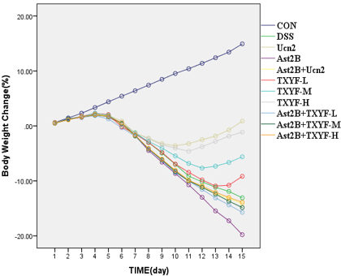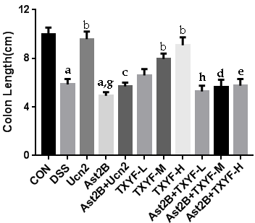
C
DSS | — | + | + | + | + | + | + | + | + | + | +
Ast2B | — | — | — | + | + | + | + | + | — | — | —
Ucn2 | — | + | — | + | — | — | — | — | — | — | —
TXYF-L | — | — | — | — | + | — | — | — | — | — | +
TXYF-M | — | — | — | — | — | + | — | — | — | + | —
TXYF-H | — | — | + | — | — | — | + | — | — | — | —
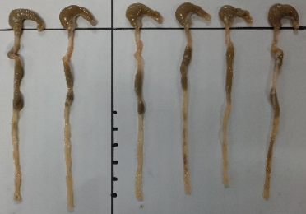
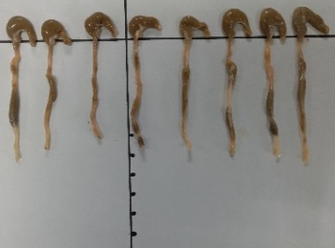
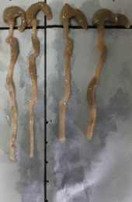

D E
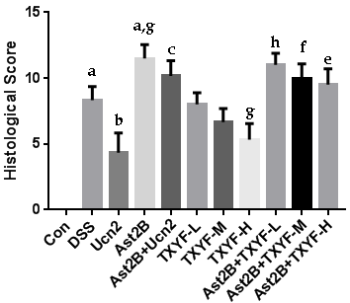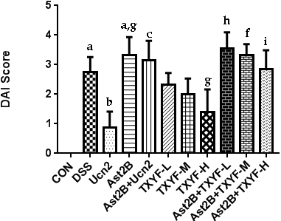

F
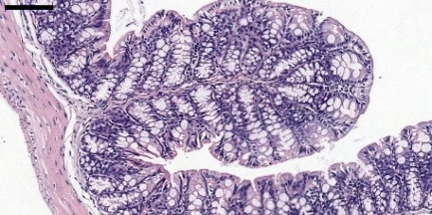
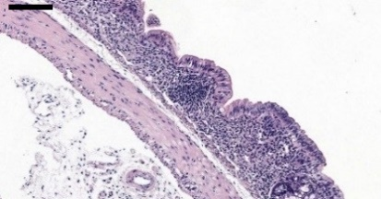
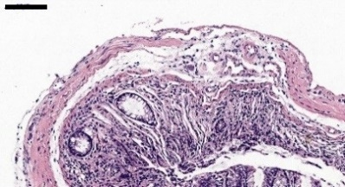

CON Ast2B DSS
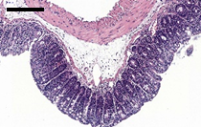
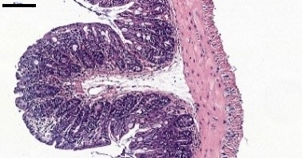
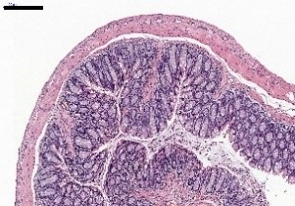
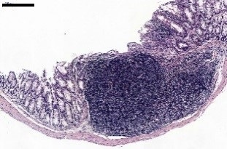

Ucn2 TXYF-H TXYF-M TXYF-L
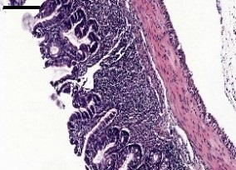
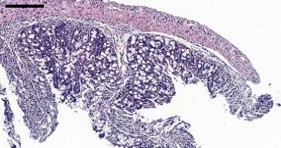
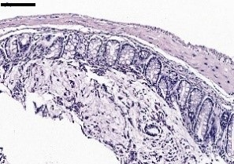
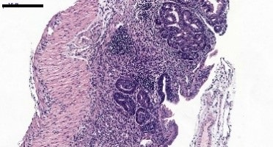

Ast2B+Ucn2 Ast2B+TXYF-L Ast2B+TXYF-M Ast2B+TXYF-H

Figure 1 Inhibition of CRH-R2 signaling aggravates symptoms of dextran sulfate sodium-induced colitis in mice. A: Mice body weight was measured for 16 d, and was shown as percentage of weight change; B: Colon length; C: Representative photographs of colon lengths; D: Disease activity index; E: histological scores were evaluated on the 16th day; F: Representative images of HE stained histology. Data are presented as mean ± SD, n = 6-10 per group, scale bar = 200 μm. ªP < 0.001 vs control group; ^{g}P < 0.05, ^{b}P < 0.001 vs DSS group; ^{c}P < 0.001 vs Ucn2 group; ^{h}P < 0.05 vs TXYF-L group; ^{f}P < 0.01, ^{d}P < 0.001 vs TXYF-M group; ^{i}P < 0.05, ^{e}P < 0.001 vs TXYF-H group.

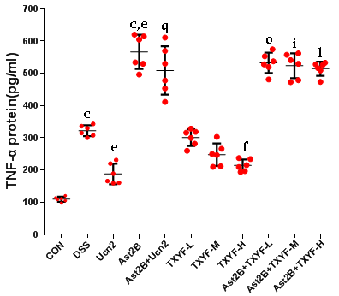
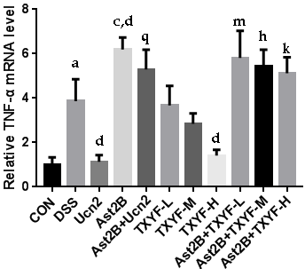
A D

B E
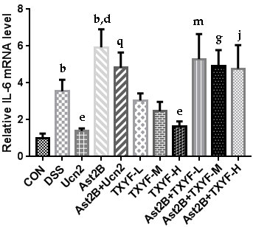
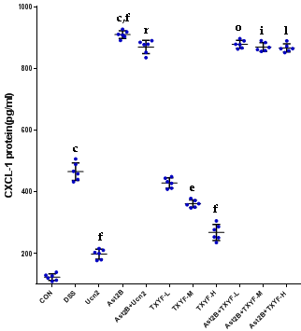

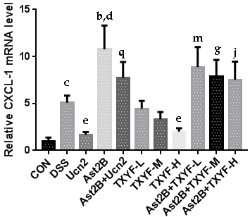
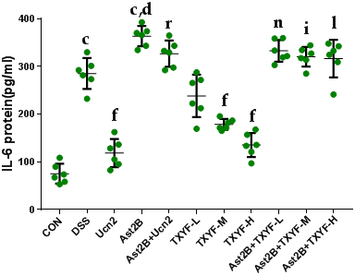
C F

Figure 2 Inhibition of CRH-R2 signaling increases secretion of inflammatory cytokines in colon tissue of dextran sulfate sodium-induced ulcerative colitis mice. RT-PCR assessed the mRNA level of TNF-α (A), CXCL-1 (B), and IL-6 (C) in colon tissue. The mRNA level in each group was determined relative to the level in the control group (defined as 100%). ELISA detected the protein levels of TNF-α (D), CXCL-1 (E), and IL-6 (F) in colon tissue. Data are presented as mean ± SD, n = 6 per group. ^{b}P < 0.01, ^{c}P < 0.001 vs control group; ^{d}P < 0.05, ^{e}P < 0.01, ^{f}P < 0.001, vs DSS group; ^{q}P < 0.01, ^{r}P < 0.001 vs Ucn2 group; ^{m}P < 0.05, ^{n}P < 0.01, ºP < 0.001 vs TXYF-L group; ^{g}P < 0.05, ^{h}P < 0.01, ^{i}P < 0.001 vs TXYF-M group; ^{j}P < 0.05, ^{k}P < 0.01, ^{l}P < 0.001 vs TXYF-H group.

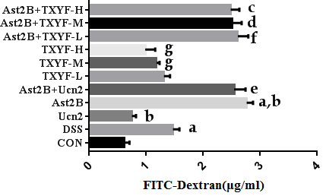

Figure 3 Inhibition of CRH-R2 signaling promotes intestinal permeability in dextran sulfate sodium induced colitis. The FITC-dextran levels in serum were determined. Data are presented as mean ± SD, n = 6 per group. ªP < 0.001 vs control group; ^{g}P < 0.05, ^{b}P < 0.001 vs DSS group; ^{e}P < 0.001 vs Ucn2 group; ^{f}P < 0.001 vs TXYF-L group; ^{d}P < 0.001 vs TXYF-M group; ^{c}P < 0.001 vs TXYF-H group.

A：CON B：Ast2B C：DSS D：Ucn2
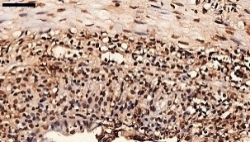
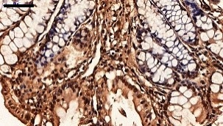
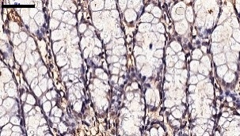
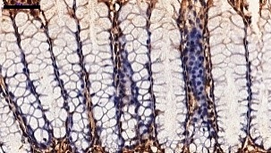

E：TXYF-H F：TXYF-M G： TXYF-L H：Ast2B+Ucn2
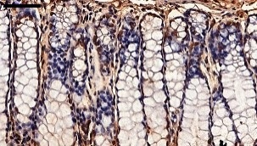
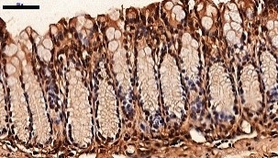
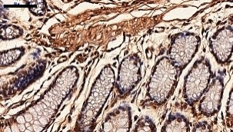
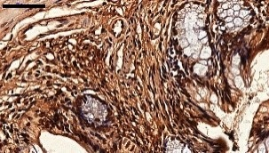

I：Ast2B+TXYF-L J：Ast2B+TXYF-M K：Ast2B+TXYF-H
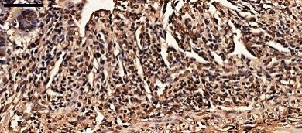
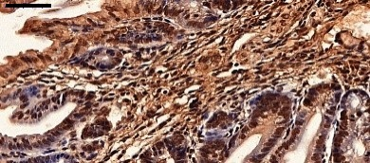
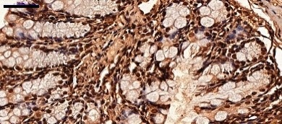

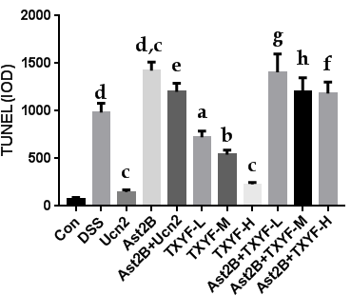
L：

Figure 4 Inhibition of CRH-R2 signaling promotes colonic epithelial cell apoptosis in dextran sulfate sodium induced colitis. A-K: Representative images from TUNEL sections; L: Quantification of TUNEL. Data are presented as mean ± SD, n = 6 per group, scale bar = 50 μm. ^{d}P < 0.001 vs control group; ªP < 0.05, ^{b}P < 0.01, ^{c}P < 0.001 vs DSS group; ^{e}P < 0.001 vs Ucn2 group; ^{g}P < 0.01 vs TXYF-L group; ^{h}P < 0.01 vs TXYF-M group; ^{f}P < 0.001 vs TXYF-H group.

A：CON B：Ast2B C：DSS D：Ucn2
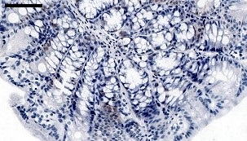
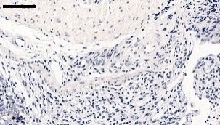
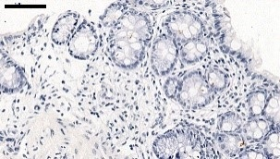
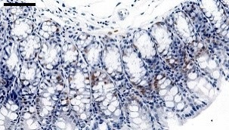

E：TXYF-H F：TXYF-M G： TXYF-L H：Ast2B+Ucn2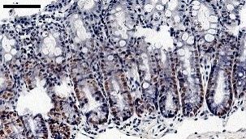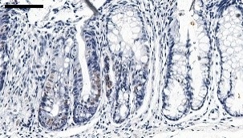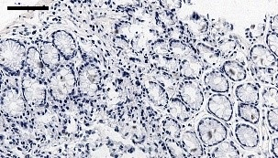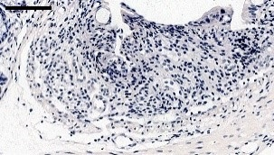
I：Ast2B+TXYF-L J：Ast2B+TXYF-M K：Ast2B+TXYF-H
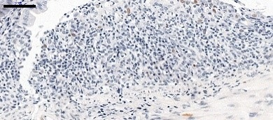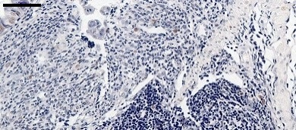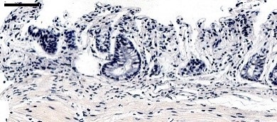
L：
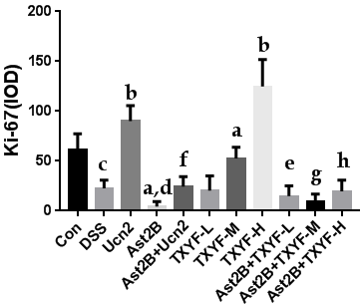
Figure 5 Inhibition of CRH-R2 signaling reduces epithelial cell proliferation in dextran sulfate sodium induced colitis. A-K：Representative images from Ki-67 immunoreactive sections; L：Quantification of Ki-67 immunohistochemistry. Data presented as mean ± SD, n = 6 per group, scale bar = 50 μm. ^{c}P < 0.05, ^{d}P < 0.01 vs control group; ªP < 0.05, ^{b}P < 0.01 vs DSS group. ^{f}P < 0.01 vs Ucn2 group; ^{e}P < 0.05 vs TXYF-L group; ^{g}P < 0.01 vs TXYF-M group; ^{h}P < 0.01 vs TXYF-H group.

