Name of Journal: World Journal of Clinical Cases
Manuscript NO: 90924
Manuscript Type: CASE REPORT

Young patient with a giant gastric bronchogenic cyst: A case report and review of literature

Lu XR et al. Gastric bronchogenic cyst

Xu-Ren Lu, Xu-Guang Jiao, Qi-Hang Sun, Bo-Wen Li, Qing-Shun Zhu, Guang-Xu Zhu, Jian-Jun Qu

Xu-Ren Lu, Qi-Hang Sun, Bo-Wen Li, School of Clinical Medicine, Shandong Second Medical University, Weifang 261000, Shandong Province, China

Xu-Ren Lu, Xu-Guang Jiao, Qi-Hang Sun, Bo-Wen Li, Qing-Shun Zhu, Guang-Xu Zhu, Jian-Jun Qu, Department of Gastrointestinal Surgery Medical Center, The First Affiliated Hospital, Shandong Second Medical University, Weifang 261000, Shandong Province, China

Author contributions: Qu JJ was responsible for the overall project progress, paper revision and submission; Lu XR and Jiao XG contributed to manuscript writing and editing and data collection; Sun QH and Zhu QS contributed to the data analysis; Li BW and Zhu GX contributed to the conceptualization and supervision. All the authors read and approved the final manuscript.

Supported by Weifang Municipal Health Commission Scientific Research Project, No. WFWSHKK-2021-028; and Shandong Province Medical Health Science and Technology Project, No. 202304010544.

Corresponding author: Jian-Jun Qu, Doctor, Chief Doctor, Department of Gastrointestinal Surgery Medical Center, The First Affiliated Hospital, Shandong Second Medical University, No. 151 Guangwen Street, Kuiwen District, Weifang 261000, Shandong Province, China. 1035123330@qq.com

Received: December 17, 2023
Revised: February 9, 2024
Accepted: April 2, 2024
Published online:

Abstract
BACKGROUND
Gastric bronchogenic cysts (BCs) are extremely rare cystic masses caused by abnormal development of the respiratory system during the embryonic period. Gastric bronchial cysts are rare lesions that were first reported in 1956; as of 2023, only 33 cases are available in the PubMed online database. BCs usually have no clinical symptoms in the early stage, and imaging findings also lack specificity. Therefore, they are difficult to diagnose before histopathological examination.

CASE SUMMARY
A 34-year-old woman with respiratory distress presented at our hospital. Endoscopic ultrasound revealed an anechoic mass between the spleen, left kidney and gastric fundus, with hyperechogenic and soft elastography textures and with a size of approximately 6.5 cm × 4.0 cm. Furthermore, a computed tomography scan demonstrated high density between the posterior stomach and the spleen and the left kidney, with uniform internal density and a small amount of calcification. The maximum cross section was approximately 10.1 cm × 6.1 cm, and the possibility of a cyst was high. Because the imaging findings did not suggest a malignancy and because the patient required complete resection, she underwent laparotomy surgery. Intraoperatively, this cystic lesion was found to be located in the posterior wall of the large curvature of the fundus and was approximately 8 cm × 6 cm in size. Finally, the pathologists verified that the cyst in the fundus was a gastric BC. The patient recovered well, her symptoms of chest tightness disappeared, and the abdominal drain was removed on postoperative day 6, after which she was discharged on day 7 for 6 months of follow-up. She had no tumor recurrence or postoperative complications during the follow-up.

CONCLUSION
This is a valuable report as it describes an extremely rare case of gastric BC. Moreover, this was a very young patient with a large BC in the stomach.

Key Words: Bronchogenic cyst; Stomach; Endoscopic ultrasound-guided fine needle aspiration; Endosonography; Case report

Lu XR, Jiao XG, Sun QH, Li BW, Zhu QS, Zhu GX, Qu JJ. Young patient with a giant gastric bronchogenic cyst: A case report and review of literature. World J Clin Cases 2024; In press

Core Tip: Gastric bronchogenic cysts (BCs) represent uncommon congenital anomalies, often manifesting as indistinct cystic formations on preoperative evaluations. Herein, we document a noteworthy instance of a sizable gastric BC occurring in a young female patient. The definitive diagnosis of gastric BC was established through histopathological examination following laparotomy resection. The analysis of the reported cases revealed that gastric BC often mimics gastrointestinal stromal tumors on preoperative imaging. We recommend elective radical surgical resection for young patients with large cysts, as they might progress to malignancies.

INTRODUCTION
Bronchogenic cysts (BCs) are uncommon developmental malformations that result from the aberrant development of the primitive tracheobronchial tube, leading to the formation of cystic lesions. These lesions are typically congenital, meaning they are present at birth, and can cause various symptoms depending on their location and size^{[1]}. The lesions can be divided into mediastinal, intrapulmonary, and ectopic types according to their location^{[2]}. The tumor is primarily located in the mediastinum if it occurs early in gestation, as opposed to the thoracic cavity if it arises later in development^{[3]}. Abdominal BCs, especially those situated within the gastric wall, are exceptionally uncommon occurrences^{[4]}. Dewing et al^{[5]} were the pioneers in describing gastric bronchial cysts in 1956, and as of 2023, only a few cases have been described in reports available in the PubMed online database. For patients with BCs, there is a wide range for the age at diagnosis, which has ranged from 17 to 81 years, and it has a higher prevalence in females, with a median age of development of 43 years^{[1]}. BCs of the gastric region typically manifest along the posterior wall of the gastric body and the lesser curvature of the stomach^{[6]}. In previous reports, it has been observed that a significant proportion of patients were asymptomatic^{[7]}. However, among those who exhibited symptoms, epigastric pain and vomiting were the most prevalent^{[8]}. Most gastric BCs are easily misdiagnosed as gastrointestinal stromal tumors (GISTs) before surgery^{[9]}; however, fortunately, their prognosis is good^{[10]}. In the current investigation, we have documented a rare instance of a gastric BCs occurring in a 34-year-old patient. Furthermore, we have undertaken a thorough examination of the existing literature (Table 1) to delve into the clinical manifestations associated with these cysts, aiming to contribute to a deeper understanding of their nature and incidence.

CASE PRESENTATION
Chief complaints
A 34-year-old Chinese woman presented to the gastrointestinal surgery clinic with a complaint of respiratory distress for 5 d.

History of present illness
A 34-year-old Chinese female patient presented with chest tightness and shortness of breath for 5 d with no nausea, vomiting, sour regurgitation, belching, dysphagia, melena, or weight loss.

History of past illness
She had a history of psoriasis.

Personal and family history
Her father died of lymphoma. In addition, the patient denied any family history of other malignancies.

Physical examination
Her abdomen was smooth and flat, and there was no gastrointestinal type or mild upper abdominal tenderness without rebound pain or an overt mass. The bowel sounds were normal.

Laboratory examinations
No abnormalities were found in routine blood or urine analyses or liver or kidney function tests.

Imaging examinations
Endoscopic ultrasound (EUS) revealed a 65 mm × 40 mm single cyst. The images also showed that the cyst was located at the bottom of the gastric wall. Anechoic masses were detected between the spleen, left kidney, and gastric fundus with punctate hyperechogenicity. Elastography revealed a soft texture. These findings suggested the presence of a cyst within the stomach (Figure 1). Additionally, an enhanced computed tomography (CT) scan revealed a cystic mass measuring 101 mm × 61 mm in size. There was no contrast enhancement, and the mass was located within the posterior wall of the gastric fundus, spleen and left kidney with regular and smooth outlines. The mass appeared to have a slightly high and uniform density with a small, calcified shadow in the posterior gastric region. No septation was observed. It also showed an extraluminal growth pattern with an obvious border, and the gastric wall was affected by pressure (Figure 2). Moreover, no significant enlargement of lymph nodes was observed in the vicinity of the stomach or retroperitoneal region. Before surgery, an EUS examination was performed to determine which layer of the gastric wall the cyst had originated from. However, because the cyst wall was evaluated by CT, because there was calcification on the cyst wall, and because the contents of the cyst were mainly liquid components according to the density, there was concern that fine needle aspiration (FNA) may cause rupture of the cyst before surgery and would increase the risk of infection. Second, we suspected that the patient's chest tightness was caused by compression of the diaphragm muscle by the large cyst. To eliminate the patient's symptoms and because the patient strongly desired surgery, after consultation and discussion with many experts, we decided to prudently remove the cyst and obtain a complete pathological specimen so that a safe postoperative examination could be performed to obtain the most accurate diagnosis. Based on these two points, we did not use preoperative FNA.

FINAL DIAGNOSIS
After treatment, the patient's symptoms of chest tightness resolved. We suspected that the chest tightness was due to the large cyst exerting pressure on the diaphragm. Based on the obtained specimen, this mass was approximately 80 mm × 50 mm × 40 mm in size. Under microscopic examination, the cyst lining exhibited pseudostratified ciliated columnar epithelial cells, while the cyst wall displayed smooth muscle and small salivary gland tissue. Immunohistochemical staining revealed the following results: CK7 (+) TTF-1 (partial +), NapsinA (+), CK20 (-), Villin (-), SMA (+), Desmin (+), P63 (+), and elastic fiber (+) (Figure 3). The pathologists conclusively confirmed that the cystic mass located in the fundus was indeed gastric BCs.

TREATMENT
Given the young age of the patient, the large cyst with prominent gastric wall compression and chest tightness could have been associated with the cystic mass, and given that the patient wished to have the lesion completely removed, the patient underwent intra-abdominal mass resection under general anesthesia and nerve block anesthesia. Intraoperative observations of this cystic mass revealed it to be a smooth, single-port cyst originating from the posterior wall of the gastric fundus and extending along the greater curvature. Surgical exploration revealed no intra-abdominal ascites or obvious abnormalities in the liver, abdominal wall, pelvic cavity, omenta, or mesentery. The cystic mass was then completely dissected from the stomach. It is worth noting that surgeons need to avoid cyst rupture during these types of surgery.

OUTCOME AND FOLLOW-UP
The patient recovered well, her symptoms of chest tightness completely disappeared, and the abdominal drain was removed on postoperative day 6, after which she was discharged on day 7 for 6 months of follow-up. The patient had no tumor recurrence or postoperative complications that occurred after surgery.

DISCUSSION
To conduct a comprehensive study on BCs of the stomach, a systematic literature review was undertaken using the PubMed database. The search was focused on articles published in English and employed the keyword "gastric BCs" to identify relevant studies. The final date for data collection was set as December 2023. The inclusion criteria stipulated that all patients must have a confirmed diagnosis of gastric BCs through pathological examination. Additionally, patients exhibiting imaging characteristics typical of gastric BCs were included, irrespective of age and sex. Conversely, patients lacking typical pathological or imaging features were excluded from the study. Based on our knowledge cutoff of December 2023, a total of 33 cases of gastric BCs were reported over a 10-year period, meeting the specified search criteria. These cases are comprehensively listed in Table 1.
BCs are primitive-foregut-derived congenital cystic abnormalities^{[11]}. Migration of BCs may ensue when their attachments to the trachea or esophagus fail to persist, resulting in their potential displacement within the anatomical structures of the body^{[12]}. The primary sites of occurrence for BCs predominantly involve the thoracic region, notably within the mediastinum. However, on rare occasions, they may also manifest in the subdiaphragmatic region. BC of the stomach appears to be a disease detected at all ages (from 17 to 76 years of age), and there was no apparent sex difference (17 females and 16 males). The dimensions of BCs exhibited considerable variability, ranging from 1.7 to 15 cm, as indicated by available data from our cases and referenced literature. However, the majority of cyst diameters fell within the range of 3 to 7 cm. Regarding localization, our investigation revealed a predilection for cysts to be situated in the gastric cardia or posterior wall of the fundus. A large proportion of patients with BC have clinical manifestations of epigastric pain, while others generally experience nonspecific symptoms, which may be due to local tumor compression and infection^{[13]}. Notably, four patients with gastric BC had elevated tumor marker levels. Elevated CA19-9 levels were present in two of the patients^{[10,14]}, and elevated CA72-4 levels were also present in patients with elevated CA72-4 levels^{[15,16]}. Interestingly, these elevated tumor markers returned to normal after surgery, suggesting that there is a direct relationship between benign BCs and elevated tumor marker levels. However, the relationship between tumor markers and BC needs further study. It is worth noting that BCs of the stomach have been associated with the presence of gastric carcinoma. Chronic inflammation of the gastric mucosa, stemming from BCs, may have contributed to the development of these adenocarcinomas in the stomach, as reported in previous studies^{[17]}. While the current investigation illustrates that EUS and other imaging modalities can aid in localizing the lesion, they are limited in their ability to offer qualitative diagnostic insights. Accurate preoperative diagnosis is challenging, and most patients are easily misdiagnosed with GIST. In summary, preoperative diagnosis of gastric BCs is challenging due to the absence of specific clinical manifestations, as well as inconclusive findings from laboratory tests and imaging studies. Moreover, the rarity of these lesions further complicates their diagnosis.
BCs are commonly detected through CT and magnetic resonance imaging (MRI). However, relying solely on imaging techniques to differentiate them from other types of cysts can be challenging due to the presence of similar radiological features among various cystic lesions. Ubukata et al^{[18]} demonstrated that far greater clarity was achieved when using MRI than when using CT, especially for identifying the contents of the cystic lesions. In the present case, since the patient had metal dental implants, this patient was not suitable to undergo MRI. EUS is commonly employed to ascertain the specific layer of the gastric wall from which the lesion originates and to delineate its approximate location within the gastrointestinal tract^{[15]}. Imaging alone cannot usually distinguish between nonneoplastic lesions and benign or malignant neoplasms. In clinically warranted situations, EUS-FNA biopsy has been previously established as a valuable tool for the unequivocal diagnosis of gastric BCs^{[19]}. Its effectiveness is further emphasized by its sensitivity range of 86%-93%^{[20]}, diagnostic accuracy spanning 82%-95%, and an exceptionally low complication rate of merely 1%-3%^{[21]}. Although the probability of complications is extremely low, there are risks of ulceration, infection and hemorrhage. EUS-FNA provides a new diagnostic and treatment approach for asymptomatic gastric BC patients. We recommend that EUS-FNA be performed first for elderly patients, patients in poor physical condition, asymptomatic patients, and patients who cannot undergo surgical treatment for various reasons in the short term; then subsequent treatment options should be discussed based on the results.
Through our systematic review of existing cases, we conclude that GIST is the most common preoperative diagnosis of gastro BCs. The two conditions are difficult to distinguish by imaging, and an accurate preoperative diagnosis can be obtained via EUS-FNA before surgery. However, there are risks such as infection and bleeding. During the operation, these masses can be distinguished by observing their nature. GISTs are brittle and prone to bleeding, while gastro BCs are composed mainly of cystic components^{[9]}. Second, due to the rarity of BCs, clinicians lack understanding of this disease, which is also one of the reasons for the failure to obtain an accurate preoperative diagnosis of this disease.
The ultimate diagnosis typically hinges on a histopathological analysis of specimens obtained postoperatively. A review of the literature revealed that surgical resection was the most common option. Surgical removal will improve the symptoms of cyst compression and reduce the risk of BC transforming into a malignant tumor^{[22]}. The findings from the current literature review indicate that asymptomatic patients harboring small masses require careful monitoring. Conversely, for symptomatic patients, particularly those who are young as exemplified in this case report, surgical resection is advisable. In the case presented, the patient's respiratory distress was attributed to the growing mass exerting pressure on the diaphragmatic muscle. In addition to routine laparoscopic resection, Lee et al^{[23]} proposed endoscopic mucosal resection (EMR) for the treatment of gastric BC. They proposed that when a lesion is suspected to be a solid tumor on the basis of EUS and CT investigations and if there is a positive cushion sign, the differential diagnosis of a developmental cyst should be considered, and EMR could be used for curative treatment. Regardless of the operation method, care should be taken to avoid intraoperative cyst rupture and postoperative infection complications. Due to the large size of the cyst in this case, open surgery was chosen to obtain a sufficient surgical field of view and ensure complete resection.
Although gastric BCs are a very rare disease, when comparing our case with those reported in PubMed, it can be seen that there are no specific clinical manifestations or laboratory indicators associated with BC. Elevated tumor markers have been reported in some cases; however, the sample size was insufficient to support an association. Early detection of suspected lesions is a favorable factor affecting patient survival. In addition, CT, MRI, and EUS are popular methods for detecting gastric BCs. Surgical removal is the most common way to relieve symptoms; however, the recommendation of surgical intervention for asymptomatic patients remains controversial. Through our diagnosis and treatment and the postoperative follow-up of this patient, we would like to show that surgical resection is recommended for young patients with large cysts and clinical symptoms to eliminate symptoms and the uncertainty of transformation of gastro BCs into malignant tumors.

CONCLUSION
Although gastric BCs are a very rare disease, when comparing our case with those reported in PubMed, it can be seen that there are no specific clinical manifestations or laboratory indicators associated with BC. Elevated tumor markers have been reported in some cases; however, the sample size was insufficient to support an association. Early detection of suspected lesions is a favorable factor affecting patient survival. In addition, CT, MRI, and EUS are popular methods for detecting gastric BCs. Surgical removal is the most common way to relieve symptoms; however, the recommendation of surgical intervention for asymptomatic patients remains controversial. Through our diagnosis and treatment and the postoperative follow-up of this patient, we would like to show that surgical resection is recommended for young patients with large cysts and clinical symptoms to eliminate symptoms and the uncertainty of transformation of gastro BCs into malignant tumors.

REFERENCES
1 Tu C, Zhu J, Shao C, Mao W, Zhou X, Lin Q, Li Z, Zhang J, Zhou Q, Chen W. Gastric bronchogenic cysts: A case report and literature review. Exp Ther Med 2016; 11: 1265-1270 [PMID: 27073434 DOI: 10.3892/etm.2016.3067]
2 McAdams HP, Kirejczyk WM, Rosado-de-Christenson ML, Matsumoto S. Bronchogenic cyst: imaging features with clinical and histopathologic correlation. Radiology 2000; 217: 441-446 [PMID: 11058643 DOI: 10.1148/radiology.217.2.r00nv19441]
3 Gross DJ, Briski LM, Wherley EM, Nguyen DM. Bronchogenic cysts: a narrative review. Mediastinum 2023; 7: 26 [PMID: 37701638 DOI: 10.21037/med-22-46]
4 Seddik H, Adioui T, Rouibaa F, El Hamdi FZ, Aourarh A, Mahi M, Benkirane A, Zentar A. Gastric bronchogenic cyst presenting as a submucosal mass: a case report. J Med Case Rep 2012; 6: 262 [PMID: 22937973 DOI: 10.1186/1752-1947-6-262]
5 Dewing SB, Roessel CW, Olmstead EV. Enterogenous cyst of the stomach wall, a rare benign lesion; case report. Ann Surg 1956; 143: 131-135 [PMID: 13275911 DOI: 10.1097/00000658-195601000-00019]
6 Yang X, Guo K. Bronchogenic cyst of stomach: two cases report and review of the English literature. Wien Klin Wochenschr 2013; 125: 283-287 [PMID: 23579880 DOI: 10.1007/s00508-013-0352-0]
7 Sun B, Wang AK, Chen H, Qian BL, Yi XK, Jiang Y, Li Q, Fu WG, Li J. Bronchogenic cyst of the stomach: A case report and literature review. Exp Ther Med 2020; 20: 166 [PMID: 33093904 DOI: 10.3892/etm.2020.9295]
8 Lou F, Chen Q, Hu H. Gastric bronchogenic cyst in a young woman. Asian J Surg 2022; 45: 1982-1984 [PMID: 35584996 DOI: 10.1016/j.asjsur.2022.04.038]
9 Xiao J, Zhang R, Chen W, Wu B. Ectopic bronchogenic cyst of the gastric cardia considered to be a gastrointestinal stromal tumor before surgery: a case report. BMC Surg 2020; 20: 42 [PMID: 32122361 DOI: 10.1186/s12893-020-00704-z]
10 Tan KK, Nandini CL, Ho CK. A case of gastric bronchogenic cyst in Singapore with multiple intrigues. ANZ J Surg 2010; 80: 286-287 [PMID: 20575959 DOI: 10.1111/j.1445-2197.2010.05260.x]
11 St-Georges R, Deslauriers J, Duranceau A, Vaillancourt R, Deschamps C, Beauchamp G, Pagé A, Brisson J. Clinical spectrum of bronchogenic cysts of the mediastinum and lung in the adult. Ann Thorac Surg 1991; 52: 6-13 [PMID: 2069465 DOI: 10.1016/0003-4975(91)91409-o]
12 Melo N, Pitman MB, Rattner DW. Bronchogenic cyst of the gastric fundus presenting as a gastrointestinal stromal tumor. J Laparoendosc Adv Surg Tech A 2005; 15: 163-165 [PMID: 15898909 DOI: 10.1089/Lap.2005.15.163]
13 Xiao J, Zhang X, Zhou H, Hong T, Li B, He X, Liu W. Subdiaphragmatic bronchogenic cysts: Case series and literature review. Front Med (Lausanne) 2022; 9: 993091 [PMID: 36275826 DOI: 10.3389/fmed.2022.993091]
14 Ikehata A, Sakuma T. Gastric duplication cyst with markedly elevated concentration of carbohydrate antigen 19-9. Am J Gastroenterol 2000; 95: 842-843 [PMID: 10710108 DOI: 10.1111/j.1572-0241.2000.01873.x]
15 He WT, Deng JY, Liang H, Xiao JY, Cao FL. Bronchogenic cyst of the stomach: A case report. World J Clin Cases 2020; 8: 1525-1531 [PMID: 32368546 DOI: 10.12998/wjcc.v8.i8.1525]
16 Qian W, Xu G. Gastric fundus bronchogenic cyst with elevated CA72-4: A case report and literature review. Asian J Surg 2023; 46: 4507-4508 [PMID: 37179180 DOI: 10.1016/j.asjsur.2023.04.133]
17 Shibahara H, Arai T, Yokoi S, Hayakawa S. Bronchogenic cyst of the stomach involved with gastric adenocarcinoma. Clin J Gastroenterol 2009; 2: 80-84 [PMID: 26192170 DOI: 10.1007/s12328-008-0042-z]
18 Ubukata H, Satani T, Motohashi G, Konishi S, Goto Y, Watanabe Y, Nakada I, Tabuchi T. Intra-abdominal bronchogenic cyst with gastric attachment: report of a case. Surg Today 2011; 41: 1095-1100 [PMID: 21773899 DOI: 10.1007/s00595-010-4398-6]
19 Sato M, Irisawa A, Bhutani MS, Schnadig V, Takagi T, Shibukawa G, Wakatsuki T, Imamura H, Takahashi Y, Sato A, Hikichi T, Obara K, Hashimoto Y, Watanabe K, Ohira H. Gastric bronchogenic cyst diagnosed by endosonographically guided fine needle aspiration biopsy. J Clin Ultrasound 2008; 36: 237-239 [PMID: 18027836 DOI: 10.1002/jcu.20425]
20 Matsui M, Goto H, Niwa Y, Arisawa T, Hirooka Y, Hayakawa T. Preliminary results of fine needle aspiration biopsy histology in upper gastrointestinal submucosal tumors. Endoscopy 1998; 30: 750-755 [PMID: 9932753 DOI: 10.1055/s-2007-1001416]
21 O'Toole D, Palazzo L, Arotçarena R, Dancour A, Aubert A, Hammel P, Amaris J, Ruszniewski P. Assessment of complications of EUS-guided fine-needle aspiration. Gastrointest Endosc 2001; 53: 470-474 [PMID: 11275888 DOI: 10.1067/mge.2001.112839]
22 Endo C, Imai T, Nakagawa H, Ebina A, Kaimori M. Bronchioloalveolar carcinoma arising in a bronchogenic cyst. Ann Thorac Surg 2000; 69: 933-935 [PMID: 10750790 DOI: 10.1016/s0003-4975(99)01402-2]
23 Lee SH, Park DH, Park JH, Kim HS, Park SH, Kim SJ, Oh MH. Endoscopic mucosal resection of a gastric bronchogenic cyst that was mimicking a solid tumor. Endoscopy 2006; 38 Suppl 2: E12-E13 [PMID: 17366384 DOI: 10.1055/s-2006-944862]
24 Braffman B, Keller R, Gendal ES, Finkel SI. Subdiaphragmatic bronchogenic cyst with gastric communication. Gastrointest Radiol 1988; 13: 309-311 [PMID: 3169478 DOI: 10.1007/bf01889087]
25 Matsubayashi J, Ishida T, Ozawa T, Aoki T, Koyanagi Y, Mukai K. Subphrenic bronchopulmonary foregut malformation with pulmonary-sequestration-like features. Pathol Int 2003; 53: 313-316 [PMID: 12713567 DOI: 10.1046/j.1440-1827.2003.01475.x]
26 Hedayati N, Cai DX, McHenry CR. Subdiaphragmatic bronchogenic cyst masquerading as an "adrenal incidentaloma". J Gastrointest Surg 2003; 7: 802-804 [PMID: 13129560 DOI: 10.1016/s1091-255x(03)00134-3]
27 Rubio CA, Orrego A, Willén R. Bronchogenic gastric cyst. A case report. In Vivo 2005; 19: 383-385 [PMID: 15796201]
28 Song SY, Noh JH, Lee SJ, Son HJ. Bronchogenic cyst of the stomach masquerading as benign stromal tumor. Pathol Int 2005; 55: 87-91 [PMID: 15693855 DOI: 10.1111/j.1440-1827.2005.01788.x]
29 Wakabayashi H, Okano K, Yamamoto N, Suzuki Y, Inoue H, Kadota K, Haba R. Laparoscopically resected foregut duplication cyst (bronchogenic) of the stomach. Dig Dis Sci 2007; 52: 1767-1770 [PMID: 17404869 DOI: 10.1007/s10620-006-9580-8]
30 Jiang L, Jiang L, Cheng N, Yan L. Bronchogenic cyst of the gastric fundus in a young woman. Dig Liver Dis 2010; 42: 826 [PMID: 19616489 DOI: 10.1016/j.dld.2009.06.014]
31 Kurokawa T, Yamamoto M, Ueda T, Enomoto T, Inoue K, Uchida A, Kikuchi K, Ohkohchi N. Gastric bronchogenic cyst histologically diagnosed after laparoscopic excision: report of a case. Int Surg 2013; 98: 455-460 [PMID: 24229041 DOI: 10.9738/INTSURG-D-12-00038.1]
32 Sun L, Lu L, Fu W, Li W, Liu T. Gastric bronchogenic cyst presenting as a gastrointestinal stromal tumor. Int J Clin Exp Pathol 2015; 8: 13606-13612 [PMID: 26722583]
33 Chhaidar A, Ammar H, Abdessayed N, Azzaza M, Gupta R, Abdennaceur N, Bdioui A, Mokni M, Ali AB. Large bronchogenic cyst of stomach: A case report. Int J Surg Case Rep 2017; 34: 126-129 [PMID: 28391172 DOI: 10.1016/j.ijscr.2017.03.021]
34 Erbenová A, Placrová B, Špůrková Z, Horák P. Bronchogenic cyst of gastric cardia - case report and literature review. Rozhl Chir 2021; 100: 507-511 [PMID: 35021843 DOI: 10.33699/PIS.2021.100.10.507-511]
35 Wang HB, Wang SL, Yu JW. A gastric bronchogenic cyst pre-operatively misdiagnosed as a gastrointestinal stromal tumor. Asian J Surg 2022; 45: 2022-2023 [PMID: 35527127 DOI: 10.1016/j.asjsur.2022.04.067]
36 Li C, Zhang XW, Zhao CA, Liu M. Abdominal bronchogenic cyst: A rare case report. World J Clin Cases 2022; 10: 12671-12677 [PMID: 36579087 DOI: 10.12998/wjcc.v10.i34.12671]
37 Lv X, Zhang M, Zhang T. A case of ectopic bronchogenic and enterogenous cysts over the gastric wall. Asian J Surg 2024; 47: 1047-1048 [PMID: 37945402 DOI: 10.1016/j.asjsur.2023.10.098]
38 Qian JW, Qian ZH, Wu YY, Liu PF. Bronchogenic cyst of stomach: A case report. Asian J Surg 2023; 46: 2896-2898 [PMID: 36805727 DOI: 10.1016/j.asjsur.2023.01.101]
39 Ma P, Gao F, Zhu W, Cao Y. Bronchial-origin gastric cyst: A rare case report. Asian J Surg 2023; 46: 988-989 [PMID: 35961895 DOI: 10.1016/j.asjsur.2022.07.106]
40 Lin Z, Cao Q. Gastric bronchogenic cyst. Rev Esp Enferm Dig 2023; 115: 665-666 [PMID: 37882202 DOI: 10.17235/reed.2023.9964/2023]
41 Liu T, Li J. Gastric cardia bronchogenic cyst with prolonged belching. Rev Esp Enferm Dig 2023 [PMID: 37539531 DOI: 10.17235/reed.2023.9865/2023]
42 Terayama M, Kumagai K, Kawachi H, Makuuchi R, Hayami M, Ida S, Ohashi M, Sano T, Nunobe S. Optimal resection of gastric bronchogenic cysts based on anatomical continuity with adherent gastric muscular layer: A case report. World J Gastrointest Surg 2023; 15: 1216-1223 [PMID: 37405090 DOI: 10.4240/wjgs.v15.i6.1216]

Footnotes
Informed consent statement: Informed written consent was obtained from the patient for publication of this report and any accompanying images.

Conflict-of-interest statement: The authors declare that they have no conflicts of interest to disclose.

CARE Checklist (2016) statement: The authors have read the CARE Checklist (2016), and the manuscript was prepared and revised according to the CARE Checklist (2016).

Open-Access: This article is an open-access article that was selected by an in-house editor and fully peer-reviewed by external reviewers. It is distributed in accordance with the Creative Commons Attribution NonCommercial (CC BY-NC 4.0) license, which permits others to distribute, remix, adapt, build upon this work non-commercially, and license their derivative works on different terms, provided the original work is properly cited and the use is non-commercial. See: https://creativecommons.org/Licenses/by-nc/4.0/

Provenance and peer review: Unsolicited article; Externally peer reviewed.

Peer-review model: Single blind

Specialty type: Medicine, research and experimental
Country/Territory of origin: China
Peer-review report’s scientific quality classification
Grade A (Excellent): 0
Grade B (Very good): 0
Grade C (Good): C
Grade D (Fair): 0
Grade E (Poor): 0

P-Reviewer: Utano K, Japan S-Editor: Liu H L-Editor: A P-Editor:
Figure Legends
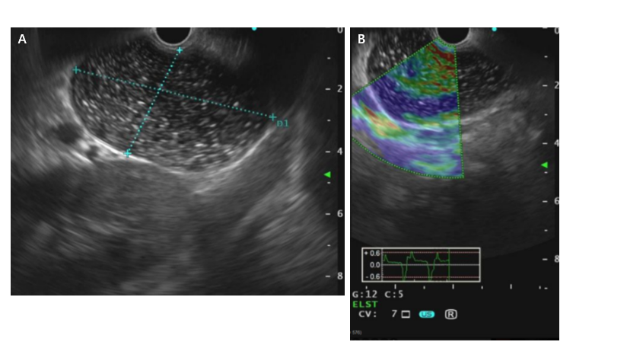
Figure 1 Imaging at admission. Endoscopic ultrasound revealed a 6.5 cm × 4.0 cm single cyst. The cyst, without any echoes or color flow signals, was located in the posterior wall of the gastric body. These results indicated the possibility of a cyst of the stomach.
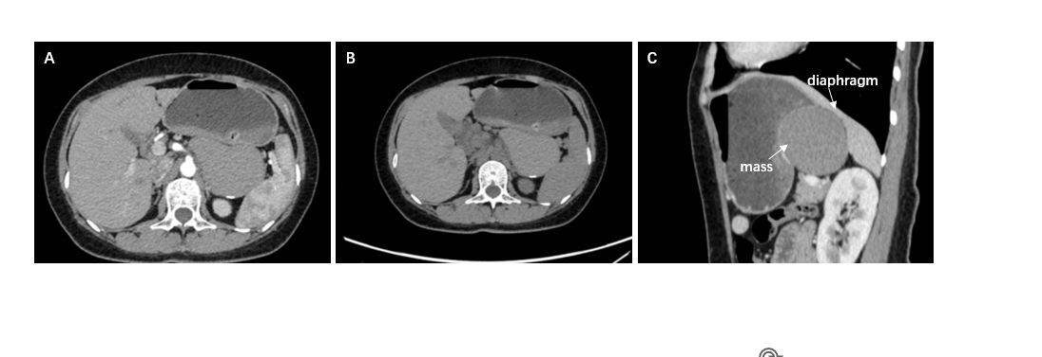
Figure 2 Imaging at admission. A: An enhanced computed tomography scan demonstrated a 10.1 cm × 6.1 cm mass. The mass was present in the posterior part of the stomach between the spleen and the left kidney; a large, slightly high-density swelling shadow with uniform internal density was shown; and a small calcification shadow could be seen at the rear. The computer tomography (CT) value was approximately 70 HU, and the gastric wall was compressed and changed; B: Noncontrast CT image; C: It can be clearly seen from the sagittal position that the diaphragm was compressed by the mass.
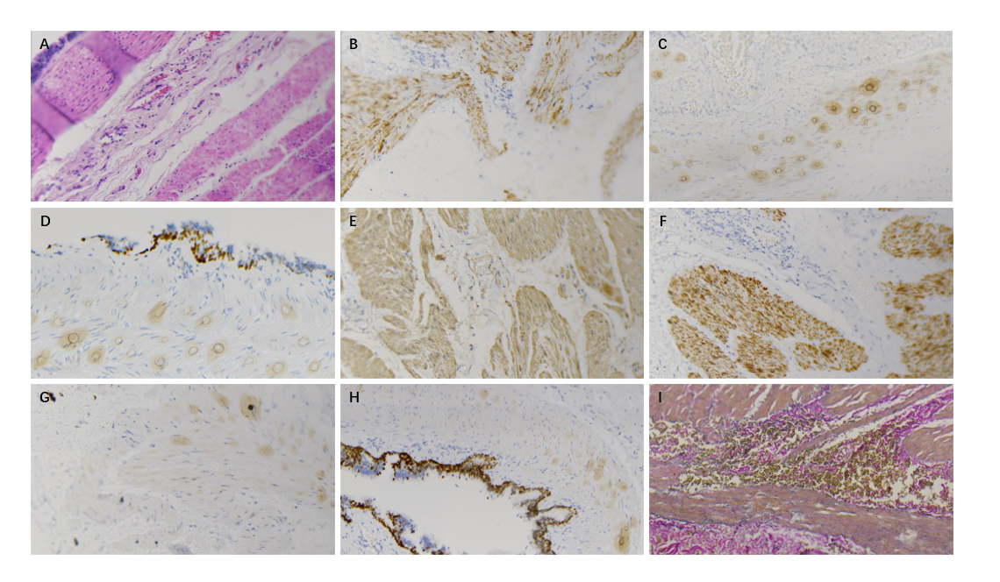
Figure 3 Histopathological analysis and immunohistochemical examination of the resected specimen. A: Microscopically, pseudostratified ciliated columnar epithelial cells could be observed in the cyst lining, and smooth muscle and small salivary gland tissue could be observed in the cyst; B: Napsin A (+); C: CK20 (-); D: P63 (+); E: SMA (+); F: Desmin (+); G: CK7 (+); H: TTF-1 (+); I: Elastic fiber (+).

Table 1 Thirty-three cases in the last 10 years
Ref. | Age (yr) | Gender | Size (cm) | Location | Symptom | Preoperative diagnosis | Intervention
Braffman et al^{[24]}, 1988 | 64 | Female | 15 × 8 | Posterior wall | Epigastric pain |  | Resection
Matsubayashi et al^{[25]}, 2003 | 62 | Male | 10 × 3 × 3 | Posterior wall |  | Lymphangioma/benign | Resection
Hedayati et al^{[26]}, 2003 | 59 | Female | 7 × 5 | Posterior wall |  | Adrenocortical cancer | Laparoscopic
Rubio et al^{[27]}, 2005 | 26 | Male |  |  | Epigastric pain
Melo et al^{[12]}, 2005 | 39 | Female | 4 × 2.5 × 1 | Gastric fundus | Rib pain | GIST | Laparoscopic resection
Song et al^{[28]}, 2005 | 62 | Female | 1.7 | Lesser curvature |  | Benign stromal tumor | Resection
Wakabayashi et al^{[29]}, 2007 | 37 | Male | 5 | Lesser curvature | Epigastric pain | A duplication cyst | Exploration
Sato et al^{[19]}, 2008 | 60 | Female | 3 |  |  | Benign cyst of the gastric submucosa
Shibahara et al^{[17]}, 2009 | 43 | Male | 9 × 4 | Lesser curvature | Epigastric pain | Gastric cancer
Jiang et al^{[30]}, 2010 | 25 | Female | 3 × 2.5 × 2.0 | Gastric fundus | Epigastric pain | GIST | Laparotomy
Tan et al^{[10]}, 2010 | 30 | Female | 5.1 × 3.6 × 4.6 | Posterior wall of the stomach |  |  | Laparoscopic wedge resection
Kurokawa et al^{[31]}, 2013 | 71 | Male | 3.2 | Gastric cardia | Throat discomfort | Cyst | Laparoscopic
Yang and Guo^{[6]}, 2013 | 50 | Male | 8.0 × 6.0 | Gastric fundus |  | Retroperitoneal mass | Laparotomy
Yang and Guo^{[6]}, 2013 | 37 | Female | 10 × 6 | Posterior wall of the stomach |  | GIST | Wedged gastrectomy
Sun et al^{[32]}, 2015 | 67 | Male | 4.1 × 3.2 | Gastric fundus | Dull epigastric pain | GIST | Laparotomy
Tu et al^{[1]}, 2016 | 17 | Female | 3 × 2.5 | Gastric cardia | Epigastric pain | Cyst | Laparotomy
Chhaidar et al^{[33]}, 2017 | 65 | Female | 7 × 8 | Gastric cardia | Epigastric pain | GIST | Total gastrectomy
Xiao et al^{[13]}, 2020 | 62 | Female | 6.4 × 4.9 | Lesser curvature of the gastric cardia | Right lower abdominal pain | GIST | Laparoscopic
He et al^{[15]}, 2020 | 55 | Female | 7 × 6 × 2 | Gastric cardia | Intermittent epigastric pain | Benign cyst of the gastric submucosa | Da vinci robotic-assisted laparoscopic
Sun et al^{[7]}, 2020 | 68 | Male | 10 × 8 × 8 | Fundus of stomach |  | Retroperitoneal mass | Laparotomy
Erbenová et al^{[34]}, 2021 | 30 | Female |  | Gastric cardia |  | Tumor of gastric cardia | Laparoscopic
Lou et al^{[8]}, 2022 | 38 | Female | 5 × 2.6 | Gastric fundus | Upper abdominal pain | Lymphatic cyst | Laparoscopic
Wang et al^{[35]}, 2022 | 76 | Male | 3.1 × 3.0 | Gastroesophageal junction | Abdominal pain and distension | GIST | Laparoscopic
Li et al^{[36]}, 2022 | 35 | Male |  | Posterior wall of the gastric cardia |  | Abdomystic Lymphangioma | Laparotomy
Lv et al^{[37]}, 2023 | 23 | Male |  | Greater curvature | Abdominal discomfort
Qian and Xu^{[16]}, 2023 | 50 | Male | 2 × 1.5 | Posterior gastric fundus wall |  | Schwannoma or low-grade  stromal tumor | Gastroscope
Qian et al^{[38]}, 2023 | 45 | Female | 3 × 2 | Gastric cardia | Upper abdominal pain | GIST | Laparoscope
Ma et al^{[39]}, 2023 | 46 | Female | 5 × 4.5 × 3.5 | Gastric body | Abdominal pain | GIST
Lin and Cao^{[40]}, 2023 | 47 | Male | 8 × 7 | Posterior wall of the fundus | Pain in the right chest
Liu and Li^{[41]}, 2023 | 65 | Male | 4 × 3 | Gastric cardia | Blech
Terayama et al^{[42]}, 2023 | 37 | Female | 3 | Gastric cardia | Asymptomatic | Bronchogenic cyst | Resection
Terayama et al^{[42]}, 2023 | 47 | Male | 5 | Gastric cardia | Asymptomatic | Gastric bronchogenic cyst | Resection
Terayama et al^{[42]}, 2023 | 37 | Male | 3.5 | Gastric cardia | Asymptomatic |  | Resection
GIST: Gastrointestinal stromal tumor.

