Name of Journal: World Journal of Clinical Cases
Manuscript NO: 79517
Manuscript Type: CASE REPORT

Double pigtail catheter reduction for seriously displaced intravenous infusion port catheter: A case report

Liu Y et al. IVAP case report

Yu Liu, Duan-Ming Du

Yu Liu, Duan-Ming Du, Department of Interventional Therapy, Shenzhen Second People’s Hospital, The First Affiliated Hospital of Shenzhen University, Shenzhen 518035, Guangdong Province, China

Author contributions: Liu Y carried out the study, participated in data collection, and drafted the manuscript; Du DM performed statistical analysis and participated in study design and participated in the acquisition, analysis, and interpretation of the data, and drafted the manuscript; all authors read and approved the final manuscript.

Supported by Shenzhen Key Medical Discipline Construction Fund, No. SZXK052.

Corresponding author: Duan-Ming Du, PhD, Chief Doctor, Department of Interventional Therapy, Shenzhen Second People’s Hospital, The First Affiliated Hospital of Shenzhen University, No. 3002 Sungang Road, Futian District, Shenzhen 518035, Guangdong Province, China. dmdu69@163.com

Received: August 25, 2022
Revised: December 29, 2022
Accepted: January 10, 2023
Published online: February 6, 2023

Abstract
BACKGROUND
Implanted intravenous infusion port (TIAP) is mainly used for patients who need central venous infusion and poor peripheral vascular conditions. With the advantages of easy to carry, long maintenance cycle, few complications and excellent quality of life, it has been widely used in the fields of malignant tumor chemotherapy, parenteral nutrition support and repeated blood collection. Implanted intravenous infusion port (IVAP) dislocation can have significant complications if not recognised and reinstated immediately.

CASE SUMMARY
A 24-year-old man was treated with adjuvant chemotherapy for osteosarcoma. Severe displacement of IVAP catheter was found by chest X-ray examination. The IVAP cannot be used normally. Therefore, we conducted an emergency procedure to reset the catheter through double pigtail catheters, the operation was successful and the infusion port was restored.

CONCLUSION
When IVAP catheter displacement cannot be reset by conventional techniques, two pigtail catheters can be successfully used instead.

Key Words: Catheter; Displaced catheter; Implantable; Implanted intravenous infusion port; Pigtail catheter; Case report

©The Author(s) 2023. Published by Baishideng Publishing Group Inc. All rights reserved.

Citation: Liu Y, Du DM. Double pigtail catheter reduction for seriously displaced intravenous infusion port catheter: A case report. World J Clin Cases 2023; 11(4): 883-887
URL: https://www.wjgnet.com/2307-8960/full/v11/i4/883.htm
DOI: https://dx.doi.org/10.12998/wjcc.v11.i4.883

Core Tip: In the face of serious ectopic infusion port, we successfully solved the problem with double pig tail catheter.

INTRODUCTION
Implanted intravenous infusion port (IVAP) catheters are mainly used for patients who need central venous infusion therapy and have poor peripheral vascular conditions. It has been widely used in malignant tumour chemotherapy, parenteral nutrition support treatment, and repeated blood collection in various nations because of the benefits of easy carrying, extended maintenance time, few complications, and excellent quality of life. Inadequate care can lead to complications such as catheter displacement, obstruction, infection, pneumothorax, haemothorax, vascular damage, thrombus, and catheter rupture^{[1-4]}. Among them, catheter displacement of the infusion port has become a critical complication as it affects the chemotherapy effect on patients and it can be life-threatening if the displacement is not recognised and repositioned promptly.
We describe a case with catheter displacement that could not be solved by conventional procedures which is a single pig tail catheter reduction or surgical removal of the port. Hence, we used the double pigtail catheters to reset the displaced catheter. Such interventional reduction surgery is rarely reported.

CASE PRESENTATION
Chief complaints
Our patient was a 24-year-old male with osteosarcoma at the distal end of the left calf. After the second chemotherapy round, the patient developed severe cough and vomiting, and it was difficult to push the catheter when using normal saline. Chest X-ray showed that the catheter had been displaced into a loop.

History of present illness
Osteosarcoma following chemotherapy

History of past illness
On December 23, 2021, the patient experienced resection of a lesion of the distal left fibula, ankle fusion and microwave ablation.

Personal and family history
The patient denied having any specific family or personal history of any illnesses.

Physical examination
The patient's vital signs at the point of presentation were 36.4°C for body temperature, 114/73 mmHg for blood pressure, 96 beats per minute for pulse, and 20 breaths per minute for respiratory rate. During the physical examination, the patient cooperated and was conscious. A 15-cm surgical incision in the left leg was visible, skin temperature was normal, the plantar flexion and extension of the left ankle were limited, and movement and sensation of the left lower limb were normal.

Laboratory examinations
D-dimer dynamic: 0.57 mg/L.

Imaging examinations
Chest X-ray indicated that the catheter was displaced into a loop (Figure 1A).

FINAL DIAGNOSIS
The final diagnosis result is that ectopic catheter in infusion port.

TREATMENT
After consulting with the appropriate departments, we prepared to reset the IVAP using an interventional approach. The patient lay flat on the digital subtraction angiography examination bed during the procedure. Digital subtraction angiography fluoroscopy showed that the catheter was displaced into a loop. We used the modified Seldinger puncture to puncture the right femoral vein, and 5F vascular sheath was successfully implanted. Using a long exchange guide wire, we guided the 5F pigtail catheter (Yixinda SCW-StraightPigtail-05110) to the right jugular vein, through the natural bending at the front end of the catheter, trapped the middle and long section of the infusion port catheter, and reset the infusion port catheter by slightly rotating and pulling down^{[5,6]}. Due to the severe displacement of the infusion tube, we failed to reset the catheter using one pigtail. Therefore, we used the same method to puncture the left femoral vein and successfully reset the displaced infusion port catheter using the double pigtail catheter (Figure 1B and C).

OUTCOME AND FOLLOW-UP
Post-operation, the patient did not complain of discomfort and successfully completed the third chemotherapy in the ward.

DISCUSSION
IVAP chemotherapy can give patients continuous venous access and shield their peripheral blood vessels from harm from irritating medications^{[7]}. Because of the benefits of easy carrying, long maintenance period, few complications and high quality of life of patients, it has been widely used in malignant tumour chemotherapy, parenteral nutrition support treatment and repeated blood collection. Increased attention has been paid to complications related to transfusion port such as thrombosis, infection, displacement, pneumothorax and others. Among them, the displacement of transfusion port pipeline is a significant complication of transfusion port implantation, as it affects chemotherapy effectivity and can be life threatening^{[8]}. Catheter displacement may be caused by (1) A catheter that is too short, and its end position is 1/3 above the superior vena cava; (2) strenuous exercise of the arm or shoulder; (3) severe cough; and (4) repeated vomiting. The catheter displacement in our patient may have been due to repeated vomiting during the second chemotherapy session^{[9,10]}.

CONCLUSION
When the catheter is displaced into a loop, the general interventional reduction surgery may not be sufficient to reset the displaced catheter. Thus, we can adopt the method of co-reduction using double pigtails to increase the traction force of the catheter reduction and make the pull-down force stronger.

ACKNOWLEDGEMENTS
We thank the patient for participating in the study and for agreeing to undergo follow-ups.

REFERENCES
1 Chou PL, Fu JY, Cheng CH, Chu Y, Wu CF, Ko PJ, Liu YH, Wu CY. Current port maintenance strategies are insufficient: View based on actual presentations of implanted ports. Medicine (Baltimore) 2019; 98: e17757 [PMID: 31689833 DOI: 10.1097/MD.0000000000017757]
2 Ding X, Ding F, Wang Y, Wang L, Wang J, Xu L, Li W, Yang J, Meng X, Yuan M, Chu J, Ge F, Dong W, Xue M; Shanghai Cooperation Group on Central Venous Access Vascular Access Committee of the Solid Tumor Theranostics Committee, Shanghai Anti-Cancer Association. Shanghai expert consensus on totally implantable access ports 2019. J Interv Med 2019; 2: 141-145 [PMID: 34805890 DOI: 10.1016/j.jimed.2019.10.008]
3 Xu L, Qin W, Zheng W, Sun X. Ultrasound-guided totally implantable venous access ports via the right innominate vein: a new approach for patients with breast cancer. World J Surg Oncol 2019; 17: 196 [PMID: 31767003 DOI: 10.1186/s12957-019-1727-0]
4 Marcy PY, Schiappa R, Ferrero JM, Dahlet C, Brenet O, Yazbec G, Dubois PY, Salm B, Fouche Y, Mari V, Montastruc M, Lebrec N, Ancel B, Paillocher N, Dupoiron D, Rangeard O, Gal J, Ettaiche M, Chateau Y, Chamorey E. Patient satisfaction and acceptance of their totally implanted central venous catheter: a French prospective multicenter study. J Vasc Access 2017; 18: 390-395 [PMID: 28731491 DOI: 10.5301/jva.5000744]
5 Chen GQ, Wu Y, Zhao KF, Shi RS. Removal of "ruptured" pulmonary artery infusion port catheter by pigtail catheter combined with gooseneck trap: A case report. World J Clin Cases 2021; 9: 8820-8824 [PMID: 34734061 DOI: 10.12998/wjcc.v9.i29.8820]
6 Letachowicz K, Gołębiowski T, Miś M, Wolańczyk M, Zmonarski S, Krajewska M. Partial breakage of a tunneled dialysis catheter: An uncommon finding. Hemodial Int 2021; 25: E15-E17 [PMID: 33073510 DOI: 10.1111/hdi.12894]
7 Nagasawa Y, Shimizu T, Sonoda H, Mekata E, Wakabayashi M, Ohta H, Murata S, Mori T, Naka S, Tani T. A comparison of outcomes and complications of totally implantable access port through the internal jugular vein versus the subclavian vein. Int Surg 2014; 99: 182-188 [PMID: 24670030 DOI: 10.9738/INTSURG-D-13-00185.1]
8 Shankar G, Jadhav V, Ravindra S, Babu N, Ramesh S. Totally Implantable Venous Access Devices in Children Requiring Long-Term Chemotherapy: Analysis of Outcome in 122 Children from a Single Institution. Indian J Surg Oncol 2016; 7: 326-331 [PMID: 27651694 DOI: 10.1007/s13193-015-0485-x]
9 Lv DN, Xu HZ, Zheng LL, Chen LL, Ling Y, Ye AQ. Extravasation of chemotherapeutic drug from an implantable intravenous infusion port in a child: A case report. World J Clin Cases 2021; 9: 7840-7844 [PMID: 34621835 DOI: 10.12998/wjcc.v9.i26.7840]
10 Miao J, Ji L, Lu J, Chen J. Randomized clinical trial comparing ultrasound-guided procedure with the Seldinger's technique for placement of implantable venous ports. Cell Biochem Biophys 2014; 70: 559-563 [PMID: 24748179 DOI: 10.1007/s12013-014-9956-x]

Footnotes
Informed consent statement: Informed written consent was obtained from the patient for publication of this report and any accompanying images.

Conflict-of-interest statement: All the authors declare that they have no conflict of interest.

CARE Checklist (2016) statement: The authors have read the CARE Checklist (2016), and the manuscript was prepared and revised according to the CARE Checklist (2016).

Open-Access: This article is an open-access article that was selected by an in-house editor and fully peer-reviewed by external reviewers. It is distributed in accordance with the Creative Commons Attribution NonCommercial (CC BY-NC 4.0) license, which permits others to distribute, remix, adapt, build upon this work non-commercially, and license their derivative works on different terms, provided the original work is properly cited and the use is non-commercial. See: https://creativecommons.org/Licenses/by-nc/4.0/

Provenance and peer review: Unsolicited article; Externally peer reviewed.
Peer-review model: Single blind

Peer-review started: August 25, 2022
First decision: December 20, 2022
Article in press: January 10, 2023

Specialty type: Surgery
Country/Territory of origin: China
Peer-review report’s scientific quality classification
Grade A (Excellent): 0
Grade B (Very good): B
Grade C (Good): 0
Grade D (Fair): 0
Grade E (Poor): 0

P-Reviewer: Dragonieri S, Italy S-Editor: Liu JH L-Editor: A P-Editor: Liu JH

Figure Legends
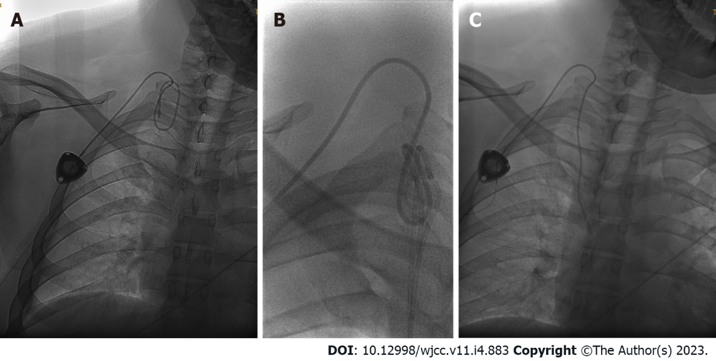
Figure 1 X-ray found severe ectopic infusion port. A: Preoperative examination revealed severe ectopic infusion port; B: Intraoperative film, two 5F pigtail catheters used to reposition the ectopic infusion port catheter; C: The ectopic infusion port catheter has been successfully reset, and the end of the catheter in the inferior margin of the 5th posterior rib.

Published by Baishideng Publishing Group Inc
7041 Koll Center Parkway, Suite 160, Pleasanton, CA 94566, USA
Telephone: +1-925-3991568
E-mail: bpgoffice@wjgnet.com
Help Desk: https://www.f6publishing.com/helpdesk
https://www.wjgnet.com

© 2023 Baishideng Publishing Group Inc. All rights reserved.

