Name of Journal: World Journal of Clinical Oncology
Manuscript NO: 76882
Manuscript Type: ORIGINAL ARTICLE

Retrospective Cohort Study
Propensity-matched analysis of patients with intrahepatic cholangiocarcinoma or mixed hepatocellular-cholangiocarcinoma and hepatocellular carcinoma undergoing a liver transplant

Brandão ABM et al. ICC or HCC-CC after LT

Ajacio Bandeira de Mello Brandão, Santiago Rodriguez, Alfeu de Medeiros Fleck Jr, Claudio Augusto Marroni, Mário B Wagner, Alex Hörbe, Matheus V Fernandes, Carlos TS Cerski, Gabriela Perdomo Coral

Ajacio Bandeira de Mello Brandão, Santiago Rodriguez, Claudio Augusto Marroni, Matheus V Fernandes, Gabriela Perdomo Coral, Graduate Program in Medicine: Hepatology, School of Medicine, Universidade Federal de Ciências da Saúde de Porto Alegre, Porto Alegre 90050170, RS, Brazil

Ajacio Bandeira de Mello Brandão, Alfeu de Medeiros Fleck Jr, Claudio Augusto Marroni, Liver Transplantation Group, Santa Casa de Misericórdia de Porto Alegre, Porto Alegre 90020090, RS, Brazil

Santiago Rodriguez, Department of Hepatology, Hospital Vozandes Quito-HVQ, Quito 170521, Ecuador

Mário B Wagner, School of Medicine, Universidade Federal do Rio Grande do Sul (UFRGS), Porto Alegre 90035002, RS, Brazil

Alex Hörbe, Interventional Radiology Unit, Santa Casa de Misericórdia de, Porto Alegre 90020090, RS, Brazil

Carlos TS Cerski, Department of Pathology, School of Medicine, Universidade Federal do Rio Grande do Sul, Porto Alegre 90035002, RS, Brazil

Author contributions: All the authors solely contributed to this paper.

Corresponding author: Ajacio Bandeira de Mello Brandão, PhD, Academic Research, Graduate Program in Medicine: Hepatology, School of Medicine, Universidade Federal de Ciências da Saúde de Porto Alegre, R. Eng. Álvaro Nunes Pereira, 400/402, Porto Alegre 90050170, RS, Brazil. ajaciob@gmail.com

Received: April 8, 2022
Revised: June 14, 2022
Accepted: July 11, 2022
Published online: August 24, 2022

Abstract
BACKGROUND
Cholangiocarcinoma (CC) is a rare tumor that arises from the epithelium of the bile ducts. It is classified according to anatomic location as intrahepatic, perihilar, and distal. Intrahepatic CC (ICC) is rare in patients with cirrhosis due to causes other than primary sclerosing cholangitis. Mixed hepatocellular carcinoma-CC (HCC-CC) is a rare neoplasm that shows histologic findings of both HCC and ICC within the same tumor mass. Due to the difficulties in arriving at the correct diagnosis, patients eventually undergo liver transplantation (LT) with a presumptive diagnosis of HCC on imaging when, in fact, they have ICC or HCC-CC.

AIM
To evaluate the outcomes of patients with intrahepatic cholangiocarcinoma or mixed hepatocellular-cholangiocarcinoma on pathological examination after liver transplant.

METHODS
Propensity score matching was used to analyze tumor recurrence (TR), overall mortality (OM), and recurrence-free survival (RFS) in LT recipients with pathologically confirmed ICC or HCC-CC matched 1:8 to those with HCC. Progression-free survival and overall mortality rates were computed with the Kaplan-Meier method using Cox regression for comparison.

RESULTS
Of 475 HCC LT recipients, 1.7% had the diagnosis of ICC and 1.5% of HCC-CC on pathological examination of the explant. LT recipients with ICC had higher TR (46% vs 11%; P = 0.006), higher OM (63% vs 23%; P = 0.002), and lower RFS (38% vs 89%; P = 0.002) than those with HCC when matched for pretransplant tumor characteristics, as well as higher TR (46% vs 23%; P = 0.083), higher OM (63% vs 35%; P = 0.026), and lower RFS (38% vs 59%; P = 0.037) when matched for posttransplant tumor characteristics. Two pairings were performed to compare the outcomes of LT recipients with HCC-CC vs HCC. There was no significant difference between the outcomes in either pairing.

CONCLUSION
Patients with ICC had worse outcomes than patients undergoing LT for HCC. The outcomes of patients with HCC-CC did not differ significantly from those of patients with HCC.

Key Words: Cholangiocarcinoma; Hepatocellular carcinoma; Liver; Prognosis; Recurrence; Survival analysis; Transplantation

©The Author(s) 2022. Published by Baishideng Publishing Group Inc. All rights reserved.

Citation: Brandão ABM, Rodriguez S, Fleck Jr AM, Marroni CA, Wagner MB, Hörbe A, Fernandes MV, Cerski CT, Coral GP. Propensity-matched analysis of patients with intrahepatic cholangiocarcinoma or mixed hepatocellular-cholangiocarcinoma and hepatocellular carcinoma undergoing a liver transplant. World J Clin Oncol 2022; 13(8): 688-702
URL: https://www.wjgnet.com/2218-4333/full/v13/i8/688.htm
DOI: https://dx.doi.org/10.5306/wjco.v13.i8.688

Core Tip: This retrospective cohort study analyzes the outcomes of patients undergoing liver transplantation (LT) with a presumptive diagnosis of hepatocellular carcinoma (HCC) in which explant analysis identified that they actually had intrahepatic cholangiocarcinoma (ICC) or mixed hepatocellular cholangiocarcinoma (HCC-CC). Propensity score matching was used to analyze tumor recurrence, overall mortality, and recurrence-free survival in LT recipients with pathologically confirmed ICC or HCC-CC matched 1:8 to those with HCC. Patients with ICC have worse outcomes than patients undergoing LT for HCC, even when matched for explant pathology. Outcomes did not differ significantly between patients with HCC-CC and patients with HCC.

INTRODUCTION
Cholangiocarcinoma (CC) is a relatively rare, aggressive tumor that arises from the epithelium of the bile ducts. It is classified according to anatomical location as intrahepatic, perihilar, or distal^{[1]}. CC is the most common tumor of the biliary tree, accounting for approximately 10%-25% of all hepatic malignancies^{[2]}. It is the second most common hepatic malignancy^{[3]}.
Intrahepatic CC (ICC) represents 5%-10% of all CCs^{[1,4,5]}. Although rare, its incidence is increasing in many countries^{[6-9]}. In Brazil, ICC-related mortality in persons aged 45-64 years increased by 100% from 2002 to 2012, reaching 0.35 and 0.37 per 100000 person-years for men and women, respectively^{[9]}. The increase is attributed, at least in part, to improved ICC classification, accurate diagnosis, and the negative impact of known risk factors, such as chronic hepatitis C virus (HCV) infection and obesity^{[10]}.
Mixed hepatocellular-cholangiocarcinoma (HCC-CC) is a rare neoplasm that histologically resembles both HCC and ICC within the same tumor mass^{[11]}. It has an estimated incidence of 1%-4.7% among hepatic malignancies^{[12]}. HCC-CC and ICC share the same risk factors^{[13]}. The diagnosis of HCC-CC is typically made by pathology after resection or transplant, and a preoperative diagnosis is unlikely^{[14]}.
Although imaging findings suggestive of the diagnosis of HCC, ICC, or HCC-CC have been described^{[15-17]}, these tumors can be challenging to diagnose because of their rarity. In addition, HCC and ICC can coexist in separate nodules within the same liver or within the same tumor mass. Therefore, due to the difficulties in arriving at the correct diagnosis, patients eventually undergo a liver transplant (LT) with the presumptive imaging diagnosis of HCC when, in fact, they have ICC or HCC-CC^{[18,19]}.
The present study aimed to determine the prevalence of ICC or HCC-CC confirmed by explant pathology in patients who underwent LT with the presumptive diagnosis of HCC and to compare recurrence, recurrence-free survival, and overall mortality rates between these patients and LT recipients with HCC.

MATERIALS AND METHODS
Study design and population
This retrospective cohort study included patients aged ≥ 18 years with liver cirrhosis and imaging findings suggestive of HCC within the Milan criteria who underwent LT between June 1997 and July 2019 at a transplant referral center/teaching hospital in southern Brazil. Patients were followed up until April 2020 and divided into three groups according to the diagnosis on explant pathology: (1) Patients with HCC; (2) Patients with ICC; and (3) Patients with mixed HCC-CC. Well-established diagnostic criteria were followed, and immunohistochemical analysis was performed if necessary^{[12,20]}.
The following variables were analyzed: Age, sex, etiology of liver cirrhosis, Child-Pugh score, pretransplant tumor characteristics, including presence and type of neoadjuvant therapy, highest alpha-fetoprotein (AFP) level, and sum of nodule diameters on imaging; and posttransplant characteristics (explant), including number of nodules and sum of nodule diameters, cases within the Milan criteria or University of California San Francisco (UCSF) criteria, tumor grade/differentiation, presence of total necrosis, and microvascular invasion.
The outcomes analyzed were tumor recurrence, recurrence-free survival, and overall mortality.

Brazilian criterion for inclusion of patients with HCC in the transplant waiting list
In Brazil, patients with liver cirrhosis and imaging findings suggestive of HCC^{[21,22]} can be placed on the LT waiting list upon detection of a lesion ≥ 2 cm and ≤ 5 cm or up to three lesions ≥ 2 cm and ≤ 3 cm.

Pretransplant locoregional therapy
Patients on the waiting list with an estimated waiting time for LT > 6 mo were treated with transarterial chemoembolization, radiofrequency ablation, or percutaneous ethanol injection.

Statistical analysis
The statistical methods of this study were reviewed by Mario B. Wagner, MD PhD DLSHTM, Full Professor of Epidemiology and Biostatistics, School of Medicine, Federal University of Rio Grande do Sul, Brazil.
Baseline patient characteristics were described using standard statistical methods. Continuous variables were compared using t-test or Mann-Whitney test when distributional assumptions were in doubt. Categorical variables were compared by the chi-square test or Fisher’s exact test when needed. Propensity score matching (PSM) was used to assess whether tumor recurrence, overall mortality, and recurrence-free survival rates in patients with ICC or HCC-CC differed from those in patients with HCC. Additionally, hazard ratios (HRs) and their confidence intervals (CIs) were calculated. Progression-free survival rate and overall mortality rate were computed with the Kaplan-Meier method using Cox regression for comparison.

Propensity score matching
Patients with ICC and HCC-CC were matched to those with HCC using PSM based on the nearest neighbor algorithm according to a 1:8 ratio. Considering pretransplant and posttransplant variables, two matching sequences were run for patients with ICC and another two sequences for those with HCC-CC, which resulted in four matching datasets.
The variables considered for the pretransplant matching were highest AFP level, largest nodule diameter or the sum of the largest diameters in the case of multiple lesions, and year of LT. The posttransplant matching was based on variables collected during explant pathology which included tumor grade/differentiation, microvascular invasion, largest nodule diameter or the sum of the largest diameters in the case of multiple lesions, and year of LT.
Simple Cox regression was applied to the four datasets (pretransplant variable-matched sets ICC vs HCC and HCC-CC vs HCC, and posttransplant variable-matched sets ICC vs HCC and HCC-CC vs HCC) to obtain HRs and 95%CIs.
PSM groups were defined using R version 4.0 and the package MatchIT (software package MatchIT in R version 4.0.4; https://www.r-project.org/). Other analyses were conducted with IBM-SPSS version 25. P-values < 0.05 were considered statistically significant.

Ethical aspects
The study followed the guidelines for the publication of observational studies^{[23]}. The Institutional Review Board of Santa Casa de Misericórdia de Porto Alegre approved the study protocol (No. 4.250.889). Informed consent was waived due to the non-interventional design of the study and retrospective nature of data collection. All investigators signed a data use agreement to ensure the ethical and secure use of the data.

RESULTS
Over a period of 22 years, 475 patients with the presumptive diagnosis of HCC underwent LT at our center. According to a retrospective review of the LT database, 15 of these patients (3.1%) were found to have either ICC (n = 8) or HCC-CC (n = 7) detected in the pathological examination of the explant. The remaining 460 patients had the diagnosis of HCC confirmed by explant pathology (Figure 1). Most ICCs (6/8; 75.0%) were moderately or poorly differentiated and had the largest nodule diameter or the sum of the largest diameters < 5 cm. The patients with HCC-CC (7/7; 100%) were also moderately or poorly differentiated. In most HCC-CC cases (5/7; 71.4%), the largest nodule diameter or the sum of the largest diameters did not exceed 5 cm.

Comparison of ICC vs HCC transplant recipients, propensity score-matched for year of transplant and pretransplant and posttransplant tumor characteristics
Table 1 shows the comparison of patients with ICC (n = 8) matched 1:8 to those with HCC (n = 64) who underwent LT in the same year and had similar pretransplant tumor characteristics (median highest AFP level and cumulative radiologic tumor diameter). Demographic characteristics and mean age did not differ significantly between the two groups: most patients were men and the most common etiology of liver cirrhosis was HCV infection. The median highest AFP level of patients with ICC was higher than that of patients with HCC, although without statistical significance. Patients with ICC more commonly received bridging therapy for transplant (100% vs 67.2%; P = 0.036), but they were less responsive than patients with HCC (total necrosis: 12.5% vs 58.1%; P = 0.008). Also, according to explant pathology, patients with ICC had less differentiated tumors (grade 2 + 3: 75% vs 56.2%; P = 0.022) and higher rates of microvascular invasion (37.5% vs 9.4%; P = 0.056) (Table 1).
Figure 2 shows the risk of tumor recurrence, overall mortality, and recurrence-free survival. When comparing these risks between patients with ICC and HCC matched for pretransplant tumor characteristics, estimated by the simple Cox regression model, patients with ICC had a higher 3-year risk of recurrence (46% vs 11%; HR 7.14 [95%CI, 1.77-28.85]; P = 0.006) and overall mortality (63% vs 23%; HR 4.41 [95%CI, 1.72-11.32]; P = 0.002) and a lower recurrence-free survival rate (38% vs 77%; HR 4.42 [95%CI, 1.74-11.24]; P = 0.002).
Given the poorer outcomes of LT recipients with ICC and pretransplant tumor characteristics like those of LT recipients with HCC, we sought to assess whether these results would be explained by the potentially more aggressive nature of ICC. To this end, an additional PSM was performed by pairing patients with ICC and HCC with similar explant pathology (median cumulative tumor diameter, nuclear grade/differentiation, and microvascular invasion), but the groups did not differ significantly in these variables (Table 1). Compared with patients with HCC, those with ICC had a higher 3-year cumulative risk of tumor recurrence (46% vs 23%; HR 3.07 [95%CI, 0.86-10.94]; P = 0.083) and overall mortality (63% vs 35%; HR 2.78 [95%CI, 1.13-6.86]; P = 0.026) and a lower recurrence-free survival rate (38% vs 65%; HR 2.59 [95%CI, 1.06-6.31]; P = 0.037) (Figure 2).
Compared with HCC transplant recipients with similar pretransplant characteristics, patients with ICC had significantly higher 1- and 5-year overall mortality (62.5% and 81.2% vs 12.5% and 29.8%; P = 0.002) and lower 1- and 5-year RFS (37.5% and 18.8% vs 87.5% and 70.2%; P = -0.002). Compared with those with similar posttransplant characteristics (explant pathologic features), patients with ICC had significantly higher 1- and 5- year mortality (20.3% and 42.8% vs 12.5% and 29.8%; P = 0.002) and lower 1- and 5-year RFS (79.7% and 57.2% vs 87.5% and 70.2%; P = 0.002) (Figure 3).

Comparison of HCC-CC vs HCC transplant recipients, propensity score-matched for year of transplant and pretransplant and posttransplant tumor characteristics
Two pairings were also performed, in a 1:8 ratio, between patients with HCC-CC (n = 7) and HCC (n = 56) who underwent LT in the same year. The first pairing considered similar pretransplant tumor characteristics (imaging findings and highest AFP level), whereas the second pairing considered similar explant pathology. There was no statistically significant difference between the two groups (Table 2). Most patients were men, and HCV infection was the most common etiology of liver cirrhosis. Also, there was no statistically significant difference between recurrence, overall mortality, or recurrence-free survival rates in either pairing (by pretransplant or posttransplant tumor characteristics) (Figure 2).
Compared with HCC transplant recipients with similar pretransplant characteristics, patients with HCC-CC showed no significant differences in 1- and 5-year overall mortality (14.3% and 52.4% vs 14.3% and 45.9%; P = 0.500) and RFS (85.7% and 47.6% vs 85.7% and 54.1%; P = 0.278). Compared with those with similar posttransplant characteristics, patients with HCC-CC also showed no statistical differences in 1- and 5-year overall mortality (14.3% and 40.9% vs 14.3% and 45;9%; P = 0.528) and 1- and 5-year RFS (85.7% and 59.1% vs 85.7% and 54,1%; P = 0.283) (Figure 4).

DISCUSSION
The present study described the experience of a Brazilian LT center with the outcomes of LT recipients with ICC or HCC-CC who had a pretransplant radiological diagnosis of HCC. Over a 22-year period, the rate of incorrect diagnosis of ICC or HCC-CC and unintentional LT was 3.1%, similar to that identified in a single-center Spanish study analyzing a 10-year period^{[24]}.
In order to assess outcomes of these entities (ICC or HCC-CC) after LT, we compared the outcomes of patients who had ICC or HCC-CC with the outcomes of patients transplanted for HCC. At first, we matched LT recipients with ICC and LT recipients with HCC for pretransplant tumor characteristics. Patients with ICC were more likely to have poorer tumor differentiation and higher microvascular invasion rates on explant pathology. To estimate the risk of recurrence, overall mortality, and recurrence-free survival in both groups, we used PSM followed by simple Cox regression. This comparative, propensity-matched analysis showed a higher risk of poorer outcomes after LT for ICC than HCC when patients were matched for pretransplant tumor characteristics. A previous study reported that worse tumor differentiation and presence of microvascular invasion are risk factors for recurrence in LT recipients with ICC^{[25]}. Therefore, in order to assess the role of the potentially more aggressive nature of ICC, we matched patients with ICC and patients with HCC for explant pathology, which included nuclear differentiation, microvascular invasion, and cumulative tumor diameter, and repeated the same statistical analyses. Again, patients with ICC had worse outcomes (tumor recurrence, overall mortality, and recurrence-free survival) than those with HCC. That is, ICC was associated with worse outcomes even when high-risk factors for tumor recurrence were considered, indicating that ICC is an inherently more aggressive tumor whose risk factors for recurrence differ from those traditionally described for HCC. To our knowledge, this is the first time that posttransplant outcomes of patients with ICC and HCC have been comparatively evaluated by matching patients for explant pathology.
LT has been contraindicated in patients with ICC due to poor results^{[26-28]}. The possibility of successfully transplanting patients with ICC began to change as it became clear that better patient selection was likely to impact posttransplant outcomes. Satisfactory results have been recently reported in LT of cirrhotic patients with grafts showing incidental ICC on explant pathology. Retrospective data from these patients demonstrated suitable 5-year overall and recurrence-free survival in patients with “very early” ICC (≤ 2 cm)^{[18,25,29]}. A Japanese study found that patients with and without cirrhosis who underwent liver resection for ICC ≤ 2 cm reached a 100% 5-year survival rate. The authors identified 2 cm as a good cutoff point when selecting patients for hepatectomy^{[30]}. Recently, French researchers suggested that this ≤ 2 cm limit could be expanded by showing, in a retrospective multicenter study analyzing posttransplant outcomes of cirrhotic patients with incidental ICC detected on the pathological examination of the explant, that patients with clearly differentiated ICC up to 3 cm had similar survival to patients with tumors ≤ 2 cm. In this study, the only independent variable associated with tumor recurrence was its differentiation^{[31]}. Prospective multicenter clinical trials are needed to confirm these results. The 2 cm cutoff point seems safe but limited because preoperative radiological diagnosis of these small tumors is challenging^{[15,16]} and ICC features are still often underestimated during pre-LT diagnostic evaluation. Nevertheless, studies indirectly state that ICC is a more aggressive tumor by suggesting that LT should only be an option for patients with tumors ≤ 2 cm. This differs from the indication for LT in patients with HCC, who can undergo LT with tumors up to 5 cm in diameter, with acceptable recurrence rates^{[32]}. It is important to note that, in our series, all patients with liver cirrhosis had ICCs > 2 cm. In order to expand the indication criteria for LT in patients with liver cirrhosis and unresectable ICC, the effectiveness of pretransplant neoadjuvant chemotherapy is being evaluated^{[33]}. The International Liver Transplantation Society (ILTS) recommends resection as the treatment of choice for patients with ICC. When the procedure is contraindicated, LT may be considered when the tumor is ≤ 2 cm; if the tumor is > 2 cm, LT may be performed under strict clinical protocols and only when the disease remains stable after neoadjuvant therapy^{[34]}.
We performed the same comparisons, using pretransplant and posttransplant tumor characteristics, for LT recipients with HCC-CC vs HCC, but no statistically significant differences were observed between the two groups. The statistical analyses (PSM and simple Cox regression) yielded similar risks for tumor recurrence, overall mortality, and recurrence-free survival when patients were matched for pretransplant or posttransplant tumor characteristics. As observed in ICC, patients with HCC-CC also had a worse prognosis than those with HCC, but the differences were smaller than those found for ICC vs HCC; consequently, in most outcomes, the differences did not reach statistical significance. This may suggest that LT recipients with ICC or HCC-CC have worse outcomes than those with HCC, but ICC appears to be more aggressive. Lunsford et al^{[35]} analyzed posttransplant outcomes of 12 patients with HCC-CC vs 36 patients with HCC matched for the pretransplant and posttransplant variables reproduced in the present study. When patients were matched for explant pathology, those with HCC-CC had a slightly higher recurrence rate, without statistical significance, whereas recurrence-free survival and overall survival rates were equivalent to those of LT recipients with HCC^{[35]}. Other authors also consider that a diagnosis of HCC-CC should not be an impediment to LT in well-selected cases^{[24,36,37]}. However, for patients with HCC-CC, the ILTS expert panel believes that this tumor is not an established indication for LT due to the limited worldwide experience, and prognostic factors need to be identified to improve patient selection and to obtain better results with the procedure^{[30]}.
Transplant oncology is a new concept encompassing multiple disciplines of transplantation medicine and oncology (transplant oncologists, hepatologists, gastroenterologists, transplant hepatobiliary surgeons, interventional radiologists, and immunologists) designed to push the envelope of the treatment and research of hepatobiliary cancers^{[38,39]}. This field will certainly improve treatments and cure rates for patients with HCC, ICC, or HCC-CC, as well as other cancer types.
This study has limitations that need to be addressed. First, it is a retrospective study conducted at a single center with a limited number of cases. However, given the rarity of these tumors, most studies are retrospective and have also included a small number of patients, which makes it difficult to perform statistical analyses that can identify factors potentially associated with the outcomes^{[40]}. Furthermore, because LT is a current contraindication for patients with ICC or HCC-CC, the diagnosis was made on explant. Finally, the study included patients receiving care over a long period of time. To minimize any bias that may have resulted from advances in research, management, and treatment during the study period, patients were also matched for year of transplant.

CONCLUSION
In this series, LT for ICC (all excepted one were larger than 2 cm) was associated with worse outcomes compared with LT for HCC, even when patients were matched for explant pathology. However, the outcomes after LT for mixed HCC-CC, despite being worse than those of LT recipients with HCC, did not reach statistical significance. Improvement in the detection of these rare tumors during pretransplant evaluation is essential for the eventual adoption of LT as an effective treatment for these patients.

ARTICLE HIGHLIGHTS
Research background
Cholangiocarcinoma (CC) is a rare tumor that arises from the epithelium of the bile ducts. It is classified according to anatomic location as intrahepatic, perihilar, or distal. Intrahepatic cholangiocarcinoma (ICC) is rare in patients with cirrhosis due to causes other than primary sclerosing cholangitis. Mixed hepatocellular-cholangiocarcinoma (HCC-CC) is a rare neoplasm with histologic findings of both hepatocellular carcinoma (HCC) and ICC within the same tumor mass.

Research motivation
Because of difficulties in reaching the correct diagnosis, patients eventually undergo liver transplantation (LT) with a presumptive diagnosis of HCC on imaging when, in fact, they have ICC or HCC-CC.

Research objectives
To determine the prevalence of ICC or HCC-CC confirmed by explant pathology in patients who underwent LT with the presumptive diagnosis of HCC and to compare tumor recurrence (TR), recurrence-free survival (RFS), and overall mortality (OM) rates between these patients and LT recipients with HCC.

Research methods
This retrospective cohort study included patients aged ≥ 18 years with liver cirrhosis and imaging findings suggestive of HCC within the Milan criteria who underwent LT between June 1997 and July 2019. Patients were divided into three groups according to the diagnosis on explant pathology: (1) Patients with HCC; (2) patients with ICC; and (3) Patients with mixed HCC-CC. The analyzed outcomes were TR, RFS, and OM. Propensity score matching was used to assess whether TR, OM, and RFS rates in patients with ICC or HCC-CC differed from those in patients with HCC. Additionally, hazard ratios (HRs) and their confidence intervals were calculated. Progression-free survival and OM rates were computed with the Kaplan-Meier method using Cox regression for comparison.

Research results
Over a 22-year period, 475 patients with the presumptive diagnosis of HCC underwent LT, and 15 (3.1%) were found to have either ICC (n = 8) or HCC-CC (n = 7) detected in the pathological examination of the explant. LT recipients with ICC had higher TR (46% vs 11%; P = 0.006), higher OM (63% vs 23%; P = 0.002), and lower RFS (38% vs 89%; P = 0.002) than those with HCC when matched for pretransplant tumor characteristics, as well as higher TR (46% vs 23%; P = 0.083), higher OM (63% vs 35%; P = 0.026), and lower RFS (38% vs 59%; P = 0.037) when matched for posttransplant tumor characteristics. Two pairings were performed to compare the outcomes of LT recipients with HCC-CC vs HCC. There was no significant difference between the outcomes in either pairing.

Research conclusions
Patients with ICC had worse outcomes than patients with HCC undergoing LT. Preoperative diagnosis of HCC-CC should not prompt the exclusion of these patients from transplant options.

Research perspectives
This study reinforces the need for more accurate criteria: (1) To identify these rare tumors in pretransplant evaluation; and (2) To select patients who may benefit from LT.

ACKNOWLEDGEMENTS
To the Liver Transplantation Group at Santa Casa de Misericórdia de Porto Alegre, RS, Brazil (Guido Cantisani Team), and to the Hospital Vozandes Quito-HVQ AS, Quito, Ecuador.

REFERENCES
1 Razumilava N, Gores GJ. Cholangiocarcinoma. Lancet 2014; 383: 2168-2179 [PMID: 24581682 DOI: 10.1016/S0140-6736(13)61903-0]
2 Tyson GL, El-Serag HB. Risk factors for cholangiocarcinoma. Hepatology 2011; 54: 173-184 [PMID: 21488076 DOI: 10.1002/hep.24351]
3 Rizvi S, Khan SA, Hallemeier CL, Kelley RK, Gores GJ. Cholangiocarcinoma - evolving concepts and therapeutic strategies. Nat Rev Clin Oncol 2018; 15: 95-111 [PMID: 28994423 DOI: 10.1038/nrclinonc.2017.157]
4 Esnaola NF, Meyer JE, Karachristos A, Maranki JL, Camp ER, Denlinger CS. Evaluation and management of intrahepatic and extrahepatic cholangiocarcinoma. Cancer 2016; 122: 1349-1369 [PMID: 26799932 DOI: 10.1002/cncr.29692]
5 Petrick JL, Yang B, Altekruse SF, Van Dyke AL, Koshiol J, Graubard BI, McGlynn KA. Risk factors for intrahepatic and extrahepatic cholangiocarcinoma in the United States: A population-based study in SEER-Medicare. PLoS One 2017; 12: e0186643 [PMID: 29049401 DOI: 10.1371/journal.pone.0186643]
6 Patel T. Increasing incidence and mortality of primary intrahepatic cholangiocarcinoma in the United States. Hepatology 2001; 33: 1353-1357 [PMID: 11391522 DOI: 10.1053/jhep.2001.25087]
7 Khan SA, Emadossadaty S, Ladep NG, Thomas HC, Elliott P, Taylor-Robinson SD, Toledano MB. Rising trends in cholangiocarcinoma: is the ICD classification system misleading us? J Hepatol 2012; 56: 848-854 [PMID: 22173164 DOI: 10.1016/j.jhep.2011.11.015]
8 Gad MM, Saad AM, Faisaluddin M, Gaman MA, Ruhban IA, Jazieh KA, Al-Husseini MJ, Simons-Linares CR, Sonbol MB, Estfan BN. Epidemiology of Cholangiocarcinoma; United States Incidence and Mortality Trends. Clin Res Hepatol Gastroenterol 2020; 44: 885-893 [PMID: 32359831 DOI: 10.1016/j.clinre.2020.03.024]
9 Bertuccio P, Malvezzi M, Carioli G, Hashim D, Boffetta P, El-Serag HB, La Vecchia C, Negri E. Global trends in mortality from intrahepatic and extrahepatic cholangiocarcinoma. J Hepatol 2019; 71: 104-114 [PMID: 30910538 DOI: 10.1016/j.jhep.2019.03.013]
10 Gupta A, Dixon E. Epidemiology and risk factors: intrahepatic cholangiocarcinoma. Hepatobiliary Surg Nutr 2017; 6: 101-104 [PMID: 28503557 DOI: 10.21037/hbsn.2017.01.02]
11 Torbenson MS. Morphologic Subtypes of Hepatocellular Carcinoma. Gastroenterol Clin North Am 2017; 46: 365-391 [PMID: 28506370 DOI: 10.1016/j.gtc.2017.01.009]
12 Yeh MM. Pathology of combined hepatocellular-cholangiocarcinoma. J Gastroenterol Hepatol 2010; 25: 1485-1492 [PMID: 20796144 DOI: 10.1111/j.1440-1746.2010.06430.x]
13 Wang Z, Sheng YY, Dong QZ, Qin LX. Hepatitis B virus and hepatitis C virus play different prognostic roles in intrahepatic cholangiocarcinoma: A meta-analysis. World J Gastroenterol 2016; 22: 3038-3051 [PMID: 26973400 DOI: 10.3748/wjg.v22.i10.3038]
14 Bergquist JR, Groeschl RT, Ivanics T, Shubert CR, Habermann EB, Kendrick ML, Farnell MB, Nagorney DM, Truty MJ, Smoot RL. Mixed hepatocellular and cholangiocarcinoma: a rare tumor with a mix of parent phenotypic characteristics. HPB (Oxford) 2016; 18: 886-892 [PMID: 27546172 DOI: 10.1016/j.hpb.2016.07.006]
15 Rimola J, Forner A, Reig M, Vilana R, de Lope CR, Ayuso C, Bruix J. Cholangiocarcinoma in cirrhosis: absence of contrast washout in delayed phases by magnetic resonance imaging avoids misdiagnosis of hepatocellular carcinoma. Hepatology 2009; 50: 791-798 [PMID: 19610049 DOI: 10.1002/hep.23071]
16 Fowler KJ, Sheybani A, Parker RA 3rd, Doherty S, M Brunt E, Chapman WC, Menias CO. Combined hepatocellular and cholangiocarcinoma (biphenotypic) tumors: imaging features and diagnostic accuracy of contrast-enhanced CT and MRI. AJR Am J Roentgenol 2013; 201: 332-339 [PMID: 23883213 DOI: 10.2214/AJR.12.9488]
17 Jhaveri KS, Hosseini-Nik H. MRI of cholangiocarcinoma. J Magn Reson Imaging 2015; 42: 1165-1179 [PMID: 25447417 DOI: 10.1002/jmri.24810]
18 Sapisochin G, de Lope CR, Gastaca M, de Urbina JO, López-Andujar R, Palacios F, Ramos E, Fabregat J, Castroagudín JF, Varo E, Pons JA, Parrilla P, González-Diéguez ML, Rodriguez M, Otero A, Vazquez MA, Zozaya G, Herrero JI, Antolin GS, Perez B, Ciria R, Rufian S, Fundora Y, Ferron JA, Guiberteau A, Blanco G, Varona MA, Barrera MA, Suarez MA, Santoyo J, Bruix J, Charco R. Intrahepatic cholangiocarcinoma or mixed hepatocellular-cholangiocarcinoma in patients undergoing liver transplantation: a Spanish matched cohort multicenter study. Ann Surg 2014; 259: 944-952 [PMID: 24441817 DOI: 10.1097/SLA.0000000000000494]
19 Chang CC, Chen YJ, Huang TH, Chen CH, Kuo FY, Eng HL, Yong CC, Liu YW, Lin TL, Li WF, Lin YH, Lin CC, Wang CC, Chen CL. Living Donor Liver Transplantation for Combined Hepatocellular Carcinoma and Cholangiocarcinoma: Experience of a Single Center. Ann Transplant 2017; 22: 115-120 [PMID: 28242867 DOI: 10.12659/aot.900779]
20 Goodman ZD, Ishak KG, Langloss JM, Sesterhenn IA, Rabin L. Combined hepatocellular-cholangiocarcinoma. A histologic and immunohistochemical study. Cancer 1985; 55: 124-135 [PMID: 2578078 DOI: 10.1002/1097-0142(19850101)55:1<124::aid-cncr2820550120>3.0.co;2-z]
21 Bruix J, Sherman M, Llovet JM, Beaugrand M, Lencioni R, Burroughs AK, Christensen E, Pagliaro L, Colombo M, Rodés J; EASL Panel of Experts on HCC. Clinical management of hepatocellular carcinoma. Conclusions of the Barcelona-2000 EASL conference. European Association for the Study of the Liver. J Hepatol 2001; 35: 421-430 [PMID: 11592607 DOI: 10.1016/s0168-8278(01)00130-1]
22 Bruix J, Sherman M; American Association for the Study of Liver Diseases. Management of hepatocellular carcinoma: an update. Hepatology 2011; 53: 1020-1022 [PMID: 21374666 DOI: 10.1002/hep.24199]
23 von Elm E, Altman DG, Egger M, Pocock SJ, Gøtzsche PC, Vandenbroucke JP; STROBE Initiative. The Strengthening the Reporting of Observational Studies in Epidemiology (STROBE) statement: guidelines for reporting observational studies. J Clin Epidemiol 2008; 61: 344-349 [PMID: 18313558 DOI: 10.1016/j.ijsu.2014.07.013]
24 Sapisochin G, Fidelman N, Roberts JP, Yao FY. Mixed hepatocellular cholangiocarcinoma and intrahepatic cholangiocarcinoma in patients undergoing transplantation for hepatocellular carcinoma. Liver Transpl 2011; 17: 934-942 [PMID: 21438129 DOI: 10.1002/Lt.22307]
25 Sapisochin G, Facciuto M, Rubbia-Brandt L, Marti J, Mehta N, Yao FY, Vibert E, Cherqui D, Grant DR, Hernandez-Alejandro R, Dale CH, Cucchetti A, Pinna A, Hwang S, Lee SG, Agopian VG, Busuttil RW, Rizvi S, Heimbach JK, Montenovo M, Reyes J, Cesaretti M, Soubrane O, Reichman T, Seal J, Kim PT, Klintmalm G, Sposito C, Mazzaferro V, Dutkowski P, Clavien PA, Toso C, Majno P, Kneteman N, Saunders C, Bruix J; iCCA International Consortium. Liver transplantation for "very early" intrahepatic cholangiocarcinoma: International retrospective study supporting a prospective assessment. Hepatology 2016; 64: 1178-1188 [PMID: 27481548 DOI: 10.1002/hep.28744]
26 Pinson CW, Moore DE. Liver transplantation is not indicated for cholangiocarcinoma. HPB (Oxford) 2003; 5: 203-205 [PMID: 18332988 DOI: 10.1080/13651820310019938]
27 Meyer CG, Penn I, James L. Liver transplantation for cholangiocarcinoma: results in 207 patients. Transplantation 2000; 69: 1633-1637 [PMID: 10836374 DOI: 10.1097/00007890-200004270-00019]
28 Mahmud N. Selection for Liver Transplantation: Indications and Evaluation. Curr Hepatol Rep 2020; 19: 203-212 [PMID: 32837824 DOI: 10.1007/s11901-020-00527-9]
29 Sapisochin G, Rodríguez de Lope C, Gastaca M, Ortiz de Urbina J, Suarez MA, Santoyo J, Castroagudín JF, Varo E, López-Andujar R, Palacios F, Sanchez Antolín G, Perez B, Guiberteau A, Blanco G, González-Diéguez ML, Rodriguez M, Varona MA, Barrera MA, Fundora Y, Ferron JA, Ramos E, Fabregat J, Ciria R, Rufian S, Otero A, Vazquez MA, Pons JA, Parrilla P, Zozaya G, Herrero JI, Charco R, Bruix J. "Very early" intrahepatic cholangiocarcinoma in cirrhotic patients: should liver transplantation be reconsidered in these patients? Am J Transplant 2014; 14: 660-667 [PMID: 24410861 DOI: 10.1111/ajt.12591]
30 Sakamoto Y, Kokudo N, Matsuyama Y, Sakamoto M, Izumi N, Kadoya M, Kaneko S, Ku Y, Kudo M, Takayama T, Nakashima O; Liver Cancer Study Group of Japan. Proposal of a new staging system for intrahepatic cholangiocarcinoma: Analysis of surgical patients from a nationwide survey of the Liver Cancer Study Group of Japan. Cancer 2016; 122: 61-70 [PMID: 26430782 DOI: 10.1002/cncr.29686]
31 De Martin E, Rayar M, Golse N, Dupeux M, Gelli M, Gnemmi V, Allard MA, Cherqui D, Sa Cunha A, Adam R, Coilly A, Antonini TM, Guettier C, Samuel D, Boudjema K, Boleslawski E, Vibert E. Analysis of Liver Resection Versus Liver Transplantation on Outcome of Small Intrahepatic Cholangiocarcinoma and Combined Hepatocellular-Cholangiocarcinoma in the Setting of Cirrhosis. Liver Transpl 2020; 26: 785-798 [PMID: 32090444 DOI: 10.1002/Lt.25737]
32 Mazzaferro V, Regalia E, Doci R, Andreola S, Pulvirenti A, Bozzetti F, Montalto F, Ammatuna M, Morabito A, Gennari L. Liver transplantation for the treatment of small hepatocellular carcinomas in patients with cirrhosis. N Engl J Med 1996; 334: 693-699 [PMID: 8594428 DOI: 10.1056/NEJM199603143341104]
33 Lunsford KE, Javle M, Heyne K, Shroff RT, Abdel-Wahab R, Gupta N, Mobley CM, Saharia A, Victor DW, Nguyen DT, Graviss EA, Kaseb AO, McFadden RS, Aloia TA, Conrad C, Li XC, Monsour HP, Gaber AO, Vauthey JN, Ghobrial RM; Methodist–MD Anderson Joint Cholangiocarcinoma Collaborative Committee (MMAJCCC). Liver transplantation for locally advanced intrahepatic cholangiocarcinoma treated with neoadjuvant therapy: a prospective case-series. Lancet Gastroenterol Hepatol 2018; 3: 337-348 [PMID: 29548617 DOI: 10.1016/S2468-1253(18)30045-1]
34 Sapisochin G, Javle M, Lenut J, Ohtsuka M, Ghobrial M, Hibi T, et al Liver transplantation for cholangiocarcinoma and mixed hepatocellular carcinoma: working group report from ILTS transplant oncology consensus conference. Transplantation 2020; 104: 1125-1130 [DOI: 10.1097/tp.0000000000003212]
35 Lunsford KE, Court C, Seok Lee Y, Lu DS, Naini BV, Harlander-Locke MP, Busuttil RW, Agopian VG. Propensity-Matched Analysis of Patients with Mixed Hepatocellular-Cholangiocarcinoma and Hepatocellular Carcinoma Undergoing Liver Transplantation. Liver Transpl 2018; 24: 1384-1397 [PMID: 29573187 DOI: 10.1002/Lt.25058]
36 Jaradat D, Bagias G, Lorf T, Tokat Y, Obed A, Oezcelik A. Liver transplantation for combined hepatocellular-cholangiocarcinoma: Outcomes and prognostic factors for mortality. A multicenter analysis. Clin Transplant 2021; 35: e14094 [PMID: 32970878 DOI: 10.1111/ctr.14094]
37 Chen X, Sun S, Lu Y, Shi X, Wang Z, Chen X, Han G, Zhao J, Gao Y, Wang X. Promising role of liver transplantation in patients with combined hepatocellular-cholangiocarcinoma: a propensity score matching analysis. Ann Transl Med 2022; 10: 434 [PMID: 35571416 DOI: 10.21037/atm-21-5391]
38 Hibi T, Sapisochin G. What is transplant oncology? Surgery 2019; 165: 281-285 [PMID: 30471780 DOI: 10.1016/j.surg.2018.10.024]
39 Abdelrahim M, Esmail A, Abudayyeh A, Murakami N, Saharia A, McMillan R, Victor D, Kodali S, Shetty A, Nolte Fong JV, Moore LW, Heyne K, Gaber AO, Ghobrial RM. Transplant Oncology: An Evolving Field in Cancer Care. Cancers (Basel) 2021; 13 [PMID: 34638395 DOI: 10.3390/cancers13194911]
40 Sapisochín G, Fernández de Sevilla E, Echeverri J, Charco R. Liver transplantation for cholangiocarcinoma: Current status and new insights. World J Hepatol 2015; 7: 2396-2403 [PMID: 26464755 DOI: 10.4254/wjh.v7.i22.2396]

Footnotes
Institutional review board statement: The Institutional Review Board of Santa Casa de Misericórdia de Porto Alegre approved the study protocol (No. 4.250.889).

Informed consent statement: Informed consent was waived due to the non-interventional design of the study and retrospective nature of data collection. All investigators signed a data use agreement to ensure the ethical and secure use of the data.

Conflict-of-interest statement: All authors have no conflicts of interest to disclose.

Data sharing statement: No additional data are available.

STROBE statement: The authors have read the STROBE Statement checklist of items, and the manuscript was prepared and revised according to the STROBE Statement checklist of items.

Open-Access: This article is an open-access article that was selected by an in-house editor and fully peer-reviewed by external reviewers. It is distributed in accordance with the Creative Commons Attribution NonCommercial (CC BY-NC 4.0) license, which permits others to distribute, remix, adapt, build upon this work non-commercially, and license their derivative works on different terms, provided the original work is properly cited and the use is non-commercial. See: https://creativecommons.org/Licenses/by-nc/4.0/

Provenance and peer review: Unsolicited article; Externally peer reviewed.
Peer-review model: Single blind

Peer-review started: April 8, 2022
First decision: May 12, 2022
Article in press: July 11, 2022

Specialty type: Oncology
Country/Territory of origin: Brazil
Peer-review report’s scientific quality classification
Grade A (Excellent): 0
Grade B (Very good): B
Grade C (Good): C, C, C, C
Grade D (Fair): D
Grade E (Poor): 0

P-Reviewer: Bellini MI, Italy; Imai Y, Japan; Kao JT, Taiwan; Nakano M, Japan; Park M, South Korea S-Editor: Wang LL L-Editor: A P-Editor: Qi WW

Figure Legends
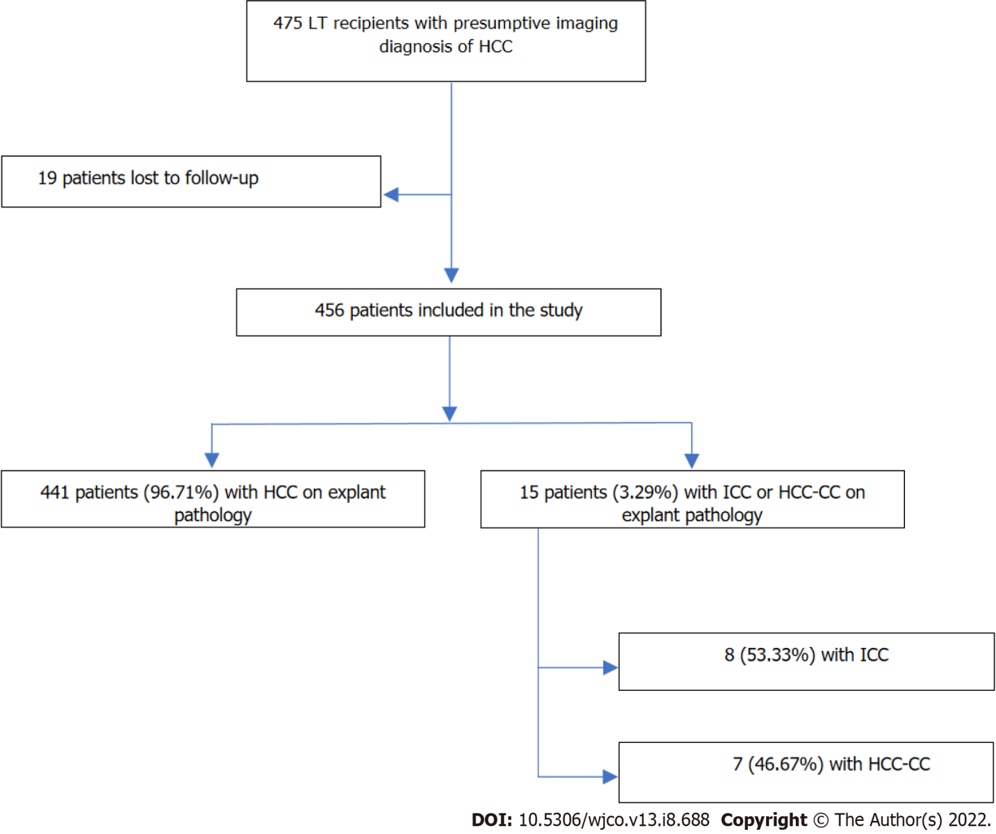
Figure 1 Flow chart of eligible patients included in the analysis according to the diagnosis of hepatocellular carcinoma, intrahepatic cholangiocarcinoma, or mixed hepatocellular-cholangiocarcinoma on explant pathology (January 1998-July 2019, southern Brazil). LT: Liver transplant; HCC: Hepatocellular carcinoma; HCC-CC: Hepatocellular cholangiocarcinoma; ICC: Intrahepatic cholangiocarcinoma.
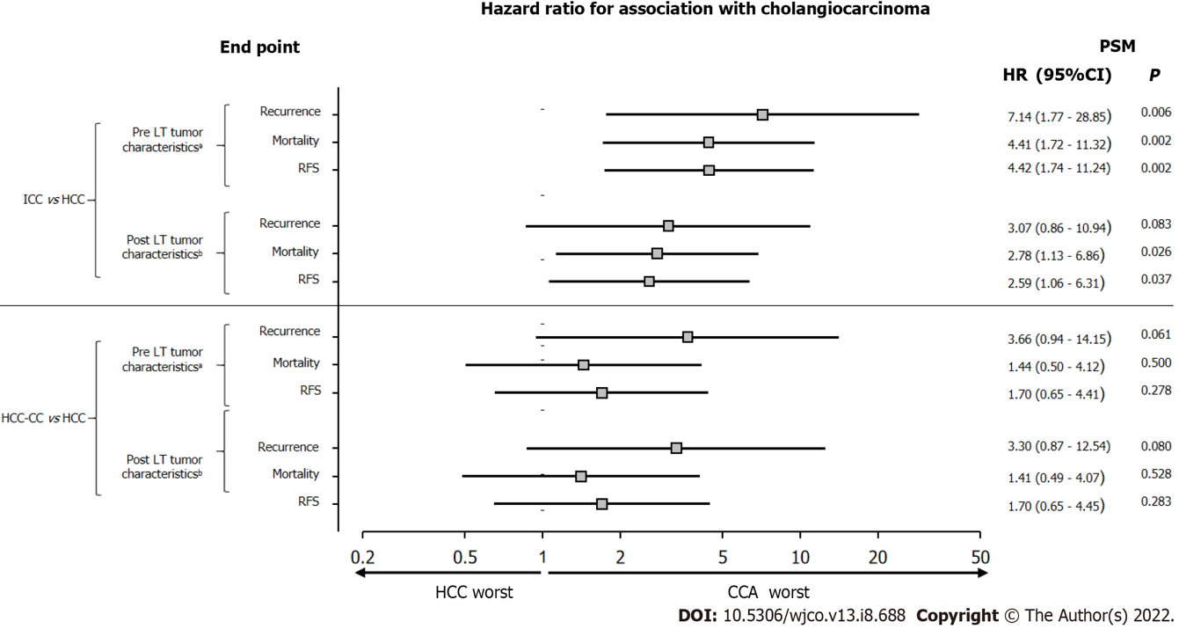
Figure 2 Post-liver transplant 3-year risk of recurrence, overall mortality, and recurrence-free survival in patients with intrahepatic cholangiocarcinoma or mixed hepatocellular-cholangiocarcinoma compared with patients with hepatocellular carcinoma, matched 1:8 for pretransplant tumor characteristics (Pre liver transplant characteristics) and pathologic tumor characteristics (Post liver transplant characteristics). ªPre liver transplant (LT) characteristics: serum alpha-fetoprotein and radiologic tumor diameter; ^{b}Post LT characteristics: tumor diameter, grade/differentiation, microvascular invasion. PSM: Propensity score matching; LT: Liver transplant; HCC: Hepatocellular carcinoma; HCC-CC: Hepatocellular cholangiocarcinoma; ICC: Intrahepatic cholangiocarcinoma.

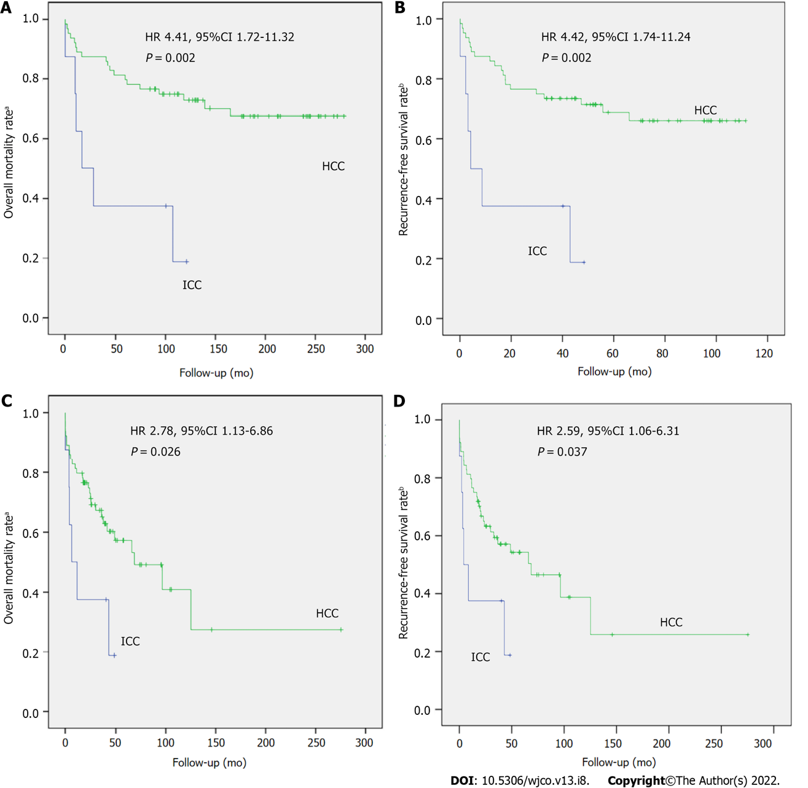
Figure 3 Kaplan-Meier curves representing. A: post-liver transplant overall survival; B: recurrence-free survival in patients with intrahepatic cholangiocarcinoma compared with patients with hepatocellular carcinoma, matched 1:8 for pretransplant tumor characteristics; C: post-liver transplant overall survival; D: recurrence-free survival in patients with intrahepatic cholangiocarcinoma compared with patients with hepatocellular carcinoma matched 1:8 for posttransplant tumor characteristics. CIs: Confidence intervals; HCC: hepatocellular carcinoma; HRs: Hazard ratios; ICC: intrahepatic cholangiocarcinoma.
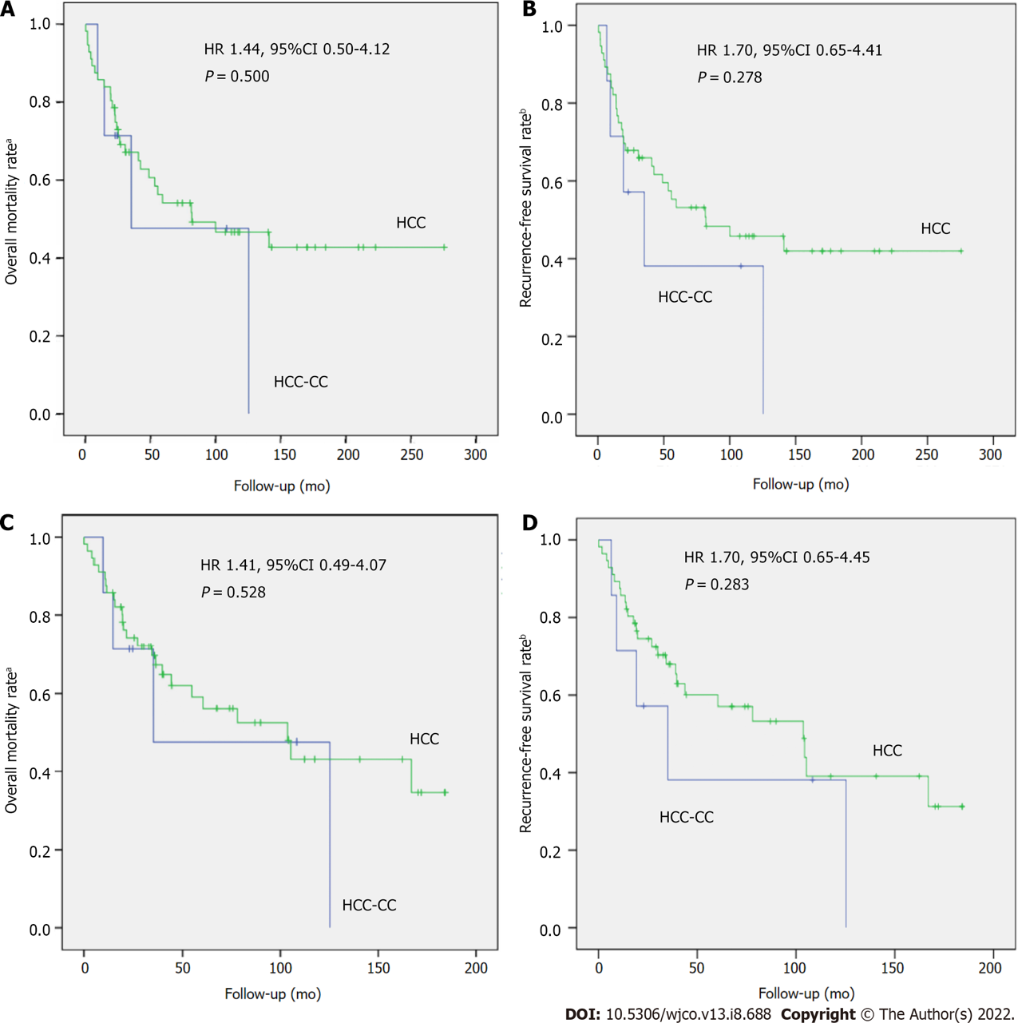
Figure 4 Kaplan-Meier curves representing. A: post-liver transplant overall survival; B: recurrence-free survival in patients with mixed hepatocellular-cholangiocarcinoma compared with patients with hepatocellular carcinoma (HCC), matched 1:8 for pretransplant tumor characteristics; C: post-liver transplant overall survival; D: recurrence-free survival in patients with mixed hepatocellular-cholangiocarcinoma compared with patients with hepatocellular carcinoma matched 1:8 for posttransplant tumor characteristics. HCC: hepatocellular carcinoma; HCC-CC: hepatocellular-cholangiocarcinoma; HRs: Hazard ratios; CIs: Confidence intervals.

Table 1 Comparison of pretransplant tumor characteristics, locoregional therapy, and posttransplant tumor characteristics between patients with intrahepatic cholangiocarcinoma and hepatocellular carcinoma, matched 1:8 for pre-liver transplant factors and explant factors
Variable | Pre-LT factors |  |  | Explant factors
 | ICC (n = 8) | HCC (n = 64) | P value | HCC (n = 64) | P value
Recipient characteristics
Age, mean ± SD | 59.4 ± 7.6 | 61.5 ± 8.0 | 0.489 | 60.3 ± 8.6 | 0.774²
Male, n (%) | 5 (62.5) | 44 (68.8) | 0.704 | 50 (78.1) | 0.382¹
Etiology of liver disease, n (%) |  |  | 0.201 |  | 0.745¹
HCV | 6 (75.0) | 50 (78.1) |  | 45 (70.3)
Alcohol | 0 | 9 (14.1) |  | 10 (15.6)
HBV | 0 | 1 (1.6) |  | 3 (4.7)
NAFLD | 1 (12.5) | 2 (3.1) |  | 1 (1.6)
Cryptogenic | 1 (12.5) | 1 (1.6) |  | 2 (3.1)
Other | 0 | 1 (1.6) |  | 3 (4.7)
CTP class, n (%) |  |  | 0.168 |  | 0.210¹
A | 7 (87.5) | 43 (67.2) |  | 40 (63.5)
B | 0 | 17 (26.6) |  | 19 (30.2)
C | 1 (12.5) | 4 (6.3) |  | 4 (6.3)
Maximum pretransplant AFP, ng/mL | 28.5  (1.60-801.0) | 10.8  (1.7-1133.0) | 0.324 | 12.5  (1.3-6123.0) | 0.620³
Radiographic tumor characteristics
Cumulative tumor diameter, cm, n (%) |  |  | 0.072 |  | 0.862¹
< 2.1 | 1 (12.5) | 21 (32.8) |  | 9 (14.1)
2.2-5.0 | 4 (50.0) | 37 (57.8) |  | 39 (60.9)
> 5.1 | 3 (37.5) | 6 (9.4) |  | 16 (25.0)
Neoadjuvant therapy, n (%) |  |  | 0.036 |  | 0.016¹
None | 0 | 21 (32.8) |  | 21 (32.8)
TACE | 8 (100.0) | 32 (50.0) |  | 29 (45.3)
Other | 0 | 11 (17.2) |  | 14 (21.9)
Pathologic tumor characteristics, n (%)
Total necrosis among treated patients, n/total n (%) | 1/8 (12.5) | 25/43 (58.1) | 0.008 | 7/43 (16.3) | 0.741¹
Within Milan criteria | 3 (37.5) | 52 (81.3) | 0.015 | 35 (54.7) | 0.463¹
Within UCSF criteria | 6 (75.0) | 56 (87.5) | 0.307 | 46 (71.9) | > 0.999¹
Median cumulative nodule size |  |  | 0.072 |  | 0.862¹
< 2.1 | 1 (12.5) | 21 (32.8) |  | 9 (14.1)
2.2-5.0 | 4 (50.0) | 37 (57.8) |  | 39 (60.9)
> 5.1 | 3 (37.5) | 6 (9.4) |  | 16 (25.0)
Tumor grade, n/total n (%) |  |  | 0.225 |  | 0.214¹
1 | 2 (25.0) | 28 (43.8) |  | 4 (6.3)
2 | 4 (50.0) | 31 (48.4) |  | 40 (62.5)
3 | 2 (25.0) | 5 (7.8) |  | 20 (31.3)
Microvascular invasion | 3 (37.5) | 6 (9.4) | 0.056 | 20 (31.3) | 0.741¹
¹Fisher exact test.
²t-test.
³Mann-Whitney test. Data expressed as mean ± SD or median (interquartile range). CTP: Child-turcotte-pugh; HBV: Hepatitis B virus; HCV: Hepatitis C virus; LT: Liver transplant; NAFLD: Nonalcoholic fatty liver disease; AFP: Alpha-fetoprotein; TACE: Transarterial chemoembolization; UCSF: University of California San Francisco.

Table 2 Comparison of pretransplant tumor characteristics, locoregional therapy, and posttransplant tumor characteristics between patients with mixed hepatocellular-cholangiocarcinoma and hepatocellular carcinoma, matched 1:8 for pre- liver transplant factors and explant factors
Variable | Pre-LT factors |  |  | Explant factors
 | HCC-CC (n = 7) | HCC (n = 56) | P value | HCC (n = 56) | P value
Recipient characteristics
Age, mean ± SD | 58.0 ± 6.9 | 60.3 ± 9.2 | 0.317 | 60.8 ± 7.1 | 0.289²
Male, n (%) | 4 (57.1) | 41 (73.2) | 0.397 | 4 (57.1) | 0.375¹
Etiology of liver disease, n (%) |  |  | 0.192 |  | 0.789¹
HCV | 6 (85.7) | 42 (75.0) |  | 41 (73.2)
Alcohol | 0 | 7 (12.5) |  | 3 (5.4)
HBV | 0 | 5 (8.9) |  | 5 (8.9)
NAFLD | 1 (14.3) | 0 |  | 3 (5.4)
Cryptogenic | 0 | 2 (3.6) |  | 4 (7.1)
CTP class, n (%) |  |  | 0.201 |  | 0.556¹
A | 3 (42.9) | 21 (37.5) |  | 29 (51.8)
B | 2 (28.6) | 30 (53.6) |  | 20 (35.7)
C | 2 (28.6) | 5 (8.9) |  | 7 (12.5)
Maximum pretransplant AFP, ng/mL | 35.3  (4.3-357.0) | 9.6  (1.1-628.0) | 0.150 | 16.5  (1.1-6123.0) | 0.668³
Radiographic tumor characteristics
Cumulative tumor diameter, cm, n (%) |  |  | 0.224 |  | 0.723^{t}
< 2.1 | 1 (14.3) | 25 (44.6) |  | 11 (19.6)
2.2-5.0 | 4 (57.1) | 23 (41.1) |  | 36 (64.3)
5.1 | 2 (28.6) | 8 (14.3) |  | 9 (16.1)
Neoadjuvant therapy, n (%) |  |  | 0.085 |  | 0.081¹
None | 0 | 14 (25.0) |  | 12 (21.4)
TACE | 3 (42.9) | 22 (39.3) |  | 28 (50.0)
Other | 4 (57.1) | 20 (35.7) |  | 16 (28.6)
Pathologic tumor characteristics, n (%)
Total necrosis among treated patients, n/total n (%) | 3/7 (33.3) | 20/42 (47.6) | 0.8000 | 18/44 (40.1) | 0.223¹
Within Milan criteria | 4 (57.1) | 39 (69.6) | 0.669 | 35 (62.5) | > 0.999¹
Within UCSF criteria | 6 (85.7) | 49 (87.5) | > 0.999 | 45 (80.4) | > 0.999¹
Median cumulative nodule size |  |  | 0.224 |  | 0.723¹
< 2.1 | 1 (14.3) | 25 (44.6) |  | 11 (19.6)
2.2-5.0 | 4 (57.1) | 23 (41.1) |  | 36 (64.3)
> 5.1 | 2 (28.6) | 8 (14.3) |  | 9 (16.1)
Tumor grade, n/total n (%) |  |  | 0.722 |  | 0.233¹
1 | 0 | 1/36 (2.8) |  | 0
2 | 4/7 (57.1) | 24/36 (66.7) |  | 18/55 (32.7)
3 | 3/7 (42.9) | 11/36 (30.6) |  | 37/55 (67.3)
Microvascular invasion | 0 | 9 (16.1) | 0.580 | 0 | 0
¹Fisher exact test.
²t-test.
³Mann-Whitney test. Data expressed as mean ± SD or median (interquartile range). CTP: Child-turcotte-pugh; HBV: Hepatitis B virus; HCV: Hepatitis C virus; LT: Liver transplant; NAFLD: Nonalcoholic fatty liver disease; AFP: Alpha-fetoprotein; TACE: Transarterial chemoembolization; UCSF: University of California San Francisco.

Published by Baishideng Publishing Group Inc
7041 Koll Center Parkway, Suite 160, Pleasanton, CA 94566, USA
Telephone: +19253991568
Email: bpgoffice@wjgnet.com
Help Desk: https://www.f6publishing.com/helpdesk
https://www.wjgnet.com

© 2022 Baishideng Publishing Group Inc. All rights reserved.

