Name of Journal: World Journal of Gastroenterology
Manuscript NO: 66914
Manuscript Type: CASE REPORT

Monomorphic epitheliotropic intestinal T-cell lymphoma presenting as melena with long-term survival: A case report and review of literature

Ozaka S et al. MEITL presenting with GI bleeding

Sotaro Ozaka, Kunimitsu Inoue, Tomoya Okajima, Takako Tasaki, Shimpei Ariki, Hideki Ono, Takeaki Ando, Tsutomu Daa, Kazunari Murakami

Sotaro Ozaka, Shimpei Ariki, Kazunari Murakami, Department of Gastroenterology, Faculty of Medicine, Oita University, Oita 879-5593, Japan

Kunimitsu Inoue, Tomoya Okajima, Takako Tasaki, Hideki Ono, Department of Gastroenterology, Almeida Memorial Hospital, Oita 870-1195, Japan

Takeaki Ando, Department of Hematology, Almeida Memorial Hospital, Oita 870-1195, Japan

Tsutomu Daa, Department of Diagnostic Pathology, Oita University, Oita 879-5593, Japan

Author contributions: Ozaka S cared for the patient, performed endoscopic treatment, and wrote and corrected the manuscript; Inoue K, Okajima T, Tasaki T, Ariki S, and Ono H cared for the patient and reviewed and corrected the manuscript; Daa T interpreted the pathological findings and contributed to manuscript drafting; Ando T performed the chemotherapy and contributed to manuscript drafting; Murakami K provided oversight for the manuscript and revised it for important intellectual content; all authors issued final approval for the version to be submitted.

Corresponding author: Sotaro Ozaka, MD, Staff Physician, Department of Gastroenterology, Faculty of Medicine, Oita University, 1-1 Idaigaoka, Hasama, Oita 879-5593, Japan. ozakaso@oita-u.ac.jp

Received: April 9, 2021
Revised: June 1, 2021
Accepted: September 6, 2021
Published online:

Abstract
BACKGROUND
Monomorphic epitheliotropic intestinal T-cell lymphoma (MEITL) is a rare primary intestinal T-cell lymphoma, previously known as enteropathy-associated T-cell lymphoma type II. MEITL is an aggressive T-cell lymphoma with a poor prognosis and high mortality rate. The known major complications of MEITL are intestinal perforation and obstruction. Here, we present a case of MEITL that was diagnosed following upper gastrointestinal bleeding from an ulcerative duodenal lesion, with recurrence-free survival for 5 years.

CASE SUMMARY
A 68-year-old female was admitted to our hospital with melena and mild anemia. An urgent esophagogastroduodenoscopy (EGD) revealed bleeding from an ulcerative lesion in the transverse part of the duodenum, for which hemostatic treatment was performed. MEITL was diagnosed following repeated biopsies of the lesion, and cyclophosphamide, doxorubicin, vincristine, and prednisone (CHOP) chemotherapy was administered. She achieved complete remission after eight full cycles of CHOP therapy. At the last follow-up examination, EGD revealed a scarred ulcer and ¹⁸Fluorodeoxyglucose (¹⁸FDG) positron emission tomography/computed tomography showed no abnormal FDG accumulation. The patient has been in complete remission for 68 mo after initial diagnosis.

CONCLUSION
To rule out MEITL, it is important to carefully perform histological examination when bleeding from a duodenal ulcer is observed.

Key Words: Monomorphic epitheliotropic intestinal T-cell lymphoma; Enteropathy-associated T-cell lymphoma type II; Gastrointestinal bleeding; Intestinal lymphoma; Duodenal ulcer; Case report

Ozaka S, Inoue K, Okajima T, Tasaki T, Ariki S, Ono H, Ando T, Daa T, Murakami K. Monomorphic epitheliotropic intestinal T-cell lymphoma presenting as melena with long-term survival: A case report and review of literature. World J Gastroenterol 2021; In press

Core Tip: Monomorphic epitheliotropic intestinal T-cell lymphoma (MEITL) is a primary intestinal T-cell lymphoma with the known major complications of intestinal perforation and obstruction. We experienced a case of MEITL that was diagnosed after gastrointestinal bleeding from an ulcerative duodenal lesion, who survived for a long time after treatment. MEITL can present as gastrointestinal bleeding. In addition, although MEITL has a poor prognosis, patients with MEITL might survive for a long time if effective treatment is administered at an early stage. Therefore, it is important to perform thorough histological examination for the early diagnosis of MEITL in cases with bleeding duodenal ulcers.

INTRODUCTION
Monomorphic epitheliotropic intestinal T-cell lymphoma (MEITL) is a rare primary intestinal T-cell lymphoma newly defined by the 2016 revision of the World Health Organization, that was previously known as enteropathy-associated T-cell lymphoma (EATL) type II^{[1]}. It arises from intestinal intraepithelial T lymphocytes and tends to behave aggressively^{[2]}. EATL was originally categorized into two major groups, EATL type I and EATL type II. EATL type I is now simply classified as EATL, and it is strongly associated with celiac disease and occurs in Western countries. In this type, tumor cells are positive for CD3 and CD30 on immunohistochemistry staining, but negative for CD8 and CD56. On the other hand, EATL type II has been renamed MEITL, shows no definite association with celiac disease, and occurs in an Asian population. In this type of malignancy, tumor cells are positive for CD3, CD8 and CD56, but negative for CD30^{[3,4]}. MEITL is most frequently found in the jejunum and ileum^{[5,6]}, and often presents with gastrointestinal perforation or obstruction^{[2]}. MEITL is known to have a very poor prognosis due to treatment resistance and perforation or obstruction of the bowel at diagnosis or during the course of treatment^{[7]}. Herein, we present a case of MEITL that was diagnosed following upper gastrointestinal bleeding from an ulcerative duodenal lesion, and who enjoyed recurrence-free survival for 5 years following treatment.

CASE PRESENTATION
Chief complaints
A 68-year-old female presented to the emergency department with melena.

History of present illness
The melena started a day before she consulted us. She had no past history of chronic abdominal symptoms suggesting the presence of celiac disease.

History of past illness
The patient had a history of hypertension and hyperlipidemia.

Personal and family history
She had no significant personal and family history.

Physical examination
Her body temperature was 36.4 ºC, blood pressure was 128/85 mmHg, and heart rate was 98 bpm with sinus rhythm. She had mild abdominal tenderness, but there was no obvious hepatosplenomegaly or lymphadenopathy. Digital rectal examination revealed melena.

Laboratory examinations
Laboratory tests indicated a hemoglobin level of 11.3 g/dL, blood urea nitrogen level of 26.0 mg/dL, and creatinine level of 1.64 mg/dL. Her serum lactate dehydrogenase level was 232 U/L (106- 211 U/L) and soluble interleukin-2 receptor level was 213 U/mL (145- 519 U/mL) (Table 1).

Imaging examinations
Urgent esophagogastroduodenoscopy (EGD) showed an ulcerative lesion with fresh blood clots in the transverse part of the duodenum (Figure 1A). Based on the location and shape of the lesion, we suspected not only a peptic ulcer, but also an ulcer caused by vascular malformation or malignancy. Therefore, we decided to interrupt the endoscopy and perform contrast-enhanced computed tomography (CT) scan, which showed slight localized contrast enhancement on the wall of the transverse part of the duodenum in the early phase of contrast injection (Figure 1B). No vascular lesions were observed, and there was no extravasation of contrast agent in the delayed phase. EGD was immediately resumed again for further observation of the lesion. When we removed the blood clots, a protruding vessel was seen at the base of the ulcer, which was coagulated using hemostatic forceps (Coagrasper; Olympus Corp., Tokyo, Japan) (Figure 1C).

Further diagnostic work-up
Following this hemostatic treatment, the patient was discharged from the hospital without re-bleeding. The lesion that caused the bleeding was suspected to be a malignant tumor of the duodenum based on its location. EGDs, including forceps biopsies from the ulcerative lesion, were performed three times after the initial hemostatic treatment. While the first and second biopsies revealed no malignancy, the third biopsy showed findings suggestive of malignant lymphoma. On pathological evaluation, diffuse proliferation of atypical medium-sized lymphoid cells was seen in the entire mucosa, along with a few intraepithelial lesions (Figure 2A and B). No necrosis was observed. Immunohistochemical analysis revealed that the cells were positive for CD3 and CD56, and negative for CD4, CD5, CD8, CD20 and EBER (Figure 2C-E).
At this point, MEITL was suspected, and examinations for systemic lesions were subsequently performed. No abnormal lymphocytes were found on iliac bone marrow examination. ¹⁸Fluorodeoxyglucose (¹⁸FDG) positron emission tomography/CT (¹⁸FDG-PET/CT) showed nodular FDG accumulation in the wall of the transverse part of the duodenum, consistent with the findings of contrast-enhanced CT (Figure 3). There was no abnormal FDG accumulation in the systemic lymph nodes or other parts of the gastrointestinal tract. The results of total colonoscopy and random biopsies of the gastrointestinal tract were unremarkable.

MULTIDISCIPLINARY EXPERT CONSULTATION
Ayako Gamachi, MD, PhD, Chief of the Department of Diagnostic Pathology, Almeida Memorial Hospital; and Tsutomu Daa, MD, PhD, Professor, Department of Diagnostic Pathology, Oita University
Pathological evaluations of the duodenal biopsy samples were performed by expert pathologists. The results of immunostaining of the duodenal biopsy specimen were consistent with MEITL.

FINAL DIAGNOSIS
Based on the clinical course, features of the tumor and imaging evaluations, we diagnosed MEITL (previously EATL type II) confined to the duodenum.

TREATMENT
Cyclophosphamide, doxorubicin, vincristine, and prednisone (CHOP) chemotherapy was administered without a dosage reduction.

OUTCOME AND FOLLOW-UP
EGD performed after three cycles of CHOP therapy clearly showed that the ulcerative lesion in the duodenum had reduced in size (Figure 4A), and no atypical lymphoid cells were detected in biopsy specimens taken from the lesion. The patient tolerated the chemotherapy well and received eight full cycles of CHOP chemotherapy. ¹⁸FDG-PET/CT after the final cycle revealed no abnormal FDG accumulation in the transverse part of the duodenum. Therefore, we concluded that the patient had achieved complete remission (CR). EGD at the last follow-up examination revealed a scarred ulcer (Figure 4B), and ¹⁸FDG-PET/CT showed no abnormal FDG accumulation (Figure 5). The patient has been in CR for 68 mo after the initial diagnosis.

DISCUSSION
Our experience in this case highlights two important clinical points. First, MEITL can present as gastrointestinal bleeding, and not just as intestinal perforation and obstruction. Second, patients with MEITL can survive for a long time if effective treatment is administered early.
MEITL is a primary intestinal T-cell lymphoma previously known as EATL type II^{[1]}. It is a rare intestinal tumor, accounting for 1.7% of all malignant lymphomas^{[8]} and less than 10%-16% of gastrointestinal lymphomas^{[9]}. MEITL differs from EATL (previously EATL type I) in that it predominantly affects Asian populations and is not associated with celiac disease^{[10]}. Histologically, it consists of monomorphic small- to medium-sized cells that usually express CD3, CD8 and CD56, but not CD30^{[3,4]}. Positive rates for CD8 and CD56 were reported to be 63-79% and 73-95%, respectively^{[8,11]}. The present case had no past history of chronic abdominal symptoms suggestive of the presence of celiac disease. Histopathological examination revealed an infiltration of atypical medium-sized lymphoid cells in the entire mucosa, along with intraepithelial lesions, and immunostaining was positive for CD3 and CD56 and negative for CD5 and CD8, leading to the diagnosis of MEITL.
Our MEITL patient presented with gastrointestinal bleeding and not intestinal perforation or obstruction. More than 50% of MEITL cases are diagnosed as a result of intestinal perforation or obstruction, and emergency surgery is required in about 40% of them^{[9,12]}. In contrast, MEITL is less frequently detected as a result of gastrointestinal bleeding. A search of the PubMed database found four case reports of MEITL or EATL that presented with gastrointestinal bleeding at the first diagnosis^{[13-16]} (Table 2). There was a male preponderance (80%) among the five cases, and all the patients were aged above 60 years including our patient. Two cases had lesions in the jejunum, two in the stomach, and only our case had a lesion in the duodenum. Most of them showed ulcerative lesions. Only one case had a perforated lesion. Four of the five patients were diagnosed with MEITL and one with EATL. Chemotherapy was administered in four cases, and surgery was performed in two cases. To the best of our knowledge, this is the first case of MEITL that was treated with an endoscopic procedure for upper gastrointestinal bleeding. In terms of the outcomes, two cases, including our case, survived for more than 24 mo, and the two cases with gastric involvement died at 13 mo. Although it was previously reported that the median overall survival of all types of MEITL is 7 mo^{[11,17]}, the cases diagnosed after gastrointestinal bleeding had a relatively good prognosis.
In a histopathological study of a case of MEITL with perforation, tumor cells positive for TIA-1 or Granzyme B, a cytotoxic molecule, were reported to have markedly infiltrated all layers of the intestinal wall^{[18,19]}. This suggests that MEITL easily penetrates the gastrointestinal tract by growing destructively through all its layers, resulting in a relatively lower incidence of gastrointestinal bleeding.
Our case suggests that patients with MEITL might survive for a long time if effective treatment is administered at an early stage. MEITL is an aggressive T-cell lymphoma with a very poor prognosis and high mortality rate^{[20]}. The median overall survival was previously reported as 7 mo^{[11,17]}, and the 5-year survival rate was reported as 20%, with a 5-year failure-free survival rate of 4%^{[8]}. Surgery, chemotherapy and radiotherapy are all used to treat MEITL, although these treatments have shown poor overall outcomes^{[21]}. Although several studies have demonstrated the benefit of autologous stem cell transplantation^{[22-25]}, there is no standardized treatment strategy. Moreover, MEITL often requires emergency surgery due to intestinal perforation or obstruction, and the lesion has usually spread before it is diagnosed^{[26]}. Unfortunately, most patients are unable to receive effective chemotherapy due to their poor performance status and severe malnutrition at the time of diagnosis^{[27]}. On the other hand, in a study of 26 patients with MEITL, the prognosis of non-perforated cases was significantly better than that of perforated cases, suggesting that early treatment before perforation might improve the prognosis of MEITL^{[28]}. The present case has shown the most favorable prognosis to date, because we were able to diagnose MEITL at an early stage due to her presentation with upper gastrointestinal bleeding, and hence performed chemotherapy while the patient was in good general condition. In the previously reported cases shown in Table 2, as well, the prognosis tended to be relatively good in cases that were diagnosed after hemorrhage. This is probably because the lesion was perforated in only one case and the other cases were able to start chemotherapy before perforation. This suggests that gastrointestinal bleeding is an important sign that can lead to early diagnosis and treatment of MEITL.
So far, only one other case of MEITL with a failure-free survival for more than 5 years has been reported^{[29]}. This case was diagnosed early by the finding of only chorionic changes (white villi) without a mass or ulcer, and CHOP therapy was started before perforation. Ishibashi et al^{[30]} reported that edematous and granular mucosae with or without villous atrophy are characteristic findings of prodromal lesions of MEITL in the small intestine or duodenum. Even in the absence of obvious masses or ulcers, it is important not to overlook such micro-changes in the gastrointestinal mucosa to facilitate the early diagnosis of MEITL.
Another point to note is that the diagnostic ratio of intestinal T-cell lymphoma (ITCL) by endoscopy, including tissue biopsy, is low. Sun et al^{[31]} reported that out of 34 ITCL patients who underwent endoscopy, eight patients (23.5%) were definitively diagnosed with ITCL by histology. Daum et al^{[32]} also reported that only 21% of intestinal non-Hodgkin lymphomas were diagnosed endoscopically. In the present case as well, a total of three tissue biopsies were required before the final diagnosis of MEITL. The following are some of the reasons for this: (1) Tissue specimens from endoscopic biopsy are usually not sufficiently large to allow correct diagnosis; (2) ITCL is known to be primarily located in the submucosa and smooth muscle, and it is difficult to detect the lesion from biopsy specimens through the mucosal layer; and (3) The disease is easy to overlook because of its rarity. Hence, a tissue biopsy of ulcerative gastrointestinal lesions should be performed carefully from the base of the ulcer, while considering the possibility of malignant lymphoma.

CONCLUSION
We report a case of MEITL diagnosed after upper gastrointestinal bleeding from an ulcerative duodenal lesion, with recurrence-free survival for 5 years after chemotherapy. MEITL can present as gastrointestinal bleeding, and not only as intestinal perforation and obstruction. In addition, although MEITL is an aggressive T-cell lymphoma with a poor prognosis, patients with MEITL can survive for a long time if effective treatment is administered early. Therefore, it is important to carefully perform histological examination to rule out MEITL when bleeding from a duodenal ulcer is observed.

ACKNOWLEDGEMENTS
We thank Dr. Ayako Gamachi (Chief of the Department of Diagnostic Pathology, Almeida Memorial Hospital) for providing histopathological images of the duodenal biopsy.

REFERENCES
1 Swerdlow SH, Campo E, Pileri SA, Harris NL, Stein H, Siebert R, Advani R, Ghielmini M, Salles GA, Zelenetz AD, Jaffe ES. The 2016 revision of the World Health Organization classification of lymphoid neoplasms. Blood 2016; 127: 2375-2390 [PMID: 26980727 DOI: 10.1182/blood-2016-01-643569]
2 van de Water JM, Cillessen SA, Visser OJ, Verbeek WH, Meijer CJ, Mulder CJ. Enteropathy associated T-cell lymphoma and its precursor lesions. Best Pract Res Clin Gastroenterol 2010; 24: 43-56 [PMID: 20206108 DOI: 10.1016/j.bpg.2009.11.002]
3 van Vliet C, Spagnolo DV. T- and NK-cell lymphoproliferative disorders of the gastrointestinal tract: review and update. Pathology 2020; 52: 128-141 [PMID: 31727264 DOI: 10.1016/j.pathol.2019.10.001]
4 Takeshita M, Nakamura S, Kikuma K, Nakayama Y, Nimura S, Yao T, Urabe S, Ogawara S, Yonemasu H, Matsushita Y, Karube K, Iwashita A. Pathological and immunohistological findings and genetic aberrations of intestinal enteropathy-associated T cell lymphoma in Japan. Histopathology 2011; 58: 395-407 [PMID: 21323966 DOI: 10.1111/j.1365-2559.2011.03768.x]
5 Ferreri AJ, Zinzani PL, Govi S, Pileri SA. Enteropathy-associated T-cell lymphoma. Crit Rev Oncol Hematol 2011; 79: 84-90 [PMID: 20655757 DOI: 10.1016/j.critrevonc.2010.06.006]
6 Liu Z, He L, Jiao Y, Wang H, Suo J. Type II enteropathy-associated T cell lymphoma in the duodenum: A rare case report. Medicine (Baltimore) 2020; 99: e20050 [PMID: 32501967 DOI: 10.1097/MD.0000000000020050]
7 Nijeboer P, Malamut G, Mulder CJ, Cerf-Bensussan N, Sibon D, Bouma G, Cellier C, Hermine O, Visser O. Enteropathy-associated T-cell lymphoma: improving treatment strategies. Dig Dis 2015; 33: 231-235 [PMID: 25925928 DOI: 10.1159/000369542]
8 Delabie J, Holte H, Vose JM, Ullrich F, Jaffe ES, Savage KJ, Connors JM, Rimsza L, Harris NL, Müller-Hermelink K, Rüdiger T, Coiffier B, Gascoyne RD, Berger F, Tobinai K, Au WY, Liang R, Montserrat E, Hochberg EP, Pileri S, Federico M, Nathwani B, Armitage JO, Weisenburger DD. Enteropathy-associated T-cell lymphoma: clinical and histological findings from the international peripheral T-cell lymphoma project. Blood 2011; 118: 148-155 [PMID: 21566094 DOI: 10.1182/blood-2011-02-335216]
9 Tse E, Gill H, Loong F, Kim SJ, Ng SB, Tang T, Ko YH, Chng WJ, Lim ST, Kim WS, Kwong YL. Type II enteropathy-associated T-cell lymphoma: a multicenter analysis from the Asia Lymphoma Study Group. Am J Hematol 2012; 87: 663-668 [PMID: 22641357 DOI: 10.1002/ajh.23213]
10 Afzal A, Esmaeili A, Ibrahimi S, Farooque U, Gehrs B. Monomorphic Epitheliotropic Intestinal T-Cell Lymphoma With Extraintestinal Areas of Peripheral T-Cell Lymphoma Involvement. Cureus 2020; 12: e10021 [PMID: 32983716 DOI: 10.7759/cureus.10021]
11 Yi JH, Lee GW, Do YR, Jung HR, Hong JY, Yoon DH, Suh C, Choi YS, Yi SY, Sohn BS, Kim BS, Oh SY, Park J, Jo JC, Lee SS, Oh YH, Kim SJ, Kim WS. Multicenter retrospective analysis of the clinicopathologic features of monomorphic epitheliotropic intestinal T-cell lymphoma. Ann Hematol 2019; 98: 2541-2550 [PMID: 31493002 DOI: 10.1007/s00277-019-03791-y]
12 Zettl A, deLeeuw R, Haralambieva E, Mueller-Hermelink HK. Enteropathy-type T-cell lymphoma. Am J Clin Pathol 2007; 127: 701-706 [PMID: 17511112 DOI: 10.1309/nw2bk1dxb0eqg55h]
13 Kinaci E, Gunes ME, Huq GE. An unusual presentation of EATL type 1: Emergency surgery due to life-threatening gastrointestinal bleeding. Int J Surg Case Rep 2013; 4: 961-964 [PMID: 24055918 DOI: 10.1016/j.ijscr.2013.08.007]
14 Ho HC, Nagar AB, Hass DJ. Obscure gastrointestinal bleeding and video capsule retention due to enteropathy-associated T-cell lymphoma. Gastroenterol Hepatol (N Y) 2013; 9: 536-538 [PMID: 24719605]
15 Lu S, Zhou G, Chen M, Liu W, Zhao S. Monomorphic Epitheliotropic Intestinal T-cell Lymphoma of the Stomach: Two Case Reports and a Literature Review. Int J Surg Pathol 2021; 29: 410-419 [PMID: 32856508 DOI: 10.1177/1066896920953906]
16 Chan TSY, Lee E, Khong PL, Tse EWC, Kwong YL. Positron emission tomography computed tomography features of monomorphic epitheliotropic intestinal T-cell lymphoma. Hematology 2018; 23: 10-16 [PMID: 28581364 DOI: 10.1080/10245332.2017.1335979]
17 Olmos-Alpiste F, Vázquez I, Gallardo F, Sánchez-Gonzalez B, Colomo L, Pujol RM. Monomorphic Epitheliotropic Intestinal T-Cell Lymphoma With Secondary Cutaneous Involvement: A Diagnostic Challenge. Am J Dermatopathol 2021; 43: 300-304 [PMID: 33264131 DOI: 10.1097/DAD.0000000000001855]
18 Yamamura K, Ishigure K, Ishida N. [Enteropathy-type T-cell lymphoma triggering perforated peritonitis successfully treated with comprehensive therapy]. J Ipn Surg Assoc 2011; 72: 821-827
19 Abouyabis AN, Shenoy PJ, Lechowicz MJ, Flowers CR. Incidence and outcomes of the peripheral T-cell lymphoma subtypes in the United States. Leuk Lymphoma 2008; 49: 2099-2107 [PMID: 19021052 DOI: 10.1080/10428190802455867]
20 Tan SY, Chuang SS, Tang T, Tan L, Ko YH, Chuah KL, Ng SB, Chng WJ, Gatter K, Loong F, Liu YH, Hosking P, Cheah PL, Teh BT, Tay K, Koh M, Lim ST. Type II EATL (epitheliotropic intestinal T-cell lymphoma): a neoplasm of intra-epithelial T-cells with predominant CD8αα phenotype. Leukemia 2013; 27: 1688-1696 [PMID: 23399895 DOI: 10.1038/leu.2013.41]
21 Gentille C, Qin Q, Barbieri A, Ravi PS, Iyer S. Use of PEG-asparaginase in monomorphic epitheliotropic intestinal T-cell lymphoma, a disease with diagnostic and therapeutic challenges. Ecancermedicalscience 2017; 11: 771 [PMID: 29062389 DOI: 10.3332/ecancer.2017.771]
22 Ikebe T, Miyazaki Y, Abe Y, Urakami K, Ohtsuka E, Saburi Y, Saburi M, Ando T, Kohno K, Ogata M, Kadota J. Successful treatment of refractory enteropathy-associated T-cell lymphoma using high-dose chemotherapy and autologous stem cell transplantation. Intern Med 2010; 49: 2157-2161 [PMID: 20930447 DOI: 10.2169/internalmedicine.49.3409]
23 Sieniawski M, Angamuthu N, Boyd K, Chasty R, Davies J, Forsyth P, Jack F, Lyons S, Mounter P, Revell P, Proctor SJ, Lennard AL. Evaluation of enteropathy-associated T-cell lymphoma comparing standard therapies with a novel regimen including autologous stem cell transplantation. Blood 2010; 115: 3664-3670 [PMID: 20197551 DOI: 10.1182/blood-2009-07-231324]
24 Jantunen E, Boumendil A, Finel H, Luan JJ, Johnson P, Rambaldi A, Haynes A, Duchosal MA, Bethge W, Biron P, Carlson K, Craddock C, Rudin C, Finke J, Salles G, Kroschinsky F, Sureda A, Dreger P; Lymphoma Working Party of the EBMT. Autologous stem cell transplantation for enteropathy-associated T-cell lymphoma: a retrospective study by the EBMT. Blood 2013; 121: 2529-2532 [PMID: 23361910 DOI: 10.1182/blood-2012-11-466839]
25 Nijeboer P, de Baaij LR, Visser O, Witte BI, Cillessen SA, Mulder CJ, Bouma G. Treatment response in enteropathy associated T-cell lymphoma; survival in a large multicenter cohort. Am J Hematol 2015; 90: 493-498 [PMID: 25716069 DOI: 10.1002/ajh.23992]
26 Chandesris MO, Malamut G, Verkarre V, Meresse B, Macintyre E, Delarue R, Rubio MT, Suarez F, Deau-Fischer B, Cerf-Bensussan N, Brousse N, Cellier C, Hermine O. Enteropathy-associated T-cell lymphoma: a review on clinical presentation, diagnosis, therapeutic strategies and perspectives. Gastroenterol Clin Biol 2010; 34: 590-605 [PMID: 21050687 DOI: 10.1016/j.gcb.2010.09.008]
27 Gale J, Simmonds PD, Mead GM, Sweetenham JW, Wright DH. Enteropathy-type intestinal T-cell lymphoma: clinical features and treatment of 31 patients in a single center. J Clin Oncol 2000; 18: 795-803 [PMID: 10673521 DOI: 10.1200/JCO.2000.18.4.795]
28 Kikuma K, Yamada K, Nakamura S, Ogami A, Nimura S, Hirahashi M, Yonemasu H, Urabe S, Naito S, Matsuki Y, Sadahira Y, Takeshita M. Detailed clinicopathological characteristics and possible lymphomagenesis of type II intestinal enteropathy-associated T-cell lymphoma in Japan. Hum Pathol 2014; 45: 1276-1284 [PMID: 24746558 DOI: 10.1016/j.humpath.2013.10.038]
29 Kakugawa Y, Terasaka S, Watanabe T, Tanaka S, Taniguchi H, Saito Y. Enteropathy-associated T-cell lymphoma in small intestine detected by capsule endoscopy. Leuk Lymphoma 2012; 53: 1623-1624 [PMID: 22242819 DOI: 10.3109/10428194.2012.656633]
30 Ishibashi H, Nimura S, Kayashima Y, Takamatsu Y, Aoyagi K, Harada N, Kadowaki M, Kamio T, Sakisaka S, Takeshita M. Multiple lesions of gastrointestinal tract invasion by monomorphic epitheliotropic intestinal T-cell lymphoma, accompanied by duodenal and intestinal enteropathy-like lesions and microscopic lymphocytic proctocolitis: a case series. Diagn Pathol 2016; 11: 66 [PMID: 27457239 DOI: 10.1186/s13000-016-0519-x]
31 Sun ZH, Zhou HM, Song GX, Zhou ZX, Bai L. Intestinal T-cell lymphomas: a retrospective analysis of 68 cases in China. World J Gastroenterol 2014; 20: 296-302 [PMID: 24415885 DOI: 10.3748/wjg.v20.i1.296]
32 Daum S, Ullrich R, Heise W, Dederke B, Foss HD, Stein H, Thiel E, Zeitz M, Riecken EO. Intestinal non-Hodgkin's lymphoma: a multicenter prospective clinical study from the German Study Group on Intestinal non-Hodgkin's Lymphoma. J Clin Oncol 2003; 21: 2740-2746 [PMID: 12860953 DOI: 10.1200/JCO.2003.06.026]

Footnotes
Informed consent statement: Informed consent was obtained from the patient for publication of this report and any accompanying images.

Conflict-of-interest statement: The authors declare that they have no conflict of interest.

CARE Checklist (2016) statement: The authors have read the CARE Checklist (2016), and the manuscript was prepared and revised according to the CARE Checklist (2016).

Open-Access: This article is an open-access article that was selected by an in-house editor and fully peer-reviewed by external reviewers. It is distributed in accordance with the Creative Commons Attribution NonCommercial (CC BY-NC 4.0) license, which permits others to distribute, remix, adapt, build upon this work non-commercially, and license their derivative works on different terms, provided the original work is properly cited and the use is non-commercial. See: http://creativecommons.org/Licenses/by-nc/4.0/

Manuscript source: Unsolicited manuscript

Peer-review started: April 9, 2021
First decision: May 24, 2021
Article in press:

Specialty type: Gastroenterology and Hepatology
Country/Territory of origin: Japan
Peer-review report’s scientific quality classification
Grade A (Excellent): 0
Grade B (Very good): B
Grade C (Good): 0
Grade D (Fair): 0
Grade E (Poor): 0

P-Reviewer: Strainiene S S-Editor: Wang JL L-Editor: P-Editor:

Figure Legends
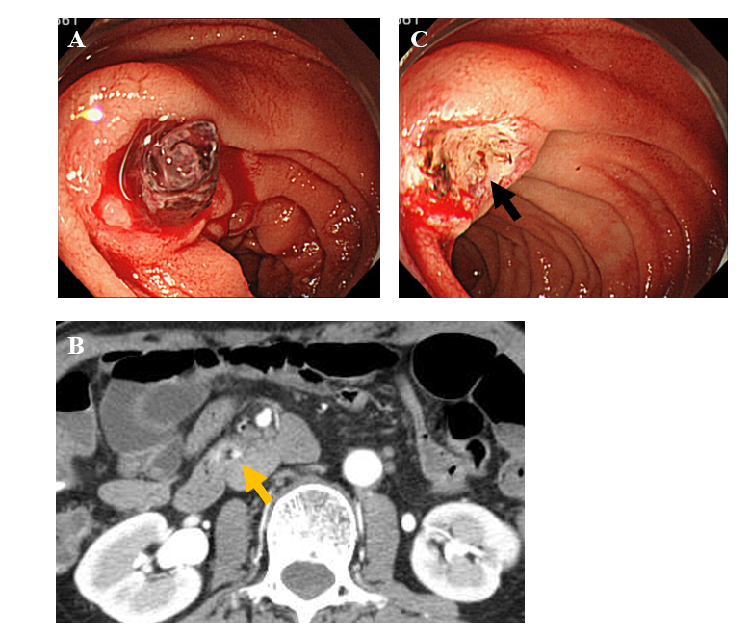
Figure 1 Endoscopic images and abdominal contrast-enhanced computed tomography scan images on initial examination. A: Esophagogastroduodenoscopy showed an ulcerative lesion with fresh blood clots in the transverse part of the duodenum; B: Contrast-enhanced computed tomography scan showed a slight localized contrast effect on the wall of the transverse part of the duodenum (arrow); C: When the blood clots were removed, a protruding vessel was observed at the base of the ulcer (arrow).

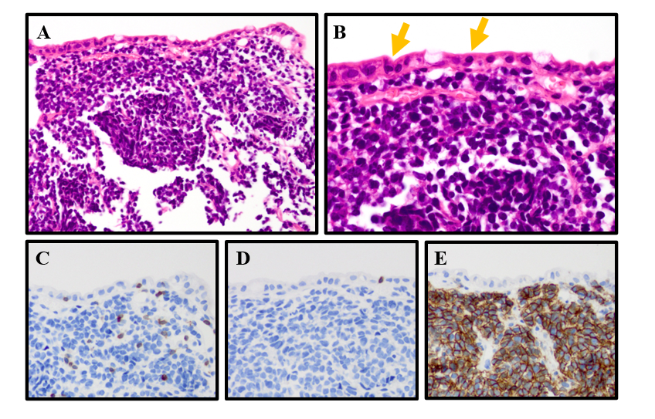
Figure 2 Histological and immunohistochemical analyses. A: Hematoxylin-eosin staining showed infiltration of medium-size atypical lymphoid cells in the mucosa; B: Lymphoid cell infiltration was also observed in the epithelium (arrow); C: Lymphoid cells expressed CD3; D: The lymphoid cells were CD8 negative; E: Lymphoid cells were CD56 positive. Magnification 200× (A, C-E) and 400× (B).

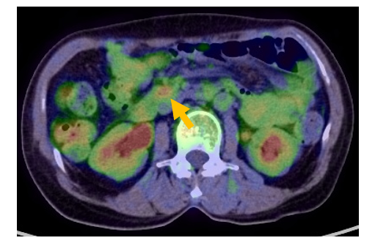
Figure 3 Pre-treatment ¹⁸Fluorodeoxyglucose positron emission tomography/computed tomography images. ¹⁸Fluorodeoxyglucose positron emission tomography/computed tomography showed abnormal nodular accumulation in the wall of the transverse part of the duodenum (arrow).

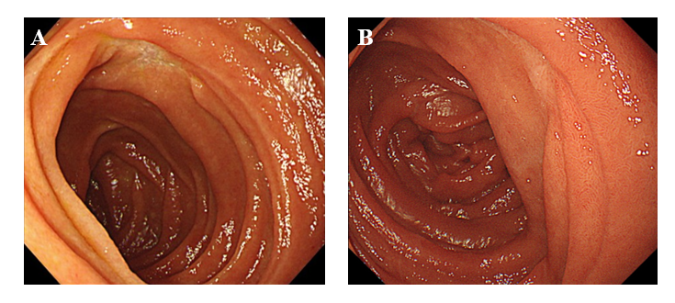
Figure 4 Follow-up endoscopic examinations. A: Esophagogastroduodenoscopy (EGD) after three cycles of cyclophosphamide, doxorubicin, vincristine, and prednisone therapy revealed that the ulcerative lesion had clearly reduced in size; B: EGD performed 60 mo after complete remission showed a scarred ulcer.
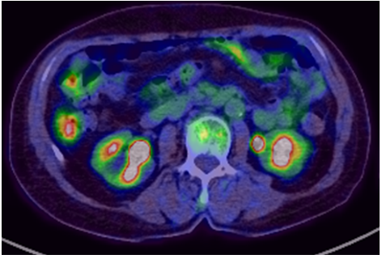
Figure 5 Follow-up ¹⁸Fluorodeoxyglucose positron emission tomography/computed tomography at 60 mo after complete remission. ⁸Fluorodeoxyglucose positron emission tomography/computed tomography showed no abnormal fluorodeoxyglucose accumulation.

Table 1 Laboratory data on admission
Items | Data | Reference | Items | Data | Reference | Items | Data | Reference
WBC | 6720 /μL | 3500-9100 | TP | 7.5 g/dL | 6.4-8.4 | γ-GTP | 12 U/L | 16-73
RBC | 393 × 10⁴ /μL | 376-500 | Alb | 4.5 g/dL | 3.6-5.2 | Na | 140 mEq/L | 135-146
Hb | 11.3 g/dL | 11.3-15.2 | BUN | 26.0 mg/dL | 6-22 | Cl | 107 mEq/L | 96-108
Hct | 34.2% | 33.4-44.9 | Cre | 0.81 mg/dL | 0.40-0.80 | K | 4.4 mEq/L | 3.5-5.0
MCV | 87.0 fL | 79-100 | T-bil | 0.5 mg/dL | 0.2-1.2 | CRP | 0.08 mg/dL | 0-0.23
MCHC | 33.0% | 13.0-36.9 | CK | 140 U/L | 43-165 | sIL-2R | 213 U/mL | 145-519
Plt | 21.4 × 10⁴ /μL | 13.0-16.9 | AST | 31 U/L | 13-33 | HBs Ag | (-) | (-)
PT | 68% | 70-130 | ALT | 12 U/L | 6-30 | HCV Ab | (-) | (-)
APTT | 38.5 s | 24-39 | LDH | 232 U/L | 106-211 | HTLV-1 Ab | (-) | (-)
 |  |  | ALP | 220 U/L | 100-340
WBC: White blood cell; RBC: Red blood cell; Hb: Hemoglobin; Hct: Hematocrit; MCV: Mean corpuscular volume; MCHC: Mean corpuscular hemoglobin concentration; Plt: Platelets; PT: Prothrombin; APTT: Activated partial thromboplastin time; TP: Total protein; Alb: Albumin; BUN: Blood urea nitrogen; Cre: Creatinine; T-bil: Total bilirubin; CK: Creatine Kinase; AST: Aspartate transaminase; ALT: Alanine transferase; LDH: Lactate dehydrogenase; ALP: Alkaline phosphatase; γ-GTP: γ-glutamyl transpeptidase; Na: Sodium; Cl: Chloride; K: Potassium; CRP: C-reactive protein; sIL-2R: Soluble interleukin-2 receptor; HBs Ag: HBs antigen; HCV Ab: HCV antibody; HTLV-1 Ab: HTLV-1 antibody.

Table 2 Case reports of enteropathy-associated T-cell lymphoma and monomorphic epitheliotropic intestinal T-cell lymphoma presenting gastrointestinal bleeding
Case | Ref. | Age/Sex | Symptom | Location | Macroscopic finding | Perforation | Diagnosis | Treatment | Outcome
1 | [13] | 76/M | Gastrointestinal bleeding | Jejunum | Ulcer | Yes | EATL | Operation → chemotherapy | 24 mo/alive
2 | [14] | 77/M | Positive for fecal occult bleeding | Jejunum | Ulcer, stenosis | No | MEITL | Operation | NA
3 | [15] | 68/M | Melena | Stomach | Ulcer (type 3 tumor) | No | MEITL | Chemotherapy | 13 mo/death
4 | [16] | 65/M | Gastrointestinal bleeding | Stomach | NA | No | MEITL | Chemotherapy | 13 mo/death
5 | Our case | 68/F | Melena | Duodenum | Ulcer | No | MEITL | Chemotherapy | 66 mo/alive
NA: Not available; MEITL: Monomorphic epitheliotropic intestinal T-cell lymphoma; EATL: Enteropathy-associated T-cell lymphoma.

