Name of journal: World Journal of Gastroenterology
ESPS Manuscript NO: 5753
Columns: TOPIC HIGHLIGHT

WJG 20th Anniversary Special Issues (5): Colorectal cancer

Telomeres, telomerase and colorectal cancer

Bertorelle R et al. Telomeres, telomerase and colorectal cancer

Roberta Bertorelle, Enrica Rampazzo, Salvatore Pucciarelli, Donato Nitti, Anita De Rossi

Roberta Bertorelle, Enrica Rampazzo, Anita De Rossi, Department of Surgery, Oncology and Gastroenterology, Section of Oncology and Immunology, University of Padova, IOV-IRCCS, 35128 Padova, Italy

Salvatore Pucciarelli, Donato Nitti, Department of Surgery, Oncology and Gastroenterology, Section of Surgery, University of Padova, 35128 Padova, Italy

Author contributions: De Rossi A designed the study; All the authors reviewed the literature and analysed the data; De Rossi A and Bertorelle R wrote the article. All authors reviewed and approved the final version of the article.

Supported by A grant from Cariparo, Project "Tumour microenvironment and tumour spread in gastrointestinal cancers”, 2013/2014, No. 6421 to Rampazzo E

Correspondence to: Anita De Rossi, PhD, Department of Surgery, Oncology and Gastroenterology, Section of Oncology and Immunology, University of Padova, IOV-IRCCS, Padova, Via Gattamelata 64, 35128 Padova, Italy. anita.derossi@unipd.it

Telephone: + 39-49-8215894 Fax: +39-49-8215894
Received: September 24, 2013 Revised: December 3, 2013
Accepted: January 14, 2014

Published online:

Abstract
Colorectal cancer (CRC) is the third most common cancer worldwide and, despite improved treatments, is still an important cause of cancer-related deaths. CRC encompasses a complex of diseases arising from a multi-step process of genetic and epigenetic events. Besides heterogeneity in the molecular and biological features of CRC, chromosomal instability is a hallmark of cancer and cancer cells may also circumvent replicative senescence and acquire the ability to sustain unlimited proliferation. Telomere/telomerase interplay is an important mechanism involved in both genomic stability and cellular replicative potential, and its dysfunction plays a key role in the oncogenetic process. The erosion of telomeres, mainly because of cell proliferation, may be accelerated by specific alterations in the genes involved in CRC, such as APC and MSH2. Although there is general agreement that the shortening of telomeres plays a role in the early steps of CRC carcinogenesis by promoting chromosomal instability, the prognostic role of telomere length in CRC is still under debate. The activation of telomerase reverse transcriptase (TERT), the catalytic component of the telomerase complex, allows cancer cells to grow indefinitely by maintaining the length of the telomeres, thus favouring tumour formation/progression. Several studies indicate that TERT increases with disease progression, and most studies suggest that telomerase is a useful prognostic factor. Plasma TERT microRNA may also be a promising marker for the minimally invasive monitoring of disease progression and response to therapy.

© 2014 Baishideng Publishing Group Co., Limited. All rights reserved.

Key words: Telomere; Telomerase; Telomerase reverse transcriptase; Colorectal cancer; Prognostic marker

Core tip: Telomere/telomerase interplay is an important mechanism involved in both genomic stability and cellular replicative potential. Telomere shortening is an early event that contributes to genetic instability, which plays a key role in the early steps of carcinogenesis. The activation of telomerase, which preserves replicative potential by maintaining the length of telomeres, occurs during the adenoma-carcinoma sequence and increases during tumour progression. While the prognostic value of telomere length is controversial, most studies agree that the level of telomerase in tumours represents a useful prognostic marker. Circulating telomerase reverse transcriptase is a promising marker for the minimally invasive monitoring of disease and response to therapy.

Bertorelle R, Rampazzo E, Pucciarelli S, Nitti D, De Rossi A. Telomeres, telomerase and colorectal cancer. World J Gastroenterol 2014;
Available from: URL: http://www.wjgnet.com/esps/
DOI: http://dx.doi.org/10.3748/wjg.v20.i0.0000

INTRODUCTION
Colorectal cancer (CRC) is the third most common cancer worldwide; over 1.2 million new cancer cases and nearly 600000 deaths are estimated to have occurred in 2008^{[1]}. Despite improved treatments, increased awareness and early detection, which have all contributed to prolonged survival, CRC is still an important cause of cancer-related deaths^{[1]}. CRCs encompass a complex of diseases with different molecular pathways and biological characteristics arising from a multi-step process that involves several genetic and epigenetic events^{[2,3]}. The stepwise change in morphology from normal epithelium to carcinoma occurs through a multi-step genetic model with the loss of the functions of tumour suppressor genes, such as adenomatous polyposis coli (APC) and TP53, and the gain of the function of oncogenes, such as KRAS. Recent genome-wide sequencing analyses have estimated as many as 80 mutated genes in CRC. Although a smaller number of mutations are considered drivers of tumourigenesis, multiple genetic hits are required for tumour onset and progression^{[4]}. Many efforts have been made to identify molecular markers that predict the outcome of CRC patients, and several genetic and epigenetic alterations that are involved in the development of CRC have been proposed as prognostic markers of disease progression; however, no agreement has been reached^{[5,6]}. Besides great heterogeneity of the molecular and biological features, chromosomal instability may play a key role in the early steps of carcinogenesis^{[7]}. Cancer cells may also circumvent replicative senescence and acquire the ability to sustain unlimited proliferation^{[8]}. Telomere/telomerase interplay is an important mechanism involved in the genomic stability and cellular replicative potential, and telomere/telomerase dysfunction has emerged as playing a key role in carcinogenesis. Here, we review the role of telomeres and telomerase in the genesis and progression of CRC.

TELOMERES AND TELOMERASE
Telomeres are specialised DNA structures located at the end of chromosomes; they are essential for stabilising chromosomes by protecting them from end-to-end fusion and DNA degradation^{[9]}. In human cells, telomeres are composed of (TTAGGG)n tandem repeats that are associated with the capping proteins TTAGGG repeat binding factor (TRF)1, TRF2, repressor and activator protein 1, TRF1-interacting nuclear protein 2, protection of telomeres 1 (POT1), which constitute the shelterin complex^{[10]}. Telomeres are progressively shortened during each cell division by replication-dependent loss of sequences at the DNA termini, caused by the failure of DNA polymerase to completely replicate the 3' end of chromosomes^{[11]}. When telomeres become critically short (i.e., the Hayflick limit), they are no longer protected by the shelterin complex; at that point they are recognised as DNA double-strand breaks that trigger a DNA damage response (DDR), and the cells undergo replicative senescence and apoptosis^{[10]}. If protective mechanisms, such as that of the TP53 protein, are inactive, cells continue to proliferate; the further erosion of telomeres impairs their role in protecting chromosome ends and ultimately causes chromosomal instability^{[12]}. Thus, telomere erosion may play two conflicting roles: tumour suppression by inducing cell death, and tumour promotion by causing genetic instability, a key event in the initiation of carcinogenesis. It has been recently advanced that short telomeres may also affect genome-wide DNA methylation, which may modulate oncogene and oncosuppressor gene expression^{[13]}. However, cell division-associated telomere shortening prevents unlimited cell proliferation and thus tumour development/progression. To escape this proliferation barrier, cells must stabilise their telomeres. Most tumours maintain their ability to grow indefinitely through the inappropriate expression of telomerase, a ribonucleoprotein complex containing an internal RNA component [telomerase RNA (TR), or telomerase RNA component (TERC)] and a catalytic protein with telomere-specific reverse transcriptase activity [telomerase reverse trancriptase (TERT)]^{[14]}. TERT which synthesises de novo telomere sequences by using TR as a template, is the rate-limiting component of the telomerase complex, and its expression is correlated with telomerase activity^{[15]}. While TR has broad tissue distribution and is constitutively present in normal and tumour cells, expression of TERT, which is usually repressed in normal somatic cells, occurs in germ-line cells and most cancer cells. TERT is essential for unlimited cell growth and thus plays a critical role in tumour formation and progression^{[16]}.
Regulation of telomerase operates at several biological levels: transcription, mRNA splicing, subcellular localisation of each component and the assembly of TR and TERT in an active ribonucleoprotein. Transcription of the TERT gene is most likely the key determinant in the regulation of telomerase activity; notably, TERT transcriptional activity is specifically up-regulated in cancer cells, but is silent in most normal cells. The TERT gene consists of approximately 35 kb DNA and comprises 16 exons and 15 introns. At the transcriptional level, more than 20 transcription factor-binding sites that act as activators or repressors have been identified within the TERT promoter. The cooperation of MYC and SP1 is required for the full activation of the TERT promoter, while TP53, through its interaction with SP1, down-regulates TERT. TERT is also directly activated by nuclear factor-kB, hypoxia-inducible factor (HIF)-1, and the ETS/MYC complex. The histone methyltransferase SMYD3 also directly contributes to inducible and constitutive TERT expression in normal and malignant human cells. TERT expression is suppressed by the oncosuppressor genes WT127 and MEN1, and through the MAD/MYC and TGF-β/SMAD pathways. The cell cycle inhibitors p16INK4a and p27KIP1 have also been shown to down-regulate TERT expression in cancer cells^{[17]}. Regulation of TERT transcription may also involve DNA methylation, because the TERT promoter contains a cluster of CpG sites. At the post-transcriptional level, modulation of telomerase may occur by alternative splicings that may be tissue-specific; at least 10 different variants of TERT mRNA have been described, and some of these splicing products may exert a dominant negative function by competitive interaction with components of the telomerase complex^{[18,19]}. Telomerase activity is also controlled through post-translational modifications of the TERT protein. Phosphorylation of the protein at critical sites by the PI3K/AKT kinase pathway seems to be crucial for telomerase activity^{[20]}. Telomere-associated shelterin plays a role in the activity of telomerase; TPP1 is heterodimerised with POT1 and the POT1-TPP1 complex can recruit and stimulate telomerase activity, thereby regulating telomere length through the TPP1-telomerase interaction^{[21]}. Notably, recent studies have suggested that, in addition to maintaining telomere length, TERT is involved in several other cell functions. The expression of TERT increases replicative kinetics^{[22,23]}, promotes cell growth under adverse conditions and may also act as an anti-apoptotic agent^{[24-26]}. High levels of telomerase confer resistance to several antineoplastic drugs ^{[27,28]}.
We direct our attention here to the questions listed in Table 1. The answers to these questions are important in defining the role of telomere/telomerase interplay in the CRC carcinogenesis.

TELOMERES AND GENETIC INSTABILITY IN THE GENESIS OF COLORECTAL CANCERS
There are at least two major pathways by which molecular events can lead to CRC; most CRCs (approximately 85% of cases) are characterised by chromosomal instability (CIN), while the other CRCs have a microsatellite instability (MSI) phenotype. CIN is a dynamic process of allelic imbalance at several chromosomal loci, with chromosome amplification and translocation, and it is an efficient mechanism for causing the loss of oncosuppressor genes, such as APC, TP53, and SMAD family member 2 and 4 involved in the TGF-β signaling pathway, and the activation of oncogenes, such as KRAS and BRAF, which activate the mitogen-activated protein kinase signalling pathway^{[29]}. The MSI phenotype is generated by a deficient DNA mismatch repair (MMR) system. Alterations to one of the seven known MMR genes (MSH2, MLH1, MSH6, PMS1, PMS2, MSH3, and MLH3) cause unrepaired errors in the nucleotide repeat sequences, known as microsatellites. Methylation of promoters of MMR genes, particularly MLH1, is the most frequent mechanism for silencing MMR genes in sporadic CRCs, which in fact is frequently associated with the GpG island methylator phenotype^{[4,30]}. While the significance of telomere alterations in MSI is unclear, telomere dysfunction may be considered a major driving force in the generation of CIN.
Several studies have demonstrated that telomeres are shorter in CRCs than in the adjacent mucosa (Table 2). While telomere length in somatic cells primarily reflects cellular proliferation, in tumour cells it reflects the balance between cellular proliferation with telomere loss and telomerase activity with de novo synthesis of telomeric sequences. Evidence that telomeres are shorter in CRCs than in adjacent mucosa, even in well-differentiated tumours, strongly supports the concept that telomere erosion is a critical initial event in colorectal carcinogenesis. TRF1 is a main negative regulator of telomere length; over-expression of TRF1 in colorectal cells is correlated with shorter telomeres^{[38]}. Telomere shortening in colorectal polyps was recently correlated with large-scale genomic rearrangements^{[43]}. Notably, telomere shortening in adenomas is not correlated with polyp size. In addition, the great differences in telomere length (differences of up to 4.6 kb between normal mucosa and polyps) are too large to be explained by replicative telomere erosion alone. Thus, the telomere length in CRC may reflect the short telomere length in the cells that originated the tumours, and telomere erosion may even precede the colorectal adenomagenesis^{[43]}. Because this pattern has been observed in colorectal adenomas from patients with familial adenomatous polyposis, it remains to be established whether it also occurs in sporadic CRCs.
Approximately 15% of CRCs present MSI, whereas the TP53 gene is the known major genetic alteration in CRCs with chromosomal instability and stable microsatellites (MSS)^{[5,44]}. A study performed on a large number of CRCs demonstrated that both MSI and MSS tumours have shorter telomeres compared with adjacent mucosa, but MSI cancers have shorter telomeres than MSS cancers^{[41]}. This result matches another study^{[44]}. The MSI pathway involves the failure of the MMR system^{[46]}, which maintains genetic stability by repairing DNA replication errors and preventing chromosomal recombinations; a deficiency in MMR helps cells overcome cellular crises caused by the critical shortening of telomeres^{[47]}. Thus, cells from MSI cancers may undergo more replicative cycles and more pronounced shortening of telomeres before stabilising compared with cells from MSS cancers. The difference is particularly great and significant when MSI tumours are compared with MSS tumours carrying the wild-type TP53 gene. Notably, MSS tumours with a mutated TP53 gene have slightly shorter telomeres than MSS tumours with the wild-type TP53 gene do. In cells with mutated TP53, telomeres may protract their shortening with cell proliferation. However, TP53 is a well-known negative regulator of the TERT promoter, and mutated TP53 protein may also result in TERT activation, so telomere stabilisation may occur earlier than it does in MSI tumours^{[41]}.
The down-regulation of MSH2 is associated with greater telomere shortening than in control cells; thus MSH2 deficiency may accelerate telomere shortening^{[48]}. It is worth noting that the leukocyte telomeres of patients with Lynch syndrome, a hereditary CRC syndrome caused by germline mutations in MMR genes are shorter than those of age-matched controls^{[49]}. Whether a shorter telomere length in leukocytes is a risk factor for CRC or a consequence of either disease treatment or disease burden is a controversial question^{[50-52]}, but there is general agreement that telomere shortening is an early event in colorectal carcinogenesis, even in sporadic CRC (Figure 1). Activation of the DDR is almost universal during the earliest stages of carcinogenesis^{[53,54]}. A recent study suggested that telomere length is inversely correlated with activation of the DDR pathway, and telomere fusion may leads to general genomic instability^{[40]}.

While there is general agreement that telomere shortening, which is mainly caused by high proliferation of preneoplastic lesions and most likely accelerated by alterations in genes such as APC and MSH2, is an early event in the CRC carcinogenesis, there is no agreement concerning the role of telomere length as a marker of disease progression. Only a few studies report that telomeres are longer in late stage cancer than in preneoplastic lesions and/or early neoplastic stages; the activation of telomerase and/or high levels of telomerase expression may explain the increase in telomere length with disease progression^{[37,38]}. However, other studies have not indicated any correlation between telomere length and tumour stage or grade (Table 2). Telomere lengths may stabilise with tumour progression because of increased telomerase activity that compensates for replicative telomere loss^{[41,55]}.

TELOMERASE AS A MARKER OF DISEASE PROGRESSION IN COLORECTAL CANCER
Two main strategies are used to estimate telomerase levels: quantification of TERT mRNA and quantification of telomerase activity. The telomerase level, even in telomerase-positive tumour cells, is estimated to be relatively low (approximately 100 molecules per cell), so its detection, either as mRNA or activity, requires methods based on polymerase chain reaction (PCR) amplification. In general, all quantitative data acquired with real-time PCR must be normalised by a housekeeping gene. The ideal housekeeping gene should not vary with disease progression. The glyceraldehyde 3-phosphate dehydrogenase gene, which is often employed as housekeeping gene, is activated by HIF and is thus expressed at higher levels in advanced disease than in tumours at early stages. Other genes, such as the hypoxanthine-guanine phosphoribosyltransferase 1 (HPRT1) gene, which does not vary with tumour stage^{[56]}, allow a more reliable estimation of TERT levels. In CRC, a study by real-time PCR with HPRT1 as a housekeeping gene demonstrated that there is a good relationship between the levels of all TERT transcripts and the full-length TERT transcript; in addition, levels of TERT mRNA correlated with telomerase activity, as estimated with a telomere repeat amplification protocol (TRAP) assay^{[54]}. Although there are no clinically approved telomerase assays, several promising approaches have recently been published^{[57]}.
There is general agreement that TERT levels and telomerase activity increase with the adenoma-carcinoma sequence^{[60,64, 70]}, and are higher in CRCs than in adjacent non-cancerous mucosa (Table 3). Normal adjacent mucosa may have some detectable TERT mRNA and telomerase activity, mainly because of intestinal crypt basal cells^{[55,58]}. These findings strongly support the hypothesis that telomerase activation is subsequent to telomere erosion (Figure 1).
Most studies have demonstrated that TERT expression and/or telomerase activity increase with tumour progression (Table 3 and Figure 2A). Well-differentiated and moderately differentiated tumours have significantly lower TERT levels than poorly differentiated tumours do, and late-stage tumours (Dukes C and D) show higher telomerase activity than early-stage tumours^{[63,67]}. Only a few studies have found no correlation between levels of telomerase activity, as assessed by the semi-quantitative TRAP assay, and tumor progressio ^{[38,58,61]}. Unlike telomere length, levels of telomerase expression/activity do not correlate with MSI status and increase with disease progression in both MSI and MSS tumours^{[68,73]}. The finding that TERT mRNA is higher in tumours bearing TP53 mutations^{[66]} may support the hypothesis that high TERT expression is a marker of poor outcome and poor response to therapy^{[27,73]}.

TELOMERASE, BUT NOT TELOMERES, MAY ACT AS A PROGNOSTIC FACTOR IN COLORECTAL CANCERS
Pathologic tumour staging remains a key determinant of CRC prognosis and treatment. Invasive cancers are confined within the wall of the colon (stages I and II), but if untreated they spread to regional lymph nodes (stage III) and then metastasise to distant sites (stage IV). Although radical resection and adjuvant therapy are effective curative treatments, the risk of disease recurrence cannot be foreseen, even among patients at the same tumour stage. Although 5-fluorouracil-based adjuvant chemotherapy is the standard care for stage III patients, the role of adjuvant therapy for stage II is still debated. The controversial results obtained in various studies^{[74-78]} may reflect the molecular and biological heterogeneity of CRC and highlight the need for definitive prognostic markers able to stratify patients.
While most studies do not confirm the prognostic role of telomere length (Table 2), there is general agreement that high levels of TERT and /or telomerase activity are associated with poor prognosis (Table 3) Only two studies do not confirm the prognostic value of TERT^{[72]} or telomerase activity^{[62]}. High levels of TERT mRNA and/or telomerase activity have been associated with worse overall survival (OS) and this negative prognostic effect is independent of pathologic stage. In particular, over a median follow-up of 70 mo, patients with high levels of TERT mRNA (above the median) had approximately double the risk of death compared with patients with low levels of TERT (below the median) did^{[73]}. Only two studies analysed stage II patients in detail. In one study, in which telomerase activity was determined with TRAP assay, patients with telomerase-positive CRCs had longer disease-free survival (DFS) than did patients with telomerase-negative tumours^{[62]}. In the second study, TERT levels estimated using real-time PCR significantly stratified stage II patients; stage II patients with high TERT levels showed significantly worse median OS and DFS than patients with low TERT levels did^{[73]}.
In recent years, great efforts have been made to identify markers for minimally invasive early diagnosis and/or monitoring of disease. The expression of epithelial cell adhesion molecules has been used primarily to detect CRC cells in the hematopoietic milieu, and the detection of circulating cancer cells is a promising approach, although its diagnostic/prognostic role needs to be established^{[79]}. The detection of cancer-related RNA molecules in plasma has recently been proposed as a marker of cancer onset and outcome, and ongoing studies indicate that circulating microRNAs may be biomarkers for the early detection of CRC^{[80,81]}. Within this framework, recent studies suggest that cell-free circulating TERT mRNA is also a potential marker of disease.
Transcripts of TERT have been detected in the plasma of patients with different tumours, including CRC^{[82,83]}. In a series of CRCs (stage I to stage IV), the TERT mRNA levels in plasma were related to those in tumours^{[55]} (Figure 2B). In addition, while 95% of patients with tumours had detectable cell-free circulating TERT, aged-matched controls were negative in almost all cases^{[55]}. This finding suggests that TERT levels in plasma reflect those in tumours. Very promising findings have been reported in patients with rectal cancer who underwent chemoradiotherapy (CRT) prior to surgery; plasma TERT was significantly decreased in patients who underwent a complete pathologic response, but remained unchanged or increased in patients who did not respond to CRT^{[84]} (Figure 2C). These findings also suggest that circulating TERT is a useful marker for monitoring the response to therapy. However, further studies with a prospective design and with a large sample sizes are required to clearly define the prognostic role of telomerase in CRC patients and to ascertain the cut-off values and reliability of circulating TERT as a marker for monitoring disease outcome and response to therapy.

CONCLUSION
Besides extensive heterogeneity in the molecular and biological features of CRC, chromosomal instability plays a key role in the early steps of carcinogenesis. The majority of studies agree that telomere shortening is an early event in the oncogenetic process and that telomere erosion leads to genetic instability. Telomerase, which maintains telomere length and preserves the cell's replicative potential, is activated during the adenoma-carcinoma sequence and its activity increases during tumour progression.
While most studies do not confirm the prognostic role of telomere length, there is general agreement that high levels of TERT and/or telomerase activity are associated with poor prognosis. Emerging data also suggest that circulating TERT levels reflects tumour TERT levels. Overall, there is sufficient evidence to indicate that telomerase is a useful marker for monitoring and predicting disease outcome. A caveat to the use of telomerase as a marker is the availability of simple and reliable assays to quantify telomerase expression and/or activity. The use of reliable assays will allow researchers to compare data and to define useful cut-off values to discriminate between patients at low and high risk of disease progression. Further studies with a prospective design and large sample sizes are required to clearly define the prognostic role of telomerase and to acertain its reliability as a circulating biomarker for the minimally invasive monitoring of disease and the response to therapy.

REFERENCES
1 Jemal A, Bray F, Center MM, Ferlay J, Ward E, Forman D. Global cancer statistics. CA Cancer J Clin 2011; 61: 69-90 [PMID: 21296855 DOI: 10.3322/caac.20107]
2 Markowitz SD, Bertagnolli MM. Molecular origins of cancer: Molecular basis of colorectal cancer. N Engl J Med 2009; 361: 2449-2460 [PMID: 20018966 DOI: 10.1056/NEJMra0804588]
3 Winder T, Lenz HJ. Beyond KRAS: a new approach in metastatic colorectal cancer. Lancet Oncol 2010; 11: 706-707 [PMID: 20619738 DOI: 10.1016/S1470-2045(10)70147-9]
4 Pino MS, Chung DC. The chromosomal instability pathway in colon cancer. Gastroenterology 2010; 138: 2059-2072 [PMID: 20420946 DOI: 10.1053/j.gastro.2009.12.065]
5 Kim GP, Colangelo LH, Paik S, O'Connell MJ, Kirsch IR, Allegra C, Wolmark N. Predictive value of microsatellite instability-high remains controversial. J Clin Oncol 2007; 25: 4857; author reply 4857-4858 [PMID: 17947740 DOI: 10.1200/JCO.2007.13.2019]
6 Cunningham D, Atkin W, Lenz HJ, Lynch HT, Minsky B, Nordlinger B, Starling N. Colorectal cancer. Lancet 2010; 375: 1030-1047 [PMID: 20304247 DOI: 10.1016/S0140-6736(10)60353-4]
7 Lengauer C, Kinzler KW, Vogelstein B. Genetic instability in colorectal cancers. Nature 1997; 386: 623-627 [PMID: 9121588 DOI: 10.1038/386623a0]
8 Hanahan D, Weinberg RA. Hallmarks of cancer: the next generation. Cell 2011; 144: 646-674 [PMID: 21376230 DOI: 10.1016/j.cell.2011.02.013]
9 Blackburn EH, Greider CW, Szostak JW. Telomeres and telomerase: the path from maize, Tetrahymena and yeast to human cancer and aging. Nat Med 2006; 12: 1133-1138 [PMID: 17024208 DOI: 10.1038/nm1006-1133]
10 Palm W, de Lange T. How shelterin protects mammalian telomeres. Annu Rev Genet 2008; 42: 301-334 [PMID: 18680434 DOI: 10.1146/annurev.genet.41.110306.130350]
11 Harley CB, Futcher AB, Greider CW. Telomeres shorten during ageing of human fibroblasts. Nature 1990; 345: 458-460 [PMID: 2342578 DOI: 10.1038/345458a0]
12 Hackett JA, Greider CW. Balancing instability: dual roles for telomerase and telomere dysfunction in tumorigenesis. Oncogene 2002; 21: 619-626 [PMID: 11850787 DOI: 10.1038/sj.onc.1205061]
13 Pucci F, Gardano L, Harrington L. Short telomeres in ESCs lead to unstable differentiation. Cell Stem Cell 2013; 12: 479-486 [PMID: 23561444 DOI: 10.1016/j.stem.2013.01.018]
14 Greider CW, Blackburn EH. Identification of a specific telomere terminal transferase activity in Tetrahymena extracts. Cell 1985; 43: 405-413 [PMID: 3907856 DOI: 10.1016/0092-8674(85)90170-9]
15 Nakamura TM, Morin GB, Chapman KB, Weinrich SL, Andrews WH, Lingner J, Harley CB, Cech TR. Telomerase catalytic subunit homologs from fission yeast and human. Science 1997; 277: 955-959 [PMID: 9252327 DOI: 10.1126/science.277.5328.955]
16 Kim NW, Piatyszek MA, Prowse KR, Harley CB, West MD, Ho PL, Coviello GM, Wright WE, Weinrich SL, Shay JW. Specific association of human telomerase activity with immortal cells and cancer. Science 1994; 266: 2011-2015 [PMID: 7605428 DOI: 10.1126/science.7605428]
17 Dolcetti R, De Rossi A. Telomere/telomerase interplay in virus-driven and virus-independent lymphomagenesis: pathogenic and clinical implications. Med Res Rev 2012; 32: 233-253 [PMID: 20549676 DOI: 10.1002/med.20211]
18 Ulaner GA, Hu JF, Vu TH, Giudice LC, Hoffman AR. Telomerase activity in human development is regulated by human telomerase reverse transcriptase (hTERT) transcription and by alternate splicing of hTERT transcripts. Cancer Res 1998; 58: 4168-4172 [PMID: 9751630]
19 Saebøe-Larssen S, Fossberg E, Gaudernack G. Characterization of novel alternative splicing sites in human telomerase reverse transcriptase (hTERT): analysis of expression and mutual correlation in mRNA isoforms from normal and tumour tissues. BMC Mol Biol 2006; 7: 26 [PMID: 16939641 DOI: 10.1186/1471-2199-7-26]
20 Haendeler J, Hoffmann J, Rahman S, Zeiher AM, Dimmeler S. Regulation of telomerase activity and anti-apoptotic function by protein-protein interaction and phosphorylation. FEBS Lett 2003; 536: 180-186 [PMID: 12586360 DOI: 10.1016/S0014-5793(03)00058-9]
21 Nandakumar J, Bell CF, Weidenfeld I, Zaug AJ, Leinwand LA, Cech TR. The TEL patch of telomere protein TPP1 mediates telomerase recruitment and processivity. Nature 2012; 492: 285-289 [PMID: 23103865 DOI: 10.1038/nature11648]
22 Rufer N, Migliaccio M, Antonchuk J, Humphries RK, Roosnek E, Lansdorp PM. Transfer of the human telomerase reverse transcriptase (TERT) gene into T lymphocytes results in extension of replicative potential. Blood 2001; 98: 597-603 [PMID: 11468156 DOI: 10.1182/blood.V98.3.597]
23 Terrin L, Trentin L, Degan M, Corradini I, Bertorelle R, Carli P, Maschio N, Bo MD, Noventa F, Gattei V, Semenzato G, De Rossi A. Telomerase expression in B-cell chronic lymphocytic leukemia predicts survival and delineates subgroups of patients with the same igVH mutation status and different outcome. Leukemia 2007; 21: 965-972 [PMID: 17344921]
24 Del Bufalo D, Rizzo A, Trisciuoglio D, Cardinali G, Torrisi MR, Zangemeister-Wittke U, Zupi G, Biroccio A. Involvement of hTERT in apoptosis induced by interference with Bcl-2 expression and function. Cell Death Differ 2005; 12: 1429-1438 [PMID: 15920535 DOI: 10.1038/sj.cdd.440167]
25 Rahman R, Latonen L, Wiman KG. hTERT antagonizes p53-induced apoptosis independently of telomerase activity. Oncogene 2005; 24: 1320-1327 [PMID: 15608686 DOI: 10.1038/sj.onc.1208232]
26 Jin X, Beck S, Sohn YW, Kim JK, Kim SH, Yin J, Pian X, Kim SC, Choi YJ, Kim H. Human telomerase catalytic subunit (hTERT) suppresses p53-mediated anti-apoptotic response via induction of basic fibroblast growth factor. Exp Mol Med 2010; 42: 574-582 [PMID: 20628269 DOI: 10.3858/emm.2010.42.8.058]
27 Tao SF, Zhang CS, Guo XL, Xu Y, Zhang SS, Song JR, Li R, Wu MC, Wei LX. Anti-tumor effect of 5-aza-2'-deoxycytidine by inhibiting telomerase activity in hepatocellular carcinoma cells. World J Gastroenterol 2012; 18: 2334-2343 [PMID: 22654424 DOI: 10.3748/wjg.v18.i19.2334]
28 Shawi M, Chu TW, Martinez-Marignac V, Yu Y, Gryaznov SM, Johnston JB, Lees-Miller SP, Assouline SE, Autexier C, Aloyz R. Telomerase contributes to fludarabine resistance in primary human leukemic lymphocytes. PLoS One 2013; 8: e70428 [PMID: 23922990 DOI: 10.1371/journal.pone.0070428]
29 Rajagopalan H, Bardelli A, Lengauer C, Kinzler KW, Vogelstein B, Velculescu VE. Tumorigenesis: RAF/RAS oncogenes and mismatch-repair status. Nature 2002; 418: 934 [PMID: 12198537 DOI: 10.1038/418934a]
30 Boland CR, Goel A. Microsatellite instability in colorectal cancer. Gastroenterology 2010; 138: 2073-2087.e3 [PMID: 20420947 DOI: 10.1053/j.gastro.2009.12.064]
31 Hastie ND, Dempster M, Dunlop MG, Thompson AM, Green DK, Allshire RC. Telomere reduction in human colorectal carcinoma and with ageing. Nature 1990; 346: 866-868 [PMID: 2392154 DOI: 10.1038/346866a0]
32 Engelhardt M, Drullinsky P, Guillem J, Moore MA. Telomerase and telomere length in the development and progression of premalignant lesions to colorectal cancer. Clin Cancer Res 1997; 3: 1931-1941 [PMID: 9815582]
33 Takagi S, Kinouchi Y, Hiwatashi N, Chida M, Nagashima F, Takahashi S, Negoro K, Shimosegawa T, Toyota T. Telomere shortening and the clinicopathologic characteristics of human colorectal carcinomas. Cancer 1999; 86: 1431-1436 [PMID: 10526269 DOI: 10.1002/(SICI)1097-0142(19991015)86: 8<1431: : AID-CNCR7>3.0.CO; 2-R]
34 Katayama S, Shiota G, Oshimura M, Kawasaki H. Clinical usefulness of telomerase activity and telomere length in the preoperative diagnosis of gastric and colorectal cancer. J Cancer Res Clin Oncol 1999; 125: 405-410 [PMID: 10394961 DOI: 10.1007/s004320050294]
35 Nakamura K, Furugori E, Esaki Y, Arai T, Sawabe M, Okayasu I, Fujiwara M, Kammori M, Mafune K, Kato M, Oshimura M, Sasajima K, Takubo K. Correlation of telomere lengths in normal and cancers tissue in the large bowel. Cancer Lett 2000; 158: 179-184 [PMID: 10960768 DOI: 10.1016/S0304-3835(00)00521-8]
36 Plentz RR, Wiemann SU, Flemming P, Meier PN, Kubicka S, Kreipe H, Manns MP, Rudolph KL. Telomere shortening of epithelial cells characterises the adenoma-carcinoma transition of human colorectal cancer. Gut 2003; 52: 1304-1307 [PMID: 12912862 DOI: 10.1136/gut.52.9.1304]
37 Gertler R, Rosenberg R, Stricker D, Friederichs J, Hoos A, Werner M, Ulm K, Holzmann B, Nekarda H, Siewert JR. Telomere length and human telomerase reverse transcriptase expression as markers for progression and prognosis of colorectal carcinoma. J Clin Oncol 2004; 22: 1807-1814 [PMID: 15143073 DOI: 10.1200/JCO.2004.09.160]
38 Garcia-Aranda C, de Juan C, Diaz-Lopez A, Sanchez-Pernaute A, Torres AJ, Diaz-Rubio E, Balibrea JL, Benito M, Iniesta P. Correlations of telomere length, telomerase activity, and telomeric-repeat binding factor 1 expression in colorectal carcinoma. Cancer 2006; 106: 541-551 [PMID: 16388518 DOI: 10.1002/cncr.21625]
39 O'Sullivan J, Risques RA, Mandelson MT, Chen L, Brentnall TA, Bronner MP, Macmillan MP, Feng Z, Siebert JR, Potter JD, Rabinovitch PS. Telomere length in the colon declines with age: a relation to colorectal cancer? Cancer Epidemiol Biomarkers Prev 2006; 15: 573-577 [PMID: 16537718 DOI: 10.1158/1055-9965.EPI-05-0542]
40 Raynaud CM, Jang SJ, Nuciforo P, Lantuejoul S, Brambilla E, Mounier N, Olaussen KA, André F, Morat L, Sabatier L, Soria JC. Telomere shortening is correlated with the DNA damage response and telomeric protein down-regulation in colorectal preneoplastic lesions. Ann Oncol 2008; 19: 1875-1881 [PMID: 18641004 DOI: 10.1093/annonc/mdn405]
41 Rampazzo E, Bertorelle R, Serra L, Terrin L, Candiotto C, Pucciarelli S, Del Bianco P, Nitti D, De Rossi A. Relationship between telomere shortening, genetic instability, and site of tumour origin in colorectal cancers. Br J Cancer 2010; 102: 1300-1305 [PMID: 20386541 DOI: 10.1038/sj.bjc.6605644]
42 Valls C, Piñol C, Reñé JM, Buenestado J, Viñas J. Telomere length is a prognostic factor for overall survival in colorectal cancer. Colorectal Dis 2011; 13: 1265-1272 [PMID: 20874798 DOI: 10.1111/j.1463-1318.2010.02433.x]
43 Roger L, Jones RE, Heppel NH, Williams GT, Sampson JR, Baird DM. Extensive telomere erosion in the initiation of colorectal adenomas and its association with chromosomal instability. J Natl Cancer Inst 2013; 105: 1202-1211 [PMID: 23918447 DOI: 10.1093/jnci/djt191]
44 Ogino S, Nosho K, Kirkner GJ, Kawasaki T, Meyerhardt JA, Loda M, Giovannucci EL, Fuchs CS. CpG island methylator phenotype, microsatellite instability, BRAF mutation and clinical outcome in colon cancer. Gut 2009; 58: 90-96 [PMID: 18832519 DOI: 10.1136/gut.2008.155473]
45 Takagi S, Kinouchi Y, Hiwatashi N, Nagashima F, Chida M, Takahashi S, Negoro K, Shimosegawa T, Toyota T. Relationship between microsatellite instability and telomere shortening in colorectal cancer. Dis Colon Rectum 2000; 43: S12-S17 [PMID: 11052472 DOI: 10.1007/BF02237220]
46 Aaltonen LA, Peltomäki P, Leach FS, Sistonen P, Pylkkänen L, Mecklin JP, Järvinen H, Powell SM, Jen J, Hamilton SR. Clues to the pathogenesis of familial colorectal cancer. Science 1993; 260: 812-816 [PMID: 8484121 DOI: 10.1126/science.8484121]
47 Bechter OE, Zou Y, Walker W, Wright WE, Shay JW. Telomeric recombination in mismatch repair deficient human colon cancer cells after telomerase inhibition. Cancer Res 2004; 64: 3444-3451 [PMID: 15150096 DOI: 10.1158/0008-5472.CAN-04-032]
48 Mendez-Bermudez A, Royle NJ. Deficiency in DNA mismatch repair increases the rate of telomere shortening in normal human cells. Hum Mutat 2011; 32: 939-946 [PMID: 21538690 DOI: 10.1002/humu.21522]
49 Seguí N, Pineda M, Guinó E, Borràs E, Navarro M, Bellido F, Moreno V, Lázaro C, Blanco I, Capellá G, Valle L. Telomere length and genetic anticipation in Lynch syndrome. PLoS One 2013; 8: e61286 [PMID: 23637804]
50 Prescott J, Wentzensen IM, Savage SA, De Vivo I. Epidemiologic evidence for a role of telomere dysfunction in cancer etiology. Mutat Res 2012; 730: 75-84 [PMID: 21756922 DOI: 10.1016/j.mrfmmm.2011.06.009]
51 Jones AM, Beggs AD, Carvajal-Carmona L, Farrington S, Tenesa A, Walker M, Howarth K, Ballereau S, Hodgson SV, Zauber A, Bertagnolli M, Midgley R, Campbell H, Kerr D, Dunlop MG, Tomlinson IP. TERC polymorphisms are associated both with susceptibility to colorectal cancer and with longer telomeres. Gut 2012; 61: 248-254 [PMID: 21708826 DOI: 10.1136/gut.2011.239772]
52 Cui Y, Cai Q, Qu S, Chow WH, Wen W, Xiang YB, Wu J, Rothman N, Yang G, Shu XO, Gao YT, Zheng W. Association of leukocyte telomere length with colorectal cancer risk: nested case-control findings from the Shanghai Women's Health Study. Cancer Epidemiol Biomarkers Prev 2012; 21: 1807-1813 [PMID: 22911335 DOI: 10.1158/1055-9965.EPI-12-0657]
53 Bartkova J, Horejsí Z, Koed K, Krämer A, Tort F, Zieger K, Guldberg P, Sehested M, Nesland JM, Lukas C, Ørntoft T, Lukas J, Bartek J. DNA damage response as a candidate anti-cancer barrier in early human tumorigenesis. Nature 2005; 434: 864-870 [PMID: 15829956 DOI: 10.1038/nature03482]
54 Gorgoulis VG, Vassiliou LV, Karakaidos P, Zacharatos P, Kotsinas A, Liloglou T, Venere M, Ditullio RA, Kastrinakis NG, Levy B, Kletsas D, Yoneta A, Herlyn M, Kittas C, Halazonetis TD. Activation of the DNA damage checkpoint and genomic instability in human precancerous lesions. Nature 2005; 434: 907-913 [PMID: 15829965 DOI: 10.1038/nature03485]
55 Terrin L, Rampazzo E, Pucciarelli S, Agostini M, Bertorelle R, Esposito G, DelBianco P, Nitti D, De Rossi A. Relationship between tumor and plasma levels of hTERT mRNA in patients with colorectal cancer: implications for monitoring of neoplastic disease. Clin Cancer Res 2008; 14: 7444-7451 [PMID: 19010861 DOI: 10.1158/1078-0432.CCR-08-0478]
56 de Kok JB, Roelofs RW, Giesendorf BA, Pennings JL, Waas ET, Feuth T, Swinkels DW, Span PN. Normalization of gene expression measurements in tumor tissues: comparison of 13 endogenous control genes. Lab Invest 2005; 85: 154-159 [PMID: 15543203 DOI: 10.1038/labinvest.3700208]
57 Zhou X, Xing D. Assays for human telomerase activity: progress and prospects. Chem Soc Rev 2012; 41: 4643-4656 [PMID: 22546968 DOI: 10.1039/c2cs35045a]
58 Tatsumoto N, Hiyama E, Murakami Y, Imamura Y, Shay JW, Matsuura Y, Yokoyama T. High telomerase activity is an independent prognostic indicator of poor outcome in colorectal cancer. Clin Cancer Res 2000; 6: 2696-2701 [PMID: 10914712]
59 Niiyama H, Mizumoto K, Sato N, Nagai E, Mibu R, Fukui T, Kinoshita M, Tanaka M. Quantitative analysis of hTERT mRNA expression in colorectal cancer. Am J Gastroenterol 2001; 96: 1895-1900 [PMID: 11419845 DOI: 10.1111/j.1572-0241.2001.03890.x]
60 Naito Y, Takagi T, Handa O, Ishikawa T, Matsumoto N, Yoshida N, Kato H, Ando T, Takemura T, Itani K, Hisatomi H, Tsuchihashi Y, Yoshikawa T. Telomerase activity and expression of telomerase RNA component and catalytic subunits in precancerous and cancerous colorectal lesions. Tumour Biol 2001; 22: 374-382 [PMID: 11786731 DOI: 10.1159/000050640]
61 Gertler R, Rosenberg R, Stricker D, Werner M, Lassmann S, Ulm K, Nekarda H, Siewert JR. Prognostic potential of the telomerase subunit human telomerase reverse transcriptase in tumor tissue and nontumorous mucosa from patients with colorectal carcinoma. Cancer 2002; 95: 2103-2111 [PMID: 12412163 DOI: 10.1002/cncr.10939]
62 Kawanishi-Tabata R, Lopez F, Fratantonio S, Kim N, Goldblum J, Tubbs R, Elson P, Lavery I, Bukowski RM, Ganapathi R, Ganapathi MK. Telomerase activity in stage II colorectal carcinoma. Cancer 2002; 95: 1834-1839 [PMID: 12404275 DOI: 10.1002/cncr.10911]
63 Ghori A, Usselmann B, Ferryman S, Morris A, Fraser I. Telomerase expression of malignant epithelial cells correlates with Dukes' stage in colorectal cancer. Colorectal Dis 2002; 4: 441-446 [PMID: 12790916 DOI: 10.1046/j.1463-1318.2002.00378.x]
64 Boldrini L, Faviana P, Gisfredi S, Zucconi Y, Di Quirico D, Donati V, Berti P, Spisni R, Galleri D, Materazzi G, Basolo F, Miccoli P, Pingitore R, Fontanini G. Evaluation of telomerase in the development and progression of colon cancer. Int J Mol Med 2002; 10: 589-592 [PMID: 12373297]
65 Maláska J, Kunická Z, Borský M, Sklenicková M, Novotná M, Fajkusová L, Zaloudík J, Fajkus J. Telomerase as a diagnostic and predictive marker in colorectal carcinoma. Neoplasma 2004; 51: 90-96 [PMID: 15190417]
66 Boldrini L, Faviana P, Gisfredi S, Donati V, Zucconi Y, Ursino S, Simi P, Baldinotti F, Berti P, Galleri D, Materazzi G, Basolo F, Miccoli P, Pingitore R, Fontanini G. Regulation of telomerase and its hTERT messenger in colorectal cancer. Oncol Rep 2004; 11: 395-400 [PMID: 14719074]
67 Sanz-Casla MT, Vidaurreta M, Sanchez-Rueda D, Maestro ML, Arroyo M, Cerdán FJ. Telomerase activity as a prognostic factor in colorectal cancer. Onkologie 2005; 28: 553-557 [PMID: 16249640 DOI: 10.1159/000088525]
68 Vidaurreta M, Maestro ML, Rafael S, Veganzones S, Sanz-Casla MT, Cerdán J, Arroyo M. Telomerase activity in colorectal cancer, prognostic factor and implications in the microsatellite instability pathway. World J Gastroenterol 2007; 13: 3868-3872 [PMID: 17657844]
69 Bautista CV, Felis CP, Espinet JM, García JB, Salas JV. Telomerase activity is a prognostic factor for recurrence and survival in rectal cancer. Dis Colon Rectum 2007; 50: 611-620 [PMID: 17297554 DOI: 10.1007/s10350-006-0820-y]
70 Valls Bautista C, Piñol Felis C, Reñé Espinet JM, Buenestado García J, Viñas Salas J. Telomerase activity and telomere length in the colorectal polyp-carcinoma sequence. Rev Esp Enferm Dig 2009; 101: 179-186 [PMID: 19388798 DOI: 10.4321/S1130-01082009000300004]
71 Kojima K, Hiyama E, Otani K, Ohtaki M, Fukuba I, Fukuda E, Sueda T, Hiyama K. Telomerase activation without shortening of telomeric 3'-overhang is a poor prognostic factor in human colorectal cancer. Cancer Sci 2011; 102: 330-335 [PMID: 21108695 DOI: 10.1111/j.1349-7006.2010.01786.x]
72 Safont MJ, Gil M, Sirera R, Jantus-Lewintre E, Sanmartín E, Gallach S, Caballero C, Del Pozo N, Palomares E, Camps C. The prognostic value of hTERT expression levels in advanced-stage colorectal cancer patients: a comparison between tissue and serum expression. Clin Transl Oncol 2011; 13: 396-400 [PMID: 21680300 DOI: 10.1007/s12094-011-0673-2]
73 Bertorelle R, Briarava M, Rampazzo E, Biasini L, Agostini M, Maretto I, Lonardi S, Friso ML, Mescoli C, Zagonel V, Nitti D, De Rossi A, Pucciarelli S. Telomerase is an independent prognostic marker of overall survival in patients with colorectal cancer. Br J Cancer 2013; 108: 278-284 [PMID: 23322193 DOI: 10.1038/bjc.2012.602]
74 Ribic CM, Sargent DJ, Moore MJ, Thibodeau SN, French AJ, Goldberg RM, Hamilton SR, Laurent-Puig P, Gryfe R, Shepherd LE, Tu D, Redston M, Gallinger S. Tumor microsatellite-instability status as a predictor of benefit from fluorouracil-based adjuvant chemotherapy for colon cancer. N Engl J Med 2003; 349: 247-257 [PMID: 12867608 DOI: 10.1056/NEJMoa022289]
75 Benson AB, Schrag D, Somerfield MR, Cohen AM, Figueredo AT, Flynn PJ, Krzyzanowska MK, Maroun J, McAllister P, Van Cutsem E, Brouwers M, Charette M, Haller DG. American Society of Clinical Oncology recommendations on adjuvant chemotherapy for stage II colon cancer. J Clin Oncol 2004; 22: 3408-3419 [PMID: 15199089 DOI: 10.1200/JCO.2004.05.063]
76 Gill S, Loprinzi CL, Sargent DJ, Thomé SD, Alberts SR, Haller DG, Benedetti J, Francini G, Shepherd LE, Francois Seitz J, Labianca R, Chen W, Cha SS, Heldebrant MP, Goldberg RM. Pooled analysis of fluorouracil-based adjuvant therapy for stage II and III colon cancer: who benefits and by how much? J Clin Oncol 2004; 22: 1797-1806 [PMID: 15067028 DOI: 10.1200/JCO.2004.09.059]
77 Quasar Collaborative Group, Gray R, Barnwell J, McConkey C, Hills RK, Williams NS, Kerr DJ. Adjuvant chemotherapy versus observation in patients with colorectal cancer: a randomised study. Lancet 2007; 370: 2020-2029 [PMID: 18083404 DOI: 10.1016/S0140-6736(07)61866-2]
78 Sargent DJ, Marsoni S, Monges G, Thibodeau SN, Labianca R, Hamilton SR, French AJ, Kabat B, Foster NR, Torri V, Ribic C, Grothey A, Moore M, Zaniboni A, Seitz JF, Sinicrope F, Gallinger S. Defective mismatch repair as a predictive marker for lack of efficacy of fluorouracil-based adjuvant therapy in colon cancer. J Clin Oncol 2010; 28: 3219-3226 [PMID: 20498393 DOI: 10.1200/JCO.2009.27.1825]
79 Kin C, Kidess E, Poultsides GA, Visser BC, Jeffrey SS. Colorectal cancer diagnostics: biomarkers, cell-free DNA, circulating tumor cells and defining heterogeneous populations by single-cell analysis. Expert Rev Mol Diagn 2013; 13: 581-599 [PMID: 23895128 DOI: 10.1586/14737159.2013.811896]
80 Schetter AJ, Okayama H, Harris CC. The role of microRNAs in colorectal cancer. Cancer J 2012; 18: 244-252 [PMID: 22647361 DOI: 10.1097/PPO.0b013e318258b78f]
81 Yong FL, Law CW, Wang CW. Potentiality of a triple microRNA classifier: miR-193a-3p, miR-23a and miR-338-5p for early detection of colorectal cancer. BMC Cancer 2013; 13: 280 [PMID: 23758639 DOI: 10.1186/1471-2407-13-280]
82 Hess JL, Highsmith WE. Telomerase detection in body fluids. Clin Chem 2002; 48: 18-24 [PMID: 11751534]
83 Lledó SM, Garcia-Granero E, Dasí F, Ripoli R, García SA, Cervantes A, Aliño SF. Real time quantification in plasma of human telomerase reverse transcriptase (hTERT) mRNA in patients with colorectal cancer. Colorectal Dis 2004; 6: 236-242 [PMID: 15206965 DOI: 10.1111/j.1463-1318.2004.00627.x]
84 Pucciarelli S, Rampazzo E, Briarava M, Maretto I, Agostini M, Digito M, Keppel S, Friso ML, Lonardi S, De Paoli A, Mescoli C, Nitti D, De Rossi A. Telomere-specific reverse transcriptase (hTERT) and cell-free RNA in plasma as predictors of pathologic tumor response in rectal cancer patients receiving neoadjuvant chemoradiotherapy. Ann Surg Oncol 2012; 19: 3089-3096 [PMID: 22395986 DOI: 10.1245/s10434-012-2272-z]

P-Reviewers: Cui W, Rubello D, Shi C S-Editor: Gou SX L-Editor: E-Editor:

Legends to Figures
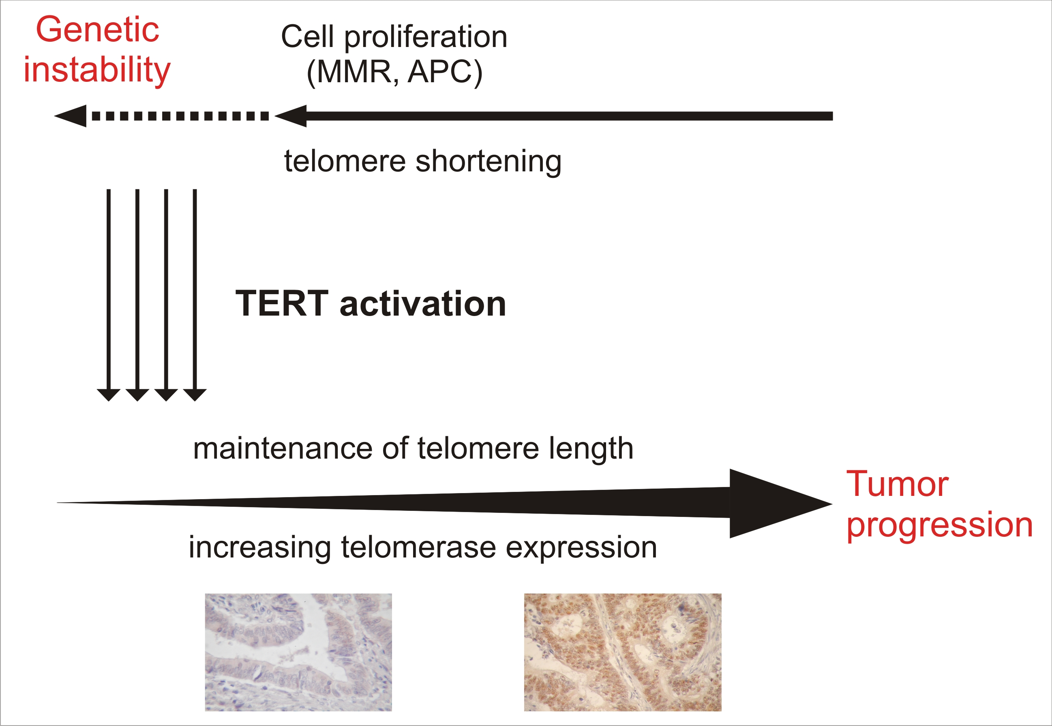
Figure 1 Model of telomere/telomerase interplay in the carcinogenesis of colorectal cancer. Telomere shortening is mainly caused by cell proliferation in preneoplastic lesions. Erosion of telomeres may be accelerated by mutations in specific genes, such as the adenomatous polyposis coli (APC) gene or DNA mismatch repair (MMR) system genes. The activation of telomerase reverse transcriptase (TERT), the catalytic unit of the telomerase, occurs during the adenoma-carcinoma sequence; TERT and telomerase activity levels increase with tumour progression. Inserts: Immunohistochemical analysis of TERT expression in stage I (left) and stage IV (right) tumours. Mayer's haematoxylin counterstaining; original magnification × 20.

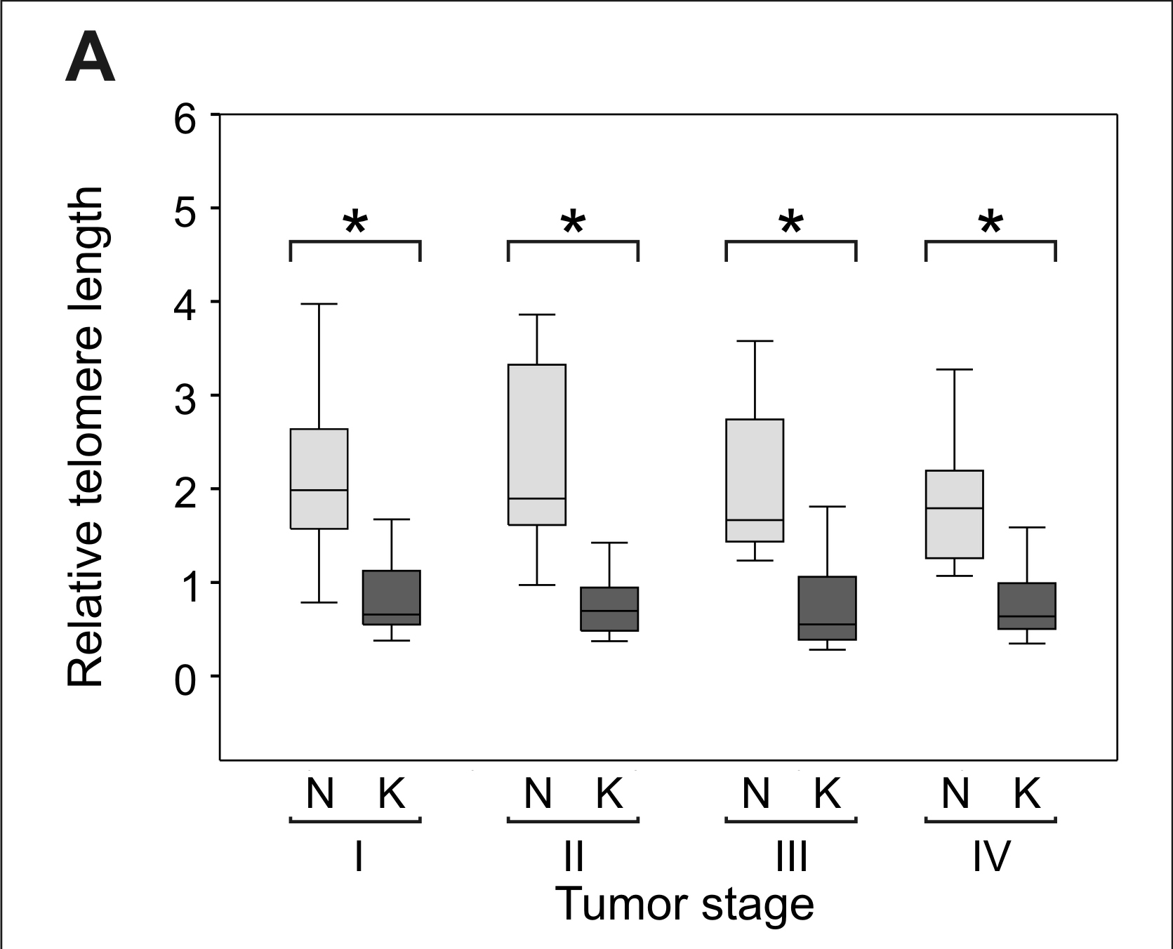
b
b
b
b

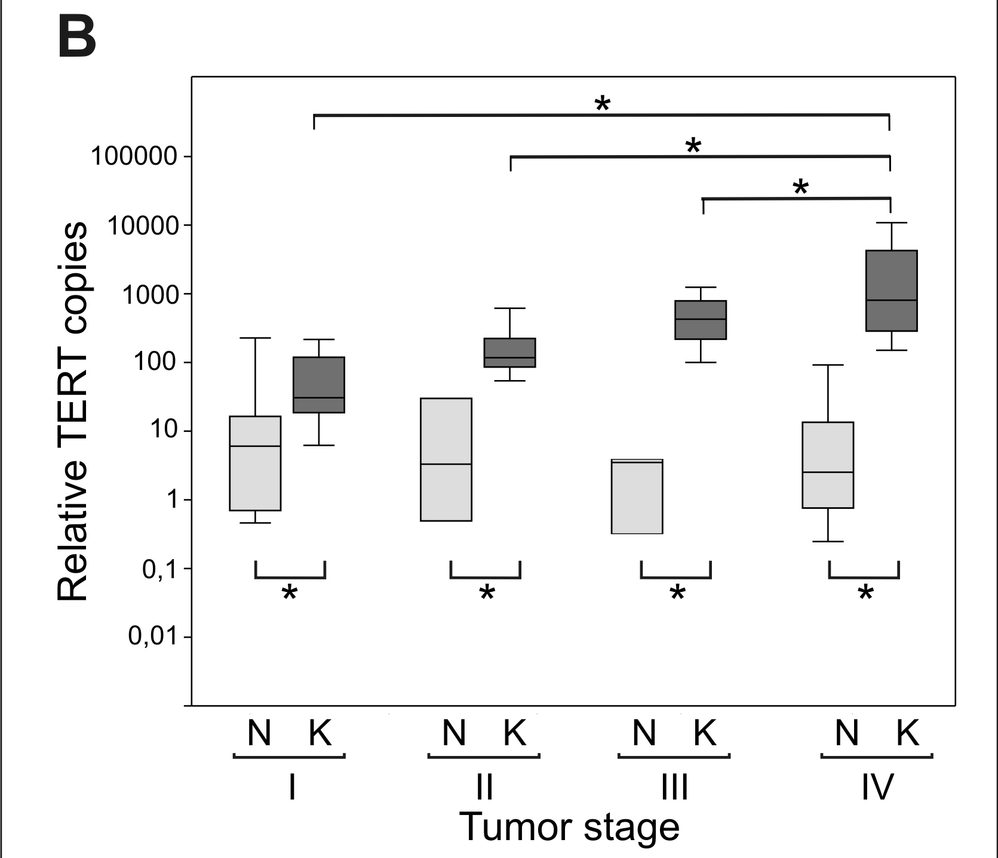
b
b
b
b
b
b
b

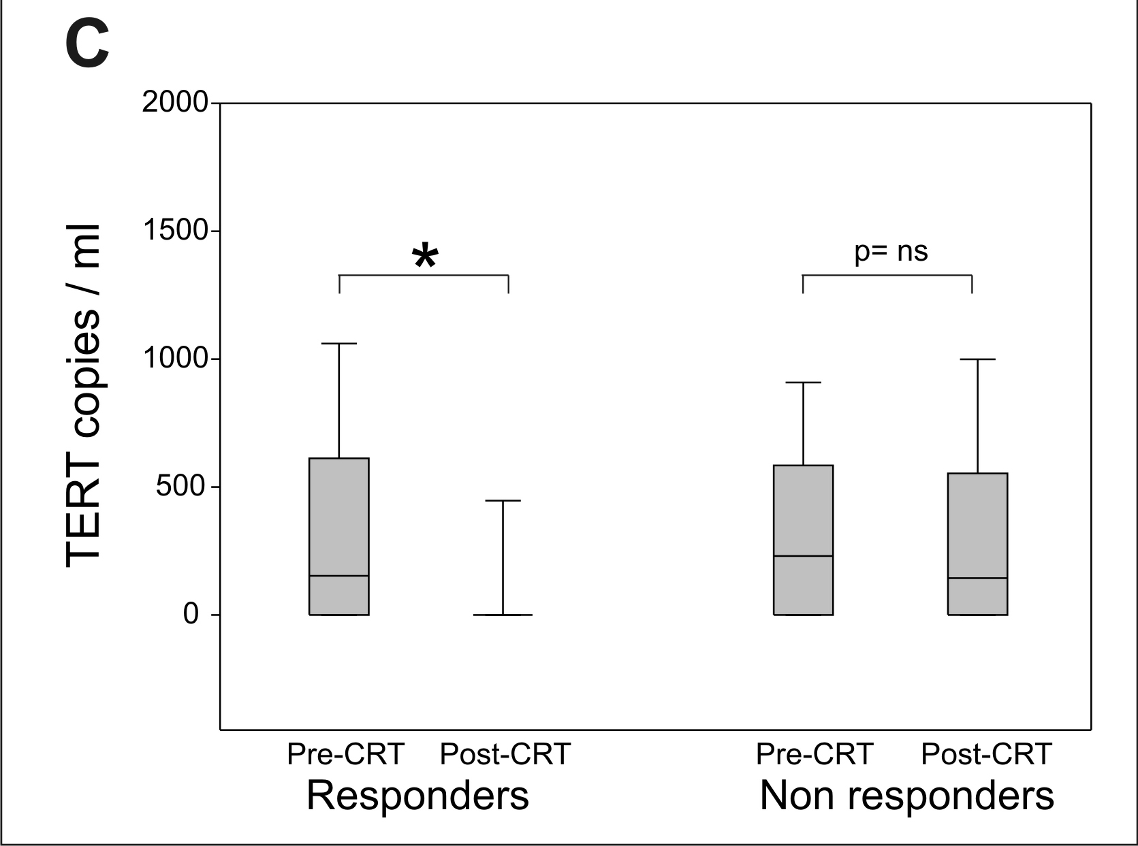
b

Figure 2 Representative panels of telomere length and telomerase reverse transcriptase levels. A: Relative telomere length in tumours (K) and adjacent mucosa (N) according to tumour stages I (30 samples), II (45 samples), III (29 samples), and IV (29 samples). The cases included those reported in Rampazzo et al^{[41]}. Telomere length was significant shorter in tumours than in adjacent mucosa (^{b}P < 0.01 vs tumours in adjacent mucosa) at all tumour stages, but telomere lengths did not significantly differ with tumour stage. Relative telomere length was estimated using real-time polymerase chain reaction (PCR)^{[41]}; B: Telomerase reverse transcriptase (TERT) levels in tumours (K) and adjacent mucosa (N) according to tumour stages I (K: 25 samples, N: 17 samples), II (K: 35 samples; N: 10 samples), III (K: 15 samples; N: 5 samples), and IV (K: 30 samples; N: 22 samples). The cases included those reported in Terrin et al^{[55]}. TERT levels were significantly higher in tumours than in adjacent mucosa and significantly increased (^{b}P < 0.01 vs tumours in adjacent mucosa) with tumour stage. TERT levels were estimated using real-time PCR ^{[41,55]}; C: Plasma TERT levels before and after the chemoradiotherapy prior to surgery in responders (35 samples) and non-responders (42 samples) with rectal cancer. The cases included those reported in Pucciarelli et al^{[85]}. TERT levels in plasma were estimated using real-time PCR^{[85]}. Boxes and whiskers: 25th to 75th and 10th to 90th percentiles, respectively; the median is the central line in each box.

Table 1 Telomeres and telomerase: outstanding questions regarding their role in the genesis and progression of colorectal cancer
Is the shortening of telomeres an early or late event in colorectal carcinogenesis?
Does telomere shortening play a role in genomic instability?
Do telomere lengths correlate with telomerase expression/activity?
Do telomere lengths correlate with disease progression?
Do levels of telomerase expression/activity increase with disease progression?
Do telomere and/or telomerase act as prognostic markers for disease outcome?

Table 2 Telomere lengths and colorectal cancer
Reference | Cases | Main findings
Hastie et al^{[31]}, 1990 | 23 (20 CRCs, 3 adenomas)  and patient-matched non-cancerous mucosa  (frozen samples) | TL  Decrease with age in noncancerous cells (33bp per year)  Shorter in CRCS and adenomas than in normal mucosa
Engelhardt et al ^{[32]} , 1997 | 80 (50 CRCs, 20 polyps, 10 colitis) and CRC patientmatched noncancerous mucosa  (frozen samples) | TL  Shorter in CRCS than in normal mucosa  Shorter in CRCS than in polyps and colitis  Longer in latestage cancer with higher telomerase activity  Do not differ between colon and rectum cancer
Takagi et al^{[33]}, 1999 | 61 CRC (including 12 nonulcerating and 39 ulcerating tumours, according to Borrmann's classification) and patientmatched noncancerous mucosa  (frozen samples) | TL  Shorter in nonulcerating CRCS than in normal mucosa  Shorter in nonulcerating than in ulcerating tumours  Not correlated with tumour stage or grade  Not correlated with telomerase activity
Katayama et al^{[34]}, 1999 | 35 (26 CRCs, 9 polyps)  (frozen samples) | TL  Do not differ between CRCS and polyps
Nakamura et al^{[35]}, 2000 | 124 CRC and patientmatched noncancerous mucosa  (frozen samples) | TL  Shorter in CRCS than in normal mucosa  Decrease with age in both cancer and noncancerous cells (44 and 50 bp/year)
Plentz et al^{[36]}, 2003 | 10 (adenomacarcinoma transition)  (paraffinembedded samples) | TL  Shorter in highgrade dysplastic areas than in the surrounding adenoma
Gertler et al^{[37]}, 2004 | 57 CRC and patientmatched noncancerous mucosa  (frozen samples) | TL  Shorter in CRCS than in adjacent mucosa  Decrease with age only in noncancer cells (19 bp per year)  Correlate with tumour stage, being longer in advanced tumours  Correlate with tert mrna levels  Lead to a poor prognosis if TL cancer/ TL noncancer > 0.9  Do not differ between colon and rectum cancer
GarciaAranda et al^{[38]}, 2006 | 91 CRC (23 rightcolon, 13 leftcolon, 55 rectum) and patientmatched noncancerous mucosa  (frozen samples) | TL  Shorter in crc than in adjacent mucosa  Shorter in rightcolon cancers than in tumours located in other sites  Shorter in poorly differentiated tumours  Tend to be longer in telomerasepositive CRCS  Have prognostic value (longer telomeres: poor clinical outcome)  Correlated with the expression of TRF1 protein
O’Sullivan et al^{[39]}, 2006 | 38 (26 adenomas, 12 CRCs)  (paraffinembedded samples) | TL  Shorter in adenomas than in adjacent and distant mucosa  Similar in CRCS and adjacent and distant mucosa
Raynaud et al^{[40]}, 2008 | 15, each case with normal mucosa, lowgrade dysplasia, highgrade dysplasia and carcinoma  (paraffinembedded samples) | TL  Shorter in lowgrade and highgrade dysplasia than in carcinoma  Inversely correlated with activation of the DDR pathway
Rampazzo et al^{[41]}, 2010 | 118 CRC (53 rightcolon, 30 leftcolon, 35 rectum) and patientmatched noncancerous mucosa  (frozen samples) | TL  Shorter in CRCS than in adjacent mucosa  Shorter in rightcolon cancers than in tumours located in other sites  Shorter in MSI than in mss tumours  Decrease with age only in noncancer cells  Not correlated with tumour stage or grade  Not correlated with tert mRNA levels
Valls et al^{[42]}, 2011 | 147 CRC and patientmatched noncancerous mucosa  (frozen samples) | TL  Shorter in CRCS than in adjacent mucosa  In cancer correlate with TL in normal mucosa  Do not differ between colon and rectum cancer  Not correlated with tumor stage  Have prognostic value (TL cancer/ TL noncancer ≤ 1: higher OS)
Roger et al^{[43]}, 2013 | 135 (85 polyps from 10 patients with FAP, 50 CRCs)  (frozen samples) | TL  Shorter in polyps than in normal mucosa  Correlated with genomic rearrangement in polyps  Independent of adenoma size  In polyps may reflect the TL of the originating cells
TL: Telomere lengths; CRC: Colorectal cancer; DDR: DNA damage response; OS: Overall survival; FAP: Familial adenomatous polyposis.

Table 3 Telomerase as a marker of disease in colorectal cancer
Reference | Cases | Main findings
Engelhardt et al^{[32]}, 1997 | 80 (50 CRCs, 20 polyps, 10 colitis) cancerous and 50 CRC patientmatched noncancerous mucosa specimens | Telomerase activity  Absent in normal tissues  Higher in CRCS than in nonneoplastic lesions  Higher in latestage than in earlystage tumours
Tatsumoto et al^{[58]}, 2000 | 100 CRC and patientmatched noncancerous mucosa specimens | Telomerase activity  Higher in CRC than in adjacent noncancerous mucosa  detectable in adjacent noncancerous mucosa derived from intestinal crypt basal cells  Not correlated with CRC stage or grade has prognostic value for OS and DFS (high telomerase activity: poor prognosis)
Niiyama et al^{[59]}, 2001 | 140 CRC and patientmatched noncancerous mucosa specimens;  20 adenomas | TERT mRNA and telomerase activity  Higher in CRCs than in adenomas  Higher in adenomas than in normal mucosa
Naito et al^{[60]}, 2001 | 66 (50 adenomas, 6 mucosal carcinomas, 10 invasive carcinomas) specimens | Positive correlation between TERT mRNA and telomerase activity  TERT levels increase with adenomacarcinoma sequence
Gertler et al^{[61]}, 2002 | 57 CRC and patientmatched noncancerous mucosa specimens | Both CRC and adjacent noncancerous mucosa are positive for TERT  TERT levels lower in tumours than in noncancerous mucosa in most cases  TERT levels not correlated with tumour stage  TERT has prognostic value for OD and DFS (high telomerase activity: poor prognosis)
Kawanishi-Tabata et al^{[62]}, 2002 | 122 CRCs, stage II  (52 colon, 70 rectum) | 80% of CRC are telomerasepositive  Higher percentage of telomerasepositive tumours in the colon than in the rectum  High telomerase activity: Good prognosis
Ghori et al^{[63]}, 2002 | 30 CRCs and 20 patientmatched noncancerous mucosa specimens | Telomerase activity  Higher in CRCs than in adjacent noncancerous mucosa  Correlated with Duke's stage
Boldrini et al^{[64]}, 2002 | 36 CRC and patientmatched noncancerous mucosa specimens,  8 adenomatous polyps,  9 dysplastic polyps | Telomerase activity  Absent in normal mucosa and adenomas  Higher in CRCs than in dysplastic polyps  Higher in latestage than in earlystage tumours
Malasaka et al^{[65]}, 2004 | 41 CRC and patientmatched noncancerous mucosa specimens | Telomerase activity  Present in 83% of CRCs  Absent or at very low level in normal mucosa  Higher in metastatic tumours
Boldrini et al^{[66]}, 2004 | 43 CRCs | TERT levels and telomerase activity higher in tumours with mutated TP53
Sanz-Casla et al^{[67]}, 2005 | 103 CRCs | Telomerase activity increases with tumour progression (Duke's stage)  Higher percentage of telomerasepositive tumours in the colon than in the rectum  Telomerase activity has prognostic value for DFS (high telomerase activity: poor prognosis)
Garcia-Aranda et al^{[38]}, 2006 | 91 CRC and patientmatched noncancerous mucosa specimens | Telomerase activity  Present in 81% of CRCs  Present at very low levels in 15% of normal samples  Not correlated with tumour progression  No prognostic value
Vidaurreta et al^{[68]}, 2007 | 97 CRCs | Telomerase activity  present both in MSI and MSS tumours  has prognostic value for OS ( high telomere activity: poor prognosis )
Bautista et al^{[69]}, 2007 | 108 rectal cancer and patientmatched noncancerous mucosa specimens | Telomerase activity  Higher in rectal cancer than in normal mucosa  Not correlated with tumour stage and grade  Has prognostic value for DFS and OS
Terrin et al^{[55]}, 2008 | 85 CRC and 42 patientmatched noncancerous mucosa specimens,  49 plasma samples | TERT levels  Higher in CRCs than in adjacent noncancerous mucosa  Increase with tumour stage and grade  Not correlated with MSI status  Not correlated with tumour location  Plasma TERT levels correlated with tumour TERT levels
Valls Bautista et al^{[70]}, 2009 | 6 cases, each with cancer, polyps and normal mucosa; 8 polyps and normal mucosa | Telomerase activity  Increases with adenomacarcinoma sequence
Kojima et al^{[71]}, 2011 | 106 CRC and paired adjacent noncancerous mucosa specimens | Elongation of the 3’OH of telomere by telomerase may increase Malignant potential of cancer cells  Telomerase activity has prognostic values for OS (telomeraseactivated without 3'OH shortened telomeres: poor prognosis)
Safont et al^{[72]}, 2011 | 48 CRC and adjacent noncancerous mucosa specimens and 48 plasma samples | Plasma TERT levels correlated with tumour TERT levels  Higher circulating TERT levels in stage IV tumours  No correlation between telomerase expression and prognosis
Bertorelle et al^{[73]}, 2013 | 137 CRCs | TERT levels:  Increase with tumour stage and grade  Not correlated with MSI status  Not correlated with tumour location  Have prognostic value for OS and for both OS and DFS for stage II patients (high TERT levels: poor prognosis)
CRC: Colorectal cancer; DFS: Disease free survival; OS: Overall survival.

