Name of Journal: World Journal of Clinical Cases
Manuscript NO: 61452
Manuscript Type: CASE REPORT

Renal artery embolization in the treatment of urinary fistula after renal duplication: A case report and review of literature

Yang T et al. Renal artery embolization treating urinary fistula

Tao Yang, Jun Wen, Tan-Tan Xu, Wen-Jing Cui, Jian Xu

Tao Yang, Jun Wen, Tan-Tan Xu, Jian Xu, Department of Interventional Radiology, Jinling Hospital, Medical School of Nanjing University, Nanjing 210029, Jiangsu Province, China

Tao Yang, Graduate School, Xuzhou Medical University, Xuzhou 221000, Jiangsu Province, China

Wen-Jing Cui, Department of Radiology, The Affiliated Hospital of Nanjing University of Chinese Medicine, Nanjing 210029, Jiangsu Province, China

Author contributions: Xu J was guarantor of integrity of the entire study and edited the manuscript; Yang T prepared and edited the manuscript; Wen J, Xu TT, and Cui WJ performed the literature research, data analysis, and text proofreading.

Corresponding author: Jian Xu, MM, Chief Doctor, Department of Interventional Radiology, Jinling Hospital, Medical School of Nanjing University, No. 305 Zhongshan East Road, Nanjing 210029, Jiangsu Province, China. 300103110564@stu.xzhmu.edu.cn

Received: December 17, 2020
Revised: February 2, 2021
Accepted: March 4, 2021
Published online: May 6, 2021

Abstract
BACKGROUND
Duplicate renal malformation is a congenital disease of the urinary system, with an incidence rate of 0.8%. Surgical treatment is suitable for symptomatic patients. Urinary fistula is one of the complications of heminephrectomy. Long-term urinary fistula has a great impact on patients' lives.

CASE SUMMARY
This article mainly reports on a 47-year-old man with duplication of kidney deformity, long urinary fistula after partial nephrectomy, and no improvement after conservative treatment. We have achieved positive results in the arterial embolization treatment of the residual renal artery, indicating that selective arterial embolization is a good way to treat urinary fistula after partial nephrectomy. It is worth noting that this patient violated the Weigert-Meyer law, which also gave us more consideration.

CONCLUSION
Renal artery embolization may be a simple and safe method to treat urinary fistula inefficacy with conservative treatment.

Key Words: Renal artery embolization; Urinary leakage; Urinary fistula; Duplicate renal malformation; Selective arterial embolization; Case report

©The Author(s) 2021. Published by Baishideng Publishing Group Inc. All rights reserved.

Yang T, Wen J, Xu TT, Cui WJ, Xu J. Renal artery embolization in the treatment of urinary fistula after renal duplication: A case report and review of literature. World J Clin Cases 2021; 9(13): 3177-3184 URL: https://www.wjgnet.com/2307-8960/full/v9/i13/3177.htm DOI: https://dx.doi.org/10.12998/wjcc.v9.i13.3177

Core Tip: Urine leakage is one of the complications of heminephrectomy, and it leads to a serious decline in the patient’s quality of life. For patients who fail conservative treatment, they may also face the risk of reoperation. We successfully treated a patient with urine leakage after heminephrectomy through selective renal artery embolization. After 3 years of follow-up observation, the patient's renal function was normal and no urinary fistula recurred.

INTRODUCTION
Duplicate renal malformation is a rare congenital disease of the urinary system, with an incidence rate of 0.8%. There is no significant difference in the incidence of bilateral kidneys. The incidence of women is twice that of men. There is genetic susceptibility, with about 1/8 of patients’ parents or siblings having similar conditions. Asymptomatic patients did not need treatment. Surgical treatment is suitable for patients with hydronephrosis, repeated urinary tract infections, and (or) urinary incontinence^{[1]}.

CASE PRESENTATION
Chief complaints
A 47-year-old patient suffered a urinary fistula for up to 14 mo after nephrectomy.

History of present illness
Within 1 wk after heminephrectomy, the patient’s daily drainage tube drained about 30-50 mL of light red liquid. From the 10th day after surgery, the patient’s wound began to seep light yellow transparent fluid, up to 350 mL in large quantities. A computed tomography (CT) scan showed a large amount of fluid around the right kidney 2 mo after the surgery. After repeated local puncture and drainage, the wound still did not heal. The symptoms had lasted for 14 mo.

History of past illness
The 47-year-old patient suffered from symptoms of recurrent right sided flank pain and discomfort. At the local hospital for the first time, CT examination results confirmed duplicate kidney on the right side, severe hydrops, and ureteral stones in the right kidney. Next, lithotripsy was performed. After 4 mo, she went to a senior hospital again because of persistent symptoms. CT was performed again and showed that the upper 1/3 renal pelvis and ureter were normal and the lower 2/3 renal pelvis was severely hydrolyzed without ureter display (Figure 1). After doctor-patient consultation, the right ureteroscopy was performed, and a double J tube was released into the right side of the normal renal pelvis and ureter. One month later, she underwent "laparoscopic right side repeated nephrectomy" under general anesthesia (Figure 2). Visible in the surgery were hydrops in the right lower kidney and normal upper right kidney. The blood supply of the upper and lower parts of the right kidney was each supplied by the renal artery and vein, and the upper and lower parts had independent ureters. The ureter belonging to the lower right kidney was significantly dilated. An ultrasonic knife was used to free completely the junction of the hydronephrosis kidney and the normal kidney to remove the diseased kidney. The ureter was cut about 15 cm away from the renal pelvis. A perinephric drainage tube was placed that led out through the puncture hole above the iliac crest. Postoperative anti-infection and hemostasis treatment was performed. Postoperative pathology proved a duplicate kidney.

Physical examination
The patient’s temperature was 36.2 °C, heart rate was 76 bpm, respiratory rate was 18 breaths/min, and blood pressure was 127/74 mmHg.

Laboratory examinations
Re-admitted to hospital on December 16, 2016, the drainage fluid biochemical examination showed creatinine 225 μmol/L, urea 9.0 mmol/L, and serum creatinine 68 μmol/L.

Imaging examinations
Renal CT angiography showed that a branch artery of the lower pole of the right kidney ran along the lower part of the right kidney (Figure 3).

Further diagnostic work-up
Fistulography showed that the fistula was located in the lower part of the right kidney, which was a limited residual cavity without entering the abdominal cavity.

FINAL DIAGNOSIS
The final diagnosis of the presented case was urinary fistula.

TREATMENT
The right renal digital subtraction angiography (DSA) and renal artery embolization were performed based on the patient’s informed consent. DSA showed that the right inferior renal artery branched to the residual kidney tissue of the right kidney (Figure 3). Polyvinyl alcohol (PVA) particles (100-300 μm) embolized the blood supply artery of the residual kidney by super-selective intubation. After embolization, DSA showed only the main trunk of the residual renal artery. One day after the operation, the drainage tube fluid was significantly reduced.

OUTCOME AND FOLLOW-UP
One month after the operation, the drainage tube was removed. The wound was completely healed 3 mo after the operation. On January 8, 2018, the abdominal CT angiography (CTA) showed that only the main trunk of the right renal residual artery remained (Figure 4). After 3 years of follow-up, the patient did not leak urine again and her renal function was normal. After 3 years of follow-up observation, the patient's renal function was normal, and no urinary fistula recurred.

DISCUSSION
This patient’s kidney has two sets of ureters. The lower kidney was accompanied by obvious ureteral dilation and hydronephrosis. CT urography suggested that the upper kidney had normal secretory function and urinary system. The lower kidney has no urinary function. This case does not conform to the Meyer-Weigert rule; the Meyer-Weigert rule predicts the double ureteral drainage pattern of bipolar renal repetition. The upper pole is generally considered to be ectopic, so it is hypoplastic resulting in obstruction^{[2]}. Although the Meyer-Weigert rule applies to most duplication kidney cases, some case reports in recent years have pointed out exceptions to this rule^{[3-7]}; this is true for our case.
According to the Meyer-Weigert rule, the clinical symptoms of duplication of kidney deformity are often related to the superior kidney. The suitable surgical treatment is heminephrectomy^{[8]}. Since the right upper kidney of this patient had normal function, heminephrectomy was performed for the right lower kidney. Partial nephrectomy is widely used in the resection of early renal cancer due to its lower overall mortality and cardiovascular morbidity compared to radical resection^{[9-11]}. However, the complication rate of urinary fistula after heminephrectomy is between 0.8% and 5.2%^{[12-14]}. After heminephrectomy, if the remaining nephrons can still secrete urine, the urine will extravasate through the damaged collecting system. The extravasated urine will gather in the perinephric space and be wrapped by fibrous tissue to form a urinoma^{[15,16]}. The patient’s drainage tube extravasated liquid contained urine, which was proved by biochemical verification after the operation. It met the diagnostic criteria for urinary fistula. Most heminephrectomy-related urinary fistula can be resolved by conservative treatment (e.g., percutaneous nephrostomy or percutaneous drainage)^{[17]}. However, when conservative treatment is not effective, we should consider changing the treatment plan.
Conservative treatment achieved a therapeutic effect by continuous drainage to reduce the pressure on the renal pelvis to close the damaged collection system. However, a small number of patients require re-surgical removal of the residual kidney^{[18]}. Meeks et al^{[17]} reported 21 cases of urinary fistula after heminephrectomy, with an average continuous urinary fistula time of up to 53 d. Li et al^{[19]} reported a case of ureteral stent implantation in the treatment of urinoma; the urinoma gradually disappeared after 5 mo. Re-surgical treatment may cause more serious complications because of difficulty in separating the residual kidney and blood vessel due to tissue adhesion. As far as we know, as early as the 1980s, scholars reported that four patients with urinary fistula after heminephrectomy were cured by the residual renal artery embolization^{[20,21]}. In 1993, Japan’s Ogawa et al^{[22]} reported that renal artery embolization was used to treat a severely impaired renal function patient with kidney urinary fistula and achieved good therapeutic effect. Wang et al^{[23]} used arterial embolization to treat urinary fistula after repeated renal surgery and got satisfactory effect. Since then, Yamamoto et al^{[25]} and Nohara et al^{[24]} reported three cases of super-selective renal artery embolization in the treatment of renal carcinoma heminephrectomy with urinary fistula. The curative effect was satisfactory, and no obvious complications occurred^{[24,25]}.
In our patient, we observed the remnant renal arteries through preoperative CTA, which clarified the relationship between renal artery lesions and surrounding tissues and organs and provided a reliable basis for the choice of surgical methods. Previous studies on CTA, as a minimally invasive vascular imaging technique, have demonstrated that CTA can clearly show the renal artery and its branches, and the diagnostic accuracy of the anatomical variation of the renal artery is 100%^{[26,27]}. DSA not only confirmed the residual renal artery but also realized the precise embolization of the residual renal artery, achieving the purpose of treatment while protecting the renal function. Permanent embolic agents have been used in previous cases, including coils, N-butyl-cyanoacrylate (NBCA) glue, and PVA particle embolic agents. We used 3F microcatheter to enter super-selectively the residual renal artery and embolized with 100-300 μm PVA granules. After embolization, only the stump of the artery remained. PVA particles are made from a polyvinyl alcohol foam sheet. They are a permanent embolic agent that can activate inflammatory reaction and focal angionecrosis, with vessel fibrosis developing over time^{[28]}. Complications of renal artery embolism mainly include fever, nausea, abdominal and (or) waist pain, ectopic embolism, infection, etc. The incidence rate is less than 10% in the literature^{[29]}. In previous reports, there have been many successful cases of using fibrin glue, coils, or NBCA glue for percutaneous obliteration of urinary fistula^{[30-37]}. However, the operation can be cumbersome sometimes, and multiple uses of materials could also lead to excessive hospitalization costs. For instance, Nouri et al^{[30]} used percutaneous puncture coils combined with NBCA glue to seal the urinary fistula tract and urinoma in 10 patients, and the highest case used 18 coils to seal the urinary fistula. In our case, residual renal artery embolization was used to treat urinary fistula, and a significant effect was achieved.

CONCLUSION
Although it is currently difficult to report large samples of arterial embolization for the treatment of urinary fistula, with the increase in the number of case reports and the development of interventional techniques, super-selective renal artery embolization is a minimally invasive, safe, effective and maximize retention renal function method to treat urinary fistula after heminephrectomy.

REFERENCES
1 Jednak R, Kryger JV, Barthold JS, González R. A simplified technique of upper pole heminephrectomy for duplex kidney. J Urol 2000; 164: 1326-1328 [PMID: 10992406]
2 Mackie GG, Stephens FD. Duplex kidneys: a correlation of renal dysplasia with position of the ureteral orifice. J Urol 1975; 114: 274-280 [PMID: 1171997 DOI: 10.1016/s0022-5347(17)67007-1]
3 Darr C, Krafft U, Panic A, Tschirdewahn S, Hadaschik BA, Rehme C. Renal duplication with ureter duplex not following Meyer-Weigert-Rule with development of a megaureter of the lower ureteral segment due to distal stenosis - A case report. Urol Case Rep 2020; 28: 101038 [PMID: 31763165 DOI: 10.1016/j.eucr.2019.101038]
4 Zamani R, Martinez R, Reddy MP. Duplicated collecting system: not following Weigert-Meyer rule as a result of renal stone obstructing the lower ureteropelvic junction. Clin Nucl Med 2004; 29: 386-387 [PMID: 15166891 DOI: 10.1097/01.rlu.0000127098.63372.30]
5 Jain P, Parelkar S, Shah H, Sanghavi B, Mishra P. Uncrossed complete ureteral duplication with dysplastic lower moiety: a violation of the Weigert-Meyer law. J Pediatr Urol 2008; 4: 404-406 [PMID: 18790429 DOI: 10.1016/j.jpurol.2008.01.210]
6 Slaughenhoupt BL, Mitcheson HD, Lee DL. Ureteral duplication with lower pole ectopia to the vas: a case report of an exception to the Weigert-Meyer law. Urology 1997; 49: 269-271 [PMID: 9037295 DOI: 10.1016/s0090-4295(96)00431-1]
7 Brown DM, Peterson NR, Schultz RE. Ureteral duplication with lower pole ectopia to the epididymis. J Urol 1988; 140: 139-142 [PMID: 3379678 DOI: 10.1016/s0022-5347(17)41509-6]
8 Chen DX, Wang ZH, Wang SJ, Zhu YY, Li N, Wang XQ. Retroperitoneoscopic approach for partial nephrectomy in children with duplex kidney: A case report. World J Clin Cases 2019; 7: 1169-1176 [PMID: 31183349 DOI: 10.12998/wjcc.v7.i10.1169]
9 Huang WC, Elkin EB, Levey AS, Jang TL, Russo P. Partial nephrectomy vs radical nephrectomy in patients with small renal tumors--is there a difference in mortality and cardiovascular outcomes? J Urol 2009; 181: 55-61; discussion 61-2 [PMID: 19012918 DOI: 10.1016/j.juro.2008.09.017]
10 Fergany AF, Saad IR, Woo L, Novick AC. Open partial nephrectomy for tumor in a solitary kidney: experience with 400 cases. J Urol 2006; 175: 1630-3; discussion 1633 [PMID: 16600716 DOI: 10.1016/S0022-5347(05)00991-2]
11 Van Poppel H, Da Pozzo L, Albrecht W, Matveev V, Bono A, Borkowski A, Marechal JM, Klotz L, Skinner E, Keane T, Claessens I, Sylvester R; European Organization for Research and Treatment of Cancer (EORTC); National Cancer Institute of Canada Clinical Trials Group (NCIC CTG); Southwest Oncology Group (SWOG); Eastern Cooperative Oncology Group (ECOG). A prospective randomized EORTC intergroup phase 3 study comparing the complications of elective nephron-sparing surgery and radical nephrectomy for low-stage renal cell carcinoma. Eur Urol 2007; 51: 1606-1615 [PMID: 17140723 DOI: 10.1016/j.eururo.2006.11.013]
12 Lesage K, Joniau S, Fransis K, Van Poppel H. Comparison between open partial and radical nephrectomy for renal tumours: perioperative outcome and health-related quality of life. Eur Urol 2007; 51: 614-620 [PMID: 17097216 DOI: 10.1016/j.eururo.2006.10.040]
13 Spana G, Haber GP, Dulabon LM, Petros F, Rogers CG, Bhayani SB, Stifelman MD, Kaouk JH. Complications after robotic partial nephrectomy at centers of excellence: multi-institutional analysis of 450 cases. J Urol 2011; 186: 417-421 [PMID: 21679980 DOI: 10.1016/j.juro.2011.03.127]
14 Potretzke AM, Knight BA, Zargar H, Kaouk JH, Barod R, Rogers CG, Mass A, Stifelman MD, Johnson MH, Allaf ME, Sherburne Figenshau R, Bhayani SB. Urinary fistula after robot-assisted partial nephrectomy: a multicentre analysis of 1 791 patients. BJU Int 2016; 117: 131-137 [PMID: 26235802 DOI: 10.1111/bju.13249]
15 Li HZ, Ma X, Zhang J, Zhang X, Wang BJ, Shi TP, Chen GF, Dong J, Ai X, Yan YJ, Wu Z, Hu DL. Retroperitoneal laparoscopic upper-pole nephroureterectomy for duplex kidney anomalies in adult patients. Urology 2011; 77: 1122-1125 [PMID: 21256545 DOI: 10.1016/j.urology.2010.07.495]
16 Titton RL, Gervais DA, Hahn PF, Harisinghani MG, Arellano RS, Mueller PR. Urine leaks and urinomas: diagnosis and imaging-guided intervention. Radiographics 2003; 23: 1133-1147 [PMID: 12975505 DOI: 10.1148/rg.235035029]
17 Meeks JJ, Zhao LC, Navai N, Perry KT Jr, Nadler RB, Smith ND. Risk factors and management of urine leaks after partial nephrectomy. J Urol 2008; 180: 2375-2378 [PMID: 18930268 DOI: 10.1016/j.juro.2008.08.018]
18 Erlich T, Abu-Ghanem Y, Ramon J, Mor Y, Rosenzweig B, Dotan Z. Postoperative Urinary Leakage Following Partial Nephrectomy for Renal Mass: Risk Factors and a Proposed Algorithm for the Diagnosis and Management. Scand J Surg 2017; 106: 139-144 [PMID: 27431979 DOI: 10.1177/1457496916659225]
19 Li SX, Dagrosa LM, Pais VM Jr. Management of Urinoma Formation After Laparoscopic Cryoablation of Renal Cyst. J Endourol Case Rep 2017; 3: 10-12 [PMID: 28164162 DOI: 10.1089/cren.2016.0137]
20 Stefani P, Selli C, Nicita G, Lapini A, Dami A. Treatment of urinary fistulas after resection of horseshoe kidneys by selective arterial embolization. Cardiovasc Intervent Radiol 1989; 12: 18-21 [PMID: 2496922 DOI: 10.1007/BF02577120]
21 Mitty HA, Dan SJ, Goldman HJ, Glickman SI. Urinary fistulas after partial nephrectomy: treatment by segmental renal embolization. AJR Am J Roentgenol 1983; 141: 101-103 [PMID: 6602504 DOI: 10.2214/ajr.141.1.101]
22 Ogawa H, Yajima I, Hori N, Ishii Y, Gomi T. [Transcatheter arterial embolization for severely dysfunctioning kidney]. Nihon Jinzo Gakkai Shi 1993; 35: 1073-1079 [PMID: 8230818]
23 Wang DS, Bird VG, Cooper CS, Austin JC, Winfield HN. Laparoscopic upper pole heminephrectomy for ectopic ureter: initial experience. Can J Urol 2004; 11: 2141-2145 [PMID: 15003155]
24 Nohara T, Matsuyama S, Kawaguchi S, Miyagi T, Seto C, Mochizuki K. Usefulness of selective renal artery embolization for urinary fistula following partial nephrectomy: Two case reports. Mol Clin Oncol 2016; 5: 158-160 [PMID: 27330790 DOI: 10.3892/mco.2016.885]
25 Yamamoto T, Kinoshita H, Ikeda J, Sugi M, Matsuda T. Refractory urinary fistula with infundibular stenosis after partial nephrectomy. Int J Urol 2015; 22: 219-221 [PMID: 25257263 DOI: 10.1111/iju.12629]
26 Davarpanah AH, Pahade JK, Cornfeld D, Ghita M, Kulkarni S, Israel GM. CT angiography in potential living kidney donors: 80 kVp vs 120 kVp. AJR Am J Roentgenol 2013; 201: W753-W760 [PMID: 24147505 DOI: 10.2214/AJR.12.10439]
27 Kapoor A, Kapoor A, Mahajan G, Singh A, Sarin P. Multispiral computed tomographic angiography of renal arteries of live potential renal donors: a review of 118 cases. Transplantation 2004; 77: 1535-1539 [PMID: 15239617 DOI: 10.1097/01.tp.0000122188.73298.54]
28 Fernández-Alvarez V, Suárez C, de Bree R, Nixon IJ, Mäkitie AA, Rinaldo A, Downer J, Ferlito A. Management of extracranial arteriovenous malformations of the head and neck. Auris Nasus Larynx 2020; 47: 181-190 [PMID: 31862283 DOI: 10.1016/j.anl.2019.11.008]
29 Huang N, Yang WZ, Jiang N, Zheng QB, Huang JY, Shen Q. Application of Guglielmi detachable coils in embolization of iatrogenic renal hemorrhage. Ann Vasc Surg 2013; 27: 1081-1087 [PMID: 24011819 DOI: 10.1016/j.avsg.2013.02.016]
30 Nouri YM, Chu HH, Shin JH, Tsauo J, Kim CS, Hong BS, Kim JW, Kim JH. Percutaneous Obliteration of Urinary Leakage after Partial Nephrectomy Using N-Butyl-Cyanoacrylate Obliteration of the Urinoma with or without Coil Embolization of the Fistula Tract. J Vasc Interv Radiol 2019; 30: 2002-2008 [PMID: 31420260 DOI: 10.1016/j.jvir.2019.05.019]
31 Muto G, D'Urso L, Castelli E, Formiconi A, Bardari F. Cyanoacrylic glue: a minimally invasive nonsurgical first line approach for the treatment of some urinary fistulas. J Urol 2005; 174: 2239-2243 [PMID: 16280778 DOI: 10.1097/01.ju.0000181809.51544.20]
32 Okada T, Kono Y, Matsumoto K, Utsunomiya N, Tsunemori H, Kawakita M. [Percutaneous Fibrin Glue Injection for Persistent Urinary Leakage after Partial Nephrectomy : A Case Report]. Hinyokika Kiyo 2017; 63: 107-110 [PMID: 28331167 DOI: 10.14989/ActaUrolJap_63_3_107]
33 Aning JJ, Stott MA, Watkinson AF. Glue ablation of a late-presentation urinary fistula after partial nephrectomy. Br J Radiol 2009; 82: e246-e248 [PMID: 19934065 DOI: 10.1259/bjr/93776392]
34 French DB, Marcovich R. Fibrin sealant for retrograde ureteroscopic closure of urine leak after partial nephrectomy. Urology 2006; 67: 1085.e1-1085.e3 [PMID: 16698381 DOI: 10.1016/j.urology.2005.11.026]
35 Aslan G, Men S, Gülcü A, Kefi A, Esen A. Percutaneous embolization of persistent urinary fistula after partial nephrectomy using N-butyl-2-cyanoacrylate. Int J Urol 2005; 12: 838-841 [PMID: 16201982 DOI: 10.1111/j.1442-2042.2005.01169.x]
36 Tekin MI, Peşkircioğlu L, Boyvat F, Ozkardes H. Practical approach to terminate urinary extravasation: percutaneous fistula tract embolization with N-butyl cyanoacrylate in a case with partial nephrectomy. Tech Urol 2001; 7: 67-69 [PMID: 11272684]
37 Selli C, De Maria M, Manica M, Turri FM, Manassero F. Minimally invasive treatment of urinary fistulas using N-butyl-2-cyanoacrylate: a valid first line option. BMC Urol 2013; 13: 55 [PMID: 24152605 DOI: 10.1186/1471-2490-13-55]

Footnotes
Informed consent statement: All study participants, or their legal guardian, provided informed written consent prior to study enrollment.

Conflict-of-interest statement: The authors declare that they have no conflict of interest.

CARE Checklist (2016) statement: The authors have read the CARE Checklist (2016), and the manuscript was prepared and revised according to the CARE Checklist (2016).

Open-Access: This article is an open-access article that was selected by an in-house editor and fully peer-reviewed by external reviewers. It is distributed in accordance with the Creative Commons Attribution NonCommercial (CC BY-NC 4.0) license, which permits others to distribute, remix, adapt, build upon this work non-commercially, and license their derivative works on different terms, provided the original work is properly cited and the use is non-commercial. See: http://creativecommons.org/Licenses/by-nc/4.0/

Manuscript source: Unsolicited manuscript

Peer-review started: December 17, 2020
First decision: January 24, 2021
Article in press: March 4, 2021

Specialty type: Urology and nephrology
Country/Territory of origin: China
Peer-review report’s scientific quality classification
Grade A (Excellent): 0
Grade B (Very good): B
Grade C (Good): 0
Grade D (Fair): 0
Grade E (Poor): 0

P-Reviewer: Vermandois JAR S-Editor: Zhang H L-Editor: Filipodia P-Editor: Li JH

Figure Legends
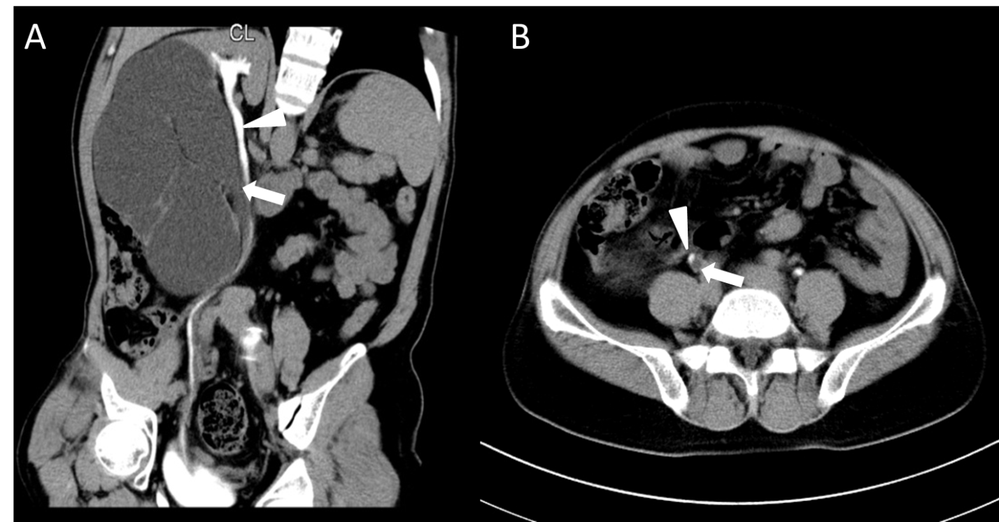
Figure 1 Duplicate renal malformation confirmed by computerized tomography urography. A and B: The patient has a duplication of renal malformation on the right side, with independent ureters in the upper (white arrows) and lower parts (white triangle), and the lower kidney is a malformed kidney with hydrops.

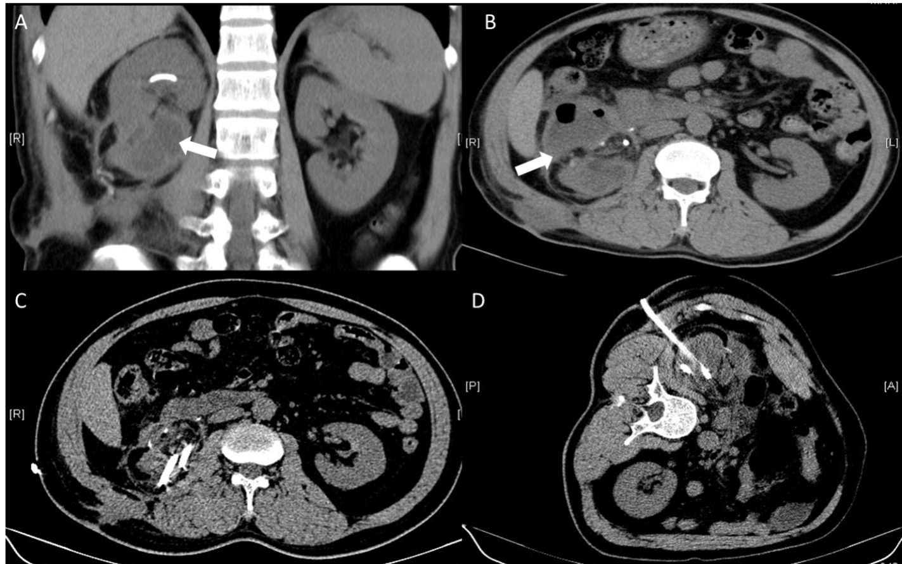
Figure 2 Perinephric effusion after heminephrectomy of computed tomography. A and B: Shown is the perinephric effusion (white arrows) in the lower pole of the right kidney after the operation; C and D: Shown is puncture drainage of right perinephric effusion.

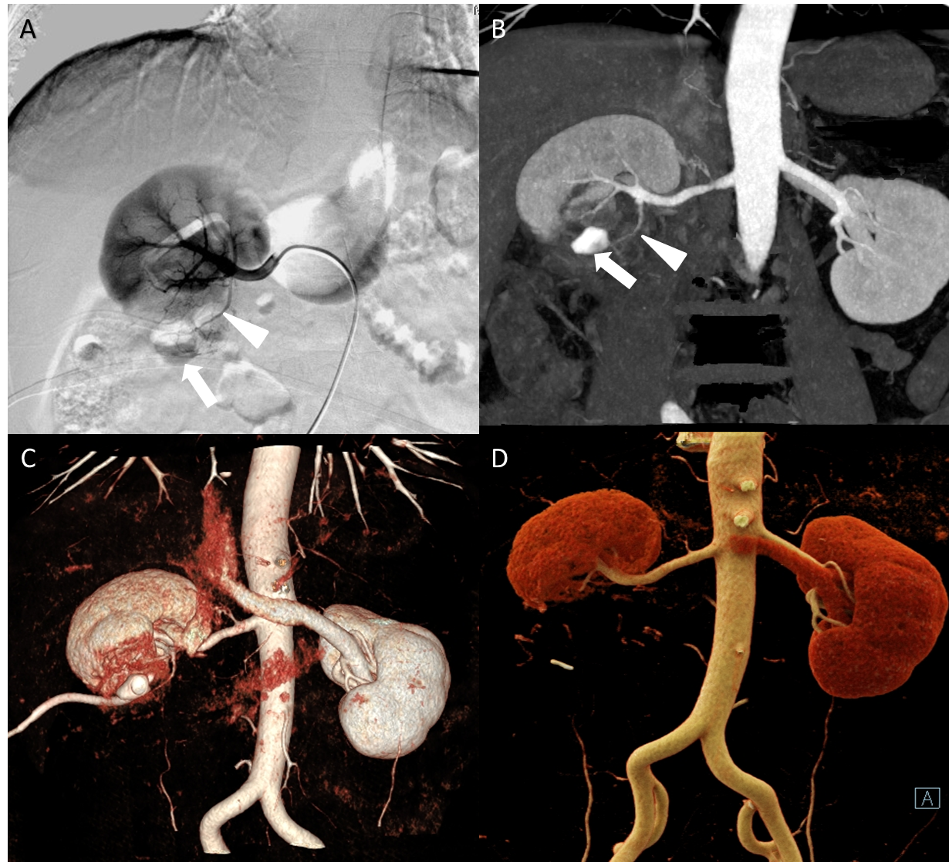
Figure 3 Residual kidney section confirmed by computed tomography angiography and digital subtraction angiography. A and B: The patient's preoperative computed tomography angiography and digital subtraction angiography comparison confirmed that a branch artery (white triangle) in the lower pole of the right kidney runs out of the contour of the kidney to supply blood to the residual kidney section (white arrows); C and D: The patient’s preoperative and postoperative computed tomography angiography comparisons confirmed that only the main trunk remained after interventional embolization of the residual renal artery branch.

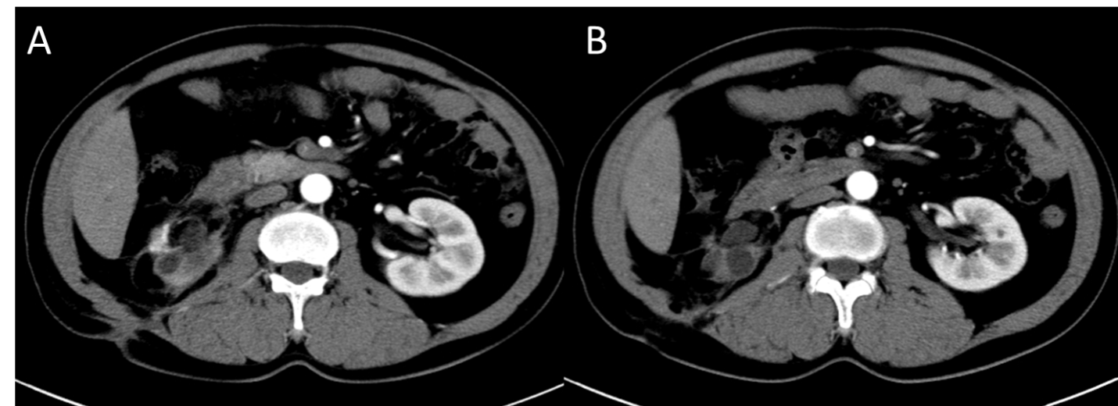
Figure 4 Abdominal computed tomography angiography 3 yr after surgery. A and B: The patient was admitted to the hospital in January 2018, and the computed tomography showed that the right perinephric effusion had disappeared.

Published by Baishideng Publishing Group Inc
7041 Koll Center Parkway, Suite 160, Pleasanton, CA 94566, USA
Telephone: +1-925-3991568
E-mail: bpgoffice@wjgnet.com
Help Desk: https://www.f6publishing.com/helpdesk
https://www.wjgnet.com

© 2021 Baishideng Publishing Group Inc. All rights reserved.

