Name of Journal: World Journal of Gastrointestinal Surgery
Manuscript NO: 84872
Manuscript Type: MINIREVIEWS

Historical changes in surgical strategy and complication management for hepatic cystic echinococcosis

A JD et al. Hepatic cystic echinococcosis

Ji-De A, Jin-Ping Chai, Sheng-Long Jia, Xiang-Ren A

Ji-De A, Department of Hepatic Hydatidosis, Qinghai Provincial People's Hospital, Xining 810007, Qinghai Province, China

Jin-Ping Chai, Department of Internal Medicine-Cardiovascular, Qinghai Provincial People's Hospital, Xining 810007, Qinghai Province, China

Sheng-Long Jia, Department of General Surgery, Huangzhong Hospital of Traditional Chinese Medicine, Xining 810007, Qinghai Province, China

Xiang-Ren A, Department of Clinical Laboratory, Qinghai Provincial People's Hospital, Xining 810007, Qinghai Province, China

Author contributions: A JD and Chai JP conceptualized the study, collected the data, designed the review, and drafted the original manuscript; Jia SL was responsible for the investigation and supervision; and A XR supervised and reviewed the final manuscript submitted for publication.

Supported by the Qinghai Province Talent Action Plan of Kunlun; National Natural Science Foundation of China, No. 82260412; Basic Research Project of Qinghai Province, No. 2020-wjzdx-27; Qinghai Province 2022 Innovation Platform Construction Special Project, No. 2022-ZJ-T01; and High-end Innovative Talent Project of Kunlun Talents of Qinghai Province in 2021.

Corresponding author: Xiang-Ren A, MBBS, Chief Physician, Doctor, Department of Clinical Laboratory, Qinghai Provincial People's Hospital, No. 2 Gonghe Road, Chengdong District, Xining 810007, Qinghai Province, China. xiangrena_001@163.com

Received: March 30, 2023
Revised: May 17, 2023
Accepted: June 21, 2023
Published online:

Abstract
Echinococcosis is a zoonotic parasitic disease caused by Escherichia larvae. It frequently involves the liver (70%-75%), followed by the lungs (15%-20%), and occasionally the brain, heart, spleen, bone, and other organs. The main pathogenic forms of human echinococcosis currently include cystic echinococcosis (CE) and alveolar echinococcosis (AE). CE is globally distributed, while the distribution of AE is generally restricted to the northern hemisphere. In China, CE accounts for 75% of all echinococcosis cases. With rapid advances in surgical techniques in recent decades, the surgical strategy for CE has changed, especially with the continuous improvement of surgical methods and the expansion of surgical contraindications. To further understand the changes in surgical treatment strategies for hepatic CE, we interpreted and analyzed the existing literature addressing the surgical treatment of hepatic CE both domestically and abroad and briefly summarized them in chronological order. This review aims to provide a deeper understanding of the progress in the surgical treatment of hepatic CE to provide clearer avenues for its clinical diagnosis and treatment.

Key Words: Echinococcosis; Hepatic cystic; Internal capsule; External capsule; Complication; Surgical excision

A JD, Chai JP, Jia SL, A XR. Historical changes in surgical strategy and complication management for hepatic cystic echinococcosis. World J Gastrointest Surg 2023; In press

Core Tip: Many articles have been published on the surgical methods and postoperative complications of hepatic cystic echinococcosis (CE), especially regarding the relationship between surgical methods and patient prognosis. However, few studies have examined the historical changes in surgical methods for hepatic CE. Therefore, this review discusses the main surgical methods and complications in the treatment of hepatic CE over time to provide readers with a deeper understanding of the surgical treatment of this disease.

INTRODUCTION
Echinococcosis, also known as hydatid disease, is a parasitic disease caused by the echinococcosis tapeworm larvae. The liver is the primary organ involved in echinococcosis, with the brain and other organs occasionally involved^{[1,2]}. To date, at least five species of larvae have been reported to cause echinococcosis, including Echinococcosis granulosus, Echinococcosis multilocularis, Echinococcosis oligarthrus, Echinococcosis vogeli, and Echinococcosis shiquicus. However, two main pathogens cause echinococcosis in humans: Echinococcosis granulosus and Echinococcosis multilocularis^{[3-5]}. Cystic echinococcosis (CE), caused by Echinococcosis granulosus, is globally distributed, while alveolar echinococcosis (AE), caused by Echinococcosis multilocularis, is restricted to the northern hemisphere^{[6]}. The distributions of CE and AE in China are slightly different from the global distribution of echinococcosis, where CE accounts for approximately 75% of all echinococcosis cases^{[7]}. With the rapid advances in surgical techniques in recent decades, the surgical treatment strategy for CE has changed, especially with the continuous improvement of surgical methods and the expansion of surgical contraindications^{[8]}. Original internal capsule excision is a widely used classical procedure because of its safety, practicality, and simplicity. However, owing to the high incidence of postoperative complications, especially residual cavity infection after long-term catheterization, which results in significant physical and psychological trauma, the procedure has been gradually abandoned^{[9]}. Subsequently, various modified methods based on this procedure have evolved, such as internal capsule removal combined with omental tamponade and internal capsule removal combined with external capsule subtotal resection. Although these procedures have addressed many complications caused by partial residual cavity retention, they have not resolved persistent problems associated with internal capsule removal^{[10]}. With the promotion of precision surgery, radical surgical procedures such as external capsule exfoliation and regular or irregular hepatectomy have gradually been accepted by most surgeons in the field^{[11]}. These procedures significantly reduce the incidence of residual cavity complications associated with internal capsule exfoliation. However, radical surgery has stringent requirements for operators and surgical conditions; therefore, it is difficult to popularize this technique. Moreover, forced radical surgery can lead to fatal complications^{[12,13]}. Specialists originally intended to design an individualized surgical plan from the perspective of patient and surgical safety. This article reviews surgical treatment strategies for hepatic CE and the historical evolution of postoperative complications (Table 1).

INITIAL SURGICAL TREATMENT for HEPATIC CE
Excision of the internal capsule
A case of successful internal capsule removal for liver CE was first described in 1871^{[14]}. Excision of the internal capsule was the only surgery performed for CE during this period and is still used as a classical surgical approach (Figure 1). Subsequently, some investigators have proposed principles for CE surgery, specifically clearance of the internal capsule, prevention of the extravasation of cyst fluid, elimination of the residual cavity of the external capsule, and prevention of infection^{[15]}. Excision of the internal capsule has the advantages of minimal surgical trauma, safety, and reliability and is a simple operation; however, each procedure has its own drawbacks. Indeed, many common complications can occur after internal capsule removal, such as in situ recurrence of the residual cavity, disseminated implantation, biliary fistula, residual cavity infection, and other refractory complications^{[16]}. Some researchers have reported that the recurrence rates of liver CE after internal capsule exocytosis and biliary fistula are as high as 40% and 20%, respectively, and the incidence of residual cavity infection is as high as 65%^{[17-20]}. The main reason for CE recurrence is rupture of the cyst during the operation or failure to completely eliminate the protoscolex when the inner CE cyst is removed, and the protoscolex left in the residual cavity continues to survive and ultimately develops into CE in the outer cavity^{[21]}. The reason for intraperitoneal implantation is that the CE cyst fluid extravasates into the abdomen and pelvis during the operation, contaminating other abdominal organs, and a large number of larvae adhere to the peritoneal surface and survive. The main cause of postoperative biliary fistula is prolonged compression of the bile duct by a CE cyst, leading to intrahepatic bile duct distortion, atrophy, and even distal ischemic necrosis. In addition, owing to the corrosive effect of bile and the dramatic increase in luminal pressure, the external capsule and biliary tract are prone to form internal fistulas. The premise of a postoperative residual cavity infection is the existence of a residual cavity. Some patients experience preoperative cystic cavity infection, or the cyst wall is thick and calcified, and the residual cavity does not heal for a prolonged period. Another major cause of residual cavity infection is the presence of an internal biliary fistula on the cyst wall. When the pressure in the cyst sharply decreases, bile enters the residual cavity from the fistula and causes infection.

MATURE STAGE OF SURGICAL TREATMENT FOR HEPATIC CE
Percutaneous puncture and catheter drainage of CE cysts
Advances and developments in modern medical science have led to a more comprehensive and in-depth understanding of CE, especially when a breakthrough was achieved in the puncture treatment of CE, in which the puncture diagnosis and treatment were no longer considered a “taboo”. In 1985, Livraghi et al^{[22]} performed an ultrasound-guided diagnostic puncture for hepatic CE. In the same year, Mueller first reported the success of fine-needle puncture in the treatment of human hepatic CE^{[23]}. In 1990, researchers reported ultrasound-guided puncture sclerotherapy for hepatic CE cysts in a large number of patients. This procedure is mainly aimed at patients with simple cyst-type CE who cannot tolerate surgery or for whom the effect of albendazole is not ideal. It has the advantages of less trauma, safety, effectiveness, low cost, and a short hospital stay^{[24]}. Investigators domestically and abroad have reported that percutaneous tube puncture under ultrasound guidance combined with albendazole for the treatment of CE achieved curative effects similar to those of surgery^{[25]}. Ultrasound-guided percutaneous puncture combined with drug therapy for CE is mainly used for cases of liver and abdominal wall adhesions caused by multiple operations and is a simple and less invasive method. Thousands of cases have been reported, both domestically and internationally. The rate of anaphylaxis and shock of puncture and extravasation of cyst fluid leading to CE implantation and dissemination is not higher than that of traditional surgical methods; as such, it is included in the World Health Organization (WHO) guidelines for the diagnosis and treatment of CE. However, some studies have reported that puncture treatment for CE is also associated with problems, including allergic reactions and cholangiosclerosis caused by head-extinguishing agents such as ethanol and formalin, residual cavity infection, biliary fistula, and recurrence in situ^{[26]}. Some investigators have reported a complication rate of approximately 17%, a CE cyst infection rate of 2.6%, and an in situ recurrence rate as high as 40%^{[27-29]}. To address this problem, researchers designed a special puncture instrument. Puncture and aspiration of the sac contents have been reported to have positive effects. However, the complication rate remained high after follow-up; therefore, this procedure was abandoned in China^{[30]}.

Modified excision of the internal capsule
At the beginning of the 20th century, Wen Hao first proposed modified enucleation of the internal capsule for the treatment of hepatic CE. The goal of this operation is to further reduce the incidence of high residual cavity complications after traditional internal capsule removal. A further improved surgical method is performed based on traditional internal capsule removal^{[31]} to completely remove the internal capsule, remove the external capsule as far as possible, convert the large residual cavity into a small residual cavity, suture and repair the biliary fistula, manage the residual cavity with omental tamponade, which can reduce CE recurrence, abdominal spread, and the occurrence of refractory biliary fistula and residual cavity fluid infection. This surgery is suitable for patients with multiple cysts in whom the external capsule cannot be completely removed. Studies have reported that the incidence rates of biliary fistula and residual cavity infections were 17.56% and 2.70%, respectively. There were no recurrences or deaths, and the cure rate was reported to be 100%^{[10]}.

Total cystectomy
In 1965, French researchers proposed the concept of radical surgery for the complete removal of the CE external capsule. Peng et al^{[32,33]} reported, for the first time in 1999, the complete excision of a hepatic CE cyst inside the outer membrane, which was based on the liver resection technique, combined with experience in the surgical treatment of hepatic CE. The main technical point and radical purpose of this procedure are to completely remove the CE cyst along the potential gap between the external capsule of the CE and the normal liver tissue (Figure 2). Compared with traditional internal capsule extraction, this operation significantly reduces postoperative bile leakage, residual cavity infection, and recurrence. It is an ideal new surgical method for radical treatment, which has been recognized by the WHO and gradually popularized^{[34,35]}. This procedure is suitable for patients with single or external cysts that can be completely resected. Complete excision of the external capsule can completely remove the lesion; however, this operation requires a high degree of knowledge and proficient surgical skills of the surgeon. Otherwise, the cyst could easily rupture during surgery, resulting in serious intraoperative complications. Some studies have reported that the incidence of biliary fistula complications after complete exfoliation of the external capsule is 2.34%, and the incidence of postoperative liver dysfunction is 3.03%. No cases of postoperative recurrence, residual cavity infection, implantation spread, or death occurred, and the cure rate was 100%^{[36]}. However, owing to the expansive growth of CE cysts, some important vessels in the liver are compressed, deformed, and/or displaced, and an internal fistula may form. Although there is a potential gap between the external capsule and normal liver tissue, these vessels and bile ducts are likely to be destroyed during the removal of the external capsule. Furthermore, intraoperative hemorrhage is significantly increased compared with the removal of the internal capsule and subtotal removal of the external capsule^{[37,38]}.

Partial hepatectomy
In 2007, researchers reported that partial hepatectomy was used in France to treat hepatic CE as early as 1965^{[37]}. With advances in liver surgery, hepatectomy has become one of the main radical treatments for hepatic CE^{[39]}. Birnbaum et al^{[40]} proposed that active hepatectomy has advantages over conservative internal capsule removal in the treatment of CE. However, not all CE cases should be treated by liver resection because regular liver resection removes part of the normal liver tissue at the same time as the resection of the lesion, especially when the residual liver volume is small; therefore, hepatectomy should be more conservative (Figure 3). This procedure is mainly suitable for patients with multiple and/or large lesions, thick and calcified CE cyst walls, or complications due to intracystic infection^{[32,41]}.

Internal capsule removal combined with external capsule subtotal resection
In 2010, researchers described the treatment of hepatic CE using internal capsule removal combined with subtotal resection^{[42]}. This procedure combines the advantages of traditional endocystectomy and complete removal of the external capsule, particularly in patients with complex CE or in whom total cystectomy is difficult. Moreover, patients with CE cysts near the main hilar vessels and biliary tract achieved satisfactory results. The primary technical aspects include conventional internal capsule extraction followed by external capsule stripping along the potential gap of the CE external capsule, which maximally preserves the normal liver parenchyma and protects the surrounding hepatic duct system. Simultaneously, separation in this space also reduces bleeding without blocking blood flow into the liver, leaving a residue in the outer capsule wall near important blood vessels and the hilus. It aims to remove the outer capsule wall to the greatest extent possible, reduce the residual cavity volume, or eliminate the residual cavity, thereby significantly reducing postoperative residual cavity infections and biliary fistula complications. However, Zhang et al^{[43]} found that, although subtotal external capsule resection removes part of the external capsule, it does not avoid the risk of a residual internal capsule. For example, during surgery, the internal capsule is routinely removed, and there is the possibility of dissemination and implantation of the cephalic segment during the removal of the internal capsule. In addition, compared with internal capsule resection, subtotal external capsule resection also requires the removal of part of the external capsule, which prolongs the operation and increases the surgical risk and incidence of postoperative complications.

CURRENT STATUS OF SURGICAL TREATMENT FOR HEPATIC CE
Laparoscopic CE cyst excision
With advances and developments in minimally invasive techniques, particularly laparoscopic surgery, to a higher level, the indications for surgery continue to expand and extend to the treatment of various diseases. The first case of laparoscopic liver CE internal capsule excision was reported^{[44]}. In the ensuing ten years, several liver surgery centers in China have successively performed total laparoscopic complete cystectomies and laparoscopic hepatectomies to treat hepatic CE. Furthermore, laparoscopic hepatectomy is safe, reliable, minimally invasive, and has a rapid postoperative recovery^{[45,46]}. However, the technical requirements for laparoscopic hepatectomy are high, the technological maturity curve is long, and cases must be carefully selected. The procedure needs to be performed in experienced endoscopic centers; therefore, it is difficult to promote wide-range adoption and a low recurrence rate in the short term. Moreover, surgical indications should be strictly controlled, such as those without a history of abdominal surgery, and cases with CE cysts located in the superficial part of the liver, and clear exposure of the surgical field^{[47]}. Additionally, the three principles of CE surgery should be strictly observed during the procedure: No cystic fluid overflow, a fully inactivated original segment, and field isolation and protection. Attention should be paid to inactivating the extravasated cystic fluid to prevent infection and implant recurrence; therefore, the choice of indication must be emphasized.

Local ablation therapy for CE
With the popularization of minimally invasive concepts in recent years, local lesion ablation, a newly emerging minimally invasive technique, has been recognized by the medical community for the treatment of diseases, especially small lesions^{[48]}. After more than 20 years of development, many domestic and foreign echinococcosis diagnosis and treatment centers have attempted to apply this technology to the treatment of CE or AE because of its simplicity, minimal trauma, low incidence of postoperative complications, and rapid recovery^{[49-52]}. The echinococcosis diagnosis and treatment center of Qinghai Provincial People’s Hospital successfully performed radiofrequency ablation for liver CE disease in more than 40 cases. In addition, we found that patients with a smaller hepatic echinococcosis diameter had a shorter operative duration, less postoperative liver damage, and faster recovery of liver function. The operative duration for a single lesion is shorter than that for multiple lesions, the postoperative liver damage is less severe, and the short term clinical effect is good. Radiofrequency ablation has the advantages of being a simple operation that results in less trauma, rapid patient recovery, and fewer complications, and it can, to a certain extent, reduce the economic burden on patients. In addition, in patients with advanced age, poor pulmonary function, or cirrhosis who do not meet the indications for surgery or cannot undergo surgery, it can replace part of the traditional open surgery. However, there are also many uncertain factors in radiofrequency ablation, such as the severity of damage to the surrounding tissues and organs, which cannot be verified. Therefore, to reduce the damage to organs, tissues, and cells caused by radiofrequency ablation puncture, it is necessary to strictly observe operative specifications, accurate preoperative positioning, and careful intraoperative ultrasound guidance, and control the temperature and ablation time during radiofrequency ablation. Reducing the number of ablation attempts with a radiofrequency needle, repeated irregular insertion of the radiofrequency needle, and avoiding careless operations can effectively reduce damage to intrahepatic bile ducts, tissues, and cells.

Liver transplantation for hepatic CE
Hepatic CE lesions compress the second hilum, resulting in severe liver congestion. Traditional treatments cannot effectively improve liver function, hypersplenism, and portal hypertension or relieve abdominal fluid^{[9]}. Allograft liver transplantation is performed when there is a risk of liver failure after autologous transplantation. However, liver transplantation has some shortcomings, such as organ shortage, postoperative complications, and high costs. Therefore, liver transplantation in patients with hepatic CE is rarely reported globally, and there are no records of liver and biliary disease treatment centers in the authors’ location.
Continuous improvements in interventional therapeutic technologies, such as laparoscopy, and their application in clinical practice have ushered in significant changes and breakthroughs in the diagnosis, treatment, and postoperative management of hepatic CE. The boundary between minimally invasive and traditional surgeries is constantly being broken, especially as laparoscopic surgery progresses to higher levels. The application of imaging techniques, such as computed tomography angiography, magnetic resonance cholangiopancreatography, and three-dimensional reconstruction, can reveal the relationship between CE lesions, liver vessels, and the biliary tract and provide detailed preoperative imaging for precision surgery for CE. Despite these remarkable achievements, problems persist in the diagnosis and treatment of hepatic CE. Accurate surgical prediction, postoperative evaluation, and the diagnosis and treatment of postoperative complications require further investigation.

MANAGEMENT OF COMPLICATIONS
Albendazole should be administered for a prolonged period after CE recurrence. Reoperation should be considered for patients with poor drug efficacy to prolong and improve their quality of life. Among patients who experience a postoperative biliary fistula, only unobstructed drainage is needed if the size of the biliary fistula is small. If stubborn biliary leakage occurs, which requires long-term catheterization or repeated debridement, and the liver is severely damaged, partial hepatectomy or reoperation can be performed. The leak is sutured, and biliary duct decompression or endoscopic duodenal papillary incision is made for biliary duct decompression, and the biliary leak can be closed by itself^{[21]}. For patients with postoperative residual cavity infection, the first step is smooth drainage, followed by reasonable use of antibiotics to control the infection. If the infection persists, repeat surgical debridement or resection of the part of the liver with bile leakage should be considered to achieve recovery. To prevent recurrence in situ or peritoneal implantation, intraoperative protection and isolation measures should be taken, such as using hypertonic saline or iodophor gauze to isolate the tissues and organs around the lesion during the operation, regularly taking albendazole after the operation, and follow-up work to achieve early detection and treatment as far as possible.

CONCLUSION
Compared with 200 years ago, there is a deeper understanding of the pathogenesis of CE, and medical diagnosis and treatment technologies have improved dramatically. However, key treatment principles for hepatic CE remain unchanged. Complete resection of the lesion and prevention of CE recurrence and implantation are lifelong pursuits of CE specialists. However, our team believes that because we cannot guarantee the integrity of the cyst, we should shift the focus of treatment to prevent the inactivation of the head segment, such as pre-inactivation of the head segment and solidification of the cyst fluid, which can not only reduce the implantation and recurrence rates of CE but also improve the safety of surgery. We hope that there will be qualitative breakthroughs in the surgical treatment of hepatic CE.

ACKNOWLEDGEMENTS
The authors gratefully acknowledge the helpful suggestions of the reviewers, who have improved the manuscript.

REFERENCES
1 Keong B, Wilkie B, Sutherland T, Fox A. Hepatic cystic echinococcosis in Australia: an update on diagnosis and management. ANZ J Surg 2018; 88: 26-31 [PMID: 29024292 DOI: 10.1111/ans.14117]
2 Zhang RQ, Chen XH, Wen H. Improved experimental model of hepatic cystic hydatid disease resembling natural infection route with stable growing dynamics and immune reaction. World J Gastroenterol 2017; 23: 7989-7999 [PMID: 29259374 DOI: 10.3748/wjg.v23.i45.7989]
3 Nunnari G, Pinzone MR, Gruttadauria S, Celesia BM, Madeddu G, Malaguarnera G, Pavone P, Cappellani A, Cacopardo B. Hepatic echinococcosis: clinical and therapeutic aspects. World J Gastroenterol 2012; 18: 1448-1458 [PMID: 22509076 DOI: 10.3748/wjg.v18.i13.1448]
4 Xing ZK, Wang EQ, Liao Y, Gao FY, Zhao XY, Tan XW, Yu XF, Wu XW. Comparison of fibrosis in the surrounding tissues of hepatic echinococcosis granulosus and echinococcosis multilocularis in mice at different stages. Zhongguo Renshou Gonghuanbing Xuebao 2021; 37: 1008-1016 [DOI: 10.3969/j.issn.1002-2694.2021.00.140]
5 Guo M, Ailiyali A, Tuerganaili A, Shao YM. Establishment and preliminaryapplication of cloud platform system for hydatid diseases. Zhongguo Renshou Gonghuanbing Xuebao 2019; 35: 970-972
6 Cao DP, Zhang YG, Jiang BP, Li JH, Pang MQ, Chen G. The effects of hydatid cyst and alveolar hydatid infection on lymphocyte subsets in Balb/c mice. Zhongguo Renshou Gonghuanbing Xuebao 2021; 37: 421-425
7 Gandhiraman K, Balakrishnan R, Ramamoorthy R, Rajeshwari R. Primary Peritoneal Hydatid Cyst Presenting as Ovarian Cyst Torsion: A Rare Case Report. J Clin Diagn Res 2015; 9: QD07-QD08 [PMID: 26436004 DOI: 10.7860/JCDR/2015/14324.6397]
8 Bayrak M, Altıntas Y. Current approaches in the surgical treatment of liver hydatid disease: single center experience. BMC Surg 2019; 19: 95 [PMID: 31315619 DOI: 10.1186/s12893-019-0553-1]
9 Chinese College of Surgeons Chinese Committee for Hadytidology. Expert consensus on the diagnosis and treatment of hepatic cystic and alveolar echinococcosis (2019 edition). Zhonghua Xiaohua Waike Zazhi 2019; 18: 711-721
10 Abulikemu W. The Application of Individualized Therapy in The Surgical treatment of hepatic Hydatid Disease and Its Clinical Significance. Xinjiang Medical University, 2013
11 Goja S, Saha SK, Yadav SK, Tiwari A, Soin AS. Surgical approaches to hepatic hydatidosis ranging from partial cystectomy to liver transplantation. Ann Hepatobiliary Pancreat Surg 2018; 22: 208-215 [PMID: 30215042 DOI: 10.14701/ahbps.2018.22.3.208]
12 Chen ZY. Surgical treatment of complex hepatic echinococcosis. Zhongguo Puwai Jichu Yu Linchuang Zazhi 2017; 24: 785-787 [DOI: 10.7507/1007-9424.201705115]
13 Li MH, Yang ZQ, Yan WT. Surgical treatment of complex hepatic cystic echinococcosis. Zhongguo Puwai Jichu Yu Linchuang Zazhi 2020; 27: 4-6 [DOI: 10.7507/1007-9424.201911079]
14 Wen H, Shao YM, Zhao JM, Tuergan A, Li HT, Maimaitijiang AK. Clinical analysis of surgical treatment for human hepatic cystic and alveolar echinococcosis. Zhonghua Xiaohua Waike Zazhi 2007; 6: 13-18 [DOI: 10.3760/cma.j.issn.1673-9752.2007.01.010]
15 Chen J, Wen H. Advances in diagnosis and treatment of hepatic echinococcosis. Dongnan Daxue Xuebao (Yixueban) 2018; 37: 929-934 [DOI: 10.3969/j.issn.1671-6264.2018.05.038]
16 Gou P, Wang ZX, Hu CL, Fu SQ, Fan HN, Wang HJ. Retrospective analysis of treatment therapies of alveolar, cystic echinococcosis and their postoperative complications in western area of China. Shiyong Linchuang Yiyao Zazhi 2019; 23: 33-37 [DOI: 10.7619/jcmp.201903010]
17 Yan XK, Luo RQ, Shi XP. Laparoscopic treatment of hepatic echinococcosis: report of 18 cases. Zhongguo Puwai Jichu Yu Linchuang Zazhi 2012; 19: 318
18 Zhao YY. Prevention and management of complications of retained cavity of postoperative hydatidosis (a report of 173 patients). Lanzhou Daxue Xuebao (Yixueban) 2005; 31: 24-26 [DOI: 10.3969/j.issn.1000-2812.2005.01.007]
19 Yisimayili A, Maimaitituerxun T, Xu QL, Tang RH, Keli M. Cause and treatment of postoperative residual biliary fistula in hepatic cystic echinococcosis. Gandanyi Waike Zazhi 2018; 30: 498-500, 509 [DOI: 10.11952/j.issn.1007-1954.2018.06.014]
20 Tang MJ, Yang JY. Management of accidental rupture of hydatid cyst during 3D laparoscopic cystic hepatic hydatid resection in plateau area. Zhongguo Weichuan Waike Zazhi 2020; 26: 272-273, 281 [DOI: 10.3969/j.issn.1009-6604.2020.03.020]
21 Surmelioglu A, Ozer I, Reyhan E, Dalgic T, Ozdemir Y, Ulas M, Bostanci EB, Akoglu M. Risk Factors for Development of Biliary Complications after Surgery for Solitary Liver Hydatid Cyst. Am Surg 2017; 83: 30-35 [PMID: 28234119]
22 Livraghi T, Bosoni A, Giordano F, Lai N, Vettori C. Diagnosis of hydatid cyst by percutaneous aspiration: value of electrolyte determinations. J Clin Ultrasound 1985; 13: 333-337 [PMID: 3924964 DOI: 10.1002/jcu.1870130507]
23 Morris DL. Hepatic echinococcal cyst: successful percutaneous drainage. Radiology 1986; 159: 567 [PMID: 3961197 DOI: 10.1148/radiology.159.2.3961197]
24 Zeng J, Ye JW, Zhang J, Li J. Advancement on Non-surgical Treatment for the Hepatic Cystic Echinococcosis. Xiandai Shengwu Yixue Jinzhan 2018; 18: 3790-3794 [DOI: 10.13241/j.cnki.pmb.2018.19.042]
25 Khuroo MS. Percutaneous Drainage in Hepatic Hydatidosis-The PAIR Technique: Concept, Technique, and Results. J Clin Exp Hepatol 2021; 11: 592-602 [PMID: 34511821 DOI: 10.1016/j.jceh.2021.05.005]
26 Giorgio A, De Luca M, Gatti P, Ciraci' E, Montesarchio L, Santoro B, Di Sarno A, Coppola C, Giorgio V. Treatment of Hydatid Liver Cyst With Double Percutaneous Aspiration and Ethanol Injection Under Ultrasound Guidance: 6.5-Year Median Follow-up Analysis. Cardiovasc Intervent Radiol 2021; 44: 1214-1222 [PMID: 33987694 DOI: 10.1007/s00270-021-02839-9]
27 Gargouri M, Ben Amor N, Ben Chehida F, Hammou A, Gharbi HA, Ben Cheikh M, Kchouk H, Ayachi K, Golvan JY. Percutaneous treatment of hydatid cysts (Echinococcus granulosus). Cardiovasc Intervent Radiol 1990; 13: 169-173 [PMID: 2121344 DOI: 10.1007/BF02575469]
28 Muhammedoğlu B, Pircanoğlu EM, Pişkin E, Torun S, Karadağ M, Topuz S, Köktaş S. Treatment of Hepatic Hydatid Disease: Role of Surgery, ERCP, and Percutaneous Drainage: A Retrospective Study. Surg Laparosc Endosc Percutan Tech 2020; 31: 313-320 [PMID: 32956333 DOI: 10.1097/SLE.0000000000000861]
29 Yan S, Li M, Tan XL. Interventional ultrasound treatment of 120 cases of hepatic hydatid cyst. Zhonghuo Chaosheng Yixue Zazhi 1995; 11: 399-400
30 Wen H, Luan MX, Yang WG. Study on standard classification and clinical significance for hepatic echinococcosis. Xinjiang Yike Daxue Xuebao 2002; 25: 129-130 [DOI: 10.3969/j.issn.1009-5551.2002.02.005]
31 Tuergan A, Shao YM, Jiang TM, Dai JB, Ran B, Wen H. Diagnosis and treatment of ruptured hepatic cystic echinococcosis: report of 109 cases. Zhonghua Xiaohua Waike Zazhi 2011; 10: 293-296 [DOI: 10.3760/cma.j.issn.1673-9752.2011.04.015]
32 Peng XY, Zhang SJ, Niu JH, Wu XW, Pan HZ, Mo LT, Chen Y, Yang HQ. Total subadventitial cystectomy for the treatment of 30 patients with hepatic hydatid cyst. Zhonghua Xiaohua Waike Zazhi 2002; 17: 529-530 [DOI: 10.3760/j.issn:1007-631X.2002.09.005]
33 Peng XY. New perspectives on surgical treatment of hepatic echinococcosis. Zhongguo Shiyong Waike Zazhi 2003; 23: 651-653 [DOI: 10.3321/j.issn:1005-2208.2003.11.007]
34 Botezatu C, Mastalier B, Patrascu T. Hepatic hydatid cyst - diagnose and treatment algorithm. J Med Life 2018; 11: 203-209 [PMID: 30364592 DOI: 10.25122/jml-2018-0045]
35 Al-Saeedi M, Ramouz A, Khajeh E, El Rafidi A, Ghamarnejad O, Shafiei S, Ali-Hasan-Al-Saegh S, Probst P, Stojkovic M, Weber TF, Hoffmann K, Mehrabi A. Endocystectomy as a conservative surgical treatment for hepatic cystic echinococcosis: A systematic review with single-arm meta-analysis. PLoS Negl Trop Dis 2021; 15: e0009365 [PMID: 33979343 DOI: 10.1371/journal.pntd.0009365]
36 Gollackner B, Längle F, Auer H, Maier A, Mittlböck M, Agstner I, Karner J, Langer F, Aspöck H, Loidolt H, Rockenschaub S, Steininger R. Radical surgical therapy of abdominal cystic hydatid disease: factors of recurrence. World J Surg 2000; 24: 717-721 [PMID: 10773125 DOI: 10.1007/s002689910115]
37 Mekeel KL, Hemming AW. Combined resection of the liver and the inferior vena cava for hydatid disease. J Gastrointest Surg 2007; 11: 1741-1743 [PMID: 17874275 DOI: 10.1007/s11605-007-0292-y]
38 Tuergan A, Shao YM, Zhao JM, Zhang JH, Li HT, Wen H. Operative technique and indication of total cystectomy for treatment of cystic echinococcosis: a report of 64 cases. Zhonghua Gandan Waike Zazhi 2007; 13: 247-249 [DOI: 10.3760/cma.j.issn.1007-8118.2007.04.011]
39 Losada Morales H, Burgos San Juan L, Silva Abarca J, Muñoz Castro C. Experience with the surgical treatment of hepatic hydatidosis: case series with follow-up. World J Gastroenterol 2010; 16: 3305-3309 [PMID: 20614487 DOI: 10.3748/wjg.v16.i26.3305]
40 Birnbaum DJ, Hardwigsen J, Barbier L, Bouchiba N, Le Treut YP. Is hepatic resection the best treatment for hydatid cyst? J Gastrointest Surg 2012; 16: 2086-2093 [PMID: 22903365 DOI: 10.1007/s11605-012-1993-4]
41 Marom G, Khoury T, Gazla SA, Merhav H, Padawer D, Benson AA, Zamir G, Luques L, Safadi R, Khalaileh A. Operative treatment of hepatic hydatid cysts: A single center experience. Asian J Surg 2019; 42: 702-707 [PMID: 30446425 DOI: 10.1016/j.asjsur.2018.09.013]
42 Deo KB, Kumar R, Tiwari G, Kumar H, Verma GR, Singh H. Surgical management of hepatic hydatid cysts - conservative versus radical surgery. HPB (Oxford) 2020; 22: 1457-1462 [PMID: 32229090 DOI: 10.1016/j.hpb.2020.03.003]
43 Zhang HZ, Chen ZY, Yan LN, Zeng Y, Li B, Wen TF, Wang WT, Wu H, Yang JY. A Single-Center Experience on Surgical Treatment of Hepatic Echinococcosis. Zhongguo Puwai Jichu Yu Linchuang Zazhi 2015; 22: 144-148 [DOI: 10.7507/1007-9424.20150040]
44 Tan JZ. Laparoscopic resection of hepatic hydatid cyst: report of 10 cases. Zhonghua Yixue Zazhi 1994; 74: 208
45 Abudusaimi A, Wang SP, Ye EF, He J, Li K, Liu D, Azi G, Zhou L, Li SX, Keli M. Treating experience of laparoscopic surgery for hepatic cystic echinococcosis in children. Zhonghua Ganzang Waike Shoushuxue Dianzi Zazhi 2019; 8: 54-57 [DOI: 10.3877/cma.j.issn.2095-3232.2019.01.013]
46 Tan Q, Mu QM, Yang J, He W. Comparative study of clinical effect of three different laparoscopic surgical treatment on hepatic hydatidosis. Zhonghua Puwaike Shoushuxue Zazhi 2020; 14: 186-188 [DOI: 10.3877/cma.j.issn.1674-3946.2020.02.023]
47 Tekin A, Kücükkartallar T, Kartal A, Kaynak A, Ozer S, Tavli S, Belviranli M, Sahin M, Yol S, Aksoy F, Tekin S, Vatansev C, Erikoglu M. Clinical and surgical profile and follow up of patients with liver hydatid cyst from an endemic region. J Gastrointestin Liver Dis 2008; 17: 33-37 [PMID: 18392241]
48 Cairang Y, Zhang L, Ren B, Ren L, Hou L, Wang H, Zhou Y, Zhang Q, Shao J, Fan H. Efficacy and safety of ultrasound-guided percutaneous microwave ablation for the treatment of hepatic alveolar echinococcosis: A preliminary study. Medicine (Baltimore) 2017; 96: e7137 [PMID: 28682866 DOI: 10.1097/MD.0000000000007137]
49 Lamonaca V, Virga A, Minervini MI, Di Stefano R, Provenzani A, Tagliareni P, Fleres G, Luca A, Vizzini G, Palazzo U, Gridelli B. Cystic echinococcosis of the liver and lung treated by radiofrequency thermal ablation: an ex-vivo pilot experimental study in animal models. World J Gastroenterol 2009; 15: 3232-3239 [PMID: 19598298 DOI: 10.3748/wjg.15.3232]
50 Sarıcık B, Kartal A, Esen H, Demircili ME. The Use of Radiofrequency Thermal Ablation Method in The Treatment of Hepatic Hydatid Cysts: Ex vivo Sheep Study. Turkiye Parazitol Derg 2019; 43: 10-15 [PMID: 30938125 DOI: 10.4274/tpd.galenos.2019.5461]
51 Guo JQ, Hua GY, Zhang XM, Ye FY, Qi LN, Yang R. Preliminary clinical study of ultrasound-guided percutaneous liver puncture microwave ablation of hepatic alveolar echinococcosis. Zhonghua Chaosheng Yingxiangxue Zazhi 2017; 26: 911-913 [DOI: 10.3760/cma.j.issn.1004-4477.2017.10.021]
52 Botsa E, Thanou I, Nikas I, Thanos L. Treatment of Hepatic Hydatid Cyst in a 7-Year-Old Boy Using a New Type of Radiofrequency Ablation Electrode. Am J Case Rep 2017; 18: 953-958 [PMID: 28871077 DOI: 10.12659/ajcr.904432]

Footnotes
Conflict-of-interest statement: The authors declare that they have no conflict of interest to disclose.

Open-Access: This article is an open-access article that was selected by an in-house editor and fully peer-reviewed by external reviewers. It is distributed in accordance with the Creative Commons Attribution NonCommercial (CC BY-NC 4.0) license, which permits others to distribute, remix, adapt, build upon this work non-commercially, and license their derivative works on different terms, provided the original work is properly cited and the use is non-commercial. See: https://creativecommons.org/Licenses/by-nc/4.0/

Provenance and peer review: Invited article; Externally peer reviewed.
Peer-review model: Single blind

Peer-review started: March 30, 2023
First decision: May 12, 2023
Article in press:

Specialty type: Infectious diseases
Country/Territory of origin: China
Peer-review report’s scientific quality classification
Grade A (Excellent): 0
Grade B (Very good): B, B
Grade C (Good): C, C
Grade D (Fair): 0
Grade E (Poor): 0

P-Reviewer: Amante MF, Argentina; El-Nakeep S, Egypt; Mikulic D, Croatia S-Editor: Yan JP L-Editor: Wang TQ P-Editor: Yan JP
Figure Legends
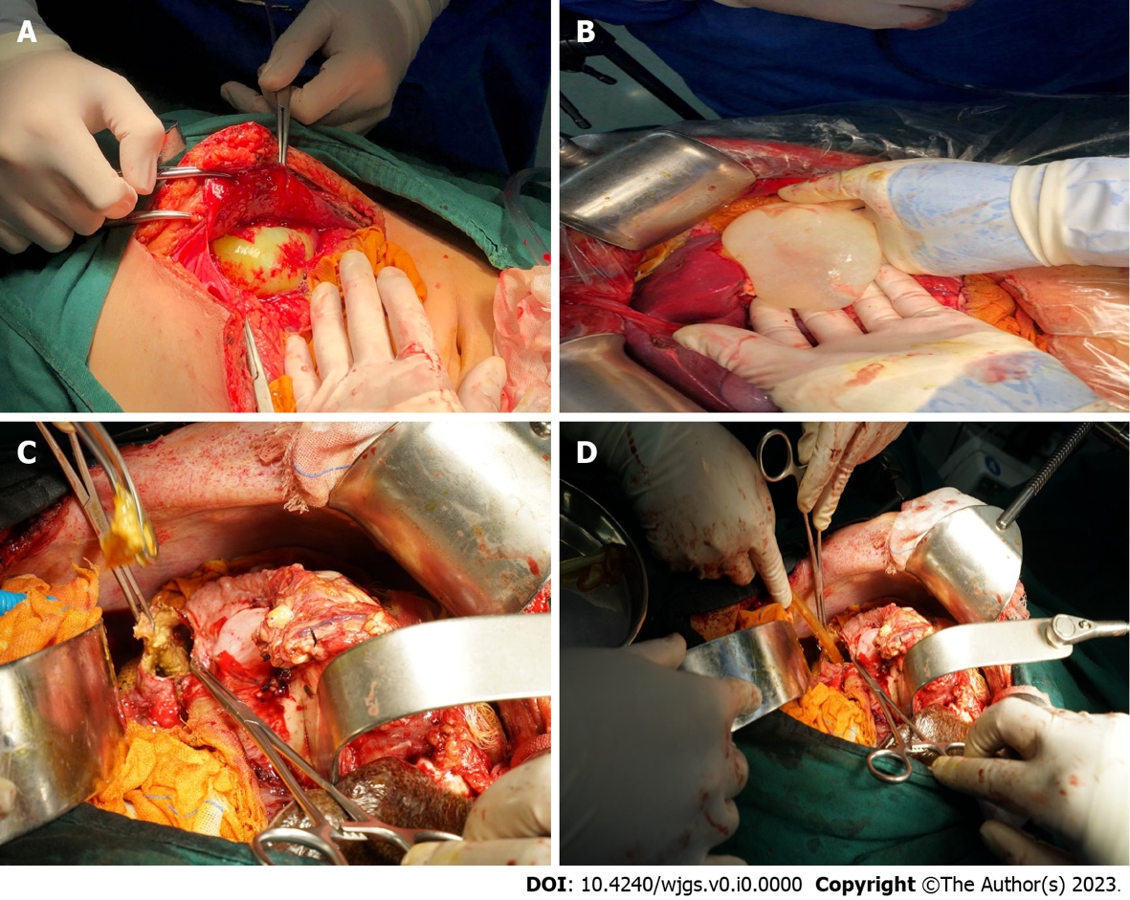
Figure 1 Excision of the internal capsule. A: After the incision of the peritoneum, the outer capsule of cystic echinococcosis (CE) was ruptured, and the inner capsule was intact; B: The gauze soaked with iodophor was used to isolate the surrounding organs and the intact ascus was removed carefully; C: The CE cyst was large in size and dense in adhesion with the diaphragm. Therefore, we chose to perform the internal capsule enucleation and found an internal fistula in the bile duct of the hydatid cyst, and the contents of the cyst were stained with bile; D: The aspirator aspirated the contents of the capsule, the capsule was repeatedly rinsed with iodophor and wiped with gauze, and a rubber drainage tube was placed.

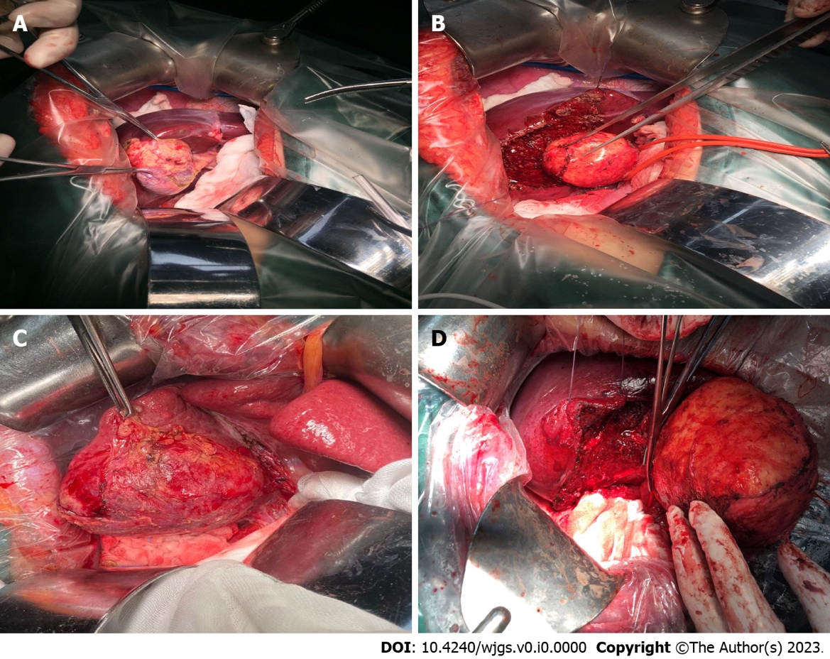

Figure 2 Total cystectomy. A: The cystic echinococcosis (CE) cyst was located behind the gallbladder, and the lesion size was small; B: The gallbladder and CE cyst were completely removed; C: CE cyst was located in the S5 and S6 segments of the liver, with a certain distance from the first and second hilum hepatitis; D: The CE cyst was completely removed along the edge of the external capsule, and the remaining liver section was definitely hemostatic.

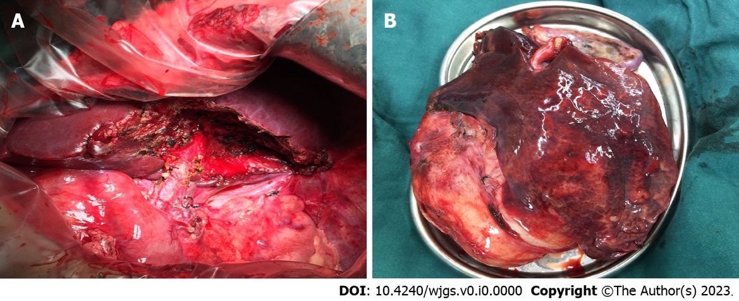
Figure 3 Partial hepatectomy. A: Cystic echinococcosis (CE) occupied the entire S3 segment of the liver, so segmentectomy was performed; B: Some liver tissue was observed on the surface of CE.

Table 1 Main surgical methods for hepatic cystic echinococcosis and their complications in different periods
Period (year) | Surgical methods | Major complications
Initial stage
1871 | Excision of the internal capsule | Recurrence in situ, abdominal implantation, biliary fistula, and residual cavity infection
Mature stage
1965 | Complete removal of the external capsule and hepatectomy | Intraoperative hemorrhage, cyst rupture, and liver dysfunction
1985 | Percutaneous puncture and catheter drainage | Allergic reaction, abdominal implantation, residual cavity infection, biliary fistula, and recurrence in situ
2002 | Modified excision of the internal capsule | Abdominal implantation and biliary fistula
2010 | Internal capsule removal combined with external capsule subtotal resection | Recurrence in situ, disseminated implantation, and biliary fistula
Current stage
1992 | Laparoscopic cyst excision | Intraoperative hemorrhage and cyst rupture
1994 | Local ablation | Damage to surrounding tissues and organs. Allergic reaction, cyst rupture, abdominal implantation, and recurrence in situ
2002 | Liver transplantation | Organ shortage, postoperative complications, and high cost

