Name of Journal: World Journal of Clinical Cases
Manuscript NO: 83651
Manuscript Type: ORIGINAL ARTICLE

Retrospective Study
Elastic fiber degradation in the development of pediatric granuloma annulare: Report of 39 cases

Zhang DY et al. Elastic fiber degradation in pediatric GA

Dong-Yuan Zhang, Li Zhang, Qin-Yan Yang, Yu-Cheng Xie, Hong-Chao Jiang, Jia-Zheng Li, Hong Shu

Dong-Yuan Zhang, Li Zhang, Hong Shu, Department of Dermatology, Kunming Children’s Hospital, Kunming 650000, Yunnan Province, China

Qin-Yan Yang, Department of Human Resource, Kunming Children’s Hospital, Kunming 650000, Yunnan Province, China

Yu-Cheng Xie, Department of Pathology, Kunming Children’s Hospital, Kunming 650000, Yunnan Province, China

Hong-Chao Jiang, Institute of Pediatric Disease Research in Yunnan, Kunming Children’s Hospital, Kunming 650000, Yunnan Province, China

Jia-Zheng Li, Department of Emergency, The Cooperation of Chinese and Western Medicine Hospital of Yunnan Province, Kunming 650000, Yunnan Province, China

Author contributions: Zhang DY and Zhang L substantial contribution to the conception and design of the work; Zhang DY, Zhang L, Xie YC, Li JZ, and Yang QY contribution to the acquisition, analysis, interpretation of data for the work; Zhang DY contributions to article writing and revising; Jiang HC and Shu H contribution to critical manuscript revisions for project design; Yang QY agreement to be accountable for all aspects of the work in ensuring that questions related to the accuracy or integrity of any part of the work are appropriately investigated and resolved; Shu H contributions to final approval of the version to be published; All authors have read and approve the final manuscript; Zhang DY and Zhang L contributed equally to this work; They are substantial contribution to the conception and design of the work.

Supported by Spring City Project Famous Doctor Special.

Corresponding author: Hong Shu, BMed, Doctor, Chief Doctor, Chief Physician, MHSc, Professor, Senior Consultant Dermatologist, Staff Physician, Department of Dermatology, Kunming Children’s Hospital, No. 288 Qianxing Road, Xishan District, Kunming 650000, Yunnan Province, China. etyyshuhong@sina.com

Received: February 3, 2023
Revised: April 23, 2023
Accepted: May 6, 2023
Published online: June 16, 2023
Abstract
BACKGROUND
Granuloma annulare (GA) has diverse clinical manifestations, multiple subtypes, and unknown etiology and pathogenesis. Existing studies regarding GA in children are scarce.

AIM
To examine the correlation between clinical manifestation and histopathology of pediatric GA.

METHODS
A total of 39 patients under 18 years of age with both a clinical and pathological diagnosis of GA at Kunming Children's Hospital from 2017 to 2022 were retrieved. Their medical records were consulted, and clinical data of the children were recorded and summarized, including gender, age, disease site, etc. Existing wax blocks of skin lesion specimens of children and pathological films were retrieved for further study and relevant histology, including hematoxylin-eosin, Alcian blue, elastic fiber (Victoria blue-Lichon red method), and antacid staining. Finally, the children’s clinical manifestations, histopathological results, and special staining characteristics were analyzed.

RESULTS
The clinical manifestations of granuloma annulare in children were diverse: 11 cases presented with a single lesion, 25 with multiple lesions, and 3 with generalized lesions. The pathological typing comprised histiocytic infiltration, palisading granuloma, epithelioid nodular, and mixed types in 4, 11, 9, and 15 cases, respectively. Thirty-nine cases were negative for antacid staining. The positive rate of Alcian blue staining was 92.3%, and that of elastic fiber staining was 100%. The degree of elastic fiber dissolution and granuloma annulare histopathological typing were positively correlated (r = 0.432, P < 0.05). No correlation was found between clinical presentation and histopathological typing of the granuloma annulare in children. In the pathological diagnosis of granuloma annulare, the positive elastic fiber staining rate was higher than that of Alcian blue staining. A correlation was found between elastic fiber dissolution degree and histopathological staging. However, the differences in pathological staging may have been related to the pathological manifestation of granuloma annulare at different periods.

CONCLUSION
Elastic fiber degradation may be a critical step in the pathogenesis of pediatric granuloma annulare. This is also one of the first studies focused on granuloma annulare in children.

Key Words: Pediatric; Granuloma annulare; Histopathology; Elastic fibers; Mucin; Case report

©The Author(s) 2023. Published by Baishideng Publishing Group Inc. All rights reserved.

Citation: Zhang DY, Zhang L, Yang QY, Xie YC, Jiang HC, Li JZ, Shu H. Elastic fiber degradation in the development of pediatric granuloma annulare: Report of 39 cases. World J Clin Cases 2023; 11(17): 4019-4025
URL: https://www.wjgnet.com/2307-8960/full/v11/i17/4019.htm
DOI: https://dx.doi.org/10.12998/wjcc.v11.i17.4019

Core Tip: This study examined the correlation between clinical manifestation and histopathology of pediatric granuloma annulare. We performed a retrospective analysis of thirty-nine cases of granuloma annulare in children and demonstrated a correlation between histopathological staining and elastic fiber dissolution. Different pathological staging may reflect the pathological manifestation of granuloma annulare at different periods. Our study demonstrates that elastic fiber degradation may be a critical step in the pathogenesis of pediatric granuloma annulare. Moreover, it is one of the first studies on granuloma annulare in children.

INTRODUCTION
Granuloma annulare (GA) manifests primarily as granulomatous inflammation infiltrating the dermis and subcutaneous tissues. Fox first reported GA in 1895, and Crocker officially named GA in 1902. The prevalence of GA is approximately 0.04% according to large cross-sectional studies, with a predilection for patients aged 3–50 years and a male-to-female ratio of approximately 2:1. However, some small single-center studies suggest that GA is common in children^{[1-3]}. GA has diverse clinical manifestations, multiple subtypes, and unknown etiology and pathogenesis. Recent studies have shown that activation of the Th1, Th2, and JAK-STAT pathways is involved in the pathogenesis of GA^{[4]}. In the early stages, the Th1-dominated immune response induces the infiltration of M1 macrophages, which triggers collagen degradation, followed by successive induction of M2 macrophage responses that mediate mucin deposition and tissue regeneration^{[5]}. However, existing studies regarding GA in children are limited. Therefore, in this study, we analyzed and discussed the clinical manifestations and histopathological features of GA in children and investigated the role of elastic fiber degradation and mucin deposition in the pathogenesis of GA in children with elastic fiber and Alcian blue staining.

MATERIALS AND METHODS
Thirty-nine cases of clinically and pathologically confirmed GA in children under 18 years of age from Kunming Children's Hospital between 2017 and 2022 were included.
Medical records were consulted and clinical data of the children were recorded and summarized, including gender, age, and disease site. Specimen wax blocks and existing pathological staining sheets were also collected for further study and relevant histological staining, including hematoxylin-eosin (HE), Alcian blue, elastic fiber (Victoria blue-Lichon red method), and antacid staining. The results were determined by two pathologists. The Medical Ethics Committee of Kunming Children's Hospital approved this study (No. 2022-03-325-K01).
HE staining was primarily used to analyze the pattern of histocyte infiltration. Referring to the histopathological typing of GA by Friedman-Birnbaum et al^{[4]}, GA was classified into these four types: Palisading granuloma, histiocytic infiltrative, epithelioid nodular, and mixed histologic types.
Elastic fiber staining was categorized into four grades according to elastic fibers' dissolution and destruction. Grade I: Disorganized arrangement of elastic fibers in the lesion without obvious disappearance and dissolution (Figure 1A). Grade II: Partial breakage of elastic fibers in the lesion with slight dissolution (Figure 1B). Grade III: Partial dissolution of elastic fibers in the lesion, but the visibility of some discontinuous elastic fibers (Figure 1C). Grade IV: Complete dissolution and disappearance of elastic fibers in the lesion (Figure 1D).
Statistical Package for the Social Sciences (SPSS, v. 20.0) was used to analyze histopathological staging and the degree of elastic fiber dissolution (grades I–IV) using Kendall's tau-b correlation analysis. Statistical significance was set at P < 0.05.

RESULTS
Clinical characteristics
Thirty-nine patients were included, 14 males and 25 females; the age distribution ranged from 2 mo and 13 d to 11 years, with a mean age of onset of 4.2 years. Eleven patients had single lesions, 25 had multiple lesions, and 3 had generalized lesions. The 3 patients with generalized lesions were all infants aged 2–4 mo. The lesions were distributed on the head in 6, face in 2, trunk in 1, extremities in 24, and whole body in 6 cases. Six cases of GA on the head involved subcutaneous nodule-like lesions (single or multiple), and three cases of generalized GA involved papule-like lesions. The lesions were plaques in 20, papules in 4, nodules in 12, and mixed manifestations in 3 cases.

Histopathological characteristics
Among the 39 cases, 4 showed histiocytic infiltration (Figure 2A), 11 showed palisading granuloma (Figure 2B), 9 showed epithelioid nodules (Figure 2C), and 15 showed mixed type findings. Of these 15 mixed-type cases, 2 showed a mixture of palisading and histiocytic infiltration, and 13 showed a mixture of palisading and epithelioid nodules (Table 1).
Antacid staining was negative in all 39 cases. Alcian blue staining was positive in 36 cases (positivity rate: 92.3%) and negative in only 3 cases (all epithelioid nodular types). Elastic fiber staining showed different degrees of dissolution and disappearance of elastic fibers, with a positivity rate of 100% (39/39 cases). The cases were classified into grades I–IV according to the degree of elastic fiber dissolution and destruction (Table 1). There was a single grade I and 3 grade II cases with histiocytic infiltration; 3, 4, and 4 grade II, grade III, and grade IV cases with palisading granuloma; 1, 5, and 9 grade II, grade III, and grade IV cases with mixed type, respectively; and 4 and 5 grade III and five grade IV cases with epithelioid nodules, respectively.
A positive correlation was found between the degree of elastolysis and GA histopathological typing (r = 0.432, P < 0.05).

Prognosis and follow-up
Telephone follow-up was conducted for all 39 children prior to the write-up (2022/10/10). Eleven were lost to follow-up, and 25 had subsided after diagnosis and were now asymptomatic. Only 3 children still had annular papules in the extremities, but no treatment was given because they were asymptomatic.

DISCUSSION
The etiology and pathogenesis of GA are unknown, and the clinical manifestations are diverse and differ between children and adults. This study included 39 cases of GA in children. The male-to-female ratio was approximately 0.56:1, which contradicts data from other studies, possibly due to the inclusion of only children in this study, although this needs to be validated in larger studies on children with GA. Clinical manifestations were more common as single or multiple annular plaques, mostly skin-colored, with a small proportion being red; however, no clear standard was available for the histopathological types of the different clinical manifestations.
Researchers have suggested that interferon produced by Th1 Lymphocytes in GA lesions activates macrophages to produce tumor necrosis factor and matrix metalloproteases (MMPs, including MMP2 and MMP9), triggering matrix degradation. Meanwhile, MMP-12 expression is also increased in tissues, which can lead to the degradation of elastic fibers and basement membrane bands. In ultrastructural studies, the main lesion of GA has been found to involve elastic fiber degeneration, suggesting that the disease is essentially an elastic fiber damage disease ^{[5]}. In this study, the positivity rate of elastic fiber staining (100%) was significantly higher than that of Alcian blue staining (92.3%), suggesting that elastic fiber changes are more common in GA.
In this study, we graded the degree of elastic fiber dissolution and disappearance in 39 cases of GA. The number of histiocytes was relatively low in histiocytic infiltrative GA, and the degree of elastolysis was grade I–II in all cases. Therefore, we speculate that this may be the early stage of the disease. The degree of elastolysis in palisading granuloma type GA and mixed type GA was mainly grade II–IV, and the elastolysis in epithelioid nodular GA was predominantly grade III–IV. The correlation between the degree of GA elastolysis and histopathological staging was verified by Kendall's tau-b correlation analysis, and we believe that these four stages are the pathological manifestations of GA at different periods. Additionally, the four pathological stages may be the gradual evolution and derivation of the course of GA. However, due to this study’s limited data and low correlation, more studies are needed to support our findings.
Recent studies have shown that activation of the Th1, Th2, and JAK-STAT pathways is involved in the pathogenesis of GA^{[6]}. In the early stages, the Th1-dominated immune response induces M1 macrophage infiltration, triggers collagen degradation, and subsequently induces an M2 macrophage response that mediates mucin deposition and tissue regeneration^{[7]}. For the 36 cases with positive Alcian blue staining in this study, mucin was usually distributed in the center of a relatively concentrated site of histiocytes. The remaining three cases with negative Alcian blue staining showed epithelioid nodular GA. We speculate that in the later stages of the disease, histiocytes and macrophages phagocytosed the mucin, causing the mucin to lyse and disappear.

CONCLUSION
For the first time, we established that the GA lesions in all 39 cases had different degrees of elastin fiber change. Moreover, the positivity rate of elastic fiber staining was approximately 100%, significantly higher than that of Alcian blue staining. There is a correlation between the degree of elastolysis and histopathological staging; and different pathological staging may be the pathological manifestation of GA at different periods. However, larger samples and prospective studies are needed to validate our results further and confirm whether elastic fiber degradation is critical for the pathogenesis of pediatric GA.

ARTICLE HIGHLIGHTS
Research background
Granuloma annulare (GA) is more common in children than in adults, and has diverse clinical manifestations, multiple subtypes, and unknown etiology and pathogenesis. However its correlation is rarely studied.

Research motivation
The main criteria for the diagnosis of GA is histopathologic biopsy, and the possible pathogenesis of GA is preliminarily discussed by analyzing the pathological characteristics of GA in children.

Research objectives
We analyzed and discussed the clinical manifestations and histopathological features of GA in children and performed elastic fiber staining and Alcian blue staining to initially investigate the role of elastic fiber degradation and mucin deposition in the pathogenesis of GA in children.

Research methods
A total of 39 cases with a pathological diagnosis of GA in Kunming Children’s Hospital between 2017 and 2022 were retrieved, and the clinical manifestations, histopathological, and special staining characteristics of the children were analyzed.

Research results
There is a correlation between the degree of elastolysis and histopathological staging, and different pathological staging may be the pathological manifestation of GA at different periods.

Research conclusions
Elastolysis is the key link of annular granuloma in children.

Research perspectives
Larger samples and prospective studies are needed to further validate our results and to confirm whether elastic fiber degradation is critical for the pathogenesis of pediatric GA.

REFERENCES
1 Barbieri JS, Rodriguez O, Rosenbach M, Margolis D. Incidence and Prevalence of Granuloma Annulare in the United States. JAMA Dermatol 2021; 157: 824-830 [PMID: 34106215 DOI: 10.1001/jamadermatol.2021.1847]
2 Joshi TP, Duvic M. Granuloma Annulare: An Updated Review of Epidemiology, Pathogenesis, and Treatment Options. Am J Clin Dermatol 2022; 23: 37-50 [PMID: 34495491 DOI: 10.1007/s40257-021-00636-1]
3 Leasure AC, Damsky W, Cohen JM. Prevalence of granuloma annulare in the United States: a cross-sectional study in the All of Us Research Program. Int J Dermatol 2022; 61: e301-e302 [PMID: 34363612 DOI: 10.1111/ijd.15832]
4 Friedman-Birnbaum R, Weltfriend S, Munichor M, Lichtig C. A comparative histopathologic study of generalized and localized granuloma annulare. Am J Dermatopathol 1989; 11: 144-148 [PMID: 2712247 DOI: 10.1097/00000372-198911020-00006]
5 Fayyazi A, Schweyer S, Eichmeyer B, Herms J, Hemmerlein B, Radzun HJ, Berger H. Expression of IFNγ, coexpression of TNFα and matrix metalloproteinases and apoptosis of T lymphocytes and macrophages in granuloma annulare. Arch Dermatol Res 2000; 292: 384-390 [PMID: 10994772 DOI: 10.1007/s004030000150]
6 Min MS, Wu J, He H, Sanz-Cabanillas JL, Del Duca E, Zhang N, Renert-Yuval Y, Pavel AB, Lebwohl M, Guttman-Yassky E. Granuloma annulare skin profile shows activation of T-helper cell type 1, T-helper cell type 2, and Janus kinase pathways. J Am Acad Dermatol 2020; 83: 63-70 [PMID: 31870914 DOI: 10.1016/j.jaad.2019.12.028]
7 Wang A, Rahman NT, McGeary MK, Murphy M, McHenry A, Peterson D, Bosenberg M, Flavell RA, King B, Damsky W. Treatment of granuloma annulare and suppression of proinflammatory cytokine activity with tofacitinib. J Allergy Clin Immunol 2021; 147: 1795-1809 [PMID: 33317858 DOI: 10.1016/j.jaci.2020.10.012]

Footnotes
Institutional review board statement: The study protocol was reviewed and approved by Kunming Children’s Hospital Medicine Ethics Committee, approval number 2022-03-325-K01.

Informed consent statement: Kunming Children’s Hospital Medicine Ethics Committee concluded that this study was ethical and determined that written informed consent was not required.

Conflict-of-interest statement: All the authors have no conflicts of interest to declare.

Data sharing statement: The data that support the findings of this study are not publicly available due to their containing information that could compromise the privacy of research participants but are available from the corresponding author Shu Hong upon reasonable request.

Open-Access: This article is an open-access article that was selected by an in-house editor and fully peer-reviewed by external reviewers. It is distributed in accordance with the Creative Commons Attribution NonCommercial (CC BY-NC 4.0) license, which permits others to distribute, remix, adapt, build upon this work non-commercially, and license their derivative works on different terms, provided the original work is properly cited and the use is non-commercial. See: https://creativecommons.org/Licenses/by-nc/4.0/

Provenance and peer review: Unsolicited article; Externally peer reviewed.
Peer-review model: Single blind

Peer-review started: February 3, 2023
First decision: April 10, 2023
Article in press: May 6, 2023

Specialty type: Pathology
Country/Territory of origin: China
Peer-review report’s scientific quality classification
Grade A (Excellent): 0
Grade B (Very good): 0
Grade C (Good): C, C
Grade D (Fair): 0
Grade E (Poor): 0

P-Reviewer: Hegazy AA, Egypt; Viswanathan VK, United States S-Editor: Liu JH L-Editor: A P-Editor: Ji MX
Figure Legends

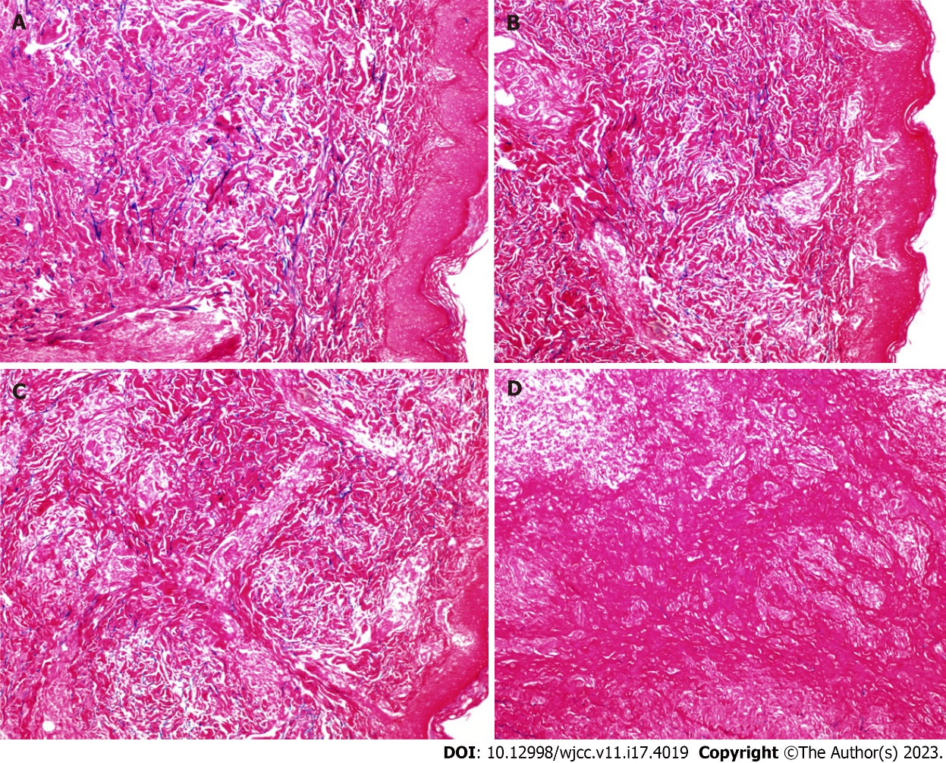
Figure 1 Elastic fiber staining was categorized into four grades according to the elastic fibers' dissolution degree and destruction. A: Grade I: Disorganized arrangement of elastic fibers in the lesion without significant dissolution (×200); B: Grade II: Partial breakage of elastic fibers in the lesion with mild dissolution (×200); C: Grade III: Partial dissolution of elastic fibers in the lesion, but small, discontinuous elastic fibers are still visible (×200); D: Grade IV: Complete dissolution and disappearance of elastic fibers in the lesion (×200).

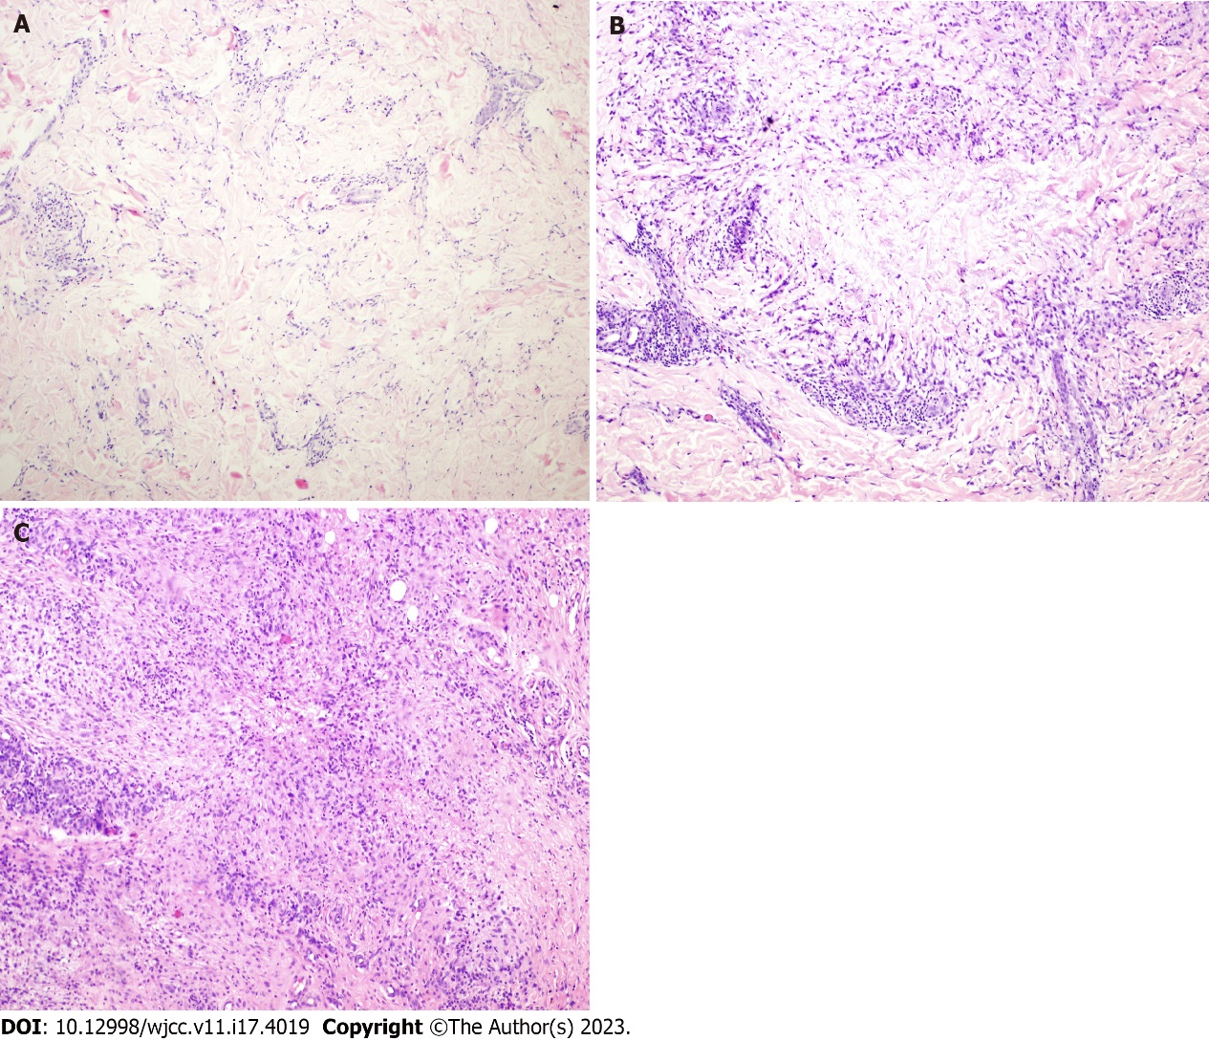
Figure 2 Granuloma annulare was classified into four types: Palisading granuloma, histiocytic infiltrative, epithelioid nodular, and mixed histologic types. A: Histiocytic infiltration type granuloma annulare (GA): Progressive necrosis is mild with incomplete degeneration of collagen fibers (×100, HE); B: Palisading granuloma type GA: progressive necrosis is evident with complete degeneration of collagen fibers in the lesion (×100, HE); C: Epithelioid nodular type GA: histiocytes aggregate to form epithelioid nodules with multinucleated giant cells mixed in the nodules and surrounded by lymphocytes (×100, HE).

Table 1 Clinical and histopathological manifestations
Clinical and special staining | Clinical manifestation |  |  |  | Special staining |  |  | Dissolution degree of elastic fiber
Pathological type | Plaque | Nodule | Papules | Mixed | Alcian blue staining (positive) | Dissolution and disappearance of elastic fibers | Acid-fast staining (negative) | Grade I | Grade II | Grade III | Grade IV
Histiocytic infiltration type | 4 | 0 | 0 | 0 | 4 | 4 | 4 | 1 | 3 | 0 | 0
Palisading granuloma type | 6 | 0 | 2 | 3 | 11 | 11 | 11 | 0 | 3 | 4 | 4
Mixed type | 8 | 7 | 0 | 0 | 15 | 15 | 15 | 0 | 1 | 5 | 9
Epithelioid nodular type | 2 | 5 | 2 | 0 | 6 | 9 | 9 | 0 | 0 | 4 | 5

Published by Baishideng Publishing Group Inc
7041 Koll Center Parkway, Suite 160, Pleasanton, CA 94566, USA
Telephone: +1-925-3991568
E-mail: bpgoffice@wjgnet.com
Help Desk: https://www.f6publishing.com/helpdesk
https://www.wjgnet.com

© 2023 Baishideng Publishing Group Inc. All rights reserved.

