Name of Journal: World Journal of Clinical Cases
Manuscript NO: 85969
Manuscript Type: CASE REPORT

Complex inferior vena cava reconstruction during ex vivo liver resection and autotransplantation: A case report

Humaerhan J et al. Complex reconstruction of inferior vena cava

Jiayidaer Humaerhan, Tie-Min Jiang, Tuerganaili Aji, Ying-Mei Shao, Hao Wen

Jiayidaer Humaerhan, Tie-Min Jiang, Tuerganaili Aji, Ying-Mei Shao, Hao Wen, Department of Hepatobiliary & Hydatid Diseases, Digestive & Vascular Surgery Center, The First Affiliated Hospital of Xinjiang Medical University, Urumqi 830054, Xinjiang Uygur Autonomous Region, China

Jiayidaer Humaerhan, Tie-Min Jiang, Tuerganaili Aji, Hao Wen, State Key Laboratory of Pathogenesis, Prevention and Management of High Incidence Diseases in Central Asia, The First Clinical Medical College of Xinjiang Medical University, Urumqi 830054, Xinjiang Uygur Autonomous Region, China

Ying-Mei Shao, Xinjiang Clinical Research Center for Echinococcosis and Hepatobiliary Diseases, First Affiliated Hospital of Xinjiang Medical University, Urumqi 830054, Xinjiang Uygur Autonomous Region, China

Author contributions: Humaerhan J and Jiang TM contributed to manuscript writing and editing, and data collection; Aji T and Shao YM contributed to data analysis; Wen H contributed to conceptualization and supervision; all authors have read and approved the final manuscript.

Supported by Key laboratory opening topic fund subsidization: The regulation of sympathetic nerve in liver regeneration in hepatic alveolar echinococcosis, No. 2021D04024.

Corresponding author: Hao Wen, PhD, Chief Doctor, State Key Laboratory of Pathogenesis, Prevention and Management of High Incidence Diseases in Central Asia, The First Clinical Medical College of Xinjiang Medical University, Department of Hepatobiliary & Hydatid Diseases, Digestive & Vascular Surgery Center, The First Affiliated Hospital of Xinjiang Medical University, No. 137 Leiyueshan South Road, Xincheng District, Urumqi 830054, Xinjiang Uygur Autonomous Region, China. dr.wenhao@163.com

Received: May 24, 2023
Revised: July 1, 2023
Accepted: July 17, 2023
Published online:

Abstract
BACKGROUND
Ex vivo liver resection and autotransplantation (ELRA) is an essential approach for treating patients with end-stage hepatic alveolar echinococcosis (AE), and its surgical indications involve severe invasion of important hepatic vessels, which makes in vivo resection impossible. Revascularization is a major step in the process of ELRA, which is extremely challenging when the invaded vessels have huge defects.

CASE SUMMARY
Herein, we have reported the case of a 26-year-old patient with hepatic AE in an autologous liver graft who underwent complex inferior vena cava (IVC) reconstruction using disease-free IVC, autologous portal vein fragments, and umbilical vein within the ligamentum teres hepatis. The patient showed good surgical recovery without vascular-related complications during the long-term follow-up.

CONCLUSION
We reviewed three studies that have reported complex revascularization of the IVC. This case report and systematic review showed that the use of autologous perihepatic vessels prevents donor-area trauma, immune rejection, and other adverse reactions. When the blood vessel is severely invaded and a single vascular material cannot repair and reconstruct the defect, ELRA may provide a safe and feasible surgical approach, which has good prospects for clinical application.

Key Words: Hepatic alveolar echinococcosis; Ex vivo liver resection and autotransplantation; Inferior vena cava; Revascularization; Case report

Humaerhan J, Jiang TM, Aji T, Shao YM, Wen H. Complex inferior vena cava reconstruction during ex vivo liver resection and autotransplantation: A case report. World J Clin Cases 2023; In press

Core Tip: Ex vivo liver resection and autotransplantation (ELRA) is an essential approach to cure end-stage hepatic alveolar echinococcosis (AE). Revascularization is a central and challenging step in the process of ELRA when the invaded vessels have large defects. Here, we report the case of a 26-year-old patient with hepatic AE in an autologous liver graft who underwent complex inferior vena cava (IVC) reconstruction using disease-free IVC, autologous portal vein fragments and umbilical vein within the ligamentum teres hepatis and with good surgical recovery without vascular-related complications at long-term follow-up. This study demonstrate that the blood vessel is severely invaded and a single vascular material cannot repair and reconstruct the defect, this technique may provide a feasible surgical option for revascularization during ELRA and has good prospects for clinical application.

INTRODUCTION
Hepatic alveolar echinococcosis (AE) is a rare zoonotic infection that is caused by Echinococcus multilocularis^{[1]}. It is an invasive disease with systemic metastasis^{[2]}; however, its insidious onset and slow progression make early diagnosis difficult. Radical hepatectomy combined with antiparasitic medication is the only curative treatment approach for patients with hepatic alveolar echinococcosis; however, this approach is feasible for only 35% of patients due to delay in diagnosis^{[3,4]}. Previous studies have shown that ex vivo liver resection and autotransplantation (ELRA) can be an effective alternative to allotransplantation in patients with end-stage hepatic AE^{[5-7]}. Compared with allotransplantation, ELRA overcomes the limitations of shortage of liver sources and long-term postoperative immunosuppression^{[8-10]}. Therefore, ELRA is a better choice for patients with end-stage hepatic AE where complete resection of the lesion is not possible and technical challenges, such as in vivo revascularization, are difficult to overcome^{[9,11,12]}. End-stage hepatic AE can invade major bile ducts and blood vessels, which requires additional repair and reconstruction procedures of the vessels during ELRA^{[1,2,13]}. In this case, the selection of an appropriate revascularization material is significant. Based on the degree of vascular invasion, reconstruction materials can be selected from autologous vessels, allogeneic vessels, and artificial vessels. Complex revascularization with multiple vascular remnants can also be an effective treatment approach when the area of lesion invasion is huge and a single vascular patch is not sufficient for revascularization. Herein, we have presented a case of complex reconstruction of the inferior vena cava (IVC) using autologous portal vein (PV) fragments, umbilical vein within the ligamentum teres hepatis (LTH), and disease-free IVC during ELRA. Furthermore, the available literature on the complex reconstruction of the IVC during ELRA was reviewed to summarize the experience of the complex reconstruction of the IVC.

CASE PRESENTATION
Chief complaints
A 26-year-old Chinese woman presented to the general surgery clinic with a complaint of upper right abdominal pain for 2 wk.

History of present illness
Symptoms started 2 wk before presentation with recurrent upper right abdominal pain.

History of past illness
No previous complaints of discomfort.

Personal and family history
The patient has a long history of living in a pastoral area. She denied any family history of malignant tumours.

Physical examination
On physical examination, the vital signs were as follows: Body temperature, 36.2℃; blood pressure, 121/72 mmHg; heart rate, 76 beats per min; respiratory rate, 16 breaths per min. Flat abdomen, no abdominal varicose veins, no abdominal muscle tension, no tenderness, no rebound pain, no liquid wave tremor, no water vibration sound, no abdominal mass, bowel sound 4 times per minute.

Laboratory examinations
No abnormality was found in routine blood, urine analyses, biochemical test and serum tumour markers.

Imaging examinations
Abdominal color doppler ultrasound revealed a moderate to high echogenic lesion in the right lobe of the liver with a size of approximately 9.5 cm × 8.7 cm. Abdominal computed tomography (CT) revealed space-occupying lesions in the right posterior lobe and the caudate lobe of the liver. The right branch of the PV, the middle hepatic vein (HV), and the initial part of the left HV were invaded. The hepatic IVC was surrounded by lesions and narrowed due to compression (Figure 1A and B).

Histology
Liver tissues were fixed for more than 24 h and then cut into 5 μm sections after paraffin embedding. Hematoxylin and eosin staining was performed according to the instructions. The staining results showed abundant granulomatous reaction and coagulative necrosis around the laminated parasitic membranes (Figure 2A and B).

FINAL DIAGNOSIS
Combined with the patient’s medical history, the final diagnosis was hepatic AE (P4N0M0/PI–II, VI–VIII, and I1V1M0).

TREATMENT
The patient underwent ELRA. The right posterior lobe of the liver, most of the right anterior lobe, the caudate lobe, and a part of the left inner lobe were invaded. The right HV, the root of the middle HV, and the root of the left HV were encircled, and the anterior and lateral walls of the hepatic IVC were surrounded by a lesion of almost 5 cm in size. After the entire liver was dissociated, the important vascular regions were transected and the infected part of the liver was removed. The hepatic IVC was reconstructed with artificial vessels to perform a temporary portal shunt. The entire liver was isolated and rapidly perfused through the left branch of PV with Histidine–Tryptophan–Ketoglutarate solution at 0 to 4℃. The hepatic parenchyma was severed at 2.0 cm along with the right edge of the falciform ligament, the vessels along the way were ligated, and the lesions that invaded the vessels were removed.
The anterolateral wall of the hepatic IVC was invaded by the lesion. Because the resection of the autograft iliac vein and internal jugular vein can be locally traumatic to the patient, we used the umbilical vein within the LTH, PV fragment, and disease-free IVC to reconstruct the huge defect of the hepatic IVC. The anastomosis between the IVC and artificial blood vessel was dismantled, and end-to-end anastomosis of the upper and lower edges of the repaired hepatic IVC was performed. The PV was anastomosed, which opened all blood vessels and ended the anhepatic phase. End-to-end anastomosis of the right branch of the proper hepatic artery with the trunk type of a proper hepatic artery was performed. Furthermore, Roux-en-Y hepaticojejunostomy was performed to drain the left hepatobiliary duct (Figure 1C-H).
The entire surgery took 14 h and 5 min to complete with stable hemodynamics. The patient had a blood loss of almost 700 mL and was transfused 630 mL of fresh plasma and 528 mL of autologous.

OUTCOME AND FOLLOW-UP
The patient developed pleural effusion 6 d post-surgery, which was treated with a pleural puncture and catheter drainage. Ultrasonography was performed on days 0, 1, 2, 4, and 6, which showed unobstructed blood flow signals in IVC. Regular abdominal CT showed normal visualization of the IVC, no distinct stenosis, and a filled defect. The follow-up time was 84 mo (Table 1). The patient showed good liver functions and no revascularization-related complications during follow-ups. The abdominal CT of the patient showed good filling of the vessels after 84 mo with no obstruction or stenosis (Figure 2C-E).
It's been eight years since the operation, the patient was still alive.

DISCUSSION
Hepatic AE is a zoonotic infection found worldwide that is caused by Echinococcus multilocularis^{[14]}. It is mainly endemic in the northern hemisphere, especially in western China. Radical surgery is the best approach to treat this condition. However, its diagnosis can be delayed because obvious symptoms are not observed during the early stages. Therefore, patients are sometimes deprived of radical surgery due to the significant invasion of vital blood vessels by the time of diagnosis. Chui et al^{[15]} achieved good results with the first ELRA in 2003. Therefore, this surgery has gradually become an effective approach for treating end-stage hepatic AE. ELRA has garnered increasing attention in recent years owing to its advantages of radical excision of lesions with no requirement of an immunosuppressive agent. Compared with allotransplantation, ELRA has better long-term efficacy for treating end-stage hepatic AE or benign liver tumors^{[12]}. The major challenge in ELRA is repairing and reconstructing the invaded blood vessels in vitro^{[5,14]}. Oldhafer et al^{[16]} proposed in situ hepatic resection and allotransplantation, which facilitate safe and complex revascularization of hepatic lesions that cannot be treated by combined liver surgery. Individual management of revascularization is challenging and crucial for patient prognosis^{[5]}.
Sometimes, the defects in the key blood vessels of the healthy side of the liver are too extensive to be repaired and recreated in vivo due to the substantial invasion of end-stage hepatic AE lesions. Therefore, selecting and obtaining proper materials for blood vascular repair is more difficult in ELRA compared with that in allotransplantation. Our center has reported 24 cases of ELRA with revascularization using LTH between August 2010 and October 2018^{[6]}. We have also reported cases of using other vessels, such as internal jugular veins, iliac veins, or artificial vessels, as vascular substitutes^{[4,5]}. However, only a few studies have reported complex revascularization using multiple materials.
In this study, due to the significant area of IVC invasion in the patient, a single vascular material was insufficient for repair and reconstruction. Moreover, blood vessel bank or donation after cardiac death (DCD) vessels was not available during the surgery. In this case, using a range of vascular substitutes that have been proven to be safe was the final option for reconstructing the IVC because of several reasons. Using artificial blood vessels increases the risk of thrombosis and failure of vascular repair and reconstruction^{[17]}. Using a DCD vascular graft requires a blood vessel bank, which is not available in all centers. Autologous vascular grafts are used for vascular reconstruction. Many studies have shown the safety of IVC repair with various autologous venous grafts in allotransplantation^{[18,19]}. The acquisition of autologous vein grafts in other parts of the patient’s body, such as the saphenous vein, and internal jugular vein, require local surgery and cause additional donor-area trauma to the patient. The use of perihepatic vessels, such as LTH and PV, can prevent additional donor-area trauma to the patient and the occurrence of revascularization-related complications because of similar blood vessel endothelium. The patient’s safety was preliminarily validated during the long-term follow-up and no vascular stenosis, thrombosis, or other complications were reported. This study and all previous studies have shown that complex vascular reconstruction, a key technique, opens up new possibilities for the successful implementation of liver transplantation, both liver transplantation and ELRA.
Herein, we reviewed three previous cases with lesions that severely invaded the hepatic IVC and required complex IVC reconstruction. A total of 3 studies with detailed descriptions of 3 cases of complex reconstruct IVC in ELRA were found^{[20-22]}. Table 2 presents the detailed data of these studies (Table 2). Based on the specific data obtained from these studies, the methods for complex reconstruction of the IVC in ELRA were summarized and analyzed. Of the 3 studies, 2 studies were reported from China, and 1 study was from the United Kingdom. These studies reported the complex reconstruction of the IVC in three patients during ELRA. In all three patients, two or more types of blood vessels except IVC were used to reconstruct IVC. The two studies from China reported two patients with hepatic AE who underwent ELRA with the IVC reconstruction. In one patient, the disease-free hepatic IVC, bilateral autologous saphenous veins, and unilateral common iliac vein were used for reconstruction, whereas in the other patient, the bilateral saphenous, inferior, and middle HV, inferior mesenteric vein, and a portion of the lateral wall of the hepatic IVC were used. The United Kingdom study reported a patient with intrahepatic smooth muscle sarcoma during ELRA. The complex reconstruction of the IVC was performed using the left iliac vein of 2 deceased donors and an autologous disease-free IVC from the patient. The postoperative prognosis was good and IVC revascularization-related complications did not occur in all the patients.
IVC invasion, huge lesions in the central location, and lesions near the IVC and HV junction are not suitable for surgical resection, and untreated patients have a dismal prognosis^{[23]}. The patient reported in this study benefited from an extracorporeal technique of ELRA and underwent complex revascularization. Ex vivo surgery with complicated revascularization is a complex and challenging technique, which is a new possible treatment for patients with end-stage hepatic AE for whom other conventional treatment options are not available.
The present study has certain limitations. This is a retrospective study of a new case report and 3 previous case reports. Due to the small sample size of this study, future studies with more cases and longer follow-ups should investigate the long-term complications of complex revascularization to verify the safety and feasibility of complex revascularization techniques.

CONCLUSION
To conclude, we showed that complex IVC reconstruction using autogenous multi-vein fragments is feasible and has a good prognosis during ELRA in patients with end-stage hepatic AE. The use of autologous perihepatic vessels prevents donor-area trauma, immune rejection, and other adverse reactions. When the blood vessel is severely invaded and a single vascular material cannot repair and reconstruct the defect, ELRA may provide a safe and feasible surgical approach for revascularization, which has good prospects for clinical application.

REFERENCES
1 Wen H, Vuitton L, Tuxun T, Li J, Vuitton DA, Zhang W, McManus DP. Echinococcosis: Advances in the 21st Century. Clin Microbiol Rev 2019; 32 [PMID: 30760475 DOI: 10.1128/CMR.00075-18]
2 Kern P, Menezes da Silva A, Akhan O, Müllhaupt B, Vizcaychipi KA, Budke C, Vuitton DA. The Echinococcoses: Diagnosis, Clinical Management and Burden of Disease. Adv Parasitol 2017; 96: 259-369 [PMID: 28212790 DOI: 10.1016/bs.apar.2016.09.006]
3 Wen H, Dong JH, Zhang JH, Zhao JM, Shao YM, Duan WD, Liang YR, Ji XW, Tai QW, Aji T, Li T. Ex vivo liver resection followed by autotransplantation for end-stage hepatic alveolar echinococcosis. Chin Med J (Engl) 2011; 124: 2813-2817 [PMID: 22040485]
4 Wen H, Dong JH, Zhang JH, Duan WD, Zhao JM, Liang YR, Shao YM, Ji XW, Tai QW, Li T, Gu H, Tuxun T, He YB, Huang JF. Ex Vivo Liver Resection and Autotransplantation for End-Stage Alveolar Echinococcosis: A Case Series. Am J Transplant 2016; 16: 615-624 [PMID: 26460900 DOI: 10.1111/ajt.13465]
5 Aji T, Dong JH, Shao YM, Zhao JM, Li T, Tuxun T, Shalayiadang P, Ran B, Jiang TM, Zhang RQ, He YB, Huang JF, Wen H. Ex vivo liver resection and autotransplantation as alternative to allotransplantation for end-stage hepatic alveolar echinococcosis. J Hepatol 2018; 69: 1037-1046 [PMID: 30031886 DOI: 10.1016/j.jhep.2018.07.006]
6 Jiang T, Ran B, Guo Q, Zhang R, Duan S, Zhong K, Wen H, Shao Y, Aji T. Use of the ligamentum teres hepatis for outflow reconstruction during ex vivo liver resection and autotransplantation in patients with hepatic alveolar echinococcosis: A case series of 24 patients. Surgery 2021; 170: 822-830 [PMID: 33994007 DOI: 10.1016/j.surg.2021.03.040]
7 Jiang T, Aji T, Wang Z, Bo R, Guo Q, Zhang R, Tuergan T, Zhong K, Shao Y, Wen H. Reconstruction of hepatic venous outflow and management of its complications using ex vivo liver resection and autotransplantation: a single-center experience. Expert Rev Gastroenterol Hepatol 2022; 16: 279-287 [PMID: 35094615 DOI: 10.1080/17474124.2022.2036123]
8 Hwang R, Liou P, Kato T. Ex vivo liver resection and autotransplantation: An emerging option in selected indications. J Hepatol 2018; 69: 1002-1003 [PMID: 30243765 DOI: 10.1016/j.jhep.2018.09.005]
9 Zhang Y, Lai ECH, Yang C, Yang H, Liu J, Zhou G, Xian D, Deng S, Lau WY. In situ reconstruction of vascular inflow/outflow to left lateral liver section, ex-vivo liver resection and autologous liver transplantation of remaining liver remnant for hepatic alveolar echinococcosis. Int J Surg Case Rep 2020; 69: 39-43 [PMID: 32251986 DOI: 10.1016/j.ijscr.2020.03.023]
10 Yang X, Qiu Y, Huang B, Wang W, Shen S, Feng X, Wei Y, Lei J, Zhao J, Li B, Wen T, Yan L. Novel techniques and preliminary results of ex vivo liver resection and autotransplantation for end-stage hepatic alveolar echinococcosis: A study of 31 cases. Am J Transplant 2018; 18: 1668-1679 [PMID: 29232038 DOI: 10.1111/ajt.14621]
11 Kato T, Hwang R, Liou P, Weiner J, Griesemer A, Samstein B, Halazun K, Mathur A, Schwartz G, Cherqui D, Emond J. Ex Vivo Resection and Autotransplantation for Conventionally Unresectable Tumors - An 11-year Single Center Experience. Ann Surg 2020; 272: 766-772 [PMID: 32833756 DOI: 10.1097/SLA.0000000000004270]
12 Yang X, Wang T, Kong J, Huang B, Wang W. Resection of retrohepatic inferior vena cava without reconstruction in ex vivo liver resection and autotransplantation: a retrospective study. BMC Surg 2020; 20: 56 [PMID: 32209078 DOI: 10.1186/s12893-020-00720-z]
13 Qiu Y, Yang X, Shen S, Huang B, Wang W. Vascular infiltration-based surgical planning in treating end-stage hepatic alveolar echinococcosis with ex vivo liver resection and autotransplantation. Surgery 2019; 165: 889-896 [PMID: 30591376 DOI: 10.1016/j.surg.2018.11.007]
14 Yang C, Yang HJ, Deng SP, Zhang Y. Current status of ex-vivo liver resection and autologous liver transplantation for end-stage hepatic alveolar echinococcosis. Ann Palliat Med 2020; 9: 2271-2278 [PMID: 32576011 DOI: 10.21037/apm-20-184]
15 Chui AK, Island ER, Rao AR, Lau WY. The longest survivor and first potential cure of an advanced cholangiocarcinoma by ex vivo resection and autotransplantation: a case report and review of the literature. Am Surg 2003; 69: 441-444 [PMID: 12769220 DOI: 10.1177/000313480306900517]
16 Oldhafer KJ, Lang H, Schlitt HJ, Hauss J, Raab R, Klempnauer J, Pichlmayr R. Long-term experience after ex situ liver surgery. Surgery 2000; 127: 520-527 [PMID: 10819060 DOI: 10.1067/msy.2000.105500]
17 Thorat A, Jeng LB, Yang HR, Li PC, Li ML, Yeh CC, Chen TH, Hsu SC, Poon KS. Outflow reconstruction for right liver allograft with multiple hepatic veins: "V-plasty" of hepatic veins to form a common outflow channel versus 2 or more hepatic vein-to-inferior vena cava anastomoses in limited retrohepatic space. Liver Transpl 2016; 22: 192-200 [PMID: 26390259 DOI: 10.1002/lt.24342]
18 Lee SG. Techniques of reconstruction of hepatic veins in living-donor liver transplantation, especially for right hepatic vein and major short hepatic veins of right-lobe graft. J Hepatobiliary Pancreat Surg 2006; 13: 131-138 [PMID: 16547674 DOI: 10.1007/s00534-005-1019-7]
19 Quinones-Baldrich W, Alktaifi A, Eilber F, Eilber F. Inferior vena cava resection and reconstruction for retroperitoneal tumor excision. J Vasc Surg 2012; 55: 1386-93; discussion 1393 [PMID: 22386140 DOI: 10.1016/j.jvs.2011.11.054]
20 Jianyong L, Jingcheng H, Wentao W, Lunan Y, Jichun Z, Bing H, Ding Y. Ex vivo liver resection followed by autotransplantation to a patient with advanced alveolar echinococcosis with a replacement of the retrohepatic inferior vena cava using autogenous vein grafting: a case report and literature review. Medicine (Baltimore) 2015; 94: e514 [PMID: 25700312 DOI: 10.1097/MD.0000000000000514]
21 Hu H, Huang B, Zhao J, Wang W, Guo Q, Ma Y. Liver autotransplantation and retrohepatic vena cava reconstruction for alveolar echinococcosis. J Surg Res 2017; 210: 169-176 [PMID: 28457324 DOI: 10.1016/j.jss.2016.11.023]
22 Buchholz BM, Pinter Carvalheiro da Silva Boteon A, Taniere P, Isaac JR, Gourevitch D, Muiesan P. Autotransplantation of the Liver for Ex Vivo Resection of Intrahepatic Caval Leiomyosarcoma: A Case Report. Exp Clin Transplant 2020; 18: 396-401 [PMID: 30880647 DOI: 10.6002/ect.2018.0183]
23 Baker MA, Maley WR, Needleman L, Doria C. Ex vivo resection of hepatic neoplasia and autotransplantation: a case report and review of the literature. J Gastrointest Surg 2015; 19: 1169-1176 [PMID: 25820488 DOI: 10.1007/s11605-015-2806-3]

Footnotes
Informed consent statement: Informed written consent was obtained from the patient for publication of this report and any accompanying images.

Conflict-of-interest statement: All the authors declare that they have no conflict of interest to disclose.

CARE Checklist (2016) statement: The authors have read the CARE Checklist (2016), and the manuscript was prepared and revised according to the CARE Checklist (2016).

Open-Access: This article is an open-access article that was selected by an in-house editor and fully peer-reviewed by external reviewers. It is distributed in accordance with the Creative Commons Attribution NonCommercial (CC BY-NC 4.0) license, which permits others to distribute, remix, adapt, build upon this work non-commercially, and license their derivative works on different terms, provided the original work is properly cited and the use is non-commercial. See: https://creativecommons.org/Licenses/by-nc/4.0/

Provenance and peer review: Unsolicited article; Externally peer reviewed.
Peer-review model: Single blind

Peer-review started: May 24, 2023
First decision: June 19, 2023
Article in press:

Specialty type: Transplantation
Country/Territory of origin: China
Peer-review report’s scientific quality classification
Grade A (Excellent): A
Grade B (Very good): 0
Grade C (Good): C
Grade D (Fair): 0
Grade E (Poor): 0

P-Reviewer: Amante MF, Argentina; Uhlmann D, Germany S-Editor: Liu JH L-Editor: A P-Editor: Liu JH
Figure Legends
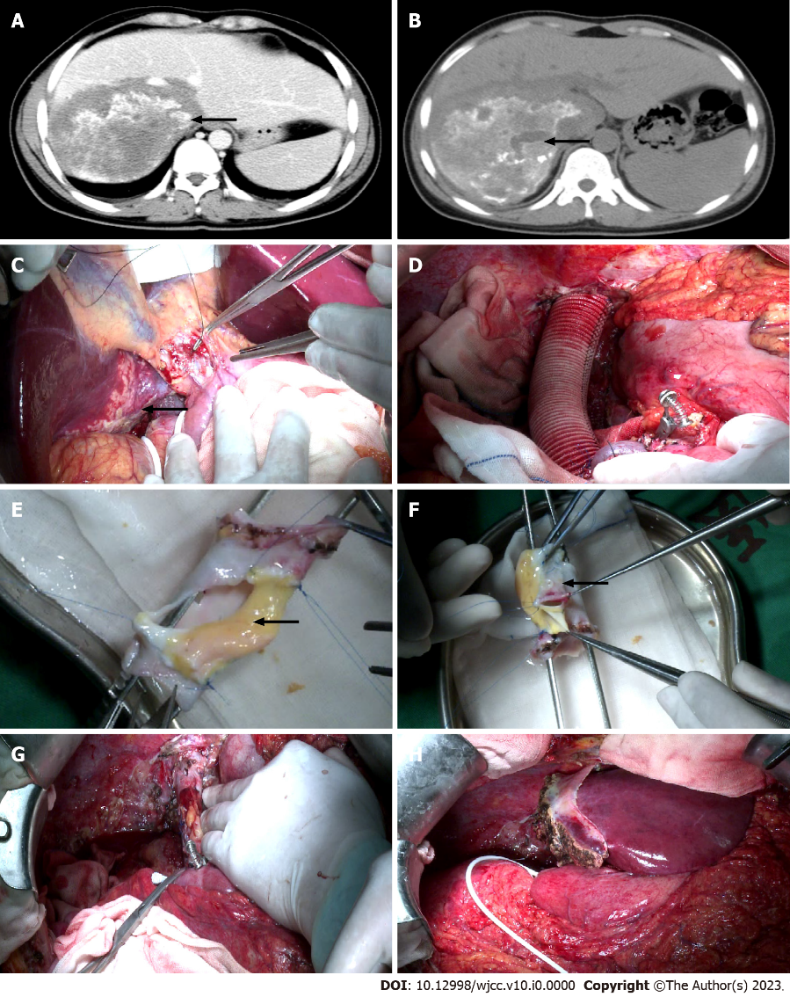
Figure 1 Preoperative imaging examination and surgical procedure. A: Preoperative enhanced computed tomography (CT) scan shows the inferior vena cava (IVC) invaded by the lesion. The black arrow indicates IVC; B: A Preoperative enhanced CT scan shows the hepatic alveolar echinococcosis (AE) lesion located in the right posterior lobe and the caudate lobe of the liver. The black arrow indicates a hepatic AE lesion; C: Ex vivo liver resection and autotransplantation (ELRA) for the treatment of hepatic end-stage AE. The black arrow indicates the lesion; D: Reconstruct the hepatic IVC with artificial vessels to perform a temporary portal shunt; E: Using disease-free IVC and the umbilical vein within the ligamentum teres hepatis (LTH) to reconstruct the IVC. The black arrow indicates the umbilical vein within the LTH; F: Using disease-free IVC and part of the portal vein (PV) to reconstruct the IVC. The black arrow indicates the PV; G: The IVC was replanted back into the abdominal cavity after complex reconstruction; H: After meticulous dissection, the left lateral lobes were replanted back into the abdominal cavity.
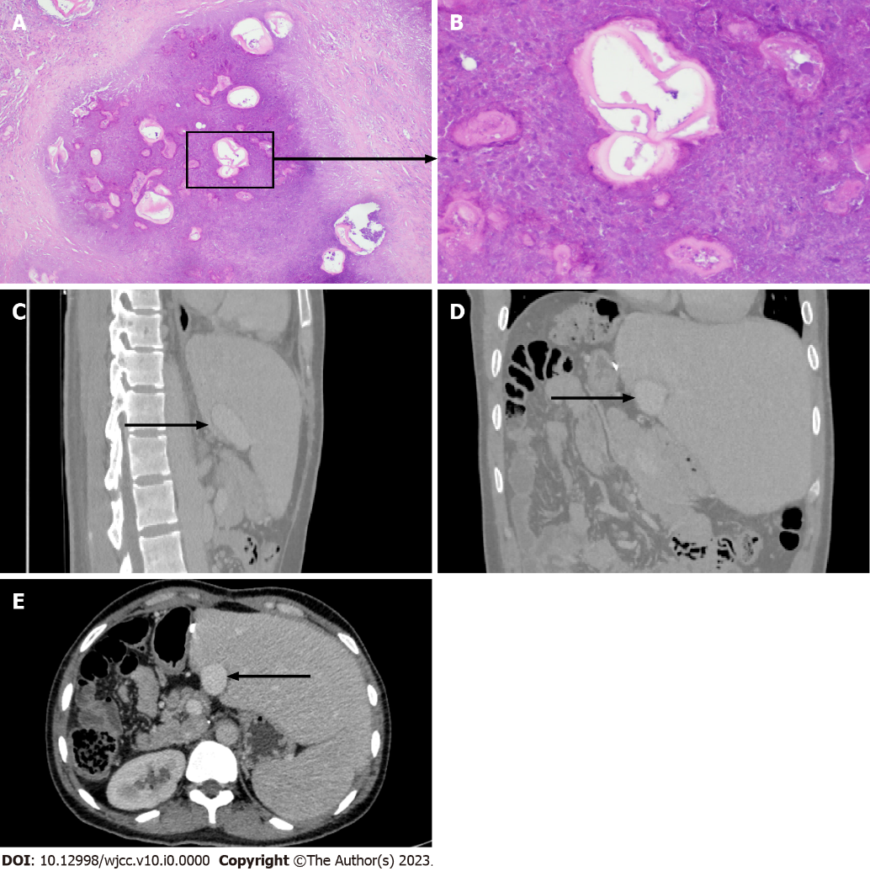
Figure 2 Pathology of alveolar echinococcosis and long-term follow up 7 years after surgery. A: Lesions of hepatic alveolar echinococcosis (AE) (hematoxylin and eosin, ×10); B: Lesions of hepatic AE (hematoxylin and eosin, ×40). Long-term follow-up abdominal computed tomography (CT) shows the morphology of the reconstructed inferior vena cava (IVC) in the coronal plane, sagittal plane, and cross-section at 84 mo post-surgery; C-E: The black arrow indicates the reconstructed IVC.
Table 1 Intraoperative and postoperative parameters
Variables | Case 1
Residual liver volume (m³) | 530
RLV/SLV (%) | 46.2
Operation time (h) | 14.08
Cold ischemia time (min) | 403
Warm ischemia time (min) | 18
Anhepatic phase (min) | 421
Time of inferior vena cava occlusion (min) | 122
Blood loss (mL) | 800
Blood transfusion volume
Suspended RBC (units) | 6
Plasma (mL) | 1070
Autotransfusion (mL) | 750
Cryoprecipitate (units) | 0
Platelet (units) | 0
ICU stay time (h) | 65.4
Hospital stays (d) | 35
Postoperative complications
Pulmonary infection | N
Pleural effusion | Y
Ascites | N
Outflow tract stenosis | N
RLV: Residual liver volume; SLV: Standard liver volume; RBC: Red blood cell; ICU: Intensive care unit.

Table 2 Detailed features of all published cases of complex reconstruction of inferior vena cava
Ref. | Country | Diagnose | Cases | Complex reconstruction of IVC | Reconstructive method | Complications associated with outflow tract reconstruction | Survival
Jianyong et al^{[20]}, 2015 | China | Alveolar echinococcosis | 1 | 1 | Bilateral great saphenous vein, part of the retro hepatic inferior vena and the middle hepatic vein, the inferior mesenteric vein, part of the infra hepatic vena cava | Not mentioned | 1
Hu et al^{[21]}, 2016 | China | Alveolar echinococcosis | 12 | 1 | Disease-free RHIVC, bilateral autogenous great saphenous veins, unilateral common iliac vein | Not mentioned | 11
Buchholz et al^{[22]}, 2020 | United Kingdom | Intrahepatic Caval Leiomyosarcoma | 1 | 1 | 2 caval grafts and the left iliac vein of the graft | Not mentioned | 1
IVC: Inferior vena cava; RHIVC: Retrohepatic inferior vena cava.

