Name of Journal: World Journal of Orthopedics
ESPS Manuscript NO: Number ID: 17041
Manuscript Type: EDITORIAL

Superior labral anterior posterior lesions of the shoulder: Current diagnostic and therapeutic standards

Popp D et al. SLAP lesions of the shoulder

Dominik Popp, Volker Schöffl

Dominik Popp, Volker Schöffl, Section of Sportsorthopedics, Sportsmedicine, Sportstraumatology, Shoulder and Elbow Surgery, Department for Orthopedics and Traumatology, Sozialstiftung Bamberg, Klinikum am Bruderwald, 96049 Bamberg, Germany

Author contributions: Popp D and Schöffl V contributed equally to this paper.

Conflict-of-interest statement: The authors declare not to have any competing interests.

Open-Access: This article is an open-access article which was selected by an in-house editor and fully peer-reviewed by external reviewers. It is distributed in accordance with the Creative Commons Attribution Non Commercial (CC BY-NC 4.0) license, which permits others to distribute, remix, adapt, build upon this work non-commercially, and license their derivative works on different terms, provided the original work is properly cited and the use is non-commercial. See: http://creativecommons.org/licenses/by-nc/4.0/

Correspondence to: Dominik Popp, MD, Section of Sportsorthopedics, Sportsmedicine, Sportstraumatology, Shoulder and Elbow Surgery, Department for Orthopedics and Traumatology, Sozialstiftung Bamberg, Klinikum am Bruderwald, Buger Str. 80, 96049 Bamberg, Germany. dominik.popp@sozialstiftung-bamberg.de
Telephone: +49-951-50315552

Received: February 8, 2015
Peer-review started: February 9, 2015
First decision: March 6, 2015
Revised: July 18, 2015
Accepted: August 4, 2015
Article in press:
Published online:
Abstract
Surgical treatment of superior labral anterior posterior (SLAP) lesion becomes more and more frequent which is the consequence of evolving progress in both, imaging and surgical technique as well as implants. The first classification of SLAP lesions was described in 1990, a subdivision in four types existed. The rising comprehension of pathology and pathophysiology in SLAP lesions contributed to increase the types in SLAP classification to ten. Concerning the causative mechanism of SLAP lesions, acute trauma has to be differed from chronic degeneration. Overhead athletes tend to develop a glenohumeral internal rotation deficit which forms the basis for two controversial discussed potential mechanisms of pathopysiology in SLAP lesions: internal impingement and peel-back mechanism. Clinical examination often remains unspecific whereas soft tissue imaging such as direct or indirect magnetic resonance arthrography has technically improved and is regarded to be indispensable in detection of SLAP lesions. Concomitant pathologies as Bankart lesions, rotator cuff tears or perilabral cysts should be taken into consideration when planning a personalized therapeutic strategy. In addition, normal variants such as sublabral recess, sublabral hole, Buford complex and other less common variants have to be distinguished. The most frequent SLAP type II needs a sophisticated approach when surgical teatment comes into consideration. While SLAP repair is considered to be the standard operative option, overhead athletes benefit from a biceps tenodesis because improved patient-reported satisfaction and higher rate of return to pre-injury level of sports has been reported.

Key words: Superior labral anterior posterior lesion; Tenodesis; Biceps tendon; Shoulder arthroscopy; Superior labral anterior posterior repair

© The Author(s) 2015. Published by Baishideng Publishing Group Inc. All rights reserved.

Core tip: Superior labral anterior posterior (SLAP) lesions often lead to painful shoulder impairment and especially in overhead athletes to restriction in sport specific activity. In the context of diagnostic examination, magnetic resonance arthrography is of particular importance, not only in detection of SLAP lesions and concomitent pathologic findings but also in differentiation from normal anatomic variants. Therapeutic options include -besides conservative treatment- arthroscopic SLAP repair and biceps tendon tenodesis. Decision-making in SLAP lesion remains challenging and requires a distinct evaluation of individual patient history, accurate examination and detailed analysis of imaging to meet the requirements of a personalized treatment.

Popp D, Schöffl V. Superior labral anterior posterior lesions of the shoulder: Current diagnostic and therapeutic standards. World J Orthop 2015; In press
INTRODUCTION
Snyder et al^{[1]} described four types of SLAP lesions (superior labral lesion anterior to posterior) which occur as single entity or associated to additional disorders of the shoulder. Progress in detection of SLAP lesions and development of modern suture anchor systems led to an increasing number of arthroscopic SLAP-repairs.
The highest incidence of SLAP lesions is observed in the 20 to 29 and 40 to 49 year age group^{[2]}. Especially overhead athletes require a precise analysis of complaints and a differentiated evaluation of clinical and radiological findings to avoid postoperative persistent pain an inability to return to previous level of activity.

PATHOPHYSIOLOGY
Anatomy
Vangsness et al^{[3]} described four types of attachment of the long head of the biceps tendon to the superior glenoid rim and to the superior labrum.
Numerous anatomic variants complicate clear discrimination between normal and pathologic findings.
A sublabral recess or sublabral sulcus is defined as a sulcus between superior glenoid cartilage and capsulo-labral complex with smooth edges and is usually located at 10 to 3 o´clock position. Fealy et al^{[4]} reported about the existence of sublabral recess in fetuses after 22nd week of pregnancy already. SLAP lesion may emerge from a sublabral recess by excessive stress.
In contrast, the sublabral hole or sublabral foramen is typically located at 12 to 2 o‘clock position^{[5]} and is a result of congenital fusion failure of the labrum which attaches to the glenoid with a smooth margin or a medial slip^{[6]}.
The Buford complex is described as a congenitally absence of the antero-superior labrum along with a thickened cord-like middle gleno-humeral ligament^{[5]}.

Acute/traumatic SLAP lesions
Traumatic SLAP lesions are commonly caused by a fall onto the outstreched arm or an unexpected pull on the arm e.g. when losing grip of heavy objects or sudden traction (e.g., high bar exercises, hold off body weight in dropping rock climbers)^{[7-10]}. Funk et al^{[11]} reported a rate of 83% among professionel rugby players with SLAP lesions following direct contact of the adducted shoulder which an opposing player or to the surface.

Chronic/degenerative SLAP lesions
Degenerative SLAP lesions can naturally develop with advanced age as a sign of wear in maturity or by increased physical stress affecting particulary overhead workers or overhead athletes. Especially overhead athletes got into center of attention and investigations revealed basic informations about cause and effect of SLAP lesions, which will be described more detailed in the following.

Glenohumeral rotation deficit
Alteration in rotational magnitude has been identified as a potential risk factor in developing shoulder injuries by changing normal glenohumeral kinematics^{[12]}.
Overhead athletes frequently present asymmetrically decreased glenohumeral internal rotation on the dominant side which is considered to be part of positive adaptation to improved force development in conjunction with increased external rotation. The total rotational range of motion usually remains symmetric. Bony changes, capsuloligamentous factors and muscular components have been related to affect glenohumeral range of motion^{[13]}.
When exceeding beyond certain dimensions, alterations in glenohumeral internal rotation and total rotational range of motion can obtain clinical relevance. Side-to-side asymmetries greater than 5° in total rotational range of motion are denoted TROMD (total rotational range of motion deficit). GIRD (glenohumeral internal rotation deficit) is defined as a side-to-side asymmetry in glenohumeral internal rotation greater than 18°^{[14]}. Both findings are implicated in increased risk of shoulder injuries by modifying normal glenohumeral kinematics^{[15]}.

Kinetic chain
Overhead action consists of a complex series of sequential coordinated motions to achieve appropriate body position and motion, and to develop required muscle activity. According to Kibler et al^{[14]}, the kinetic chain meets the following requirements: linking multiple body segments into one functional segment^{[16]}, providing a stable base for distal arm mobility, maximizing force development of the core and transferring it to the hand, interaction of distal joints to increase force and energy capability and decrease distal joint load^{[17]}, and reduction of deceleration forces by producing torques^{[18]}.
Deficits in kinetic chain components have been shown to be associated with shoulder injuries in baseball players and tennis players^{[19]}. To maintain the same energy at ball impact in case of a 20% reduced provision of trunk kinetic energy, 33% more velocity or 70% more mass in distal segments was necessary in mathematical calculations^{[20]}.
Kinetic chain alterations become clinically significant by identifying components of non-shoulder deficits in shoulder injury pathogenesis, even though occurrence and mechanisms in the course of injury sequence remain unclear^{[14]}.

Scapula dyskinesis
The scapula occupies a central position in basic movement patterns of the shoulder and there is strong evidence of scapular kinematic alteration contributing to a variety of shoulder pathologies^{[21]}. Scapula performance is essential to maintain functional interaction with the humerus for efficent motion, joint stabilisation, muscular capability and control^{[22]}.
By definition, scapular dyskinesis characterizes the alteration of normal kinematics and reflects the loss of normal control of scapular motion^{[23]}.
Subsequent internal rotation and anterior tilt can lead to increased tensile strain on the anterior ligaments, enhance the peel-back mechanism of the labro-bicipital complex and give rise to a pathologic internal impingement^{[24]}.
The acronym SICK (Scapular malposition/inferior medial border prominence/coracoid pain/dyskinesis of scapular movement) was used by Burkhart et al^{[25]} to characterize a pattern of scapular abnormality in the disabled overhead athlete shoulder. The excessive scapular protraction leads to glenohumeral hyperangulation in external rotation increasing strain to the undersuface of the posterior rotator cuff area and the anterior-inferior capsular structures, which can intensify the peel-back mechanism^{[25]}.

Internal impingement
Some clinical and cadaveric studies^{[26,27]} demonstrated that contact occurs between the undersurface of the postersuperior rotator cuff and the posterosuperior part of the glenoid in abduction and external rotation both in symptomatic and asymptomatic shoulders. In overhead athletes internal posterosuperior impingement sometimes gets pathologic and has been associated with partial-thickness articular surface tears of the deep side of the rotator cuff and lesions of the labro-bicipital complex resulting from repetitive microtrauma due to recurrent overhead motion under extreme loading conditions^{[28]}. This leads to anterior microinstability caused by gradual stretching of anterior capsulolabral structures and consecutive aggravation of internal impingement^{[27]}.

Peel-back mechanism
Burkhart et al^{[24]} disagreed with the hypothesis of internal impingement provoking shoulder pathologies in the overhead athlete and presented a pathologic cascade leading to SLAP lesions with peel-back mechanism as an important factor.
The posteroinferior capsular contraction is assumed to be the point of origin over the course of the above-mentioned cascade because glenohumeral rotation center migrates to a posterosuperior position with consecutive relaxation of the anteroinferior capsule. Now hyperexternal rotation is possible by reason of minimized cam effect of the proximal humerus and greater tuberosity clearence off the glenoid rim resulting in a magnified arc of external rotation before internal impingement appears.
The peel-back phenomenon^{[29]} has its origin in a biceps vector change in the position of abduction and external rotation resulting in torsional forces to the labrobicipital complex. Once fatigue failure of the posterior superior labrum is nascent, it will start to progressively rotate medially over the upper rim of the glenoid. In cocking position, peel-back forces are at a maximum and additional shearing forces arise during throwing cycle from core energy which is transmitted to the shoulder^{[24]}.

CLASSIFICATION
SLAP lesions were first described by Andrews et al^{[30]}. In 1990 Snyder et al^{[1]} published a classification including four types of lesion which has been extended with three additional types by Maffet et al^{[31]}. At present ten types of SLAP lesions have been defined, although it is controversial whether extensive labral tears such as type VIII or type IX should be classified as SLAP lesion.
The primal classification by Snyder is universally accepted and used. Figure 1 shows SLAP types I to IV (Figure 1).
Type I: predominantly degenerative fraying of the superior labrum without involving the origin of the long head of the biceps tendon.
Type II: most frequent type of lesion. Both superior labrum and biceps tendon are detached from the superior glenoidal rim leading to instability of the labro-bicipital complex (LBC). Morgan et al^{[32]} sub-divided SLAP-II lesions into three subcategories: anterior extension of labral tear (type IIA), posterior extension of labral tear (type IIB), anterior and posterior extension of labral tear (type IIC).
Type III: bucket-handle tear with potential displacement of the mobile labral fragment into the glenohumeral joint. The attachment of the long head of the biceps tendon remains intact.
Type IV: buckle-handle tear with extension to the biceps tendon in a variable degree of affecting the tendon´s cross-section dimension.
Type V: anterior-inferior Bankart lesion in continuity with a type II SLAP lesion
Type VI: combination of a type II SLAP lesion and an unstable labral flap either anterior or posterior.
Type VII: type II SLAP lesion with extension to the capsule and the middle glenohumeral ligament (MGHL).
Type VIII: type IIB SLAP lesion with posterior labral extension.
Type IX: complete or almost complete circumferential detachment of the labrum from the glenoid.
Type X: superior labral tear in combination with extension to the rotator cuff interval or the superior glenohumeral ligament (SGHL) or the coracohumeral ligament (CHL).
Table 1 gives a summary of SLAP types I to X.

DIAGNOSIS
Medical history and examination
A typical symptom especially in overhead athletes is a sudden or gradual deterioration of shoulder function and concomitant pain. In the majority of cases, the predominant arm is concerned. The term “dead arm syndrome“ specifies the inability to execute sports specific movements at pre-injury velocity^{[33]}. Other disorders are sensation of intermittent clicking or popping during cocking phase and anterior shoulder pain. Non-specific history and medical conditions due to concomitant shoulder injuries like rotator cuff tears, capsular-labral lesions, biceps tendinopathy or internal impingement complicate any evaluation of a possible SLAP lesion^{[34]}.
A huge number of clinical tests have been described in detection of SLAP lesions but currently no gold standard could be established with regard to sensitivity or specifity. Initial reports of specific SLAP tests appeared quite promising but mostly did not stand up to further surveys^{[35,36]}.
In order to determine utility of clinical tests in physical examination of the shoulder, Hegedus^{[37]} presented a systematic review with meta-analysis. Among the traditional SLAP tests, relocation test showed best sensitivity; best specificity was found in Yergason‘s test. The compression-rotation test presented the best positive predictive value (Table 2).
More recent tests seem to be encouraging but warrant further investigation. The passive compression test^{[38]} showed a sensitivity of 81.8% and a specificity of 85.7%. The positive predictive value was 87.1%, and the negative predictive value was 80.0%.
The modified dynamic labral shear demonstrated sensitivity of 72%, specificity of 98%, accuracy of 0.84, and a positive likelihood ratio of 31.57^{[39]}. Combinations of clinical tests provide higher accuracy, in case of labral lesions, the best combination was identified to be the modified dynamic labral shear test and O’Brien’s maneuver.
As clinical tests are a key element in diagnosing SLAP lesions, there is still a great need for further studies to improve the diagnostic conclusion and allow the shoulder surgeon to be more efficient in making a firm diagnosis.

Imaging
The central element to confirm the diagnosis of a SLAP lesion is the implementation of magnetic resonance imaging (MRI) and magnetic resonance arthrography (MRA) or computed tomography arthrography (CTA).
Conventional arthrography and computed tomography arthrography are rarely used in detection of SLAP lesions. Specificity of CTA is in the order of 50% to 80%^{[40]}. Investigations comparing conventional MRI to MRA demonstrated a significant improvement in sensitivity and accuracy with little or no reduction in specificity in favor to MRA^{[41-43]}. MRA sensitivity is ranged from 82% to 100%, specificity from 71% to 98% and accuracy from 83% to 94%^{[41,42,44]}. MRA can be realized as direct or indirect MRA. Direct or intraarticular MRA needs increased logisic effort, a contrast medium is applied directly to the glenohumeral joint space by puncture. Advantages are an improved outlining of intraarticular and synovial surfaces^{[45]} by mild distension of the capsule. Potential disadvantages include sensation of pain, bleeding, extravasate into surrounding tissue and risk of infection due to the invasive nature of the procedure.
Indirect or intravenous MRA is non-invasive. Intravenous contrast medium is able to diffuse into the shoulder joint due to the lack of basement membrane^{[46]}. Attention is demanded because of general enhancement of all vascularized structures which may lead to overestimation of pathologies^{[47]}. Figures 2 and 3 give examples of SLAP lesions in MRI.
MRA has not been proven to reliably distinguish between ten types of SLAP lesions. Practically speaking, a detailed description of location, morphology, extend of abnormality and associated injuries is more valuable to the shoulder surgeon than a simple SLAP classification^{[40]}.

MANAGEMENT
A distinct evaluation of individual patient history, accurate examination and detailed analysis of imaging should be the basis for decision-making in therapy of SLAP lesions. Global algorithms of treatment by means of SLAP classification do not exist and do not meet requirements of a personalized treatment.

Non operative treatment
In selected cases non-operative treatment can be successful. SLAP I lesions predispose to a conservative treatment in absence of other intra-articular pathologies. Non-operative treatment for SLAP tears in overhead athletes has been suggested by Edwards et al^{[48]} who showed a 66% of throwers being able to return to play at the same or better level than before. When presenting a GIRD, further progression of external rotation gain and posterior-superior shift of the humeral head can be stopped by conservative treatment with the objective to eliminate posterior-inferior capsular tightness due to shortened IGHL. Various exercises are utilized like the “sleeper stretch” in which the patient lies on his side, flexing both the elbow and shoulder to 90° while the shoulder is passively internally rotated^{[24]}, shoulder cross-body adduction with forward elevation^{[49]}, capsular mobilization^{[50]} or towel/racquet stretches^{[51]}. Additionally performed exercises include strengthening programs for rotator cuff and, especially in the setting of SICK scapula, scapular stabilizers. Closed chain exercises are initially executed in order to address protraction, retraction, elevation/depression and retraction, internal rotation and elevation, and external rotation and depression^{[25]} followed by open chain exercises in the course. Exercises have to be individualized based on the mechanism of injury, functional demand and activity level^{[33]}.
In case of apparent SLAP lesions, overhead athletes often require operative treatment to return to a high level of function, whereas in patients without sportive demands conservative treatment may be sufficient and definitive.

Operative treatment
Operative treatment becomes more and more frequent since arthroscopic techniques and implants have advanced. Individual variety has been shown in operative technique, patient positioning and arthroscopic access.
Several operative concepts coexist in SLAP lesions: simple arthroscopic debridement, arthroscopic SLAP repair/refixation, arthroscopic tenotomy of the long head of the biceps tendon, arthroscopic tenodesis or open/mini-open tenodesis of the long head of the biceps tendon.
Patient positioning can either be in beach chair position or lateral decubitus position. Two or three portal techniques exist (standard posterior viewing portal, anterior portal superior to the upper border of the subscapularis tendon and optional anterosuperior rotator interval portal approximately 1cm off the anterolateral tip of the acromion)^{[52]}.
Isolated arthroscopic labral debridement in unstable SLAP tears demonstrated short-term improvement inside first studies in the 90s, but outcome declined over time^{[53-55]}.
Actually, arthroscopic debridement is recommended in type I SLAP lesions. An example of a type I lesion and concomitant sublabral recess ist shown in Figure 4.
Controversial debates about surgical treatment in case of type II SLAP lesions are still in progress. Surgical reattachment of the LBC at ist origin with the use of transosseous sutures, staples, metal screws, bioabsorbable tacks and bioabsorbable anchors are performed. The use of bioabsorbable tacks has been abandoned due to complications with this fixation type. Persistent postoperative pain and disability^{[56]} as well as dislocation and broken tacks with chondral damage have been reported. Further complications following the use of polyglycolide lactic acid (PLLA) tacks include foreign body synovitis and full-thickness humeral head chondral injury^{[57]}. Sileo et al^{[58]} demonstrated decreased biomechanical strength of knotless suture anchors versus standard suture anchors even though pullout strength was noted to be higher in certain knotless anchor systems^{[59]}. Dines et al^{[60]} suspect the bulky suture knot of standard anchors to be the source of postoperative pain in throwers due to the limited glenohumeral joint space. Positioning of the anchors is supposed to be ideal at the most superior portion of the glenoid rim because glenoid bone stock is most solid there^{[61]}. The anchor should be placed at a 45° angle to the osseous surface at the articular margin. Some authors warn against anchor placement anterior to the biceps tendon to avoid undesired tightening of the MGHL or closure of a sublabral foramen, which may lead to a restricted external rotation^{[62]}.
Numerous biomechanical investigations exist about suture anchor location and configuration. The results are inconsistent; some consider simple sutures to be superior to mattress type configuration^{[63]}, while others demonstrated an advantage of mattress sutures compared to simple sutures with one- and two-point fixation^{[64]}. Morgan et al^{[65]} found parity between one anterior and one posterior simple suture and two posterior simple sutures in resisting “peel-back” forces. No significant differences in functional scores between vertical knot technique and horizontal mattress technique could be found by Yang et al^{[66]} even though last mentionned technique seemed to be favorable with regard to pain and internal rotation at abduction. Castagna et al^{[67]} described a combined technique with one mattress stich posterior and medial to the biceps tendon and one simple stich anterior, which was characterized as an anatomic repair technique. Finally, most surgeons prefer simple translabral sutures with a variety of arthroscopic knots^{[52]}. Figure 4 demonstrates an arthroscopic SLAP repair (Figure 5.).
Due to descouraging results in overhead athletes after arthroscopic SLAP repair, with inconsistent return to their previous level of sports participation and inconsistent subjective patient satisfaction, biceps tenodesis became more and more important^{[68]}. Arthroscopic tenotomy can be performed in patients without esthetic demand and high work load or sporting activities. Tenotomy can be done without need of extraneous material for fixation but down-slippage of the long head of the biceps tendon has to be kept in mind.
During arthroscopic tenodesis, the tendon is fixed at the top of the bicipital groove with bioabsorbable interference screws or bioresorbable anchors. Alternatively a mini-open tenodesis after arthroscopic tenotomyof the long head of the biceps tendon has been described recently. The extraarticular tenodesis is located either subpectoral to preserve length and shape of the tendon and to avoid groove tenderness^{[69]} or above the upper rim of the major pectoral tendon^{[9]} which is assumed to be more favourable in justification of the biceps tendon’s tension. The intraarticular remaining superior labrum should be reattached to prevent articular entrapment. Figures 6 and 7 demonstrate the principle technique of mini-open tenodesis.
Type III SLAP lesions require the resection of the unstable bucket-handle fragment, usually no further stabilisation of the biceps anchor is necessary. If the lesion is causative from an acute trauma and located within the “red-red zone”, refixation of the torn flap analogous to meniscal tears has been recommended by some authors^{[8]}.
Type IV lesion repair depends on biceps tendon stability after resection of the torn flap. At least half of the tendon’s calibre should be intact to preserve stability of the LBC. In case of instable biceps tendon, degenerative appearance and substantial loss of more than 50% of calibre, a tenotomy or tenodesis is performed.
Types V to X include more extended SLAP lesions and require additional treatment of concomitant pathologies.

OUTCOME
SLAP lesion and SLAP repair
Morgan et al^{[32]} presented excellent short-term results after SLAP repair with 87% excellent results overall and 84% return to sports at previous level at 1 year follow-up. In 2010, Friel et al^{[70]} could not observe differences in outcome between overhead athletes, non-overhead athletes, recreational overhead athletes and collegiate overhead athletes after SLAP repair. The conclusion drawn by the authors was that SLAP repair is succesful regardless of occupation or athletics. Funk et al^{[11]} analyzed the outcome in professional rugby players with isolated SLAP lesions in a retrospective cohort study. By 6 month post-operative 89% were satisfied and 95% were able to return to pre-injury level of play. A retrospective study published by Enad et al^{[71]} described efficiency of SLAP repair in military (competitive recreational sports level). Seventy-six point nine percent reached an activity level equal or higher than pre-operative and 96.2% were able to stay in full active duty at final follow-up 30.5 mo after surgery.
Several investigations focused upon SLAP repair in overhead athletes. Among athletes Sayde et al^{[72]} had 83% good to excellent results after SLAP repair and 73% return to previous level of play, but only 63% of overhead athletes could regain the pre-injury level of play. They took the higher incidence of concomitant shoulder pathologies (e.g., shoulder instability, rotator cuff injury) in overhead athletes as a reason for worse outcome. O‘Brien et al^{[73]} used a trans-rotator cuff approach for SLAP repair with only 16 of 31 patints succeeding to return to their previous level of sports, 11 returned to limited activity and two remained inactive at an average follow-up of 3.7 years. In 41 patients treated by arthroscopic type II SLAP lesion repair, only 71% were satisfied, 41% had continued night pain and merely 14 of 29 athletes were able to return to their previous level of sports^{[74]}. Kim et al^{[75]} could prove, that in 34 patients (30 involved in athletic avtivities, 18 overhead athletes) after arthroscopic SLAP repair, overhead athletes had significantly lower shoulder scores and lower percentage of return to preoperative shoulder function than non-overhead athletes.
Overall, reported results after SLAP repair are non-homogeneous and uniform recommendations can not be imposed as a general rule for specific surgical treatment, resulting in variable rates of return to preinjury level. This might be based on multiple confounding variables not consistently accounted for including differences between studies in population demographics, surgical details related to surgical technique, surgeon experience, hardware used, and post-surgical rehabilitation parameters.

SLAP lesion and tenodesis
A prospective cohort study has been published by Boileau et al^{[68]} dividing overhead athletes with SLAP lesion in arthroscopic SLAP repair group (10 patients) and arthroscopic biceps tendon tenodesis group (15 patients). After arthroscopic SLAP repair, only 40% were satisfied and only 20% could return to their pre-injury level of sports. As for athletes treated by arthroscopic biceps tenodesis, 93% were satisfied and 87% were able to return to their previous level of sport. As a source of failure in SLAP repair, the authors stated that the rigid reattachment of the labro-bicipital complex to the upper rim of the glenoid disables the physiological medial rolling of the biceps tendon anchor during abduction and external rotation. Due to traction to the LBC which is innervated by a dense network of sensory sympathetic fibres^{[76]}, persistent shoulder pain is a result. Study validity is lessened by a relatively small sample size and the nonrandomized design.
Schoeffl et al^{[9]} registered excellent results in high-level rock climbers following mini-open tenodesis in a prospective cohort study. At a follow-up of 6 months self-perception of shoulder function and climbing ability was at 96.8%.
Table 3 gives an overview of outcomes after repair of SLAP lesions.

CONCLUSION
Diagnosis and therapy of SLAP lesions remain a challenge despite improvement in imaging and surgical techniques and implants. In face of a various number of clinical SLAP tests, no one could bear up under the aspect of acceptable sensitivity or specificity. Interpretation of MR imaging requires a high degree of specialized knowledge about both pathologic findings and normal variants like sublabral recess or sublabral hole. Decision-making in SLAP lesions, may it be conservativ or surgical, has to be based on multiple factors: patient´s history (acute trauma or chronic degeneration), age, level of physical activity, patient´s expectations and functional demands. SLAP repair represents the standard treatment for the most common SLAP type II with excellent results especially in case of traumatic SLAP lesions. In overhead athletes poor results after SLAP repair have been reported in more focused studies with persistent shoulder pain and long-term inability to return to previous level of sports. A constant pull at the origin of the long head of the biceps tendon, degeneration of the LBC as a consequence of repetitive microtrauma and reduced blood flow are accused to be causative for poor healing tendency. In this cases tenodesis of the biceps tendon may be an appropriate alternative with proven benefit to the patient. Concerns about humeral head migration or anterior instability after removal of the intraarticular part of the long head of the biceps tendon were disproved^{[68]}. As the authors deal with a stately number of overhead athletes (especially rock climbers), a mini-open tenodesis above the upper border of the great pectoral tendon is an alternative in cases with absent signs of fresh injury^{[77]}.

ACKNOWLEDGEMENTS
The author expresses his gratitute to Mr. Willie E Starnes, CW5, Salado (Tx), United States for his extensive help in proofreading in terms of linguistic accuracy.

REFERENCES
1 Snyder SJ, Karzel RP, Del Pizzo W, Ferkel RD, Friedman MJ. SLAP lesions of the shoulder. Arthroscopy 1990; 6: 274-279 [PMID: 2264894 DOI: 10.1016/0749-8063(90)90056-j]
2 Zhang AL, Kreulen C, Ngo SS, Hame SL, Wang JC, Gamradt SC. Demographic trends in arthroscopic SLAP repair in the United States. Am J Sports Med 2012; 40: 1144-1147 [PMID: 22328710]
3 Vangsness CT, Jorgenson SS, Watson T, Johnson DL. The origin of the long head of the biceps from the scapula and glenoid labrum. An anatomical study of 100 shoulders. J Bone Joint Surg Br 1994; 76: 951-954 [PMID: 7983126]
4 Fealy S, Rodeo SA, Dicarlo EF, O'Brien SJ. The developmental anatomy of the neonatal glenohumeral joint. J Shoulder Elbow Surg 2000; 9: 217-222 [PMID: 10888166 DOI: 10.1067/mse.2000.105624]
5 Kwak SM, Brown RR, Resnick D, Trudell D, Applegate GR, Haghighi P. Anatomy, anatomic variations, and pathology of the 11- to 3-o'clock position of the glenoid labrum: findings on MR arthrography and anatomic sections. AJR Am J Roentgenol 1998; 171: 235-238 [PMID: 9648795 DOI: 10.2214/ajr.171.1.9648795]
6 Chang D, Mohana-Borges A, Borso M, Chung CB. SLAP lesions: anatomy, clinical presentation, MR imaging diagnosis and characterization. Eur J Radiol 2008; 68: 72-87 [PMID: 18499376 DOI: 10.1016/j.ejrad.2008.02.026]
7 Mileski RA, Snyder SJ. Superior labral lesions in the shoulder: pathoanatomy and surgical management. J Am Acad Orthop Surg 1998; 6: 121-131 [PMID: 9682075]
8 Lichtenberg S, Magosch P, Habermeyer P. [Superior labrum-biceps anchor complex]. Orthopade 2003; 32: 616-626 [PMID: 12883761 DOI: 10.1007/s00132-003-0491-5]
9 Schöffl V, Popp D, Dickschass J, Küpper T. Superior labral anterior-posterior lesions in rock climbers—primary double tenodesis? Clin J Sport Med 2011; 21: 261-263 [PMID: 21487291 DOI: 10.1097/JSM.0b013e31821a61e3]
10 Schöffl V, Popp D, Küpper T, Schöffl I. Injury trends in rock climbers: evaluation of a case series of 911 injuries between 2009 and 2012. Wilderness Environ Med 2015; 26: 62-67 [PMID: 25712297 DOI: 10.1016/j.wem.2014.08.013]
11 Funk L, Snow M. SLAP tears of the glenoid labrum in contact athletes. Clin J Sport Med 2007; 17: 1-4 [PMID: 17303998 DOI: 10.1097/jsm.0b013e31802ede87]
12 Grossman MG, Tibone JE, McGarry MH, Schneider DJ, Veneziani S, Lee TQ. A cadaveric model of the throwing shoulder: a possible etiology of superior labrum anterior-to-posterior lesions. J Bone Joint Surg Am 2005; 87: 824-831 [PMID: 15805213 DOI: 10.2106/JBJS.D.01972]
13 Meister K, Day T, Horodyski M, Kaminski TW, Wasik MP, Tillman S. Rotational motion changes in the glenohumeral joint of the adolescent/Little League baseball player. Am J Sports Med 2005; 33: 693-698 [PMID: 15722284 DOI: 10.1177/0363546504269936]
14 Kibler WB, Kuhn JE, Wilk K, Sciascia A, Moore S, Laudner K, Ellenbecker T, Thigpen C, Uhl T. The disabled throwing shoulder: spectrum of pathology-10-year update. Arthroscopy 2013; 29: 141-161.e26 [PMID: 23276418]
15 Wilk KE, Macrina LC, Fleisig GS, Porterfield R, Simpson CD, Harker P, Paparesta N, Andrews JR. Correlation of glenohumeral internal rotation deficit and total rotational motion to shoulder injuries in professional baseball pitchers. Am J Sports Med 2011; 39: 329-335 [PMID: 21131681 DOI: 10.1177/]
16 Lintner D, Noonan TJ, Kibler WB. Injury patterns and biomechanics of the athlete's shoulder. Clin Sports Med 2008; 27: 527-551 [PMID: 19064144]
17 Hirashima M, Yamane K, Nakamura Y, Ohtsuki T. Kinetic chain of overarm throwing in terms of joint rotations revealed by induced acceleration analysis. J Biomech 2008; 41: 2874-2883 [PMID: 18678375 DOI: 10.1016/]
18 Fleisig GS, Barrentine SW, Escamilla RF, Andrews JR. Biomechanics of overhand throwing with implications for injuries. Sports Med 1996; 21: 421-437 [PMID: 8784962]
19 Robb AJ, Fleisig G, Wilk K, Macrina L, Bolt B, Pajaczkowski J. Passive ranges of motion of the hips and their relationship with pitching biomechanics and ball velocity in professional baseball pitchers. Am J Sports Med 2010; 38: 2487-2493 [PMID: 20807860 DOI: 10.1177/0363546510375535]
20 Kibler WB. Biomechanical analysis of the shoulder during tennis activities. Clin Sports Med 1995; 14: 79-85 [PMID: 7712559]
21 Green RA, Taylor NF, Watson L, Ardern C. Altered scapula position in elite young cricketers with shoulder problems. J Sci Med Sport 2013; 16: 22-27 [PMID: 22748568 DOI: 10.1016/j.jsams.2012.05.017]
22 Kibler WB, Ludewig PM, McClure PW, Michener LA, Bak K, Sciascia AD. Clinical implications of scapular dyskinesis in shoulder injury: the 2013 consensus statement from the 'Scapular Summit'. Br J Sports Med 2013; 47: 877-885 [PMID: 23580420 DOI: 10.1136/bjsports-2013-092425]
23 Kibler WB, Ludewig PM, McClure P, Uhl TL, Sciascia A. Scapular Summit 2009: introduction. July 16, 2009, Lexington, Kentucky. J Orthop Sports Phys Ther 2009; 39: A1-A13 [PMID: 19881011 DOI: 10.2519/jospt.2009.0303]
24 Burkhart SS, Morgan CD, Kibler WB. The disabled throwing shoulder: spectrum of pathology Part I: pathoanatomy and biomechanics. Arthroscopy 2003; 19: 404-420 [PMID: 12671624 DOI: 10.1053/jars.2003.50128]
25 Burkhart SS, Morgan CD, Kibler WB. The disabled throwing shoulder: spectrum of pathology Part III: The SICK scapula, scapular dyskinesis, the kinetic chain, and rehabilitation. Arthroscopy 2003; 19: 641-661 [PMID: 12861203 DOI: 10.1016/s0749-8063(03)00389-x]
26 Walch G, Boileau P, Noel E, Donell ST. Impingement of the deep surface of the supraspinatus tendon on the posterosuperior glenoid rim: An arthroscopic study. J Shoulder Elbow Surg 1992; 1: 238-245 [PMID: 22959196 DOI: 10.1016/S1058-2746(09)80065-7]
27 Jobe CM. Posterior superior glenoid impingement: expanded spectrum. Arthroscopy 1995; 11: 530-536 [PMID: 8534293]
28 Drakos MC, Rudzki JR, Allen AA, Potter HG, Altchek DW. Internal impingement of the shoulder in the overhead athlete. J Bone Joint Surg Am 2009; 91: 2719-2728 [PMID: 19884449 DOI: 10.2106/JBJS.I.00409]
29 Burkhart SS, Morgan CD. The peel-back mechanism: its role in producing and extending posterior type II SLAP lesions and its effect on SLAP repair rehabilitation. Arthroscopy 1998; 14: 637-640 [PMID: 9754487]
30 Andrews JR, Carson WG, McLeod WD. Glenoid labrum tears related to the long head of the biceps. Am J Sports Med 1985; 13: 337-341 [PMID: 4051091 DOI: 10.1177/036354658501300508]
31 Maffet MW, Gartsman GM, Moseley B. Superior labrum-biceps tendon complex lesions of the shoulder. Am J Sports Med 1995; 23: 93-98 [PMID: 7726358 DOI: 10.1177/036354659502300116]
32 Morgan CD, Burkhart SS, Palmeri M, Gillespie M. Type II SLAP lesions: three subtypes and their relationships to superior instability and rotator cuff tears. Arthroscopy 1998; 14: 553-565 [PMID: 9754471 DOI: 10.1016/s0749-8063(98)70049-0]
33 Bedi A, Allen AA. Superior labral lesions anterior to posterior-evaluation and arthroscopic management. Clin Sports Med 2008; 27: 607-630 [PMID: 19064147 DOI: 10.1016/j.csm.2008.06.002]
34 Angelo RL. The overhead athlete: how to examine, test, and treat shoulder injuries. Intra-articular pathology. Arthroscopy 2003; 19 Suppl 1: 47-50 [PMID: 14673419 DOI: 10.1016/j.arthro.2003.09.046]
35 Myers TH, Zemanovic JR, Andrews JR. The resisted supination external rotation test: a new test for the diagnosis of superior labral anterior posterior lesions. Am J Sports Med 2005; 33: 1315-1320 [PMID: 16002494 DOI: 10.1177/0363546504273050]
36 Parentis MA, Glousman RE, Mohr KS, Yocum LA. An evaluation of the provocative tests for superior labral anterior posterior lesions. Am J Sports Med 2006; 34: 265-268 [PMID: 16219944 DOI: 10.1177/0363546505279911]
37 Hegedus EJ, Goode AP, Cook CE, Michener L, Myer CA, Myer DM, Wright AA. Which physical examination tests provide clinicians with the most value when examining the shoulder? Update of a systematic review with meta-analysis of individual tests. Br J Sports Med 2012; 46: 964-978 [PMID: 22773322 DOI: 10.1136/bjsports-2012-091066]
38 Kim YS, Kim JM, Ha KY, Choy S, Joo MW, Chung YG. The passive compression test: a new clinical test for superior labral tears of the shoulder. Am J Sports Med 2007; 35: 1489-1494 [PMID: 17478654 DOI: 10.1177/0363546507301884]
39 Ben Kibler W, Sciascia AD, Hester P, Dome D, Jacobs C. Clinical utility of traditional and new tests in the diagnosis of biceps tendon injuries and superior labrum anterior and posterior lesions in the shoulder. Am J Sports Med 2009; 37: 1840-1847 [PMID: 19509414 DOI: 10.1177/0363546509332505]
40 Simoni P, Scarciolla L, Kreutz J, Meunier B, Beomonte Zobel B. Imaging of superior labral anterior to posterior (SLAP) tears of the shoulder. J Sports Med Phys Fitness 2012; 52: 622-630 [PMID: 23187325]
41 Herold T, Hente R, Zorger N, Finkenzeller T, Feuerbach S, Lenhart M, Paetzel C. [Indirect MR-arthrography of the shoulder-value in the detection of SLAP-lesions]. Rofo 2003; 175: 1508-1514 [PMID: 14610702 DOI: 10.1055/s-2004-827736]
42 Dinauer PA, Flemming DJ, Murphy KP, Doukas WC. Diagnosis of superior labral lesions: comparison of noncontrast MRI with indirect MR arthrography in unexercised shoulders. Skeletal Radiol 2007; 36: 195-202 [PMID: 17139503 DOI: 10.1007/s00256-006-0237-7]
43 Holzapfel K, Waldt S, Bruegel M, Paul J, Heinrich P, Imhoff AB, Rummeny EJ, Woertler K. Inter- and intraobserver variability of MR arthrography in the detection and classification of superior labral anterior posterior (SLAP) lesions: evaluation in 78 cases with arthroscopic correlation. Eur Radiol 2010; 20: 666-673 [PMID: 19727741 DOI: 10.1007/s00330-009-1593-1]
44 Applegate GR, Hewitt M, Snyder SJ, Watson E, Kwak S, Resnick D. Chronic labral tears: value of magnetic resonance arthrography in evaluating the glenoid labrum and labral-bicipital complex. Arthroscopy 2004; 20: 959-963 [PMID: 15525929 DOI: 10.1016/j.arthro.2004.08.017]
45 Tuite MJ, Rutkowski A, Enright T, Kaplan L, Fine JP, Orwin J. Width of high signal and extension posterior to biceps tendon as signs of superior labrum anterior to posterior tears on MRI and MR arthrography. AJR Am J Roentgenol 2005; 185: 1422-1428 [PMID: 16303992 DOI: 10.2214/ajr.04.1684]
46 Bergin D, Schweitzer ME. Indirect magnetic resonance arthrography. Skeletal Radiol 2003; 32: 551-558 [PMID: 12942203 DOI: 10.1007/s00256-003-0669-2]
47 Sahin G, Demirtaş M. An overview of MR arthrography with emphasis on the current technique and applicational hints and tips. Eur J Radiol 2006; 58: 416-430 [PMID: 16464555 DOI: 10.1016/j.ejrad.2006.01.002]
48 Edwards SL, Lee JA, Bell JE, Packer JD, Ahmad CS, Levine WN, Bigliani LU, Blaine TA. Nonoperative treatment of superior labrum anterior posterior tears: improvements in pain, function, and quality of life. Am J Sports Med 2010; 38: 1456-1461 [PMID: 20522835 DOI: 10.1177/0363546510370937]
49 McClure P, Tate AR, Kareha S, Irwin D, Zlupko E. A clinical method for identifying scapular dyskinesis, part 1: reliability. J Athl Train 2009; 44: 160-164 [PMID: 19295960 DOI: 10.4085/1062-6050-44.2.160]
50 Tyler TF, Nicholas SJ, Roy T, Gleim GW. Quantification of posterior capsule tightness and motion loss in patients with shoulder impingement. Am J Sports Med 2000; 28: 668-673 [PMID: 11032222 DOI: 10.1177/0363546509346050]
51 Kibler WB, Chandler TJ. Range of motion in junior tennis players participating in an injury risk modification program. J Sci Med Sport 2003; 6: 51-62 [PMID: 12801210 DOI: 10.1016/s1440-2440(03)80008-7]
52 Burkhart SS, Morgan CD, Kibler WB. The disabled throwing shoulder: spectrum of pathology. Part II: evaluation and treatment of SLAP lesions in throwers. Arthroscopy 2003; 19: 531-539 [PMID: 12724684 DOI: 10.1053/jars.2003.50139]
53 Snyder SJ, Banas MP, Karzel RP. An analysis of 140 injuries to the superior glenoid labrum. J Shoulder Elbow Surg 1995; 4: 243-248 [PMID: 8542365 DOI: 10.1016/s1058-2746(05)80015-1]
54 Altchek DW, Warren RF, Wickiewicz TL, Ortiz G. Arthroscopic labral debridement. A three-year follow-up study. Am J Sports Med 1992; 20: 702-706 [PMID: 1456364 DOI: 10.1177/036354659202000611]
55 Cordasco FA, Steinmann S, Flatow EL, Bigliani LU. Arthroscopic treatment of glenoid labral tears. Am J Sports Med 1993; 21: 425-30; discussion 430-1 [PMID: 8346758 DOI: 10.1177/036354659302100317]
56 Sassmannshausen G, Sukay M, Mair SD. Broken or dislodged poly-L-lactic acid bioabsorbable tacks in patients after SLAP lesion surgery. Arthroscopy 2006; 22: 615-619 [PMID: 16762699 DOI: 10.1016/j.arthro.2006.03.009]
57 Wilkerson JP, Zvijac JE, Uribe JW, Schürhoff MR, Green JB. Failure of polymerized lactic acid tacks in shoulder surgery. J Shoulder Elbow Surg 2003; 12: 117-121 [PMID: 12700561 DOI: 10.1067/mse.2003.16]
58 Sileo MJ, Lee SJ, Kremenic IJ, Orishimo K, Ben-Avi S, McHugh M, Nicholas SJ. Biomechanical comparison of a knotless suture anchor with standard suture anchor in the repair of type II SLAP tears. Arthroscopy 2009; 25: 348-354 [PMID: 19341920 DOI: 10.1016/j.arthro.2008.10.019]
59 Leedle BP, Miller MD. Pullout strength of knotless suture anchors. Arthroscopy 2005; 21: 81-85 [PMID: 15650671 DOI: 10.1016/j.arthro.2004.08.011]
60 Dines JS, Elattrache NS. Horizontal mattress with a knotless anchor to better recreate the normal superior labrum anatomy. Arthroscopy 2008; 24: 1422-1425 [PMID: 19038714 DOI: 10.1016/j.arthro.2008.06.012]
61 Lehtinen JT, Tingart MJ, Apreleva M, Ticker JB, Warner JJ. Anatomy of the superior glenoid rim. Repair of superior labral anterior to posterior tears. Am J Sports Med 2003; 31: 257-260 [PMID: 12642262 DOI: 10.1016/j.arthro.2003.11.029]
62 Yoneda M, Nakagawa S, Mizuno N, Fukushima S, Hayashida K, Mae T, Izawa K. Arthroscopic capsular release for painful throwing shoulder with posterior capsular tightness. Arthroscopy 2006; 22: 801.e1-801.e5 [PMID: 16848064 DOI: 10.1016/j.arthro.2005.12.056]
63 Domb BG, Ehteshami JR, Shindle MK, Gulotta L, Zoghi-Moghadam M, MacGillivray JD, Altchek DW. Biomechanical comparison of 3 suture anchor configurations for repair of type II SLAP lesions. Arthroscopy 2007; 23: 135-140 [PMID: 17276220 DOI: 10.1016/j.arthro.2006.10.018]
64 Yoo JC, Ahn JH, Lee SH, Lim HC, Choi KW, Bae TS, Lee CY. A biomechanical comparison of repair techniques in posterior type II superior labral anterior and posterior (SLAP) lesions. J Shoulder Elbow Surg 2008; 17: 144-149 [PMID: 18069010 DOI: 10.1016/j.jse.2007.03.025]
65 Morgan RJ, Kuremsky MA, Peindl RD, Fleischli JE. A biomechanical comparison of two suture anchor configurations for the repair of type II SLAP lesions subjected to a peel-back mechanism of failure. Arthroscopy 2008; 24: 383-388 [PMID: 18375268 DOI: 10.1016/j.arthro.2007.09.014]
66 Yang HJ, Yoon K, Jin H, Song HS. Clinical outcome of arthroscopic SLAP repair: conventional vertical knot versus knotless horizontal mattress sutures. Knee Surg Sports Traumatol Arthrosc 2014; [PMID: 25427975 DOI: 10.1007/s00167-014-3449-8]
67 Castagna A, De Giorgi S, Garofalo R, Tafuri S, Conti M and Moretti B. A new anatomic technique for type II SLAP lesions repair. Knee Surg Sports Traumatol Arthrosc 2014 [PMID: 25413594 DOI: 10.1007/s00167-014-3440-4]
68 Boileau P, Parratte S, Chuinard C, Roussanne Y, Shia D, Bicknell R. Arthroscopic treatment of isolated type II SLAP lesions: biceps tenodesis as an alternative to reinsertion. Am J Sports Med 2009; 37: 929-936 [PMID: 19229046 DOI: 10.1177/0363546508330127]
69 Braun S, Minzlaff P, Imhoff AB. [Subpectoral tenodesis of the long head of the biceps tendon for pathologies of the long head of the biceps tendon and the biceps pulley]. Oper Orthop Traumatol 2012; 24: 479-485 [PMID: 22805714 DOI: 10.1007/s00064-012-0178-3]
70 Friel NA, Karas V, Slabaugh MA, Cole BJ. Outcomes of type II superior labrum, anterior to posterior (SLAP) repair: prospective evaluation at a minimum two-year follow-up. J Shoulder Elbow Surg 2010; 19: 859-867 [PMID: 20554453 DOI: 10.1016/j.jse.2010.03.004]
71 Enad JG, Gaines RJ, White SM, Kurtz CA. Arthroscopic superior labrum anterior-posterior repair in military patients. J Shoulder Elbow Surg 2007; 16: 300-305 [PMID: 17363292 DOI: 10.1016/j.jse.2006.05.015]
72 Sayde WM, Cohen SB, Ciccotti MG, Dodson CC. Return to play after Type II superior labral anterior-posterior lesion repairs in athletes: a systematic review. Clin Orthop Relat Res 2012; 470: 1595-1600 [PMID: 22395873 DOI: 10.1007/s11999-012-2295-6]
73 O'Brien SJ, Allen AA, Coleman SH, Drakos MC. The trans-rotator cuff approach to SLAP lesions: technical aspects for repair and a clinical follow-up of 31 patients at a minimum of 2 years. Arthroscopy 2002; 18: 372-377 [PMID: 11951195 DOI: 10.1053/jars.2002.30646]
74 Cohen DB, Coleman S, Drakos MC, Allen AA, O'Brien SJ, Altchek DW, Warren RF. Outcomes of isolated type II SLAP lesions treated with arthroscopic fixation using a bioabsorbable tack. Arthroscopy 2006; 22: 136-142 [PMID: 16458798 DOI: 10.1016/j.arthro.2005.11.002]
75 Kim SH, Ha KI, Kim SH, Choi HJ. Results of arthroscopic treatment of superior labral lesions. J Bone Joint Surg Am 2002; 84-A: 981-985 [PMID: 12063332 DOI: 10.4055/cios.2014.6.2.159]
76 Alpantaki K, McLaughlin D, Karagogeos D, Hadjipavlou A, Kontakis G. Sympathetic and sensory neural elements in the tendon of the long head of the biceps. J Bone Joint Surg Am 2005; 87: 1580-1583 [PMID: 15995126 DOI: 10.2106/jbjs.d.02840]
77 Popp D, Schöffl V. Shoulder SLAP and biceps tendon repair. Minerva Ortopedicae Traumatologica 2013; 64: 247-263
78 Powell S, Nord K, Ryu R. The diagnosis, classification and treatment of SLAP lesions. Oper Tech Sports Med 2004; 12: 99-110 [DOI: 10.1053/j.otsm.2004.07.001]
79 Coleman SH, Cohen DB, Drakos MC, Allen AA, Williams RJ, O'brien SJ, Altchek DW, Warren RF. Arthroscopic repair of type II superior labral anterior posterior lesions with and without acromioplasty: a clinical analysis of 50 patients. Am J Sports Med 2007; 35: 749-753 [PMID: 17267765 DOI: 10.1177/0363546506296735]
80 Brockmeier SF, Voos JE, Williams RJ, Altchek DW, Cordasco FA, Allen AA. Outcomes after arthroscopic repair of type-II SLAP lesions. J Bone Joint Surg Am 2009; 91: 1595-1603 [PMID: 19571081 DOI: 10.2106/JBJS.H.00205]
81 Voos JE, Pearle AD, Mattern CJ, Cordasco FA, Allen AA, Warren RF. Outcomes of combined arthroscopic rotator cuff and labral repair. Am J Sports Med 2007; 35: 1174-1179 [PMID: 17387217 DOI: 10.1177/0363546507300062]
82 Youm T, Matthews PV, El Attrache NS. Treatment of patients with spinoglenoid cysts associated with superior labral tears without cyst aspiration, debridement, or excision. Arthroscopy 2006; 22: 548-552 [PMID: 16651166 DOI: 10.1016/j.arthro.2005.12.060]

P-Reviewer: Ertem K, Ko SH, Sciascia AD S-Editor: Ji FF L-Editor: E-Editor:

A B
C D

Figure 1 Superior labral anterior posterior classification. A: SLAP I lesion: degenerative fraying of the superior labrum; B: SLAP II lesion: detached labro-bicipital complex; C: SLAP III lesion: bucket-handle tear; D: SLAP III lesion: bucket-handle tear with extension to the biceps tendon. SLAP: Superior labral anterior posterior.

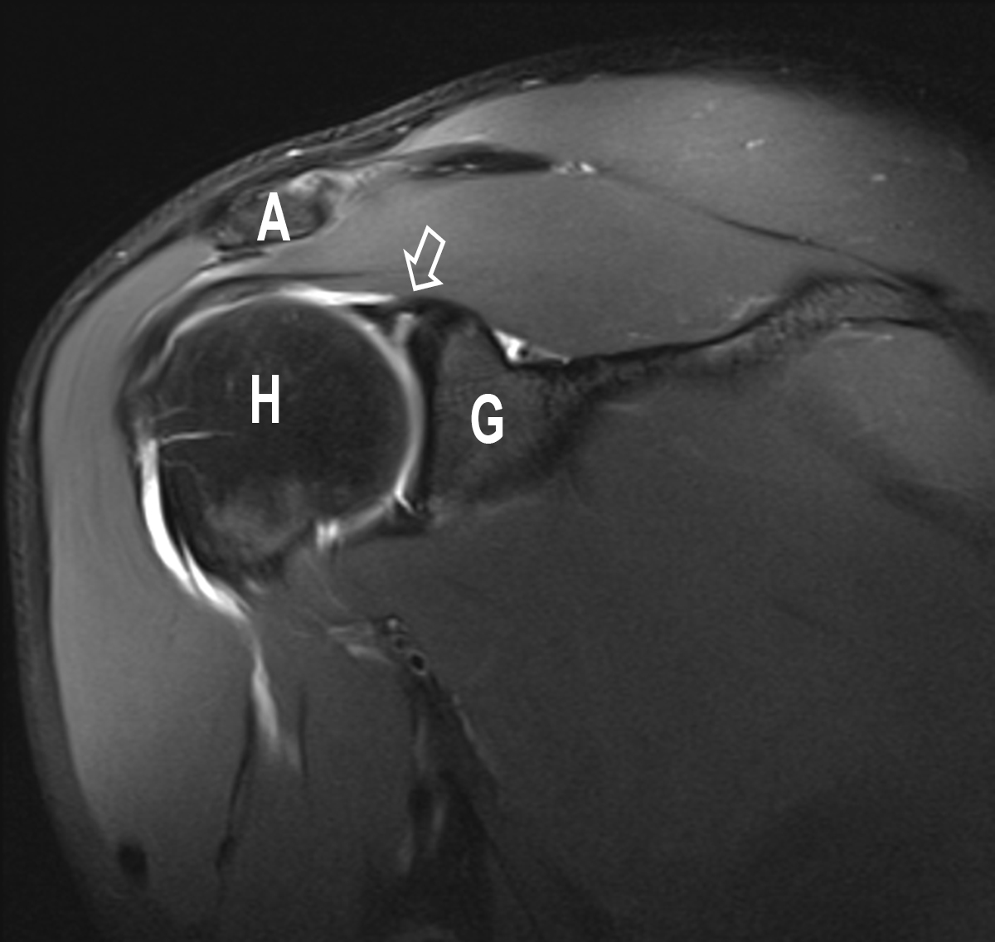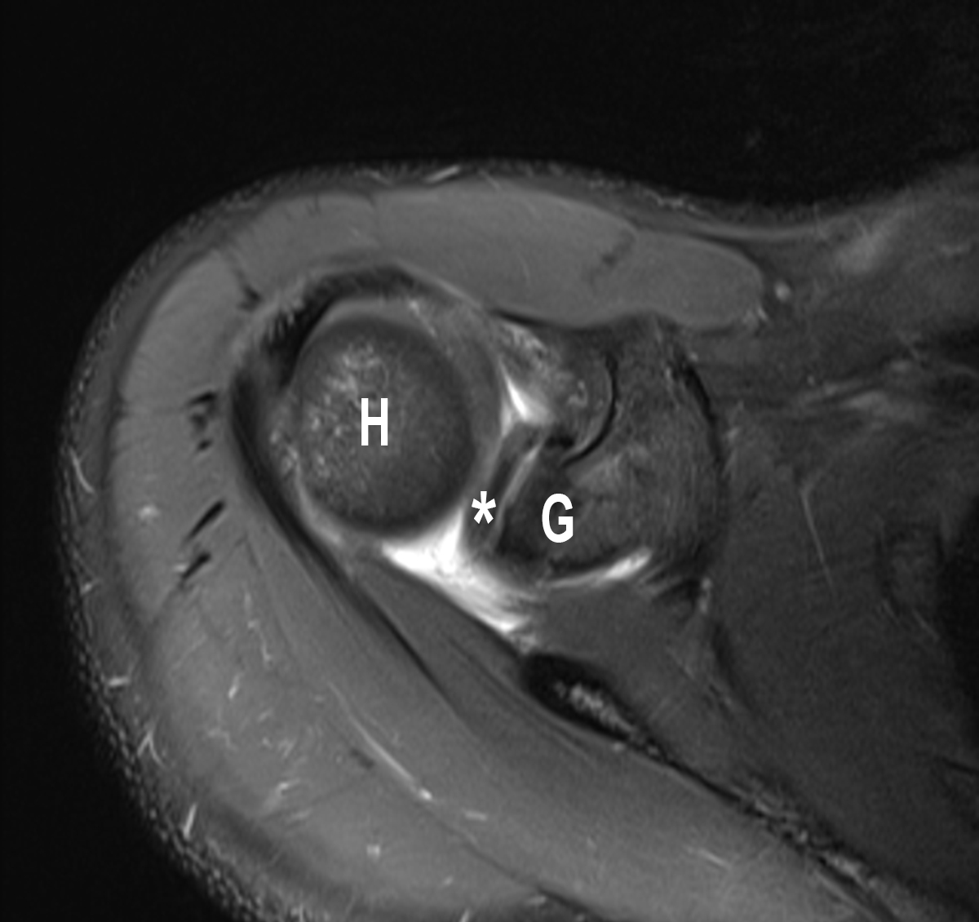

Figure 2 Superior labral anterior posterior II lesion: Findings in direct magnetic resonance arthrography. A: The coronal oblique fat saturated image (cor pd tse fs) shows the detached labro-bicipital complex from the upper rim of the glenoid. The tear is marked by the arrow; B: The transverse fat saturated MRA-image (tra pd tse fs) reveals the slight runnel of contrast agent between superior labrum (*) and glenoid. A: Acromion; H: Humeral head; G: Glenoid;

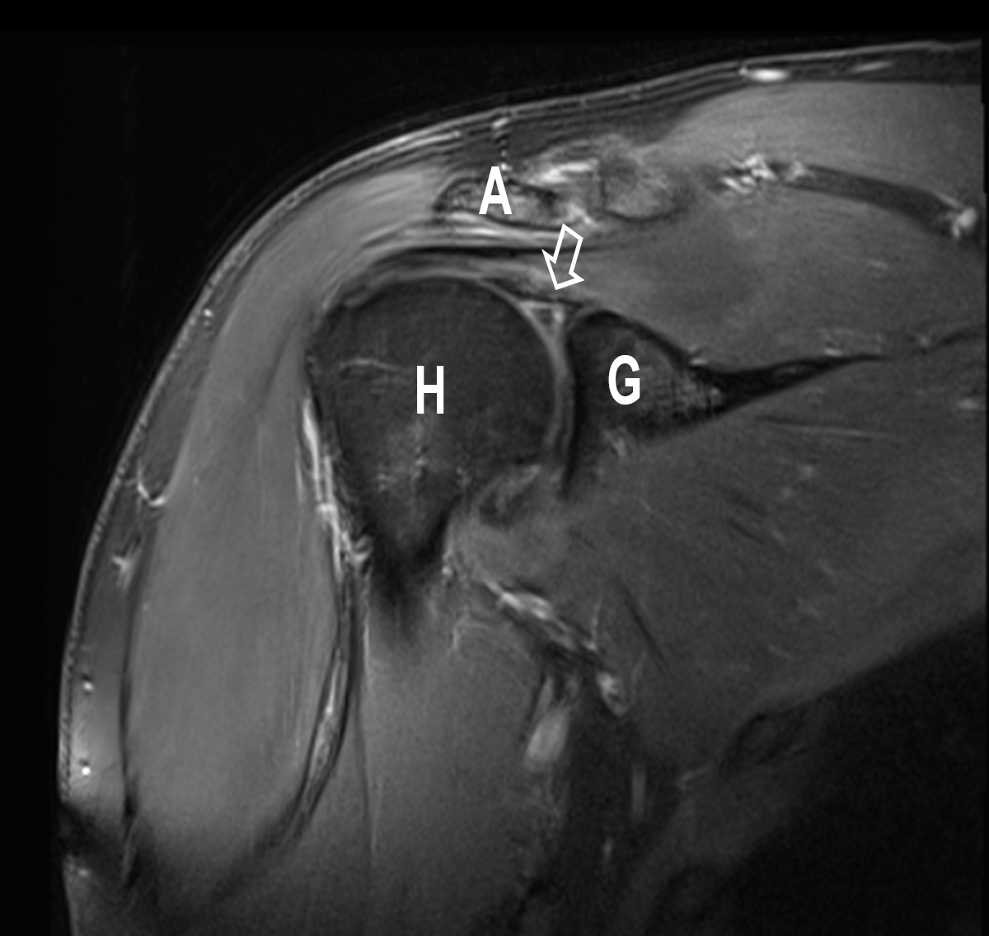

Figure 3 Superior labral anterior posterior III lesion: Findings in direct magnetic resonance arthrography. The coronal T1-weighted (cor t1 tse fs) fat-saturated image shows the separated triangle (arrow) of the bucket-handle without instability of the labro-bicipital complex. A: Acromion; H: Humeral head; G: Glenoid
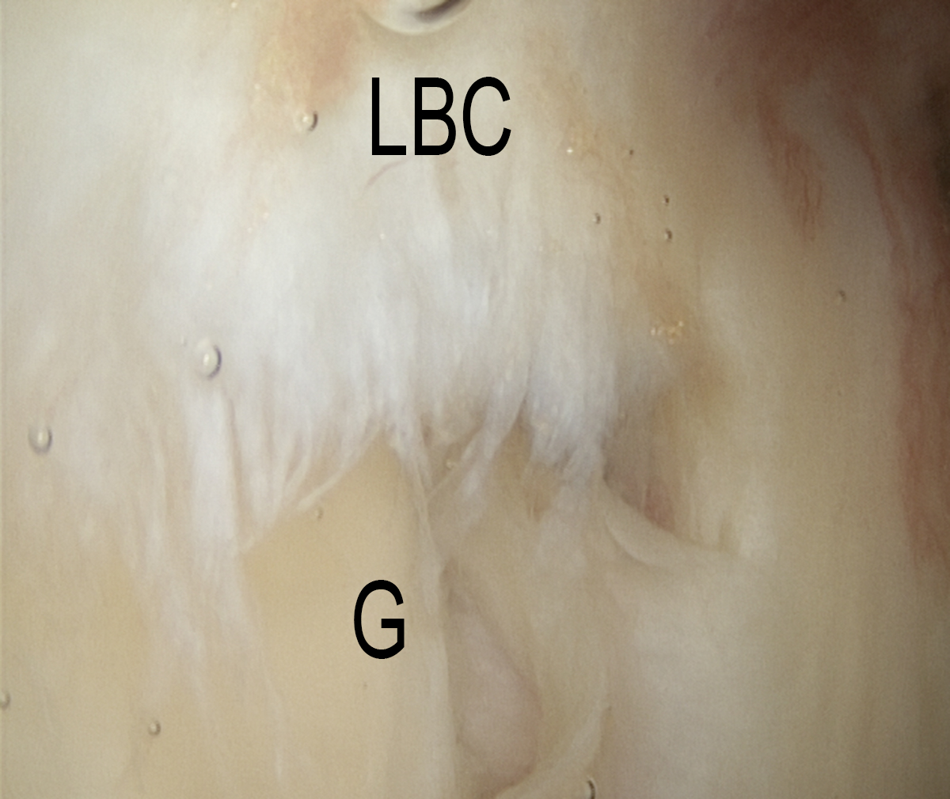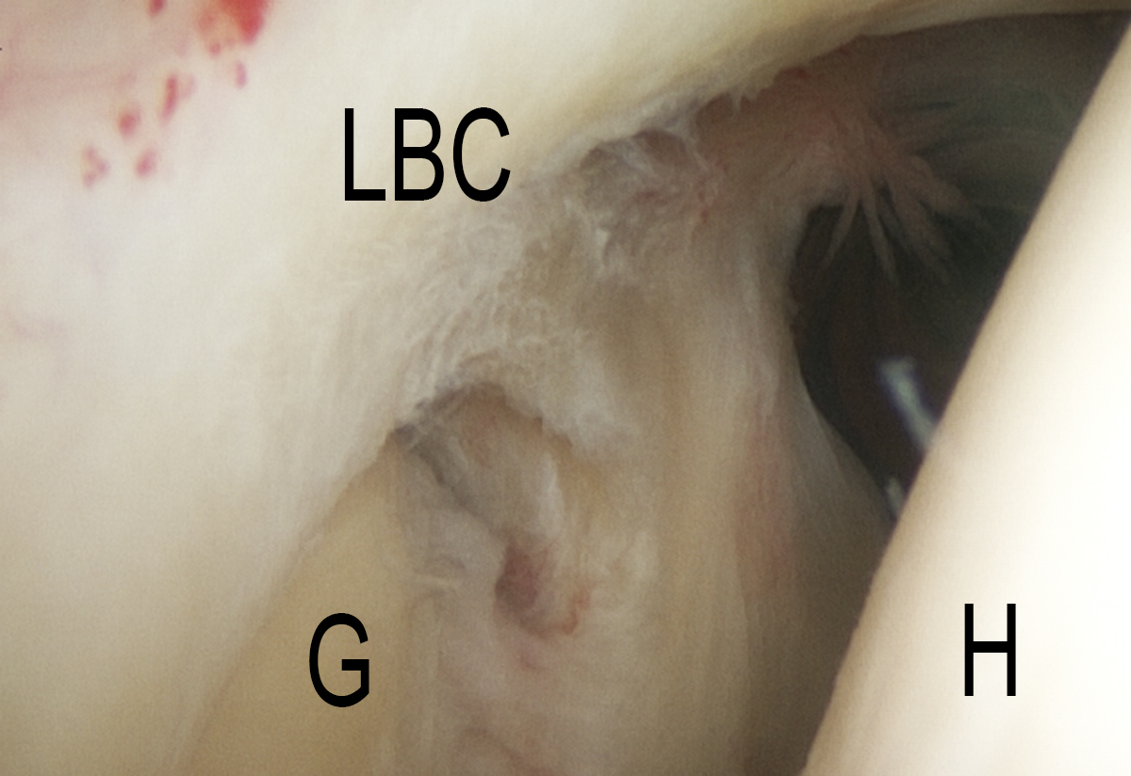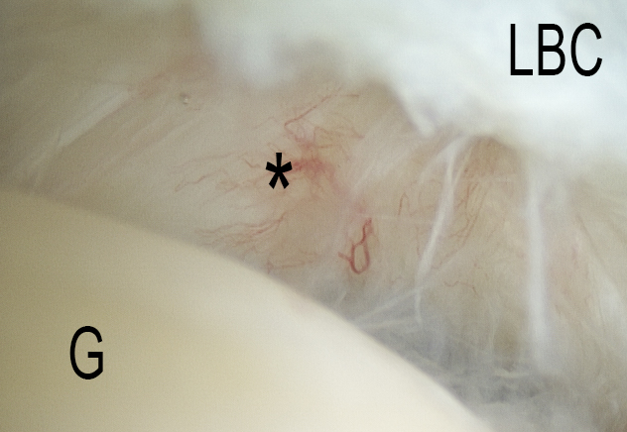

Figure 4 Superior labral anterior posterior I lesion: intraoperative findings in shoulder arthroscopy (posterior-anterior view from the posterior portal of a right shoulder). A: A degenerative fraying of the superior labrum could be detected by
diagnostic arthroscopy; B: After debridement of the superior labrum, a sublabral recess appears. The presence of a type II SLAP lesion should be excluded; C: A more detailed demonstration of the sublabral recess (*) with smooth
lining without instability of the labro-bicipital complex. LBC: Labro-bicipital complex; H: Humeral head; G: Glenoid; SLAP: Superior labral anterior posterior.

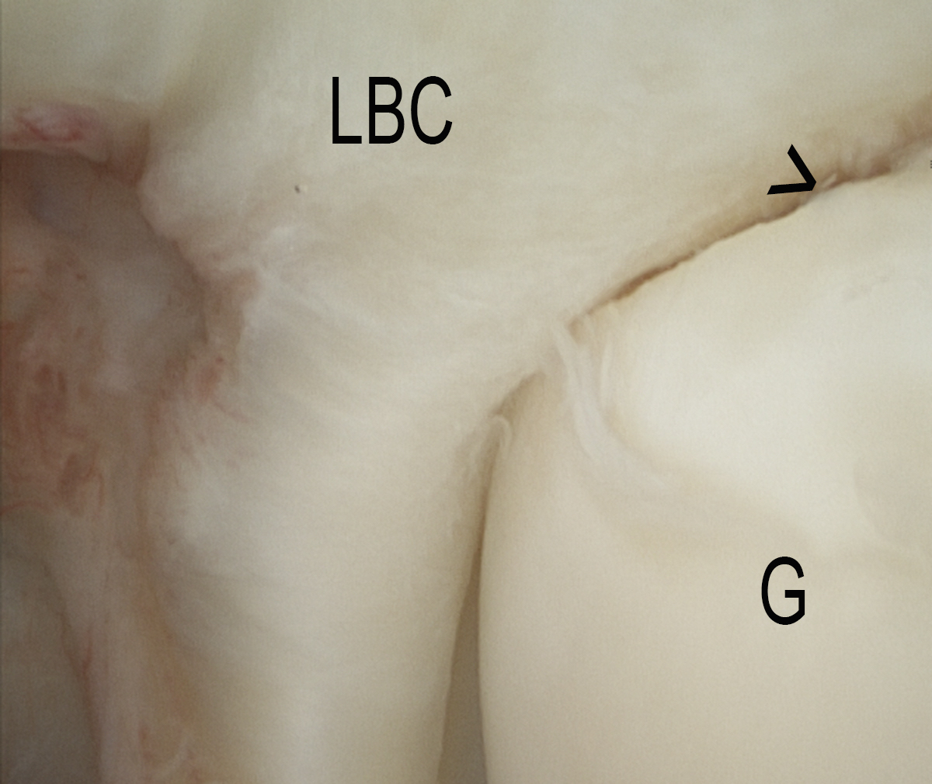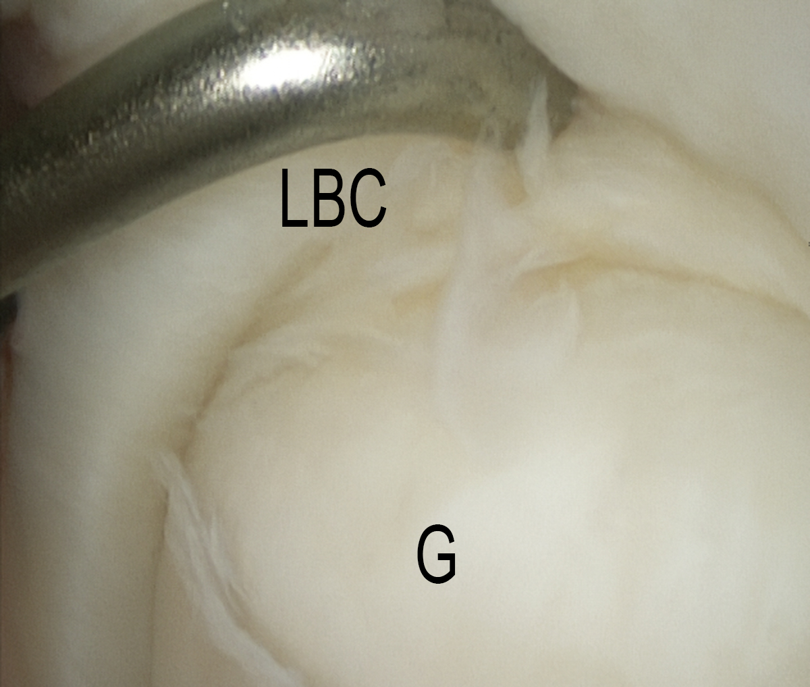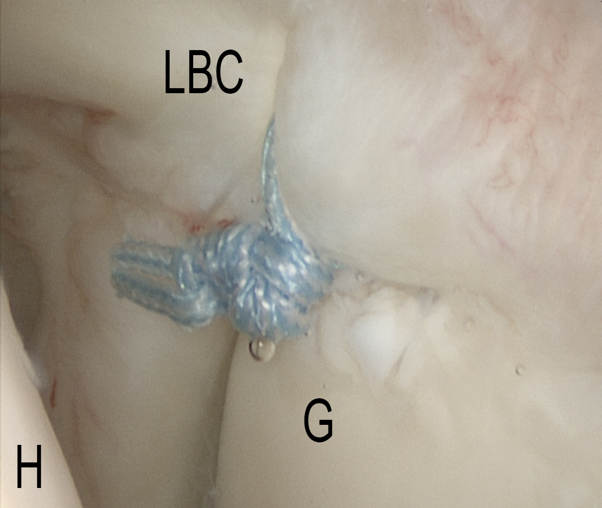

Figure 5 Superior labral anterior posterior II lesion: Intraoperative findings in shoulder arthroscopy (posterior-anterior view from the posterior portal of a left shoulder). A: Intraoperative aspect of a non-displaced SLAP II lesion (>);B: Verifiction by inserting a probe; C: SLAP repair by a single stich posterior to the biceps tendon. LBC: Labro-bicipital complex; H: Humeral head; G: Glenoid; SLAP: Superior labral anterior posterior.

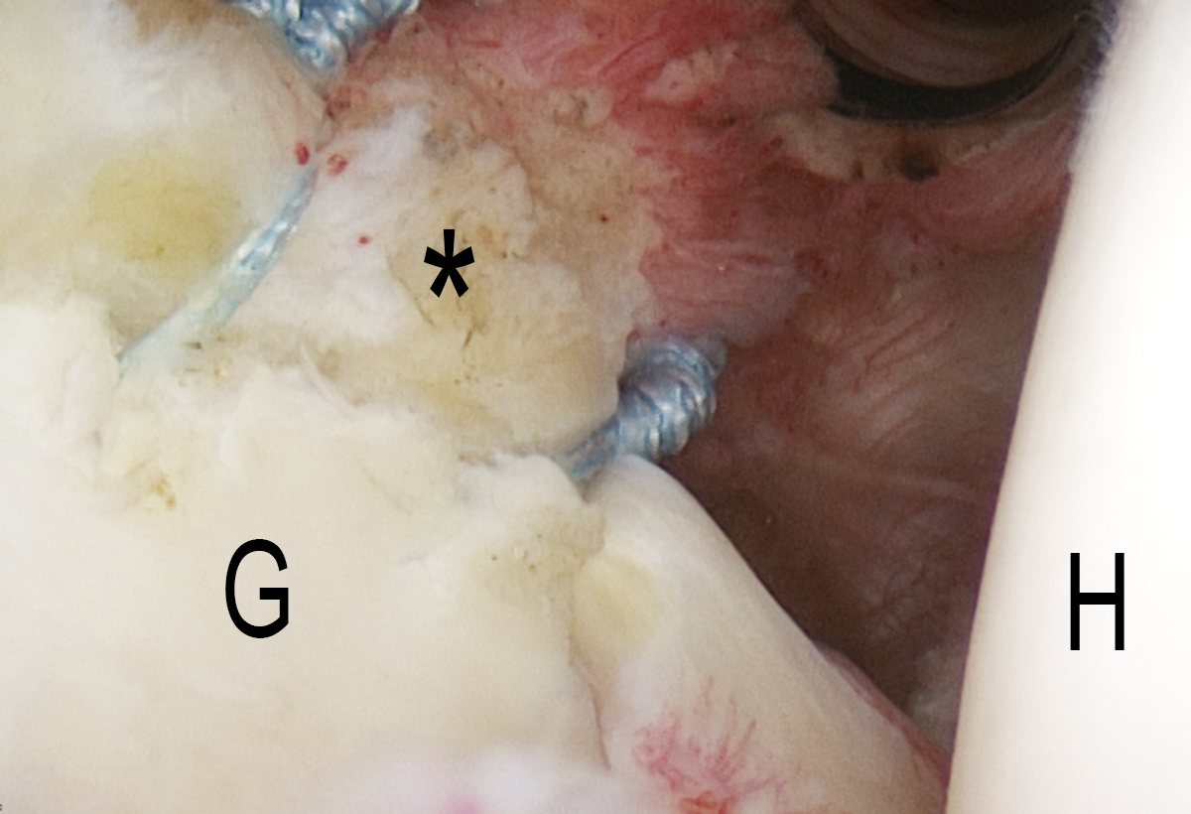

Figure 6 Superior labral anterior posterior II lesion: Intraoperative findings in shoulder arthroscopy (posterior-anterior view from the posterior portal of a right shoulder). First step in mini-open tenodesis is an arthroscopic tenotomy of the biceps tendon (*) and reattachement of the superior labrum. H: Humeral head; G: Glenoid.

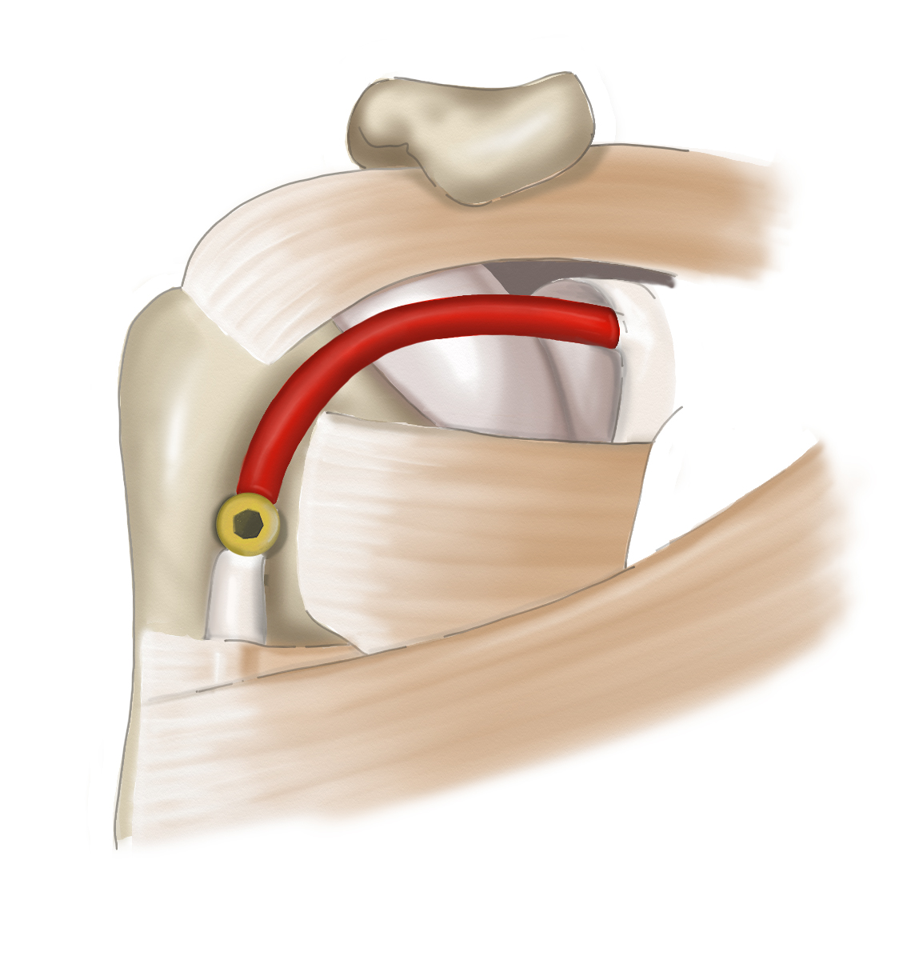

Figure 7 Mini-open biceps tenodesis: The red tagged part of the biceps tendon is resected. An extra-anatomical fixation is performed above the upper border of the tendon of the great pectoral muscle.

Table 1 Superior labral anterior posterior classification, adapted from^{[77]}

SLAP  type | Location  (o’clock) | Description | Comments
Snyder et al^{[1]}
I | 11 – 1 | Fraying with intact biceps tendon | More significant in young people with repetitive overhead motion or patients with degenerative change
II | 11 – 1 | Tear of BLC and biceps tendon stripping | Most common SLAP type, associated with repetitive overhead motion
III | 11 – 1 | Bucket-handle tear of superior labrum with biceps tendon intact | Associated with fall on outstretched hand
IV | 11 – 1 | Bucket-handle tear of superior labrum extension to biceps tendon | Associated with fall on outstretched hand
Morgan et al^{[32]}
IIA | 11 – 3 | Tear of BLC with more anterior extension
IIB | 9 – 11 | Tear of BLC with more posterior extension | Associated infraspinatus tendon tear may be present
IIC | 9 – 3 | Tear of BLC with anterior and posterior extension | Associated infraspinatus tendon tear may be present
Maffet et al^{[31]}
V | 11 – 5 | Bankart lesion in continuity with type II SLAP tear | Can result from anterior shoulder dislocation
VI | 11 – 1 | Anterior or posterior flap tear of the superior labrum with biceps tendon stripping | Probably represents a bucket-handle tear (SLAP III/IV) with tear of the handle
VII | 11 – 3 | Tear extends into MGHL | Can result from acute trauma with anterior dislocation
Powell et al^{[78]}
VIII | 7 – 1 | Superior labral tear with posteroinferior labral tear | Associated with posterior shoulder dislocation
IX | 7 – 5 | Superior labral tear with extensive anterior and posterior extension | Global labral abnormality, probably secondary to trauma
X | 11 - 1 | Superior labral tear with extension to the rotator interval | Involving the rotator interval structures including SGHL, long head biceps tendon and CHL

BLC: Bicipito-labral complex; MGHL: Middle glenohumeral ligament; SGHL: Superior glenohumeral ligament; CHL: Coraco-humeral ligament; SLAP: Superior labral anterior posterior.

Table 2 Traditional superior labral anterior posterior tests, adapted from^{[37]}
SLAP test | Sensitivity  (95%CI) | Specificity  (95%CI) | PPV  (95%CI) | NPV  (95%CI) | OR  (95%CI)
O´Brien | 0.67  (0.51, 0.80) | 0.37  (0.22, 0.54) | 1.06  (0.90, 1.25) | 0.89  (0.67, 1.20) | 1.19  (0.76, 1.86)
Speed | 0.20  (0.05, 0.53) | 0.78  (0.58, 0.90) | 0.90  (0.43, 1.90) | 1.03  (0.86, 1.23) | 0.87  (0.35, 2.55)
Anterior Slide | 0.17  (0.03, 0.55) | 0.86  (0.81, 0.89) | 1.20  (0.22, 6.51) | 0.97  (0.96, 1.36) | 1.24  (0.16, 9.47)
Crank | 0.34  (0.19, 0.53) | 0.75  (0.65, 0.83) | 1.36  (0.84, 2.21) | 0.88  (0.69, 1.12) | 1.54  (0.75, 3.18)
Yergason | 12,4  (6.60, 20.6) | 95.3  (90.6, 98.1) | 2.49  (0.97, 6.40) | 0.91  (0.84, 0.99) | 2.67  (0.99, 7.73)
Relocation | 51.6  (41.2, 61.8) | 52.4  (44.0, 60.6) | 1.13  (0.88, 1.45) | 0.93  (0.72, 1.20) | 1.23  (0.72, 2.11)
Biceps Palpation | 38.6  (26.0, 52.4) | 66,7  (52.9, 78.6) | 1.06  (0.66, 1.68) | 0.95  (0.74, 1.22) | 1.13  (0.51, 2.50)
Compression Rotation | 24.5  (13.8, 38.3) | 78.0  (72.9, 82.5) | 2.81  (0.20, 39.70) | 0.87  (0.66, 1.16) | 3.39  (0.15, 74.78)

PPV: Positive predictive value; NPV: Negative predictive value; OR: Odds ratio; CI: Confidence intervall; SLAP: Superior labral anterior posterior.
Table 3 Outcomes after repair of superior labral anterior posterior tears, adapted from^{[77]}

Ref. | Study design | No. of patients | Repair techniques | Outcome summary
Morgan et al^{[32]} | Retrospective | 102 | Type II repair, sture anchor | 83% excellent overall; 87% excellent results in 53 overhead athletes
Friel et al^{[70]} | Prospective cohort | 48 | Suture anchor fixation | 54% returns to previous level of sport
Sayde et al^{[72]} | Systematic review | 506 | Suture anchor, bioabsorbable tacks, staples | 63% return to previous level of play
Snyder et al^{[53]} | Retrospective | 140 | Type I: debridement, 56% type II: debridement, 44% suture fixation | N/A
Cohen et al^{[74]} | Retrospective | 39 | Biodegradable tacks | 27/39 G-E results; 14/29 return to play at preinjury level at 3.7 year follow-up
Funk/Snow^{[11]} | Retrospective | 18 | Suture anchor fixation | 89% satisfaction rate; 95% return to play at preinjury level
Enad et al^{[71]} | Retrospective | 27 | Suture anchor fixation | 24/27 G-E results
Coleman et al^{[79]} | Retrospective | ± 50  acromioplasties | Biodegradable tacks | 65% G-E results at 3.4 year follow-up
Brockmeier et al^{[80]} | Prospective cohort | 47 | Suture anchor fixation | 41/47 G-E results at 2.7 year follow-up
O’Brien et al^{[73]} | Retrospective | 31 | Biodegradable tacks | 22/31 G-E results at 3.9 year follow-up
Kim et al^{[75]} | Retrospective | 34 | Suture anchor fixation | 31/34 return to play at preinjury level
Boileau et al^{[68]} | Prospective cohort | 25 (2 groups) | Suture anchor fixation (SLAP repair) vs interference screw (biceps tenodesis) | 4/10 satisfied in SLAP repair group; 13/15 satisfied in tenodesis group
Schöffl et al^{[9]} | Prospective cohort | 6 (rock climbers only) | Mini-open biceps tenodesis | 96.8% satisfaction, 100% return to preinjury level of climbing
Voos et al^{[81]} | Retrospective | 34 SLAP + RCR  28 RCR alone | Suture anchor fixation for RCR ± SLAP | 90% G-E results, 77% return to play at preinjury level
Youm et al^{[82]} | Retrospective | 10 SLAP + spinoglenoid cyst | SLAP repair, no cyst treatment | 8/10 resolution of cyst and labral healing in MRI

G-E: Good to excellent; RCR: Rotator cuff repair; SLAP: Superior labral anterior posterior; N/A: Not available.

