Name of Journal: World Journal of Orthopedics
ESPS Manuscript NO: 20206
Manuscript Type: MINIREVIEWS

Current concepts in total femoral replacement

Ramanathan D et al. Current concepts in total femoral replacement

Deepak Ramanathan, Marcelo BP Siqueira, Alison K Klika, Carlos A Higuera, Wael K Barsoum, Michael J Joyce

Deepak Ramanathan, Marcelo BP Siqueira, Alison K Klika, Carlos A Higuera, Wael K Barsoum, Michael J Joyce, Department of Orthopaedic Surgery, Cleveland Clinic Foundation, Cleveland, OH 44195, United States

Author contributions: Ramanathan D and Siqueira MBP reviewed the literature for this minireview; Ramanathan D and Joyce MJ wrote the manuscript; Klika AK, Higuera CA and Barsoum WK reviewed and revised the manuscript.

Conflict-of-interest statement: No financial support was received for this study. Dr. Carlos A Higuera has received research funding from Zimmer. Dr. Wael K Barsoum has received research funding and royalties from Stryker and Zimmer. He is also a consultant for Stryker. Dr. Michael J Joyce is a Medical Board Trustee of the Musculoskeletal Transplant Foundation. None of the other authors have any relevant disclosures to report.

Open-Access: This article is an open-access article which was selected by an in-house editor and fully peer-reviewed by external reviewers. It is distributed in accordance with the Creative Commons Attribution Non Commercial (CCBY-NC 4.0) license, which permits others to distribute, remix, adapt, build upon this work non-commercially, and license their derivative works on different terms, provided the original work is properly cited and the use is non-commercial. See: http://creativecommons.org/licenses/by-nc/4.0/

Correspondence to: Alison K Klika, MS, Research Program Manager, Department of Orthopaedic Surgery, Cleveland Clinic Foundation, 9500 Euclid Avenue, Cleveland, OH 44195, United States. klikaa@ccf.org
Telephone: +1-216-4444954
Fax: +1-216-4456255

Received: May 29, 2015
Peer-review started: June 3, 2015
First decision: July 3, 2015
Revised: July 31, 2015
Accepted: September 29, 2015
Article in press:
Published online:

Abstract
Total femoral replacement (TFR) is a salvage arthroplasty procedure used as an alternative to lower limb amputation. Since its initial description in the mid-20th century, this procedure has been used in a variety of oncologic and non-oncologic indications. The most compelling advantage of TFR is the achievement of immediate fixation which permits early mobilization. It is anticipated that TFR will be increasingly performed as the rate of revision arthroplasty rises worldwide. The existing literature is mainly composed of a rather heterogeneous mix of retrospective case series and a wide assortment of case reports. Numerous TFR prostheses are currently available and the surgeon must understand the unique implications of each implant design. Long-term functional outcomes are dependent on adherence to proper technique and an appropriate physical therapy program for postoperative rehabilitation. Revision TFR is mainly performed for periprosthetic infection and the severe femoral bone loss associated with aseptic revisions. Depending on the likelihood of attaining infection clearance, it may sometimes be advisable to proceed directly to hip disarticulation without attempting salvage of the TFR. Other reported complications of TFR include hip joint instability, limb length discrepancy, device failure, component loosening, patellar maltracking and delayed wound healing. Further research is needed to better characterize the long-term functional outcomes and complications associated with this complex procedure.

Key words: Hip disarticulation; Limb salvage; Revision arthroplasty; Salvage arthroplasty; Total femoral arthroplasty; Total femur arthroplasty; Total femoral replacement; Total femur replacement

© The Author(s) 2015. Published by Baishideng Publishing Group Inc. All rights reserved.

Core tip: The inherent mechanical limitations of the total femoral replacement implant, the complexities of the associated surgical technique and the typically poor condition of the host soft tissue bed have contributed to the mixed outcomes and high complication rates which are reported in the literature. Although this procedure could provide satisfactory long-term ambulatory outcomes by salvaging the extremity for weight bearing, prudent selection and management of the well-evaluated surgical candidate is essential to ensuring the successful achievement of this goal.

Ramanathan D, Siqueira MBP, Klika AK, Higuera CA, Barsoum WK, Joyce MJ. Current concepts in total femoral replacement. World J Orthop 2015; In press

INTRODUCTION
The total femoral replacement (TFR) represents an important surgical option in limb salvage reconstruction. Otherwise known as total femur replacement or total femoral arthroplasty, the procedure and its indications have continually evolved since its earliest descriptions in the middle of the 20th century^{[1]}. Apart from its more recognized applications in oncologic reconstruction, the TFR has also been utilized in the non-oncologic setting as rates of revision arthroplasty continue to rise worldwide^{[2]}. However, the inherent mechanical limitations of the TFR implant design, the complexity of the associated surgical technique and the typically poor condition of the local host soft tissue bed have contributed to the mixed outcomes and high complication rates which are reported in the literature.
This is a minireview conducted to identify current practice in TFR. Relevant articles were independently identified by two research personnel using PubMed (65 results), EMBASE (75 results) and Scopus (76 results) with the earliest retrieved article dating from September 1970. The following search parameters were used: (“total femoral arthroplasty” or “total femoral replacement”) or [“total replacement” and (femur or femoral) and arthroplast*)]. Both English and non-English articles were qualitatively reviewed and multiple large case series were studied to determine TFR survivorship and complication rates (Table 1).

INDICATIONS AND PATIENT SELECTION
The decision to perform TFR must be made only after careful consideration of the specific reconstructive needs and functional expectations of the patient. The most commonly considered surgical alternatives to this procedure include hip disarticulation and above knee amputation^{[3]}. Although TFR could provide better long-term ambulatory outcomes by salvaging the extremity for weight bearing, prudent selection of the well-evaluated surgical candidate is essential to ensure the successful achievement of this goal.
In the appendicular skeleton, the femur is the most common bone to be affected by primary and secondary malignancies. Therefore, the oncologic applications of TFR have been well documented in a variety of conditions with extensive bone involvement, including: osteosarcoma, Ewing’s sarcoma, chondrosarcoma, pleomorphic undifferentiated sarcoma and bony metastases^{[4,5]}. Expandable prostheses have been implanted in skeletally immature individuals to address the challenge of limb length discrepancy due to ongoing growth of the contralateral limb^{[6,7]}. However, the requirement for multiple lengthening revision procedures may increase the risk of deep periprosthetic joint infection with this technique. Other surgical alternatives in such situations include van Nes rotationplasty and amputation^{[7]}. Rotationplasty involves the rotation of the tibia during reconstruction to allow the ankle to simulate functional mobility of the former knee joint. It is noted for excellent long-term functional outcomes in young, motivated individuals who would otherwise be rendered unable to perform high impact activities with a TFR^{[8]}.
As the yearly number of revision arthroplasty procedures continues to rise, it is anticipated that there will be a correspondingly greater incidence of salvage arthroplasty^{[9]}. The performance of multiple revision surgeries predisposes to extensive bone loss which would then necessitate either partial or total endoprosthetic replacement of the femur (Figure 1)^{[10]}. Similarly, repeated surgical debridement in the setting of periprosthetic joint infection could also lead to the dramatic reduction of femoral bone stock^{[11]}. The orthopaedic challenge posed by these multiple revision surgeries has been labeled by some surgeons as a “shattered femur,” that is, a femur which cannot be reconstructed by more conventional methods^{[12]}. Extensively comminuted periprosthetic fractures which were managed by TFR have reportedly good functional outcomes and an implant survival rate of 86% at 10 year follow-up^{[13]}. Occasionally, TFR may provide a single surgical solution for multiple concurrent, ipsilateral orthopaedic issues. For example, in a limb requiring proximal or distal femoral replacement, the coexistence of severe knee or hip osteoarthritis, respectively, may be simultaneously managed by TFR^{[12]}.
Other clinical conditions which can alter the biomechanical integrity of the femur and predispose to pathologic fractures have been successfully managed with TFR^{[14]}. Past use of customized curved femoral stems for the management of Paget’s disease of the femur had been associated with periprosthetic fractures at the level of the prosthesis tip^{[15]}. However, in 1965, it was shown that a vitallium endoprosthesis could be used to successfully replace a deformed Pagetic femur^{[1]}. That case report represented one of the earliest descriptions of TFR in the orthopaedic literature^{[16]}. Similarly, it has been shown that amputation may be avoided in radical resection of massive hemophilic pseudotumors of the femur and soft tissues of the thigh by simultaneous reconstruction with a custom total femoral prosthesis^{[17]}. It is known that hemophilia results in extensive bone loss and cavitation along with significant joint ankylosis secondary to repeated episodes of hemarthrosis^{[18]}. This represents yet another potential situation where TFR could treat structural deformity of the femur while concurrently managing degenerative changes in the ipsilateral hip or knee.

CURRENT PRACTICES IN SURGICAL TECHNIQUE
Given the technical complexity of this procedure, it is anticipated that TFR will require significantly longer operating time than most other revision arthroplasty surgeries. This potentially increases the risk of intraoperative wound contamination and the subsequent development of periprosthetic joint infection^{[19]}. In recognition of this, some manufacturers have recently begun to coat their TFR prostheses with silver in order to provide an antimicrobial advantage in the local tissue bed. Of note, a recent prospective study of megaprostheses with galvanized silver coatings (including six TFR prostheses) noted that 23% of the study population developed local argyria after a median of 25.7 mo^{[20]}. However, despite this local idiosyncratic reaction to silver metal, the study did not find clinical evidence of any systemic complications.
Also, the extensive dissection required for this procedure is likely to result in a greater volume of blood loss. However, adherence to a subperiosteal dissection will help minimize bleeding^{[12]}. In specific situations, recent technological advancements, such as intraoperative blood salvage, bipolar sealing device and argon beam coagulation, may assist with hemostasis and lessen the requirement for blood transfusions^{[21-23]}. Also, the frequently multiple comorbidities of the TFR patient population and the intensive physiologic demands of the procedure itself make the requirement for postoperative intensive care highly likely.
There are two varying implant designs of TFR prostheses available for consideration when limb salvage reconstruction is planned (Table 2)^{[12]}. The intramedullary total femoral replacement (IM-TFR) represents an important alternative to the more conventional “tumor-type” TFR. The IM-TFR is based on the prosthetic linkage of previously implanted femoral components of past hip and knee arthroplasties. This can be accomplished by two different surgical approaches: either (1) the use of a custom intramedullary sleeve to link the well-fixed hip stem with a stemmed component of a total knee arthroplasty; or (2) the use of an intercalary segment to connect revised hip and knee arthroplasties via morse taper junctions^{[24]}. The IM-TFR has been designed to address the central disadvantages of the conventional TFR by reducing the need for extensive dissection and by maintaining the soft tissue attachments. However, it is highly advisable to have both implant options readily available at the time of surgery^{[12]}..With regard to surgical approach in TFR, options include a lateral incision proximally and a separate midline incision distally or a single anterolateral incision. In the prior trauma patient with past incisional scars on the lateral aspect of the thigh, a lateral parapatellar approach may be used when implanting the distal portion of the TFR, as with rotating hinge knee arthroplasty^{[25]}. In order to ensure optimal wound closure, the surgical plan must take into consideration the preexisting surgical scars in this frequently re-operated patient population. Poor preoperative planning predisposes to inadequate wound healing which may eventually lead to secondary periprosthetic infection of the TFR^{[26]}.
Most of the TFR systems which are currently available on the market are fixed constructs and therefore the surgeon is permitted only limited control of the proximal femoral version. This key feature of the TFR implant may predispose to postoperative hip dislocation proximally and altered patellofemoral tracking distally. Hence, the proximal end of the TFR system is often connected to a bipolar or tripolar constrained liner to lower the risk of postoperative hip dislocation^{[3]}. Of note, certain TFR systems are designed with interdigitating fins which allow some customizability of proximal femoral version. In oncologic settings, the native acetabulum may be retained and purse stringing of the joint capsule can be performed to provide hip joint stability. Appropriate external rotation of the tibial component is critical to facilitate patellofemoral tracking, particularly with the use of a constrained condylar articulation. Prior to wound closure, it is essential to evaluate patellofemoral tracking. Performance of lateral retinacular release with or without reefing/imbrication of the vastus medialis obliquus muscle may be required to enhance patellofemoral tracking^{[12]}.
Adequate soft tissue reattachment, particularly of the hip abductor muscle group, is a critical part of the surgical technique^{[10]}. The TFR prostheses contain holes for passing suture material through the implant itself (Figure 2). These holes are smoothly beveled to prevent the potential fraying of suture material upon repeated friction over the metal surface. Polyester graft materials are commonly used to help reattach the muscle groups to the greater trochanter^{[10]}. However, detecting failure of these materials can challenging because of their radiolucency.
Newer designs have tried to incorporate trabecular metal pads to increase the possibility of tissue metallic ingrowth. Proximally, clawed devices may lead to lateral trochanteric tissue irritation. The screws in these clawed devices may loosen and subsequently lead to failure of hardware fixation. This could be a potential source of long-term pain and increased instability.

REHABILITATION AND FUNCTIONAL OUTCOMES
The most compelling advantage of TFR is the achievement of immediate fixation which permits early mobilization^{[27]}. Rehabilitation protocols described in the literature are generally similar, with most emphasizing the importance of quadriceps muscle strengthening in ensuring competence of the extensor mechanism^{[28]}. The use of a custom-molded polypropylene brace to limit flexion and adduction has been advocated for up to six weeks postoperatively^{[27]}. In the setting of difficulty in hip flexion, TFR patients may perform circumduction at the hip in order to clear the foot during gait.
A recent series of oncologic TFR patients observed that mean patient-reported functional scores were significantly lower than among comparison patients who underwent only proximal or distal femoral reconstruction^{[29]}. However, in another large series of patients who underwent TFR after multiple failed revisions, there was significant postoperative improvement in functional scores for both knees and hips^{[30]}. Arthroplasty with the IM-TFR has been theorized to provide better functional outcomes because of the less invasive surgical technique associated with its implantation^{[24]}.
Of note, there is considerable heterogeneity in long-term outcomes among the TFR patient population, particularly between oncologic and non-oncologic patient groups^{[3]}. Reported follow-up and survivorship in the literature is also highly variable due to differences in mortality rates between both groups in adults (Table 2). Despite this heterogeneity, all TFR patients are typically faced with a challenging rehabilitation course due to the almost invariably complex medical history and the immediate physiological demands of the surgery itself.
It is imperative that each patient’s functional expectations are carefully assessed at the preoperative visit. The possibility of future surgeries and the potential for lifelong requirement of an assistive device must be discussed with the patient.^{[12]} However, it is clear that even a TFR with moderate functional outcomes will provide far better ambulatory capabilities than hip disarticulation^{[29]}.

COMPLICATIONS ASSOCIATED WITH TOTAL FEMORAL REPLACEMENT
As the incidence of TFR surgeries continues to rise, a correspondingly greater need for revision TFR surgery is anticipated. One of the most common indications for revision surgery is deep periprosthetic infection. In a large series of non-oncologic TFR performed for revision arthroplasty in 100 consecutive patients who were infection-free at time of surgery, 12% developed periprosthetic infection of the TFR^{[30]}. It was determined that seven of these patients were newly infected whereas the others five patients had a remote history of prior infection.
In the current era of multi-, extreme- and even total-drug resistance, the TFR patient is at a significantly greater risk for acquiring a life-threatening infection. There are multiple predisposing factors involved in the development of TFR periprosthetic infection, namely: extensive surgical dissection, large metal surface area, prolonged operative time, multiple patient comorbidities and repeated hospitalization for past surgical procedures in this patient population, including prior revision arthroplasty for periprosthetic infection^{[31]}. Moreover, this risk of infection may be increased by an inadequacy of initial antibiotic therapy or a lack of thoroughness in surgical debridement (secondary to retained cement material or implant hardware). It is imperative that postoperative antibiotic therapy is of appropriate duration and intensity in order to ensure satisfactory prophylaxis, particularly in patients known to have been colonized with drug resistant strains preoperatively.
In the management of TFR periprosthetic infections, there are various options including one-stage prosthesis exchange with chronic antibiotic suppression and two-stage revision arthroplasty with cement spacer placement. However, it is reported that patients above 50 years of age or recipients of secondary TFR are at a particularly high risk for developing a periprosthetic infection which could render the TFR unsalvageable^{[27]}. Therefore, depending on the likelihood of attaining infection clearance, it may sometimes be advisable to proceed directly to hip disarticulation without attempting salvage of the TFR^{[3]}. When considering salvage of the infected TFR, the surgeon must be particularly mindful of the virulence and treatability of the infective organism. Recent reports of nearly untreatable periprosthetic infections in frequently re-operated patients underscore the importance of this decision^{[32]}. In such situations, eventual infection clearance is often attained at high physical and financial cost with survivors suffering from major disability secondary to renal toxicity and unsatisfactory functional outcome of the salvaged limb.
Post-operative hip instability causing recurrent dislocations is another leading cause of TFR revision. Concomitant infection could also further complicate matters in these cases. Hip dislocations in TFR can be managed by placement of a constrained liner screw into the cup or the insertion of additional interpositional segments^{[30]}. Limb length discrepancy is another potential complication which may require revision surgery with exchange of modular components to shorten or lengthen the TFR as required.
Other less common complications which are reported to have required additional surgery include mechanical failure of the prosthesis, acetabular or tibial component loosening, patellar complications (such as revision for patellar maltracking) and difficulty with wound healing^{[32,33]}. Free flap coverage may be performed either at the time of TFR or later as part of a staged treatment plan. Inadequate wound coverage and the presence of local necrotic tissue may quickly lead to secondary periprosthetic infection of the TFR.
Postoperative complications associated with TFR are frequent and expensive to manage. Appropriate patient selection is necessary to minimize this risk and avoid high healthcare costs associated with failure of TFR.

CONCLUSION
Total femoral replacement is anticipated to become an increasingly favored salvage option in the setting of extensive femoral bone loss. Careful patient selection, excellent surgical technique, a comprehensive rehabilitation program and the prompt management of postoperative complications are essential to ensure optimal long-term outcomes in this challenging patient population. Therefore, given the complex nature of this procedure, it would seem that TFR should probably be performed by the orthopaedic oncologist or adult reconstruction surgeon who is familiar with the unique challenges involved. In lieu of a prospectively compiled, central registry for TFR, continued research with larger patient series and retrospective cohort studies is needed to better characterize the functional outcomes and complications associated with this procedure.

REFERENCES
1 Buchman J. Total femur and knee joint replacement with a vitallium endoprosthesis. Bull Hosp Joint Dis 1965; 26: 21-34 [PMID: 14333593]
2 Berend KR, Lombardi AV, Mallory TH, Adams JB, Dodds KL. Total femoral arthroplasty for salvage of end-stage prosthetic disease. Clin Orthop Relat Res 2004; (427): 162-170 [PMID: 15552153 DOI: 10.1097/01.blo.0000142351.88039.e8]
3 Amanatullah DF, Trousdale RT, Hanssen AD, Lewallen DG, Taunton MJ. Non-oncologic total femoral arthroplasty: retrospective review. J Arthroplasty 2014; 29: 2013-2015 [PMID: 25041874 DOI: 10.1016/j.arth.2014.05.012]
4 Pan K, Chan W, Shanmugam P, Ong G, Kamaruddin F, Tan S. Large volume osteosarcomas of the femur treated with total femoral replacement. Malays Orthop J 2014; 8: 32-36 [PMID: 25347294 DOI: 10.5704/MOJ.1403.015]
5 Sewell MD, Spiegelberg BG, Hanna SA, Aston WJ, Bartlett W, Blunn GW, David LA, Cannon SR, Briggs TW. Total femoral endoprosthetic replacement following excision of bone tumours. J Bone Joint Surg Br 2009; 91: 1513-1520 [PMID: 19880899 DOI: 10.1302/0301-620X.91B11.21996]
6 Schindler OS, Cannon SR, Briggs TW, Blunn GW, Grimer RJ, Walker PS. Use of extendable total femoral replacements in children with malignant bone tumors. Clin Orthop Relat Res 1998; (357): 157-170 [PMID: 9917713 DOI: 10.1097/00003086-199812000-00021]
7 Eckardt JJ, Safran MR, Eilber FR, Rosen G, Kabo JM. Expandable endoprosthetic reconstruction of the skeletally immature after malignant bone tumor resection. Clin Orthop Relat Res 1993; (297): 188-202 [PMID: 8242930 DOI: 10.1097/00003086-199312000-00032]
8 Harris JD, Trinh TQ, Scharschmidt TJ, Mayerson JL. Exceptional functional recovery and return to high-impact sports after Van Nes rotationplasty. Orthopedics 2013; 36: e126-e131 [PMID: 23276345 DOI: 10.3928/01477447-20121217-32]
9 Kurtz SM, Ong KL, Schmier J, Mowat F, Saleh K, Dybvik E, Kärrholm J, Garellick G, Havelin LI, Furnes O, Malchau H, Lau E. Future clinical and economic impact of revision total hip and knee arthroplasty. J Bone Joint Surg Am 2007; 89 Suppl 3: 144-151 [PMID: 17908880 DOI: 10.2106/JBJS.G.00587]
10 Fountain JR, Dalby-Ball J, Carroll FA, Stockley I. The use of total femoral arthroplasty as a limb salvage procedure: the Sheffield experience. J Arthroplasty 2007; 22: 663-669 [PMID: 17689773 DOI: 10.1016/j.arth.2006.11.017]
11 Sherman SL, Cunneen KP, Walcott-Sapp S, Brause B, Westrich GH. Custom total femur spacer and second-stage total femur arthroplasty as a novel approach to infection and periprosthetic fracture. J Arthroplasty 2008; 23: 781-786 [PMID: 18534389 DOI: 10.1016/j.arth.2007.05.027]
12 Lombardi AV, Berend KR. The shattered femur: radical solution options. J Arthroplasty 2006; 21: 107-111 [PMID: 16781442 DOI: 10.1016/j.arth.2006.01.007]
13 Clement ND, MacDonald D, Ahmed I, Patton JT, Howie CR. Total femoral replacement for salvage of periprosthetic fractures. Orthopedics 2014; 37: e789-e795 [PMID: 25350621 DOI: 10.3928/01477447-20140825-55]
14 Mankin HJ, Hornicek FJ, Harris M. Total femur replacement procedures in tumor treatment. Clin Orthop Relat Res 2005; 438: 60-64 [PMID: 16131870 DOI: 10.1097/00003086-200509000-00012]
15 Dunlop DJ, Donnachie NJ, Treacy RB. Failure after customized curved femoral stems in total hip arthroplasty for Paget's disease. J Arthroplasty 2000; 15: 398-401 [PMID: 10794240 DOI: 10.1016/S0883-5403(00)90923-9]
16 Present DA, Kuschner SH. Total femur replacement. A case report with 35-year follow-up study. Clin Orthop Relat Res 1990; (251): 166-167 [PMID: 2295169]
17 Buchowski JM, Cascio BM, Streiff MB, Frassica FJ. Resection and reconstruction of a massive femoral hemophilic pseudotumor. Clin Orthop Relat Res 2005; (430): 237-242 [PMID: 15662330 DOI: 10.1097/01.blo.0000137545.37824.b0]
18 Naderi A, Nikvarz M, Arasteh M, Shokoohi M. Osteoporosis/osteopenia and hemophilic arthropathy in severe hemophilic patients. Arch Iran Med 2012; 15: 82-84 [PMID: 22292576]
19 Davis N, Curry A, Gambhir AK, Panigrahi H, Walker CR, Wilkins EG, Worsley MA, Kay PR. Intraoperative bacterial contamination in operations for joint replacement. J Bone Joint Surg Br 1999; 81: 886-889 [PMID: 10530856 DOI: 10.1302/0301-620X.81B5.9545]
20 Glehr M, Leithner A, Friesenbichler J, Goessler W, Avian A, Andreou D, Maurer-Ertl W, Windhager R, Tunn PU. Argyria following the use of silver-coated megaprostheses: no association between the development of local argyria and elevated silver levels. Bone Joint J 2013; 95-B: 988-992 [PMID: 23814255 DOI: 10.1302/0301-620X.95B7.31124]
21 Ashworth A, Klein AA. Cell salvage as part of a blood conservation strategy in anaesthesia. Br J Anaesth 2010; 105: 401-416 [PMID: 20802228 DOI: 10.1093/bja/aeq244]
22 Kaibori M, Matsui K, Ishizaki M, Sakaguchi T, Matsushima H, Matsui Y, Kwon AH. A prospective randomized controlled trial of hemostasis with a bipolar sealer during hepatic transection for liver resection. Surgery 2013; 154: 1046-1052 [PMID: 24075274 DOI: 10.1016/j.surg.2013.04.053]
23 Go PM, Goodman GR, Bruhn EW, Hunter JG. The argon beam coagulator provides rapid hemostasis of experimental hepatic and splenic hemorrhage in anticoagulated dogs. J Trauma 1991; 31: 1294-1300 [PMID: 1920562 DOI: 10.1097/00005373-199109000-00015]
24 Peters CL, Hickman JM, Erickson J, Lombardi AV, Berend KR, Mallory TH. Intramedullary total femoral replacement for salvage of the compromised femur associated with hip and knee arthroplasty. J Arthroplasty 2006; 21: 53-58 [PMID: 16446185 DOI: 10.1016/j.arth.2004.12.061]
25 Pour AE, Parvizi J, Slenker N, Purtill JJ, Sharkey PF. Rotating hinged total knee replacement: use with caution. J Bone Joint Surg Am 2007; 89: 1735-1741 [PMID: 17671012 DOI: 10.2106/JBJS.F.00893]
26 Nerubay J, Katznelson A, Tichler T, Rubinstein Z, Morag B, Bubis JJ. Total femoral replacement. Clin Orthop Relat Res 1988; (229): 143-148 [PMID: 3349669 DOI: 10.1097/00003086-198804000-00018]
27 Hwang JS, Beebe KS, Patterson FR, Benevenia J. Infected total femoral replacements: evaluation of limb loss risk factors. Orthopedics 2011; 34: e736-e740 [PMID: 22049955 DOI: 10.3928/01477447-20110922-11]
28 Ahmed AR. Total femur replacement. Arch Orthop Trauma Surg 2010; 130: 171-176 [PMID: 19644695 DOI: 10.1007/s00402-009-0945-2]
29 Jones KB, Griffin AM, Chandrasekar CR, Biau D, Babinet A, Deheshi B, Bell RS, Grimer RJ, Wunder JS, Ferguson PC. Patient-oriented functional results of total femoral endoprosthetic reconstruction following oncologic resection. J Surg Oncol 2011; 104: 561-565 [PMID: 21695701 DOI: 10.1002/jso.22003]PMID: 21695701]
30 Friesecke C, Plutat J, Block A. Revision arthroplasty with use of a total femur prosthesis. J Bone Joint Surg Am 2005; 87: 2693-2701 [PMID: 16322619 DOI: 10.2106/JBJS.D.02770]
31 Morimoto S, Futani H, Ogura H, Okayama A, Maruo S. Successful reimplantation of total femoral prosthesis after deep infection. J Arthroplasty 2003; 18: 216-220 [PMID: 12629615 DOI: 10.1054/arth.2003.50037]
32 de Sanctis J, Teixeira L, van Duin D, Odio C, Hall G, Tomford JW, Perez F, Rudin SD, Bonomo RA, Barsoum WK, Joyce M, Krebs V, Schmitt S. Complex prosthetic joint infections due to carbapenemase-producing Klebsiella pneumoniae: a unique challenge in the era of untreatable infections. Int J Infect Dis 2014; 25: 73-78 [PMID: 24813874 DOI: 10.1016/j.ijid.2014.01.028]
33 Steinbrink K, Engelbrecht E, Fenelon GC. The total femoral prosthesis. A preliminary report. J Bone Joint Surg Br 1982; 64: 305-312 [PMID: 7096396]
34 Ward WG, Dorey F, Eckardt JJ. Total femoral endoprosthetic reconstruction. Clin Orthop Relat Res 1995; (316): 195-206 [PMID: 7634705 DOI: 10.1097/00003086-199507000-00027]
P-Reviewer: Finestone AS, Hasegawa M, Lee SH S-Editor: Tian YL
L-Editor: E-Editor:

Table 1 Types of total femoral replacement prostheses
Feature | Intramedullary TFR System | Tumor-style TFR System
Basic design | Modular hip femoral component; Constrained knee femoral component with customized intercalary segments; May require strut allografts and cerclage cables | Modular and available in multiple lengths
Femoral bone stock | Possibility of preservation; can maintain muscle attachment | Absent
Distal femur resection | Can preserve distal femur or remove femoral component using standard revision techniques | Entire distal femur can be removed by subperiosteal dissection (less bleeding)
Tibial component | Suitable for constrained condylar articulation | Suitable for rotating hinge articulation

Table 2 Large case series of total femoral replacement in current literature
Ref. | Publication | n= | Age | Indications | Follow-up (months) | Patients living at time of publication | Survivorship | All-cause revision rate | Complications | Prosthesis used
Ahmed^{[28]} | Arch Orthop Trauma Surg | 9 | 47 (10-74) | Oncologic | 51 (8-200) | 4/9 | No failures | 0% | Infection (2), Tibial component loosening (1) | Zimmer
Amanatullah et al^{[3]} | J Arthroplasty | 20 | 65 ± 11 | Non-oncologic (revision arthroplasty) | 73 ± 49 | 0/20 | 70% at 5 year follow-up | 30% | Infection (7), Hip dislocation (5), Limb length discrepancy (2), Knee flexion contracture (1) | Biomet, Link Stryker
Berend et al^{[2]} | Clin Orthop Relat Res | 59 | 74 (39-91) | Non-oncologic (end-stage prosthetic disease) | 58 (12-156) | 14/59 | 65% at 5 year follow-up | 30.5% | Infection (8), Hip dislocation (7), Tibial component loosening (2), Acetabular component loosening (1) | Biomet, Link
Fountain et al^{[10]} | J Arthroplasty | 14 | 63.7 (48-79) | Non-oncologic (revision arthroplasty) | 90 (12- 204) | 13/14 | NA | 35.7% | Hip dislocation (5), Infection (3) | Link
Friesecke et al^{[30]} | J Bone Joint Surg Am | 100 | 68 (40-94) | Non-oncologic (revision arthroplasty) | 59 (1-138) | 95/100 | NA | 21% | Infection (12), Hip dislocation (6), Prosthesis failure (3), Patellar issues (2), Hematoma (2), Peroneal nerve palsy (1), Delayed wound healing (1) | Link
Lombardi et al^{[12]} | J Arthroplasty | 75 | 73 (36-92) | Non-oncologic (end-stage prosthetic disease) | 42 (1-158) | 50/75 | NA | 30.7% | Infection (11), Hip dislocation (7), Tibial component loosening (2), Acetabular component loosening (1), Hematoma (1), Periprosthetic fracture (1) | NA
Mankin et al^{[14]} | Clin Orthop Relat Res | 15 | 52 ± 1 (16-82) | Oncologic, Non-oncologic (Paget’s disease, Rheumatoid arthritis) | 54 (12-192) | 7/15 | NA | 33.3% | Prosthesis failure (4), Infection (1) | NA
Nerubay et al^{[26]} | Clin Orthop Relat Res | 19 | 20 | Oncologic | 18-96 | 7/19 | NA | - | Wound healing problems (10), Infection (1), Popliteal vein injury (1), Prosthesis failure (1) | NA
Steinbrink et al^{[33]} | J Bone Joint Surg Br | 32 (28 patients) | 56 (21-81) | Oncologic, Non-oncologic (end-stage prosthetic disease, revision arthroplasty, pathologic fractures, osteoporosis) | 6-84 | 23/28 | NA | 9.4% | Infection (2), Hip dislocation (1), Prosthesis failure (1), Patellar pain (1) | Custom
Ward et al^{[34]} | Clin Orthop Relat Res | 21 | 44.6 (11-91) | Oncologic, Non-oncologic (Revision arthroplasty, end-stage prosthetic disease) | 31 (1- 125) | 11/21 | NA | 2.4% | Infection (3), Hip dislocation (2), Patellar pain (1) | Custom
NA: Information was not available in article.

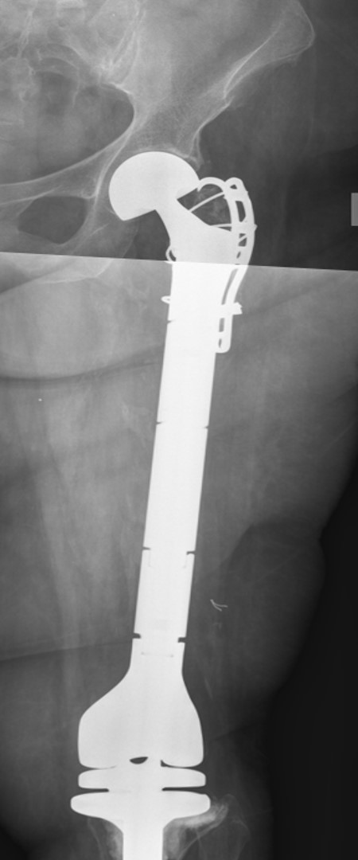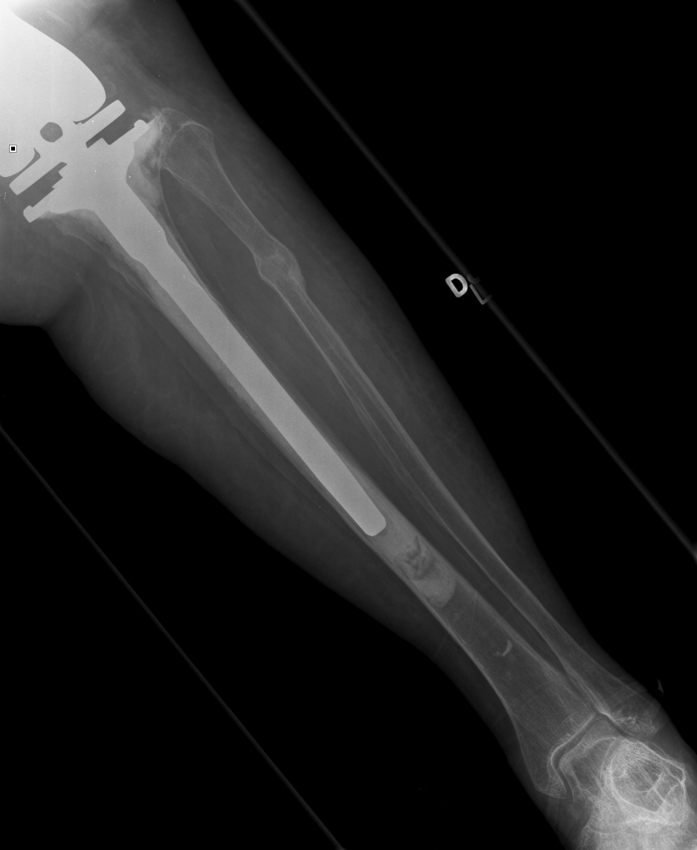
Figure 1 Total femoral replacement with intercalary body to connect proximal femoral replacement with distal rotating hinge knee implant. A: Composite radiographic images of our patient who underwent revision arthroplasty with TFR after periprosthetic infection necessitated removal of distal femoral replacement rotating hinge component and en bloc resection saucerization excision of remnant native proximal femur; B: Reconstruction was accomplished with intercalary body connecting proximal femoral replacement component with rotating hinge knee implant. Extensor mechanism was reconstructed and the greater trochanter repaired with a long claw cable fixation and Mersilene tapes.

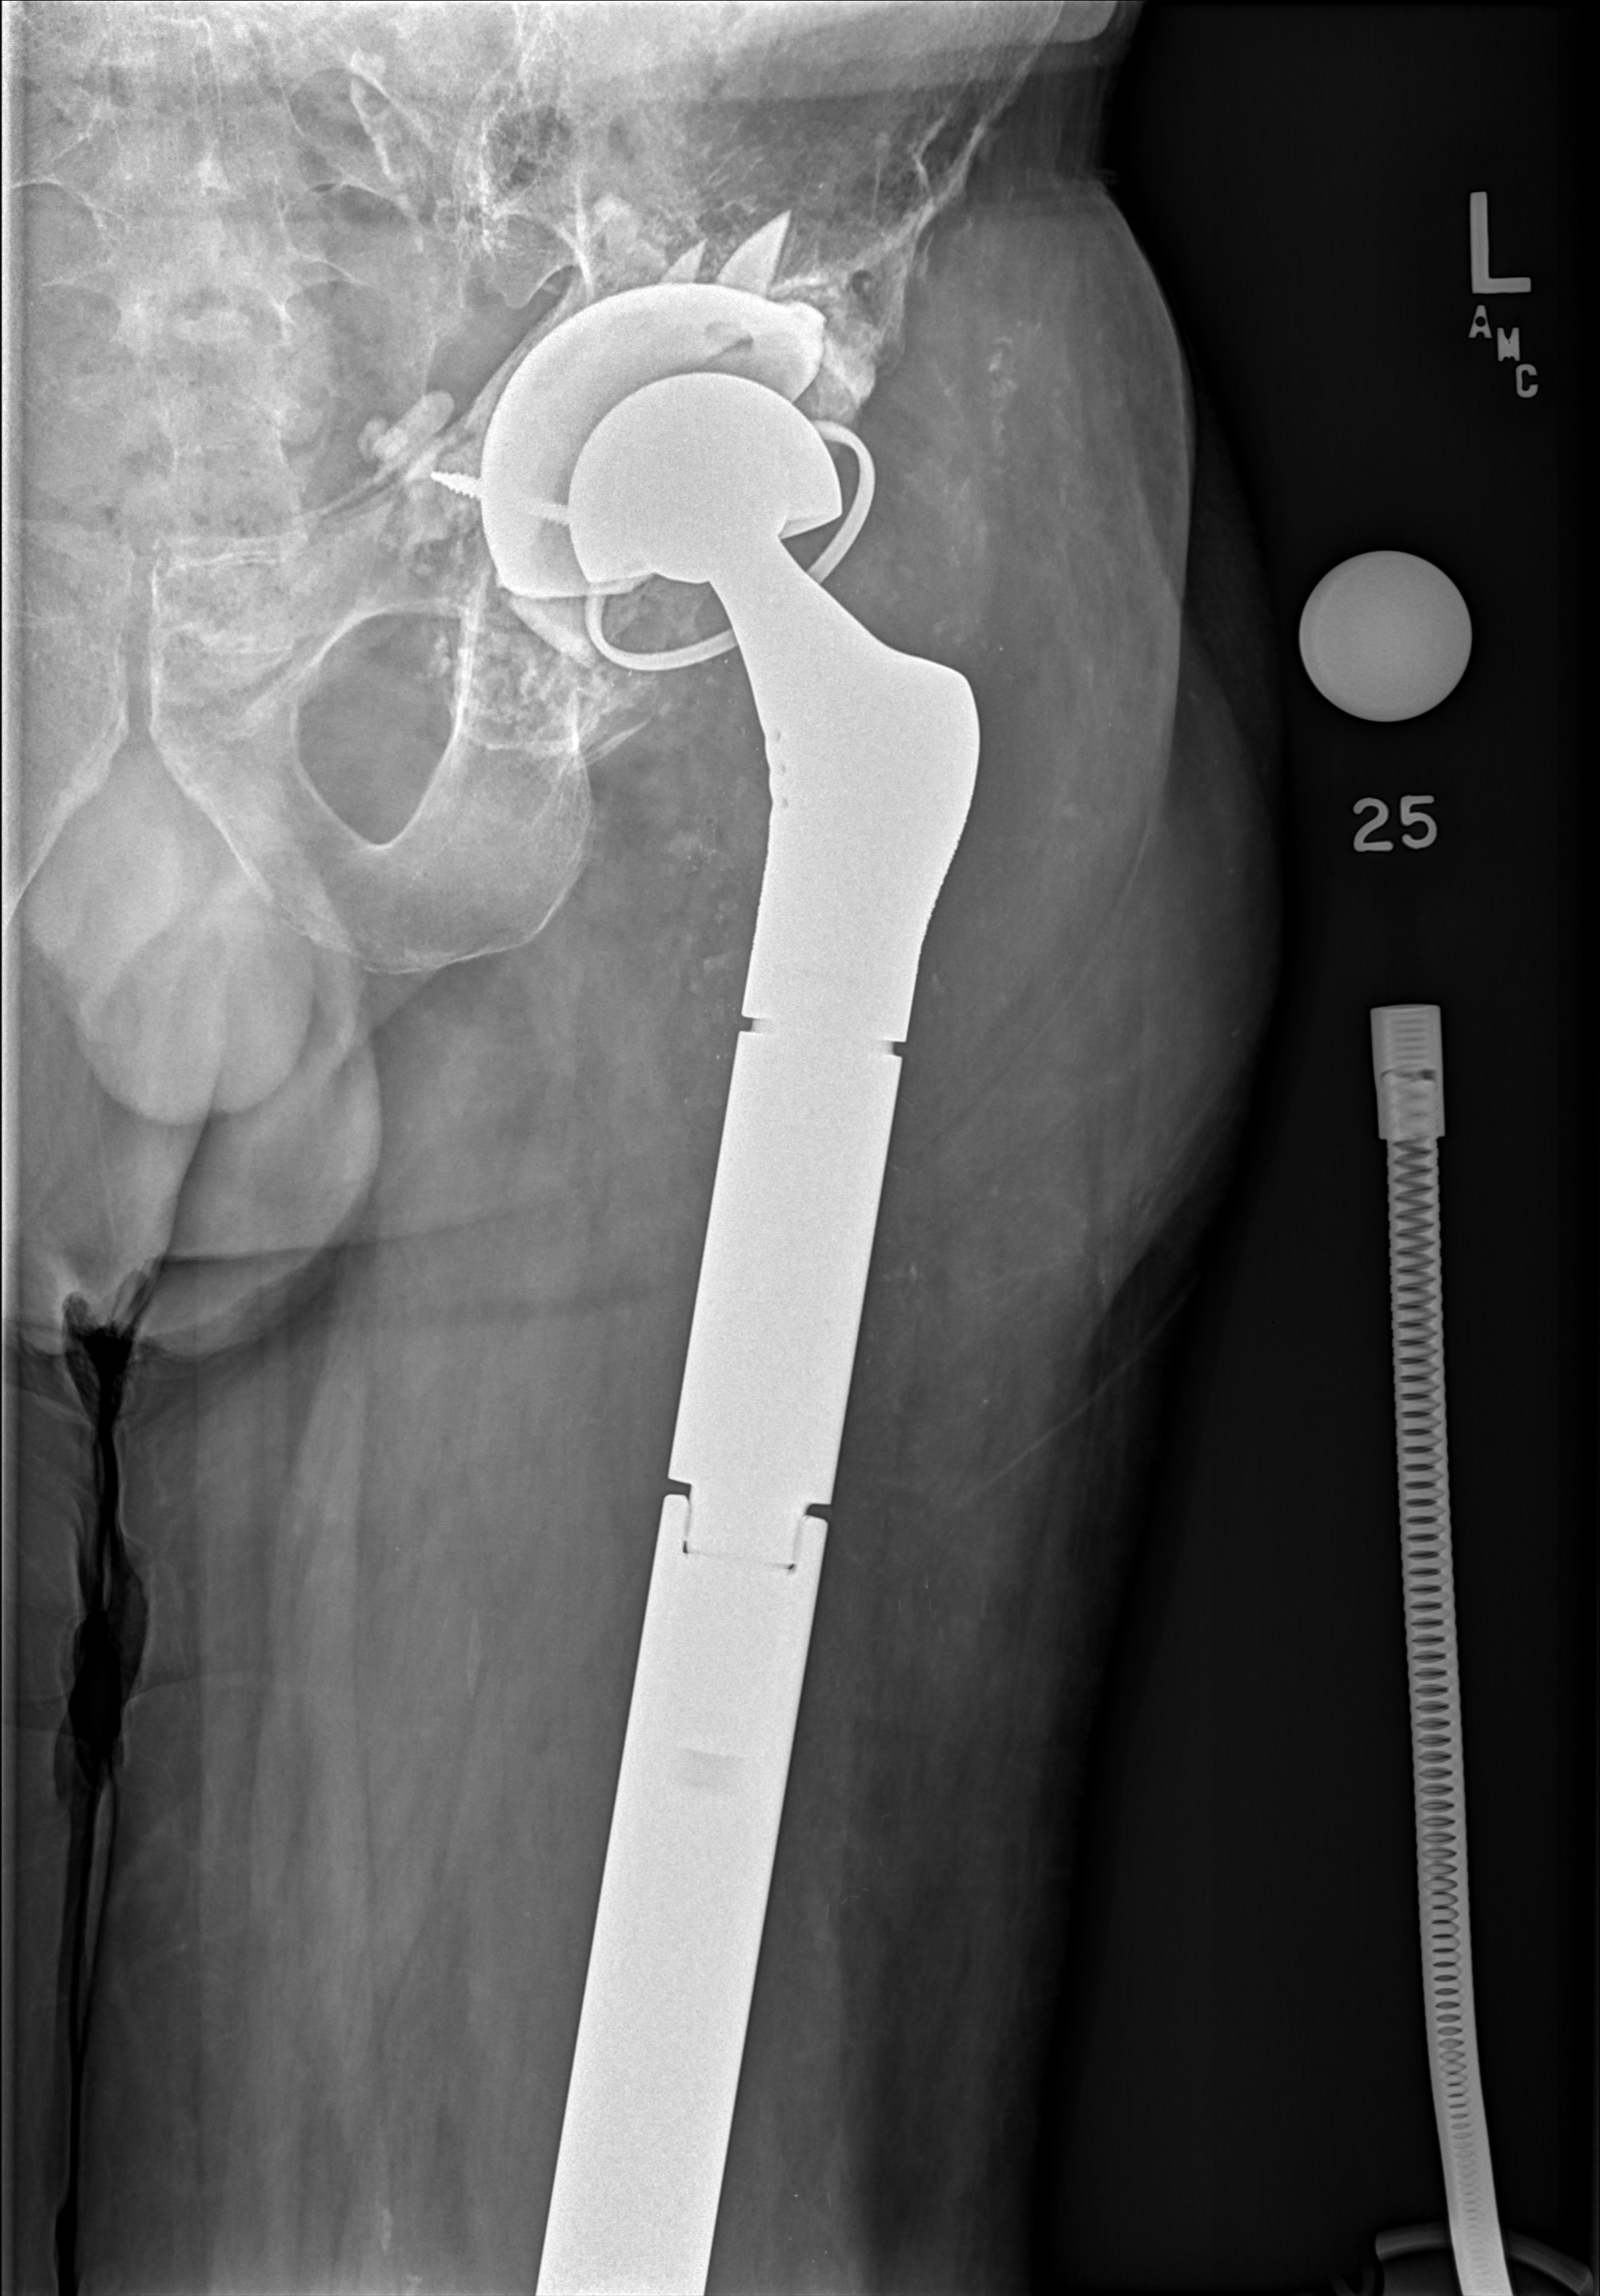
Figure 2 Total femoral replacements with constrained acetabular component and rotating hinge knee implant. A: Composite radiographic images of our patient who underwent total femoral replacement (TFR) after multiplerevisions of total hip arthroplasty; B: TFR was done with constrained acetabular component, rotating hinge knee arthroplasty and patellar resurfacing. Abductor muscle repair was done by using a locking suture technique sewing into holes in the proximal femoral replacement component. Somatosensory evoked potentials were used intraoperatively to monitor sciatic nerve function during correction of a 4 cm limb length discrepancy. Potentials remained normal throughout.

