Name of Journal: World Journal of Gastroenterology
Manuscript NO: 62719
Manuscript Type: MINIREVIEWS

Artificial intelligence in perioperative management of major gastrointestinal surgeries

Solanki SL et al. Artificial intelligence in perioperative management

Sohan Lal Solanki, Saneya Pandrowala, Abhirup Nayak, Manish Bhandare, Reshma P Ambulkar, Shailesh V Shrikhande

Sohan Lal Solanki, Abhirup Nayak, Reshma P Ambulkar, Department of Anesthesiology, Critical Care and Pain, Tata Memorial Hospital, Homi Bhabha National Institute, Mumbai 400012, Maharashtra, India

Saneya Pandrowala, Manish Bhandare, Shailesh V Shrikhande, Gastro-Intestinal Services, Department of Surgical Oncology, Tata Memorial Hospital, Homi Bhabha National Institute, Mumbai 400012, Maharashtra, India

Author contributions: Solanki SL contributed idea of writing, literature search, scientific writing and manuscript writing, editing and final approval; Pandrowala S contributed literature search, scientific writing and manuscript writing, editing and final approval; Nayak A contributed literature search, manuscript editing, and final approval; Bhandare M, Ambulkar RP and Shrikhande SV contributed manuscript editing, proofreading and final approval.

Corresponding author: Sohan Lal Solanki, MD, Professor, Department of Anesthesiology, Critical Care and Pain, Tata Memorial Hospital, Homi Bhabha National Institute, E Borges Marg, Parel, Mumbai 400012, Maharashtra, India. me_sohans@yahoo.co.in

Received: January 16, 2021
Revised: April 6, 2021
Accepted: April 28, 2021
Published online: June 7, 2021

Abstract
Artificial intelligence (AI) demonstrated by machines is based on reinforcement learning and revolves around the usage of algorithms. The purpose of this review was to summarize concepts, the scope, applications, and limitations in major gastrointestinal surgery. This is a narrative review of the available literature on the key capabilities of AI to help anesthesiologists, surgeons, and other physicians to understand and critically evaluate ongoing and new AI applications in perioperative management. AI uses available databases called “big data” to formulate an algorithm. Analysis of other data based on these algorithms can help in early diagnosis, accurate risk assessment, intraoperative management, automated drug delivery, predicting anesthesia and surgical complications and postoperative outcomes and can thus lead to effective perioperative management as well as to reduce the cost of treatment. Perioperative physicians, anesthesiologists, and surgeons are well-positioned to help integrate AI into modern surgical practice. We all need to partner and collaborate with data scientists to collect and analyze data across all phases of perioperative care to provide clinical scenarios and context. Careful implementation and use of AI along with real-time human interpretation will revolutionize perioperative care, and is the way forward in future perioperative management of major surgery.

Key Words: Algorithms; Artificial intelligence; Big data; Data management; Machine learning; Perioperative care

©The Author(s) 2021. Published by Baishideng Publishing Group Inc. All rights reserved.

Citation: Solanki SL, Pandrowala S, Nayak A, Bhandare M, Ambulkar RP, Shrikhande SV. Artificial intelligence in perioperative management of major gastrointestinal surgeries. World J Gastroenterol 2021; 27(21): 2758-2770
URL: https://www.wjgnet.com/1007-9327/full/v27/i21/2758.htm
DOI: https://dx.doi.org/10.3748/wjg.v27.i21.2758

Core Tip: Artificial intelligence (AI) has revolutionized the way surgery and anesthesia are taught and practiced. Applications of AI in anesthesia are risk prediction, control of anesthesia by closed-loop anesthesia delivery systems, monitoring the depth of anesthesia, robotic intubation, monitoring cardiac output based on algorithms and ultrasound guidance. In surgery, AI focuses on generating evidence-based, real-time clinical decision support designed to optimize patient care and surgeon workflow. AI can be used to appropriately convey the results of prognosis and treatment algorithms to patients. Nevertheless, there is a lack of problem-solving by AI and a continuing dependence of human analysis.
INTRODUCTION
Artificial Intelligence (AI) which means intelligence demonstrated by machines is based on reinforcement learning and revolves around the usage of algorithms. AI has already found an irreplaceable place in our lives with it use by smartphones, personal assistants like Alexa and many other applications. AI derives inspiration from the brain's complex neural network and uses artificial “neurons” that learn by comparing themselves to the desired output and "reinforce" connections that are useful, thus creating the basis of the artificial neural network approach. The healthcare field generates vast medical databases, also known as “big data” that include healthcare records, imaging, pathology, and surgical videos. Analysis of big data with the help of AI can help diagnose diseases early as well as predict outcomes better, which will eventually lead to effective and economical healthcare. Involvement of AI in perioperative management includes preoperative assessment with accurate risk predictions, intraoperative management includes intubating and operating robots, infusion devices, monitoring the depth of anesthesia (DOA), and early detection of anesthesia and surgical complications. The vast spectrum of AI and the ability of deep neural networks (DNN) to analyze intraoperative videos, the learning curve, and near misses may be reduced in minimally invasive surgery^{[1]}. Postoperatively, AI has shown a role in reducing surgical site infections (SSI), intra-abdominal SSI after gastrointestinal (GI) surgeries^{[2,3]}, and identifying anastomotic leaks from electronic health records (EHRs)^{[4,5]}. The applications of AI in the near future are expected to be significantly practice-changing, hence it becomes essential for surgeons and anesthesiologists to be updated with current applications and possible future uses.

Basics of AI in a nutshell
AI is a vast field in which machine learning (ML) forms a subfield (Figure 1). ML enables machines to learn from experience just as humans do. ML depends on the ability to perform tasks based on algorithms without actual programming and can be divided into supervised, unsupervised, and reinforcement learning^{[6]}. Supervised learning enables the ML algorithm to achieve a predesigned outcome, unsupervised ML does not have prescribed output categories and can detect subtle patterns in large datasets that are imperceptible to human analysis. In supervised ML, datasets are divided into a training set and a test set to test the algorithm using the new dataset. Reinforcement learning is similar to conditioning and involves repeated trial and error situations that lead to a reward. DNN or deep learning involves multiple layers of the network that allow for the learning of more complex patterns (Figure 2). In DNN, to achieve the best association between the input and output layer, there are multiple intermediate hidden layers in that are fed data by their previous layers and thus influence the outcome. DNN can use EHR variables and accurately predict anastomotic leaks or mortality in postoperative patients^{[4,5]}. Conventional neural networks, recurrent neural networks, and residual neural networks are currently commonly used architectures in deep learning. Techniques used by AI include computer vision (CV) and natural language processing (NLP). CV allows AI to identify objects through the processing of patterns and images; NLP allows machines to analyze human language beyond their machine language or code. CV and NLP have diverse applications in surgery and anesthesia.

Preoperative Management and Planning
Preoperative planning of GI surgeries includes the combined use of pathological diagnosis, endoscopy, and imaging to identify patients at risk of complications, for early detection, and for timely treatment. Digital pathology with the transfer of slide images is in practice to report them remotely and can help obtain second opinions by remote centers with pathological dilemmas. Due to the sheer volume of specimen and ability to focus the microscope in an area of the field, even expert pathologists are bound to miss areas of interest. AI helps to analyze the whole field as well as to detect subtle changes^{[7,8]}. AI algorithms can identify celiac disease^{[9]}, Helicobacter pylori^{[10]}, grade liver fibrosis^{[11]}, classify colonic polyps^{[12]}, grade dysplasia^{[13]}, predict 5-year overall survival in colorectal cancer from pathology^{[14]}, and predict microsatellite instability^{[15]}. The drawbacks include large data storage and the need for an efficient network, computer, and equipment. ML learns from the data feed and because of baseline inter-individual variability amongst pathologists, there is a grey zone regarding a 100% precision. Endoscopists have embraced AI and currently used it increase detection of polyps as well as to differentiate hyperplastic from adenomatous polyps based on endoscopic images^{[16,17]}. However, most of the additional polyps detected by trained DNN are sub-centimetric adenomas^{[17]}. It can also be used to differentiate malignant vs nonmalignant tissue, identify the depth of invasion, and margins of endoscopic resection^{[18,19]}. An important feat achieved through AI is the evaluation of huge numbers of endoscopic images obtained by wireless capsule endoscopy^{[20]} as well as an integrated ultrasound system in the capsule for evaluation as described by Sonopill^{[21]}. Owing to the problem of organ deformation in the abdomen, integration of AI in imaging of GI pathologies has not been as fast as in breast or lung diseases. However, for a complex solid organ like the liver AI has expanded the scope of complex surgeries by three-dimensional (3D) visualization, virtual simulation surgery^{[22-24]} and navigation-assisted surgery (see below). With that technology, it is possible to assess patients with large tumors initially considered inoperable^{[25]}. The ability of 3D imaging to assess biliary anatomy and the liver remnant helps to predict the optimal surgical path to avoid residual tissue in complex hepatolithiasis^{[26-28]}. 3D imaging has helped to better understand pancreatic vascular anatomy and determine the resectability of tumors^{[29-31]}. Photoacoustic imaging combines optical imaging with high resolution ultrasound and large penetration depth. This has shown promise in Crohn's disease to assess intestinal hemoglobin levels and differentiate between active and inactive disease to avoid unnecessary invasive procedures^{[32]}.
The other aspect of perioperative planning is decision making and risk assessment. The surgical decision is not made only by the surgeon, a shared-decision includes patient involvement in the management, increases patient satisfaction, compliance and allows the patient to cope up with any unfortunate complications^{[33]}. IBM Watson Oncology was built to help oncologists to keep up to date with current evidence and guide decision making. Despite the associated hype, it has not been able to deliver well for GI cancers^{[34,35]}. Unfortunately, the available risk assessment models like major adverse cardiac events, the Revised Cardiac Risk Index, and Gupta Perioperative Risk for Myocardial Infarction or Cardiac Arrest underestimate the risk involved^{[36-38]}. The American Society of Anesthesiologists (ASA) classification, which is used widely is also not devoid of subjective assessment errors^{[39]}. AI and ML platforms that are fed data from vast databases of patients outcomes can identify and accurately predict risk based on the variables available EHRs. The MySurgeryRisk platform uses EHR data of 285 variables and has been shown to predict perioperative risk with better accuracy than clinical judgement^{[5]}. It utilizes the big data from EHRs and obviates manual input of variables to give accurate mortality prediction. ML has been shown to accurately predict mortality, sepsis, and acute kidney injury using intraoperative data^{[40-43]}. The Predictive OpTimization Trees in Emergency Surgery Risk (POTTER) calculator is an ML platform based on the American College of Surgeons National Surgical Quality Improvement Program (ACS-NSQIP) database to calculate perioperative risk and mortality^{[44]}. POTTER is accurate, user-friendly and can be integrated with EHR data to identify and prevent risks like SSI, sepsis, pneumonia, urinary tract infection, cardiac complications, and prolonged intensive care unit (ICU) stay in postoperative patients. Similarly, for the prevention of anesthesia-related complications, ML algorithms can interpret data from previous surgery that includes both patient risk factors and postoperative outcomes to recommend the anesthetic drugs to be used^{[45]}.

Intraoperative Management
AI has led to several advancements for the induction and maintenance of anesthesia in the current era. Intubation robots like the Kepler intubation system, which uses a video laryngoscope and a robotic arm to place the endotracheal tube, has shown a 91% success rate^{[46]}. Monitoring DOA requires the assessment of a multitude of parameters and is a complex task to be converted in real-time to an ML algorithm. AI utilizes the bispectral index (BIS), which is derived from electroencephalogram data, to maintain tight feedback and control of DOA^{[47]}. McSleepy automated intravenous infusion machines use the BIS along with vital signs to maintain DOA by administering propofol, narcotics, and muscle relaxants^{[48]}. The maintenance of DOA is a critical balance between infusion and assessment of parameters and under-dosing or excessive DOA may be caused by equipment imbalance, therefore automated anesthesia is still in its infancy and not ready to be adopted in general practice. Closed-loop anesthesia delivery systems which are another automated delivery system based on BIS have been shown to be effective and efficient^{[49]}.
Apart from induction and maintenance, automated regional anesthetic blockade has been performed by the da Vinci® system, and the Magellan robot has been used to place peripheral nerve blocks^{[50,51]}. Intraoperative intelligence can help to predict return of consciousness after general anesthesia, and neural networks can predict post-induction hypotension as well as the rate of recovery from neuromuscular blockade^{[47]}. Hatib et al^{[52]} have utilized arterial waveforms to formulate a model that was able to predict hypotension 15 min before its occurrence using waveform analysis. In an unblinded randomized clinical trial (HYPE trial), the use of a ML-derived early warning system compared resulted in less intraoperative hypotension with standard care^{[53]}. Neural networks can assist in the identification of vertebral level and epidural landmarks for postoperative pain from ultrasound images^{[47]}. In supra major abdominal surgeries like cytoreductive surgeries or hyperthermic intraperitoneal chemotherapy, it is recommended to use cardiac output monitoring. Currently, noninvasive arterial pressure-based cardiac output monitoring is used in a majority of cases^{[54]}. A noise-robust bioimpedance approach for cardiac output monitoring using a regression support vector machine and DNN is the most accurate and robust method for monitoring cardiac output, but it has not been used in surgical patients^{[55]}.
Today’s operation theater (OR) utilizes a multitude of anesthesia and surgical machines that provide a regular status report and adequate assistance. The heterogeneous sensors in the OR are known as “context-aware assistance” and help in the smooth functioning of the surgical procedures^{[56]}. ML and data annotation can be used to identify the phases of surgery and apply them to identify any deviation or delay in surgical steps^{[57]}. Surgical navigation technology or computer-assisted abdominal surgery use preoperative or intraoperative imaging to track surgical instruments and help to describe hidden surgical anatomy. These have been described in case reports in laparoscopic adrenalectomy^{[58]}, splenectomy^{[59]}, pancreaticoduodenectomy^{[60]}, and esophagectomy^{[61]}. However, integrating this entire system in current practice is difficult because of the effort required in the setup and the problem of organ deformation in the abdomen. Liver surgery, with its complex biliary and vascular anatomy, makes a perfect match for the use of navigation-assisted procedures^{[62-65]}. Prediction of the resectability of peritoneal carcinomatosis often requires a laparotomy to assess the burden of disease. ML like the random forest model have been shown to predict resectability with an accuracy of 97.82% in peritoneal carcinomatosis^{[66]} and could help prevent unnecessary laparotomies and to improve the efficiency of the OR.
The da Vinci Surgical System® (Intuitive Surgical, Sunnyvale, CA, United States) is the most commonly used robotic platform and is used for a majority of pelvic surgeries, where it has shown superior postoperative outcomes^{[67]}. Robotic surgery gives surgeons full control with robotic arms, but there is an increase in operative time and cost. A standalone robotic camera can reduce costs and has been evaluated for pancreatic procedures^{[68]} and for laparoscopic cholecystectomy^{[69]}. In laparoscopic cholecystectomy, there was an increase in operating time, which was possibly caused by a lack of real autonomy or reinforced learning and needs to be controlled by the surgeon either verbally or by manual interaction. The human-machine interface can be controlled by gaze gesture recognition or recognition of the surgeon’s head movement to control the laparoscope or endoscope remotely^{[70-72]}. As an alternative to automated anesthesia and robotic surgery, Jacob et al^{[73,74]}, designed Gestonurse, a robotic scrub nurse with a sensor that understands nonverbal hand gestures, can help to deliver surgical instruments to surgeons. The Smart tissue anastomosis robot is used for minimally invasive suturing and it has been shown in experimental models to have better accuracy and consistency than human surgeons^{[75,76]}. Minimally invasive laparoscopic surgery is a continuously evolving process for surgeons, requires skill and has a learning curve. With AI it is possible to identify the real-time automatic surgical phase for real-time workflow recognition and teaching^{[77]}. A DNN approach has shown an accuracy of 91.9% for the identification of surgical phases in 71 patients with laparoscopic sigmoidectomy^{[77]}. With the help of AI and DNN, it will be possible to predict the occurrence of intrasurgical events and to avoid near-miss events in laparoscopic surgery^{[1]}.

Postoperative Management
A smooth postoperative recovery for all patients is the goal. NLP allows ML algorithms to understand EHR data and to utilize it to predict outcomes^{[5,78]}. ML algorithms have been shown to accurately predict superficial SSI, organ space SSI, sepsis, and bleeding requiring transfusion after liver, pancreatic, or colorectal surgery^{[79]}. Statistically, it has shown to outperform the ASA and ACS-Surgical Risk Calculator. One of the most undesirable complications after major GI surgeries is an anastomotic leak. Various clinical signs and biochemical and radiological investigations are used to assess leaks. The use of NLP data from EHRs can predict anastomotic leaking after colorectal or bariatric surgery^{[5,80]}. AI has been shown to predict the risk of postoperative pancreatic fistula (POPF) after pancreaticoduodenectomy by using prediction platform algorithms. A patient’s predicted POPF risk could guide clinical management and prevent or mitigate untoward outcomes^{[81]}. ML has been used in the postoperative period or in ICUs in patients with sepsis to predict urine output and fluid status after fluid administration and to help avoid fluid overload and oliguria^{[82]}.
As has been recently published, an ML algorithm performed by the DASH Analytics High-Definition Care Platform can use EHR data predict the risk of SSI and suggest ways to reduce the risk in real-time during the closure. The platform reduced SSIs by 74% in 3 years at the University of Iowa Hospitals and Clinics^{[83]}. AI research has also focused on minimizing postoperative pain and maximizing patient comfort. Postoperative pain after abdominal surgeries was studied in a randomized controlled trial (RCT) involving 50 patients using the Nociception Level (NOL) index, a multiparameter AI-driven index designed to monitor nociception during surgery. That study found no differences in perioperative opioid (fentanyl and morphine) consumption, but there was a 1.6-point improvement in postoperative pain scores in the NOL-guided group^{[84]} (Figure 3).

Education and Training
AI can help in the training of anesthesiologists by recreating realistic case scenarios not encountered in routine training, which makes them more prepared for possible situations in the OR. Virtual reality (VR) uses computer technology to simulate the real environment. Minimally invasive surgeries or liver surgeries that require a high level of skill or expertise, are performed better by surgeons who have been trained by VR^{[85,86]}. Currently, there is no robust objective assessment tool to assess competency in advanced laparoscopic colorectal surgery. Observational clinical human reliability analysis and assessment of errors in laparoscopic videos may potentially be useful for specialist recertification and revalidation^{[87,88]}.

Role in THE coronavirus disease 2019 pandemic
The coronavirus disease 2019 (COVID-19) pandemic has changed lives worldwide and has affected healthcare delivery to a great extent. Elective major surgeries were put on hold because of the sudden need of beds and the risk of postoperative infection with the virus, which could lead to adverse outcomes^{[89]}. Healthcare workers were at high risk for infection along with the elderly and individuals with comorbidities. As of July 2020, more than 1800 healthcare workers from 64 countries had died of COVID-19^{[90]}. Intubation generates aerosols that increase the risk of infection, and the use of intubation robots might reduce exposure of healthcare workers. The da Vinci® system, the most widely used surgical robot can reduce exposure allowing minimal contact with the patient. Robotic surgeries require fewer OR personnel than open surgeries, require less intrabdominal pressure than laparoscopic surgery, which reduces aerosol generation^{[91,92]}. Robotic procedures are moving towards contactless surgeries with the help of magnetic navigation systems, which require an external magnet placed on the patient’s body^{[93]}. Delaying elective surgery has resulted in a patient backlog. Clearing the backlog requires the efficient use of OR time and resources. An ML algorithm with a custom Python script has been shown to optimize the efficiency of operating room booking times that resulted in a reduction in nursing overtime of 21%, which was equivalent to saving of half a million dollars^{[94]}. Robots can be used to perform surgery on weekends and after hours under supervision that will help to clear the surgical backlog and mitigate surgeon fatigue^{[95]}. Training programs have also been transformed by the pandemic is the surgical. Conversion of hospitals to dedicated COVID-19 centers, halting of non-urgent surgeries, and reallocation of space to ICU services have drastically hampered the training of surgery residents^{[96]}. VR can allow residents to engage in minimally invasive surgeries amongst others rather than experiencing a complete void in surgical training^{[85,86]}. AI can help to resolve and provide alternative solutions to a few of the problems resulting from the pandemic.

Limitations
AI should not be looked upon as the answer to all problems. AI can help identify subtle differences in large datasets, but there are certain instances where traditional methods perform better. AI is as good as the data that is used to generate the answers. The results will depend on the questions asked, the variables labelled, and the datasets that are available. Any glitches in those components will result in an incorrect algorithm. Also, the generalizability of the algorithm is dependent on the data that is used to generate it. If the algorithm has been derived from data extracted from an Asian population, then it cannot be generalized and used to predict accurate answers for white Americans. Similarly, there unknown confounders might be present. For example, in one study, an algorithm was more likely to classify a skin lesion as malignant if an image had a ruler in it^{[97]}. The practice of evidence-based medicine has been built upon strictly regulated RCTs. To adopt AI as standard, it will need to undergo vigorous RCTs to confirm their performance in a blinded fashion. Lack of transparency because of multiple layers in a neural network becomes problematic and may not be considered trustworthy or accepted in healthcare because wrong results can lead to devastating consequences^{[98]}.

Legal implications
Ethicos is a Greek word meaning a way of conduct accepted in society. Moralis is a Latin word that denotes judgement of the appropriateness of a given action. Most of the time, ethics and morality are used interchangeably. The ethical and legal implications of AI are heavily debated. It has already been explained that if the algorithm is flawed, AI will generate inaccurate results. Those errors are different from ones that occurring because of network loss or computer malfunction. AI was initially used only to augment clinical decision making but with its current development and autonomy, flaws in the device that harm patients, resulting in medical negligence, require that responsibility needs to be predetermined. The allocation of responsibility was traditionally to the surgeon, but with the self-learning capability of AI, it may not be possible for the surgeon to override certain procedures. Legal implications have still not reached a consensus regarding allocation. O’Sullivan et al^{[99]} have classified the responsibility of AI and autonomous robotic surgery as (1) accountability; (2) liability; and (3) culpability. Accountability means the capacity of a system to explain its actions, liability is subject to action by the legal system, and culpability relates to punishment. Accountability can be determined by recording the actions, but the issues of liability and culpability require a consensus to adapt to the scenario of AI and robotics.

CONCLUSION
AI is emerging as a powerful tool in healthcare, with the ultimate aim of achieving better patient outcomes. However, we have not yet achieved that goal. Many aspects need to be refined or addressed, beginning with algorithm development and extending to legal and ethical issues. Future advances could definitely allow patients entering the clinic to be given accurate perioperative risks related to both anesthesia and surgery derived from previous surgical experience and patient histories. Intraoperatively along with automated anesthesia and robotic surgery, AI could help predict events like hypotension or delay in surgical steps or to avoid near misses. AI could identify the risk of postoperative complications like sepsis or renal failure as well as anastomotic leak to plan for early intervention. The use of AI in the OR is not intended to replace the surgeon or the anesthesiologist but to expand human capacity and capability through enhanced vision, dexterity, and complementary machine intelligence for improved surgical safety and outcomes.

REFERENCES
1 Bonrath EM, Gordon LE, Grantcharov TP. Characterising 'near miss' events in complex laparoscopic surgery through video analysis. BMJ Qual Saf 2015; 24: 516-521 [PMID: 25947330 DOI: 10.1136/bmjqs-2014-003816]
2 da Silva DA, Ten Caten CS, Dos Santos RP, Fogliatto FS, Hsuan J. Predicting the occurrence of surgical site infections using text mining and machine learning. PLoS One 2019; 14: e0226272 [PMID: 31834905 DOI: 10.1371/journal.pone.0226272]
3 Chapman AB, Mowery DL, Swords DS, Chapman WW, Bucher BT. Detecting Evidence of Intra-abdominal Surgical Site Infections from Radiology Reports Using Natural Language Processing. AMIA Annu Symp Proc 2017; 2017: 515-524 [PMID: 29854116]
4 Soguero-Ruiz C, Hindberg K, Rojo-Alvarez JL, Skrovseth SO, Godtliebsen F, Mortensen K, Revhaug A, Lindsetmo RO, Augestad KM, Jenssen R. Support Vector Feature Selection for Early Detection of Anastomosis Leakage From Bag-of-Words in Electronic Health Records. IEEE J Biomed Health Inform 2016; 20: 1404-1415 [PMID: 25312965 DOI: 10.1109/JBHI.2014.2361688]
5 Brennan M, Puri S, Ozrazgat-Baslanti T, Feng Z, Ruppert M, Hashemighouchani H, Momcilovic P, Li X, Wang DZ, Bihorac A. Comparing clinical judgment with the MySurgeryRisk algorithm for preoperative risk assessment: A pilot usability study. Surgery 2019; 165: 1035-1045 [PMID: 30792011 DOI: 10.1016/j.surg.2019.01.002]
6 Hashimoto DA, Rosman G, Rus D, Meireles OR. Artificial Intelligence in Surgery: Promises and Perils. Ann Surg 2018; 268: 70-76 [PMID: 29389679 DOI: 10.1097/SLA.0000000000002693]
7 Komura D, Ishikawa S. Machine learning approaches for pathologic diagnosis. Virchows Arch 2019; 475: 131-138 [PMID: 31222375 DOI: 10.1007/s00428-019-02594-w]
8 Nielsen JA, Lager DJ, Lewin M, Weber JJ, Roberts CA. Incidence of diagnostic change in colorectal polyp specimens after deeper sectioning at 2 different laboratories staffed by the same pathologists. Am J Clin Pathol 2013; 140: 231-237 [PMID: 23897260 DOI: 10.1309/AJCPPXU66QZAZNYN]
9 Wei JW, Wei JW, Jackson CR, Ren B, Suriawinata AA, Hassanpour S. Automated Detection of Celiac Disease on Duodenal Biopsy Slides: A Deep Learning Approach. J Pathol Inform 2019; 10: 7 [PMID: 30984467 DOI: 10.4103/jpi.jpi_87_18]
10 Martin DR, Hanson JA, Gullapalli RR, Schultz FA, Sethi A, Clark DP. A Deep Learning Convolutional Neural Network Can Recognize Common Patterns of Injury in Gastric Pathology. Arch Pathol Lab Med 2020; 144: 370-378 [PMID: 31246112 DOI: 10.5858/arpa.2019-0004-OA]
11 Yu Y, Wang J, Ng CW, Ma Y, Mo S, Fong ELS, Xing J, Song Z, Xie Y, Si K, Wee A, Welsch RE, So PTC, Yu H. Deep learning enables automated scoring of liver fibrosis stages. Sci Rep 2018; 8: 16016 [PMID: 30375454 DOI: 10.1038/s41598-018-34300-2]
12 Korbar B, Olofson AM, Miraflor AP, Nicka CM, Suriawinata MA, Torresani L, Suriawinata AA, Hassanpour S. Deep Learning for Classification of Colorectal Polyps on Whole-slide Images. J Pathol Inform 2017; 8: 30 [PMID: 28828201 DOI: 10.4103/jpi.jpi_34_17]
13 Tomita N, Abdollahi B, Wei J, Ren B, Suriawinata A, Hassanpour S. Attention-Based Deep Neural Networks for Detection of Cancerous and Precancerous Esophagus Tissue on Histopathological Slides. JAMA Netw Open 2019; 2: e1914645 [PMID: 31693124 DOI: 10.1001/jamanetworkopen.2019.14645]
14 Bychkov D, Linder N, Turkki R, Nordling S, Kovanen PE, Verrill C, Walliander M, Lundin M, Haglund C, Lundin J. Deep learning based tissue analysis predicts outcome in colorectal cancer. Sci Rep 2018; 8: 3395 [PMID: 29467373 DOI: 10.1038/s41598-018-21758-3]
15 Kather JN, Pearson AT, Halama N, Jäger D, Krause J, Loosen SH, Marx A, Boor P, Tacke F, Neumann UP, Grabsch HI, Yoshikawa T, Brenner H, Chang-Claude J, Hoffmeister M, Trautwein C, Luedde T. Deep learning can predict microsatellite instability directly from histology in gastrointestinal cancer. Nat Med 2019; 25: 1054-1056 [PMID: 31160815 DOI: 10.1038/s41591-019-0462-y]
16 Byrne MF, Chapados N, Soudan F, Oertel C, Linares Pérez M, Kelly R, Iqbal N, Chandelier F, Rex DK. Real-time differentiation of adenomatous and hyperplastic diminutive colorectal polyps during analysis of unaltered videos of standard colonoscopy using a deep learning model. Gut 2019; 68: 94-100 [PMID: 29066576 DOI: 10.1136/gutjnl-2017-314547]
17 Urban G, Tripathi P, Alkayali T, Mittal M, Jalali F, Karnes W, Baldi P. Deep Learning Localizes and Identifies Polyps in Real Time With 96% Accuracy in Screening Colonoscopy. Gastroenterology 2018; 155: 1069-1078.e8 [PMID: 29928897 DOI: 10.1053/j.gastro.2018.06.037]
18 Tokai Y, Yoshio T, Aoyama K, Horie Y, Yoshimizu S, Horiuchi Y, Ishiyama A, Tsuchida T, Hirasawa T, Sakakibara Y, Yamada T, Yamaguchi S, Fujisaki J, Tada T. Application of artificial intelligence using convolutional neural networks in determining the invasion depth of esophageal squamous cell carcinoma. Esophagus 2020; 17: 250-256 [PMID: 31980977 DOI: 10.1007/s10388-020-00716-x]
19 Ichimasa K, Kudo SE, Mori Y, Misawa M, Matsudaira S, Kouyama Y, Baba T, Hidaka E, Wakamura K, Hayashi T, Kudo T, Ishigaki T, Yagawa Y, Nakamura H, Takeda K, Haji A, Hamatani S, Mori K, Ishida F, Miyachi H. Artificial intelligence may help in predicting the need for additional surgery after endoscopic resection of T1 colorectal cancer. Endoscopy 2018; 50: 230-240 [PMID: 29272905 DOI: 10.1055/s-0043-122385]
20 Aoki T, Yamada A, Aoyama K, Saito H, Tsuboi A, Nakada A, Niikura R, Fujishiro M, Oka S, Ishihara S, Matsuda T, Tanaka S, Koike K, Tada T. Automatic detection of erosions and ulcerations in wireless capsule endoscopy images based on a deep convolutional neural network. Gastrointest Endosc 2019; 89: 357-363.e2 [PMID: 30670179 DOI: 10.1016/j.gie.2018.10.027]
21 Cummins G, Lay H, Cox B, Seetohul V, Qiu Y, Stewart F, Faerber J, Mitrakos V, Al Rawhani M, Beeley J, Watson DE. Sonopill: A platform for gastrointestinal disease diagnosis and therapeutics. Proceedings of the 6th Joint Workshop on New Technologies for Computer/Robot Assisted Surgery; Pisa, Italy. 2016: 12-14
22 Mise Y, Hasegawa K, Satou S, Shindoh J, Miki K, Akamatsu N, Arita J, Kaneko J, Sakamoto Y, Kokudo N. How Has Virtual Hepatectomy Changed the Practice of Liver Surgery?: Experience of 1194 Virtual Hepatectomy Before Liver Resection and Living Donor Liver Transplantation. Ann Surg 2018; 268: 127-133 [PMID: 28288065 DOI: 10.1097/SLA.0000000000002213]
23 Fang CH, Tao HS, Yang J, Fang ZS, Cai W, Liu J, Fan YF. Impact of three-dimensional reconstruction technique in the operation planning of centrally located hepatocellular carcinoma. J Am Coll Surg 2015; 220: 28-37 [PMID: 25456781 DOI: 10.1016/j.jamcollsurg.2014.09.023]
24 Fang CH, Liu J, Fan YF, Yang J, Xiang N, Zeng N. Outcomes of hepatectomy for hepatolithiasis based on 3-dimensional reconstruction technique. J Am Coll Surg 2013; 217: 280-288 [PMID: 23870220 DOI: 10.1016/j.jamcollsurg.2013.03.017]
25 Fang C, Zhang P, Qi X. Digital and intelligent liver surgery in the new era: Prospects and dilemmas. EBioMedicine 2019; 41: 693-701 [PMID: 30773479 DOI: 10.1016/j.ebiom.2019.02.017]
26 Xiang N, Fang C. [Application of hepatic segment resection combined with rigid choledochoscope in the treatment of complex hepatolithiasis guided by three-dimensional visualization technology]. Zhonghua Waike Zazhi 2015; 53: 335-339 [PMID: 26082246]
27 Xie A, Fang C, Huang Y, Fan Y, Pan J, Peng F. Application of three-dimensional reconstruction and visible simulation technique in reoperation of hepatolithiasis. J Gastroenterol Hepatol 2013; 28: 248-254 [PMID: 23190368 DOI: 10.1111/jgh.12066]
28 Li G, Fang CH, Fan YF, Wu TC, Zhong SZ. A comparative study of the diagnostic accuracy of the medical image three-dimensional visualization system, MRCP, CT and US in hepatolithiasis. Hepatogastroenterology 2014; 61: 1901-1907 [PMID: 25713886]
29 Fang CH, Kong D, Wang X, Wang H, Xiang N, Fan Y, Yang J, Zhong SZ. Three-dimensional reconstruction of the peripancreatic vascular system based on computed tomographic angiography images and its clinical application in the surgical management of pancreatic tumors. Pancreas 2014; 43: 389-395 [PMID: 24622068 DOI: 10.1097/MPA.0000000000000035]
30 Fang CH, Zhu W, Wang H, Xiang N, Fan Y, Yang J, Wang X, Zhong Sz. A new approach for evaluating the resectability of pancreatic and periampullary neoplasms. Pancreatology 2012; 12: 364-371 [PMID: 22898639 DOI: 10.1016/j.pan.2012.05.006]
31 Miyamoto R, Oshiro Y, Nakayama K, Kohno K, Hashimoto S, Fukunaga K, Oda T, Ohkohchi N. Three-dimensional simulation of pancreatic surgery showing the size and location of the main pancreatic duct. Surg Today 2017; 47: 357-364 [PMID: 27368278 DOI: 10.1007/s00595-016-1377-6]
32 Knieling F, Neufert C, Hartmann A, Claussen J, Urich A, Egger C, Vetter M, Fischer S, Pfeifer L, Hagel A, Kielisch C, Görtz RS, Wildner D, Engel M, Röther J, Uter W, Siebler J, Atreya R, Rascher W, Strobel D, Neurath MF, Waldner MJ. Multispectral Optoacoustic Tomography for Assessment of Crohn's Disease Activity. N Engl J Med 2017; 376: 1292-1294 [PMID: 28355498 DOI: 10.1056/NEJMc1612455]
33 Loftus TJ, Tighe PJ, Filiberto AC, Efron PA, Brakenridge SC, Mohr AM, Rashidi P, Upchurch GR Jr, Bihorac A. Artificial Intelligence and Surgical Decision-making. JAMA Surg 2020; 155: 148-158 [PMID: 31825465 DOI: 10.1001/jamasurg.2019.4917]
34 Somashekhar S, Sepúlveda M, Norden AD, Rauthan A, Arun K, Patil P, Ethadka RY, Kumar RC. Early experience with IBM Watson for Oncology (WFO) cognitive computing system for lung and colorectal cancer treatment. J Clin Onco 2017; 35: 8527 [DOI: 10.1200/JCO.2017.35.15_suppl.8527]
35 Tian Y, Liu X, Wang Z, Cao S, Liu Z, Ji Q, Li Z, Sun Y, Zhou X, Wang D, Zhou Y. Concordance Between Watson for Oncology and a Multidisciplinary Clinical Decision-Making Team for Gastric Cancer and the Prognostic Implications: Retrospective Study. J Med Internet Res 2020; 22: e14122 [PMID: 32130123 DOI: 10.2196/14122]
36 Lee TH, Marcantonio ER, Mangione CM, Thomas EJ, Polanczyk CA, Cook EF, Sugarbaker DJ, Donaldson MC, Poss R, Ho KK, Ludwig LE, Pedan A, Goldman L. Derivation and prospective validation of a simple index for prediction of cardiac risk of major noncardiac surgery. Circulation 1999; 100: 1043-1049 [PMID: 10477528 DOI: 10.1161/01.cir.100.10.1043]
37 Gupta PK, Gupta H, Sundaram A, Kaushik M, Fang X, Miller WJ, Esterbrooks DJ, Hunter CB, Pipinos II, Johanning JM, Lynch TG, Forse RA, Mohiuddin SM, Mooss AN. Development and validation of a risk calculator for prediction of cardiac risk after surgery. Circulation 2011; 124: 381-387 [PMID: 21730309 DOI: 10.1161/CIRCULATIONAHA.110.015701]
38 Wijeysundera DN, Pearse RM, Shulman MA, Abbott TEF, Torres E, Ambosta A, Croal BL, Granton JT, Thorpe KE, Grocott MPW, Farrington C, Myles PS, Cuthbertson BH; METS study investigators. Assessment of functional capacity before major non-cardiac surgery: an international, prospective cohort study. Lancet 2018; 391: 2631-2640 [PMID: 30070222 DOI: 10.1016/S0140-6736(18)31131-0]
39 Wolters U, Wolf T, Stützer H, Schröder T. ASA classification and perioperative variables as predictors of postoperative outcome. Br J Anaesth 1996; 77: 217-222 [PMID: 8881629 DOI: 10.1093/bja/77.2.217]
40 Adhikari L, Ozrazgat-Baslanti T, Ruppert M, Madushani RWMA, Paliwal S, Hashemighouchani H, Zheng F, Tao M, Lopes JM, Li X, Rashidi P, Bihorac A. Improved predictive models for acute kidney injury with IDEA: Intraoperative Data Embedded Analytics. PLoS One 2019; 14: e0214904 [PMID: 30947282 DOI: 10.1371/journal.pone.0214904]
41 Henry KE, Hager DN, Pronovost PJ, Saria S. A targeted real-time early warning score (TREWScore) for septic shock. Sci Transl Med 2015; 7: 299ra122 [PMID: 26246167 DOI: 10.1126/scitranslmed.aab3719]
42 Delahanty RJ, Kaufman D, Jones SS. Development and Evaluation of an Automated Machine Learning Algorithm for In-Hospital Mortality Risk Adjustment Among Critical Care Patients. Crit Care Med 2018; 46: e481-e488 [PMID: 29419557 DOI: 10.1097/CCM.0000000000003011]
43 Koyner JL, Carey KA, Edelson DP, Churpek MM. The Development of a Machine Learning Inpatient Acute Kidney Injury Prediction Model. Crit Care Med 2018; 46: 1070-1077 [PMID: 29596073 DOI: 10.1097/CCM.0000000000003123]
44 Bertsimas D, Dunn J, Velmahos GC, Kaafarani HMA. Surgical Risk Is Not Linear: Derivation and Validation of a Novel, User-friendly, and Machine-learning-based Predictive OpTimal Trees in Emergency Surgery Risk (POTTER) Calculator. Ann Surg 2018; 268: 574-583 [PMID: 30124479 DOI: 10.1097/SLA.0000000000002956]
45 Karpagavalli S, Jamuna KS, and Vijaya MS. Machine learning approach for pre-operative anaesthetic risk prediction. Int J Rece Trends Engineering 2009; 1: 19-22
46 Hemmerling TM, Taddei R, Wehbe M, Zaouter C, Cyr S, Morse J. First robotic tracheal intubations in humans using the Kepler intubation system. Br J Anaesth 2012; 108: 1011-1016 [PMID: 22457483 DOI: 10.1093/bja/aes034]
47 Hashimoto DA, Witkowski E, Gao L, Meireles O, Rosman G. Artificial Intelligence in Anesthesiology: Current Techniques, Clinical Applications, and Limitations. Anesthesiology 2020; 132: 379-394 [PMID: 31939856 DOI: 10.1097/ALN.0000000000002960]
48 Hughes DJ. Automated anesthesia and natural Orifice transuluminal endoscopic surgery. Surg Technol 2011
49 Puri GD, Kumar B, Aveek J. Closed-loop anaesthesia delivery system (CLADS) using bispectral index: a performance assessment study. Anaesth Intensive Care 2007; 35: 357-362 [PMID: 17591128 DOI: 10.1177/0310057X0703500306]
50 Tighe PJ, Badiyan SJ, Luria I, Boezaart AP, Parekattil S. Technical communication: robot-assisted regional anesthesia: a simulated demonstration. Anesth Analg 2010; 111: 813-816 [PMID: 20581161 DOI: 10.1213/ANE.0b013e3181e66386]
51 Wehbe M, Giacalone M, Hemmerling TM. Robotics and regional anesthesia. Curr Opin Anaesthesiol 2014; 27: 544-548 [PMID: 25115767 DOI: 10.1097/ACO.0000000000000117]
52 Hatib F, Jian Z, Buddi S, Lee C, Settels J, Sibert K, Rinehart J, Cannesson M. Machine-learning Algorithm to Predict Hypotension Based on High-fidelity Arterial Pressure Waveform Analysis. Anesthesiology 2018; 129: 663-674 [PMID: 29894315 DOI: 10.1097/ALN.0000000000002300]
53 Wijnberge M, Geerts BF, Hol L, Lemmers N, Mulder MP, Berge P, Schenk J, Terwindt LE, Hollmann MW, Vlaar AP, Veelo DP. Effect of a Machine Learning-Derived Early Warning System for Intraoperative Hypotension vs Standard Care on Depth and Duration of Intraoperative Hypotension During Elective Noncardiac Surgery: The HYPE Randomized Clinical Trial. JAMA 2020; 323: 1052-1060 [PMID: 32065827 DOI: 10.1001/jama.2020.0592]
54 Solanki SL, Mukherjee S, Agarwal V, Thota RS, Balakrishnan K, Shah SB, Desai N, Garg R, Ambulkar RP, Bhorkar NM, Patro V, Sinukumar S, Venketeswaran MV, Joshi MP, Chikkalingegowda RH, Gottumukkala V, Owusu-Agyemang P, Saklani AP, Mehta SS, Seshadri RA, Bell JC, Bhatnagar S, Divatia JV. Society of Onco-Anaesthesia and Perioperative Care consensus guidelines for perioperative management of patients for cytoreductive surgery and hyperthermic intraperitoneal chemotherapy (CRS-HIPEC). Indian J Anaesth 2019; 63: 972-987 [PMID: 31879421 DOI: 10.4103/ija.IJA_765_19]
55 Murphy EK, Amoh J, Arshad SH, Halter RJ, Odame K. Noise-robust bioimpedance approach for cardiac output measurement. Physiol Meas 2019; 40: 074004 [PMID: 30840932 DOI: 10.1088/1361-6579/ab0d45]
56 Vercauteren T, Unberath M, Padoy N, Navab N. CAI4CAI: The Rise of Contextual Artificial Intelligence in Computer Assisted Interventions. Proc IEEE Inst Electr Electron Eng 2020; 108: 198-214 [PMID: 31920208 DOI: 10.1109/JPROC.2019.2946993]
57 Bodenstedt S, Wagner M, Müller-Stich BP, Weitz J, Speidel S. Artificial Intelligence-Assisted Surgery: Potential and Challenges. Visc Med 2020; 36: 450-455 [PMID: 33447600 DOI: 10.1159/000511351]
58 Marescaux J, Rubino F, Arenas M, Mutter D, Soler L. Augmented-reality-assisted laparoscopic adrenalectomy. JAMA 2004; 292: 2214-2215 [PMID: 15536106 DOI: 10.1001/jama.292.18.2214-c]
59 Ieiri S, Uemura M, Konishi K, Souzaki R, Nagao Y, Tsutsumi N, Akahoshi T, Ohuchida K, Ohdaira T, Tomikawa M, Tanoue K, Hashizume M, Taguchi T. Augmented reality navigation system for laparoscopic splenectomy in children based on preoperative CT image using optical tracking device. Pediatr Surg Int 2012; 28: 341-346 [PMID: 22130783 DOI: 10.1007/s00383-011-3034-x]
60 Onda S, Okamoto T, Kanehira M, Suzuki F, Ito R, Fujioka S, Suzuki N, Hattori A, Yanaga K. Identification of inferior pancreaticoduodenal artery during pancreaticoduodenectomy using augmented reality-based navigation system. J Hepatobiliary Pancreat Sci 2014; 21: 281-287 [PMID: 23970384 DOI: 10.1002/jhbp.25]
61 Kenngott HG, Neuhaus J, Müller-Stich BP, Wolf I, Vetter M, Meinzer HP, Köninger J, Büchler MW, Gutt CN. Development of a navigation system for minimally invasive esophagectomy. Surg Endosc 2008; 22: 1858-1865 [PMID: 18157716 DOI: 10.1007/s00464-007-9723-9]
62 Okamoto T, Onda S, Matsumoto M, Gocho T, Futagawa Y, Fujioka S, Yanaga K, Suzuki N, Hattori A. Utility of augmented reality system in hepatobiliary surgery. J Hepatobiliary Pancreat Sci 2013; 20: 249-253 [PMID: 22399157 DOI: 10.1007/s00534-012-0504-z]
63 Kingham TP, Scherer MA, Neese BW, Clements LW, Stefansic JD, Jarnagin WR. Image-guided liver surgery: intraoperative projection of computed tomography images utilizing tracked ultrasound. HPB (Oxford) 2012; 14: 594-603 [PMID: 22882196 DOI: 10.1111/j.1477-2574.2012.00487.x]
64 Peterhans M, vom Berg A, Dagon B, Inderbitzin D, Baur C, Candinas D, Weber S. A navigation system for open liver surgery: design, workflow and first clinical applications. Int J Med Robot 2011; 7: 7-16 [PMID: 21341357 DOI: 10.1002/rcs.360]
65 Nozaki T, Fujiuchi Y, Komiya A, Fuse H. Efficacy of DynaCT for surgical navigation during complex laparoscopic surgery: an initial experience. Surg Endosc 2013; 27: 903-909 [PMID: 23052511 DOI: 10.1007/s00464-012-2531-x]
66 Maubert A, Birtwisle L, Bernard JL, Benizri E, Bereder JM. Can machine learning predict resecability of a peritoneal carcinomatosis? Surg Oncol 2019; 29: 120-125 [PMID: 31196475 DOI: 10.1016/j.suronc.2019.04.008]
67 Moran PS, O'Neill M, Teljeur C, Flattery M, Murphy LA, Smyth G, Ryan M. Robot-assisted radical prostatectomy compared with open and laparoscopic approaches: a systematic review and meta-analysis. Int J Urol 2013; 20: 312-321 [PMID: 23311943 DOI: 10.1111/iju.12070]
68 Gumbs AA, Croner R, Rodriguez A, Zuker N, Perrakis A, Gayet B. 200 consecutive laparoscopic pancreatic resections performed with a robotically controlled laparoscope holder. Surg Endosc 2013; 27: 3781-3791 [PMID: 23644837 DOI: 10.1007/s00464-013-2969-5]
69 Gillen S, Pletzer B, Heiligensetzer A, Wolf P, Kleeff J, Feussner H, Fürst A. Solo-surgical laparoscopic cholecystectomy with a joystick-guided camera device: a case-control study. Surg Endosc 2014; 28: 164-170 [PMID: 23990155 DOI: 10.1007/s00464-013-3142-x]
70 Fujii K, Gras G, Salerno A, Yang GZ. Gaze gesture based human robot interaction for laparoscopic surgery. Med Image Anal 2018; 44: 196-214 [PMID: 29277075 DOI: 10.1016/j.media.2017.11.011]
71 Nishikawa A, Hosoi T, Koara K, Negoro D, Hikita A, Asano S, Kakutani H, Miyazaki F, Sekimoto M, Yasui M, Miyake Y. FAce MOUSe: A novel human-machine interface for controlling the position of a laparoscope. IEEE Trans Rob Autom 2003; 19: 825-841 [DOI: 10.1109/TRA.2003.817093]
72 Hong N, Kim M, Lee C, Kim S. Head-mounted interface for intuitive vision control and continuous surgical operation in a surgical robot system. Med Biol Eng Comput 2019; 57: 601-614 [PMID: 30280331 DOI: 10.1007/s11517-018-1902-4]
73 Jacob M, Li YT, Akingba G, Wachs JP. Gestonurse: a robotic surgical nurse for handling surgical instruments in the operating room. J Robot Surg 2012; 6: 53-63 [PMID: 27637980 DOI: 10.1007/s11701-011-0325-0]
74 Jacob MG, Li YT, Akingba GA, Wachs JP. Collaboration with a robotic scrub nurse. Commun ACM 2013; 56: 68-75 [DOI: 10.1145/2447976.2447993]
75 Leonard S, Wu KL, Kim Y, Krieger A, Kim PC. Smart tissue anastomosis robot (STAR): a vision-guided robotics system for laparoscopic suturing. IEEE Trans Biomed Eng 2014; 61: 1305-1317 [PMID: 24658254 DOI: 10.1109/TBME.2014.2302385]
76 Shademan A, Decker RS, Opfermann JD, Leonard S, Krieger A, Kim PC. Supervised autonomous robotic soft tissue surgery. Sci Transl Med 2016; 8: 337ra64 [PMID: 27147588 DOI: 10.1126/scitranslmed.aad9398]
77 Kitaguchi D, Takeshita N, Matsuzaki H, Takano H, Owada Y, Enomoto T, Oda T, Miura H, Yamanashi T, Watanabe M, Sato D, Sugomori Y, Hara S, Ito M. Real-time automatic surgical phase recognition in laparoscopic sigmoidectomy using the convolutional neural network-based deep learning approach. Surg Endosc 2020; 34: 4924-4931 [PMID: 31797047 DOI: 10.1007/s00464-019-07281-0]
78 Murff HJ, FitzHenry F, Matheny ME, Gentry N, Kotter KL, Crimin K, Dittus RS, Rosen AK, Elkin PL, Brown SH, Speroff T. Automated identification of postoperative complications within an electronic medical record using natural language processing. JAMA 2011; 306: 848-855 [PMID: 21862746 DOI: 10.1001/jama.2011.1204]
79 Merath K, Hyer JM, Mehta R, Farooq A, Bagante F, Sahara K, Tsilimigras DI, Beal E, Paredes AZ, Wu L, Ejaz A, Pawlik TM. Use of Machine Learning for Prediction of Patient Risk of Postoperative Complications After Liver, Pancreatic, and Colorectal Surgery. J Gastrointest Surg 2020; 24: 1843-1851 [PMID: 31385172 DOI: 10.1007/s11605-019-04338-2]
80 Nudel J, Bishara AM, de Geus SWL, Patil P, Srinivasan J, Hess DT, Woodson J. Development and validation of machine learning models to predict gastrointestinal leak and venous thromboembolism after weight loss surgery: an analysis of the MBSAQIP database. Surg Endosc 2021; 35: 182-191 [PMID: 31953733 DOI: 10.1007/s00464-020-07378-x]
81 Han IW, Cho K, Ryu Y, Shin SH, Heo JS, Choi DW, Chung MJ, Kwon OC, Cho BH. Risk prediction platform for pancreatic fistula after pancreatoduodenectomy using artificial intelligence. World J Gastroenterol 2020; 26: 4453-4464 [PMID: 32874057 DOI: 10.3748/wjg.v26.i30.4453]
82 Lin PC, Huang HC, Komorowski M, Lin WK, Chang CM, Chen KT, Li YC, Lin MC. A machine learning approach for predicting urine output after fluid administration. Comput Methods Programs Biomed 2019; 177: 155-159 [PMID: 31319943 DOI: 10.1016/j.cmpb.2019.05.009]
83 Cromwell JW. DASH Analytics High Definition Care Platform Chosen for CDC Epicenter Trial in Surgical Site Infection. [cited 14 August 2020]. In: Businesswire [Internet]. Available from: https://www.businesswire.com/news/home/20180814005047/en/DASH-Analytics-High-Definition-Care-Platform-Chosen-for-CDC-Epicenter-Trial-in-Surgical-Site-Infection
84 Meijer F, Honing M, Roor T, Toet S, Calis P, Olofsen E, Martini C, van Velzen M, Aarts L, Niesters M, Boon M, Dahan A. Reduced postoperative pain using Nociception Level-guided fentanyl dosing during sevoflurane anaesthesia: a randomised controlled trial. Br J Anaesth 2020; 125: 1070-1078 [PMID: 32950246 DOI: 10.1016/j.bja.2020.07.057]
85 Zendejas B, Cook DA, Bingener J, Huebner M, Dunn WF, Sarr MG, Farley DR. Simulation-based mastery learning improves patient outcomes in laparoscopic inguinal hernia repair: a randomized controlled trial. Ann Surg 2011; 254: 502-9; discussion 509-11 [PMID: 21865947 DOI: 10.1097/SLA.0b013e31822c6994]
86 Müller-Stich BP, Löb N, Wald D, Bruckner T, Meinzer HP, Kadmon M, Büchler MW, Fischer L. Regular three-dimensional presentations improve in the identification of surgical liver anatomy - a randomized study. BMC Med Educ 2013; 13: 131 [PMID: 24066729 DOI: 10.1186/1472-6920-13-131]
87 Miskovic D, Ni M, Wyles SM, Parvaiz A, Hanna GB. Observational clinical human reliability analysis (OCHRA) for competency assessment in laparoscopic colorectal surgery at the specialist level. Surg Endosc 2012; 26: 796-803 [PMID: 22042584 DOI: 10.1007/s00464-011-1955-z]
88 Foster JD, Miskovic D, Allison AS, Conti JA, Ockrim J, Cooper EJ, Hanna GB, Francis NK. Application of objective clinical human reliability analysis (OCHRA) in assessment of technical performance in laparoscopic rectal cancer surgery. Tech Coloproctol 2016; 20: 361-367 [PMID: 27154295 DOI: 10.1007/s10151-016-1444-4]
89 Solanki SL, Thota RS, Garg R, Pingle AA, Goswami J, Ranganath N, Mukherjee S, Gupta S, Patkar S, Chikkalingegowda RH, Jindal T, Ray MD, Upadhye SM, Divatia JV. Society of Onco-Anesthesia and Perioperative Care (SOAPC) advisory regarding perioperative management of onco-surgeries during COVID-19 pandemic. Indian J Anaesth 2020; 64: S97-S102 [PMID: 32773846 DOI: 10.4103/ija.IJA_447_20]
90 Medscape. In Memoriam: healthcare workers who have died of COVID-19. [cited 1 April 2020]. In: Medscape [Internet]. Available from: https://www.medscape.com/viewarticle/927976
91 Zheng MH, Boni L, Fingerhut A. Minimally Invasive Surgery and the Novel Coronavirus Outbreak: Lessons Learned in China and Italy. Ann Surg 2020; 272: e5-e6 [PMID: 32221118 DOI: 10.1097/SLA.0000000000003924]
92 Angioli R, Terranova C, Plotti F, Cafà EV, Gennari P, Ricciardi R, Aloisi A, Miranda A, Montera R, De Cicco Nardone C. Influence of pneumoperitoneum pressure on surgical field during robotic and laparoscopic surgery: a comparative study. Arch Gynecol Obstet 2015; 291: 865-868 [PMID: 25260990 DOI: 10.1007/s00404-014-3494-z]
93 Petruska AJ, Ruetz F, Hong A, Regli L, Sürücü O, Zemmar A, Nelson BJ. Magnetic needle guidance for neurosurgery: Initial design and proof of concept. IEEE 2016: 4392-4397 [DOI: 10.1109/ICRA.2016.7487638]
94 Rozario N, Rozario D. Can machine learning optimize the efficiency of the operating room in the era of COVID-19? Can J Surg 2020; 63: E527-E529 [PMID: 33180692 DOI: 10.1503/cjs.016520]
95 Zemmar A, Lozano AM, Nelson BJ. The rise of robots in surgical environments during COVID-19. Nat Mach Intell 2020; 2: 566-572 [DOI: 10.1038/s42256-020-00238-2]
96 Bernardi L, Germani P, Del Zotto G, Scotton G, de Manzini N. Impact of COVID-19 pandemic on general surgery training program: An Italian experience. Am J Surg 2020; 220: 1361-1363 [PMID: 32564874 DOI: 10.1016/j.amjsurg.2020.06.010]
97 Esteva A, Kuprel B, Novoa RA, Ko J, Swetter SM, Blau HM, Thrun S. Dermatologist-level classification of skin cancer with deep neural networks. Nature 2017; 542: 115-118 [PMID: 28117445 DOI: 10.1038/nature21056]
98 Kelly CJ, Karthikesalingam A, Suleyman M, Corrado G, King D. Key challenges for delivering clinical impact with artificial intelligence. BMC Med 2019; 17: 195 [PMID: 31665002 DOI: 10.1186/s12916-019-1426-2]
99 O'Sullivan S, Nevejans N, Allen C, Blyth A, Leonard S, Pagallo U, Holzinger K, Holzinger A, Sajid MI, Ashrafian H. Legal, regulatory, and ethical frameworks for development of standards in artificial intelligence (AI) and autonomous robotic surgery. Int J Med Robot 2019; 15: e1968 [PMID: 30397993 DOI: 10.1002/rcs.1968]

Footnotes
Conflict-of-interest statement: The authors declare that they have no competing interests.

Open-Access: This article is an open-access article that was selected by an in-house editor and fully peer-reviewed by external reviewers. It is distributed in accordance with the Creative Commons Attribution NonCommercial (CC BY-NC 4.0) license, which permits others to distribute, remix, adapt, build upon this work non-commercially, and license their derivative works on different terms, provided the original work is properly cited and the use is non-commercial. See: http://creativecommons.org/Licenses/by-nc/4.0/

Manuscript source: Invited manuscript

Peer-review started: January 16, 2021
First decision: March 29, 2021
Article in press: April 28, 2021

Specialty type: Gastroenterology and hepatology
Country/Territory of origin: India
Peer-review report’s scientific quality classification
Grade A (Excellent): 0
Grade B (Very good): B, B
Grade C (Good): 0
Grade D (Fair): 0
Grade E (Poor): 0

P-Reviewer: Kvolik S S-Editor: Gao CC L-Editor: Filipodia P-Editor: Ma YJ
Figure Legends
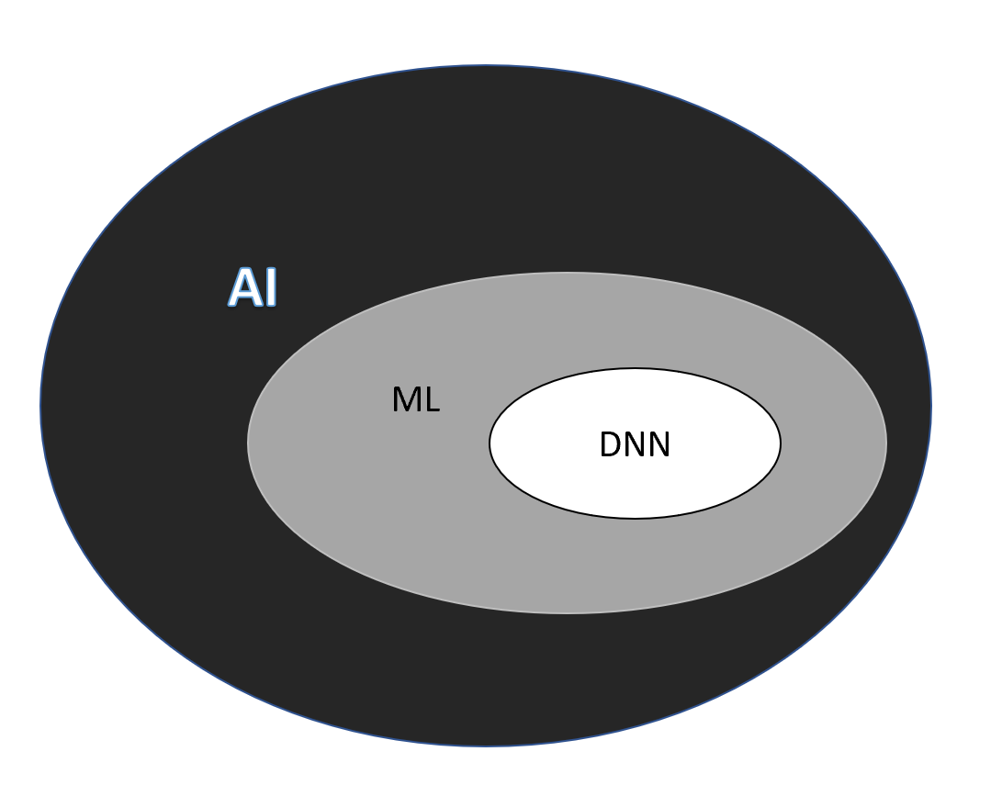
Figure 1 Machine learning is a subfield of artificial intelligence; deep neural networks in turn form a subfield of machine learning. AI: Artificial intelligence; DNN: Deep neural networks; ML: Machine learning.
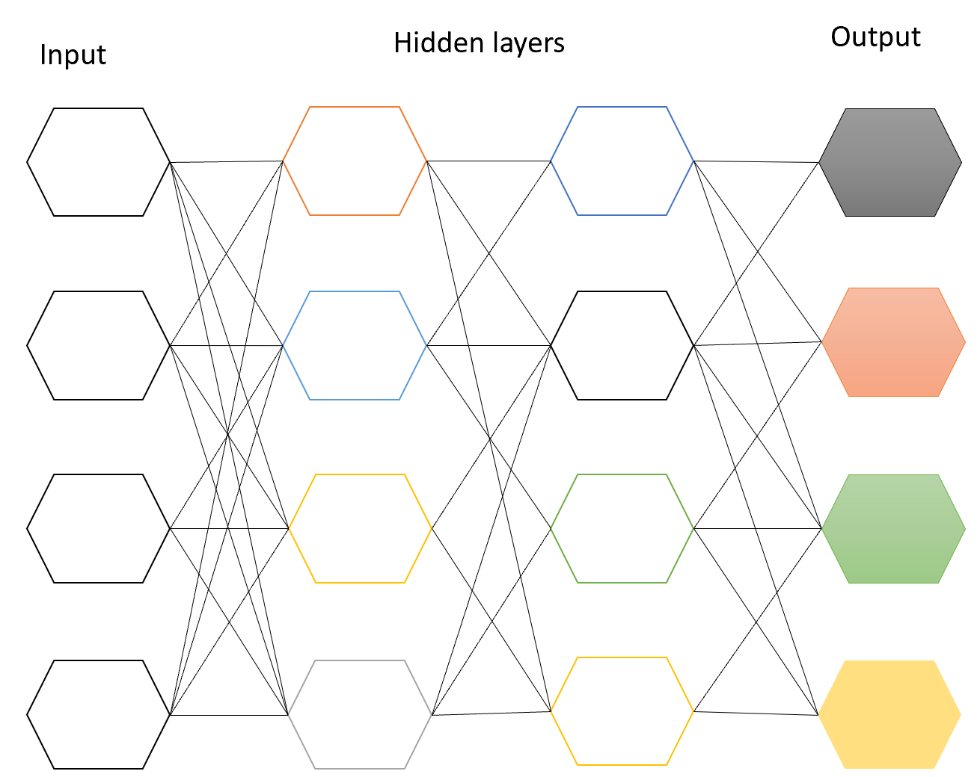
Figure 2 Deep neural networks have multiple intermediate layers that are hidden between the input and output layers.
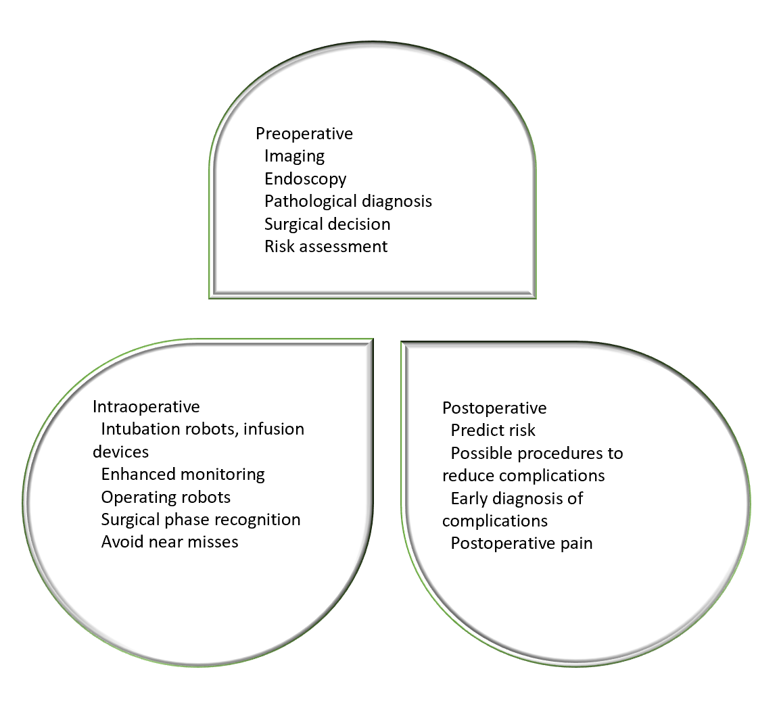
Figure 3 Comprehensive view of areas that reflect the benefits of artificial intelligence in management of major gastrointestinal surgery.

Published by Baishideng Publishing Group Inc
7041 Koll Center Parkway, Suite 160, Pleasanton, CA 94566, USA
Telephone: +1-925-3991568
E-mail: bpgoffice@wjgnet.com
Help Desk: https://www.f6publishing.com/helpdesk
https://www.wjgnet.com

© 2021 Baishideng Publishing Group Inc. All rights reserved.

