Name of Journal: World Journal of Clinical Cases
Manuscript NO: 89375
Manuscript Type: CASE REPORT

Paradoxical herniation associated with hyperbaric oxygen therapy after decompressive craniectomy: A case report

Ye ZX et al. PH associated with HBOT

Zhong-Xing Ye, Xin-Xin Fu, Yang-Zong Wu, Ling Lin, Liang-Qi Xie, Yu-Ling Hu, Yi Zhou, Zhu-Gui You, Hai Lin

Zhong-Xing Ye, Xin-Xin Fu, Ling Lin, Liang-Qi Xie, Yu-Ling Hu, Yi Zhou, Hai Lin, Department of Neurosurgery, The Second People's Hospital of Fujian Province (The Second Affiliated Hospital of Fujian University of Traditional Chinese Medicine), Fuzhou 350001, Fujian Province, China

Yang-Zong Wu, Department of Neurosurgery, The Second Hospital of Longyan, Longyan 364000, Fujian Province, China

Zhu-Gui You, Department of Neurosurgery, Zhangping City Hospital, Longyan 364400, Fujian Province, China

Author contributions: Ye ZX, Fu XX, Wu YZ, Lin L, Xie LQ, Hu YL, and Zhou Y designed the research study; Ye ZX, Fu XX, Wu YZ, and Lin L performed the research; You ZG analyzed the data; Lin H analyzed the data and wrote the manuscript.

Corresponding author: Hai Lin, PhD, Associate Chief Physician, Department of Neurosurgery, The Second People's Hospital of Fujian Province (The Second Affiliated Hospital of Fujian University of Traditional Chinese Medicine), No. 282 Wusi Road, Fuzhou 350001, Fujian Province, China. 461898474@qq.com

Received: October 29, 2023
Revised: February 3, 2024
Accepted: March 12, 2024
Published online:

Abstract
BACKGROUND
Whether hyperbaric oxygen therapy (HBOT) can cause paradoxical herniation is still unclear.

CASE SUMMARY
A 65-year-old patient who was comatose due to brain trauma underwent decompressive craniotomy and gradually regained consciousness after surgery. HBOT was administered 22 d after surgery due to speech impairment. Paradoxical herniation appeared on the second day after treatment, and the patient’s condition worsened after receiving mannitol treatment at the rehabilitation hospital. After timely skull repair, the paradoxical herniation was resolved, and the patient regained consciousness and had a good recovery as observed at the follow-up visit.

CONCLUSION
Paradoxical herniation is rare and may be caused by HBOT. However, the underlying mechanism is unknown, and the understanding of this phenomenon is insufficient. The use of mannitol may worsen this condition. Timely skull repair can treat paradoxical herniation and prevent serious complications.

Keywords: Decompressive craniectomy; Hyperbaric oxygen therapy; Mannitol; Paradoxical herniation; Case report

Ye ZX, Fu XX, Wu TZ, Lin L, Xie LQ, Hu YL, Zhou Y, You ZG, Lin H. Paradoxical herniation associated with hyperbaric oxygen therapy after decompressive craniectomy: A case report. World J Clin Cases 2024; In press

Core Tip: Paradoxical herniation may be caused by high-pressure oxygen therapy after decompressive craniectomy has not been reported. Paradoxical herniation has been misdiagnosed by the neurosurgery department of subordinate hospitals and provincial neurological rehabilitation hospitals for many times, thus delaying treatment. This report is to improve the understanding of paradoxical herniation.

INTRODUCTION
Decompression with a bone flap is an effective rescue measure for alleviating various types of malignant intracranial hypertension. After cerebral edema subsides, the skull loses mechanical support, and the force generated by atmospheric pressure directly acts on the skull defect site. This causes the flap to sag after collapsing downward and inward, leading to a series of neurological declines. The mechanism by which paradoxical herniation occurs remains unclear because it is relatively rare. Moreover, many doctors do not have a comprehensive understanding of this disease, which can lead to misdiagnosis, missed diagnosis, or even deterioration of the patient’s condition and, in severe cases, death. We encountered a rare patient with paradoxical herniation caused by hyperbaric oxygen therapy (HBOT) that was misdiagnosed. Here we report such case to improve the understanding of this disease.

CASE PRESENTATION
Chief complaints
A 65-year-old male patient was in a coma for more than a month due to a high fall.

History of present illness
A 65-year-old male patient presented to Zhangping City Hospital in Fujian Province on May 2, 2021 (Figure 1A) with loss of consciousness for 20 min following a fall from a high height. Cranial computed tomography (CT) revealed a bilateral acute temporal subdural hematoma and contusion in the right frontotemporal lobe. The patient was admitted to the hospital and underwent physical examination. The Glasgow Coma Scale score of the patient was 7 (E1, V2, M4), and he was slightly unconscious, irritable, and unable to answer and cooperate during examination. The bilateral pupils were equally round and large, 0.2 cm in diameter, and slow to respond to light. Lacerations were observed in the left temporal area with obvious local swelling. Bright red bloody fluid was observed in the left external auditory canal and bilateral nasal cavity, with slight resistance in the neck. Lacerations were present in the left thorax, waist, and left anterior abdominal region, with slightly greater muscle tension. The Barnberg sign and Ke's sign were negative. In the Emergency Department, "right craniotomy + intracranial hematoma removal + bone decompression + secondary artificial dural repair" was performed (Figure 1B). After the operation, fluid rehydration therapy, hemostatic agents, nutritional support, brain tissue assessment, infection prevention treatment, stomach protection measures, electrolyte balance therapy, and sedation and analgesia were administered. After the operation (Figure 1C), the patient’s condition gradually improved, but he was unable to speak. On May 24, 2021 (Figure 1D), "hyperbaric oxygen" (inside the cabin, gauge pressure 0.1 mPa, oxygen inhalation for 30 min, rest for 10 min (air inhalation), and oxygen inhalation for 30 min) was administered. The next day (May 25, 2021, Figure 1E), the bone window collapse was obvious; however, local doctors considered it to be normal and thus continued two courses of hyperbaric oxygen treatment. The duration of each treatment course was 10 d, and the degree of bone window collapse did not significantly improve. The patient’s family considered that the treatment response was poor due to his speech disturbance, dysphagia, and occasional dizziness. On June 14, 2021, the patient was transferred to a higher-level hospital for rehabilitation treatment, and on June 15, 202, he was transferred to the Rehabilitation Hospital Affiliated with Fujian University of Chinese Medicine. On the day after admission, cranial CT examination revealed paradoxical herniation (Figure 1F). An attempt to lower cranial pressure using mannitol resulted in drowsiness. On June 17, 2021 (Figure 1G), craniocerebral CT revealed worsened paradoxical herniation, and further treatment was not effective. Five days later (June 22, 2021), a craniocerebral CT review revealed no improvement, and consultation was requested due to continued drowsiness. The patient was referred to our hospital on June 25, 2021, at which point the effects of fluid rehydration were unsatisfactory. A review of the craniocerebral CT images revealed that the paradoxical herniation was still present (June 27, 2021; Figure 1H and I). Cranioplasty was performed on July 1, 2021 (Figure 1J), and the patient was no longer drowsy on the second day after surgery. The stitches were removed, and the patient was discharged from the hospital one week later.

History of past illness
The patient had a medical history of pulmonary tuberculosis.

Personal and family history
The patient denied any family history of malignant tumors or other genetic conditions.

Physical examination
The vital signs of the patient were as follows: Body temperature, 36.9 °C; heart rate, 68/min; respiratory rate, 20/min; and blood pressure, 123/83 mmHg.

Laboratory examinations
Laboratory examinations showed no abnormalities.

Imaging examinations
Cranial CT showed the presence of paradoxical herniation on the next day of HBOT initiation (May 25, 2021, Figure 1E), abnormal aggravation of the cerebral hernia on June 17, 2021 after receiving mannitol treatment (Figure 1G), and the disappearance of paradoxical herniation following cranioplasty on July 1, 2021 (Figure 1J).

FINAL DIAGNOSIS
Paradoxical herniation associated with HBOT.

TREATMENT
After the patient’s skull was repaired, the paradoxical herniation disappeared.

OUTCOME AND FOLLOW-UP
At the postoperative follow-up visit, the patient was mentally clear. Repeat magnetic resonance imaging showed that the paradoxical herniation did not reappear. The patient’s speech gradually improved (Figure 1).

DISCUSSION
Paradoxical herniation, also known as paradoxical herniation syndrome or acute progressive hypotension syndrome, was first described by Schwab et al^{[1]} in 1998 as the result of the absence of a portion of the skull after craniotomy. Cerebrospinal fluid (CSF) flow produces a siphoning effect, and atmospheric pressure directly acts on the cerebral cortex and causes intracranial venous reflux, ultimately leading to flap collapse. Thus, surgery-induced dynamic changes in CSF that cause an intracranial infection or require mannitol dehydration after decompression of the bone flap may lead to brain tissue displacement and brain hernia. Although the pathophysiological mechanism of paradoxical herniation remains unclear, the sum of the changes in intracranial pressure, cerebral blood flow dynamics, and CSF dynamics after bone flap removal can be evaluated using brain compliance (ΔV/ΔP). All factors causing increased cerebral compliance reduce CSF pulsation, resulting in the abovementioned CSF dynamics disorders^{[2-4]}. It has often been reported that excessive drainage reduces the pressure gradient and creates bilateral imbalances, ultimately leading to paradoxical herniation^{[5-9]}.
HBOT-induced paradoxical herniation has not been reported in the literature. However, whether it affects CSF circulation is unknown. Early use of HBOT is conducive to the rehabilitation of patients after decompressive craniotomy. Its main mechanism of action is to increase the oxygen supply to the lesion area in the brain, reduce blood oxygen tension, increase oxygen dispersion, facilitate the establishment of collateral circulation, reverse the inhibition of brain cells, and prevent further decline in brain cell function^{[10]}. However, the establishment of collateral circulation increases CSF absorption, which decreases the amount of CSF. HBOT helps to improve the absorption function of the cerebral surface and arachnoid granulations to establish a balance between CSF secretion and absorption. However, in this case, the patient received HBOT after decompressive craniectomy surgery, during which time excessive dehydration was not achieved and cranial pressure was not reduced; this led to paradoxical herniation on the second day. In a normal cranial cavity^{[11]}, brain pulsation is closely related to changes in intracranial arterial and venous pulsation; however, bone flap decompression may have an impact on this process. Atmospheric pressure may act on the defective cranial cavity, resulting in a sunken bone window flap and a compressed intracranial cortex, which may lead to neurological function damage, insufficient cerebrospinal fluid volume, and flap sinking syndrome. If the atmospheric pressure increases significantly, the volume of CSF becomes insufficient, resulting in the formation of a paradoxical herniation. Siphoning due to skull defects may lead to excessive drainage of CSF^{[1]}, which reduces the intracranial pressure and the "fluid cushion" effect of CSF. Direct compression caused by high atmospheric pressure causes the cranial contents to shift to the normal tissue side, resulting in symptoms of neuropathy. The dural space may be partially deformed or displaced by high air pressure, thus increasing the size of the cerebral cortex and the intracranial venous return flow. This results in the dynamic siphoning effect of CSF, which may also lead to insufficient CSF volume and the occurrence of paradoxical herniation^{[8,12]}. Bender et al^{[13]} suggested that due to the loss of protective support provided by a bone flap as a unilateral decompressor, atmospheric pressure and flap gravity directly act on the flap, the elastic modulus of which is much smaller than that of the skull, resulting in flap collapse. This further diminishes the integrity of the already collapsing flap, causing scalp depression. In addition, surgical damage to the scalp and surrounding tissues leads to the formation of adhesions between the scalp and surrounding tissues and scar formation. With increasing depression, the volume of the cranial cavity gradually decreases, and paradoxical herniation occurs^{[14,15]}.
Ignoring the nature of the high compliance and low cranial pressure associated with disordered CSF dynamics, attempting to drain CSF, or using dehydrating agents to change its abnormal distribution will further exacerbate disordered CSF dynamics, destroy the homeostasis of the central nervous system, and seriously worsen nerve function. Because doctors, including neurosurgeons^{[14]} and neurorehabilitation doctors, have some deficiencies in understanding this phenomenon, mannitol dehydration treatment is often administered immediately after the discovery of a cerebral hernia. This method of treatment has been a standard protocol for a long time but results in worsening of both paradoxical herniation and consciousness disorders, thereby affecting patient rehabilitation.
Intracranial pressure can be effectively reduced by placing the patient in the low-head and high-foot supine position^{[15]}, discontinuing drugs that promote dehydration, increasing the intravenous fluid supply, eliminating all factors leading to CSF loss (lumbar cisternal drainage, ventriculoperitoneal shingles, and cerebrospinal fluid rhinorrhea and otorrhea), and restoring skull integrity as soon as possible. Restoring the integrity of the skull is not only the aim of treatment for paradoxical herniation^{[12,13,15]} but also a means to improve the blood supply to the brain on the skull defect side in patients with paradoxical herniation and to aid in the recovery of nerve function.
In summary, paradoxical herniation is a rare complication after decompressive craniotomy, but its pathological mechanism is unknown. HBOT may cause paradoxical herniation after decompressive craniotomy. However, due to the limitations of single cases, further studies are needed to confirm the exact role of HBOT in the pathogenesis of paradoxical herniation. To improve the in-depth understanding of paradoxical herniation, early diagnosis and timely detection are necessary to ensure timely implementation of effective treatment measures, such as skull repair. Moreover, effective treatment measures are beneficial for repairing the peripheral nerves of lesions and improving patient prognosis.

CONCLUSION
HBOT may cause paradoxical herniation after decompressive craniotomy. Early diagnosis and timely detection are necessary to ensure timely implementation of effective treatment measures, such as skull repair.

REFERENCES
1 Schwab S, Erbguth F, Aschoff A, Orberk E, Spranger M, Hacke W. ["Paradoxical" herniation after decompressive trephining]. Nervenarzt 1998; 69: 896-900 [PMID: 9834480 DOI: 10.1007/s001150050360]
2 Greitz D, Franck A, Nordell B. On the pulsatile nature of intracranial and spinal CSF-circulation demonstrated by MR imaging. Acta Radiol 1993; 34: 321-328 [PMID: 8318291 DOI: 10.1080/02841859309173251]
3 Wagshul ME, Eide PK, Madsen JR. The pulsating brain: A review of experimental and clinical studies of intracranial pulsatility. Fluids Barriers CNS 2011; 8: 5 [PMID: 21349153 DOI: 10.1186/2045-8118-8-5]
4 Idris Z, Mustapha M, Abdullah JM. Microgravity environment and compensatory: Decompensatory phases for intracranial hypertension form new perspectives to explain mechanism underlying communicating hydrocephalus and its related disorders. Asian J Neurosurg 2014; 9: 7-13 [PMID: 24891884 DOI: 10.4103/1793-5482.131058]
5 Creutzfeldt CJ, Vilela MD, Longstreth WT Jr. Paradoxical herniation after decompressive craniectomy provoked by lumbar puncture or ventriculoperitoneal shunting. J Neurosurg 2015; 123: 1170-1175 [PMID: 26067613 DOI: 10.3171/2014.11.JNS141810]
6 Watanabe J, Maruya J, Nishimaki K. Sinking skin flap syndrome after unilateral cranioplasty and ventriculoperitoneal shunt in a patient with bilateral decompressive craniectomy. Interdiscip Neurosurg 2016; 5: 6-8 [DOI: 10.1016/j.inat.2016.03.010]
7 Nasi D, Dobran M, Iacoangeli M, Di Somma L, Gladi M, Scerrati M. Paradoxical Brain Herniation After Decompressive Craniectomy Provoked by Drainage of Subdural Hygroma. World Neurosurg 2016; 91: 673.e1-673.e4 [PMID: 27108031 DOI: 10.1016/j.wneu.2016.04.041]
8 Shen L, Qiu S, Su Z, Ma X, Yan R. Lumbar puncture as possible cause of sudden paradoxical herniation in patient with previous decompressive craniectomy: report of two cases. BMC Neurol 2017; 17: 147 [PMID: 28768486 DOI: 10.1186/s12883-017-0931-1]
9 Zhao J, Li G, Zhang Y, Zhu X, Hou K. Sinking skin flap syndrome and paradoxical herniation secondary to lumbar drainage. Clin Neurol Neurosurg 2015; 133: 6-10 [PMID: 25817571 DOI: 10.1016/j.clineuro.2015.03.010]
10 Galbiati G, Paola C. Effects of Open and Closed Endotracheal Suctioning on Intracranial Pressure and Cerebral Perfusion Pressure in Adult Patients With Severe Brain Injury: A Literature Review. J Neurosci Nurs 2015; 47: 239-246 [PMID: 25951310 DOI: 10.1097/JNN.0000000000000146]
11 Wee HY, Kuo JR. Never neglect the atmospheric pressure effect on a brain with a skull defect. Int Med Case Rep J 2014; 7: 67-69 [PMID: 24741332 DOI: 10.2147/IMCRJ.S59410]
12 Hiruta R, Jinguji S, Sato T, Murakami Y, Bakhit M, Kuromi Y, Oda K, Fujii M, Sakuma J, Saito K. Acute paradoxical brain herniation after decompressive craniectomy for severe traumatic brain injury: A case report. Surg Neurol Int 2019; 10: 79 [PMID: 31528417 DOI: 10.25259/SNI-235-2019]
13 Bender PD, Brown AEC. Head of the Bed Down: Paradoxical Management for Paradoxical Herniation. Clin Pract Cases Emerg Med 2019; 3: 208-210 [PMID: 31403093 DOI: 10.5811/cpcem.2019.4.41331]
14 Jung HJ, Kim DM, Kim SW. Paradoxical transtentorial herniation caused by lumbar puncture after decompressive craniectomy. J Korean Neurosurg Soc 2012; 51: 102-104 [PMID: 22500203 DOI: 10.3340/jkns.2012.51.2.102]
15 Narro-Donate JM, Huete-Allut A, Escribano-Mesa JA, Rodríguez-Martínez V, Contreras-Jiménez A, Masegosa-González J. [Paradoxical transtentorial herniation, extreme trephined syndrome sign: A case report]. Neurocirugia (Astur) 2015; 26: 95-99 [PMID: 25455761 DOI: 10.1016/j.neucir.2014.09.006]

Footnotes
Informed consent statement: Informed written consent was obtained from the patient for publication of this report and any accompanying images.

Conflict-of-interest statement: All the authors report no relevant conflicts of interest for this article.

CARE Checklist (2016) statement: The authors have read the CARE Checklist (2016), and the manuscript was prepared and revised according to the CARE Checklist (2016).

Open-Access: This article is an open-access article that was selected by an in-house editor and fully peer-reviewed by external reviewers. It is distributed in accordance with the Creative Commons Attribution NonCommercial (CC BY-NC 4.0) license, which permits others to distribute, remix, adapt, build upon this work non-commercially, and license their derivative works on different terms, provided the original work is properly cited and the use is non-commercial. See: https://creativecommons.org/Licenses/by-nc/4.0/

Provenance and peer review: Unsolicited article; Externally peer reviewed.
Peer-review model: Single blind
Corresponding Author's Membership in Professional Societies: China Medical Education Association, ETCHB-203.

Peer-review started: October 29, 2023
First decision: January 17, 2024
Article in press:

Specialty type: Neurosciences
Country/Territory of origin: China
Peer-review report’s scientific quality classification
Grade A (Excellent): 0
Grade B (Very good): 0
Grade C (Good): 0
Grade D (Fair): D
Grade E (Poor): 0

P-Reviewer: Shen HN, Taiwan S-Editor: Gong ZM L-Editor: Wang TQ P-Editor:

Figure Legends
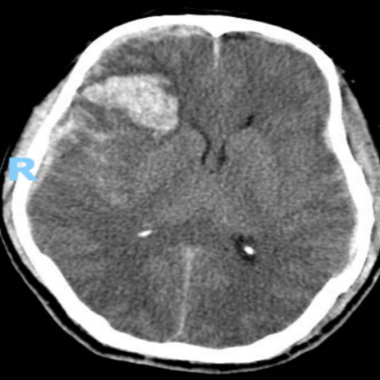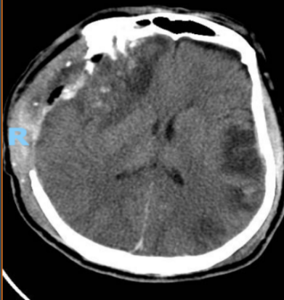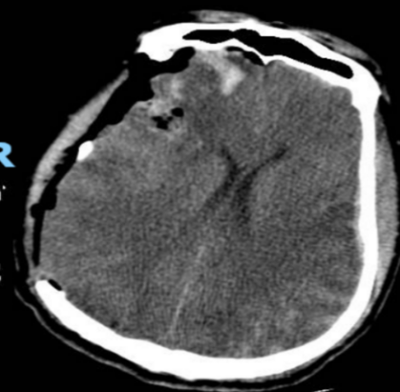
B
C
A
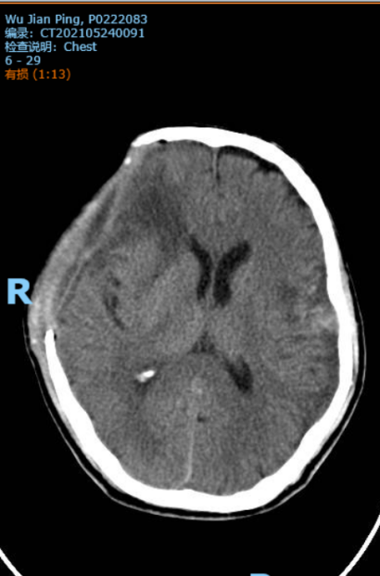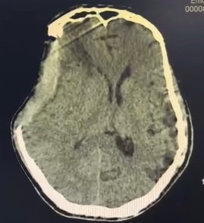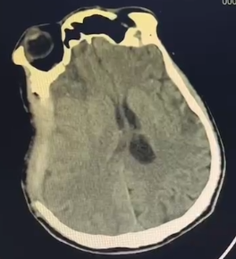
F
E
D
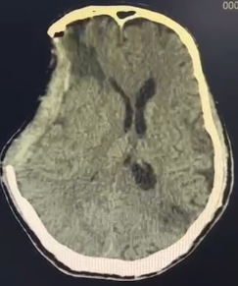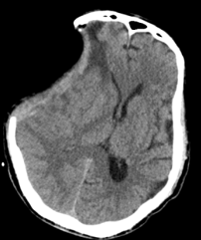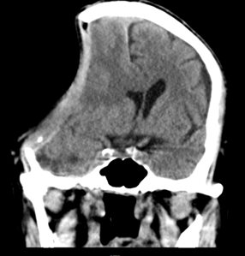
I
H
G
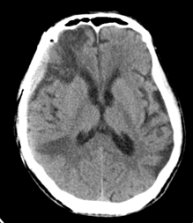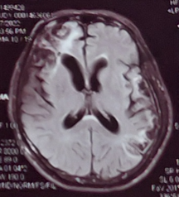
L
K
J
Figure 1 Computed tomography findings during patient diagnosis and treatment. A: Preoperative cranial computed tomography (CT) image on May 2, 2021; B: First postoperative cranial CT image (May 2, 2021); C: Cranial CT image obtained 1 wk after the first surgery (May 8, 2021); D: Cranial CT image before hyperbaric oxygen therapy (HBOT) (May 24, 2021); E: Cranial CT image on the second day of HBOT (May 25, 2021); F: Cranial CT image on the tenth day of HBOT (June 15, 2021); G: Cranial CT image before mannitol treatment (June 17, 2021); H: Second preoperative cranial CT image (axial) (June 27, 2021); I: Second preoperative cranial CT image (coronal) (June 27, 2021); J: Cranial CT before the second surgery (July 2, 2021); K: Cranial CT at 20 d after the second surgery (July 22, 2021); L: One-year postoperative cranial MR image (June 17, 2022).

