Name of Journal: World Journal of Clinical Cases
Manuscript NO: 76768
Manuscript Type: CASE REPORT

Bronchogenic cysts with infection in the chest wall skin of a 64-year-old asymptomatic patient: A case report

Ma B et al. Bronchogenic cysts with infection

Ben Ma, Kai-Wen Fu, Xu-Dong Xie, Yue Cheng, Sheng-Qiang Wang

Ben Ma, Kai-Wen Fu, Xu-Dong Xie, Yue Cheng, Sheng-Qiang Wang, Department of General, Chongqing University Cancer Hospital, Chongqing 400030, China

Author contributions: Ma B was the major contributor in preparing the manuscript; Ma B, Fu KW, Xie XD and Cheng Y collected the patient’s clinical data; Ma B wrote the paper; Wang SQ advised the manuscript; all authors reviewed and edited the article before submission.

Corresponding author: Ben Ma, MD, Attending Doctor, Department of General, Chongqing University Cancer Hospital, No. 181 Hanyu Road, Shapingba District, Chongqing 400030, China. benma@cqu.edu.cn

Received: March 30, 2022
Revised: June 13, 2022
Accepted: July 5, 2022
Published online:

Abstract
BACKGROUND
Skin bronchogenic cysts are extremely rare congenital bronchocystic changes caused by the abnormal development of the trachea, bronchial trees or lung buds during the embryonic period. The first case of skin bronchogenic cysts was reported in 1945. Since then, this disease has attracted increasing attention, but due to the low incidence, its pathogenesis is still not clear.

CASE SUMMARY
Here, we report another case of skin bronchogenic cysts with infection in a 64-year-old female patient. The patient had no symptoms for more than 60 years until her chest wall was recently found to be swollen, and she felt pain and discomfort. At the same time, secretions were found on the surface of the swelling. Color Doppler ultrasound examination showed abnormal echoes in the soft tissue under the frontal chest wall, suggesting the presence of cysts. Cytological puncture resulted in about 2 mL of pus and showed the presence of more acute inflammatory cells. The final clinical diagnosis was skin cyst with infection, and surgery was carried out. The pathological results obtained after surgery showed that the cystic wall was covered with column-like cilia epithelial cells, and the interstitial structure was partially inundated with inflammatory cells. After a variety of examinations and clinical diagnoses, we finally confirmed that the patient was suffering from bronchogenic cyst.

CONCLUSION
This article not only describes the case of an elderly patient with rare skin bronchogenic cysts with infection but also provides a detailed and correct diagnosis and a successful treatment process, which is of great value for the diagnosis and treatment of the disease.

Key Words: Bronchogenic cyst; Chest wall infection; Dermal cyst; Benign chest wall lesion; Case report

Ma B, Fu K, Xie X, Cheng Y, Wang S. Bronchogenic cysts with infection in the chest wall skin of a 64-year-old asymptomatic patient: A case report. World J Clin Cases 2022; In press

Core Tip: Skin bronchogenic cysts are a rare disease with low incidence, which is easy to be misdiagnosed. We have reported a case of bronchogenic cysts with infection in the frontal chest wall of a 64-year-old patient. Pain-accompanied secretions appeared in the patient’s frontal thoracic wall. Combined with color Doppler ultrasound examinations and cytological puncture examinations, we suggest that skin cysts with infections had been present before surgery. The diagnosis of skin bronchogenic cysts was confirmed by the final pathological results obtained after resection. We emphasize that the diagnosis of skin bronchogenic cysts needs to be corroborated by a variety of methods. The detailed diagnostic process and successful treatment of the case reported here are highly valuable for the treatment of bronchogenic cysts with infection.

INTRODUCTION
Bronchogenic cysts are an extremely rare congenital disease that is caused by the abnormal development of the trachea, bronchial trees or lung buds during the embryonic period. The first case of skin bronchogenic cysts was reported by Seybold and Clagett^{[1]} in 1945. Bronchogenic cysts may occur in various areas, such as the mediastinum^{[2]}, lungs^{[3]}, heart^{[4]}, stomach^{[5]}, peritoneum^{[6]} and in other areas. The disease is more commonly diagnosed in childhood than in adulthood^{[7]}. Furthermore, the incidence of this disease is approximately four times higher in males than in females^{[8]}. In older female patients, fewer cases of skin bronchogenic cysts with infections are reported. Unfortunately, obvious clinical symptoms are absent, imaging examination does not provide any specific findings, the diagnosis of bronchogenic cysts before surgery is very difficult, and the rate of misdiagnosis is high^{[9]}. To lay a foundation for future clinical work, we report the detailed diagnostic process and successful treatment of a 64-year-old female patient with skin bronchogenic cysts with infection. The timeline is shown in Table 1.

CASE PRESENTATION
Chief complaints
Chest wall swelling occurred for more than 60 years. Intermittent pain was accompanied by secretions for nearly half a year.

History of present illness
On September 24, 2020, a 64-year-old Chinese female patient visited our hospital presenting with intermittent pain. After careful outpatient examination, we thought that the patient may have a skin cyst and recommended surgery. At that time, the patient rejected surgery as a treatment option and received only oral antibiotics for treatment. For nearly half a year, the patient felt intermittent pain in the chest wall swellings and had secretions on the surface of the swellings. Therefore, the patient came to our hospital again for medical treatment on July 20, 2021.

History of past illness
The patient had no history of other diseases, such as diabetes, high blood pressure and heart disease. Moreover, she had no history of drug allergies.

Personal and family history
The patient has gone through the menopause. She has one son and one daughter.

Physical examination
The patient’s vital signs were stable. We found a swelling of about 3 cm × 3 cm in the front chest wall near the thoracic bone handle protruding from the surface of the skin. The texture of the swelling was soft and caused slight pain upon pressure. Except for secretion in the skin around the swelling, no other obvious abnormalities were found, and the boundaries of the swelling were clear.

Laboratory examinations
We further performed a fine-needle cytological puncture, which resulted in about 2 mL of pus. The results showed many acute inflammatory cells (Figure 1). Furthermore, other preoperative indicators, including blood biochemistry, complete blood count, HIV test and an electrocardiogram, were within the normal range. Based on the above results and findings, we speculate that the patient was most likely to have a skin cyst with infection.

Imaging examinations
Color Doppler ultrasound examination revealed abnormal echoes in the soft tissue under the frontal chest wall, suggesting the presence of cysts in the corresponding area (Figure 2).

FINAL DIAGNOSIS
A large amount of yellow viscous liquid was found in the sample obtained from the patient. The pathological diagnosis was made based on the obtained tissue specimen (Figure 3). We found cyst lesions in the sample. The cystic wall was covered with column-like cilia epithelial cells. These cells had the same structure as the bronchus. At the same time, we found that the interstitial structure was partially infested with inflammatory cells, which were not reported in the usual histopathological findings of bronchogenic cysts. Combined with these results, the pathologists ultimately verified that the cyst of this patient was a bronchogenic cyst.

TREATMENT
As the patient chose the complete removal of the cysts, we developed a personalized treatment plan in conjunction with our imaging examination. First, we cut open the skin at the location of the cysts and observed secretion of pus. Then, the sac wall and necrosis tissue were completely removed. We repeatedly rinsed the wound with hydrogen peroxide solution until no more obvious cyst wall, necrotic tissue and secretions were found. Then, the wound was rinsed again using normal saline. After that, the wound surface was filled with medical gauze, and we carefully observed the wound healing every day. After 8 d, the leakage of fluid from the trauma location was significantly reduced, and we observed bright red granulation tissue at the trauma location. Finally, we performed debridement and suture surgery again under local anesthesia. During the surgery, the secretions on the wound surface were thoroughly removed, and the cut edge and some inactivated tissues were trimmed to fit the skin well. As a result, the patient recovered well, and her symptoms disappeared completely (Figure 4).

OUTCOME AND FOLLOW-UP
The patient recovered well, and her symptoms disappeared completely within the following 30 d.

DISCUSSION
As bronchogenic cysts are a rare congenital disease, the pathogenesis of this disease is not yet known. Lots of medical doctors and researchers consider bronchogenic cysts to be congenital broncho saccharin changes caused by the abnormal development of trachea, bronchial trees or lung buds during the embryonic period^{[6,10]}. Shah et al^{[7]} reported a total of 86 cases of bronchogenic cysts, and about 74% of these patients were male. In these cases, the most common locations of subcutaneous bronchogenic cysts were thoracic bone incision (26), followed by neck (18), shoulder blade (15) and thoracic bone handle (13). Only 2 cases (2.3%, 2/86) were found in the front of the chest wall. In the present case, the cyst was in the frontal chest wall of the patient.
As previously reported, imaging generally shows no obvious clinical symptoms or specific signs. The clinical manifestations of the patient may be papules, cystic nodules, sinus tracts or secretions associated with the sinus tract^{[11]}. Some patients even had no symptoms. It is worth noting that the patient reported in this case did not show any symptoms for up to 64 years. The cause of this phenomenon may have a lot to do with the location of the cyst and the limited size of the cyst (8-9 mm thick). For example, it has been reported that bronchial cysts located in the stomach can cause symptoms such as abdominal pain, nausea and vomiting in patients^{[5,12]}. The clinical symptoms of benign masses in the skin layer are mostly the continuous growth of the mass, which affects the skin morphology. Due to these characteristics of bronchogenic cysts, the misdiagnosis rate of this disease is so high that it can delay the patients’ treatment processes.
In the case of the patient reported herein, the swelling was present for more than 60 years. Over time, the swelling grew at a very slow rate. Furthermore, no obvious clinical symptoms occurred in any stage of the disease. Therefore, this disease has not attracted the attention of the patient, and she did not seek urgent treatment. However, skin bronchogenic cysts can result in repeated breakages, infections and even malfunctions of the skin^{[13]}. The current patient sought further treatment in our hospital as she had developed redness, intermittent pain and discomfort in recent months.
Pathological diagnosis is the gold standard for the diagnosis of bronchogenic cysts. Cysts are mainly located in the dermis and subcutaneous tissue. The cystic wall is composed of pseudo-complex respiratory cilia column epithelial cells and cup-shaped cells but sometimes contains smooth muscles and cartilage^{[14,15]}. When the pathology cannot be clearly diagnosed, it has been suggested that the growth site of the lesion can be used as a criterion for the diagnosis of the disease. We performed a postoperative pathological diagnosis of the patient reported in this case. Combined with the patient’s symptoms, color Doppler ultrasound results, cytological puncture results and histopathological diagnosis, we confirmed that the disease was a bronchogenic cyst with infection.
This is an interesting case, as the patient did not show any symptoms for up to 64 years. Most regrettable in this case is that the preoperative diagnosis was not clear before the pathological diagnosis. Because of the rarity of bronchogenic cysts, the misdiagnosis rate of this disease is so high that it can delay the patients’ treatment processes. We emphasize that the possibility of bronchogenic cysts should be considered by doctors in the diagnosis and treatment of patients when imaging examination suggests fluid-containing cysts. Since the cystic wall is composed of pseudo-complex respiratory cilia column epithelial cells, cup-shaped cells, smooth muscles and cartilage^{[14,15]}, we recommend that medical researchers should be able to identify some markers specific to bronchial cysts by comparing genetic or metabolite differences between different cyst types. At the same time, considering the cost of treating patients, it is necessary to establish some simple and low-cost methods to accurately identify the corresponding special markers. This strategy can improve the doctor’s confidence in diagnosis and enable the patients to understand the disease in detail.
The suitable treatment of bronchogenic cysts is surgical excision in the early stage of the disease, and the cyst wall should be completely removed during surgery to prevent the recurrence of the disease^{[8]}. We have selected 16 cases of chest wall cutaneous bronchial cysts, all of which were also treated by surgical excision (Supplementary Table 1). Among them, the first 2 cases were accompanied by infection. The patient in this case had repeatedly broken chest wall skin and secretions. The treatment process of this disease is different from that of other related diseases, such as sebum adeno cysts, epidermal cysts and cilia skin cysts^{[16]}. On the other hand, the presence of infection further increases the difficulty of treating the disease. As shown in Supplementary Table 1, the first patient was treated with incision and drainage of the wound and oral antibiotics^{[17]}. Then, the wound was allowed to heal spontaneously. As a result, a fistula formed in the wound. The second patient was treated with complete excision of the cyst^{[18]}. However, complete excision of diseased tissue during inflammation often results in an excessively large excision, causing unnecessary damage to the patient. At the same time, in the presence of inflammation, the wound of the patient may become infected after the complete removal of the cyst. Therefore, we designed a personalized treatment plan for the patient based on our successful treatment strategy. As a result, the patient recovered well, and her symptoms disappeared completely.

CONCLUSION
This case report is of great value for the diagnosis and treatment of bronchogenic cysts as a rare disease. This successful experience allows improving the preoperative diagnosis and develops a personalized treatment plan for the patient. Furthermore, it is helpful to improve our understanding of the disease.

REFERENCES
1 Seybold WD, Clagett OT. Presternal Cyst: Report of a Case. J Thorac Surg 1945; 14: 217-220 [DOI:10.1016/s0096-5588(20)31502-6]
2 Tan GJS, Ooi WM, Law RHF, Nardini M. Robotic pericardial patch repair of the bronchus intermedius after bronchogenic cyst removal. Interact Cardiovasc Thorac Surg 2018; 26: 711-712 [PMID: 29194484 DOI: 10.1093/icvts/ivx382]
3 Kosar A, Tezel C, Orki A, Kiral H, Arman B. Bronchogenic cysts of the lung: report of 29 cases. Heart Lung Circ 2009; 18: 214-218 [PMID: 19119078 DOI: 10.1016/j.hlc.2008.10.011]
4 Park J, Cho GY, Park KH, Oh IY. Intracardiac bronchogenic cyst: report of a growing lesion. Circulation 2014; 130: 1107-1109 [PMID: 25245848 DOI: 10.1161/circulationaha.114.010992]
5 He WT, Deng JY, Liang H, Xiao JY, Cao FL. Bronchogenic cyst of the stomach: A case report. World J Clin Cases 2020; 8: 1525-1531 [PMID: 32368546 DOI: 10.12998/wjcc.v8.i8.1525]
6 Chen HY, Fu LY, Wang ZJ. Ileal bronchogenic cyst: A case report and review of literature. World J Clin Cases 2018; 6: 807-810 [PMID: 30510947 DOI: 10.12998/wjcc.v6.i14.807]
7 Shah SK, Stayer SE, Hicks MJ, Brandt ML. Suprasternal bronchogenic cyst. J Pediatr Surg 2008; 43: 2115-2117 [PMID: 18970953 DOI: 10.1016/j.jpedsurg.2008.07.029]
8 Pul N, Pul M. Bronchogenic cyst of the scapular area in an infant: case report and review of the literature. J Am Acad Dermatol 1994; 31: 120-122 [PMID: 8021357 DOI: 10.1016/s0190-9622(09)80243-0]
9 Tan KK, Nandini CL, Ho CK. A case of gastric bronchogenic cyst in Singapore with multiple intrigues. ANZ J Surg 2010; 80: 286-287 [PMID: 20575959 DOI: 10.1111/j.1445-2197.2010.05260.x]
10 Tu C, Zhu J, Shao C, Mao W, Zhou X, Lin Q, Li Z, Zhang J, Zhou Q, Chen W. Gastric bronchogenic cysts: A case report and literature review. Exp Ther Med 2016; 11: 1265-1270 [PMID: 27073434 DOI: 10.3892/etm.2016.3067]
11 Sun J, Yuan T, Deng H. Cutaneous bronchogenic cyst in the left scapular region of a boy. World J Pediatr 2014; 10: 365-367 [PMID: 25515809 DOI: 10.1007/s12519-014-0514-9]
12 Sun B, Wang AK, Chen H, Qian BL, Yi XK, Jiang Y, Li Q, Fu WG, Li J. Bronchogenic cyst of the stomach: A case report and literature review. Exp Ther Med 2020; 20: 166 [PMID: 33093904 DOI: 10.3892/etm.2020.9295]
13 Tanita M, Kikuchi-Numagami K, Ogoshi K, Suzuki T, Tabata N, Kudoh K, Suetake T, Takahashi T, Tagami H. Malignant melanoma arising from cutaneous bronchogenic cyst of the scapular area. J Am Acad Dermatol 2002; 46: S19-S21 [PMID: 11807461 DOI: 10.1067/mjd.2002.105476]
14 Kim DH, Kim HK, Lee JW, Lee HI, Park KY, Li K, Seo SJ, Hong CK, Song KY. A case of cutaneous bronchogenic cyst presenting with lymphoid follicles. Ann Dermatol 2011; 23: 392-395 [PMID: 21909217 DOI: 10.5021/ad.2011.23.3.392]
15 Perrot P, Lescour V, Jossic F, Barbarot S, Duteille F. [A rare congenital lesion: bronchogenic cyst. Case report and review of the literature]. Ann Chir Plast Esthet 2013; 58: 263-266 [PMID: 21440974 DOI: 10.1016/j.anplas.2011.01.006]
16 Avalos P, García-Hernández MJ, Ríos JJ, Moreno D, Camacho F. [Cutaneous bronchogenic cyst]. Actas Dermosifiliogr 2005; 96: 186-187 [PMID: 16476364 DOI: 10.1016/s0001-7310(05)73065-9]
17 Carden C, Dykes E, Pollock AM. An unusual midline swelling--case report of a cutaneous bronchogenic cyst. Eur J Pediatr Surg 2008; 18: 345-346 [PMID: 18629774 DOI: 10.1055/s-2008-1038494]
18 Shilova M, Wong MCL, Davies J, Kimble R. A bronchogenic cyst presenting as a presternal abscess. J Pediat Surg Case R 2020; 63: 101653 [DOI:10.1016/j.epsc.2020.101653]

Footnotes
Informed consent statement: Written informed consent was obtained from the patient for publication of this case report and any accompanying images.

Conflict-of-interest statement: All the authors report no relevant conflicts of interest for this article.

CARE Checklist (2016) statement: The authors have read the CARE Checklist (2016), and the manuscript was prepared and revised according to the CARE Checklist (2016)

Open-Access: This article is an open-access article that was selected by an in-house editor and fully peer-reviewed by external reviewers. It is distributed in accordance with the Creative Commons Attribution NonCommercial (CC BY-NC 4.0) license, which permits others to distribute, remix, adapt, build upon this work non-commercially, and license their derivative works on different terms, provided the original work is properly cited and the use is non-commercial. See: https://creativecommons.org/Licenses/by-nc/4.0/

Provenance and peer review: Unsolicited article; Externally peer reviewed.
Peer-review model: Single blind

Peer-review started: March 30, 2022
First decision: May 30, 2022
Article in press:

Specialty type: Surgery
Country/Territory of origin: China
Peer-review report’s scientific quality classification
Grade A (Excellent): 0
Grade B (Very good): 0
Grade C (Good): C, C
Grade D (Fair): 0
Grade E (Poor): 0

P-Reviewer: Abdul Aziz JM, Iraq; Esch M, Germany S-Editor: Xing YX L-Editor: Filipodia P-Editor: Xing YX

Figure Legends
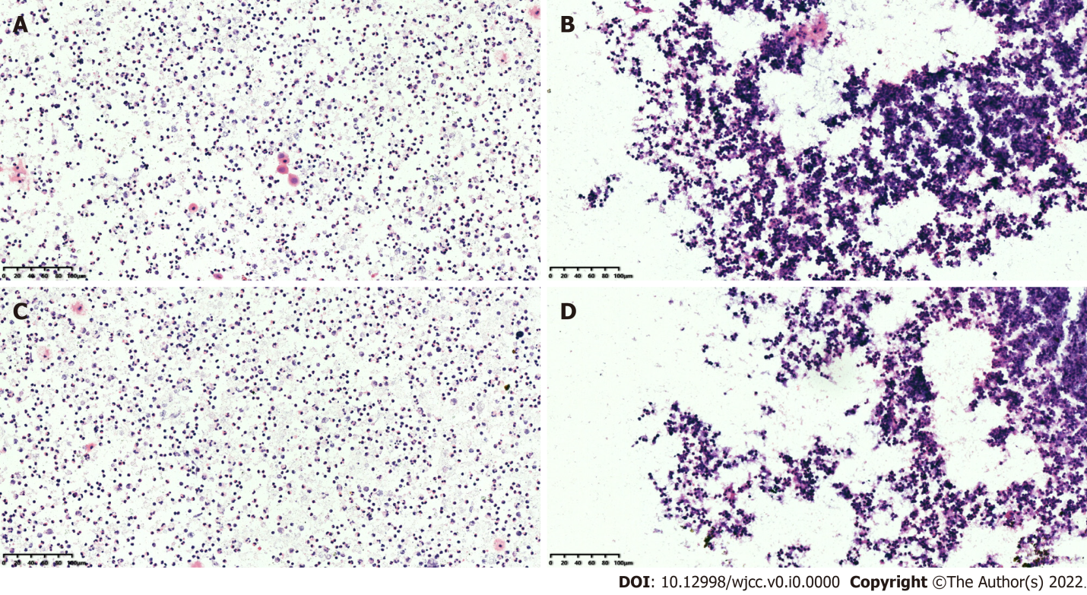
Figure 1 Imaging of the puncture test prior to surgery. A: On September 24, 2020, cytological puncture resulted in about 2 mL of pus, and a large number of acute inflammatory cells were found (× 200); B: On July 20, 2021, cytological puncture resulted in about 2 mL of pus, and an increased number of acute inflammatory cells were found (× 200); C and D: Represent other microscope fields of view of A and B, respectively.
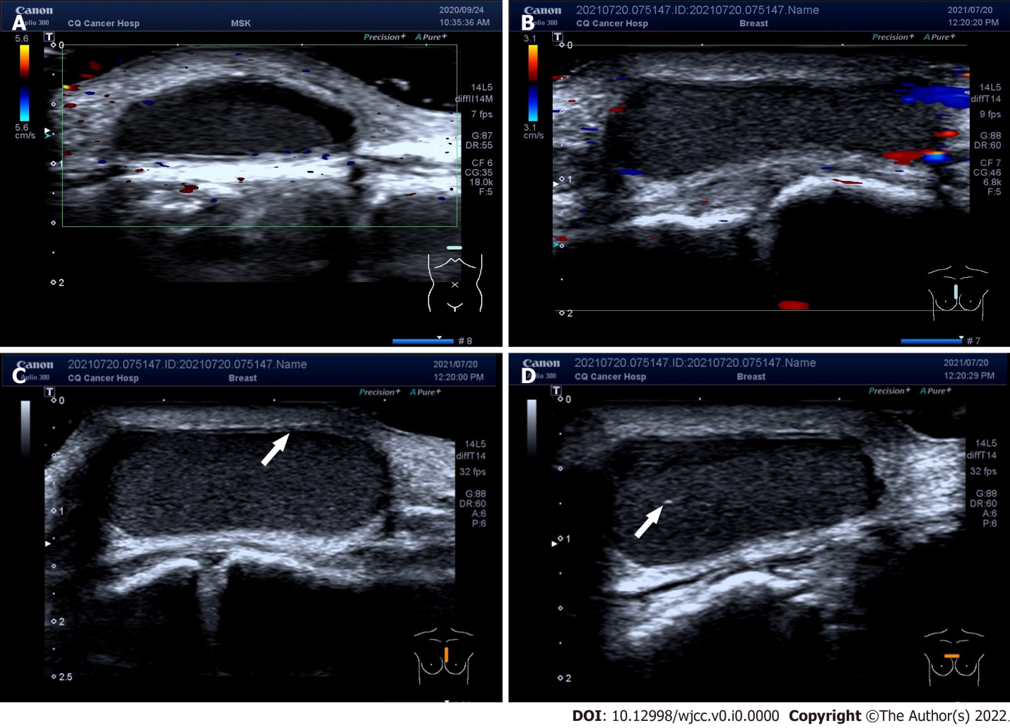
Figure 2 Imaging prior to surgery. A: A low-to-no-echo area of about 8 mm × 19 mm × 26 mm in the patient’s subcutaneous soft tissue. The boundaries of the area were clear, and the morphology was clear. Furthermore, this area showed no obvious blood flow signal (September 24, 2020); B: A low-echo nodule of about 9 mm × 21 mm × 26 mm in the patient’s subcutaneous soft tissue. The boundaries of the nodule were clear, and the morphology was clear. At the same time, no intact envelope was found. A dense dot weak echo was found inside. The internal blood flow signal was not intense (July 20, 2021); C: Most of the cyst borders did not resemble the smooth walls of typical cysts, and the cyst appeared as a frizzy capsule instead. Echoes of the smooth wall can be seen in a few areas (white arrow; July 20, 2021); D: The inside of the cyst showed a relatively homogeneous low echo, and a small amount of oxalate calcification (white arrow) was found in some areas. The inflammation was mainly manifested in the cyst wall (July 20, 2021).
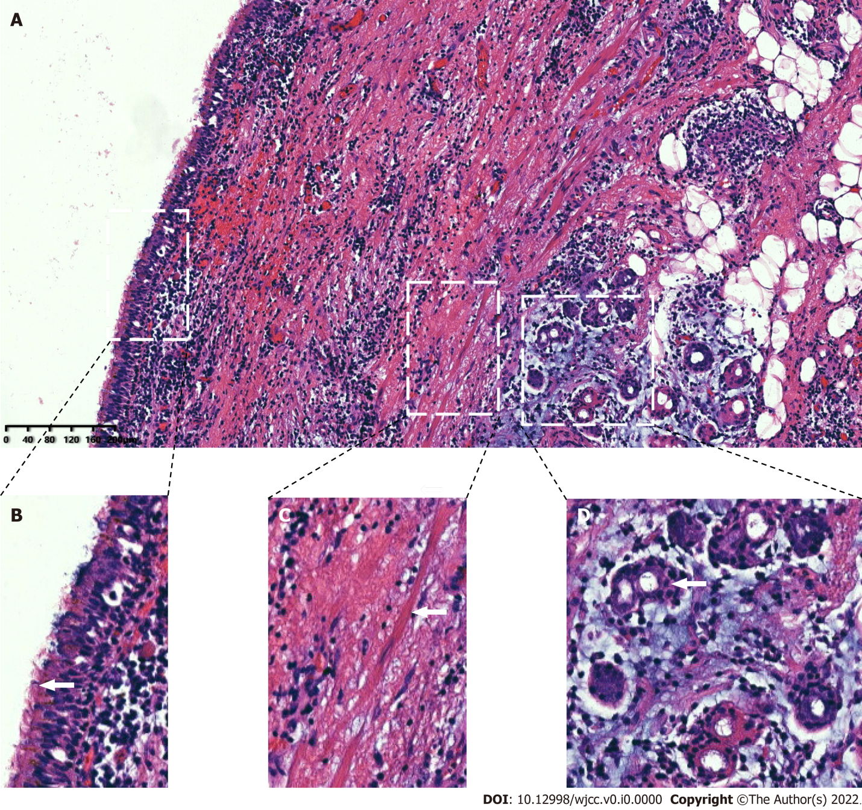
Figure 3 Postoperative histopathology. A: Combined with immunohistochemical staining for CK7 (+), CK20 (-), TTF1 (-) and S-100 (-), the histopathological examinations showed that the specimen was consistent with a bronchogenic cyst with obvious hyperplasia of histiocytes (× 100); B: The white arrows represent column-like cilia epithelial cells; C: Smooth muscle bundles; D: Bronchial glands.
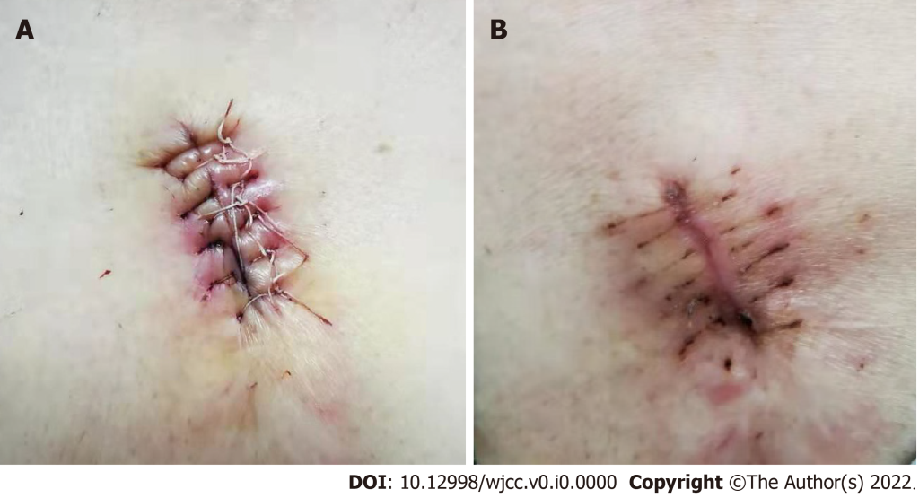
Figure 4 Imaging of the postoperative area. A: Imaging of the postoperative area after 3 d of debridement and suture surgery; B: Imaging of the postoperative area after 20 d of debridement and suture surgery.

Table 1 Timeline of the case
Time | Information about the patient
September 24, 2020 | Admitted to our hospital
July 20, 2021 | Admitted to our hospital
July 20, 2021 | Received laboratory and imaging examinations
July 20, 2021 | Received ultrasonography
July 20, 2021 | Received cytological puncture
July 20, 2021 | The sac wall and necrosis tissue were completely removed
July 23, 2021 | Pathological results confirmed skin bronchogenic cysts
July 28, 2021 | Debridement and suture surgery
August 20, 2021 | Follow-up

