Name of Journal: World Journal of Gastrointestinal Oncology
Manuscript NO: 78855
Manuscript Type: CASE REPORT

Silent advanced large cell neuroendocrine carcinoma with synchronous adenocarcinoma of the colon: A case report

Baek HS et al. Silent LCNEC of the colon

Hyeon Seok Baek, Sang Wook Kim, Soo Teik Lee, Ho Sung Park, Seung Young Seo

Hyeon Seok Baek, Sang Wook Kim, Soo Teik Lee, Seung Young Seo, Department of Internal Medicine, Research Institute of Clinical Medicine of Jeonbuk National University-Biomedical Research Institute of Jeonbuk National University Hospital, Jeonju-si 56445, Jeollabuk-do, South Korea

Ho Sung Park, Department of Pathology, Jeonbuk National University Medical School, Jeonju-si 56445, Jeollabuk-do, South Korea

Author contributions: Baek HS analyzed clinical data and drafted the manuscript; Lee ST, Kim SW, Seo SY advised and reviewed the manuscript; Park HS performed the pathologic review.

Corresponding author: Seung Young Seo, MD, PhD, Professor, Department of Internal Medicine, Research Institute of Clinical Medicine of Jeonbuk National University-Biomedical Research Institute of Jeonbuk National University Hospital, 20 Geonji-ro, Deokjin-gu, Jeonju-si 56445, Jeollabuk-do, South Korea. bear7905@jbnu.ac.kr

Received: July 22, 2022
Revised: August 31, 2022
Accepted: October 12, 2022
Published online: November 15, 2022

Abstract
BACKGROUND
Large cell neuroendocrine carcinoma (LCNEC) accounts for about 0.25% of colorectal cancer patients. Furthermore, synchronous LCNEC and adenocarcinoma coexistence in the colon is very rare. LCNEC are usually aggressive and have a poor prognosis. Usually, colorectal LCNEC patients complain of abdominal symptoms such as pain, diarrhea or hematochezia because it is often diagnosed as an advanced disease that accompanies metastatic lesions.

CASE SUMMARY
We describe a case of relatively asymptomatic synchronous LCNEC and colon adenocarcinoma. A 62-year-old male patient visited our hospital due to anemia detected by a local health check-up. He did not complain of melena, hematochezia or abdominal pain. Physical examination was unremarkable and his abdomen was soft, nontender and nondistended with no palpable mass. Laboratory tests revealed anemia with hemoglobin 5.1 g/dL. Colonoscopy revealed an ulcerofungating lesion in the ascending colon and about a 1.5 cm-sized large sessile polyp in the sigmoid colon. Endoscopic biopsy of the ascending colon lesion revealed the ulcerofungating mass that was LCNEC and endoscopic mucosal resection at the sigmoid colon lesion showed a large polypoid lesion that was adenocarcinoma. Multiple liver, lung, bone and lymph nodes metastasis was found on chest/abdominal computed tomography and positron emission tomography. The patient was diagnosed with advanced colorectal LCNEC with liver, lung, bone and lymph node metastasis (stage IV) and synchronous colonic adenocarcinoma metastasis. In this case, no specific symptom except anemia was observed despite the multiple metastases. The patient refused systemic chemotherapy and was discharged after transfusion.

CONCLUSION
We report a case of silent LCNEC of the colon despite the advanced state and synchronous adenocarcinoma.

Key Words: Large cell neuroendocrine carcinoma; Colon; Synchronous; Adenocarcinoma; Case report

©The Author(s) 2022. Published by Baishideng Publishing Group Inc. All rights reserved.

Citation: Baek HS, Kim SW, Lee ST, Park HS, Seo SY. Silent advanced large cell neuroendocrine carcinoma with synchronous adenocarcinoma of the colon: A case report. World J Gastrointest Oncol 2022; 14(11): 2266-2272
URL: https://www.wjgnet.com/1948-5204/full/v14/i11/2266.htm
DOI: https://dx.doi.org/10.4251/wjgo.v14.i11. 2266

Core Tip: Large cell neuroendocrine carcinoma (LCNEC) account for about 0.25% of colorectal cancer patients. Furthermore, LCNEC with synchronous or metachronous adenocarcinoma in the colon has been reported in only a few cases. We report the diagnostic experience of a 62-year-old patient with advanced LCNEC in the colon and synchronous adenocarcinoma metastasis but no definitive symptoms except anemia. We suggest the possibility of an association between the two types of primary colon cancer. Therefore, if a patients diagnosed with LCNEC in the colon, appropriate screening tests are required. Further studies are needed on the pathogenesis of the two primary cancers.

INTRODUCTION
Large cell neuroendocrine carcinoma (LCNEC) accounts for about 0.25% of colorectal cancer patients^{[1]}. Patients with colorectal LCNEC are usually found to be in an advanced stage with metastasis at the time of diagnosis^{[2]}. Furthermore, LCNEC with synchronous or metachronous adenocarcinoma in the colon has been reported in only a few cases^{[3,4]}.
The symptoms of colorectal LCNEC are not different from those of conventional colonic adenocarcinoma. Patients with colorectal LCNEC usually present with abdominal symptoms such as abdominal pain, diarrhea, hematochezia or tenesmus. Paraneoplastic and carcinoid syndromes which have resulted from excessive hormone production, may rarely be a clinical presentation^{[5]}. Contrast enhanced computed tomography (CT) and magnetic resonance imaging are useful for initial diagnosis and staging of disease in patients with gastroenteropancreatic neuroendocrine tumors (NETs)^{[6]}. However, there are no specific characteristic imaging findings of colorectal LCNEC.
The diagnosis of LCNEC is based on pathologic findings. Histologic features of LCNEC are trabecular growth, organoid nesting, rosettes and perilobular palisading patterns. The tumor cells are generally large and shows moderate to abundant cytoplasm. Nucleoli are often detected and their presence facilitates distinction from small cell carcinoma. Several immunohistochemical markers such as synaptophysin, chromogranin and neural cell adhesion molecule (CD56) are useful for confirmation of neuroendocrine differentiation. However, one positive marker is enough if the staining is clearcut^{[7]}.
Here, we report on a case of advanced LCNEC (stage IV) in the colon and synchronous adenocarcinoma metastasis in a patient with no specific symptoms except anemia. This case report was approved by the Institutional Review Board of Jeonbuk National University Hospital (IRB No. CUH 2022-07-002), and the patient has signed the informed consent for publication of the case (date of the consent: 2022-04-14).

CASE PRESENTATION
Chief complaints
A 62-year-old male patient visited the hospital for anemia detected by a local health check-up.

History of present illness
He denied abdominal symptoms such as pain, diarrhea and hematochezia.

History of past illness
His medical history was unremarkable.

Personal and family history
He was a non-smoker and non-alcohol drinker and had no significant family history.

Physical examination
Physical examination was unremarkable.

Laboratory examinations
Laboratory tests revealed anemia with hemoglobin 5.1 g/dL and a normal liver function test. Serum carcinoembryonic antigen (3.01 ng/mL) and carbohydrate antigen 19-9 (< 9.0 U/mL) were also within normal limits.

Imaging examinations
Esophagogastroduodenoscopy and colonoscopy were performed to find the cause of anemia. Colonoscopy revealed a circumferential ulcerofungating mass in the ascending colon and a biopsy was performed (Figure 1A). Furthermore, about a 1.5 cm-sized large sessile polyp was seen in the sigmoid colon and endoscopic mucosal resection was performed (Figure 1B). Advanced ascending colon cancer was suspected and the patient underwent a chest/abdominopelvic CT. The abdominopelvic CT showed irregular wall thickening over a length of about 10 cm in the ascending colon with regional fat stranding and multiple pericolic lymph node enlargements, thickening and nodularity in the adjacent peritoneum. Moreover, numerous low-density lesions with a maximal 8.7 cm diameter in both the liver lobe (Figure 2A). The chest CT showed left supraclavicular lymph node enlargement (Figure 2B) and a tiny nodule of about 6 mm in the right lung upper lobe.
In the pathology report, an ulcerofungating mass in the ascending colon was confirmed as LCNEC, and a large polypoid lesion in the sigmoid colon was confirmed as adenocarcinoma (Figure 3). The LCNEC showed strong immunoreactivity for synaptophysin. The mitotic index was > 30/10HPF and the Ki-67 index was 65.7%, suggesting a poor prognosis. Both the LCNEC and colonic adenocarcinoma showed positive immunohistochemical stain for CK20.
Positron emission tomography revealed abnormal fluorodeoxyglucose uptake at the ascending colon with enlarged lymph nodes at the adjacent mesentery and hematogenous metastasis in the liver, lung, bones, peritoneum and supraclavicular lymph node (Figure 4).

FINAL DIAGNOSIS
The patient was diagnosed with advanced colorectal LCNEC with liver, lung, bone and lymph nodes metastasis (stage IV) and synchronous colonic adenocarcinoma metastasis.

TREATMENT
Systemic chemotherapy was considered but the patient refused treatment and was discharged.

OUTCOME AND FOLLOW-UP
At 3 mo after diagnosis, the patient received the best supportive care and was still alive.

DISCUSSION
Gastroenteropancreatic neuroendocrine neoplasms (NENs) occur in the neuroendocrine cells of the gastroenteropancreatic tract and are also known as carcinoids and islet cell tumors. Well-differentiated NENs are classified as NETs G1 or G2. NET G1 can be identical with carcinoid. The term NEC refers to all poorly differentiated NENs. NEC is classified into minor and large cell variants^{[8]}. Most NETs are carcinoids and have a better prognosis than conventional adenocarcinomas.
On the other hand, LCNEC is known to be an aggressive disease and have a poor prognosis^{[9]}. However, in this case, the patient had no abdominal symptoms such as melena, hematochezia or pain despite the advanced LCNEC with multiple metastases. Moreover, no progressive LCNEC-associated symptoms except asymptomatic anemia were observed in this case.
The prognosis of colorectal LCNEC is poor. Colorectal LCNEC is a highly aggressive neoplasm with a high mortality rate^{[10]}, and 36% of LCNEC patients had distant metastasis at the time of diagnosis. The liver is the most involved organ in metastatic disease^{[11]}. In this case, multiple metastatic lesions in the liver, lungs, bones, peritoneum and lymph nodes were noted at the diagnosis.
LCNEC with synchronous or metachronous adenocarcinoma in the colon has been reported only in a few cases. The pathophysiological association between neuroendocrine carcinoma and adenocarcinoma is still unclear. Some suggest a possible association in the pathogenesis of the colorectal NET and adenocarcinoma^{[12,13]}. CK20 is known as a common marker in colorectal adenocarcinoma. Kato et al^{[13]} reported a CK20 positive colonic LCNEC which is accompanied by synchronous colorectal adenocarcinoma. This report suggested different types of gastrointestinal neoplasm might originate from a common stem cell clone which might share a similar genetic mutation(s) during early oncogenesis. In our case, an immunohistochemical stain for CK20 was performed on the colonic LCNEC and adenocarcinoma, and both were confirmed to be immunoreactive (Figures 3G and 3H), supporting the theory of Kato et al^{[13]}. Therefore, when LCNEC of the colon is diagnosed, it can be accompanied by synchronous or metachronous colonic adenocarcinoma and a close examination of the remaining colon is required. In addition, colonoscopy follow-up should be considered.
The primary treatment of colorectal LCNEC is surgery if R0 resection is possible^{[14]}. When complete resection is impossible, a debulking procedure and cytoreductive therapy or systemic chemotherapy should be considered^{[15]}. LCNEC is similar to small cell neuroendocrine carcinoma (SCNEC) in histogenesis, biology and clinical behavior. For patients with locally advanced or metastatic disease, extrapolation from the treatment paradigms for both non-SCNEC and SCNEC, with chemoradiation and chemotherapy in stage III, and chemotherapy and palliative radiation in stage IV, seems reasonable. Regarding drug choice for systemic chemotherapy, regimens based on efficacy in SCNEC such as etoposide and a platinating agent are preferred^{[16]}. There are no established guidelines for patients diagnosed with LCNEC with synchronous adenocarcinoma of the colon, but chemotherapy can be considered depending on which disease is predominant. In this case, LCNEC was considered a more predominant lesion than adenocarcinoma and a chemotherapy with a combination of cisplatin and etoposide was considered, but the patient refused.

CONCLUSION
In conclusion, we report on a case of silent LCNEC of the colon despite the advanced state and synchronous adenocarcinoma, suggesting the possibility of an association between the two types of primary colon cancer. In patients diagnosed with LCNEC in the colon, there is a possibility of synchronous or metachronous adenocarcinoma after surgical treatment, so appropriate screening tests are required. Further studies are needed on the pathogenesis of the two primary cancers.

REFERENCES
1 Bernick PE, Klimstra DS, Shia J, Minsky B, Saltz L, Shi W, Thaler H, Guillem J, Paty P, Cohen AM, Wong WD. Neuroendocrine carcinomas of the colon and rectum. Dis Colon Rectum 2004; 47: 163-169 [PMID: 15043285 DOI: 10.1007/s10350-003-0038-1]
2 Minocha V, Shuja S, Ali R, Eid E. Large cell neuroendocrine carcinoma of the rectum presenting with extensive metastatic disease. Case Rep Oncol Med 2014; 2014: 386379 [PMID: 25225617 DOI: 10.1155/2014/386379]
3 Park JS, Kim L, Kim CH, Bang BW, Lee DH, Jeong S, Shin YW, Kim HG. Synchronous large-cell neuroendocrine carcinoma and adenocarcinoma of the colon. Gut Liver 2010; 4: 122-125 [PMID: 20479925 DOI: 10.5009/gnl.2010.4.1.122]
4 Lin KH, Chang NJ, Liou LR, Su MS, Tsao MJ, Huang ML. Metachronous adenocarcinoma and large cell neuroendocrine carcinoma of the colon. Formos J Surg 2018; 51: 76 [DOI: 10.4103/fjs.fjs_2_17]
5 Vilallonga R, Espín Basany E, López Cano M, Landolfi S, Armengol Carrasco M. [Neuroendocrine carcinomas of the colon and rectum. A unit's experience over six years]. Rev Esp Enferm Dig 2008; 100: 11-16 [PMID: 18358055 DOI: 10.4321/s1130-01082008000100003]
6 Sahani DV, Bonaffini PA, Fernández-Del Castillo C, Blake MA. Gastroenteropancreatic neuroendocrine tumors: role of imaging in diagnosis and management. Radiology 2013; 266: 38-61 [PMID: 23264526 DOI: 10.1148/radiol.12112512]
7 The International Agency for Research on Cancer, Travis WD, Brambilla E, Muller-Hermelink HK, Harris CC. Pathology and Genetics of Tumours of the Lung, Pleura, Thymus and Heart (IARC WHO Classification of Tumours) 1st Edition. Switzerland: World Health Organization, 2004
8 Schott M, Klöppel G, Raffel A, Saleh A, Knoefel WT, Scherbaum WA. Neuroendocrine neoplasms of the gastrointestinal tract. Dtsch Arztebl Int 2011; 108: 305-312 [PMID: 21629514 DOI: 10.3238/arztebl.2011.0305]
9 Emory RE Jr, Emory TS, Goellner JR, Grant CS, Nagorney DM. Neuroendocrine ampullary tumors: spectrum of disease including the first report of a neuroendocrine carcinoma of non-small cell type. Surgery 1994; 115: 762-766 [PMID: 8197570]
10 Staren ED, Gould VE, Jansson DS, Hyser M, Gooch GT, Economou SG. Neuroendocrine differentiation in "poorly differentiated" colon carcinomas. Am Surg 1990; 56: 412-419 [PMID: 2368984]
11 Aytac E, Ozdemir Y, Ozuner G. Long term outcomes of neuroendocrine carcinomas (high-grade neuroendocrine tumors) of the colon, rectum, and anal canal. J Visc Surg 2014; 151: 3-7 [PMID: 24412088 DOI: 10.1016/j.jviscsurg.2013.12.007]
12 Lipka S, Hurtado-Cordovi J, Avezbakiyev B, Freedman L, Clark T, Rizvon K, Mustacchia P. Synchronous Small Cell Neuroendocrine Carcinoma and Adenocarcinoma of the Colon: A Link for Common Stem Cell Origin? ACG Case Rep J 2014; 1: 96-99 [PMID: 26157837 DOI: 10.14309/crj.2014.13]
13 Kato T, Terashima T, Tomida S, Yamaguchi T, Kawamura H, Kimura N, Ohtani H. Cytokeratin 20-positive large cell neuroendocrine carcinoma of the colon. Pathol Int 2005; 55: 524-529 [PMID: 15998383 DOI: 10.1111/j.1440-1827.2005.01864.x]
14 Pascarella MR, McCloskey D, Jenab-Wolcott J, Vala M, Rovito M, McHugh J. Large cell neuroendocrine carcinoma of the colon: A rare and aggressive tumor. J Gastrointest Oncol 2011; 2: 250-253 [PMID: 22811859 DOI: 10.3978/j.issn.2078-6891.2011.026]
15 Arnold R. Endocrine tumours of the gastrointestinal tract. Introduction: definition, historical aspects, classification, staging, prognosis and therapeutic options. Best Pract Res Clin Gastroenterol 2005; 19: 491-505 [PMID: 16183523 DOI: 10.1016/j.bpg.2005.03.006]
16 Glisson BS, Moran CA. Large-cell neuroendocrine carcinoma: controversies in diagnosis and treatment. J Natl Compr Canc Netw 2011; 9: 1122-1129 [PMID: 21975912 DOI: 10.6004/jnccn.2011.0093]

Footnotes
Informed consent statement: Informed written consent was obtained from the patient regarding the publication of this report and accompanying images.

Conflict-of-interest statement: All the authors report no relevant conflicts of interest for this article.

CARE Checklist (2016) statement: The authors have read the CARE Checklist (2016), and the manuscript was prepared and revised according to the CARE Checklist (2016).

Open-Access: This article is an open-access article that was selected by an in-house editor and fully peer-reviewed by external reviewers. It is distributed in accordance with the Creative Commons Attribution NonCommercial (CC BY-NC 4.0) license, which permits others to distribute, remix, adapt, build upon this work non-commercially, and license their derivative works on different terms, provided the original work is properly cited and the use is non-commercial. See: https://creativecommons.org/Licenses/by-nc/4.0/

Provenance and peer review: Unsolicited article; Externally peer reviewed
Peer-review model: Single blind

Peer-review started: July 22, 2022
First decision: August 19, 2022
Article in press: October 12, 2022

Specialty type: Oncology
Country/Territory of origin: South Korea
Peer-review report’s scientific quality classification
Grade A (Excellent): 0
Grade B (Very good): 0
Grade C (Good): C, C, C, C
Grade D (Fair): 0
Grade E (Poor): 0

P-Reviewer: Liu J, China; Liu Z, China; Niu JK, China; Tanabe H, Japan S-Editor: Wang JJ L-Editor: Filipodia P-Editor: Wang JJ

Figure Legends
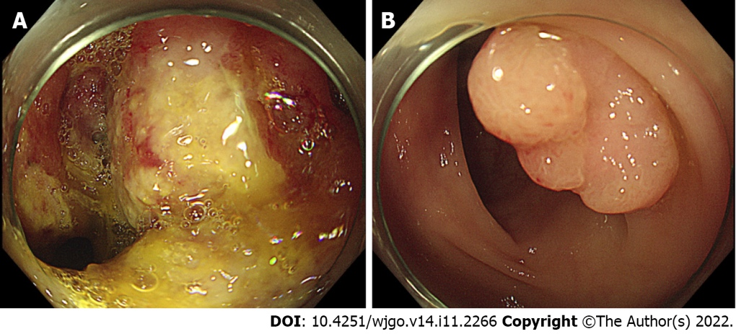
Figure 1 Colonoscopy images. A: Ulcerofungating lesion involving the luminal circumference in the ascending colon; B: About a 1.5 cm sized sessile polyp in the sigmoid colon.

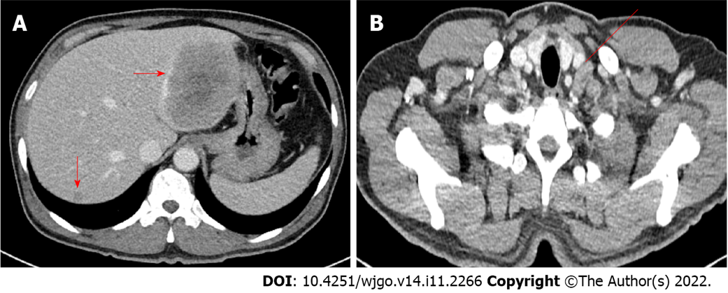
Figure 2 Abdominopelvic computed tomography and chest computed tomography images. A: Low density lesion of about 8.7 cm in the left lobe of the liver, and several smaller lesions in the right lobe of the liver (arrow); B: Left supraclavicular lymph node enlargement (line).

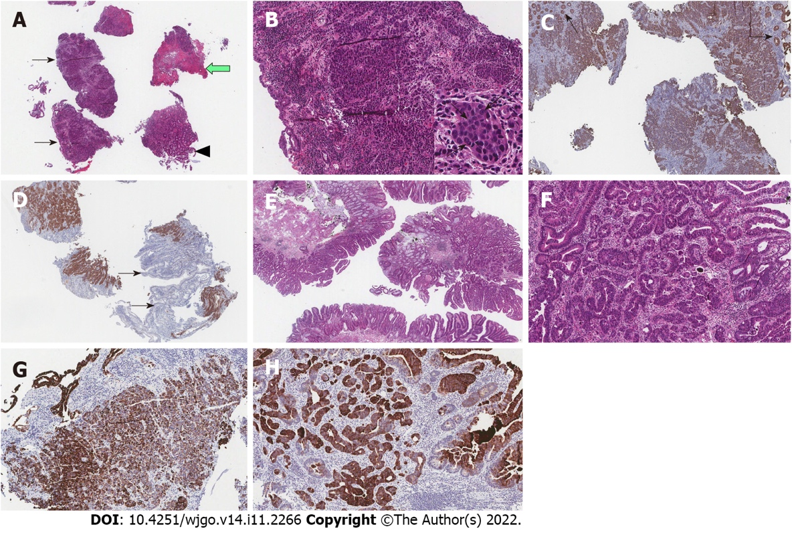
Figure 3 Histologic and immunohistochemical findings of colonic large cell neuroendocrine carcinoma. Histologic findings of colonic adenocarcinoma. Immunohistochemical stain for CK20 in both colonic large cell neuroendocrine carcinoma and colonic adenocarcinoma. A: Low power view of biopsy specimen reveals several tissue fragments mainly consisted of tumor (black arrows), ulcer debris (white arrow), and non-neoplastic colonic mucosa (arrowhead) (HE, × 20); B: Medium power view displays invasive tumor cells forming organoid structures such as cords or small nests (HE, × 100). Tumor cells display severe atypia and have round nuclei, sometimes with prominent nucleoli (arrows), and moderate amounts of cytoplasm, with high mitotic rate (Inset, HE, × 400); C: Infiltrating tumor cells are identified by immunohistochemical stain for cytokeratin (CK, × 100). Note the non-neoplastic mucosal glands (arrows) that are separated from the tumor; D: Tumor cells show strong immunoreactivity for neuroendocrine marker (synaptophysin, × 100). Note the non-neoplastic mucosal glands (arrows) are negative for neuroendocrine marker; E: Low power view of biopsy specimen reveals colonic epithelial proliferative lesion forming tubular and papillary structures (HE, × 20); F: Medium power view displays invasive growth of tumor cells that form irregular branching and budding of glands (HE, × 100); G: Infiltrating tumor cells of colonic large cell neuroendocrine carcinoma are immunoreactive for CK20 (× 100); H: Invasive tumor glands of colonic adenocarcinoma are also immunoreactive for CK20 (× 100).

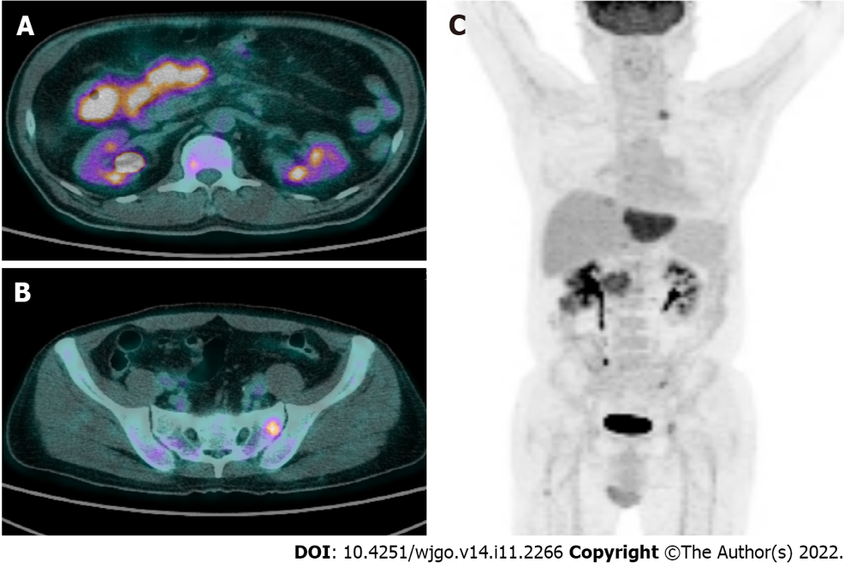
Figure 4 Positron emission tomography images. A: Abnormal fluorodeoxyglucose uptake at the ascending colon with enlarged lymph nodes at the adjacent mesentery; B and C: Hematogenous metastasis in the liver, lung, bones, peritoneum, supraclavicular lymph node.

Published by Baishideng Publishing Group Inc
7041 Koll Center Parkway, Suite 160, Pleasanton, CA 94566, USA
Telephone: +1-925-3991568
E-mail: bpgoffice@wjgnet.com
Help Desk: https://www.f6publishing.com/helpdesk
https://www.wjgnet.com

© 2022 Baishideng Publishing Group Inc. All rights reserved.

