Name of Journal: World Journal of Gastroenterology
Manuscript NO: 80399
Manuscript Type: ORIGINAL ARTICLE

Basic Study
Impact of endothelial nitric oxide synthase activation on accelerated liver regeneration in a rat ALPPS model

Masuo H et al. eNOS activation in ALPPS

Hitoshi Masuo, Akira Shimizu, Hiroaki Motoyama, Koji Kubota, Tsuyoshi Notake, Takahiro Yoshizawa, Kiyotaka Hosoda, Koya Yasukawa, Akira Kobayashi, Yuji Soejima

Hitoshi Masuo, Akira Shimizu, Hiroaki Motoyama, Koji Kubota, Tsuyoshi Notake, Takahiro Yoshizawa, Kiyotaka Hosoda, Koya Yasukawa, Akira Kobayashi, Yuji Soejima, Division of Gastroenterological, Hepato-Biliary-Pancreatic, Transplantation and Pediatric Surgery, Department of Surgery, Shinshu University School of Medicine, Matsumoto 390-8621, Japan

Author contributions: Masuo H, Motoyama H, Yoshizawa T, Hosoda K, and Yasukawa K contributed to the acquisition and analysis of experimental data and drafting of the manuscript; Shimizu A, Kubota K, Notake T, Kobayashi A, and Soejima Y contributed to the conception and design of the study and made critical revisions related to the important intellectual content of the manuscript; and all authors have provided final approval for the version of the manuscript for submission.

Supported by the JSPS KAKENHI, JP17K10664.

Corresponding author: Akira Shimizu, MD, PhD, Associate Professor, Division of Gastroenterological, Hepato-Biliary-Pancreatic, Transplantation and Pediatric Surgery, Department of Surgery, Shinshu University School of Medicine, 3-1-1, Asahi, Matsumoto 390-8621, Japan. ashimizu@shinshu-u.ac.jp

Received: October 29, 2022
Revised: December 7, 2022
Accepted: January 11, 2023
Published online: February 7, 2023

Abstract
BACKGROUND
Although the associating liver partition and portal vein ligation for staged hepatectomy (ALPPS) induces more rapid liver regeneration than portal vein embolization, the mechanism remains unclear.

AIM
To assess the influence of inflammatory cytokines and endothelial nitric oxide synthase (eNOS) activation on liver regeneration in ALPPS.

METHODS
The future liver remnant/body weight (FLR/BW) ratio, hepatocyte proliferation, inflammatory cytokine expression, and activation of the Akt-eNOS pathway were evaluated in rat ALPPS and portal vein ligation (PVL) models. Hepatocyte proliferation was assessed based on Ki-67 expression, which was confirmed using immunohistochemistry. The serum concentrations of inflammatory cytokines were measured using enzyme linked immune-solvent assays. The Akt-eNOS pathway was assessed using western blotting. To explore the role of inflammatory cytokines and NO, Kupffer cell inhibitor gadolinium chloride (GdCl₃), NOS inhibitor N-nitro-arginine methyl ester (L-NAME), and NO enhancer molsidomine were administered intraperitoneally.

RESULTS
The ALPPS group showed significant FLR regeneration (FLR/BW: 1.60% ± 0.08%, P < 0.05) compared with that observed in the PVL group (1.33% ± 0.11%) 48 h after surgery. In the ALPPS group, serum interleukin-6 expression was suppressed using GdCl₃ to the same extent as that in the PVL group. However, the FLR/BW ratio and Ki-67 labeling index were significantly higher in the ALPPS group administered GdCl₃ (1.72% ± 0.19%, P < 0.05; 22.25% ± 1.30%, P < 0.05) than in the PVL group (1.33% ± 0.11% and 12.78% ± 1.55%, respectively). Phospho-Akt Ser⁴⁷³ and phospho-eNOS Ser¹¹⁷⁷ levels were enhanced in the ALPPS group compared with those in the PVL group. There was no difference between the ALPPS group treated with L-NAME and the PVL group in the FLR/BW ratio and Ki-67 labeling index. In the PVL group treated with molsidomine, the FLR/BW ratio and Ki-67 labeling index increased to the same level as in the ALPPS group.

CONCLUSION
Early induction of inflammatory cytokines may not be pivotal for accelerated FLR regeneration after ALPPS, whereas Akt-eNOS pathway activation may contribute to accelerated regeneration of the FLR.

Key Words: Hepatectomy; Nitric oxide; Liver regeneration; Cytokines; NG-Nitroarginine methyl ester; Molsidomine

©The Author(s) 2023. Published by Baishideng Publishing Group Inc. All rights reserved.

Citation: Masuo H, Shimizu A, Motoyama H, Kubota K, Notake T, Yoshizawa T, Hosoda K, Yasukawa K, Kobayashi A, Soejima Y. Impact of endothelial nitric oxide synthase activation on accelerated liver regeneration in a rat ALPPS model. World J Gastroenterol 2023; 29(5): 867-878
URL: https://www.wjgnet.com/1007-9327/full/v29/i5/867.htm
DOI: https://dx.doi.org/10.3748/wjg.v29.i5.867

Core Tip: In extended hepatectomy for hepatobiliary tumors, adequate future liver remnant (FLR) is essential to prevent postoperative liver failure. Portal vein embolization (PVE) and associated liver partition and portal vein ligation for staged hepatectomy (ALPPS) are performed to increase the FLR. Although ALPPS induces more rapid liver regeneration than PVE, the mechanism remains unclear. In this study, we compared ALPPS with portal vein ligation (PVL) in a rat model and found that activation of the Akt-endothelial nitric oxide synthase pathway promotes liver regeneration. The combination of PVL and nitric oxide-producing agents may induce liver regeneration comparable to ALPPS in a non-invasive manner.

INTRODUCTION
Hepatectomy is the most curative treatment for hepatobiliary carcinoma^{[1,2]}. Extended hepatectomy is occasionally performed to achieve R0 surgical margins. However, postoperative liver failure may occur in these cases because of an inadequate volume of the future liver remnant (FLR)^{[3,4]}. To resolve this issue, portal vein embolization (PVE) is widely performed before major hepatectomy to obtain a sufficient FLR volume^{[5,6]}. Although PVE results in a 10%-45% increase in FLR, it requires a waiting period of 2-8 wk^{[6-8]}. Hepatectomy cannot be performed in some cases because of tumor progression, inadequate volume increase, or both in the FLR, even after PVE. Therefore, the resection rate after PVE has been reported as only 70%^{[7,8]}. Furthermore, it has been reported that hepatocellular carcinoma (HCC) is nourished by abnormal vessels in the hepatic artery (HA). Thus, PVE may reduce blood flow in the portal vein and increase blood flow in the HA of the liver to be resected, which may result in rapid progression of HCC^{[9]}. As described above, PVE has limited indications and therapeutic effects. Therefore, the development of new surgical or therapeutic methods is desired to promote further liver regeneration in the short term.
As an alternative to PVE, associating liver partition and portal vein ligation for staged hepatectomy (ALPPS) was reported in 2012^{[6]}. This method enables the FLR to increase by 70%-80% within 10 d^{[6]}. ALPPS promotes a much faster increase of FLR than PVE^{[6,9]}, but the mechanism of this rapid liver regeneration remains unclear. Although increases in inflammatory cytokines, such as interleukin-6 (IL-6), which is an inducer in the early stage of liver regeneration, have been reported as a cause of rapid liver regeneration^{[10-13]}, it remains controversial^{[14]}. However, in previous studies on the mechanism of liver regeneration after liver resection and portal vein ligation (PVL), shear stress caused by blood viscosity, blood flow velocity, and endothelial nitric oxide synthase (eNOS) activation, followed by NO induction, has been reported to promote liver regeneration^{[15,16]}. This study aimed to explore the mechanism of promoting liver regeneration in ALPPS and investigate the involvement of inflammatory cytokines and eNOS activation using PVL and ALPPS rat models.

MATERIALS AND METHODS
Animals
Eight-week-old male Wistar rats (CLEA Japan, Kanagawa, Japan) weighing 230-300 g were used in this study. The animals were housed in wood-chip-bedded cages in an air-conditioned room (24 ± 1 °C) with a 12 h light/dark cycle under specific pathogen free condition. There were no diet restrictions. Based on national and institutional regulations and guidelines, all procedures for animal experiments were reviewed by the Committee for Animal Experiments and approved by the President of Shinshu University (Approval numbers 270018 and 019067).

Surgical procedures and study design
Rats were divided into two groups, PVL and ALPPS, and examined 72 h after surgery. A midline laparotomy was performed under isoflurane-induced anesthesia. In the PVL model, the portal vein branches to the caudate lobe, left lobe, left side of the median lobe, and right lobes were ligated with 7-0 silk (Figure 1A). In the ALPPS model, in addition to PVL, liver parenchymal transection between the right lobe and the left side of the middle lobe was performed based on the gross morphology and demarcation line after PVL. The Glisson flowing into the left side of the median lobe was ligated with 7-0 nylon (Figure 1B). Little bleeding occurred during the liver parenchymal transection because the parenchyma on either side of the dissection line was ligated with 6-0 Prolene before parenchymal transection to control intraoperative bleeding. The abdomen was then closed in layers.
The rats were sacrificed to collect blood samples and liver tissue from the right side of the median lobe (RML) at 1, 4, 6, 24, 48, and 72 h after surgery (n = 5 for each group per time point). Blood samples were collected from the inferior vena cava at the time of liver removal and centrifuged at 2600 × g for 5 min. The serum was stored at -80 °C. Liver tissue samples were frozen in liquid nitrogen and stored at -80 °C. The remaining liver tissue was fixed with 4% paraformaldehyde.
The weight of the FLR, that is, the RML, and body weight (BW) were measured before surgery and at 24, 48, and 72 h after surgery. The BW (FLR/BW) ratio (%) was used as the liver regeneration index. In western blotting analysis and volumetric blood flow analysis, the PVL and ALPPS groups were compared based on the control group, in which only open and closed abdomens were performed.

ELISAs of serum inflammatory cytokines and hepatocyte growth factor
Serum concentrations of IL-6, tumor necrosis factor-α (TNF-α), and hepatocyte growth factor (HGF) were measured at 1, 4, 6, and 24 h after surgery using ELISA kits (R&D Systems, Minneapolis, MN, United States). IL-6 concentration in the RML tissue was also quantified 1 h after surgery.

Immunohistochemistry
The liver tissues were fixed with paraformaldehyde and embedded in paraffin. After deparaffinization, antigen retrieval, and quenching of endogenous peroxidases, the sections were incubated overnight at 4 °C with a mouse monoclonal anti-Ki-67 antibody (1:200 dilution; Dako, Glostrup, Denmark; 1:200 dilution, Abcam, Cambridge, United Kingdom), followed by incubation for 30 min at room temperature with a peroxidase-labeled anti-mouse antibody (Histofine Simplestain Max PO; Nichirei). The sections were immersed in diaminobenzidine solution for visualization and counterstained with hematoxylin. To evaluate hepatocyte proliferation 48 h after surgery, the average percentage of Ki-67-positive cells to total hepatocytes in three random high-power fields was used as the Ki-67 labeling index.

Kupffer cell inhibition in the ALPPS model
To explore the role of inflammatory cytokines in liver regeneration, the Kupffer cell inhibitor gadolinium chloride (GdCl₃; Sigma-Aldrich, St. Louis, MO, United States) was used. Another set of animals was used for the Kupffer cell inhibition experiments. We prepared an ALPPS model for GdCl₃ administration (n = 3). GdCl₃ (10 mg/kg) was administered intraperitoneally 24 h before surgery. In the control group, physiological saline was administered. All rats were sacrificed 48 h after surgery to obtain liver samples.

NOS inhibition in the ALPPS model and NO enhancement in the PVL model
To explore the role of NO in liver regeneration, the NOS inhibitor NG-nitro-arginine methyl ester (L-NAME; Sigma-Aldrich) and the NO enhancer molsidomine (Cayman Chemical, MI, United States) were used. Another set of animals was used for the NOS inhibition and NO enhancement experiments. We prepared the ALPPS model for L-NAME administration, the PVL model for molsidomine administration, and the corresponding control PVL and ALPPS models (n = 5 for each group). L-NAME (100 mg/kg) or molsidomine (10 mg/kg) was administered intraperitoneally 24 h before and during surgery. In each control group, physiological saline was administered. All rats were sacrificed 24, 48, and 72 h after surgery to obtain liver samples.

Western blot analysis
The RML tissue proteins were collected at 1, 4, and 6 h after surgery using radioimmunoprecipitation assay lysis buffer (Santa Cruz Biotechnology, Inc., CA, United States). The protein concentration was measured using the bicinchoninic acid assay method. Samples of 10 μg proteins from FLRs of PVL and ALPPS models were separated on 4%-12% NuPAGE Gels and transferred onto nitrocellulose membranes. After blocking with 5% dry skim milk for 1 h, the membranes were incubated with primary antibodies overnight at 4 °C, followed by incubation with horseradish peroxidase-conjugated secondary antibodies for 1 h. The blots were developed with ECL Select western blotting Detection Reagent (Amersham, GE Healthcare Life Sciences, Chicago, IL, United States) and photographed using a Molecular Imager ChemiDoc XRS device (Bio-Rad Laboratories, Inc., Hercules, CA, United States). The density of the bands in the immunoblots was analyzed using Image Lab Software (Bio-Rad Laboratories, Inc.). The results are expressed as a percentage of the β-actin internal control. The anti-human antibodies used were rabbit monoclonal antibodies against p-Akt (Ser 473) (cat. no. 4060), p-eNOS (Ser1177) (Cat. no. 9570), p-eNOS (Thr495) (Cat. no. 9574), total eNOS (Cat. no. 32027) (Cell Signaling Technology, Inc., Danvers, MA, United States), and mouse monoclonal antibody against β-actin (Cat. no. A5441; Sigma-Aldrich). Anti-β-actin antibody was used at a 1:3000 dilution, and the other antibodies were used at a 1:1000 dilution.

Volumetric blood flow analysis
Before the estimation of volumetric blood flow in the HA and PV of the FLR, blood velocity and vascular diameter (r) were measured using ultrasonography (Vevo2100, Primetech, Tokyo, Japan). Volumetric blood flow was estimated from the blood velocity and vascular cross-sectional area (πr²) (volumetric blood flow = blood velocity × πr²) in mm³ per second.

Statistical analysis
The collected data were evaluated statistically using the JMP software, version 13.2 (SAS Institute, Cary, NC, United States). Data are expressed as mean ± SD. Statistical analysis was performed using an unpaired student’s t-test. Statistical significance was defined as P < 0.05.

RESULTS
Differences in liver regeneration in PVL and ALPPS models
The FLR/BW ratio increased over time in both groups. At 48 h after surgery, the FLR/BW ratio in the ALPPS group was significantly higher (1.60% ± 0.08%, P < 0.05) than that in the PVL group (1.33% ± 0.11%) (Figures 1C and 2A). However, no significant difference was observed between the two groups at 24 and 72 h after surgery. The Ki-67 labeling index of the RML at 48 h after surgery was significantly increased in the ALPPS group (22.1% ± 4.01%, P < 0.05) compared with that in the PVL group (12.8% ± 1.73%), which was consistent with the FLR/BW ratio (Figures 2B and 2C).

Association between serum inflammatory cytokines and liver regeneration
The serum concentrations of IL-6, TNF-α, and HGF in RML were measured at 1, 4, 6, and 24 h after surgery. Serum IL-6 and TNF-α levels increased in both groups after surgery compared with the levels before surgery. However, no difference was found in the two groups at 1, 4, and 6 h after surgery. At 24 h after surgery, IL-6 and TNF-α concentrations were significantly higher in the ALPPS group (25.91 ± 6.05 pg/mL, P < 0.05 and 1.52 ± 0.68 pg/mL, P < 0.05) compared with that in the PVL group (4.11 ± 3.99 pg/mL and 0.54 ± 0.38 pg/mL). Serum HGF concentration at 1 h after surgery was significantly higher in the ALPPS group (68.86 ± 4.89 ng/mL, P < 0.05) compared with that in the PVL group (55.34 ± 9.97 ng/mL). However, no significant difference was observed in serum HGF concentration at 4, 6, and 24 h (Figures 3A-C).

Liver regeneration in the ALPPS model under the suppression of IL-6 using GdCl₃
To evaluate the effect of IL-6 on liver regeneration, ALPPS rats were administered GdCl₃, which suppressed the activation of Kupffer cells in the liver. In the GdCl₃-ALPPS group, the IL-6 concentrations in serum (40.3 ± 11.3 pg/mL, P < 0.05) and the RML tissue (3.27 ± 0.54 ng/TP 1 g, P < 0.05) 1 h after surgery were significantly decreased compared with the concentrations in the corresponding groups without administration of GdCl₃ (Figures 4A and 4B). However, there was no significant difference in the FLR/BW ratio or Ki-67 labeling index at 48 h after surgery in the ALPPS group with or without administration of GdCl₃ (Figures 4C and 4D).

Short-term postoperative liver regeneration induced by eNOS
Phosphorylation of Akt and eNOS in RML tissue at 1, 4, and 6 h after surgery was evaluated using western blotting (Figure 5A). Phospho-Akt Ser⁴⁷³ and phospho-eNOS Ser¹¹⁷⁷ levels increased in the ALPPS group compared with those in the PVL group. The quantitative measurement revealed that the phosphorylation levels of eNOS Ser¹¹⁷⁷ in the ALPPS group was significantly higher than that in the PVL group at 1 and 4 h after surgery. However, there was no significant difference at 6 h after surgery (Figure 5B).
L-NAME, an NOS inhibitor, was administered to rats to examine whether suppression of eNOS affected liver regeneration. The FLR/BW ratio and Ki-67 labeling index at 48 h after surgery in the L-NAME-ALPPS group were significantly lower than those in the ALPPS group without L-NAME administration and were comparable to those in the PVL group (Figures 6A and 6B).
Additionally, molsidomine, which induces eNOS activation, was administered to the rats to examine whether eNOS activation affects liver regeneration. The FLR/BW ratio and Ki-67 labeling index at 48 h after surgery in the molsidomine-administered PVL (molsidomine-PVL) group were significantly higher than those in the PVL group without molsidomine administration and comparable with those in the ALPPS group (Figures 6C and 6D). However, there was no significant difference in the long-term FLR/BW ratio on a postoperative day 7 between the PVL, ALPPS, and molsidomine-administered PVL groups (data not shown).

Increased HA blood flow in the ALPPS model
PV flow in the PVL and ALPPS groups was significantly faster than that in the control group; however, there was no significant difference in PV flow between the PVL and ALPPS groups (180.1 ± 54.4, 216.6 ± 71.4 mm³/s) (Figure 7A). HA flow in the PVL group was significantly slower than that in the control group without surgical intervention (1.73 ± 1.14 vs 3.66 ± 0.74 mm³/s, P < 0.05), whereas that in the ALPPS group was significantly faster (11.32 ± 2.40 mm³/s, P < 0.05) than that in control and PVL groups (Figure 7B). The total blood flow, that is, the sum of PV and HA, was not significantly different between the PVL and ALPPS groups (Figure 7C).

DISCUSSION
Hepatectomy is the most curative treatment for HCC and intraductal cholangiocarcinoma^{[1,2]}. Additionally, major hepatectomy is the standard operative procedure for perihilar cholangiocarcinoma^{[17,18]}. Extended hepatectomy may be required, depending on the location of the cancer. Postoperative liver failure that results from insufficient residual liver volume is a fatal complication of hepatectomy. PVE and ALPPS were developed with the aim of pre-operative liver enlargement to avoid postoperative liver failure^{[5,6,18]}. ALPPS leads to the rapid regeneration of FLR compared with PVE, although high mortality (90-d mortality of 9%) and morbidity (grade IIIb of 40% in the Clavien-Dindo classification) are limitations^{[19]}. Elucidation of the mechanism of rapid liver regeneration after ALPPS may contribute to improving surgical outcomes for patients who undergo extended hepatectomy for hepatobiliary malignancies and to the development of novel alternative treatments that provide effective and safe regeneration of the FLR.
In this study, we obtained two crucial findings regarding the mechanism of liver regeneration in ALPPS. First, the induction of inflammatory cytokines, such as IL-6, might not be pivotal for the rapid regeneration of FLR after ALPPS in the early phase. Second, activation of the Akt-eNOS pathway may be an important factor in promoting liver regeneration after ALPPS.
The mechanism of liver regeneration has been studied in animal models of partial hepatectomy. The regeneration process is distinctive, complex, and well-coordinated and depends on the interactions of several signaling pathways, cytokines, and growth factors. Additionally, endocrine hormones, such as norepinephrine, growth hormone, insulin, and thyroid hormones, have been reported to influence these pathways and factors^{[20-22]}. Since Schnitzbauer et al^{[6]} reported ALPPS in 2012, there have been several reports to elucidate the major factors in liver regeneration of ALPPS, which promote rapid liver regeneration compared with PVL^{[10-13,23]}. Activation of downstream signals, such as c-Jun N-terminal kinase-Indian hedgehog signaling from stellate cells by inflammatory cytokines^{[24]}, activation of the Janus kinase 2/signal transducer and activator of transcription 3 pathway via regenerating islet-derived 3α/3β, and hypoxia-induced stabilization of hypoxia-inducible factor-α subunits by hypoxia^{[14,25,26]}, have been reported as major factors. However, the mechanism of liver regeneration in ALPPS has not yet been completely elucidated.
Previous studies have reported that the peak of cell proliferation is 48 h after surgery, and inflammatory cytokines and their downstream signal enhancement cause liver regeneration in ALPPS^{[11,12,23]}. Although the peak liver regeneration in this study was consistent with previous studies, the relationship between the early induction of inflammatory cytokines and liver regeneration was not consistent. In this study, serum concentrations of inflammatory cytokines, such as IL-6 and TNF-α, in the short term (1, 4, and 6 h) after surgery did not differ between the ALPPS and PVL groups. However, the ALPPS group showed a greater increase in FLR and a higher Ki-67 labeling index than in the PVL group. Additionally, suppression of inflammatory cytokines using GdCl₃ did not suppress liver regeneration. These results suggest that the induction of inflammatory cytokines in the early phase after ALLPS is not necessarily a major factor in accelerating liver regeneration. The reason why no difference was observed in the expression of inflammatory cytokines may be the site of liver resection, setting of FLR, or differences in animal models. The timing of specimen collection may have influenced the results, as specimens collected 24 h after surgery had higher concentrations in the ALPPS group.
Activation of eNOS and NO induction have been reported to be a mechanism of liver regeneration other than inflammatory cytokines^{[15,16]}. In this study, we focused on the effect of eNOS activation on liver regeneration after PVL and ALPPS. Evaluation of eNOS activation in the liver tissue showed that eNOS Ser¹¹⁷⁷ phosphorylation was significantly increased in the ALPPS model at 1 and 4 h after surgery. Thus, the FLR/BW ratio and Ki-67 labeling index in the ALPPS model were increased compared with those in the PVL model. Furthermore, the activation of Akt, which is upstream of eNOS, was observed, suggesting that the Akt-eNOS pathway contributes to the mechanism of liver regeneration in ALPPS. The administration of L-NAME, which suppresses NO, inhibits liver regeneration. The administration of molsidomine, which activates eNOS, promotes liver regeneration. Molsidomine is a nitrate drug used as a coronary vasodilator for the treatment of angina pectoris; its intermediate metabolite, SIN-1 (ionidamine chlorohydrate) produces NO^{[27]}. When endothelial cells are stimulated by shear stress or vascular endothelial growth factor, phosphoinositide 3-kinase (PI3K) is activated and PIP3 is produced, which activates the PI3K-Akt pathway and activates downstream signals such as eNOS^{[28,29]}. An increase in shear stress, which has been reported to cause NO production^{[30]}, is due to hemodynamic changes in the residual liver caused by hepatectomy, which is expected to affect liver regeneration in ALPPS. To evaluate the effect of increased shear stress on liver regeneration, we examined the blood flow exchange after PVL and ALPPS. Contrary to our expectations, there was no difference in PV or total blood flow, which might be associated with shear stress, between the PVL and ALPPS groups; however, HA flow in the ALPPS group was significantly higher than that in the PVL and control groups. Therefore, the difference in oxygenation of the FLR, rather than the shear stress between ALPPS and PVL, might be associated with the difference in liver regeneration. However, Schadde et al^{[25]} reported that hypoxia due to reduced HA flow in the FLR promotes hepatic regeneration in patients who underwent ALPPS and in the rat ALPPS model. However, in their study, HA flow was evaluated only in patients who underwent ALPPS, and this evaluation was not compared with that in patients who underwent PVE. Furthermore, the transition of HA flow before and after ALPPS has not been evaluated in a rat model. In the rat ALPPS model, liver transection between the right and left median lobes with ligation of the Glisson of the left median lobe caused a necrotic change in the left median lobe, which is synonymous with liver resection of the left median lobe considering hemodynamics. These results suggest that both hemodynamic changes and differences in oxygenation of the FLR affect regeneration rates in the ALPPS and PVL models. The increased HA flow to the RML observed in the ALPPS group may have been due to a hepatic arterial buffer response derived from collateral blood flow blockage by hepatectomy. In contrast, the reason for the observed decrease in HA flow to the RML in the PVL group might be the effect of HA influx from the RML to the left median lobe (LML) via collateral circulation after the PV blockade to the LML.
This study had some limitations. First, because we observed short-term changes in rat models, it is unknown whether NO activation promotes clinically meaningful liver regeneration in humans. Second, the mechanism underlying the activation of the Akt-eNOS pathway is unclear and requires further investigation that includes real-time monitoring of oxygenation in the FLR. Despite these shortcomings, we believe that our results are of interest because few reports have focused on the relationship between eNOS activation and liver regeneration after ALPPS.

CONCLUSION
The activation of the Akt-eNOS pathway in ALPPS may be an important factor in promoting early liver regeneration. If a combination of NO-producing agents and PVL or PVE enables liver regeneration within a short time after surgery, it may be an alternative to ALPPS and is expected to be applied clinically as a less invasive procedure.

ARTICLE HIGHLIGHTS
Research background
Associating liver partition and portal vein ligation for staged hepatectomy (ALPPS) has already been clinically applied in various countries. Although it has been reported that ALPPS offers faster and larger liver regeneration compared to portal vein embolization (PVE), the mechanism of this phenomenon is still unclear.

Research motivation
The aim of this study was to investigate the underlying mechanism of rapid liver regeneration after ALPPS focusing on inflammatory cytokines and endothelial nitric oxide synthase (eNOS) activation.

Research objectives
Activation of eNOS was considered one of key points on mechanism of rapid liver regeneration after ALPPS.

Research methods
Liver regeneration was compared between the rat portal vein ligation (PVL) model and the rat ALPPS model. In addition, impact of administration of gadolinium chloride (GdCl₃, Kupffer cell inhibitor), NG-nitro-arginine methyl ester (L-NAME, NOS inhibitor), and molsidomine (NO enhancer) on liver regeneration after PVL and/or ALPPS.

Research results
Administration of GdCl₃ before ALPPS provided no significant negative influence of liver regeneration after ALPPS. Administration of L-NAME before ALPPS suppressed liver regeneration after ALPPS, while administration of molsidomine before PVL accerelated liver regeneration after PVL as well as ALPPS.

Research conclusions
ALPPS is an alternative to PVE for reducing posthepatectomy liver failure after major hepatectomy.

Research perspectives
Combination of NO-producing agents and less invasive procedure can be an alternative to ALPPS procedure in the future.

REFERENCES
1 Orcutt ST, Anaya DA. Liver Resection and Surgical Strategies for Management of Primary Liver Cancer. Cancer Control 2018; 25: 1073274817744621 [PMID: 29327594 DOI: 10.1177/1073274817744621]
2 Mavros MN, Economopoulos KP, Alexiou VG, Pawlik TM. Treatment and Prognosis for Patients With Intrahepatic Cholangiocarcinoma: Systematic Review and Meta-analysis. JAMA Surg 2014; 149: 565-574 [PMID: 24718873 DOI: 10.1001/jamasurg.2013.5137]
3 Clavien PA, Oberkofler CE, Raptis DA, Lehmann K, Rickenbacher A, El-Badry AM. What is critical for liver surgery and partial liver transplantation: size or quality? Hepatology 2010; 52: 715-729 [PMID: 20683967 DOI: 10.1002/hep.23713]
4 Clavien PA, Petrowsky H, DeOliveira ML, Graf R. Strategies for safer liver surgery and partial liver transplantation. N Engl J Med 2007; 356: 1545-1559 [PMID: 17429086 DOI: 10.1056/NEJMra065156]
5 Makuuchi M, Thai BL, Takayasu K, Takayama T, Kosuge T, Gunvén P, Yamazaki S, Hasegawa H, Ozaki H. Preoperative portal embolization to increase safety of major hepatectomy for hilar bile duct carcinoma: a preliminary report. Surgery 1990; 107: 521-527 [PMID: 2333592]
6 Schnitzbauer AA, Lang SA, Goessmann H, Nadalin S, Baumgart J, Farkas SA, Fichtner-Feigl S, Lorf T, Goralcyk A, Hörbelt R, Kroemer A, Loss M, Rümmele P, Scherer MN, Padberg W, Königsrainer A, Lang H, Obed A, Schlitt HJ. Right portal vein ligation combined with in situ splitting induces rapid left lateral liver lobe hypertrophy enabling 2-staged extended right hepatic resection in small-for-size settings. Ann Surg 2012; 255: 405-414 [PMID: 22330038 DOI: 10.1097/SLA.0b013e31824856f5]
7 Abulkhir A, Limongelli P, Healey AJ, Damrah O, Tait P, Jackson J, Habib N, Jiao LR. Preoperative portal vein embolization for major liver resection: a meta-analysis. Ann Surg 2008; 247: 49-57 [PMID: 18156923 DOI: 10.1097/SLA.0b013e31815f6e5b]
8 Liu H, Zhu S. Present status and future perspectives of preoperative portal vein embolization. Am J Surg 2009; 197: 686-690 [PMID: 19249737 DOI: 10.1016/j.amjsurg.2008.04.022]
9 Knoefel WT, Gabor I, Rehders A, Alexander A, Krausch M, Schulte am Esch J, Fürst G, Topp SA. In situ liver transection with portal vein ligation for rapid growth of the future liver remnant in two-stage liver resection. Br J Surg 2013; 100: 388-394 [PMID: 23124776 DOI: 10.1002/bjs.8955]
10 Schlegel A, Lesurtel M, Melloul E, Limani P, Tschuor C, Graf R, Humar B, Clavien PA. ALPPS: from human to mice highlighting accelerated and novel mechanisms of liver regeneration. Ann Surg 2014; 260: 839-46; discussion 846-7 [PMID: 25379855 DOI: 10.1097/SLA.0000000000000949]
11 Yao L, Li C, Ge X, Wang H, Xu K, Zhang A, Dong J. Establishment of a rat model of portal vein ligation combined with in situ splitting. PLoS One 2014; 9: e105511 [PMID: 25144490 DOI: 10.1371/journal.pone.0105511]
12 Shi H, Yang G, Zheng T, Wang J, Li L, Liang Y, Xie C, Yin D, Sun B, Sun J, Wang H, Pan S, Jiang H, Lau W, Liu L. A preliminary study of ALPPS procedure in a rat model. Sci Rep 2015; 5: 17567 [PMID: 26631552 DOI: 10.1038/srep17567]
13 García-Pérez R, Revilla-Nuin B, Martínez CM, Bernabé-García A, Baroja Mazo A, Parrilla Paricio P. Associated Liver Partition and Portal Vein Ligation (ALPPS) vs Selective Portal Vein Ligation (PVL) for Staged Hepatectomy in a Rat Model. Similar Regenerative Response? PLoS One 2015; 10: e0144096 [PMID: 26630386 DOI: 10.1371/journal.pone.0144096]
14 Otsuka N, Yoshioka M, Abe Y, Nakagawa Y, Uchinami H, Yamamoto Y. Reg3α and Reg3β Expressions Followed by JAK2/STAT3 Activation Play a Pivotal Role in the Acceleration of Liver Hypertrophy in a Rat ALPPS Model. Int J Mol Sci 2020; 21 [PMID: 32517345 DOI: 10.3390/ijms21114077]
15 Schoen JM, Wang HH, Minuk GY, Lautt WW. Shear stress-induced nitric oxide release triggers the liver regeneration cascade. Nitric Oxide 2001; 5: 453-464 [PMID: 11587560 DOI: 10.1006/niox.2001.0373]
16 Mei Y, Thevananther S. Endothelial nitric oxide synthase is a key mediator of hepatocyte proliferation in response to partial hepatectomy in mice. Hepatology 2011; 54: 1777-1789 [PMID: 21748771 DOI: 10.1002/hep.24560]
17 Furusawa N, Kobayashi A, Yokoyama T, Shimizu A, Motoyama H, Miyagawa S. Surgical treatment of 144 cases of hilar cholangiocarcinoma without liver-related mortality. World J Surg 2014; 38: 1164-1176 [PMID: 24305942 DOI: 10.1007/s00268-013-2394-x]
18 Kawasaki S, Imamura H, Kobayashi A, Noike T, Miwa S, Miyagawa S. Results of surgical resection for patients with hilar bile duct cancer: application of extended hepatectomy after biliary drainage and hemihepatic portal vein embolization. Ann Surg 2003; 238: 84-92 [PMID: 12832969 DOI: 10.1097/01.Sla.0000074984.83031.02]
19 Schadde E, Raptis DA, Schnitzbauer AA, Ardiles V, Tschuor C, Lesurtel M, Abdalla EK, Hernandez-Alejandro R, Jovine E, Machado M, Malago M, Robles-Campos R, Petrowsky H, Santibanes ED, Clavien PA. Prediction of Mortality After ALPPS Stage-1: An Analysis of 320 Patients From the International ALPPS Registry. Ann Surg 2015; 262: 780-5; discussion 785-6 [PMID: 26583666 DOI: 10.1097/SLA.0000000000001450]
20 Michalopoulos GK. Hepatostat: Liver regeneration and normal liver tissue maintenance. Hepatology 2017; 65: 1384-1392 [PMID: 27997988 DOI: 10.1002/hep.28988]
21 Abu Rmilah A, Zhou W, Nelson E, Lin L, Amiot B, Nyberg SL. Understanding the marvels behind liver regeneration. Wiley Interdiscip Rev Dev Biol 2019; 8: e340 [PMID: 30924280 DOI: 10.1002/wdev.340]
22 Abu Rmilah AA, Zhou W, Nyberg SL. Hormonal Contribution to Liver Regeneration. Mayo Clin Proc Innov Qual Outcomes 2020; 4: 315-338 [PMID: 32542223 DOI: 10.1016/j.mayocpiqo.2020.02.001]
23 Dhar DK, Mohammad GH, Vyas S, Broering DC, Malago M. A novel rat model of liver regeneration: possible role of cytokine induced neutrophil chemoattractant-1 in augmented liver regeneration. Ann Surg Innov Res 2015; 9: 11 [PMID: 26535054 DOI: 10.1186/s13022-015-0020-3]
24 Langiewicz M, Graf R, Humar B, Clavien PA. JNK1 induces hedgehog signaling from stellate cells to accelerate liver regeneration in mice. J Hepatol 2018; 69: 666-675 [PMID: 29709677 DOI: 10.1016/j.jhep.2018.04.017]
25 Schadde E, Tsatsaris C, Swiderska-Syn M, Breitenstein S, Urner M, Schimmer R, Booy C, Z'graggen BR, Wenger RH, Spahn DR, Hertl M, Knechtle S, Diehl AM, Schläpfer M, Beck-Schimmer B. Hypoxia of the growing liver accelerates regeneration. Surgery 2017; 161: 666-679 [PMID: 27436690 DOI: 10.1016/j.surg.2016.05.018]
26 Dirscherl K, Schläpfer M, Roth Z'graggen B, Wenger RH, Booy C, Flury-Frei R, Fatzer R, Aloman C, Bartosch B, Parent R, Kurtcuoglu V, de Zélicourt D, Spahn DR, Beck Schimmer B, Schadde E. Hypoxia sensing by hepatic stellate cells leads to VEGF-dependent angiogenesis and may contribute to accelerated liver regeneration. Sci Rep 2020; 10: 4392 [PMID: 32152325 DOI: 10.1038/s41598-020-60709-9]
27 Rosenkranz B, Winkelmann BR, Parnham MJ. Clinical pharmacokinetics of molsidomine. Clin Pharmacokinet 1996; 30: 372-384 [PMID: 8743336 DOI: 10.2165/00003088-199630050-00004]
28 Dimmeler S, Fleming I, Fisslthaler B, Hermann C, Busse R, Zeiher AM. Activation of nitric oxide synthase in endothelial cells by Akt-dependent phosphorylation. Nature 1999; 399: 601-605 [PMID: 10376603 DOI: 10.1038/21224]
29 Fulton D, Gratton JP, McCabe TJ, Fontana J, Fujio Y, Walsh K, Franke TF, Papapetropoulos A, Sessa WC. Regulation of endothelium-derived nitric oxide production by the protein kinase Akt. Nature 1999; 399: 597-601 [PMID: 10376602 DOI: 10.1038/21218]
30 Kelm M, Feelisch M, Deussen A, Strauer BE, Schrader J. Release of endothelium derived nitric oxide in relation to pressure and flow. Cardiovasc Res 1991; 25: 831-836 [PMID: 1747876 DOI: 10.1093/cvr/25.10.831]

Footnotes
Institutional animal care and use committee statement: Based on national and institutional regulations and guidelines, all procedures for animal experiments were reviewed by the Committee for Animal Experiments and approved by the President of Shinshu University (Approval numbers 270018 and 019067).

Conflict-of-interest statement: All the authors report no relevant conflicts of interest for this article.

Data sharing statement: The datasets used and/or analyzed during the current study are available from the corresponding author upon reasonable request.

ARRIVE guidelines statement: The authors have read the ARRIVE guidelines, and the manuscript was prepared and revised according to the ARRIVE guidelines.

Open-Access: This article is an open-access article that was selected by an in-house editor and fully peer-reviewed by external reviewers. It is distributed in accordance with the Creative Commons Attribution NonCommercial (CC BY-NC 4.0) license, which permits others to distribute, remix, adapt, build upon this work non-commercially, and license their derivative works on different terms, provided the original work is properly cited and the use is non-commercial. See: https://creativecommons.org/Licenses/by-nc/4.0/

Provenance and peer review: Unsolicited article; Externally peer reviewed.
Peer-review model: Single blind
Corresponding Author’s Membership in Professional Societies: The Japanese Society of Gastroenterology, 048188.

Peer-review started: October 29, 2022
First decision: November 30, 2022
Article in press: January 11, 2023

Specialty type: Gastroenterology and hepatology
Country/Territory of origin: Japan
Peer-review report’s scientific quality classification
Grade A (Excellent): A
Grade B (Very good): B, B, B
Grade C (Good): 0
Grade D (Fair): 0
Grade E (Poor): 0

P-Reviewer: A JD, China; Kordzaia D, Georgia; Tan W, China; Xiao LK, China S-Editor: Wang JJ L-Editor: A P-Editor: Wang JJ

Figure Legends
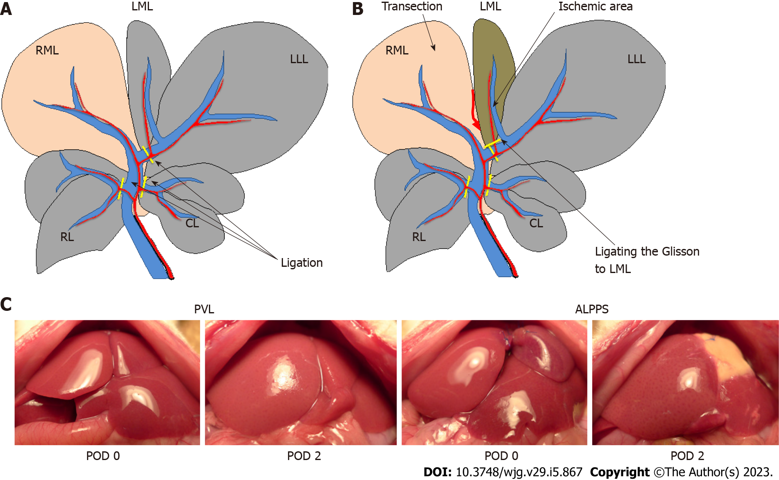
Figure 1 Schema of experimental models. A: Portal vein ligation (PVL) group. Portal vein branches were ligated, other than the right median lobe; B: Associating liver partition and PVL for staged hepatectomy group. In addition to ligating the portal vein as performed in the PVL group, the median lobe was transected, and the left Glisson was ligated; C: Macroscopic findings after operations in each group. ALPPS: Associating liver partition and portal vein ligation for staged hepatectomy; PVL: Portal vein ligation; RML: Right median lobe; LML: Left median lobe; LLL: Left lateral lobe; RL: Right lobe; CL: Caudate lobe; POD: Postoperative day.

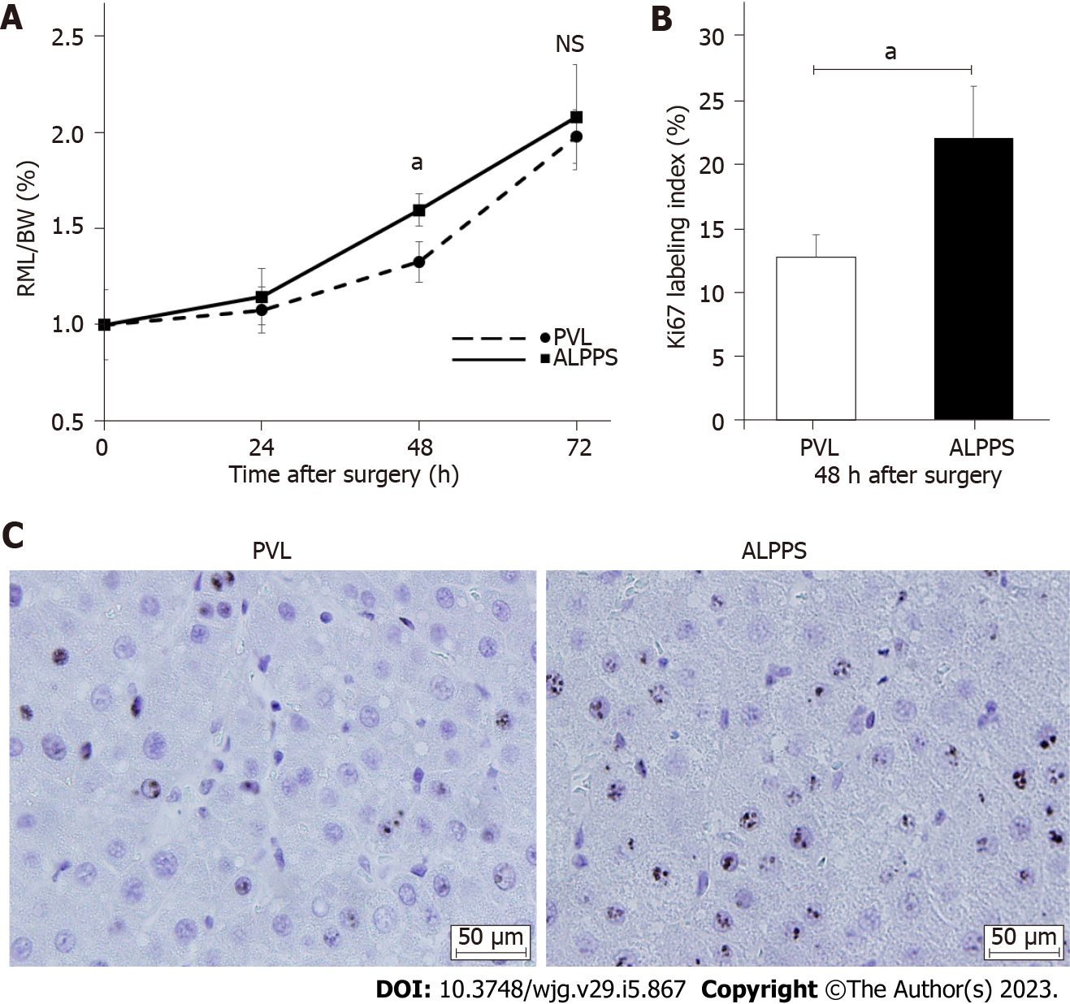
Figure 2 Changes in the right side of the median lobe weight to body weight ratio and Ki-67 index after surgery. A: Future liver remnant/body weight ratio up to 72 h after surgery; B: Immunohistochemistry of Ki-67 at 48 h after the operation; C: Ki-67 labeling index at 48 h after the surgery. Values are expressed as the mean ± SD; n = 5 for each group; ªP < 0.05; NS: Not significant; RML/BW: Right side of the median lobe weight/body weight; PVL: Portal vein ligation; ALPPS: Associating liver partition and portal vein ligation for staged hepatectomy.

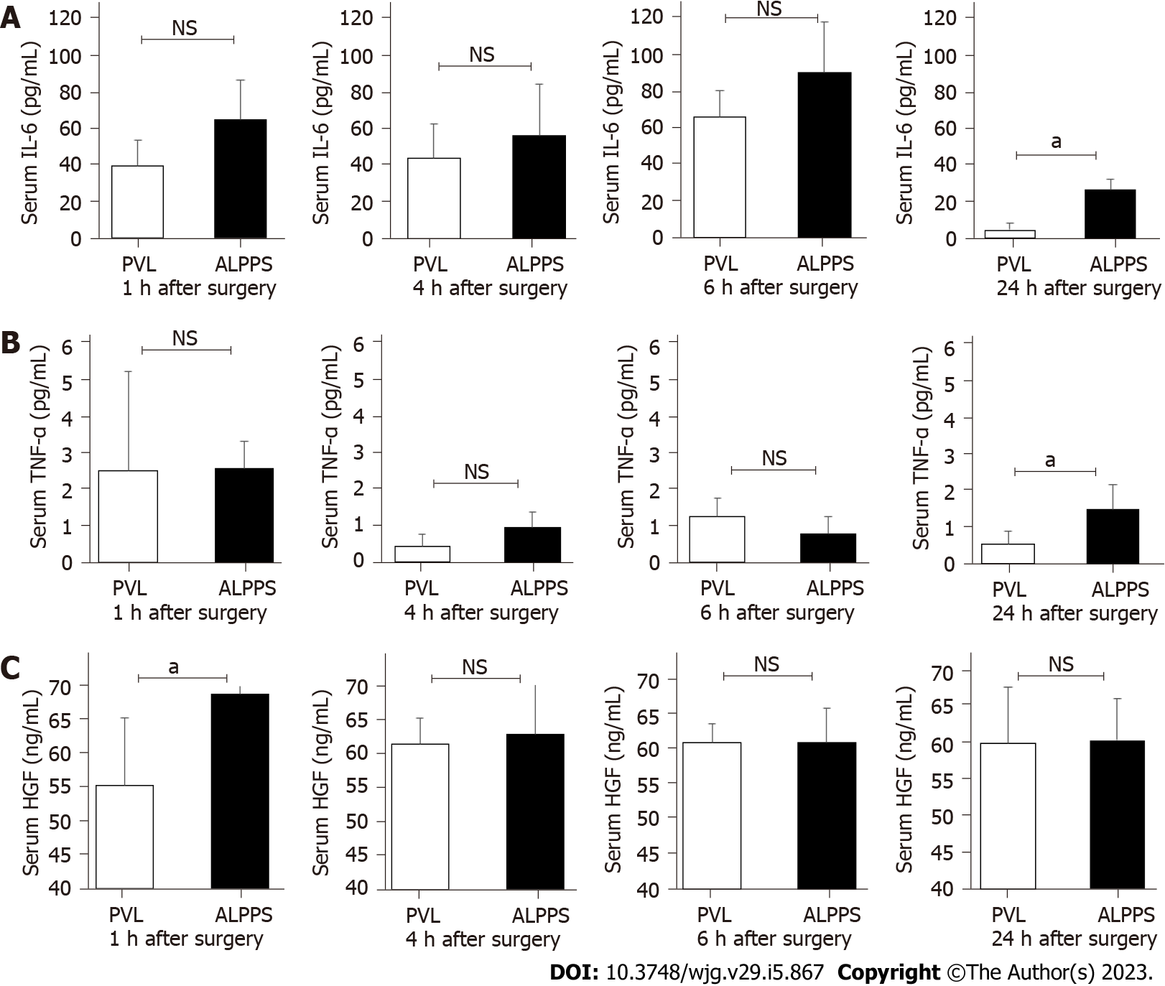
Figure 3 Expression of inflammatory cytokines and hepatocyte growth factor in serum and right side of the median lobe tissue. A: Serum interleukin-6 concentrations at 1, 4, 6, and 24 h after surgery; B: Tumor necrosis factor-α concentrations at 1, 4, 6, and 24 h after surgery; C: Hepatocyte growth factor concentration at 1, 4, 6, and 24 h after surgery. Values are expressed as the mean ± SD; n = 5 for each group; ªP < 0.05; NS: Not significant; PVL: Portal vein ligation; ALPPS: Associating liver partition and portal vein ligation for staged hepatectomy; IL: Interleukin; TNF: Tumor necrosis factor; HGF: Hepatocyte growth factor.

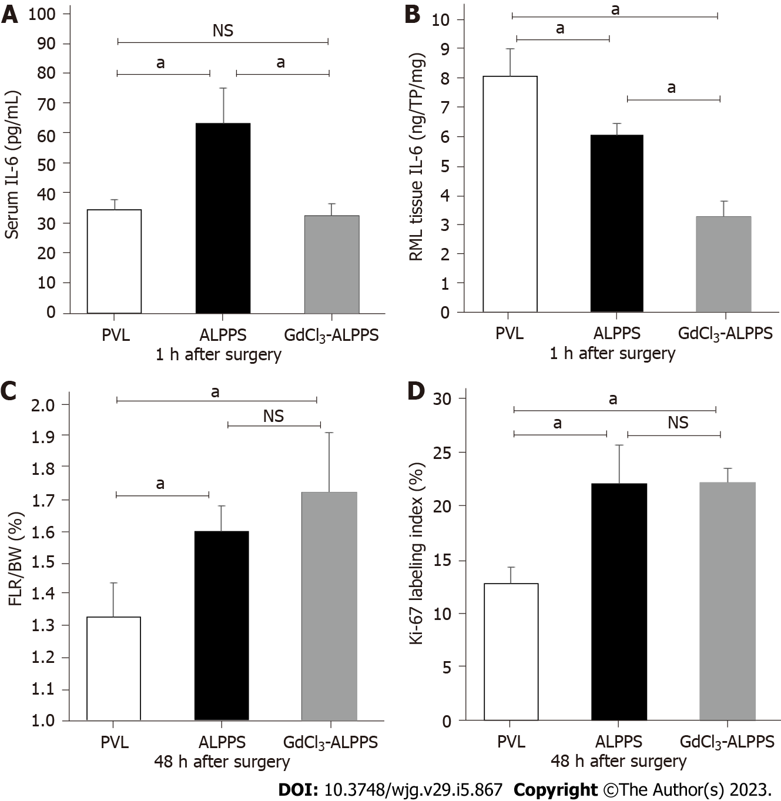
Figure 4 Interleukin-6 expression and liver regeneration in the gadolinium chloride model. A: The serum concentration of interleukin (IL)-6 at 1 h after surgery; B: IL-6 concentration in right side of the median lobe tissue at 1 h after surgery; C: Future liver remnant/body weight ratio at 48 h after surgery; D: Ki-67 labeling index. Values are expressed as mean ± SD; n = 3 or 5 for each group; ªP < 0.05; NS: Not significant; PVL: Portal vein ligation; ALPPS: Associating liver partition and portal vein ligation for staged hepatectomy; IL: Interleukin; RML: Right median lobe; FLR/BW: Future liver remnant/body weight; CdCl₃: Gadolinium chloride.

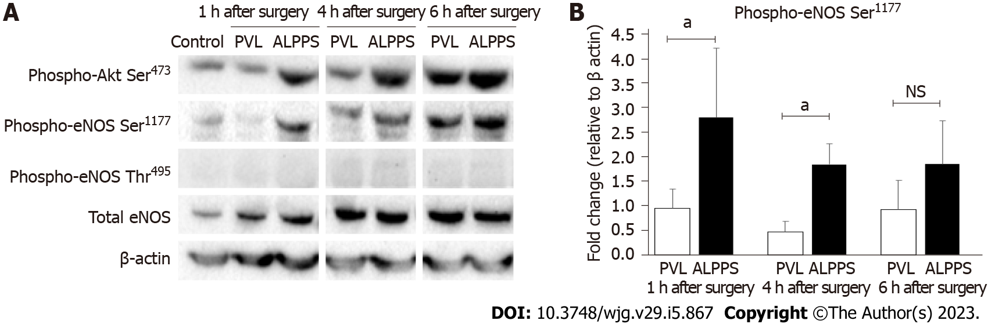
Figure 5 Western blotting of Akt-endothelial nitric oxide synthase pathway-related proteins. A: Western blotting was used to evaluate the expression of phosphorylated Akt and endothelial nitric oxide synthase (eNOS) in right side of the median lobe at 1, 4, and 6 h after surgery in portal vein ligation (PVL) and associating liver partition and portal vein ligation for staged hepatectomy (ALPPS) groups; B: Comparison of the expression of P-Akt Ser⁴⁷³ and P-eNOS Ser¹¹⁷⁷ in PVL and ALPPS groups (quantification of western blots, n = 5 for each group). Values are expressed as the mean ± SD; n = 5 for each group; ªP < 0.05; NS: Not significant; eNOS: Endothelial nitric oxide synthase; PVL: Portal vein ligation; ALPPS: Associating liver partition and portal vein ligation for staged hepatectomy.

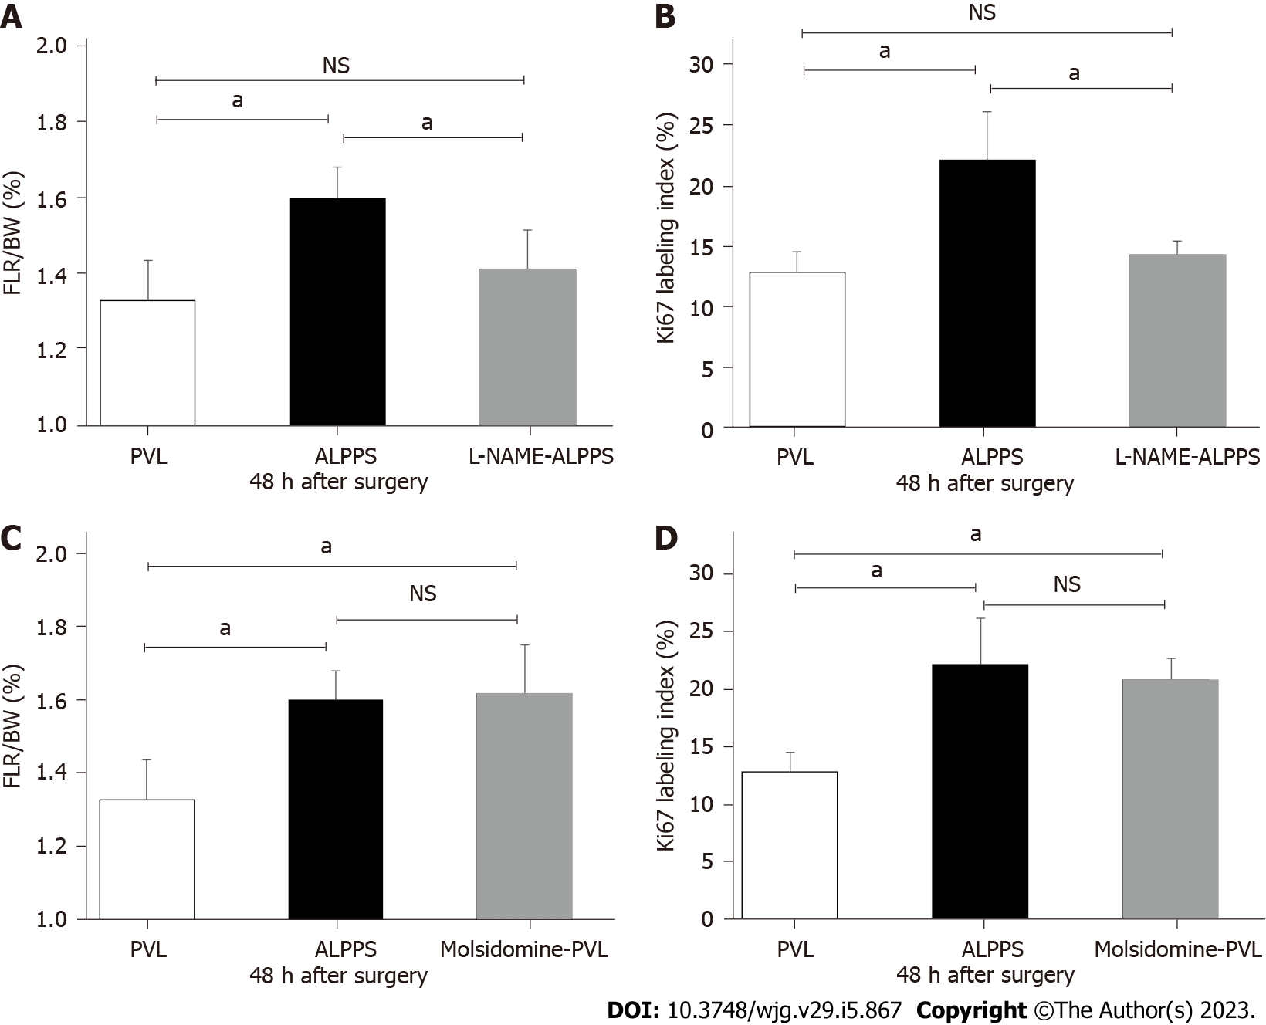
Figure 6 Changes in liver regeneration and cell proliferation due to drug administration. A: Future liver remnant/body weight (FLR/BW) ratio in the N-nitro-arginine methyl ester (L-NAME)-administered associating liver partition and portal vein ligation for staged hepatectomy (ALPPS) group; B: Ki-67 labeling index in the L-NAME-administered ALPPS group; C: FLR/BW ratio in the molsidomine-administered portal vein ligation (PVL) group; D: Ki-67 labeling index in the molsidomine-administered PVL group; n = 5 for each group; ªP < 0.05; NS: Not significant; PVL: Portal vein ligation; ALPPS: Associating liver partition and portal vein ligation for staged hepatectomy; FLR/BW: Future liver remnant/body weight; L-NAME: N-nitro-arginine methyl ester.

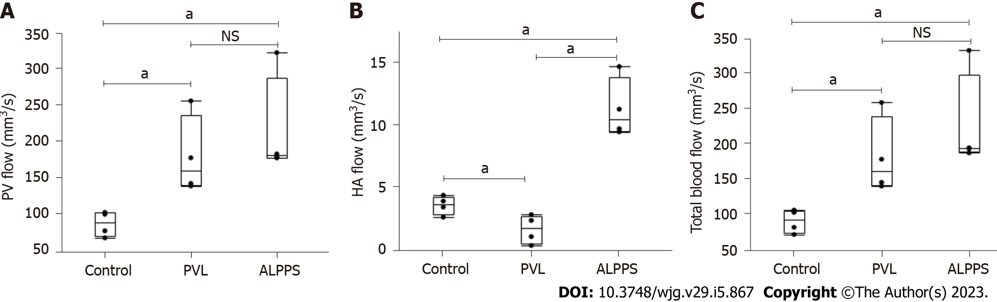
Figure 7 Evaluation of hepatic artery and portal vein volumetric blood flow in the future liver remnant after surgery. A: Portal vein (PV) flow in control, PV ligation (PVL), and associating liver partition and portal vein ligation for staged hepatectomy (ALPPS) groups; B: Hepatic artery flow in control, PVL, and ALPPS groups; C: Total blood flow in control, PVL, and ALPPS groups. Values are expressed as the mean ± SD; n = 4 for each group; ªP < 0.05; NS: Not significant; PVL: Portal vein ligation; ALPPS: Associating liver partition and portal vein ligation for staged hepatectomy; HA: Hepatic artery.

Published by Baishideng Publishing Group Inc
7041 Koll Center Parkway, Suite 160, Pleasanton, CA 94566, USA
Telephone: +1-925-3991568
E-mail: bpgoffice@wjgnet.com
Help Desk: https://www.f6publishing.com/helpdesk
https://www.wjgnet.com

© 2023 Baishideng Publishing Group Inc. All rights reserved.

