Name of Journal: World Journal of Clinical Cases
Manuscript NO: 66401
Manuscript Type: CASE REPORT

Successful totally laparoscopic right trihepatectomy following conversion therapy for hepatocellular carcinoma: A case report

Zhang JJ et al. Laparoscopic right trihepatectomy

Jun-Jing Zhang, Ze-Xin Wang, Jian-Xiang Niu, Ming Zhang, Ni An, Peng-Fei Li, Wei-Hua Zheng

Jun-Jing Zhang, Department of General Surgery, Huhhot First Hospital, Huhhot 010030, Inner Mongolia Autonomous Region, China

Ze-Xin Wang, Department of Interventional Medicine, The Affiliated Hospital of Inner Mongolia Medical University, Huhhot 010000, Inner Mongolia Autonomous Region, China

Jian-Xiang Niu, Ming Zhang, Ni An, Peng-Fei Li, Wei-Hua Zheng, Department of Hepatobiliary Surgery, The Affiliated Hospital of Inner Mongolia Medical University, Huhhot 010000, Inner Mongolia Autonomous Region, China

Author contributions: Zhang JJ reviewed the literature and drafted the manuscript, and was responsible for the revision of the manuscript for important intellectual content; Wang ZX analyzed and interpreted the imaging findings; Zhang JJ, Niu JX, and Zhang M were the patient’s surgeon; Li PF, Zheng WH, and An N were the postgraduates, reviewed the literature, and contributed to manuscript drafting; All authors issued final approval for the version to be submitted.

Supported by the Inner Mongolia Autonomous Region Grassland Talent Cultivation Program, No. CYYC2012040

Corresponding author: Jun-Jing Zhang, MD, Chief Physician, Department of General Surgery, Huhhot First Hospital, No. 150 South Second Ring Road, Huhhot 010030, Inner Mongolia Autonomous Region, China. zhang.jj@vip.163.com

Received: April 7, 2021
Revised: May 6, 2021
Accepted: May 25, 2021
Published online:

Abstract
BACKGROUND
About 20%-30% of newly diagnosed hepatocellular carcinoma (HCC) patients are surgically feasible due to a variety of reasons. Active conversion therapy may provide opportunities of surgery for these patients. Nevertheless, the choice of surgical procedure is controversial after successful conversion therapy. We report a patient with HCC who underwent successful laparoscopic right trisectionectomy after conversion therapy with portal vein embolization and transarterial chemoembolization.

CASE SUMMARY
A 67-year-old male patient presented to our hospital with epigastric distention/discomfort and nausea/vomiting for more than 1 mo. Contrast-enhanced computed tomography scan of the abdomen demonstrated multiple tumors (the largest was ≥ 10 cm in diameter) located in the right liver and left medial lobe, and the left lateral lobe was normal. The future remnant liver (FRL) of the left lateral lobe accounted for only 18% of total liver volume after virtual resection on the three-dimensional liver model. Conversion therapy was adopted after orally administered entecavir for antiviral treatment. First, the right portal vein was embolized. Then tumor embolization was performed via the variant hepatic arteries. After 3 wk, the FRL of the left lateral lobe accounted for nearly 30% of the total liver volume. Totally laparoscopic right trisectionectomy was performed under combined epidural and general anesthesia. The in situ resection was performed via an anterior approach. The operating time was 240 min. No clamping was required during the surgery, and the intraoperative blood loss was 300 mL. There were no postoperative complications such as bile leakage, and the incision healed well. The patient was discharged on the 8th postoperative day. During the 3-mo follow-up, there was no recurrence and obvious hyperplasia of residual liver was observed. Alpha-fetoprotein decreased significantly and tended to be normal.

CONCLUSION
Due to the different biological characteristics of the liver cancer and the pathophysiological features of the liver from other organs, the conversion treatment should take into account both the feasibility of tumor downstaging and the volume and function of the remnant liver. Our case provides a reference for clinicians in terms of both conversion therapy and laparoscopic right trisectionectomy.

Key Words: Laparoscopy; Right trihepatectomy; Conversion therapy; Hepatocellular carcinoma; Primary liver cancer; Case report

Zhang JJ, Wang ZX, Niu JX, Zhang M, An N, Li PF, Zheng WH. Successful totally laparoscopic right trihepatectomy following conversion therapy for hepatocellular carcinoma: A case report. World J Clin Cases 2021; In press

Core Tip: Only 20%-30% of newly-diagnosed hepatocellular carcinoma (HCC) patients are feasible for surgical resection. We report a HCC patient who underwent successful laparoscopic right trisectionectomy after conversion therapy with portal vein embolization and transarterial chemoembolization. There are few reports in the literature. Our case provided reference for clinicians in terms of both conversion therapy and laparoscopic right trisectionectomy.
INTRODUCTION
Primary liver cancer is the fourth most frequently diagnosed malignancy and the second most frequent cause of cancer-related deaths in China^{[1,2]}. Primary liver cancer includes three major pathological types: hepatocellular carcinoma (HCC), intrahepatic cholangiocarcinoma (ICC), and HCC-ICC mixed type, among which HCC accounts for 85%-90%. Surgical resection remains the treatment of choice for HCC patients and the most important strategy for achieving long-term survival. However, as most HCC patients have underlying cirrhosis or are already in the advanced stages when diagnosed, only 20%-30% of newly diagnosed HCC patients are eligible for surgical resection^{[3]}. Compared with other therapies, surgical resection can lead to better quality of life and higher survival rates in liver cancer patients; therefore active conversion therapy to enable subsequent surgical intervention should be a therapeutic goal, and a variety of conversion methods are available.
Surgical resection includes liver transplantation, traditional open partial hepatectomy, and laparoscopic (or robotic) hepatectomy. Liver transplantation is limited by its indications and the availability of donor organs, while partial hepatectomy is the mainstream surgery at present. The past three decades have witnessed advances in laparoscopic liver resection from partial hepatectomy to regular lobectomy and then segmentectomy (resection of segments I, VII, and VIII). Now most liver surgeries can be performed laparoscopically. Compared with conventional open hepatectomy, laparoscopic surgeries can achieve superior short-term outcomes, with equivalent long-term prognosis^{[4,5]}. However, there are few reports on the application of totally laparoscopic anatomical right hepatic trisectionectomy in the treatment of liver cancer, especially for giant HCC.
Here, we report an HCC patient who underwent successful laparoscopic right trisectionectomy after conversion therapy.

CASE PRESENTATION
Chief complaints
A 67-year-old male patient was presented to our hospital with epigastric distention/discomfort and nausea/vomiting.

History of present illness
The patient’s symptoms started 1 mo prior with epigastric distention/discomfort and nausea/vomiting.

History of past illness
He denied any history of hypertension, diabetes, coronary heart disease, and infectious diseases such as hepatitis or tuberculosis.

Personal and family history
He denied any history of personal and family history.

Physical examination
The patient’s temperature was 36.3 ℃, heart rate was 74 beats per min, respiratory rate was 20 breaths per min, blood pressure was 120/75 mmHg. On physical examination, a fixed, painless and relatively hard abdominal mass with a diameter of 8 cm was palpated in the right upper quadrant.

Laboratory examinations
The results of laboratory examinations at admission are shown in Table 1.

Imaging examinations
Contrast-enhanced computed tomography scan of the abdomen demonstrated variations of the hepatic artery; the left branch of the hepatic artery arose from the abdominal trunk and the right branch of the hepatic artery originated from the superior mesenteric artery, multiple tumors (the largest was ≥ 10 cm in diameter) were located in the right liver and the left medial lobe, and the left lateral lobe was normal. The future remnant liver (FRL) of the left lateral lobe accounted for only 18% of total liver volume after virtual resection on the three-dimensional (3D) liver model (Figure 1).

MULTIDISCIPLINARY EXPERT CONSULTATION
Yu Lin, MD, The Affiliated Hospital of Inner Mongolia Medical University, Department of Radiotherapy
Radiotherapy is not recommended as the first choice of treatment for patients with diffuse tumor distribution but can be used as a complementary or adjuvant treatment.

Xiao-Juan Qiao, MD, The Affiliated Hospital of Inner Mongolia Medical University, Internal Medicine-Oncology
Surgery is the preferred treatment for HCC. If there is no indication for surgery, targeted therapy or systemic chemotherapy can be considered.

Ze-Xin Wang, MD, The Affiliated Hospital of Inner Mongolia Medical University, Department of Interventional Medicine
Portal vein embolization (PVE) and trans-arterial chemoembolization (TACE) can be considered for follow-up surgery.

Jun-Jing Zhang, MD, The Affiliated Hospital of Inner Mongolia Medical University, Department of General Surgery
Based on experts’ advice, we should take the lead in conversion therapy. If successful, we should carry out laparoscopic right trisectionectomy.

FINAL DIAGNOSIS
The final diagnosis of the presented case was HCC.

TREATMENT
After multidisciplinary evaluation, conversion therapy was adopted after orally administered entecavir for antiviral treatment. The right portal vein was embolized first; after the liver function returned normal 1 wk later, tumor embolization was performed via the variant hepatic arteries (Figure 2). After 3 wk, a second abdominal CECT revealed obvious hyperplasia of the left lateral lobe, and the FRL of the left lateral lobe accounted for nearly 30% of the total liver volume (Figure 3). The results of laboratory examinations before surgery are shown in Table 2. The Child-Pugh score was still A.
Totally laparoscopic right trisectionectomy was performed under combined epidural and general anesthesia, and the technique was approved by the ethics committee of our hospital. The in situ resection was performed via an anterior approach. The first porta hepatis was first exposed. The clamping band was reserved. The liver parenchyma was dissected along the right side of the sagittal branch of the portal vein, and the middle hepatic vein and the root of the right hepatic vein were exposed in turn. After the right hepatic artery in the first hepatic hilum and the right branch of the portal vein were dissected, the middle hepatic vein and the right hepatic vein were dissected with a cutting stapler under laparoscope. Finally, the third hepatic hilum and the perihepatic ligament were proceeded (Figure 4). The operating time was 240 min. No clamping was required during surgery, and the intraoperative blood loss was 300 mL. The resected specimens were observed with the naked eye and under microscope (Figure 5).

OUTCOME AND FOLLOW-UP
There were no postoperative complications such as bile leakage, and the incision healed well. The patient was discharged on the 8th postoperative day (Figure 6A and B). TACE was applied prophylactically once after surgery. During the 3-mo follow-up, there was no recurrence and obvious hyperplasia of residual liver was observed (Figure 6C). Alpha-fetoprotein (AFP) decreased significantly and tended to be normal (Figure 7).

DISCUSSION
For patients with Barcelona Clinic Liver Cancer stage B or China Liver Cancer Staging stage Ⅱb liver cancer^{[3]}, surgical resection is not superior to non-surgical treatments (e.g., TACE). However, for tumors confined to the same segment or the ipsilateral half of the liver, surgical resection may achieve better outcomes than other treatment modalities^{[6,7]}. In the present case, as the tumor was not only located in the right lobe but also in the left medial lobe (Figure 5A), an anatomical right trisectionectomy was required. Since there was an inadequate volume of FRL, successful conversion therapy was the only way to enable the subsequent surgery. Due to the different biological characteristics of the liver cancer and the pathophysiological features of the liver from other organs, the conversion treatment should take into account both the feasibility of tumor down staging and the volume and function of the remnant liver.
Tumor downstaging can be achieved using a variety of techniques, which can be applied in a combined or sequential manner. Among them, TACE is the most commonly used treatment and is considered to have the highest success rate^{[8]}. In addition, TACE also allows the early detection of undetectable lesions by other imaging modalities. In the present case, if TACE revealed the presence of a lesion in the remaining left lateral lobe, surgery would have a limited value. Solutions for the inadequate volume of FRL include the associating liver partition and portal vein ligation for staged hepatectomy (ALPPS), a two-stage hepatectomy, and PVE. ALPPS can induce rapid hypertrophy of FRL and provide a high resection rate; however, it is associated with high complication and mortality rates and should be performed with caution. After multidisciplinary consultations, PVE combined with TACE was applied in our case, with the aim of achieving radical resection. Compared with PVE alone, PVE plus TACE accelerates the regeneration of FRL tissue while avoiding or delaying the growth of tumors in the left medial lobe. The interval from PVE to surgery was nearly 4 wk, during which the ratio of FRL to standard liver volume increased from 18% to 30%. Despite the successful conversion, tumors progressed during the waiting period; AFP increased from ≥ 2000 ng/mL at admission to ≥ 3000 ng/mL before surgery, which might be related to the varying tumor diameters and the extensive distribution of the tumors in liver tissue (Figure 5A). TACE combined with systematic drug administration may help to address this problem.
For patients with giant HCC (> 10 cm in diameter) requiring anatomical right trisectionectomy, surgical resection by laparoscopic approach alone is rarely reported in the literature. Safety is the first concern during a laparoscopic procedure, followed by the “tumor-free” principle^{[4,5]}. In 2014, Ban et al^{[9]} developed a difficulty scoring system (DSS-BAN) based on 90 patients undergoing laparoscopic surgery for HCC at three medical centers according to the extent of liver resection, tumor location, tumor size, preoperative liver function, and tumor proximity to major vessels. In DSS-BAN, performing laparoscopic liver resection with a difficulty score of 10 requires experience with more than 50 cases of laparoscopic liver resection. Our team had experience with more than 100 cases, which ensured the successful operation in our current case^{[10]}. Another technical challenge during the operation is to ensure sufficient tumor margin to prevent tumor rupture. The preoperative 3D reconstruction, precise evaluation and intraoperative ultrasound if necessary can help determine the resection margin. If the resection margin is close to important vessels/ducts, removal of the tumor exactly along the resection margin is not required, but a pathologically negative margin should be ensured. Laparoscopic in situ liver resection was performed via an anterior approach to avoid compression of tumors. During the operation, the liver parenchyma between the left lateral lobe and left medial lobe was divided firstly, followed by the division of right hepatic pedicle, middle hepatic vein, right hepatic vein, and vessels at the third porta of liver. Finally, the perihepatic ligament was transected to remove the specimen. These steps were expected to avoid the iatrogenic hematogenous spread of cancer cells. Postoperative morphological examination showed that the resected specimen was intact and unbroken, and the pathological examination showed that the resection margin was negative for tumor cells. The surgical procedure adhered to the tumor-free principle, and the results were equivalent to traditional open surgery.
Our case provided reference for clinicians in terms of both conversion therapy and laparoscopic right trisectionectomy. No recurrence has been noted, but the follow-up period is still short. The patient has been treated with prophylactic TACE once after surgery. There is no evidence on whether additional TACE sessions or other techniques are required to prevent recurrence. In addition, there are also controversies on the treatment options for potential recurrence. In conclusion, there are still many concerns about this case, and follow-up will be continued.

CONCLUSION
In this case, as the tumor was not only located in the right lobe but also in the left medial lobe (Figure 5A), an anatomical right trisectionectomy was required. Since there was an inadequate volume of FRL, successful conversion therapy was the only way to enable the subsequent surgery. Due to the different biological characteristics of the liver cancer and the pathophysiological features of the liver from other organs, the conversion treatment should take into account both the feasibility of tumor downstaging and the volume and function of the remnant liver. Our case provided reference for clinicians in terms of both conversion therapy and laparoscopic right trisectionectomy.

ACKNOWLEDGEMENTS
First of all, I would like to thank the patient in this case for his support and approval of this article. Second, I would like to express my gratitude to the authors of this article and thank them for their help and dedication from the end. Without them, I would not be able to complete this work. I also want to thank the government for providing us with a strong backing. Finally, I would like to thank all the staff in the editorial department, and thank you for all your valuable comments.

REFERENCES
1 Torre LA, Bray F, Siegel RL, Ferlay J, Lortet-Tieulent J, Jemal A. Global cancer statistics, 2012. CA Cancer J Clin 2015; 65: 87-108 [PMID: 25651787 DOI: 10.3322/caac.21262]
2 Zhou M, Wang H, Zeng X, Yin P, Zhu J, Chen W, Li X, Wang L, Wang L, Liu Y, Liu J, Zhang M, Qi J, Yu S, Afshin A, Gakidou E, Glenn S, Krish VS, Miller-Petrie MK, Mountjoy-Venning WC, Mullany EC, Redford SB, Liu H, Naghavi M, Hay SI, Wang L, Murray CJL, Liang X. Mortality, morbidity, and risk factors in China and its provinces, 1990-2017: a systematic analysis for the Global Burden of Disease Study 2017. Lancet 2019; 394: 1145-1158 [PMID: 31248666 DOI: 10.1016/S0140-6736(19)30427-1]
3 Department of Medical Administration, National Health and Health Commission of the People's Republic of China. [Guidelines for diagnosis and treatment of primary liver cancer in China (2019 edition)]. Zhonghua Gan Zang Bing Za Zhi 2020; 28: 112-128 [PMID: 32164061 DOI: 10.3760/cma.j.issn.1007-3418.2020.02.004]
4 Cheung TT, Han HS, She WH, Chen KH, Chow PKH, Yoong BK, Lee KF, Kubo S, Tang CN, Wakabayashi G. The Asia Pacific Consensus Statement on Laparoscopic Liver Resection for Hepatocellular Carcinoma: A Report from the 7th Asia-Pacific Primary Liver Cancer Expert Meeting Held in Hong Kong. Liver Cancer 2018; 7: 28-39 [PMID: 29662831 DOI: 10.1159/000481834]
5 Abu Hilal M, Aldrighetti L, Dagher I, Edwin B, Troisi RI, Alikhanov R, Aroori S, Belli G, Besselink M, Briceno J, Gayet B, D'Hondt M, Lesurtel M, Menon K, Lodge P, Rotellar F, Santoyo J, Scatton O, Soubrane O, Sutcliffe R, Van Dam R, White S, Halls MC, Cipriani F, Van der Poel M, Ciria R, Barkhatov L, Gomez-Luque Y, Ocana-Garcia S, Cook A, Buell J, Clavien PA, Dervenis C, Fusai G, Geller D, Lang H, Primrose J, Taylor M, Van Gulik T, Wakabayashi G, Asbun H, Cherqui D. The Southampton Consensus Guidelines for Laparoscopic Liver Surgery: From Indication to Implementation. Ann Surg 2018; 268: 11-18 [PMID: 29064908 DOI: 10.1097/SLA.0000000000002524]
6 Metussin A, Patanwala I, Cross TJ. Partial hepatectomy vs. transcatheter arterial chemoembolization for resectable multiple hepatocellular carcinoma beyond Milan criteria: a RCT. J Hepatol 2015; 62: 747-748 [PMID: 25450210 DOI: 10.1016/j.jhep.2014.08.057]
7 Bruix J, Fuster J. A Snapshot of the Effective Indications and Results of Surgery for Hepatocellular Carcinoma in Tertiary Referral Centers: Is It Adherent to the EASL/AASLD Recommendations? An Observational Study of the HCC East-West Study Group. Ann Surg 2015; 262: e30 [PMID: 24374519 DOI: 10.1097/SLA.0000000000000381]
8 Lencioni R, de Baere T, Soulen MC, Rilling WS, Geschwind JF. Lipiodol transarterial chemoembolization for hepatocellular carcinoma: A systematic review of efficacy and safety data. Hepatology 2016; 64: 106-116 [PMID: 26765068 DOI: 10.1002/hep.28453]
9 Ban D, Tanabe M, Ito H, Otsuka Y, Nitta H, Abe Y, Hasegawa Y, Katagiri T, Takagi C, Itano O, Kaneko H, Wakabayashi G. A novel difficulty scoring system for laparoscopic liver resection. J Hepatobiliary Pancreat Sci 2014; 21: 745-753 [PMID: 25242563 DOI: 10.1002/jhbp.166]
10 Liu YB, Meng XK, Ren JJ, Li J, Qiao JL, Zhang JJ. Comparison of safety and short-term efficacy between laparoscopic hepatectomy and open hepatectomy. Zhonghua Ganzang Waike Shoushuxue Dianzi Zazhi 2020; 9: 547-551 [DOI: 10.3877/cma.j.issn.2095-3232.2020.06.011]

Footnotes
Informed consent statement: Informed written consent was obtained from the patient for publication of this report and any accompanying images.

Conflict-of-interest statement: The authors declare that they have no conflict of interest.

CARE Checklist (2016) statement: The authors have read the CARE Checklist (2016), and the manuscript was prepared and revised according to the CARE Checklist (2016).

Open-Access: This article is an open-access article that was selected by an in-house editor and fully peer-reviewed by external reviewers. It is distributed in accordance with the Creative Commons Attribution NonCommercial (CC BY-NC 4.0) license, which permits others to distribute, remix, adapt, build upon this work non-commercially, and license their derivative works on different terms, provided the original work is properly cited and the use is non-commercial. See: http://creativecommons.org/Licenses/by-nc/4.0/

Manuscript source: Unsolicited manuscript

Peer-review started: April 7, 2021
First decision: April 23, 2021
Article in press:

Specialty type: Surgery
Country/Territory of origin: China
Peer-review report’s scientific quality classification
Grade A (Excellent): 0
Grade B (Very good): 0
Grade C (Good): C
Grade D (Fair): 0
Grade E (Poor): 0

P-Reviewer: Martínez-Pérez A S-Editor: Zhang H L-Editor: Filipodia P-Editor:
Figure Legends
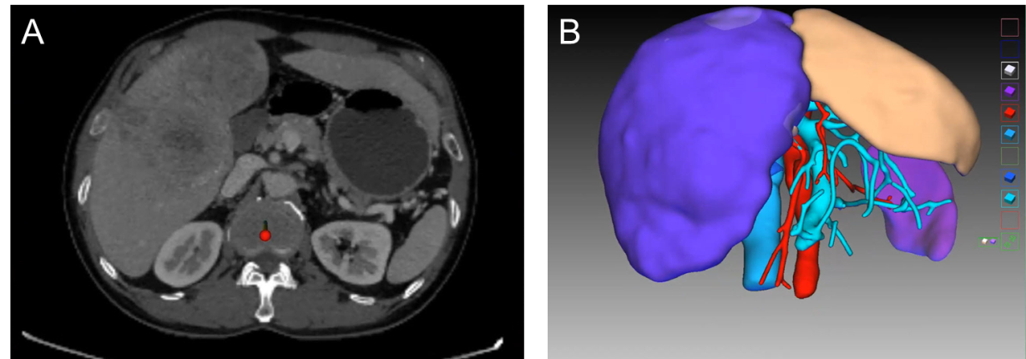
Figure 1 Computed tomography result and three-dimensional reconstruction of the patient at first presentation. A: Venous phase contrast-enhanced computed tomography shows huge space-occupying lesions in the left medial lobe and right liver, and the left lateral lobe is normal; B: Virtual resection on the three-dimensional liver model.
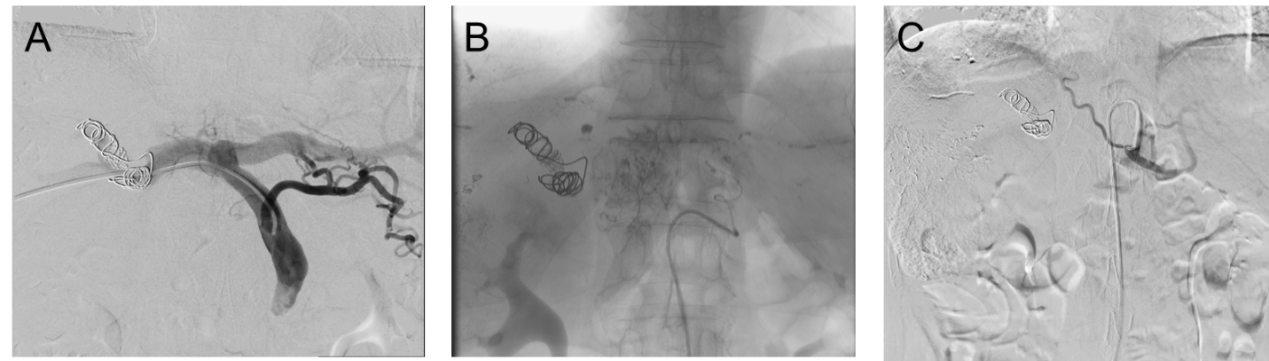
Figure 2 Conversion therapy. A: Embolization of the right portal vein; B: Chemoembolization of the tumor in left medial lobe via left hepatic artery and abdominal trunk; C: Chemoembolization of tumors in the right liver via right hepatic artery and superior mesenteric artery.
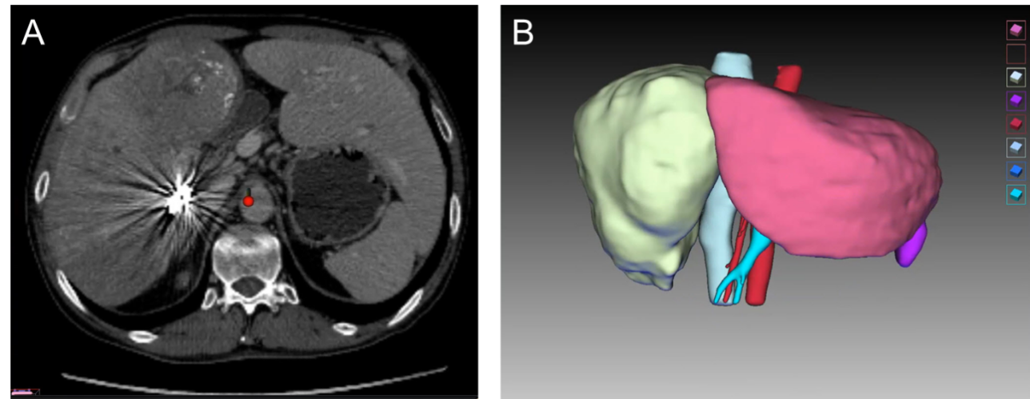
Figure 3 Computed tomography result and three-dimensional reconstruction of the patient prior to surgery. A: Pre-operative venous phase contrast-enhanced computed tomography shows huge space-occupying lesions in the left medial lobe and right liver and obvious hyperplasia in the left lateral lobe; B: Virtual resection on the three-dimensional liver model.
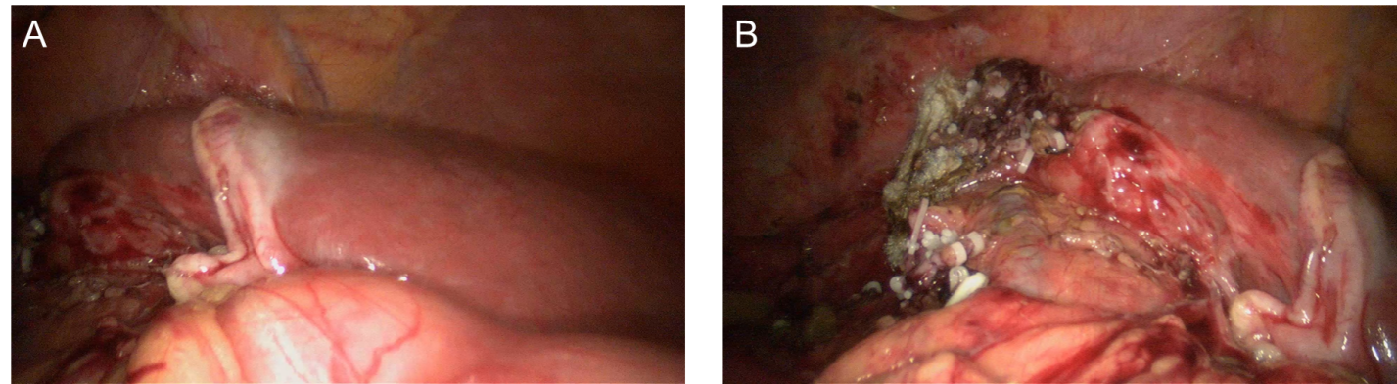
Figure 4 Intraoperative observation. A: Liver remnant of the left lateral lobe, with normal color; B: Liver cutting surface, with intact Glisson sheath covering the left lateral lobe.
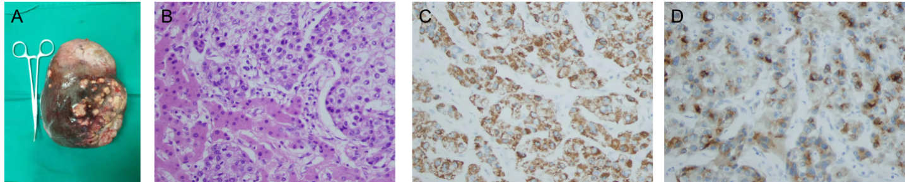
Figure 5 Resected specimen (diaphragmatic surface of liver). A: Microscopic findings. Hematoxylin and eosin (H&E) staining showing polygonal tumor cells in a trabecular arrangement, H&E × 400; B-D: Immunohistochemistry showing a strong and diffuse cytoplasmic (B) positivity with Hep Par 1 (C) and glypican 3 (D), × 400. The tumor cells were negative for cytokeratin 7 and cytokeratin 20.
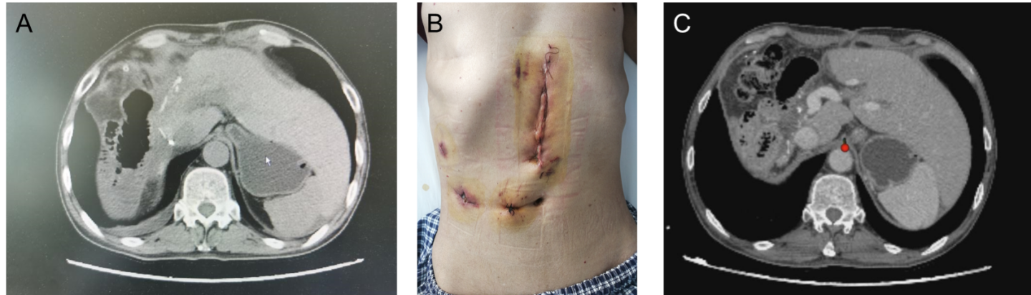
Figure 6 Postoperative recovery and short-term follow-up. A: Abdominal plain computed tomography (CT) at discharge showed no accumulation of fluid in the abdominal cavity, whereas there was hyperplasia of the left lateral lobe; B: Abdominal incision at discharge; C: A recent CT scan showed that there was no tumor recurrence, and the hyperplasia of the left lateral lobe was obvious.

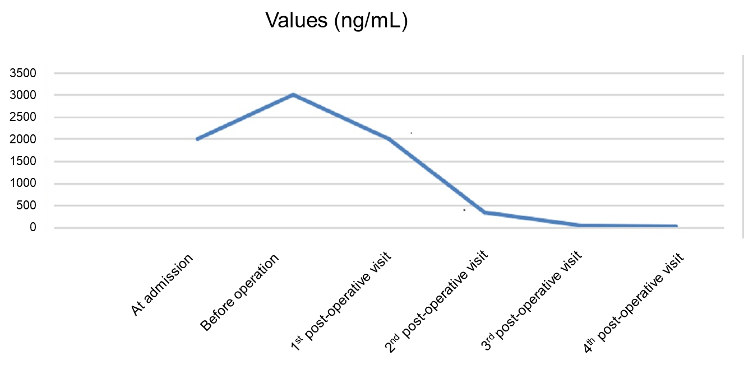
Figure 7 Change in alpha-fetal protein level.
Table 1 Laboratory parameters of the patient at first presentation
Parameters | Values | Normal limits
PT | 10.8 | 9-13
ALB | 40.6 g/L | 35-52 g/L
AFP | ≥ 2000 ng/mL | 0-9 ng/mL
TBIL | 22.1 µmol/L | 3–20 µmol/L
DBIL | 8.6 µmol/L | 0-6.8 µmol/L
AST | 32.6 U/L | 15-40 U/L
ALT | 27.4 U/L | 9-50 U/L
HBsAg | Positive | Negative
HBeAb | Positive | Negative
HBcAb | Positive | Negative
Hepatitis B DNA | 2.27E+03 | < 500
HA | 268.7 ng/mL | 0-120 ng/mL
CIV | 187.5 ng/mL | 0-95 ng/mL
Child-Pugh score | 5 | 5
ICGR 15 | 4.8% | ≤ 10%
ALB: Albumin; AFP: Alpha-fetoprotein; ALT: Alanine aminotransferase; AST: Aspartate aminotransferase; DBIL: Direct bilirubin; HA: Hyaluronic acid; HBcAb: Hepatitis B core antibody; HBeAb: Hepatitis B e antibody; HBsAg: Hepatitis B surface antigen; ICGR 15: Indocyanine green 15 min retention rate; PT: Prothrombin time; TBIL: Total bilirubin.
Table 2 Laboratory parameters of the patient prior to surgery
Parameters | Values | Normal limits
PT | 10.7 | 9-13
ALB | 41.7 g/L | 35-52 g/L
AFP | ≥ 3000 ng/mL | 0-9 ng/mL
TBIL | 16.8 µmol/L | 3-20 µmol/L
DBIL | 8.8 µmol/L | 0-6.8 µmol/L
AST | 42.6 U/L | 15-40 U/L
ALT | 54.3 U/L | 9-50 U/L
Hepatitis B DNA | < 500 | < 500
HA | 149.20 ng/mL | 0-120 ng/mL
CIV | 161.49 ng/mL | 0-95 ng/mL
Child-Pugh score | 5 | 5
ICGR 15 | 10.1% | ≤ 10%
ALB: Albumin; AFP: Alpha-fetoprotein; ALT: Alanine aminotransferase; AST: Aspartate aminotransferase; DBIL: Direct bilirubin; HA: Hyaluronic acid; ICGR 15: Indocyanine green 15 min retention rate; PT: Prothrombin time; TBIL: Total bilirubin.

