Name of Journal: World Journal of Clinical Cases
Manuscript NO: 58198
Manuscript Type: CASE REPORT

Acute celiac artery occlusion secondary to blunt trauma: Two case reports

Li H et al. Acute celiac artery occlusion

Hui Li, Yu Zhao, Yan-An Xu, Tao Li, Jun Yang, Ping Hu, Tao Ai

Hui Li, Yan-An Xu, Tao Li, Jun Yang, Ping Hu, Tao Ai, Department of Traumatology, Chongqing University Central Hospital, Chongqing 400080, China

Yu Zhao, Department of Radiology, Chongqing University Central Hospital, Chongqing 400080, China

Author contributions: All the authors participated in the treatment of this patient; Li H, Zhao Y, Li T, Yang J, Hu P, and Ai T developed the conclusions; Li H wrote the draft; Zhao Y, Xu YA, Li T and Ai T reviewed the draft; Yang J and Ai T edited the final draft; All authors have read and approve the final version of the manuscript.

Corresponding author: Tao Ai, MD, Attending Doctor, Department of Traumatology, Chongqing University Central Hospital, No. 1 Jiankang Road, Yuzhong District, Chongqing 400080, China. aitao0916@126.com

Received: July 22, 2020
Revised: September 27, 2020
Accepted: October 20, 2020
Published online:

Abstract
BACKGROUND
Acute celiac artery (CA) injuries are extremely rare but potentially life-threatening and are more often caused by a penetrating injury rather than a blunt injury. The clinical manifestation of CA injuries is usually atypical, which easily causes missed diagnosis and misdiagnosis. Currently, there are only a few reports of acute traumatic occlusion of CA. The CA artery gives off branches to dominate the liver, stomach. and spleen; however, occluded CA did not cause significant organ ischemia, and the compensatory blood flow from the superior mesenteric artery (SMA) played a pivotal role.

CASE SUMMARY
Herein, we report two cases of acute CA occlusion secondary to severe blunt trauma. Case one was a 19-year-old male, suffered from a motorcycle crash. He complained of dyspnea, and the closed drainage was performed soon after the hemopneumothorax was confirmed by ultrasound. Computed tomography (CT) scan revealed hemopneumothorax, multiple rib fractures, right scapular fracture, and liver rupture. Reexamination with contrast-enhanced CT suggested perihepatic fluid was significantly increased, and CA was occluded. Because the hepatic hemorrhage is associated with hepatic artery injury, the CA was retrogradely opened through the SMA, and then, the right hepatic artery was embolized with coils successfully through the conventional pathway. Stent implantation was not performed, and the CA occlusion was managed by conservative treatment. A follow-up CT scan 3 mo after discharge showed the origin of CA remained occluded. Case two was a 37-year-old man, suffered injury from fall from height. He complained of lower back and bilateral heel pain. Contrast-enhanced CT examination revealed multiple rib fractures, bilateral pneumothorax, fourth lumbar (L4) vertebral burst fracture, and pelvic fractures. Furthermore, a small high-density mass in a lesser peritoneal sac and in front of the abdominal aorta was detected. The reexamination 14 h after admission showed the CA was occluded. The patient was conservatively treated. The symptoms of nausea after meals disappeared about 4 wk later, and abdominal distension was significantly relieved after 6 wk. The abdominal CT angiography at 60 d showed that the CA thrombus was not recanalized.

CONCLUSION
Patients with CA occlusion will have different clinical manifestations, and the dominant organ will not have obvious ischemia. Conservative treatment is safe, and the patient’s symptoms will be improved with the establishment of collateral circulation.

Key Words: Celiac artery; Acute occlusion; Superior mesenteric artery; Multiple trauma; Liver injury; Case report; Collateral branches

Li H, Zhao Y, Xu YA, Li T, Yang J, Hu P, Ai T. Acute celiac artery occlusion secondary to blunt trauma: Two case reports. World J Clin Cases 2020; In press

Core Tip: We present two cases of acute blunt celiac artery (CA) occlusion. Two patients showed significant differences after CA occlusion. The first patient had clinically evident bleeding from the hepatic artery after liver trauma, while the second patient had obvious gastrointestinal symptoms. Although CA occlusion is extremely rare, our continuous management of two such patients within a week suggests that the incidence of the disease may be underestimated. Early use of enhanced computed tomography examination can help increase the detection rate of CA injury. Due to the establishment of collateral circulation, CA occlusion will not cause obvious organ ischemia, and conservative treatment is safe.
INTRODUCTION
Acute celiac artery (CA) injuries are rare, potentially life-threatening, and more often caused by a penetrating injury rather than a blunt injury^{[1,2]}. The CA is located just below the diaphragm at the T12 level, originating from the anterior wall of the abdominal aorta, and is usually between 1.0 and 1.5 cm in length. CA artery further divides into the common hepatic artery, the left gastric artery, and the splenic artery. Blunt abdominal vascular injuries account for 5% of abdominal vascular injuries, and CA injuries are the rarest type of abdominal vascular injuries^{[2]}. The clinical manifestation of CA injuries is usually atypical, so it is easy to fail to diagnose them^{[3]}, early detection and treatment are important. We report two cases of patients with CA occlusion secondary to blunt injuries, both of whom recovered after conservative treatment.

CASE PRESENTATION
Chief complaints
Case 1: A 19-year-old male without protective clothing was injured while driving a motorcycle after hitting the rear-end of a car at a speed of approximately 60 km/h. Upon presentation to our institution, the patient complained of dyspnea and mild chest pain. During hospitalization, the patient had not mentioned any symptoms of abdominal discomfort.

Case 2: A 37-year-old male was admitted to the emergency department after falling from a height of 15 m with complaints of pain on the lower back and bilateral heel. Two days later, abdominal distension and nausea became the main symptoms.

Physical examination
Case 1: The physical examination revealed tenderness, dullness to percussion, and decreased breath sounds over the right chest.

Case 2: At physical examination, L4 level and bilateral heel tenderness and an open wound were found on the right heel with serious contamination.

Laboratory examinations
Case 1: In the emergency room, the patient’s blood pressure was stable. The blood oxygen saturation was reduced to 88% before the placement of the chest tube. The hemoglobin at admission was 120 g/L but dropped to 95 g/L 3 h later.

Case 2: On admission, the patient’s blood pressure was 88/47 mmHg. The blood oxygen saturation was about 95%-98%. The hemoglobin was 106 g/L in the emergency department, and it dropped to 90 g/L.

Imaging examinations
Case 1: The ultrasound assessment in the emergency room indicated right hemopneumothorax. After the chest tube was placed, the vital signs of this patient were gradually stabilized. Under the protection of cervical gear, a whole-body computed tomography (CT) scan was performed and showed right hemopneumothorax, multiple rib fractures, comminuted fractures of the scapula on the right side, and liver contusion but no perihepatic hemorrhage. Twelve hours after admission, an abdominal contrast-enhanced CT showed that the liver injury was severe, and the perihepatic hemorrhage had significantly increased.

Case 2: After the vital signs were stable, a whole-body CT and contrast-enhanced CT scan of the chest and abdomen showed that there was a small high-density mass in a lesser peritoneal sac and in front of the abdominal aorta. Furthermore, a small bilateral pneumothorax, sternal and bilateral multiple rib fractures, an L4 vertebral burst fracture, iliac wing fracture, acetabular fracture, and bilateral calcaneal fractures were also discovered. The chest and abdominal cavity were assessed by ultrasound 6 h after admission and showed no bleeding or solid organ injuries. Fourteen hours later, the chest and abdomen were evaluated by a contrast-enhanced CT scan, and vascular injury with thrombosis at the initial segment of the CA was confirmed (Figure 1). Furthermore, hemorrhage in the abdominal and retroperitoneal spaces and renal contusion were also found.

FINAL DIAGNOSIS
Case 1
The patient was finally diagnosed with severe multiple injuries, including right hemopneumothorax, multiple rib fractures, comminuted fractures of the scapula on the right side, and liver contusion. The discovery of CA occlusion was made in the interventional radiology chamber.

Case 2
Finally, the patient was diagnosed with severe multiple injuries, including bilateral pneumothorax, sternal and bilateral multiple rib fractures, L4 vertebral burst fracture, pelvic fracture, and bilateral calcaneal fractures. The CA occlusion and renal contusion were confirmed by the abdominal contrast-enhanced CT scan.

TREATMENT
Case 1
Closed thoracic drainage was urgently performed after the chest ultrasonography, and a large amount of gas and approximately 600 mL of blood were evacuated. Twelve hours after admission, the abdomen was reexamined with contrast-enhanced CT and showed the perihepatic hemorrhage had significantly increased. The patient was directly transferred to an interventional radiology chamber for hepatic artery angiography and embolization. The beginning of the interventional operation was not smooth because the opening of the CA could not be found. Instead, the catheter entered the superior mesenteric artery (SMA) on each attempt. After carefully rereading the abdominal contrast-enhanced CT, it was found that the root of the CA was occluded (Figure 2). As a result, hepatic artery interventional embolization and hemostasis could not be achieved by the routine procedure. Therefore, angiography of the hepatic artery through the SMA was attempted, which showed that collateral circulation between the SMA and the celiac trunk had developed and that there were retrograde contrast agents in the initial segment of the splenic artery and occluded site of the CA. Due to the distortion and stenosis of the anastomotic branch, after repeated attempts, the microcatheter was inserted into the hepatic artery. Angiography showed that there was contrast medium leakage in the branch of the right hepatic artery, and active bleeding was still being considered. Given the tiny diameter of the collateral branch, the coil could not be smoothly released. Therefore, the CA was retrogradely opened with a microwire through the SMA (Figure 3A), and then, the right hepatic artery was embolized with coils successfully through the CA (Figure 3B). The CA was not treated with stent implantation.

Case 2
Right calcaneus debridement was emergently performed after admission. The patient complained of abdominal distension and occasional nausea, but there was no obvious abdominal pain or any other symptoms. Due to the lack of obvious abdominal tenderness and the presence of bowel sounds, the patient was conservatively treated. No thrombolysis, stent implantation, or other treatment was performed. Ten days after admission, internal fixation of the lumbar vertebrae, pelvis, and left calcaneus was performed, and anticoagulant therapy with enoxaparin sodium was initiated after the operation.

OUTCOME AND FOLLOW-UP
Case 1
After the operation, the hemoglobin did not decrease further; the blood pressure returned to normal; and there were no complaints of abdominal distension, abdominal pain, nausea, or vomiting. During hospitalization, the patient was in good spirits, and his appetite was even better than before the surgery. The laboratory examination showed normal liver function. Approximately 1 wk later, the risk of bleeding decreased, and anticoagulant therapy with enoxaparin sodium was initiated. A re-examination approximately 2 wk after the injury showed that the CA was still not recanalized. Thereafter, internal fixation of the scapula was performed. A biloma formed in the right liver, and it was drained with a pigtail tube. The patient was discharged 6 wk post-injury. A follow-up CT scan 3 mo later showed the origin of CA remained occluded.

Case 2
The abdominal CT angiography (CTA) on the 5th day revealed that the CA thrombus was not recanalized. The symptoms of nausea after meals disappeared approximately 4 wk after admission, and abdominal distension was significantly relieved after 6 wk. At 60 d, the abdominal CTA showed that the CA thrombus was still not recanalized, and the patient was then discharged. At 3 mo follow-up, the patient had no abdominal symptoms.

DISCUSSION
CA injuries account for 0.01%-0.1% of all vascular injuries and have a high mortality rate^{[2,4]}, which has been reported as high as 38%-75% in the literature^{[5]}. However, there are no mortality data for blunt CA injuries. Currently, only a few cases of blunt CA injury have been published in the literature. After considering the two patients in this paper, the mortality rate is about 10%^{[6-9]}. As CA injuries are prone to being missed, it is estimated that the actual mortality rate is lower. Patients with blunt CA injury often have multiple injuries, and the injury severity score of the two cases we reported were 36 and 27, respectively.
The first case is the first report of CA occlusion with severe hepatic trauma thus far, and the first case in which hepatic artery embolization was performed when CA was occluded. This situation is extremely rare, and the retrograde recanalization of the CA via the collateral branch is also technically challenging. The two patients were consecutively admitted within 1 wk, considering only a few cases had been reported, this may suggest that the incidence of CA injury is underestimated.
Studies have speculated that CA injury is related to the compression of or shear force from the median arcuate ligament. The data indicated that arcuate ligament compression exists in approximately 34% of the CA injury population. Therefore, the anatomical basis of this injury is not uncommon. This injury process can lead to intimal tears, occlusions, dissection flaps, and avulsions^{[4]}. In the above two cases, one was due to drastic compression of the chest and downward movement of the diaphragm, and the other was due to the shear force from deceleration of the diaphragm caused by falling. Due to intimal injury, a thrombus in the lumen gradually forms and blocks the initial segment of the CA. These two injury mechanisms are also the most common causes of blunt CA injuries. Some studies have also suggested that the dense nerve plexus may also be involved in the compression of the beginning of the celiac trunk^{[10]}.
Due to the abundant collateral circulation between the CA and the SMA, blood flow through the pancreaticoduodenal arcade and the communicating branches from the esophagus and diaphragm substantially increases when the CA is occluded. The blood flow through the CA can be partially or even completely compensated^{[8]}.
The diagnosis of CA injury depends on CTA or interventional radiography. We encountered two consecutive patients with blunt CA injury in 1 wk, which is relevant to the frequent use of contrast-enhanced CT to evaluate abdominal injury in recent years. If there are no obvious symptoms of ischemia or massive hemorrhage after blunt CA injury, it is easy to miss the diagnosis or make a misdiagnosis. Also, the risk of CA and mesenteric vascular injury should be considered when patients have suffered thoracic and abdominal compression or a high fall injury. In the emergency room, the injury mechanism of the trauma patients should be carefully inquired. If there is suspicion of abdominal organ or blood vessel injury, if conditions permit, early and routine enhanced CT scan can help to detect hidden injuries and provide important information for emergent surgery.
With the widespread use of modern diagnostic techniques, including contrast-enhanced CT, magnetic resonance imaging, and angiography, the diagnosis rate of CA injury may gradually improve^{[11,12]}. Therefore, abdominal contrast-enhanced CT should be used as a preliminary screening examination for CA injury^{[11]}. To evaluate the blood flow from collateral branches and the risk of gastrointestinal ischemia, further angiography is more valuable and helpful. For patients with extremely rare celiacomesenteric trunk injuries^{[13,14]}, the outcome can be catastrophic if the injury is not diagnosed in time.
Currently, there are no guidelines for the treatment of CA injury. We believe that conservative treatment is feasible when the patient’s hemodynamics are stable and there is no evidence of abdominal organ ischemia. For stable and asymptomatic patients, short-term anticoagulation should be used to prevent thrombus progression. Before a CA thrombus is stable, abdominal signs should be closely observed. If there are signs of intestinal colic, a lack of bowel sounds, or peritonitis, it is suggested that the local thrombus may progress^{[15]}. Therefore, if there are changes in the abdominal signs, it is necessary to promptly perform contrast-enhanced CT and determine the need for surgery.
The following indications suggest that emergent laparotomy may be required: Active arterial bleeding, progressive pseudoaneurysms, and perivascular retroperitoneal hematoma, evidence of obvious ischemia of the stomach, intestines or liver, vascular anatomical variations (such as in the celiacomesenteric trunk)^{[16]}, and arterial dissection or concomitant abdominal organ injuries. When there are no resources available for interventional operations, direct surgical treatment of the CA is the simplest and most effective treatment method. Surgical treatments include repair, ligation, and bypass. The risk of organ ischemia is small after CA injury, which also shows that it is safe and reasonable to ligate the CA during damage control surgery^{[16]}.
Endovascular interventions include balloon dilation, stent implantation, and coil embolization. Intravascular procedures may increase the risk of vascular injury. Other related complications include endoleaks, stent-graft occlusion, stent-graft migration, and aneurysms. Negri et al^{[17]} reported a patient who underwent abdominal stent implantation due to abdominal angina and found that the stent migrated to the splenic artery 3 mo later. We did not choose balloon dilation or stent implantation because the first patient’s liver had sufficient blood supply, and the occluded CA was beneficial to the patient’s injury at that time. For patients with CA occlusion, our experience suggests that the celiac trunk can be retrogradely opened through the SMA with a microwire, and then, the stent can be placed in an antegrade manner. Though the retrograde recanalization of the CA via its branches with SMA is technically challenging, this approach represents a feasible alternative in case of a failed antegrade way.
There may be occlusion, arterial rupture, aneurysm, or dissection after a CA injury^{[12]}. If the patient has atherosclerosis or hypertension, intravascular stent implantation can help reduce the risk of long-term complications. In theory, due to compensatory dilation, aneurysms and even rupture of the pancreaticoduodenal artery may occur[^{18]}. There have been no reports of recanalization of the CA after it became occluded.

CONCLUSION
Blunt CA injuries are rare events with a high mortality rate. The management of two cases in a short period in our department may indicate the incidence of CA injury has been underestimated. Early use of contrast-enhanced CT for patients with chest and abdomen injuries, especially in the emergency room period, will reduce the missing rate of CA injury. Due to the abundance of collateral branches, although there are different manifestations among individuals, the dominant organs usually do not show significant ischemia after CA occlusion. In our experience, interventional treatment of the CA or dominant organs can be performed through SMA, and this retrograde approach is a feasible alternative way. As of today, there are no guidelines for the treatment of CA injury, so management should be individualized. For patients with stable hemodynamics and no abdominal organ ischemia, conservative treatment and close observation of abdominal signs are safe and feasible.

ACKNOWLEDGEMENTS
We thank Professor Gao JM for his helpful advice on the preparation of this paper.

REFERENCES
1 Osborne Z, Oliphant UJ, Aucar J, Olson MM. Celiac Artery Avulsion Secondary to Blunt Trauma: A Case Report and Review of the Literature. J Med Cases 2013; 4: 280-283 [DOI: 10.4021/jmc1009e]
2 Asensio JA, Petrone P, Kimbrell B, Kuncir E. Lessons learned in the management of thirteen celiac axis injuries. South Med J 2005; 98: 462-466 [PMID: 15898524 DOI: 10.1097/01.SMJ.0000136239.16913.C2]
3 Ghetti B. Old age before cognitive impairment. Curr Alzheimer Res 2009; 6: 323 [PMID: 19689229 DOI: 10.1001/archsurg.2009.22]
4 Kirchhoff C, Stegmaier J, Krotz M, Muetzel Rauch E, Mutschler W, Kanz KG, Heindl B. Celiac dissection after blunt abdominal trauma complicated by acute hepatic failure: case report and review of literature. J Vasc Surg 2007; 46: 576-580 [PMID: 17826250 DOI: 10.1016/j.jvs.2007.04.041]
5 Asensio JA, Forno W, Roldán G, Petrone P, Rojo E, Ceballos J, Wang C, Costaglioli B, Romero J, Tillou A, Carmody I, Shoemaker WC, Berne TV. Visceral vascular injuries. Surg Clin North Am 2002; 82: 1-20, xix [PMID: 11905939 DOI: 10.1016/S0039-6109(03)00138-5]
6 Megalou A, Pantazopoulos IN, Antonopoulos CN, Argiriou M, Zakynthinos S, Mastora Z. Celiac Artery Avulsion Secondary to Blunt Trauma: A Case Report. Ann Vasc Surg 2017; 43: 314.e13-314.e16 [PMID: 28479448 DOI: 10.1016/j.avsg.2017.02.018]
7 Kronick MD, Doben AR, Morris ME, Gross RI, Kravetz A, Nahmias JT. Blunt traumatic celiac artery avulsion managed with celiac artery ligation and open aorto-celiac bypass. Trauma Case Rep 2017; 11: 8-12 [PMID: 29644269 DOI: 10.1016/j.tcr.2017.10.002]
8 Lim KH, Park J. Successful conservative treatment of acute traumatic occlusions of the celiac artery and superior mesenteric artery: A case report emphasizing the importance of the visceral collateral circulations. Medicine (Baltimore) 2018; 97: e13270 [PMID: 30431612 DOI: 10.1097/MD.0000000000013270]
9 Li BV, Damodaran Prabha R, Narra M, Nguyen H. Traumatic dissection of the coeliac artery and splenic injury following blunt trauma. BMJ Case Rep 2019; 12: [PMID: 31420424 DOI: 10.1136/bcr-2019-229405]
10 Harjola PT. A Rare Obstruction of The Coeliac Artery. Report of a Case. Ann Chir Gynaecol Fenn 1963; 52: 547-550 [PMID: 14083857]
11 Savastano S, Teso S, Corrà S, Fantozzi O, Miotto D. Multislice CT angiography of the celiac and superior mesenteric arteries: comparison with arteriographic findings. Radiol Med 2002; 103: 456-463 [PMID: 12207181]
12 Jiang HL, Lu C, Wang XX, Wang X, Zhang WY. Cesarean section does not affect neonatal outcomes of pregnancies complicated with preterm premature rupture of membranes. Chin Med J (Engl) 2020; 133: 25-32 [PMID: 31923101 DOI: 10.1097/CM9.0000000000000582]
13 Song SY, Chung JW, Yin YH, Jae HJ, Kim HC, Jeon UB, Cho BH, So YH, Park JH. Celiac axis and common hepatic artery variations in 5002 patients: systematic analysis with spiral CT and DSA. Radiology 2010; 255: 278-288 [PMID: 20308464 DOI: 10.1148/radiol.09090389]
14 Lovisetto F, Finocchiaro De Lorenzi G, Stancampiano P, Corradini C, De Cesare F, Geraci O, Manzi M, Arceci F. Thrombosis of celiacomesenteric trunk: report of a case. World J Gastroenterol 2012; 18: 3917-3920 [PMID: 22876046 DOI: 10.3748/wjg.v18.i29.3917]
15 Sarkar J, Plackett TP, Kellicut DC, Edwards KD. A case report of coeliac artery dissection following a motor vehicle collision. Injury Extra 2012; 43: 15-17 [DOI: 10.1016/j.injury.2011.10.022]
16 Rosenblum JD, Boyle CM, Schwartz LB. The mesenteric circulation. Anatomy and physiology. Surg Clin North Am 1997; 77: 289-306 [PMID: 9146713 DOI: 10.1016/s0039-6109(05)70549-1]
17 Negri S, Ferraro S, Piffaretti G, Rivolta N, Bossi M, Carrafiello G, Castelli P. An unusual case of stent migration after celiac trunk endovascular revascularization. Cardiovasc Intervent Radiol 2012; 35: 950-953 [PMID: 22113207 DOI: 10.1007/s00270-011-0303-y]
18 Kimura N, Tsuchiya A, Nakamura A, Ueda M, Yoshikawa S, Hoshi T, Takano A, Takagi S, Miura T, Yamada S, Yanagi M, Tani T, Hirahara H. A Case of Successful Treatment of Ruptured Pancreaticoduodenal Artery Aneurysm Caused by Celiac Artery Dissection. Case Rep Gastroenterol 2018; 12: 385-389 [PMID: 30186089 DOI: 10.1159/000491384]

Footnotes
Informed consent statement: Written informed consent for publication of the clinical data and images was obtained from the patient.

Conflict-of-interest statement: The authors declare no conflict of interest.

CARE Checklist (2016) statement: The authors have read the CARE Checklist (2016), and the manuscript was prepared and revised according to the CARE Checklist (2016).

Open-Access: This article is an open-access article that was selected by an in-house editor and fully peer-reviewed by external reviewers. It is distributed in accordance with the Creative Commons Attribution NonCommercial (CC BY-NC 4.0) license, which permits others to distribute, remix, adapt, build upon this work non-commercially, and license their derivative works on different terms, provided the original work is properly cited and the use is non-commercial. See: http://creativecommons.org/Licenses/by-nc/4.0/

Manuscript source: Unsolicited manuscript

Peer-review started: July 22, 2020
First decision: September 24, 2020
Article in press:

Specialty type: Medicine, research and experimental
Country/Territory of origin: China
Peer-review report’s scientific quality classification
Grade A (Excellent): 0
Grade B (Very good): 0
Grade C (Good): C
Grade D (Fair): 0
Grade E (Poor): 0

P-Reviewer: Dinç T S-Editor: Huang P L-Editor: Filipodia P-Editor:
Figure Legends
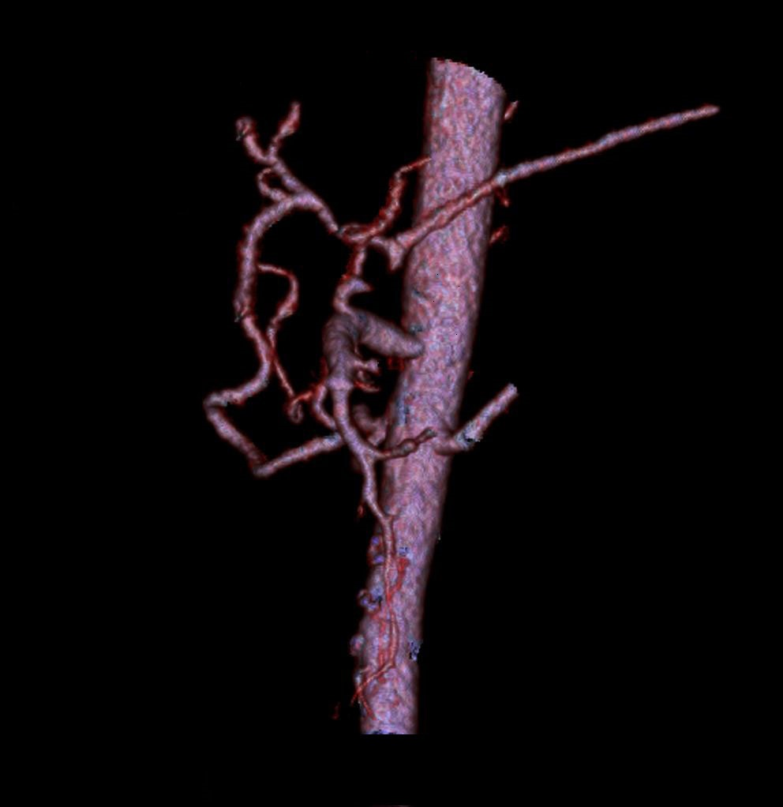

Figure 1 The initial segment of the celiac artery was occluded; collateral circulation had already been established, and compensatory dilation of the pancreaticoduodenal artery was demonstrated.
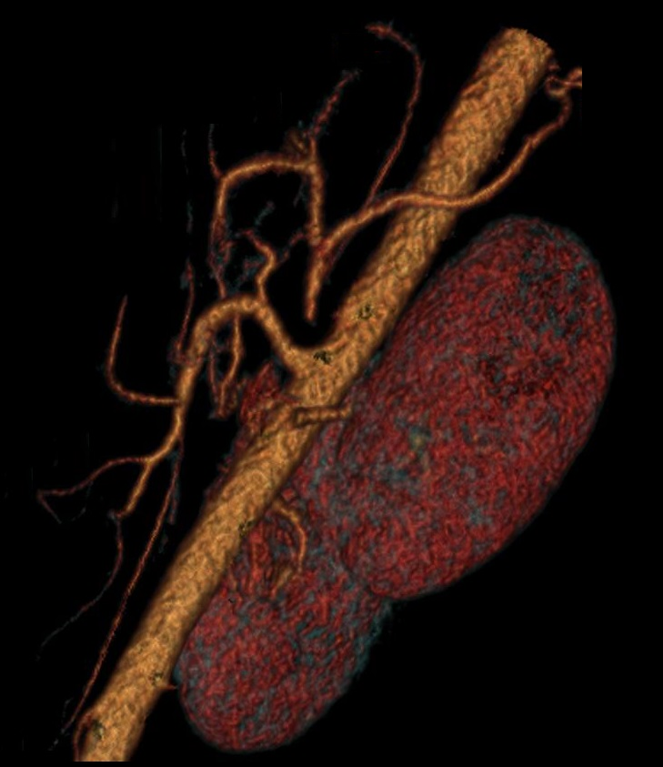
Figure 2 Abdominal computed tomography angiography indicated that the initial segment of the celiac artery was not visualized, and the length of the occlusion was approximately 1.5 cm.
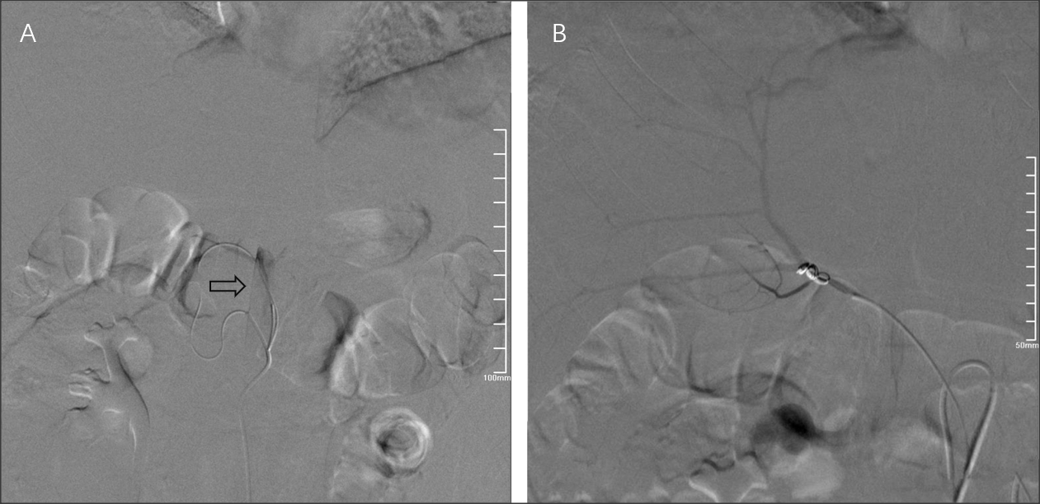

Figure 3 The images during hepatic arteriography embolization. A: The microcatheter was inserted into the abdominal aorta through the superior mesenteric artery and celiac artery (CA), and the abdominal aorta is indicated by the arrow; B: The CA was retrogradely opened with a microwire through the superior mesenteric artery, and the right hepatic artery was embolized with coils through the CA.

