Name of Journal: World Journal of Clinical Cases
Manuscript NO: 71159
Manuscript Type: CASE REPORT

Daptomycin and linezolid for severe methicillin-resistant Staphylococcus aureus psoas abscess and bacteremia: A case report and review of the literature

Hong XB et al. Psoas abscess and bacteremia

Xiao-Bing Hong, Ze-Lin Yu, Hong-Bo Fu, Ze-Hong Cai, Jie Chen

Xiao-Bing Hong, Ze-Lin Yu, Hong-Bo Fu, Department of Pharmacy, The Second Affiliated Hospital of Shantou University of Medical College, Shantou 515041, Guangdong Province, China

Ze-Hong Cai, Department of Pharmacology, Shantou University Medical College, Shantou 515041, Guangdong Province, China

Jie Chen, Department of Pharmacy, The First Affiliated Hospital, Sun Yat-Sen University, Guangzhou 510080, Guangdong Province, China

Author contributions: Hong XB and Yu ZL were responsible for the article writing and data analysis; Hong XB and Yu ZL contributed equally to this study, and considered as co-first authors; Hong XB was the chief investigator and responsible for the data analysis; Chen J, Fu HB and Cai ZH were responsible for modifying the article; and all authors contributed to the writing of the final manuscript.

Supported by Shantou Medical and Health Science and Technology Program, No. SFK [2020] 66-23.

Corresponding author: Jie Chen, MD, Associate Chief Pharmacist, Department of Pharmacy, The First Affiliated Hospital, Sun Yat-Sen University, No. 58 Second Zhongshan Road, Yuexiu District, Guangzhou 510080, Guangdong Province, China. chenjiezs@163.com

Received: August 31, 2021
Revised: November 18, 2021
Accepted: January 27, 2022
Published online: March 16, 2022

Abstract
BACKGROUND
Vancomycin remains a first-line treatment drug as per the treatment guidelines for methicillin-resistant Staphylococcus aureus (MRSA) bacteremia. However, a number of gram-positive cocci have developed resistance to several drugs, including glycopeptides. Therefore, there is an urgent need for effective and innovative antibacterial drugs to treat patients with infections caused by drug-resistant bacteria.

CASE SUMMARY
A 24-year-old male was admitted to hospital owing to lumbago, fever, and hematuria. Computed tomography (CT) results showed an abscess in the psoas major muscle of the patient. Repeated abscess drainage and blood culture suggested MRSA, and vancomycin was initiated. However, after day 10, CT scans showed abscesses in the lungs and legs of the patient. Therefore, treatment was switched to daptomycin. Linezolid was also added considering inflammation in the lungs. After 10 d of the dual-drug anti-MRSA treatment, culture of the abscess drainage turned negative for MRSA. On day 28, the patient was discharged without any complications.

CONCLUSION
This case indicates that daptomycin combined with linezolid is an effective remedy for bacteremia caused by MRSA with pulmonary complications.

Key Words: Bacteremia; Daptomycin; Gram-positive cocci; Linezolid; Methicillin-resistant Staphylococcus aureus; Vancomycin; Case report

©The Author(s) 2022. Published by Baishideng Publishing Group Inc. All rights reserved.

Citation: Hong XB, Yu ZL, Fu HB, Cai ZH, Chen J. Daptomycin and linezolid for severe methicillin-resistant Staphylococcus aureus psoas abscess and bacteremia: A case report and review of the literature. World J Clin Cases 2022; 10(8): 2550-2558
URL: https://www.wjgnet.com/2307-8960/full/v10/i8/2550.htm
DOI: https://dx.doi.org/10.12998/wjcc.v10.i8.2550

Core Tip: We analyzed a case of severe methicillin-resistant Staphylococcus aureus (MRSA) bacteremia who failed to respond to first line treatment using vancomycin. We believe that our study makes a significant contribution to the literature because it indicates that daptomycin combined with linezolid is an effective remedy for bacteremia caused by MRSA with pulmonary complications.

INTRODUCTION
Vancomycin is the first-line treatment drug as per the treatment guidelines for methicillin-resistant Staphylococcus aureus (MRSA) infections. However, daptomycin is considered to be at least as effective as vancomycin in treating MRSA bacteremia, and a high dose of daptomycin is recommended in combination with another drug (including gentamicin, rifampicin, or linezolid) as a salvage treatment plan for persistent MRSA bacteremia when vancomycin fails. In general, the basic principles of using combination therapy involve a wide antibacterial spectrum, synergistic effect, and low risk of development of drug-resistant strains^{[1]}. Daptomycin is a cyclic lipopeptide antibacterial agent produced by Streptomyces roseosporus. This agent targets the bacterial cell membrane through calcium-dependent pathways, disrupting electrical potential, altering cell membrane permeability, opening ion channels, and eventually causing cell death^{[2]}. The drug has been approved by the U.S. Food and Drug Administration for adult patients with MRSA infections, including MRSA blood flow infections, right-sided infective endocarditis, and complicated skin and soft tissue infections^{[3]}. Several studies have shown that daptomycin exhibits very good efficacy against bacteremia caused by MRSA, even when the minimum inhibitory concentration (MIC) of vancomycin is high^{[4]}. In general, the use of 6 mg/kg daptomycin is recommended each day for bacteremia caused by MRSA^{[2]}. However, several studies have shown that up to 8 mg/kg daptomycin each day is required for patients with refractory MRSA infections^{[5,6]}. In such clinical situations, the combination of daptomycin and other synergistic antibacterial agents may serve as an effective therapeutic strategy. In this report, a case of severe MRSA bacteremia observed in the clinical setting was analyzed to provide a reference for clinical treatment.

CASE PRESENTATION
Chief complaints
The patient (male, aged 24 years, height 175 cm, weight 72 kg, Han nationality, unmarried) was admitted to our hospital for bilateral lumbago without obvious inducement and fever accompanied by hematuria for 14 d. He complained of reduced urine volume and gross hematuria at the end of urination.

History of present illness
He visited another hospital, but experienced not significant pain relief, before visiting our hospital for treatment.

History of past illness
The patient did not have any past medical history.

Personal and family history
The patient did not have any personal and family history.

Physical examination
The highest body temperature was recorded to be 37.7 ℃.

Laboratory examinations
Laboratory examination results upon admission were the following: white blood cell (WBC), 42.08 × 10⁹/L; neutrophil count (NEUT %), 0.89; C-reactive protein (CRP), 271.42 mg/L; procalcitonin (PCT), 46.97 ng/mL; creatinine, 199 μmol/L; Na, 123 mmol/L; alanine aminotransferase, 63 U/L; aspartate transaminase, 96 U/L; and total bilirubin, 177.3 μmol/L. Abscess drainage culture was positive, but blood culture was negative for MRSA [Sensitive to vancomycin (MIC 0.5 μg/mL), teicoplanin, linezolid, and daptomycin; Table 1].

Imaging examinations
The chest, abdominal, and pelvic computed tomography (CT) scans revealed the following: multiple lesions in the left psoas major, iliopsoas, iliacus, and piriformis, suggesting the possibility of inflammation and abscess formation accompanied by a small amount of local pneumatosis; multiple calculi in the left kidney; a calculus in the left upper ureter; and mild dilation and effusion in the left renal pelvis, calyx, and upper ureter.

Further diagnostic work-up
He was admitted to the emergency department (observation area) of our hospital on May 27, 2020, where treatment with vancomycin (1 g every 12 h) was initiated. His condition did not significantly improve after active anti-infective treatment (vancomycin 1 g every 12 h), percutaneous catheter drainage from the psoas major and gluteus maximus, and other treatments. CT re-examination on June 2, 2020 showed that the abscess in the psoas major was similar to that reported in the previous scan (Figure 1). Bilateral pleural effusion had further progressed. Re-examination on June 3, 2020 revealed the following: WBC, 23.59 × 10⁹/L; NEUT %, 0.902; CRP, 113.2 mg/L; creatinine, 176 μmol/L; Na, 126 mmol/L; PCT, 2.57 ng/mL. The patient was transferred to the intensive care unit (ICU) on June 3, 2020.
Conditions upon transfer to the ICU on 3 June 2020 were as follows: fever, temperature of 37.9℃; shortness of breath, respiratory rate 33 bpm; stable circulation; and fast heart rate, 116 bpm. As the patient had multiple renal calculi accompanied by ureteral calculi, indwelling urinary catheter, and a complicated urinary tract infection, common pathogenic bacteria of urinary tract infections, including Enterobacteriaceae bacteria such as Escherichia coli, were assumed to be present. Thus, imipenem and cilastatin sodium (1 g every 8 h) was added to the treatment regimen to treat the urinary tract infection upon transfer to the ICU. The dose of vancomycin was maintained, and blood was drawn to measure the trough concentration.
Pathogenic metagenomics testing on June 4, 2020 revealed Streptomyces aureus presence both in the blood and the right gluteus maximus drainage fluid. Culture of the drained pus continued to show presence of MRSA [sensitive to vancomycin (MIC 1.5 μg/mL, an increase from that of earlier), teicoplanin, linezolid, and daptomycin]. The patient had persistent hyperpyrexia on June 5, 2020, with the highest temperature of 38.9 ℃ (the duration with a temperature above 38℃ was 13 h). The anterior side of the left leg was red and swollen. Flowing liquid was observed under B-ultrasonography, indicating a new abscess. CT scans of the thighs and lungs also revealed new infectious lesions (Figure 2). The decreases in inflammation indicators were not significant (CRP, 139.62 mg/L; WBC, 26.86 × 10⁹/L; NEUT %, 0.883).

FINAL DIAGNOSIS
Psoas abscess, sepsis (MRSA bacteremia), kidney calculi with ureteral calculi, skin and soft tissue infection.

TREATMENT
The trough concentration of vancomycin was 35.18 μg/mL. Although the trough concentration of vancomycin reached the target, infection control was poor. Following these results, the patient was switched from vancomycin to daptomycin (0.5 g daily). At the same time, slight high-density patchy shadows were found in the lower lobes of both lungs; thus, the spread of the infection to the lungs through blood circulation could not be ruled out. Therefore, linezolid was added to treat the possible MRSA infection in the lungs (Figure 3).

OUTCOME AND FOLLOW-UP
The patient also had a ureteral obstruction, and ultrasound-guided catheter drainage from the left renal pelvis performed on June 5, 2020. On June 6, 2020, fever persisted, but the peak temperature was lower than that observed earlier, with the highest temperature of 38.8 ℃ (the duration with a temperature above 38 ℃ was 10 h). The duration of fever was shorter and the values of infection indicators were lower (CRP, 79.86 mg/L; WBC, 19.17 × 10 9/L; NEUT %, 0.841; PCT, 0.61 ng/mL) than those earlier. On June 13, 2020, the patient had stable respiration and circulation, shorter fever duration (the duration with a temperature above 38 ℃ was 8 h), and decreased levels of infection indicators than those earlier, suggesting that the infection was controlled. Therefore, the patient was transferred back to the general ward for further treatment.
After the transfer to the general ward, the combination of daptomycin (0.5 g daily, June 5–June 23) and linezolid (0.6 g every 12 h, June 5–July 3) was continued to be administered as anti-infection treatment, while imipenem and cilastatin sodium were de-escalated to cefoperazone sodium and sulbactam sodium to combat gram-negative bacteria infection (Figure 3). On June 15, 2020, the culture of the patient drainage was tested negative and no fever was reported. On June 29, 2020, the levels of PCT, WBC, CRP, and NEUT % were 0.21 ng/mL, 10.36 × 10⁹/L, 35.56 mg/L, and 0.706, respectively, and no fever was recorded. On July 3, 2020, the patient was in stable condition without fever. Considering the left nephrostomy of the patient and the amelioration of urinary obstruction, the department of urology suggested to maintain the left nephrostomy tube unobstructed, which could be treated after the complete recovery of the patient. Therefore, the patient was discharged on July 3, 2020.

DISCUSSION
Initial treatment plan selection for the psoas abscess and analysis of the reasons for treatment failure
According to the 2014 Infectious Diseases Society of America Practice Guidelines for the Diagnosis and Management of Skin and Soft-Tissue Infections (SSTIs)^{[7]}, the infection of the patient belonged to the category of severe purulent SSTIs, which was treated by incision and drainage of a small volume of fluid. During hospitalization, multiple drainage fluid cultures and next-generation sequencing (blood and drainage fluid samples) indicated MRSA (sensitive to vancomycin MIC 0.5 μg/mL) infection, consistent with the fact that Streptomyces aureus is a common pathogen of skin and soft tissue infections. The patient was administered vancomycin (1 g every 12 h) after admission. The levels of infection indicators decreased, but high fever persisted. CT re-examination showed that the abscess was similar to that observed before. As the creatinine level was 176 μmol/L and creatinine clearance rate was 56.4 mL/min, the condition was mild renal insufficiency; hence, it was not necessary to reduce the vancomycin dose of 0.5 g every 8 h (loading dose 1 g). Although the trough concentration of vancomycin on June 5, 2020 was 35.18 μg/mL, the infection continued to spread further from the original site in the psoas major to the thighs, legs, and lungs.
There might have been two reasons for the spread of the infection. First, the MIC value of vancomycin increased; the initial MIC value was 0.5 μg/mL, which increased to 1.5 μg/mL on June 5, 2020, suggesting that the sensitivity to vancomycin decreased. For a long time, vancomycin has been used as the gold standard for the treatment of MRSA infections, but there have been clinical reports on strains with MIC values of 1–2 μg/mL where the underlying infections were associated with treatment failure^{[8]}. According to the latest guidelines on vancomycin in 2020^{[9]}, both in vitro and in vivo experiments of vancomycin have shown that the ratio of 24 h area under the concentration-time curve to MIC (AUC/MIC) can effectively predict the efficacy of vancomycin in Streptomyces aureus infection. A study^{[10]} simulated the efficacy of vancomycin in Streptomyces aureus infection under different MIC values using a single-compartment pharmacokinetic model and Monte Carlo simulation by including intensive care unit patients; this study concluded that, at an MIC of 1 μg/mL, the daily dose of vancomycin should be at least 3–4 g to achieve a 90% probability of target attainment. According to a systematic review and meta-analysis^{[11]}, a high vancomycin MIC of ≥ 1.5 μg/mL is related to mortality, and it is difficult to achieve a target AUC/MIC of ≥ 400, especially in MRSA bacteremia once the MIC rises beyond a certain value. This also explains why the clinical efficacy in this case was unsatisfactory when the trough concentration of vancomycin reached the target; it was possibly owing to the AUC/MIC failing to reach the target value with the increase in the MIC value of vancomycin. Second, the tissue penetration was poor. Vancomycin is a water-soluble drug with a small volume of distribution value of 0.4–1 L/kg, and its binding rate to plasma albumin is 10%–50%. As this patient had skin and soft tissue infection, the vancomycin concentration in the skin and soft tissues may have been insufficient.

Selection of treatment schemes for MRSA bloodstream infections after vancomycin treatment failure
Under normal circumstances, infections caused by drug-resistant gram-positive cocci can be treated with monotherapies, as drug combinations may increase the incidence of adverse drug reactions and treatment costs. Hence, it is necessary to strictly grasp the indications and avoid misuse of the drug. The best treatment strategy for severe MRSA infections has not yet been determined. The 2011 Clinical Practice Guidelines by the Infectious Diseases Society of America for the Treatment of Methicillin-resistant Staphylococcus aureus Infections in Adults and Children^{[3]} propose that MRSA bloodstream infections that cannot be effectively controlled with a single antibacterial agent should be treated with drug combinations. A high dose of daptomycin combined with other drugs (e.g., gentamicin, rifampicin, linezolid, compound sulfamethoxazole tablets, or anti-Staphylococcus β-lactam antibiotics) can be chosen for combination treatment. Another novel aminomethylcycline antibiotic Omadacycline has a potential role in the treatment of patients with acute bacterial skin and skin structure infections (ABSSSI) caused by Gram-positive (including MRSA), and as the 2 randomized, controlled studies show Omadacycline had high efficacy and acceptable safety, similar to that of linezolid, in the treatment of ABSSSI caused by gram-positive pathogens, including MRSA^{[12,13]}.
Glycopeptide monotherapies have many shortcomings, including poor tissue permeability, slow bactericidal action, and the emergence of drug-resistant strains^{[14]}. Daptomycin, which has a rapid bactericidal effect on MRSA, may be an ideal treatment option^{[5]}. However, daptomycin needs to be administered at a high dose in patients with high MIC^{[15]}, and the prognosis is poor^{[16]}. Linezolid is the first marketed synthesized oxazolidinone that can inhibit protein synthesis by affecting the 50S subunit of the bacterial ribosome^{[6]}. In addition, a number of in vitro and in vivo studies as well as case reports have shown the efficacy of daptomycin combined with linezolid. Parra-Ruiz et al^{[17]} reported that linezolid fails to achieve bactericidal activity against MRSA for planktonic bacteria (PB) or biofilm-embedded bacteria (BB) within 72 h in pharmacokinetic/pharmacodynamic biofilm models in vitro. The sustained bactericidal activity of daptomycin on PB was achieved within 48 h, whereas neither daptomycin nor linezolid exerted bactericidal effects on BB. In contrast, when linezolid was used in combination with daptomycin, the bactericidal effect was significantly increased. The combination showed bactericidal activity against PB and BB in 48 h. Therefore, the daptomycin and linezolid combination therapy is more effective than monotherapy using either of them^{[17]}. Similar results were observed using a simulated endocardial neoplasm model^{[18]}. Two recent studies have reported the same result through an in vitro combined drug sensitivity test^{[19,20]}; the synergistic effect was 66%-77% for daptomycin combined with linezolid against MRSA, with no antagonistic effect. We conducted a literature search in PubMed in an attempt to identify all published cases reporting on the efficacy of linezolid and daptomycin combination for MRSA infection. Three cases published in the literature previously were eventually summarized in Table 2. A case report on the effectiveness of this treatment scheme reported, for the first time, a case involving a 62-year-old patient with MRSA bacteremia and MRSA meningitis^{[21]}. Initially, he was administered daptomycin and linezolid because of his allergy to vancomycin. However, the persistent MRSA bacteremia led to the addition of rifampin because of its anti-MRSA activity and its ability to pass through the blood-brain barrier. Finally, his blood cultures were negative after 10 d of admission. In addition, linezolid combined with daptomycin can be used to treat endocarditis caused by MRSA^{[22]}; this was a case of a 26-year-old patient with endocarditis caused by MRSA complicated by pneumonia. The patient was initially treated with vancomycin combined with gentamicin, but vancomycin was switched to daptomycin (8 mg/kg) because of acute renal injury, and linezolid (600 mg every 12 h) was used to treat the MRSA in the lungs. Thirteen days after switching to daptomycin and linezolid, the MRSA bacteremia test results were negative. Another case very similar to the previous one involved a 36-year-old young female with infective endocarditis complicated by a septic pulmonary embolism who had a history of MRSA bacteremia infection that had occurred a year before this infection^{[23]}. The initial treatment plan for this patient was also vancomycin, but the sensitivity to vancomycin decreased on the fourth day of treatment (MIC 2 μg/mL); hence, the treatment was adjusted with linezolid (600 mg every 12 h) and daptomycin (8 mg/kg), and the blood culture result turned negative after 13 d. In this present case, vancomycin was selected as the initial treatment drug. After 9 d of vancomycin treatment, the drain culture continued to be positive, and CT re-examination revealed progression of the abscess. Therefore, the combined treatment of daptomycin and linezolid was started. The peak temperature significantly decreased after the second day, and the drain culture turned negative after 11 d without fever. One month later, the patient was stable and was discharged. These combination therapies may be considered, along with daptomycin and linezolid, following vancomycin treatment failure depending on patient-specific risk factors and hospital formulary constraints. Since combination antimicrobial regimens are not always supported by conclusive trials, further studies are needed to confirm the efficacy of specific combination strategies. These combination therapies may be considered, along with daptomycin and linezolid, following vancomycin treatment failure depending on patient-specific risk factors. Further studies are needed to fully understand the mechanisms of the possible synergistic effects between daptomycin and linezolid.

CONCLUSION
In conclusion, we report a case of an abscess in the major psoas muscle complicated with pulmonary infection caused by MRSA that was successfully treated with a combination of daptomycin and linezolid. Our experience shows that the combination therapy of daptomycin and linezolid, instead of vancomycin, is an effective alternative therapy for refractory MRSA bacteremia.

REFERENCES
1 García AB, Candel FJ, López L, Chiarella F, Viñuela-Prieto JM. In vitro ceftaroline combinations against meticillin-resistant Staphylococcus aureus. J Med Microbiol 2016; 65: 1119-1122 [PMID: 27553740 DOI: 10.1099/jmm.0.000341]
2 Bayer AS, Schneider T, Sahl HG. Mechanisms of daptomycin resistance in Staphylococcus aureus: role of the cell membrane and cell wall. Ann N Y Acad Sci 2013; 1277: 139-158 [PMID: 23215859 DOI: 10.1111/j.1749-6632.2012.06819.x]
3 Liu C, Bayer A, Cosgrove SE, Daum RS, Fridkin SK, Gorwitz RJ, Kaplan SL, Karchmer AW, Levine DP, Murray BE, J Rybak M, Talan DA, Chambers HF; Infectious Diseases Society of America. Clinical practice guidelines by the infectious diseases society of america for the treatment of methicillin-resistant Staphylococcus aureus infections in adults and children. Clin Infect Dis 2011; 52: e18-e55 [PMID: 21208910 DOI: 10.1093/cid/ciq146]
4 Moore CL, Osaki-Kiyan P, Haque NZ, Perri MB, Donabedian S, Zervos MJ. Daptomycin versus vancomycin for bloodstream infections due to methicillin-resistant Staphylococcus aureus with a high vancomycin minimum inhibitory concentration: a case-control study. Clin Infect Dis 2012; 54: 51-58 [PMID: 22109947 DOI: 10.1093/cid/cir764]
5 Gonzalez-Ruiz A, Seaton RA, Hamed K. Daptomycin: an evidence-based review of its role in the treatment of Gram-positive infections. Infect Drug Resist 2016; 9: 47-58 [PMID: 27143941 DOI: 10.2147/IDR.S99046]
6 MacGowan AP. Pharmacokinetic and pharmacodynamic profile of linezolid in healthy volunteers and patients with Gram-positive infections. J Antimicrob Chemother 2003; 51 Suppl 2: ii17-ii25 [PMID: 12730139 DOI: 10.1093/jac/dkg248]
7 Kwak YG, Choi SH, Kim T, Park SY, Seo SH, Kim MB, Choi SH. Clinical Guidelines for the Antibiotic Treatment for Community-Acquired Skin and Soft Tissue Infection. Infect Chemother 2017; 49: 301-325 [PMID: 29299899 DOI: 10.3947/ic.2017.49.4.301]
8 Soriano A, Marco F, Martínez JA, Pisos E, Almela M, Dimova VP, Alamo D, Ortega M, Lopez J, Mensa J. Influence of vancomycin minimum inhibitory concentration on the treatment of methicillin-resistant Staphylococcus aureus bacteremia. Clin Infect Dis 2008; 46: 193-200 [PMID: 18171250 DOI: 10.1086/524667]
9 Rybak MJ, Le J, Lodise TP, Levine DP, Bradley JS, Liu C, Mueller BA, Pai MP, Wong-Beringer A, Rotschafer JC, Rodvold KA, Maples HD, Lomaestro BM. Therapeutic monitoring of vancomycin for serious methicillin-resistant Staphylococcus aureus infections: A revised consensus guideline and review by the American Society of Health-System Pharmacists, the Infectious Diseases Society of America, the Pediatric Infectious Diseases Society, and the Society of Infectious Diseases Pharmacists. Am J Health Syst Pharm 2020; 77: 835-864 [PMID: 32191793 DOI: 10.1093/ajhp/zxaa036]
10 del Mar Fernández de Gatta Garcia M, Revilla N, Calvo MV, Domínguez-Gil A, Sánchez Navarro A. Pharmacokinetic/pharmacodynamic analysis of vancomycin in ICU patients. Intensive Care Med 2007; 33: 279-285 [PMID: 17165021 DOI: 10.1007/s00134-006-0470-5]
11 van Hal SJ, Lodise TP, Paterson DL. The clinical significance of vancomycin minimum inhibitory concentration in Staphylococcus aureus infections: a systematic review and meta-analysis. Clin Infect Dis 2012; 54: 755-771 [PMID: 22302374 DOI: 10.1093/cid/cir935]
12 Zhanel GG, Esquivel J, Zelenitsky S, Lawrence CK, Adam HJ, Golden A, Hink R, Berry L, Schweizer F, Zhanel MA, Bay D, Lagacé-Wiens PRS, Walkty AJ, Lynch JP 3rd, Karlowsky JA. Omadacycline: A Novel Oral and Intravenous Aminomethylcycline Antibiotic Agent. Drugs 2020; 80: 285-313 [PMID: 31970713 DOI: 10.1007/s40265-020-01257-4]
13 Abrahamian FM, Sakoulas G, Tzanis E, Manley A, Steenbergen J, Das AF, Eckburg PB, McGovern PC. Omadacycline for Acute Bacterial Skin and Skin Structure Infections. Clin Infect Dis 2019; 69: S23-S32 [PMID: 31367742 DOI: 10.1093/cid/ciz396]
14 Davis JS, Van Hal S, Tong SY. Combination antibiotic treatment of serious methicillin-resistant Staphylococcus aureus infections. Semin Respir Crit Care Med 2015; 36: 3-16 [PMID: 25643267 DOI: 10.1055/s-0034-1396906]
15 Soon RL, Turner SJ, Forrest A, Tsuji BT, Brown J. Pharmacokinetic/pharmacodynamic evaluation of the efficacy and safety of daptomycin against Staphylococcus aureus. Int J Antimicrob Agents 2013; 42: 53-58 [PMID: 23684388 DOI: 10.1016/j.ijantimicag.2013.02.009]
16 Ruiz J, Ramirez P, Concha P, Salavert-Lletí M, Villarreal E, Gordon M, Frasquet J, Castellanos-Ortega Á. Vancomycin and daptomycin minimum inhibitory concentrations as a predictor of outcome of methicillin-resistant Staphylococcus aureus bacteraemia. J Glob Antimicrob Resist 2018; 14: 141-144 [PMID: 29601996 DOI: 10.1016/j.jgar.2018.03.007]
17 Parra-Ruiz J, Bravo-Molina A, Peña-Monje A, Hernández-Quero J. Activity of linezolid and high-dose daptomycin, alone or in combination, in an in vitro model of Staphylococcus aureus biofilm. J Antimicrob Chemother 2012; 67: 2682-2685 [PMID: 22796888 DOI: 10.1093/jac/dks272]
18 Steed ME, Vidaillac C, Rybak MJ. Novel daptomycin combinations against daptomycin-nonsusceptible methicillin-resistant Staphylococcus aureus in an in vitro model of simulated endocardial vegetations. Antimicrob Agents Chemother 2010; 54: 5187-5192 [PMID: 20921318 DOI: 10.1128/AAC.00536-10]
19 Lee YC, Chen PY, Wang JT, Chang SC. A study on combination of daptomycin with selected antimicrobial agents: in vitro synergistic effect of MIC value of 1 mg/L against MRSA strains. BMC Pharmacol Toxicol 2019; 20: 25 [PMID: 31060599 DOI: 10.1186/s40360-019-0305-y]
20 Aktas G, Derbentli S. In vitro activity of daptomycin combined with dalbavancin and linezolid, and dalbavancin with linezolid against MRSA strains. J Antimicrob Chemother 2017; 72: 441-443 [PMID: 28073963 DOI: 10.1093/jac/dkw416]
21 Kelesidis T, Humphries R, Ward K, Lewinski MA, Yang OO. Combination therapy with daptomycin, linezolid, and rifampin as treatment option for MRSA meningitis and bacteremia. Diagn Microbiol Infect Dis 2011; 71: 286-290 [PMID: 21855248 DOI: 10.1016/j.diagmicrobio.2011.07.001]
22 Yazaki M, Oami T, Nakanishi K, Hase R, Watanabe H. A successful salvage therapy with daptomycin and linezolid for right-sided infective endocarditis and septic pulmonary embolism caused by methicillin-resistant Staphylococcus aureus. J Infect Chemother 2018; 24: 845-848 [PMID: 29534850 DOI: 10.1016/j.jiac.2018.02.006]
23 Galanter KM, Ho J. Treatment of tricuspid valve endocarditis with daptomycin and linezolid therapy. Am J Health Syst Pharm 2019; 76: 1033-1036 [PMID: 31201773 DOI: 10.1093/ajhp/zxz101]

Footnotes
Informed consent statement: We obtained written informed consent from the patient, according to the rules of the Clinical Research Ethics Committee of the First Affiliated Hospital of Sun Yat-Sen University.

Conflict-of-interest statement: The authors declare that they have no competing interests.

CARE Checklist (2016) statement: The authors have read the CARE Checklist (2016), and the manuscript was prepared and revised according to the CARE Checklist (2016).

Open-Access: This article is an open-access article that was selected by an in-house editor and fully peer-reviewed by external reviewers. It is distributed in accordance with the Creative Commons Attribution NonCommercial (CC BY-NC 4.0) license, which permits others to distribute, remix, adapt, build upon this work non-commercially, and license their derivative works on different terms, provided the original work is properly cited and the use is non-commercial. See: https://creativecommons.org/Licenses/by-nc/4.0/

Provenance and peer review: Unsolicited article; Externally peer reviewed.
Peer-review model: Single blind

Peer-review started: August 31, 2021
First decision: November 17, 2021
Article in press: January 27, 2022

Specialty type: Infectious Diseases
Country/Territory of origin: China
Peer-review report’s scientific quality classification
Grade A (Excellent): 0
Grade B (Very good): B
Grade C (Good): C
Grade D (Fair): 0
Grade E (Poor): 0

P-Reviewer: Apiratwarakul K, Surani S S-Editor: Wang JL L-Editor: A P-Editor: Wang JL

Figure Legends

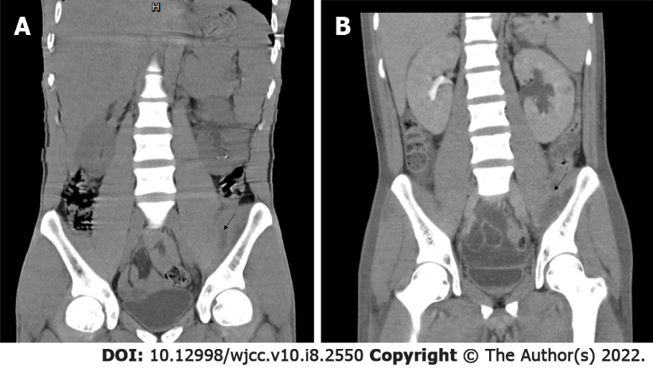
Figure 1 Chest, abdominal, and pelvic computed tomography scans. A: May 27, 2020 computed tomography (CT) scan; B: June 2, 2020 CT scan.

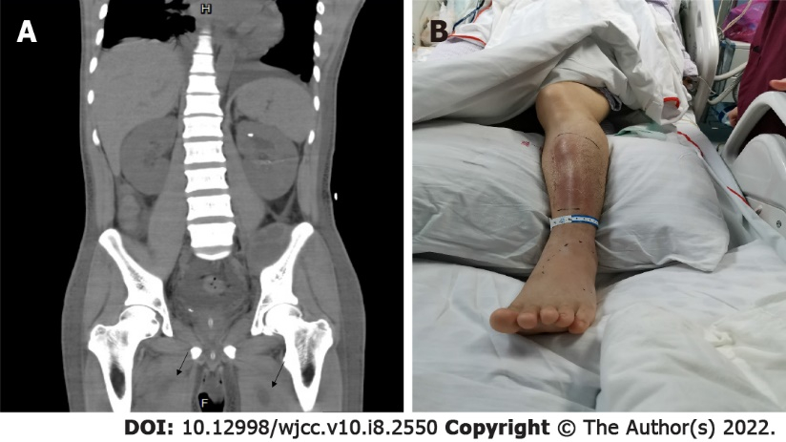
Figure 2 Computed tomography scan and anterior side of the left leg. A: June 10, 2020 chest, abdominal, and pelvic computed tomography scan; B: June 10, 2020 anterior side of the left leg.

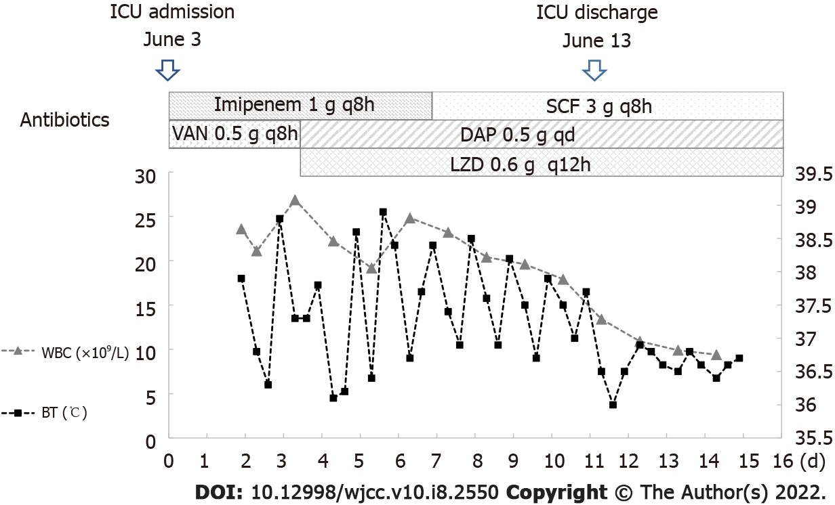
Figure 3 Clinical course during the intensive care unit stay. Although vancomycin (VAN) had been administered for the control of methicillin-resistant Staphylococcus aureus blood flow infection, the poor efficacy of the drug led us to switch treatment from VAN to daptomycin combined with linezolid on the 4th day. Imipenem 1 g q8h, June 3–June 8; cefoperazone sulbactam 3 g q8h, June 9-June 16; daptomycin 0.5 g daily, June 5–June 23; and linezolid 0.6 g every 12 h, June 5-July 3. SCF: Cefoperazone sulbactam; VAN: Vancomycin; DAP: Daptomycin; LZD: Linezolid; WBC: White blood cell; BT: Body temperature.

Table 1 Antimicrobial-susceptibility of the isolated strain on May 30th and June 7th
Antibiotics | MIC (mg/mL) |  | MIC categories
 | Pre-test | Post-test | Pre-test | Post-test
Penicillin G | ≥ 0.5 | ≥ 0.5 | R | R
Oxacillin | ≥ 4 | ≥ 4 | R | R
Gentamicin | ≤ 0.5 | ≤ 0.5 | S | S
Levofloxacin | 0.5 | 0.5 | S | S
Erythromycin | ≥ 8 | ≥ 8 | R | R
Clindamycin | ≥ 4 | ≥ 4 | R | R
Linezolid | 2 | 2 | S | S
Teicoplanin | ≤ 0.5 | ≤ 0.5 | S | S
Vancomycin | ≤ 0.5 | 1 | S | S
Tigecycline | ≤ 0.12 | ≤ 0.12 | S | S
Main treatment course and monitoring. MIC: Minimal inhibitory concentration; R: Resistance; S: Susceptible.

Table 2 Clinical factors, treatment details, and outcomes among 3 patients treated with Daptomycin and linezolid for methicillin-resistant Staphylococcus aureus bacteremia and complication.
Patients | Ref. | Reason for Daptomycin/linezolid use | Host factors | Complication | Prior antimicrobial  therapy | Other active antimicrobials available | Daptomycin/linezolid dose; duration | MIC (mg/mL) | Outcome, follow-up duration
1 | Kelesidis et al^{[21]}, 2011 | Allergy | 62 y/o with placement of the coatrial and  lumboperitoneal shunts | Meningitis | Daptomycin | Vancomycin | Daptomycin (NS); linezolid (600 mg twice daily); 4 d | Daptomycin (≤ 0.5 μg /mL), vancomycin (1 μg /mL), linezolid (4 μg/mL), rifampin (0.06 μg/mL) | Clinical cure, NS
2 | Yazaki et al^{[22]}, 2018 | Allergy, acute kidney injury | 26 y/o woman with surgical closure of ventricular septal defect | Septic pulmonary embolism | Levofloxacin, meropenem, azithromycin, vancomycin, rifampicin, gentamicin | None | Daptomycin (8 mg/kg q48h), linezolid (600 mg q12h); 6 wk | Vancomycin (1 μg/mL), Linezolid (2 μg/mL), Daptomycin (1 μg/mL) | Clinical cure, 2 mo
3 | Galanter et al^{[23]}, 2019 | Vancomycin resistance, worsening of septic emboli in  both lungs, blood cultures remained positive for MRSA | 26 y/o woman with native tricuspid value endocarditis | Suspected septic embolism | Vancomycin, daptomycin, gentamicin | None | Daptomycin (8 mg/kg iv daily), linezolid (600 mg iv twice daily), 15 d | Daptomycin 1 μg/mL; daptomycin MIC 4 μg/mL (on the 15th day) | Clinical cure, 6 wk
y/o: Year old; NS: Not specified; MRSA: Methicillin-resistant Staphylococcus aureus; MIC: Minimum inhibitory concentration.

Published by Baishideng Publishing Group Inc
7041 Koll Center Parkway, Suite 160, Pleasanton, CA 94566, USA
Telephone: +1-925-3991568
E-mail: bpgoffice@wjgnet.com
Help Desk: https://www.f6publishing.com/helpdesk
https://www.wjgnet.com

© 2022 Baishideng Publishing Group Inc. All rights reserved.

