Name of journal: World Journal of Gastroenterology
Manuscript NO: 47271
Manuscript type: META-ANALYSIS

Immunotherapy with dendritic cells and cytokine-induced killer cells for hepatocellular carcinoma: A meta-analysis

Cao J et al. Immunotherapy for hepatocellular carcinoma

Jing Cao, Fan-Hua Kong, Xi Liu, Xiao-Bo Wang

Jing Cao, Xiao-Bo Wang, Department of Surgery, Technical University of Munich, Munich 80333, Germany

Fan-Hua Kong, Xi Liu, Department of General Surgery, The Second Xiangya Hospital, Central South University, Changsha 410011, Hunan Province, China

ORCID number: Jing Cao (0000-0001-9302-4850); Fan-Hua Kong (0000-0003-3126-2508); Xi Liu (0000-0001-7349-8792); Xiao-Bo Wang (0000-0002-3603-3707).

Author contributions: Cao J performed research; Cao J, Kong FH and Liu X analyzed data; Cao J drafted the paper; Wang XB designed research and revised the article.

Conflict-of-interest statement: The authors declare that they have no conflict of interest.

Data sharing statement: No additional data are available.

PRISMA 2009 Checklist statement: The manuscript was prepared and revised according to the PRISMA 2009 Checklist.

Open-Access: This is an open-access article that was selected by an in-house editor and fully peer-reviewed by external reviewers. It is distributed in accordance with the Creative Commons Attribution Non Commercial (CC BY-NC 4.0) license, which permits others to distribute, remix, adapt, build upon this work non-commercially, and license their derivative works on different terms, provided the original work is properly cited and the use is non-commercial. See: http://creativecommons.org/licenses/by-nc/4.0/

Manuscript source: Invited manuscript

Corresponding author: Xiao-Bo Wang, MD, Surgeon, Department of Surgery, Technical University of Munich, Arcisstrasse 21, Munich 80333, Germany. xiaobo.wang@tum.de
Telephone: +49-152-37359648

Received: March 18, 2019
Peer-review started: March 18, 2019
First decision: April 11, 2019
Revised: April 18, 2019
Accepted: June 7, 2019
Article in press:
Published online:

Abstract

BACKGROUND
Hepatocellular carcinoma (HCC) has been revealed as the second common cause of cancer-related death worldwide. The introduction of cell-based immunotherapy, including dendritic cells (DCs), cytokine-induced killer cells (CIKs), has brought HCC patients with effective benefit. However, the efficacy and necessity of cellular immunotherapy after different interventional therapy remain to be further explored.

AIM
To investigate the efficacy of cellular immunotherapy, involving DCs and CIK, combined with different conventional treatment of HCC.

METHODS
We performed a literature search on PubMed and Web of Science up to February 15, 2019. Long-term efficacy [overall survival (OS) and recurrence] and short-term adverse effects were investigated to assess the effectiveness of immunotherapy with DCs and/or CIKs. Review Manager 5.3 was used to perform the analysis.

RESULTS
A total of 22 studies involving 3756 patients selected by eligibility inclusion criteria and forwarded for meta-analysis. Combined with the conventional clinical treatment, immunotherapy with DCs and/or CIKs was demonstrated to significantly improved OS at 6 months [risk ratio (RR) = 1.07; 95% confidence interval (CI): 1.01-1.13, P = 0.02], 1 year (RR = 1.12; 95%CI: 1.07-1.17, P < 0.00001), 3 years (RR = 1.23; 95%CI: 1.15-1.31, P < 0.00001) and 5 years (RR = 1.26; 95%CI: 1.15-1.37, P < 0.00001). Recurrence rate was significantly reduced by cellular immunotherapy at 6 months (RR = 0.50; 95%CI: 0.36-0.69, P < 0.0001) and 1 year (RR = 0.82; 95%CI: 0.75-0.89, P < 0.00001). Adverse effect assessment addressed that immunotherapy with DCs and/or CIKs was accepted as a safe, feasible treatment.

CONCLUSION
Combination immunotherapy with DCs, CIKs and DC/CIK with various routine treatments for HCC was evidently suggested to improve patients’ prognosis by increasing OS and reducing cancer recurrence.

Key words: Hepatocellular carcinoma; Immunotherapy; Dendritic cells; Cytokine-induced killer cells

© The Author(s) 2019. Published by Baishideng Publishing Group Inc. All rights reserved.

Core tip: Liver cancer, approximately 75% of which is ascribed to hepatocellular carcinoma, has been revealed as the second common cause of cancer-related death worldwide. Though several analyses have supported the effective benefit of cellular immunotherapy when combined with specific hepatocellular carcinoma (HCC) treatment, the efficacy and necessity of cellular immunotherapy after different interventional therapy remains to be interrogated. Our study suggested that the combination of immunotherapy with dendritic cells (DCs), cytokine-induced killer cells (CIKs) and DC-CIK with various routine HCC treatments could evidently improve patients’ prognosis by increasing the overall survival and reduce the recurrence of the malignancy.

Cao J, Kong FH, Liu X, Wang XB. Immunotherapy with dendritic cells and cytokine-induced killer cells for hepatocellular carcinoma: A meta-analysis. World J Gastroenterol 2019; In press

INTRODUCTION
Liver cancer, approximately 75% of which is ascribed to hepatocellular carcinoma (HCC), has been revealed as the second most common cause of cancer-related death worldwide, with around 745000 deaths annually^{[1]}. Both the incidence and mortality are rising worldwide. Cirrhosis, hepatitis B virus (HBV) and hepatitis C virus (HCV) are commonly regarded as the main risk factors for HCC.
Curative treatment is achieved by surgical resection, orthotopic liver transplantation, transarterial chemoembolization (TACE) and local percutaneous tumor ablation. However, these curative approaches are only accessible to limited numbers of patients, as most are diagnosed at advanced stages with unresectable tumors. Although much progress has been made with promising phase II trial results, drug development has been disappointing with many failures in phase III trials^{[2]}; hence, few drugs have been approved so far by the United States Food and Drug Administration (FDA). A multitarget tyrosine kinase inhibitor, sorafenib, the only approved systemic therapy, achieves an increased survival of only up to 3 mo^{[3,4]}.
Immunotherapy was introduced into field, as the ability to escape from immunological surveillance forms the basis for tumor progression. The underlying mechanism comprises defective antigen presentation, dysfunction of effector T cells, cytokine disarray, and alterations in immune checkpoints^{[5]}. While conventional chemotherapy exerts its effect by directly reducing tumor volume morphologically, immunotherapy works in an indirect way and takes longer to induce an effective immune response, but it provides a more durable antitumor effect. Immune-based approaches include cytokines, vaccines, adoptive cell therapy [based on peripheral blood mononuclear cells (PBMCs) or dendritic cells (DCs)]^{[6-8]}, tumor-antibody-based immunotherapy^{[9]}, and immune checkpoint inhibitors. Recombinant interferon-α was the first immunotherapeutic agent introduced into the field, although, even with its features of immunostimulation and antiangiogenesis, it failed to show a significant effect in clinical trials of patients with HCC^{[10,11]}.
Vaccine strategies are carried out on different anti-cancer platforms, including RNA-, peptide-, protein-based vaccines, whole-tumor-cell vaccine, and most widely, DCs-based vaccine. DC-based vaccines are adapted more for solid malignancies, including melanoma, renal cancer, prostate cancer, as well as HCC^{[12,13]}. As mature DCs prime T cells and boost memory T cells, induction of DC maturation by Toll-like receptor ligand or cytokines is often applied clinically. Cross-presentation, the process of DCs presenting captured antigen to CD8⁺ cells via major histocompatibility complex class I, is regarded as a critical step in the efficient induction of antitumor cytotoxic response^{[12]}. An important subtype of DCs was identified in 2010 on account of its high capability in cross-presentation with high expression of CD141 and Toll-like receptor 3. These CD141⁺ DCs yield high amount of type I interferon under stimulation with polyinsionic-polycytidylic acid (poly IC), which leads to a vigorous T helper 1 cell response; hence the effective anticancer response^{[14]}. Therefore, poly IC and its derivatives are adopted as adjuvants for DC-based vaccines.
Adoptive cell therapy is commonly performed with cytokine-induced killer cells (CIKs), tumor-infiltrating lymphocytes and genetically modified T cells. Among these, CIKs have been used in more clinical trials. CIKs, consisting of NKG2D^{high} T cells, activated natural killer (NK) cells and NK T cells^{[15]}, are generated ex vivo from PBMCs and stimulated with cytokines and antibodies targeting CD3. CIKs harbor high capacity of proliferation and have a cytolytic effect against cancer cells. Although several analyses have supported the beneficial effect of cellular immunotherapy when combined with specific HCC treatment^{[16,17]}, the efficacy and necessity of cellular immunotherapy after different interventional therapy remains to be interrogated. In this study, a systematic review and meta-analysis was performed to investigate the efficacy of cellular immunotherapy, involving DCs, CIKs and DC/CIK combination therapy, combined with different treatments of HCC.

MATERIALS AND METHODS

Systematic literature search
We conducted a widespread literature search on PubMed and Web of Science Core Collection. Articles up to February 15, 2019 were filtered out by key words including hepatocellular OR liver AND cancer OR tumor OR tumour OR carcinoma OR neoplasm AND immunotherapy OR immune checkpoint OR immunotherapeutic. Study selection was conducted by two independent investigators. Discrepancies were resolved by discussion and consensus. Full text was retrieved for further decision if the abstract was insufficient to support the inclusion criteria. Three reviewers independently evaluated studies for eligibility.

Inclusion and exclusion criteria
Randomized controlled trials (RCTs) and controlled trials were taken into consideration, but trials with only safety data, animal studies and in vitro studies were excluded. Studies that met the following criteria were included: (1) clinical trials on immunotherapy for HCC patients, with full text and available data in English; and (2) clinical trials providing survival data (disease-free survival, progression-free survival, and overall survival) and adverse effects.

Data extraction and quality assessment
The following information was extracted for each article: last name of first author, year of publication, phase of clinical trial, number of enrolled subjects, treatment arms, number of patients in control and conventional groups, overall survival, recurrence rate and adverse effects. The quality assessment was performed with Cochrane Collaboration’s tool for RCT trails and MINORS^{[18]} for non-RCT cohort studies.

Statistical analysis
We conducted all the analysis with Review Manager 5.3 (Cochrane Collaboration). Risk ratio (RR) was calculated to assess the effect of interventions. Results were presented with 95% confidence interval (CI). We performed Cochrane’s Q statistic (χ²) to assess the heterogeneity of the trials and the I² statistic for inconsistency. P < 0.05 or I² > 50% was considered as an invalid assumption of homogeneity. A random-effects model was applied for clinical trials of significant heterogeneity, otherwise a fixed-effects model was applied instead. Assessment of potential publication bias was evaluated by funnel plot, where two-tailed P < 0.05 was considered statistically significant.

RESULTS

Description of included trials
A total of 2643 citations were identified from the primary literature search. Among them, 2621 studies were excluded for the following reasons: overlapping studies, reviews, no access to full-text in English, letters, and individual case studies. According to the inclusion criteria, 22 studies^{[19-40]} including 3756 patients were adopted in the meta-analysis (Figure 1). Five of the included studies involving 390 patients were aligned for analyzing the effect of mono-immunotherapy with DC-based vaccines. A total of 3211 patients involved in 13 trials were assigned for comparative analysis of mono-immunotherapy with CIKs. The other four trials with 155 patients focused on the effect of combined approach with DC vaccines and CIKs (Table 1). Most of those trials evaluated the effect of immunotherapy based on interventions for primary tumor ablation by surgical resection, radiofrequency ablation and cryoablation. Five studies^{[19,20,24,26,27]} were conducted with patients receiving TACE treatment. A few studies assigned patients with chemotherapy^{[32]} or only supportive treatment^{[21]} as the control group.

Efficacy and prognosis assessment
Compared with the patients in the control group, regardless of original treatment arm, patients receiving monotherapy with DC-based vaccine had a higher 1-year OS (RR = 1.16; 95%CI: 1.03-1.30, P = 0.01), although there was no significant improvement in OS at 6 months or 3 years. Monotherapy with CIKs demonstrated significant improvement in OS at 6 months (RR = 1.09; 95%CI: 1.03-1.16, P = 0.005), 1 year (RR = 1.11; 95%CI: 1.06-1.16, P < 0.00001), 3 years (RR = 1.23; 95%CI: 1.15-1.31, P < 0.00001) and 5 years (RR = 1.25; 95%CI: 1.14-1.36, P < 0.00001). Unsurprisingly, combined therapy with DCs and CIKs also improved OS at 1 year (RR = 3.8; 95%CI: 1.29-11.22, P = 0.02) and 5 years (RR = 1.45; 95%CI: 0.99-2.12, P = 0.05). Taken together, immunotherapy based on DCs and/or CIKs significantly increased OS at 6 months (RR = 1.07; 95%CI: 1.01-1.13, P = 0.02), 1 year (RR = 1.12; 95%CI: 1.07-1.17, P < 0.00001), 3 years (RR = 1.23; 95%CI: 1.15-1.31, P < 0.00001) and 5 years (RR = 1.26; 95%CI: 1.15-1.37, P < 0.00001) (Figure 2).
Besides the improved OS of patients, reduced tumor recurrence rate was achieved in most trials. DC-based vaccination alone addressed a declining shift in 1-year recurrence (RR = 0.64; 95%CI: 0.44-1.93, P = 0.02). Immunotherapy with CIKs showed similar effects on recurrence at 6 months (RR = 0.45; 95%CI: 0.30-0.66, P < 0.0001), 1 year (RR = 0.83; 95%CI: 0.76-0.91, P < 0.0001) and 1.5 years (RR = 0.39; 95%CI: 0.18-0.85, P = 0.02). The data on recurrence with DC/CIK combined therapy were unfortunately not available. The retardation effect of recurrence was observed at 6 months (RR = 0.50; 95%CI: 0.36-0.69, P < 0.0001) and 1 year (RR = 0.82; 95%CI: 0.75-0.89, P < 0.00001) (Figure 3).

Adverse effect analysis
None of the studies reported immunotherapy-related hospital mortality. Only 23 patients in four studies^{[23,29,32,36]} were reported with grade III or IV adverse events. Fever was addressed as the most common event after immunotherapy. Other adverse effects included shivering, vomiting, fatigue, abdominal pain and leukopenia. The overall adverse event rate was higher in immunotherapy groups, but symptomatic remissions were declared within 24 h. In brief, immunotherapy was accepted as a safe, feasible treatment, though with an increased incidence of adverse events.

Quality assessment of trials
Seven studies included in this systematic review were RCTs, including two with DC-based vaccine, three with mono-immunotherapy with CIKs and two with combination immunotherapies. Cochrane Collaboration’s tool was used to assess the quality of the RCTs. All these RCTs were verified with high quality (Table 2), and 15 non-RCTs were validated as high quality by MINORS (Table 3).

Publication bias
Funnel plots and Egger’s regression test were applied to OS and recurrence rate in order to guarantee the potency of this meta-analysis (Figure 4). Symmetrical distribution of individual studies indicated no evident publication bias.

DISCUSSION
Although surgical resection, transplantation, local tumor ablation and TACE are well accepted with proven survival benefit^{[41]}, these clinical treatments of HCC have their limited scope of application according to the tumor progression of individual patients. Besides, tumor recurrence can occur within 5 years even with curative interventions^{[42]}. Unlike some other solid tumors, no effective neoadjuvant or adjuvant therapy has been validated to reduce the recurrence risk so far^{[41]}. The introduction of immunotherapy, however, brought new hope in this regard. In this meta-analysis, we found that immunotherapy could increase OS and decrease recurrence rate in HCC.
We analyzed comprehensively 22 individual studies with 3756 HCC patients in this meta-analysis and illustrated a positive prognostic efficacy of immunotherapy with DC-based vaccine and/or CIK-based adoptive therapy. Our results demonstrated that an extended OS (6 mo, and 1, 3 and 5 years) was achieved with the aforesaid immunotherapy based on different HCC interventional therapies. Similar benefits in OS were described in another meta-analysis of adjuvant adoptive immunotherapy, including CIKs, lymphokine-activated killer cells and lymphocytes in HCC patients after surgery. In that study, a significant reduction in mortality and recurrence was observed at 1, 2 and 3 years but not 5 years^{[43]}. However, compared to the slight increase in OS in our study, another systematic review demonstrated a more dramatic shift on OS in TACE-treated HCC patients^{[16]}. The smaller increase in OS in our analysis could have been ascribed to the heterogeneity of the patients included in the controlled trials. Yet, a significant benefit in OS was confirmed regardless of subgroup composition, and more intriguingly, our analysis indicated that short-term recurrence was intensely reduced with immunotherapy independent of the heterogeneity. The clinical benefit of the combined immunotherapy with DCs and CIKs has been demonstrated in many clinical studies^{[17,44]}. This combined approach was reported to have greater antitumor activity in vitro than CIK treatment alone^{[45]}, while our analysis failed to find sufficient clinical data to support it.
One RCT^{[22]} and one non-RCT cohort study^{[32]} included in this meta-analysis were based on conventional chemotherapy as the control group. Cellular immunotherapy also resulted in improved outcomes, implying a critical role for immunotherapy in patients who have lost their chance for tumor ablation. The combination of chemotherapy and immunotherapy has accumulated positive efficacy in a number of unresectable malignancies^{[46-48]}.
A bias could have been raised due to the low number of available trials and the low number of included patients in the DC-based vaccine group and DC/CIK combination group, which comprised five trials with 390 patients and four trials with 155 patients, respectively. The quality of this meta-analysis was still assured as we have shown no evidence of publication bias.
There were a few limitations to this systematic review and meta-analysis. First, although we included 22 trials in the analysis, the DC and DC/CIK groups comprised only five and four trials, respectively. Most of the trials were conducted in East Asian countries (China, Japan and South Korea); hence, they had less-sufficient statistical power due to the lack of multinational or multiracial clinical data. Second, heterogeneity was observed between the included studies. Factors, including stage of malignancy, different surgical method, number of immunotherapy fusion cycles, and duration of immunotherapy in different clinical centers could have contributed to the heterogeneity.
Recently, the introduction of immune checkpoint inhibitors has led to a clinical breakthrough in cancer treatment^{[49]}. Six immune checkpoint inhibitors for HCC treatment have been approved by the FDA and even one (nivolumab) has been introduced as a second-line treatment^{[50,51]}, due to its promising effect of immune checkpoints inhibitors in HCC patients. Although some clinical data have presented a good safety profile, disease control and time to progression^{[50-52]}, clinical data concerning comparative trials with immune checkpoints in HCC patients are still insufficient for analysis.
In conclusion, we demonstrated that the application of immunotherapy with DCs, CIKs and DCs/CIK in addition to various routine HCC treatments could evidently improve patients’ prognosis by increasing OS and reducing recurrence. The efficacy of novel immune checkpoint inhibitors based on clinical trials should be assessed in further studies when sufficient data are available. Due to the diverse mechanism behind the immune evasion of tumor cells, approaches combining different immunotherapies might lead to an appealing strategy to treat HCC.

Article Highlights
Research background
Hepatocellular carcinoma (HCC) has been revealed as the second common cause of cancer-related death worldwide. The introduction of cell-based immunotherapy, including dendritic cells (DCs), cytokine-induced killer cells (CIKs), has brought HCC patients with effective benefit. However, the efficacy and necessity of cellular immunotherapy after different interventional therapy remain to be further explored.

Research motivation
Only patients with early to intermediate stage of HCC could benefit from curable interventions, while tumor recurrence occurred within 5 years even with curable treatment. As the introduction of immunotherapy has brought beneficial effects to HCC treatment, better strategies with combined interventions would help to improve the outcomes of HCC patients.

Research objectives
A systematic review and meta-analysis were performed in this study to investigate the efficacy of cellular immunotherapy, involving DCs, CIKs and DC/CIK combination therapy, combined with different treatments of HCC.

Research methods
A literature search was performed on PubMed and Web of Science up to February 15, 2019. Long-term efficacy [overall survival (OS) and recurrence] and short-term adverse effects were investigated to assess the effectiveness of immunotherapy with DCs and/or CIKs. Review Manager 5.3 was used to perform the analysis.

Research results
A total of 22 studies involving 3756 patients selected by eligibility inclusion criteria and forwarded for meta-analysis. Combined with the conventional clinical treatment, immunotherapy with DCs and/or CIKs was demonstrated to significantly improved OS at 6 months [risk ratio (RR) = 1.07; 95% confidence interval (CI): 1.01-1.13, P = 0.02], 1 year (RR = 1.12; 95%CI: 1.07-1.17, P < 0.00001), 3 years (RR = 1.23; 95%CI: 1.15-1.31, P < 0.00001) and 5 years (RR = 1.26; 95%CI: 1.15-1.37, P < 0.00001). Recurrence rate was significantly reduced by cellular immunotherapy at 6 mo (RR = 0.50; 95%CI: 0.36-0.69, P < 0.0001) and 1 year (RR = 0.82; 95%CI: 0.75-0.89, P < 0.00001). Adverse effect assessment addressed that immunotherapy with DCs and/or CIKs was accepted as a safe, feasible treatment.

Research conclusions
Combination immunotherapy with DCs, CIKs and DC/CIK with various routine treatments for HCC was evidently suggested to improve patients’ prognosis by increasing OS and reducing cancer recurrence.

Research perspectives
This meta-analysis indicated that the combination of conventional therapy and the intervention of immunotherapy with DCs, CIK and DC-CIK could pave the way for a promising approach for hepatocellular carcinoma treatment. And further assessment of the efficacy of novel immune checkpoint inhibitors based on clinical trials will help us to identify better immunotherapy strategies to treat HCC.

REFERENCES
1 Ferlay J, Soerjomataram I, Dikshit R, Eser S, Mathers C, Rebelo M, Parkin DM, Forman D, Bray F. Cancer incidence and mortality worldwide: sources, methods and major patterns in GLOBOCAN 2012. Int J Cancer 2015; 136: E359-E386 [PMID: 25220842 DOI: 10.1002/ijc.29210]
2 Greten TF, Sangro B. Targets for immunotherapy of liver cancer. J Hepatol 2017; pii: S0168-8278(17)32287-0 [PMID: 28923358 DOI: 10.1016/j.jhep.2017.09.007]
3 European Association For The Study Of The Liver; European Organisation For Research And Treatment Of Cancer. EASL-EORTC clinical practice guidelines: management of hepatocellular carcinoma. J Hepatol 2012; 56: 908-943 [PMID: 22424438 DOI: 10.1016/j.jhep.2011.12.001]
4 Bruix J, Qin S, Merle P, Granito A, Huang YH, Bodoky G, Pracht M, Yokosuka O, Rosmorduc O, Breder V, Gerolami R, Masi G, Ross PJ, Song T, Bronowicki JP, Ollivier-Hourmand I, Kudo M, Cheng AL, Llovet JM, Finn RS, LeBerre MA, Baumhauer A, Meinhardt G, Han G; RESORCE Investigators. Regorafenib for patients with hepatocellular carcinoma who progressed on sorafenib treatment (RESORCE): a randomised, double-blind, placebo-controlled, phase 3 trial. Lancet 2017; 389: 56-66 [PMID: 27932229 DOI: 10.1016/S0140-6736(16)32453-9]
5 Tsuchiya N, Sawada Y, Endo I, Uemura Y, Nakatsura T. Potentiality of immunotherapy against hepatocellular carcinoma. World J Gastroenterol 2015; 21: 10314-10326 [PMID: 26420958 DOI: 10.3748/wjg.v21.i36.10314]
6 Iwashita Y, Tahara K, Goto S, Sasaki A, Kai S, Seike M, Chen CL, Kawano K, Kitano S. A phase I study of autologous dendritic cell-based immunotherapy for patients with unresectable primary liver cancer. Cancer Immunol Immunother 2003; 52: 155-161 [PMID: 12649744 DOI: 10.1007/s00262-002-0360-9]
7 Lee WC, Wang HC, Hung CF, Huang PF, Lia CR, Chen MF. Vaccination of advanced hepatocellular carcinoma patients with tumor lysate-pulsed dendritic cells: a clinical trial. J Immunother 2005; 28: 496-504 [PMID: 16113606]
8 Takayama T, Sekine T, Makuuchi M, Yamasaki S, Kosuge T, Yamamoto J, Shimada K, Sakamoto M, Hirohashi S, Ohashi Y, Kakizoe T. Adoptive immunotherapy to lower postsurgical recurrence rates of hepatocellular carcinoma: a randomised trial. Lancet 2000; 356: 802-807 [PMID: 11022927 DOI: 10.1016/S0140-6736(00)02654-4]
9 Zhu AX, Stuart K, Blaszkowsky LS, Muzikansky A, Reitberg DP, Clark JW, Enzinger PC, Bhargava P, Meyerhardt JA, Horgan K, Fuchs CS, Ryan DP. Phase 2 study of cetuximab in patients with advanced hepatocellular carcinoma. Cancer 2007; 110: 581-589 [PMID: 17583545 DOI: 10.1002/cncr.22829]
10 Llovet JM, Sala M, Castells L, Suarez Y, Vilana R, Bianchi L, Ayuso C, Vargas V, Rodés J, Bruix J. Randomized controlled trial of interferon treatment for advanced hepatocellular carcinoma. Hepatology 2000; 31: 54-58 [PMID: 10613728 DOI: 10.1002/hep.510310111]
11 Chen LT, Chen MF, Li LA, Lee PH, Jeng LB, Lin DY, Wu CC, Mok KT, Chen CL, Lee WC, Chau GY, Chen YS, Lui WY, Hsiao CF, Whang-Peng J, Chen PJ; Disease Committee of Adjuvant Therapy for Postoperative Hepatocellular Carcinoma, Taiwan Cooperative Oncology Group, National Health Research Institutes, Zhunan, Taiwan. Long-term results of a randomized, observation-controlled, phase III trial of adjuvant interferon Alfa-2b in hepatocellular carcinoma after curative resection. Ann Surg 2012; 255: 8-17 [PMID: 22104564 DOI: 10.1097/SLA.0b013e3182363ff9]
12 Radford KJ, Tullett KM, Lahoud MH. Dendritic cells and cancer immunotherapy. Curr Opin Immunol 2014; 27: 26-32 [PMID: 24513968 DOI: 10.1016/j.coi.2014.01.005]
13 Quinn DI, Shore ND, Egawa S, Gerritsen WR, Fizazi K. Immunotherapy for castration-resistant prostate cancer: Progress and new paradigms. Urol Oncol 2015; 33: 245-260 [PMID: 25575714 DOI: 10.1016/j.urolonc.2014.10.009]
14 Bachem A, Güttler S, Hartung E, Ebstein F, Schaefer M, Tannert A, Salama A, Movassaghi K, Opitz C, Mages HW, Henn V, Kloetzel PM, Gurka S, Kroczek RA. Superior antigen cross-presentation and XCR1 expression define human CD11c+CD141+ cells as homologues of mouse CD8+ dendritic cells. J Exp Med 2010; 207: 1273-1281 [PMID: 20479115 DOI: 10.1084/jem.20100348]
15 Prieto J, Melero I, Sangro B. Immunological landscape and immunotherapy of hepatocellular carcinoma. Nat Rev Gastroenterol Hepatol 2015; 12: 681-700 [PMID: 26484443 DOI: 10.1038/nrgastro.2015.173]
16 Ding M, Wang Y, Chi J, Wang T, Tang X, Cui D, Qian Q, Zhai B. Is Adjuvant Cellular Immunotherapy Essential after TACE-Predominant Minimally-Invasive Treatment for Hepatocellular Carcinoma? A Systematic Meta-Analysis of Studies Including 1774 Patients. PLoS One 2016; 11: e0168798 [PMID: 28006010 DOI: 10.1371/journal.pone.0168798]
17 He G, Zheng C, Huo H, Zhang H, Zhu Z, Li J, Zhang H. TACE combined with dendritic cells and cytokine-induced killer cells in the treatment of hepatocellular carcinoma: A meta-analysis. Int Immunopharmacol 2016; 40: 436-442 [PMID: 27716591 DOI: 10.1016/j.intimp.2016.09.015]
18 Slim K, Nini E, Forestier D, Kwiatkowski F, Panis Y, Chipponi J. Methodological index for non-randomized studies (minors): development and validation of a new instrument. ANZ J Surg 2003; 73: 712-716 [PMID: 12956787]
19 Nakamoto Y, Mizukoshi E, Tsuji H, Sakai Y, Kitahara M, Arai K, Yamashita T, Yokoyama K, Mukaida N, Matsushima K, Matsui O, Kaneko S. Combined therapy of transcatheter hepatic arterial embolization with intratumoral dendritic cell infusion for hepatocellular carcinoma: clinical safety. Clin Exp Immunol 2007; 147: 296-305 [PMID: 17223971 DOI: 10.1111/j.1365-2249.2006.03290.x]
20 Nakamoto Y, Mizukoshi E, Kitahara M, Arihara F, Sakai Y, Kakinoki K, Fujita Y, Marukawa Y, Arai K, Yamashita T, Mukaida N, Matsushima K, Matsui O, Kaneko S. Prolonged recurrence-free survival following OK432-stimulated dendritic cell transfer into hepatocellular carcinoma during transarterial embolization. Clin Exp Immunol 2011; 163: 165-177 [PMID: 21087443 DOI: 10.1111/j.1365-2249.2010.04246.x]
21 El Ansary M, Mogawer S, Elhamid SA, Alwakil S, Aboelkasem F, Sabaawy HE, Abdelhalim O. Immunotherapy by autologous dendritic cell vaccine in patients with advanced HCC. J Cancer Res Clin Oncol 2013; 139: 39-48 [PMID: 22886490 DOI: 10.1007/s00432-012-1298-8]
22 Sun TY, Yan W, Yang CM, Zhang LF, Tang HL, Chen Y, Hu HX, Wei X. Clinical research on dendritic cell vaccines to prevent postoperative recurrence and metastasis of liver cancer. Genet Mol Res 2015; 14: 16222-16232 [PMID: 26662415 DOI: 10.4238/2015.December.8.12]
23 Lee JH, Tak WY, Lee Y, Heo MK, Song JS, Kim HY, Park SY, Bae SH, Lee JH, Heo J, Kim KH, Bae YS, Kim YJ. Adjuvant immunotherapy with autologous dendritic cells for hepatocellular carcinoma, randomized phase II study. Oncoimmunology 2017; 6: e1328335 [PMID: 28811965 DOI: 10.1080/2162402X.2017.1328335]
24 Weng DS, Zhou J, Zhou QM, Zhao M, Wang QJ, Huang LX, Li YQ, Chen SP, Wu PH, Xia JC. Minimally invasive treatment combined with cytokine-induced killer cells therapy lower the short-term recurrence rates of hepatocellular carcinomas. J Immunother 2008; 31: 63-71 [PMID: 18157013 DOI: 10.1097/CJI.0b013e31815a121b]
25 Hui D, Qiang L, Jian W, Ti Z, Da-Lu K. A randomized, controlled trial of postoperative adjuvant cytokine-induced killer cells immunotherapy after radical resection of hepatocellular carcinoma. Dig Liver Dis 2009; 41: 36-41 [PMID: 18818130 DOI: 10.1016/j.dld.2008.04.007]
26 Hao MZ, Lin HL, Chen Q, Ye YB, Chen QZ, Chen MS. Efficacy of transcatheter arterial chemoembolization combined with cytokine-induced killer cell therapy on hepatocellular carcinoma: a comparative study. Chin J Cancer 2010; 29: 172-177 [PMID: 20109346]
27 Pan CC, Huang ZL, Li W, Zhao M, Zhou QM, Xia JC, Wu PH. Serum alpha-fetoprotein measurement in predicting clinical outcome related to autologous cytokine-induced killer cells in patients with hepatocellular carcinoma undergone minimally invasive therapy. Chin J Cancer 2010; 29: 596-602 [PMID: 20507732]
28 Pan K, Li YQ, Wang W, Xu L, Zhang YJ, Zheng HX, Zhao JJ, Qiu HJ, Weng DS, Li JJ, Wang QJ, Huang LX, He J, Chen SP, Ke ML, Wu PH, Chen MS, Li SP, Xia JC, Zeng YX. The efficacy of cytokine-induced killer cell infusion as an adjuvant therapy for postoperative hepatocellular carcinoma patients. Ann Surg Oncol 2013; 20: 4305-4311 [PMID: 23892527 DOI: 10.1245/s10434-013-3144-x]
29 Lee JH, Lee JH, Lim YS, Yeon JE, Song TJ, Yu SJ, Gwak GY, Kim KM, Kim YJ, Lee JW, Yoon JH. Adjuvant immunotherapy with autologous cytokine-induced killer cells for hepatocellular carcinoma. Gastroenterology 2015; 148: 1383-1391.e6 [PMID: 25747273 DOI: 10.1053/j.gastro.2015.02.055]
30 Pan QZ, Wang QJ, Dan JQ, Pan K, Li YQ, Zhang YJ, Zhao JJ, Weng DS, Tang Y, Huang LX, He J, Chen SP, Ke ML, Chen MS, Wicha MS, Chang AE, Zeng YX, Li Q, Xia JC. A nomogram for predicting the benefit of adjuvant cytokine-induced killer cell immunotherapy in patients with hepatocellular carcinoma. Sci Rep 2015; 5: 9202 [PMID: 25776856 DOI: 10.1038/srep09202]
31 Chen CL, Pan QZ, Zhao JJ, Wang Y, Li YQ, Wang QJ, Pan K, Weng DS, Jiang SS, Tang Y, Zhang XF, Zhang HX, Zhou ZQ, Zeng YX, Xia JC. PD-L1 expression as a predictive biomarker for cytokine-induced killer cell immunotherapy in patients with hepatocellular carcinoma. Oncoimmunology 2016; 5: e1176653 [PMID: 27622026 DOI: 10.1080/2162402X.2016.1176653]
32 Li W, Wang Y, Kellner DB, Zhao L, Xu L, Gao Q. Efficacy of RetroNectin-activated cytokine-induced killer cell therapy in the treatment of advanced hepatocelluar carcinoma. Oncol Lett 2016; 12: 707-714 [PMID: 27347204 DOI: 10.3892/ol.2016.4629]
33 Chang B, Shen L, Wang K, Jin J, Huang T, Chen Q, Li W, Wu P. High number of PD-1 positive intratumoural lymphocytes predicts survival benefit of cytokine-induced killer cells for hepatocellular carcinoma patients. Liver Int 2018; 38: 1449-1458 [PMID: 29356308 DOI: 10.1111/liv.13697]
34 Lee JH, Lee JH, Lim YS, Yeon JE, Song TJ, Yu SJ, Gwak GY, Kim KM, Kim YJ, Lee JW, Yoon JH. Sustained efficacy of adjuvant immunotherapy with cytokine-induced killer cells for hepatocellular carcinoma: an extended 5-year follow-up. Cancer Immunol Immunother 2019; 68: 23-32 [PMID: 30232520 DOI: 10.1007/s00262-018-2247-4]
35 Cui J, Wang N, Zhao H, Jin H, Wang G, Niu C, Terunuma H, He H, Li W. Combination of radiofrequency ablation and sequential cellular immunotherapy improves progression-free survival for patients with hepatocellular carcinoma. Int J Cancer 2014; 134: 342-351 [PMID: 23825037 DOI: 10.1002/ijc.28372]
36 Qian L, Wang N, Tian H, Jin H, Zhao H, Niu C, He H, Ge T, Han W, Hu J, Li D, Han F, Xu J, Ding X, Chen J, Li W, Cui J. Dual Effects of Cellular Immunotherapy in Inhibition of Virus Replication and Prolongation of Survival in HCV-Positive Hepatocellular Carcinoma Patients. J Immunol Res 2016; 2016: 6837241 [PMID: 27069936 DOI: 10.1155/2016/6837241]
37 Qiu Y, Xu MB, Yun MM, Wang YZ, Zhang RM, Meng XK, Ou-Yang XH, Yun S. Hepatocellular carcinoma-specific immunotherapy with synthesized α1,3- galactosyl epitope-pulsed dendritic cells and cytokine-induced killer cells. World J Gastroenterol 2011; 17: 5260-5266 [PMID: 22219594 DOI: 10.3748/wjg.v17.i48.5260]
38 Niu LZ, Li JL, Zeng JY, Mu F, Liao MT, Yao F, Li L, Liu CY, Chen JB, Zuo JS, Xu KC. Combination treatment with comprehensive cryoablation and immunotherapy in metastatic hepatocellular cancer. World J Gastroenterol 2013; 19: 3473-3480 [PMID: 23801841 DOI: 10.3748/wjg.v19.i22.3473]
39 Shimizu K, Kotera Y, Aruga A, Takeshita N, Katagiri S, Ariizumi S, Takahashi Y, Yoshitoshi K, Takasaki K, Yamamoto M. Postoperative dendritic cell vaccine plus activated T-cell transfer improves the survival of patients with invasive hepatocellular carcinoma. Hum Vaccin Immunother 2014; 10: 970-976 [PMID: 24419174]
40 Yu MA, Liang P, Yu XL, Han ZY, Dong XJ, Wang YU, Cheng C, Li X. Multiple courses of immunotherapy with different immune cell types for patients with hepatocellular carcinoma after microwave ablation. Exp Ther Med 2015; 10: 1460-1466 [PMID: 26622507 DOI: 10.3892/etm.2015.2681]
41 Forner A, Reig M, Bruix J. Hepatocellular carcinoma. Lancet 2018; 391: 1301-1314 [PMID: 29307467 DOI: 10.1016/S0140-6736(18)30010-2]
42 Hasegawa K, Kokudo N, Makuuchi M, Izumi N, Ichida T, Kudo M, Ku Y, Sakamoto M, Nakashima O, Matsui O, Matsuyama Y. Comparison of resection and ablation for hepatocellular carcinoma: a cohort study based on a Japanese nationwide survey. J Hepatol 2013; 58: 724-729 [PMID: 23178708 DOI: 10.1016/j.jhep.2012.11.009]
43 Yuan BH, Li RH, Yuan WP, Yang T, Tong TJ, Peng NF, Li LQ, Zhong JH. Harms and benefits of adoptive immunotherapy for postoperative hepatocellular carcinoma: an updated review. Oncotarget 2017; 8: 18537-18549 [PMID: 28061472 DOI: 10.18632/oncotarget.14507]
44 Li XD, Xu B, Wu J, Ji M, Xu BH, Jiang JT, Wu CP. Review of Chinese clinical trials on CIK cell treatment for malignancies. Clin Transl Oncol 2012; 14: 102-108 [PMID: 22301398 DOI: 10.1007/s12094-012-0768-4]
45 Pan Y, Tao Q, Wang H, Xiong S, Zhang R, Chen T, Tao L, Zhai Z. Dendritic cells decreased the concomitant expanded Tregs and Tregs related IL-35 in cytokine-induced killer cells and increased their cytotoxicity against leukemia cells. PLoS One 2014; 9: e93591 [PMID: 24705499 DOI: 10.1371/journal.pone.0093591]
46 Rizvi NA, Peters S. Immunotherapy for Unresectable Stage III Non-Small-Cell Lung Cancer. N Engl J Med 2017; 377: 1986-1988 [PMID: 29141165 DOI: 10.1056/NEJMe1711430]
47 Simon A, Kourie HR, Kerger J. Is there still a role for cytotoxic chemotherapy after targeted therapy and immunotherapy in metastatic melanoma? A case report and literature review. Chin J Cancer 2017; 36: 10 [PMID: 28086948 DOI: 10.1186/s40880-017-0179-6]
48 Yang Y, Lin H, Zhao L, Song Y, Gao Q. Combination of sorafenib and cytokine-induced killer cells in metastatic renal cell carcinoma: a potential regimen. Immunotherapy 2017; 9: 629-635 [PMID: 28653574 DOI: 10.2217/imt-2016-0133]
49 McNutt M. Cancer immunotherapy. Science 2013; 342: 1417 [PMID: 24357273 DOI: 10.1126/science.1249481]
50 Duffy AG, Ulahannan SV, Makorova-Rusher O, Rahma O, Wedemeyer H, Pratt D, Davis JL, Hughes MS, Heller T, ElGindi M, Uppala A, Korangy F, Kleiner DE, Figg WD, Venzon D, Steinberg SM, Venkatesan AM, Krishnasamy V, Abi-Jaoudeh N, Levy E, Wood BJ, Greten TF. Tremelimumab in combination with ablation in patients with advanced hepatocellular carcinoma. J Hepatol 2017; 66: 545-551 [PMID: 27816492 DOI: 10.1016/j.jhep.2016.10.029]
51 El-Khoueiry AB, Sangro B, Yau T, Crocenzi TS, Kudo M, Hsu C, Kim TY, Choo SP, Trojan J, Welling TH Rd, Meyer T, Kang YK, Yeo W, Chopra A, Anderson J, Dela Cruz C, Lang L, Neely J, Tang H, Dastani HB, Melero I. Nivolumab in patients with advanced hepatocellular carcinoma (CheckMate 040): an open-label, non-comparative, phase 1/2 dose escalation and expansion trial. Lancet 2017; 389: 2492-2502 [PMID: 28434648 DOI: 10.1016/S0140-6736(17)31046-2]
52 Sangro B, Gomez-Martin C, de la Mata M, Iñarrairaegui M, Garralda E, Barrera P, Riezu-Boj JI, Larrea E, Alfaro C, Sarobe P, Lasarte JJ, Pérez-Gracia JL, Melero I, Prieto J. A clinical trial of CTLA-4 blockade with tremelimumab in patients with hepatocellular carcinoma and chronic hepatitis C. J Hepatol 2013; 59: 81-88 [PMID: 23466307 DOI: 10.1016/j.jhep.2013.02.022]

P-Reviewer: Jiang YF, Tashiro H
S-Editor: Ma RY L-Editor: E-Editor:
Specialty type: Gastroenterology and hepatology
Country of origin: Germany
Peer-review report classification
Grade A (Excellent): 0
Grade B (Very good): 0
Grade C (Good): C, C
Grade D (Fair): 0
Grade E (Poor): 0

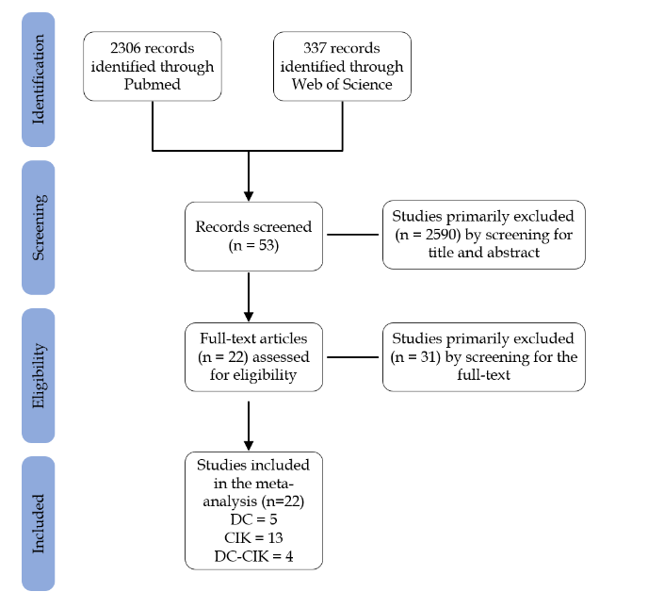
Figure 1 Flow diagram of literature screening process. DC: Dendritic cell; CIK: Cytokine-induced killer cell.

A: 6-mo overall survival
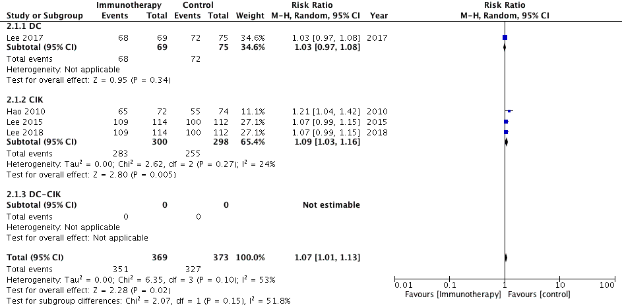
B: 1-yr overall survial
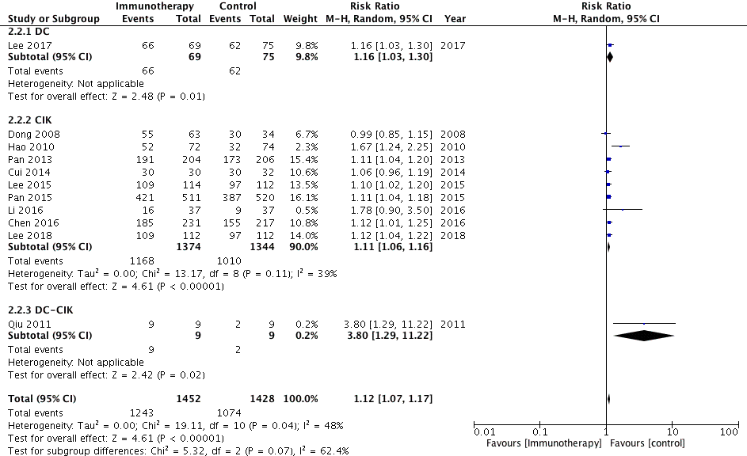
C: 3-yr overall survival
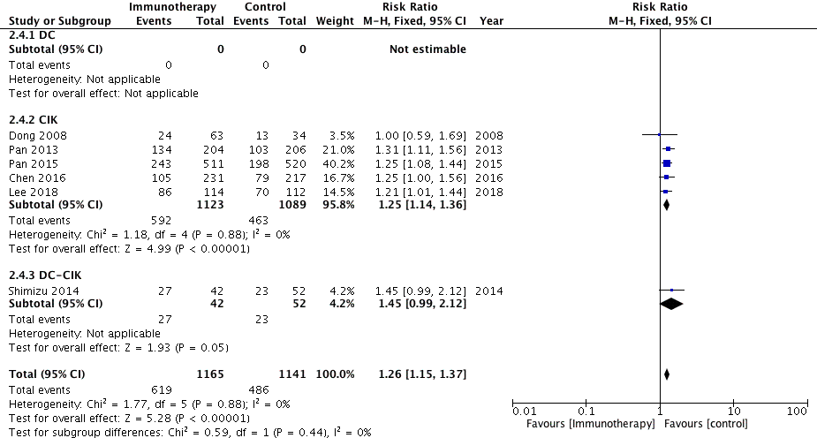

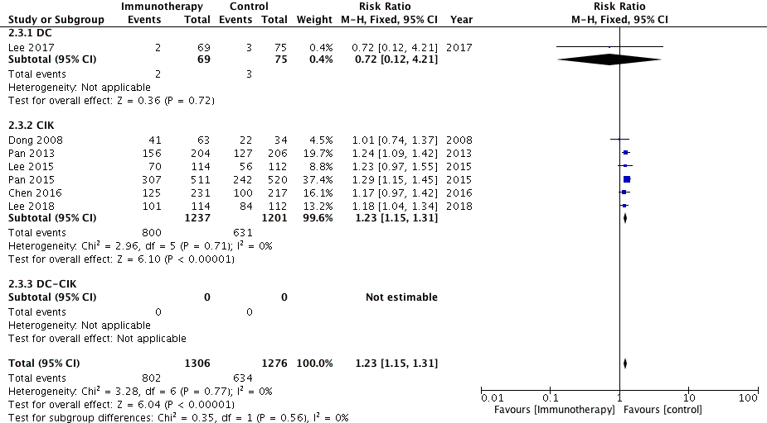
D: 5-yr overall survival
Figure 2 Comparison of 6-mo and 1- , 3- and 5-yr overall survival between immunotherapy groups and control groups. M-H: Mantel-Haenszel estimates; CI: Confidence interval.

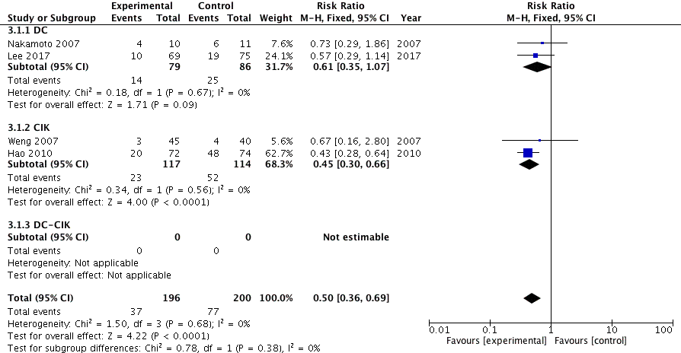
A: 6-mo recurrence

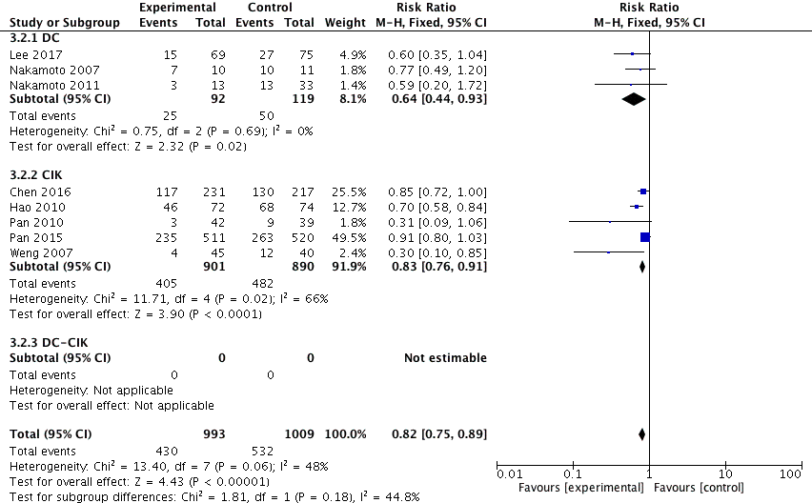
B: 1-yr recurrence

C: 1.5-yr recurrence
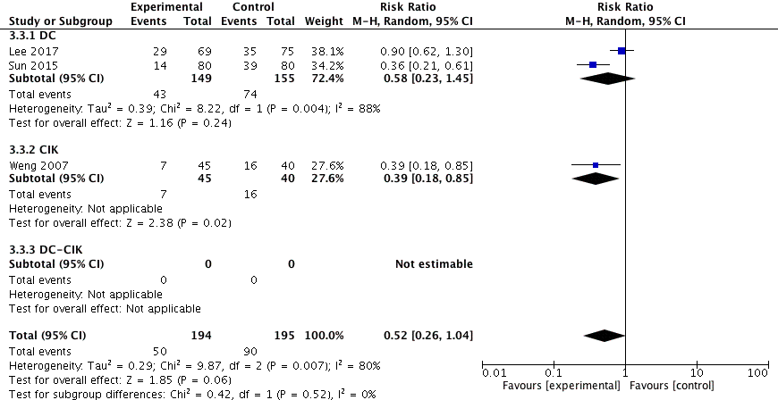
Figure 3 Comparison of 6-mo and 1- and 1.5-yr recurrence between immunotherapy groups and control groups. M-H: Mantel-Haenszel estimates; CI: Confidence interval.

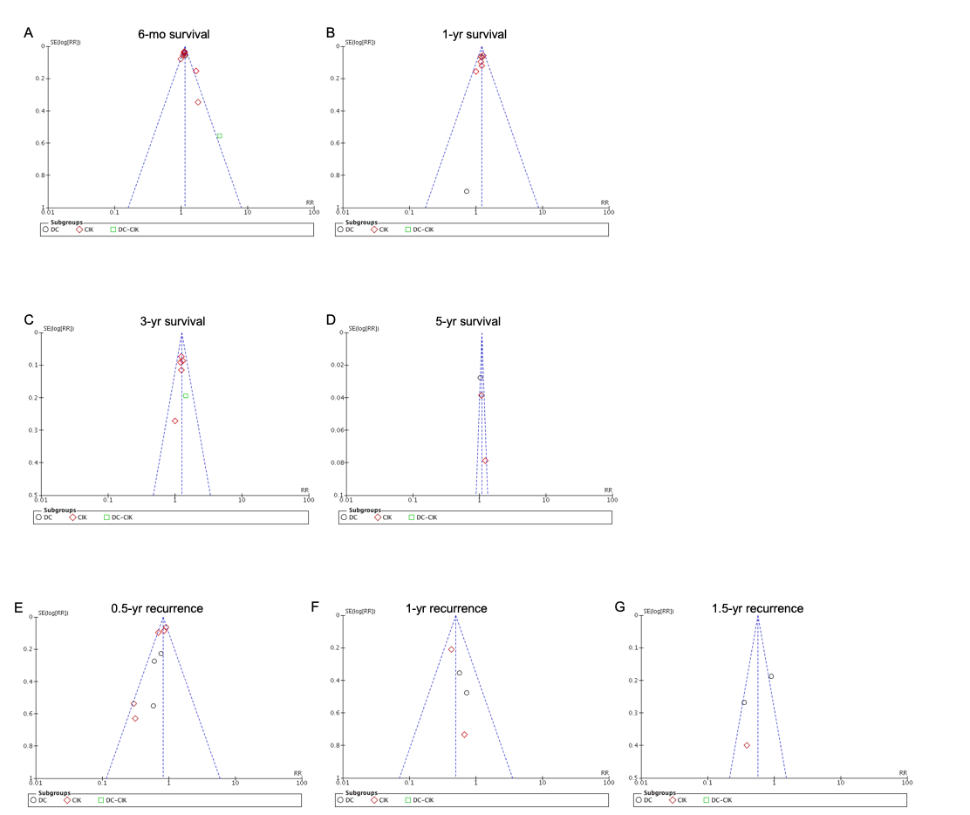
Figure 4 Funnel plots to detect publication bias. DC: Dendritic cell; CIK: Cytokine-induced killer cell.

Table 1 Clinical information and characteristics of included studies
Author (year) | Country | Control | Immunotherapy interventions | Patients |  | Child-Pugh score A/B/C |  | Immune cell regimens | Course
 |  |  |  | (control) | (trial) | (control) | (trial)
Nakamoto 2007^{[19]} | Japan | TACE | TACE+DC | 11 | 10 | 4/7/0 | 8/2/0 | 5 × 10^6 | 1
Nakamoto 2011^{[20]} | Japan | TACE | TACE+DC | 22 | 13 | NR | 5/8/0 | 5 × 10^6 | 1
El Ansary 2013^{[21]} | Egypt | Supportive treatment | DC | 15 | 15 | 0/14/1 | 0/15/0 | 20 × 10^6 | 1
Sun 2015^{[22]} | China | Resection+FOLFOX6 | Resection+DC | 80 | 80 | NR | NR | 8.9 × 10^9 | 6
Lee 2017^{[23]} | South Korea | Resection/RFA/PEI | Resection/RFA/PEI+DC | 75 | 69 | NR | NR | 3 × 10^7 | 6
Weng 2007^{[24]} | China | TACE+RFA | TACE+RFA+CIK | 40 | 45 | 33/7/0 | 36/9/0 | 1.0-1.5 × 10^10 | 8-9
Dong 2008^{[25]} | China | Resection | Resection+CIK | 43 | 84 | 34/9/0 | 68/16/0 | 1.0-2.0 × 10^10 | 3/5
Hao 2010^{[26]} | China | TACE | TACE+RFA+CIK | 74 | 72 | 66/8/0 | 65/7/0 | 1.0-5.0 × 10^10 | 4
Pan 2010^{[27]} | China | TACE+RFA | TACE+RFA+CIK | 39 | 42 | NR | NR | 1.0 × 10^10 | 4
Pan 2013^{[28]} | China | Resection | Resection+CIK | 206 | 204 | 206/0/0 | 204/0/0 | 1.0-1.5 × 10^10 | 4
Lee 2015^{[29]} | South Korea | Resection/RFA/PEI | Resection/RFA/PEI+CIK | 112 | 114 | 112/0/0 | 114/0/0 | NR | 16
Pan 2015^{[30]} | China | Resection | Resection+CIK | 520 | 511 | NR | NR | 1.0-1.5 × 10^10 | 4
Chen 2016^{[31]} | China | Resection | Resection+CIK | 118 | 231 | 205/12/0 | 222/9/0 | 1.0-1.5 × 10^10 | 4
Li 2016^{[32]} | China | Oxaliplatin+Capecitabine | CIK | 37 | 37 | 33(A+B)/4(C) | 27(A+B)/10(C) | NR | NR
Chang 2018^{[33]} | China | Resection | Resection+CIK | 145 | 145 | 145/0/0 | 145/0/0 | NR | NR
Lee 2018^{[34]} | South Korea | Resection/RFA/PEI | Resection/RFA/PEI+CIK | 112 | 114 | 112/0/0 | 114/0/0 | 6.4 × 10^9 | 16
Cui 2014^{[35]} | China | RFA | RFA+NK/𝛾𝛿T/CIK | 32 | 30 | 14/18/0 | 18/12/0 | 1.2-2.0 × 10^9 | 8
Qian 2016^{[36]} | China | RFA | RFA+NK/𝛾𝛿T/CIK | 31 | 73 | NR | NR | 1.0-2.0 × 10^9 | 8
Qiu 2011^{[37]} | China | Resection | Resection+DC-CIK | 9 | 9 | NR | NR | 2-20 × 10^9 | NR
Niu 2013^{[38]} | China | Cryoablation | Cytotherapy+DC-CIK | 12 | 21 | NR | NR | 6.0-10.0 × 10^9 | NR
Shimizu 2014^{[39]} | Japan | Resection | Resection+DC-CIK | 40 | 35 | 44/8/0 | 34/8/0 | NR | NR
Yu 2015^{[40]} | China | microwave ablation | microwave ablation+DC‐CIK | 15 | 14 | 15/0/0 | 13/1/0 | NR | NR
TACE: Transcatheter arterial chemoembolization; RFA: Radiofrequency ablation; PEI: Percutanous ethanol injection; DC: Dendritic cells; CIK: Cytokine-induced killer cells; NK: Nature killer cells; NR: Not reported.

Table 2 Quality assessment of randomized controlled trials with Cochrane Collaboration’s tool
Author (year) | Selection | Performance | Detection | Attrition | Reporting | Other
 | bias | bias | bias | bias | bias | bias
El Ansary 2013 | Unclear | High | Unclear | Low | Low | Low
Sun 2015 | Unclear | High | Unclear | Low | Low | Low
Dong 2008 | Unclear | High | Unclear | Low | Low | Low
Lee 2015 | Unclear | High | Unclear | Low | Low | Low
Lee 2018 | Unclear | High | Unclear | Low | Low | Low
Qiu 2011 | Unclear | High | Unclear | Low | Low | Low
Yu 2015 | Unclear | High | Unclear | Low | Low | Low

Table 3 Quality assessment of non-randomized controlled trials with MINORS
Author (year) | 1 | 2 | 3 | 4 | 5 | 6 | 7 | 8 | 9 | 10 | 11 | 12
Nakamoto 2007 | 2 | 2 | 2 | 0 | 0 | 1 | 2 | 0 | 2 | 2 | 2 | 2
Nakamoto 2011 | 2 | 2 | 2 | 2 | 0 | 1 | 2 | 0 | 2 | 2 | 2 | 2
Lee 2017 | 2 | 2 | 2 | 2 | 0 | 2 | 0 | 2 | 2 | 2 | 2 | 2
Weng 2007 | 2 | 2 | 2 | 2 | 0 | 2 | 2 | 0 | 2 | 2 | 2 | 2
Hao 2010 | 2 | 2 | 2 | 2 | 0 | 2 | 2 | 2 | 2 | 2 | 2 | 2
Pan 2010 | 2 | 2 | 2 | 2 | 0 | 1 | 2 | 0 | 2 | 2 | 2 | 2
Pan 2013 | 2 | 2 | 2 | 2 | 0 | 1 | 2 | 0 | 2 | 2 | 2 | 2
Pan 2015 | 2 | 2 | 2 | 2 | 0 | 2 | 2 | 0 | 2 | 2 | 2 | 2
Chen 2016 | 2 | 2 | 2 | 2 | 0 | 2 | 2 | 0 | 2 | 2 | 2 | 2
Li 2016 | 2 | 2 | 2 | 2 | 0 | 1 | 2 | 2 | 2 | 2 | 2 | 2
Chang 2018 | 2 | 2 | 2 | 2 | 0 | 2 | 2 | 2 | 2 | 2 | 2 | 2
Cui 2014 | 2 | 2 | 2 | 0 | 0 | 1 | 2 | 0 | 2 | 2 | 2 | 2
Qian 2016 | 2 | 2 | 2 | 1 | 0 | 2 | 0 | 0 | 2 | 2 | 2 | 2
Niu 2013 | 2 | 2 | 2 | 0 | 0 | 2 | 2 | 0 | 2 | 2 | 2 | 2
Shimizu 2014 | 2 | 2 | 2 | 0 | 0 | 2 | 2 | 2 | 2 | 2 | 2 | 2

