Name of Journal: World Journal of Cardiology
ESPS Manuscript NO: 24630
Manuscript Type: Case Report

Asymptomatic post-rheumatic giant left atrium

Özkartal T et al. Asymptomatic giant left atrium

Tardu Özkartal, Felix C Tanner, Markus Niemann

Tardu Özkartal, Felix C Tanner, Clinic of Cardiology, University Heart Center, University Hospital Zurich, 8091 Zurich, Switzerland

Markus Niemann, Faculty of Mechanical and Medical Engineering, Furtwangen University, 78054 Villingen-Schwenningen, Germany

Author contributions: All the authors contributed to the acquisition of data, drafting, writing, and revision of the manuscript; the final manuscript was approved by all authors.

Institutional review board statement: Since this is not a study but just a case report, there is no institutional review board statement.

Informed consent statement: This study was approved by the local ethics committee.

Conflict-of-interest statement: None of the authors has any conflicts of interests to declare.

Open-Access: This article is an open-access article which was selected by an in-house editor and fully peer-reviewed by external reviewers. It is distributed in accordance with the Creative Commons Attribution Non Commercial (CC BY-NC 4.0) license, which permits others to distribute, remix, adapt, build upon this work non-commercially, and license their derivative works on different terms, provided the original work is properly cited and the use is non-commercial. See: http://creativecommons.org/licenses/by-nc/4.0/

Correspondence to: Tardu Özkartal, MD, Clinic of Cardiology, University Heart Center, University Hospital Zurich, Rämistrasse 100, 8091 Zurich, Switzerland. tardu.oezkartal@usz.ch
Telephone: +41-44-2552846
Fax: +41-44-2554401

Received: January 29, 2016
Peer-review started: February 1, 2016
First decision: March 1, 2016
Revised: April 1, 2016
Accepted: April 14, 2016
Article in press:
Published online:

Abstract
A 78 years old asymptomatic woman was referred to our clinic for a second opinion regarding indication for mitral valve surgery. An echocardiogram showed a moderate mitral stenosis with a concomitant severe regurgitation. The most striking feature, however, was a giant left atrium with a parasternal anteroposterior diameter of 79 mm and a left atrial volume index of 364 mL/m². There are various echocardiographic definitions of a giant left atrium, which are mainly based on measurements of the anteroposterior diameter of the left atrium using M-mode in the parasternal long axis view. Since the commonly accepted method for echocardiographic evaluation of left atrial size is left atrial volume index, we propose a cut-off value of 140 mL/m² for the definition of a “giant left atrium”.

Key words: Giant; Left; Atrium; Postrheumatic; Mitral; Valve; Stenosis; Regurgitation

© The Author(s) 2016. Published by Baishideng Publishing Group Inc. All rights reserved.

Core tip: There are various echocardiographic definitions of a giant left atrium, which are mainly based on measurements of the anteroposterior diameter of the left atrium using M-mode in the parasternal long axis view. Since the commonly accepted method for echocardiographic evaluation of left atrial size is left atrial volume index, we propose a cut-off value of 140 mL/m² for the definition of a “giant left atrium”.

Özkartal T, Tanner FC, Niemann M. Asymptomatic post-rheumatic giant left atrium. World J Cardiol 2016; In press

INTRODUCTION
Early in the 20th century Owen and Fenton^{[1]} presented “A case of extreme dilatation of the left auricle of the heart”. The patient initially presented because of dyspnea, which after clinical examination was thought to be due to a right sided pleural effusion. However, paracentesis produced pure blood. Postmortem examination showed a severely enlarged left atrium occupying the entire thoracic cavity that was accidentally punctured during paracentesis. To our knowledge, this is the first published case of a so called “giant left atrium”, a term that was introduced by Kent et al^{[2]} in 1956.
It is well known that various cardiac conditions such as valvular heart disease, systolic or diastolic dysfunction of the left ventricle, atrial fibrillation and others can cause an enlargement of the left atrium. However, an enlargement fulfilling the criteria for “giant left atrium” is most commonly due to mitral valve pathology, in particular mitral valve stenosis^{[3]}.

CASE REPORT
A 78 years old woman with known atrial fibrillation and arterial hypertension was referred to our clinic for a second opinion regarding indication for mitral valve surgery. As a child she had suffered from rheumatic fever and subsequently developed mitral valve dysfunction. However, having been asymptomatic ever since, she refused surgery in the past - even when an endocarditis of the mitral valve with enterococcus coli in 2013 was detected. The endocarditis was treated conservatively at that time.
At presentation the patient denied any cardiac symptoms such as dyspnea, nocturia, chest pain or palpitations. She was able to walk two floors without a break and was perfectly capable of mastering her daily life.
Physical examination showed an alert and oriented patient. The pulse was irregular with 53 beats per minute, respiration rate was normal and systolic blood pressure was elevated with 167/83 mmHg. A 2/6 holosystolic heart murmur was present at the left sternal border and at the apex with radiation to the left axilla. The lungs were clear to auscultation with no crackles or wheezes. No signs of volume retention such as distension of the jugular veins, peripheral edema or positive hepatojugular reflux were present.
The electrocardiogram showed atrial fibrillation with a heart rate of 56 beats per minute and a left anterior fascicular block. Apart from a slightly reduced kidney function with an estimated glomerular filtration rate of 61 mL/min (CKD-EPI 2009) and an elevated proBNP of 1345 ng/L (normal < 738 ng/L) there were no pathologic findings.
On the treadmill exercise test the patient reached 5.2 MET (metabolic equivalent of task) without cardiac symptoms or significant ECG changes. The test had to be abandoned due to joint pain in the knees.
An echocardiogram showed a moderately dilated left ventricle (end-diastolic volume index: 88 mL/m²) with a moderately reduced ejection fraction of 38% due to global hypokinesis. The mitral annulus was calcified. In a pattern consistent with post-rheumatic changes the mitral valve leaflets were thickened and partially calcified. Moderate mitral stenosis with a mean diastolic pressure of 7 mmHg and a concomitant severe regurgitation was present. The estimated pulmonary pressure was slightly elevated (41 mmHg), the dimension and function of the right ventricle normal. The most striking feature, however, was a giant left atrium with an anteroposterior diameter of 79 mm (Figure 1), a left atrial circumference of 88 cm², a total volume of 525 mL and a left atrial volume index (LAVI) of 364 mL/m² (see video core tip).

DISCUSSION
Left atrial size is influenced by increased left atrial pressure and its duration. Hence, left atrial dilatation occurs under various cardiac conditions such as mitral valve disease, left ventricular systolic as well as diastolic dysfunction and others. In general it can be assumed that the more severe and chronic the cardiac condition, the larger the left atrium. The chronicity might be a key factor why the patient presented such a dilated atrium, having suffered from rheumatic fever as a child and subsequently developed mitral stenosis (and regurgitation). The persistent atrial fibrillation as well as arterial hypertension certainly contributed to the severity of left atrial enlargement.
There are several empirical definitions of giant left atrium, but no established diagnostic criteria^{[4]} so far. Piccoli et al^{[5]} published a paper in 1984 using a cardiothoracic ratio > 0.7 on chest X-ray in combination with an echocardiographic and angiographic evidence of aneurysmal dilatation of the left atrium to define giant left atrium. The measured atrial anteroposterior diameters ranged from 7 to 12 cm. Isomura et al^{[6]} defined a left atrium as giant, if the echocardiographic diameter exceeded 6.0 cm. In 1991 Minagoe et al^{[7]} used another arbitrary anteroposterior diameter of 65 mm in the parasternal long axis view using M-mode echocardiography as a cut-off value (Figure 1). To our knowledge this is the generally used echocardiographic criteria for a giant left atrium. All echocardiographic cut-off values have in common that they are based on a single, monoplane, linear measurement.
In clinical practice, however, we occasionally are confronted with severely enlarged and anatomically distorted left atria, making it difficult to find a correct angle for an adequate measurement of the anteroposterior diameter in M-mode. This can even lead to different values between measurements in M- and B-mode (Figures 1 and 2). Moreover, since the left atrium is a three dimensional structure, we think that the LAVI is a more suitable method for evaluating its size.
Interestingly, no definition of a giant left atrium based on indexed left atrial volume is available. An anteroposterior atrial diameter below 40 mm is regarded normal, a value above 65 mm “giant”, corresponding to 1.6 times the normal value. A LAVI below 34 mL/m² is regarded as normal^{[8]}. Thus, LAVI being a three dimensional measurement, one might extrapolate a LAVI of more than 140 mL/m² as a cut off for a giant left atrium (> 1.6 times of the length in each of the three spatial directions: 34 mL/m² × 1.6³). However, this cut off is arbitrary and the prognostic relevance, whether an atrium is severely dilated or “giant”, is unknown. This has to be explored in future studies.

COMMENTS
Case characteristics
A 78 years old patient with rheumatic heart disease and no cardiac symptoms such as dyspnea, nocturia, chest pain or palpitations.

Clinical diagnosis
Irregular heart beat with a rate of 53 beats per minute, elevated blood pressure with 167/83 mmHg and a 2/6 holosystolic heart murmur at the left sternal border and the apex with radiation to the left axilla.

Differential diagnosis
Severely enlarged left atrium because of mitral valve pathology due to rheumatic heart disease, persistent atrial fibrillation and arterial hypertension.

Laboratory diagnosis
Reduced estimated glomerular filtration rate of 61 mL/min as a sign of chronic kidney disease stage 2 and increased proBNP of 1345 ng/L as a marker for chronic heart failure.

Imaging diagnosis
Echocardiography showed a giant left atrium with a left atrial total volume of 525 mL and an indexed volume of 364 mL/m².

Treatment
Medication for chronic heart failure, i.e., ACE-inhibitor, beta-blocker and loop diuretic and a vitamin K antagonist for atrial fibrillation.

Related reports
Rheumatic heart disease is defined by the world heart federation as a chronic heart condition caused by rheumatic fever due to a preceding group A streptococcal infection that can cause fibrosis of heart valves, leading to crippling valvular heart disease, heart failure and death.

Term explanation
M-mode is an echocardiographic modality (M for motion) with high temporal resolution of up to 1000 Hz that allows detailed analysis of rapidly moving structures.

Experiences and lessons
Obtaining a correct anteroposterior diameter in the parasternal long-axis using M-mode echocardiography can sometimes be difficult. The authors therefore propose to measure left atrial volume index and suggest a cut-off value of greater than 140 mL/m² for the definition of giant left atrium.

Peer-review
The authors present a case of a giant aneurysm in a 78 years old patient with prior history of rheumatic fever and subsequent mitral disease and mitral endocarditis medically treated. The evolution of both entities to a chronic severe mitral regurgitation might probably lead to dilate the left atrium to that extent. The paper is well written.

REFERENCES
1 Owen I, Fenton WJ. A case of extreme dilatation of the left auricle of the heart. Trans Clin Soc London 1901; 34: 183-191
2 Fisher DL, Ford WB, Kent EM, Neville JF. Mitral valve surgery and left heart catheterization in giant left atrium. AMA Arch Surg 1956; 73: 503-507 [PMID: 13361701]
3 El Maghraby A, Hajar R. Giant left atrium: a review. Heart Views 2012; 13: 46-52 [PMID: 22919448 DOI: 10.4103/1995-705X.99227]
4 Oh JK. Echocardiographic evaluation of morphological and hemodynamic significance of giant left atrium. An important lesson. Circulation 1992; 86: 328-330 [PMID: 1535572]
5 Piccoli GP, Massini C, Di Eusanio G, Ballerini L, Iacobone G, Soro A, Palminiello A. Giant left atrium and mitral valve disease: early and late results of surgical treatment in 40 cases. J Cardiovasc Surg (Torino) 1984; 25: 328-336 [PMID: 6237112]
6 Isomura T, Hisatomi K, Hirano A, Maruyama H, Kosuga K, Ohishi K. Left atrial plication and mitral valve replacement for giant left atrium accompanying mitral lesion. J Card Surg 1993; 8: 365-370 [PMID: 8507966]
7 Minagoe S, Yoshikawa J, Yoshida K, Akasaka T, Shakudo M, Maeda K, Tei C. Obstruction of inferior vena caval orifice by giant left atrium in patients with mitral stenosis. A Doppler echocardiographic study from the right parasternal approach. Circulation 1992; 86: 214-225 [PMID: 1617774]
8 Lang RM, Badano LP, Mor-Avi V, Afilalo J, Armstrong A, Ernande L, Flachskampf FA, Foster E, Goldstein SA, Kuznetsova T, Lancellotti P, Muraru D, Picard MH, Rietzschel ER, Rudski L, Spencer KT, Tsang W, Voigt JU. Recommendations for cardiac chamber quantification by echocardiography in adults: an update from the American Society of Echocardiography and the European Association of Cardiovascular Imaging. Eur Heart J Cardiovasc Imaging 2015; 16: 233-270 [PMID: 25712077 DOI: 10.1093/ehjci/jev014]

P-Reviewer: Fett JD, Iacoviello M, Petretta M, Sabate M S-Editor: Ji FF L-Editor: E-Editor:

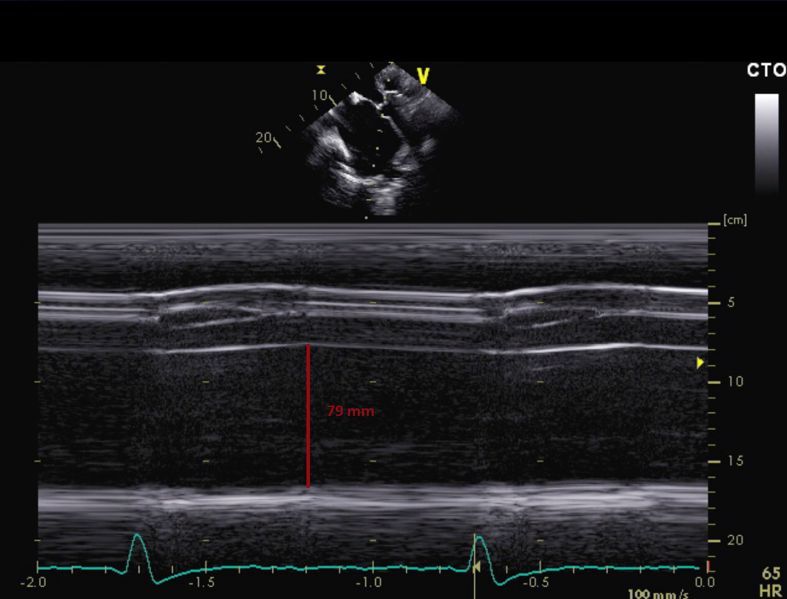
Figure 1 Parasternal long axis view in M-mode at the level of the aortic valve and left atrium. The dilated diameter of the left atrium (79 mm) is shown.

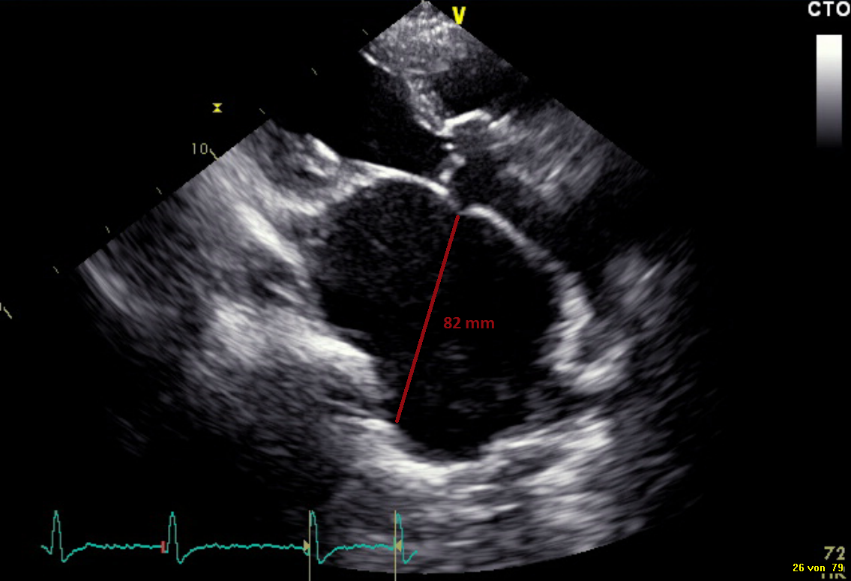
Figure 2 Modified parasternal long axis view in B-mode showing the dimension of the giant left atrium (82 mm).

