NMR Spectrum 1. ¹H-NMR of M. erythroxylon extract (200 MHz, CDCl3).

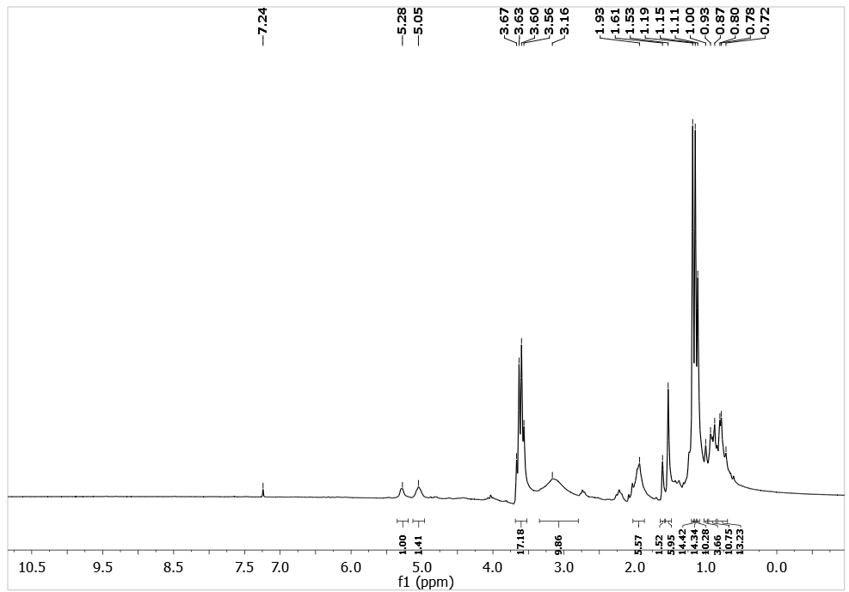

NMR Spectrum 2. ¹³C-NMR of M. erythroxylon extract (50 MHz, CDCl3).

