Name of Journal: World Journal of Clinical Cases
Manuscript NO: 71890
Manuscript Type: CASE REPORT

Deep Sylvian fissure meningiomas: A case report

Wang A et al. Deep sylvian fissure meningiomas

Anni Wang, Xu Zhang, Kun-Kun Sun, Can Li, Zi-Mu Song, Tao Sun, Feng Wang

Anni Wang, Xu Zhang, Can Li, Zi-Mu Song, Tao Sun, Department of Neurosurgery, General Hospital of Ningxia Medical University, Yinchuan 750000, Ningxia Hui Autonomous Region, China

Kun-Kun Sun, Department of Pathology, Peking University People's Hospital, Beijing 100000, China

Feng Wang, Department of Neurosurgery, People's Hospital of Ningxia Hui Autonomous Region, Yinchuan 750001, Ningxia Hui Autonomous Region, China.

Author contributions: Wang F put forward the conception and design; Wang A collected data; all authors participated in the analysis and interpretation of data, draft the article, revise the manuscript critically and approve the final version of the manuscript.

Supported by the key research and development program of Ningxia, No. 2018BFG02007.

Corresponding author: Feng Wang, PhD, Chief Doctor, Department of Neurosurgery, People's Hospital of Ningxia Hui Autonomous Region, No. 255 Zhengyuan North Street, Yinchuan 750001, Ningxia Hui Autonomous Region, China. nxwwang@163.com

Received: October 7, 2021
Revised: March 30, 2022
Accepted: June 4, 2022
Published online: July 26, 2022

Abstract
BACKGROUND
Deep Sylvian meningiomas are rare and difficult to diagnose when small tumours lead to various symptoms. The difficulty associated with surgery is underestimated. Our case involved a mass (11 × 12 × 12 mm³ in size) in the right Sylvian fissure. It is the smallest deep Sylvian meningioma known and might be more easily misdiagnosed than previous examples.

CASE SUMMARY
A well-enhanced mass in the right Sylvian fissure of a 26-year-old male with a three-month history of seizure was identified via magnetic resonance imaging. The patient underwent operations twice for seizure control. During the first operation, the tumour was surrounded by the second segment of the middle cerebral artery and its numerous perforators. Partial resection had to be selected due to mild arterial damage. After the first operation, the patient presented with simple partial seizure. During reoperation, we isolated the anatomical structure near the tumour and the tumour over and removed it from its dorsal side by piecemeal resection.

CONCLUSION
This case reported the smallest deep Sylvian meningioma according to a literature review. Preoperative diagnosis is a crucial step due to deep Sylvian meningioma firmly adhering to the middle cerebral artery and its perforators. Adequate preparation is crucial to ensure the success of surgery.

Key Words: Meningioma; Deep Sylvian fissure; Atypical; Neurosurgery; Imaging characteristics; Case report

©The Author(s) 2022. Published by Baishideng Publishing Group Inc. All rights reserved.

Citation: Wang A, Zhang X, Sun KK, Li C, Song ZM, Sun T, Wang F. Deep Sylvian fissure meningiomas: A case report. World J Clin Cases 2022; 10(21): 7438-7444
URL: https://www.wjgnet.com/2307-8960/full/v10/i21/7438.htm
DOI: https://dx.doi.org/10.12998/wjcc.v10.i21.7438

Core Tip: This case reported the smallest deep Sylvian meningioma according to literature review. Preoperative diagnosis is a crucial step due to deep Sylvian meningioma firmly adhering to the middle cerebral artery and its perforators. Then, adequate preparation is the crucial point to ensure the success of surgery.

INTRODUCTION
Meningiomas are neoplasms of the central nervous system and stem from arachnoid cap cells. It is rare for them to originate from a Sylvian fissure or the Virchow-Robin space of middle cerebral artery (MCA) and its branches^{[1]}. Therefore, they might easily be misdiagnosed before surgical operations. Since 1938, 40 cases of deep Sylvian fissure meningiomas have been reported^{[2,3]}. Here, we describe the case of a 26-year-old man with the smallest deep Sylvian fissure meningioma and review the associated literature.

CASE PRESENTATION
Chief complaints
A 26-year-old male had a three-month history of seizures.

History of present illness
A 26-year-old male had a three-month history of seizures developed intermittent abdominal discomfort followed by throat constriction, which spread from spells of numbness (from scalp to limb), lip smacking, and then severe seizures, with athetosis of the left upper limb and loss of consciousness. These symptoms persisted for only for four to five minutes; sometimes, symptoms of severe seizures occurred 4-5 times a day.

History of past illness
The patient was physically healthy and had no abnormal medical history.

Personal and family history
No abnormalities.

Physical examination
The patient had no neurological deficits or physical abnormalities.

Laboratory examinations
No abnormalities.

Imaging examinations
Computed tomography (CT) demonstrated a small calcified-like mass in the right temporal lobe adjacent to the Sylvian fissure. Magnetic resonance imaging (MRI) revealed a mass (11 × 12 × 12 mm³) in the right insula without any dural attachment; the mass was primarily hypointense on T1 and hyperintense on the T2-weighted image, with satisfactory enhancement by contrast medium. Magnetic resonance spectroscopy (MRS) showed a lower peak of N-acetyl-L-aspartic acid (NAA). The peaks of choline and creatine showed no significant change. Computed tomographic angiography (CTA) did not show any tumour stain or dilatation of the MCA (Figures 1 and 2).

FINAL DIAGNOSIS
The patient was diagnosed with psammomatous meningioma (World Health Organization grade I)

TREATMENT
An insular lesion, angioreticuloma, or cavernous haemangioma was suspected. Right frontotemporal craniotomy and excision of the tumour were planned. The tumour was located deep in the lateral fissure, which is the surface of the insular cortex. It was closely attached to M2 segment of the MCA and its numerous perforators. Gravel-like particles were present on the surface of the tumour. Although we carefully isolated the tumor, unfortunately, a perforator artery was damaged, and the amount of blood loss was approximately 700 mL. To protect the main trunk of the MCA, we had to perform final partial resection of the mass. Histopathology and immunohistochemistry of the mass revealed a psammomatous meningioma (World Health Organization grade I) (Figure 3).
On the second day after the operation, the patient began to develop anomic aphasia and weakness in his left limb, which lasted for nearly two weeks. He gradually recovered after vasodilation therapy. After the operation, the seizures were significantly reduced, but the patient still occasionally presented with them (once a month). Along with the seizures, intermittent dizziness and vomiting occurred, followed by left limb numbness without loss of consciousness.
Considering the lack of seizure freedom and his young age, surgical resection was planned again a year after the initial surgery. MRI was performed again, and a small tumour was shown to be stable in the left Sylvian fissure. Positron emission tomography-computed tomographic (PET-CT) demonstrated the low metabolic area around the tumour and relatively limited surgical access (Figure 4). During reoperation, the opercular and MCA with its branch were exposed in the primary incision. After dissecting the Sylvian fissure, the tumor was found in the insular lobe, which was bared after separating the vascular structure of the insular surface. Then, we separated the tumour carefully from the insular lobe and MCA and removed it thoroughly by piecemeal resection. It was observed that the tumour originated from the adventitia of the MCA with strong adhesion (Figure 5).

OUTCOME AND FOLLOW-UP
After the second surgery, the patient was seizure-free and presented no seizure recurrence for approximately a year. MRI showed no lesion in the right temporal lobe adjacent to the lateral fissure (Figure 6).

DISCUSSION
The patient presented typical symptoms of insular epilepsy with a small tumour and atypical imaging characteristics^{[4,5]}. Therefore, it was difficult to make the first and differential diagnoses. Thus, the difficulty of the operation was underestimated.
Meningiomas are the most common primary intracranial tumors. Their incidence is higher in middle-aged females^{[6,7]}. Deep Sylvian meningioma is rare. Forty cases were reported from 1938 to 2021. We reviewed the papers and found that Sylvian meningiomas are mostly present in the children, with a male predominance, and sometimes in young men (Supplementary Table 1). Our case was a young man. The incidence in the age group of deep Sylvian meningioma was next to that in children. Similar to previous articles, histopathology and immunohistochemistry of the tumour revealed a psammomatous meningioma, which is the common pathological type of deep Sylvian meningioma.
Compared with other tumours, the level of evidence for the diagnosis and treatment of meningiomas is low. The preoperative diagnosis of meningioma is limited and often depends on MRI. CT plays an important role in the diagnosis of meningioma by detecting calcium in tumors. Our patient’s CT showed partial calcification, but MRI demonstrated homogenous enhancement and the absence of peritumoral oedema. In particularly, MRS revealed a low peak of NAA. All these findings made it difficult to support the diagnosis of meningiomas. The EEG in this case suggested that abnormal discharge was located on the left side, which was not consistent with seizures, considering the mirror effect. Intermittent and ictal scalp EEG changes might be variable and misleading due to the location of the insula in the deep area of the brain. Furthermore, the mass was so small that the region of interest contained brain tissue. All these findings led to the misdiagnosis.
Our case presented typical insular epilepsy symptoms, such as throat constriction, perioral and hemisensory symptoms, and then unilateral motor symptoms, thereby indicating that the lesion was in the posterior insula^{[8]}. To our knowledge, the tumour of our patient is the smallest among those previously reported (Supplementary Table 1). However, the tumour was located on the insula and perisylvian, and the seizures were relieved after the first operation and disappeared after complete tumour resection in the second operation, which indicated that the location of the tumour in the brain was very important regardless of tumor size. Intermittent and ictal scalp EEG changes might be variable and misleading due to the location of the insula deep in the brain. Therefore, young adults and children with typical insular epilepsy symptoms combined with atypical imaging characteristics can have deep Sylvian meningioma.
The level of difficulty of surgery increased because of the origin and location of the deep Sylvian meningioma. We had to separate the tumour carefully from the MCA and then remove it by piecemeal resection in the second operation. Before the first operation, we suspected the lesion was angioreticuloma or cavernous haemangioma, which led to underestimation the difficulty of surgery. Because of the tight connection of deep Sylvian meningioma and MCA, precise microsurgery skills and perfect surgical plans, are important for the success of the operation.

CONCLUSION
Deep Sylvian meningiomas that originate from the MCA and its branches are rare. They can easily be misdiagnosed. The origin and location of deep Sylvian meningioma increase the difficulty of surgery. This study reported the smallest tumour with typical insular seizures and an atypical radiological examination of deep Sylvian meningiomas. Accurate diagnosis and adequate preoperative preparation are key to successful treatment.

REFERENCES
1 Cai C, Zhu Z, Guo X, Guo X, Jiang H, Zheng Z, Zhang J, Shao A, Zhu J. Sylvian Fissure Meningiomas: Case Report and Literature Review. Front Oncol 2020; 10: 427 [PMID: 32373509 DOI: 10.3389/fonc.2020.00427]
2 Cushing H, Eisenhardt L. Meningiomas: their classification, regional behavior, life history and surgical end results. Charles C Thomas. City 1938
3 Shrivastava RK, Segal S, Camins MB, Sen C, Post KD. Harvey Cushing's Meningiomas text and the historical origin of resectability criteria for the anterior one third of the superior sagittal sinus. J Neurosurg 2003; 99: 787-791 [PMID: 14567620 DOI: 10.3171/jns.2003.99.4.0787]
4 Jobst BC, Gonzalez-Martinez J, Isnard J, Kahane P, Lacuey N, Lahtoo SD, Nguyen DK, Wu C, Lado F. The Insula and Its Epilepsies. Epilepsy Curr 2019; 19: 11-21 [PMID: 30838920 DOI: 10.1177/1535759718822847]
5 Nieuwenhuys R. The insular cortex: a review. Prog Brain Res 2012; 195: 123-163 [PMID: 22230626 DOI: 10.1016/B978-0-444-53860-4.00007-6]
6 Goldbrunner R, Minniti G, Preusser M, Jenkinson MD, Sallabanda K, Houdart E, von Deimling A, Stavrinou P, Lefranc F, Lund-Johansen M, Moyal EC, Brandsma D, Henriksson R, Soffietti R, Weller M. EANO guidelines for the diagnosis and treatment of meningiomas. Lancet Oncol 2016; 17: e383-e391 [PMID: 27599143 DOI: 10.1016/S1470-2045(16)30321-7]
7 Ostrom QT, Cioffi G, Gittleman H, Patil N, Waite K, Kruchko C, Barnholtz-Sloan JS. CBTRUS Statistical Report: Primary Brain and Other Central Nervous System Tumors Diagnosed in the United States in 2012-2016. Neuro Oncol 2019; 21: v1-v100 [PMID: 31675094 DOI: 10.1093/neuonc/noz150]
8 Mazzola L, Mauguière F, Isnard J. Functional mapping of the human insula: Data from electrical stimulations. Rev Neurol (Paris) 2019; 175: 150-156 [PMID: 30827578 DOI: 10.1016/j.neurol.2018.12.003]

Footnotes
Informed consent statement: Informed written consent was obtained from the patient.

Conflict-of-interest statement: The authors report no conflict of interest concerning the materials or methods used in this study or the findings specified in this paper.

CARE Checklist (2016) statement: The authors have read the CARE Checklist (2016), and the manuscript was prepared and revised according to the CARE Checklist (2016).

Open-Access: This article is an open-access article that was selected by an in-house editor and fully peer-reviewed by external reviewers. It is distributed in accordance with the Creative Commons Attribution NonCommercial (CC BY-NC 4.0) license, which permits others to distribute, remix, adapt, build upon this work non-commercially, and license their derivative works on different terms, provided the original work is properly cited and the use is non-commercial. See: https://creativecommons.org/Licenses/by-nc/4.0/

Provenance and peer review: Unsolicited article; Externally peer reviewed.
Peer-review model: Single blind

Peer-review started: October 7, 2021
First decision: March 3, 2022
Article in press: June 4, 2022

Specialty type: Surgery
Country/Territory of origin: China
Peer-review report’s scientific quality classification
Grade A (Excellent): 0
Grade B (Very good): 0
Grade C (Good): C, C
Grade D (Fair): 0
Grade E (Poor): 0

P-Reviewer: Jugovic D, Germany; Vahedi P, Iran A-Editor: Liu X, China S-Editor: Wu YXJ L-Editor: A P-Editor: Wu YXJ

Figure Legends

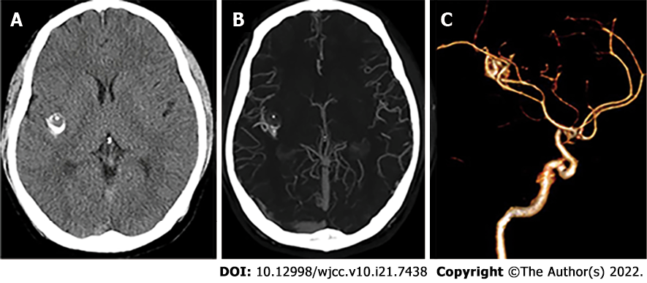
Figure 1 Computed tomographic angiography before the first operation. A: A preoperative non-contrast enhanced axial computed tomographic (CT) shows an area of high density in the right Sylvian fissure, most likely a calcification (an 11 × 12 × 12 mm³ mass lesion); B: Contrast CT imaging shows an enhanced mass in the right deep Sylvian fissure region with edema and areas of calcification; C: Computed tomographic angiography did not show any tumor stain or dilatation of the middle cerebral artery.

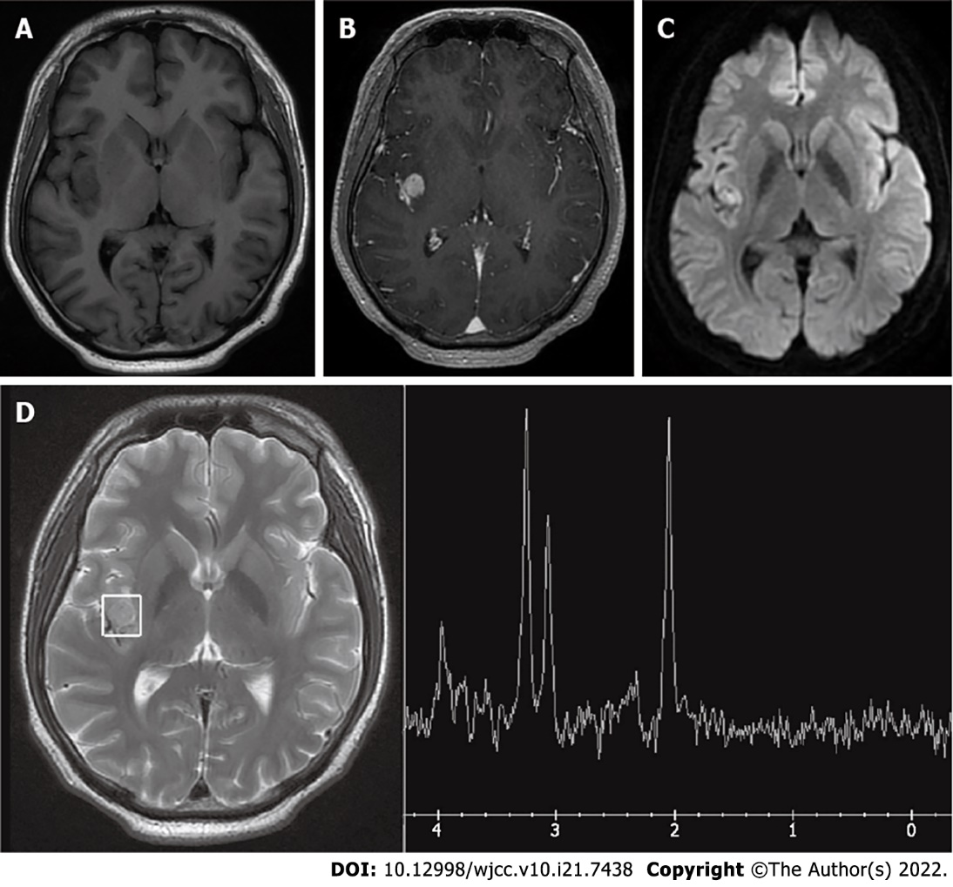

Figure 2 Magnetic resonance imaging and magnetic resonance spectroscopy before the first operation. A and B: Axial T1-weighted magnetic resonance imaging scan demonstrating a hypointense right Sylvian fissure lesion, which was homogenously enhanced after contrast administration; C: Diffusion weighted imaging shows a hyperintense mass in the posterior part of the insular lobe; D: The magnetic resonance spectroscopy (MRS) N-acetyl aspartate (NAA) peak was slightly decreased.

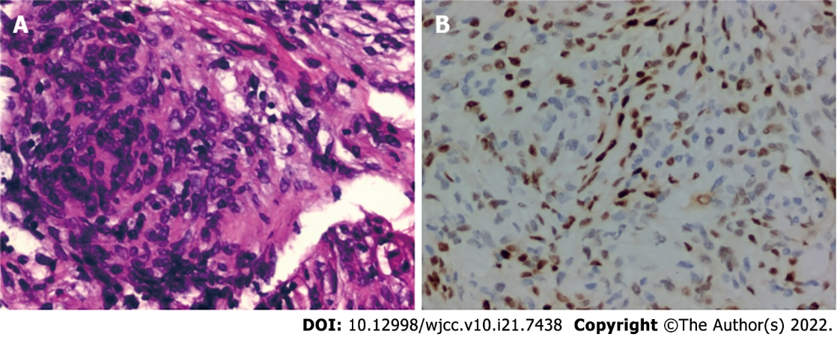
Figure 3 Postoperative histopathology. A: Hematoxylin and eosin staining; original magnification, × 200: Microscopically, the tissue demonstrates spindle-shaped tumor cells and characteristic diffused arrangement in sheets with multiple gravel structures; B: Estimated proliferation index of 5% stained by Ki67 (Immunohistochemical staining, original magnification, × 200). Considering the H&E results, findings were consistent with meningioma.

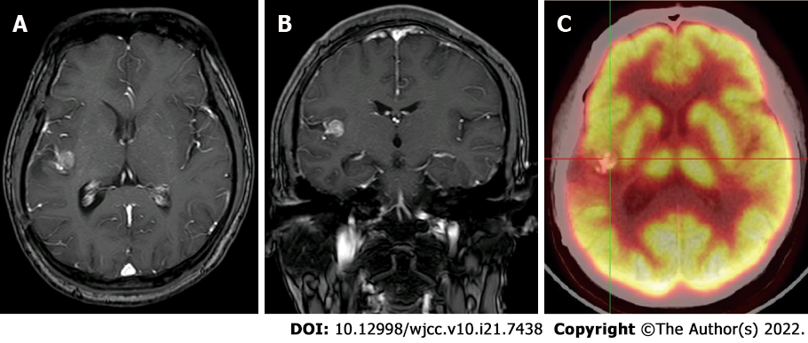
Figure 4 Positron emission tomography-computed tomographic. A and B: After the first operation, contrast magnetic resonance imaging T2-weighted image shows a small and stable residual tumor in the right Sylvian fissure: Axial view (A), Coronal view (B); C: Positron emission tomography-computed tomographic shows the limited hypometabolism zone around the tumor and surgical exposure area.

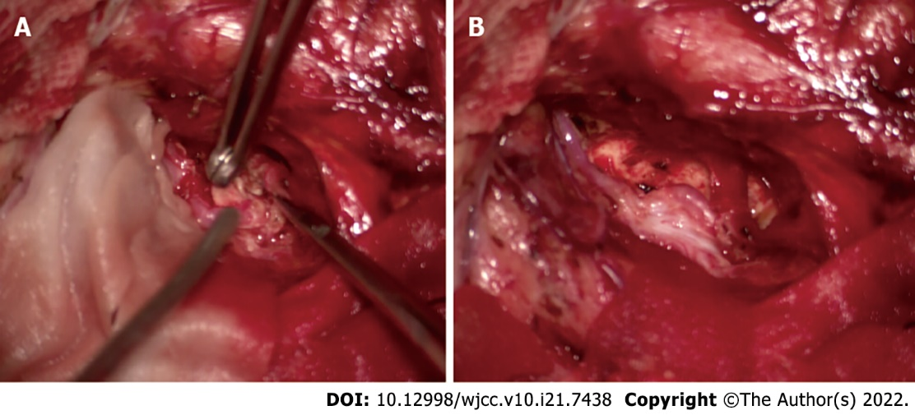
Figure 5 Intraoperative picture demonstrates complete removal of the tumor. A: The exposed brain cortex shows shallow sulci, marked flattening, and thinning of gyri around the Sylvian fissure; B: After splitting the Sylvian fissure, the mass is exposed.

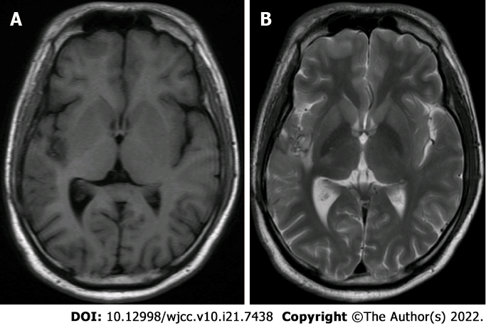
Figure 6 Magnetic resonance imaging images after one year of the second operation. Magnetic resonance imaging (MRI) images show no mass in the right sylvian fissure: MRI-T1 weighted image, axial view (A), MRI-T2 weighted image, axial view (B).

Published by Baishideng Publishing Group Inc
7041 Koll Center Parkway, Suite 160, Pleasanton, CA 94566, USA
Telephone: +1-925-3991568
E-mail: bpgoffice@wjgnet.com
Help Desk: https://www.f6publishing.com/helpdesk
https://www.wjgnet.com

© 2022 Baishideng Publishing Group Inc. All rights reserved.

