Name of Journal: World Journal of Clinical Cases
Manuscript NO: 88186
Manuscript Type: LETTER TO THE EDITOR

Lyophilized recombinant human brain natriuretic peptide: A promising therapy in patients with chronic heart failure

Kourek C et al. Lyophilized recombinant human BNP

Christos Kourek, Alexandros Briasoulis, Grigorios Giamouzis, John Skoularigis, Andrew Xanthopoulos

Christos Kourek, Medical School of Athens, National and Kapodistrian University of Athens, Athens 15772, Greece

Alexandros Briasoulis, Department of Clinical Therapeutics, Alexandra Hospital, Faculty of Medicine, National and Kapodistrian University of Athens, Athens 11528, Greece

Grigorios Giamouzis, John Skoularigis, Andrew Xanthopoulos, Department of Cardiology, University Hospital of Larissa, Larissa 41110, Greece

Author contributions: Kourek C conceived and designed the study, acquired the data, and analyzed and interpreted the data; Briasoulis A, Giamouzis G, Skoularigis J, and Xanthopoulos A drafted and made critical revisions to the manuscript; all authors have read and gave final approval of the version of the article to be published.

Corresponding author: Andrew Xanthopoulos, FACC, MD, PhD, Senior Postdoctoral Fellow, Department of Cardiology, University Hospital of Larissa, Mezourlo, Larissa 41110, Greece. andrewvxanth@gmail.com

Received: September 13, 2023
Revised: December 5, 2023
Accepted: December 12, 2023
Published online: December 26, 2023

Abstract
Lyophilized recombinant brain natriuretic peptide (BNP) is an exogenous peptide synthesized by artificial recombination technology, with a similar structure and similar physiological effects with the endogenous natriuretic peptide secreted by the human body. It’s main mechanism of action is to increase cyclic guanosine monophosphate by binding with its corresponding receptor in the body, regulating, thus, the imbalance of the vascular system and cardiac hemodynamics, improving the heart’s pumping capacity, and inhibiting sympathetic excitability and myocardial remodeling. Moreover, it can promote mitochondrial metabolism and enhance the use of adenosine triphosphate in cardiomyocytes. In the present study, 102 chronic heart failure (HF) patients were randomly assigned to a control and an observation group consisting of 51 patients each. Patients of the control group were treated with standard HF therapy for 3 d including oral metoprolol tartrate tablets, spironolactone, and olmesartanate while patients of the observation group were administered the recombinant human BNP injection for the same time-period, plus the standard HF therapy. The recombinant human BNP group (observation group) demonstrated better physical, emotional, social, and economic scores, as well as cardiac and inflammatory biomarkers such as serum hypersensitive C-reactive protein, N-terminal pro BNP and troponin I levels, compared to the control group. Moreover, cardiac function was also improved, as left ventricular ejection fraction and stroke volume were significantly higher in the observation group than in the control group. Interestingly, adverse reactions were not different between the 2 groups. However, these results are not generalizable and the need of large multicenter randomized controlled trials examining the safety and efficacy of recombinant human BNP in HF patients is of major importance.

Key Words: Heart failure; Recombinant; Brain natriuretic peptide; Outcomes

©The Author(s) 2023. Published by Baishideng Publishing Group Inc. All rights reserved.

Citation: Kourek C, Briasoulis A, Giamouzis G, Skoularigis J, Xanthopoulos A. Lyophilized recombinant human brain natriuretic peptide: A promising therapy in patients with chronic heart failure. World J Clin Cases 2023; 11(36): 8603-8605
URL: https://www.wjgnet.com/2307-8960/full/v11/i36/8603.htm
DOI: https://dx.doi.org/10.12998/wjcc.v11.i36.8603

Core Tip: Lyophilized recombinant brain natriuretic peptide is an exogenous peptide synthesized by artificial recombination technology, with a similar structure and similar physiological effects with the endogenous natriuretic peptide secreted by the human body. A recent single center, randomized study examined its safety and efficacy in 102 chronic heart failure patients, showing promising results. Larger randomized controlled trials are urgently needed.

TO THE EDITOR
We read with great interest the original research article entitled "Lyophilized recombinant human brain natriuretic peptide (BNP) for chronic heart failure (HF) (CHF): Effects on cardiac function and inflammation by Li et al^{[1]}, published in the September 2023 issue of World Journal of Clinical Cases. In this study, authors investigated the actions of lyophilized recombinant human BNP administration on myocardium and microinflammatory profile in CHF patients. Lyophilized recombinant BNP is an exogenous peptide synthesized by artificial recombination technology, with a similar structure and similar physiological effects with the endogenous natriuretic peptide secreted by the human body^{[2]}. It is widely used in cardiovascular diseases, including acute myocardial infarction and HF, and the main mechanism of action of this recombinant BNP is to increase cyclic guanosine monophosphate, regulating the imbalance of the vascular system and cardiac hemodynamics, improving the heart’s pumping capacity, and inhibiting sympathetic excitability and myocardial remodeling^{[1,2]}. As a result, there is an improvement in the quality of life of patients with cardiovascular diseases. Lyophilized recombinant human BNP has been shown to have a significant effect in improving cardiac function and flow-mediated dilatation in patients with acute myocardial infarction^{[2]}, acute renal injury induced by endotoxin in canines^{[3]}, acute carbon monoxide poisoning^{[4]}, as well as patients with weaning-induced cardiac failure^{[5]}. In their study, Li et al^{[1]} randomly assigned 102 CHF patients from a single center, with a mean age of 63-80 years, to a control and an observation group consisting of 51 patients each. Patients of the control group were treated with standard HF therapy for 3 d including oral metoprolol tartrate tablets, spironolactone, and olmesartanate while patients of the observation group were administered the recombinant human BNP injection for the same time-period, plus the standard HF therapy. The recombinant human BNP was shown to excel the standard HF therapy in terms of the overall clinical efficacy and quality of life in CHF patients including physical, emotional, social, and economic scores, and further improved significantly cardiac and inflammatory biomarkers such as serum hypersensitive C-reactive protein, N-terminal proBNP and troponin I levels^{[1]}. Moreover, cardiac function was also improved, as left ventricular ejection fraction (LVEF) and stroke volume were significantly increased^{[1]}. Interestingly, adverse reactions were not different between the 2 groups. Overall, the specific therapy (i.e., recombinant human BNP) seemed to be safe and reliable. These findings could be explained by the mechanism of action of the recombinant human BNP on the renin-angiotensin-aldosterone system, through the inhibition of norepinephrine and aldosterone secretion, the protection of the coronary artery cells and cardiomyocytes, and the inhibition of endothelial cell apoptosis, leading to reduced inflammatory factor secretion and myocardial damage^{[1]} (Figure 1). Despite these interesting and promising findings of this study, there are major limitations that need to be highlighted. Firstly, lyophilized recombinant human BNP was implemented in a small number of patients with reduced LVEF (i.e., ≤ 40%). Secondly, the duration of the drug administration was short (i.e., 3 d) and there was no follow-up. Therefore, data on the safety and efficacy of the drug beyond 3 d are lacking. Thirdly, data on the baseline characteristics of the study population were scarce. In conclusion, lyophilized recombinant human BNP could be a quite promising therapy in HF by improving the cardiac function, the microinflammatory status, and thus, the overall quality of patients’ life. It seems to be safe and reliable without causing any significant adverse effects at the time of administration. However, these results are not generalizable and the need of large multicenter randomized controlled trials examining the safety and efficacy of recombinant human BNP in HF patients is of utmost importance.

REFERENCES
1 Li F, Li H, Luo R, Pei JB, Yu XY. Lyophilized recombinant human brain natriuretic peptide for chronic heart failure: Effects on cardiac function and inflammation. World J Clin Cases 2023; 11: 6066-6072 [PMID: 37731575 DOI: 10.12998/wjcc.v11.i26.6066]
2 Wang B, Xu H, Li C, Wang X, Sun W, Li J. Analysis of the Effect of Lyophilized Recombinant Human Brain Natriuretic Peptide on Endothelial Function in patients with acute myocardial infarction. Pak J Med Sci 2021; 37: 99-103 [PMID: 33437258 DOI: 10.12669/pjms.37.1.2706]
3 Li N, Jin HX, Song Z, Bai CZ, Cui Y, Gao Y. Protective effect of recombinant human brain natriuretic peptide on acute renal injury induced by endotoxin in canines. Cell Biochem Biophys 2014; 70: 1317-1324 [PMID: 24943350 DOI: 10.1007/s12013-014-0057-7]
4 Li N, Gao X, Wang W, Wang P, Zhu B. Protective effects of recombinant human brain natriuretic peptide on the myocardial injury induced by acute carbon monoxide poisoning. Cardiovasc Diagn Ther 2020; 10: 1785-1794 [PMID: 33381423 DOI: 10.21037/cdt-20-591]
5 Dres M, Teboul JL, Monnet X. Weaning the cardiac patient from mechanical ventilation. Curr Opin Crit Care 2014; 20: 493-498 [PMID: 25159477 DOI: 10.1097/MCC.0000000000000131]

Footnotes
Conflict-of-interest statement: All the authors state that they have no potential or real conflicts of interest to declare.

Open-Access: This article is an open-access article that was selected by an in-house editor and fully peer-reviewed by external reviewers. It is distributed in accordance with the Creative Commons Attribution NonCommercial (CC BY-NC 4.0) license, which permits others to distribute, remix, adapt, build upon this work non-commercially, and license their derivative works on different terms, provided the original work is properly cited and the use is non-commercial. See: https://creativecommons.org/Licenses/by-nc/4.0/

Provenance and peer review: Invited article; Externally peer reviewed.

Peer-review model: Single blind

Peer-review started: September 13, 2023
First decision: December 5, 2023
Article in press: December 12, 2023

Specialty type: Medicine, research and experimental
Country/Territory of origin: Greece
Peer-review report’s scientific quality classification
Grade A (Excellent): 0
Grade B (Very good): B
Grade C (Good): 0
Grade D (Fair): 0
Grade E (Poor): 0

P-Reviewer: Tokumine J, Japan S-Editor: Qu XL L-Editor: A P-Editor: Zhao S

Figure Legends
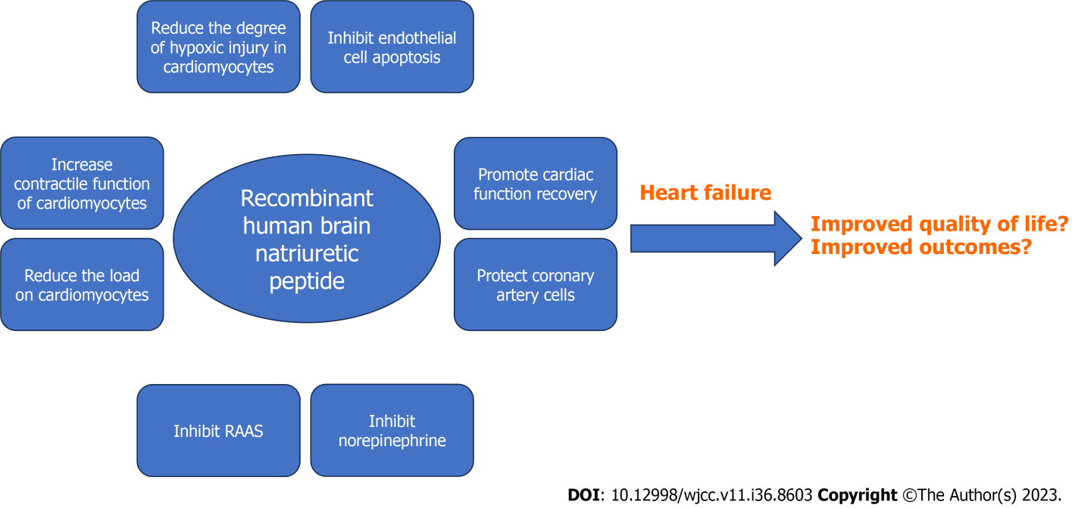
Figure 1 Recombinant human brain natriuretic peptide as a promising therapy in patients with heart failure. Its beneficial effects could be explained by the mechanisms of action of the recombinant human brain natriuretic peptide on the renin-angiotensin-aldosterone system, through the inhibition of norepinephrine and aldosterone secretion, the reduction of the load on cardiomyocytes, the protection of the coronary artery cells, and the inhibition of endothelial cell apoptosis, resulting in reduced inflammatory factor secretion and myocardial damage.

Published by Baishideng Publishing Group Inc
7041 Koll Center Parkway, Suite 160, Pleasanton, CA 94566, USA
Telephone: +1-925-3991568
E-mail: bpgoffice@wjgnet.com
Help Desk: https://www.f6publishing.com/helpdesk
https://www.wjgnet.com

© 2023 Baishideng Publishing Group Inc. All rights reserved.

