Name of Journal: World Journal of Gastroenterology
Manuscript NO: 83633
Manuscript Type: ORIGINAL ARTICLE

Retrospective Cohort Study
Prediction of lymph node metastasis in early gastric signet-ring cell carcinoma: A real-world retrospective cohort study

Yang JJ et al. Lymph node metastasis in gastric SRCC

Jia-Jia Yang, Xiao-Yong Wang, Rui Ma, Mei-Hong Chen, Guo-Xin Zhang, Xuan Li

Jia-Jia Yang, Mei-Hong Chen, Guo-Xin Zhang, Xuan Li, Department of Gastroenterology, The First Affiliated Hospital of Nanjing Medical University, Nanjing 210029, Jiangsu Province, China

Xiao-Yong Wang, Department of Gastroenterology, The Affiliated Changzhou No. 2 People's Hospital of Nanjing Medical University, Changzhou 213000, Jiangsu Province, China

Rui Ma, Department of Nursing, Jiangsu Health Vocational College, Nanjing 211800, Jiangsu Province, China

Author contributions: Yang JJ, Wang XY, Ma R and Chen MH contributed equally to this work; Yang JJ and Wang XY designed the research study and performed the research; Ma R and Chen MH contributed new reagents and analytic tools; Yang JJ, Wang XY, Ma R and Chen MH analyzed the data and wrote the manuscript; all authors have read and approve the final manuscript.

Supported by National Natural Science Foundation of China, No. 82200625 and No. 82100595; Youth Talent Development Program, No. YNRCQN0313; Young Scholar Fostering Fund of the First Affiliated Hospital of Nanjing Medical University, No. PY2021023; Top Talent of Changzhou “The 14th Five-Year Plan” High-Level Health Talents Training Project, No. 2022CZBJ051; and Natural Science Foundation of Jiangsu Province, China, No. BK20210958.

Corresponding author: Xuan Li, PhD, Attending Doctor, Department of Gastroenterology, The First Affiliated Hospital of Nanjing Medical University, No. 300 Guangzhou Road, Nanjing 210029, Jiangsu Province, China. lixuan20091225@163.com

Received: February 2, 2023
Revised: March 30, 2023
Accepted: May 16, 2023
Published online: June 28, 2023

Abstract
BACKGROUND
Signet-ring cell carcinoma (SRCC) was previously thought to have a worse prognosis than other differentiated gastric cancer (GC), however, recent studies have shown that the prognosis of SRCC is related to pathological type. We hypothesize that patients with SRCC and with different SRCC pathological components have different probability of lymph node metastasis (LNM).

AIM
To establish models to predict LNM in early GC (EGC), including early gastric SRCC.

METHODS
Clinical data from EGC patients who had undergone gastrectomy at the First Affiliated Hospital of Nanjing Medical University from January 2012 to March 2022 were reviewed. The patients were divided into three groups based on type: Pure SRCC, mixed SRCC, and non-signet ring cell carcinoma (NSRC). The risk factors were identified through statistical tests using SPSS 23.0, R, and EmpowerStats software.

RESULTS
A total of 1922 subjects with EGC were enrolled in this study, and included 249 SRCC patients and 1673 NSRC patients, while 278 of the patients (14.46%) presented with LNM. Multivariable analysis showed that gender, tumor size, depth of invasion, lymphovascular invasion, ulceration, and histological subtype were independent risk factors for LNM in EGC. Establishment and analysis using prediction models of EGC showed that the artificial neural network model was better than the logistic regression model in terms of sensitivity and accuracy (98.0% vs 58.1%, P = 0.034; 88.4% vs 86.8%, P < 0.001, respectively). Among the 249 SRCC patients, LNM was more common in mixed (35.06%) rather than in pure SRCC (8.42%, P < 0.001). The area under the ROC curve of the logistic regression model for LNM in SRCC was 0.760 (95%CI: 0.682-0.843), while the area under the operating characteristic curve of the internal validation set was 0.734 (95%CI: 0.643-0.826). The subgroups analysis of pure types showed that LNM was more common in patients with a tumor size > 2 cm (OR = 5.422, P = 0.038).

CONCLUSION
A validated prediction model was developed to recognize the risk of LNM in EGC and early gastric SRCC, which can aid in pre-surgical decision making of the best method of treatment for patients.

Key Words: Early gastric cancer; Signet-ring cell carcinoma; Lymph node metastasis; Nomogram; Prediction model

©The Author(s) 2023. Published by Baishideng Publishing Group Inc. All rights reserved.

Citation: Yang JJ, Wang XY, Ma R, Chen MH, Zhang GX, Li X. Prediction of lymph node metastasis in early gastric signet-ring cell carcinoma: A real-world retrospective cohort study. World J Gastroenterol 2023; 29(24): 3807-3824
URL: https://www.wjgnet.com/1007-9327/full/v29/i24/3807.htm
DOI: https://dx.doi.org/10.3748/wjg.v29.i24.3807

Core Tip: By establishing and comparing prediction models of lymph node metastasis (LNM) in early gastric cancer, we found that artificial neural network model was better than logistic regression model in sensitivity and accuracy. Among 249 signet-ring cell carcinoma (SRCC) patients, LNM was more common in mixed than in pure SRCC. A validated prediction model was also developed to recognize the risk for LNM in early gastric SRCC, which can be used to help make decisions regarding treatment of patients before performing surgery.

INTRODUCTION
According to the latest global cancer statistics, gastric cancer is considered to be the fifth leading type of cancer and the fourth leading cause of cancer-related deaths worldwide^{[1]}. However, the progression of diagnostic methods has led to early gastric cancer (EGC) being more easily detectable^{[2]}. Our previous study revealed that the rate of EGC diagnosis was 10.0%, while the rate of lymph node metastasis (LNM) in EGC was 12.3%^{[3]}. EGC can be treated using surgical therapy with a 5-year survival rate of 80%-100%^{[4]}, and can also be resected via endoscopic resection, which is recommended as an effective method of treatment for EGC. Endoscopic submucosal dissection (ESD) can effectively improve the prognosis of patients^{[5]}. Clinical decision of endoscopic vs surgical resection for EGC relies on the accurate assessment of the risk of LNM^{[6]}. LNM mainly depends on tumor size, depth of invasion, and histological type^{[7]}.
Signet ring cell carcinoma (SRCC) is a common histological type with dismal prognosis^{[8]} that predominantly consists of cells with poor cohesiveness with the predominance of cells in the signet ring. Among gastric cancer cases, the incidence of SRCC has increased and is reported to vary from 8.7% to 23.4%^{[9-11]}, while the behavior of SRCC in gastric cancer is controversial. In advanced gastric cancer, SRCC is considered to be a more severe invasive type with a higher level of peritoneal dissemination and a similar or worse prognosis than non-signet ring cell carcinoma (NSRC)^{[5,12,13]}. However, it has been reported that the behavior of early SRCC may be equivalent to, or more favorable than other types of EGC due to its lower probability of LNM^{[14,15]}, suggesting that less invasive surgery is suitable. In addition, only few reports have been published on risk factors for LNM in early SRCC and the clinicopathological differences between pure and mixed SRCC.
Therefore, the objectives of this research study were to: (1) To identify the factors that can predict LNM in EGC to establish suitable models; and (2) to investigate the differences between pure and mixed SRCC to identify factors that can predict LNM in EGC with a signet-ring cell histology.

MATERIALS AND METHODS
Patients
We examined the retrospective clinical information of patients who had undergone surgery at the First Affiliated Hospital of Nanjing Medical University, Nanjing, China, from January 2012 to March 2022. A total of 1922 patients were enrolled. The eligibility criteria used is illustrated in the flow diagram shown in Figure 1. Standard gastrectomy was the principal surgical procedure performed with a curative intent. Only patients who did not receive preoperative therapy were included in the study. The exclusion criteria were as follows: (1) pT2-4 gastric cancer identified using histopathological examination after radical gastrectomy; (2) high-grade dysplasia of the gastric mucosa; (3) a lack of lymphadenectomy; (4) cancer treated using neoadjuvant chemotherapy, (5) multiple gastric cancers; and (6) stump gastric cancer.

Gross and histopathological evaluation
All resected tumors samples made into 2-mm-thick slices, stained with hematoxylin and eosin (H&E) and immunohistochemical staining, and assessed by qualified pathologists at the institution using World Health Organization (WHO) diagnostic criteria. Based on this, the patients were divided into 3 groups: (1) pure SRCC (p-SRCC), which is defined as having a predominant component (> 50%) isolated carcinoma cells containing intracytoplasmic mucin16; (2) mixed SRCC (m-SRCC), which is defined as adenocarcinoma with a minor component (10-50%) of isolated carcinoma cells containing intracytoplasmic mucin; and (3) NSRC. Identification of risk factors associated with LNM in patients with EGC were conducted by comparing the clinicopathological characteristics of the patients and the gross findings of cancer lesions, including the age and gender, tumor size, location and macroscopic type, lymphovascular invasion (LVI), LNM, depth of invasion, perineural invasion, histological type, and ulceration during surgery. The patients were also divided into 5 macroscopic type groups: Protruded (I), elevate (IIa), flat (IIb), depressed (IIc), and excavated (III). As for the location of lesion, we divided the stomach into five sections: cardia, fundus, body, antrum, and angle.
LNM was determined based on the indications for ESD recommended by the Japanese Gastric Cancer Association. Based on the guidelines for ESD and endoscopic mucosal resection for EGC (2nd edition)^{[16]}, the absolute indications for endoscopic treatment are as follows: (1) Differentiated intramucosal carcinoma with a maximum diameter of ≤ 2 cm and without ulcerative lesions; (2) differentiated intramucosal carcinoma with a maximum diameter of > 2 cm and without ulcerative lesions; (3) cT1a with a diameter of ≤ 3 cm and ulceration [UL (+)]; and (4) undifferentiated intramucosal carcinoma with a maximum diameter of ≤ 2 cm and without ulcerative lesions. The terminology used in this study is based on the Japanese classification of gastric carcinoma.

Development of a predictive model for LNM
Variables that are significantly associated with LNM (P < 0.05) were identified as candidate variables for the artificial neural network (ANN) model and multivariate logistic regression (LR). A random sample of 75% of all EGC patients were assigned to the training set, while the remaining 25% were used as internal validation of the LR model. The cut-off value was determined using ROC curves, which were then used to evaluate the discriminatory ability of the model. Then, a backward step-down selection process, with a maximum threshold of P < 0.05, was used for the final LR model selection of the nomogram. Bootstrapping using 2000 replications was conducted for internal validation.
In the ANN model, a total of 13 neural nodes were used as input layers. There were five neural nodes in the hidden layer, while the hyperbolic tangent transfer function was adopted. Two of the neural nodes in the output layer were LNM or not. The softmax transfer function was used as the transfer function. All samples were randomly assigned to the training group and the verification group at a ratio of 7:3. The training group was used to train the neural network. The verification group was used to evaluate the final neural network, and to construct the topological hierarchical structure of the neural network model. The final neural network fitting results were represented using the normalized importance percentage graph and a bar diagram was drawn. Finally, the area under the operating characteristic curve (AUC) of the recipients of the two models were calculated to compare and evaluate diagnostic accuracy using the chi-square test.

Statistical analysis
Continuous variables were converted to binary variables, and the cut-off point of age was determined by maximizing the sum of sensitivity and specificity after spline smoothing, which was found to be 65 years. Categorical variables are displayed as a percentage. Univariable analysis was performed to identify risk factors associated with LNM using various statistical tests, including the student t-test, Chi-square test, or the Fisher exact test. Multivariable analysis only included variables with a P < 0.05 in the univariate analysis. The results are shown as an odds ratio (OR), 95% confidence interval (CI), and a P value. The multivariate LR model was used to identify independent factors associated with LNM. Calibration of the model was assessed using the Hosmer-Lemeshow nomogram and ROC curve goodness-of-fit test. R (http://www.R-project.org) and EmpowerStats software (www.empowerstats.com, X&Y solutions, Inc. Boston, MA, United States) was used to determine the nomogram and ROC curve. The ANN model and further statistical analyses were performed using IBM SPSS Statistics for Windows v.23.0 software. A P value of < 0.05 was used to indicate statistical significance.

RESULTS
Clinicopathological features of patients with EGC
Among the 1922 patients enrolled, 249 patients were with SRCC and 1673 patients were with NSRC, and their outcomes are reported in Figure 1. The clinicopathological characteristics of SRCC and NSRC are described in Table 1. For patients with SRCC, the mean age was 53.14 ± 10.03, the male-to-female ratio was 1.15:1 (133/116), and the mean lesion size was 2.14 ± 1.43 cm. For patients with NSRC, the mean age was 57.01 ± 11.78, the male-to-female ratio was 2.85:1 (1238/435), and the mean lesion size was 1.89 ± 1.22 cm. When the patients were divided into five groups based on location, a majority of the EGCs were found to be in the gastric antrum and angle (n = 1189, 61.86%). There was a significant difference in SRCC and NSRC (P < 0.001) based on location. Most tumors were depressed (IIc), followed by flat (IIb) and elevated (IIa), protruded and excavated, which were in the minority, but no statistical significance was found based on macroscopic type between SRCC and NSRC (P = 0.105). Mucosa invasion occurred in 59.84% of (n = 149) SRCC, while submucosa invasion was observed more often in NSRC (n = 865, 51.70%). LVI was identified in 136 patients, among which 18 were diagnosed with SRCC and 118 were NSRC. LNM was identified in 278 patients, in which 62 were SRCC patients and 216 were NSRC patients. A total of 22 EGCs occurred with perineural invasion, of which 7 were SRCC and 15 were NSRC. Ulceration was identified in 701 patients, in which 74 (29.72%) were diagnosed with SRCC and 627 (37.48%) with NSRC. Overall, these results showed significant differences in age, gender, tumor size, LNM, depth of invasion, perineural invasion, tumor location, and ulceration between SRCC and NSRC.

Risk factors of LNM in EGC as shown through the univariate and multivariate analyses
In the univariate analysis, LNM was significantly associated with age (P = 0.015), gender (P < 0.001), tumor size (P < 0.001), macroscopic type (P = 0.008), depth of invasion (P < 0.001), LVI (P < 0.001), perineural invasion (P < 0.001), tumor location (P = 0.001), ulceration (P < 0.001) and histological subtype (P < 0.001). The multivariable analysis showed that being female (OR = 1.912, P < 0.001), tumor size (> 2 cm) (OR = 1.875, P = 0.001), submucosal invasion (OR = 3.340, P < 0.001), LVI (OR = 6.682, P < 0.001), the presence of ulcers (OR = 1.695, P = 0.001), and the pathological pattern of mixed SRCC (OR = 4.595, P < 0.001) were independent predictors of LNM in EGC (Table 2).

Comparison of clinical models of LNM in EGC
The LR model nomogram revealed that LVI had the greatest impact on scoring, followed by histological subtype and depth of invasion. The effects of gender, tumor size, and ulceration on model performance were also significant. Each level of the variable was summed using the total score based on the point scale and was positioned on the total score scale to determine the corresponding LNM probability for each patient (Figure 2). This predictive model demonstrated that the AUC was 0.797 with 95%CI: 0.776-0.818. Following 2000 bootstrap repetitions, the AUC of the internal validation in the training set was 0.816 (95%CI: 0.794-0.839).
We also established an ANN model and assessed its ability by comparing it with a traditional LR model to predict the risk of LNM in EGC patients (Figure 3) presents the structure of the established ANN model and was influenced by 6 significant predictors: Gender, tumor size, submucosal invasion, LVI, histological type and ulceration, and histological type revealed the greatest impact on scoring, followed by the depth of invasion and LVI, while ulceration accounted for the least but still exerted a significant effect. The predictive model demonstrated an AUC of 0.878 with a 95%CI of 0.862-0.893.
In addition, differences between ANN and the multivariate LR model were further compared based on sensitivity, specificity, positive predictive value, negative predictive value, accuracy, and AUC according to the actual rate of LNM confirmed pathologically. Table 3 shows the classification distribution of the two models. The sensitivity and accuracy of the ANN model (96.4% vs 58.3%, P = 0.034, 88.2% vs 86.7%, P < 0.001) and the AUC (0.878 vs 0.797, P < 0.001; 0.899 vs 0.816, P < 0.001; respectively) were better than that of the multivariate LR model in the training and validation sets (Figure 4). The specificity (88.0% vs 88.8%, P < 0.001) and positive predictive value (19.4% vs 27.7%, P < 0.001) was inferior to that of the multivariate LR model. There was no difference in the negative predictive value between the two groups (99.9% vs 96.7%, P = 0.202). The comparisons of the diagnostic assessment are listed in Table 4.

Comparison of the clinicopathological features of pure SRCC and mixed SRCC
As shown in Table 5, differences in the clinicopathological characteristics between pure SRCC (p-SRCC) and mixed SRCC (m-SRCC) patients were significant based on the following factors: (1) Age was younger in the p-SRCC (73.68%) patients than in the m-SRCC (59.09%) group (P = 0.037); (2) m-SRCC patients were more likely to show invasion into the SM layer, compared with p-SRCC (49.35% vs 25.26%, P < 0.001); (3) LVI resulted in a significantly higher proportion of cases in the m-SRCC (11.69% vs 0.00%, P = 0.002) group; (4) LNM was much more frequent in the m-SRCC group (35.06% vs 8.42%, P < 0.001) than in the p-SRCC group. We also found that ulcers were more likely to be present in the m-SRCC group than in the p-SRCC group, although the difference was no statistically significant. There were no significant differences in the other characteristics between the p-SRCC and m-SRCC groups.

Risk factors for LNM in early SRCC as shown by the univariate and multivariate analyses
The univariate analyses demonstrated that the depth of invasion (M and SM), histological type and LVI differed significantly between patients with and without LNM in early SRCC patients. More frequent ulceration was observed in LNM positive SRCC patients, although the difference was not statistically significant. Based on the stepwise multivariate analysis, the significant independent risk factors for LNM in early SRCC were SM invasion (OR = 2.615, P = 0.008), LVI (OR = 14.903, P = 0.001), and a pathological pattern of mixed SRCC (OR = 1.982, P = 0.043). The independent risk factors are listed in Table 6. In addition, we also performed a risk analysis for LNM in SRCC limited to the mucosa and in SRCC with different histological types (p-SRCC and m-SRCC). In SRCC limited to the mucosa (Table 7), histological type (P = 0.010) and LVI (P = 0.016) were significantly different between patients with and without LNM, and the multivariate analysis showed that the pathological pattern of mixed SRCC (OR = 4.557, P = 0.023) was an independent predictor of LNM. In m-SRCC (Table 8), the univariate analyses showed that depth of invasion (M and SM) (P = 0.004) and LVI (P < 0.001) were risk factors for LNM, and that LVI (OR = 16.173, P = 0.001) was a significant independent risk factor for LNM. In p-SRCC, the analyses showed that patients with a tumor size that exceeded 2 cm (P = 0.014) and submucosal infiltration (P=0.045) were at a greater risk of LNM, indicating that tumor size > 2 cm (OR = 5.422, P = 0.038) is a significant independent risk factor for LNM (Table 8).

Clinical model of LNM in early SRCC
A preoperative predictive nomogram containing important risk factors related to early gastric SRCC LNM was constructed based on the LR model. All parameters of the clinicopathological risk factors of LNM in early gastric SRCC in the univariate analysis were included in the multivariable analysis. The nomogram revealed that LVI had the greatest impact on scoring, followed by invasion depth, and histological subtype (Figure 5). The equation stepwise selected prediction model from observed data included total risk points of LNM = -3.24513 + 0.93264*DEPTH + 2.86614*LVI + 0.42064*HISTOLOGICAL. This predictive model demonstrated an area under the curve (AUC) of 0.760 with a 95%CI of 0.682-0.843 (Figure 6A), while the AUC of internal validation was 0.734 (95%CI: 0.643-0.826) (Figure 6B). In the calibration plots, the bias-corrected line was calculated using 2000 bootstrapping iterations were indistinguishable and nearly approached the ideal line, while the 95%CI of the prediction model was also relatively accurate (Figure 6C). Therefore, the predictive power of the model was found to be good.

Positive LNM results in early SRCC based on the indications for ESD
In the p-SRCC group, the LNM rate of patients with an expanded indication was 2.44% (1/41), and that of patients out of indication was 12.96% (7/54). In the m-SRCC group, the LNM rate in patients with an expanded indication was 16.13% (5/31), and in patients out of indication was 36.59% (45/123). The LNM rate between the expanded indication and out of indication patients in the m-SRCC group was statistically significantly different (P = 0.048), while there was no statistical difference in the p-SRCC group (P = 0.132). Among all 228 patients, the LNM rate between the expanded indication (6/72, 8.33%) and the out of indication (52/177, 29.38%) patients was statistically significantly different (P = 0.001) (Table 9).

DISCUSSION
As the fifth most common type of cancer worldwide, gastric cancer is a significant threat to human health. Recently, its incidence (mainly of the intestinal type) has declined in Asia, which may be associated with an increase in focus on and treatment using Helicobacter pylori in Asia. However, the incidence of SRCC is rising and needs more attention. The biological behavior of a case is very important when assessing whether ESD is feasible or not. However, the characteristics of early gastric SRCC, including LNM, clinicopathological features and prognosis, are still disputable^{[9,10,12]}. Numerous reports have identified SRCC as an independent predictor of poor prognosis due to its specific characteristics, such as the high incidence of LNM, as well as the high rate of peritoneal carcinomatosis^{[17,18]}, and low sensitivity to chemotherapy^{[19]}, especially as the vast majority of these tumors are diagnosed at an advanced stage. Several studies have reported that tumors with a diameter > 2 cm, submucous infiltration, and lymphatic vascular infiltration are risk factors and independent risk factors for LNM in early gastric SRCC^{[19]}. Huh et al^{[11]} and Japanese Gastric Cancer Association^{[20]} showed that the LNM rate was higher in early mixed SRCC than in early pure SRCC, and that mixed SRCC was more aggressive than pure SRCC. To reach an agreement on the treatment options for EGC and early gastric SRCC, these aspects need to be further explored.
A previous study found that being male, age, depressed type, submucosal invasion, LVI, and tumor location were independent risk factors for LNM in EGC^{[3]}. Oh et al^{[21]} demonstrated that in patients with EGC without LVI, a tumor size of > 3 cm, submucosal invasion, and undifferentiated histological type were significant risk factors for LNM. In our research study, the incidence of LNM was 14.46%, which is similar to that of previous studies^{[9,10,13,22-24]}, and we found that patients of EGC in younger (≤ 60), female, tumor size >2cm, with elevated macroscopic type, submucosal invasion, LVI, perineural invasion, tumor located in the gastric antrum and angle, ulceration, and a pathological pattern of mixed SRCC are more likely to have LNM, and all factors were statistically different. In the multivariate analysis, being female, tumor size of > 2 cm, with submucosal invasion, LVI, ulceration, and mixed SRCC were independent predictors of LNM in EGC.
Since SRCC shows different clinicopathological and biological characteristics, compared to NSRC, there are only a few studies that have previously reported on it. Therefore, we analyzed the clinicopathological and biological characteristics of SRCC, including pure-SRCC, mixed-SRCC, and SRCC limited to the mucosa in our research. By comparing the clinicopathological features of patients with NSRC and SRCC, we observed that patients with SRCC were of a younger age, were usually female, and showed fewer lesions in the upper section of the stomach with remarkable statistics differences. With respect to the risk factors for LNM in SRCC, our findings demonstrated that patients with a mixed type, submucosal invasion, and higher LVI are more likely to experience LNM. At the same time, we found that the mixed type was the only independent risk factor for LNM in patients with SRCC limited to the mucosa, which is consistent with the multivariable analysis of LNM in patients with mixed SRCC. In addition, the LNM rate in m-SRCC patients with an expanded ESD indication had a higher LNM rate than p-SRCC patients, and the difference was statistically significant. Therefore, for early gastric m-SRCC patients, caution should be exercised when selecting ESD treatment when the lesion exceeds the mucosal layer. For early gastric m-SRCC patients, a tumor size of > 2 cm was independent risk factor for LNM.
At present the predictive probability of LNM has not been clearly defined, and the clinical diagnosis of gastric LNM in EGC is still challenging. Quantitative predictive models are beneficial for both clinicians and patients in making more objective decisions regarding treatment options. The optimal threshold depends on the extent to which the patient or clinician rejects the risk. It is widely known that LR is a simple machine learning algorithm used for binary classification tasks. Neural networks are similar to a LR and can be referred to as a generalized LR. The neural network has advantages over LR models: the hidden layers facilitate the discovery of more complex and non-linear associations of variables. In our research study, we established two models: the ANN and LR model (nomogram) of LNM in EGC, and the LR model (nomogram) of LNM in early gastric SRCC patients. The ANN model and LR model both showed satisfactory performance through internal cross-validation. The methods of assessing diagnostic test accuracy were further used for model comparison. Then, we found that the ANN model of LNM in EGC performed better than the LR model with a significantly higher level of sensitivity, accuracy, and AUC. There were also some differences in the proportion of each risk factor in these two models of EGC. In the nomogram, LVI was dominant, and it was assigned 100 points; while in the ANN, the histological subtype was the most important risk factor, and it was assigned 100%. In addition, we established a nomogram of LNM in early gastric SRCC. In the nomogram, LVI was assigned 100 points; while, submucosal invasion was assigned 32.5 points, and mixed type SRCC was assigned 15 points. The potential of LNM gradually increased along with point accumulation. Our nomogram could predict the potential of LNM in every individual patient, which may help clinicians make informed and customized decisions that guide clinical treatment. Since only a few independent risk factors of LNM were obtained from the multivariate analysis, the ANN model cannot be further established in SRCC patients.
Our ANN and nomogram may serve as effective tools for predicting the incidence of LNM in Chinese patients with EGC, including early gastric SRCC, which may lead to improved selection of appropriate treatments methods. However, there are still several limitations in our study. Firstly, we utilized single-center, retrospective data to build and validate the predictive model. Secondly, we confirmed the predictability of the model only using internal validation. However, it is necessary to conduct external validation to demonstrate the accuracy of these models. Thirdly, only a limited number of participants were included in this study, which may lead to a statistical analysis bias. Finally, we did not develop a specific cut-off value for LNM for each of the different methods of treatment available for patients with EGC or early gastric SRCC. Hence, further multicenter, large-sample clinical studies that can help establish additional risk factors for LNM in EGC or early gastric SRCC are still necessary.

CONCLUSION
In conclusion, we constructed an ANN model and a nomogram to predict the probability of LNM in patients with EGC. The ANN model was better than the LR model nomogram in terms of sensitivity and accuracy. We constructed a nomogram for LNM in SRCC as well. These models can be used not only for preoperative evaluation to determine whether standard radical gastrectomy is needed for patients with EGC or early gastric SRCC patients at a high risk of LNM, but also for intraoperative evaluation to determine whether radical lymphadenectomy is necessary.

ARTICLE HIGHLIGHTS
Research background
Signet-ring cell carcinoma (SRCC) has shown discriminative biological characteristics compared with adenocarcinoma, and the behavior of SRCC in gastric cancer is controversial. In this study, we recognize the risk of lymph node metastasis (LNM) in early gastric SRCC, which can aid in pre-surgical decision making of the best method of treatment for patients.

Research motivation
At present the predictive probability of LNM has not been clearly defined, and the clinical diagnosis of gastric LNM in early gastric cancer (EGC) and early gastric SRCC is still challenging. Quantitative predictive models are beneficial for both clinicians and patients in making more objective decisions regarding treatment options.

Research objectives
We aimed to establish models to predict LNM in EGC, including early gastric SRCC, which can aid in pre-surgical decision making of the best method of treatment for patients.

Research methods
We examined the retrospective large-sample clinical information of patients who had undergone surgery, by comparing the clinicopathological features of patients with non-signet ring cell carcinoma and SRCC. Variables that are significantly associated with LNM were identified as candidate variables for the artificial neural network (ANN) model and multivariate logistic regression.

Research results
Our ANN and nomogram may serve as effective tools for predicting the incidence of LNM in Chinese patients with EGC, including early gastric SRCC, which may lead to improved selection of appropriate treatments methods.

Research conclusions
With respect to the risk factors for LNM in SRCC, our findings demonstrated that patients with a mixed type, submucosal invasion, and higher LVI are more likely to experience LNM. At the same time, we found that the mixed type was the only independent risk factor for LNM in patients with SRCC limited to the mucosa, which is consistent with the multivariable analysis of LNM in patients with mixed SRCC.

Research perspectives
Further multicenter, large-sample clinical and randomized controlled studies that can help establish additional risk factors for LNM in EGC or early gastric SRCC are still necessary.

REFERENCES
1 Sung H, Ferlay J, Siegel RL, Laversanne M, Soerjomataram I, Jemal A, Bray F. Global Cancer Statistics 2020: GLOBOCAN Estimates of Incidence and Mortality Worldwide for 36 Cancers in 185 Countries. CA Cancer J Clin 2021; 71: 209-249 [PMID: 33538338 DOI: 10.3322/caac.21660]
2 Park CH, Song KY, Kim SN. Treatment results for gastric cancer surgery: 12 years' experience at a single institute in Korea. Eur J Surg Oncol 2008; 34: 36-41 [PMID: 17442532 DOI: 10.1016/j.ejso.2007.03.004]
3 Li X, Liu S, Yan J, Peng L, Chen M, Yang J, Zhang G. The Characteristics, Prognosis, and Risk Factors of Lymph Node Metastasis in Early Gastric Cancer. Gastroenterol Res Pract 2018; 2018: 6945743 [PMID: 29853864 DOI: 10.1155/2018/6945743]
4 Smith DD, Schwarz RR, Schwarz RE. Impact of total lymph node count on staging and survival after gastrectomy for gastric cancer: data from a large US-population database. J Clin Oncol 2005; 23: 7114-7124 [PMID: 16192595 DOI: 10.1200/JCO.2005.14.621]
5 Gotoda T, Yamamoto H, Soetikno RM. Endoscopic submucosal dissection of early gastric cancer. J Gastroenterol 2006; 41: 929-942 [PMID: 17096062 DOI: 10.1007/s00535-006-1954-3]
6 Hu Q, Dekusaah R, Cao S, Pang T, Wang Y, Zhang B, Lv Y, Zhang X, Ling T, Zhuge Y, Wang L, Zou X, Zhang W, Huang Q, Xu G. Risk Factors of Lymph Node Metastasis in Patients with Early Pure and Mixed Signet Ring Cell Gastric Carcinomas. J Cancer 2019; 10: 1124-1131 [PMID: 30854120 DOI: 10.7150/jca.29245]
7 Hirasawa T, Gotoda T, Miyata S, Kato Y, Shimoda T, Taniguchi H, Fujisaki J, Sano T, Yamaguchi T. Incidence of lymph node metastasis and the feasibility of endoscopic resection for undifferentiated-type early gastric cancer. Gastric Cancer 2009; 12: 148-152 [PMID: 19890694 DOI: 10.1007/s10120-009-0515-x]
8 Fléjou JF. [WHO Classification of digestive tumors: the fourth edition]. Ann Pathol 2011; 31: S27-S31 [PMID: 22054452 DOI: 10.1016/j.annpat.2011.08.001]
9 Zhang M, Zhu G, Zhang H, Gao H, Xue Y. Clinicopathologic features of gastric carcinoma with signet ring cell histology. J Gastrointest Surg 2010; 14: 601-606 [PMID: 20033340 DOI: 10.1007/s11605-009-1127-9]
10 Chiu CT, Kuo CJ, Yeh TS, Hsu JT, Liu KH, Yeh CN, Hwang TL, Jan YY, Lin CJ. Early signet ring cell gastric cancer. Dig Dis Sci 2011; 56: 1749-1756 [PMID: 21104129 DOI: 10.1007/s10620-010-1487-8]
11 Huh CW, Jung DH, Kim JH, Lee YC, Kim H, Kim H, Yoon SO, Youn YH, Park H, Lee SI, Choi SH, Cheong JH, Noh SH. Signet ring cell mixed histology may show more aggressive behavior than other histologies in early gastric cancer. J Surg Oncol 2013; 107: 124-129 [PMID: 22991272 DOI: 10.1002/jso.23261]
12 Kunisaki C, Shimada H, Nomura M, Matsuda G, Otsuka Y, Akiyama H. Therapeutic strategy for signet ring cell carcinoma of the stomach. Br J Surg 2004; 91: 1319-1324 [PMID: 15376179 DOI: 10.1002/bjs.4637]
13 Endoscopic Classification Review Group. Update on the paris classification of superficial neoplastic lesions in the digestive tract. Endoscopy 2005; 37: 570-578 [PMID: 15933932 DOI: 10.1055/s-2005-861352]
14 Yokota T, Kunii Y, Teshima S, Yamada Y, Saito T, Kikuchi S, Yamauchi H. Signet ring cell carcinoma of the stomach: a clinicopathological comparison with the other histological types. Tohoku J Exp Med 1998; 186: 121-130 [PMID: 10223615 DOI: 10.1620/tjem.186.121]
15 Gronnier C, Messager M, Robb WB, Thiebot T, Louis D, Luc G, Piessen G, Mariette C; FREGAT working group-FRENCH. Is the negative prognostic impact of signet ring cell histology maintained in early gastric adenocarcinoma? Surgery 2013; 154: 1093-1099 [PMID: 24075273 DOI: 10.1016/j.surg.2013.05.020]
16 Ono H, Yao K, Fujishiro M, Oda I, Uedo N, Nimura S, Yahagi N, Iishi H, Oka M, Ajioka Y, Fujimoto K. Guidelines for endoscopic submucosal dissection and endoscopic mucosal resection for early gastric cancer (second edition). Dig Endosc 2021; 33: 4-20 [PMID: 33107115 DOI: 10.1111/den.13883]
17 Piessen G, Messager M, Leteurtre E, Jean-Pierre T, Mariette C. Signet ring cell histology is an independent predictor of poor prognosis in gastric adenocarcinoma regardless of tumoral clinical presentation. Ann Surg 2009; 250: 878-887 [PMID: 19855261 DOI: 10.1097/SLA.0b013e3181b21c7b]
18 Otsuji E, Yamaguchi T, Sawai K, Takahashi T. Characterization of signet ring cell carcinoma of the stomach. J Surg Oncol 1998; 67: 216-220 [PMID: 9579367 DOI: 10.1002/(sici)1096-9098(199804)67:4<216::aid-jso2>3.0.co;2-b]
19 Messager M, Lefevre JH, Pichot-Delahaye V, Souadka A, Piessen G, Mariette C; FREGAT working group - FRENCH. The impact of perioperative chemotherapy on survival in patients with gastric signet ring cell adenocarcinoma: a multicenter comparative study. Ann Surg 2011; 254: 684-93; discussion 693 [PMID: 22005144 DOI: 10.1097/SLA.0b013e3182352647]
20 Japanese Gastric Cancer Association. Japanese classification of gastric carcinoma: 3rd English edition. Gastric Cancer 2011; 14: 101-112 [PMID: 21573743 DOI: 10.1007/s10120-011-0041-5]
21 Oh YJ, Kim DH, Han WH, Eom BW, Kim YI, Yoon HM, Lee JY, Kim CG, Kook MC, Choi IJ, Kim YW, Ryu KW. Risk factors for lymph node metastasis in early gastric cancer without lymphatic invasion after endoscopic submucosal dissection. Eur J Surg Oncol 2021; 47: 3059-3063 [PMID: 33934939 DOI: 10.1016/j.ejso.2021.04.029]
22 Kim DY, Park YK, Joo JK, Ryu SY, Kim YJ, Kim SK, Lee JH. Clinicopathological characteristics of signet ring cell carcinoma of the stomach. ANZ J Surg 2004; 74: 1060-1064 [PMID: 15574148 DOI: 10.1111/j.1445-1433.2004.03268.x]
23 Hyung WJ, Noh SH, Lee JH, Huh JJ, Lah KH, Choi SH, Min JS. Early gastric carcinoma with signet ring cell histology. Cancer 2002; 94: 78-83 [PMID: 11815962 DOI: 10.1002/cncr.10120]
24 Henson DE, Dittus C, Younes M, Nguyen H, Albores-Saavedra J. Differential trends in the intestinal and diffuse types of gastric carcinoma in the United States, 1973-2000: increase in the signet ring cell type. Arch Pathol Lab Med 2004; 128: 765-770 [PMID: 15214826 DOI: 10.5858/2004-128-765-DTITIA]

Footnotes
Institutional review board statement: The study was reviewed and approved by the Medical Ethics Committee of the First Affiliated Hospital of Nanjing Medical University and the Affiliated Changzhou No. 2 People's Hospital of Nanjing Medical University (Approval No. 2021KY311-01).

Informed consent statement: All study participants, or their legal guardian, provided informed written consent prior to study enrollment.

Conflict-of-interest statement: The authors declare that they have no conflict of interest.

Data sharing statement: No additional data are available.

STROBE statement: The authors have read the STROBE Statement—checklist of items, and the manuscript was prepared and revised according to the STROBE Statement—checklist of items.

Open-Access: This article is an open-access article that was selected by an in-house editor and fully peer-reviewed by external reviewers. It is distributed in accordance with the Creative Commons Attribution NonCommercial (CC BY-NC 4.0) license, which permits others to distribute, remix, adapt, build upon this work non-commercially, and license their derivative works on different terms, provided the original work is properly cited and the use is non-commercial. See: https://creativecommons.org/Licenses/by-nc/4.0/

Provenance and peer review: Unsolicited article; Externally peer reviewed.
Peer-review model: Single blind

Peer-review started: February 2, 2023
First decision: March 20, 2023
Article in press: May 16, 2023

Specialty type: Gastroenterology and hepatology
Country/Territory of origin: China
Peer-review report’s scientific quality classification
Grade A (Excellent): 0
Grade B (Very good): B, B
Grade C (Good): 0
Grade D (Fair): 0
Grade E (Poor): 0

P-Reviewer: Dimofte GM, Romania; Muguruma N, Japan S-Editor: Yan JP L-Editor: A P-Editor: Chen YX
Figure Legends
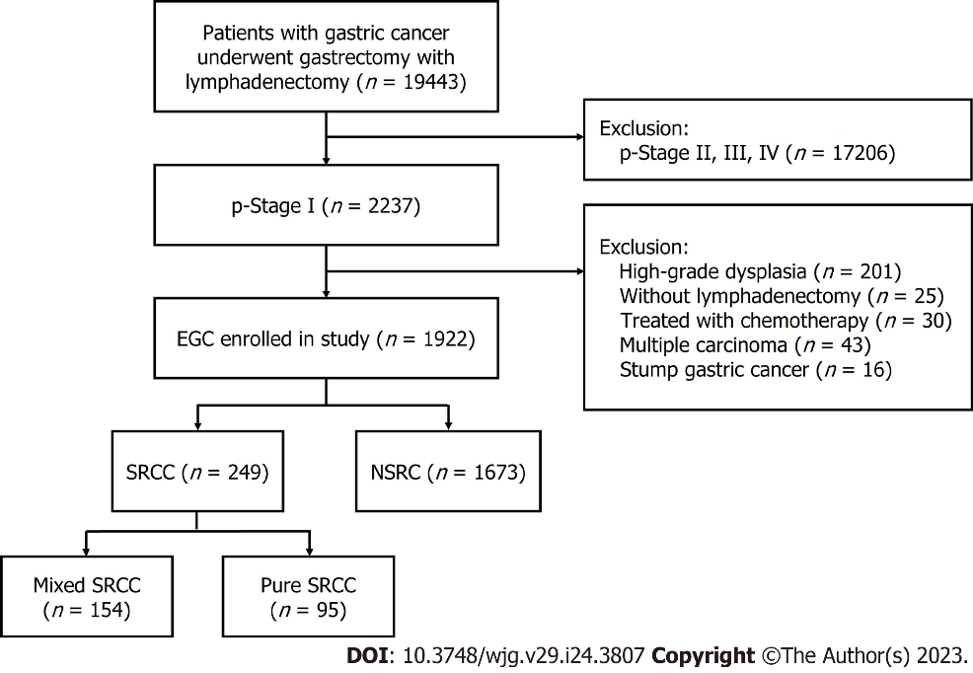
Figure 1 Flow diagram showing the study design and population. EGC: Early gastric cancer; SRCC: Signet ring cell carcinoma; NSRC: Non-signet ring cell carcinoma.

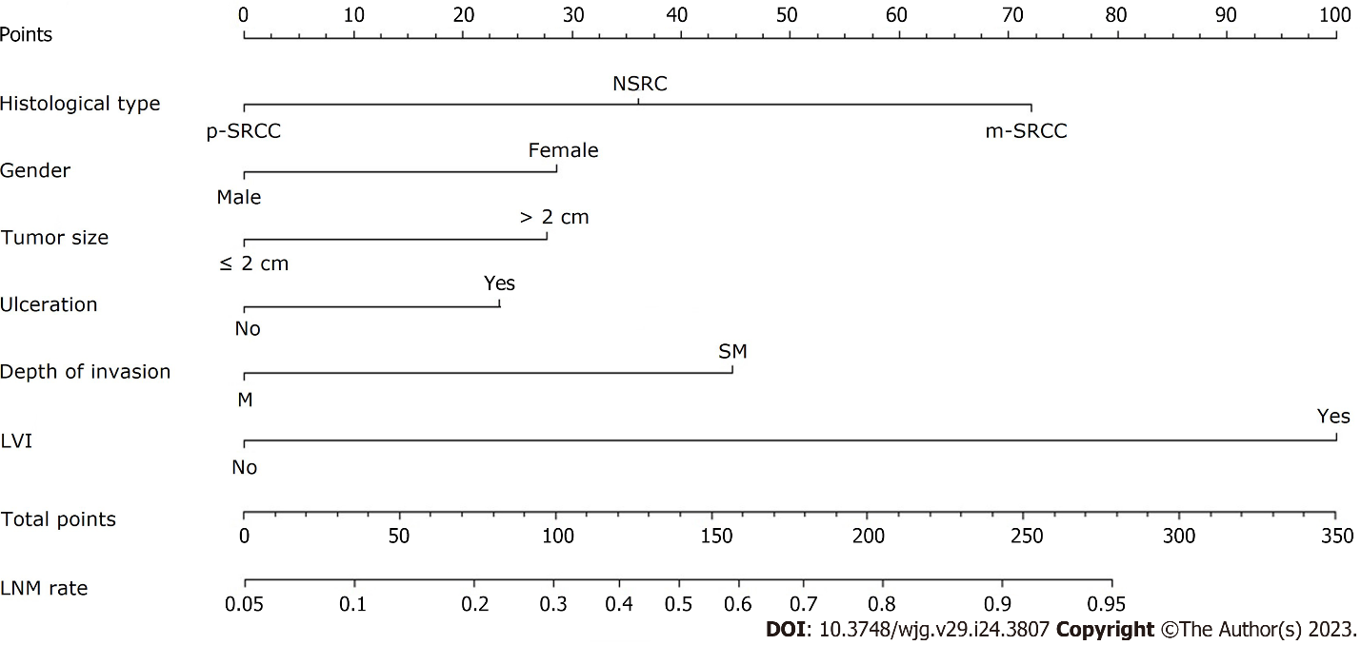
Figure 2 Nomogram for predicting lymph node metastasis in early gastric cancer patients. The factors of histological type, gender, tumor size, ulceration, depth of invasion and lymphovascular invasion were included in the model. p-SRCC: Pure signet-ring cell carcinoma; NSRC: Non-signet ring cell carcinoma; m-SRCC: Mixed signet-ring cell carcinoma; M: Mucosal; SM: Submucosal; LVI: Lymphovascular invasion; LNM: Lymph node metastasis.

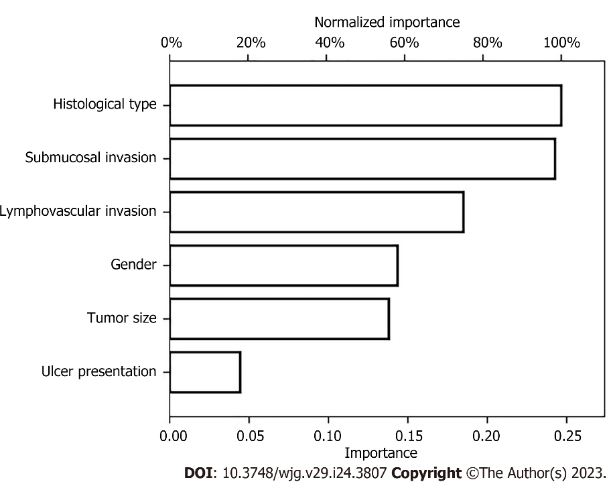
Figure 3 Artificial neural network model for predicting lymph node metastasis in early gastric cancer patients. This model consists of six parameters: histological type, submucosal invasion, lymphovascular invasion, gender, tumor size and ulcer presentation.

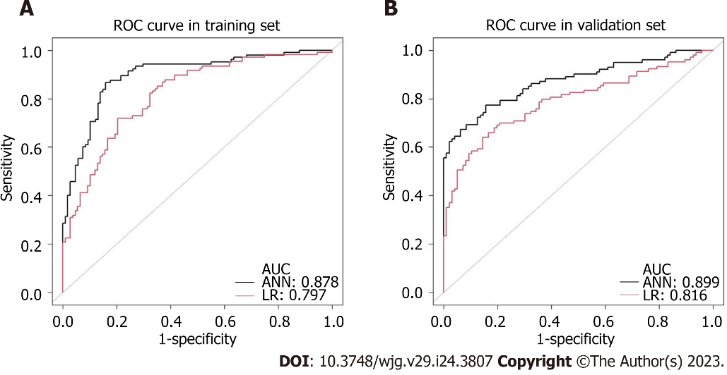
Figure 4 Receiver-operating characteristic curves of the established models for predicting lymph node metastasis in early gastric cancer. The black and the red curve represent the development data of the artificial neural network and logistic regression model, respectively. A: Comparison of receiver-operating characteristic (ROC) plot in the training set, the area under the curve (AUC) was 0.878 vs 0.797, P < 0.001; B: Comparison of ROC plot in the validation set, the AUC was 0.899 vs 0.816, P < 0.001. ROC: Receiver-operating characteristic; AUC: Area under the curve; ANN: Artificial neural network; LR: Logistic regression.

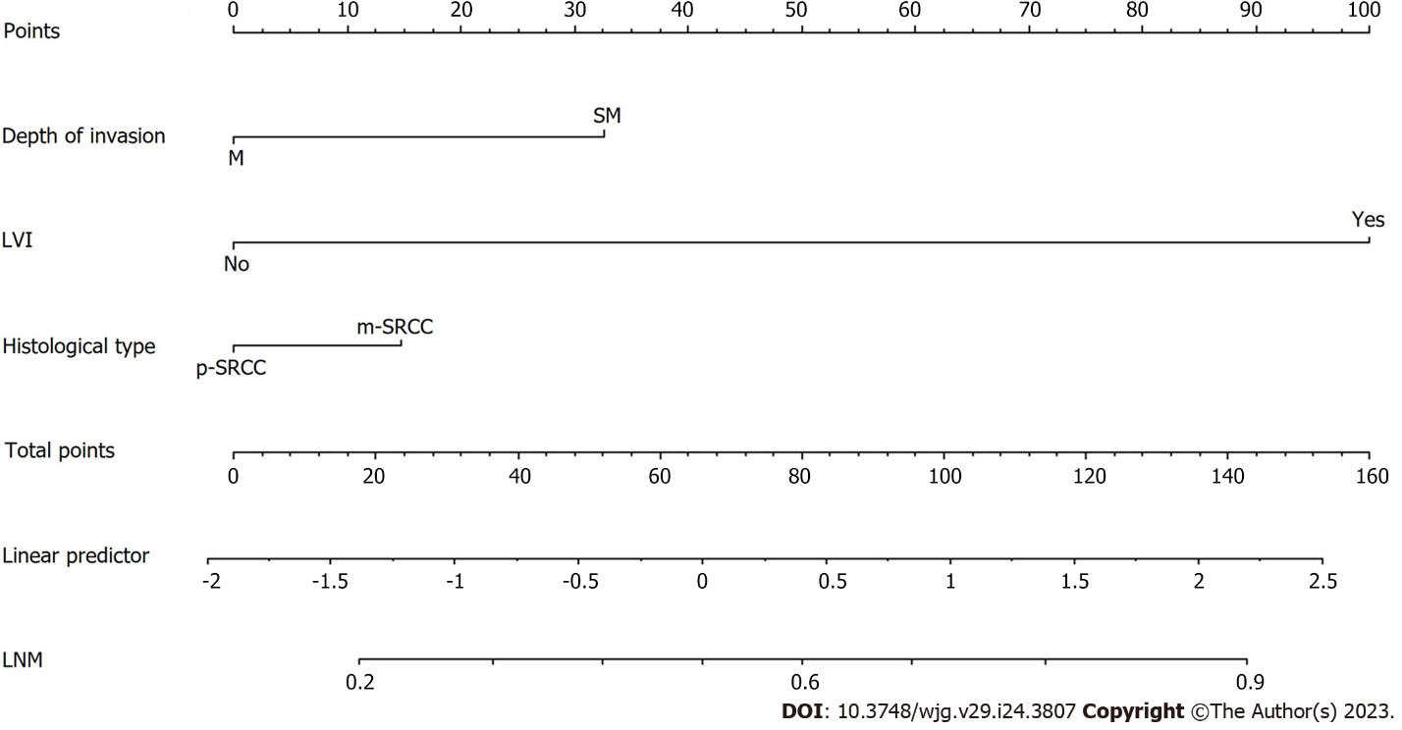
Figure 5 Nomogram for predicting lymph node metastasis in early signet-ring cell carcinoma patients. The factors of histological type, depth of invasion and lymphovascular invasion were included in the model. M: Mucosal; SM: Submucosal; LVI: Lymphovascular invasion; p-SRCC: Pure signet-ring cell carcinoma; m-SRCC: Mixed signet-ring cell carcinoma; LNM: Lymph node metastasis.

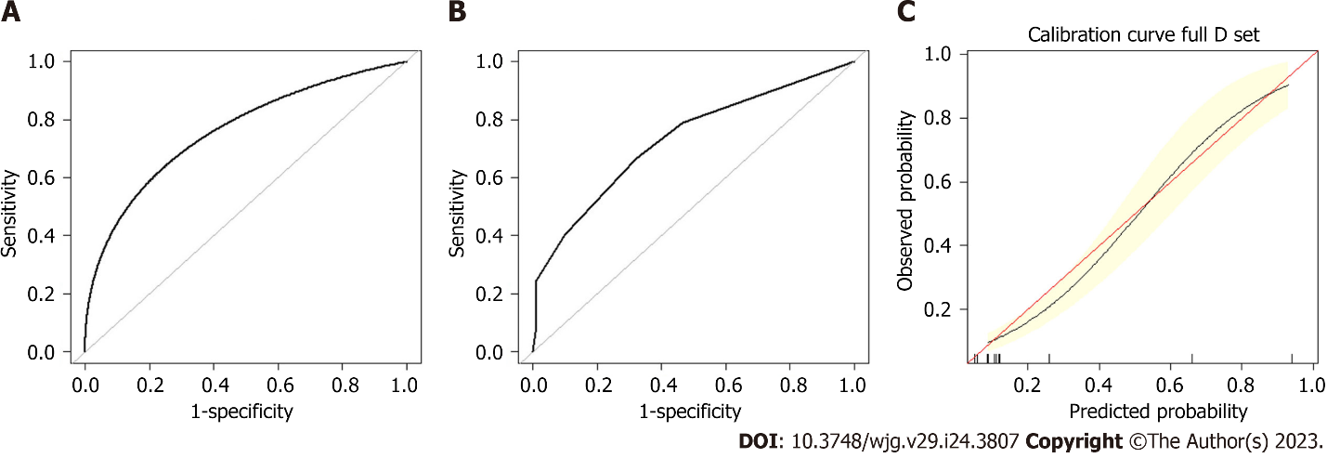
Figure 6 Assessment of the nomogram for predicting lymph node metastasis in the training set and validation set. A: Receiver-operating characteristic receiver-operating characteristic (ROC) plot in the training set. The area under the curve (AUC) of the ROC was 0.760 (95%CI: 0.682-0.843); B: ROC plot in the validation set. The AUC of the ROC was 0.734 (95%CI: 0.643-0.826); C: Calibration plot in the training set. After 2000 repetitions, the bootstrap-corrected calibration curve (black line) lay close to the ideal reference line (red line), which demonstrated a perfect agreement between the predicted and actual outcomes (mean absolute error 0.012).

Table 1 Clinical characteristics in patients with early gastric cancer
 | SRCC | NSRC | P value
 | n = 249, n (%) | n = 1673, n (%)
Age (yr) | 53.14 ± 10.03 | 57.01 ± 11.78 | < 0.001
≤ 65 | 161 (64.66) | 634 (37.90)
> 65 | 88 (35.34) | 1039 (62.10)
Gender |  |  | < 0.001
Male | 133 (53.41) | 1238 (74.00)
Female | 116 (46.59) | 435 (26.00)
Location |  |  | < 0.001
Cardia | 11 (4.42) | 235 (14.05)
Fundus | 5 (2.01) | 143 (8.55)
Body | 43 (17.27) | 296 (17.69)
Antrum | 129 (51.81) | 641 (38.31)
Angle | 61 (24.50) | 358 (21.40)
Macroscopic type |  |  | 0.105
Protruded (0-I) | 3 (1.20) | 27 (1.61)
Elevated (0-IIa) | 11 (4.42) | 128 (7.65)
Flat (0-IIb) | 52 (20.88) | 353 (21.10)
Depressed (0-IIc) | 178 (71.49) | 1076 (64.32)
Excavated (0-III) | 5 (2.01) | 89 (5.32)
Tumor size (cm) | 2.14 ± 1.43 | 1.89 ± 1.22 | 0.001
≤ 2 | 139 (55.82) | 1124 (67.18)
> 2 | 110 (44.18) | 549 (32.82)
Ulceration |  |  | 0.027
UL (-) | 175 (70.28) | 1046 (62.52)
UL (+) | 74 (29.72) | 627 (37.48)
Depth of invasion |  |  | 0.001
M | 149 (59.84) | 808 (48.30)
SM | 100 (40.16) | 865 (51.70)
LVI |  |  | 1
Absence | 231 (92.77) | 1555 (92.95)
Presence | 18 (7.23) | 118 (7.05)
Perineural invasion |  |  | 0.041
Absence | 242 (97.19) | 1658 (99.10)
Presence | 7 (2.81) | 15 (0.90)
LNM |  |  | < 0.001
Absence | 187 (75.10) | 1457 (87.09)
Presence | 62 (24.90) | 216 (12.91)
SRCC: Signet-ring cell carcinoma; NSRC: Non-signet ring cell carcinoma; LVI: Lymphovascular invasion; LNM: Lymph node metastasis; M: Mucosal; SM: Submucosal; UL (-): Ulcer or ulcer scar is absent; UL (+): Ulcer or ulcer scar is present.

Table 2 Logistic regression analysis of the risk factors of lymph node metastasis in early gastric cancer
 | LNM |  | Univariate | Multivariate analysis
 | Present | Absent | P value | OR | 95%CI | P value
Total | 278 | 1644
Age |  |  | 0.015
≤ 65 | 135 | 660
> 65 | 143 | 984
Gender |  |  | < 0.001
Male | 160 | 1211 |  | 1
Female | 118 | 433 |  | 1.912 | 1.392-2.626 | < 0.001
Location |  |  | 0.001
Cardia | 17 | 229
Fundus | 9 | 139
Body | 45 | 294
Antrum | 141 | 629
Angle | 66 | 353
Macroscopic type |  |  | 0.008
Protruded (0-I) | 9 | 21
Elevated (0-IIa) | 16 | 123
Flat (0-IIb) | 37 | 368
Depressed (0-IIc) | 201 | 1053
Excavated (0-III) | 15 | 79
Tumor size (cm) |  |  | < 0.001
≤ 2 | 134 | 1129 |  | 1
> 2 | 144 | 515 |  | 1.875 | 1.260-2.417 | 0.001
Ulceration |  |  | < 0.001
UL (-) | 134 | 1087 |  | 1
UL (+) | 144 | 557 |  | 1.695 | 1.246-2.306 | 0.001
Depth of invasion |  |  | < 0.001
M | 54 | 903 |  | 1
SM | 224 | 741 |  | 3.34 | 2.156-5.174 | < 0.001
LVI |  |  | < 0.001
Absence | 199 | 1587 |  | 1
Presence | 79 | 57 |  | 6.682 | 4.358-10.245 | < 0.001
Perineural invasion |  |  | < 0.001
Absence | 262 | 1638
Presence | 16 | 6
Histological type
Pure SRCC | 8 | 87 | < 0.001 | 1 |  | < 0.001
NSRC | 216 | 1457 |  | 2.619 | 1.454-3.598 | 0.894
Mixed SRCC | 54 | 100 |  | 4.595 | 2.654-6.954 | < 0.001
SRCC: Signet-ring cell carcinoma; NSRC: Non-signet ring cell carcinoma; M: Mucosal; SM: Submucosal; LVI: Lymphovascular invasion; LNM: Lymph node metastasis; UL (-): Ulcer or ulcer scar is absent; UL (+): Ulcer or ulcer scar is present.

Table 3 The Classification of the artificial neural network model and logistic regression model
Models | Predicted results | Pathological diagnosis
 |  | + | - | Percent correct
LR | + | 77 | 55 | 58.3%
 | - | 201 | 1589 | 88.8%
 | Percent correct | 27.7% | 96.7% | 86.7%
ANN | + | 54 | 2 | 96.4%
 | - | 224 | 1642 | 88.0%
 | Percent correct | 19.4% | 99.9% | 88.2%
LR: Logistic regression; ANN: Artificial neural network.

Table 4 Comparison of artificial neural network model and logistic regression model for predicting lymph node metastasis
Diagnostic Index | LR model, (%, 95%CI) | ANN model (%, 95%CI) | P value
Sensitivity | 58.3% (48.6-67.1%) | 96.4% (87.8-99.9%) | 0.034
Specificity | 88.8% (87.2-90.4%) | 88.0% (86.4-89.6%) | < 0.001
PPV | 27.7% (22.3-33.9%) | 19.4% (14.9-25.2%) | < 0.001
NPV | 96.7% (95.6-97.5%) | 99.9% (99.6-1.000%) | 0.202
Accuracy | 86.7% (85.1-88.2%) | 88.2% (86.8-89.8%) | < 0.001
AUC | 0.797 (0.776-0.818) | 0.878 (0.862-0.893) | < 0.001
PPV: Positive predictive value; NPV: Negative predictive value; AUC: Area under the curve.

Table 5 Clinical characteristics in patients with pure signet-ring cell carcinoma and mixed signet-ring cell carcinoma
Variable | Pure SRCC | Mixed SRCC | P value
 | n = 95, n (%) | n = 154, n (%)
Age (yr) |  |  | 0.037
≤ 65 | 70 (73.68) | 91 (59.09)
> 65 | 25 (26.32) | 63 (40.91)
Gender |  |  | 0.131
Male | 46 (48.42) | 87 (56.49)
Female | 49 (51.58) | 67 (43.51)
Location |  |  | 0.255
Cardia | 4 (4.21) | 7 (4.55)
Fundus | 2 (2.11) | 3 (1.95)
Body | 13 (13.68) | 30 (19.48)
Antrum | 51 (53.68) | 78 (50.65)
Angle | 25 (26.32) | 36 (23.38)
Macroscopic type |  |  | 0.152
Protruded (0-I) | 1 (1.05) | 2 (1.30)
Elevated (0-IIa) | 5 (5.26) | 6 (3.90)
Flat (0-IIb) | 23 (24.21) | 29 (18.83)
Depressed (0-IIc) | 65 (68.42) | 113 (73.38)
Excavated (0-III) | 1 (1.05) | 4 (2.60)
Tumor size (cm) |  |  | 0.126
≤ 2 | 60 (63.16) | 79 (51.30)
> 2 | 35 (36.84) | 75 (48.70)
Ulceration |  |  | 0.051
UL (-) | 75 (78.95) | 100 (64.94)
UL (+) | 20 (21.05) | 54 (35.06)
Depth of invasion |  |  | < 0.001
M | 71 (74.74) | 78 (50.65)
SM | 24 (25.26) | 76 (49.35)
LVI |  |  | 0.002
Absence | 95 (100.00) | 136 (88.31)
Presence | 0 (0.00) | 18 (11.69)
Perineural invasion |  |  | 0.420
Absence | 94 (98.95) | 148 (96.10)
Presence | 1 (1.05) | 6 (3.90)
LNM |  |  | < 0.001
Absence | 87 (91.58) | 100 (64.94)
Presence | 8 (8.42) | 54 (35.06)
SRCC: Signet-ring cell carcinoma; M: Mucosal; SM: Submucosal; LNM: Lymph node metastasis; LVI: Lymphovascular invasion; UL (-): Ulcer or ulcer scar is absent; UL (+): Ulcer or ulcer scar is present.

Table 6 Logistic regression analysis of the risk factors of lymph node metastasis in signet-ring cell carcinoma
 | LNM |  | Univariate | Multivariate analysis
 | Present | Absent | P value | OR | 95%CI | P value
Total | 62 | 187
Age |  |  | 0.617
≤ 65 | 41 | 120
> 65 | 21 | 67
Gender |  |  | 0.639
Male | 32 | 101
Female | 30 | 86
Location |  |  | 0.544
Cardia | 2 | 9
Fundus | 1 | 4
Body | 10 | 33
Antrum | 33 | 96
Angle | 16 | 45
Macroscopic type |  |  | 0.209
Protruded (0-I) | 0 | 3
Elevated (0-IIa) | 1 | 10
Flat (0-IIb) | 13 | 39
Depressed (0-IIc) | 46 | 132
Excavated (0-III) | 2 | 3
Tumor size (cm) |  |  | 0.351
≤ 2 | 30 | 109
> 2 | 32 | 78
Ulceration |  |  | 0.06
UL (-) | 37 | 128
UL (+) | 25 | 46
Depth of invasion |  |  | < 0.001
M | 20 | 129 |  | 1
SM | 42 | 58 |  | 2.615 | 1.282-5.334 | 0.008
LVI |  |  | < 0.001
Absence | 46 | 185 |  | 1
Presence | 16 | 2 |  | 14.903 | 3.143-70.680 | 0.001
Perineural invasion |  |  | 0.146
Absence | 58 | 184
Presence | 4 | 3
Histological type |  |  | < 0.001
Pure SRCC | 8 | 87 |  | 1
Mixed SRCC | 54 | 100 |  | 1.982 | 0.923-4.237 | 0.043
SRCC: Signet-ring cell carcinoma; M: Mucosal; SM: Submucosal; LNM: Lymph node metastasis; LVI: Lymphovascular invasion; UL (-): Ulcer or ulcer scar is absent; UL (+): Ulcer or ulcer scar is present.

Table 7 Logistic regression analysis of the risk factors of lymph node metastasis in signet-ring cell carcinoma limited in mucosal
 | LNM |  | Univariate | Multivariate analysis
 | Present | Absent | P value | OR | 95%CI | P value
Total | 20 | 129
Age |  |  | 0.195
≤ 65 | 10 | 80
> 65 | 10 | 49
Gender |  |  | 0.306
Male | 9 | 77
Female | 11 | 52
Tumor size (cm) |  |  | 0.123
≤ 2 | 8 | 78
> 2 | 12 | 51
Macroscopic type |  |  | 0.209
Protruded (0-I) | 0 | 2
Elevated (0-IIa) | 0 | 7
Flat (0-IIb) | 4 | 27
Depressed (0-IIc) | 15 | 91
Excavated (0-III) | 1 | 2
LVI |  |  | 0.016
Absence | 18 | 129
Presence | 2 | 0
Perineural invasion |  |  | -
Absence | 20 | 129
Presence | 0 | 0
Location |  |  | 0.688
Cardia | 1 | 6
Fundus | 0 | 3
Body | 3 | 23
Antrum | 11 | 66
Angle | 5 | 31
Ulceration |  |  | 1
UL (-) | 15 | 101
UL (+) | 3 | 28
Histological type |  |  | 0.01
Pure SRCC | 3 | 66 |  | 1
Mixed SRCC | 17 | 63 |  | 4.557 | 1.235-16.820 | 0.023
SRCC: Signet-ring cell carcinoma; LNM: Lymph node metastasis; LVI: Lymphovascular invasion; UL (-): Ulcer or ulcer scar is absent; UL (+): Ulcer or ulcer scar is present.

Table 8 Logistic regression analysis of the risk factors of lymph node metastasis in pure and mixed signet-ring cell carcinoma
 | LNM |  |  |  | Univariate |  | Multivariate analysis
 | Present |  | Absent |  | P value |  | OR, 95%CI, P value
 | Pure | Mixed | Pure | Mixed | Pure | Mixed | Pure | Mixed
Total | 8 | 54 | 87 | 100
Age |  |  |  |  | 1 | 1
≤ 65 | 7 | 33 | 58 | 63
> 65 | 1 | 21 | 29 | 37
Gender |  |  |  |  | 1 | 0.377
Male | 3 | 29 | 39 | 62
Female | 5 | 25 | 48 | 38
Location |  |  |  |  | 0.706 | 0.412
Cardia | 0 | 2 | 4 | 5
Fundus | 0 | 1 | 2 | 2
Body | 1 | 9 | 12 | 21
Antrum | 5 | 28 | 46 | 50
Angle | 2 | 14 | 23 | 22
Macroscopic type |  |  |  |  | 0.788 | 0.314
Protruded (0-I) | 0 | 0 | 1 | 2
Elevated (0-IIa) | 0 | 1 | 5 | 5
Flat (0-IIb) | 3 | 10 | 20 | 19
Depressed (0-IIc) | 4 | 42 | 61 | 71
Excavated (0-III) | 1 | 1 | 0 | 3
Tumor size (cm) |  |  |  |  | 0.014 | 0.751
≤ 2 | 4 | 26 | 56 | 53 |  |  | 1
> 2 | 4 | 28 | 31 | 47 |  |  | 5.422 (1.095-26.856), 0.038
Ulceration |  |  |  |  | 1 | 0.189
UL (-) | 6 | 31 | 69 | 69
UL (+) | 2 | 23 | 18 | 31
Depth of invasion |  |  |  |  | 0.045 | 0.004
M | 3 | 17 | 70 | 59 |  |  |  | 1
SM | 5 | 37 | 17 | 41 |  |  |  | 2.395 (0.891-4.998), 0.054
LVI |  |  |  |  | - | < 0.001
Absence | 8 | 38 | 87 | 98 |  |  |  | 1
Presence | 0 | 16 | 0 | 2 |  |  |  | 16.173 (4.085-76.619), 0.001
Perineural invasion |  |  |  |  | 1 | 0.376
Absence | 8 | 50 | 86 | 98
Presence | 0 | 4 | 1 | 2
Mixed component |  |  |  |  |  | 0.458
Differentiated | - | 1 | - | 7
Undifferentiated | - | 30 | - | 58
Mixed | - | 23 | - | 35
M: Mucosal; SM: Submucosal; LNM: Lymph node metastasis; LVI: Lymphovascular invasion; UL (-): Ulcer or ulcer scar is absent; UL (+): Ulcer or ulcer scar is present.

Table 9 Lymph node metastasis in early gastric signet-ring cell carcinoma according to therapeutic criteria
 | Meet expanded ESD indication |  |  | Beyond expanded ESD indication |  |  | P value
 | Total | LNM (+) | LNM (-) | Total | LNM (+) | LNM (-)
p-SRCC | 41 | 1 | 40 | 54 | 7 | 47 | 0.132
m-SRCC | 31 | 5 | 26 | 123 | 45 | 78 | 0.048
Total | 72 | 6 | 66 | 177 | 52 | 125 | 0.001
ESD: Endoscopic submucosal dissection; p-SRCC: Pure signet-ring cell carcinoma; m-SRCC: Mixed signet-ring cell carcinoma; LNM: Lymph node metastasis.

Published by Baishideng Publishing Group Inc
7041 Koll Center Parkway, Suite 160, Pleasanton, CA 94566, USA
Telephone: +19253991568
Email: bpgoffice@wjgnet.com
Help Desk: https://www.f6publishing.com/helpdesk
https://www.wjgnet.com

© 2023 Baishideng Publishing Group Inc. All rights reserved.

