Name of Journal: World Journal of Gastrointestinal Surgery
Manuscript NO: 87027
Manuscript Type: MINIREVIEWS

Indocyanine green fluorescence in gastrointestinal surgery: Appraisal of current evidence

Kalayarasan R et al. ICG fluorescence in gastrointestinal surgery

Raja Kalayarasan, Murugesan Chandrasekar, Pothugunta Sai Krishna, Dasarathan Shanmugam

Raja Kalayarasan, Murugesan Chandrasekar, Pothugunta Sai Krishna, Dasarathan Shanmugam, Department of Surgical Gastroenterology, Jawaharlal Institute of Postgraduate Medical Education and Research, Puducherry 605006, India

Author contributions: Kalayarasan R and Chandrasekar M conceptualized the work, supervised the writing, gave intellectual inputs, and critically revised the manuscript; Sai Krishna P and Shanmugam D did the literature search and wrote the first draft of the manuscript.

Corresponding author: Raja Kalayarasan, FRCS (Ed), MBBS, MCh, MS, Additional Professor, Department of Surgical Gastroenterology, Jawaharlal Institute of Postgraduate Medical Education and Research, Dhanvantari nagar, Puducherry 605006, India. kalayarasanraja@yahoo.com

Received: July 19, 2023
Revised: October 12, 2023
Accepted: November 9, 2023
Published online: December 27, 2023

Abstract
Applying indocyanine green (ICG) fluorescence in surgery has created a new dimension of navigation surgery to advance in various disciplines. The research in this field is nascent and fragmented, necessitating academic efforts to gain a comprehensive understanding. The present review aims to integrate diverse perspectives and recent advances in its application in gastrointestinal surgery. The relevant articles were selected by using the appropriate keyword search in PubMed. The angiography and cholangiography property of ICG fluorescence is helpful in various hepatobiliary disorders. In gastroesophageal and colorectal surgery, the lymphangiography and angiography property of ICG is applied to evaluate bowel vascularity and guide lymphadenectomy. The lack of objective parameters to assess ICG fluorescence has been the primary limitation when ICG is used to evaluate bowel perfusion. The optimum dose and timing of ICG administration need to be standardized in some new application areas in gastrointestinal surgery. Binding tumor-specific ligands with fluorophores can potentially widen the fluorescence application to detect primary and metastatic gastrointestinal tumors. The narrative review outlines prior contributions, limitations, and research opportunities for future studies across gastrointestinal sub-specialty. The findings of the present review would be helpful for scholars and practitioners to explore and progress in this exciting domain of gastrointestinal surgery.

Key Words: Indocyanine green; Fluorescence; Navigation surgery; Angiography; Cholangiography; Lymphangiography

©The Author(s) 2023. Published by Baishideng Publishing Group Inc. All rights reserved.

Citation: Kalayarasan R, Chandrasekar M, Sai Krishna P, Shanmugam D. Indocyanine green fluorescence in gastrointestinal surgery: Appraisal of current evidence. World J Gastrointest Surg 2023; 15(12): 2693-2708
URL: https://www.wjgnet.com/1948-9366/full/v15/i12/2693.htm
DOI: https://dx.doi.org/10.4240/wjgs.v15.i12.2693

Core Tip: Indocyanine green (ICG)’s unique absorption and emission spectrum allows its wide application in gastrointestinal surgery. The fluorescence cholangiography property of ICG is widely used in hepatobiliary surgery to identify bile ducts. Its angiography property is used in liver surgery for tumor identification and to facilitate anatomic liver resection. Also, the angiography function is helpful in luminal surgeries to assess bowel perfusion. The limitations of ICG fluorescence highlighted in the present review could guide future research on ICG in gastrointestinal surgery.

INTRODUCTION
Fluorescence is the property of a substance to absorb light at one wavelength and emits at a higher wavelength, primarily within the visible spectrum, with a loss of photons. Since the late 19th century, the fluorescence property of many agents has been used in microscopic labelling for antigen or antibody detection^{[1]}. Most commonly used fluorescence agents absorb and emit light within the visible spectrum. However, its use is limited in-vivo due to the absorption of wavelengths of visible light less than 650 nm and greater than 900 nm by blood hemoglobin and water, respectively. Hence, for in-vivo application, the fluorescence agent should be within the optical window of 650-900 nm^{[2]}. Indocyanine green (ICG) absorbs light at 760 nm and emits at 820-830 nm, which is outside the visible human spectrum but can be identified with infrared camera devices^{[3]}. The unique absorption and emission spectrum allow its wide application in gastrointestinal surgery.
ICG, approved for human use in 1956, is a non-toxic, anionic, hydrophilic tricarbocyanine with a wide safety margin. It is excreted unmetabolized by the liver with no enterohepatic circulation. ICG has a short half-life of 3-5 min. When administered parenterally, ICG binds to plasma proteins and remains within the intravascular compartment with insignificant interstitial space translocation. The initial application of ICG for cardiac output, renal blood flow, and hepatic function monitoring was based on its metabolic characteristics^{[4]}. However, the fluorescence property of ICG expanded its application manifold, as documented by the phenomenal growth in publications and scholarly interest (Figure 1).
Kogure et al^{[5]} incidentally detected the fluorescence property of the ICG in an animal study. The development of near infra-red video camera facilitated its use in real-time surgery as an angiography, cholangiography or lymphangiography agent. With extravascular administration, ICG is taken by draining lymph nodes through lymphatic channels. Utilizing this property, Kitai et al^{[6]} used ICG for breast cancer sentinel lymph node mapping. Subsequently, Miyashiro et al^{[7]} demonstrated its usefulness in identifying lymphatic vessels and sentinel lymph nodes draining primary gastric tumors using intraoperative endoscopic peritumoral ICG injection. Aoki et al^{[8]} reported the role of ICG fluorescence in liver segmentation and cholangiography. In 2011, Kawaguchi et al^{[9]} demonstrated fusion imaging of ICG fluorescence and white light for real-time liver resection. ICG-related publications peaked at 293 for 2022, making it the most productive year in this domain. Further, most ICG-related publications are from Japan (n = 527), followed by the United States (n = 451) and China (n = 201) (Figure 2).

SEARCH STRATEGY
All the authors did a PubMed search of relevant articles. The keywords and combinations included in the search were: “fluorescence”; “Indocyanine green”; “surgery”; “liver segmentation”; “hepatectomy”; “liver resection”; “cholangiography”; “transplantation”; “esophagectomy”; ”gastrectomy”; “gastric conduit”; “colonic conduit”; “lymphadenectomy”. Appropriate search syntaxes, such as parentheses and Boolean operators, were used as required for each topic. The search was limited to human studies and articles in English.

ICG FLUORESCENCE IN LIVER SURGERY
ICG fluorescence imaging facilitates intraoperative decision-making and improves patient safety through applications like liver segmentation, tumor detection, cholangiography and perfusion assessment.

Anatomical segmentation for liver resection
The surgical anatomy of the liver is complex, with the intersection of the portal pedicle and the hepatic vein in the liver parenchyma. It employs the imaginary plane of the portal pedicle and hepatic vein for liver segmentation. Surgical resection is the primary treatment for both primary and secondary liver tumors. Also, anatomical liver resection is preferred for less intraoperative bleeding and superior oncological outcomes in selected patients^{[10]}. The surgeon utilizes preoperative computed tomography and intraoperative ultrasound images to create an imaginary visual plane of anatomical transection. ICG fluorescence with fusion image enables precise real-time visualization of this imaginary plane^{[11]}.
Kobayashi et al^{[12]} demonstrated five techniques of staining portal vein territory for intraoperative liver segmentation. It includes single staining, multiple staining, counterstaining, paradoxical negative and negative staining. In single and multiple staining, ICG is directly injected into the portal pedicle of interest under ultrasound guidance, and the area of interest shows fluorescence. In counterstaining and paradoxical negative staining, the portal or hepatic vein to the region of interest is blocked by tumor thrombus, invasion, or embolism. Hence, direct injection of ICG to the portal vein results in positive staining of the liver parenchyma adjacent to the area of interest. In negative staining, the portal pedicle supplying the area of interest is clamped, and ICG is given intravenously to stain the normal area (Figure 3). The initial four techniques require direct puncture of portal vein branches. The ICG dose for positive and negative staining is 0.25 mg/kg of body weight and 2.5 mg/kg of body weight, respectively^{[12]}.
The negative staining technique is primarily used for major hepatectomy where the Glissonean pedicle of the hemi-liver or sector to be resected is ligated. For mono-segmentectomy and sub-segmentectomy, positive staining techniques are preferred^{[13]}. However, the success of positive staining depends on the operator’s ability to accurately puncture the segmental or sub-segmental portal vein under ultrasound guidance and inject the dye slowly without reflux to adjacent segments. Also, with the increasing use of the minimal access approach in liver surgery, positive staining by direct portal vein puncture using laparoscopic intraoperative ultrasound is challenging. To overcome that, Ueno et al^{[14]} reported the use of interventional radiology-guided placement of microcatheter in the target segmental hepatic artery branch. 2 mL of diluted ICG saline solution (0.125 mg/mL) is injected with the embolic agent (gelatin particles) to retain ICG in the area of interest (Tables 1 and 2)^{[14-16]}. Qian et al^{[16]} reported a high success rate of 80% in trans-arterial staining compared to 60% in portal venous staining method. Li et al^{[17]} reported a similar technique of super-selective arterial injection of ICG and noted a 100% success rate in identifying an appropriate intersegmental plane for hepatic resection. However, this technique is contraindicated in patients with significant arteriovenous shunting in the region of interest. In addition to failure to cannulate the target portal vein branch, reflux to the non-target segment, collateral to adjacent segment and uneven uptake due to tumor obstructing the pedicle are other causes of failure with a positive staining technique^{[18,19]}. The main advantage of ICG fluorescence over other staining techniques is the ability to identify the intersegmental plane during deep parenchymal transection and the application of the pringle maneuver^{[20,21]}.

Hepatic tumor detection
ICG bound to lipoprotein is taken up by hepatocytes via organic anions-transporting polypeptides and sodium taurocholate co-transporting polypeptides channels. Subsequently, ICG is secreted unmetabolized into the bile via multidrug resistance-associated proteins 2. In well and moderately differentiated hepatocellular carcinoma (HCC) tumor cells, the ICG uptake mechanism is intact, but the excretion is impaired. Hence, HCC shows complete or partial fluorescence, depending upon the differentiation grade. In poorly differentiated HCC and metastatic liver tumors ICG uptake is also impaired, resulting in negative staining. However, some of these lesions may show rim fluorescence. It is due to immature hepatocytes in the peritumoral region that take up ICG but unable to secrete it into bile canaliculus^{[22]}. Fluorescence imaging is primarily helpful for detecting subcapsular tumors within 10 mm of the liver surface. However, it is not useful for deep parenchymal tumors except those on the cut surface of the liver parenchyma. Thus, ICG fluorescence and intraoperative ultrasound supplement each other (Table 3). Despite the high sensitivity of fluorescence imaging to detect liver tumors, a false positive rate close to 40% due to regenerative nodules in cirrhosis patients and Von-Meyenburg complex underscores the need for further clinical assessment of fluorescent liver lesions^{[23]}. Cai et al^{[24]} reported the application of ICG for tumor margin identification in patients undergoing laparoscopic liver resection for HCC and colorectal liver metastases in 86 patients (Table 3). The authors reported a 96% positive rate of ICG staining for the hepatic malignant lesions.
Similarly, Piccolo et al^{[25]} and Terasawa et al^{[26]} reported a 100% and 85% high success rate in identifying malignant liver lesions. The dose and timing of ICG injection for tumor imaging depend on the indication^{[27,28]}. If ICG is primarily used for preoperative estimation of liver function with an added indication of tumor detection recommended dose is 0.5 mg/kg of body weight 7-14 d before surgery. If the primary indication is tumor detection 0.2 mg/kg of body weight is administered 1-2 d before surgery^{[29,30]}.

Liver transplantation
In living donor transplantation optimal site of bile duct division is critical to prevent biliary complications in both donor and recipient. Mizuno et al^{[31]} documented its usefulness in delineating the right posterior sectoral bile duct following intrabiliary injection into the left hepatic duct in a donor undergoing left hepatectomy. Hong et al^{[32]} reported that intravenous ICG injection allowed real-time identification of the biliary tree around the hilar plate and facilitated optimal bile duct division in patients undergoing laparoscopic living donor hepatectomy. The optimal route and timing of ICG administration in living donor transplantation are not standardized. However, intravenous ICG injection following inflow control of the ipsilateral hemi-liver facilitates the identification of the transection plane and bile duct division, as by the time the liver transection is completed, ICG would have been excreted into the bile duct.
ICG fluorescence imaging also allows the evaluation of graft perfusion and veno-occlusive regions. Hepatic venous outflow obstruction is a significant cause of graft dysfunction due to a reduction in functional liver volume. Kawaguchi et al^{[33]} documented the usefulness of ICG fluorescence intensity in evaluating veno-occlusive regions. They calculated the ICG concentration of the veno-occlusive and non-veno-occlusive regions from the plateau fluorescence intensity. The study showed that portal uptake is diminished to 40% in the veno-occlusive area compared to the non-veno-occlusive region. It allows real-time evaluation of functional liver volume and guides the need for venous reconstruction in veno-occlusive regions. Also, they documented that the reduction in portal uptake function in the veno-occlusive areas of S5 tends to be smaller compared to the similar regions in S8. The difference is due to a more prominent communication vein to the right hepatic vein in segment 5 compared to segment 8. Hence, reconstruction is often needed for the segment 8 vein. Traditionally intraoperative ultrasound with Doppler is used for the evaluation of vascular anastomosis. However, intravenous ICG administration facilitates real-time evaluation of graft perfusion and complements Doppler evaluation for vascular thrombosis^{[33]}.

ICG FLUORESCENCE IN BILIARY SURGERY
The feasibility of fluorescence cholangiography-guided laparoscopic cholecystectomy was documented by Ishizawa et al^{[34]}. Subsequently, multiple studies, including an randomized controlled trial (RCT), have shown that fluorescence cholangiography is superior to conventional white-light imaging for identifying extrahepatic biliary anatomy before and after the dissection of the Calot triangle. While the first RCT comparing fluorescence cholangiography with conventional white light imaging was not adequately powered to identify differences in the rates of bile duct injuries between the two techniques, fluorescence cholangiography could reduce the risk of bile duct injuries related to anatomical variation or visual misperception of biliary anatomy^{[35]}. Also, fluorescence cholangiography is helpful in delineating the biliary anatomy clearly in challenging cases such as acute cholecystitis and Mirizzi syndrome, thereby reducing conversion rate and bile duct injuries^{[36]}.
Compared to conventional intraoperative radiographic cholangiography, fluorescence cholangiography does not require ionizing radiation and provides images in real-time, even before the dissection of the Calot triangle. However, fluorescence cholangiography does not help visualize common bile duct stones and intrahepatic biliary anatomy. Also, fluorescence cholangiography is not helpful in obese patients with thick fat in the Calot triangle due to limited penetration of near infra-red light. While fluorescence cholangiography could reduce the need for radiographic cholangiography in the future, it cannot wholly replace the radiographic technique, and both will have a complementary role^{[37]}.
For fluorescence cholangiography, ICG can be injected intravenously or intrabiliary. Intravenous ICG can be injected from 30 min up to 24 h before surgery at a dose of 0.05 mg/kg body weight or a total dose of 2.5 mg. Until 24 h, as the interval between intravenous injection and surgery increases, the bile duct to background liver contrast ratio improves, thereby facilitating the identification of the biliary tree^{[38]}. As most laparoscopic cholecystectomy is done as a day-care surgical procedure, intravenous ICG is often administered at the time of induction of anaesthesia or 3-6 h before surgery. For intrabiliary administration, like direct portal vein injection, dilute ICG (0.025 mg/mL) is administered through a trans cystic tube. While intrabiliary injection permits immediate visualization without background liver fluorescence, intravenous ICG injection is more convenient and avoids bile duct injuries associated with inserting a trans cystic tube. Also, spillage of ICG during an injection can obscure adequate visualization of the biliary tree due to background fluorescence. However, intrabiliary injection is preferred in patients with a preoperative percutaneous biliary drainage tube.

ICG FLUORESCENCE IN PANCREATIC SURGERY
In pancreatic surgery, ICG is helpful for tumor localization, assessing pancreatic stump vascularity, and obtaining retroperitoneal margin in patients undergoing pancreaticoduodenectomy. Also, in patients undergoing duodenum preserving pancreas head resection, ICG helps localize the bile duct and assess duodenal vascularity. Pancreas is a highly vascular organ, and most pancreatic tumors, except neuroendocrine tumors, are poorly vascular^{[39]}. In contrast to the fluorescence mechanism of liver tumors, pancreatic lesions were visualized based on the difference in vascularity between the lesions and the surrounding parenchyma. ICG fluorescence is more sensitive to detecting pancreatic neuroendocrine tumors and cystic neoplasms than pancreatic ductal adenocarcinoma. Pancreatic neuroendocrine tumors appear highly fluorescent, whereas cystic neoplasms appear as fluorescence defect lesions. Real-time visualization of pancreatic tumors permits parenchyma-preserving surgeries for low-grade tumors and improves the R0 resection rate with malignant tumors. Tumor visualization is potentially helpful in patients undergoing minimally invasive resection without tactile feedback. As fluorescence imaging fails to visualize minor differences in fluorescence intensity between tumor and pancreatic parenchyma, pancreatic duct adenocarcinomas are not detected well with ICG. Also, fluorescence imaging cannot detect deeper parenchymal lesions. Hence, the current role of ICG fluorescence imaging is to complement conventional intraoperative tumor detection techniques like visual inspection, palpation, and intra-operative ultrasound.
Strasberg et al^{[40]} reported that the pancreatic neck region commonly used for pancreaticoenteric anastomosis following pancreaticoduodenectomy is the vascular watershed region of the pancreas. Ischemia of the pancreatic stump following pancreas mobilization was proposed as a contributing factor for pancreaticojejunostomy leak. Rho et al^{[41]} reported the usefulness of ICG in assessing the perfusion of the pancreatic stump. Pancreatic perfusion was observed within 30 s after an intravenous injection of 5 mg ICG. However, this technique’s current limitations are the lack of objective quantification of perfusion, optimum ICG dosage, and time to assess perfusion. As pancreatic hypo perfusion is not the only contributor to pancreatic leak, documenting the potential usefulness of ICG-fluorescence imaging in reducing pancreatic fistula is challenging.
A negative retroperitoneal margin is a significant predictor of long-term oncological outcomes in patients undergoing pancreaticoduodenectomy. In open pancreaticoduodenectomy, frequent palpation of the superior mesenteric artery guides the correct dissection plane. However, in a minimally invasive approach, due to the lack of tactile feedback differentiating pancreatic tissue of the uncinate process from the nerve plexus around the superior mesenteric artery could be a challenge. Rho et al^{[42]} reported the usefulness of ICG-fluorescence-guided uncinate dissection in 10 patients undergoing laparoscopic pancreaticoduodenectomy. Following the intravenous injection of ICG, the initially detected fluorescence signal disappeared from the superior mesenteric artery. Whereas fluorescence signal gradually accumulated in the pancreas providing good contrast between the ICG-stained uncinate process of the pancreas and the superior mesenteric artery. However, their study could not demonstrate the oncological advantage of ICG-guided uncinate dissection due to the small sample size.
Duodenum preserving pancreatic head resection is indicated in patients with non-invasive tumors of the pancreas head and chronic pancreatitis patients with head mass. However, the reported incidence of bile leak due to injury to the intrapancreatic bile duct ranges from 11.8% to 16.7%. Lu et al^{[43]} reported that intravenous administration of ICG 12-24 h before surgery identified intrapancreatic bile duct in 93.3% of patients. Also, ICG injected 24 h before surgery at a dose of 0.5 mg/kg had the highest signal-to-noise ratio (Figure 4). Also, in this group of patients, intraoperative administration of ICG permits the assessment of duodenal vascularity through the pancreaticoduodenal arcade along the medial wall of the duodenum.

ICG FLUORESCENCE IN ESOPHAGEAL SURGERY
In esophageal surgery, lymphangiography function of the ICG fluorescence is used for lymphatic mapping and visualization of the thoracic duct. The angiography function of the ICG is used to assess the vascularity of the conduit for esophageal reconstruction.

Vascular assessment of oesophageal replacement conduit
Evaluation of conduit vascularity is the most studied application of ICG fluorescence in esophageal surgery. Anastomotic leak is a significant complication after esophageal replacement, and poor conduit perfusion is a considerable risk factor. After esophagectomy, ICG is used to assess the vascularity of the gastric or colon conduit before anastomosis. A meta-analysis of 17 studies reported a pooled anastomotic leak rate of 10.8%, comparable to the control group (without ICG), with a cervical leak rate of 12.3% and a thoracic anastomotic leak rate of 9.3%. However, when the analysis is restricted to six studies where specific intraoperative intervention was used to correct regions that showed poor perfusion, there was a 69% (5.7% vs 22.9%) absolute risk reduction of the anastomotic leak. Interventions commonly used in patients with low conduit perfusion are changing the site of anastomosis and supercharging the conduit with microvascular anastomosis^{[44]}. In contrast to cervical anastomosis, in patients undergoing intrathoracic anastomosis, a recent meta-analysis reported that the use of ICG fluorescence for perfusion assessment did not reduce the anastomotic leak rate^{[45]}. The discordant results regarding the usefulness of ICG fluorescence in reducing anastomotic leak rate could be explained by including many observational studies with small sample size and using subjective assessment tools like good and poor perfusion. Recent studies support using more objective parameters like time of appearance and disappearance of ICG fluorescence to assess arterial perfusion and venous congestion, the correlation of time of perfusion to the size of the area perfused, and software to quantitatively evaluate the ICG fluorescence^{[46]}. Future studies should incorporate these objective parameters as primary endpoints.

Fluorescence guided lymphadenectomy
The lymphangiography property of ICG helps evaluate sentinel lymph nodes and visualization of nodal stations draining the primary tumor to improve the quality of lymphadenectomy. Yuasa et al^{[47]} studied the role of ICG-fluorescence in detecting sentinel nodes in esophageal cancer. Although ICG fluorescence had a sentinel node detection rate of 95%, a high false-negative rate of 25% is concerning. Hence, ICG fluorescence may not be helpful in avoiding lymphadenectomy in patients with negative sentinel node. Hachey et al^{[48]} first reported the feasibility of fluorescent lymphatic mapping in esophageal adenocarcinoma patients undergoing Ivor-Lewis esophagectomy. Four quadrant submucosal injection of diluted ICG mixture with human serum albumin or normal saline is given endoscopically before positioning the patient. Six out of 9 patients had an uptake of fluorescence in regional nodes aiding dissection. Further, the mixture of ICG to 25% human serum albumin resulted in better fluorescence retention in the lymphatics than normal saline. As the dissection of recurrent laryngeal nodes is an important cause of lymphadenectomy-related morbidity, a prospective study evaluated the feasibility of mapping bilateral recurrent laryngeal nerve nodes. Authors reported that ICG-guided lymphatic mapping had 100% negative predictive value for recurrent laryngeal nodes, thereby guiding the optimum extent of lymphadenectomy (Table 4). However, the study had only 29 patients with squamous cell carcinoma and more studies with larger sample sizes are required to confirm the findings^{[49]}. While ICG fluorescence could facilitate lymphadenectomy, the basic principles of lymphadenectomy in esophageal cancer should be followed to ensure good oncological outcomes.

Identification of thoracic duct
Chyle leak is a potentially morbid complication of esophagectomy, and recent studies have shown the usefulness of ICG fluorescence in thoracic duct identification (Figure 5). Compared to subcutaneous injection of ICG in the dorsum of the foot between toes, injection into groin nodes under sonographic guidance has produced more consistent results. Vecchiato et al^{[50]} demonstrated thoracic duct after a mean time of 52.7 min in 19 patients undergoing thoracoscopic esophagectomy by injecting 0.5 mg/kg ICG in the bilateral superficial inguinal nodes with ultrasound guidance. However, the ICG dose is not standardized; while some studies have used 0.2 mg/kg, others have used 0.5 mg/kg. In addition to thoracic duct identification, ICG lymphangiography facilitates the identification of aberrant ducts, thereby preventing iatrogenic injury and postoperative chylothorax.

ICG FLUORESCENCE IN GASTRIC SURGERY
In gastric surgery, ICG fluorescence is used to detect sentinel lymph nodes in early gastric cancer patients and guide lymphadenectomy in patients with advanced gastric cancer. Also, ICG is utilized for tattooing tumor sites in early gastric cancer patients, facilitating intraoperative identification.

Sentinel node mapping for early gastric cancer
The aim of sentinel lymph node sampling in early gastric cancer patients is to avoid unnecessary lymphadenectomy. Traditionally radioisotopes are used for sentinel node detection. Compared to other techniques, low cost and easy availability are the main advantages of ICG lymphangiography. Both submucosal and subserosal ICG injections have been used to detect sentinel nodes. However, most studies used the endoscopic peritumoral submucosal injection of 2 mL ICG (5 mg/mL). Subserosal injection requires tumor visualization or palpation, which may not be feasible in many patients with early gastric cancer. Also, the intraoperative subserosal injection might result in leakage of ICG into the surgical field. The timing of injection has been variable in different studies. However, preoperative injection a day before surgery has better accuracy and fewer false negative results than intraoperative injection before skin incision. Park et al^{[51]} reported the utilization of ICG in the dissection of infrapyloric nodes in patients undergoing laparoscopic distal gastrectomy for gastric cancer. The mean time taken for the exposure of the right gastroepiploic vein was significantly shorter in the ICG group compared to non ICG group (P = 0.001). In a retrospective study, ICG guided laparoscopic lymphadenectomy resulted in a significantly increased number of retrieved lymph nodes (47.5 ± 1.7 vs 42.6 ± 1.7, P = 0.046)^{[52]}. Similar results were reported by Cianchi et al^{[53]} in robotic gastrectomy for gastric cancer. A Korean multicentre randomized trial reported that a dual tracer that combines Te⁹⁹⁻ labelled Human serum albumin and ICG improved the overall detection rate of sentinel nodes. Also, the Korean study showed that sentinel basin dissection has better lymph node yield than the pick-up method used in other studies^{[54]}. A reliable intraoperative diagnostic technique to detect metastatic tumor cells is an essential component of sentinel node navigation surgery. However, as highlighted in the JCOG0302 trial frozen section investigation with only one plane has a high false negative rate of 46%^{[55]}. Hence, all lymph nodes retrieved from the sentinel basins were evaluated in the SENORITA trial. Also, for nodes larger than 4 mm, serial sections at 2 mm intervals were taken for examination. Further, rapid molecular diagnostic techniques like one-step nucleic acid amplification assay might improve the sensitivity of intraoperative evaluation (Table 5). Isozaki et al^{[56]} reported an excellent gastric cancer-specific cumulative 5-year survival rate of 98.5% for ICG sentinel lymph node mapping in early gastric cancer.

Improving the performance of D2 lymphadenectomy
Studies comparing the ICG and non-ICG-guided lymphadenectomy have shown significantly better lymph node yield, less blood loss, and operative time in the ICG group. A meta-analysis of 13 studies with 1882 patients also showed significantly better lymph node yield in the ICG group (40.33 vs 33.40 nodes)^{[57]}. In the RCT, Chen et al^{[58]} reported a significantly higher mean number of retrieved nodes (50.5 vs 42, P < 0.001) and a lower noncompliance rate (31.8% vs 57.4%, P < 0.001) with the ICG arm (Table 4). Each lymph node station in gastric cancer has well-defined anatomical boundaries (Figure 6). ICG fluorescence complements proper surgical technique in achieving D2 lymphadenectomy. Improvement in compliance to D2 lymphadenectomy with ICG fluorescence is primarily seen in patients undergoing total gastrectomy. Also, patients in the ICG arm had better 3-year overall and progression-free survival^{[59]}. Another potential utility of ICG-guided lymphangiography in patients with advanced gastric cancer is identifying metastatic lymph nodes beyond D2. However, the clinical utility of identifying and dissecting the nodes beyond D2 needs to be further studied.

ICG FLUORESCENCE IN COLORECTAL SURGERY
In large bowel surgery, ICG fluorescence is used to evaluate intraoperative bowel perfusion at the anastomotic site, identification of ureter, detection of metastases, lymphatic mapping, and tattooing of early colonic malignancy.

Assessment of bowel perfusion and anastomosis
The blood supply of the large bowel is variable in critical watershed areas due to diminished or absent collateral vessels. For satisfactory anastomosis healing, the bowel should be tension free and have sufficient vascular perfusion. Perfusion assessment is done before the bowel transection to identify the demarcation line and after anastomosis to decide for diversion in low rectal anastomosis (Figure 7). Multiple meta-analyses had reported lower anastomotic leak and complication rates with ICG fluorescence angiography. A recent meta-analysis reported a lower pooled anastomotic leak rate (4.3% vs 9.43%, P < 0.00001) with ICG use^{[60]}. Emile et al^{[61]} reported that ICG-guided vascular assessment resulted in the revision of the transection point in 9.6% of patients. The main pitfall with using ICG for vascular assessment is the inability to assess mucosal perfusion. Sherwinter^{[62]} first described the feasibility of assessing mucosal perfusion using a rigid sigmoidoscope and 12 mm laparoscopic trocar to introduce a laparoscopic ICG camera to assess staple line. Another limitation of the current technique is subjective perfusion assessment. Wada et al^{[63]} reviewed the prospectively maintained video recordings of 112 patients undergoing left colonic resection with ICG fluorescence and used computer-based analysis to create fluorescent intensity to time curve and used parameters like Fmax, T_{max}, and slope (F_{max}/T_{max}) to quantitatively assess the vascular perfusion. Further studies to validate its application in surgery are awaited.

Ureter identification
Ureteral injury is reported in up to 0.6% of patients undergoing colorectal procedures. Preoperative ureteral stenting is done in high-risk patients with inflammatory disorders and advanced malignancy to aid ureteral identification and prevent injury. Meta-analysis of retrospective studies showed that stenting does not significantly reduce the chance of injury. However, it may help in the intraoperative identification of the damage^{[64]}. Currently, many colorectal procedures are done using a minimally invasive approach. To identify the ureter, ICG is instilled along with ureteral stenting to aid in visual identification and preservation.

Lymphatic mapping and lymph nodal assessment
Colorectal malignancy spreads through the periarteriolar lymphatics to principal lymph nodes; hence, complete mesocolic excision and central vascular ligation is suggested. The Japanese also recommend D3 lymphadenectomy for clinical stage II and III colorectal malignancies based on a similar model. However, the regional lymph node zone varies and depends on the location of the tumor and its relationship to the feeding vessel. Nishigori et al^{[65]} initially studied ICG fluorescence imaging in 21 patients undergoing colectomy with perioperative submucosal injection and observed lymph flow in 18 patients. Also, the principle lymph nodal basin was observed in 4 patients (23.5%), which changed the line of vascular ligation and extent of lymphadenectomy. Similarly, Watanabe et al^{[66]} did lymphatic mapping in 31 patients undergoing colectomy for splenic flexure malignancy. Splenic flexure, the watershed area between the superior and inferior mesenteric artery territory, is classically treated with complete mesocolic excision of the middle and left colic regions. However, the study showed no bidirectional lymph flow. Hence the study hypothesized CME with middle colic ligation of distal third transverse colon cancer and CME with left colic ligation for proximal descending colon cancer. The study, which evaluated the histopathological examination of the fluorescent and non-fluorescent metastatic lymph nodes, showed no uptake of ICG in lymph nodes with complete tumor infiltration. Also, it revealed no ICG uptake in cancerous areas within partially fluorescent nodes. Thus ICG fluorescence-guided lymphatic mapping is primarily suited for early malignancy with no bulky node. Meta-analysis on sentinel lymph nodal biopsy showed higher pooled accuracy in T₁-T₂ (98%) compared to T₃-T₄ (77%)^{[67]}.

Tattooing
Colorectal polyps are treated with colonoscopic polypectomy, and submucosal invasion on pathological examination mandates completion segmental colectomy. Conventionally India ink and radioactive colloids are used for tattooing these early lesions. However, both are associated with limitations like short levelling time, radiation exposure, and surgical plane diminution. Preoperative endoscopic ICG injection to the polypectomy region or early colonic malignancy helps identify the tumor site promptly with a near-infrared camera. The addition of albumin to the ICG injection increases the levelling time to up to 10 d^{[68]}.

FUTURE PERSPECTIVES
ICG and its fluorescence property have created a new era of navigation surgery with the potential for better postoperative outcomes. Currently, ICG fluorescence employs angiography and cholangiography features for tumor-to-background differentiation. Experimental studies of binding tumor-specific ligands with fluorophore have improved the detection of primary and metastatic tumors^{[69]}. Boogerd et al^{[70]} reported improved colorectal malignancy (primary, recurrent and metastatic) detection using fluorescent anti-carcinoembryonic antigen antibodies in 26 patients. This enhanced detection led to a change in surgical management in about one-third of the patients.
The use of ICG angiography in liver segmentation and mapping improves precision and R0 resection rate. However, its impact on oncological outcomes has not been well studied. Gon et al^{[71]} have published their study protocol to evaluate long-term outcomes like recurrence-free survival following ICG fluorescence-guided liver resection. The study has completed patient recruitment, and clinical results are awaited.
Novel routes and formulations of ICG are being explored to widen its application. Thammineedi et al^{[72]} reported the feasibility of administering ICG in an aerosol form via nebulization to visualise the tracheobronchial tree. Tracheobronchial fluorescence could minimize the incidence of airway injury in patients undergoing minimally invasive salvage esophagectomy and those with extensive periesophageal fibrosis following neoadjuvant chemoradiotherapy. Tokumaru et al^{[73]} reported that subcutaneous injection of ICG in the inguinal region is as effective as ultrasound-guided injection into inguinal nodes to visualize the thoracic duct. The median time from the simple subcutaneous injection technique to the observation of ICG fluorescence of the thoracic duct was 119 min.
Experimental studies using ICG as a dual tracer that is detectable by radiography and fluorescent devices have increased its applicability as a marker for in-vivo mapping^{[74]}. The results of future clinical trials to establish the usage of ICG as a marker are anticipated. He et al^{[75]} in their clinical report regarding the fusion of lipiodol and Nano-ICG formulation, revealed its potential to enhance the photostability and fluorescence intensity of ICG. The growing trend of navigation surgeries using ICG fluorescence implies the impending need for research studies to explore, validate and develop this arena. Future studies would expand the research scope, increase the application of ICG fluorescence and overcome limitations.

CONCLUSION
The use of ICG as a guiding tool for dissection in gastrointestinal cancer surgery seems extremely promising. Further evidence from high-quality studies on larger sample sizes is needed to include ICG-guided surgery in standard practice. Our review has examined the contribution of prior research in multiple disciplines of hepato-biliary-pancreatic and gastrointestinal surgery. This study provides a comprehensive and contemporary representation of the literature and enhances understanding of the current affairs of this domain. This may serve as a practical guide for researchers in developing their study to be highly relevant to both research and practice.

REFERENCES
1 Renz M. Fluorescence microscopy-a historical and technical perspective. Cytometry A 2013; 83: 767-779 [PMID: 23585290 DOI: 10.1002/cyto.a.22295]
2 Kobayashi H, Ogawa M, Alford R, Choyke PL, Urano Y. New strategies for fluorescent probe design in medical diagnostic imaging. Chem Rev 2010; 110: 2620-2640 [PMID: 20000749 DOI: 10.1021/cr900263j]
3 Benson RC, Kues HA. Fluorescence properties of indocyanine green as related to angiography. Phys Med Biol 1978; 23: 159-163 [PMID: 635011 DOI: 10.1088/0031-9155/23/1/017]
4 Reinhart MB, Huntington CR, Blair LJ, Heniford BT, Augenstein VA. Indocyanine Green: Historical Context, Current Applications, and Future Considerations. Surg Innov 2016; 23: 166-175 [PMID: 26359355 DOI: 10.1177/1553350615604053]
5 Kogure K, David NJ, Yamanouchi U, Choromokos E. Infrared absorption angiography of the fundus circulation. Arch Ophthalmol 1970; 83: 209-214 [PMID: 4983539 DOI: 10.1001/archopht.1970.00990030211015]
6 Kitai T, Inomoto T, Miwa M, Shikayama T. Fluorescence navigation with indocyanine green for detecting sentinel lymph nodes in breast cancer. Breast Cancer 2005; 12: 211-215 [PMID: 16110291 DOI: 10.2325/jbcs.12.211]
7 Miyashiro I, Miyoshi N, Hiratsuka M, Kishi K, Yamada T, Ohue M, Ohigashi H, Yano M, Ishikawa O, Imaoka S. Detection of sentinel node in gastric cancer surgery by indocyanine green fluorescence imaging: comparison with infrared imaging. Ann Surg Oncol 2008; 15: 1640-1643 [PMID: 18379850 DOI: 10.1245/s10434-008-9872-7]
8 Aoki T, Yasuda D, Shimizu Y, Odaira M, Niiya T, Kusano T, Mitamura K, Hayashi K, Murai N, Koizumi T, Kato H, Enami Y, Miwa M, Kusano M. Image-guided liver mapping using fluorescence navigation system with indocyanine green for anatomical hepatic resection. World J Surg 2008; 32: 1763-1767 [PMID: 18543027 DOI: 10.1007/s00268-008-9620-y]
9 Kawaguchi Y, Ishizawa T, Masuda K, Sato S, Kaneko J, Aoki T, Beck Y, Sugawara Y, Hasegawa K, Kokudo N. Hepatobiliary surgery guided by a novel fluorescent imaging technique for visualizing hepatic arteries, bile ducts, and liver cancers on color images. J Am Coll Surg 2011; 212: e33-e39 [PMID: 21450495 DOI: 10.1016/j.jamcollsurg.2011.03.006]
10 Makuuchi M, Hasegawa H, Yamazaki S, Takayasu K, Moriyama N. The use of operative ultrasound as an aid to liver resection in patients with hepatocellular carcinoma. World J Surg 1987; 11: 615-621 [PMID: 2823489 DOI: 10.1007/BF01655837]
11 Aoki T, Murakami M, Yasuda D, Shimizu Y, Kusano T, Matsuda K, Niiya T, Kato H, Murai N, Otsuka K, Kusano M, Kato T. Intraoperative fluorescent imaging using indocyanine green for liver mapping and cholangiography. J Hepatobiliary Pancreat Sci 2010; 17: 590-594 [PMID: 19844652 DOI: 10.1007/s00534-009-0197-0]
12 Kobayashi Y, Kawaguchi Y, Kobayashi K, Mori K, Arita J, Sakamoto Y, Hasegawa K, Kokudo N. Portal vein territory identification using indocyanine green fluorescence imaging: Technical details and short-term outcomes. J Surg Oncol 2017; 116: 921-931 [PMID: 28695566 DOI: 10.1002/jso.24752]
13 Ueno M, Hayami S, Sonomura T, Kawai M, Hirono S, Okada KI, Tanaka R, Yamaue H. Concomitant Use of Indocyanine Green Fluorescence Imaging and Interventional Radiology for Detection of Liver Segments During Laparoscopic Anatomical Liver Resection: Pilot Feasibility Study. Surg Laparosc Endosc Percutan Tech 2019; 29: 242-246 [PMID: 30676538 DOI: 10.1097/SLE.0000000000000631]
14 Ueno M, Hayami S, Sonomura T, Tanaka R, Kawai M, Hirono S, Okada KI, Yamaue H. Indocyanine green fluorescence imaging techniques and interventional radiology during laparoscopic anatomical liver resection (with video). Surg Endosc 2018; 32: 1051-1055 [PMID: 29273869 DOI: 10.1007/s00464-017-5997-8]
15 Xu Y, Chen M, Meng X, Lu P, Wang X, Zhang W, Luo Y, Duan W, Lu S, Wang H. Laparoscopic anatomical liver resection guided by real-time indocyanine green fluorescence imaging: experience and lessons learned from the initial series in a single center. Surg Endosc 2020; 34: 4683-4691 [PMID: 32500459 DOI: 10.1007/s00464-020-07691-5]
16 Qian X, Hu W, Gao L, Xu J, Wang B, Song J, Yang S, Lu Q, Zhang L, Yan J, Dong J. Trans-arterial positive ICG staining-guided laparoscopic liver watershed resection for hepatocellular carcinoma. Front Oncol 2022; 12: 966626 [PMID: 35936704 DOI: 10.3389/fonc.2022.966626]
17 Li WF, Al-Taher M, Yu CY, Liu YW, Liu YY, Marescaux J, Cheng YF, Diana M, Wang CC. Super-Selective Intra-Arterial Indocyanine Green Administration for Near-Infrared Fluorescence-Based Positive Staining of Hepatic Segmentation: A Feasibility Study. Surg Innov 2021; 28: 669-678 [PMID: 33787401 DOI: 10.1177/1553350621996972]
18 Lan X, Tang Y, Wei W, Jiang K, Chen K, Du C, Hao X, Liu H. Indocyanine green fluorescence staining based on the "hepatic pedicle first" approach during laparoscopic anatomic liver resection. Surg Endosc 2022; 36: 8121-8131 [PMID: 35469092 DOI: 10.1007/s00464-022-09237-3]
19 Uchiyama K, Ueno M, Ozawa S, Kiriyama S, Shigekawa Y, Hirono S, Kawai M, Tani M, Yamaue H. Combined intraoperative use of contrast-enhanced ultrasonography imaging using a sonazoid and fluorescence navigation system with indocyanine green during anatomical hepatectomy. Langenbecks Arch Surg 2011; 396: 1101-1107 [PMID: 21918930 DOI: 10.1007/s00423-011-0778-7]
20 Berardi G, Igarashi K, Li CJ, Ozaki T, Mishima K, Nakajima K, Honda M, Wakabayashi G. Parenchymal Sparing Anatomical Liver Resections With Full Laparoscopic Approach: Description of Technique and Short-term Results. Ann Surg 2021; 273: 785-791 [PMID: 31460879 DOI: 10.1097/SLA.0000000000003575]
21 Funamizu N, Ozaki T, Mishima K, Igarashi K, Omura K, Takada Y, Wakabayashi G. Evaluation of accuracy of laparoscopic liver mono-segmentectomy using the Glissonian approach with indocyanine green fluorescence negative staining by comparing estimated and actual resection volumes: A single-center retrospective cohort study. J Hepatobiliary Pancreat Sci 2021; 28: 1060-1068 [PMID: 33638899 DOI: 10.1002/jhbp.924]
22 Ishizawa T, Fukushima N, Shibahara J, Masuda K, Tamura S, Aoki T, Hasegawa K, Beck Y, Fukayama M, Kokudo N. Real-time identification of liver cancers by using indocyanine green fluorescent imaging. Cancer 2009; 115: 2491-2504 [PMID: 19326450 DOI: 10.1002/cncr.24291]
23 Franz M, Arend J, Wolff S, Perrakis A, Rahimli M, Negrini VR, Stockheim J, Lorenz E, Croner R. Tumor visualization and fluorescence angiography with indocyanine green (ICG) in laparoscopic and robotic hepatobiliary surgery - valuation of early adopters from Germany. Innov Surg Sci 2021; 6: 59-66 [PMID: 34589573 DOI: 10.1515/iss-2020-0019]
24 Cai X, Hong H, Pan W, Chen J, Jiang L, Du Q, Li G, Lin S, Chen Y. Does Using Indocyanine Green Fluorescence Imaging for Tumors Help in Determining the Safe Surgical Margin in Real-Time Navigation of Laparoscopic Hepatectomy? A Retrospective Study. Ann Surg Oncol 2023; 30: 1981-1987 [PMID: 36484905 DOI: 10.1245/s10434-022-12893-3]
25 Piccolo G, Barabino M, Diana M, Lo Menzo E, Epifani AG, Lecchi F, Santambrogio R, Opocher E. Application of Indocyanine Green Fluorescence as an Adjuvant to Laparoscopic Ultrasound in Minimally Invasive Liver Resection. J Laparoendosc Adv Surg Tech A 2021; 31: 517-523 [PMID: 33651631 DOI: 10.1089/lap.2020.0895]
26 Terasawa M, Ishizawa T, Mise Y, Inoue Y, Ito H, Takahashi Y, Saiura A. Applications of fusion-fluorescence imaging using indocyanine green in laparoscopic hepatectomy. Surg Endosc 2017; 31: 5111-5118 [PMID: 28455774 DOI: 10.1007/s00464-017-5576-z]
27 Marino MV, Podda M, Fernandez CC, Ruiz MG, Fleitas MG. The application of indocyanine green-fluorescence imaging during robotic-assisted liver resection for malignant tumors: a single-arm feasibility cohort study. HPB (Oxford) 2020; 22: 422-431 [PMID: 31409539 DOI: 10.1016/j.hpb.2019.07.013]
28 Wakabayashi T, Cacciaguerra AB, Abe Y, Bona ED, Nicolini D, Mocchegiani F, Kabeshima Y, Vivarelli M, Wakabayashi G, Kitagawa Y. Indocyanine Green Fluorescence Navigation in Liver Surgery: A Systematic Review on Dose and Timing of Administration. Ann Surg 2022; 275: 1025-1034 [PMID: 35121701 DOI: 10.1097/SLA.0000000000005406]
29 Zhou Y, Lin Y, Jin H, Hou B, Yu M, Yin Z, Jian Z. Real-Time Navigation Guidance Using Fusion Indocyanine Green Fluorescence Imaging in Laparoscopic Non-Anatomical Hepatectomy of Hepatocellular Carcinomas at Segments 6, 7, or 8 (with Videos). Med Sci Monit 2019; 25: 1512-1517 [PMID: 30806378 DOI: 10.12659/MSM.914070]
30 Kudo H, Ishizawa T, Tani K, Harada N, Ichida A, Shimizu A, Kaneko J, Aoki T, Sakamoto Y, Sugawara Y, Hasegawa K, Kokudo N. Visualization of subcapsular hepatic malignancy by indocyanine-green fluorescence imaging during laparoscopic hepatectomy. Surg Endosc 2014; 28: 2504-2508 [PMID: 24566751 DOI: 10.1007/s00464-014-3468-z]
31 Mizuno S, Isaji S. Indocyanine green (ICG) fluorescence imaging-guided cholangiography for donor hepatectomy in living donor liver transplantation. Am J Transplant 2010; 10: 2725-2726 [PMID: 21062417 DOI: 10.1111/j.1600-6143.2010.03288.x]
32 Hong SK, Lee KW, Kim HS, Yoon KC, Ahn SW, Choi JY, Kim H, Yi NJ, Suh KS. Optimal bile duct division using real-time indocyanine green near-infrared fluorescence cholangiography during laparoscopic donor hepatectomy. Liver Transpl 2017; 23: 847-852 [PMID: 27935193 DOI: 10.1002/lt.24686]
33 Kawaguchi Y, Akamatsu N, Ishizawa T, Kaneko J, Arita J, Sakamoto Y, Hasegawa K, Kokudo N. Evaluation of hepatic perfusion in the liver graft using fluorescence imaging with indocyanine green. Int J Surg Case Rep 2015; 14: 149-151 [PMID: 26275740 DOI: 10.1016/j.ijscr.2015.07.031]
34 Ishizawa T, Bandai Y, Kokudo N. Fluorescent cholangiography using indocyanine green for laparoscopic cholecystectomy: an initial experience. Arch Surg 2009; 144: 381-382 [PMID: 19380655 DOI: 10.1001/archsurg.2009.9]
35 Dip F, LoMenzo E, Sarotto L, Phillips E, Todeschini H, Nahmod M, Alle L, Schneider S, Kaja L, Boni L, Ferraina P, Carus T, Kokudo N, Ishizawa T, Walsh M, Simpfendorfer C, Mayank R, White K, Rosenthal RJ. Randomized Trial of Near-infrared Incisionless Fluorescent Cholangiography. Ann Surg 2019; 270: 992-999 [PMID: 30614881 DOI: 10.1097/SLA.0000000000003178]
36 Roy M, Dip F, Nguyen D, Simpfendorfer CH, Menzo EL, Szomstein S, Rosenthal RJ. Fluorescent incisionless cholangiography as a teaching tool for identification of Calot's triangle. Surg Endosc 2017; 31: 2483-2490 [PMID: 27778170 DOI: 10.1007/s00464-016-5250-x]
37 Wang X, Teh CSC, Ishizawa T, Aoki T, Cavallucci D, Lee SY, Panganiban KM, Perini MV, Shah SR, Wang H, Xu Y, Suh KS, Kokudo N. Consensus Guidelines for the Use of Fluorescence Imaging in Hepatobiliary Surgery. Ann Surg 2021; 274: 97-106 [PMID: 33351457 DOI: 10.1097/SLA.0000000000004718]
38 Pesce A, Piccolo G, La Greca G, Puleo S. Utility of fluorescent cholangiography during laparoscopic cholecystectomy: A systematic review. World J Gastroenterol 2015; 21: 7877-7883 [PMID: 26167088 DOI: 10.3748/wjg.v21.i25.7877]
39 Shirata C, Kawaguchi Y, Kobayashi K, Kobayashi Y, Arita J, Akamatsu N, Kaneko J, Sakamoto Y, Kokudo N, Hasegawa K. Usefulness of indocyanine green-fluorescence imaging for real-time visualization of pancreas neuroendocrine tumor and cystic neoplasm. J Surg Oncol 2018; 118: 1012-1020 [PMID: 30261107 DOI: 10.1002/jso.25231]
40 Strasberg SM, Drebin JA, Mokadam NA, Green DW, Jones KL, Ehlers JP, Linehan D. Prospective trial of a blood supply-based technique of pancreaticojejunostomy: effect on anastomotic failure in the Whipple procedure. J Am Coll Surg 2002; 194: 746-58; discussion 759-60 [PMID: 12081065 DOI: 10.1016/s1072-7515(02)01202-4]
41 Rho SY, Kim SH, Kang CM, Lee WJ. Is ICG-enhanced image able to help predicting pancreatic fistula in laparoscopic pancreaticoduodenectomy? Minim Invasive Ther Allied Technol 2019; 28: 29-32 [PMID: 29869569 DOI: 10.1080/13645706.2018.1479271]
42 Rho SY, Kim JS, Chong JU, Hwang HK, Yoon DS, Lee WJ, Kang CM. Indocyanine Green Perfusion Imaging-Guided Laparoscopic Pancreaticoduodenectomy: Potential Application in Retroperitoneal Margin Dissection. J Gastrointest Surg 2018; 22: 1470-1474 [PMID: 29633118 DOI: 10.1007/s11605-018-3760-7]
43 Lu C, Xu B, Mou Y, Zhou Y, Jin W, Xia T, Wang Y, Zhu Q, Fu Z. Laparoscopic duodenum-preserving pancreatic head resection with real-time indocyanine green guidance of different dosage and timing: enhanced safety with visualized biliary duct and its long-term metabolic morbidity. Langenbecks Arch Surg 2022; 407: 2823-2832 [PMID: 35854048 DOI: 10.1007/s00423-022-02570-0]
44 Ladak F, Dang JT, Switzer N, Mocanu V, Tian C, Birch D, Turner SR, Karmali S. Indocyanine green for the prevention of anastomotic leaks following esophagectomy: a meta-analysis. Surg Endosc 2019; 33: 384-394 [PMID: 30386983 DOI: 10.1007/s00464-018-6503-7]
45 Casas MA, Angeramo CA, Bras Harriott C, Dreifuss NH, Schlottmann F. Indocyanine green (ICG) fluorescence imaging for prevention of anastomotic leak in totally minimally invasive Ivor Lewis esophagectomy: a systematic review and meta-analysis. Dis Esophagus 2022; 35 [PMID: 34378016 DOI: 10.1093/dote/doab056]
46 Talavera-Urquijo E, Parise P, Palucci M, Olivari G, Turi S, Cossu A, Barbieri L, Elmore U, Rosati R. Perfusion speed of indocyanine green in the stomach before tubulization is an objective and useful parameter to evaluate gastric microcirculation during Ivor-Lewis esophagectomy. Surg Endosc 2020; 34: 5649-5659 [PMID: 32856151 DOI: 10.1007/s00464-020-07924-7]
47 Yuasa Y, Seike J, Yoshida T, Takechi H, Yamai H, Yamamoto Y, Furukita Y, Goto M, Minato T, Nishino T, Inoue S, Fujiwara S, Tangoku A. Sentinel lymph node biopsy using intraoperative indocyanine green fluorescence imaging navigated with preoperative CT lymphography for superficial esophageal cancer. Ann Surg Oncol 2012; 19: 486-493 [PMID: 21792510 DOI: 10.1245/s10434-011-1922-x]
48 Hachey KJ, Gilmore DM, Armstrong KW, Harris SE, Hornick JL, Colson YL, Wee JO. Safety and feasibility of near-infrared image-guided lymphatic mapping of regional lymph nodes in esophageal cancer. J Thorac Cardiovasc Surg 2016; 152: 546-554 [PMID: 27179838 DOI: 10.1016/j.jtcvs.2016.04.025]
49 Park SY, Suh JW, Kim DJ, Park JC, Kim EH, Lee CY, Lee JG, Paik HC, Chung KY. Near-Infrared Lymphatic Mapping of the Recurrent Laryngeal Nerve Nodes in T1 Esophageal Cancer. Ann Thorac Surg 2018; 105: 1613-1620 [PMID: 29518388 DOI: 10.1016/j.athoracsur.2018.01.083]
50 Vecchiato M, Martino A, Sponza M, Uzzau A, Ziccarelli A, Marchesi F, Petri R. Thoracic duct identification with indocyanine green fluorescence during minimally invasive esophagectomy with patient in prone position. Dis Esophagus 2020; 33 [PMID: 32448899 DOI: 10.1093/dote/doaa030]
51 Park SH, Berlth F, Choi JH, Park JH, Suh YS, Kong SH, Park DJ, Lee HJ, Yang HK. Near-infrared fluorescence-guided surgery using indocyanine green facilitates secure infrapyloric lymph node dissection during laparoscopic distal gastrectomy. Surg Today 2020; 50: 1187-1196 [PMID: 32246228 DOI: 10.1007/s00595-020-01993-w]
52 Ushimaru Y, Omori T, Fujiwara Y, Yanagimoto Y, Sugimura K, Yamamoto K, Moon JH, Miyata H, Ohue M, Yano M. The Feasibility and Safety of Preoperative Fluorescence Marking with Indocyanine Green (ICG) in Laparoscopic Gastrectomy for Gastric Cancer. J Gastrointest Surg 2019; 23: 468-476 [PMID: 30084063 DOI: 10.1007/s11605-018-3900-0]
53 Cianchi F, Indennitate G, Paoli B, Ortolani M, Lami G, Manetti N, Tarantino O, Messeri S, Foppa C, Badii B, Novelli L, Skalamera I, Nelli T, Coratti F, Perigli G, Staderini F. The Clinical Value of Fluorescent Lymphography with Indocyanine Green During Robotic Surgery for Gastric Cancer: a Matched Cohort Study. J Gastrointest Surg 2020; 24: 2197-2203 [PMID: 31485904 DOI: 10.1007/s11605-019-04382-y]
54 An JY, Min JS, Hur H, Lee YJ, Cho GS, Park YK, Jung MR, Park JH, Hyung WJ, Jeong SH, Kim YW, Yoon HM, Eom BW, Kook MC, Han MR, Nam BH, Ryu KW; SEntinel Node ORIented Tailored Approach (SENORITA) Study Group. Laparoscopic sentinel node navigation surgery versus laparoscopic gastrectomy with lymph node dissection for early gastric cancer: short-term outcomes of a multicentre randomized controlled trial (SENORITA). Br J Surg 2020; 107: 1429-1439 [PMID: 32492186 DOI: 10.1002/bjs.11655]
55 Miyashiro I, Hiratsuka M, Sasako M, Sano T, Mizusawa J, Nakamura K, Nashimoto A, Tsuburaya A, Fukushima N; Gastric Cancer Surgical Study Group (GCSSG) in the Japan Clinical Oncology Group (JCOG). High false-negative proportion of intraoperative histological examination as a serious problem for clinical application of sentinel node biopsy for early gastric cancer: final results of the Japan Clinical Oncology Group multicenter trial JCOG0302. Gastric Cancer 2014; 17: 316-323 [PMID: 23933782 DOI: 10.1007/s10120-013-0285-3]
56 Isozaki H, Matsumoto S, Murakami S. Survival outcomes after sentinel node navigation surgery for early gastric cancer. Ann Gastroenterol Surg 2019; 3: 552-560 [PMID: 31549015 DOI: 10.1002/ags3.12280]
57 Pang HY, Liang XW, Chen XL, Zhou Q, Zhao LY, Liu K, Zhang WH, Yang K, Chen XZ, Hu JK. Assessment of indocyanine green fluorescence lymphography on lymphadenectomy during minimally invasive gastric cancer surgery: a systematic review and meta-analysis. Surg Endosc 2022; 36: 1726-1738 [PMID: 35079880 DOI: 10.1007/s00464-021-08830-2]
58 Chen QY, Xie JW, Zhong Q, Wang JB, Lin JX, Lu J, Cao LL, Lin M, Tu RH, Huang ZN, Lin JL, Zheng HL, Li P, Zheng CH, Huang CM. Safety and Efficacy of Indocyanine Green Tracer-Guided Lymph Node Dissection During Laparoscopic Radical Gastrectomy in Patients With Gastric Cancer: A Randomized Clinical Trial. JAMA Surg 2020; 155: 300-311 [PMID: 32101269 DOI: 10.1001/jamasurg.2019.6033]
59 Zhong Q, Zhong LY, Liu ZY, Zhuang LP, Chen QY, Huang C. 77P Long-term outcomes of indocyanine green fluorescence imaging-guided laparoscopic lymphadenectomy for gastric cancer: The FUGES-012 randomized clinical trial. Ann Oncol 2022; 33: S1462 [DOI: 10.1016/j.annonc.2022.10.113]
60 Tang G, Du D, Tao J, Wei Z. Effect of Indocyanine Green Fluorescence Angiography on Anastomotic Leakage in Patients Undergoing Colorectal Surgery: A Meta-Analysis of Randomized Controlled Trials and Propensity-Score-Matched Studies. Front Surg 2022; 9: 815753 [PMID: 35372484 DOI: 10.3389/fsurg.2022.815753]
61 Emile SH, Khan SM, Wexner SD. Impact of change in the surgical plan based on indocyanine green fluorescence angiography on the rates of colorectal anastomotic leak: a systematic review and meta-analysis. Surg Endosc 2022; 36: 2245-2257 [PMID: 35024926 DOI: 10.1007/s00464-021-08973-2]
62 Sherwinter DA. Transanal near-infrared imaging of colorectal anastomotic perfusion. Surg Laparosc Endosc Percutan Tech 2012; 22: 433-436 [PMID: 23047388 DOI: 10.1097/SLE.0b013e3182601eb8]
63 Wada T, Kawada K, Takahashi R, Yoshitomi M, Hida K, Hasegawa S, Sakai Y. ICG fluorescence imaging for quantitative evaluation of colonic perfusion in laparoscopic colorectal surgery. Surg Endosc 2017; 31: 4184-4193 [PMID: 28281123 DOI: 10.1007/s00464-017-5475-3]
64 Hird AE, Nica A, Coburn NG, Kulkarni GS, Nam RK, Gien LT. Does prophylactic ureteric stenting at the time of colorectal surgery reduce the risk of ureteric injury? A systematic review and meta-analysis. Colorectal Dis 2021; 23: 1060-1070 [PMID: 33340227 DOI: 10.1111/codi.15498]
65 Nishigori N, Koyama F, Nakagawa T, Nakamura S, Ueda T, Inoue T, Kawasaki K, Obara S, Nakamoto T, Fujii H, Nakajima Y. Visualization of Lymph/Blood Flow in Laparoscopic Colorectal Cancer Surgery by ICG Fluorescence Imaging (Lap-IGFI). Ann Surg Oncol 2016; 23 Suppl 2: S266-S274 [PMID: 25801355 DOI: 10.1245/s10434-015-4509-0]
66 Watanabe J, Ota M, Suwa Y, Ishibe A, Masui H, Nagahori K. Evaluation of lymph flow patterns in splenic flexural colon cancers using laparoscopic real-time indocyanine green fluorescence imaging. Int J Colorectal Dis 2017; 32: 201-207 [PMID: 27695977 DOI: 10.1007/s00384-016-2669-4]
67 Burghgraef TA, Zweep AL, Sikkenk DJ, van der Pas MHGM, Verheijen PM, Consten ECJ. In vivo sentinel lymph node identification using fluorescent tracer imaging in colon cancer: A systematic review and meta-analysis. Crit Rev Oncol Hematol 2021; 158: 103149 [PMID: 33450679 DOI: 10.1016/j.critrevonc.2020.103149]
68 Miyoshi N, Ohue M, Noura S, Yano M, Sasaki Y, Kishi K, Yamada T, Miyashiro I, Ohigashi H, Iishi H, Ishikawa O, Imaoka S. Surgical usefulness of indocyanine green as an alternative to India ink for endoscopic marking. Surg Endosc 2009; 23: 347-351 [PMID: 18443867 DOI: 10.1007/s00464-008-9938-4]
69 Kaushal S, McElroy MK, Luiken GA, Talamini MA, Moossa AR, Hoffman RM, Bouvet M. Fluorophore-conjugated anti-CEA antibody for the intraoperative imaging of pancreatic and colorectal cancer. J Gastrointest Surg 2008; 12: 1938-1950 [PMID: 18665430 DOI: 10.1007/s11605-008-0581-0]
70 Boogerd LSF, Hoogstins CES, Schaap DP, Kusters M, Handgraaf HJM, van der Valk MJM, Hilling DE, Holman FA, Peeters KCMJ, Mieog JSD, van de Velde CJH, Farina-Sarasqueta A, van Lijnschoten I, Framery B, Pèlegrin A, Gutowski M, Nienhuijs SW, de Hingh IHJT, Nieuwenhuijzen GAP, Rutten HJT, Cailler F, Burggraaf J, Vahrmeijer AL. Safety and effectiveness of SGM-101, a fluorescent antibody targeting carcinoembryonic antigen, for intraoperative detection of colorectal cancer: a dose-escalation pilot study. Lancet Gastroenterol Hepatol 2018; 3: 181-191 [PMID: 29361435 DOI: 10.1016/S2468-1253(17)30395-3]
71 Gon H, Komatsu S, Murakami S, Kido M, Tanaka M, Kuramitsu K, Tsugawa D, Awazu M, Toyama H, Fukumoto T. Real-time navigation during hepatectomy using fusion indocyanine green-fluorescence imaging: protocol for a prospective cohort study. BMJ Open 2019; 9: e030233 [PMID: 31427337 DOI: 10.1136/bmjopen-2019-030233]
72 Thammineedi SR, Patnaik SC, Nusrath S, Naik V, Rayani B, Ramalingam PR, Vashist Y, Shukla S. Evaluation of indocyanine green tracheobronchial fluorescence (ICG-TBF) via nebulization during minimally invasive esophagectomy. Dis Esophagus 2023 [PMID: 37702438 DOI: 10.1093/dote/doad059]
73 Tokumaru S, Kitazawa M, Nakamura S, Koyama M, Soejima Y. Intraoperative visualization of morphological patterns of the thoracic duct by subcutaneous inguinal injection of indocyanine green in esophagectomy for esophageal cancer. Ann Gastroenterol Surg 2022; 6: 873-879 [PMID: 36338584 DOI: 10.1002/ags3.12594]
74 Hayashi H, Toyota T, Goto S, Ooishi A, Gao T, Ee LB, Hatayama H, Nomoto T, Fujinami M, Matsubara H. Development of a non-blurring, dual-imaging tissue marker for gastrointestinal tumor localization. Surg Endosc 2015; 29: 1445-1451 [PMID: 25171886 DOI: 10.1007/s00464-014-3822-1]
75 He P, Xiong Y, Ye J, Chen B, Cheng H, Liu H, Zheng Y, Chu C, Mao J, Chen A, Zhang Y, Li J, Tian J, Liu G. A clinical trial of super-stable homogeneous lipiodol-nanoICG formulation-guided precise fluorescent laparoscopic hepatocellular carcinoma resection. J Nanobiotechnology 2022; 20: 250 [PMID: 35658966 DOI: 10.1186/s12951-022-01467-w]

Footnotes
Conflict-of-interest statement: All the authors report no relevant conflicts of interest for this article.

Open-Access: This article is an open-access article that was selected by an in-house editor and fully peer-reviewed by external reviewers. It is distributed in accordance with the Creative Commons Attribution NonCommercial (CC BY-NC 4.0) license, which permits others to distribute, remix, adapt, build upon this work non-commercially, and license their derivative works on different terms, provided the original work is properly cited and the use is non-commercial. See: https://creativecommons.org/Licenses/by-nc/4.0/

Provenance and peer review: Invited article; Externally peer reviewed.
Peer-review model: Single blind
Corresponding Author’s Membership in Professional Societies: International Hepato-Pancreato-Biliary Association; Asia-Pacific Hepato-Pancreato-Biliary Association.

Peer-review started: July 19, 2023
First decision: October 9, 2023
Article in press: November 9, 2023

Specialty type: Gastroenterology and hepatology
Country/Territory of origin: India
Peer-review report’s scientific quality classification
Grade A (Excellent): A
Grade B (Very good): B
Grade C (Good): C
Grade D (Fair): 0
Grade E (Poor): 0

P-Reviewer: Costache RS, Romania; Mansour AM, Lebanon; Mayol J, Spain S-Editor: Wang JJ L-Editor: A P-Editor: Xu ZH

Figure Legends
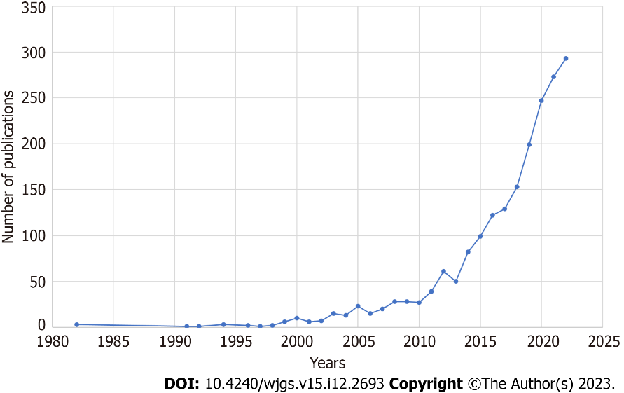
Figure 1 Annual publication trend of articles related to indocyanine green fluorescence.

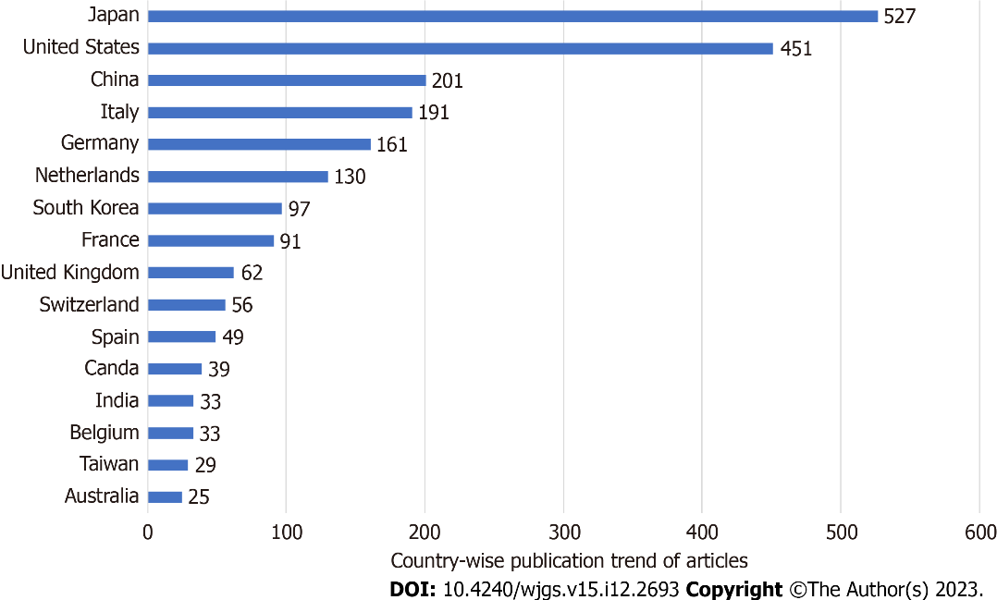
Figure 2 Country-wise publication trend of articles related to indocyanine green fluorescence.

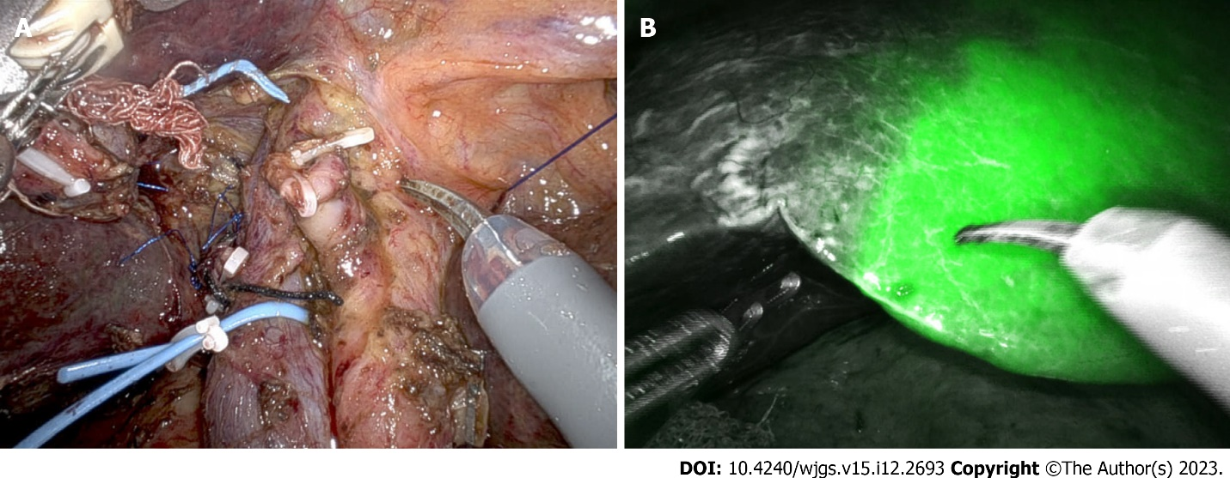
Figure 3 Negative indocyanine green staining technique used in a patient with hilar cholangiocarcinoma planned for right hepatectomy with caudate lobectomy. A: Portal and hepatic artery branches of the right hemiliver to be resected are ligated; B: Line of transection for right hepatectomy identified with the help of indocyanine green fluorescence.

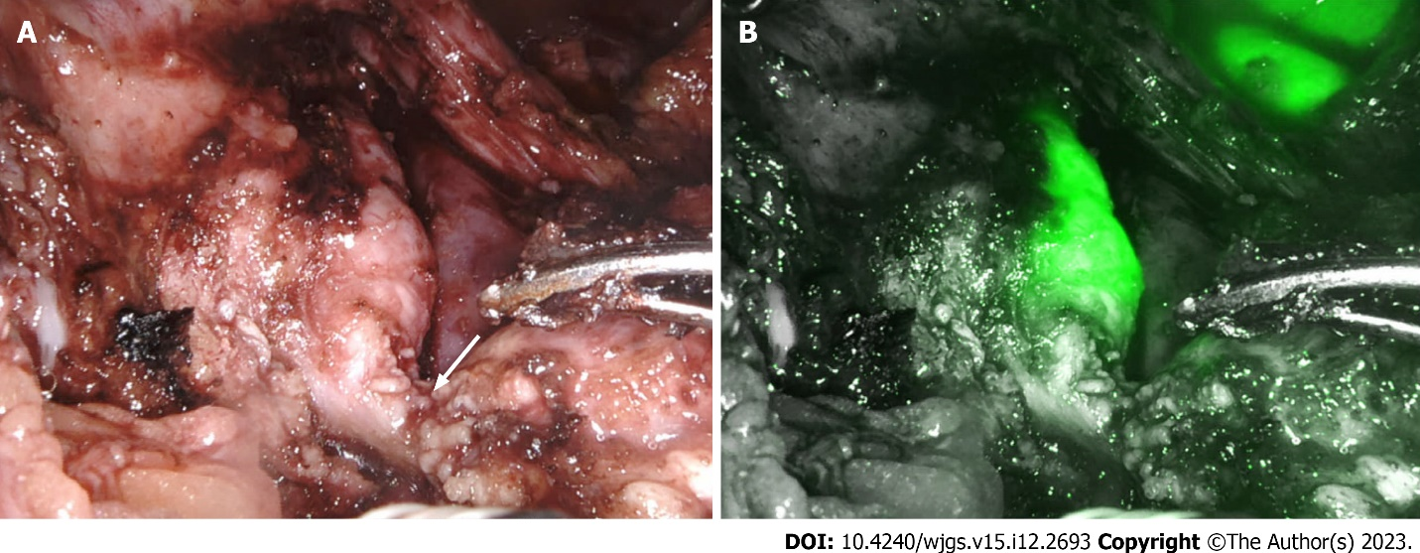
Figure 4 Identification of bile duct during robotic duodenum preserving pancreas head resection. A: Pancreatic duct (arrow) divided at its junction with the bile duct; B: Indocyanine green fluorescence demonstrates bile duct.

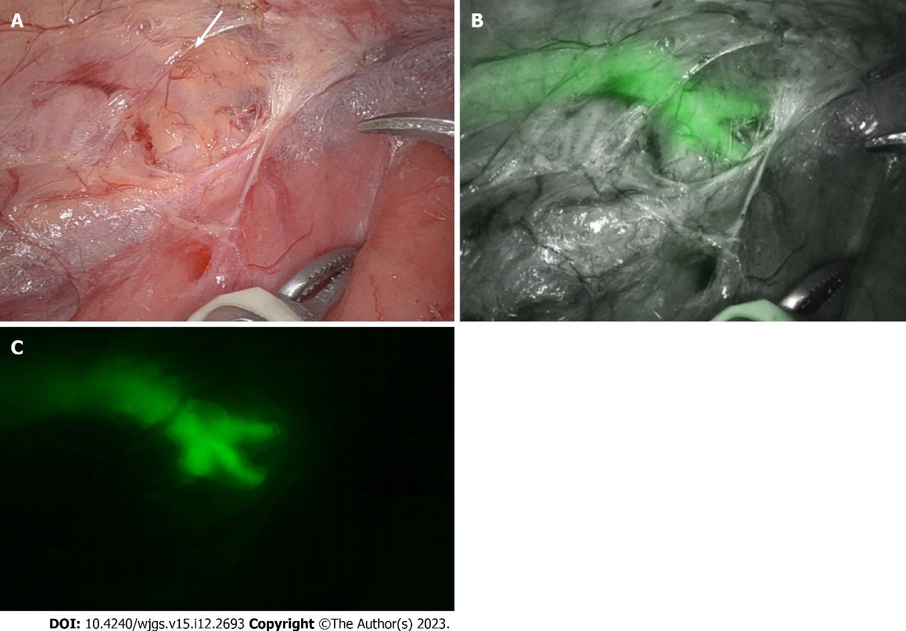
Figure 5 Visualization of the thoracic duct. A and B: Visualization of the thoracic duct during robotic esophagectomy in normal mode (A) is enhanced by indocyanine green fluorescence (B); C: The branching pattern of the thoracic duct is well visualized in fluorescence mode.

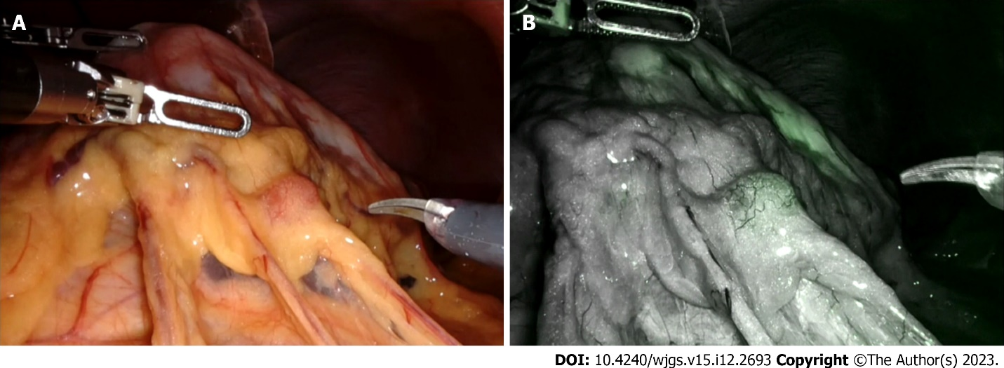
Figure 6 Visualization of perigastric lymph node during robotic D2 gastrectomy in normal mode and fluorescence mode. A: In normal mode; B: In fluorescence mode.

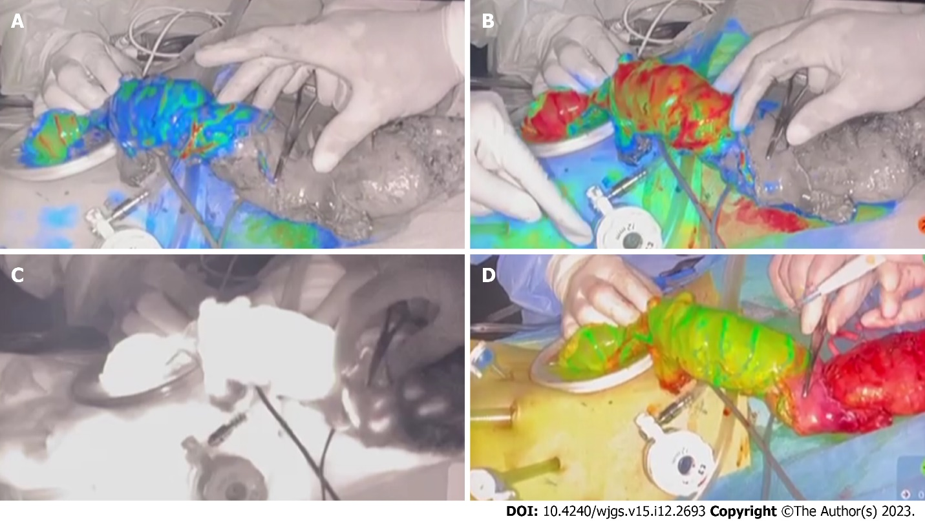
Figure 7 Objective evaluation of colonic perfusion using indocyanine green fluorescence during low anterior resection. A and B: Increasing fluorescence levels show the transition from blue (A) to red (B) and guide the selection of the line of bowel division; C: Fluorescence is displayed on a Grayscale; D: Fluorescence displayed in overlay mode.

Table 1 Studies on liver segmentation and mapping using direct staining technique
Ref. | Country | Study type | Patient | Camera device | ICG dose and time | Guide/approach | Target liver | Success rate | Procedure time
Qian et al^{[16]}, 2022 | China | Prospective cohort | Grp A: 10. Grp C: 20 | - | 0.0125 mg/mL, up to 10 mL | DSA: Hepatic artery. USG: Portal vein | Grp A: Seg, sub-seg. Grp C: Seg | Grp A: 80 %. Grp C: 60 % | Grp A: 305.3 ± 23.2 min. Grp C: 268.4 ± 34.7 min
Li et al^{[17]}, 2021 | Taiwan | Prospective cohort | 8 | Karl storz, Pinpoint Stryker | Conc -0.125 mg/mL, rate of 1 mL/min | DSA: Hepatic artery | Segment bisegment | 100% | DSA: 32.7 +/5.3 min, operative time: 242 +/118 min
Lan et al^{[18]}, 2022 | China | Retrospective cohort | 24 | Pinpoint Stryker | 5 mL of 0.025 mg/mL | Glissonian pedicle approach | Hemiliver: 10. Left lateral: 7. Segment: 7 | 79.40% | Staining time: 25.92 ± 14.64, operative time: 334.17 ± 98.65
Xu et al^{[15]}, 2020 | China | Retrospective cohort | 9 | Pinpoint Stryker | 0.025 mg/mL, 5-10 mL | Intraoperative ultrasound. Glissonian pedicle approach | Segment, section | 56% | Median operative time: 260 min (range 150-360 min)
Ueno et al^{[13]}, 2019 | Japan | Prospective cohort | 10 | Pinpoint Stryker | 0.125 mg/mL, 2 mL ICG, 2 mL Indigo carmine, 1 mL Sonazoid embolic agent-Gelatin particles | DSA | Segment | 100% | IVR procedures- 41 (30-102) min. Median operating time with IVR time: 432 min
Ueno et al^{[14]}, 2018 | Japan | Prospective cohort | 5 | Pinpoint Stryker | 0.125 mg/mL, 2 mL ICG, 2 mL Indigo carmine, 1 mL Sonazoid embolic agent-Gelatin particles | DSA | Segment | 100% | Operative time: 432 (293-572) min
Aoki et al^{[11]}, 2010 | Japan | Prospective cohort | 81 | PDE: 2 | 5 mg/mL | IOUS | Segment. Sub-segment | 73/81 (90.1%) | NA
ICG: Indocyanine green; IOUS: Intraoperative ultrasound; DSA: Digital subtraction angiography; USG: Trans abdominal ultrasound; NA: Not available; PDE: Photodynamic eye.

Table 2 Studies on liver segmentation and mapping using counterstaining technique
Ref. | Country | Study type | Patients | Camera device | ICG dose and time | Approach | Target liver | Success rate | Median (range) operative time, in minutes
Funamizu et al^{[21]}, 2021 | Japan | Retrospective cohort | 74 | Viscera Elite II, Olympus, Pinpoint, Stryker, Hopkins II, Karl storz | 0.5 mg | Glissonian pedicle approach | Monosegmectomy | 100% | 351
Xu et al^{[15]}, 2020 | China | Retrospective cohort | 27 | Pinpoint, Stryker | 2.5 mg/mL | Glissonian pedicle approach | Hemiliver. Section. Segment | 52% | 260 (150-360)
Uchiyama et al^{[19]}, 2011 | Japan | Prospective cohort | 22 | PDE; Hamamatsu Photonic | 0.5 mg/kg | CE-IOUS: Glissonian pedicle approach | Hemiliver: 8. Section: 8. Segment: 6 | 100% | 280 (140-380)
Berardi et al^{[20]}, 2021 | Japan | Retrospective cohort | 86 patients: HCC: 55; CRLM: 31 | Viscera Elite II, Olympus, Pinpoint, Stryker, Hopkins II, Karl storz | 0.5 mg | Glissonian approach | Section: 14. Segment: 56. Sub-segment: 16 | 98.80% | 328 (270-437)
ICG: Indocyanine green; HCC: Hepatocellular carcinoma; CRLM: Colorectal liver metastasis; CE-IOUS: Contrast enhanced intraoperative ultrasound.

Table 3 Studies on hepatic tumor detection with indocyanine green fluorescence
Ref. | Country | Study type | Patients | Device | ICG dose and time | Tumor detection rate | New lesions | Correlation with histology | Micro metastases detection
Cai et al^{[24]}, 2023 | China | Retrospective cohort | Total: 86. HCC: 52, CRLM: 34 | Pinpoint, Stryker | Dose: 0.5 mg/kg, ICG < 7: 5 d prior; ICG > 7: 7 d prior | 96% | 8 | Positive (P = 0.001) | False positive: 3/8 (37.5 %)
Franz et al^{[23]}, 2021 | Germany | Prospective cohort | Total: 18. HCC: 9, CRLM: 4, IHCC: 2 | Firefly, DaVinci NIR-ICG, Karl storz | Dose: 0.5 mg/kg, 2-14 d prior | 100% | 27.8 | - | False positive: 39%
Piccolo et al^{[25]}, 2021 | Italy | Prospective cohort | Total lesions: 29. HCC: 14, CRLM: 13, IHCC: 1, non-CRLM: 1 | NIR-ICG, Karl storz | 0.5 mg/kg, HCC/IHCC: 7 d prior; CRLM: 5 d prior | ICG: 100%, LUS: 72.4% | - | R0: 100% | -
Marino et al^{[27]}, 2020 | Spain | Retrospective cohort | Total lesions: 59. HCC: 23, CRLM: 27, IHCC: 6, hemangioma: 2, steatosis: 1 | Davinci- Firefly | 0.5 mg/kg 5 d prior | 52/59 (88.1%) | 6 (11.5%) | R0: 100% | False positive: 3/52
Zhou et al^{[29]}, 2019 | China | Retrospective cohort | ICG: 21, IOUS: 21 | Pinpoint, Stryker | 0.25 mg/kg 3-5 d prior | 100% | - | - | NA
Terasawa et al^{[26]}, 2017 | Japan | Prospective cohort | Total lesions: 59. CRLM: 46, HCC: 7, others: 6 | Pinpoint, Stryker | 0.5 mg/kg body within 3 d | 45/53 (85%) | 22/45 | R0: 100% | True negative: 100%
Kudo et al^{[30]}, 2014 | Japan | Prospective cohort | Total lesions: 32. HCC: 16, CRLM: 16 | Olympus | 0.5 mg/kg within 14 d | 23/32 (71.8%) | - | - | -
ICG: Indocyanine green; HCC: Hepatocellular carcinoma; CRLM: Colorectal liver metastasis; IHCC: Intrahepatic cholangiocarcinoma; CE-IOUS: Contrast enhanced intraoperative ultrasound; ICG: Indocyanine green; LUS: Laparoscopic ultrasound; NA: Not available.

Table 4 Studies on lymphatic mapping in esophageal and gastric surgery
Ref. | Country | Study type | Patient | Device | ICG dose and time | Surgery | Results | Long term  outcome
Esophageal
Hachey et al^{[48]}, 2016 | United States | Prospective PFS | EAC: 9 | NOVADAQ, Stryker | 2.5 mg/mL, 1 cc, 4 sites, endoscopic injection diluted with sterile water/HSA 25% | Ivor Lewis esophagectomy | 6/9 patients showed 2-6 regional NIR + | NA
Park et al^{[49]}, 2018 | Korea | Prospective PFS | ESCC, cT1: 29 | Firefly, Da Vinci | 0.5 mg/m, 0.5 m: Each quadrant 1 d prior | Robotic Mckeown esophagectomy | High NPV | NA
Stomach
Chen et al^{[58]}, 2020 | China | RCT | ICG 129; non-ICG: 129 | NOVADAQ, Stryker | Submucosal endoscopic 1 d prior 2 mL, 0.5 mL/quadrant 0.625 mg/m | Laparoscopic distal and total gastrectomy | Lymph node yield, mean ± SD: ICG: 50.5 ± 15.9; non-ICG: 42.0 ± 10.3 | 3-yr: DFS: 81.4% vs 68.2%; OS: 86.0% vs 73.6%
Park et al^{[51]}, 2020 | Korea | Prospective feasibility study, PSM | ICG: 20; non-ICG: 60 | NOVADAQ, Stryker | Endoscopic sub-mucosal 0.1 mg/mL, 1 mL 5 sites | Laparoscopic distal gastrectomy, station 6 dissection | ICG vs non-CIG lymph node yield 30.15 vs 32.55, bleeding events 4 (20.0) vs 41 (68.3) | NA
Cianchi et al^{[53]}, 2020 | Italy | Retrospective, PSM | ICG: 37; non-ICG: 37 | Firefly, Da Vinci | Endoscopic sub-mucosal 0.1 mg/mL, 0.5 mL, 4 quatrants | Robotic distal or total gastrectomy | Operative time  mean ± SD: 293.1 ± 6 vs 321.2 ± 77.8 harvested lymph nodes: vs 50.8 ± 17 | NA
Ushimaru et al^{[52]}, 2019 | Japan | Retrospective, PSM | ICG: 84; non-ICG: 84 | NIR, Karl storz | Endoscopic submucosal 0.05 mg/mL, 10 mL, 4 sites | Laparoscopic distal gastrectomy | Operative time  mean ± SD: 206.1 ± 5.0 vs 237.0 ± 5.0, harvested lymph nodes: 47.5 vs 42.6 | NA
ICG: Indocyanine green; PSM: Propensity score matching; PFS: Progression free survival; HAS: Human albumin solution; ESCC: Esophageal squamous cell carcinoma; EAC: Esophageal adenocarcinoma; DNIR: Near infra-red; DFS: Disease free survival; OS: Overall survival; NA: Not available.

Table 5 Studies on sentinel nodal navigation in early gastric cancer
Ref. | Country | Study type | Patient | ICG dose | Surgery | Mean SN yield | Results | Long term outcome
Isozaki et al^{[56]}, 2019 | Japan | Multicenter retrospective cohort | 100 | Intraop endoscopic submucosal 1 mL 2.5% ICG 4 sites wait 15 min. Sentinel node biopsy followed by frozen | Open SNNS/DiG WDG: 3; 1/2 DG: 18; PPG: 19; SG: 31; LR: 29 | 3.8 | Sensitivity: 85.7%. Specificity: 98.9%. Accuracy: 98% | 5-yr OS: 89.6%. Gastric cancer specific survival: 98.5%
An et al^{[54]}, 2020 | Korea | Multicenter RCT | 580 patients; LSG: 292; LSNNS: 245 | Dual tracer, ICG 2.5 mg/mL, 2 ml, and 99mTc-HSA, 2 mL | LSG group: Open: 3; LSG: 266. LSNNS group: LSNNS: 210 | 9 | SBD: SB nodes: 59.7%; hot nodes: 23.4%; hot and green: 12%; green nodes: 4.9%. Operative time: LSG: 180 min; LSNNS: 192.5 min. Upstaging: 7.4% | NA
Miyashiro et al^{[55]}, 2014 | Japan | Multicenter RCT | 440 patients suspended | Serosal injection 4-5 mL, 25 mg/5 mL ICG | Sentinel node biopsy followed by gastrectomy with lymphadenectomy | 4 | False negative: 46.4% | NA
RCT: Randomized controlled trial; ICG: Indocyanine green; SNSS: Sentinel node navigation surgery; WDG: Wide-extent distal gastrectomy; LR: Local resection of stomach; SG: Segmental gastrectomy; PPG: Pylorus preserving gastrectomy; OS: Overall survival; DiG: Diminished gastrectomy; SBD: Sentinel basin dissection; HN: Hot nodes; SB: Sentinel basin; LSG: Laparoscopic standard gastrectomy; LSNNS: Laparoscopic sentinel node navigation surgery.

Published by Baishideng Publishing Group Inc
7041 Koll Center Parkway, Suite 160, Pleasanton, CA 94566, USA
Telephone: +1-925-3991568
E-mail: bpgoffice@wjgnet.com
Help Desk: https://www.f6publishing.com/helpdesk
https://www.wjgnet.com

© 2023 Baishideng Publishing Group Inc. All rights reserved.

