Name of Journal: World Journal of Clinical Cases
Manuscript NO: 68030
Manuscript Type: CASE REPORT

Idiopathic acute superior mesenteric venous thrombosis after renal transplantation: A case report

Zhang P et al. Acute mesenteric venous thrombosis after renal transplantation

Peng Zhang, Xiao-Jie Li, Ruo-Mi Guo, Kun-Peng Hu, Shi-Lei Xu, Bo Liu, Qing-Liang Wang

Peng Zhang, Shi-Lei Xu, Bo Liu, Qing-Liang Wang, Kun-Peng Hu, Department of General Surgery, The Third Affiliated Hospital of Sun Yat-Sen University, Guangzhou 510530, Guangdong Province, China

Xiao-Jie Li, Laboratory Medicine, The Third Affiliated Hospital of Sun Yat-Sen University, Guangzhou 510530, Guangdong Province, China

Ruo-Mi Guo, Department of Radiology, The Third Affiliated Hospital of Sun Yat-Sen University, Guangzhou 510530, Guangdong Province, China

Author contributions: Zhang P performed the literature search, collected the images, and wrote the paper; Li XJ, Guo RM, Hu KP, Xu SL, Liu B, and Wang QL designed the research and revised the paper; All authors have read and approved the final manuscript.

Corresponding author: Qing-Liang Wang, MD, Attending Doctor, Department of General Surgery, The Third Affiliated Hospital of Sun Yat-Sen University, No. 2693 Kaichuang Avenue, Huangpu District, Guangzhou 510530, Guangdong Province, China. wangql5@mail.sysu.edu.cn

Received: June 9, 2021
Revised: July 5, 2021
Accepted: August 31, 2021
Published online: November 16, 2021

Abstract
BACKGROUND
Acute superior mesenteric venous thrombosis (MVT) is a rare condition associated with a high mortality rate. The treatment strategy for MVT is clinically challenging due to its insidious onset and rapid development, especially when accompanied by kidney transplantation.

CASE SUMMARY
Here we present a rare case of acute MVT developed 3 years after renal transplantation. A 49-year-old patient was admitted with acute abdominal pain and diagnosed as MVT with intestinal necrosis. An emergency exploratory laparotomy was performed to remove the infarcted segment of the bowel. Immediate systemic anticoagulation was also initiated. During the treatment, the patient experienced bleeding, anastomotic leakage, and sepsis. However, after aggressive treatment was administered, all thrombi were completely resolved, and the patient recovered with his renal graft function unimpaired.

CONCLUSION
The present case suggests that accurate diagnosis and timely surgical treatment are important to improve the survival rate of MVT patients. Bleeding with anastomotic fistula needs to be treated with caution because of grafts. Also, previously published cases of mesenteric thrombosis after renal transplantation were reviewed.

Key Words: Acute mesenteric vein thrombosis; Anticoagulation; Anastomotic fistula; Renal transplantation; Case report

©The Author(s) 2021. Published by Baishideng Publishing Group Inc. All rights reserved.

Citation: Zhang P, Li XJ, Guo RM, Hu KP, Xu SL, Liu B, Wang QL. Idiopathic acute superior mesenteric venous thrombosis after renal transplantation: A case report. World J Clin Cases 2021; 9(32): 9896-9902
URL: https://www.wjgnet.com/2307-8960/full/v9/i32/9896.htm
DOI: https://dx.doi.org/10.12998/wjcc.v9.i32.9896

Core Tip: We present a rare case of acute superior mesenteric venous thrombosis developed 3 years after renal transplantation. Despite their infrequency, idiopathic acute mesenteric venous thrombosis with renal transplantation should be considered seriously. The accurate diagnosis and timely surgical treatment are very important to improve the survival rate of patients. Bleeding and anastomotic fistula during treatment need to be treated with caution because of grafts.

INTRODUCTION
Acute mesenteric venous thrombosis (MVT) is an uncommon but potentially lethal complication of thrombotic conditions^{[1]}. MVT accounts for 5%-15% of all mesenteric ischemia and 6%-9% of cases of acute mesenteric ischemia^{[2]}. Recent improvements and widespread use of diagnostic imaging modalities have facilitated the early recognition of this disease. Early and timely surgical interventions are required when patients present with peritoneal signs or are refractory to initial measures. Medical management with systemic anticoagulation is the cornerstone of modern therapy^{[3]}. MVT is either primary or secondary, and the proportion of primary patients continues to decline due to technology development^{[4]}. Acute MVT has been reported several times in the literature. However, there have been few reports of MVT after renal transplantation.

CASE PRESENTATION
Chief complaints
A 49-year-old male was referred to our emergency department complaining of progressive aggravated abdominal pain for 3 d.

History of present illness
The initial pain was in the hypogastric region and worsened to diffuse abdominal pain 1 d prior, along with nausea, abdominal distension, and vomiting.

History of past illness
The patient had suffered from hypertension for 10 years, which was well controlled medically by nifedipine and metoprolol. His past surgical history of renal transplantation had been 4 years due to chronic kidney disease. The immunosuppression therapy included prednisolone, mycophenolate mofetil, and tacrolimus.

Personal and family history
The patient had a free personal and family history.

Physical examination
Clinical examination revealed tenderness on palpation of his full abdomen with rebound tenderness and muscle guarding.

Laboratory examinations
Laboratory evaluation showed that the leucocytes count was elevated at 31 × 10⁹/mL, hemoglobin was 13 g/dL, and C-reactive protein was 33.86 mg/dL. The hepatitis serology and cytomegalovirus results did not suggest clinical virus infection.

Imaging examinations
The abdominal contrast-enhanced computed tomography (CT) scan exhibited an extensive filling defect within the portal vein and right branch, extending to the superior mesenteric vein as well as splenic vein (Figure 1A).

FINAL DIAGNOSIS
Based on the above findings, a final diagnosis of acute superior MTV was made.

TREATMENT
An emergency exploratory laparotomy was performed. On exploration, 600 mL bloody ascites were found, and jejunum, approximately 120 cm from the Treitz ligament, was gangrenous. Almost no pulsations were palpable in the mesentery of the affected bowel, and thromboembolism was discovered in the corresponding mesenteric veins (Figure 2). The necrotic intestine, measuring approximately 100 cm, was resected, and a functional side-to-side anastomosis with staplers was performed. Total parenteral nutrition, intravenous antibiotics, and full anticoagulation with low molecular weight heparin were initiated postoperatively. Methylprednisolone was used as a substitute for immunosuppression, and thrombolytic therapy was withheld due to bleeding risk. Further inquiry about the medical history revealed no personal or immediate family history of inherited thrombophilia, deep vein thrombosis, vascular disease, or pulmonary embolism. The patient’s body mass index was 27 kg/m² without dyslipidemia. Thrombophilia test was negative for the factor V Leiden gene mutation, anticardiolipin antibodies, prothrombin G20210A mutation, and prothrombin gene mutation. The patient had normal levels of homocysteine, protein C, protein S, and antithrombin III.
In the following 10 d, the patient recovered well, and the abdominal symptoms improved. On the 11th day after surgery, the patient had a sudden fever of 39 ºC, and ultrasonography showed fluid (55 mm × 10 mm) accumulation surrounding the surgical area. Thus, percutaneous catheterization was performed. On the other hand, the drainage tube of the pelvic cavity was removed. Unexpectedly, a rare hernia happened (Figure 3). The black stool suddenly appeared 3 wk after the operation, with hemoglobin decreasing to 6.5 g/dL. Even more disappointing was radiography from percutaneous catheter revealed anastomotic fistula (Figure 4). The condition worsened because the thrombus was aggravated, and the patient developed a severe bacterial infection with repeated fever to 40 ºC and platelets dropped to 3 × 10⁹/mL (Table 1).
Considering the possibility of exacerbating intestinal ischemia, the use of vasopressors and somatostatin was avoided. Anticoagulant therapy was also temporarily discontinued due to the risk of massive bleeding. To balance the healing of the anastomosis, the hormones for immunosuppression therapy were reduced. Anti-infective therapy had also been strengthened, and the bleeding was finally stopped after a whole week of blood transfusion and mucosal protection treatment. The condition was gradually controlled in the following 2 wk, and anticoagulation therapy with dalteparin sodium was initiated. CT scan showed decreased portal vein thrombosis, and thrombosis in the splenic vein was completely absorbed. Although still with intestinal fistula, the patient gradually returned to a normal diet, and anticoagulation therapy was changed to rivaroxaban. The patient was discharged when another CT demonstrated all thrombi were completely absorbed 2 mo after operation (Figure 1B).

OUTCOME AND FOLLOW-UP
On follow-up, the anticoagulation therapy was continued for an additional 4 mo, and the drainage tube for the anastomotic fistula was removed. Until now, no abnormalities were observed in the 2-year follow-up.

DISCUSSION
MVT is an uncommon, life-threatening disease, which accounts for less than 10% of cases of acute mesenteric ischemia^{[1]}. It is characterized by an insidious onset, and early non-specific clinical presentation but can progress rapidly. The superior mesenteric vein does not have collateral vessels; its complete obstruction accompanied by improper venous drainage can easily result in bowel infarction. Abdominal pain is the most common clinical manifestation of acute superior MVT (SMVT) and is largely determined by the location and extent of the thrombus, the size of the involved vessels, and the depth of bowel-wall ischemia^{[5]}. For this patient, abdominal symptoms gradually worsened with the development of peritonitis, which indicated a complete embolization of a wide range of blood vessels.
Successful treatment of acute SMVT relies on prompt diagnosis. Until now, there has been no single laboratory marker that is sensitive and specific for SMVT. D-dimer testing has the potential to detect thrombosis, and the level in the blood can significantly rise when a thrombus is present^{[6]}. However, D-dimer testing is non-specific, can be elevated duo to abdominal inflammation, and has not been well studied in the evaluation of SMVT. CT scan with arterial and portal phase is the most effective tool, with high sensitivity (96%) and specificity (94%). Image features of CT for bowel ischemia can be divided into mural, vascular, and extramural-nonvascular signs, from which one can make a timely and accurate diagnosis easily^{[7]}.
In general, MVT can be classified as primary or secondary depending based on its cause. Secondary MVT can result from various underlying diseases and acquired risk factors, including primary hypercoagulable states or prothrombotic disorders^{[8]}, myeloproliferative neoplasms, cancer, diverse inflammatory conditions, trauma, post-operative condition, portal hypertension, or pregnancy^{[8,9]}. When no etiologic or predisposing factor has been found, it is considered primary or idiopathic. The proportion of primary patients continues to decline due to increased awareness of predisposing disorders and a growing ability to diagnose technique^{[4]}. As we were able to rule out any coagulation factor deficiency or other risks that could be the cause, we identified the diagnosis for idiopathic MVT.
Alander et al^{[10]} reported the first case of MVT after renal transplantation in 1974. Due to the hypercoagulable state, the patient developed an iliofemoral venous thrombosis 1 mo after transplantation, worsened 8 mo later, and eventually died. Another case with sudden abdominal pain 10 years after successful renal transplantation was also confirmed as an acute portal MVT. The patient was recovered after anticoagulation, and the authors attribute the thrombosis to lupus anticoagulant without lupus erythematodes^{[11]}. The reason why the patient in this study developed acute SMVT after successful kidney transplantation is unclear. The thrombophilic state is well known in cases with nephrotic syndrome but not chronic kidney disease^{[12]}. Although the overall period of hemodialysis had been 10 mo, there is no thrombosis in his arterio-venous shunts. Although the mechanism involved remains speculative, many prothrombotic effects might be responsible. Iliac veins are used for venous drainage of allografts, and the corresponding changes in blood flow may be an inevitable risk factor. It is not clear whether immunosuppressive drugs increase the risk of thrombosis in renal transplant recipients. In principle, tacrolimus can trigger thrombotic microangiopathy^{[13]}. Additional factors might be endothelial injury caused by hypertension, an essential factor for thrombosis formation^{[14]}.
Despite advances in treating thromboembolic disease over the past 40 years, acute MVT has an average 30 d mortality of up to 32.1% in severe cases^{[15]}. Management for MVT includes surgery, anticoagulation and supportive treatment. When exploratory laparotomy is performed in the acute stage, the boundary between ischemic bowel and viable bowel is often diffuse. Segments of nonviable bowel are resected and areas of bowel with questionable viability are left for this patient. This more conservative strategy is favored over aggressive resection because of the long-term risks associated with short bowel syndrome. However, this also increases the risk of anastomotic leakage, especially together with the application of methylprednisolone. The contradictory treatment forced us to reduce the dose for the further treatment of anastomotic fistula. Fortunately, the graft showed excellent renal function without episodes of graft rejection.
Systemic anticoagulation as the first-line therapy in MVT should be initiated as soon as the diagnosis is made^{[3]}. Anticoagulation can effectively prevent thrombosis, recanalize occluded veins, and improve intestinal reperfusion. There is sufficient time for venous collateral vessels to develop when the thrombus evolves slowly, and the risk of bowel infarction can be decreased. Low molecular weight heparin is preferable over unfractionated heparin due to its better safety profile, ease of administration, and not requiring regular laboratory monitoring. For long-term management, anticoagulation with warfarin with a targeted international normalized ratio of 2.0 to 3.0 is the standard of care. Although most researchers recommend maintaining anticoagulation therapy for at least 6 mo after diagnosis to prevent the recurrence of the thrombosis, its benefit is still questioned in some reports^{[16]}.

CONCLUSION
Despite its infrequency, idiopathic acute MVT after renal transplantation should be considered seriously. An accurate diagnosis and timely surgical treatment are important to improve a patient’s survival rate and conserve as much of the bowel as possible. Bleeding and anastomotic fistula during treatment need to be treated with caution because of grafts.

REFERENCES
1 Bala M, Kashuk J, Moore EE, Kluger Y, Biffl W, Gomes CA, Ben-Ishay O, Rubinstein C, Balogh ZJ, Civil I, Coccolini F, Leppaniemi A, Peitzman A, Ansaloni L, Sugrue M, Sartelli M, Di Saverio S, Fraga GP, Catena F. Acute mesenteric ischemia: guidelines of the World Society of Emergency Surgery. World J Emerg Surg 2017; 12: 38 [PMID: 28794797 DOI: 10.1186/s13017-017-0150-5]
2 Singal AK, Kamath PS, Tefferi A. Mesenteric venous thrombosis. Mayo Clin Proc 2013; 88: 285-294 [PMID: 23489453 DOI: 10.1016/j.mayocp.2013.01.012]
3 Gross PL, Weitz JI. New anticoagulants for treatment of venous thromboembolism. Arterioscler Thromb Vasc Biol 2008; 28: 380-386 [PMID: 18296593 DOI: 10.1161/ATVBAHA.108.162677]
4 Kumar S, Sarr MG, Kamath PS. Mesenteric venous thrombosis. N Engl J Med 2001; 345: 1683-1688 [PMID: 11759648 DOI: 10.1056/NEJMra010076]
5 Kumar S, Kamath PS. Acute superior mesenteric venous thrombosis: one disease or two? Am J Gastroenterol 2003; 98: 1299-1304 [PMID: 12818273 DOI: 10.1111/j.1572-0241.2003.07338.x]
6 Jiang Y, Li J, Liu Y, Zhang W. Diagnostic accuracy of deep vein thrombosis is increased by analysis using combined optimal cut-off values of postoperative plasma D-dimer levels. Exp Ther Med 2016; 11: 1716-1720 [PMID: 27168793 DOI: 10.3892/etm.2016.3125]
7 Duran R, Denys AL, Letovanec I, Meuli RA, Schmidt S. Multidetector CT features of mesenteric vein thrombosis. Radiographics 2012; 32: 1503-1522 [PMID: 22977032 DOI: 10.1148/rg.325115100]
8 Hmoud B, Singal AK, Kamath PS. Mesenteric venous thrombosis. J Clin Exp Hepatol 2014; 4: 257-263 [PMID: 25755568 DOI: 10.1016/j.jceh.2014.03.052]
9 Harnik IG, Brandt LJ. Mesenteric venous thrombosis. Vasc Med 2010; 15: 407-418 [PMID: 20926500 DOI: 10.1177/1358863X10379673]
10 Alander JT, Kaartinen I, Laakso A, Pätilä T, Spillmann T, Tuchin VV, Venermo M, Välisuo P. A review of indocyanine green fluorescent imaging in surgery. Int J Biomed Imaging 2012; 2012: 940585 [PMID: 22577366 DOI: 10.1155/2012/940585]
11 Hauser AC, Pabinger-Fasching I, Quehenberger P, Kettenbach J, Hörl WH. A patient with sudden abdominal pain 10 years after successful renal transplantation. Nephrol Dial Transplant 2003; 18: 1021-1025 [PMID: 12686684 DOI: 10.1093/ndt/gfg047]
12 Kerlin BA, Ayoob R, Smoyer WE. Epidemiology and pathophysiology of nephrotic syndrome-associated thromboembolic disease. Clin J Am Soc Nephrol 2012; 7: 513-520 [PMID: 22344511 DOI: 10.2215/CJN.10131011]
13 Pham PT, Peng A, Wilkinson AH, Gritsch HA, Lassman C, Pham PC, Danovitch GM. Cyclosporine and tacrolimus-associated thrombotic microangiopathy. Am J Kidney Dis 2000; 36: 844-850 [PMID: 11007689 DOI: 10.1053/ajkd.2000.17690]
14 Previtali E, Bucciarelli P, Passamonti SM, Martinelli I. Risk factors for venous and arterial thrombosis. Blood Transfus 2011; 9: 120-138 [PMID: 21084000 DOI: 10.2450/2010.0066-10]
15 Schoots IG, Koffeman GI, Legemate DA, Levi M, van Gulik TM. Systematic review of survival after acute mesenteric ischaemia according to disease aetiology. Br J Surg 2004; 91: 17-27 [PMID: 14716789 DOI: 10.1002/bjs.4459]
16 van der Hulle T, Tan M, den Exter PL, van Roosmalen MJ, van der Meer FJ, Eikenboom J, Huisman MV, Klok FA. Recurrence risk after anticoagulant treatment of limited duration for late, second venous thromboembolism. Haematologica 2015; 100: 188-193 [PMID: 25261098 DOI: 10.3324/haematol.2014.112896]

Footnotes
Informed consent statement: Informed written consent was obtained from the patient for publication of this report and any accompanying images.

Conflict-of-interest statement: The authors declare that they have no conflict of interest.

CARE Checklist (2016) statement: The authors have read the CARE Checklist (2016), and the manuscript was prepared and revised according to the CARE Checklist (2016).

Open-Access: This article is an open-access article that was selected by an in-house editor and fully peer-reviewed by external reviewers. It is distributed in accordance with the Creative Commons Attribution NonCommercial (CC BY-NC 4.0) license, which permits others to distribute, remix, adapt, build upon this work non-commercially, and license their derivative works on different terms, provided the original work is properly cited and the use is non-commercial. See: http://creativecommons.org/Licenses/by-nc/4.0/

Manuscript source: Unsolicited manuscript

Peer-review started: June 9, 2021
First decision: June 25, 2021
Article in press: August 31, 2021

Specialty type: Surgery
Country/Territory of origin: China
Peer-review report’s scientific quality classification
Grade A (Excellent): 0
Grade B (Very good): 0
Grade C (Good): C, C
Grade D (Fair): 0
Grade E (Poor): 0

P-Reviewer: Maglangit SACA, Parajuli S S-Editor: Wu YXJ L-Editor: Filipodia P-Editor: Guo X

Figure Legends
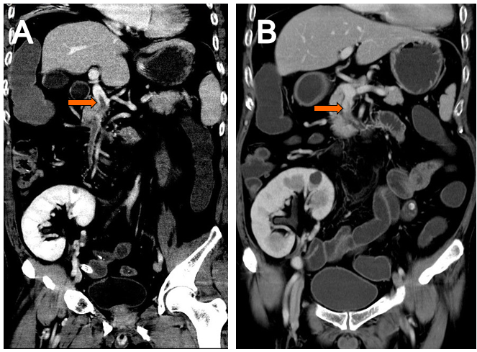
Figure 1 Whole abdomen enhanced computed tomography scan. A: An acute mesenteric venous thrombosis (orange arrow); B: Recanalization after 2 mo of anticoagulation (orange arrow).

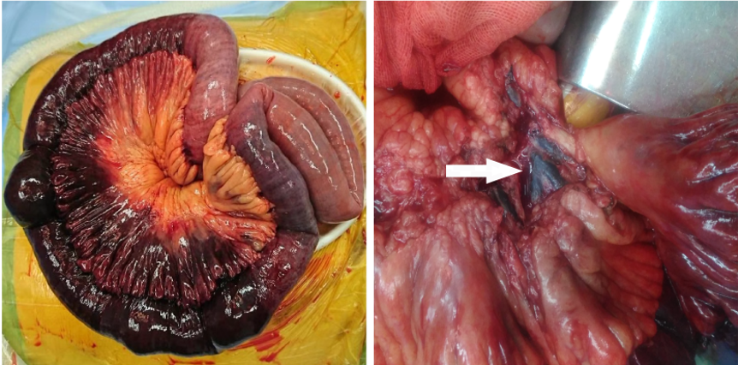
Figure 2 Intraoperative images of infarcted small bowel secondary to thrombosis of mesenteric vein (as indicated by white arrow).

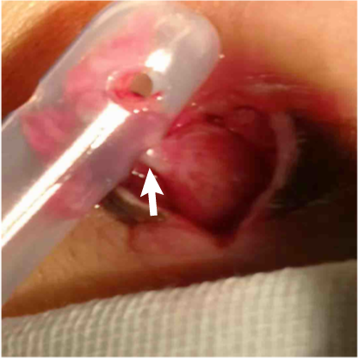
Figure 3 A rare hernia, partial intestinal wall (white arrow) incarcerated in the hole of drainage tube.

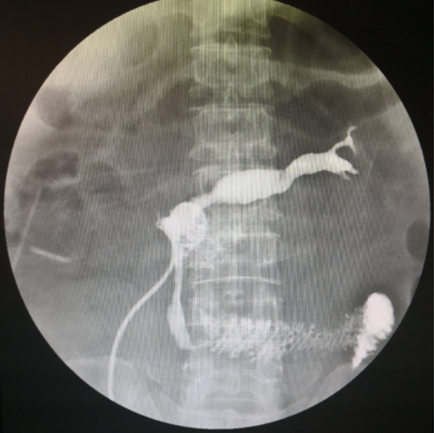
Figure 4 Fistula formation at the anastomotic site.

Table 1 Progress of labs during hospitalization
Lab examinations | Reference range | Preoperation | Postoperation
 |  |  | Day 1 | Day 3 | Day 6 | Day 10 | Day 26 | Day 28 | Day 42
WBC (× 10⁹/L) | 3-9 | 30 | 6 | 11 | 15 | 21 | 11 | 8 | 10
Hb (g/L) | 130-175 | 184 | 126 | 123 | 125 | 117 | 61 | 75 | 96
PLT (× 10⁹/L) | 100-350 | 199 | 90 | 78 | 224 | 125 | 26 | 3 | 122
PT (sec) | 11-14 | 15 | 18 | 17 | 16 | 14 | 18 | 17 | 14
Tbili (μmol/L) | 4-23 | 28 | 46 | 111 | 89 | 54 | 15 | 45 | 20
CreaT (μmol/L) | 31-116 | 115.0 | 178 | 118 | 109 | 82 | 102 | 82 | 47
WBC: White blood cell; Hb: Hemoglobin; PLT: Platelet; PT: Prothrombin time; CreaT: Creatinine; Tbili: Total bilirubin.

Published by Baishideng Publishing Group Inc
7041 Koll Center Parkway, Suite 160, Pleasanton, CA 94566, USA
Telephone: +1-925-3991568
E-mail: bpgoffice@wjgnet.com
Help Desk: https://www.f6publishing.com/helpdesk
https://www.wjgnet.com

© 2021 Baishideng Publishing Group Inc. All rights reserved.

