Name of journal: World Journal of Gastroenterology
ESPS Manuscript NO: 9969
Columns: CASE REPORT

Preoperative trans-jugular porto-systemic shunt to oncologic gastric surgery in a cirrhotic patient

Liverani A et al. TIPSS to oncologic gastric surgery

Andrea Liverani, Luigi Solinas, Tatiana Di Cesare, Luca Velari, Tiziano Neri, Francesco Cilurso, Francesco Favi, Giancarlo Bizzarri

Andrea Liverani, Luigi Solinas, Tatiana Di Cesare, Tiziano Neri, Francesco Cilurso, Francesco Favi, Department of General Surgery, Regina Apostolorum Hospital, 00100 Rome, Italy

Luca Velari, Giancarlo Bizzarri, Department of Radiology, Regina Apostolorum Hospital, 00100 Rome, Italy

Author contributions: Liverani A designed research and final approval of the version to be published; Solinas L, Di Cesare T performed research; Velari L, Bizzarri G contributed new reagents or analytic tools; Neri T, Cilurso F substantial contributions to conception and design; Favi F analyzed data; Liveani A, Solinas L, Di Cesare T wrote the paper.

Correspondence to: Tatiana Di Cesare, MD, Department of General Surgery, Regina Apostolorum Hospital, Via San Francesco 50, 00040 Albano Laziale (RM), 00100 Rome Italy. tatiana.dicesare@hotmail.it

Telephone: +39-6-932989 Fax: +39-6-9321138
Received: March 6, 2014 Revised: May 13, 2014
Accepted: October 15, 2014

Published online:

Abstract
Abdominal surgery in cirrhotic patients with portal hypertension is connected with high incidence of disease and mortality. In these patients oncologic gastric procedures with lymph-nodes dissection show much higher complications rate than in normotensive portal vein patients. So, normalization of portal vein pressure may be a favourable determinant factor in order to reduce complications rate. We report a case of a patient with hepatitis C virus-related hepatic cirrhosis, oesophageal varices, portal hypertension and gastric cancer. We demonstrated the efficacy of preoperative trans-jugular porto-systemic shunt in order to perform an oncologic radical resection more safely. We retain preoperative tipss in the patients with elevated portal pressure and gastric cancer to perform a gastrectomy more safely and to decrease morbidity and mortality of these cases.

© 2014 Baishideng Publishing Group Inc. All rights reserved.

Key words: Gastric cancer; Cirrhotic patients; Oesophageal varices; Portal hypertension; Trans-jugular porto-systemic shunt; Gastric surgery

Core tip: We suggest a preoperative trans-jugular porto-systemic shunt in the patients with portal hypertension and gastric cancer to perform a gastrectomy. This procedure decreases safely intraoperatory bloodloss and postoperative morbidity. Moreover the normalization of portal vein pressure permits to perform an oncological nodes dissection. Finally this technique may reduce perioperative mortality.

Liverani A, Solinas L, Di Cesare T, Velari L, Neri T, Cilurso F, Favi F, Bizzarri G. Preoperative trans-jugular porto-systemic shunt to oncologic gastric surgery in a cirrhotic patient. World J Gastroenterol 2014; In press

INTRODUCTION
Abdominal surgery in cirrhotic patients with portal hypertension is connected with high incidence of disease and mortality. In these patients oncologic gastric procedures with lymph-nodes dissection show much higher complications rate than in normotensive portal vein patients. So, normalization of portal vein pressure may be a favourable determinant factor in order to reduce complications rate.

CASE REPORT
An 80 years old female patient presented an endoscopic report of gastric neoplasia. Two months before she was submitted to an endoscopic oesophageal varices ligation due to variceal rupture (Figure 1). The Child-Pugh classification was B and portal pressure was up to 28 mmHg.
Preoperative oncologic staging showed the absence of local or distant metastasis and the patient was candidate for radical resection. In order to reduce portal pressure and risks of esofago-gastric variceal rupture relapsing, preoperative transjugular intrahepatic portosystemic shunt was proposed and successfully created. The right gastric vein was coiled. Normal portal pressure was reached, with values ranging from 12 to 15 mmHg.
Radiological procedure: the patient was placed supine in angiographic suite . A rotation of the head to the left is required.
We use a spontaneous breathing general anesthesia for radiological procedure using a laryngeal mask with a mixture of O₂, N₂O, and isoflurane (1%–2%).
Puncture of the right internal jugular vein was performed with real-time sonography guidance with an 18-gauge needle.
A 0.035 degree angle Hydrophilic Coated Guidewires (Terumo Glidewire®, Tokyo, Japan) was inserted into the jugular vein down to the inferior vena cava (IVC).
A 12-F introducer sheath was positioned into the right atrium and then into the IVC to measure pressure. The hepatic vein was then catheterised directly using the curved metallic cannula of the transjugular intrahepatic portosystemic shunts (TIPS) set (AngioDynamics®; Queensberry, NY, United States) and the glidewire (Terumo Glidewire®). The blood flow through the vein was definite to visualize the structure of the hepatic vein. Percutaneous puncture of portal vein was performed with placement of a small introducer in order to obtein a portography (Figure 2).
Right hepatic vein was catheterised; portal vein puncture was performed through the wall of the hepatic vein 1–3 cm from its origin; it was turned anteriorly and advanced into the liver parenchyma for 4–5 cm. It was then slowly moved back and at the same time it was aspirated with a syringe. The correct puncture was checked with a portography and a guidewire was introduced into the mesenteric vein.
Pressure was measured to evaluate the portosystemic differential pressure; a venogram was used to define the measure of the intrahepatic tract using a marked pigtail catheter.
Afterwards, a Amplatz Super Stiff™ Guidewire (Boston Scientific; Natick, MA, United States) was inserted into the splenic or mesenteric vein, and the intrahepatic tract was dilated using a 8 mm low-profile balloon (Wanda TM, Boston Scientific; Natick, MA, United States).
The GORE® VIATORR® stent graft consists of a self-expanding nitinol endoprosthesis with a high radial strength and covered with an ultrathin expanded polytetrafluoroethylene tube.
The 12-F introducer sheath was positioned into the portal system for 3 cm and moved back to have release of the uncovered tract within the portal vein. Once the endoprosthesis was positioned, the whole device was carefully removed until a resistance was felt, thus showing that the proximal tract of the device had positioned at the junction of the portal vein with the intrahepatic tract. The introducer was marched largely upstrem the beginning of the endoprosthesis and, while positioning the system in place, the coated portion of the VIATORR® (60-20-10 mm, Figure 3) was simply released .
The endoprosthesis was then expanded, with the low-profile balloon catheter used previously. After complete deployment of the Viatorr, a graphic of blood flow through the shunt was performed to check its function, and the mean atrial and portal pressures were evalueted to ascertain the hemodynamic significance of the procedure (PSG < 12 mmHg).
In conclusion right gastric vein that fueled massive variceal was embolized with coils. One month later, the patient was readmitted in Surgical Department and a D-2 distal gastrectomy with a B2 gastrojejunal anastomosis was performed.
No intraoperative complications were observed and no transfusions were requested during the procedure. No postoperative bleeding or hepatic dysfunctions occurred and postoperative course was uneventful except for delayed gastric stump empting with hospital discharge in 14 d.

DISCUSSION
Cirrhotic patient with portal hypertension candidate to an extrahepatic abdominal major procedure is a surgical challenge, especially if variceal bleeding is referred. In these cases morbidity and mortality is higher, ranging from 10% to 60%^{[1]}. Gastric surgery in patients with portal hypertension is associated with mortality more than 10% and morbidity rate of 25%^{[2]}.
The two major factors that contribute to higher operative mortality are bleeding propensity and ascites which higher risk of infection. Less frequently hepatic insufficiency, hepato-renal syndrome or sepsis are determinants for postoperative complications, often determine a fatal multiorgan failure^{[3]}.
So, it’ seems really relevant preoperative control as best we can of all correctable factors as ascites control, correction of coagulopathies, malnutrition and protein catabolism, amelioration of Child’s class or, finally, reduction of portal pressure.
In fact preoperative procedure in order to reduce or normalize portal pressure seems decrease surgical risks with lower incidence of complications and deaths^{[4-6]}.
Uptoday TIPS is preferred nonivasive procedure of treating the complication of portal hypertension and variceal bleeding^{[7-9]}, but its use in preoperative schedule before extrahepatic abdominal surgery is rarely described (Figure 4).
In our patient recent recurrent variceal bleeding had been referred and oncologic gastric procedure was mandatory.
We retain preoperative TIPSs in the patients with elevated portal pressure and gastric cancer to perform a gastrectomy more safely and to decrease morbidity and mortality of these cases.

COMMENTS
Case characteristics
The patients had oesophageal varices bleeding to times last year treated by endoscopy. In the last month the patient had dysphagia, epigastric pain and weight loss.

Clinical diagnosis
Gastroscopy showed a endoluminal haemorrhagic pyloric lesion of stomach.

Differential diagnosis
Histopathology examination after endoscopic biopsy showed gastric carcinoma.

Laboratory diagnosis
Anaemia, low dosage of albumin and coagulopathy.

Imaging diagnosis
Total body computed tomography scan showed gastric lesion, oesophageal varices, hepatic cirrhosis and ascites.

Treatment
Trans-jugular porto-systemic shunt (TIPSS) and gastric resection was performed in two steps.

Experiences and lessons
This case showed as preoperative TIPSS to gastric surgery reduced perioperative morbidity and mortality.

Peer review
TIPSS is useful and safe radiologic procedure to treat portal vein hypertension. Cirrhotic patients that underwent oncologic gastric surgery can be submitted to TIPSS 40-60 d before surgery. This procedure decreases intraoperatory bleeding, morbidity and mortality.

REFERENCES
1 Guglielmi A, Girlanda R, Lombardo F, de Manzoni G, Frameglia M, Pelosi G, Baldin M. TIPS allowing for an endoscopic mucosal resection of early gastric cancer in a cirrhotic patient with severe hypertensive gastropathy: report of a case. Surg Today 1999; 29: 902-905 [PMID: 10489133 DOI: 10.1007/BF02482783]
2 Catalano G, Urbani L, De Simone P, Morelli L, Coletti L, Cioni R, Matocci G, Mosca F, Filipponi F. Expanding indications for TIPSS: portal decompression before elective oncologic gastric surgery in cirrhotic patients. J Clin Gastroenterol 2005; 39: 921-923 [PMID: 16208123 DOI: 10.1097/01.mcg.0000180798.41704.43]
3 Minicozzi A, Veraldi GF, Borzellino G. Minimally invasive treatment of portal hypertension, abdominal aortic aneurysm, and colon cancer: a case report. Surg Laparosc Endosc Percutan Tech 2010; 20: 281-283 [PMID: 20729703 DOI: 10.1097/SLE.0b013e3181e1348d]
4 Norton SA, Vickers J, Callaway MP, Alderson D. The role of preoperative TIPSS to facilitate curative gastric surgery. Cardiovasc Intervent Radiol 2003; 26: 398-399 [PMID: 14667124 DOI: 10.1007/s00270-003-0018-9]
5 Gil A, Martínez-Regueira F, Hernández-Lizoain JL, Pardo F, Olea JM, Bastarrika G, Cienfuegos JA, Bilbao JI. The role of transjugular intrahepatic portosystemic shunt prior to abdominal tumoral surgery in cirrhotic patients with portal hypertension. Eur J Surg Oncol 2004; 30: 46-52 [PMID: 14736522 DOI: 10.1016/j.ejso.2003.10.014]
6 Rumstadt B, Schilling D. The preoperative placement of transjugular intrahepatic portosystemic shunt for treatment of a patient with portal hypertension and gastric cancer. Hepatogastroenterology 2008; 55: 303-304 [PMID: 18507130]
7 von Renteln D, Riecken B, Muehleisen H, Caca K. Transjugular intrahepatic portosystemic shunt and endoscopic submucosal dissection for treatment of early gastric cancer in a cirrhotic patient. Endoscopy 2008; 40 Suppl 2: E32-E33 [PMID: 18283618 DOI: 10.1055/s-2007-966800]
8 Han SG, Han KJ, Cho HG, Gham CW, Choi CH, Hwang SY, Song SY. A case of successful treatment of stomal variceal bleeding with transjugular intrahepatic portosystemic shunt and coil embolization. J Korean Med Sci 2007; 22: 583-587 [PMID: 17596678 DOI: 10.3346/jkms.2007.22.3.583]
9 Palikhe M, Xue H, Jha RK, Li YC, Yuan J, Wang J, Zhang M. Changes in portal hemodynamics after TIPS in liver cirrhosis and portal hypertension. Scand J Gastroenterol 2013; 48: 570-576 [PMID: 23452021]

P-Reviewer: Anand BS S-Editor: Gou SX L-Editor: E-Editor:

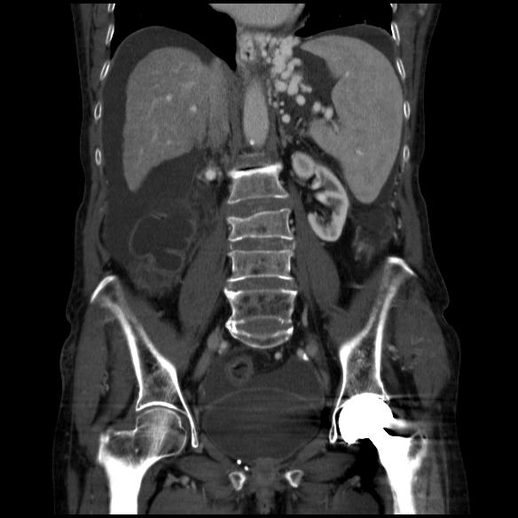
Figure 1 Stomal varices and ascites.

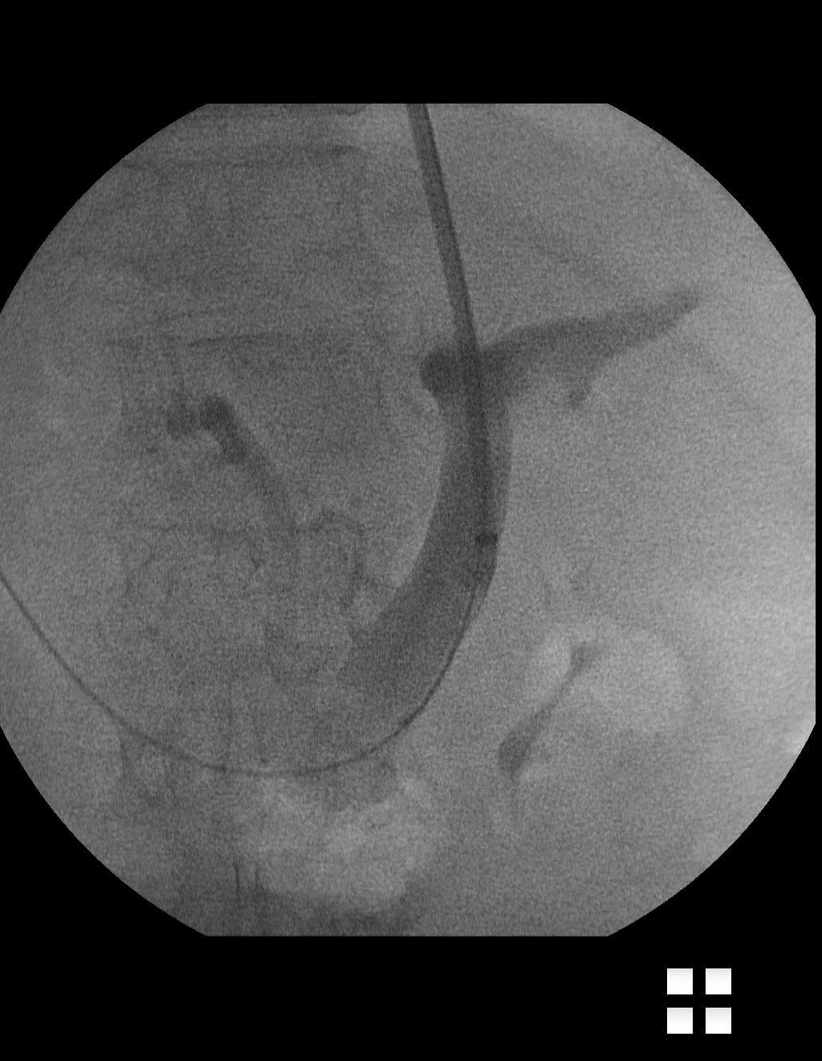
A
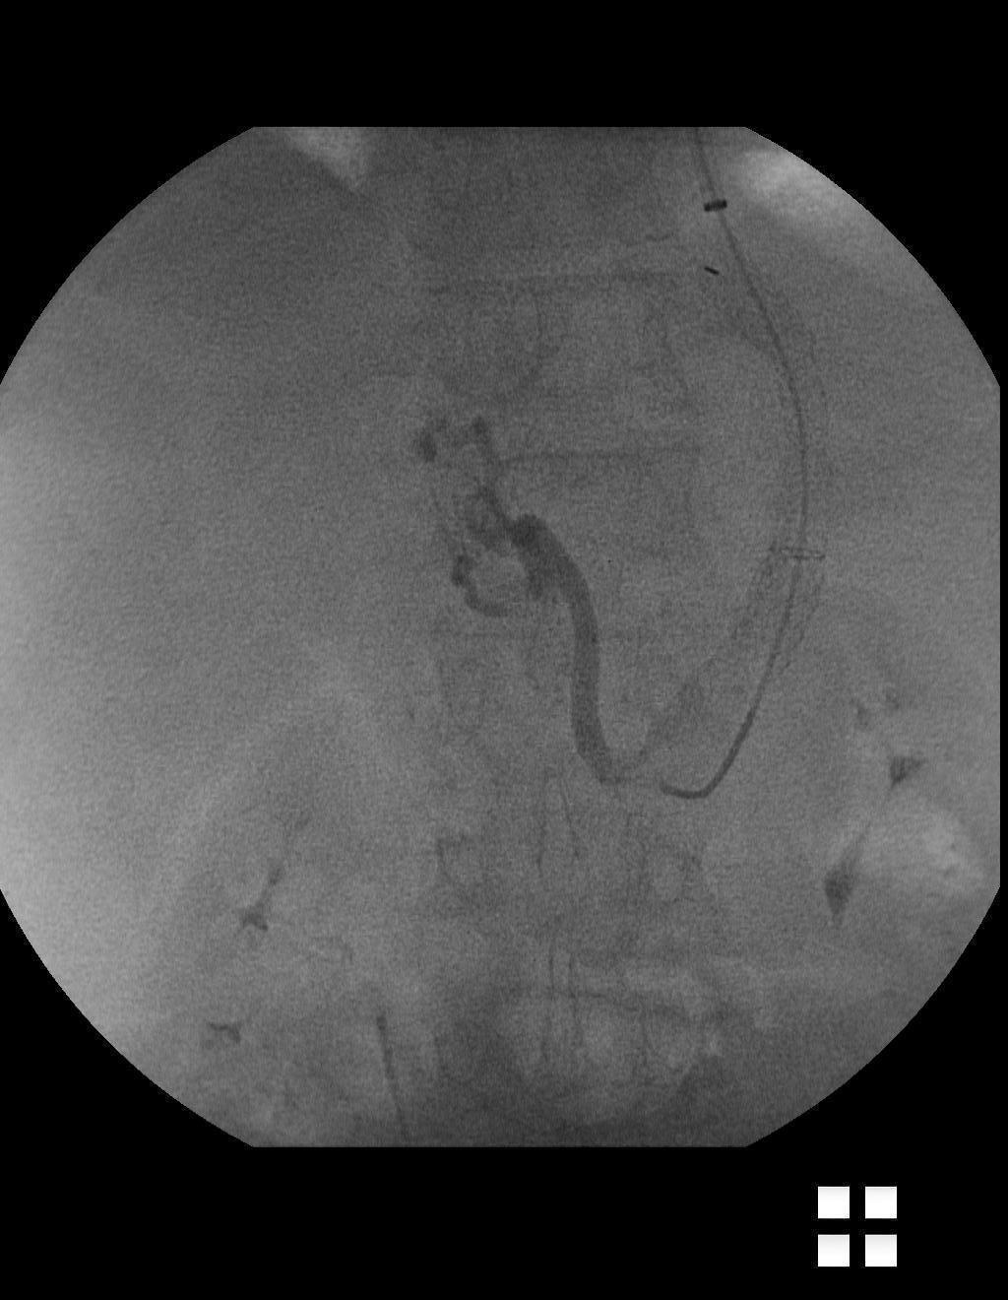
B
Figure 2 Portography. A: Transjugular intrahepatic porto-systemic shunt 1; B: Transjugular intrahepatic porto-systemic shunt 2.

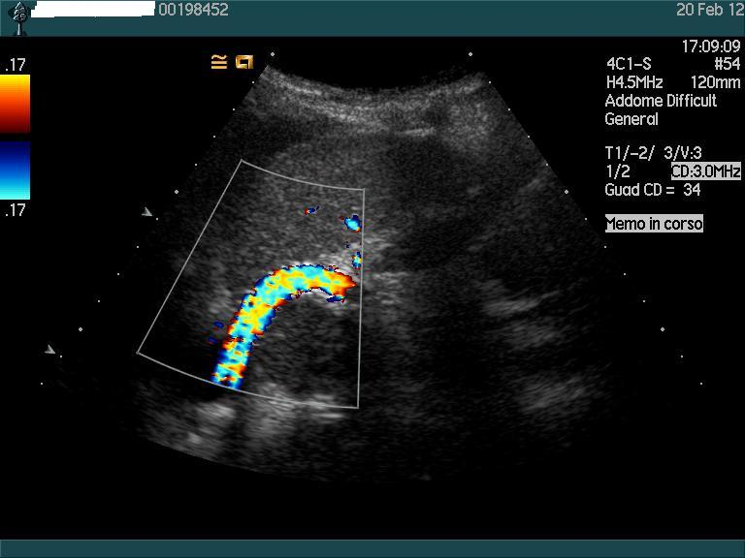
Figure 3 Ecocolor Doppler transjugular intrahepatic porto-systemic shunt.

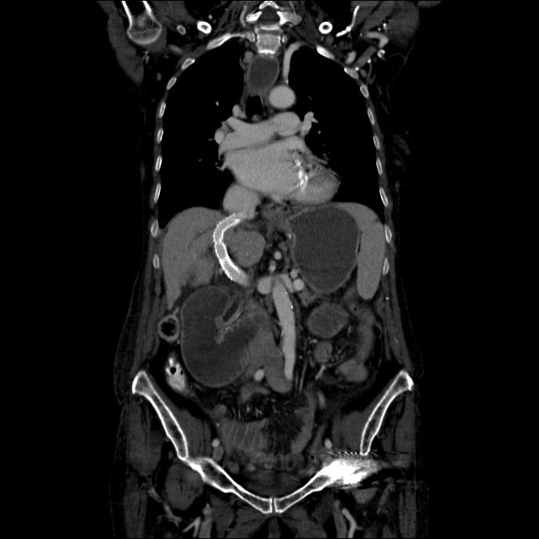
A
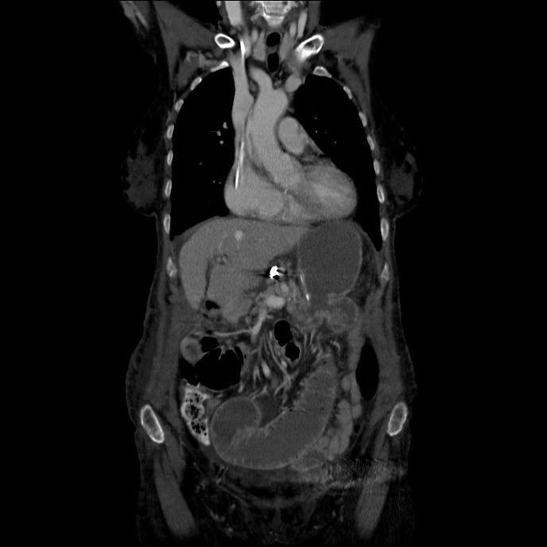
B
Figure 4 Computed tomography. A: Computed tomography after transjugular intrahepatic porto-systemic shunt; B: Coil embolization of right gastric vein.

