Name of Journal: World Journal of Clinical Cases
Manuscript NO: 66742
Manuscript Type: CASE REPORT

Rare monolocular intrahepatic biliary cystadenoma: A case report

Che CH et al. IBC that lacks internal septations

Chen-Hao Che, Zhen-Hua Zhao, Hui-Ming Song, Yuan-Yuan Zheng

Chen-Hao Che, The First Clinical Medical School, Southern Medical University, Guangzhou 510515, Guangdong Province, China

Zhen-Hua Zhao, Department of Radiology, Shaoxing People's Hospital (Shaoxing Hospital, Zhejiang University School of Medicine), Shaoxing 312000, Zhejiang Province, China

Hui-Ming Song, Yuan-Yuan Zheng, Department of Ultrasonography, Shaoxing People's Hospital (Shaoxing Hospital, Zhejiang University School of Medicine), Shaoxing 312000, Zhejiang Province, China

Author contributions: Che CH reviewed the literature and drafted the manuscript; Zhao ZH analyzed the case and contributed to manuscript drafting; Song HM and Zheng YY prepared the case and collected the clinical data; all authors approved the final version to be submitted.

Supported by Shaoxing Municipal Science and Technology Project, No. 2020A13027; and Key Laboratory of Functional Molecular Imaging of Tumor and Interventional Diagnosis and Treatment of Shaoxing City.

Corresponding author: Yuan-Yuan Zheng, MBBS, Chief Physician, Department of Ultrasonography, Shaoxing People's Hospital (Shaoxing Hospital, Zhejiang University School of Medicine), No. 568 Zhongxing North Road, Yuecheng District, Shaoxing 312000, Zhejiang Province, China. 13735299770@126.com

Received: April 19, 2021
Revised: May 27, 2021
Accepted: July 21, 2021
Published online:

Abstract
BACKGROUND
Intrahepatic biliary cystadenoma (IBC) is a rare hepatic benign tumor that is often misdiagnosed as other hepatic cystic diseases. Therefore, imaging examinations are critical to its preoperative diagnosis. Contrast-enhanced ultrasound (CEUS) has gained increasing popularity as an emerging imaging modality and it is considered the primary method for screening IBC due to its specificity of performance. We have described a special case of monolocular IBC and emphasized the performance of CEUS.

CASE SUMMARY
A 45-year-old man complained of epigastric pain lasting one week and had no medical history of hepatitis, liver cirrhosis or parasitization. Physical examination revealed a mass approximately 6 cm in size below subxiphoid process of upper abdominal. A tumor marker test showed elevated CA19-9 Levels (119.3 U/mL), but other laboratory tests were unremarkable. Ultrasound and computerized tomography revealed a round thick-walled mass measuring 83 mm × 68 mm located in the left lateral lobe of the liver, which rarely lacked internal septations and manifested as monolocular cystic structure. CEUS demonstrated that, in the arterial phase, the anechoic area manifested peripheral ring homogeneous enhancement, while the central part presented no enhancement. During the portal phase, the enhanced portion began to subside but was still above the surrounding liver tissue. The patient underwent left partial liver lobectomy and recovered well without tumor recurrence or metastasis. Eventually, the results of pathological examination confirmed IBC.

CONCLUSION
A few IBC cases present with monolocular characteristics, and the lack of intracystic septa in imaging performance cannot exclude IBC.

Key Words: Intrahepatic biliary cystadenoma; Monolocular; Diagnosis; Imaging performance; Contrast-enhanced ultrasound; Case report

Che CH, Zhao ZH, Song HM, Zheng YY. Rare monolocular intrahepatic biliary cystadenoma: A case report. World J Clin Cases 2021; In press

Core Tip: We report the case of a 45-year-old man with intrahepatic biliary cystadenoma (IBC), which infrequently manifests as a monolocular cystic structure due to the lack of intracystic septa. This case was diagnosed by imaging examinations, especially contrast-enhanced ultrasound. Herein, we have summarized the characteristics of contrast-enhanced ultrasound performance for IBC to attain a more accurate diagnosis. Moreover, it is worth noting that the lack of intracystic septa in this case cannot be regarded as imaging evidence to exclude IBC.

INTRODUCTION
Intrahepatic biliary cystadenoma (IBC) is a rare, benign hepatic tumor that is often misdiagnosed as other hepatic cystic diseases in view of its atypical clinical manifestations^{[1]}. Therefore, imaging examinations are critical to the preoperative diagnosis of the disease^{[2]}. Due to its convenience and precision and the absence of radiation, contrast-enhanced ultrasound (CEUS) has gained increasing popularity as an emerging imaging modality. The use of CEUS for the diagnosis of IBC shows a good performance and is highly specific, and CEUS is considered a primary method for tumor screening^{[3]}. Herein, we describe a unique case of monolocular IBC, which rarely exhibits a lack of internal septations, and emphasize the performance of CEUS while reviewing the literature.

CASE PRESENTATION
Chief complaints
A 45-year-old man was admitted to our hospital due to epigastric pain lasting one week.

History of present illness
The patient felt persistent upper abdominal pain 1 wk ago, without obvious inducement, without nausea or vomiting, without intolerance of cold or fever. At a local hospital, abdominal ultrasound demonstrated a honeycomb structure in left lateral lobe of liver. Then he presented to our hospital for further treatment.

History of past illness
He was in good health and did not have a medical history of hepatitis, liver cirrhosis or parasitization.

Personal and family history
The patient had a 20-year history of smoking and alcohol abuse but did not have other risk factors. His parents and family members were healthy.

Physical examination
The patient's skin and sclera were not yellow, and the abdomen did not appear floppy. A mass approximately 6 cm in size was palpable below subxiphoid process of upper abdominal, which was soft and had a fair range of motion, clear boundaries and local tenderness. There was no significant tenderness or rebound tenderness in the remaining abdomen. The liver and spleen were not palpable under the ribs, and normal bowel sounds were observed. Shifting dullness was noted, and Murphy’s sign was negative.

Laboratory examinations
Laboratory findings demonstrated a decreased erythrocyte count (3.46 × 1012/L; normal range: 4.3-5.8 × 1012/L), decreased hemoglobin count (122 g/L; normal range: 130-175 g/L), decreased Hematocrit count (0.37%; normal range: 40%-50%), elevated MCV count (105.2 fl; normal range: 82-100 fl) and elevated MCH count (35.1 pg; normal range: 27-34 pg). However, beyond that, the leucocyte and platelet counts were normal. And liver function and renal function tests revealed no abnormalities. The tumor marker test showed apparently elevated CA19-9 (119.3 U/mL; normal range: 0-37.00 U/mL) and elevated CA50 (27.34 IU/mL; normal range: 0-25.00 IU/mL), but AFP, CEA, CA-125, CA-242 and CA72-4 were within the normal range.

Imaging examinations
Sonographically, a round anechoic area measuring 83 mm × 68 mm was located in the left lateral lobe of the liver. The wall was homogeneously thickened with clear borders, a regular shape, and septations (Figure 1A). Color Doppler ultrasound revealed no blood flow signal inside the thick-walled anechoic area.
Contrast-enhanced ultrasound (CEUS) was performed after a 2 mL injection of the ultrasound contrast agent SonoVue (known as Lumason in the United States; Bracco, Milan, Italy) followed by a bolus injection of 5 mL of 0.9% sodium chloride solution. At 14 s of the arterial phase, the intrahepatic thick-walled anechoic area manifested peripheral ring homogeneous enhancement, while the central part presented no enhancement with no enhancement of separation (Figure 1B). The enhanced portion began to subside slowly at 50 s during the portal phase, but the cyst wall was still above the surrounding liver tissue (Figure 1C).
Computerized tomography (CT) revealed that the size and shape of the liver and spleen were normal, with an intact capsule. A thick-walled, low-density and clear-boundary shadow measuring 83 mm × 68 mm in size was observed in the left lateral lobe of the liver with a CT value of approximately 23 HU. The cyst fluid density was uniform, with a CT value of approximately 17 HU. In addition, intracapsular septa were absent (Figure 1D). Enhanced CT revealed wall enhancement in the arterial phase with a CT value of approximately 41 HU (Figure 1E) and homogeneous enhancement in the portal phase (Figure 1F). There were multiple small cystic lesions without enhancement. Meanwhile, the density of the remaining parenchyma was uniform. The biliary tract was not significantly dilated, and the gallbladder and pancreas showed no abnormalities.

FINAL DIAGNOSIS
Pathologically, the tumor wall was composed of a single layer of cuboidal and columnar epithelium cells (Figure 2A), with fibrinoid necrosis observed in the cyst. Fibrosis, inflammatory cell infiltration and interstitial mucinous degeneration were observed in the peripheral stroma (Figure 2B). Some biliary epithelium proliferated actively. Immunohistochemically, the tumor was AFP (+), CD34 (+) (vessel), CK19 (+), hepatocyte (+), and Ki-67 (+) (< 10%). The patient was eventually diagnosed with IBC.

TREATMENT
The patient underwent left partial liver lobectomy. The resected left lateral lobe specimen showed a monolocular cystic lesion of approximately 8 cm, which was soft, well-defined and surrounded by a white capsular wall. A yellowish, gelatinous fluid filled the mass.

OUTCOME AND FOLLOW-UP
After reexamination, all indicators were normal, and the patient recovered well after treatment without obvious discomfort and was discharged 1 wk later. After two years of follow-up, to date, reexamination CT has revealed no tumor recurrence or metastasis.

DISCUSSION
IBC, which originates from the biliary epithelial cells and usually appears within the intrahepatic bile duct (80%-90%), rarely in the extrahepatic bile duct and gallbladder, is an uncommon hepatic benign cystic tumor that accounts for less than five percent of all hepatic solitary cysts. It has been reported that the disease can occur at any age, especially in middle-aged women, with a median age of 50 years. Statistically, the tumor size typically ranges from 1.5 cm to 35 cm^{[2,4]}.
At present, the etiology of IBC is unclear and possibly related to residual foregut or gonadal epithelial tissues in the liver resulting from abnormal embryonic development^{[5]}. Grossly, IBC manifests as a single structure with an intact capsule and smooth cyst wall, and the majority present multiple septations in the tumor. In the current case, the tumor was viewed as monolocular due to lack of septation. The capsule is filled with radiolucent or gelatinous yellow cystic fluid, and intracapsular nodules or papillary structures can sometimes exist^{[6]}. Histologically, the cyst wall is composed of a single layer of cuboidal or columnar epithelium cells with mesenchymal stroma presenting as ovarian-like, fibroid, hyaline, myxoid or others. In addition, very few IBCs lack stroma^{[1,7]}.
IBC progresses slowly, with a long disease duration. The majority of patients are asymptomatic, while others experience nonspecific manifestations such as abdominal pain, abdominal distension, nausea, vomiting, and jaundice^{[8]}. On physical examination, abdominal masses and local tenderness will be observed. Laboratory findings of these patients are usually normal, but sometimes mildly elevated serum liver enzyme and bilirubin levels are noted. Serum tumor markers, including AFP, CA19-9, CA-125 and CEA, are usually within the normal range. However, the serum level of CA19-9 was exceedingly elevated in this case. We believe the increased serum level of CA19-9 can be helpful for the preoperative diagnosis of IBC under the premise of excluding malignant pancreatic cancer and significant biliary obstruction, in which CA19-9 is elevated^{[9,10]}.
Imaging examination is one of the main diagnostic methods. Ultrasound is the main examination method, while CEUS has been gradually applied in clinical practice in recent years. US reveals that IBC often presents as an anechoic area that is round or lobulated in shape, with a thick and homogeneous cystic wall showing hyperechogenicity, a smooth inner margin, and a clear outer margin. The characteristic of IBC is multiple septations in anechoic areas^{[7]}. CEUS revealed homogeneous and continuously high enhancement of the cyst wall and septa in the arterial phase, which was significantly higher than the surrounding normal liver tissue, due to abundant blood perfusion in the cyst wall and septa. Solid tissues such as nodules, also rich in blood flow, are sometimes observed on the cyst wall or septa, which were of a small size and regular shape and showed homogeneous enhancement. Meanwhile, the central anechoic area showed no enhancement because the sac is filled with serous or mucinous capsule fluid without blood perfusion. In the portal phase, solid structures such as the cyst walls, septa and nodules gradually showed decreasing enhancement until reaching the surrounding normal liver tissue.
Although it is difficult to distinguish IBC from some hepatic cystic diseases in terms of clinical manifestations, CEUS can be used as the mainstay of differential diagnosis due to the distinctive characteristics of IBC on imaging. We have summarized the differences between IBC and the following diseases in terms of ultrasound and CEUS performance: (1) Liver abscess: US shows single or multiple anechoic areas. The abscess wall is hyperechogenic with uneven wall thickness, a rough inner margin and an unclear outer margin. CEUS demonstrates significant enhancement of the abscess wall and internal septa but no enhancement of the liquefied necrotic part, which presents as a typical honeycomb; (2) Hepatic echinococcosis: US reveals a round anechoic area with floating small light spots. The capsule wall, presenting a double-layered structure, is smooth and intact, and the internal wall can sometimes collapse and dissect. Simultaneously, strongly echoic areas due to calcification can be observed in the periphery of the capsule wall. CEUS shows no significant enhancement; (3) Caroli’s disease: Color Doppler ultrasound reveals a circumscribed dilated anechoic area in the common hepatic duct or intrahepatic bile duct, which is oval or triangular in shape and without obvious enhancement; (4) Biliary cystadenocarcinoma: US reveals that the cyst wall is rough and has an uneven thickness, sometimes accompanied by strongly echoic areas of calcification. CEUS reveals that mural nodules show enhanced heterogeneity and are large in size, numerous and irregular in shape; and (5) Primary liver cancer: US reveals single or multiple masses presenting complex echoes in the liver parenchyma, with annular hypoechoic vocal cords around the tumor. On CEUS, the tumor presents overall homogeneous hyperenhancement earlier than the liver parenchyma in the arterial phase and hypoenhancement in the portal phase.
As an imaging examination that is complementary to US, CT can more graphically illustrate cystic lesions. Enhanced CT reveals a uniform and continuous enhancement of solid structures such as cyst walls, septa, and cyst wall nodules but no enhancement of the contents of the cyst^{[11]}. MRI facilitates the assessment of cystic fluid properties, and cystic fluid in IBC generally presents hypointensity on T1WI and hyperintensity on T2WI. The signal intensity of T1WI might be elevated with increasing cyst fluid protein concentrations, with lower intensity for serous fluid and bile and higher intensity for mucinous components^{[12]}.
It is worth noting that in this case, CEUS, scan and enhanced CT showed no visible septation within the tumor; only a small septation was observed on ordinary ultrasound because the internal septa were scant and lacked blood perfusion. Therefore, it has been confirmed that a small number of IBCs lack intracapsular septa, presenting a round or irregularly shaped monolocular cystic structure. The absence of intracapsular septation on US or CT cannot be used as an imaging basis to exclude IBC.
Surgical resection is the preferred method of treatment for IBC. Provided that resection of the lesion is not complete, postoperative recurrence will generally occur or even be cancerous (the recurrence rate is 90% and cancerization rate is 30%)^{[13]}. Therefore, early radical tumor resection is vital for surgical efficacy and prognosis. The scope of radical surgery includes the tumor and a small amount of liver tissue around it. If necessary, it is feasible to expand the scope of surgery or even perform liver transplantation. Frozen sectioning during the operation can help to determine whether the tumor is benign or malignant and whether the scope of resection is sufficient. It is currently believed that conservative treatments for simple liver cysts, such as aspiration, drainage and marsupialization, are not recommended due to the poor patient prognosis^{[14]}.
IBC patients usually recover well, with a low recurrence rate of 5%-10%. Sang et al^{[15]} reported that the 10-year survival rate of IBC patients exceeded 90%.

CONCLUSION
This article reported a rare case of monolocular IBC and focused on its imaging features, especially on CEUS, which is helpful for disease diagnosis. However, because only a minority of IBCs manifest as monolocular cystic tumors, the lack of intracystic septa cannot be regarded as imaging evidence to exclude IBC.

REFERENCES
1 Tholomier C, Wang Y, Aleynikova O, Vanounou T, Pelletier JS. Biliary mucinous cystic neoplasm mimicking a hydatid cyst: a case report and literature review. BMC Gastroenterol 2019; 19: 103 [PMID: 31234803 DOI: 10.1186/s12876-019-1001-5]
2 Kazama S, Hiramatsu T, Kuriyama S, Kuriki K, Kobayashi R, Takabayashi N, Furukawa K, Kosukegawa M, Nakajima H, Hara K. Giant intrahepatic biliary cystadenoma in a male: a case report, immunohistopathological analysis, and review of the literature. Dig Dis Sci 2005; 50: 1384-1389 [PMID: 16047491 DOI: 10.1007/s10620-005-2791-6]
3 Pang EHT, Chan A, Ho SG, Harris AC. Contrast-Enhanced Ultrasound of the Liver: Optimizing Technique and Clinical Applications. AJR Am J Roentgenol 2018; 210: 320-332 [PMID: 29220210 DOI: 10.2214/AJR.17.17843]
4 Xu RM, Li XR, Liu LH, Zheng WQ, Zhou H, Wang XC. Intrahepatic biliary cystadenoma: A case report. World J Clin Cases 2020; 8: 5670-5677 [PMID: 33344559 DOI: 10.12998/wjcc.v8.i22.5670]
5 Treska V, Ferda J, Daum O, Liska V, Skalicky T, Bruha J. Intrahepatic biliary cystadenoma-diagnosis and treatment options. Turk J Gastroenterol 2016; 27: 252-256 [PMID: 27210781 DOI: 10.5152/tjg.2016.15447]
6 Wang C, Miao R, Liu H, Du X, Liu L, Lu X, Zhao H. Intrahepatic biliary cystadenoma and cystadenocarcinoma: an experience of 30 cases. Dig Liver Dis 2012; 44: 426-431 [PMID: 22169273 DOI: 10.1016/j.dld.2011.11.007]
7 Bardin RL, Trupiano JK, Howerton RM, Geisinger KR. Oncocytic biliary cystadenocarcinoma: a case report and review of the literature. Arch Pathol Lab Med 2004; 128: e25-e28 [PMID: 14736268 DOI: 10.5858/2004-128-e25-OBCACR]
8 Soares KC, Arnaoutakis DJ, Kamel I, Anders R, Adams RB, Bauer TW, Pawlik TM. Cystic neoplasms of the liver: biliary cystadenoma and cystadenocarcinoma. J Am Coll Surg 2014; 218: 119-128 [PMID: 24045144 DOI: 10.1016/j.jamcollsurg.2013.08.014]
9 Erdogan D, Busch OR, Rauws EA, van Delden OM, Gouma DJ, van-Gulik TM. Obstructive jaundice due to hepatobiliary cystadenoma or cystadenocarcinoma. World J Gastroenterol 2006; 12: 5735-5738 [PMID: 17007033 DOI: 10.3748/wjg.v12.i35.5735]
10 Steinberg W. The clinical utility of the CA 19-9 tumor-associated antigen. Am J Gastroenterol 1990; 85: 350-355 [PMID: 2183589]
11 Xu HX, Lu MD, Liu LN, Zhang YF, Guo LH, Liu C, Wang S. Imaging features of intrahepatic biliary cystadenoma and cystadenocarcinoma on B-mode and contrast-enhanced ultrasound. Ultraschall Med 2012; 33: E241-E249 [PMID: 23154870 DOI: 10.1055/s-0031-1299276]
12 Ratti F, Ferla F, Paganelli M, Cipriani F, Aldrighetti L, Ferla G. Biliary cystadenoma: short- and long-term outcome after radical hepatic resection. Updates Surg 2012; 64: 13-18 [PMID: 22038379 DOI: 10.1007/s13304-011-0117-0]
13 Teoh AY, Ng SS, Lee KF, Lai PB. Biliary cystadenoma and other complicated cystic lesions of the liver: diagnostic and therapeutic challenges. World J Surg 2006; 30: 1560-1566 [PMID: 16865321 DOI: 10.1007/s00268-005-0461-7]
14 Thomas KT, Welch D, Trueblood A, Sulur P, Wise P, Gorden DL, Chari RS, Wright JK Jr, Washington K, Pinson CW. Effective treatment of biliary cystadenoma. Ann Surg 2005; 241: 769-73; discussion 773-5 [PMID: 15849512 DOI: 10.1097/01.sla.0000161982.57360.1b]
15 Sang X, Sun Y, Mao Y, Yang Z, Lu X, Yang H, Xu H, Zhong S, Huang J. Hepatobiliary cystadenomas and cystadenocarcinomas: a report of 33 cases. Liver Int 2011; 31: 1337-1344 [PMID: 21745301 DOI: 10.1111/j.1478-3231.2011.02560.x]

Footnotes
Informed consent statement: Informed written consent was obtained from the patient for publication of this report and any accompanying images.

Conflict-of-interest statement: The authors declare that they have no conflicts of interest to report.

CARE Checklist (2016) statement: The authors have read the CARE Checklist (2016), and the manuscript was prepared and revised according to the CARE Checklist (2016).

Open-Access: This article is an open-access article that was selected by an in-house editor and fully peer-reviewed by external reviewers. It is distributed in accordance with the Creative Commons Attribution NonCommercial (CC BY-NC 4.0) license, which permits others to distribute, remix, adapt, build upon this work non-commercially, and license their derivative works on different terms, provided the original work is properly cited and the use is non-commercial. See: http://creativecommons.org/Licenses/by-nc/4.0/

Manuscript source: Unsolicited manuscript

Corresponding Author's Membership in Professional Societies: Chinese Society of Ultrasonography; Interventional Medicine Branch of Zhejiang Medical Association; Key Discipline of Ultrasound Medicine in Shaoxing City.

Peer-review started: April 19, 2021
First decision: May 24, 2021
Article in press:

Specialty type: Medicine, research and experimental
Country/Territory of origin: China
Peer-review report’s scientific quality classification
Grade A (Excellent): 0
Grade B (Very good): B
Grade C (Good): 0
Grade D (Fair): 0
Grade E (Poor): 0

P-Reviewer: Machado P S-Editor: Yan JP L-Editor: P-Editor:
Figure Legends
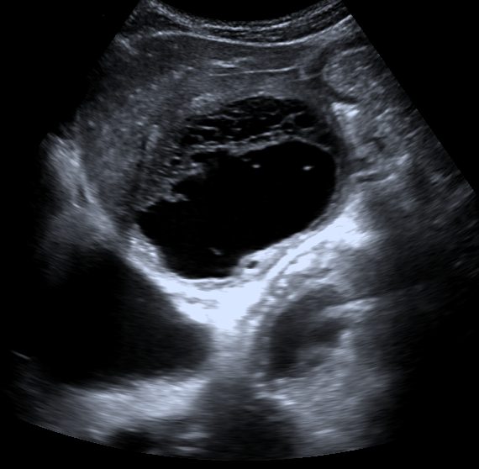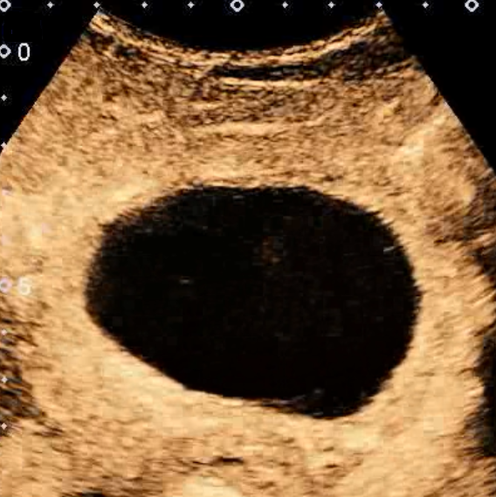
A B
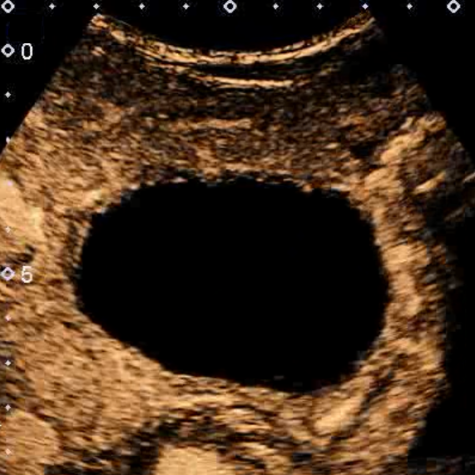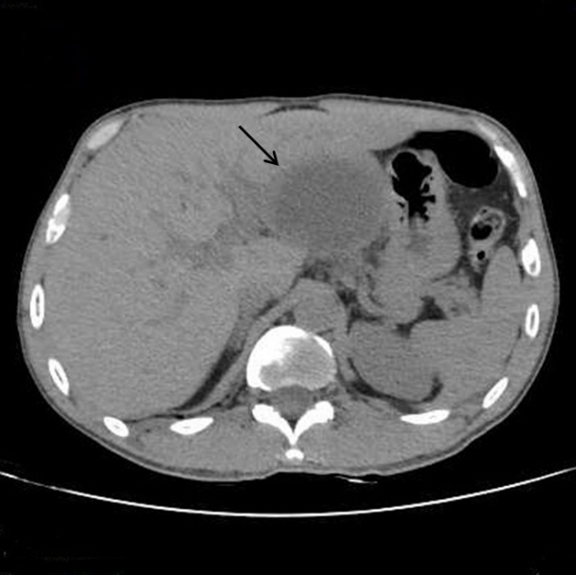
C D
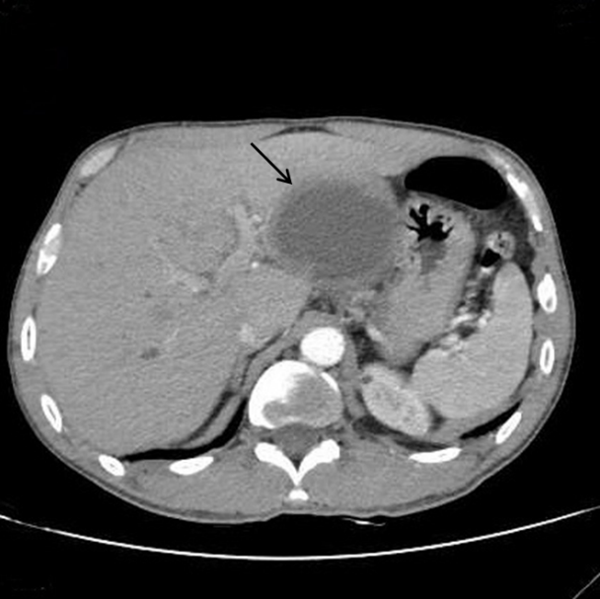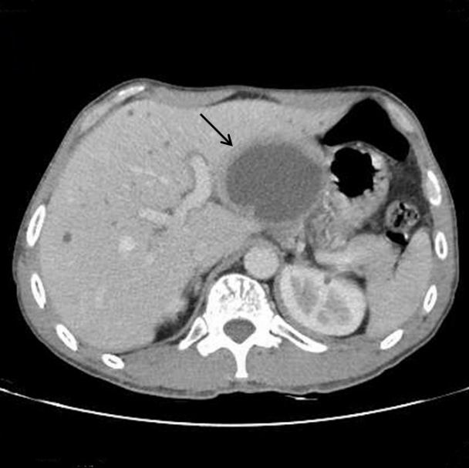
E F
Figure 1 Ultrasound and computerized tomography imaging of Intrahepatic biliary cystadenoma. A: Ultrasound (US) showed that the thick-walled anechoic area in the left lateral lobe was regular and had a clear boundary; B: The arterial phase of contrast-enhanced US (CEUS) showed that the anechoic area presented peripheral annular hyperenhancement, while the central part and internal septations showed no enhancement; C: The portal phase of CEUS showed that the enhanced cyst wall subsided slowly but was still above the surrounding liver tissue; D: Computerized tomography revealed a round thick-walled monolocular mass (arrow) in the left lateral lobe with clear borders and uniform density of cyst fluid but no visible separation; E: In the arterial phase, the cyst wall was enhanced, but the cyst fluid was not enhanced (arrow); F: In the portal phase, homogeneous enhancement was observed for the cyst wall close to the surrounding normally enhanced liver tissue (arrow).

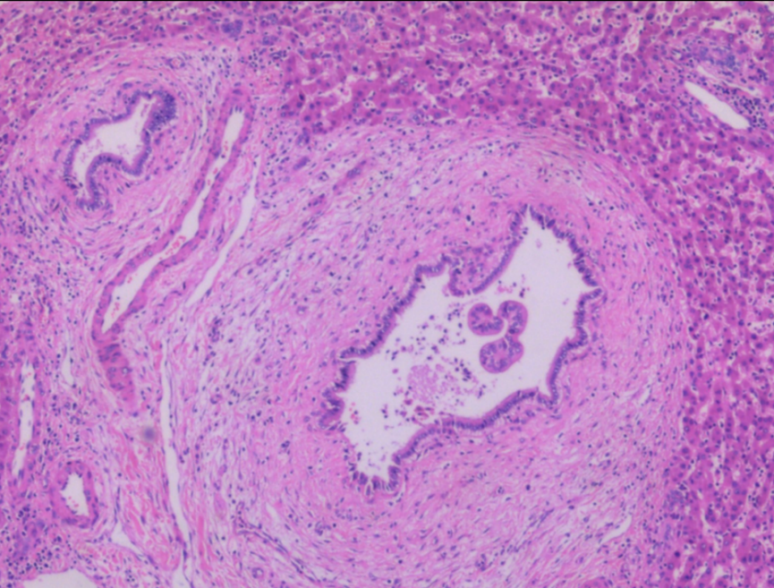
A
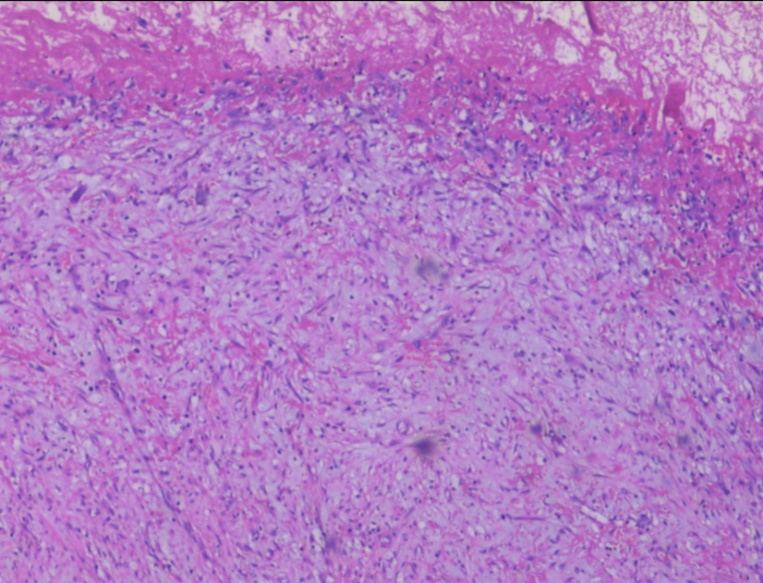
B
Figure 2 Postoperative pathological image of Intrahepatic biliary cystadenoma. A: The tumor wall was lined with a single layer of cuboidal or columnar epithelial cells, which was arranged regularly without conspicuous atypia. Fibrinoid necrosis was observed in the capsule (hematoxylin and eosin stain, × 200); B: Fibroplasia and mucinous degeneration presented in the subepithelial stroma, with acute and chronic inflammatory cell infiltration (hematoxylin and eosin stain, × 200).

