Name of Journal: World Journal of Radiology
Manuscript NO: 86671
Manuscript Type: CASE REPORT

Distinctive magnetic resonance imaging features in primary central nervous system lymphoma: A case report

Liu LH et al. Distinctive MRI imaging features in PCNSL

Li-Hong Liu, Han-Wen Zhang, Hong-Bo Zhang, Xiao-Lei Liu, Hua-Zhen Deng, Fan Lin, Biao Huang

Li-Hong Liu, Han-Wen Zhang, Xiao-Lei Liu, Hua-Zhen Deng, Fan Lin, Department of Radiology, The First Affiliated Hospital of Shenzhen University, Health Science Center, Shenzhen Second People’s Hospital, Shenzhen 518036, Guangdong Province, China

Han-Wen Zhang, Hong-Bo Zhang, Biao Huang, The Second School of Clinical Medicine, Southern Medical University, Guangzhou 510282, Guangdong Province, China

Hong-Bo Zhang, Department of Radiology, Sun Yat-Sen University, Shenzhen 518000, Guangdong Province, China

Biao Huang, Department of Radiology, Guangdong Provincial People’s Hospital, Guangdong Academy of Medical Sciences, Guangzhou 510000, Guangdong Province, China

Author contributions: Case studies were provided by Liu LH; Zhang HW wrote the article; Deng HZ searched the literature; Zhang HB analyzed the case; Huang B and Lin F revised and reviewed the manuscript; Huang B (huangbiao@gdph.org.cn), Lin F (foxetfoxet@gmail.com), and Zhang HW contributed equally to this research.

Supported by National Natural Science Foundation of China, No. 82071871; Guangdong Basic and Applied Basic Research Foundation, No. 2021A1515220131; Guangdong Medical Science and Technology Research Fund Project, No. 2022111520491834; and Clinical Research Project of Shenzhen Second People's Hospital, China, No. 20223357022.

Corresponding author: Han-Wen Zhang, MD, Doctor, Department of Radiology, The First Affiliated Hospital of Shenzhen University, Health Science Center, Shenzhen Second People’s Hospital, No. 3002 Sungangxi Road, Shenzhen 518036, Guangdong Province, China. zhwstarcraft@outlook.com

Received: June 30, 2023
Revised: September 4, 2023
Accepted: September 22, 2023
Published online: September 28, 2023

Abstract
BACKGROUND
Primary central nervous system lymphoma (PCNSL) is a rare malignant tumor originating from the lymphatic hematopoietic system. It exhibits unique imaging manifestations due to its biological characteristics.

CASE SUMMARY
Magnetic resonance imaging (MRI) with diffusion-weighted imaging (DWI), perfusion-weighted imaging (PWI), and magnetic resonance spectroscopy was performed. The imaging findings showed multiple space-occupying lesions with low signal on T1-weighted imaging, uniform high signal on T2-weighted imaging, and obvious enhancement on contrast-enhanced scans. DWI revealed diffusion restriction, PWI demonstrated hypoperfusion, and spectroscopy showed elevated choline peak and decreased N-acetylaspartic acid. The patient's condition significantly improved after hormone shock therapy.

CONCLUSION
This case highlights the distinctive imaging features of PCNSL and their importance in accurate diagnosis and management.

Key Words: Primary central nervous system lymphoma; Primary central nervous system lymphoma; Diffusion-weighted imaging; Perfusion-weighted imaging; Magnetic resonance imaging; Case report

©The Author(s) 2023. Published by Baishideng Publishing Group Inc. All rights reserved.

Citation: Liu LH, Zhang HW, Zhang HB, Liu XL, Deng HZ, Lin F, Huang B. Distinctive magnetic resonance imaging features in primary central nervous system lymphoma: A case report. World J Radiol 2023; 15(9): 274-280
URL: https://www.wjgnet.com/1949-8470/full/v15/i9/274.htm
DOI: https://dx.doi.org/10.4329/wjr.v15.i9.274

Core Tip: Primary central nervous system lymphoma (PCNSL) is a rare tumor of the central nervous system with distinctive imaging features. This case report highlights the imaging manifestations of multiple PCNSL lesions using diffusion-weighted imaging, perfusion-weighted imaging, and magnetic resonance imaging. Accurate diagnosis is crucial for appropriate management. Further research and larger studies are needed to enhance the understanding and diagnostic accuracy of PCNSL.

INTRODUCTION
Primary central nervous system lymphoma (PCNSL) is an exceptionally rare and aggressive malignancy originating within the central nervous system. Despite its infrequency, PCNSL presents unique diagnostic and therapeutic challenges, rendering it a subject of profound clinical importance^{[1]}. In recent years, advanced imaging techniques, including diffusion-weighted imaging (DWI), perfusion-weighted imaging (PWI), and magnetic resonance (MR) spectroscopy, have greatly enhanced our ability to comprehend the disease and its distinctive manifestations^{[2]}.
While previous studies have provided valuable insights into the broader understanding of PCNSL, there is a critical gap in characterizing the imaging features on an individual case level^{[3]}. This study endeavors to bridge this gap by conducting an in-depth examination of DWI, PWI, and MR spectroscopy findings in a single PCNSL case. By scrutinizing these imaging modalities within the unique context of this individual case, we aim to contribute to the comprehensive understanding of PCNSL's imaging features and their potential clinical implications^{[4]}.
The primary research problem addressed in this study is to delineate the specific magnetic resonance imaging (MRI) imaging manifestations of PCNSL within the scope of a single case analysis and to comprehend their diagnostic and clinical significance. To accomplish this, we have conducted a detailed analysis of DWI, PWI, and MR spectroscopy findings in the context of this singular PCNSL case.

CASE PRESENTATION
Chief complaints
A 79-year-old female patient with a previously unremarkable medical history presented with a sudden onset of unexplained dizziness accompanied by projectile vomiting, characterized by the ejection of gastric contents. She also reported a sense of heaviness and weakness in her limbs.

History of present illness
Initial evaluation at another medical facility revealed the presence of multiple intracranial space-occupying lesions. These lesions were detected through a computed tomography scan, which indicated the involvement of the cerebellar hemisphere, corpus callosum's splenium, and the left parietal lobe.

History of past illness
No special notes.

Personal and family history
No special notes.

Physical examination
Physical examination revealed no abnormalities.

Laboratory examinations
The platelet specific volume was slightly elevated. The monocyte count was mildly elevated. The bacterial content in the urine test increased [4225.40, reference value: 0-4000 (/μL)]

Imaging examinations
Upon admission, the patient underwent a comprehensive evaluation, including MRI with DWI, PWI, and MR spectroscopy (MRS). The MRI results confirmed the presence of multiple space-occupying lesions, characterized by low signal intensity on T1-weighted imaging, uniform high signal intensity on T2-weighted imaging, and prominent enhancement on contrast-enhanced scans (Figure 1). DWI further revealed diffusion restriction, while PWI demonstrated hypoperfusion in all the identified lesions. Additionally, spectroscopy (MRS) depicted an elevated choline peak and decreased N-acetylaspartic acid. Notably, MRS also revealed the presence of a Lip peak within the lesion (Figure 2). These combined imaging features strongly suggested the possibility of PCNSL.

FINAL DIAGNOSIS
Pathological examination of the intracranial lesion confirmed the presence of an aggressive B-cell lymphoma. Immunohistochemical analysis demonstrated the following profile: CD21 (-), CD10 (-), CD20 (+), CD3 (background T-cells +), CD30 (-), PAX-5 (+), Bcl-6 (+), MUM-1 (+), Ki-67 (approximately 80%), CD5 (-), CD23 (-), Bcl-2 (-), CyclinD1 (-), CD79A (+), C-MYC (approximately 30%+), P53 (10%+ with varying intensity), GFAP (glial cells +). Importantly, Epstein-Barr virus-encoded small RNA (EBER) was not detected. These findings confirmed the diagnosis of diffuse large B-cell lymphoma of the non-germinal center B-cell (non-GCB) subtype, supporting the diagnosis of PCNSL.

TREATMENT
Treatment and response
In response to the initial presentation and MRI findings, the patient underwent a diagnostic trial of steroid therapy. This treatment led to a significant improvement in the patient's neurological condition, although it was accompanied by the emergence of certain neuropsychiatric symptoms. Subsequent administration of medications, including lorazepam and olanzapine, resulted in a notable improvement in the patient's neuropsychiatric symptoms. Follow-up MRI examinations indicated a reduction in enhancement in the lesions located in the hippocampus and left parietal lobe, with the other lesions remaining stable or showing slight reductions (Figure 3).

OUTCOME AND FOLLOW-UP
The patient subsequently received standardized lymphoma immunotherapy and chemotherapy regimens, and her prognosis remains favorable.

DISCUSSION
There is no lymphoid tissue present within the central nervous system, making brain lymphomas relatively rare. Currently, the origin of intracerebral lymphoma can be attributed to the following factors: Firstly, reactive lymphocytes enter the brain tissue during intracerebral infection and undergo malignant transformation through various mechanisms. Secondly, activated peripheral lymphocytes transform into tumor cells and migrate to the brain through the bloodstream, resulting in tumors primarily located around the ventricles, basal ganglia, and frontoparietal lobes. Thirdly, undifferentiated pluripotent stem cells surrounding blood vessels in the brain may serve as the source of intracerebral lymphoma. Histologically, intracerebral lymphomas exhibit predominant sleeve-shaped growth, infiltrating the surrounding brain parenchyma, and demonstrating multicentric growth within the tumor^{[5]}.
PCNSL typically presents as supratentorial lesions, with predilection sites in the cerebral hemisphere, corpus callosum, basal ganglia, and thalamus^{[6]}. The imaging findings of PCNSL are closely related to its pathological features. In this case, the lesions were confined to the brain tissue, involving both supratentorial and infratentorial areas, which is relatively rare^{[7]}.
On conventional MRI, PCNSL shows iso-hypointensity on T1-weighted imaging and iso-hypointensity on T2-weighted imaging^{[8]}. DWI demonstrates diffusion restriction due to densely arranged tumor cells. According to Lin et al^{[9]}, their study suggests that combining DWI ADC value with T1WI enhanced scan can aid in the differentiation of glioblastoma from PCNSL. PWI reveals hypoperfusion, reflecting the hypo-vascular nature of PCNSL^{[10]}. Contrast-enhanced scans show uniform enhancement when the tumor invades adjacent brain parenchyma and disrupts the blood-brain barrier (BBB). In our previous study, we compared high-grade glioma (HGG) with lymphoma using dynamic contrast-enhanced (DCE) imaging, and found that lymphoma has more obvious damage to the BBB, resulting in transfer constant(K^{trans}) values even higher than HGG^{[11]}. The characteristic imaging features, such as the "fist sign," "sharp horn sign," and "butterfly wing sign,"(usually occurs in the corpus callosum) are associated with the tumor's angiophilic growth.
MRS plays a crucial role in the evaluation of PCNSL. Elevated choline peak, decreased N-acetylaspartic acid, and a towering lipid peak are commonly observed^{[12]}. The towering lipid peak is highly specific for the diagnosis of PCNSL, attributed to the accelerated turnover of lymphocytes and macrophages. PCNSL should be differentiated from demyelinating diseases, as their imaging findings may resemble each other^{[13]}. Hormone shock therapy can provide symptomatic relief in both PCNSL and demyelinating diseases, but recovery of symptoms after hormone therapy withdrawal is indicative of PCNSL.
In addition to our contributions to the understanding of PCNSL, it is essential to recognize the limitations of our study. The utilization of a single-case design inherently limits the generalizability of our findings to a broader population of PCNSL patients. Future research should strive to replicate these findings in larger cohorts to establish their broader applicability. Furthermore, our study primarily focuses on the imaging aspects of PCNSL, and future investigations could explore the correlation between imaging features and specific clinical outcomes. These considerations highlight both the strengths and the areas for improvement in our research.

CONCLUSION
This single-case analysis of PCNSL has shed light on the distinctive MRI imaging features of this rare malignancy. By employing advanced techniques such as DWI, PWI, and MR spectroscopy, we have provided a comprehensive characterization of PCNSL's imaging manifestations. However, it is important to acknowledge the limitations of this study. The use of a single-case design restricts the generalizability of our findings to a broader population. Future research should aim to replicate these findings in larger cohorts of PCNSL patients to establish their broader applicability. Additionally, our study focused on the imaging aspects, and future investigations could explore the correlation between imaging features and specific clinical outcomes. Despite these limitations, our study contributes valuable insights into the unique imaging features of PCNSL and serves as a foundation for further research in this area.

REFERENCES
1 Krebs S, Barasch JG, Young RJ, Grommes C, Schöder H. Positron emission tomography and magnetic resonance imaging in primary central nervous system lymphoma-a narrative review. Ann Lymphoma 2021; 5 [PMID: 34223561 DOI: 10.21037/aol-20-52]
2 Schaff LR, Grommes C. Primary central nervous system lymphoma. Blood 2022; 140: 971-979 [PMID: 34699590 DOI: 10.1182/blood.2020008377]
3 Deng B, Dai Y, Wang Q, Yang J, Chen X, Liu TT, Liu J. The clinical analysis of new-onset status epilepticus. Epilepsia Open 2022; 7: 771-780 [PMID: 36214088 DOI: 10.1002/epi4.12657]
4 Han Y, Wang ZJ, Li WH, Yang Y, Zhang J, Yang XB, Zuo L, Xiao G, Wang SZ, Yan LF, Cui GB. Differentiation Between Primary Central Nervous System Lymphoma and Atypical Glioblastoma Based on MRI Morphological Feature and Signal Intensity Ratio: A Retrospective Multicenter Study. Front Oncol 2022; 12: 811197 [PMID: 35174088 DOI: 10.3389/fonc.2022.811197]
5 Barajas RF, Politi LS, Anzalone N, Schöder H, Fox CP, Boxerman JL, Kaufmann TJ, Quarles CC, Ellingson BM, Auer D, Andronesi OC, Ferreri AJM, Mrugala MM, Grommes C, Neuwelt EA, Ambady P, Rubenstein JL, Illerhaus G, Nagane M, Batchelor TT, Hu LS. Consensus recommendations for MRI and PET imaging of primary central nervous system lymphoma: guideline statement from the International Primary CNS Lymphoma Collaborative Group (IPCG). Neuro Oncol 2021; 23: 1056-1071 [PMID: 33560416 DOI: 10.1093/neuonc/noab020]
6 Weller M. The vanishing role of whole brain radiotherapy for primary central nervous system lymphoma. Neuro Oncol 2014; 16: 1035-1036 [PMID: 24958097 DOI: 10.1093/neuonc/nou120]
7 Bhattacharjee R, Gupta M, Singh T, Sharma S, Khanna G, Parvaze SP, Patir R, Vaishya S, Ahlawat S, Singh A, Gupta RK. Role of intra-tumoral vasculature imaging features on susceptibility weighted imaging in differentiating primary central nervous system lymphoma from glioblastoma: a multiparametric comparison with pathological validation. Neuroradiology 2022; 64: 1801-1818 [PMID: 35435463 DOI: 10.1007/s00234-022-02946-5]
8 Toh CH, Wei KC, Chang CN, Ng SH, Wong HF. Differentiation of primary central nervous system lymphomas and glioblastomas: comparisons of diagnostic performance of dynamic susceptibility contrast-enhanced perfusion MR imaging without and with contrast-leakage correction. AJNR Am J Neuroradiol 2013; 34: 1145-1149 [PMID: 23348763 DOI: 10.3174/ajnr.A3383]
9 Lin X, Lee M, Buck O, Woo KM, Zhang Z, Hatzoglou V, Omuro A, Arevalo-Perez J, Thomas AA, Huse J, Peck K, Holodny AI, Young RJ. Diagnostic Accuracy of T1-Weighted Dynamic Contrast-Enhanced-MRI and DWI-ADC for Differentiation of Glioblastoma and Primary CNS Lymphoma. AJNR Am J Neuroradiol 2017; 38: 485-491 [PMID: 27932505 DOI: 10.3174/ajnr.A5023]
10 Kang KM, Choi SH, Chul-Kee P, Kim TM, Park SH, Lee JH, Lee ST, Hwang I, Yoo RE, Yun TJ, Kim JH, Sohn CH. Differentiation between glioblastoma and primary CNS lymphoma: application of DCE-MRI parameters based on arterial input function obtained from DSC-MRI. Eur Radiol 2021; 31: 9098-9109 [PMID: 34003350 DOI: 10.1007/s00330-021-08044-z]
11 Zhang HW, Lyu GW, He WJ, Lei Y, Lin F, Feng YN, Wang MZ. Differential diagnosis of central lymphoma and high-grade glioma: dynamic contrast-enhanced histogram. Acta Radiol 2020; 61: 1221-1227 [PMID: 31902220 DOI: 10.1177/0284185119896519]
12 Du X, He Y, Lin W. Diagnostic Accuracy of the Diffusion-Weighted Imaging Method Used in Association With the Apparent Diffusion Coefficient for Differentiating Between Primary Central Nervous System Lymphoma and High-Grade Glioma: Systematic Review and Meta-Analysis. Front Neurol 2022; 13: 882334 [PMID: 35812103 DOI: 10.3389/fneur.2022.882334]
13 Miyajima T, Ohigashi H, Yaguchi H, Teshima T. Neurolymphomatosis in Intravascular Large B-cell Lymphoma. Intern Med 2023; 62: 1381-1382 [PMID: 36198588 DOI: 10.2169/internalmedicine.0021-22]

Footnotes
Informed consent statement: The patient signed an informed consent to the publication of this case.

Conflict-of-interest statement: The author(s) declared no potential conflicts of interest with respect to the research, authorship, and/or publication of this article.

CARE Checklist (2016) statement: The authors have read the CARE Checklist (2016), and the manuscript was prepared and revised according to the CARE Checklist (2016).

Open-Access: This article is an open-access article that was selected by an in-house editor and fully peer-reviewed by external reviewers. It is distributed in accordance with the Creative Commons Attribution NonCommercial (CC BY-NC 4.0) license, which permits others to distribute, remix, adapt, build upon this work non-commercially, and license their derivative works on different terms, provided the original work is properly cited and the use is non-commercial. See: https://creativecommons.org/Licenses/by-nc/4.0/

Provenance and peer review: Unsolicited article; Externally peer reviewed.
Peer-review model: Single blind

Peer-review started: June 30, 2023
First decision: August 24, 2023
Article in press: September 22, 2023

Specialty type: Radiology, nuclear medicine and medical imaging
Country/Territory of origin: China
Peer-review report’s scientific quality classification
Grade A (Excellent): 0
Grade B (Very good): B
Grade C (Good): 0
Grade D (Fair): D
Grade E (Poor): 0

P-Reviewer: Mahmoud MZ, Saudi Arabia S-Editor: Liu JH L-Editor: A P-Editor: Liu JH

Figure Legends
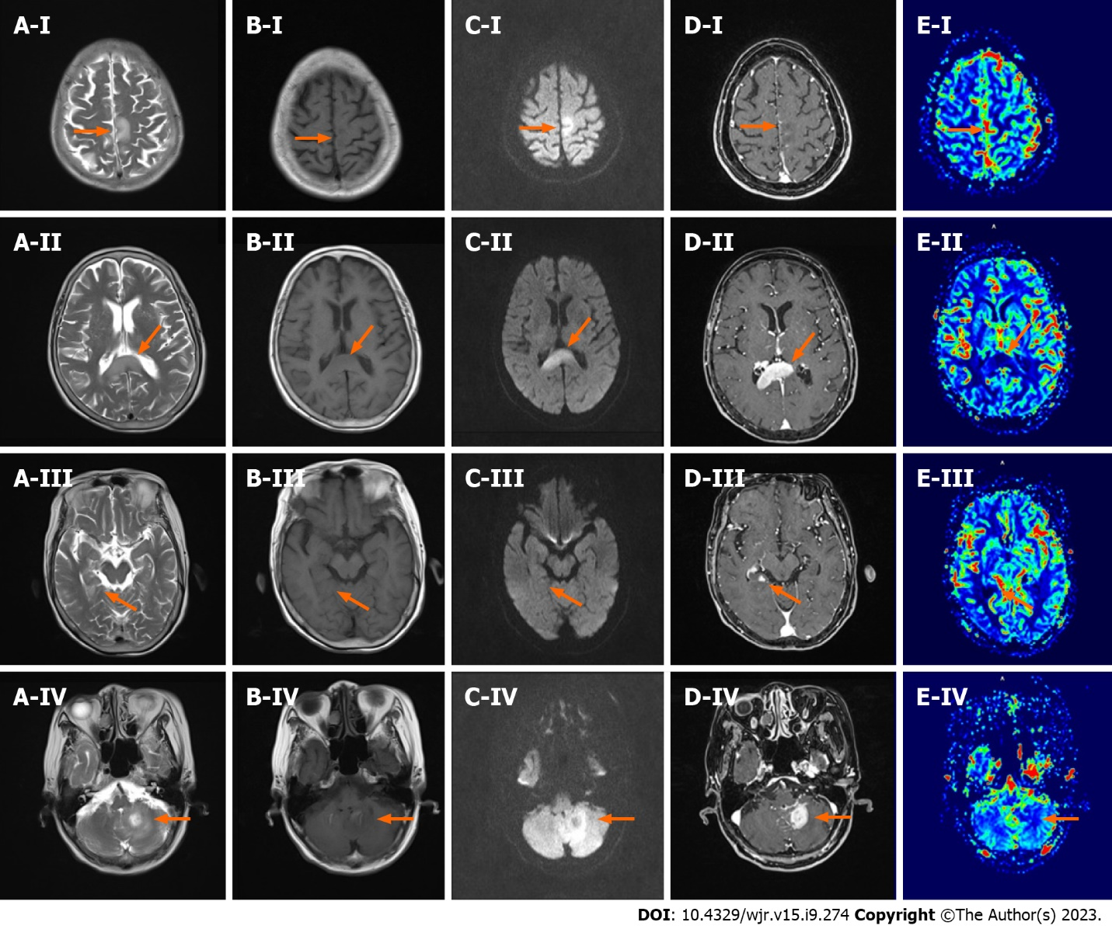
Figure 1 Images of the patient prior to corticosteroid pulse therapy. A: T2WI; B: T1WI; C: Diffusion-weighted imaging; D: T1-weighted enhanced scan; E: Dynamic susceptibility contrast perfusion-weighted imaging cerebral blood volume; I: parietal lobe lesions; II: corpus callosum lesions; III: hippocampal lesions; IV: Left cerebellar hemisphere lesions.
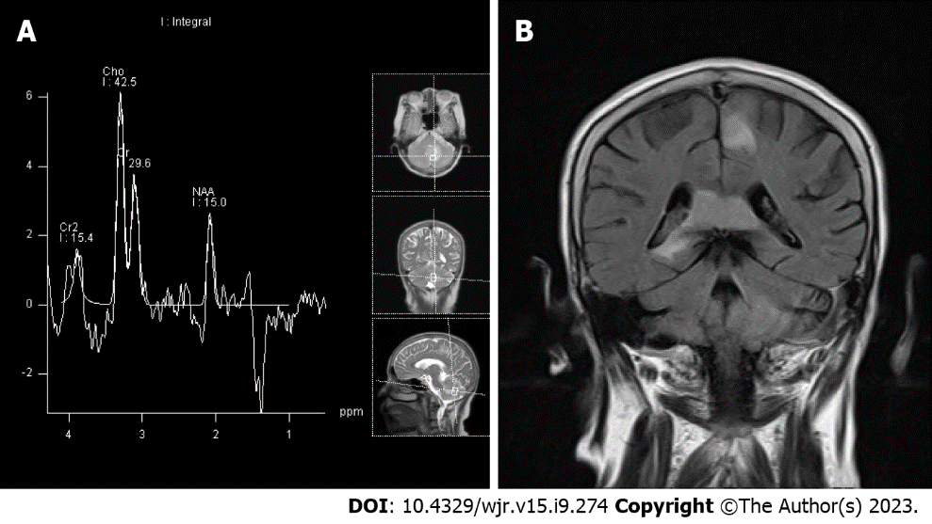V
Figure 2 Notably, magnetic resonance spectroscopy also revealed the presence of a lip peak within the lesion. A: Magnetic resonance spectroscopy; B: Butterfly sign when primary central nervous system lymphoma is located in the corpus callosum.
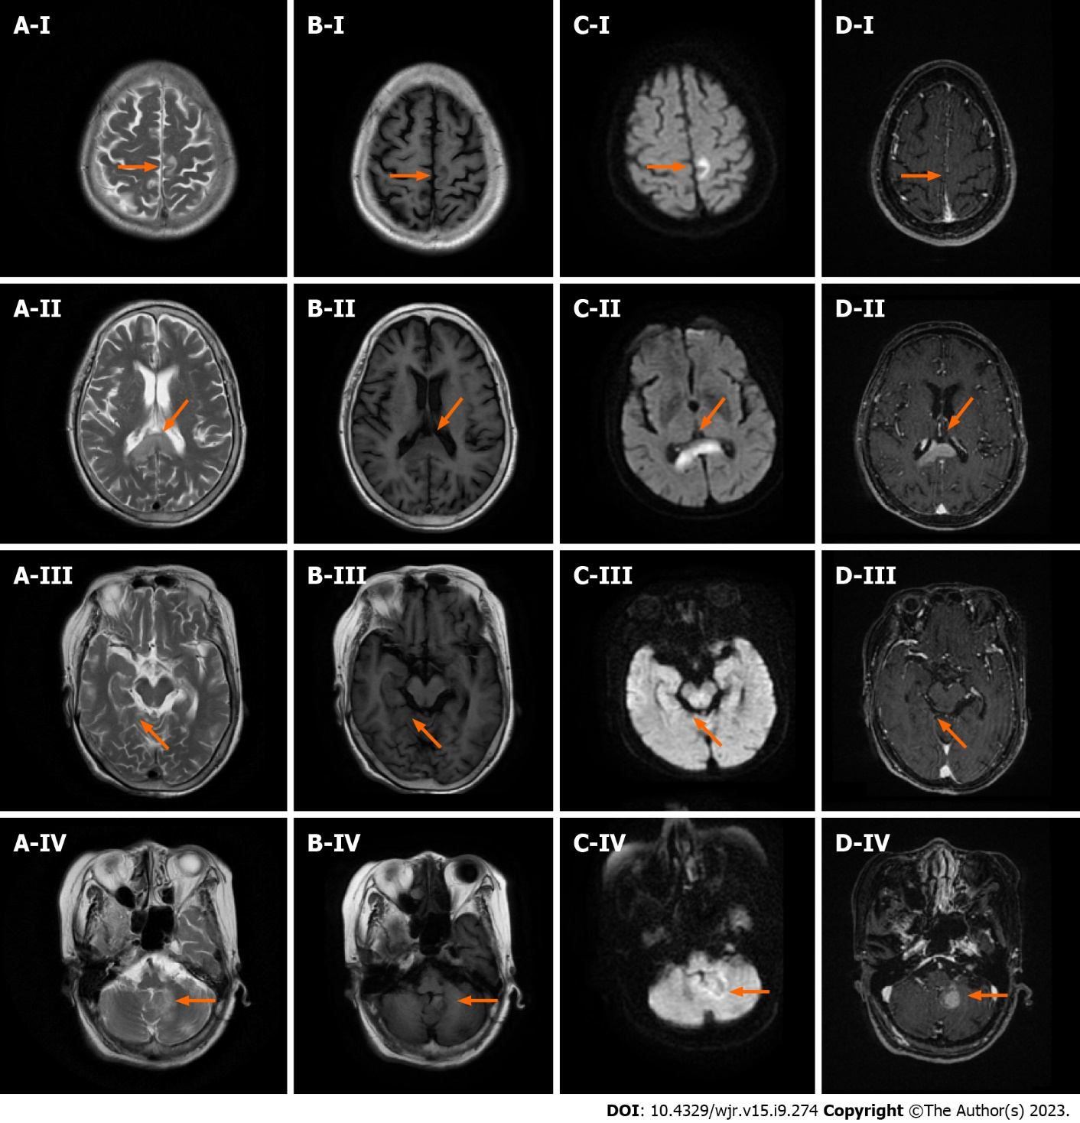
Figure 3 Images of the patient following corticosteroid pulse therapy. A: T2WI; B: T1WI; C: Diffusion-weighted imaging; D: T1-weighted enhanced scan; I: Parietal lobe lesions; II: Corpus callosum lesions; III: Hippocampal lesions; IV: Left cerebellar hemisphere lesions.

Published by Baishideng Publishing Group Inc
7041 Koll Center Parkway, Suite 160, Pleasanton, CA 94566, USA
Telephone: +1-925-3991568
E-mail: bpgoffice@wjgnet.com
Help Desk: https://www.f6publishing.com/helpdesk
https://www.wjgnet.com

© 2023 Baishideng Publishing Group Inc. All rights reserved.

