Name of Journal: World Journal of Gastroenterology
Manuscript NO: 75228
Manuscript Type: MINIREVIEWS

Interventional strategies in infected necrotizing pancreatitis: Indications, timing, and outcomes

Purschke B et al. Interventional strategies in infected necrotizing pancreatitis

Birte Purschke, Louisa Bolm, Max Nikolaus Meyer, Hiroki Sato

Birte Purschke, Louisa Bolm, Department of Gastrointestinal Surgery, Massachusetts General Hospital, Boston, MA 02114, United States

Max Nikolaus Meyer, Department of Radiation Oncology, Massachusetts General Hospital, Boston, MA 02114, United States

Hiroki Sato, Department of Medicine, Asahikawa Medical University, Asahikawa 0788510, Hokkaido, Japan

Hiroki Sato, Department of Gastroenterology, Asahikawa Kosei Hospital, Asahikawa 0788211, Hokkaido, Japan

Author contributions: Purschke B wrote and edited the manuscript, and collected the clinical data and evidence; Bolm L edited the manuscript and reviewed the discussion about interventional surgical strategies; Meyer MN reviewed the manuscript and provided recommendations on treatment strategies; Sato H reviewed the manuscript and provided strategies and recommendations on the endoscopic intervention part; all authors have read and approved the final manuscript.

Supported by Japan Society for the Promotion of Science KAKENHI, No. 19K17480 and No. 21KK0283 (to Sato H).

Corresponding author: Hiroki Sato, MD, PhD, Academic Fellow, Chief Doctor, Research Fellow, Department of Medicine, Asahikawa Medical University, 1-1, Midorigaoka Higashi 2 Jyo 1 Chome, Asahikawa 0788510, Hokkaido, Japan. hirokisato@asahikawa-med.ac.jp

Received: January 20, 2022
Revised: March 7, 2022
Accepted: June 15, 2022
Published online: July 21, 2022

Abstract
Acute pancreatitis (AP) is one of the most common gastrointestinal diseases and remains a life-threatening condition. Although AP resolves to restitutio ad integrum in approximately 80% of patients, it can progress to necrotizing pancreatitis (NP). NP is associated with superinfection in a third of patients, leading to an increase in mortality rate of up to 40%. Accurate and early diagnosis of NP and associated complications, as well as state-of-the-art therapy are essential to improve patient prognoses. The emerging role of endoscopy and recent trials on multidisciplinary management of NP established the “step-up approach”. This approach starts with endoscopic interventions and can be escalated to other interventional and ultimately surgical procedures if required. Studies showed that this approach decreases the incidence of new multiple-organ failure as well as the risk of interventional complications. However, the optimal interventional sequence and timing of interventional procedures remain controversial. This review aims to summarize the indications, timing, and treatment outcomes for infected NP and to provide guidance on multidisciplinary decision-making.

Key Words: Pancreatitis; Acute necrotizing pancreatitis; Necrosis; Superinfection; Endoscopy; Surgery

©The Author(s) 2022. Published by Baishideng Publishing Group Inc. All rights reserved.

Citation: Purschke B, Bolm L, Meyer MN, Sato H. Interventional strategies in infected necrotizing pancreatitis: Indications, timing, and outcomes. World J Gastroenterol 2022; 28(27): 3383-3397
URL: https://www.wjgnet.com/1007-9327/full/v28/i27/3383.htm
DOI: https://dx.doi.org/10.3748/wjg.v28.i27.3383

Core Tip: Acute pancreatitis remains a potentially life-threatening disease. Necrotizing pancreatitis (NP) is associated with superinfection and increases the mortality rate. We summarized the current evidence and clinical recommendations of multidisciplinary approaches focusing on conservative, interventional, and surgical treatment. The interventional approach is often required as a first step in treating infected NP, while further options include minimal invasive or an escalation to open surgical treatment. Although this “step-up approach” is well-established, the exact timing, sequence, and procedure choice remain controversial; this review aims to summarize current evidence and to provide guidance for decision making in clinical practice.

INTRODUCTION
Acute pancreatitis (AP) is one of the most common and severe gastrointestinal diseases^{[1]}. The rate of AP-related hospitalization in the United States increased from 65.38 to 81.88 per 100000 United States adults per year from 2001 to 2014^{[2]}.
The pathophysiology of AP is characterized by acinar cell injury leading to premature intrapancreatic activation of digestive proteases. ATP depletion and mixed lineage kinase domain-like protein phosphorylation lead to acinar cell necroptosis and necrosis^{[3]}. This results in a cascade effect leading to autodigestion of the pancreatic parenchyma. The acinar cell injury and autodigestion can be induced by different mechanisms; recent publications discuss, for example, the role of hypercalcemia and organelle dysfunction. Cholecystokinin, biliary acids, and alcohol consumption can lead to increased Ca²⁺ efflux by the endoplasmic reticulum (ER). In turn, hypercalcemia can damage the mitochondrial membrane, reducing ATP production and hence the function of the Ca²⁺ efflux mechanisms of the cell itself, which increases the intracellular Ca²⁺ levels even further. This intracellular Ca²⁺ overload ultimately leads to the release and activation of digestive enzymes, which results in premature activation of trypsin. In addition, bile acids, alcohol, and other pancreatic toxic substances can trigger the acinar cells themselves, leading to higher secretion of trypsin^{[4-6]}.
AP can be classified as either interstitial edematous or necrotizing pancreatitis (NP). While inflammation and edema of the pancreatic parenchyma and peripancreatic tissues characterize intestinal edematous pancreatitis, further pancreatic or peripancreatic necrosis is known as NP^{[6]}, which is a potentially life-threatening disease associated with a 15% mortality rate. In approximately a third of patients with NP, superinfection (fungal or bacterial infection) of necrosis occurs during the clinical course, mostly within 2 to 4 wk after disease onset. Infected NP (INP) results in an even higher mortality rate of up to 30% to 39% (Figure 1)^{[7-9]}. The major causes of INP are obstructing gallstones (up to 50%) and alcohol abuse (20%)^{[10]}.
Several scores were introduced in order to predict the severity of AP and its mortality. A retrospective study from 2013 comparing some of these scores revealed that especially the Bedside Index for Severity in Acute Pancreatitis (BISAP) and Acute Physiology and Chronic Health Evaluation (APACHE-II) score stand out compared to scores like the computed tomography (CT) severity index, Ranson Score, body mass index, or hematocrit in terms of predicting severity, organ failure, and death. The BISAP score is a combination of the following five parameters, each worth one point: Altered mental state, blood urea nitrogen > 25.2 mg/dL or more, positive systemic inflammatory response syndrome criteria, age over 60 years, and pleural effusion on CT scan. In comparison, the APACHE-II score uses 14 different parameters, ranging from age to the Glasgow Coma Scale^{[11]}.
Another applicable score in INP is the Marshall Score, which determines the presence of organ failure, which, according to the 2012 revised Atlanta Classification of AP, is a criterion that differentiates between mild (no organ failure), moderate (organ failure after less than 48 h), and severe (organ failure after more than 48 h) pancreatitis. The Marshall Score assesses the respiratory system on a scale from 0 to 4 using PaO₂/FIO₂, the renal system using serum creatinine in mg/dL, and the cardiovascular system using the systolic blood pressure in mmHg. A score of 2 or higher for any of the systems indicates organ failure^{[12]}.
The clinical management of INP is complex and involves a multidisciplinary team of intensive care specialists, gastroenterologists, and surgeons. Recent trials have provided important insight into the disease mechanisms and have optimized the treatment strategies. However, the indications, timing, and outcomes of different interventional strategies remain controversial.

PHASES OF AP
According to the 2012 revised Atlanta classification of pancreatitis, two AP phases can be differentiated: the early (< 1 wk after onset) and late (> 1 wk after onset) phases. The early phase is characterized by the first clinical signs of pancreatitis: Abdominal pain, biochemical findings, and imaging findings consistent with pancreatitis. During this time, a pro-inflammatory sterile response occurs, which can lead to systemic inflammatory response syndrome (SIRS)^{[13]}. Nevertheless, AP is self-limited in more than 80% of patients, and treatment in the early phase consists of supportive care instead of a curative intervention^{[14]}. However, necrosis and acute necrotic collection (ANC) can occur in the late phase. ANC is considered a local complication of AP and is characterized by a collection of both fluid and necrosis without a defined wall^{[8]}. ANC can resolve spontaneously or eventually become encapsulating, which allows the collection to become more organized within a well-defined inflammatory wall^{[15,16]}. This process takes approximately 4-6 wk and the end-product is called a walled-off necrosis (WON)^{[17]}. Once WON is diagnosed, whether the pancreatic or peripancreatic necrotic tissue and ANCs are sterile or infected must be determined to plan the subsequent treatment course. Superinfection of acute NP increases the mortality rate (24% vs 3.5%)^{[18,19]}. In order to prevent SIRS, sepsis, and multiple (respiratory, cardiovascular, hepatic, and renal) organ failure, the treatment goal is to remove the infected non-vital tissue^{[13,18,20]}.

DIAGNOSIS OF ACUTE INP
The diagnosis of AP is mostly based on clinical symptoms; the major ones being abdominal pain, fever, nausea, and vomiting. The diagnosis is further narrowed by measuring the levels of serum amylase and/or lipase. As a diagnostic criterion for pancreatitis, these markers exceed the physiological range by approximately three times. Characteristic imaging findings, such as enlargement of the pancreas and hypodense areas within the parenchyma and/or the peripancreatic tissue, are radiological imaging criteria^{[8,17,21]}.
The primary imaging modality within the first 48 h is a transabdominal ultrasound, primarily to determine the need for cholecystectomy for biliary pancreatitis. If the diagnosis of AP remains uncertain, a CT scan can be performed. However, changes on CT are most evident approximately 72 h after AP onset^{[21]}.
To diagnose NP, contrast-enhanced CT (CECT) is the preferred imaging modality, as it can identify the presence of gas in the necrotic collection. Magnetic resonance imaging can also be used but is less sensitive than CECT^{[22]}. The diagnosis of infected necrosis is based on clinical criteria including fever and rising serum inflammatory markers^{[23]}.

INP REQUIRES A MULTIDISCIPLINARY APPROACH
INP requires both closely monitored intensive care and interventional approaches to remove infected necrotic areas. Endoscopic interventional options involve endoscopic drainage and/or endoscopic necrosectomy. Further interventions are percutaneous transgastric drainage, minimally invasive or open necrosectomy. Using the acronym “PANCREAS”, Gomes et al^{[24]} summarized eight important steps in the management of severe AP: Perfusion, analgesia, nutrition, clinical and radiological assessment, endoscopy, antibiotics, and surgery.
Historically, INP patients have undergone early open debridement of necrotic tissue (median timing of the operation 21^{[25]} to 28^{[26]} d), mostly followed by local continuous lavage^{[26]}. Recently, interventional strategies have shifted towards a so-called “step-up approach,” which involves endoscopic or surgical interventions that comprise open and minimally invasive procedures. The approach starts with simple, less invasive interventions like endoscopic drainage, and escalates to more invasive and finally surgical procedures if these approaches fail.

CONSERVATIVE TREATMENT
INP patients require close monitoring and may need to be admitted to intensive care treatment due to the risk of sepsis and consequent organ failure^{[27]}. The major components of conservative therapy are fluid administration, nutrition, and antibiotics.

FLUID ADMINISTRATION
Hypovolemia is a constant risk in AP patients; moreover, installing fluid infusions and closely monitoring patient circulation parameters is therefore essential. The duration of intravenous infusions as well as the total volume of fluids per day, are subject to ongoing debate^{[24]}.
A recent meta-analysis analyzed the impact of early aggressive fluid therapy (infusion rate of 3-5 mL/kg/h in the first 24 h) as compared to non-aggressive hydration. Eleven trials were included, and the authors could not detect a difference in mortality rate; however, aggressive fluid therapy increased the risk of acute kidney injury and pulmonary edema. Furthermore, there was no difference in overall outcomes such as incidence of SIRS, organ failure, or pancreatic necrosis for both therapeutic strategies^{[28]}. Another study demonstrated that early rapid fluid therapy is associated with persistent organ failure, primarily of the respiratory system^{[29]}.
Recent studies have favored Ringer’s lactate solution as the fluid of choice as opposed to saline solution, as the former reduced systemic inflammation^{[30]}. Recent studies have concluded that the optimal AP regimen involves 3-4 L of Ringer’s lactate solution every 24 h and predefined checkpoints at 6-8 h in order to tailor the fluid management to the condition of the patient. Furthermore, measuring urine output, intraabdominal pressure, and vital signs can help adjust the regimen of fluid therapy^{[31]}.

NUTRITION
While fasting was considered helpful in AP in the past, current evidence supports early oral or enteral nutrition even if patients experience AP-related complications. As patients with acute NP have increased energy requirements and sustained protein catabolism, an early start of enteral nutrition within the first 48 h of symptom onset is the current standard of care^{[32]}. Regarding nutrition protocol, 25 kcal/kg/d up to a maximum of 30 kcal/kg/d with 1.2-1.5 g/kg of protein per day is recommended^{[24]}. As compared to parenteral nutrition, enteral nutrition is associated with a lower rate of infectious complications and organ failure, shorter hospital stay, and reduced mortality rate^{[33,34]}.

ANTIBIOTICS AND PANCREATIC FUNGAL INFECTION
In contrast to patients with general AP, INP patients require immediate antibiotic therapy starting as soon as the diagnosis of INP is confirmed. INP should be initially treated with empirical antibiotics covering both aerobic and anaerobic Gram-negative and Gram-positive microorganisms, such as Imipenem or Ciprofloxacin^{[35]}. A CT-guided fine-needle aspiration (FNA) can help design a more targeted treatment plan. The bacteria most frequently identified in IPN are Escherichia coli, Enterococcus, Staphylococcus aureus, Staphylococcus epidermidis, Klebsiella pneumoniae, Pseudomonas spp., and Streptococcus spp.^{[36]}.
Although antibiotic therapy is an essential tool in the treatment of INP patients, there is insufficient evidence to support the role of antibiotic prophylaxis after the diagnosis of sterile pancreatitis in order to prevent superinfection^{[36-38]}.
The use of prophylactic antibacterial therapy and duration of antibacterial therapy have been observed to increase the incidence of pancreatic fungal infection, which is a condition in patients with NP that is associated with increased mortality, intensive care unit admission rate, and length of stay. Its incidence was 26.6% in a study including 2151 patients with NP^{[39]}.

INVASIVE TREATMENT
Treatment planning and determining therapy concepts in INP patients should be performed within a multidisciplinary team of surgeons, interventional radiologists, and gastrointestinal endoscopists at experienced centers. Specialists should assess the feasibility of different access routes (transgastric, transduodenal, percutaneous, retroperitoneal, laparoscopic, or laparotomic) and weigh the treatment options, while considering the individual clinical condition of each patient (Table 1).

ENDOSCOPY
Endoscopy plays an emerging role in the treatment of INP^{[40]}. Interventional approaches such as the placement of plastic or metal stents for endoscopic transluminal drainage (ETD) or direct necrosectomy are endoscopically feasible^{[41]}.

ETD AND STENT CHOICE
ETD is performed as the standard first step of endoscopic INP treatment. The aim of this procedure is to establish a temporary connection between the gastric cavity and necrotic cavity in the adjacent pancreas in order to drain necrotic collections.
ETD is performed with the assistance of endoscopic ultrasound, which helps avoid puncturing of vessels (via color doppler) or targets other than the necrotic collections^{[42]}. The endoscopist then places either a plastic, double pigtail stent; a self-expandable metal stent (SEMS); or a lumen-apposing metal stent (LAMS). The metal stents are larger in diameter (15-20 mm) than the plastic stents (2.33–3.33 mm) and provide access for potential subsequent debridement (Figure 2). SEMS are not commonly used, as they have been reported to migrate into the collapsed fluid collection, posing a risk of major bleeding^{[43]}. LAMS are designed to prevent migration and minimize the risk of leakage with their apposing features^{[44,45]}. Another advantage of LAMS over plastic stents is the delivery system via a single-step platform, resulting in a shorter intervention time^{[46]}. Retrospective studies comparing drainage with either LAMS or plastic stents found that the procedure time is significantly shorter for LAMS drainage^{[47,48]}. One of these studies also shows that LAMS drainage results in increased clinical success, reduced need for surgery, and a lower recurrence rate^{[47]}.
A more recent randomized clinical trial, however, compared both stent types in a total of 60 patients (31 undergoing LAMS placement and 29 undergoing plastic stent placement) and found that LAMS was not superior to plastic stents. The authors detected no difference in treatment success, the number of procedures required, length of stay, adverse events (within < 3 wk of LAMS removal), readmissions, or overall treatment costs^{[49,50]}. Moreover, the study showed significant stent-related adverse events if LAMS were left in place for more than 3 wk. Given these heterogeneous results, future studies are needed to further evaluate the outcomes of different ETD strategies. Nevertheless, the treating medical team should consider the different procedure duration, since the average time to place the LAMS is shorter compared to plastic stents (15 vs 40 min, P < 0.001)^{[51]}.

ENDOSCOPIC NECROSECTOMY
If the clinical condition of INP patients fails to improve 72 h after ETD, necrosectomy should be considered. Endoscopic transluminal necrosectomy (ETN) can be performed, using a LAMS as access route to the necrotic cavity. With help of forceps, nets, and lavage techniques with saline or hydrogen peroxide, the necrotic tissues are removed endoscopically. ETN can be performed several times if necroses cannot be removed in one procedure^{[52,53]}. It is important to consider that multiple ETN attempts also cause an increased risk of procedure-related complications such as bleeding or perforation^{[42]}.
If a transgastric access is not possible or WONs are located in an inaccessible lateral position, a sinus tract endoscopy (STE) may be an option. In order to perform STE, a CT-guided percutaneous drainage catheter is placed 10 d prior to the procedure. The catheter causes the tract wall to mature, so the insertion of an adult gastroscope under fluoroscopic control can be performed safely. The necrotic cavity is lavaged and necrotic tissue is removed, as is done in the ETN procedure (Figure 3)^{[54]}.
Endoscopic necrosectomy reduces the rate of surgical interventions^{[55]}. However, these interventions are limited to small necrotic areas and can be very time consuming (60-120 min)^{[56]}.

PERCUTANEOUS CATHETER DRAINAGE
Percutaneous catheter drainage (PCD) is often used prior to endoscopic necrosectomy if the ANC is located in the flank or pelvic region and access via ETD is not possible. An interventional radiologist places a general-purpose pigtail drainage catheter into the necrotic collection using the Seldinger technique via the most direct transperitoneal route. The preferred route for PCD is through the retroperitoneum. In this case, the drain can be used to guide potential further minimally invasive retroperitoneal necrosectomy (i.e., video-assisted retroperitoneal debridement or STE). A combination of endoscopic transluminal and PCD (also known as dual-modality drainage) is a further option in patients with large collections extending into the paracolic gutters or pelvic region^{[57]}. PCD is the least invasive intervention and was the only intervention needed for patients with INP in 35% (15 out of 43) patients in the randomized PANTER trial^{[40]}.

SURGERY
Larger, more complex, and endoscopically not accessible necrotic areas may require minimally invasive or open surgical approaches^{[16]}.

OPEN SURGERY
AP can lead to severe complications, such as hemorrhage, perforation, or ischemia. These complications may require immediate open surgical treatment. Abdominal compartment syndrome is a further severe potential complication of AP that must be managed via laparotomy. The drainage or debridement of ANCs and contacting the omental bursa should be avoided during these surgical emergency procedures^{[58]}. Beside emergency indications, INP itself is a well-accepted indication for surgical treatment^{[59]}.
Open surgical necrosectomy follows the main principle of exposing the necrotic area and bluntly debriding necrotic tissue: Necrosectomy can be performed with: (1) Open packing; (2) Closed packing; (3) Closed continuous lavage; and (4) Planned re-laparotomies. Open packing involves packing the necrotic cavity with non-adherent dressing after surgical necrosectomy. Readmissions follow every 48 h until the abdomen can be closed after inserting drains. Closed packing is performed when multiple, large, gauze-filled Penrose drains are placed in the residual cavity after necrosectomy and the abdomen is subsequently closed. Closed continuous lavage is performed with the help of two or more double-lumen Salem sump tubes and single-lumen silicone rubber tubes, which are inserted from each flank side and have an in- and outflow of the lavage. Up to 40 L of lavage fluids are used. Planned re-laparotomies provide continuous removal of necrotic tissue over several following days. Surgeons often incorporate zippers into the abdominal wall facilitating repetitive surgical intervention^{[59]}.
The standard surgical access is performed either as a transperitoneal or retroperitoneal access. Transgastric access has been added more recently and is considered a fast single-stage option for the treatment of symptomatic WON in severely ill patients^{[60]}. A recent study suggested choosing surgical transgastric necrosectomy whenever feasible in the case of a disconnected pancreatic duct, for dense and large necrosis, and if cholecystectomy must be performed. If the transgastric access is not possible, the authors suggested video-assisted retroperitoneal debridement (VARD) as an alternative procedure^{[61]}.

MINIMALLY INVASIVE SURGERY
The main procedures of minimal invasive management of INP are minimal access retroperitoneal pancreatic necrosectomy (MARPN) and VARD. MARPN involves the placement of a 12-French catheter under CT guidance by an interventional radiologist prior to surgery. The preformed access tract is then dilated up to 30-French during the minimal invasive procedure, so that a rigid nephroscope can be entered. The nephroscope serves as visualization instrument and working channel for necrosectomy at the same time. An irrigation drainage system for continuous lavage is installed at the end of the procedure. MARPN can be done multiple times until the patient’s condition improves.
VARD consists of combined manual and laparoscopical necrosectomy. It was first reported in 2007 by van Santvoort et al^{[62]}, who described it as “a hybrid between pure endoscopic retroperitoneal necrosectomy and the open translumbar approach.” The procedure starts with a left flank subcostal incision facilitating direct manual debridement followed by a laparoscopic deeper inspection and debridement by laparoscopic instruments. The intervention ends with a continuous lavage.

COMPARISON BETWEEN OPEN AND MINIMALLY INVASIVE SURGERY
Open surgical necrosectomy in AP was historically associated with a mortality rate of 50% or higher^{[63,64]}. Improved intensive care management, as well as advances in surgical techniques, including minimally invasive options, and the availability of first line endoscopic and minimally invasive procedures have improved patient outcomes over the past decades^{[65]}.
A retrospective study compared outcomes of INP patients between 1997-2008 and 2009-2013 and revealed decreased mortality (23.8% vs 11.2%, P = 0.001) and overall complication rates (73.3% vs 64.4%, P = 0.80) in the more recent cohort. Minimal invasive approaches contribute to better treatment success rates and improved outcomes in INP as compared to open surgery. MARPN also reportedly results in decreased postoperative multiorgan failure compared to open pancreatic necrosectomy (35% vs 20.4%, P = 0.001)^{[66]}.
A recent retrospective cohort study comparing 88 patients with open surgical necrosectomy to 91 patients who were treated with minimal invasive surgery (MIS) showed that MIS results in a fivefold decrease in mortality^{[49]}. A meta-analysis published in 2018 reported lower risk of death rates in the very high-risk group when comparing minimally invasive necrosectomy to open surgery^{[67]}.

STEP-UP APPROACH
The therapeutic approach in INP patients has shifted from open surgical treatment to a less invasive management that can be summarized by “three Ds”: Delay – drain – debride. This approach leads to the introduction of the so-called “step-up approach”, which was first described in 2006 by the Dutch Pancreatitis Study group in their PANTER trial^{[40]}.
Delay refers to the solidification and complete encapsulation of the pancreatic collection when WON occurs. This is presumed to optimize conditions for intervention, with a lower risk of bleeding and less reinterventions. Drain alludes to using a percutaneous or endoscopic transgastric catheter drainage to mitigate sepsis. Finally, when patients fail to show clinical improvement, debridement is required; in such cases, performing endoscopic or surgical necrosectomy is the next step^{[40]}. A multidisciplinary team of INP experts can choose from different treatment options for each step and decides on the most suitable approach for each individual patient. Re-evaluation periods of 72 h between steps should be maintained^{[49]}. This therapeutic management is also referred to as the “step-up approach”, which comprises both an endoscopic and a surgical approach. The overall paradigm is to start with the least invasive and harmful intervention with an option to escalate to more radical approaches with continuous evaluation. The step-up approach decreased the incidence of new multiple-organ failure from 40% to 12% when compared to primary laparotomy^{[40]}. It is the current state-of-the-art approach and has been implemented in all major guidelines (Figure 4)^{[23,68]}.

ENDOSCOPIC OR SURGICAL STEP-UP APPROACH
The step-up approach can be performed using endoscopic or surgical necrosectomy. Comparing both approaches has been subject of several randomized trials. From 2008 to 2010, the first prospective, multicentric randomized controlled trial comparing the surgical and endoscopic step-up approaches was performed in the Netherlands. The so-called PENGUIN trial compared endoscopic transgastric necrosectomy with prior retroperitoneal drainage and different techniques of surgical necrosectomy (VARD or, if not feasible, laparotomy) in 10 INP patients per group. The results demonstrated reduced inflammatory response as measured by serum interleukin 6 Levels, reduced rates of pancreatic fistulas (10% vs 70%, P = 0.020), and no occurrence of new-onset multiorgan failure (0% vs 50%, P = 0.030) in patients in the endoscopic arm^{[69]}. The authors concluded that the endoscopic approach was associated with reduced physiological stress, while surgical access was more invasive.
The multicentric TENSION trial was conducted during 2011-2015 in the Netherlands and compared the outcomes of 51 patients following the endoscopic step-up approach to 47 following the surgical step-up approach. The findings showed no significant difference in mortality and major morbidity between both groups (43% in the endoscopic step-up approach vs. 45% in the surgical step-up approach, P = 0.880). However, the mean hospital stay was shorter (53 vs 69 d, P = 0.014), fewer pancreatic fistulas occurred (5% vs 32%, P = 0.001), and there was a lower overall mean cost (60228 € vs 73883 € in the endoscopic step-up approach group^{[70]}).
From 2014 to 2017, the monocentric MISER trial was performed in the United States, comparing minimally invasive surgery (laparoscopic debridement or VARD) to the endoscopic step-up approach in a total of 66 patients. They included severely ill patient cohorts and excluded patients who had improved clinically with only percutaneous drainage as treatment. Consistent with the findings of the TENSION trial, MISER showed no difference in mortality rates (8.8% with the endoscopic step-up approach vs. 6.3% with minimally invasive surgery, P = 0.999). However, patients assigned to the endoscopic approach were less likely to develop enteral and pancreatic-cutaneous fistulas (0% vs 28.1%, P = 0.001), experienced a lower rate of major complications (12% vs. 41%, P = 0.007), and had lower rates of SIRS (20.6% vs 65.6 %, P < 0.001). Six months after treatment, patients in the surgical group had significantly more disease-related adverse events than did those in the endoscopic group (43.8 % vs 5.9 %, P < 0.001). Finally, the physical health scores for quality of life at 3 mo were better with the endoscopic approach (P = 0.039) and the mean total cost were lower ($75830) compared with the surgical approach ($117492)^{[49]}.
The currently available randomized controlled trials point to the endoscopic step-up approach as the preferred treatment for INP patients. However, if the endoscopic treatment is unfeasible, or the necrotic collection extends to the flank or pelvic region (which is difficult to access endoscopically), surgical interventions constitute the alternative when performed as a step-up approach. Each INP patient should be assessed and treated by a multidisciplinary team with sufficient experience in both approaches.

TIMING OF INTERVENTIONS
The optimal timing of interventions remains a controversial topic and is subject to ongoing debate. An international survey performed in 2016 among 87 pancreatologists revealed that 55% of experts routinely postponed invasive interventions after diagnosing infected necrosis in AP and awaited the effect of antibiotics. However, 33% of pancreatologists preferred surgical necrosectomy as early as possible in infected necrosis, while the remaining 67% would select that route only in the case of WON^{[71]}.
A 2014 prospective study including 223 patients revealed that a postponed surgical intervention after 30 d was associated with a lower mortality rate compared to that associated with surgical intervention before day 30 [10% (9/87) vs 21% (28/136), P = 0.040]^{[72]}. This study followed up on a retrospective study from 2007 that also revealed that patients receiving a postponed surgical necrosectomy exhibited lower mortality rates as compared to those receiving surgical treatment after 15-29 d and 1-14 d (8% vs 45% vs 75%, P < 0.001)^{[26]}.
A recent study of the Dutch Pancreatic Study Group, the POINTER trial, determined whether the outcomes in INP patients could be improved by early catheter drainage. In the study, catheter drainage was performed immediately in 55 patients, while 49 received the treatment after waiting until WON occurred. Patients were included when there was gas reported on CECT, positive gram/culture FNA, and clinical suspicion for INP. The rate of organ failure was comparable in both groups and there was no difference in mortality rates. The total number of interventions was 4:1 in the early intervention group compared to the group with delayed intervention, and the total number of necrosectomies in the whole number of patients was 28 (51%) in the immediate as compared to 11 (22%) in the postponed drainage group. Postponing the intervention led to conservative treatment in nearly 40% of patients. This trial could not detect a benefit of immediate drainage over postponed drainage. Conversely, postponing intervention may ultimately avoid necrosectomy and its potential complications^{[73]}.

CONCLUSION
Recent advances in endoscopic and minimally invasive therapy have led to a shift in the interventional strategy for INP. Although no standardized approach suits every patient, the “step-up approach” has emerged as a paradigm to treat this severe disease. The key is to start with the least invasive procedure and potentially escalate to more invasive interventions after continuous evaluation, if necessary. This approach highlights the importance of a multidisciplinary team to guide therapeutic approaches in INP patients. The strategy should be based on the individual patient and should allow for dynamic changes in regard to the patient’s clinical condition. This claim is also backed by the studies presented in this review that demonstrate lower rates of new multiorgan failure and reduction of hospitalization days, among other preferred outcomes. Even with these recent advances, INP continues to elicit a high mortality rate and further research is required to optimize strategic approaches.

ACKNOWLEDGEMENTS
We thank Hiramatsu K at Asahikawa Kosei Hospital for providing percutaneous radiological drainage pictures; We also thank Okada T, Kawamoto T, Fujinaga A, and Goto M at Asahikawa Kosei Hospital, as well as Hayashi A, the member of Division of Metabolism and Biosystemic Science, Gastroenterology and Hematology/Oncology Department of Medicine, Asahikawa Medical University for providing endoscopic drainage pictures.

REFERENCES
1 Peery AF, Crockett SD, Murphy CC, Lund JL, Dellon ES, Williams JL, Jensen ET, Shaheen NJ, Barritt AS, Lieber SR, Kochar B, Barnes EL, Fan YC, Pate V, Galanko J, Baron TH, Sandler RS. Burden and Cost of Gastrointestinal, Liver, and Pancreatic Diseases in the United States: Update 2018. Gastroenterology 2019; 156: 254-272.e11 [PMID: 30315778 DOI: 10.1053/j.gastro.2018.08.063]
2 Gapp J, Hall AG, Walters RW, Jahann D, Kassim T, Reddymasu S. Trends and Outcomes of Hospitalizations Related to Acute Pancreatitis: Epidemiology From 2001 to 2014 in the United States. Pancreas 2019; 48: 548-554 [PMID: 30946239 DOI: 10.1097/MPA.0000000000001275]
3 Zheng Z, Ding YX, Qu YX, Cao F, Li F. A narrative review of acute pancreatitis and its diagnosis, pathogenetic mechanism, and management. Ann Transl Med 2021; 9: 69 [PMID: 33553362 DOI: 10.21037/atm-20-4802]
4 Mayerle J, Sendler M, Hegyi E, Beyer G, Lerch MM, Sahin-Tóth M. Genetics, Cell Biology, and Pathophysiology of Pancreatitis. Gastroenterology 2019; 156: 1951-1968.e1 [PMID: 30660731 DOI: 10.1053/j.gastro.2018.11.081]
5 Habtezion A, Gukovskaya AS, Pandol SJ. Acute Pancreatitis: A Multifaceted Set of Organelle and Cellular Interactions. Gastroenterology 2019; 156: 1941-1950 [PMID: 30660726 DOI: 10.1053/j.gastro.2018.11.082]
6 Mederos MA, Reber HA, Girgis MD. Acute Pancreatitis: A Review. JAMA 2021; 325: 382-390 [PMID: 33496779 DOI: 10.1001/jama.2020.20317]
7 Werge M, Novovic S, Schmidt PN, Gluud LL. Infection increases mortality in necrotizing pancreatitis: A systematic review and meta-analysis. Pancreatology 2016; 16: 698-707 [PMID: 27449605 DOI: 10.1016/j.pan.2016.07.004]
8 Colvin SD, Smith EN, Morgan DE, Porter KK. Acute pancreatitis: an update on the revised Atlanta classification. Abdom Radiol (NY) 2020; 45: 1222-1231 [PMID: 31494708 DOI: 10.1007/s00261-019-02214-w]
9 van Santvoort HC, Bakker OJ, Bollen TL, Besselink MG, Ahmed Ali U, Schrijver AM, Boermeester MA, van Goor H, Dejong CH, van Eijck CH, van Ramshorst B, Schaapherder AF, van der Harst E, Hofker S, Nieuwenhuijs VB, Brink MA, Kruyt PM, Manusama ER, van der Schelling GP, Karsten T, Hesselink EJ, van Laarhoven CJ, Rosman C, Bosscha K, de Wit RJ, Houdijk AP, Cuesta MA, Wahab PJ, Gooszen HG; Dutch Pancreatitis Study Group. A conservative and minimally invasive approach to necrotizing pancreatitis improves outcome. Gastroenterology 2011; 141: 1254-1263 [PMID: 21741922 DOI: 10.1053/j.gastro.2011.06.073]
10 Nesvaderani M, Eslick GD, Vagg D, Faraj S, Cox MR. Epidemiology, aetiology and outcomes of acute pancreatitis: A retrospective cohort study. Int J Surg 2015; 23: 68-74 [PMID: 26384834 DOI: 10.1016/j.ijsu.2015.07.701]
11 Park JY, Jeon TJ, Ha TH, Hwang JT, Sinn DH, Oh TH, Shin WC, Choi WC. Bedside index for severity in acute pancreatitis: comparison with other scoring systems in predicting severity and organ failure. Hepatobiliary Pancreat Dis Int 2013; 12: 645-650 [PMID: 24322751 DOI: 10.1016/s1499-3872(13)60101-0]
12 Foster BR, Jensen KK, Bakis G, Shaaban AM, Coakley FV. Revised Atlanta Classification for Acute Pancreatitis: A Pictorial Essay. Radiographics 2016; 36: 675-687 [PMID: 27163588 DOI: 10.1148/rg.2016150097]
13 Zerem E. Treatment of severe acute pancreatitis and its complications. World J Gastroenterol 2014; 20: 13879-13892 [PMID: 25320523 DOI: 10.3748/wjg.v20.i38.13879]
14 Kayar Y, Senturk H, Tozlu M, Baysal B, Atay M, Ince AT. Prediction of Self-Limited Acute Pancreatitis Cases at Admission to Emergency Unit. GE Port J Gastroenterol 2019; 26: 251-259 [PMID: 31328139 DOI: 10.1159/000493762]
15 Yasuda I, Takahashi K. Endoscopic management of walled-off pancreatic necrosis. Dig Endosc 2021; 33: 335-341 [PMID: 32306430 DOI: 10.1111/den.13699]
16 Heckler M, Hackert T, Hu K, Halloran CM, Büchler MW, Neoptolemos JP. Severe acute pancreatitis: surgical indications and treatment. Langenbecks Arch Surg 2021; 406: 521-535 [PMID: 32910276 DOI: 10.1007/s00423-020-01944-6]
17 van Dijk SM, Hallensleben NDL, van Santvoort HC, Fockens P, van Goor H, Bruno MJ, Besselink MG; Dutch Pancreatitis Study Group. Acute pancreatitis: recent advances through randomised trials. Gut 2017; 66: 2024-2032 [PMID: 28838972 DOI: 10.1136/gutjnl-2016-313595]
18 Büchler MW, Gloor B, Müller CA, Friess H, Seiler CA, Uhl W. Acute necrotizing pancreatitis: treatment strategy according to the status of infection. Ann Surg 2000; 232: 619-626 [PMID: 11066131 DOI: 10.1097/00000658-200011000-00001]
19 da Costa DW, Boerma D, van Santvoort HC, Horvath KD, Werner J, Carter CR, Bollen TL, Gooszen HG, Besselink MG, Bakker OJ. Staged multidisciplinary step-up management for necrotizing pancreatitis. Br J Surg 2014; 101: e65-e79 [PMID: 24272964 DOI: 10.1002/bjs.9346]
20 Werner J, Feuerbach S, Uhl W, Büchler MW. Management of acute pancreatitis: from surgery to interventional intensive care. Gut 2005; 54: 426-436 [PMID: 15710995 DOI: 10.1136/gut.2003.035907]
21 Leppäniemi A, Tolonen M, Tarasconi A, Segovia-Lohse H, Gamberini E, Kirkpatrick AW, Ball CG, Parry N, Sartelli M, Wolbrink D, van Goor H, Baiocchi G, Ansaloni L, Biffl W, Coccolini F, Di Saverio S, Kluger Y, Moore E, Catena F. 2019 WSES guidelines for the management of severe acute pancreatitis. World J Emerg Surg 2019; 14: 27 [PMID: 31210778 DOI: 10.1186/s13017-019-0247-0]
22 McPherson SJ, O'Reilly DA, Sinclair MT, Smith N. The use of imaging in acute pancreatitis in United Kingdom hospitals: findings from a national quality of care study. Br J Radiol 2017; 90: 20170224 [PMID: 28869389 DOI: 10.1259/bjr.20170224]
23 Working Group IAP/APA Acute Pancreatitis Guidelines. IAP/APA evidence-based guidelines for the management of acute pancreatitis. Pancreatology 2013; 13: e1-15 [PMID: 24054878 DOI: 10.1016/j.pan.2013.07.063]
24 Gomes CA, Di Saverio S, Sartelli M, Segallini E, Cilloni N, Pezzilli R, Pagano N, Gomes FC, Catena F. Severe acute pancreatitis: eight fundamental steps revised according to the 'PANCREAS' acronym. Ann R Coll Surg Engl 2020; 102: 555-559 [PMID: 32159357 DOI: 10.1308/rcsann.2020.0029]
25 Fernández-del Castillo C, Rattner DW, Makary MA, Mostafavi A, McGrath D, Warshaw AL. Débridement and closed packing for the treatment of necrotizing pancreatitis. Ann Surg 1998; 228: 676-684 [PMID: 9833806 DOI: 10.1097/00000658-199811000-00007]
26 Besselink MG, Verwer TJ, Schoenmaeckers EJ, Buskens E, Ridwan BU, Visser MR, Nieuwenhuijs VB, Gooszen HG. Timing of surgical intervention in necrotizing pancreatitis. Arch Surg 2007; 142: 1194-1201 [PMID: 18086987 DOI: 10.1001/archsurg.142.12.1194]
27 Schepers NJ, Bakker OJ, Besselink MG, Ahmed Ali U, Bollen TL, Gooszen HG, van Santvoort HC, Bruno MJ; Dutch Pancreatitis Study Group. Impact of characteristics of organ failure and infected necrosis on mortality in necrotising pancreatitis. Gut 2019; 68: 1044-1051 [PMID: 29950344 DOI: 10.1136/gutjnl-2017-314657]
28 Gad MM, Simons-Linares CR. Is aggressive intravenous fluid resuscitation beneficial in acute pancreatitis? A meta-analysis of randomized control trials and cohort studies. World J Gastroenterol 2020; 26: 1098-1106 [PMID: 32206000 DOI: 10.3748/wjg.v26.i10.1098]
29 Li L, Jin T, Wen S, Shi N, Zhang R, Zhu P, Lin Z, Jiang K, Guo J, Liu T, Philips A, Deng L, Yang X, Singh VK, Sutton R, Windsor JA, Huang W, Xia Q. Early Rapid Fluid Therapy Is Associated with Increased Rate of Noninvasive Positive-Pressure Ventilation in Hemoconcentrated Patients with Severe Acute Pancreatitis. Dig Dis Sci 2020; 65: 2700-2711 [PMID: 31912265 DOI: 10.1007/s10620-019-05985-w]
30 Wu BU, Hwang JQ, Gardner TH, Repas K, Delee R, Yu S, Smith B, Banks PA, Conwell DL. Lactated Ringer's solution reduces systemic inflammation compared with saline in patients with acute pancreatitis. Clin Gastroenterol Hepatol 2011; 9: 710-717.e1 [PMID: 21645639 DOI: 10.1016/j.cgh.2011.04.026]
31 Garg PK, Mahapatra SJ. Optimum Fluid Therapy in Acute Pancreatitis Needs an Alchemist. Gastroenterology 2021; 160: 655-659 [PMID: 33412126 DOI: 10.1053/j.gastro.2020.12.017]
32 Bakker OJ, van Brunschot S, Farre A, Johnson CD, Kalfarentzos F, Louie BE, Oláh A, O'Keefe SJ, Petrov MS, Powell JJ, Besselink MG, van Santvoort HC, Rovers MM, Gooszen HG. Timing of enteral nutrition in acute pancreatitis: meta-analysis of individuals using a single-arm of randomised trials. Pancreatology 2014; 14: 340-346 [PMID: 25128270 DOI: 10.1016/j.pan.2014.07.008]
33 Li W, Liu J, Zhao S, Li J. Safety and efficacy of total parenteral nutrition versus total enteral nutrition for patients with severe acute pancreatitis: a meta-analysis. J Int Med Res 2018; 46: 3948-3958 [PMID: 29962261 DOI: 10.1177/0300060518782070]
34 Oláh A, Romics L Jr. Enteral nutrition in acute pancreatitis: a review of the current evidence. World J Gastroenterol 2014; 20: 16123-16131 [PMID: 25473164 DOI: 10.3748/wjg.v20.i43.16123]
35 Isenmann R, Büchler MW, Friess H, Uhl W, Beger HG. Antibiotics in acute pancreatitis. Dig Surg 1996; 13: 365-369 [DOI: 10.1159/000172465]
36 Barie PS. A critical review of antibiotic prophylaxis in severe acute pancreatitis. Am J Surg 1996; 172: 38S-43S [PMID: 9003689 DOI: 10.1016/S0002-9610(96)00349-2]
37 Villatoro E, Mulla M, Larvin M. Antibiotic therapy for prophylaxis against infection of pancreatic necrosis in acute pancreatitis. Cochrane Database Syst Rev 2010: CD002941 [PMID: 20464721 DOI: 10.1002/14651858.CD002941.pub3]
38 Jafri NS, Mahid SS, Minor KS, Idstein SR, Hornung CA, Galandiuk S. Meta-analysis: antibiotic prophylaxis to prevent peristomal infection following percutaneous endoscopic gastrostomy. Aliment Pharmacol Ther 2007; 25: 647-656 [PMID: 17311597 DOI: 10.1111/j.1365-2036.2007.03247.x]
39 Singh RR, Mitchell W, David Y, Cheesman A, Dixon RE, Nagula S, DiMaio CJ, Greenwald DA, Kumta NA. Pancreatic Fungal Infection in Patients With Necrotizing Pancreatitis: A Systematic Review and Meta-analysis. J Clin Gastroenterol 2021; 55: 218-226 [PMID: 33252558 DOI: 10.1097/MCG.0000000000001467]
40 Besselink MG, van Santvoort HC, Nieuwenhuijs VB, Boermeester MA, Bollen TL, Buskens E, Dejong CH, van Eijck CH, van Goor H, Hofker SS, Lameris JS, van Leeuwen MS, Ploeg RJ, van Ramshorst B, Schaapherder AF, Cuesta MA, Consten EC, Gouma DJ, van der Harst E, Hesselink EJ, Houdijk LP, Karsten TM, van Laarhoven CJ, Pierie JP, Rosman C, Bilgen EJ, Timmer R, van der Tweel I, de Wit RJ, Witteman BJ, Gooszen HG; Dutch Acute Pancreatitis Study Group. Minimally invasive 'step-up approach' versus maximal necrosectomy in patients with acute necrotising pancreatitis (PANTER trial): design and rationale of a randomised controlled multicenter trial [ISRCTN13975868]. BMC Surg 2006; 6: 6 [PMID: 16606471 DOI: 10.1186/1471-2482-6-6]
41 Ruiz-Clavijo D, de la Higuera BG, Vila JJ. Advances in the endoscopic management of pancreatic collections. World J Gastrointest Endosc 2015; 7: 381-388 [PMID: 25901217 DOI: 10.4253/wjge.v7.i4.381]
42 Trikudanathan G, Attam R, Arain MA, Mallery S, Freeman ML. Endoscopic interventions for necrotizing pancreatitis. Am J Gastroenterol 2014; 109: 969-81; quiz 982 [PMID: 24957157 DOI: 10.1038/ajg.2014.130]
43 Talreja JP, Shami VM, Ku J, Morris TD, Ellen K, Kahaleh M. Transenteric drainage of pancreatic-fluid collections with fully covered self-expanding metallic stents (with video). Gastrointest Endosc 2008; 68: 1199-1203 [PMID: 19028232 DOI: 10.1016/j.gie.2008.06.015]
44 Mussetto A, Fugazza A, Fuccio L, Triossi O, Repici A, Anderloni A. Current uses and outcomes of lumen-apposing metal stents. Ann Gastroenterol 2018; 31: 535-540 [PMID: 30174389 DOI: 10.20524/aog.2018.0287]
45 Dalsania R, Willingham FF. Treatment of walled-off pancreatic necrosis. Curr Opin Gastroenterol 2019; 35: 478-482 [PMID: 31313686 DOI: 10.1097/MOG.0000000000000564]
46 Bang JY, Varadarajulu S. Lumen-apposing metal stents for endoscopic ultrasonography-guided interventions. Dig Endosc 2019; 31: 619-626 [PMID: 31050068 DOI: 10.1111/den.13428]
47 Chen YI, Yang J, Friedland S, Holmes I, Law R, Hosmer A, Stevens T, Franco MC, Jang S, Pawa R, Mathur N, Sejpal DV, Inamdar S, Trindade AJ, Nieto J, Berzin TM, Sawhney M, DeSimone ML, DiMaio C, Kumta NA, Gupta S, Yachimski P, Anderloni A, Baron TH, James TW, Jamil LH, Ona MA, Lo SK, Gaddam S, Dollhopf M, Bukhari MA, Moran R, Gutierrez OB, Sanaei O, Fayad L, Ngamruengphong S, Kumbhari V, Singh V, Repici A, Khashab MA. Lumen apposing metal stents are superior to plastic stents in pancreatic walled-off necrosis: a large international multicenter study. Endosc Int Open 2019; 7: E347-E354 [PMID: 30834293 DOI: 10.1055/a-0828-7630]
48 Rana SS, Sharma R, Dhalaria L, Gupta R. Efficacy and safety of plastic versus lumen-apposing metal stents for transmural drainage of walled-off necrosis: a retrospective single-center study. Ann Gastroenterol 2020; 33: 426-432 [PMID: 32624665 DOI: 10.20524/aog.2020.0499]
49 Bang JY, Arnoletti JP, Holt BA, Sutton B, Hasan MK, Navaneethan U, Feranec N, Wilcox CM, Tharian B, Hawes RH, Varadarajulu S. An Endoscopic Transluminal Approach, Compared With Minimally Invasive Surgery, Reduces Complications and Costs for Patients With Necrotizing Pancreatitis. Gastroenterology 2019; 156: 1027-1040.e3 [PMID: 30452918 DOI: 10.1053/j.gastro.2018.11.031]
50 Bang JY, Hasan MK, Navaneethan U, Sutton B, Frandah W, Siddique S, Hawes RH, Varadarajulu S. Lumen-apposing metal stents for drainage of pancreatic fluid collections: When and for whom? Dig Endosc 2017; 29: 83-90 [PMID: 27199157 DOI: 10.1111/den.12681]
51 Bang JY, Navaneethan U, Hasan MK, Sutton B, Hawes R, Varadarajulu S. Non-superiority of lumen-apposing metal stents over plastic stents for drainage of walled-off necrosis in a randomised trial. Gut 2019; 68: 1200-1209 [PMID: 29858393 DOI: 10.1136/gutjnl-2017-315335]
52 Arvanitakis M, Dumonceau JM, Albert J, Badaoui A, Bali MA, Barthet M, Besselink M, Deviere J, Oliveira Ferreira A, Gyökeres T, Hritz I, Hucl T, Milashka M, Papanikolaou IS, Poley JW, Seewald S, Vanbiervliet G, van Lienden K, van Santvoort H, Voermans R, Delhaye M, van Hooft J. Endoscopic management of acute necrotizing pancreatitis: European Society of Gastrointestinal Endoscopy (ESGE) evidence-based multidisciplinary guidelines. Endoscopy 2018; 50: 524-546 [PMID: 29631305 DOI: 10.1055/a-0588-5365]
53 Baron TH. Endoscopic pancreatic necrosectomy. Gastroenterol Hepatol (N Y) 2008; 4: 617-620 [PMID: 22798744 DOI: 10.1016/s0016-5085(08)60559-4]
54 Goenka MK, Goenka U, Mujoo MY, Tiwary IK, Mahawar S, Rai VK. Pancreatic Necrosectomy through Sinus Tract Endoscopy. Clin Endosc 2018; 51: 279-284 [PMID: 29301065 DOI: 10.5946/ce.2017.066]
55 Gardner TB, Coelho-Prabhu N, Gordon SR, Gelrud A, Maple JT, Papachristou GI, Freeman ML, Topazian MD, Attam R, Mackenzie TA, Baron TH. Direct endoscopic necrosectomy for the treatment of walled-off pancreatic necrosis: results from a multicenter U.S. series. Gastrointest Endosc 2011; 73: 718-726 [PMID: 21237454 DOI: 10.1016/j.gie.2010.10.053]
56 Voermans RP, Besselink MG, Fockens P. Endoscopic management of walled-off pancreatic necrosis. J Hepatobiliary Pancreat Sci 2015; 22: 20-26 [PMID: 25345777 DOI: 10.1002/jhbp.180]
57 Boxhoorn L, Voermans RP, Bouwense SA, Bruno MJ, Verdonk RC, Boermeester MA, van Santvoort HC, Besselink MG. Acute pancreatitis. Lancet 2020; 396: 726-734 [PMID: 32891214 DOI: 10.1016/S0140-6736(20)31310-6]
58 Trikudanathan G, Wolbrink DRJ, van Santvoort HC, Mallery S, Freeman M, Besselink MG. Current Concepts in Severe Acute and Necrotizing Pancreatitis: An Evidence-Based Approach. Gastroenterology 2019; 156: 1994-2007.e3 [PMID: 30776347 DOI: 10.1053/j.gastro.2019.01.269]
59 Werner J, Hartwig W, Hackert T, Büchler MW. Surgery in the treatment of acute pancreatitis--open pancreatic necrosectomy. Scand J Surg 2005; 94: 130-134 [PMID: 16111095 DOI: 10.1177/145749690509400209]
60 Driedger M, Zyromski NJ, Visser BC, Jester A, Sutherland FR, Nakeeb A, Dixon E, Dua MM, House MG, Worhunsky DJ, Munene G, Ball CG. Surgical Transgastric Necrosectomy for Necrotizing Pancreatitis: A Single-stage Procedure for Walled-off Pancreatic Necrosis. Ann Surg 2020; 271: 163-168 [PMID: 30216220 DOI: 10.1097/SLA.0000000000003048]
61 Luckhurst CM, El Hechi M, Elsharkawy AE, Eid AI, Maurer LR, Kaafarani HM, Thabet A, Forcione DG, Fernández-Del Castillo C, Lillemoe KD, Fagenholz PJ. Improved Mortality in Necrotizing Pancreatitis with a Multidisciplinary Minimally Invasive Step-Up Approach: Comparison with a Modern Open Necrosectomy Cohort. J Am Coll Surg 2020; 230: 873-883 [PMID: 32251846 DOI: 10.1016/j.jamcollsurg.2020.01.038]
62 van Santvoort HC, Besselink MG, Horvath KD, Sinanan MN, Bollen TL, van Ramshorst B, Gooszen HG; Dutch Acute Pancreatis Study Group. Videoscopic assisted retroperitoneal debridement in infected necrotizing pancreatitis. HPB (Oxford) 2007; 9: 156-159 [PMID: 18333133 DOI: 10.1080/13651820701225688]
63 Mier J, León EL, Castillo A, Robledo F, Blanco R. Early versus late necrosectomy in severe necrotizing pancreatitis. Am J Surg 1997; 173: 71-75 [PMID: 9074366 DOI: 10.1016/S0002-9610(96)00425-4]
64 Götzinger P, Sautner T, Kriwanek S, Beckerhinn P, Barlan M, Armbruster C, Wamser P, Függer R. Surgical treatment for severe acute pancreatitis: extent and surgical control of necrosis determine outcome. World J Surg 2002; 26: 474-478 [PMID: 11910483 DOI: 10.1007/s00268-001-0252-8]
65 Szeliga J, Jackowski M. Minimally invasive procedures in severe acute pancreatitis treatment - assessment of benefits and possibilities of use. Wideochir Inne Tech Maloinwazyjne 2014; 9: 170-178 [PMID: 25097683 DOI: 10.5114/wiitm.2014.41628]
66 Gomatos IP, Halloran CM, Ghaneh P, Raraty MG, Polydoros F, Evans JC, Smart HL, Yagati-Satchidanand R, Garry JM, Whelan PA, Hughes FE, Sutton R, Neoptolemos JP. Outcomes From Minimal Access Retroperitoneal and Open Pancreatic Necrosectomy in 394 Patients With Necrotizing Pancreatitis. Ann Surg 2016; 263: 992-1001 [PMID: 26501713 DOI: 10.1097/SLA.0000000000001407]
67 van Brunschot S, Hollemans RA, Bakker OJ, Besselink MG, Baron TH, Beger HG, Boermeester MA, Bollen TL, Bruno MJ, Carter R, French JJ, Coelho D, Dahl B, Dijkgraaf MG, Doctor N, Fagenholz PJ, Farkas G, Castillo CFD, Fockens P, Freeman ML, Gardner TB, Goor HV, Gooszen HG, Hannink G, Lochan R, McKay CJ, Neoptolemos JP, Oláh A, Parks RW, Peev MP, Raraty M, Rau B, Rösch T, Rovers M, Seifert H, Siriwardena AK, Horvath KD, van Santvoort HC. Minimally invasive and endoscopic versus open necrosectomy for necrotising pancreatitis: a pooled analysis of individual data for 1980 patients. Gut 2018; 67: 697-706 [PMID: 28774886 DOI: 10.1136/gutjnl-2016-313341]
68 Tenner S, Baillie J, DeWitt J, Vege SS; American College of Gastroenterology. American College of Gastroenterology guideline: management of acute pancreatitis. Am J Gastroenterol 2013; 108: 1400-15; 1416 [PMID: 23896955 DOI: 10.1038/ajg.2013.218]
69 Bakker OJ, van Santvoort HC, van Brunschot S, Geskus RB, Besselink MG, Bollen TL, van Eijck CH, Fockens P, Hazebroek EJ, Nijmeijer RM, Poley JW, van Ramshorst B, Vleggaar FP, Boermeester MA, Gooszen HG, Weusten BL, Timmer R; Dutch Pancreatitis Study Group. Endoscopic transgastric vs surgical necrosectomy for infected necrotizing pancreatitis: a randomized trial. JAMA 2012; 307: 1053-1061 [PMID: 22416101 DOI: 10.1001/jama.2012.276]
70 van Brunschot S, van Grinsven J, Voermans RP, Bakker OJ, Besselink MG, Boermeester MA, Bollen TL, Bosscha K, Bouwense SA, Bruno MJ, Cappendijk VC, Consten EC, Dejong CH, Dijkgraaf MG, van Eijck CH, Erkelens GW, van Goor H, Hadithi M, Haveman JW, Hofker SH, Jansen JJ, Laméris JS, van Lienden KP, Manusama ER, Meijssen MA, Mulder CJ, Nieuwenhuis VB, Poley JW, de Ridder RJ, Rosman C, Schaapherder AF, Scheepers JJ, Schoon EJ, Seerden T, Spanier BW, Straathof JW, Timmer R, Venneman NG, Vleggaar FP, Witteman BJ, Gooszen HG, van Santvoort HC, Fockens P; Dutch Pancreatitis Study Group. Transluminal endoscopic step-up approach versus minimally invasive surgical step-up approach in patients with infected necrotising pancreatitis (TENSION trial): design and rationale of a randomised controlled multicenter trial [ISRCTN09186711]. BMC Gastroenterol 2013; 13: 161 [PMID: 24274589 DOI: 10.1186/1471-230X-13-161]
71 van Grinsven J, van Brunschot S, Bakker OJ, Bollen TL, Boermeester MA, Bruno MJ, Dejong CH, Dijkgraaf MG, van Eijck CH, Fockens P, van Goor H, Gooszen HG, Horvath KD, van Lienden KP, van Santvoort HC, Besselink MG; Dutch Pancreatitis Study Group. Diagnostic strategy and timing of intervention in infected necrotizing pancreatitis: an international expert survey and case vignette study. HPB (Oxford) 2016; 18: 49-56 [PMID: 26776851 DOI: 10.1016/j.hpb.2015.07.003]
72 Guo Q, Li A, Xia Q, Lu H, Ke N, Du X, Zhang Z, Hu W. Timing of intervention in necrotizing pancreatitis. J Gastrointest Surg 2014; 18: 1770-1776 [PMID: 25091844 DOI: 10.1007/s11605-014-2606-1]
73 Boxhoorn L, van Dijk SM, van Grinsven J, Verdonk RC, Boermeester MA, Bollen TL, Bouwense SAW, Bruno MJ, Cappendijk VC, Dejong CHC, van Duijvendijk P, van Eijck CHJ, Fockens P, Francken MFG, van Goor H, Hadithi M, Hallensleben NDL, Haveman JW, Jacobs MAJM, Jansen JM, Kop MPM, van Lienden KP, Manusama ER, Mieog JSD, Molenaar IQ, Nieuwenhuijs VB, Poen AC, Poley JW, van de Poll M, Quispel R, Römkens TEH, Schwartz MP, Seerden TC, Stommel MWJ, Straathof JWA, Timmerhuis HC, Venneman NG, Voermans RP, van de Vrie W, Witteman BJ, Dijkgraaf MGW, van Santvoort HC, Besselink MG; Dutch Pancreatitis Study Group. Immediate versus Postponed Intervention for Infected Necrotizing Pancreatitis. N Engl J Med 2021; 385: 1372-1381 [PMID: 34614330 DOI: 10.1056/NEJMoa2100826]

Footnotes
Conflict-of-interest statement: Authors declare no conflicts of interests for this article.

Open-Access: This article is an open-access article that was selected by an in-house editor and fully peer-reviewed by external reviewers. It is distributed in accordance with the Creative Commons Attribution NonCommercial (CC BY-NC 4.0) license, which permits others to distribute, remix, adapt, build upon this work non-commercially, and license their derivative works on different terms, provided the original work is properly cited and the use is non-commercial. See: https://creativecommons.org/Licenses/by-nc/4.0/

Provenance and peer review: Invited article; Externally peer reviewed.
Peer-review model: Single blind

Corresponding Author's Membership in Professional Societies: Japan Gastroenterological Endoscopy Society, No. 20190318; Japanese Society of Gastroenterology, No. 39625; American Gastroenterological Association, No. 1156949; Japan Society of Human Genetics, No. 1517082360; Japanese Society of Internal Medicine, No. 99021; Japanese Association for Medical Artificial Intelligence, No. 388; Japanese Board of Cancer Therapy, No. 1810053; Japan Society of Medical Oncology, No. 20-0076; Japanese Society for Helicobacter Research; Japan Society of Hepatology, No. 8987; Royal Society of Medicine, No. 00723754.

Peer-review started: January 20, 2022
First decision: February 24, 2022
Article in press:

Specialty type: Gastroenterology and hepatology
Country/Territory of origin: Japan
Peer-review report’s scientific quality classification
Grade A (Excellent): 0
Grade B (Very good): B
Grade C (Good): C
Grade D (Fair): 0
Grade E (Poor): 0

P-Reviewer: Jiang M, China; Shalli K, United Kingdom S-Editor: Yan JP L-Editor: A P-Editor: Yan JP
Figure Legends
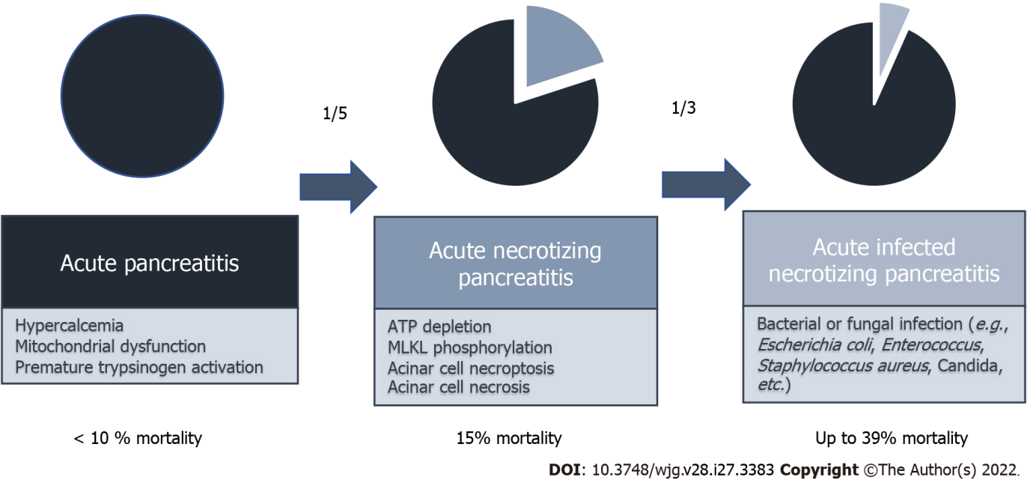
Figure 1 Mortality rates of acute pancreatitis and pathomechanisms. The mortality rate of all patients with acute pancreatitis (AP) is less than 10%. One-fifth of the patients developed necrotizing AP by ATP depletion, MLKL phosphorylation, acinar cell necroptosis, and/or acinar cell necrosis. One-third of the patients with necrotizing AP developed bacterial or fungal infection. The mortality rate of the infected necrotizing pancreatitis is up to 39%.

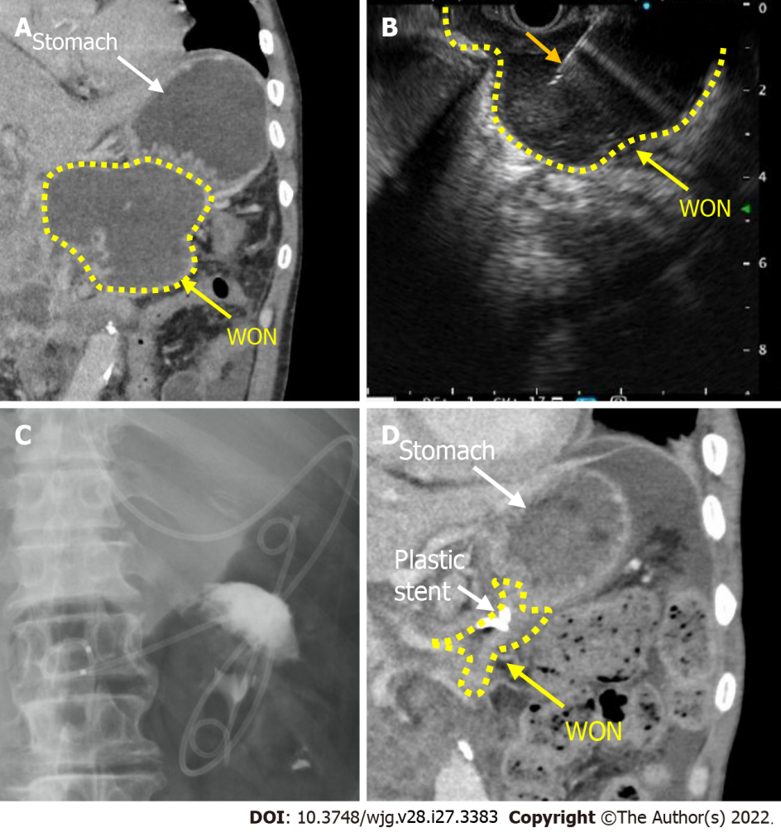

Figure 2 Endoscopic transluminal drainage with plastic stenting. A: A typical computed tomography (CT) scan with walled-off necrosis (WON) formed by necrotizing pancreatitis (white arrow shows stomach and yellow dotted line is the demarcation line of the WON); B: Endoscopic ultrasonography (EUS)-guided drainage for WON was performed (orange arrow shows the needle of 22-gauge EUS needle); C: Two plastic stents and nasobiliary drainage tube was placed into the WON; D: The size of the WON was reduced in the CT scan one month after the procedure. WON: Walled-off necrosis.

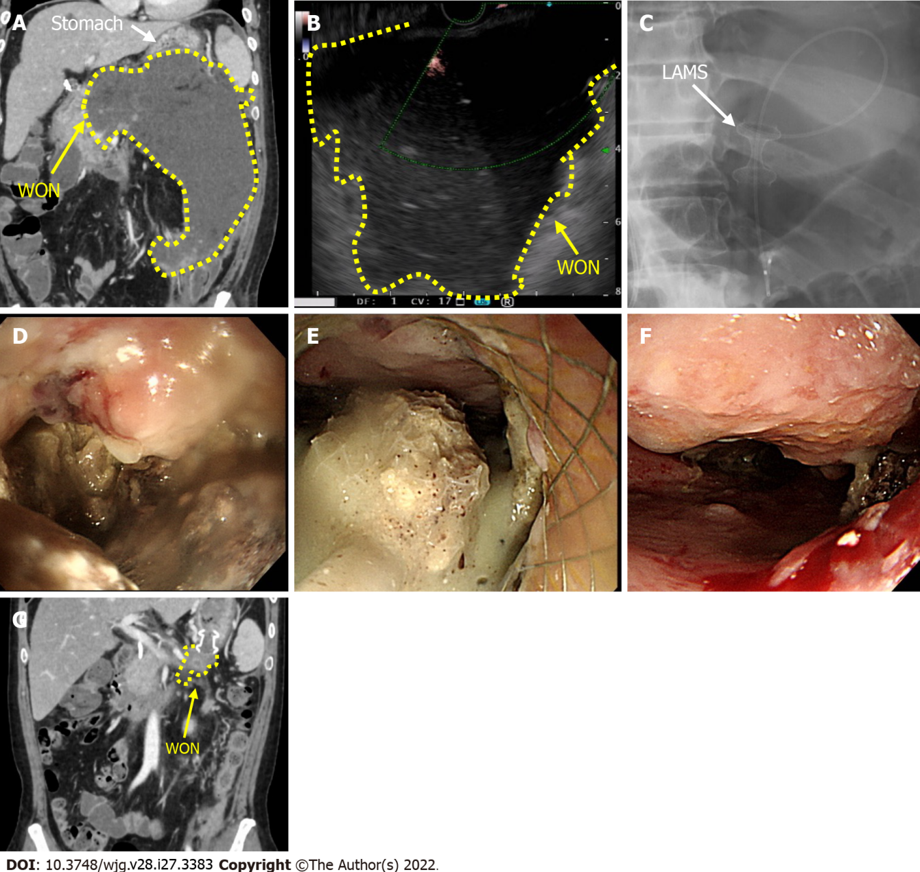
Figure 3 A case with endoscopic transluminal drainage with lumen-apposing metal stent. A: Computed tomography (CT) scan before performing the endoscopic ultrasonography (EUS)-guided drainage (White arrow shows the stomach and the yellow arrow shows the walled-off necrosis (WON); the yellow dotted line is the demarcation line of the WON); B: EUS (with color doppler) picture shows marked echoic lesion without vessels; C: Lumen-apposing metal stent (LAMS) and nasobiliary drainage tube were placed (white arrow shows LAMS: Hot AXIOSTM 15 mm × 10 mm, Boston Scientific, Marlborough, MA, United States; Boston Scientific Japan, Tokyo, Japan); D: Esophagogastroduodenoscopy was inserted into necrotic cavity through LAMS; E: Necrosectomy was performed using endoscopic retrieval net; F: Endoscopic findings of the WON one month after the multiple necrosectomy sessions (2-3 times/wk); G: CT scan shows marked reduction of WON cavity one month after multiple necrosectomy sessions. WON: Walled-off necrosis; LAMS: Lumen-apposing metal stent.

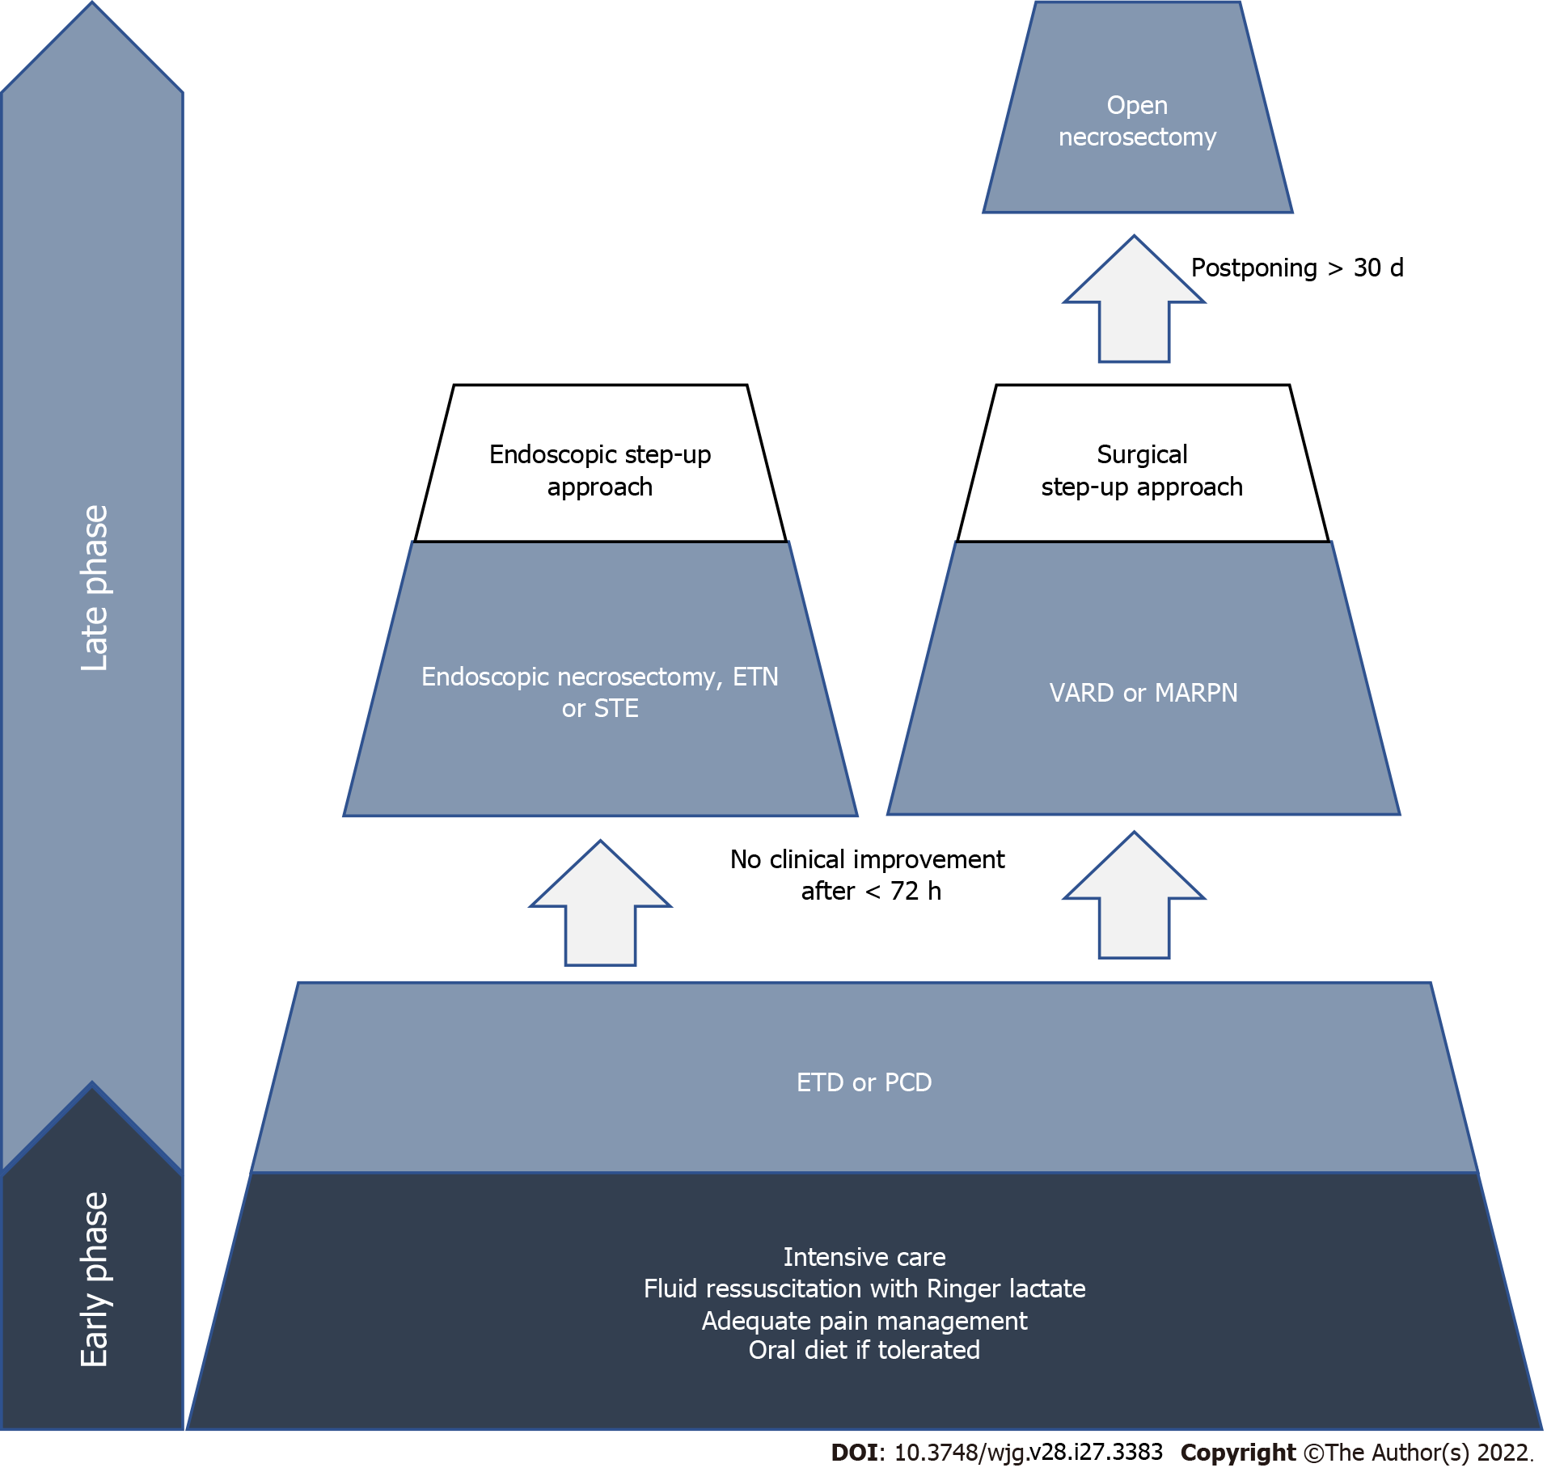
Figure 4 Overview of the step-up approaches of infected necrotizing pancreatitis patients. In the acute phase, multidisciplinary treatment for acute pancreatitis is recommended. Endoscopic necrosectomy or surgical step-up should be considered if there no clinical improvement is observed within 72 h. Open necrosectomy should be considered after video-assisted retroperitoneal debridement or minimal access retroperitoneal pancreatic necrosectomy. ETN: Endoscopic transluminal necrosectomy; STE: Sinus tract endoscopy; ETD: Endoscopic transluminal drainage; PCD: Percutaneous catheter drainage; VARD: Video-assisted retroperitoneal debridement; MARPN: Minimal access retroperitoneal pancreatic necrosectomy.

Table 1 Overview of possible interventions in infected necrotizing pancreatitis
 |  | Indications | Contraindications | Most common complications | Ref.
Interventions | Endoscopic transluminal drainage | Standard first step for INP, standard for PFC treatment | Unencapsulated collections, distance from gastroduodenal duct (> 1 cm), vascular pseudoaneuryms | Major bleedings, perforation, post-procedure infection, recurrence, migration of the stent | [37,38,40]
 | Endoscopic necrosectomy | No improvement in clinical condition within < 72 h after ETD, follow-up treatment | Large necrotic areas, dense necrosis, disconnected duct | Bleeding, perforation, pancreatic fistula, infections | [37,48,50]
 | Percutaneous catheter drainage | Hardly accessible ANC, ETD not feasible, as combination with ETD | Intracystic haemorrhagia, pancreatic ascites | Intestinal fistula, infection | [36,51]
 | Open surgery | Infected necrosis, suspected perforation, abdominal compartment syndrome, ischemia, intrabadominal haemorrhagia, poorly walled off necrosis, final treatment option if other interventions fail | No clear contraindications reported | Bleeding, infection, perforation, multi-organ failure | [52,53]
 | Minimally invasive surgery | Infected necrosis | Extensive or hardly accessible collections | Bleeding, infection, perforation | [44,57,58]
INP: Infected necrotizing pancreatitis; ANC: Acute necrotic collection; ETD: Endoscopic transluminal drainage.

