Name of journal: World Journal of Gastrointestinal Endoscopy
ESPS Manuscript NO: 14544
Columns: Case Report

Anaemia in Waldmann’s disease: A rare presentation of a rare disease

El-Etreby SA et al. Intestinal lymphangiectasia and gastrointestinal bleeding

Shahira A El-Etreby, Ahmed Y Altonbary, Mohamed El-Sorogy, Wagdi Elkashef, Jehan A Mazroa, Monir H Bahgat

Shahira A El-Etreby, Ahmed Y Altonbary, Mohamed El-Sorogy, Wagdi Elkashef, Jehan A Mazroa, Monir H Bahgat, Division of Hepatology and Gastroenterology, Specialized Medical Hospital, Mansoura University, Mansoura 35516, Egypt

Author contributions: All authors performed the research, designed, wrote, critically analysed the manuscript; El-Etreby AS, Bahgat HM and Altonbary YA were responsible for medical assessment and follow up of the patient; Mazroa AJ was responsible of radiological assessment; Elkashef W examined the pathological specimens; El-Sorogy M performed the surgical procedure; Finally, El-Etreby AS and Bahgat HM analyzed the data, revised the draft and approved of the final version of the paper to be published.

Supported by Specialized Medical Hospital and Gastrointestinal Surgery Center, Mansoura University, Mansoura, Egypt.

Ethics approval: The study was reviewed and approved by the Mansoura Faculty of Medicine Institutional Review Board, Mansoura University, Egypt.

Informed consent: The study participant, or her legal guardian, provided informed written consent prior to study enrollment.

Conflict-of-interest: None.

Open-Access: This article is an open-access article which was selected by an in-house editor and fully peer-reviewed by external reviewers. It is distributed in accordance with the Creative Commons Attribution Non Commercial (CC BY-NC 4.0) license, which permits others to distribute, remix, adapt, build upon this work non-commercially, and license their derivative works on different terms, provided the original work is properly cited and the use is non-commercial. See: http://creativecommons.org/licenses/by-nc/4.0/

Correspondence to: Shahira Aly Abdo El-Etreby, MD, Division of Hepatology and Gastroenterology, Specialized Medical Hospital, Mansoura University, Mansoura 35516, Egypt. aly_shahira@yahoo.com

Telephone: +2-114-3543995
Fax: +2-50-2230287
Received: October 11, 2014
Peer-review started: October 11, 2014
First decision: November 14, 2014
Revised: November 29, 2014
Accepted: February 9, 2015
Article in press:
Published online:

Abstract
A 32 years old female presented with 5 year history of iron deficiency anemia, marked pallor and edema of both lower limbs. Laboratory investigations including complete blood count, blood film, iron studies, lipid profile, ascitic fluid analysis, test of stool for occult blood and alpha 1 anti-trypsin. Upper, lower gastrointestinal (GIT) endoscopies, and enteroscopy were performed. Imaging techniques as abdominal ultrasonography and computed tomography were done. Echocardiography, lymph node biopsy and bone marrow examination were normal. The case was diagnosed as Waldmann’s disease with protein losing enteropathy and recurrent GIT bleeding. Low fat diet with medium chain triglyceride, octreotide 200 μg/twice a day, tranexamic acid and blood transfusion. Then, exploratory laparotomy with pathological examination of resected segment was done when recurrent GIT bleeding occurred and to excluded malignant transformation.

Key words: Waldmann’s disease; Lymphangiectasia; Gastrointestinal bleeding; Iron deficiency anemia

© The Author(s) 2015. Published by Baishideng Publishing Group Inc. All rights reserved.

Core tip: To our knowledge, this is the first “Egyptian” case of primary intestinal lymphangiectasia. In addition, its presentation is rare with blood loss anemia in contrast to the more common presentation with hypoproteinemia and edema. So, we are reporting a case with a rare clinical presentation of a rare disease. Double balloon enteroscopy was so beneficial in the diagnosis of the case superior to capsule endoscopy because the advantage of biopsy and histopathologic examination. There is controversy about medical treatment options, surgical treatment may be preferred in localized lesions otherwise, has no role. Prognosis may be favorable.

El-Etreby SA, Altonbary AY, El-Sorogy M, Elkashef W, Mazroa JA, Bahgat MH. Anaemia in Waldmann’s disease: A rare presentation of a rare disease. World J Gastrointest Endosc 2015; In press

INTRODUCTION
Waldmann´s disease; also called primary intestinal lymphangiectasia (PIL) is a rare form of protein losing enteropathy caused by leakage of lymph inside the small intestinal lumen from dilated lacteals. The manifestations begin before the age of 30 years in 90% of cases, often in childhood. Whether bleeding into gastrointestinal tract a feature of PIL or not is still controversial. Here, we present a case of a young women with chronic blood loss anemia (iron deficiency and positive fecal occult blood test) caused by Waldmann´s disease.

CASE REPORT
A 32 years old female with 5 year history of iron deficiency anemia was referred to our Gastroenterology Unit for further evaluation. History was irrelevant apart from easily fatigability and repeated blood transfusions as well as iron therapy. Examination revealed marked pallor and edema of both lower limbs.
Laboratory findings of a 32 year old female with Waldmann´s disease are shown in Table 1:
Upper and lower GI endoscopies were done twice within two-month period and did not reveal any gross pathology. So, Fujinon’s Double Balloon Endoscopy System (with 2.8 mm forceps channel) was used to examine the small bowel through oral route down to 310 cm from the ligament of Trietz. Multiple lymphangectasias (Figure 1) were seen starting at about 100 cm, extending all through the assessed parts; some of them were actively bleeding. The most affected area (at about 100 cm) was tattooed with India Ink. Histopathological examination of the lesions revealed multiple dilated vascular and lymphatic spaces and few lymphocytes with no evidence of malignancy, picture consistent with capillary telangiectasia.
Abdominal ultrasonography, abdominal computed tomography (CT), echocardiography, inguinal lymph node biopsy, and bone marrow examination were performed to exclude secondary causes of lymphangiectasia. All tests were normal except for mild splenomegaly (due to multiple hemangiomas).
Management started with low fat diet with medium chain triglyceride, octreotide 200 μg/twice a day, tranexamic acid and blood transfusion till an acceptable level of hemoglobin was achieved (about 9 g/dL). She was discharged on diet regimen and regular follow up.
Nine months later during routine follow up, clinical examination showed marked pallor (Hb 6 g/dL) and abdominal ultrasonography revealed moderate ascites and mild right sided pleural effusion. Ascitic fluid was milky and turbid. Chemical analysis of ascitic fluid sample revealed glucose of 108 mg/dL, total protein of 1170 mg/dL, LDH of 195 U/L, triglycerides of 1232 mg/dL (diagnostic of chylous ascites), WBCs of 250 cell/cm³ mainly lymphocytes, and RBCs of 0.01x 10⁶. Cytological examination of ascitic fluid revealed no atypical or malignant cells. ZN stain and adenosine deaminase were negative. Triphasic CT scan was performed by 8 multi-slice G.E. CT scanner. It revealed right pleural effusion, mild ascites; both had uncomplicated fluid density: 0-20HU (Figure 2) and multiple splenic hemangiomas (Figure 3). Regarding small intestine, CT revealed dilated small intestinal loops with diffuse, nodular wall thickening (reaching up to 9 mm), mesenteric hypodense bands representing dilated lymphatic channels and mesenteric edema (Figure 4). Neither lymphadenopathy nor hepatomegaly was detected.
Surgical opinion was sought and malignant transformation was suspected. So, exploratory laparotomy was done through midline incision. Findings include minimal ascites, multiple cysts related to the small intestinal wall and its mesentry and a discolored segment of the proximal jejunum previously marked with India Ink by enteroscopy (Figure 5) but no masses were found. Resection anastomosis of the discolored segment was done. Histopathological examination revealed large gaping vascular spaces lined by flat endothelial cells and filled by lymph fluid, picture consistent with primary intestinal lymphangectasia (Figure 6).
Postoperative outcome was favorable and she was discharged home after 5 d.
On the 20th postoperative day, patient achieved marked improvement of her general condition, disappearance of edema lower limb, ascites, and pleural effusion. Laboratory investigations were; s. albumin 4.1 g/dL, HB 10.9 g/dL, platelets count 147.000 cell/cm³, WBCs 4900 cell/cm³ with normal distribution. Six months later, she remained asymptomatic with weight gain of 5 kg and rather stable hemoglobin level.

DISCUSSION
Protein losing enteropathy (PLE) is a rare cause of hypoproteinemia due to gastrointestinal (GI) loss of serum protein. This rare condition has many reported causes (Table 2) including the rare Waldmann´s disease (PIL) in which GI protein loss results from leakage of lymph through the ectatic intestinal lacteals^{[2]}.
PIL predominantly affects young children although it may also be diagnosed in older age. There is slight male preponderance with 3:2 ratio. On the other hand, race is not a predictor of PIL^{[3,4]}.
Patients usually present with bilateral lower limb edema^{[2-7]}. Other manifestations like pain, loose motion, and malnutrition are less common^{[8]}. Rare manifestations include abdominal mass, Mechanical ileus^{[9-11]}, chylous reflux^{[12,13]}, iron deficiency with anemia^{[14]}, necrolytic migratory erythema^{[15]}, recurrent hemolytic uremic syndrome^{[16]}, and osteomalacia^{[17]}. Recurrent gastrointestinal bleeding was even more rare being reported in only 2 cases^{[18,19]}.
Work up of diagnosis consist of laboratory, imaging studies and GIT endoscopy with confirmatory histopathological examination^{[20]}.
The most common laboratory finding is hypoproteinemia. Hypo-albuminemia is most prominent and lymphopenia. Cholesterol levels are not usually elevated. PLE can be confirmed by presence of excess fecal α1-antitrypsin^{[21,22]}.
Abdominal CT scan may show dilated thickened small intestinal loops, ascites, halo sign and edematous mesentery. It also helps rule out secondary causes^{[23,24]}.
Diagnosis can only be confirmed by finding dilated lacteals both on endoscopic and histopathologic examination^{[25,26]}. Video capsule endoscopy imaging provides the same information and allow exploration of the whole small bowel but does not allow biopsies^{[27]}.
PIL has to be differentiated from secondary causes of intestinal lymphangiectasia such as Crohn's disease, intestinal tuberculosis, and Whipple's disease as well as from causes of PLE without lymphangiectasia such as Mentrier’s disease and SLE ^{[20]}.
Medical management relies on diet modification with low fat replaced by medium-chain triglycerides thus preventing fat overloading of intestinal lacteal^{[28,29]}.
Response to other medications, such as octreotide^{[32-36]} and steroids^{[37]} is variable.
Small intestinal resection is indicated in localized forms of the disease^{[38,39]}.
Natural history of PIL is greatly variable; depending on involvement of intestine either generalized or localized with blockage of mesenteric lymphatic drainage. Prognosis may be favorable unless it is complicated by intestinal B-lymphoma or effusion in serous sacs^{[20,40]}.

COMMENTS
Case characteristics
A 32 year old female presented with 5 year history of iron deficiency anemia, marked pallor and edema of both lower limbs.

Clinical diagnosis
Examination revealed marked pallor and edema of both lower limbs.

Differential diagnosis
PIL has to be differentiated from secondary causes of intestinal lymphangiectasia such as Crohn’s disease, intestinal tuberculosis, and Whipple's disease as well as from causes of protein losing enteropathy without lymphangiectasia such as Mentrier’s disease and SLE.

Laboratory diagnosis
Patient hemoglobin level and serum albumin were 5.2 g/dL, 2.1 g/dL respectively. α-1 AT clearance was 2 folds above normal range and stool test for occult blood yield positive result.

Imaging diagnosis
CT of the abdomen revealed dilated small intestinal loops with diffuse, nodular wall thickening, mesenteric hypodense bands representing dilated lymphatic channels and mesenteric edema.

Endoscopy diagnosis
Double balloon enteroscopy was performed, and revealed presence of multiple lymphangectasias, some of them were actively bleeding.

Pathological diagnosis
Histopathological examination of the lesions revealed multiple dilated vascular and lymphatic spaces and few lymphocytes with no evidence of malignancy, picture consistent with capillary telangiectasia.

Treatment
Management started with low fat diet with medium chain triglyceride, octreotide 200 μg/twice a day, tranexamic acid and blood transfusion till an acceptable level of hemoglobin was achieved (about 9 g/dL). But the results was unsatisfactory.

Related reports
Only two cases with primary intestinal lymphangiectasia were presented in literatures by gastrointestinal bleeding.

Term explanation
Chronic blood loss anemia (iron deficiency and positive fecal occult blood test) could be a one of manifestation of primary intestinal lymphangiectasia.

Experiences and lessons
This case report represents a case of primary intestinal lymphangiectasia with rare presentation, recurrent gastrointestinal bleeding and iron deficiency anemia. Also, it yields our experience with different treatment modalities that could be used.

Peer-review
The article highlights the clinical characteristics, diagnostic modalities and treatment options available for primary intestinal lymphangiectasia.

REFERENCES
1 Greenwald D. Protein-Losing Gastroenteropathy. In: Feldman M, Friedman LS, Brandt LJ, Sleisinger MH, editors. Sleisenger&Fordtran's Gastrointestinal and Liver Disease. 8th ed. Saunders: Philadelphia, 2006: 557-563
2 Waldmann TA, Steinfeld JL, Dutcher TF, Davidson JD, Gordon RS. The role of the gastrointestinal system in "idiopathic hypoproteinemia". Gastroenterology 1961; 41: 197-207 [PMID: 13782654]
3 Boursier V, Vignes S. Lymphangiectasiesintestinales primitives (maladie de Waldmann) révélées par unlymphoedème des membres. J Mal Vasc 2004; 29: 103-106 [DOI: 10.1016/S0398-0499(04)96722-4]
4 Tift WL, Lloyd JK. Intestinal lymphangiectasia. Long-term results with MCT diet. Arch Dis Child 1975; 50: 269-276 [PMID: 50050 DOI: 10.1136/adc.50.4.269]
5 Le Bougeant P, Delbrel X, Grenouillet M, Leou S, Djossou F, Beylot J, Lebras M, Longy-Boursier M. [Familial Waldmann's disease]. Ann Med Interne 2000; 151: 511-512 [PMID: 11104932]
6 Vardy PA, Lebenthal E, Shwachman H. Intestinal lymphagiectasia: a reappraisal. Pediatrics 1975; 55: 842-851 [PMID: 1134884]
7 Goktan C, Pekindil G, Orguc S, Coskun T, Serter S. Bilateral breast edema in intestinal lymphangiectasia. Breast J 2005; 11: 360 [PMID: 16174162 DOI: 10.1111/j.1075-122X.2005.21578.x]
8 Lee WS, Boey CC. Chronic diarrhoea in infants and young children: causes, clinical features and outcome. J Paediatr Child Health 1999; 35: 260-263 [PMID: 10404446 DOI: 10.1046/j.1440-1754.1999.00356.x]
9 Rao R, Shashidhar H. Intestinal lymphangiectasia presenting as abdominal mass. Gastrointest Endosc 2007; 65: 522-523, discussion 523 [PMID: 17321261 DOI: 10.1016/j.gie.2006.10.026]
10 Lobo B, Casellas F, de Torres I, Chicharro L, Malagelada JR. Usefulness of jejunal biopsy in the study of intestinal malabsorption in the elderly. Rev Esp Enferm Dig 2004; 96: 259-264 [PMID: 15117239 DOI: 10.4321/S1130-01082004000400005]
11 Lenzhofer R, Lindner M, Moser A, Berger J, Schuschnigg C, Thurner J. Acute jejunal ileus in intestinal lymphangiectasia. Clin Investig 1993; 71: 568-571 [PMID: 8374252 DOI: 10.1007/BF00208483]
12 O'Driscoll JB, Chalmers RJ, Warnes TW. Chylous reflux into abdominal skin simulating lymphangioma circumscriptum in a patient with primary intestinal lymphangiectasia. Clin Exp Dermatol 1991; 16: 124-126 [PMID: 2032374 DOI: 10.1111/j.1365-2230.1991.tb00322.x]
13 Karg E, Bereczki C, Kovacs J, Korom I, Varkonyi A, Megyeri P, Turi S. Primary lymphoedema associated with xanthomatosis, vaginal lymphorrhoea and intestinal lymphangiectasia. Br J Dermatol 2002; 146: 134-137 [PMID: 11841381 DOI: 10.1046/j.1365-2133.2002.04477.x]
14 Iida F, Wada R, Sato A, Yamada T. Clinicopathologic consideration of protein-losing enteropathy due to lymphangiectasia of the intestine. Surg Gynecol Obstet 1980; 151: 391-395 [PMID: 7404312]
15 Baricault S, Soubrane JC, Courville P, Young P, Joly P. [Necrolytic migratory erythema in Waldmann's disease]. Ann Dermatol Venereol 2006; 133: 693-696 [PMID: 17053741 DOI: 10.1016/S0151-9638(06)70994-2]
16 Kalman S, Bakkaloğlu S, Dalgiç B, Ozkaya O, Söylemezoğlu O, Buyan N. Recurrent hemolytic uremic syndrome associated with intestinal lymphangiectasia. J Nephrol 2007; 20: 246-249 [PMID: 17514630]
17 Sahli H, Ben Mbarek R, Elleuch M, Azzouz D, Meddeb N, Chéour E, Azzouz MM, Sellami S. Osteomalacia in a patient with primary intestinal lymphangiectasis (Waldmann's disease). Joint Bone Spine 2008; 75: 73-75 [PMID: 17900962 DOI: 10.1016/j.jbspin.2007.01.045]
18 Herfarth H, Hofstädter F, Feuerbach S, Jürgen Schlitt H, Schölmerich J, Rogler G. A case of recurrent gastrointestinal bleeding and protein-losing gastroenteropathy. Nat Clin Pract Gastroenterol Hepatol 2007; 4: 288-293 [PMID: 17476211 DOI: 10.1038/ncpgasthep0812]
19 Maamer AB, Baazaoui J, Zaafouri H, Soualah W, Cherif A. Primary intestinal lymphangiectasia or Waldmann's disease: a rare cause of lower gastrointestinal bleeding. Arab J Gastroenterol 2012; 13: 97-98 [PMID: 22980601 DOI: 10.1016/j.ajg.2012.03.001]
20 Vignes S, Bellanger J. Primary intestinal lymphangiectasia (Waldmann's disease). Orphanet J Rare Dis 2008; 3: 5 [PMID: 18294365 DOI: 10.1186/1750-1172-3-5]
21 Karbach U, Ewe K, Bodenstein H. Alpha 1-antitrypsin, a reliable endogenous marker for intestinal protein loss and its application in patients with Crohn's disease. Gut 1983; 24: 718-723 [PMID: 6603392 DOI: 10.1136/gut.24.8.718]
22 Strygler B, Nicar MJ, Santangelo WC, Porter JL, Fordtran JS. Alpha 1-antitrypsin excretion in stool in normal subjects and in patients with gastrointestinal disorders. Gastroenterology 1990; 99: 1380-1387 [PMID: 2210245]
23 Holzknecht N, Helmberger T, Beuers U, Rust C, Wiebecke B, Reiser M. Cross-sectional imaging findings in congenital intestinal lymphangiectasia. J Comput Assist Tomogr 2002; 26: 526-528 [PMID: 12218814 DOI: 10.1097/00004728-200207000-00009]
24 Hashemi J, Farhoodi M, Farrokh D, Pishva A. Congenital Intestinal Lymphangiectasia: Report of a Case. Iran J Radiol 2008; 5: 189
25 Waldmann TA. Protein –losing gastroenteropathies. In: Berk JE, Haubrich WS, Kaiser MH, Roth JA, Schaff-ner F, editors. Bockus gastroenterology. Philadelphia: WB Saunders; 1985: 1814-1837
26 Kazemi F, Lemann M, Modigliani R. Interet des explorations digestives invasives pour le diagnostic des lymphangiectasiesintestinales primitives. Gastroenterology cliniquesetbiologique 2001; 25: 0399-8320
27 Oh TG, Chung JW, Kim HM, Han SJ, Lee JS, Park JY, Song SY. Primary intestinal lymphangiectasia diagnosed by capsule endoscopy and double balloon enteroscopy. World J Gastrointest Endosc 2011; 3: 235-240 [PMID: 22110841 DOI: 10.4253/wjge.v3.i11.235]
28 Alfano V, Tritto G, Alfonsi L, Cella A, Pasanisi F, Contaldo F. Stable reversal of pathologic signs of primitive intestinal lymphangiectasia with a hypolipidic, MCT-enriched diet. Nutrition 2000; 16: 303-304 [PMID: 10758368 DOI: 10.1016/S0899-9007(00)00223-9]
29 Aoyagi K, Iida M, Matsumoto T, Sakisaka S. Enteral nutrition as a primary therapy for intestinal lymphangiectasia: value of elemental diet and polymeric diet compared with total parenteral nutrition. Dig Dis Sci 2005; 50: 1467-1470 [PMID: 16110837 DOI: 10.1007/s10620-005-2863-7]
30 Mine K, Matsubayashi S, Nakai Y, Nakagawa T. Intestinal lymphangiectasia markedly improved with antiplasmin therapy. Gastroenterology 1989; 96: 1596-1599 [PMID: 2714582]
31 MacLean JE, Cohen E, Weinstein M. Primary intestinal and thoracic lymphangiectasia: a response to antiplasmin therapy. Pediatrics 2002; 109: 1177-1180 [PMID: 12042562 DOI: 10.1542/peds.109.6.1177]
32 Ballinger AB, Farthing MJ. Octreotide in the treatment of intestinal lymphangiectasia. Eur J Gastroenterol Hepatol 1998; 10: 699-702 [PMID: 9744700]
33 Kuroiwa G, Takayama T, Sato Y, Takahashi Y, Fujita T, Nobuoka A, Kukitsu T, Kato J, Sakamaki S, Niitsu Y. Primary intestinal lymphangiectasia successfully treated with octreotide. J Gastroenterol 2001; 36: 129-132 [PMID: 11227670 DOI: 10.1007/s005350170142]
34 Klingenberg RD, Homann N, Ludwig D. Type I intestinal lymphangiectasia treated successfully with slow-release octreotide. Dig Dis Sci 2003; 48: 1506-1509 [PMID: 12924644 DOI: 10.1023/A: 1024707605493]
35 Reichlin S. Somatostatin. N Engl J Med 1983, 309: 1495-1501 [PMID: 6139753]
36 Nakabayashi H, Sagara H, Usukura N, Yoshimitsu K, Imamura T, Seta T, Yanase E, Kawato M, Hiraiwa Y, Sakato S, Takeda R. Effect of somatostatin on the flow rate and triglyceride levels of thoracic duct lymph in normal and vagotomized dogs. Diabetes 1981; 30: 440-445 [PMID: 6112179 DOI: 10.2337/diab.30.5.440]
37 Fleisher TA, Strober W, Muchmore AV, Broder S, Krawitt EL, Waldmann TA. Corticosteroid-responsive intestinal lymphangiectasia secondary to an inflammatory process. N Engl J Med 1979; 300: 605-606 [PMID: 763272 DOI: 10.1056/NEJM197903153001106]
38 Warshaw AL, Waldmann TA, Laster L. Protein-losing enteropathy and malabsorption in regional enteritis: cure by limited ileal resection. Ann Surg 1973; 178: 578-580 [PMID: 4748296 DOI: 10.1097/00000658-197311000-00004]
39 Chen CP, Chao Y, Li CP, Lo WC, Wu CW, Tsay SH, Lee RC, Chang FY. Surgical resection of duodenal lymphangiectasia: a case report. World J Gastroenterol 2003; 9: 2880-2882 [PMID: 14669360]
40 Lymphoedema Framework: Best practice for the management of lymphoedema. International consensus. London: MEP Ltd, 2006
P-Reviewer: Bilir C, Chow KW, Kurtoglu E S-Editor: Tian YL
L-Editor: E-Editor:

Table 1 Laboratory results for the patient
Test | Result | Normal reference
Complete Blood Count
Hemoglobin | 5.2 g/dL | 12-18g/dL
HCT | 18.3% | 37-51%
MCV | 70.2 pg | 80-97 flpg
MCHC | 28.4 g/dL | 31-36 g/dL
Platelets | 284.000 | 140.000-440.000cell/cm³
WBCs | 3.800 | 4.100-10.900 cell/cm³
Lymphocytes | 500 | 600-1400
Blood film
Hypercellular bone marrow with no blast cells.
Blood Chemistry
s. Albumin | 2.1 g/ dL | 3.5-5 g/ dL
AST | 30 IU/L | Up to 40U/L
ALT | 25 IU/L | Up to 45U/L
s. cholesterol | 107 mg/ dL | Up to 200 mg/dL
s. triglyceride | 54 mg/ dL | Up to 160 mg/dL
s. iron | 23 ng/ dL | 28-170 ng/dL
s. ferritin | 12 ng/mL | 40-430 ng/mL
TIBC | 750 ng/dL | 261-478 ng/dL
s. TSH | 1.2 mIU/L | 0.3-3.04 mIU/L
Stool tests
Occult blood | Positive
α-1 AT clearance | 2 folds above normal range
HCT: Hematocrit; MCV: Mean corpusclar volume; MCHC: Mean corpuscular hemoglobin concentration; WBCs: White blood cells; AST: Aspartate aminotransferase; ALT: Alanine aminotransferase; TIBC: Total iron binding capacity; TSH: Thyroid stimulating hormone; α-1 AT: alpha 1 antitrypsin.

Table 2 Causes of protein losing enteropathy^{[1]}
Erosive gastrointestinal disease
Inflammatory bowel disease
Gut malignancy
Non steroidal anti-inflammatory drug enteropathy
Erosive gastropathy
Acute graft vs host disease
Pseudomembranous enterocolitis
Ulcerative jejunoenterocolitis
Intestinal lymphoma
Sarcoidosis
Non erosive gastrointestinal disease
Celiac disease
Hypertrophic gastropathies
Eosinophilic gastroenteritis
Connective tissue disorders
Small intestinal bacterial overgrowth
Amyloidosis
Microscopic colitis
Tropical sprue
Whipple ´s disease
Parasitic diseases
Viral gastroenteritis
Increased interstitial pressure
Intestinal lymphangiectasia
Congestive heart failure
Constrictive pericarditis
Congenital heart diseases
Fontan procedure for single ventricle
Portal hypertensive gastroenteropathy
Hepatic venous outflow obstruction
Enteric lymphatic fistula
Mesenteric venous thrombosis
Sclerosing mesenteritis
Mesenteric tuberculosis or sarcoidosis
Neoplasia involving mesenteric lymph nodes or lymphatics
Chronic pancreatitis with pseudocysts
Congenital malformations of lymphatic
Retoperitoneal fibrosis

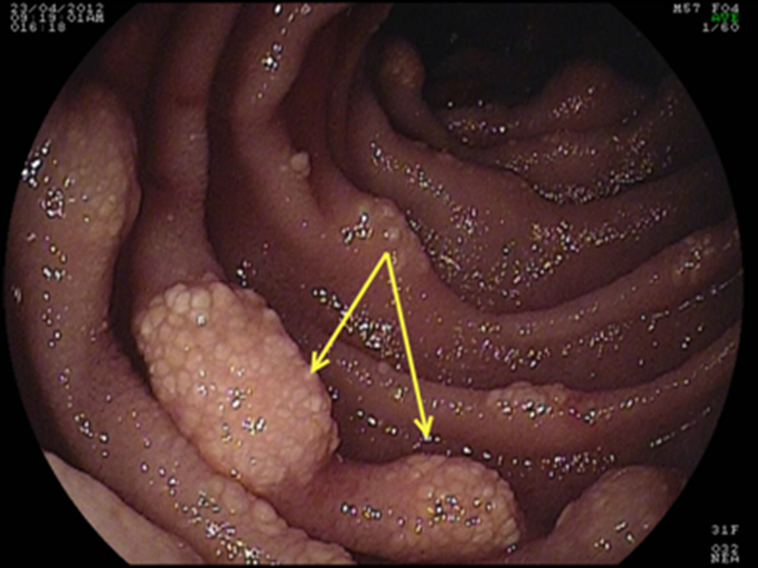

Figure 1 Multiple jejunal lymphangiectasia.

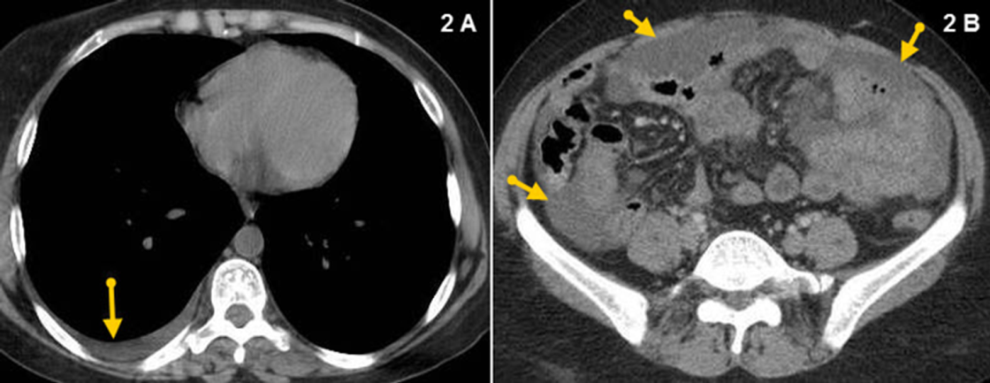

Figure 2 Pre contrast axial CT scan showing (A) Mild right-sided pleural effusion and (B) mild ascites.

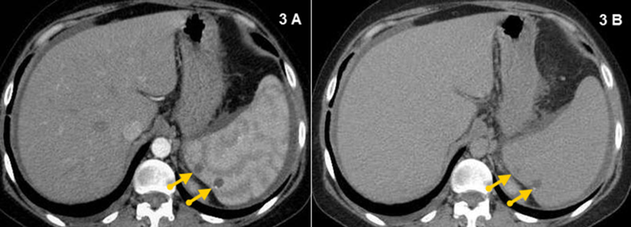
Figure 3 Triphasic post contrast axial CT showing. Multiple splenic hemangiomas in portal (A) and delayed (B) phases respectively showing filling in (arrows).
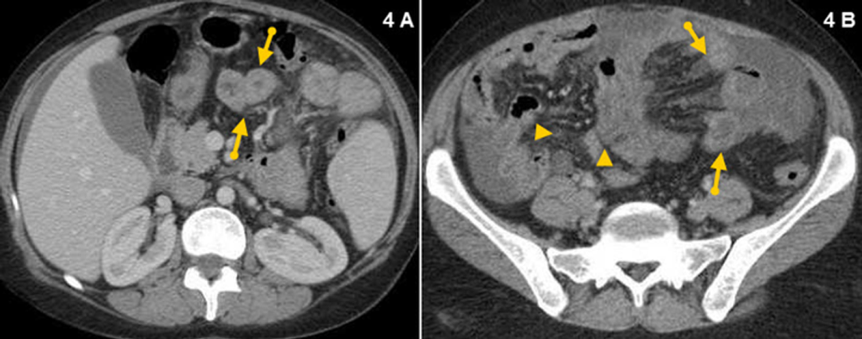
Figure 4 Triphasic post contrast axial CT (portal phase) showing. A: Dilated small intestinal wall (arrows); B: Mesenteric hypodense bands indicating obstructed lymphatics (arrows), and Dirty fat appearance due to mesenteric oedema (arrow heads).

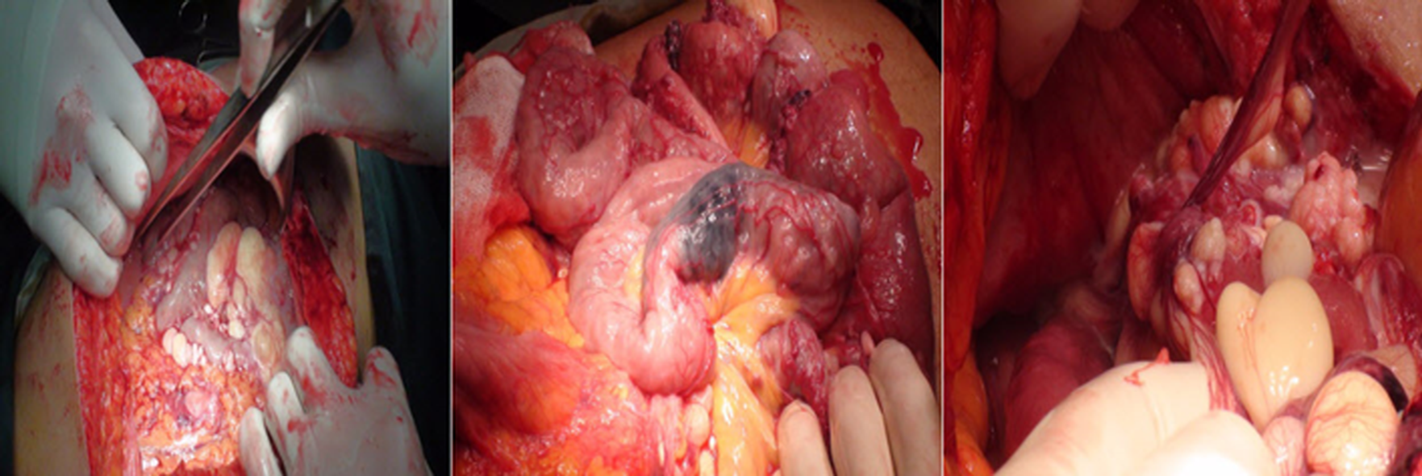
Figure 5 Exploratory laparotomy, multiple cysts was seen related to the small intestinal wall and its mesentry and a discolored segment of the proximal jejunum.

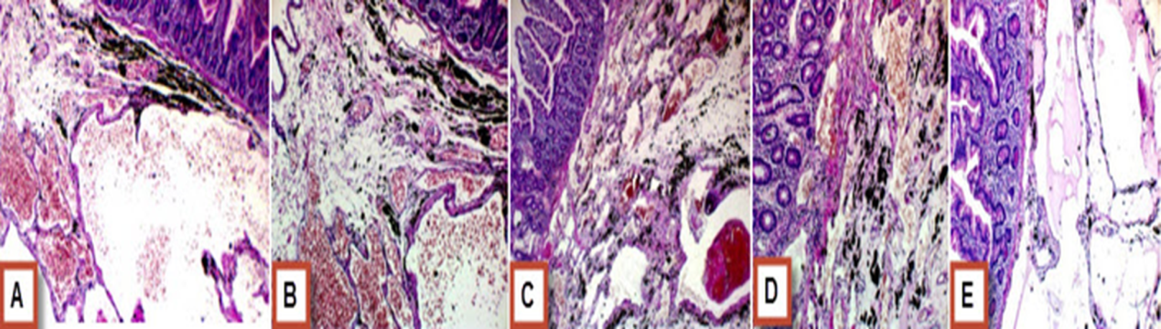
Figure 6 Histopathological examination of the resected part of small intestine. A: The sub-mucosa shows large gaping vascular spaces lined by flat endothelial cells and filled by RBCs (H&E x 100) (Black staining is due to labeling material); B: The sub-mucosa shows large gaping vascular spaces lined by flat endothelial cells and filled by RBCs (H&E x 400) (Black staining is due to labeling material); C: The sub-mucosa shows large gaping vascular spaces lined by flat endothelial cells and filled by RBCs (H&E x 100) (Black staining is due to labeling material); D: The sub-mucosa shows large gaping vascular spaces lined by flat endothelial cells and filled by RBCs (H&E x 400) (Black staining is due to labeling material); E: The sub-mucosa shows large gaping vascular spaces lined by flat endothelial cells and filled by lymph fluid (H&E x 400) (Black staining is due to labeling material).

