Name of Journal: World Journal of Clinical Cases
Manuscript NO: 69441
Manuscript Type: CASE REPORT

Uretero-lumbar artery fistula: A case report

Chen JJ et al. Case of uretero-lumbar artery fistula

Jia-Jian Chen, Jian Wang, Qi-Gang Zheng, Zhao-Hui Sun, Jia-Cheng Li, Zi-Lei Xu, Xiao-Jun Huang

Jia-Jian Chen, Jian Wang, Qi-Gang Zheng, Zhao-Hui Sun, Jia-Cheng Li, Zi-Lei Xu, The Second Clinical Medical College of Zhejiang Chinese Medical University, Hangzhou 310053, Zhejiang Province, China

Xiao-Jun Huang, Department of Urology, The Second Clinical Medical College of Zhejiang Chinese Medical University, The Second Affiliated Hospital of Zhejiang Chinese Medical University, Hangzhou 310005, Zhejiang Province, China

Author contributions: Chen JJ and Huang XJ conceived and wrote the report; Chen JJ and Wang J performed the operation; Zheng QG, Sun ZH, Li JC, and Xu ZL organized the data; Huang XJ revised the paper; All authors have read and approved the final manuscript.

Supported by National Natural Science Foundation of China (General Program), No. 81874400.

Corresponding author: Xiao-Jun Huang, Doctor, Department of Urology, The Second Clinical Medical College of Zhejiang Chinese Medical University, The Second Affiliated Hospital of Zhejiang Chinese Medical University, No. 318 Chaowang Road, Gongshu District, Hangzhou 310005, Zhejiang Province, China. hxj258111@163.com

Received: July 2, 2021
Revised: July 29, 2021
Accepted: September 10, 2021
Published online: November 16, 2021

Abstract
BACKGROUND
Uretero-arterial fistula (UAF) is a disease that usually involves the aorta, common iliac artery, external iliac artery, hypogastric artery, and lumbar artery. Among them, uretero-lumbar artery fistula (ULAF) is the most unusual type. So, both in China and around the world, the diagnosis and treatment of ULAF is a big challenge.

CASE SUMMARY
A 55-year-old female patient with a history of pelvic radiotherapy developed unexplained massive hemorrhage during replacement of the right Resonance metallic ureteral double-J tubes due to a long-standing indwelling ureteral stent for ureteral stricture. Later, we found contrast extravasation from the patient's right L4 artery into the ureter under digital subtraction angiography (DSA) and administered polyvinyl alcohol particle embolic agent and coil embolization; hematuria was controlled. Follow-up investigations at 18 mo showed no sign of recurrence.

CONCLUSION
DSA is very important in the diagnosis and treatment of UAF, and DSA should be preferred when UAF is suspected. In addition, the use of softer ureteral stents in patients with primary disease and risk factors for UAF should be considered to avoid increasing the risk of the development of the disease; endovascular treatment should be preferred in patients who have developed UAF.

Key Words: Uretero-arterial fistula; Uretero-lumbar artery fistula; Hematuria; Diagnosis; Endovascular treatment; Case report

©The Author(s) 2021. Published by Baishideng Publishing Group Inc. All rights reserved.

Citation: Chen JJ, Wang J, Zheng QG, Sun ZH, Li JC, Xu ZL, Huang XJ. Uretero-lumbar artery fistula: A case report. World J Clin Cases 2021; 9(32): 10013-10017
URL: https://www.wjgnet.com/2307-8960/full/v9/i32/10013.htm
DOI: https://dx.doi.org/10.12998/wjcc.v9.i32.10013

Core Tip: Uretero-arterial fistula (UAF) has an unclear etiology due to the small number of cases. Uretero-lumbar artery fistula is the least common type of UAF. We report the case of a patient with uretero-lumbar artery fistula in whom we embolized the patient's right L4 artery under digital subtraction angiography, and hematuria was controlled. This case highlights the importance of digital subtraction angiography in the diagnosis and treatment of UAF. We recommend the use of softer ureteral stents in patients with primary disease and risk factors for UAF to avoid increasing the risk of the development of the disease; endovascular treatment should be preferred in patients who have developed UAF.

INTRODUCTION
The first uretero-arterial fistula (UAF) was reported in 1908 by Moschcowitz^{[1]}. The incidence of UAF is increasing year by year with an aging population, improved cancer survival, and widespread multimodal pelvic cancer treatment^{[2]}. Before 1994, there were only 33 cases reported in the literature^{[3]}; however, to date, more than 150 cases have been reported^{[4]}. Bergqvist et al^{[5]} suggested that the etiology of UAF is closely associated with pelvic surgery (resection of malignant tumor, urinary diversion, ureteral stent implantation, etc.) and radiotherapy and may be related to degenerative iliac artery disease or previous arterial reconstruction surgery. UAF usually involves the iliac artery but rarely the lumbar artery. Given the rarity of uretero-lumbar artery fistula (ULAF), there is a lack of diagnostic and therapeutic information. Therefore, we retrospectively summarized some cases of UAF that can offer some perspectives on the diagnosis and therapy of ULAF.

CASE PRESENTATION
Chief complaints
A 55-year-old Chinese woman with a history of pelvic radiotherapy was hospitalized in the Urology Department of The Second Affiliated Hospital of Zhejiang Chinese Medical University (Hangzhou, Zhejiang Province, China) due to a long-standing indwelling ureteral stent for ureteral obstruction and unexplained massive hemorrhage during replacement of the right resonance metal ureteral double-J tube.

History of present illness
The patient had a long term indwelling ureteral stent due to ureteral obstruction. We considered that the patient's ureteral obstruction was due to retroperitoneal fibrosis (RPF). Resonance metal ureteral double-J tube is resistant to external compression secondary to RPF and also is resistant to occlusion. These properties allow longer dwelling time and less frequent stent exchanges. However, the stent should still be refreshed once a year. The patient experienced massive unexplained bleeding during the procedure to replace the right Resonance metal ureteral double-J tube.

History of past illness
The patient received radiation therapy after radical hysterectomy for cervical cancer in 2008 with a radiation regimen of 80Gy/25F/5W. The patient had a history of hypertension for 12 years and had been taking irbesartan hydrochlorothiazide tablets for a long time.

Personal and family history
The patient did not smoke or drink and had no relevant family history.

Physical examination
The patient experienced unexplained massive hemorrhage during the replacement of the right Resonance metal ureteral double-J tube, with blood pressure as low as 11.6/5.9 kPa.

Laboratory examinations
The patient experienced massive unexplained bleeding during the replacement of the right resonance metal ureteral double-J catheter, with hemoglobin as low as 62 g/L.

Imaging examinations
Digital subtraction angiography (DSA) showed that the anterior trunk of the L4 artery was involved in the supply of the right middle ureter, with the formation of an arterial fistula with local bleeding at the distal end (Figures 1).

FINAL DIAGNOSIS
Based on the findings of the examination and imaging, a diagnosis of ULAF was made on November 27, 2019.

TREATMENT
She underwent angioembolization procedure on November 27, 2019 after the diagnosis was confirmed. The microcatheter was super-selectively cannulated to the bleeding artery, and the bleeding vessels were embolized using Polyvinyl Alcohol Particle Embolic Agent particles and coils, and the local bleeding vessels were no longer visualized after the completion of embolization (Figure 2).

OUTCOME AND FOLLOW-UP
The patient recovered without any event and visited our hospital for ureteral stent replacement every 3 mo. The patient was followed up for 20 mo after discharge, and the hematuria did not recur.

DISCUSSION
Gynecological cancer is the most frequent primary disease leading to UAF, followed by rectal cancer and bladder cancer; risk factors include long-term ureteral stent placement, pelvic surgery, pelvic radiotherapy, etc.^{[6]}. Therefore, we must attach great importance to patients with these primary diseases and risk factors. The main clinical manifestation of UAF is hematuria, severe cases of which can cause massive urinary tract bleeding, which can lead to hypotension or even shock; however, most cases are characterized by recurrent minor and primarily nonlife-threatening hematuria. When the urinary tract is bleeding profusely, excessive bleeding may cause retrograde blood flow to the renal pelvis. This could lead urologists to consider initially a case of kidney bleeding, resulting in unnecessary nephrectomy^{[7]}. Gross hematuria caused by UAF is generally paroxysmal and stops spontaneously^{[8]}. One possible explanation is the increase of blood pressure in some moments (e.g., due to anxiety for the change of stent made as outpatient procedure without anesthesia); a possible valve mechanism of fistula can explain passage of blood with arterial pressure from artery to ureter overcoming the flap of valve. Another possible explanation is the presence of stent compressing the fistula and preventing the continuous passage of blood^{[9]}.
The diagnosis of UAF is difficult and relies mainly on computed tomography and arteriography. However, Krambeck et al^{[10]} and Dervanian et al^{[11]} concluded that computed tomography and arteriography have low diagnostic accuracy for UAF. Quillin et al^{[12]} and Dangle et al^{[13]} reported that the diagnostic accuracy of arteriography for UAF was only 23% to 41%. Therefore, when patients with risk factors for UAF present with unexplained hematuria, UAF cannot be completely excluded, even if multiple arteriography is negative^{[7]}. In order to improve the accuracy of DSA in the diagnosis of UAF, we believe that the microcatheter is super-selected to smaller suspicious arterial collaterals in angiography rather than limited to the main arterial trunk. In cases where the patient's condition is relatively stable, multidisciplinary discussions must be held with the radiologist, interventionalist, and vascular surgeon to discover and solve the problem^{[13,14]}. Keller et al^{[15]} suggested that almost 90% of patients with a correct diagnosis are treated successfully. However, the mortality of patients with an undiagnosed condition can reach up to 52%, which shows that timely diagnosis of UAF is the key to treatment.
Endovascular treatment of the disease has been increasingly used clinically since Kerns et al^{[16]} reported the treatment of UAF with autologous vein-covered stents. Fox et al^{[17]} retrospectively compared the advantages and disadvantages of endovascular treatment and open surgery for the treatment of the disease and did not find that endovascular treatment had a significant advantage in efficacy, but open surgery had higher surgical risks and comorbidities.
In this case, the patient experienced massive unexplained bleeding after changing from traditional polymer double-J tubes to Resonance metallic ureteral double-J tubes. The possible reason is that RPF caused by radiotherapy fixed the relative position between the ureter and artery, while the resonance metallic ureteral double J tubes, composed of a relatively hard material, compressed the more fragile ureteral tissue after radiotherapy, causing ischemia and leading to necrosis and fistula formation. We therefore considered that the constancy and hardness of the stent may also be one of the causes of UAF^{[18]}.

CONCLUSION
DSA is very important in the diagnosis and treatment of UAF, and DSA should be preferred when you suspect that the patient is UAF. We recommend the use of softer ureteral stents in patients with primary disease and risk factors for UAF to avoid increasing the risk of the development of the disease; endovascular treatment should be preferred in patients who have developed UAF.

REFERENCES
1 Moschcowitz AV. IX. Simultaneous Ligation of Both External Iliac Arteries for Secondary Hemorrhage. Ann Surg 1908; 48: 872-875 [PMID: 17862274 DOI: 10.1097/00000658-190812000-00009]
2 Turo R, Hadome E, Somov P, Hamid B, Gulur DM, Pettersson BA, Awsare NS. Uretero-Arterial Fistula - Not So Rare? Curr Urol 2018; 12: 54-56 [PMID: 30374282 DOI: 10.1159/000489419]
3 van den Bergh RC, Moll FL, de Vries JP, Yeung KK, Lock TM. Arterio-ureteral fistula: 11 new cases of a wolf in sheep's clothing. J Urol 2008; 179: 578-581 [PMID: 18078959 DOI: 10.1016/j.juro.2007.09.087]
4 Simon B, Neubauer J, Schoenthaler M, Hein S, Bamberg F, Maruschke L. Management and endovascular therapy of ureteroarterial fistulas: experience from a single center and review of the literature. CVIR Endovasc 2021; 4: 36 [PMID: 33864536 DOI: 10.1186/s42155-021-00226-6]
5 Bergqvist D, Pärsson H, Sherif A. Arterio-ureteral fistula--a systematic review. Eur J Vasc Endovasc Surg 2001; 22: 191-196 [PMID: 11506509 DOI: 10.1053/ejvs.2001.1432]
6 Subiela JD, Balla A, Bollo J, Dilme JF, Soto Carricas B, Targarona EM, Rodriguez-Faba O, Breda A, Palou J. Endovascular Management of Ureteroarterial Fistula: Single Institution Experience and Systematic Literature Review. Vasc Endovascular Surg 2018; 52: 275-286 [PMID: 29482486 DOI: 10.1177/1538574418761721]
7 Sarwal G, Bidnur S, Chedgy ECP, Kavanagh A. Case - Uretero-internal iliac artery fistula presenting with multiple negative angiographic studies. Can Urol Assoc J 2018; 12: E250-E252 [PMID: 29405910 DOI: 10.5489/cuaj.4758]
8 Guntau M, Hegele A, Rheinheimer S, Hofmann R, Mahnken AH. Balloon-Expandable Stent Graft for Treating Uretero-Iliac Artery Fistula. Cardiovasc Intervent Radiol 2017; 40: 831-835 [PMID: 28150018 DOI: 10.1007/s00270-017-1586-4]
9 Leone L, Scarcella S, Dell'Atti L, Tiroli M, Sternardi F, Galosi AB. Uretero-iliac artery fistula: a challenge diagnosis for a life-threatening condition: monocentric experience and review of the literature. Int Urol Nephrol 2019; 51: 789-793 [PMID: 30929222 DOI: 10.1007/s11255-019-02097-2]
10 Krambeck AE, DiMarco DS, Gettman MT, Segura JW. Ureteroiliac artery fistula: diagnosis and treatment algorithm. Urology 2005; 66: 990-994 [PMID: 16286109 DOI: 10.1016/j.urology.2005.05.036]
11 Dervanian P, Castaigne D, Travagli JP, Chapelier A, Tabet G, Parquin F, Michel G, Roche A, Dartevelle P. Arterioureteral fistula after extended resection of pelvic tumors: report of three cases and review of the literature. Ann Vasc Surg 1992; 6: 362-369 [PMID: 1390025 DOI: 10.1007/BF02008794]
12 Quillin SP, Darcy MD, Picus D. Angiographic evaluation and therapy of ureteroarterial fistulas. AJR Am J Roentgenol 1994; 162: 873-878 [PMID: 8141010 DOI: 10.2214/ajr.162.4.8141010]
13 Dangle PP, Bahnson R, Patel A. Ureteral stent-related aortoureteric fistula: case report and literature review. Can Urol Assoc J 2009; 3: E84-E86 [PMID: 20019961 DOI: 10.5489/cuaj.1187]
14 Rittenberg L, Nordsiek M, Cahn D, Zhang K, Taylor N, Ginsberg P. Diagnosis and Management of a Challenging Patient: Ureteroarterial Fistula. Urology 2016; 97: e9-e10 [PMID: 27450345 DOI: 10.1016/j.urology.2016.07.017]
15 Keller FS, Barton RE, Routh WD, Gross GM. Gross hematuria in two patients with ureteral-ileal conduits and double-J stents. J Vasc Interv Radiol 1990; 1: 69-77; discussion 77-9 [PMID: 2134038 DOI: 10.1016/s1051-0443(90)72505-5]
16 Kerns DB, Darcy MD, Baumann DS, Allen BT. Autologous vein-covered stent for the endovascular management of an iliac artery-ureteral fistula: case report and review of the literature. J Vasc Surg 1996; 24: 680-686 [PMID: 8911417 DOI: 10.1016/s0741-5214(96)70084-8]
17 Fox JA, Krambeck A, McPhail EF, Lightner D. Ureteroarterial fistula treatment with open surgery versus endovascular management: long-term outcomes. J Urol 2011; 185: 945-950 [PMID: 21247595 DOI: 10.1016/j.juro.2010.10.062]
18 Levine RS, Pollack HM, Banner MP. Transient ureteral obstruction after ureteral stenting. AJR Am J Roentgenol 1982; 138: 323-327 [PMID: 6976738 DOI: 10.2214/ajr.138.2.323]

Footnotes
Informed consent statement: Informed written consent was obtained from the patient for publication of this report and any accompanying images.

Conflict-of-interest statement: The authors declare that they have no conflict of interest.

CARE Checklist (2016) statement: The authors have read the CARE Checklist (2016), and the manuscript was prepared and revised according to the CARE Checklist (2016).

Open-Access: This article is an open-access article that was selected by an in-house editor and fully peer-reviewed by external reviewers. It is distributed in accordance with the Creative Commons Attribution NonCommercial (CC BY-NC 4.0) license, which permits others to distribute, remix, adapt, build upon this work non-commercially, and license their derivative works on different terms, provided the original work is properly cited and the use is non-commercial. See: http://creativecommons.org/Licenses/by-nc/4.0/

Manuscript source: Unsolicited manuscript

Peer-review started: July 2, 2021
First decision: July 15, 2021
Article in press: September 10, 2021

Specialty type: Urology and nephrology
Country/Territory of origin: China
Peer-review report’s scientific quality classification
Grade A (Excellent): 0
Grade B (Very good): 0
Grade C (Good): C
Grade D (Fair): 0
Grade E (Poor): 0

P-Reviewer: Esch M S-Editor: Yan JP L-Editor: Filipodia P-Editor: Liu JH

Figure Legends

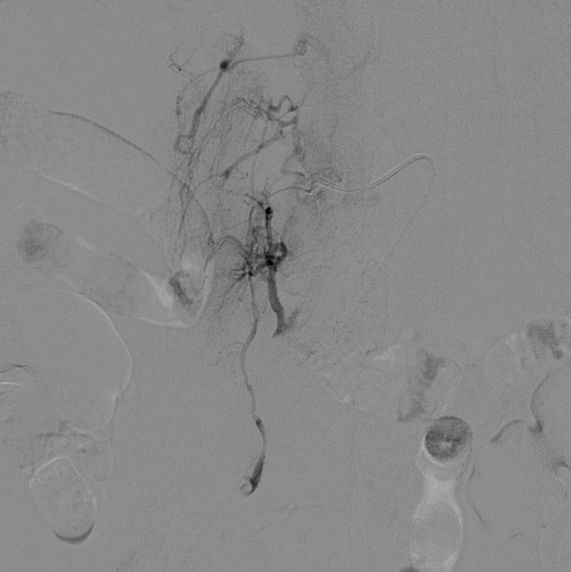
Figure 1 Pre-operative digital subtraction angiography. Contrast agent leakage from the patient's right L4 artery into the right ureter.

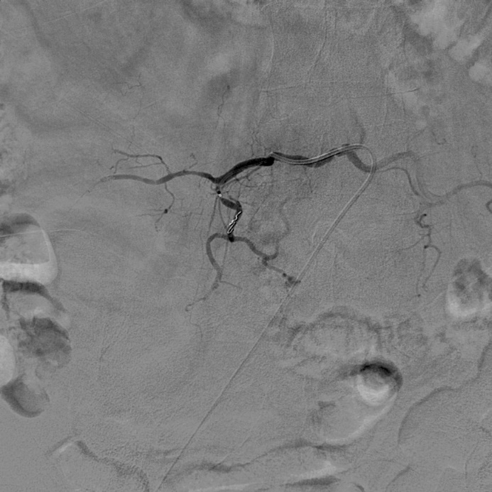
Figure 2 Post-operative digital subtraction angiography. The local bleeding vessels were no longer visualized after the completion of embolization.

Published by Baishideng Publishing Group Inc
7041 Koll Center Parkway, Suite 160, Pleasanton, CA 94566, USA
Telephone: +1-925-3991568
E-mail: bpgoffice@wjgnet.com
Help Desk: https://www.f6publishing.com/helpdesk
https://www.wjgnet.com

© 2021 Baishideng Publishing Group Inc. All rights reserved.

