Name of Journal: World Journal of Gastrointestinal Oncology
Manuscript NO: 45459
Manuscript Type: REVIEW

Identification of genomic features associated with immunotherapy response in gastrointestinal cancers

He Y et al. Identification of genomic features in gastrointestinal cancers

Yin He, Zhi-Xian Liu, Ze-Hang Jiang, Xiao-Sheng Wang

Yin He, Zhi-Xian Liu, Ze-Hang Jiang, Xiao-Sheng Wang, Biomedical Informatics Research Lab, School of Basic Medicine and Clinical Pharmacy, Nanjing 211198, Jiangsu Province, China

Yin He, Zhi-Xian Liu, Ze-Hang Jiang, Xiao-Sheng Wang, Cancer Genomics Research Center, School of Basic Medicine and Clinical Pharmacy, Nanjing 211198, Jiangsu Province, China

Yin He, Zhi-Xian Liu, Ze-Hang Jiang, Xiao-Sheng Wang, Big Data Research Institute, China Pharmaceutical University, Nanjing 211198, Jiangsu Province, China

ORCID number: Yin He (0000-0003-2460-6472); Zhi-Xian Liu (0000-0002-4194-4492); Ze-Hang Jiang (0000-0001-5398-7097); Xiao-Sheng Wang (0000-0002-7199-7093).

Author contributions: He Y performed the study and wrote the manuscript. Liu ZX wrote the manuscript; Jiang ZH performed data analyses; Wang XS conceived of and designed the study and wrote the manuscript.

Funding: This work was supported by the China Pharmaceutical University (grant number 3150120001).

Conflict-of-interest statement: No potential conflicts of interest.

Open-Access: This article is an open-access article that was selected by an in-house editor and fully peer-reviewed by external reviewers. It is distributed in accordance with the Creative Commons Attribution Non Commercial (CC BY-NC 4.0) license, which permits others to distribute, remix, adapt, build upon this work non-commercially, and license their derivative works on different terms, provided the original work is properly cited and the use is non-commercial. See: http://creativecommons.org/licenses/by-nc/4.0/

Manuscript source: Invited manuscript

Corresponding author: Xiao-Sheng Wang, MD, PhD, Associate Professor, School of Basic Medicine and Clinical Pharmacy, China Pharmaceutical University, Department of Basic Medicine, School of Basic Medicine and Clinical Pharmacy, China Pharmaceutical University, Nanjing, 211198, China. xiaosheng.wang@cpu.edu.cn

Received: January 2, 2019
Peer-review started: January 4, 2019
First decision: January 21, 2019
Revised: January 29, 2019
Accepted: March 27, 2019
Article in press: March 28, 2019
Published online: April 15, 2019

Abstract
Gastrointestinal (GI) cancers prevail and account for an extremely high number of cancer deaths worldwide. The traditional treatment strategies, including surgery, chemotherapy, radiotherapy, and targeted therapy, have a limited therapeutic effect for advanced GI cancers. Recently, immunotherapy has shown promise in treating various refractory malignancies, including the GI cancers with mismatch repair deficiency (dMMR) or microsatellite instability (MSI). Thus, immunotherapy could be a promising treatment approach for GI cancers. Unfortunately, only a small proportion of GI cancer patients currently respond to immunotherapy. Therefore, it is important to discover predictive biomarkers for stratifying GI cancer patients response to immunotherapy. Certain genomic features, such as dMMR/MSI, tumor mutation burden (TMB), and tumor aneuploidy have been associated with tumor immunity and immunotherapy response and may serve as predictive biomarkers for cancer immunotherapy. In this review, we examined the correlations between tumor immunity and three genomic features: dMMR/MSI, TMB, and tumor aneuploidy. We also explored their correlations using The Cancer Genome Atlas data and confirmed that the dMMR/MSI status, high TMB, and low tumor aneuploidy are associated with elevated tumor immunity in GI cancers. To improve the immunotherapeutic potential in GI cancers, more genetic or genomic features associated with tumor immune response need to be identified. Furthermore, it is worth exploring the combination of different immunotherapeutic methods and the combination of immunotherapy with other therapeutic approaches for cancer therapy.

Key words: Gastrointestinal cancer; Tumor immunity; Tumor immunotherapy; DNA mismatch repair; Tumor mutation burden; Tumor aneuploidy

© The Author(s) 2019. Published by Baishideng Publishing Group Inc. All rights reserved.

Core tip: The traditional treatment strategies have a limited effect on advanced gastrointestinal (GI) cancers. Immunotherapy has shown improved effectiveness in treating diverse malignancies, including the GI cancers with mismatch repair deficiency (dMMR) or microsatellite instability (MSI). However, only a small subset of GI cancers can benefit from immunotherapy. Hence, it is crucial to identify predictive biomarkers for GI cancer patients responsive to immunotherapy. We reviewed the associations between three genomic features (dMMR/MSI, tumor mutation burden, and aneuploidy) and tumor immunity. These genomic features have significant correlations with antitumor immune response and are useful biomarkers for immunotherapy of GI cancers.

Citation: He Y, Liu ZX, Jiang ZH, Wang XS. Identification of genomic features associated with immunotherapy response in gastrointestinal cancers. World J Gastrointest Oncol 2019; 11(4): 270-280
URL: https://www.wjgnet.com/1948-5204/full/v11/i4/270.htm
DOI: https://dx.doi.org/10.4251/wjgo.v11.i4.270

INTRODUCTION
Gastrointestinal (GI) cancers, including malignancies of the esophagus, stomach, biliary system, pancreas, small intestine, large intestine, rectum, and anus are the most prevalent malignant carcinomas globally and account for a large number of cancer deaths^{[1]}. Traditional treatment strategies for GI cancers include surgery, chemotherapy, radiotherapy, and targeted therapy^{[2]}. However, for the refractory or metastatic GI malignancies these traditional treatment strategies often have a limited therapeutic effect^{[3]}. Recently, immunotherapy has demonstrated rapid success in treating various refractory malignancies, such as melanoma^{[4]}, non-small cell lung cancer (NSCLC)^{[5]}, head and neck cancer^{[6]}, renal cell carcinoma^{[7]}, leukemia^{[8]}, and lymphoma^{[9]}. In particular, the immune checkpoint blockade (ICB) that targets molecules involved in mediating antitumor immunosuppression has been used clinically for treating diverse cancers^{[10]}. Several immune checkpoint inhibitors have been approved by the Food and Drug Administration in clinically treating cancer, including ipilimumab (anti-CTLA4), nivolumab and pembrolizumab (anti-PD1), and atezolizumab and avelumab (anti-PD-L1). However, there is currently no immunotherapeutic drug specifically used for treating a GI cancer, although pembrolizumab is being used for treating DNA mismatch repair-deficient GI cancers.
Abundant evidence shows that the response to ICB is associated with certain genomic features^{[4,11,12]}. These include DNA mismatch repair deficiency^{[13]}, tumor mutation burden (TMB)^{[14]} or neoantigen load^{[15]}, and tumor aneuploidy^{[16]}. Several studies have revealed that the colorectal cancers (CRCs) with mismatch repair deficiency (dMMR) were more sensitive to anti-PD-1 therapy than those with mismatch repair proficiency (pMMR)^{[17,18]}. Similar results have been demonstrated in other cancer types including ovarian^{[19]}, endometrial^{[20]}, and gastric cancers^{[21-23]}. In addition, previous studies found that higher TMB was associated with a more favorable response to ICB in diverse cancer types, indicating the potential role of TMB in predicting ICB efficacy^{[14]}. A recent study revealed an inverse correlation between tumor aneuploidy and immunotherapy response^{[16]}. These prior studies suggest that it is significant to identify the genomic features associated with immunotherapy response for treating diverse refractory malignancies, including a large number of GI cancers.
In this review, we examined the associations between three genomic features (dMMR or microsatellite instability (MSI) status, TMB, and tumor aneuploidy) and tumor immunity in GI cancers.

ASSOCIATION BETWEEN DMMR/MSI AND TUMOR IMMUNITY IN GI CANCERS
DNA mismatch repair is a highly conserved system for repairing the errors of deletion, insertion, and mismatch occurring in DNA replication and recombination^{[24]}. It plays a key role in maintaining genomic stability^{[25]}. dMMR is associated with genome-wide instability and can lead to tumorigenesis and cancer development^{[26]}. dMMR may cause a high increase in the frequency of insertion and deletion mutations in simple repeat (microsatellite) sequences, a phenomenon known as MSI^{[27,28]}. Plentiful evidence shows that MSI can trigger hyperimmunity in a tumor that may promote response to ICB therapy. First, tumors with MSI are hypermutated and thus generate many neoantigens to incite the tumor immune response^{[13]}. In fact, MSI is associated with the increased infiltration of tumor-infiltrating lymphocytes (TILs) in the tumor^{[29,30]}. It has been shown that MSI CRCs exhibited high infiltration of activated CD8⁺ cytotoxic T lymphocytes and activated Th1 cells^{[31]}. Second, MSI tumors often exhibit the elevated expression of immune checkpoint molecules such as PD-L1 that may increase the sensitivity to immunotherapy^{[32]}.
Several GI cancers harbor a comparatively high proportion of MSI-high (MSI-H) tumors, including gastric cancer (GC) (22%), hepatocellular carcinoma (16%), CRC (13%), and esophageal adenocarcinoma (ESCA) (7%)^{[33]}. A number of studies have revealed that MSI-H GI tumors are more responsive to ICB^{[13,17,21]}. In the clinical trial study (KEYNOTE-012)^{[21]}, two out of four MSI-H GC patients responded to pembrolizumab. In a phase 2 clinical study of CRC treatment with pembrolizumab^{[13]}, the objective response rate (ORR) in dMMR CRCs was 40% vs 0% in pMMR CRCs^{[13]}. Pancreatic cancer generally has a poor response to immunotherapy^{[34]}. However, a study showed that six pancreatic cancer patients with dMMR or MSI exhibited an objective response rate of 83% to pembrolizumab^{[17]}. The high TMB, neoantigen load, and TIL infiltration in MSI-H GI cancers could explain why this subtype has a favorable response to immunotherapy. Furthermore, because the expression of PD-L1 in this subtype is common^{[35]}, and anti-PD-1/PD-L1 therapy may achieve a higher response rate in PD-L1-positive tumors than in PD-L1-negative tumors^{[36]}, MSI-H GI cancer patients are likely to respond to immunotherapy. Therefore, dMMR/MSI is an important predictive biomarker in GI cancer immunotherapy.
To further investigate the relationship between MSI status and tumor immunity in GI cancers, we downloaded RNA-Seq gene expression (Level 3) and clinical data from The Cancer Genome Atlas (TCGA) project (https://portal.gdc.cancer.gov/). We first quantified the enrichment levels of six immune signatures (B cells, CD8⁺ T cells, cytolytic activity, human leukocyte antigen (HLA), interferon response, and natural killer (NK) cells) (Table1)^{[37]} in each GI sample using the single-sample gene-set enrichment analysis score^{[38]}. We compared the enrichment levels between MSI-H GI cancers and MSI low (MSI-L) or microsatellite stability (MSS) GI cancers. We observed a significant upregulation of the six immune signatures in the MSI-H colon adenocarcinoma (COAD) vs the MSI-L/MSS COAD (Mann-Whitney U test, P < 0.05) (Figure 1A). Similar results were observed for stomach adenocarcinoma (STAD) (Figure 1B). Next, we used the ESTIMATE algorithm^{[39]} to evaluate the immune score for each GI sample, which represents the degree of immune cell infiltration in the tumor. We found that the MSI-H COAD had significantly higher immune scores than the MSI-L/MSS COAD (Mann-Whitney U test, P < 0.05) (Figure 1A). Collectively, these results confirmed that MSI-H GI tumors tend to have stronger tumor immunity compared to MSI-L/MSS GI tumors, suggesting that the MSI-H GI cancer subtype could be more responsive to immunotherapy.

ASSOCIATION BETWEEN TMB AND TUMOR IMMUNITY IN GI CANCERS
TMB represents the overall load of somatic mutations in the tumor. Tumor somatic mutations may produce neoantigens to drive antitumor immune responses^{[40]}. Therefore, the increase in TMB would result in elevated tumor immunogenicity as well as antitumor immunity^{[41,42]}. Previous studies have shown that TMB varies with cancer type^{[43,44]}. Some cancer types generally have high TMB, such as skin cutaneous melanoma, lung cancer, esophageal carcinoma, and bladder urothelial carcinoma, and some have low TMB, such as leukemia. Most GI cancers have a medium level of TMB (defined as total somatic mutation counts) (Figure 2A). However, some GI cancer subtypes, such as the MSI-H subtype, often have high TMB (Figure 2A).
The high TMB cancer types, such as melanoma, NSCLC, and MSI-H cancers, are more sensitive to the ICB therapy because they can produce more neoantigens^{[17,45-47]}. As a result, high TMB is associated with long-term clinical benefit to anti-CTLA-4^{[46,48]} and anti-PD-1/PD-L1^{[49-51]} therapy. In GI cancers, the high TMB in ESCA was associated with clinical benefit of the ICB therapy^{[52]}, the EBV⁺ (Epstein–Barr virus⁺) and MSI⁺ molecular subsets of GC with high TMB showed increased immune cell infiltration and PD-1/PD-L1 pathway activation^{[53]}, and the high TMB CRC patients were commonly responsive to PD-1/PD-L1 blockade^{[14]}. Interestingly, a high TMB in pancreatic cancer was negatively associated with T cell activity and a worse overall survival^{[54]}.
We evaluated the correlation between TMB and tumor immunity in GI cancers based on the TCGA data. We found that the six immune signatures showed significant positive correlations with TMB in COAD (Spearman's correlation test, P < 0.05) (Figure 2B). In STAD, the cytolytic activity and NK cell signatures were significantly positively associated with TMB (Figure 2B). These data confirmed that TMB is likely to be positively associated with tumor immunity in GC cancers.

ASSOCIATION BETWEEN TUMOR ANEUPLOIDY AND TUMOR IMMUNITY IN GI CANCERS
Tumor cells often display a high degree of chromosomal instability (CIN)^{[55]}. CIN refers to distortions in the number of chromosome (aneuploidy) or the chromosomal structure (translocation, inversion, and duplication)^{[56]}. Aneuploidy, also known as somatic copy number alterations (SCNAs), is a common characteristic present in 88% of solid tumors^{[57]} and plays a key role in tumor development^{[58-61]}. Numerous studies have revealed a significant correlation between tumor aneuploidy and tumor immunity^{[16,57]}. Davoli et al^{[16]} found that tumors with a high level of aneuploidy inversely correlated with cytotoxic immune infiltration and that the tumor patients with high aneuploidy had a poor survival prognosis. Taylor et al^{[57]} demonstrated that aneuploidy was negatively associated with tumor immune activity. Moreover, tumor aneuploidy is likely to increase intratumor heterogeneity^{[62,63]}, which may inhibit tumor immunity^{[64,65]}.
In GI cancers, the genomic feature of ESCA resembles the CIN subtype of GC^{[66]}. The CIN subtype, characterized with a high degree of SCNAs^{[53,67,68]}, accounts for nearly half of all GC cases^{[53]}. Our previous study showed that immune signatures were significantly downregulated in the CIN subtype versus the genomically stable subtype in GC and COAD^{[69]}.
To further explore the relationship between tumor aneuploidy and tumor immunity in GI cancers, we used the absolute algorithm^{[70]} to assess the ploidy score for each GI sample in TCGA, and evaluated the correlations between the six immune signatures and the ploidy scores in GI cancers. We found that diverse immune signatures were significantly inversely correlated with the ploidy scores in GI cancers, including all six immune signatures in STAD, five in liver hepatocellular carcinoma, and four in COAD (Spearman's correlation test, P < 0.05) (Figure 3). We also found that the immune scores were inversely correlated with the aneuploidy in these GI cancer types (Figure 3). Collectively, these results confirmed the negative correlation between tumor aneuploidy and tumor immunity in GI cancers and suggested an important role for aneuploidy in predicting the immunotherapy response in GI cancers.

CONCLUSION
Due to the limited therapeutic effect of traditional treatment strategies on refractory or metastatic GI cancers, immunotherapy could be an alternative approach for these cancers. Immunotherapy is likely to be effective for the “hot” tumors whose microenvironment has dense T cell infiltration^{[71]}. The tumors with MSI, high TMB, or low aneuploidy are often “hot” tumors that respond to immunotherapy. Nevertheless, immunotherapy often has poor efficiency for the “cold” tumors that lack immune infiltration^{[71]}. To improve the immunotherapy response in “cold” tumors, a combination of different treatment strategies may convert “cold” tumors into “hot” tumors. The combined treatment strategies could be the combination of different immunotherapeutic methods^{[72-75]} or the combination of immunotherapy with other therapeutic approaches^{[76-79]}.
Besides the genomic features, mutations in some specific genes may suggest an immunotherapy response. Our previous study showed that TP53 mutations were associated with depressed tumor immunity in STAD and COAD^{[69]}, suggesting that the TP53 mutation status may predict the response of STAD and COAD patients to immunotherapy. In addition, KRAS mutations are associated with suppressed immune activity in CRC^{[80]}.
Previous studies revealed that ICB was effective in a subset of GI cancer patients, but the response rate in an unselected GI tumor cohort was modest^{[81]}. It suggests that the predictive genetic and genomic features are important for stratifying GI cancer patients responsive to immunotherapy. A large volume of cancer genomics data has been produced through the advancement of next-generation sequencing technology, enabling us to investigate the cancer genomic features associated with tumor immunity and immunotherapy response. The dMMR/MSI status, TMB, and tumor aneuploidy are genomic features associated with tumor immunity and immunotherapy response. Generally speaking, the high TMB tumors are more likely to respond to immunotherapy^{[14]}. However, the association between TMB and immunotherapy response is not absolutely positive. Some responders have a low TMB and some non-responders have a high TMB^{[12]}. One possible explanation is that the intratumor heterogeneity confounds the mutation landscape, affecting tumor immunity^{[82]}. In fact, a previous study has shown that it is clonal neoantigens (generated by mutations identified in distinct regions of a tumor) that associate with immunotherapy response rather than subclonal neoantigens (generated by mutations identified in only a subset of regions of a tumor)^{[83]}. Tumor aneuploidy is another genomic feature that is associated with the antitumor immune response, and could be a stronger predictor of tumor immune infiltration than TMB^{[16]}.
In conclusion, dMMR/MSI, TMB, and tumor aneuploidy are the well-recognized genomic features that are associated with the immunotherapy response of GI and other cancers. To improve the potential of immunotherapy for GI cancers, more genomic features need to be identified, and the relevant investigations should remain a high priority.

REFERENCES
1 Bray F, Ferlay J, Soerjomataram I, Siegel RL, Torre LA, Jemal A. Global cancer statistics 2018: GLOBOCAN estimates of incidence and mortality worldwide for 36 cancers in 185 countries. CA Cancer J Clin 2018; 68: 394-424 [PMID: 30207593 DOI: 10.3322/caac.21492]
2 Long J, Lin J, Wang A, Wu L, Zheng Y, Yang X, Wan X, Xu H, Chen S, Zhao H. PD-1/PD-L blockade in gastrointestinal cancers: lessons learned and the road toward precision immunotherapy. J Hematol Oncol 2017; 10: 146 [PMID: 28774337 DOI: 10.1186/s13045-017-0511-2]
3 Kirk R. Gastrointestinal cancer: New drug shows promise in refractory colorectal cancer. Nat Rev Clin Oncol 2012; 9: 610 [PMID: 22965155 DOI: 10.1038/nrclinonc.2012.165]
4 Van Allen EM, Miao D, Schilling B, Shukla SA, Blank C, Zimmer L, Sucker A, Hillen U, Foppen MHG, Goldinger SM, Utikal J, Hassel JC, Weide B, Kaehler KC, Loquai C, Mohr P, Gutzmer R, Dummer R, Gabriel S, Wu CJ, Schadendorf D, Garraway LA. Genomic correlates of response to CTLA-4 blockade in metastatic melanoma. Science 2015; 350: 207-211 [PMID: 26359337 DOI: 10.1126/science.aad0095]
5 Herbst RS, Baas P, Kim DW, Felip E, Pérez-Gracia JL, Han JY, Molina J, Kim JH, Arvis CD, Ahn MJ, Majem M, Fidler MJ, de Castro G Jr, Garrido M, Lubiniecki GM, Shentu Y, Im E, Dolled-Filhart M, Garon EB. Pembrolizumab versus docetaxel for previously treated, PD-L1-positive, advanced non-small-cell lung cancer (KEYNOTE-010): a randomised controlled trial. Lancet 2016; 387: 1540-1550 [PMID: 26712084 DOI: 10.1016/S0140-6736(15)01281-7]
6 Bauml J, Seiwert TY, Pfister DG, Worden F, Liu SV, Gilbert J, Saba NF, Weiss J, Wirth L, Sukari A, Kang H, Gibson MK, Massarelli E, Powell S, Meister A, Shu X, Cheng JD, Haddad R. Pembrolizumab for Platinum- and Cetuximab-Refractory Head and Neck Cancer: Results From a Single-Arm, Phase II Study. J Clin Oncol 2017; 35: 1542-1549 [PMID: 28328302 DOI: 10.1200/JCO.2016.70.1524]
7 Tomita Y, Fukasawa S, Shinohara N, Kitamura H, Oya M, Eto M, Tanabe K, Kimura G, Yonese J, Yao M, Motzer RJ, Uemura H, McHenry MB, Berghorn E, Ozono S. Nivolumab versus everolimus in advanced renal cell carcinoma: Japanese subgroup analysis from the CheckMate 025 study. Jpn J Clin Oncol 2017; 47: 639-646 [PMID: 28419248 DOI: 10.1093/jjco/hyx049]
8 Maude SL, Laetsch TW, Buechner J, Rives S, Boyer M, Bittencourt H, Bader P, Verneris MR, Stefanski HE, Myers GD, Qayed M, De Moerloose B, Hiramatsu H, Schlis K, Davis KL, Martin PL, Nemecek ER, Yanik GA, Peters C, Baruchel A, Boissel N, Mechinaud F, Balduzzi A, Krueger J, June CH, Levine BL, Wood P, Taran T, Leung M, Mueller KT, Zhang Y, Sen K, Lebwohl D, Pulsipher MA, Grupp SA. Tisagenlecleucel in Children and Young Adults with B-Cell Lymphoblastic Leukemia. N Engl J Med 2018; 378: 439-448 [PMID: 29385370 DOI: 10.1056/NEJMoa1709866]
9 Smyth L, Buckstein R, Pennell N, Weerasinghe R, Cheung MC, Imrie K, Spaner D, Piliotis E, Chodirker L, Reis M, Ghorab Z, Zhang L, Boudreau V, Miliken A, Berinstein N. Autologous stem cell transplant and combination immunotherapy of rituximab and interferon-α induces prolonged clinical and molecular remissions in patients with follicular lymphoma. Br J Haematol 2019; 184: 469-472 [PMID: 29380359 DOI: 10.1111/bjh.15118]
10 Topalian SL, Drake CG, Pardoll DM. Immune checkpoint blockade: a common denominator approach to cancer therapy. Cancer Cell 2015; 27: 450-461 [PMID: 25858804 DOI: 10.1016/j.ccell.2015.03.001]
11 Hugo W, Zaretsky JM, Sun L, Song C, Moreno BH, Hu-Lieskovan S, Berent-Maoz B, Pang J, Chmielowski B, Cherry G, Seja E, Lomeli S, Kong X, Kelley MC, Sosman JA, Johnson DB, Ribas A, Lo RS. Genomic and Transcriptomic Features of Response to Anti-PD-1 Therapy in Metastatic Melanoma. Cell 2016; 165: 35-44 [PMID: 26997480 DOI: 10.1016/j.cell.2016.02.065]
12 Braun DA, Burke KP, Van Allen EM. Genomic Approaches to Understanding Response and Resistance to Immunotherapy. Clin Cancer Res 2016; 22: 5642-5650 [PMID: 27698000 DOI: 10.1158/1078-0432.CCR-16-0066]
13 Le DT, Uram JN, Wang H, Bartlett BR, Kemberling H, Eyring AD, Skora AD, Luber BS, Azad NS, Laheru D, Biedrzycki B, Donehower RC, Zaheer A, Fisher GA, Crocenzi TS, Lee JJ, Duffy SM, Goldberg RM, de la Chapelle A, Koshiji M, Bhaijee F, Huebner T, Hruban RH, Wood LD, Cuka N, Pardoll DM, Papadopoulos N, Kinzler KW, Zhou S, Cornish TC, Taube JM, Anders RA, Eshleman JR, Vogelstein B, Diaz LA Jr. PD-1 Blockade in Tumors with Mismatch-Repair Deficiency. N Engl J Med 2015; 372: 2509-2520 [PMID: 26028255 DOI: 10.1056/NEJMoa1500596]
14 Goodman AM, Kato S, Bazhenova L, Patel SP, Frampton GM, Miller V, Stephens PJ, Daniels GA, Kurzrock R. Tumor Mutational Burden as an Independent Predictor of Response to Immunotherapy in Diverse Cancers. Mol Cancer Ther 2017; 16: 2598-2608 [PMID: 28835386 DOI: 10.1158/1535-7163.MCT-17-0386]
15 Efremova M, Finotello F, Rieder D, Trajanoski Z. Neoantigens Generated by Individual Mutations and Their Role in Cancer Immunity and Immunotherapy. Front Immunol 2017; 8: 1679 [PMID: 29234329 DOI: 10.3389/fimmu.2017.01679]
16 Davoli T, Uno H, Wooten EC, Elledge SJ. Tumor aneuploidy correlates with markers of immune evasion and with reduced response to immunotherapy. Science 2017; 355: eaaf8399 [PMID: 28104840 DOI: 10.1126/science.aaf8399]
17 Le DT, Durham JN, Smith KN, Wang H, Bartlett BR, Aulakh LK, Lu S, Kemberling H, Wilt C, Luber BS, Wong F, Azad NS, Rucki AA, Laheru D, Donehower R, Zaheer A, Fisher GA, Crocenzi TS, Lee JJ, Greten TF, Duffy AG, Ciombor KK, Eyring AD, Lam BH, Joe A, Kang SP, Holdhoff M, Danilova L, Cope L, Meyer C, Zhou S, Goldberg RM, Armstrong DK, Bever KM, Fader AN, Taube J, Housseau F, Spetzler D, Xiao N, Pardoll DM, Papadopoulos N, Kinzler KW, Eshleman JR, Vogelstein B, Anders RA, Diaz LA Jr. Mismatch repair deficiency predicts response of solid tumors to PD-1 blockade. Science 2017; 357: 409-413 [PMID: 28596308 DOI: 10.1126/science.aan6733]
18 Lee JJ, Chu E. Recent Advances in the Clinical Development of Immune Checkpoint Blockade Therapy for Mismatch Repair Proficient (pMMR)/non-MSI-H Metastatic Colorectal Cancer. Clin Colorectal Cancer 2018; 17: 258-273 [PMID: 30072278 DOI: 10.1016/j.clcc.2018.06.004]
19 Xiao X, Dong D, He W, Song L, Wang Q, Yue J, Xie L. Mismatch repair deficiency is associated with MSI phenotype, increased tumor-infiltrating lymphocytes and PD-L1 expression in immune cells in ovarian cancer. Gynecol Oncol 2018; 149: 146-154 [PMID: 29496294 DOI: 10.1016/j.ygyno.2018.02.009]
20 Gargiulo P, Della Pepa C, Berardi S, Califano D, Scala S, Buonaguro L, Ciliberto G, Brauchli P, Pignata S. Tumor genotype and immune microenvironment in POLE-ultramutated and MSI-hypermutated Endometrial Cancers: New candidates for checkpoint blockade immunotherapy? Cancer Treat Rev 2016; 48: 61-68 [PMID: 27362548 DOI: 10.1016/j.ctrv.2016.06.008]
21 Muro K, Chung HC, Shankaran V, Geva R, Catenacci D, Gupta S, Eder JP, Golan T, Le DT, Burtness B, McRee AJ, Lin CC, Pathiraja K, Lunceford J, Emancipator K, Juco J, Koshiji M, Bang YJ. Pembrolizumab for patients with PD-L1-positive advanced gastric cancer (KEYNOTE-012): a multicentre, open-label, phase 1b trial. Lancet Oncol 2016; 17: 717-726 [PMID: 27157491 DOI: 10.1016/S1470-2045(16)00175-3]
22 Kang YK, Boku N, Satoh T, Ryu MH, Chao Y, Kato K, Chung HC, Chen JS, Muro K, Kang WK, Yeh KH, Yoshikawa T, Oh SC, Bai LY, Tamura T, Lee KW, Hamamoto Y, Kim JG, Chin K, Oh DY, Minashi K, Cho JY, Tsuda M, Chen LT. Nivolumab in patients with advanced gastric or gastro-oesophageal junction cancer refractory to, or intolerant of, at least two previous chemotherapy regimens (ONO-4538-12, ATTRACTION-2): a randomised, double-blind, placebo-controlled, phase 3 trial. Lancet 2017; 390: 2461-2471 [PMID: 28993052 DOI: 10.1016/S0140-6736(17)31827-5]
23 Ott PA, Le DT, Kim JW, Ascierto PA, Sharma P, Bono P, Peltola K, Jager D, Evans TRJ, de Braud F, Chau I, Bendell JC, Tschaika M, Harbison CT, Zhao H, Calvo E, Janjigian Y. Nivolumab (NIVO) in patients (pts) with advanced (adv) chemotherapy-refractory (CT-Rx) esophagogastric (EG) cancer according to microsatellite instability (MSI) status: checkmate 032. Ann Oncol 2017; 28: v209-v268 [DOI: 10.1093/annonc/mdx369]
24 Zhang L, Peng Y, Peng G. Mismatch repair-based stratification for immune checkpoint blockade therapy. Am J Cancer Res 2018; 8: 1977-1988 [PMID: 30416850]
25 Harfe BD, Jinks-Robertson S. DNA mismatch repair and genetic instability. Annu Rev Genet 2000; 34: 359-399 [PMID: 11092832 DOI: 10.1146/annurev.genet.34.1.359]
26 Li GM. Mechanisms and functions of DNA mismatch repair. Cell Res 2008; 18: 85-98 [PMID: 18157157 DOI: 10.1038/cr.2007.115]
27 Jiricny J. The multifaceted mismatch-repair system. Nat Rev Mol Cell Biol 2006; 7: 335-346 [PMID: 16612326 DOI: 10.1038/nrm1907]
28 Aaltonen LA, Peltomäki P, Leach FS, Sistonen P, Pylkkänen L, Mecklin JP, Järvinen H, Powell SM, Jen J, Hamilton SR. Clues to the pathogenesis of familial colorectal cancer. Science 1993; 260: 812-816 [PMID: 8484121 DOI: 10.1126/science.8484121]
29 Giampieri R, Maccaroni E, Mandolesi A, Del Prete M, Andrikou K, Faloppi L, Bittoni A, Bianconi M, Scarpelli M, Bracci R, Scartozzi M, Cascinu S. Mismatch repair deficiency may affect clinical outcome through immune response activation in metastatic gastric cancer patients receiving first-line chemotherapy. Gastric Cancer 2017; 20: 156-163 [PMID: 26796888 DOI: 10.1007/s10120-016-0594-4]
30 Mlecnik B, Bindea G, Angell HK, Maby P, Angelova M, Tougeron D, Church SE, Lafontaine L, Fischer M, Fredriksen T, Sasso M, Bilocq AM, Kirilovsky A, Obenauf AC, Hamieh M, Berger A, Bruneval P, Tuech JJ, Sabourin JC, Le Pessot F, Mauillon J, Rafii A, Laurent-Puig P, Speicher MR, Trajanoski Z, Michel P, Sesboüe R, Frebourg T, Pagès F, Valge-Archer V, Latouche JB, Galon J. Integrative Analyses of Colorectal Cancer Show Immunoscore Is a Stronger Predictor of Patient Survival Than Microsatellite Instability. Immunity 2016; 44: 698-711 [PMID: 26982367 DOI: 10.1016/j.immuni.2016.02.025]
31 Halama N, Michel S, Kloor M, Zoernig I, Benner A, Spille A, Pommerencke T, von Knebel DM, Folprecht G, Luber B, Feyen N, Martens UM, Beckhove P, Gnjatic S, Schirmacher P, Herpel E, Weitz J, Grabe N, Jaeger D. Localization and density of immune cells in the invasive margin of human colorectal cancer liver metastases are prognostic for response to chemotherapy. Cancer Res 2011; 71: 5670-5677 [PMID: 21846824 DOI: 10.1158/0008-5472.CAN-11-0268]
32 Llosa NJ, Cruise M, Tam A, Wicks EC, Hechenbleikner EM, Taube JM, Blosser RL, Fan H, Wang H, Luber BS, Zhang M, Papadopoulos N, Kinzler KW, Vogelstein B, Sears CL, Anders RA, Pardoll DM, Housseau F. The vigorous immune microenvironment of microsatellite instable colon cancer is balanced by multiple counter-inhibitory checkpoints. Cancer Discov 2015; 5: 43-51 [PMID: 25358689 DOI: 10.1158/2159-8290.CD-14-0863]
33 Dudley JC, Lin MT, Le DT, Eshleman JR. Microsatellite Instability as a Biomarker for PD-1 Blockade. Clin Cancer Res 2016; 22: 813-820 [PMID: 26880610 DOI: 10.1158/1078-0432.CCR-15-1678]
34 Tan E, El-Rayes B. Pancreatic Cancer and Immunotherapy: Resistance Mechanisms and Proposed Solutions. J Gastrointest Cancer 2019; 50: 1-8 [PMID: 30446922 DOI: 10.1007/s12029-018-0179-z]
35 Ma C, Patel K, Singhi AD, Ren B, Zhu B, Shaikh F, Sun W. Programmed Death-Ligand 1 Expression Is Common in Gastric Cancer Associated With Epstein-Barr Virus or Microsatellite Instability. Am J Surg Pathol 2016; 40: 1496-1506 [PMID: 27465786 DOI: 10.1097/PAS.0000000000000698]
36 Patel SP, Kurzrock R. PD-L1 Expression as a Predictive Biomarker in Cancer Immunotherapy. Mol Cancer Ther 2015; 14: 847-856 [PMID: 25695955 DOI: 10.1158/1535-7163.MCT-14-0983]
37 Liu Z, Li M, Jiang Z, Wang X. A Comprehensive Immunologic Portrait of Triple-Negative Breast Cancer. Transl Oncol 2018; 11: 311-329 [PMID: 29413765 DOI: 10.1016/j.tranon.2018.01.011]
38 Hänzelmann S, Castelo R, Guinney J. GSVA: gene set variation analysis for microarray and RNA-seq data. BMC Bioinformatics 2013; 14: 7 [PMID: 23323831 DOI: 10.1186/1471-2105-14-7]
39 Yoshihara K, Shahmoradgoli M, Martínez E, Vegesna R, Kim H, Torres-Garcia W, Treviño V, Shen H, Laird PW, Levine DA, Carter SL, Getz G, Stemke-Hale K, Mills GB, Verhaak RG. Inferring tumour purity and stromal and immune cell admixture from expression data. Nat Commun 2013; 4: 2612 [PMID: 24113773 DOI: 10.1038/ncomms3612]
40 Castle JC, Kreiter S, Diekmann J, Löwer M, van de Roemer N, de Graaf J, Selmi A, Diken M, Boegel S, Paret C, Koslowski M, Kuhn AN, Britten CM, Huber C, Türeci O, Sahin U. Exploiting the mutanome for tumor vaccination. Cancer Res 2012; 72: 1081-1091 [PMID: 22237626 DOI: 10.1158/0008-5472.CAN-11-3722]
41 Schumacher TN, Schreiber RD. Neoantigens in cancer immunotherapy. Science 2015; 348: 69-74 [PMID: 25838375 DOI: 10.1126/science.aaa4971]
42 Rooney MS, Shukla SA, Wu CJ, Getz G, Hacohen N. Molecular and genetic properties of tumors associated with local immune cytolytic activity. Cell 2015; 160: 48-61 [PMID: 25594174 DOI: 10.1016/j.cell.2014.12.033]
43 Sun Q, Li M, Wang X. The Cancer Omics Atlas: an integrative resource for cancer omics annotations. BMC Med Genomics 2018; 11: 63 [PMID: 30089500 DOI: 10.1186/s12920-018-0381-7]
44 Kandoth C, McLellan MD, Vandin F, Ye K, Niu B, Lu C, Xie M, Zhang Q, McMichael JF, Wyczalkowski MA, Leiserson MDM, Miller CA, Welch JS, Walter MJ, Wendl MC, Ley TJ, Wilson RK, Raphael BJ, Ding L. Mutational landscape and significance across 12 major cancer types. Nature 2013; 502: 333-339 [PMID: 24132290 DOI: 10.1038/nature12634]
45 Alexandrov LB, Nik-Zainal S, Wedge DC, Aparicio SA, Behjati S, Biankin AV, Bignell GR, Bolli N, Borg A, Børresen-Dale AL, Boyault S, Burkhardt B, Butler AP, Caldas C, Davies HR, Desmedt C, Eils R, Eyfjörd JE, Foekens JA, Greaves M, Hosoda F, Hutter B, Ilicic T, Imbeaud S, Imielinski M, Jäger N, Jones DT, Jones D, Knappskog S, Kool M, Lakhani SR, López-Otín C, Martin S, Munshi NC, Nakamura H, Northcott PA, Pajic M, Papaemmanuil E, Paradiso A, Pearson JV, Puente XS, Raine K, Ramakrishna M, Richardson AL, Richter J, Rosenstiel P, Schlesner M, Schumacher TN, Span PN, Teague JW, Totoki Y, Tutt AN, Valdés-Mas R, van Buuren MM, van 't Veer L, Vincent-Salomon A, Waddell N, Yates LR; Australian Pancreatic Cancer Genome Initiative; ICGC Breast Cancer Consortium; ICGC MMML-Seq Consortium; ICGC PedBrain, Zucman-Rossi J, Futreal PA, McDermott U, Lichter P, Meyerson M, Grimmond SM, Siebert R, Campo E, Shibata T, Pfister SM, Campbell PJ, Stratton MR. Signatures of mutational processes in human cancer. Nature 2013; 500: 415-421 [PMID: 23945592 DOI: 10.1038/nature12477]
46 Snyder A, Makarov V, Merghoub T, Yuan J, Zaretsky JM, Desrichard A, Walsh LA, Postow MA, Wong P, Ho TS, Hollmann TJ, Bruggeman C, Kannan K, Li Y, Elipenahli C, Liu C, Harbison CT, Wang L, Ribas A, Wolchok JD, Chan TA. Genetic basis for clinical response to CTLA-4 blockade in melanoma. N Engl J Med 2014; 371: 2189-2199 [PMID: 25409260 DOI: 10.1056/NEJMoa1406498]
47 Rizvi NA, Hellmann MD, Snyder A, Kvistborg P, Makarov V, Havel JJ, Lee W, Yuan J, Wong P, Ho TS, Miller ML, Rekhtman N, Moreira AL, Ibrahim F, Bruggeman C, Gasmi B, Zappasodi R, Maeda Y, Sander C, Garon EB, Merghoub T, Wolchok JD, Schumacher TN, Chan TA. Cancer immunology. Mutational landscape determines sensitivity to PD-1 blockade in non-small cell lung cancer. Science 2015; 348: 124-128 [PMID: 25765070 DOI: 10.1126/science.aaa1348]
48 Robert C, Thomas L, Bondarenko I, O'Day S, Weber J, Garbe C, Lebbe C, Baurain JF, Testori A, Grob JJ, Davidson N, Richards J, Maio M, Hauschild A, Miller WH Jr, Gascon P, Lotem M, Harmankaya K, Ibrahim R, Francis S, Chen TT, Humphrey R, Hoos A, Wolchok JD. Ipilimumab plus dacarbazine for previously untreated metastatic melanoma. N Engl J Med 2011; 364: 2517-2526 [PMID: 21639810 DOI: 10.1056/NEJMoa1104621]
49 Muller M, Schouten RD, De Gooijer CJ, Baas P. Pembrolizumab for the treatment of non-small cell lung cancer. Expert Rev Anticancer Ther 2017; 17: 399-409 [PMID: 28338376 DOI: 10.1080/14737140.2017.1311791]
50 Robert C, Long GV, Brady B, Dutriaux C, Maio M, Mortier L, Hassel JC, Rutkowski P, McNeil C, Kalinka-Warzocha E, Savage KJ, Hernberg MM, Lebbé C, Charles J, Mihalcioiu C, Chiarion-Sileni V, Mauch C, Cognetti F, Arance A, Schmidt H, Schadendorf D, Gogas H, Lundgren-Eriksson L, Horak C, Sharkey B, Waxman IM, Atkinson V, Ascierto PA. Nivolumab in previously untreated melanoma without BRAF mutation. N Engl J Med 2015; 372: 320-330 [PMID: 25399552 DOI: 10.1056/NEJMoa1412082]
51 Borghaei H, Paz-Ares L, Horn L, Spigel DR, Steins M, Ready NE, Chow LQ, Vokes EE, Felip E, Holgado E, Barlesi F, Kohlhäufl M, Arrieta O, Burgio MA, Fayette J, Lena H, Poddubskaya E, Gerber DE, Gettinger SN, Rudin CM, Rizvi N, Crinò L, Blumenschein GR Jr, Antonia SJ, Dorange C, Harbison CT, Graf Finckenstein F, Brahmer JR. Nivolumab versus Docetaxel in Advanced Nonsquamous Non-Small-Cell Lung Cancer. N Engl J Med 2015; 373: 1627-1639 [PMID: 26412456 DOI: 10.1056/NEJMoa1507643]
52 Hazama S, Tamada K, Yamaguchi Y, Kawakami Y, Nagano H. Current status of immunotherapy against gastrointestinal cancers and its biomarkers: Perspective for precision immunotherapy. Ann Gastroenterol Surg 2018; 2: 289-303 [PMID: 30003192 DOI: 10.1002/ags3.12180]
53 Cancer Genome Atlas Research Network. Comprehensive molecular characterization of gastric adenocarcinoma. Nature 2014; 513: 202-209 [PMID: 25079317 DOI: 10.1038/nature13480]
54 Bailey P, Chang DK, Forget MA, Lucas FA, Alvarez HA, Haymaker C, Chattopadhyay C, Kim SH, Ekmekcioglu S, Grimm EA, Biankin AV, Hwu P, Maitra A, Roszik J. Exploiting the neoantigen landscape for immunotherapy of pancreatic ductal adenocarcinoma. Sci Rep 2016; 6: 35848 [PMID: 27762323 DOI: 10.1038/srep35848]
55 Sansregret L, Swanton C. The Role of Aneuploidy in Cancer Evolution. Cold Spring Harb Perspect Med 2017; 7: a028373 [PMID: 28049655 DOI: 10.1101/cshperspect.a028373]
56 Bockorny B, Pectasides E. The emerging role of immunotherapy in gastric and esophageal adenocarcinoma. Future Oncol 2016; 12: 1833-1846 [PMID: 27166503 DOI: 10.2217/fon-2016-0103]
57 Taylor AM, Shih J, Ha G, Gao GF, Zhang X, Berger AC, Schumacher SE, Wang C, Hu H, Liu J, Lazar AJ; Cancer Genome Atlas Research Network, Cherniack AD, Beroukhim R, Meyerson M. Genomic and Functional Approaches to Understanding Cancer Aneuploidy. Cancer Cell 2018; 33: 676-689.e3 [PMID: 29622463 DOI: 10.1016/j.ccell.2018.03.007]
58 Watson EV, Elledge SJ. Aneuploidy Police Detect Chromosomal Imbalance Triggering Immune Crackdown! Trends Genet 2017; 33: 662-664 [PMID: 28800914 DOI: 10.1016/j.tig.2017.07.007]
59 Lengauer C, Kinzler KW, Vogelstein B. Genetic instability in colorectal cancers. Nature 1997; 386: 623-627 [PMID: 9121588 DOI: 10.1038/386623a0]
60 Cahill DP, Kinzler KW, Vogelstein B, Lengauer C. Genetic instability and darwinian selection in tumours. Trends Cell Biol 1999; 9: M57-M60 [PMID: 10611684 DOI: 10.1016/S0962-8924(99)01661-X]
61 Weaver BA, Silk AD, Montagna C, Verdier-Pinard P, Cleveland DW. Aneuploidy acts both oncogenically and as a tumor suppressor. Cancer Cell 2007; 11: 25-36 [PMID: 17189716 DOI: 10.1016/j.ccr.2006.12.003]
62 Caswell DR, Swanton C. The role of tumour heterogeneity and clonal cooperativity in metastasis, immune evasion and clinical outcome. BMC Med 2017; 15: 133 [PMID: 28716075 DOI: 10.1186/s12916-017-0900-y]
63 Oltmann J, Heselmeyer-Haddad K, Hernandez LS, Meyer R, Torres I, Hu Y, Doberstein N, Killian JK, Petersen D, Zhu YJ, Edelman DC, Meltzer PS, Schwartz R, Gertz EM, Schäffer AA, Auer G, Habermann JK, Ried T. Aneuploidy, TP53 mutation, and amplification of MYC correlate with increased intratumor heterogeneity and poor prognosis of breast cancer patients. Genes Chromosomes Cancer 2018; 57: 165-175 [PMID: 29181861 DOI: 10.1002/gcc.22515]
64 Safonov A, Jiang T, Bianchini G, Győrffy B, Karn T, Hatzis C, Pusztai L. Immune Gene Expression Is Associated with Genomic Aberrations in Breast Cancer. Cancer Res 2017; 77: 3317-3324 [PMID: 28428277 DOI: 10.1158/0008-5472.CAN-16-3478]
65 Thorsson V, Gibbs DL, Brown SD, Wolf D, Bortone DS, Ou Yang TH, Porta-Pardo E, Gao GF, Plaisier CL, Eddy JA, Ziv E, Culhane AC, Paull EO, Sivakumar IKA, Gentles AJ, Malhotra R, Farshidfar F, Colaprico A, Parker JS, Mose LE, Vo NS, Liu J, Liu Y, Rader J, Dhankani V, Reynolds SM, Bowlby R, Califano A, Cherniack AD, Anastassiou D, Bedognetti D, Rao A, Chen K, Krasnitz A, Hu H, Malta TM, Noushmehr H, Pedamallu CS, Bullman S, Ojesina AI, Lamb A, Zhou W, Shen H, Choueiri TK, Weinstein JN, Guinney J, Saltz J, Holt RA, Rabkin CE; Cancer Genome Atlas Research Network, Lazar AJ, Serody JS, Demicco EG, Disis ML, Vincent BG, Shmulevich L. The Immune Landscape of Cancer. Immunity 2018; 48: 812-830.e14 [PMID: 29628290 DOI: 10.1016/j.immuni.2018.03.023]
66 Cancer Genome Atlas Research Network; Analysis Working Group: Asan University; BC Cancer Agency; Brigham and Women’s Hospital; Broad Institute; Brown University; Case Western Reserve University; Dana-Farber Cancer Institute; Duke University; Greater Poland Cancer Centre; Harvard Medical School; Institute for Systems Biology; KU Leuven; Mayo Clinic; Memorial Sloan Kettering Cancer Center; National Cancer Institute; Nationwide Children’s Hospital; Stanford University; University of Alabama; University of Michigan; University of North Carolina; University of Pittsburgh; University of Rochester; University of Southern California; University of Texas MD Anderson Cancer Center; University of Washington; Van Andel Research Institute; Vanderbilt University; Washington University; Genome Sequencing Center: Broad Institute; Washington University in St. Louis; Genome Characterization Centers: BC Cancer Agency; Broad Institute; Harvard Medical School; Sidney Kimmel Comprehensive Cancer Center at Johns Hopkins University; University of North Carolina; University of Southern California Epigenome Center; University of Texas MD Anderson Cancer Center; Van Andel Research Institute; Genome Data Analysis Centers: Broad Institute; Brown University:; Harvard Medical School; Institute for Systems Biology; Memorial Sloan Kettering Cancer Center; University of California Santa Cruz; University of Texas MD Anderson Cancer Center; Biospecimen Core Resource: International Genomics Consortium; Research Institute at Nationwide Children’s Hospital; Tissue Source Sites: Analytic Biologic Services; Asan Medical Center; Asterand Bioscience; Barretos Cancer Hospital; BioreclamationIVT; Botkin Municipal Clinic; Chonnam National University Medical School; Christiana Care Health System; Cureline; Duke University; Emory University; Erasmus University; Indiana University School of Medicine; Institute of Oncology of Moldova; International Genomics Consortium; Invidumed; Israelitisches Krankenhaus Hamburg; Keimyung University School of Medicine; Memorial Sloan Kettering Cancer Center; National Cancer Center Goyang; Ontario Tumour Bank; Peter MacCallum Cancer Centre; Pusan National University Medical School; Ribeirão Preto Medical School; St. Joseph’s Hospital &Medical Center; St. Petersburg Academic University; Tayside Tissue Bank; University of Dundee; University of Kansas Medical Center; University of Michigan; University of North Carolina at Chapel Hill; University of Pittsburgh School of Medicine; University of Texas MD Anderson Cancer Center; Disease Working Group: Duke University; Memorial Sloan Kettering Cancer Center; National Cancer Institute; University of Texas MD Anderson Cancer Center; Yonsei University College of Medicine; Data Coordination Center: CSRA Inc; Project Team: National Institutes of Health. Integrated genomic characterization of oesophageal carcinoma. Nature 2017; 541: 169-175 [PMID: 28052061 DOI: 10.1038/nature20805]
67 Geigl JB, Obenauf AC, Schwarzbraun T, Speicher MR. Defining 'chromosomal instability'. Trends Genet 2008; 24: 64-69 [PMID: 18192061 DOI: 10.1016/j.tig.2007.11.006]
68 Tsai CK, Yeh TS, Wu RC, Lai YC, Chiang MH, Lu KY, Hung CY, Ho HY, Cheng ML, Lin G. Metabolomic alterations and chromosomal instability status in gastric cancer. World J Gastroenterol 2018; 24: 3760-3769 [PMID: 30197481 DOI: 10.3748/wjg.v24.i33.3760]
69 Jiang Z, Liu Z, Li M, Chen C, Wang X. Immunogenomics Analysis Reveals that TP53 Mutations Inhibit Tumor Immunity in Gastric Cancer. Transl Oncol 2018; 11: 1171-1187 [PMID: 30059832 DOI: 10.1016/j.tranon.2018.07.012]
70 Carter SL, Cibulskis K, Helman E, McKenna A, Shen H, Zack T, Laird PW, Onofrio RC, Winckler W, Weir BA, Beroukhim R, Pellman D, Levine DA, Lander ES, Meyerson M, Getz G. Absolute quantification of somatic DNA alterations in human cancer. Nat Biotechnol 2012; 30: 413-421 [PMID: 22544022 DOI: 10.1038/nbt.2203]
71 Haanen JBAG. Converting Cold into Hot Tumors by Combining Immunotherapies. Cell 2017; 170: 1055-1056 [PMID: 28886376 DOI: 10.1016/j.cell.2017.08.031]
72 Postow MA, Chesney J, Pavlick AC, Robert C, Grossmann K, McDermott D, Linette GP, Meyer N, Giguere JK, Agarwala SS, Shaheen M, Ernstoff MS, Minor D, Salama AK, Taylor M, Ott PA, Rollin LM, Horak C, Gagnier P, Wolchok JD, Hodi FS. Nivolumab and ipilimumab versus ipilimumab in untreated melanoma. N Engl J Med 2015; 372: 2006-2017 [PMID: 25891304 DOI: 10.1056/NEJMoa1414428]
73 Wang B, Zhang W, Jankovic V, Golubov J, Poon P, Oswald EM, Gurer C, Wei J, Ramos I, Wu Q, Waite J, Ni M, Adler C, Wei Y, Macdonald L, Rowlands T, Brydges S, Siao J, Poueymirou W, MacDonald D, Yancopoulos GD, Sleeman MA, Murphy AJ, Skokos D. Combination cancer immunotherapy targeting PD-1 and GITR can rescue CD8+ T cell dysfunction and maintain memory phenotype. Sci Immunol 2018; 3: eaat7061 [PMID: 30389797 DOI: 10.1126/sciimmunol.aat7061]
74 Ribas A, Dummer R, Puzanov I, VanderWalde A, Andtbacka RHI, Michielin O, Olszanski AJ, Malvehy J, Cebon J, Fernandez E, Kirkwood JM, Gajewski TF, Chen L, Gorski KS, Anderson AA, Diede SJ, Lassman ME, Gansert J, Hodi FS, Long GV. Oncolytic Virotherapy Promotes Intratumoral T Cell Infiltration and Improves Anti-PD-1 Immunotherapy. Cell 2017; 170: 1109-1119.e10 [PMID: 28886381 DOI: 10.1016/j.cell.2017.08.027]
75 Bourgeois-Daigneault MC, Roy DG, Aitken AS, El Sayes N, Martin NT, Varette O, Falls T, St-Germain LE, Pelin A, Lichty BD, Stojdl DF, Ungerechts G, Diallo JS, Bell JC. Neoadjuvant oncolytic virotherapy before surgery sensitizes triple-negative breast cancer to immune checkpoint therapy. Sci Transl Med 2018; 10: eaao1641 [PMID: 29298865 DOI: 10.1126/scitranslmed.aao1641]
76 Song W, Shen L, Wang Y, Liu Q, Goodwin TJ, Li J, Dorosheva O, Liu T, Liu R, Huang L. Synergistic and low adverse effect cancer immunotherapy by immunogenic chemotherapy and locally expressed PD-L1 trap. Nat Commun 2018; 9: 2237 [PMID: 29884866 DOI: 10.1038/s41467-018-04605-x]
77 Bommareddy PK, Aspromonte S, Zloza A, Rabkin SD, Kaufman HL. MEK inhibition enhances oncolytic virus immunotherapy through increased tumor cell killing and T cell activation. Sci Transl Med 2018; 10: eaau0417 [PMID: 30541787 DOI: 10.1126/scitranslmed.aau0417]
78 Goel S, DeCristo MJ, Watt AC, BrinJones H, Sceneay J, Li BB, Khan N, Ubellacker JM, Xie S, Metzger-Filho O, Hoog J, Ellis MJ, Ma CX, Ramm S, Krop IE, Winer EP, Roberts TM, Kim HJ, McAllister SS, Zhao JJ. CDK4/6 inhibition triggers anti-tumour immunity. Nature 2017; 548: 471-475 [PMID: 28813415 DOI: 10.1038/nature23465]
79 Li M, Liu Z, Wang X. Exploration of the Combination of PLK1 Inhibition with Immunotherapy in Cancer Treatment. J Oncol 2018; 2018: 3979527 [PMID: 30631355 DOI: 10.1155/2018/3979527]
80 Lal N, White BS, Goussous G, Pickles O, Mason MJ, Beggs AD, Taniere P, Willcox BE, Guinney J, Middleton GW. KRAS Mutation and Consensus Molecular Subtypes 2 and 3 Are Independently Associated with Reduced Immune Infiltration and Reactivity in Colorectal Cancer. Clin Cancer Res 2018; 24: 224-233 [PMID: 29061646 DOI: 10.1158/1078-0432.CCR-17-1090]
81 Lee B, Hutchinson R, Wong HL, Tie J, Putoczki T, Tran B, Gibbs P, Christie M. Emerging biomarkers for immunomodulatory cancer treatment of upper gastrointestinal, pancreatic and hepatic cancers. Semin Cancer Biol 2018; 52: 241-252 [PMID: 29258858 DOI: 10.1016/j.semcancer.2017.12.009]
82 Gerlinger M, Rowan AJ, Horswell S, Math M, Larkin J, Endesfelder D, Gronroos E, Martinez P, Matthews N, Stewart A, Tarpey P, Varela I, Phillimore B, Begum S, McDonald NQ, Butler A, Jones D, Raine K, Latimer C, Santos CR, Nohadani M, Eklund AC, Spencer-Dene B, Clark G, Pickering L, Stamp G, Gore M, Szallasi Z, Downward J, Futreal PA, Swanton C. Intratumor heterogeneity and branched evolution revealed by multiregion sequencing. N Engl J Med 2012; 366: 883-892 [PMID: 22397650 DOI: 10.1056/NEJMoa1113205]
83 McGranahan N, Furness AJ, Rosenthal R, Ramskov S, Lyngaa R, Saini SK, Jamal-Hanjani M, Wilson GA, Birkbak NJ, Hiley CT, Watkins TB, Shafi S, Murugaesu N, Mitter R, Akarca AU, Linares J, Marafioti T, Henry JY, Van Allen EM, Miao D, Schilling B, Schadendorf D, Garraway LA, Makarov V, Rizvi NA, Snyder A, Hellmann MD, Merghoub T, Wolchok JD, Shukla SA, Wu CJ, Peggs KS, Chan TA, Hadrup SR, Quezada SA, Swanton C. Clonal neoantigens elicit T cell immunoreactivity and sensitivity to immune checkpoint blockade. Science 2016; 351: 1463-1469 [PMID: 26940869 DOI: 10.1126/science.aaf1490]

P-Reviewer: Mastoraki A, Nakayama Y, Koukourakis GVV S-Editor: Wang JL L-Editor: Filipodia E-Editor: Wu YXJ

Specialty type: Oncology
Country of origin: China
Peer-review report classification
Grade A (Excellent): 0
Grade B (Very good): B, B
Grade C (Good): C
Grade D (Fair): 0
Grade E (Poor): 0

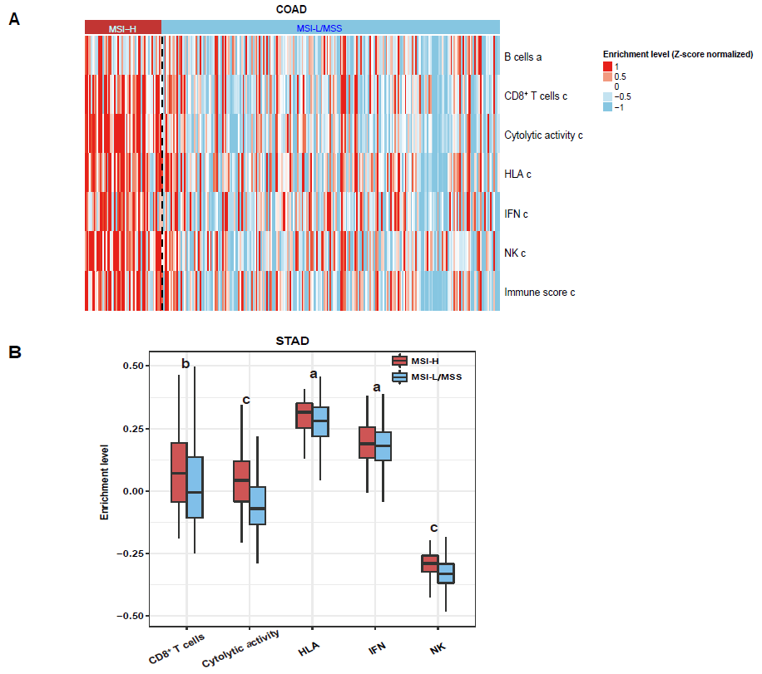
Figure 1 Association between mismatch repair deficiency/microsatellite instability and tumor immunity in gastrointestinal cancers. A: Immune signatures are upregulated in the microsatellite instability-high (MSI-H) colon adenocarcinoma (COAD) vs the MSI low (MSI-L)/microsatellite stability (MSS) COAD (Mann-Whitney U test, P < 0.05); B: Immune signatures are upregulated in the MSI-H stomach adenocarcinoma (STAD) vs the MSI-L/MSS STAD. dMMR: Mismatch repair deficiency; MSI: Microsatellite instability; MSI-H: Microsatellite instability-high; MSI-L: Microsatellite instability-low; MSS: Microsatellite stability. ªP < 0.05, ^{b}P < 0.01, ^{c}P < 0.001, MSI-H vs MSI-L/MSS. HLA: Human leukocyte antigen; IFN: Interferon; NK: Natural killer.

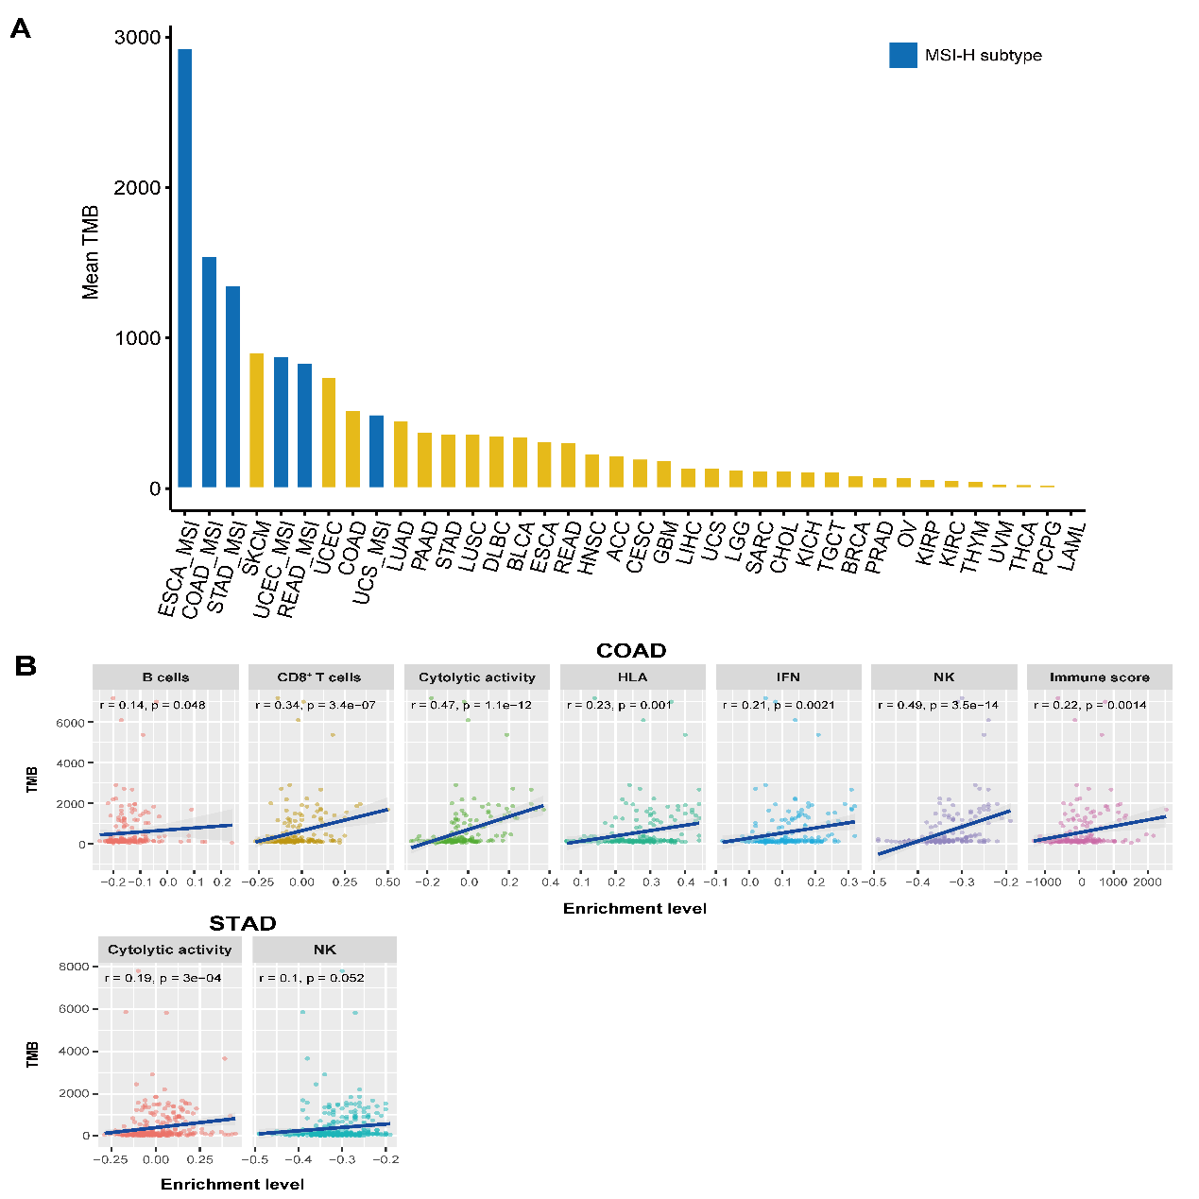
Figure 2 Association between tumor mutation burden and tumor immunity in gastrointestinal cancers. A: Comparison of tumor mutation burden (TMB) between different cancer types and microsatellite instability-high subtypes; B: Immune signatures are positively correlated with TMB in colon adenocarcinoma and in stomach adenocarcinoma (Spearman's correlation test, P < 0.05). MSI-H: Microsatellite instability-high; ESCA: Esophageal adenocarcinoma; COAD: Colon adenocarcinoma; STAD: Stomach adenocarcinoma; SKCM: Skin cutaneous melanoma; UCEC: Uterine corpus endometrial carcinoma; READ: Rectum adenocarcinoma; UCS: Uterine carcinosarcoma; LUAD: Lung adenocarcinoma; LUSC: Lung squamous cell carcinoma; DLBC: Lymphoid neoplasm diffuse large B-cell lymphoma; BLCA: Bladder urothelial carcinoma; ACC: Adrenocortical carcinoma; CESC: Cervical and endocervical cancers; GBM: Glioblastoma multiforme; LIHC: Liver hepatocellular carcinoma; LGG: Brain lower-grade glioma; SARC: Sarcoma; CHOL: Cholangiocarcinoma; KICH: Kidney chromophobe; TGCT: Testicular germ-cell tumors; BRCA: Breast invasive carcinoma; PRAD: Prostate adenocarcinoma; OV: Ovarian serous cystadenocarcinoma; KIRP: Kidney renal papillary cell carcinoma; KIRC: Kidney renal clear cell carcinoma; THYM: Thymoma; UVM: Uveal melanoma; THCA: Thyroid carcinoma; PCPG: Pheochromocytoma and paraganglioma; LAML: Acute myeloid leukemia; HLA: Human leukocyte antigen; IFN: Interferon; NK: Natural killer.

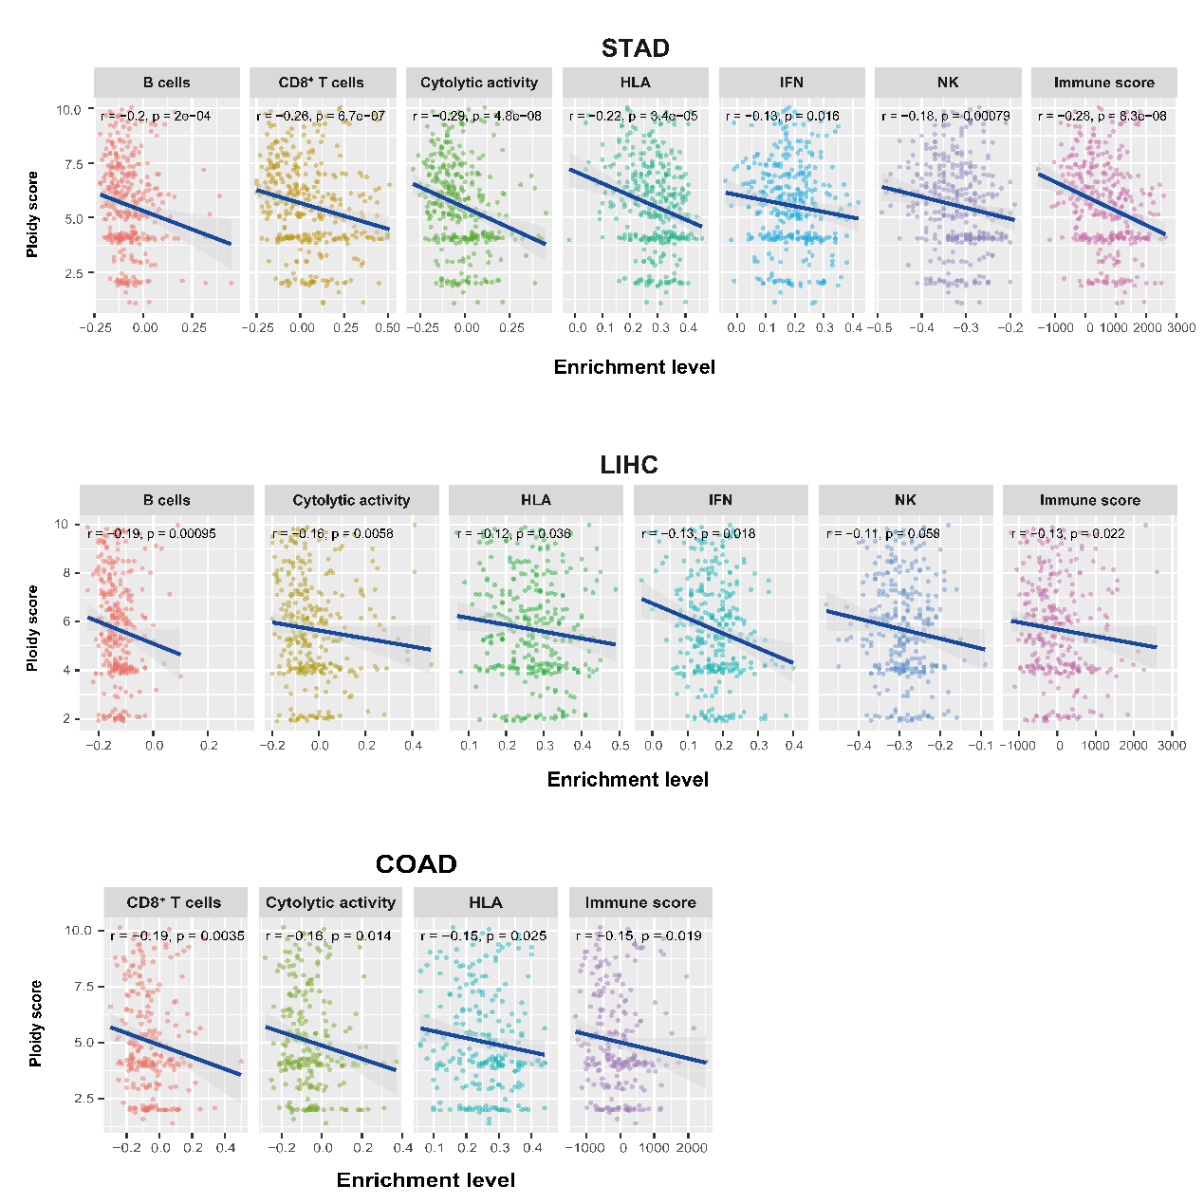
Figure 3 Tumor aneuploidy is negatively associated with tumor immunity in gastrointestinal cancers. LIHC: Liver hepatocellular carcinoma; HLA: Human leukocyte antigen; IFN: Interferon; NK: Natural killer. STAD: Stomach adenocarcinoma; COAD: Colon adenocarcinoma.

Table 1 Six immune signatures and their associated gene sets
Immune signature | Gene set
B cells | BACH2, BANK1, BLK, BTLA, CD79A, CD79B, FCRL1, FCRL3, HVCN1, RALGPS2
CD8⁺ T cells | CD8A
Cytolytic activity | PRF1, GZMA
HLA | HLA-A, HLA-B, HLA-C, HLA-DMA, HLA-DMB, HLA-DOA, HLA-DOB, HLA-DPA1, HLA-DPB1, HLA-DPB2, HLA-DQA1, HLA-DQA2, HLA-DQB1, HLA-DQB2, HLA-DRA, HLA-DRB1, HLA-DRB5, HLA-DRB6, HLA-E, HLA-F, HLA-G, HLA-J
IFN | DDX4, IFIT1, IFIT2, IFIT3, IRF7, ISG20, MX1, MX2, RSAD2, TNFSF10, GPR146, SELP, AHR
NK | KLRC1, KLRF1
HLA: Human leukocyte antigen; IFN: Interferon; NK: Natural killer.

