Name of Journal: World Journal of Clinical Oncology
Manuscript NO: 64152
Manuscript Type: META-ANALYSIS

Phytochemically rich dietary components and the risk of colorectal cancer: A systematic review and meta-analysis of observational studies

Borgas P et al. Diet and reduced colorectal cancer risk

Pia Borgas, Guadalupe Gonzalez, Kirill Veselkov, Reza Mirnezami

Pia Borgas, Faculty of Medical Sciences, University College London, London WC1E 6BT, United Kingdom

Guadalupe Gonzalez, Department of Computing, Imperial College London, London SW7 2RH, United Kingdom

Kirill Veselkov, Department of Surgery and Cancer, Faculty of Medicine, Imperial College London, London SW7 2AZ, United Kingdom

Reza Mirnezami, Department of Colorectal Surgery, Royal Free Hospital, London NW3 2QG, United Kingdom

Author contributions: Borgas P performed the literature searching, study identification, data analysis and manuscript preparation; Gonzalez G performed data analysis and manuscript preparation; Veselkov K performed study inception, data analysis and manuscript preparation; Mirnezami R performed study inception, study identification, literature searching, data analysis and manuscript preparation; all authors have read and approved the final manuscript.

Corresponding author: Reza Mirnezami, FRCS, MBBS, PhD, Senior Lecturer, Surgeon, Department of Colorectal Surgery, Royal Free Hospital, Pond Street, Hampstead, London NW3 2QG, United Kingdom. reza.mirnezami@nhs.net

Received: February 9, 2021
Revised: April 6, 2021
Accepted: June 2, 2021
Published online:

Abstract
BACKGROUND
Personalized nutrition and protective diets and lifestyles represent a key cancer research priority. The association between consumption of specific dietary components and colorectal cancer (CRC) incidence has been evaluated by a number of population-based studies, which have identified certain food items as having protective potential, though the findings have been inconsistent. Herein we present a systematic review and meta-analysis on the potential protective role of five common phytochemically rich dietary components (nuts, cruciferous vegetables, citrus fruits, garlic and tomatoes) in reducing CRC risk.

AIM
To investigate the independent impact of increased intake of specific dietary constituents on CRC risk in the general population.

METHODS
Medline and Embase were systematically searched, from time of database inception to January 31, 2020, for observational studies reporting CRC incidence relative to intake of one or more of nuts, cruciferous vegetables, citrus fruits, garlic and/or tomatoes in the general population. Data were extracted by two independent reviewers and analyzed in accordance with the Meta-analysis of Observational Studies in Epidemiology (MOOSE) and Preferred Reporting Items for Systematic Review and Meta-analysis (PRISMA) reporting guidelines and according to predefined inclusion/exclusion criteria. Effect sizes of studies were pooled using a random-effects model.

RESULTS
Forty-six studies were identified. CRC risk was significantly reduced in patients with higher vs lower consumption of cruciferous vegetables [odds ratio (OR) = 0.90; 95% confidence interval (CI): 0.85-0.95; P < 0.005], citrus fruits (OR = 0.90; 95%CI: 0.84-0.96; P < 0.005), garlic (OR = 0.83; 95%CI: 0.76-0.91; P < 0.005) and tomatoes (OR = 0.89; 95%CI: 0.84-0.95; P < 0.005). Subgroup analysis showed that this association sustained when looking at case-control studies alone, for all of these four food items, but no significant difference was found in analysis of cohort studies alone. Nut consumption exhibited a similar trend, but overall results were not significant (OR = 0.72; 95%CI: 0.50-1.03; P < 0.07; I² = 90.70%). Putative anticarcinogenic mechanisms are proposed using gene-set enrichment analysis of gene/protein perturbations caused by active compounds within each food item.

CONCLUSION
Increased cruciferous vegetable, garlic, citrus fruit and tomato consumption are all inversely associated with CRC risk. These findings highlight the potential for developing precision nutrition strategies for CRC prevention.

Key Words: Colorectal cancer; Disease prevention; Diet; Risk; Nutrigenomics; Meta-analysis

Borgas P, Gonzalez G, Veselkov K, Mirnezami R. Phytochemically rich dietary components and the risk of colorectal cancer: A systematic review and meta-analysis of observational studies. World J Clin Oncol 2021; In press

Core Tip: Personalized nutrition and protective diets and lifestyles represent a key cancer research priority. Herein we present a systematic review and meta-analysis on the potential protective role of five common phytochemically rich dietary components (nuts, cruciferous vegetables, citrus fruits, garlic and tomatoes) in reducing colorectal cancer (CRC) risk. Results show that increased dietary consumption of cruciferous vegetables, citrus fruits, garlic and tomatoes is associated with reduced CRC risk. Active components of these may interact with certain genes to exert this anticarcinogenic effect, highlighting the potential for developing precision nutrition strategies for CRC prevention.
INTRODUCTION
Colorectal cancer (CRC) imposes a major public health burden and is the third most commonly diagnosed cancer worldwide^{[1]}. Incidence varies globally between ethnicities and geographical locations^{[2]} with an increase noted amongst migrants moving from low- to high-risk countries^{[3]}. Likewise, socioeconomic disparities correlate with CRC incidence with higher rates occurring in more deprived regions^{[4,5]}. Large-scale epidemiological studies have served to highlight the impact of potentially modifiable factors such as diet, obesity, physical activity and smoking on CRC incidence^{[6,7]}.
Diet is an essential component of health and is known to play a key role in the development of a vast array of diseases, including cancers of the digestive system^{[3]}. CRC is strongly associated with inflammation and oxidative stress, both of which are believed to be highly influenced by diet^{[8-10]}. For many decades, considerable research efforts have been directed towards the identification of food groups which increase CRC risk, and broadly these have concluded that diets rich in red- and processed-meat, alcohol, saturated fat, refined grains and sugars, increase the risk of developing CRC^{[11-15]}. Likewise, it is believed that a diet rich in fiber, fruits and vegetables can exert a protective effect^{[12-14]}.
The Third Expert Report from the World Cancer Research Fund (2018) has emphasized the importance of protective dietary and lifestyle pattern in creating a metabolic state which is more favorable in preventing cancer as a whole through genetic and epigenetic alterations in carcinogenesis, rather than focusing on specific nutrients or food components alone^{[14]}. However, in order to build a holistic protective lifestyle, it remains important to understand which specific foods have the potential to reduce the risk of certain cancers, so as to establish the determinants of external and endogenous challenges contributing to or preventing cancer carcinogenesis. Additionally, in light of the recently published National Institute of Health (NIH) strategic plan, and the call for research into ‘precision nutrition’ as a potential “holistic approach to developing comprehensive and dynamic nutritional recommendations relevant to both individual and population health”^{[16]}, it is vital to explore ways in which specific foods have the potential to beneficially modify cancer incidence and outcomes.
Observational studies have investigated the relationship between CRC incidence and the consumption of certain food items. This study investigated nuts, cruciferous vegetables, citrus fruits, garlic and tomatoes, because these remain amongst those foods with most epidemiological data available. Additionally, Veselkov et al^{[17]} have previously uncovered compounds with anticancer properties within these foods by analyzing the genomic effects of the said compounds which may help explain the underlying cause for any protective associations found through observational studies. Thus, food items were included for analysis in circumstances where a substantial number of studies provided comparative outcome data based on consumption levels and fulfilled all inclusion and no exclusion criteria, as outlined in the methods. Although previous meta-analyses have sought to evaluate the impact of some of these food items^{[18-23]}, results have been contradictory and inconclusive. Furthermore, to date there has been no comprehensive meta-analysis, including more recent multinational cohort studies, which unifies all five of these food items, assessing all available and recent evidence. To meet this need, we conducted a systematic review of the literature with pooled analysis of data from all eligible observational studies exploring the effect of increased consumption of nuts, cruciferous vegetables, citrus fruits, garlic and tomatoes on CRC risk in the general population. Furthermore, putative anticarcinogenic mechanisms are highlighted through gene-set enrichment analysis (GSEA).

MATERIALS AND METHODS
Search strategy and study selection
This systematic review and meta-analysis was conducted according to Meta-analysis of Observational Studies in Epidemiology guidelines (MOOSE)^{[24]} and Preferred Reporting Items for Systematic Review and Meta-analyses (PRISMA)^{[25]} guidelines. Two reviewers (Borgas P and Mirnezami R) independently conducted a systematic literature search of Medline and Embase, from time of database inception to January 31, 2020. A detailed summary of the search terms used is provided in the supplementary material (Supplementary material, Appendix 1). There were no restrictions to language or study population. Duplicates between databases were removed. Food items were included for analysis in circumstances where a substantial amount of studies provided comparative outcome data based on consumption levels and fulfilled all inclusion and no exclusion criteria as outlined below.
Inclusion criteria comprised: (1) Observational studies (i.e., case-control or cohort); (2) The exposure variable being at least one of the following five dietary components; nuts (including peanuts and peanut butter), cruciferous vegetables (including studies reporting data on individual types of cruciferous vegetables as well as grouped data for several types of Cruciferae), citrus fruits, garlic, tomatoes; (3) Colorectal adenocarcinoma incidence being the outcome (studies investigating benign adenomas or polyps were excluded); (4) Provision of adjusted odds ratios (ORs) or relative risks (RRs) with 95% confidence intervals (CIs); (5) Participants aged ≥ 18 without prevalent cancers at baseline; and (6) Newcastle-Ottawa scale (NOS) > 5 indicating sufficient study quality^{[26]}. A sensitivity analysis was performed to assess the robustness of results with respect to the NOS selection criterion.
Further exclusion criteria comprised: (1) Grouping of the above listed food items with other foods (e.g., nuts often with legumes, cruciferous vegetables often with other vegetables); (2) Where multiple publications from the same study population were found, only the study with the largest case cohort and/or most relevant/recent information was included for analysis; and (3) Non-human research.
Additional criteria such as number of cases, method of outcome assessment and, for case-control studies, method cases and controls selected for, were considered and selected for as part of each studies’ individual quality assessment using NOS.
Two authors (Borgas P and Mirnezami R) screened the titles of all identified articles independently, to exclude those that were not relevant to the question at hand, did not meet all inclusion criteria or met at least one exclusion criteria. Abstracts and full texts of potentially relevant remaining articles were then screened for eligibility according to the same principles. Full text articles which met all criteria outlined above were retrieved. Discrepancies were resolved by discussion between the two reviewers (Borgas P and Mirnezami R). Reference lists of all identified articles, and other related review articles, systematic reviews and meta-analyses were hand-searched for additional articles

Data extraction
Two authors (Borgas P and Mirnezami R) independently extracted the following information: name of first author, year of publication, study design, characteristics of study population (age range or mean age, sex, country, specific details on patient demographic), dietary exposure, dietary assessment instrument used, outcomes (including cancer site), comparison, OR or RR (95%CI), adjusted variables, NOS. For case-control studies the following additional information was extracted: number of cases and number of controls. For cohort studies the following additional information was extracted: number of participants at baseline, number of CRC cases, person years, length of follow-up (Supplementary Tables 1 and 2 in the supplementary material). These variables were judged to be most relevant to the outcome studied. Where multiple estimates for the association of the same outcome were used, the one with the highest number of adjusted variables was extracted.

Quality assessment
The NOS was used to grade the quality and assess confounding of each included study by two independent investigators (Borgas P and Mirnezami R)^{[26]}. Studies scoring less than 6 were excluded in analysis. Disagreements were resolved by discussion.

Statistical analysis
Meta-analyses were conducted in Stata software, version 16.1 (StataCorp LLC). A random-effects model was employed, and the inverse variance method with restricted maximum likelihood was applied to assess the association of intake of each dietary component with the risk of CRC. Between-study heterogeneity was assessed using I², in order to define the percentage of variability in effect size estimates which were the result of differences between studies. An I² > 50% suggests high heterogeneity. Subgroup analyses were performed, stratifying by study design to account for the increased risk of biases related to the retrospective assessment of diet in case-control studies compared to cohort studies.
For all studies, we selected the effect- sizes computed by comparing the highest vs lowest dietary exposure category and adjusted for confounding variables. For studies reporting gender-specific results only, we included effect size for male and female participants separately and these are therefore displayed as separate studies in the accompanying forest plots, despite originating from the same publication. For studies presenting gender-specific as well as merged male and female data, we included the merged data only. We followed the same procedure for studies reporting data on all CRC types vs site-specific CRC. Given that the absolute risk of CRC is low in human, the ORs should approximate the RRs; therefore, we reported all results as ORs for simplicity. Supplementary Table 3 in the supplement demonstrates the number of studies reporting sub-type specific data based on sex and/or site of cancer for each food item, confirming a relative lack in sufficient numbers of studies reporting such specified data to be able to perform separate analyses for sex and CRC subsite.

Bias analysis
We evaluated the presence of bias in the form of small-study effects using contour-enhanced funnel plots and Egger regression asymmetry testing. For funnel plots, we used contour lines representing 1%, 5% and 10% significance. We assessed publication bias by visually inspecting the funnel plots, with publication bias being suspected when smaller studies were absent from the non-significant regions. Egger’s test was used to obtain a statistical measure of funnel plot asymmetry with the null hypothesis being that the funnel plot is symmetric (i.e., there is no evidence of small-study effects). In this case, a P value > 0.05 implies no evidence of small-study effects.

GSEA
We investigated potential anticarcinogenic mechanisms of food items by building a profile of genomic perturbations caused by each food item and identifying biological pathways affected by these perturbations. We built food profiles of genomic perturbations by averaging genomic perturbations caused by predicted anticarcinogenic compounds within each food as previously proposed by Veselkov et al^{[17]}. Pathway analytics were performed using Gene Set Enrichment Analysis v4.0.3, and PANTHER^{[27]}. An extended description of this methodology is provided in Supplementary material, Appendix 2.

RESULTS
Our initial search strategy identified 534, 236, 466, 113 and 370 records on cruciferous vegetables, citrus fruits, garlic, tomatoes and nuts, respectively. Based on our predefined inclusion/exclusion criteria 33, 12, 10, 11 and 7 records, respectively, have been included in this systematic review and meta-analysis. Figure 1 summarizes the study selection process for each dietary component.

Sensitivity analysis
For each of the 5 food items, there was no significant discrepancy between pooled ORs of analyses including all studies, before exclusion based on NOS, compared to analyses after excluding studies with NOS ≤ 5 (Supplementary Table 4 in the supplement). This confirms robustness of the NOS ≤ 5 exclusion criteria used in study selection. All other parameters used in study selection were not arbitrary but rather based on the research question at hand, and thus do not require sensitivity analysis.

Meta-analysis
Pooled ORs for each of the five food items are presented in Table 1. Overall analysis of case-control and cohort studies combined showed that higher dietary intake of cruciferous vegetables, citrus fruits, garlic and tomatoes were all significantly associated with reduced incidence of CRC. Cohort studies on nut consumption showed the same trend.
Cruciferous vegetable intake was associated with a 10% reduction in CRC risk, with low heterogeneity and no evidence of small-study effect (61 studies, 33 publications^{[28-60]}; OR = 0.90; 95%CI: 0.85-0.95; P = 0.00; I² = 31.02%, Egger P = 0.57) (Figure 2). Dietary intake of citrus fruits was also associated with a 10% risk reduction in CRC incidence, with low heterogeneity and no evidence of small-study effect (20 studies, 12 publications[33,35,42,48,50,52,53,55,56,61-63]; OR = 0.90; 95%CI: 0.84-0.96; P = 0.00; I² = 21.65%, Egger P = 0.46) (Figure 3). Higher garlic intake was associated with a 17% reduction in risk of CRC with low heterogeneity and no evidence of small-study effect (14 studies, 10 publications^{[33,42,48,58,60,61,64-67]}; OR = 0.83; 95%CI: 0.76-0.91; P = 0.00; I² = 32.64%, Egger P = 0.11) (Figure 4). Higher dietary tomato intake was associated with an 11% reduction in CRC risk, with low heterogeneity (16 studies, 11 publications[33,34,42-44,48,51,54,63,68,69]; OR = 0.89; 95%CI: 0.84-0.95; P = 0.00; I² = 0%, Egger P = 0.02) (Figure 5). However, the p-value acquired with Egger’s regression indicates that we could not discard the presence of small-study effects.
The association of increased dietary intake of all four food items with reduced CRC risk, is maintained in subgroup analysis of case-control studies alone, however cohort studies alone show an association which does not reach significance for all four aforementioned food items (Table 1).
Overall analysis of both case-control and cohort studies investigating higher dietary nut consumption demonstrated no statistically significant association with reduced risk of CRC, and significant heterogeneity was observed between studies (9 studies, 7 publications^{[28,40,49,70-73]}; OR = 0.72; 95%CI: 0.50-1.03; P = 0.07; I² = 91.85%, Egger P = 0.21) (Figure 6). However, subgroup analysis of cohort and case-control studies separately showed a significant association between nut consumption and reduced CRC risk for cohort studies with low heterogeneity (4 studies, 3 publications^{[49,71,73]}; OR = 0.74; 95%CI: 0.58-0.94; P = 0.01; I² = 35.48%). Case-control studies showed no significant association with high heterogeneity (5 studies, 4 publications^{[28,40,70,72]}; OR 0.74; 95%CI: 0.39-1.43; P = 0.38; I² = 94.35%).

Bias analysis
Funnel plots of citrus fruits and cruciferous vegetables show a clear symmetrical distribution of studies, with both large and small-sized studies in the significant and non-significant regions. Symmetrical distribution is not evident in funnel plots generated for garlic, nuts and tomato. The P values for Egger’s test can be found in Table 1. As expected, tests of symmetry for cruciferous vegetable and citrus fruit studies demonstrated robust P values (0.58 and 0.46, respectively); garlic and nuts studies had more modest but still non-significant P values (0.12 and 0.22 respectively); the P value for tomato studies was 0.02. Funnel plots of all food items can be found in Supplementary Figures 1-5 in the supplementary material. These analyses suggest that there is no evidence of small study effects (publication bias) in studies evaluating cruciferous vegetables, citrus fruits, garlic, and nuts; whereas this possibility cannot be discarded for studies exploring tomato intake in relation to CRC incidence.

GSEA
A list of the genes and proteins most affected by active compounds within each food item (Supplementary Tables 5 and 6 in the supplementary material) was subjected to pathway analytics using gene-set enrichment analysis (see Methods and Supplementary material, Appendix 2 in the supplementary material). The most affected genes and pathways are presented in Figure 7. The node colour represents shared biological pathway functionality or entity category (food compounds, food genomic perturbation profile). Among the top perturbed pathways were cell cycle, apoptosis, p53 signalling, and the MAPK signalling pathway, as well as other colorectal-cancer-specific pathways. Supplementary Table 6 in the supplementary material contains a full list of perturbed genes/pathways for each food item.

DISCUSSION
Dietary chemoprevention is emerging as a potentially cost effective and innovative way to prevent and treat cancer and has been highlighted as a key research priority by the NIH. The importance of this in implementing a holistic protective lifestyle is also highlighted in the Third Expert Report from the WCRF (World Cancer Research Fund)^{[14,16]}. The findings of this meta-analysis indicate that higher dietary intake of the phytochemically rich cruciferous vegetables, citrus fruits, garlic and tomatoes is associated with a significant reduction in the risk of CRC, suggesting that promoting increased consumption of these foods should be considered as part of a holistic CRC protective diet. Meta-analysis of cohort studies investigating increased nut consumption showed the same significant association. Compared to existing systematic reviews and meta-analyses which have only explored the effect of single dietary components on CRC or have largely focused on dietary components associated with increased CRC risk^{[18-23]}, this is the first study to investigate the protective potential of these five highly investigated dietary components on CRC incidence. Additionally, to the authors’ knowledge, data on increased dietary intake of tomatoes and citrus fruits and CRC risk have not previously been subjected to meta-analytical evaluation.
Combined analysis of case-control and cohort studies showed significant results overall, however sub-group analyses revealed that the results are significant for case-control but not cohort studies. Although the Third Expert Report published by the WCRF has highlighted the importance of focusing evidence on cohort studies, there are a number of factors which make the evidence from cohort studies more difficult to interpret and subject to bias. Case-control studies remain a stronger source of evidence for diseases with long latency periods including CRC for which the incidence increases with age in both men and women. Thus, evidence from cohort studies is stronger if patients are closer to this age group and with longer follow-up period. However, many of the studies included patients as young as approximately 30 or 45 years old^{[49,50,53,55,59,66,71]} and the average years of follow up of all cohort studies in this analysis was 9.4 years with certain studies having follow-up periods as short as 3-6 years^{[49,54,58,65,66]}. Only 3 out of a total of 16 identified cohort studies followed patients up for 10 or more years^{[50,71,73]}. This could lead to significant amounts of bias which is likely to be a major contributing factor as to why the association observed was not significant when analyzing cohort studies alone. For this reason, emphasis in this meta-analysis was not set solely on cohort studies alone but case-control studies were also viewed as highly informative and valuable in analysis despite the potential for biases related to retrospective assessment of diet in case-control studies. Hence, and in view of both types of epidemiological studies having the potential for different types of bias, it was thought to be most accurate to place most emphasis on the overall results in combination rather than focusing on the results of the sub-type analysis alone.
Despite an overall protective correlation having been observed for these foods, variability between outcomes of individual studies is evident, which may be attributable to a number of factors. Firstly, there is much variation in highest vs lower intake comparisons between studies with some not providing numerical data on intake servings, making a continuous dose-response analysis not feasible. Additionally, differences in geographical location may also explain variability in results between individual studies as cultural differences in dietary and lifestyle patterns as a whole may influence any protective effects observed. Although only studies which provided adjusted OR and RR data were included in analysis, there was a degree of variance in stratified analysis between studies and the extent to which confounders and other lifestyle factors were adjusted for between studies was inconsistent.
Significant divergences of individual studies from the mean may be attributable to study design and quality. For example, Levi et al^{[61]}, investigating citrus fruits and garlic, included much younger patients (from 27 years) compared to the majority of remaining studies which had an approximate age range between 50-80 years. Others, like Fernandez et al^{[63]}, investigating citrus fruits and tomatoes, did not adjust for as many significant variables like smoking, alcohol, total energy intake, education, consumption of other foods, as most other studies. These factors may have contributed to increased variability demonstrated in wide CIs and could explain the reason for the risk association to appear much stronger in these studies compared to the overall result. Conversely, some studies included a relatively low number of participants^{[31,36,39,44,63,72]}, participants selected from a defined population group attributing to selection bias^{[57]}, did not report details of their study design leading to low NOS^{[44]} or studied specific individual components of the overall food items investigated here (e.g., single types of cruciferous vegetables)^{[31]}. All such factors lead to reduced reliability of the studies’ results which is evidenced in the analysis by a low weight in random-effects model. Nevertheless, all studies scored > 5 on the quality assessment criteria using NOS and did not meet any other exclusion criteria and hence remain valuable contributors to the overall analysis.
Although the exact mechanisms for the associations reported here remain unclear, all four dietary components are rich in compounds believed to exert anticarcinogenic effect. To investigate these putative mechanisms further, we compiled a list of ‘anticarcinogenic' compounds found in each of the food items studied, based on data previously published by Veselkov et al^{[17]} (see Supplementary Table 5 in the supplementary material). We performed further pathway enrichment analyses of genes with which these anticarcinogenic compounds are known to interact, as per the methodology described by Veselkov et al^{[17]} (see Supplementary material, Appendix 2 in the supplementary material).
Garlic contains five anticarcinogenic compounds, belonging to organosulfur (ajoene, Di-2-propenyl sulphide), flavonoid (apigenin, quercetin) and phenol (phloroglucinol) categories. Several of the top 20 genes perturbed by these compounds take part in pathways related to inflammation, apoptosis, and angiogenesis. Furthermore, organosulfur and flavonoid compounds are thought to have chemoprotective properties^{[74,75]} through a number of mechanisms including reduction of aberrant crypt formation^{[76]}, antioxidant effects, regulation of cell cycle arrest, induction of apoptosis, and activation of metabolizing enzymes which detoxify carcinogens and inhibit angiogenesis^{[77,78]}.
In addition to flavonoids (quercetin), tomatoes contain anticarcinogenic compounds including prenol lipids (prolycopene, lupeol), progesterone and carbohydrate (ferulic acid 4-glucoside). Citrus fruits are also rich in flavonoids (luteolin 7-rhamnosylglucoside, quercetin, tetramethylquercetin, didymin, quercetagetin) and prenol lipids (carvone, obacunon, umbelliprenin) and additionally contain steroids (brassinolide) and carbohydrates (xyan). The genes targeted by these anticarcinogenic compounds were also predominantly found to be involved in apoptosis, angiogenesis and inflammation. GSEA revealed interaction with MAPK and p53 signalling pathways, which are key drivers of CRC development and progression^{[79, 80]}.
Cruciferous vegetables contain nine anticarcinogenic compounds including flavonoids (quercetin), and prenol lipids (carvone, gibberellin A116) but also isothiocyanates (erucin), indoles (1H-Indole-3-methanol, brassinin), allyl sulphur compounds (di-2-propenyl sulfide), organooxygen compounds (4-methoxyglucobrassicin) and steroids (brassinolide). Glucosinolates are precursors of isothiocyanates and indole-3-carbinol^{[81,82]}, which inhibit carcinogen-activating enzyme and angiogenesis, and detoxify carcinogens, inducing apoptosis and preventing cell cycle progression^{[44,83]}. Animal studies have shown that cruciferous vegetables activate phase I (cytochrome P450) and II (glutathionin S-transferase) cell-cycle enzymes, and that this joint induction leads to a favourable metabolic profile, aiding in the elimination of chemical carcinogens by interacting with isothocyanate metabolism^{[44,59,81-83]}.
Nuts contain macro- and micro-nutrients including fibre, vitamins (BE, folate, niacin), minerals (zinc, potassium, calcium, magnesium) polyphenols, folate, phytoestrogens, phytochemicals (flavonoids, carotenoid and phytosteroils) and other bioactive substances. Additional anticarcinogenic compounds, as confirmed through our analysis, also include unsaturated fatty acids (dihydroxystearic acid), flavonoids (procyanidin B3 procyanidin B2, quercetin), garlic acid, naphthalene (plumbagin) prenol lipids (betulinic acid) and hydorcycoumarins (aesculetin), all of which harbour anti-inflammatory properties^{[84-86]}. They display anticarcinogenic effect by reducing DNA damage and regulating immunological activity and inflammatory responses^{[84,87]}. In vitro studies have demonstrated that fermented nuts exhibit chemopreventative effects by decreasing tumour-promoting deoxycholic acid, increasing short-chain fatty acids and protecting against oxidative stress^{[88]}. Our results showed a significant association between higher dietary nut intake, and reduced CRC risk, supporting the findings of a previous meta-analysis^{[18]}. However significant heterogeneity was observed meaning that a conclusion cannot reliably be reached based on currently available data.
In addition to these postulated mechanisms specific to each food items’ associated bioactive compounds, pathway enrichment analysis of genomic perturbation profiles of all food items showed an over-representation of several pathways known to be linked with CRC pathogenesis including the MAPK, EGFR, PI3K/AKT, TGF-b and Wnt signalling pathways^{[89]}. This implies that the active compounds present in the five food items studied, interact with genes and pathways involved in the development of CRC. This in turn suggests that the protective influence of these dietary components, as demonstrated by this meta-analysis, may be directly attributable to novel nutrigenomic interactions.
The findings presented herein support the vision recently outlined in the NIH strategic plan, which highlights an urgent need to accelerate nutrition research over the next decade and demonstrate the potentially important role that precision nutrition can play in the prevention and treatment of CRC. These findings should form the foundation on which to design randomized clinical trials for the evaluation of food-based approaches in modifying CRC risk. In the future, we envisage that those at risk of CRC could have personalized ‘food passports’ developed by care providers, specifically composed of food plans to build dietary patterns designed to reduce their risk of cancer. Future research should focus on understanding the underlying mechanisms behind the observed effects and exploring the potential interactions between individual genes/pathways and active compounds of the investigated foods in more detail. Furthermore, the nature of the observed findings should be explored using linear and continuous exposure analyses to identify thresholds and plateaus in the protective effect and investigate dose-response effects of consumption of the foods evaluated. Lastly, the influence of food cultivation, packaging, storage and preparation methods should be explored, all of which may influence the associations observed.

CONCLUSION
This meta-analysis demonstrates that an increased consumption of cruciferous vegetables, citrus fruits, garlic and tomatoes is associated with a reduction in the incidence of CRC. These findings support the rapidly expanding initiative for exploring the role of nutrition in the prevention and treatment of cancer and could pave the way for personalized CRC protective diets in the future.

ARTICLE HIGHLIGHTS
Research background
Personalized nutrition and protective diets and lifestyles represent a key cancer research priority according to The Third Expert Report from the World Cancer Research Fund (2018) and the recently published National Institute of Health strategic plan. The association between consumption of specific dietary components and colorectal cancer (CRC) incidence has been evaluated by a number of large-scale, population-based, epidemiological studies, which have identified certain food items as having protective potential, though the findings have been inconsistent.

Research motivation
Although previous meta-analyses have sought to evaluate the impact of some of these food items, results have been contradictory and inconclusive. To date there has been no comprehensive meta-analysis, including more recent multinational cohort studies, which unifies all five of these food items, assessing all available and recent evidence. Furthermore, anticancer properties could be explained by genomic effects of certain compounds contained in these phytochemically rich foods. This may help explain the underlying cause for any protective associations. Thus, we present a systematic review and meta-analysis on the potential protective role of five common phytochemically rich dietary components (nuts, cruciferous vegetables, citrus fruits, garlic and tomatoes) in reducing CRC risk. Putative anticarcinogenic mechanisms are highlighted through gene-set enrichment analysis.

Research objectives
To investigate the independent impact of increased intake of five dietary constituents (nuts, cruciferous vegetables, citrus fruits, garlic and tomatoes) on CRC risk in the general population.

Research methods
Medline and Embase were systematically searched, from time of database inception to January 31, 2020, for observational studies reporting CRC incidence relative to intake of one or more of nuts, cruciferous vegetables, citrus fruits, garlic and/or tomatoes in the general population. Data were extracted by two independent reviewers and analyzed in accordance with the Meta-analysis of Observational Studies in Epidemiology (MOOSE) and Preferred Reporting Items for Systematic Review and Meta-analysis (PRISMA) reporting guidelines and according to predefined inclusion/exclusion criteria. Effect sizes of studies were pooled using a random-effects model. Using gene set enrichment analysis, a profile of genomic perturbations caused by each food item was built and biological pathways affected by these perturbations were identified.

Research results
This systematic review and meta-analysis of 46 observational studies found that increased dietary consumption of cruciferous vegetables, citrus fruits, garlic and tomatoes is associated with a significant reduction in the risk of developing CRC. Consumption of nuts exhibited a similar trend, but results were not significant. The underlying mechanisms of the observed effects remain unclear, although putative anticarcinogenic mechanisms are proposed using the results of gene-set enrichment analysis of gene-protein perturbations caused by active compounds within each food item.

Research conclusions
Increased cruciferous vegetable, garlic, citrus fruit and tomato consumption are all inversely associated with CRC risk. These findings highlight the potential for precision nutrition strategies and development of personalized food maps in CRC prevention for both the general population and at-risk individuals.

Research perspectives
The findings should stimulate future research to focus on understanding the nature of the observed effects, by exploring the epigenetic interactions of active compounds within the investigated foods. Additionally, linear and continuous exposure analyses should be explored to identify consumption thresholds for the observed effects. Results should then encourage the design of randomized controlled trials to assess food-based approached in modifying CRC risk.

REFERENCES
1 Bray F, Ferlay J, Soerjomataram I, Siegel RL, Torre LA, Jemal A. Global cancer statistics 2018: GLOBOCAN estimates of incidence and mortality worldwide for 36 cancers in 185 countries. CA Cancer J Clin 2018; 68: 394-424 [PMID: 30207593 DOI: 10.3322/caac.21492]
2 Global Burden of Disease Cancer Collaboration, Fitzmaurice C, Allen C, Barber RM, Barregard L, Bhutta ZA, Brenner H, Dicker DJ, Chimed-Orchir O, Dandona R, Dandona L, Fleming T, Forouzanfar MH, Hancock J, Hay RJ, Hunter-Merrill R, Huynh C, Hosgood HD, Johnson CO, Jonas JB, Khubchandani J, Kumar GA, Kutz M, Lan Q, Larson HJ, Liang X, Lim SS, Lopez AD, MacIntyre MF, Marczak L, Marquez N, Mokdad AH, Pinho C, Pourmalek F, Salomon JA, Sanabria JR, Sandar L, Sartorius B, Schwartz SM, Shackelford KA, Shibuya K, Stanaway J, Steiner C, Sun J, Takahashi K, Vollset SE, Vos T, Wagner JA, Wang H, Westerman R, Zeeb H, Zoeckler L, Abd-Allah F, Ahmed MB, Alabed S, Alam NK, Aldhahri SF, Alem G, Alemayohu MA, Ali R, Al-Raddadi R, Amare A, Amoako Y, Artaman A, Asayesh H, Atnafu N, Awasthi A, Saleem HB, Barac A, Bedi N, Bensenor I, Berhane A, Bernabé E, Betsu B, Binagwaho A, Boneya D, Campos-Nonato I, Castañeda-Orjuela C, Catalá-López F, Chiang P, Chibueze C, Chitheer A, Choi JY, Cowie B, Damtew S, das Neves J, Dey S, Dharmaratne S, Dhillon P, Ding E, Driscoll T, Ekwueme D, Endries AY, Farvid M, Farzadfar F, Fernandes J, Fischer F, G/Hiwot TT, Gebru A, Gopalani S, Hailu A, Horino M, Horita N, Husseini A, Huybrechts I, Inoue M, Islami F, Jakovljevic M, James S, Javanbakht M, Jee SH, Kasaeian A, Kedir MS, Khader YS, Khang YH, Kim D, Leigh J, Linn S, Lunevicius R, El Razek HMA, Malekzadeh R, Malta DC, Marcenes W, Markos D, Melaku YA, Meles KG, Mendoza W, Mengiste DT, Meretoja TJ, Miller TR, Mohammad KA, Mohammadi A, Mohammed S, Moradi-Lakeh M, Nagel G, Nand D, Le Nguyen Q, Nolte S, Ogbo FA, Oladimeji KE, Oren E, Pa M, Park EK, Pereira DM, Plass D, Qorbani M, Radfar A, Rafay A, Rahman M, Rana SM, Søreide K, Satpathy M, Sawhney M, Sepanlou SG, Shaikh MA, She J, Shiue I, Shore HR, Shrime MG, So S, Soneji S, Stathopoulou V, Stroumpoulis K, Sufiyan MB, Sykes BL, Tabarés-Seisdedos R, Tadese F, Tedla BA, Tessema GA, Thakur JS, Tran BX, Ukwaja KN, Uzochukwu BSC, Vlassov VV, Weiderpass E, Wubshet Terefe M, Yebyo HG, Yimam HH, Yonemoto N, Younis MZ, Yu C, Zaidi Z, Zaki MES, Zenebe ZM, Murray CJL, Naghavi M. Global, Regional, and National Cancer Incidence, Mortality, Years of Life Lost, Years Lived With Disability, and Disability-Adjusted Life-years for 32 Cancer Groups, 1990 to 2015: A Systematic Analysis for the Global Burden of Disease Study. JAMA Oncol 2017; 3: 524-548 [PMID: 27918777 DOI: 10.1001/jamaoncol.2016.5688]
3 Marmot M, Atinmo T, Byers T, Chen J, Hirohata T, Jackson A, James WPT, Kolonel LN, Kumanyika S, Leitzmann C, Mann J, Hilary JP, Reddy KS, Riboli E, Rivera JA, Schatzkin A, Seidell JC, Shuker DE, Uauy R, Willett WC, Zeisel SH, Beaglehole R. Food, Nutrition, Physical Activity, and the Prevention of Cancer: A Global Perspective. Washington, DC: World Cancer Research Fund/American institute for Cancer Research, 2007
4 Doubeni CA, Laiyemo AO, Major JM, Schootman M, Lian M, Park Y, Graubard BI, Hollenbeck AR, Sinha R. Socioeconomic status and the risk of colorectal cancer: an analysis of more than a half million adults in the National Institutes of Health-AARP Diet and Health Study. Cancer 2012; 118: 3636-3644 [PMID: 22898918 DOI: 10.1002/cncr.26677]
5 Arnold M, Sierra MS, Laversanne M, Soerjomataram I, Jemal A, Bray F. Global patterns and trends in colorectal cancer incidence and mortality. Gut 2017; 66: 683-691 [PMID: 26818619 DOI: 10.1136/gutjnl-2015-310912]
6 Willett WC. Diet and cancer: an evolving picture. JAMA 2005; 293: 233-234 [PMID: 15644551 DOI: 10.1001/jama.293.2.233]
7 Doubeni CA, Major JM, Laiyemo AO, Schootman M, Zauber AG, Hollenbeck AR, Sinha R, Allison J. Contribution of behavioral risk factors and obesity to socioeconomic differences in colorectal cancer incidence. J Natl Cancer Inst 2012; 104: 1353-1362 [PMID: 22952311 DOI: 10.1093/jnci/djs346]
8 Reuter S, Gupta SC, Chaturvedi MM, Aggarwal BB. Oxidative stress, inflammation, and cancer: how are they linked? Free Radic Biol Med 2010; 49: 1603-1616 [PMID: 20840865 DOI: 10.1016/j.freeradbiomed.2010.09.006]
9 Terzić J, Grivennikov S, Karin E, Karin M. Inflammation and colon cancer. Gastroenterology 2010; 138: 2101-2114.e5 [PMID: 20420949 DOI: 10.1053/j.gastro.2010.01.058]
10 Klampfer L. Cytokines, inflammation and colon cancer. Curr Cancer Drug Targets 2011; 11: 451-464 [PMID: 21247378 DOI: 10.2174/156800911795538066]
11 Tárraga López PJ, Albero JS, Rodríguez-Montes JA. Primary and secondary prevention of colorectal cancer. Clin Med Insights Gastroenterol 2014; 7: 33-46 [PMID: 25093007 DOI: 10.4137/CGast.S14039]
12 Aune D, Chan DS, Lau R, Vieira R, Greenwood DC, Kampman E, Norat T. Dietary fibre, whole grains, and risk of colorectal cancer: systematic review and dose-response meta-analysis of prospective studies. BMJ 2011; 343: d6617 [PMID: 22074852 DOI: 10.1136/bmj.d6617]
13 Vieira AR, Abar L, Chan DSM, Vingeliene S, Polemiti E, Stevens C, Greenwood D, Norat T. Foods and beverages and colorectal cancer risk: a systematic review and meta-analysis of cohort studies, an update of the evidence of the WCRF-AICR Continuous Update Project. Ann Oncol 2017; 28: 1788-1802 [PMID: 28407090 DOI: 10.1093/annonc/mdx171]
14 World Cancer Research Fund International. Diet, Nutrition, Physical Activity and Cancer: a Global Perspective - The Third Expert Report. Third Expert Report ed. London, UK: World Cancer Research Fund International, 2018
15 IARC Monographs on the Evaluation of Carcinogeni Risks To Humans. Red Meat And Processed Meat. Lyon, France: International Agency for Research on Cancer, 2018
16 Collins FS, Rodgers GP. 2020-2030 Strategic Plan for NIH Nutrition Research. In: Force TNRT. National Institute of Health, 2020
17 Veselkov K, Gonzalez G, Aljifri S, Galea D, Mirnezami R, Youssef J, Bronstein M, Laponogov I. HyperFoods: Machine intelligent mapping of cancer-beating molecules in foods. Sci Rep 2019; 9: 9237 [PMID: 31270435 DOI: 10.1038/s41598-019-45349-y]
18 Wu L, Wang Z, Zhu J, Murad AL, Prokop LJ, Murad MH. Nut consumption and risk of cancer and type 2 diabetes: a systematic review and meta-analysis. Nutr Rev 2015; 73: 409-425 [PMID: 26081452 DOI: 10.1093/nutrit/nuv006]
19 Schwingshackl L, Schwedhelm C, Hoffmann G, Knüppel S, Laure Preterre A, Iqbal K, Bechthold A, De Henauw S, Michels N, Devleesschauwer B, Boeing H, Schlesinger S. Food groups and risk of colorectal cancer. Int J Cancer 2018; 142: 1748-1758 [PMID: 29210053 DOI: 10.1002/ijc.31198]
20 Verhoeven DT, Goldbohm RA, van Poppel G, Verhagen H, van den Brandt PA. Epidemiological studies on brassica vegetables and cancer risk. Cancer Epidemiol Biomarkers Prev 1996; 5: 733-748 [PMID: 8877066]
21 Wu QJ, Yang Y, Vogtmann E, Wang J, Han LH, Li HL, Xiang YB. Cruciferous vegetables intake and the risk of colorectal cancer: a meta-analysis of observational studies. Ann Oncol 2013; 24: 1079-1087 [PMID: 23211939 DOI: 10.1093/annonc/mds601]
22 Fleischauer AT, Poole C, Arab L. Garlic consumption and cancer prevention: meta-analyses of colorectal and stomach cancers. Am J Clin Nutr 2000; 72: 1047-1052 [PMID: 11010950 DOI: 10.1093/ajcn/72.4.1047]
23 Chiavarini M, Minelli L, Fabiani R. Garlic consumption and colorectal cancer risk in man: a systematic review and meta-analysis. Public Health Nutr 2016; 19: 308-317 [PMID: 25945653 DOI: 10.1017/S1368980015001263]
24 Stroup DF, Berlin JA, Morton SC, Olkin I, Williamson GD, Rennie D, Moher D, Becker BJ, Sipe TA, Thacker SB. Meta-analysis of observational studies in epidemiology: a proposal for reporting. Meta-analysis Of Observational Studies in Epidemiology (MOOSE) group. JAMA 2000; 283: 2008-2012 [PMID: 10789670 DOI: 10.1001/jama.283.15.2008]
25 Moher D, Liberati A, Tetzlaff J, Altman DG; PRISMA Group. Preferred reporting items for systematic reviews and meta-analyses: the PRISMA statement. BMJ 2009; 339: b2535 [PMID: 19622551 DOI: 10.1136/bmj.b2535]
26 Wells G, Shea B, O’Connell D, Peterson J, Welch V, Losos M, Tugwell P. The Newcastle-Ottawa Scale (NOS) for assessing the quality of nonrandomised studies in meta-analyses. Ottawa Hosp Res Instit 2011
27 Thomas PD, Campbell MJ, Kejariwal A, Mi H, Karlak B, Daverman R, Diemer K, Muruganujan A, Narechania A. PANTHER: a library of protein families and subfamilies indexed by function. Genome Res 2003; 13: 2129-2141 [PMID: 12952881 DOI: 10.1101/gr.772403]
28 Young TB, Wolf DA. Case-control study of proximal and distal colon cancer and diet in Wisconsin. Int J Cancer 1988; 42: 167-175 [PMID: 3403062 DOI: 10.1002/ijc.2910420205]
29 Fang W, Qu X, Shi J, Li H, Guo X, Wu X, Liu Y, Li Z. Cruciferous vegetables and colorectal cancer risk: a hospital-based matched case-control study in Northeast China. Eur J Clin Nutr 2019; 73: 450-457 [PMID: 30323175 DOI: 10.1038/s41430-018-0341-5]
30 Steinmetz KA, Potter JD. Food-group consumption and colon cancer in the Adelaide Case-Control Study. I. Vegetables and fruit. Int J Cancer 1993; 53: 711-719 [PMID: 8449594 DOI: 10.1002/ijc.2910530502]
31 Tayyem RF, Shehadah I, Abu-Mweis SS, Bawadi HA, Bani-Hani KE, Al-Jaberi T, Al-Nusairr M, Heath DD. Fruit and vegetable intake among Jordanians: results from a case-control study of colorectal cancer. Cancer Control 2014; 21: 350-360 [PMID: 25310217 DOI: 10.1177/107327481402100412]
32 Chiu BC, Ji BT, Dai Q, Gridley G, McLaughlin JK, Gao YT, Fraumeni JF Jr, Chow WH. Dietary factors and risk of colon cancer in Shanghai, China. Cancer Epidemiol Biomarkers Prev 2003; 12: 201-208 [PMID: 12646508]
33 Le Marchand L, Hankin JH, Wilkens LR, Kolonel LN, Englyst HN, Lyu LC. Dietary fiber and colorectal cancer risk. Epidemiology 1997; 8: 658-665 [PMID: 9345666 DOI: 10.1097/00001648-199710000-00008]
34 Abu Mweis SS, Tayyem RF, Shehadah I, Bawadi HA, Agraib LM, Bani-Hani KE, Al-Jaberi T, Al-Nusairr M. Food groups and the risk of colorectal cancer: results from a Jordanian case-control study. Eur J Cancer Prev 2015; 24: 313-320 [PMID: 25415835 DOI: 10.1097/CEJ.0000000000000089]
35 Deneo-Pellegrini H, Boffetta P, De Stefani E, Ronco A, Brennan P, Mendilaharsu M. Plant foods and differences between colon and rectal cancers. Eur J Cancer Prev 2002; 11: 369-375 [PMID: 12195164 DOI: 10.1097/00008469-200208000-00009]
36 Hara M, Hanaoka T, Kobayashi M, Otani T, Adachi HY, Montani A, Natsukawa S, Shaura K, Koizumi Y, Kasuga Y, Matsuzawa T, Ikekawa T, Sasaki S, Tsugane S. Cruciferous vegetables, mushrooms, and gastrointestinal cancer risks in a multicenter, hospital-based case-control study in Japan. Nutr Cancer 2003; 46: 138-147 [PMID: 14690789 DOI: 10.1207/s15327914nc4602_06]
37 Ganesh B, Talole SD, Dikshit R. A case-control study on diet and colorectal cancer from Mumbai, India. Cancer Epidemiol 2009; 33: 189-193 [PMID: 19717354 DOI: 10.1016/j.canep.2009.07.009]
38 Inoue M, Tajima K, Hirose K, Hamajima N, Takezaki T, Hirai T, Kato T, Ohno Y. Subsite-specific risk factors for colorectal cancer: a hospital-based case-control study in Japan. Cancer Causes Control 1995; 6: 14-22 [PMID: 7718730 DOI: 10.1007/bf00051676]
39 Zaridze D, Filipchenko V, Kustov V, Serdyuk V, Duffy S. Diet and colorectal cancer: results of two case-control studies in Russia. Eur J Cancer 1992; 29A: 112-115 [PMID: 1445726 DOI: 10.1016/0959-8049(93)90586-5]
40 Evans RC, Fear S, Ashby D, Hackett A, Williams E, Van Der Vliet M, Dunstan FD, Rhodes JM. Diet and colorectal cancer: an investigation of the lectin/galactose hypothesis. Gastroenterology 2002; 122: 1784-1792 [PMID: 12055585 DOI: 10.1053/gast.2002.33659]
41 Bosetti C, Filomeno M, Riso P, Polesel J, Levi F, Talamini R, Montella M, Negri E, Franceschi S, La Vecchia C. Cruciferous vegetables and cancer risk in a network of case-control studies. Ann Oncol 2012; 23: 2198-2203 [PMID: 22328735 DOI: 10.1093/annonc/mdr604]
42 Annema N, Heyworth JS, McNaughton SA, Iacopetta B, Fritschi L. Fruit and vegetable consumption and the risk of proximal colon, distal colon, and rectal cancers in a case-control study in Western Australia. J Am Diet Assoc 2011; 111: 1479-1490 [PMID: 21963014 DOI: 10.1016/j.jada.2011.07.008]
43 Hu J, Mery L, Desmeules M, Macleod M; Canadian Cancer Registries Epidemiology Research Group. Diet and vitamin or mineral supplementation and risk of rectal cancer in Canada. Acta Oncol 2007; 46: 342-354 [PMID: 17450470 DOI: 10.1080/02841860600746982]
44 Seow A, Quah SR, Nyam D, Straughan PT, Chua T, Aw TC. Food groups and the risk of colorectal carcinoma in an Asian population. Cancer 2002; 95: 2390-2396 [PMID: 12436447 DOI: 10.1002/cncr.10971]
45 West DW, Slattery ML, Robison LM, Schuman KL, Ford MH, Mahoney AW, Lyon JL, Sorensen AW. Dietary intake and colon cancer: sex- and anatomic site-specific associations. Am J Epidemiol 1989; 130: 883-894 [PMID: 2554725 DOI: 10.1093/oxfordjournals.aje.a115421]
46 Freedman AN, Michalek AM, Marshall JR, Mettlin CJ, Petrelli NJ, Black JD, Zhang ZF, Satchidanand S, Asirwatham JE. Familial and nutritional risk factors for p53 overexpression in colorectal cancer. Cancer Epidemiol Biomarkers Prev 1996; 5: 285-291 [PMID: 8722220]
47 Vogtmann E, Xiang YB, Li HL, Cai Q, Wu QJ, Xie L, Li GL, Yang G, Waterbor JW, Levitan EB, Zhang B, Zheng W, Shu XO. Cruciferous vegetables, glutathione S-transferase polymorphisms, and the risk of colorectal cancer among Chinese men. Ann Epidemiol 2014; 24: 44-49 [PMID: 24238877 DOI: 10.1016/j.annepidem.2013.10.003]
48 Franceschi S, Parpinel M, La Vecchia C, Favero A, Talamini R, Negri E. Role of different types of vegetables and fruit in the prevention of cancer of the colon, rectum, and breast. Epidemiology 1998; 9: 338-341 [PMID: 9583427]
49 Singh PN, Fraser GE. Dietary risk factors for colon cancer in a low-risk population. Am J Epidemiol 1998; 148: 761-774 [PMID: 9786231 DOI: 10.1093/oxfordjournals.aje.a009697]
50 Michels KB, Edward Giovannucci, Joshipura KJ, Rosner BA, Stampfer MJ, Fuchs CS, Colditz GA, Speizer FE, Willett WC. Prospective study of fruit and vegetable consumption and incidence of colon and rectal cancers. J Natl Cancer Inst 2000; 92: 1740-1752 [PMID: 11058617 DOI: 10.1093/jnci/92.21.1740]
51 Flood A, Velie EM, Chaterjee N, Subar AF, Thompson FE, Lacey JV Jr, Schairer C, Troisi R, Schatzkin A. Fruit and vegetable intakes and the risk of colorectal cancer in the Breast Cancer Detection Demonstration Project follow-up cohort. Am J Clin Nutr 2002; 75: 936-943 [PMID: 11976170 DOI: 10.1093/ajcn/75.5.936]
52 Voorrips LE, Goldbohm RA, van Poppel G, Sturmans F, Hermus RJ, van den Brandt PA. Vegetable and fruit consumption and risks of colon and rectal cancer in a prospective cohort study: The Netherlands Cohort Study on Diet and Cancer. Am J Epidemiol 2000; 152: 1081-1092 [PMID: 11117618 DOI: 10.1093/aje/152.11.1081]
53 Nomura AM, Wilkens LR, Murphy SP, Hankin JH, Henderson BE, Pike MC, Kolonel LN. Association of vegetable, fruit, and grain intakes with colorectal cancer: the Multiethnic Cohort Study. Am J Clin Nutr 2008; 88: 730-737 [PMID: 18779290 DOI: 10.1093/ajcn/88.3.730]
54 Park Y, Subar AF, Kipnis V, Thompson FE, Mouw T, Hollenbeck A, Leitzmann MF, Schatzkin A. Fruit and vegetable intakes and risk of colorectal cancer in the NIH-AARP diet and health study. Am J Epidemiol 2007; 166: 170-180 [PMID: 17485731 DOI: 10.1093/aje/kwm067]
55 Lin J, Zhang SM, Cook NR, Rexrode KM, Liu S, Manson JE, Lee IM, Buring JE. Dietary intakes of fruit, vegetables, and fiber, and risk of colorectal cancer in a prospective cohort of women (United States). Cancer Causes Control 2005; 16: 225-233 [PMID: 15947874 DOI: 10.1007/s10552-004-4025-1]
56 McCullough ML, Robertson AS, Chao A, Jacobs EJ, Stampfer MJ, Jacobs DR, Diver WR, Calle EE, Thun MJ. A prospective study of whole grains, fruits, vegetables and colon cancer risk. Cancer Causes Control 2003; 14: 959-970 [PMID: 14750535 DOI: 10.1023/b:caco.0000007983.16045.a1]
57 Pietinen P, Malila N, Virtanen M, Hartman TJ, Tangrea JA, Albanes D, Virtamo J. Diet and risk of colorectal cancer in a cohort of Finnish men. Cancer Causes Control 1999; 10: 387-396 [PMID: 10530608 DOI: 10.1023/a:1008962219408]
58 Steinmetz KA, Kushi LH, Bostick RM, Folsom AR, Potter JD. Vegetables, fruit, and colon cancer in the Iowa Women's Health Study. Am J Epidemiol 1994; 139: 1-15 [PMID: 8296768 DOI: 10.1093/oxfordjournals.aje.a116921]
59 Yang G, Gao YT, Shu XO, Cai Q, Li GL, Li HL, Ji BT, Rothman N, Dyba M, Xiang YB, Chung FL, Chow WH, Zheng W. Isothiocyanate exposure, glutathione S-transferase polymorphisms, and colorectal cancer risk. Am J Clin Nutr 2010; 91: 704-711 [PMID: 20042523 DOI: 10.3945/ajcn.2009.28683]
60 Sellers TA, Bazyk AE, Bostick RM, Kushi LH, Olson JE, Anderson KE, Lazovich D, Folsom AR. Diet and risk of colon cancer in a large prospective study of older women: an analysis stratified on family history (Iowa, United States). Cancer Causes Control 1998; 9: 357-367 [PMID: 9794167 DOI: 10.1023/a:1008886715597]
61 Levi F, Pasche C, La Vecchia C, Lucchini F, Franceschi S. Food groups and colorectal cancer risk. Br J Cancer 1999; 79: 1283-1287 [PMID: 10098773 DOI: 10.1038/sj.bjc.6690206]
62 Foschi R, Pelucchi C, Dal Maso L, Rossi M, Levi F, Talamini R, Bosetti C, Negri E, Serraino D, Giacosa A, Franceschi S, La Vecchia C. Citrus fruit and cancer risk in a network of case-control studies. Cancer Causes Control 2010; 21: 237-242 [PMID: 19856118 DOI: 10.1007/s10552-009-9454-4]
63 Fernandez E, La Vecchia C, D'Avanzo B, Negri E, Franceschi S. Risk factors for colorectal cancer in subjects with family history of the disease. Br J Cancer 1997; 75: 1381-1384 [PMID: 9155063 DOI: 10.1038/bjc.1997.234]
64 Galeone C, Pelucchi C, Levi F, Negri E, Franceschi S, Talamini R, Giacosa A, La Vecchia C. Onion and garlic use and human cancer. Am J Clin Nutr 2006; 84: 1027-1032 [PMID: 17093154 DOI: 10.1093/ajcn/84.5.1027]
65 Dorant E, van den Brandt PA, Goldbohm RA. A prospective cohort study on the relationship between onion and leek consumption, garlic supplement use and the risk of colorectal carcinoma in The Netherlands. Carcinogenesis 1996; 17: 477-484 [PMID: 8631133 DOI: 10.1093/carcin/17.3.477]
66 Giovannucci E, Rimm EB, Stampfer MJ, Colditz GA, Ascherio A, Willett WC. Intake of fat, meat, and fiber in relation to risk of colon cancer in men. Cancer Res 1994; 54: 2390-2397 [PMID: 8162586]
67 Hu JF, Liu YY, Yu YK, Zhao TZ, Liu SD, Wang QQ. Diet and cancer of the colon and rectum: a case-control study in China. Int J Epidemiol 1991; 20: 362-367 [PMID: 1917235 DOI: 10.1093/ije/20.2.362]
68 Tayyem RF, Bawadi HA, Shehadah I, Bani-Hani KE, Takruri H, Al-Jaberi T, Heath DD. Fast Foods, Sweets and Beverage Consumption and Risk of Colorectal Cancer: A Case-Control Study in Jordan Asian Pac J Cancer Prev 2018; 19: 261-269 [PMID: 29374411 DOI: 10.22034/apjcp.2018.19.1.261]
69 La Vecchia C. Tomatoes, lycopene intake, and digestive tract and female hormone-related neoplasms. Exp Biol Med (Maywood) 2002; 227: 860-863 [PMID: 12424326 DOI: 10.1177/153537020222701004]
70 Lee J, Shin A, Oh JH, Kim J. The relationship between nut intake and risk of colorectal cancer: a case control study. Nutr J 2018; 17: 37 [PMID: 29514652 DOI: 10.1186/s12937-018-0345-y]
71 Yang M, Hu FB, Giovannucci EL, Stampfer MJ, Willett WC, Fuchs CS, Wu K, Bao Y. Nut consumption and risk of colorectal cancer in women. Eur J Clin Nutr 2016; 70: 333-337 [PMID: 25944181 DOI: 10.1038/ejcn.2015.66]
72 Chun YJ, Sohn SK, Song HK, Lee SM, Youn YH, Lee S, Park H. Associations of colorectal cancer incidence with nutrient and food group intakes in korean adults: a case-control study. Clin Nutr Res 2015; 4: 110-123 [PMID: 25954732 DOI: 10.7762/cnr.2015.4.2.110]
73 Yeh CC, You SL, Chen CJ, Sung FC. Peanut consumption and reduced risk of colorectal cancer in women: a prospective study in Taiwan. World J Gastroenterol 2006; 12: 222-227 [PMID: 16482621 DOI: 10.3748/wjg.v12.i2.222]
74 Iciek M, Kwiecień I, Włodek L. Biological properties of garlic and garlic-derived organosulfur compounds. Environ Mol Mutagen 2009; 50: 247-265 [PMID: 19253339 DOI: 10.1002/em.20474]
75 El-Bayoumy K, Sinha R, Pinto JT, Rivlin RS. Cancer chemoprevention by garlic and garlic-containing sulfur and selenium compounds. J Nutr 2006; 136: 864S-869S [PMID: 16484582 DOI: 10.1093/jn/136.3.864S]
76 Ross SA, Finley JW, Milner JA. Allyl sulfur compounds from garlic modulate aberrant crypt formation. J Nutr 2006; 136: 852S-854S [PMID: 16484579 DOI: 10.1093/jn/136.3.852S]
77 Powolny AA, Singh SV. Multitargeted prevention and therapy of cancer by diallyl trisulfide and related Allium vegetable-derived organosulfur compounds. Cancer Lett 2008; 269: 305-314 [PMID: 18579286 DOI: 10.1016/j.canlet.2008.05.027]
78 Bayan L, Koulivand PH, Gorji A. Garlic: a review of potential therapeutic effects. Avicenna J Phytomed 2014; 4: 1-14 [PMID: 25050296]
79 Tanaka T, Kohno H, Tsukio Y, Honjo S, Tanino M, Miyake M, Wada K. Citrus limonoids obacunone and limonin inhibit azoxymethane-induced colon carcinogenesis in rats. Biofactors 2000; 13: 213-218 [PMID: 11237184 DOI: 10.1002/biof.5520130133]
80 Manthey JA, Guthrie N. Antiproliferative activities of citrus flavonoids against six human cancer cell lines. J Agric Food Chem 2002; 50: 5837-5843 [PMID: 12358447 DOI: 10.1021/jf020121d]
81 Hecht SS. Inhibition of carcinogenesis by isothiocyanates. Drug Metab Rev 2000; 32: 395-411 [PMID: 11139137 DOI: 10.1081/dmr-100102342]
82 Conaway CC, Yang YM, Chung FL. Isothiocyanates as cancer chemopreventive agents: their biological activities and metabolism in rodents and humans. Curr Drug Metab 2002; 3: 233-255 [PMID: 12083319 DOI: 10.2174/1389200023337496]
83 Zhang Y, Yao S, Li J. Vegetable-derived isothiocyanates: anti-proliferative activity and mechanism of action. Proc Nutr Soc 2006; 65: 68-75 [PMID: 16441946 DOI: 10.1079/pns2005475]
84 González CA, Salas-Salvadó J. The potential of nuts in the prevention of cancer. Br J Nutr 2006; 96 Suppl 2: S87-S94 [PMID: 17125538 DOI: 10.1017/bjn20061868]
85 Bolling BW, Chen CY, McKay DL, Blumberg JB. Tree nut phytochemicals: composition, antioxidant capacity, bioactivity, impact factors. A systematic review of almonds, Brazils, cashews, hazelnuts, macadamias, pecans, pine nuts, pistachios and walnuts. Nutr Res Rev 2011; 24: 244-275 [PMID: 22153059 DOI: 10.1017/S095442241100014X]
86 Alasalvar C, Bolling BW. Review of nut phytochemicals, fat-soluble bioactives, antioxidant components and health effects. Br J Nutr 2015; 113 Suppl 2: S68-S78 [PMID: 26148924 DOI: 10.1017/S0007114514003729]
87 Kris-Etherton PM, Hecker KD, Bonanome A, Coval SM, Binkoski AE, Hilpert KF, Griel AE, Etherton TD. Bioactive compounds in foods: their role in the prevention of cardiovascular disease and cancer. Am J Med 2002; 113 Suppl 9B: 71S-88S [PMID: 12566142 DOI: 10.1016/s0002-9343(01)00995-0]
88 Lux S, Scharlau D, Schlörmann W, Birringer M, Glei M. In vitro fermented nuts exhibit chemopreventive effects in HT29 colon cancer cells. Br J Nutr 2012; 108: 1177-1186 [PMID: 22172380 DOI: 10.1017/s0007114511006647]
89 Koveitypour Z, Panahi F, Vakilian M, Peymani M, Seyed Forootan F, Nasr Esfahani MH, Ghaedi K. Signaling pathways involved in colorectal cancer progression. Cell Biosci 2019; 9: 97 [PMID: 31827763 DOI: 10.1186/s13578-019-0361-4]
90 Cowen L, Ideker T, Raphael BJ, Sharan R. Network propagation: a universal amplifier of genetic associations. Nat Rev Genet 2017; 18: 551-562 [PMID: 28607512 DOI: 10.1038/nrg.2017.38]

Footnotes
Conflict-of-interest statement: The authors declare no conflicts interests.

PRISMA 2009 Checklist statement: The authors have read the PRISMA 2009 Checklist, and the manuscript was prepared and revised according to the PRISMA 2009 Checklist.

Open-Access: This article is an open-access article that was selected by an in-house editor and fully peer-reviewed by external reviewers. It is distributed in accordance with the Creative Commons Attribution NonCommercial (CC BY-NC 4.0) license, which permits others to distribute, remix, adapt, build upon this work non-commercially, and license their derivative works on different terms, provided the original work is properly cited and the use is non-commercial. See: http://creativecommons.org/Licenses/by-nc/4.0/

Manuscript source: Invited manuscript

Peer-review started: February 9, 2021
First decision: March 31, 2021
Article in press:

Specialty type: Oncology
Country/Territory of origin: United Kingdom
Peer-review report’s scientific quality classification
Grade A (Excellent): A
Grade B (Very good): 0
Grade C (Good): 0
Grade D (Fair): 0
Grade E (Poor): 0

P-Reviewer: Swai JD S-Editor: Gao CC L-Editor: P-Editor:
Figure Legends
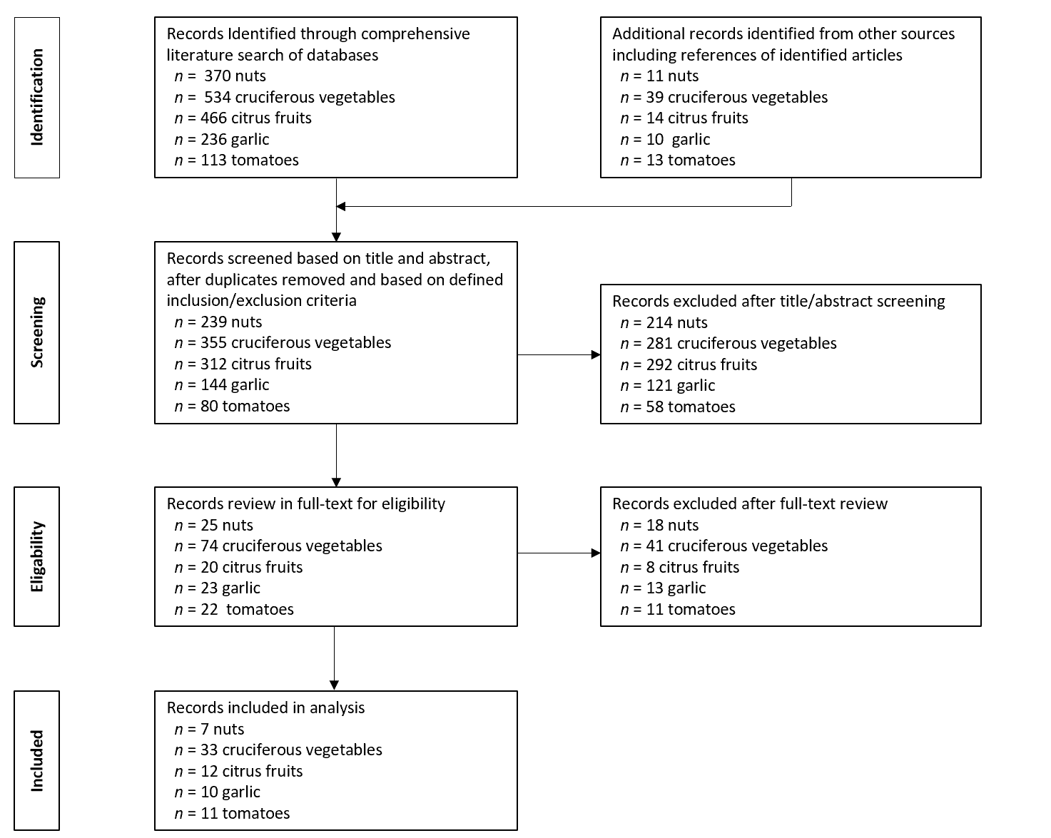
Figure 1 Flow Diagram summarizing systematic literature search strategy and outcomes.
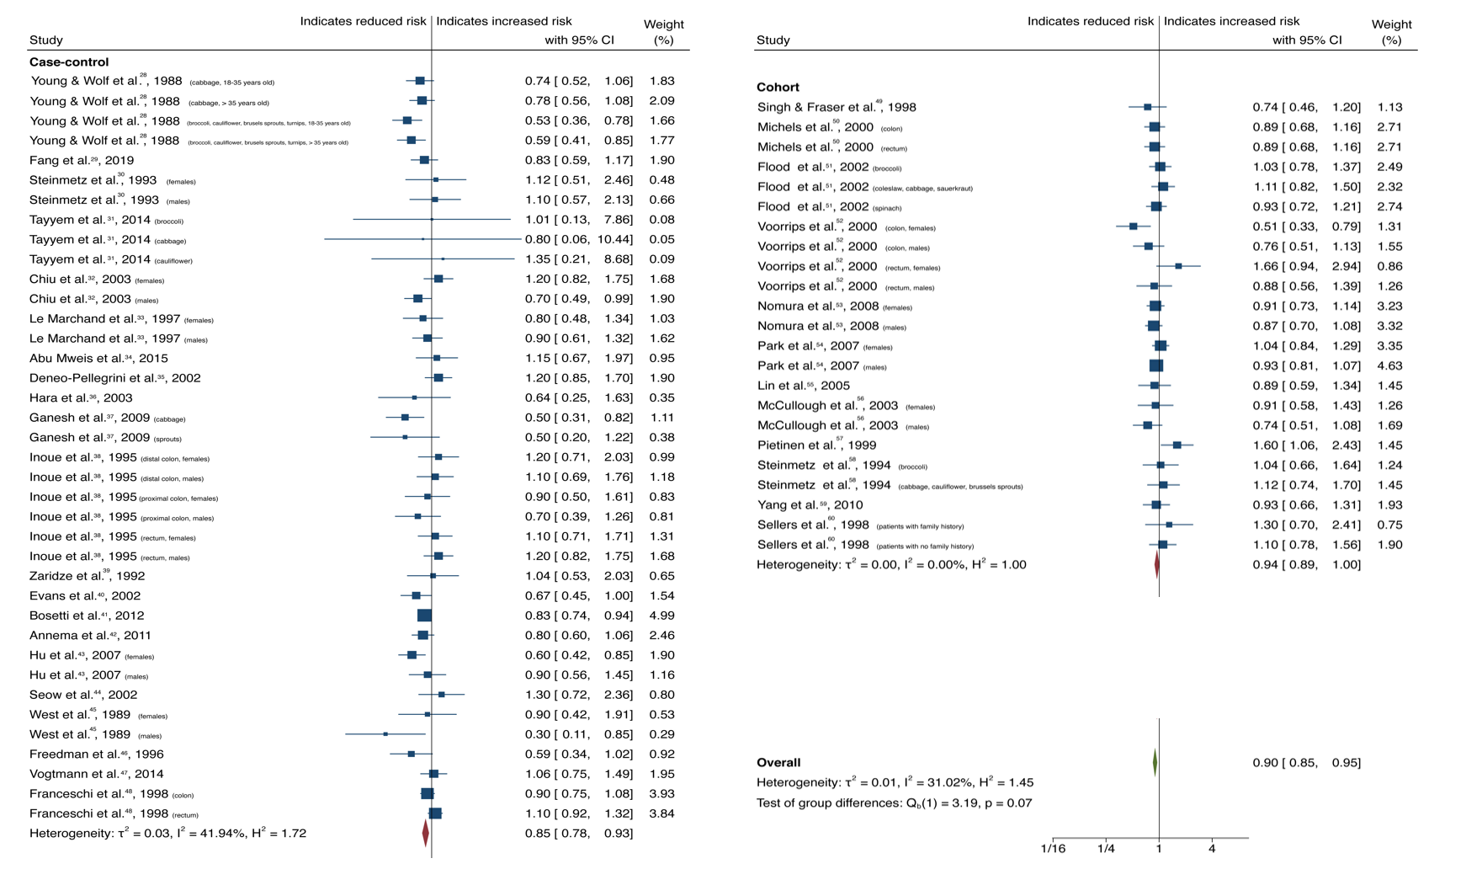
Figure 2 Forest plot showing the association between dietary cruciferous vegetable consumption and colorectal cancer risk. Squares and horizontal lines represent study-specific odds ratios (ORs) and 95% confidence intervals (CIs). The size of each square indicates the weighting of the study in the overall analysis depending on population size. Diamonds represent pooled ORs of all studies of that food item and 95%CI of the overall population. Vertical line indicates OR 1.0. CI: Confidence interval.
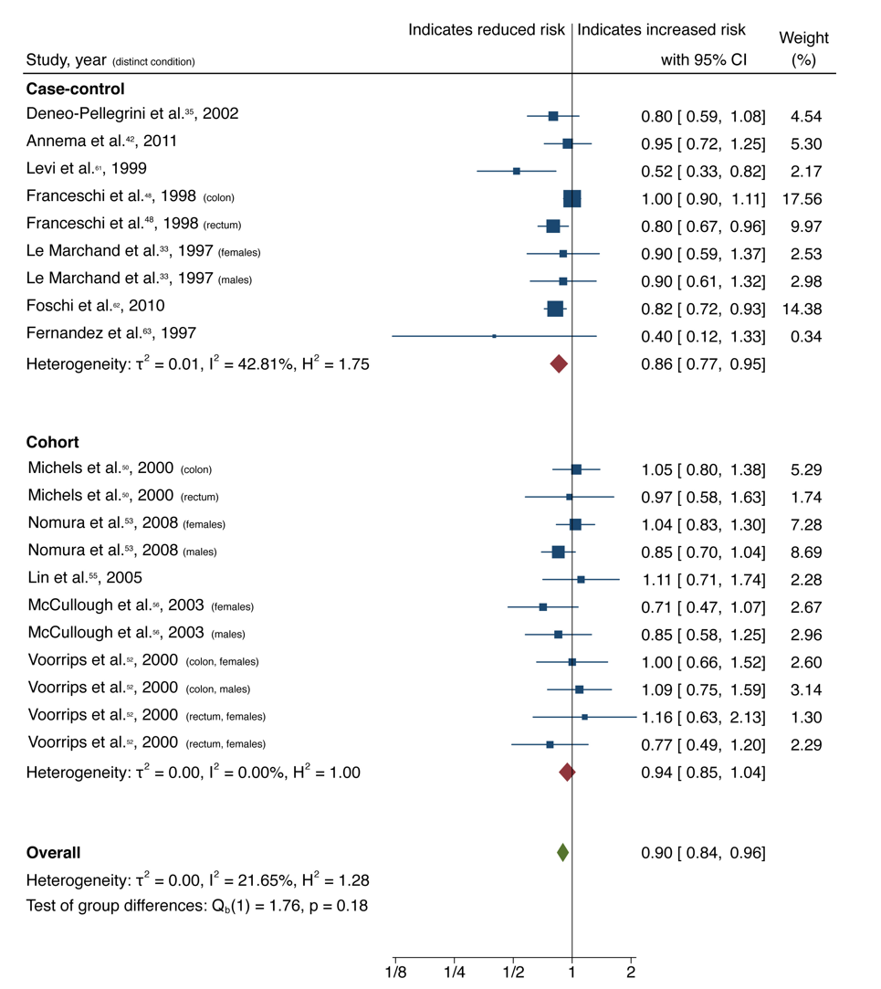
Figure 3 Forest plot showing the association between dietary citrus fruit consumption and colorectal cancer risk. Squares and horizontal lines represent study-specific odds ratios (ORs) and 95% confidence intervals (CIs). The size of each square indicates the weighting of the study in the overall analysis depending on population size. Diamonds represent pooled ORs of all studies of that food item and 95%CI of the overall population. Vertical line indicates OR 1.0. CI: Confidence interval.
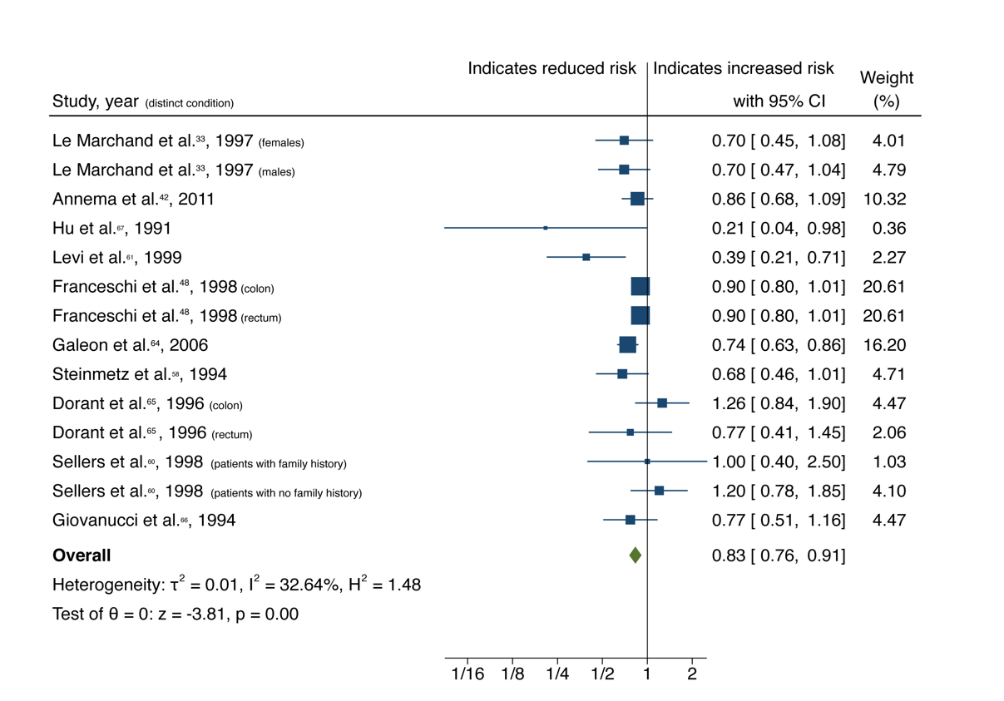
Figure 4 Forest plot showing the association between dietary garlic consumption and colorectal cancer risk. Squares and horizontal lines represent study-specific odds ratios (ORs) and 95% confidence intervals (CIs). The size of each square indicates the weighting of the study in the overall analysis depending on population size. Diamonds represent pooled ORs of all studies of that food item and 95%CI of the overall population. Vertical line indicates OR 1.0. CI: Confidence interval.
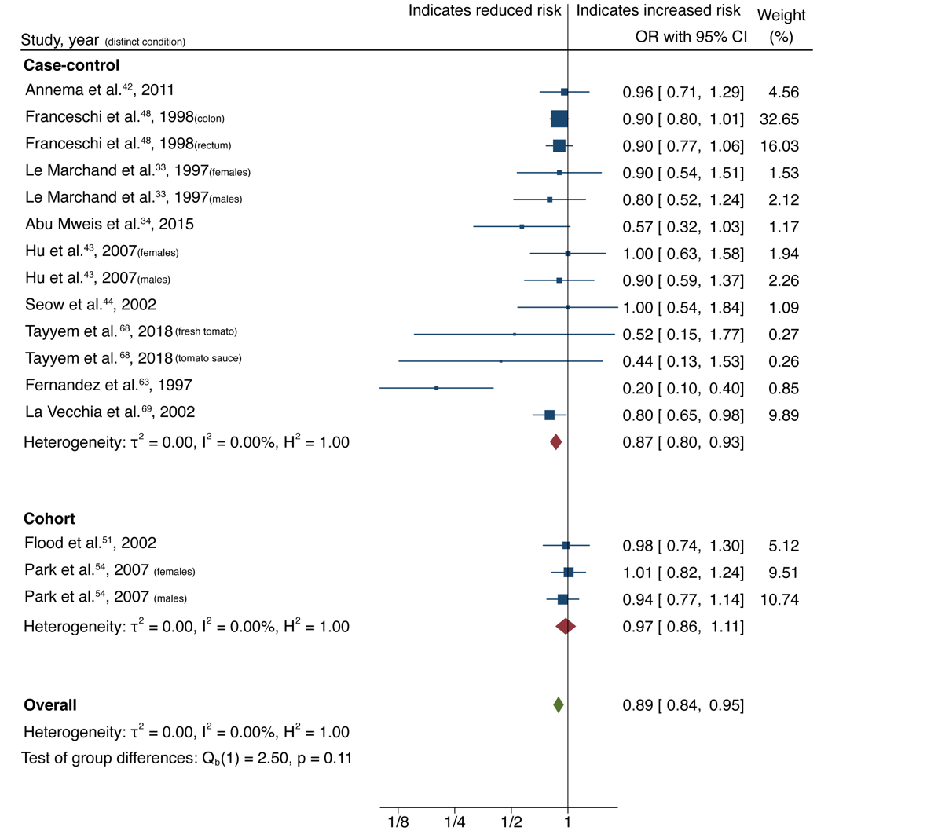
Figure 5 Forest plot showing the association between dietary tomato consumption and colorectal cancer risk. Squares and horizontal lines represent study-specific odds ratios (ORs) and 95% confidence intervals (CIs). The size of each square indicates the weighting of the study in the overall analysis depending on population size. Diamonds represent pooled ORs of all studies of that food item and 95%CI of the overall population. Vertical line indicates OR 1.0. OR: Odds ratio; CI: Confidence interval.
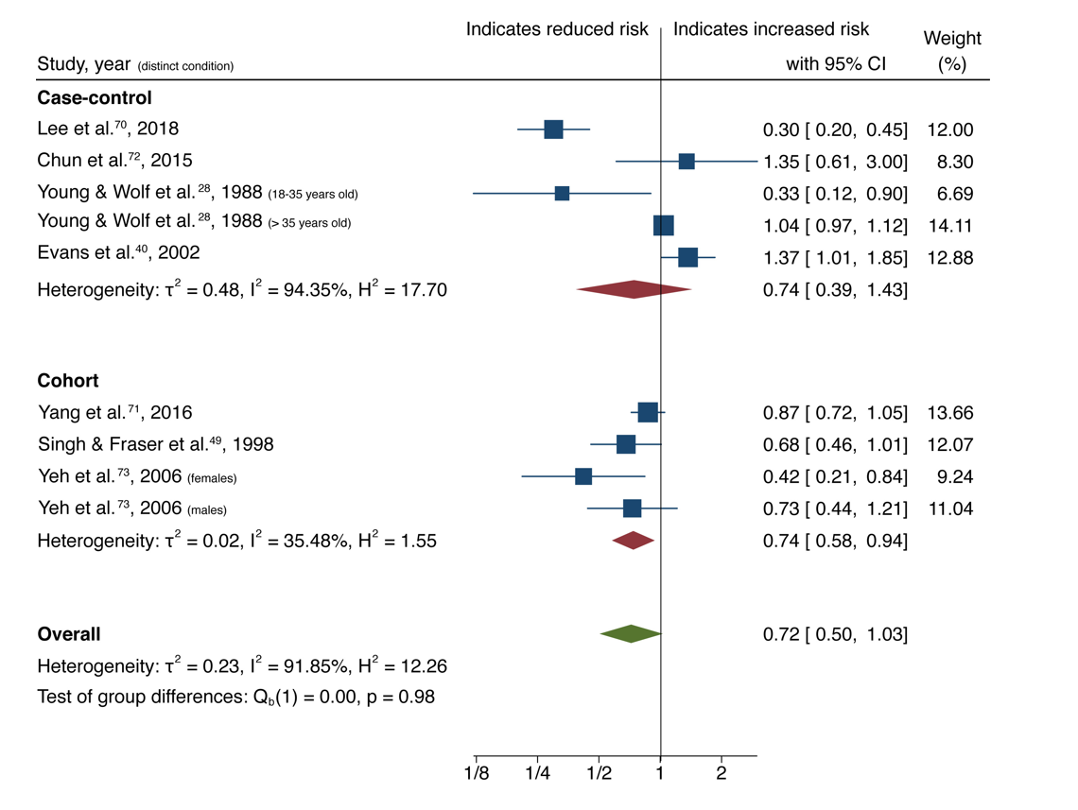
Figure 6 Forest plot showing the association between dietary nut consumption and colorectal cancer risk. Squares and horizontal lines represent study-specific odds ratios (ORs) and 95% confidence intervals (CIs). The size of each square indicates the weighting of the study in the overall analysis depending on population size. Diamonds represent pooled ORs of all studies of that food item and 95%CI of the overall population. Vertical line indicates OR 1.0. CI: Confidence interval.

Figure 7 Top genes and pathways perturbed by food items. Each food item is connected to the active compounds found commonly within that food. Food genomic profiles are connected to genes perturbed. Node colour represents shared biological pathway functionality or entity category (food compounds, food genomic perturbation profile).

Table 1 Association between dietary components and colorectal cancer risk
Dietary component |  | Number of studies (number of publications)¹ | Pooled OR (95%CI) | P value | Heterogeneity [I² (%)] | Egger P value
Cruciferous vegetables | All | 61 (33) | 0.90 (0.85-0.95) | 0.00 | 31.02 | 0.58
 | Case-control | 38 (21) | 0.85 (0.78-0.93) | 0.00 | 41.94
 | Cohort | 23 (12) | 0.94 (0.89-1.00) | 0.07 | 0.00
Citrus fruits | All | 20 (12) | 0.90 (0.84-0.96) | 0.00 | 21.65 | 0.46
 | Case-control | 9 (7) | 0.94 (0.85-1.04) | 0.00 | 42.81
 | Cohort | 11 (5) | 0.86 (0.77-0.95) | 0.26 | 0.00
Garlic | All | 14 (10) | 0.83 (0.76-0.91) | 0.00 | 32.64 | 0.12
 | Case-control | 8 (6) | 0.92 (0.72-1.18) | 0.00 | 47.80
 | Cohort | 6 (4) | 0.81 (0.72-0.90) | 0.51 | 35.38
Tomatoes | All | 16 (11) | 0.89 (0.84-0.95) | 0.00 | 0.00 | 0.02
 | Case-control | 13 (9) | 0.97 (0.84-0.95) | 0.00 | 0.00
 | Cohort | 3 (2) | 0.87 (0.8-0.93) | 0.68 | 0.00
Nuts | All | 9 (7) | 0.72 (0.50-1.03) | 0.07 | 91.85 | 0.22
 | Case-control | 5 (4) | 0.74 (0.39-1.43) | 0.38 | 94.35
 | Cohort | 4 (3) | 0.74 (0.58-0.94) | 0.01 | 35.48
¹where studies reported gender-specific or cancer site-specific results only rather than combining these into one result, we included effect size for male and female participants separately and likewise site-specific cancer data separately, and these are therefore displayed as 2 separate studies in the accompanying forest plots, despite originating from the same publication. CI: Confidence interval; OR: Odds ratio.

